Supplementary Material
- Funnel Plot for Figure 2
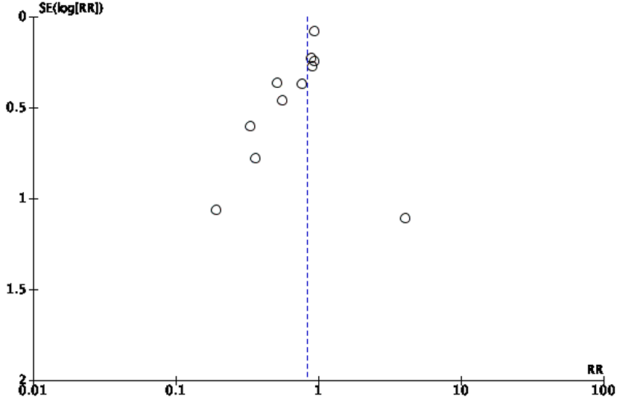
Figure S1. Funnel Plot for up to 6-month Mortality

- Search Terms
PubMed
Search: (((((((((((((((((((nutrit*) OR (Enteral Nutrition or Nutrition Assessment or Nutrition Therapy or Nutrition Disorders)) OR (diet*)) OR (Diet/ or Diet Therapy/)) OR (eat*)) OR (Food Service* or Feeding Behavio* or Food Habit*)) OR (food)) OR (Food Fortifi* or Food or Food Formulat*)) OR (feed*)) OR (Energy Intake)) OR (Protein-Energy Malnutrition)) OR (energy)) OR (oral nutrition* supplement*)) OR (oral nutrition* supplement*)) OR (Dietary Supplement*)) OR (sip feed)) OR (nutrit* status) AND (Adult* or Elderl*))) AND (diet* educat* or diet* counsel* or nutrition* educat* or nutrition* counsel*)) AND (hospital* or inpatient or hospital admission* or acute care or acute setting*) Filters: Clinical Trial, Randomized Controlled Trial, Humans, Adult: 19+ years, from 2014 - 2021

CINAHL
TX weight OR TX nutrit* OR TX diet* OR TX eat* OR TX ( food or snack ) OR TX feed* OR TX calori* OR TX energy OR TX ( oral nutritional supplements or dietary proteins or nutritional support ) OR TX sip feed* OR TX suppl* OR TX ( educat* or behav* ) AND
TX hospital or acute setting or inpatient or ward
AND
TX malnutrition or undernutrition or undernourishment

EMBASE
(nutrit* OR 'enteral nutrition'/exp OR 'nutritional assessment'/exp OR 'diet therapy'/exp OR 'nutritional disorder'/exp OR diet* OR eat OR 'food services'/exp OR 'feeding behavior'/exp OR 'food habits'/exp OR food OR 'fortified food'/exp OR 'food formulated'/exp OR feed OR 'protein calorie malnutrition'/exp OR 'caloric intake'/exp OR 'oral nutritional supplement' OR 'dietary supplements'/exp OR 'nutritional support'/exp OR malnutrition OR malnourish* OR undernutrition OR undernourish*) AND (adult OR aged OR elder*) AND ((hospital OR hospitali* OR acute) AND care OR acute) AND setting* AND ([controlled clinical trial]/lim OR [randomized controlled trial]/lim) AND [2011-2021]/py

- Risk of Bias Assessment

Table S1. Risk of Bias Assessment for Selected Randomised Controlled Trials
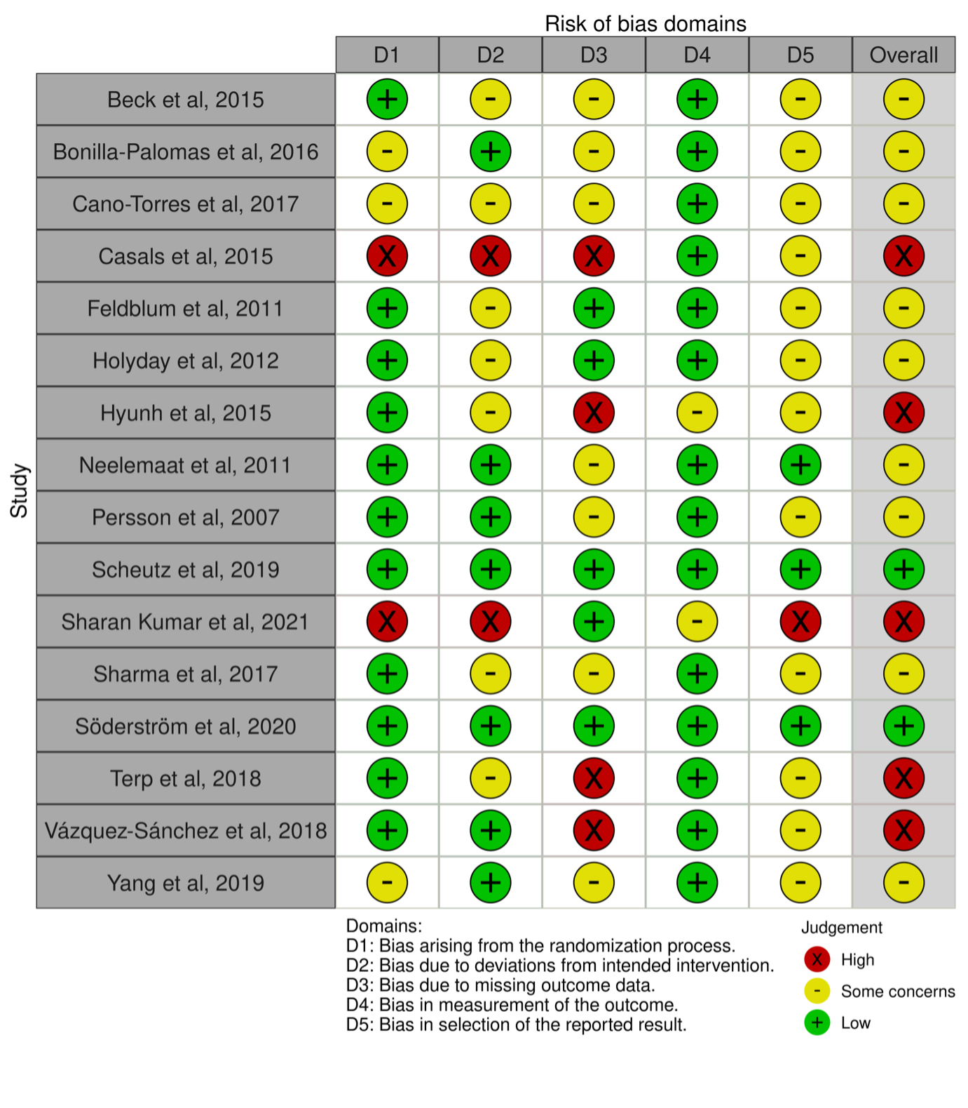

For Domain 5 (measurement of outcome), most studies (13 of 16 studies, 81.3%) were of some concerns or high RoB as they were either not registered on any trial registry or did not have a pre-specified analysis plan. Another 69% (11 of 16 studies) were of some concerns or high RoB in Domain 3 (missing outcome data), as there were missing outcomes from randomised participants or results were not fully reported in tables or figures. Finally, Domain 2 (deviations from the intended intervention) had 56% (9 of 16 studies) of some concerns or high risk of bias, due to either participants not being blinded to the intervention, or participants in the control group receiving ONS.

- Summary of Study Outcomes
Table S2: Clinical Outcomes of Studies
Source | Mortality | Infections/ Complications | Readmission | Hospital Length of Stay
Beck et al¹⁹, 2015 | 3-month:  INT: 1/34 vs CON: 2/37, p=NS  6-month:  INT: 2/34 vs CON: 6/37, p=NS  OR=0.323, 95%CI (0.060-1.724), p=NS | NA | 30-day  INT: 5/34 vs CON :7/37, p=0.756  3-month  INT: 8/34 vs CON: 12/37, p=0.435  6-month  INT: 9/34 vs CON: 16/37, p=0.074  OR=0.367, 95%CI (0.129-1.042), p=0.074 | NA
Bonilla-Palomas et al²⁰, 2016 | Inpatient mortality:  INT: 2/59 vs CON: 1/61  6-month:  INT: 9/59 vs CON: 18/61  (derived from study’s Kaplan-Meir curves)  12-month:  INT: 12/59 vs CON: 29/61,  HR=0.37, 95%CI: 0.19-0.72, p=0.003 | NA | 6-month  INT: 6/59 vs CON: 22/61, p=0.001  HR= 0.21, 95% CI (0.09-0.52), p=0.001 | NA
Cano-Torres et al²¹, 2017 | 6-month:  INT: 1/28 vs CON: 5/27 control,  HR=0.85; 95%CI: 0.17–4.21, p=NS | NA | NA | Mean LOS  INT: 6.4 (3.0) vs CON 8.4 (4.0) days, p=0.03
Casals et al²², 2015 | 6-month:  INT: 6/52 vs CON: 6/53, p=NS | NA | 6-month  INT: 0.25 (0.40) = 13/52 vs CON: 0.62 (1.11) = 33/53 readmissions/patient (difference=0.37 p=0.040).  INT required 2.02 (4.53) days for readmissions  vs CON 8.77 (24.77) days | Mean LOS  INT: 21.0 (17.08) vs CON: 14.6(8.24) vs, p=0.021
Feldblum et al²³, 2011 | 6-month:  INT: 3/78 vs CON: 21/181, p=0.046 | NA | NA | NA
Holyday et al²⁴, 2012 | Inpatient mortality:  INT: 4/71 vs CON: 1/72, p=NS  6-month:  Authors reported nil additional deaths over 6 months | NA | 1-month  INT: 0.09 (0.04) = 6/67 vs CON 0.11 (0.04) = 8/71, p=NS  6-month  INT: 0.45 (0.09) = 30/67 vs CON: 0.53 (0.08) =38/71 , p=NS | Mean LOS adjusted for deaths (days):  INT: 13.7 (1.4) vs CON: 13.5 (1.3), p = 0.85  the reduction in LOS for the malnourished group was marginally significant  19.8 (3.0) vs 11.2 (1.5) days, p=0.054
Hyunh et al²⁵, 2015 | NA | NA | NA | NA
Neelemaat et al²⁶, 2011  Neelemaat et al³⁵, 2012a  Neelemaat et al³⁶, 2012b  Neelemaat et al³⁷, 2017 | 30-day: 8/105 vs CON: 8/105  3-month:  INT: 14/105 vs CON: 11/105  HR: 0.98 (0.71-1.35)  6-month:  INT: 20/104 vs CON: 22/104  HR: 1.00 (0.73-1.39)  1-year:  INT 35/104 vs CON: 28/104  HR: 0.93 (0.68-1.29) | Fall  INT: 10/105 vs CON: 24/105  HR = 0.41, 95% CI = 0.19–0.86, P = .02, | NA | Mean LOS  INT: 13 (16.8) vs CON: 14 (12.5), p=0.684
Persson et al¹⁶, 2007 | 4-month:  INT: 6/51 vs CON: 12/57, nil statistical analysis | NA | NA | NA
Scheutz et a²⁷, 2019  &  Kaegi-Braun et al³⁴, 2020# | 30-day:  INT: 73/1015 vs CON: 100/1013  Adjusted OR = 0·65 95%CI (0·47–0·91), p=0·011  6-month:  INT: 231/994 vs CON: 246/999  HR = 0.90 95%CI (0.76-1.08), p= 0.277  (Reported in post-hoc study) | Adverse Event  INT: 232/1015 vs CON: 272/1013,  Adjusted OR = 0·79, 95%CI (0·64–0·97), p=0·023  Major complications:  INT: 74/1015 vs CON: 78/1013,  OR= 0.95 (0.68 to 1.34), p=0.788  Admission to ICU:  INT: 23/1015 vs CON: 26/1013,  OR=0.85, 95%CI (0.48-1.51), p =0.58 | Non elective 30 days  INT: 89/1015 vs CON: 91/1013, OR=0.99, 95%CI 0.73-1.35, p=0.96  6-month  INT: 274/994 vs CON: 273/999,  HR 1.00, 95%CI (0.84-1.18), p = 0.974) | Mean LOS  INT: 9.5 (7.0) vs CON: 9.6 (6.1),  OR=-0.21, 95%CI (-0.76-0.35), p=0.46
Sharan Kumar et al²⁸, 2021 | NA | NA | NA | NA
Sharma et al²⁹, 2017 | Inpatient:  INT 7/78 vs CON: 1/70, p=0.09  3-month:  INT: 13/78 vs CON 11/70, nil statistical analysis  (derived from Kaplan Meier Curve)  6-month:  INT: 23/78 vs CON: 22/70 control, nil statistical analysis  (derived from Kaplan Meier Curve)  1-year:  INT: 43/78 vs CON: 40/70, nil statistical analysis  (derived from Kaplan Meier Curve) | Total complications:  INT: 21/78 vs CON: 23/70, p=0.47  Infective complications:  INT: 9/78 vs CON: 7/70, p=0.74  Non-infective complications:  INT: 19/78 vs CON: 21/70, p=0.48 | Total readmissions  INT 46/78 vs CON 46/70, p=0.47  1-month  INT: 14/78 vs CON 17/70, p=0.37  3-month  INT: 26/78 vs CON: 29/70, p=0.34  6-month  INT: 37/78 vs CON: 35/70, p=0.82 | Median LOS  INT: 5.0 (IQR 3.0–8.4) vs. CON: 8.8 (IQR 4.1–13.9), P=0.007  Mean LOS (converted)  INT: 5.5 (4.1) vs CON: 8.9 (7.5), P=0.007
Söderström et al³⁰, 2020  &  Söderström et al³⁸, 2021# | 1-year:  INT:  Diet Advice Only: 30/168 vs  Nutritional Supplements Only: 39/170  Diet Advice + Nutritional Supplements: 36/169  vs  CON: 31/164, p=NS  Additional information obtained from Author  6-month:  INT:  Diet Advice Only: 21/168 vs  Nutritional Supplements Only: 23/170  Diet Advice + Nutritional Supplements: 25/169  Vs  CON: 25/164 | No significant differences in side effects between INT and CON at 1, 3, and 6 months after discharge | NA | NA
Terp et al³¹, 2018 | 90-day:  INT: 10/67 vs CON: 9/67, p=0.778  120-day:  INT: 12/67 vs CON: 10/67, p=0.614 | NA | 90-day  INT: 26/67 vs CON: 23/67, p=0.547  Number of days to first readmission,  INT: 38 (32) days vs CON: 29(20) days,  p=0.297 | NA
Vázquez-Sánchez et al³², 2018 | 6-month:  INT: 6/52 vs CON: 6/54, nil statistical analysis | NA | NA | NA
Yang et al³³, 2019 | 3-month:  INT: 8/39 vs CON: 10/43, nil statistical analysis  6-month  INT: 9/39 vs CON: 13/43, nil statistical analysis | NA | After adjusting for sex, the readmission rate for pneumonia decreased by 77% in INT vs CON  INT: 12/39 vs CON: 15/43, p=NS  OR=0.228, 95% CI (0.06–0.87), p = 0.03 | No significant difference was found in hospital stay between the two groups at the six-month  follow-up.  INT: 15.4 (8.1) vs CON 15.5 (7.4) days, p=NS
CON: Control; INT: Intervention; HR: Hazard Ratio; LOS: Length of Stay; NA: Not Applicable; NS: Not Significant; OR: Odds Ratio; RR: Relative Risk; vs: versus
Results expressed in Mean (S.D.) or Ratio

Table S3. Nutritional and Functional Outcomes
Source | Quality of Life | Nutritional Outcomes | Functional Outcomes
Beck et al¹⁹, 2015 | EQ5D-3L  Baseline, median (95 % CI)  INT: 0.623 (0.496;0.723) vs  CON: 0.708 (0.654;0.743), p=0.087  Baseline, mean (SD)^  INT: 0.614 (0.18) vs  CON: 0.702 (0.07)  3-month, median (95 % CI)  INT: 0.722, 95%CI (0.655-0.771) vs  CON: 0.722, 95%CI (0.594-0.723), p= 0.657  3-month, mean (SD)^  INT: 0.716 (0.10) vs  CON: 0.680 (0.09) | Weight changes median (95 % CI):  INT: 0.5 (–1.0-3.1) vs CON: −0.9 (–3.2-0.8), p= 0.025  Protein intake changes median (95 % CI):  INT::19 (12-26) vs  CON: 3 (–4-15), p=0.003 | NA
Bonilla-Palomas et al²⁰ 2016 | NA | NA | NA
Cano-Torres et al²¹, 2017 | NA | BMI mean (SD):  INT: 24.6 (7.4) vs CON: 26.1 (7.0), p = 0.47
Casals et al²², 2015 | SF-12  Baseline, mean (SD)  INT: 37.9 (13.66) vs  CON 38.7 (13.56), p=0.89  6-month (Change in Score), mean (SD)  INT: 15.51 (15.07) vs  CON: 1.79(12.86)  Difference=13.72, p<0 .001 | Change in Malnutrition Universal Screening Tool scores, mean (SD)  INT: -2.457 (1.39) vs CON: -1.170 (1.67) (difference, −1.29; p < .001)  INT: 39/46 (84.8%; 95% CI 73.32-96.25%) vs CON: 19/47 (40.4%; 95%CI 25.33-55.12) were of low risk for MUST at the end of study, for a difference of 44.4% (95%CI 24.8---64.0%; p <0.001).  Change in BMI, mean (SD)  INT: 1.745 (2.06) vs Control -0.395 (2.43) vs difference=2.14, p<0.001 | Barthel index, mean (SD)  Baseline:  INT 58.6 (28.84) vs CON 62.5 (28.54), p = 0.928  6-month (Change in Score)  INT: 16.848 (19.29) vs CON: 9.362 (19.07), difference=7.49, p=0.025
Feldblum et al²³, 2011 | NA | Change in MNA score  adjusted for education and hospitalization ward, mean (SD):  Intervention 3.0 (2.6) vs CON: 1.8 (3.0), p=0.004  Diet Intake:  No significant change in intake after 6 months | Barthel Index, mean (SD):  Baseline:  INT 93.5 (15.6) vs CON 91.7 (15.7), p=0.41  6-month (Change in Score), adjusted for education and ward type  INT: -2.6(18.3) vs CON: -3.6 (18.9) p=0.76
Holyday et al²⁴, 2012 | NA | Nil significant differences in weight change | NA
Hyunh et al²⁵, 2015 | NA | Weight Change (%):  4-week  INT: 2.6% vs CON: 1.4%, p=0.0025  8-week  INT: 3.2% vs CON: 1.1%, p=0.0004  12-week  INT: 4.0% vs CON: 2.1%, p=0.0007  Nutritional status based on mSGA score improved in  both groups | Lowest tertile of baseline handgrip strength score in INT  Greater improvement in handgrip strength at week 4 in INT vs CON (p=0.0452)
Neelemaat et al ²⁶ , 2011  Neelemaat et al,³⁵ 2012a  Neelemaat et al,³⁶ 2012b  Neelemaat et al,³⁷ 2017 | EQ-5D-3L index  3-month, mean(SD)  INT: 0.15 (0.01) vs  CON: 0.13 (0.01), p=NS | Weight gain (kg),  was significant for the highest body weight category:  mean difference 3.4 kg, 95% CI (0.2–6.6)  No differences in fat free mass. | No differences in physical performance and activities, handgrip strength and fat free mass.  For functional limitations, INT improved  significantly more than CON (95% CI-1.2;  -0.3).
Persson et al ¹⁶, 2007 | SF-36 Physical  Baseline vs 4-month, mean (SD)  INT:  Baseline 204(81) vs 4-month 219(101), p=NS  CON:  Baseline 252(138) vs 4-month 205(135), p=NS  SF-36 Mental  Baseline vs 4-month, mean (SD)  INT:  Baseline 210(74) vs 4-month 217(107), p=NS  CON:  Baseline 216(110) vs 4-month 219(121), p=NS | BMI  Difference over time between the two groups, p<0.001.  No difference between INT vs CON. | Hand Grip Strength  No difference between intervention vs control.
Scheutz et al ²⁷, 2019  &  Kaegi-Braun et al³⁴, 2020 | EQ-5D-3L VAS  1-month/Discharge, mean (SD)  INT: 59 (26) vs  CON: 56 (29), p<0.0001  6-month, mean (SD)  INT: 50.9 (34.9) vs  CON: 50.7 (35.5), p=0.90  EQ-5D-3L index  1-month/ Discharge, mean (SD)  INT: 0.75 (0.32) vs  CON: 0.73 (0.34), p=0.018  6-month, mean (SD)  INT: 0.83(0.21) vs  CON: 0.83 (0.21), p = 0.81 | NA | Barthel Score 30-day, mean (SD):  INT: 88 (26) vs CON: 85 (30) Adjusted OR=3·26 95%CI (0·93-5·60), p=0·006  Decline in functional status of ≥10%:  INT: 35/942 vs CON: 55/913,  Adjusted OR=0.62, 95%CI (0.40-0.96), p = 0.034
Sharan Kumar et al²⁸, 2021 | SGRQ Total  Baseline vs 6-month, mean (SD)  INT: Baseline 33.7 (23.4) vs 6-mth 20.0 (22.0), p<0.0001  CON: Baseline 39.1 (21.7) vs 6-mth 22.4 (18.3), p<0.0001  Differences, p=0.0036 | Total protein intake is higher in INT vs CON, p=0.0025  BMI (kg/m²), mean (SD)  INT: Baseline 19.7 (4.0) vs 6-mth 21.9 (3.9) p<0.0001  CON: Baseline 19.1 (2.7) vs 6-mth 20.9 (2.9) p<0.0001  Differences, p=0.0053 | NA
Sharma et al²⁹, 2017 | EQ-5D-5L index  Baseline (All), mean (95%CI / SD^)  INT: 0.693, 95%CI (0.639-0.747 / 0.08) vs  CON: 0.674 95% CI (0.617-0.730 / 0.09), p = 0.63  Baseline (ITT) vs 3-month, mean (95%CI / SD^)  INT:  Baseline 0.725, (0.665–0.784 / 0.09) vs  3-month 0.770, (0.720–0.818 / 0.08), p = 0.10  CON:  Baseline 0.655, (0.582–0.728 / 0.11) vs  3-month 0.740, (0.675–0.805 / 0.10), p = 0.03  Baseline (ITT) vs 3-month, mean difference (95%CI / SD^)  INT: 0.045 (-0.009 to 0.099 / 0.024) vs  CON: 0.085 (0.008–0.162 / 0.035), p=0.38 | PG SGA Score, mean (95%CI):  INT: Baseline 11.7 (10.4–12.9) vs 3-month 5.8 (4.8–6.9)  p<0.001  CON: Baseline 13.2 (11.6–14.8) vs 3-month 6.9 (5.6–8.2) p<0.001  Differences  INT: -5.9 (-7.3 - -4.4) vs CON: -6.2 (-8.1 - -4.2) vs p=0.79  BMI (kg/m²), mean (95%CI):  INT: Baseline 20.85 (19.75–21.95) vs 3-month 21.26 (20.16–22.35) p=0.11  CON: Baseline 22.18 (20.76–23.61) vs 3 months 21.82 (20.59–23.06) p=0.20  Differences  INT: 0.41 (-0.09-0.90) vs CON: -0.36 (-0.92 - 0.19), p=0.04  Mid-upper arm circumference (cm), mean difference (95%CI):  INT: 0.77 95%CI (0.24–1.30) vs CON: 0.64 (0–1.3), p = 0.75 | NA
Söderström et al³⁰, 2020  &  Söderström et al³⁸, 2021 | EQ-5D-3L index  Baseline, mean (SD)  INT:  Diet Advice & ONS group 0.746 (0.14) vs  Diet Advice Only group 0.783 (0.12) vs  Diet Advice with/without ONS 0.764 (0.18)  CON: 0.763 (0.15), p=NS  6-month, mean (SD)  INT:  Diet Advice & ONS group 0.778 (0.13) vs  Diet Advice Only group 0.797 (0.13) vs  Diet Advice with/without ONS 0.787 (0.18)  CON: 0.785 (0.13), p=NS  No statistically significant differences among the four study arms for the total group (n = 409) at any of the follow-up times.  Values at the 6-month differed significantly (p=0·031) only in the malnourished participants. | NA | NA
Terp et al³¹, 2018 | NA | Weight gain (kg), mean (SD):  INT: 0.9 (4.2) vs CON: -0.8 (3.6), p=0.032 | Handgrip strength:  Nil significant differences between groups.
Vázquez-Sánchez et al³², 2018 | NA – no results available for both groups | NA – no results available for both groups | NA – no results available for both groups
Yang et al³³, 2019 | NA | MNA-SF scores varied significantly with time for both groups (p < 0.001).  INT increased MNA-SF scores at three and six months vs baseline (p<0.05).  INT higher MNA-SF scores than CON at three and six months (p<0.05).  Calorie and Protein intake higher in INT vs CON (p<0.001)  MUAC – no difference between groups | NA
CON: Control; INT: Intervention; HR: Hazard Ratio; LOS: Length of Stay; NA: Not Applicable; NS: Not Significant; OR: Odds Ratio; RR: Relative Risk; vs: versus
Results expressed in Mean (S.D.) or Ratio unless specified
^ SD derived from 95% CI

- Narrative Review of Nutritional, Functional and Physical Outcomes

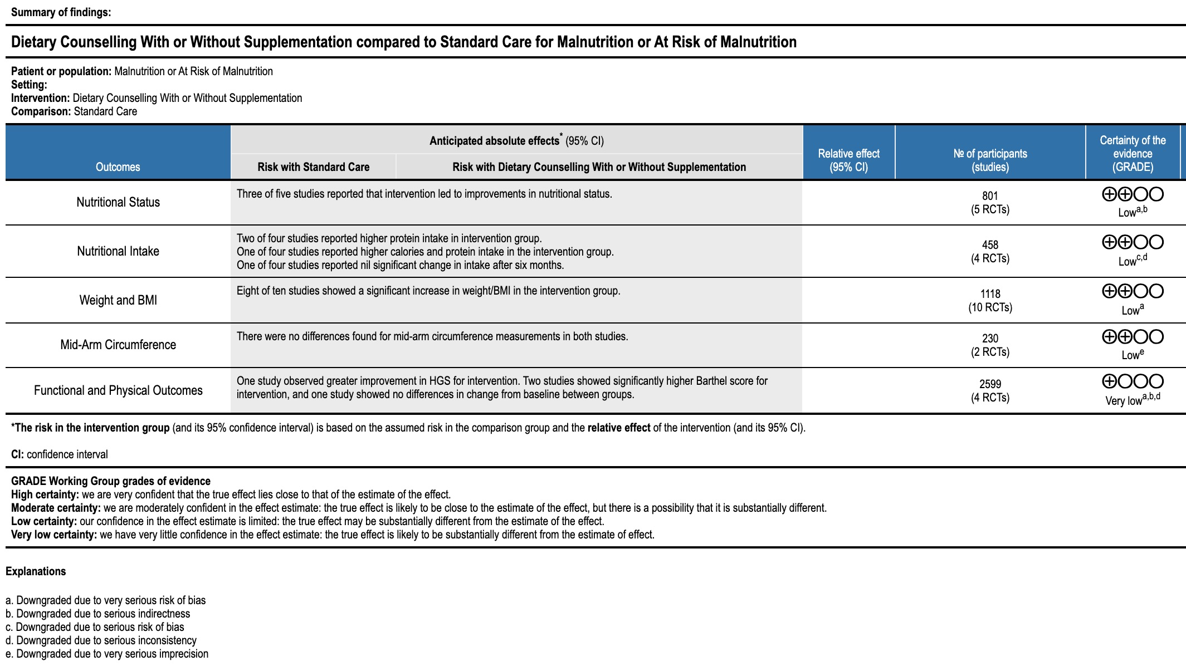

- Subgroup and Secondary Analyses
The results of subgroup analyses and the GRADE certainty of the evidence of these outcomes are summarised in Table S4.
Table S4. Summary of Subgroup Analysis Results and GRADE Certainty of Evidence
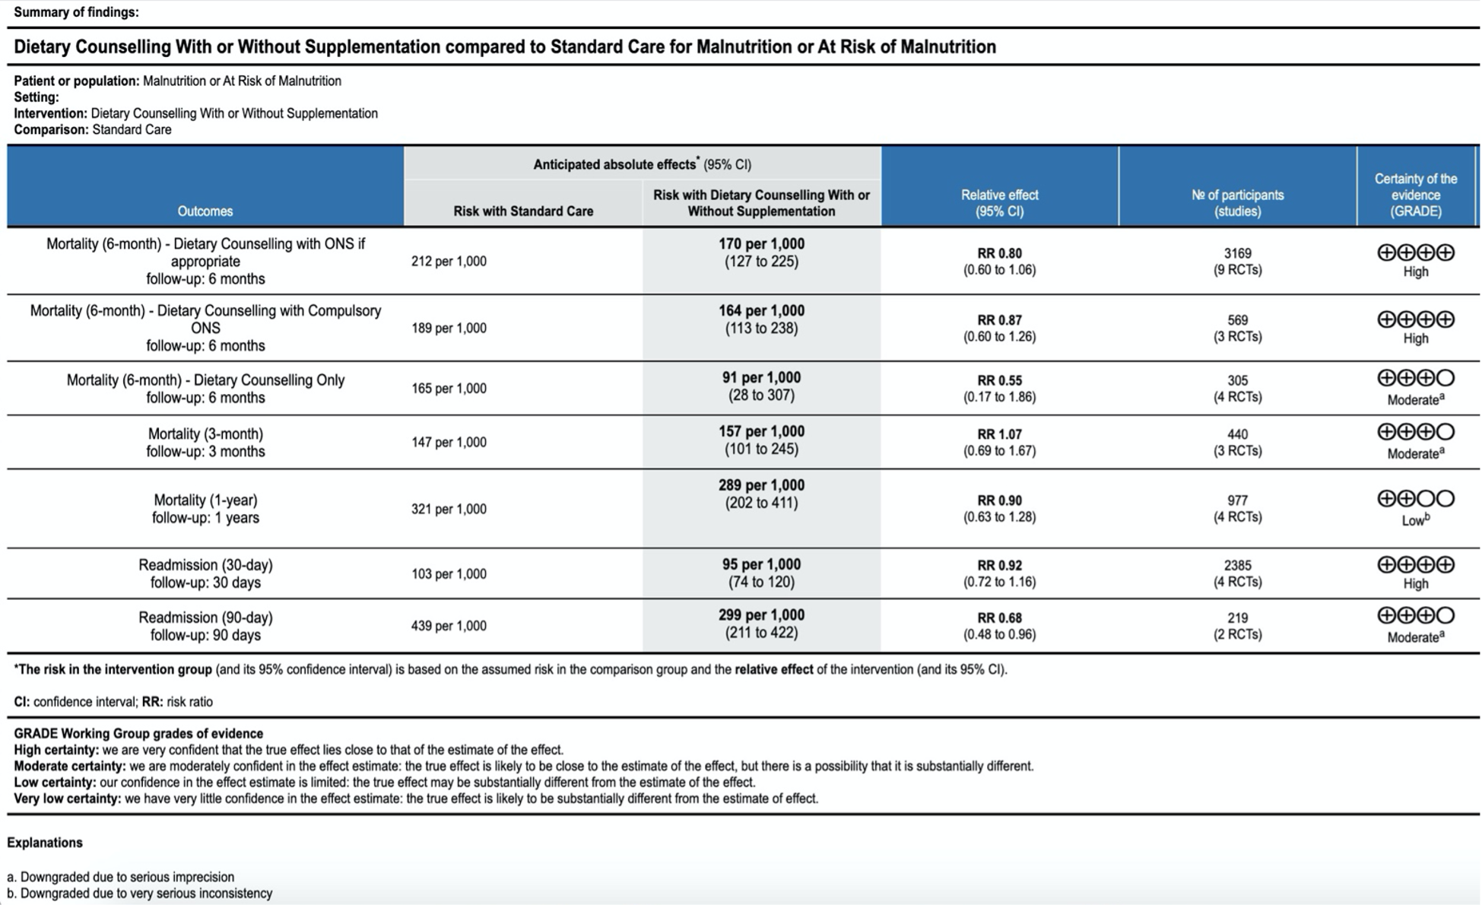
Figure S2 shows the meta-analysis of the pooled effect sizes for 6-month mortality.

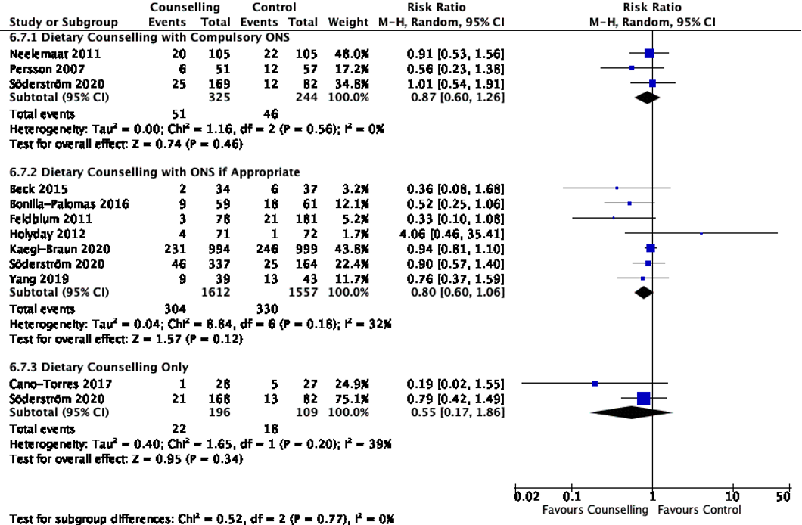
Figure S2. Analysis of Intervention Subgroups – Up to 6-Month Mortality

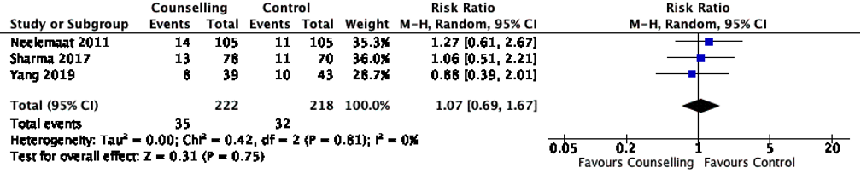
Figure S3a. Analysis of Mortality – 3-Month Mortality

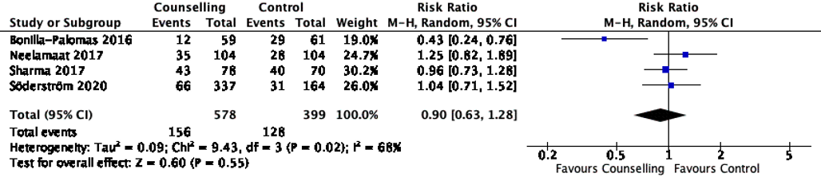

Figure S3b. Analysis of Mortality – 1-Year Mortality
Heterogeneity was high among these studies (I² = 73%). Removal of one study by Bonilla-Palomas et al.²⁰ reduced the heterogeneity to 0%, but results remained insignificant (RR 1.04, 95% CI 0.85 – 1.28, p= 0.43). This study recruited heart failure patients specifically, whereas the other studies recruited elderly patients with malnutrition.

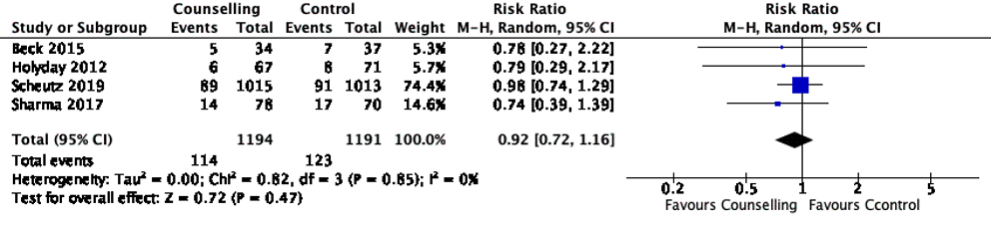
Figure S4a. Analysis of Readmission – 30-day Readmission

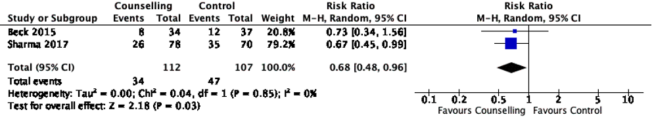
Figure S4b. Analysis of Readmission – 90-day Readmission

