SUPPLEMENT MATERIAL

Fraction of Inspired Oxygen During General Anesthesia for Non-Cardiac Surgery: Systematic Review and Meta-Analysis

CONTENT
SUPPLEMENTAL METHODS 4
Outcomes 4
Risk of bias assessment 6
Search for ongoing trials 8
Updated search for studies 8
GRADE evaluation 9
TABLES 12
Table S1: Registered randomized trials comparing oxygen targets 12
Table S2: Patient and surgical characteristics in included manuscripts 15
Table S3: Reported outcomes in the included manuscriptsª 17
Table S4: Bias assessment of included manuscripts 20
Table S5. Meta regression analyses 22
Table S6: Sensitivity analyses 24
Table S7: GRADE assessment 26
FIGURES 28
Figure S1: PRISMA diagram 28
Figure S2: Long-term mortality, meta-analysis 29
Figure S3: Long-term mortality, abdominal surgery subgroup analysis 30
Figure S4: Overall mortality (closets to 30 days), meta-analysis 31
Figure S5: Bubble plot for meta-regression of short-term mortality and median year of patient inclusion 32
Figure S6: Bubble plot for meta-regression of short-term mortality and mortality in the control group 33
Figure S7: Bubble plot for meta-regression of short-term mortality and sample size 34
Figure S8: Funnel plot short-term mortality 35
Figure S9: Hospital length of stay, meta-analysis 36
Figure S10: Hospital length of stay, acute surgery subgroup analysis 37
Figure S11: Hospital length of stay, abdominal surgery subgroup analysis 38
Figure S12: Bubble plot for meta-regression of length of stay and median year of patient inclusion 39
Figure S13: Bubble plot for meta-regression of length of stay and mortality in the control group 40
Figure S14: Bubble plot for meta-regression of length of stay and length of stay in the control group 41
Figure S15: Bubble plot for meta-regression of length of stay and duration of surgery 42
Figure S16: Bubble plot for meta-regression of length of stay and sample size 43
Figure S17: Funnel plot hospital length of stay 44
Figure S18: Surgical site infection, acute surgery subgroup analysis 45
Figure S19: Surgical site infection, abdominal surgery subgroup analysis 46
Figure S20: Bubble plot for meta-regression of surgical site infection and median year of patient inclusion 47
Figure S21: Bubble plot for meta-regression of surgical site infection and mortality in the control group 48
Figure S22: Bubble plot for meta-regression of surgical site infection and length of stay in the control group 49
Figure S23: Bubble plot for meta-regression of surgical site infection and duration of surgery 50
Figure S24: Bubble plot for meta-regression of surgical site infection and sample size 51
Figure S25: Funnel plot surgical site infection 52
Figure S26: Anastomotic leakage, meta-analysis 53
Figure S27: Wound dehiscence, meta-analysis 54
Figure S28: Reoperation, meta-analysis 55
Figure S29: Reoperation, acute surgery subgroup analysis 56
Figure S30: Atelectasis, meta-analysis 57
Figure S31: Pneumonia, meta-analysis 58
Figure S32: Atelectasis, abdominal surgery subgroup analysis 59
Figure S33: Pneumonia, abdominal surgery subgroup analysis 60
Figure S34: Myocardial injury/myocardial infarction, meta-analysis 61
Figure S35: Myocardial injury/myocardial infarction, abdominal surgery subgroup analysis 62
PRISMA CHECKLIST 63
REFERENCES 66

SUPPLEMENTAL METHODS

Outcomes
Mortality
Mortality was defined as all-cause mortality. We considered the timeframes in-hospital, during study period, 7-day, 15-day, and 30-day mortality as comparable, and they were grouped as short-term mortality. Mortality after 30 days was considered as long-term mortality. Long-term mortality ranged from 180-days to 4 years across the five included trials. We also included an analysis of overall mortality considering all timeframes. If a trial reported more than one timeframe, we used the time closest to 30 days.

Hospital length of stay
The respective authors’ definitions of hospital length of stay were accepted without requirement of further specification. Length of stay was reported as both median with quartiles and as mean with standard deviation (SD). Medians and SD were estimated from medians and quartiles as described in the main manuscript. One trial reported length of stay as mean with range, and this trial was excluded as this does not allow for estimation of mean and SD. Two trials in patients undergoing ambulatory gynecological laparoscopy were excluded as the length of stay was less than 6 hours in the intervention as well as the control group.

Surgical site infection
The majority of the trials defined surgical site infection according to the Centers for Disease Control and Prevention criteria¹ or referring to ASEPSIS score² (most studies included a score $≥$ 20 as evidence of wound infection). Only a few trials used definitions based on non-standardized measurements. Only one trial did not report their definition of surgical site infection. The timeframe for data collection on this complication ranged from first 7 postoperative days to 12 months postoperatively. The majority, however, reported data from within the first 30 postoperative days.

Anastomotic leakage
Most of the included trials reporting data on anastomotic leakage did not specify a definition. One trial defined it as requiring antibiotics ± surgery. All the studies reporting data on anastomotic leakage were included.

Wound dehiscence
Wound dehiscence was defined as requiring secondary suture of the fascia combined with identification of ICD-9 codes or as requiring surgical closure of the cutaneous or subcutaneous tissue or the fascia and muscular plane during the early postoperative period. Only one trial did not define this postoperative complication.

Reoperation
This outcome was not defined across all trials, although the majority specified the outcome as patients requiring ‘wound exploration’ or ‘reoperation’.

Atelectasis
Atelectasis was defined based on radiological findings on postoperative x-rays or CT-scans for most included trials. Three of eight included trials provided no explicit definition hereof.

Pneumonia
The authors’ criteria for defining pneumonia, including trials using guideline definitions, were only explicitly defined in 3 of 7 included trials. For the remainder of trials, pneumonia was either defined based on clinical and radiological signs or not defined at all. Guideline definitions included CDC³ and ARISCAT⁴ criteria.

Myocardial injury/infarction
This outcome was reported quite heterogeneously in the included trials and was therefore included as “myocardial injury/infarction” in this review. Four studies used blood samples for troponin T/I, two studies used definitions pertinent to “acute coronary syndrome”, and one study used ICD-10 codes to identify acute coronary syndrome, unstable angina pectoris, and myocardial infarction as a composite outcome. Thus, both cases of type I infarction (i.e., infarction due to coronary thrombus formation) and type II infarction (i.e., postoperative rise in troponins) are included in this outcome.

Risk of bias assessment
Risk of bias was assessed using version 2 of the Cochrane Risk-of-Bias tool for individually-randomized parallel-group trials.⁵ Results for risk of bias are presented in Table S4. General considerations related to this specific review are provided below.

Risk of bias arising from the randomization process
Three elements are considered within this domain: random allocation sequence, allocation concealment, and baseline imbalances. In general, if randomization was described and there was no indication of loss of allocation concealment, we categorized the trial as low risk of bias – this included trials with no clear description of allocation concealment as we then assumed it to be present. If the randomization process was not described at all, we generally considered trials to be in intermediate risk of bias.

Risk of bias due to deviations from the intended interventions
This domain focuses on whether participants received the intended intervention without other differences in care. As such, the domain primarily focuses on blinding of participants and the clinical team. It is difficult to blind the clinician who provides the intervention, and for much of the treatment data it is infeasible to decipher whether differences result from the intervention or non-protocol treatments. We therefore decided to judge all trials as at least intermediate risk of bias.
The difference between the effect of assignment to an intervention and the effect of adherence to an intervention was difficult to assess and often not described in the trials. Although we were technically interested in the effect of adherence to the intervention, the distinction between the two is probably minimal and therefore not considered further. Since appropriate per-protocol analyses were rarely performed, we – when possible – included results from (modified) intention-to-treat analyses.

Risk of bias due to missing outcome data
For most trials, outcomes were only assessed in-hospital, and the amount of missing data was low. These trials were therefore classified as having a low risk of bias. In a few trials, loss to follow-up was more substantial. When this loss to follow-up was moderate and equal among groups, the risk of bias was assessed as intermediate; if the loss to follow-up was more substantial and different between groups, the risk of bias was classified as high.

Risk of bias in measurement of the outcome
This domain includes multiple elements including whether the method of measuring the outcome was appropriate and similar between groups, whether outcome assessors were aware of the intervention, and whether this knowledge could have influenced the measurement of the outcome.
For most trials, the methods of measuring the outcomes were described very limited. Survival and hospital length of stay were considered objective outcomes, why knowledge of the intervention is unlikely to influence measurement of the outcome, and risk of bias was therefore considered low. For postoperative complications, the risk of bias was classified as low if the outcomes assessors were blinded and intermediate if they were not. We considered it unlikely that this non-blinding would have a major influence on the measurement of the outcome.

Risk of bias in selection of the reported result
If the trials reported results consistent with a protocol or trial registration, this domain was classified as low risk of bias. If there was no protocol or trial registration, the trial was classified as intermediate risk of bias. Outcome-relevant discrepancies between the manuscript and the protocol or trial registration were classified as intermediate or high based on whether or not it was selected from multiple outcome measurements or analyses of the data.

Overall risk of bias
The overall risk of bias was generally based on the highest risk reported within an individual domain.

Search for ongoing trials
The International Clinical Trials Registry Platform (ICTRP) was searched on April 5, 2021, and on June 28, 2021. The searches yielded 4034 records, of which 25 records were ongoing randomized controlled trials comparing oxygenation targets during general anesthesia (Table S1).
To optimize sensitivity, we performed an additional search for the term general anesthesia (filters: recruiting, not yet recruiting, enrolling by invitation, active but not recruiting, and interventional study type) on ClinicalTrials.Gov on April 5, 2021. Of 311 records, no additional randomized controlled trials were identified.
We did not consider records for which 1) the recruitment status was unknown, 2) the trial status was marked as unknown for more than 5 years, 3) the trial was marked as completed for more than 5 years, and/or 4) the last update was posted over 5 years ago.
Search at ICTRP on April 5, 2021:

anesthesia AND hemodynamic OR anesthesia AND respiratory OR surgery AND hemodynamic OR surgery AND respiratory

Search at ICTRP on June 28, 2021:

((anesthesia OR anaesthesia OR surgery OR surgical) AND (arterial blood pressure OR heart rate OR cardiac output OR stroke volume OR pulse pressure OR goal directed therapy OR goal-directed therapy OR oxygen OR carbon dioxide OR tidal volume OR respiratory rate OR PEEP OR recruitment maneuver OR lung protective ventilation))

Updated search for studies
An updated search for the term oxygen was performed in PubMed and Embase on March 22, 2022, to identify any trials published after the search on March 8, 2021. The search strategies are provided below.

PubMed:

(Anesthesia, General[Mesh] OR universal anesthesia[Title/Abstract] OR universal anaesthesia[Title/Abstract] OR general anesthesia[Title/Abstract] OR general anaesthesia[Title/Abstract] OR General Surgery[Mesh] OR surgery[Title/Abstract] OR surgical[Title/Abstract] OR perioperative[Title/Abstract] OR “peri-operative”[Title/Abstract] OR intraoperative[Title/Abstract] OR “intra-operative”[Title/Abstract]) AND (oxygen[Title/Abstract]) AND (randomized controlled trial[Publication Type] OR controlled clinical trial[Publication Type] OR randomized[Title/Abstract] OR placebo[Title/Abstract] OR clinical trials as topic[Mesh:noexp] OR randomly[Title/Abstract] OR trial[Title]) NOT (animals[Mesh] NOT humans [Mesh]) AND (English[Language])

EMBASE:

('anesthesia'/exp OR 'universal anesthesia':ti,ab OR 'universal anaesthesia':ti,ab OR 'general anesthesia':ti,ab OR 'general anaesthesia':ti,ab OR 'surgery':ti,ab OR 'surgical':ti,ab OR 'perioperative':ti,ab OR 'intraoperative':ti,ab) AND ('oxygen':ti,ab OR 'arterial oxygen pressure':ti,ab) AND ('randomized controlled trial'/exp OR 'controlled clinical trial'/exp OR randomly:ti,ab OR randomized:ti,ab OR placebo:ti,ab OR trial:ti,ab) NOT ('animal'/exp NOT 'human'/exp) AND ('article'/it OR 'article in press'/it) AND [english]/lim

GRADE evaluation
The GRADE methodology was used to evaluate the overall certainty in the evidence for a given intervention and outcome. The following domains were considered.

Risk of bias
Risk of bias was rated as “serious” for all interventions and outcomes since almost all of the individual trials were assessed as having an intermediate risk of bias.

Inconsistency
Inconsistency was evaluated with the I² statistic as well as visual inspection of the forest plot. As a guide, inconsistency was considered “serious” if the I² statistic was > 30%, but this also depended on the distribution of the individual trials.

Indirectness
Given that all the trials met our predefined criteria for inclusion and therefore represent the patient population of interest, indirectness was considered “not serious”. However, if the interest is in specific patient populations defined by patient characteristics or surgery type, it could be considered to assess indirectness as “serious”.

Imprecision
In determining whether a given comparison and outcome should be downgraded for imprecision, we considered both the width of the confidence interval and the sample size (in that order). For binary outcomes, we mainly considered the effect on the relative scale (i.e., odds ratio), but also evaluated the effect on the absolute scale (i.e., risk difference). If the confidence interval was very wide (i.e., < 0.50 and > 2.00 for the odds ratio) and included both potential benefit and harm, we considered imprecision to be “very serious”. If the confidence was less wide and included potential benefit and no clear effect or harm, imprecision was considered “serious”. If the confidence interval only included clear benefit or harm or was narrow around no effect (i.e., within 0.80 to 1.20 for the odds ratio), we considered the sample size in relation to the optimal information size.⁶ For length of stay, a narrow confidence interval was considered within -0.25 to 0.25 days.
The optimal information size is equivalent to the required sample size of a single, adequately powered trial. It is challenging to determine a general optimal information size. However, considering an absolute risk reduction of 1%, the optimal information size would be 6,206 for a control group outcome proportion of 2% and 39,494 for a control group outcome proportion of 11%. If a 5% absolute risk reduction was considered, the optimal information size would be 1,164 for a control group outcome proportion of 10% and 2,424 for 20%. These calculations are based on a chi-squared test, an alpha of 5%, and 90% power. Based on these considerations and previous suggestions⁶, we considered imprecision to be “serious” if the sample size was less than 2,000 patients. If the sample size was less than 100 patients, we considered imprecision to be “very serious”. For consistency, we used the same sample sizes for length of stay.

Others
In this domain, multiple aspects are considered, including publication bias, the size of the effect, the direction of potential bias, and dose response gradients. The last two were not of relevance in the current review. Given the small number of trials, it was generally not feasible to evaluate for publication bias. We considered a large effect to be < 0.50 or > 2.00 on the odds ratio scale. For hospital length of stay, we considered a large effect to be > 2 days.

TABLES

Table S1: Registered randomized trials comparing oxygen targets
Title | ID | Country | Year registered | Estimated completion | Comparator group | Comparator group | Comparator group | Patients | Status
Effects of inspiring oxygen concentration on pulmonary oxygenation and respiratory mechanics in morbidly obese patients undergoing laparoscopic bariatric surgery | ChiCTR1900020619 | China | 2019 | 12/2019 | FiO₂ 40% | FiO₂ 60% | FiO₂ 80% | 60 | Not recruiting
The effect of perioperative oxygen supplementation to reduce the incidence of surgical site infections in patients undergoing elective major abdominal surgeries | CTRI/2021/02/031436 | India | 2021 | 01/2022 | FiO₂ and 70% nitrous oxide | FiO₂ and 20% nitrous oxide | NA | 50 | Not recruiting
Perioperative respiratory care and outcomes for patients undergoing high risk abdominal surgery (PENGUIN) | NCT04256798 | South Africa | 2020 | 06/2024 | Mouthwash and/or liberal oxygen | Mouthwash and/or restrictive oxygen | NA | 12,942 | Recruiting
Immunological effect of intraoperative fraction of inspired oxygen in patients undergoing major abdominal cancer surgery | NCT04772794 | Egypt | 2021 | 05/2022 | FiO₂ 80% | FiO₂ 30% | NA | 20 | Recruiting
Pulmonary complications and clinical outcomes using ultrasound according to the inspired oxygen concentration during general anesthesia: multi-center, randomized controlled trials | KCT0005872 | South Korea | 2021 | 12/2021 | FiO₂ 100% | FiO₂ 40% | NA | 320 | Not recruiting
Effects of different oxygen concentrations on air embolization in hysteroscopic surgery: a randomized controlled trial | ChiCTR2000033202 | China | 2020 | 09/2020 | FiO₂ 30% | FiO₂ 50% | FIO2 100% | 120 | Not recruiting
Effect of intraoperative oxygen use on cerebral blood flow in adult patients under general anaesthesia: a randomized controlled trial | CTRI/2020/03/024295 | India | 2020 | 04/2020 | FiO₂ 30% | FiO₂ 80% | NA | 56 | Not recruiting
Effect of different fraction of inspired oxygen on ventilator-induced lung injury in patients during prolonged general anesthesia | ChiCTR2000029075 | China | 2020 | 02/2021 | FiO₂ 30% | FiO₂ 50% | FiO2 80% | 90 | Recruiting
Is peri-operative hyperoxemia a risk factor for postoperative complications? A randomised, prospective study in patients undergoing vascular surgery | NCT02562781 | Sweden | 2015 | 01/2021 | FiO₂ > 50% and SpO₂ of 98-100% | Air or lowest possible inspired concentration of oxygen to maintain SpO₂ > 90% | NA | 184 | Completed
Comparison of oxygen exposure amount between oxygen reserve index based FiO2 titration and conventional FiO2 titration in thoracic surgery | KCT0004782 | South Korea | 2020 | 02/2021 | Oxygen fraction with the aim of ORI 0.21 | Standard of care | NA | 140 | Not recruiting
Efficacy of oxygen reserve index (ORI) to reduce hyperoxia in major abdominal surgery | NCT04211246 | South Korea | 2019 | 12/2021 | FiO₂ titrated by SpO2 | FiO₂ titrated by SpO2 and ORI | NA | 64 | Recruiting
Increasing FiO2 influences accuracy of fick-based assessments of cardiac output in cardiac surgery patients | NCT03970980 | Taiwan | 2019 | 01/2017 | FiO₂ >90% | FiO₂ <70% | NA | 24 | Completed
A study on the effects of hyperbaric oxygen therapy on preventing surgical site infection in orofacial surgery - a study on the effects of hyperbaric oxygen therapy on preventing surgical site infection in orofacial surgery | JPRN-UMIN000035786 | Japan | 2019 | 09/2022 | FiO₂ 80% | FiO₂ 30% | NA | 300 | Completed
Perioperative utilisation of supplemental oxygen | NCT03552627 | USA | 2018 | 01/2022 | FiO₂ 80% | FiO₂ 55% | FiO₂ 30% | 39 | Recruiting
Efficacy of high oxygen supply in perioperative period of thyroid surgery to prevent postoperative laryngopharyngeal symptoms, recurrent laryngeal nerve palsy, and parathyroid dysfunction: a double blind randomized controlled trial | ChiCTR-POR-17012765 | China | 2017 | 10/2018 | FiO₂ 80% | FiO₂ 30% | NA | 600 | Not recruiting
Supplemental perioperative oxygen to reduce surgical site infection after high energy fracture surgery (OXYGEN study) | NCT01798810 | USA | 2013 | 06/2021 | FiO₂ 80% | FiO₂ 30% | NA | 1,000 | Not recruiting
Effect of different inhaled oxygen concentration on cerebral oxygen saturation and delirium after abdominal surgery | ChiCTR1900022371 | China | 2019 | 06/2020 | FiO₂ 40% | FiO₂ 60% | FiO2 80% | 480 | Recruiting
A multi-centre, patient and assessor-blinded, parallel groups, randomised controlled trial comparing restricted and liberal oxygen therapy with standard oxygen therapy in patients having major surgery | ACTRN12619000115134 | New Zealand | 2019 | 06/2022 | Minimal FiO₂ to achieve an SpO2 greater than or equal to 93% | FiO₂ 80% | FiO2 between 0.4 and 0.6 | 210 | Recruiting
Effect of different fraction of inspired oxygen concentrations on cerebral oxygen saturation and postoperative cognitive function in elderly patients undergoing spinal surgery | ChiCTR-IOR-17013775 | China | 2017 | 10/2018 | FiO₂ 30% | FiO₂ 60% | FiO2 80% | 60 | Recruiting
The effect of supplemental oxygen during the procedure on postoperative nausea and vomiting in patients undergoing cataract surgery | IRCT2016020126300N1 | Iran | 2016 | 09/2016 | FiO₂ 30% | FiO₂ 80% | NA | 200 | Completed
Hyperoxia and antioxidants during major non-cardiac surgery and risk of cardiovascular complications, a blinded 2x2 factorial randomised clinical trial | NCT03494387 | Denmark | 2018 | 03/2020 | FiO₂ 80% | FiO₂ 30% | NA | 600 | Completed
Is high oxygen concentration a risk factor for postoperative complications? A prospective, randomized, single blinded study in elderly patients undergoing vascular surgery | EUCTR2016-001584-36-SE | Sweden | 2016 | NR | FiO₂ <30% | FiO₂ >50% | NA | 200 | Ongoing
Cardiac complications associated to perioperative hyperoxia in elective colorectal surgery | EUCTR2018-001917-34-ES | Spain | 2018 | NR | FiO₂ 80% | FiO₂ 40% | NA | 400 | Ongoing
Reduction of surgical wound infection breathing high concentrations of oxygen during anesthesia | EUCTR2016-002936-34-ES | Spain | 2016 | NR | FiO₂ 80% | FiO₂ 30% | NA | 756 | Completed
The influence of 100% oxygen inhaled under hyperbaric conditions on traumatic injury of the spinal cord. | EUCTR2018-004679-11-AT | Austria | 2020 | NR | FiO₂ 100% | NR | NA | 100 | Ongoing

Table S2: Patient and surgical characteristics in included manuscripts
Study | Ageª | Sex (% male) | BMIª | ASA I+II (%) | Abdominal surgery (%) | Laparoscopic surgery (%) | Acute surgery (%) | Duration of surgery (min)ª | Duration of anesthesia (min)ª
Kotani, 2000⁷ | 49 | 60 | NR | 100 | 0 | NR | 0 | NR | 495
Greif, 2000⁸ | 57 | 56 | 25 | 84 | 100 | 0 | NR | 186 | NR
Purhonen, 2002⁹ | 37 | 0 | 24 | NR | 0 | 100 | 0 | 31 | 43
Pryor, 2004¹⁰ | 56 | 43 | 26 | 78 | 83 | 0 | NR | 221 | NR
Mayzler, 2005¹¹ | 68 | 58 | 26 | NR | 100 | NR | 0 | 138 | NR
Belda, 2005¹² | 63 | 56 | 27 | 73 | 100 | 0 | 0 | 160 | NR
Myles, 2007¹³ | 55 | 52 | NR | 76 | 46 | NR | 4 | 198 | 222
Meyhoff, 2009¹⁴ | 64 | 42 | 25 | 81 | 81 | 0 | 28 | 130 | 193
McKeen, 2009¹⁵ | 36 | 0 | 26 | 100 | 0 | 100 | 0 | 22 | 44
Bickel, 2011¹⁶ | 28 | 73 | NR | NR | 100 | 0 | 100 | 33 | NR
Thibon, 2012¹⁷ | 52 | 10 | 25 | 96 | 20 | 27 | NR | 87 | NR
Staehr, 2012¹⁸ | 62 | 0 | 25 | 83 | 0 | 0 | 0 | NR | 167
Meyhoff, 2012¹⁹ | 64 | 42 | 25 | 81 | NR | 0 | 27 | 130 | NR
Stall, 2013²⁰ | 42 | 69 | 28 | NR | 0 | 0 | 100 | 230 | NR
Chen, 2013²¹ | 61 | 58 | NR | NR | 100 | 0 | 0 | NR | 192
Meyhoff, 2014²² | 64 | 43 | 25 | 81 | NR | 0 | 28 | 129 | NR
Kurz, 2015²³ | 53 | 50 | 27 | 74 | 100 | 32 | 0 | 210 | NR
Wasnik, 2015²⁴ | 28 | 20 | NR | NR | 100 | 0 | 100 | 61 | NR
Fonnes, 2016²⁵ | 64 | 42 | 25 | 81 | 100 | 0 | 28 | 130 | NR
Chiang, 2017²⁶ | 70 | 66 | 27 | NR | 0 | 0 | 0 | 229 | NR
Kurz, 2017²⁷ | 52 | 48 | 26 | 32 | 100 | 27 | NR | 240 | NR
Mayank, 2018²⁸ | 55 | 62 | 21 | 59 | 100 | NR | 0 | 221 | NR
Kongebro, 2018²⁹ | 64 | 42 | 25 | 81 | 100 | 0 | 29 | NR | 193
Alvandipour, 2018³⁰ | 59 | 25 | 26 | NR | 100 | 0 | 31 | NR | NR
Ruetzler, 2019³¹ | 52 | 48 | 26 | 32 | 100 | 27 | NR | 263 | NR
Cohen, 2019³² | 52 | 52 | 27 | 33 | 100 | 2 | 3 | 240 | NR
Ferrando, 2019³³ | 64 | 38 | 26 | 66 | 82 | 50 | NR | NR | NR
Li, 2020³⁴ | 54 | 50 | 23 | 86 | 100 | 27 | 0 | 195 | 260
Jiang, 2021³⁵ | 54 | 49 | 27 | 30 | 100 | 28 | NR | 252 | NR
Lin, 2021³⁶ | 71 | 54 | 23 | 88 | 100 | 100 | NR | 188 | 224
Park, 2021³⁷ | 63 | 69 | 24 | 93 | 100 | 83 | 0 | NR | NR
Reiterer, 2021³⁸ | 74 | 67 | 26 | 29 | 46 | NR | 0 | 195 | 261
Holse, 2022³⁹ | 72 | 59 | 27 | 46 | 51 | 36 | NR | 132 | 205
BMI: body mass index, ASA: American Society of Anaesthesiologists classification, NR: not reported. a: Mean or median

Table S3: Reported outcomes in the included manuscriptsª
Trial | Mortality | LOS^{b} | Atelectasis | ARDS | Respiratory failure | Extubation failure/reintubation | Pleural effusion | Pneumonia | Composite pulmonary | MI | Arrhythmias | Composite cardiac | SSI | Neurological complications | Renal failure | Sepsis | Anastomotic leakage | Wound dehiscence | Reoperation
Kotani, 2000⁷ |  |  | X |  |  |  |  | X
Greif, 2000⁸ | X | X | X^{c} |  |  |  |  |  |  |  |  |  | X
Purhonen, 2002⁹ |  | X
Pryor, 2004¹⁰ | X | X |  |  |  |  |  |  |  |  |  |  | X |  |  |  |  |  | X
Mayzler, 2005¹¹ |  |  |  |  |  |  |  |  |  |  |  |  | X |  |  |  | X
Belda, 2005¹² | X | X |  |  |  |  |  |  |  |  |  |  | X
Myles, 2007¹³ | X | X | X |  |  |  |  | X |  | X |  |  | X | X
Meyhoff, 2009¹⁴ | X | X | X |  |  |  |  | X |  |  |  | X | X |  |  | X | X |  | X
McKeen, 2009¹⁵ |  | X
Bickel, 2011¹⁶ |  | X |  |  |  |  |  |  |  |  |  |  | X |  |  |  |  |  | X
Thibon, 2012¹⁷ |  |  |  |  |  |  |  |  |  |  |  |  | X
Staehr, 2012¹⁸ |  |  | X
Meyhoff, 2012¹⁹ | X
Stall, 2013²⁰ |  | X |  |  |  |  |  |  |  |  |  |  | X
Chen, 2013²¹ | X | X |  |  |  |  |  | X |  | X |  |  | X
Meyhoff, 2014²² | X
Kurz, 2015²³ | X | X |  |  |  |  |  |  |  |  |  |  | X
Wasnik, 2015²⁴ |  | X |  |  |  |  |  |  |  |  |  |  | X
Fonnes, 2016²⁵ |  |  |  |  |  |  |  |  |  | X | X
Chiang, 2017²⁶ | X |  |  |  |  |  |  | X |  | X^{d} |  |  | X |  |  |  |  | X
Kurz, 2017²⁷ | X |  |  |  |  |  |  |  |  |  |  |  | X |  |  | X | X | X
Mayank, 2018²⁸ | X | X |  |  |  |  |  |  |  |  |  |  | X |  |  |  | X
Kongebro, 2018²⁹ | X |  |  |  |  |  |  |  |  |  |  |  |  | X
Alvandipour, 2018³⁰ |  | X | X |  |  |  |  |  |  |  |  |  | X |  |  |  | X
Ruetzler, 2019³¹ | X | X |  |  |  |  |  |  |  | X |  |  |  |  | X
Cohen, 2019³² | X |  | X |  |  | X |  | X | X
Ferrando, 2019³³ | X | X | X |  |  |  |  |  | X |  |  | X | X
Li, 2020³⁴ | X | X | X |  |  | X |  | X |  | X |  |  | X |  | X | X
Jiang, 2021³⁵ | X
Lin, 2021³⁶ | X | X | X |  |  |  |  | X |  | X |  |  | X
Park, 2021³⁷ |  | X | X | X |  | X |  | X |  |  | X |  | X |  |  |  |  |  | X
Reiterer, 2021³⁸ | X |  |  |  | X |  |  |  |  | X |  |  |  |  |  |  |  |  | X
Holse, 2022³⁹ | X |  |  |  | X |  |  | X |  | X |  |  | X |  | X | X
LOS: length of stay, ARDS: acute respiratory distress syndrome, MI: myocardial infarction, SSI: surgical site infection,
a: Raw data provided in the separate forest plots for meta-analysis
b: Hospital/post-anaesthesia care unit/intensive care unit
c: Reported in subanalysis⁴⁰
d: Acute coronary syndrome

Table S4: Bias assessment of included manuscripts
Study | Randomization | Adherence to intervention^{b} | Missing outcome data | Measurement of the outcome | Selective reporting^{d} | Overall
Kotani, 2000⁷ | Low | Intermediate | Low | Intermediate | Intermediate | Intermediate
Greif, 2000⁸ | Low | Intermediate | Low | Low | Intermediate | Intermediate
Purhonen, 2002⁹ | Low | Intermediate | Low | Low | Intermediate | Intermediate
Pryor, 2004¹⁰ | Low | Intermediate | Low | Low | Intermediate | Intermediate
Mayzler, 2005¹¹ | Low | Intermediate | Low | Low | Intermediate | Intermediate
Belda, 2005¹² | Low | Intermediate | Low | Low | Intermediate | Intermediate
Myles, 2007¹³ | Low | Intermediate | Low | Low | Intermediate | Intermediate
Meyhoff, 2009¹⁴ | Low | Intermediate | Low | Low | Low | Intermediate
McKeen, 2009¹⁵ | Low | Intermediate | Low | Low | Intermediate | Intermediate
Bickel, 2011¹⁶ | Low | Intermediate | Low | Low | Intermediate | Intermediate
Thibon, 2012¹⁷ | Low | Intermediate | Low | Low | Intermediate | Intermediate
Staehr, 2012¹⁸ | Low | Intermediate | Low | Low | Intermediate | Intermediate
Meyhoff, 2012¹⁹ | Low | Intermediate | Low | Low | Intermediate | Intermediate
Stall, 2013²⁰ | Low | Intermediate | Low | Low | Intermediate | Intermediate
Chen, 2013²¹ | Low | Intermediate | Low | Low | Low | Intermediate
Meyhoff, 2014²² | Low | Intermediate | Low | Low | Intermediate | Intermediate
Kurz, 2015²³ | Low | Intermediate | Low | Low | Intermediate | Intermediate
Wasnik, 2015²⁴ | Intermediate^{e} | Intermediate | Intermediate^{e} | Low | Low | Intermediate
Fonnes, 2016²⁵ | Low | Intermediate | Low | Low | Intermediate | Intermediate
Chiang, 2017²⁶ | Low | Intermediate | Low | Low | Intermediate | Intermediate
Kurz, 2017²⁷ | Intermediateª | Intermediate | Low | Low | Low | Intermediate
Mayank, 2018²⁸ | Low | Intermediate | Low | Low | Low | Intermediate
Kongebro, 2018²⁹ | Low | Intermediate | Low | Low | Intermediate | Intermediate
Alvandipour, 2018³⁰ | Low | Intermediate | Low | Low | Intermediate | Intermediate
Ruetzler, 2019³¹ | Intermediateª | Intermediate | Intermediate^{c} | Low | Intermediate | Intermediate
Cohen, 2019³² | Intermediateª | Intermediate | Low | Low | Intermediate | Intermediate
Ferrando, 2019³³ | Low | Intermediate | Low | Low | Low | Intermediate
Li, 2020³⁴ | Low | Intermediate | Low | Intermediate | Low | Intermediate
Jiang, 2021³⁵ | Intermediateª | Intermediate | Low | Low | Low | Intermediate
Lin, 2021³⁶ | Low | Intermediate | Intermediate^{c} | Intermediate | Intermediate | Intermediate
Park, 2021³⁷ | Low | Intermediate | Low | Low | Intermediate | Intermediate
Reiterer, 2021³⁸ | Low | Intermediate | Low | Low | Low | Intermediate
Holse, 2022³⁹ | Low | Intermediate | Low | Intermediate | Low | Intermediate
a: No allocation sequence concealment
b: All studies intermediate risk of bias due to anaesthesiologist not being blinded
c: Many patients excluded due to missing data
d: Intermediate due to no published protocol
e: Not described

Table S5. Meta regression analyses
Outcomes and moderators | Number of  studies | Intercept | β-coefficients  (95% CI) | Ratio of geometric mean ORs*  (95% CI) | P value
Mortality
Year of patient inclusion (per year) | 12 | -149.1 | 0.074  (0.023, 0.126) | 1.08  (1.02, 1.13) | 0.005
Mortality in the control group (per 1%) | 12 | 0.307 | -0.066  (-0.266, 0.133) | 0.94  (0.77, 1.14) | 0.52
Sample size (per 100 subjects) | 12 | -0.083 | 0.0125  (-0.004, 0.029) | 1.01  (1.00, 1.03) | 0.15
Hospital length of stay
Year of patient inclusion (per year) | 14 | 46.92 | -0.023  (-0.064, 0.018) | NA | 0.27
Mortality in the control group (per 1%) | 12 | -0.056 | -0.228  (-0.985, 0.528) | NA | 0.55
Length of stay in control group (per day) | 14 | 0.328 | -0.027  (-0.122, 0.068) | NA | 0.57
Duration of surgery (per minute) | 10 | -0.653 | 0.005  (-0.001, 0.011) | NA | 0.09
Sample size (per 100 subjects) | 14 | 0.183 | -0.031  (-0.057, -0.004) | NA | 0.03
Surgical site infection
Year of patient inclusion (per year) | 17 | -35.84 | 0.018  (-0.004, 0.040) | 1.02  (1.00, 1.04) | 0.11
Mortality in the control group (per 1%) | 12 | -0.053 | -0.043  (-0.137, 0.051) | 0.96  (0.87, 1.05) | 0.37
Length of stay in control group (per day) | 13 | -0.454 | 0.024  (-0.012, 0.061) | 1.02  (0.99, 1.06) | 0.19
Duration of surgery (per minute) | 14 | -0.531 | 0.002  (-0.001, 0.005) | 1.00  (1.00, 1.01) | 0.11
Sample size (per 100 subjects) | 17 | -0.232 | 0.004  (-0.002, 0.010) | 1.00  (1.00, 1.01) | 0.16
CI: confidence interval, OR: odds ratio
* Not reported for hospital length of stay as the β-coefficients represents the mean difference in effect size per each each unit change in the moderator variable

Table S6: Sensitivity analyses
Analysis | Number of trials | Number of patients |  | Heterogeneity (I² [%]) | Effect estimate (95% CI)
Analysis | Number of trials | Intervention | Control | Heterogeneity (I² [%]) | Effect estimate (95% CI)
Short-term mortality
Primary analysis | 12 | 6183 | 6152 | 38 | 1.27 (0.90; 1.79)
Excluding trials with FiO₂ ≠ 80% or 30% | 10 | 6056 | 6052 | 40 | 1.29 (0.91; 1.83)
Long-term mortality
Primary analysis | 6 | 3283 | 3249 | 66 | 1.04 (0.90; 1.21)
Excluding trials with FiO₂ ≠ 80% or 30% | 4 | 2819 | 2792 | 64 | 1.08 (0.93; 1.26)
Hospital length of stay
Primary analysis | 17 | 4529 | 4535 | 70 | 0.03  (-0.25, 0.30)
Excluding trials with FiO₂ ≠ 80% or 30% | 12 | 3853 | 3864 | 66 | -0.14  (-0.53, 0.25)
Surgical site infection
Primary analysis | 21 | 7168 | 7100 | 38 | 0.91 (0.81; 1.02)
Excluding trials with FiO₂ ≠ 80% or 30% | 16 | 6765 | 6701 | 35 | 0.88 (0.78; 0.99)
Anastomotic leakage
Primary analysis | 5 | 3687 | 3660 | 0 | 0.78 (0.54; 1.14)
Excluding trials with FiO₂ ≠ 80% or 30% | 4 | 3640 | 3613 | 3 | 0.79 (0.54; 1.16)
Reoperation
Primary analysis | 5 | 1083 | 105 | 47 | 1.09 (0.84; 1.43)
Excluding trials with FiO₂ ≠ 80% or 30% | 3 | 916 | 938 | 0 | 1.04 (0.79; 1.3643)
Atelectasis
Primary analysis | 8 | 4826 | 4766 | 61 | 0.90 (0.78, 1.04)
Excluding trials with FiO₂ ≠ 80% or 30% | 7 | 4796 | 4736 | 65 | 0.96 (0.74, 1.24)
Pneumonia
Primary analysis | 7 | 4457 | 4405 | 52 | 0.96 (0.74, 1.24)
Excluding trials with FiO₂ ≠ 80% or 30% | 6 | 4427 | 4375 | 52 | 0.96 (0.74, 1.24)
CI: confidence interval, FiO₂: Fraction of inspired oxygen

Table S7: GRADE assessment
 | Certainty assessment |  |  |  |  |  |  | Number of patients |  | Effect |  | Certainty
Outcome | № of studies | Study design | Risk of bias | Inconsistency | Indirectness | Imprecision | Other considerations | FiO₂ 80% | FiO₂ 30% | Odds ratio  (95% CI) | Absolute  (95% CI) | Certainty
Short-term mortality | 12 | Randomised trials | Not serious | Serious ª | Not serious | Serious ^{b} | None | 73/6183 (1.2%) | 58/6152 (0.9%) | OR 1.27  (0.90 to 1.79) | 3 more per 1,000  (from 1 fewer to 7 more) | ⨁⨁◯◯  LOW
Long-term mortality | 6 | Randomised trials | Not serious | Serious ª | Not serious | Serious ^{c} | None | 421/3283 (12.8%) | 405/3249 (12.5%) | OR 1.04  (0.90 to 1.21) | 4 more per 1,000  (from 11 fewer to 22 more) | ⨁⨁◯◯  LOW
Hospital length of stay | 15 | Randomised trials | Not serious | Serious ª | Not serious | Not serious | None | 4529 | 4535 | - | MD 0.03 days more  (0.3 fewer to 0.3 more) | ⨁⨁⨁◯  MODERATE
Surgical site infection | 21 | Randomised trials | Not serious | Serious ª | Not serious | Serious ^{d} | None | 623/7168 (8.7%) | 675/7100 (9.5%) | OR 0.91  (0.81 to 1.02) | 8 fewer per 1,000  (from 17 fewer to 2 more) | ⨁⨁◯◯  LOW
Anastomotic leakage | 5 | Randomised trials | Not serious | Not serious | Not serious | Serious ^{c} | None | 49/3687 (1.3%) | 62/3660 (1.7%) | 0.78  (0.54 to 1.14) | 4 fewer per 1,000  (from 8 fewer to 2 more) | ⨁⨁⨁◯  MODERATE
Wound dehiscence | 2 | Randomised trials | Not serious | Serious ª | Not serious | Serious ^{c} | None | 49/2915 (1.7%) | 45/2871 (1.6%) | 1.07  (0.71 to 1.62) | 1 fewer per 1,000  (from 4 fewer to 9 more) | ⨁⨁◯◯  LOW
Reoperation | 5 | Randomised trials | Not serious | Serious ª | Not serious | Serious ^{c} | None | 130/1083 (12.0%) | 123/1105 (11.1%) | OR 1.09  (0.84 to 1.43) | 9 more per 1,000  (from 16 fewer to 41 more) | ⨁⨁◯◯  LOW
Atelectasis | 10 | Randomised trials | Not serious | Serious ª | Not serious | Serious ^{b} | None | 560/5229 (10.7%) | 505/5165 (9.8%) | OR 1.11  (0.98 to 1.27) | 10 more per 1,000  (from 2 fewer to 23 more) | ⨁⨁◯◯  LOW
Pneumonia | 9 | Randomised trials | Not serious | Serious ª | Not serious | Serious ^{c} | None | 135/4841 (2.8%) | 146/4786 (3.1%) | OR 0.92  (0.72 to 1.17) | 2 fewer per 1,000  (from 8 fewer to 5 more) | ⨁⨁◯◯  LOW
Myocardial infarction/injury | 9 | Randomised trials | Not serious | Serious ª | Not serious | Serious ^{c} | None | 145/3411 (4.3%) | 154/3454 (4.5%) | OR 0.94  (0.73 to 1.10) | 3 fewer per 1,000  (from 12 fewer to 4 more) | ⨁⨁◯◯  LOW
CI: Confidence interval; OR: Odds ratio; MD: Mean difference
a. Moderate inconsistency (I² = 30-70%)
b. Confidence interval includes both harm and no clinically meaningful effect
c. Confidence interval includes both clinically meaningful harm and benefit
d: Confidence interval includes both benefit and no clinically meaningful effect

FIGURES

Figure S1: PRISMA diagram
Chart illustrating the flow of studies.

PubMed
(n = 14 836)
EMBASE
(n = 21 951)
Total number of records identified
(n = 36 787)
Records screened
(n = 23 936)
Records excluded (Kappa = 0.61)
(n = 23 393)
Full-text articles assessed for eligibility
(n = 543)
Full-text articles excluded
(n = 513)

No relevant intervention = 235
Not relevant outcome = 188
Other = 28
One lung ventilation = 15
Obstetrics = 11
Not general anaesthesia = 9
Cross over study = 7
Missing full texts = 5
No relevant study type = 5
Paediatric = 3
Very short duration of anaesthesia = 2
Invasive radiology = 1
Data irregularities = 4
Manuscripts included
for the review
(n = 33)
Duplicates excluded
(n = 12 851)
Identified in bibliographies
(n = 3)

Figure S2: Long-term mortality, meta-analysis
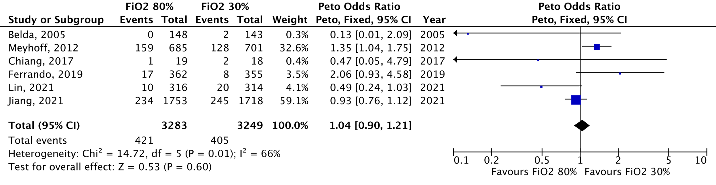
FiO₂: Fraction of inspired oxygen, CI: confidence interval
Reported length of long-term mortality ranged from 180-days to 3.2 years

Figure S3: Long-term mortality, abdominal surgery subgroup analysis
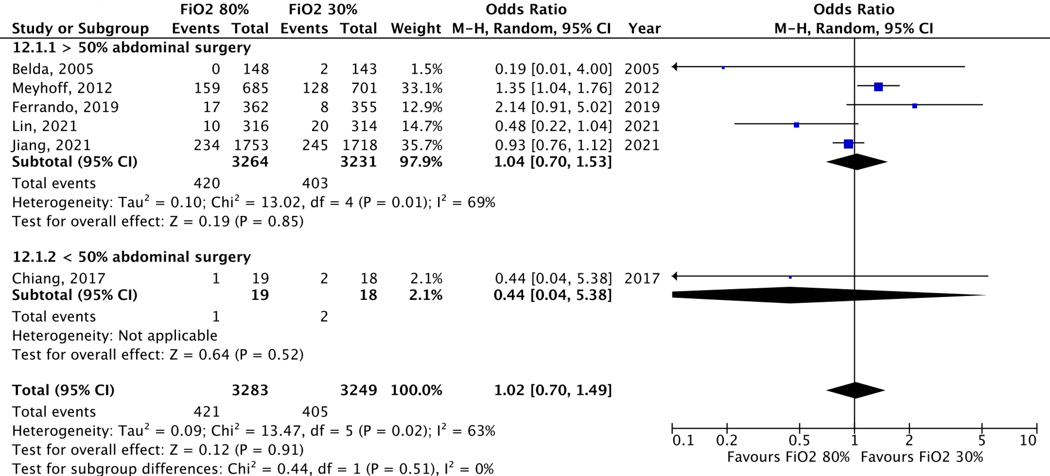
FiO₂: Fraction of inspired oxygen, CI: confidence interval

Figure S4: Overall mortality (closets to 30 days), meta-analysis
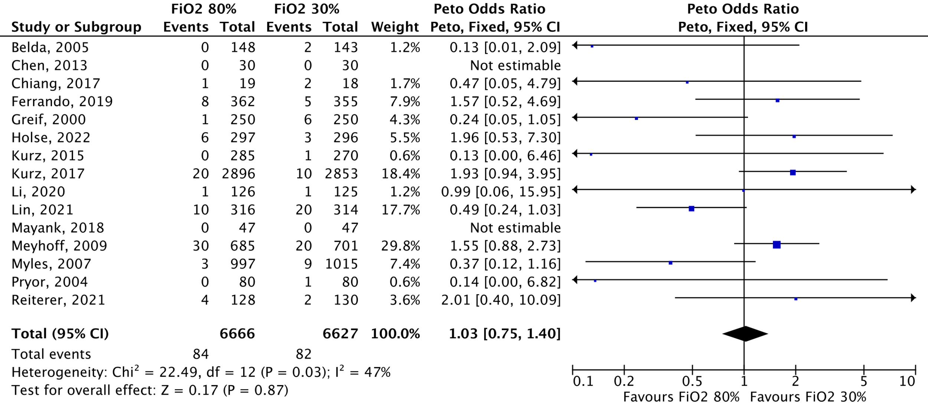
FiO₂: Fraction of inspired oxygen, CI: confidence interval

Figure S5: Bubble plot for meta-regression of short-term mortality and median year of patient inclusion
The Y-axis represents logarithmic odds ratios of the outcome. The X-axis represents the moderator. The circles represent the inverse variance of the study effect sizes. The dotted line represents an odds ratio of 1.0. Values above the dotted line favors FiO₂ 30% and values below the dotted line favors FiO₂ 80%. The shaded area represents the 95%

Figure S6: Bubble plot for meta-regression of short-term mortality and mortality in the control group
The Y-axis represents logarithmic odds ratios of the outcome. The X-axis represents the moderator. The circles represent the inverse variance of the study effect sizes. The dotted line represents an odds ratio of 1.0. Values above the dotted line favors FiO₂ 30% and values below the dotted line favors FiO₂ 80%. The shaded area represents the 95% confidence intervals.

Figure S7: Bubble plot for meta-regression of short-term mortality and sample size
The Y-axis represents logarithmic odds ratios of the outcome. The X-axis represents the moderator. The circles represent the inverse variance of the study effect sizes. The dotted line represents an odds ratio of 1.0. Values above the dotted line favors FiO₂ 30% and values below the dotted line favors FiO₂ 80%. The shaded area represents the 95% confidence intervals.

Figure S8: Funnel plot short-term mortality

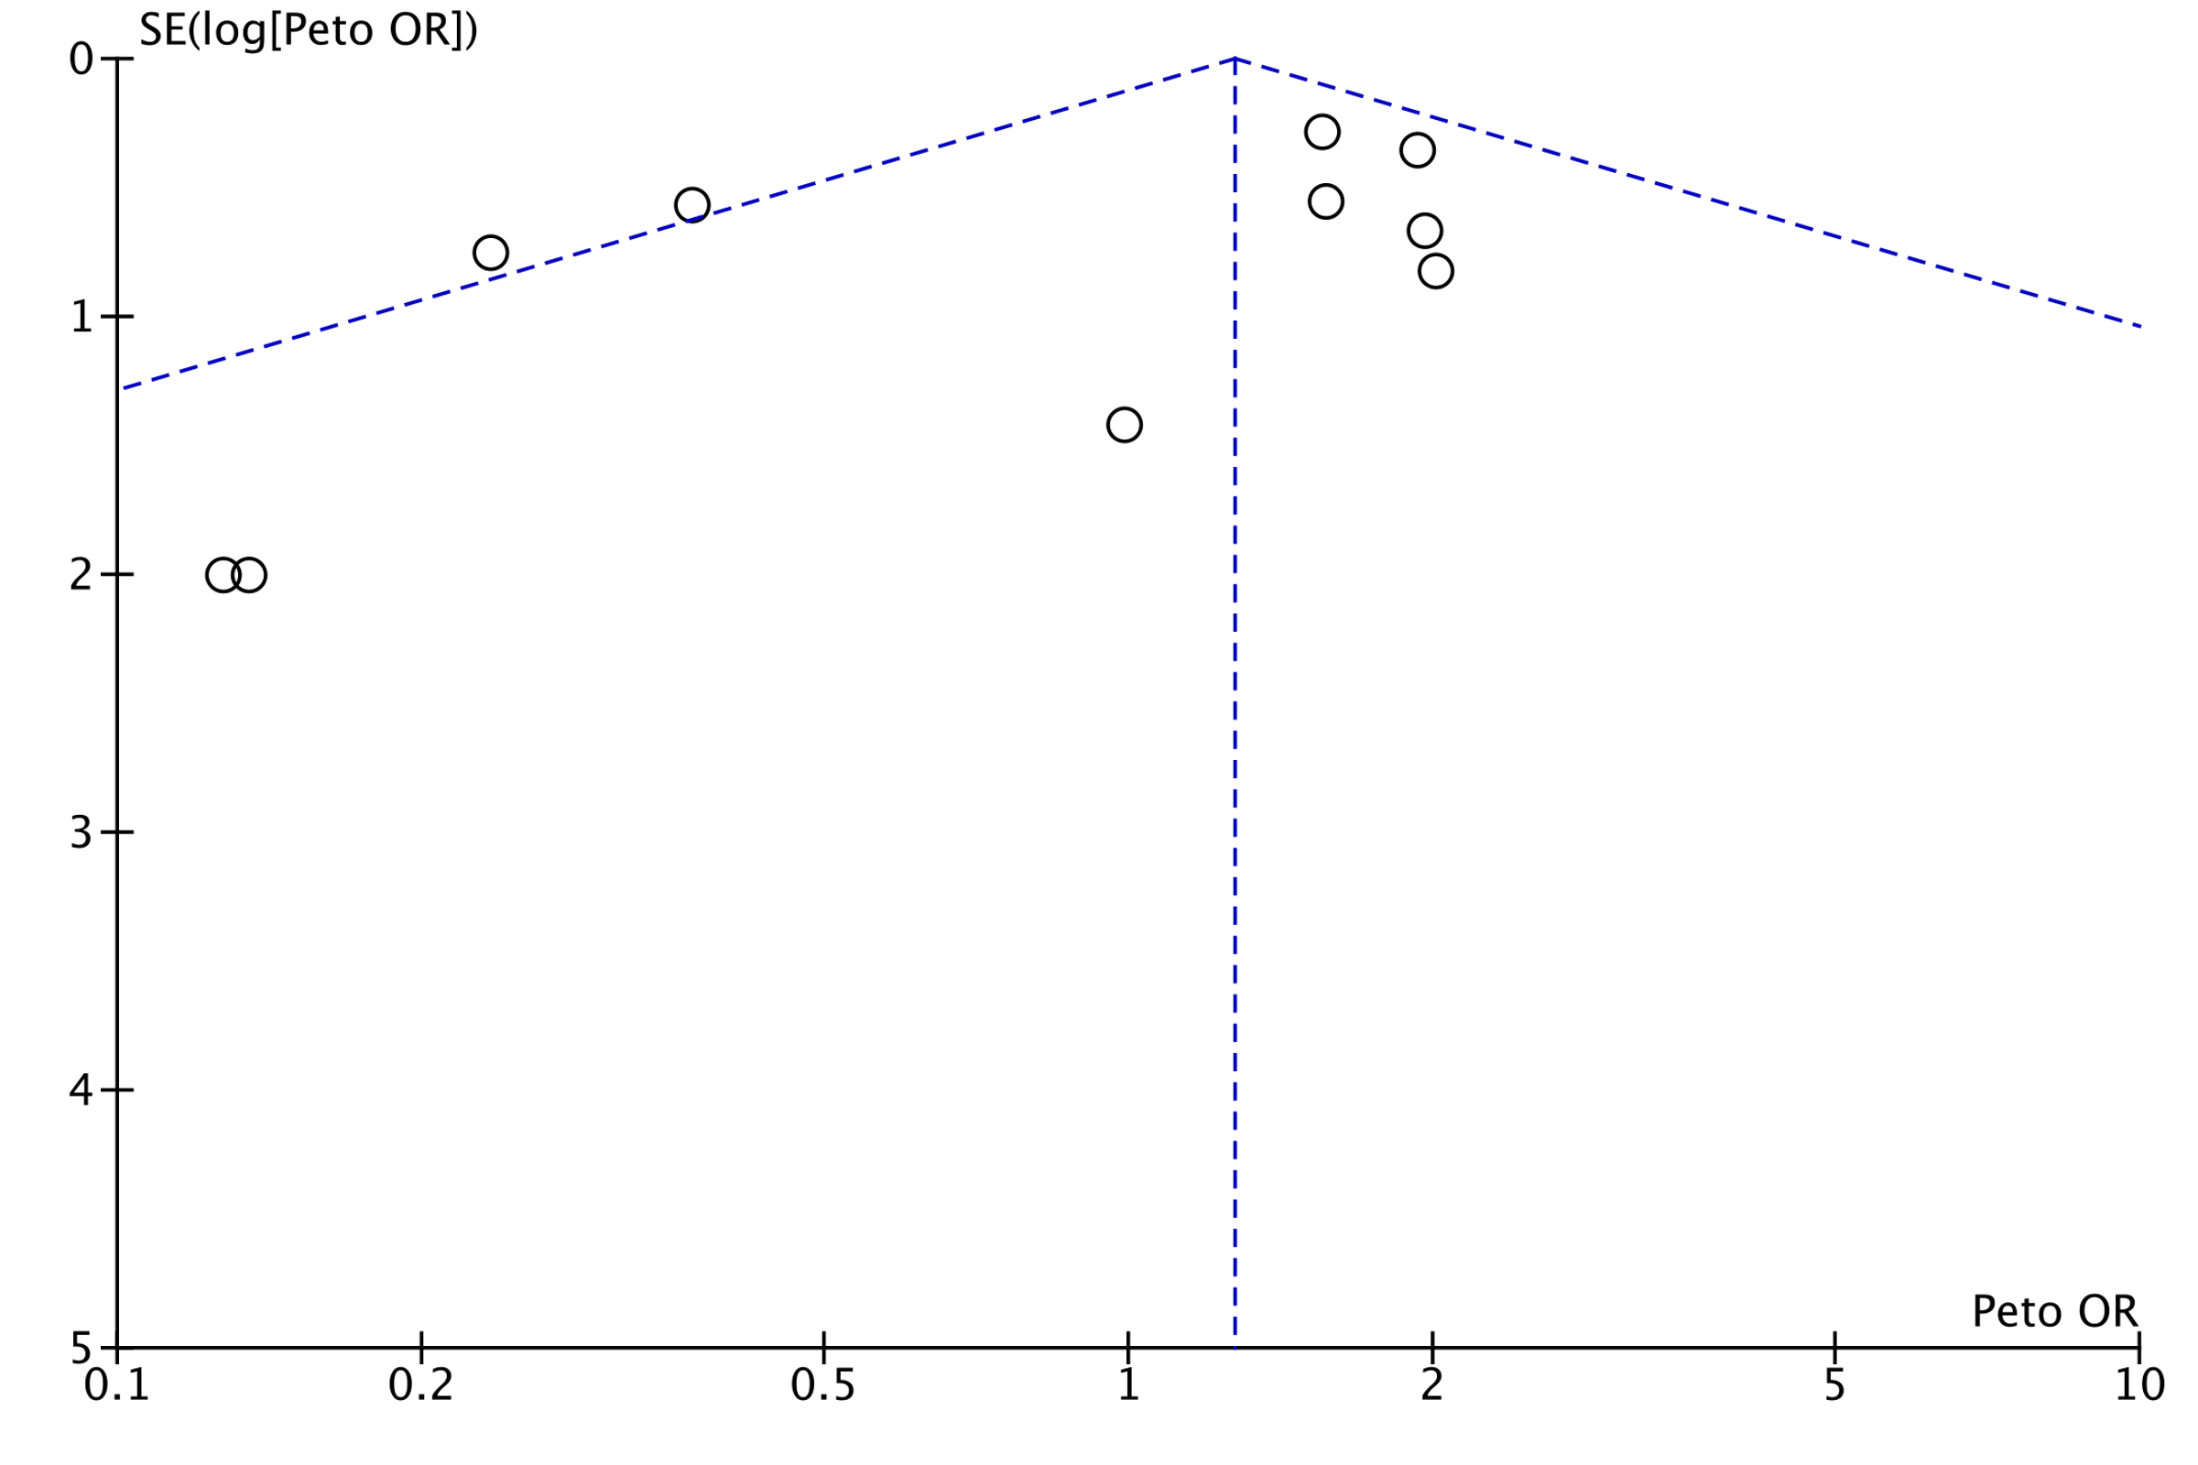
SE: standard error, OR: odds ratio
Funnel plot representing risk of publication bias; a plot of odds ratios for short-term mortality in high vs. low FiO₂ group against its precision (standard error). Every circle represents one clinical trial.

Figure S9: Hospital length of stay, meta-analysis
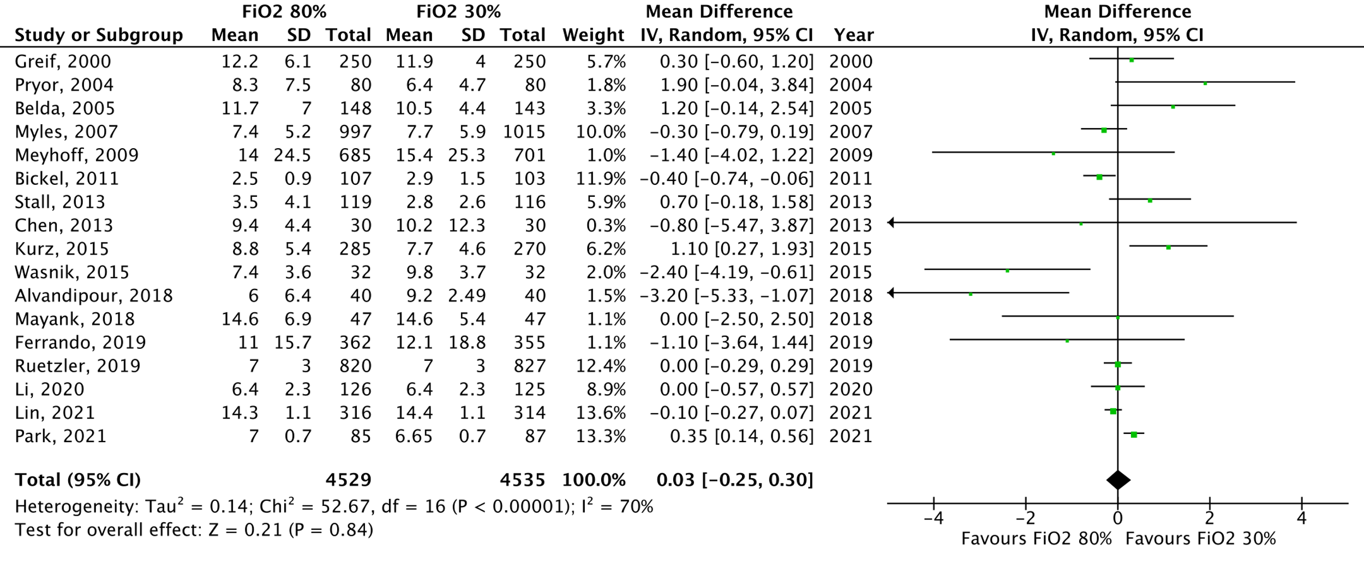
FiO₂: Fraction of inspired oxygen, CI: confidence interval

Figure S10: Hospital length of stay, acute surgery subgroup analysis
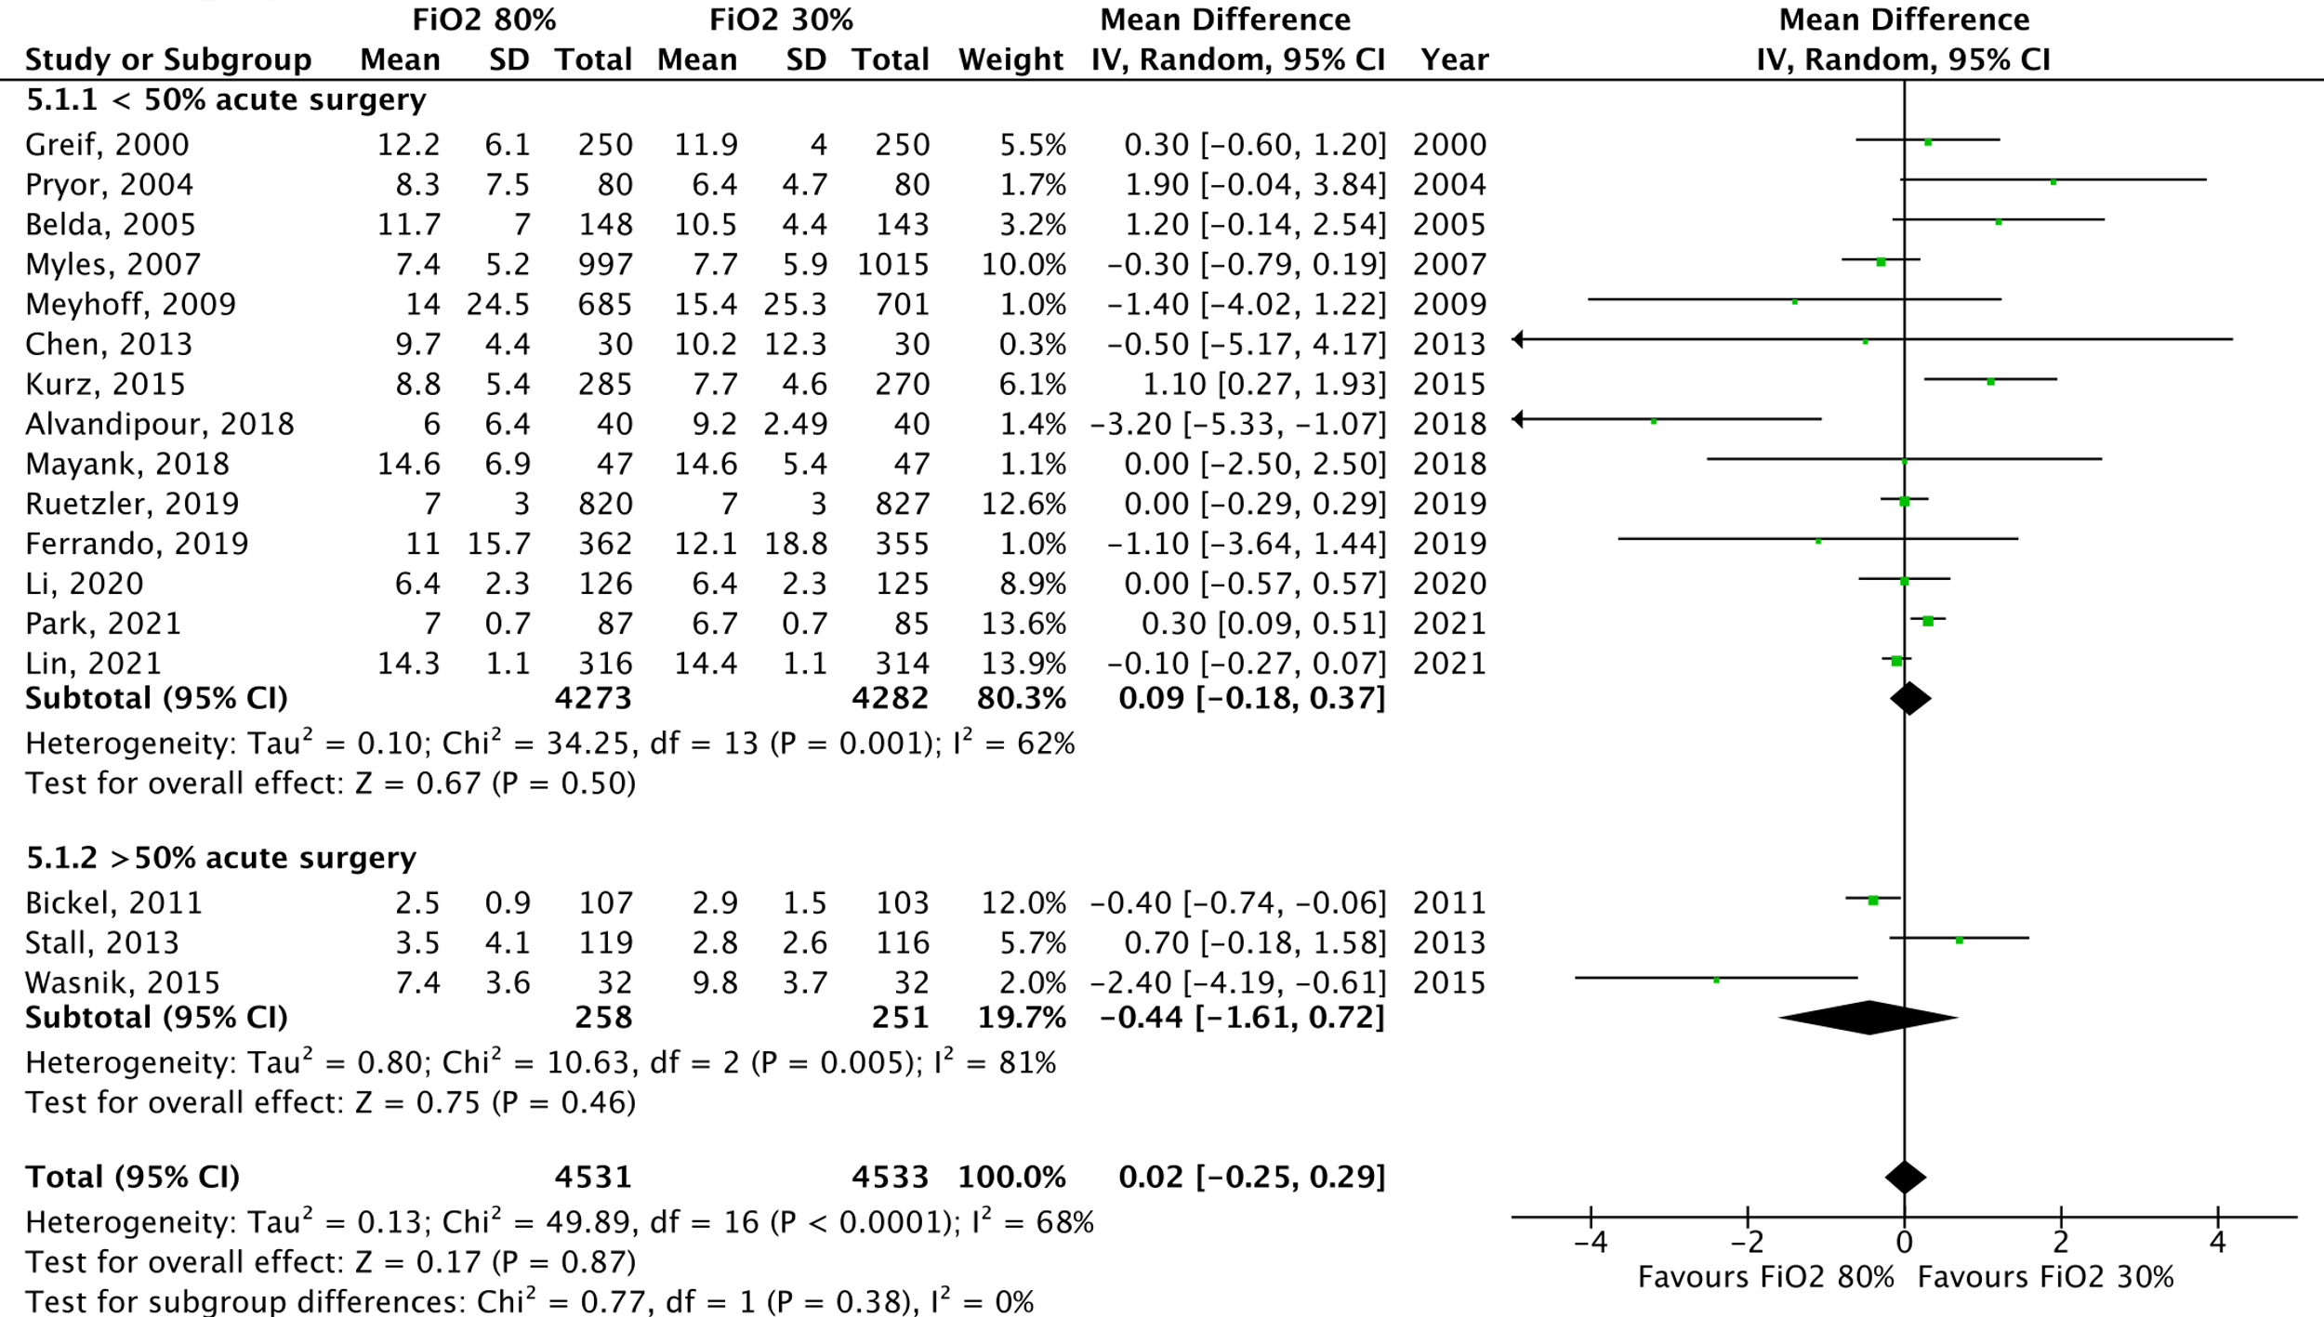
FiO₂: Fraction of inspired oxygen, CI: confidence interval

Figure S11: Hospital length of stay, abdominal surgery subgroup analysis
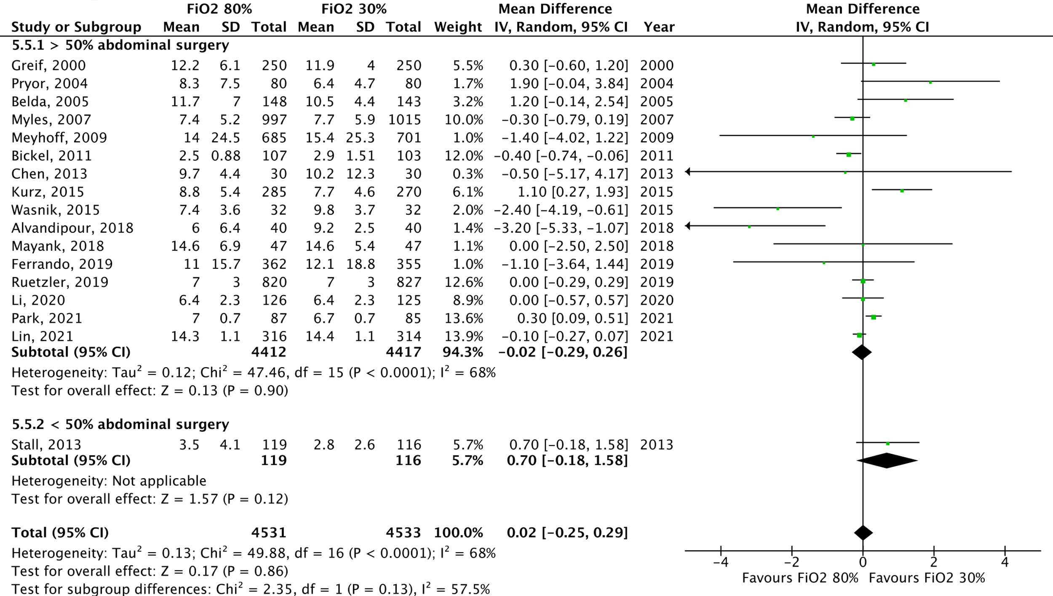
FiO₂: Fraction of inspired oxygen, CI: confidence interval

Figure S12: Bubble plot for meta-regression of length of stay and median year of patient inclusion
The Y-axis represents mean differences of the outcome. The X-axis represents the moderator. The circles represent the inverse variance of the study effect sizes. The dotted line represents an odds ratio of 1.0. Values above the dotted line favors FiO₂ 30% and values below the dotted line favors FiO₂ 80%. The shaded area represents the 95% confidence intervals.

Figure S13: Bubble plot for meta-regression of length of stay and mortality in the control group
The Y-axis represents logarithmic odds ratios of the outcome. The X-axis represents the moderator. The circles represent the inverse variance of the study effect sizes. The dotted line represents an odds ratio of 1.0. Values above the dotted line favors FiO₂ 30% and values below the dotted line favors FiO₂ 80%. The shaded area represents the 95% confidence intervals.

Figure S14: Bubble plot for meta-regression of length of stay and length of stay in the control group
The Y-axis represents mean differences of the outcome. The X-axis represents the moderator. The circles represent the inverse variance of the study effect sizes. The dotted line represents an odds ratio of 1.0. Values above the dotted line favors FiO₂ 30% and values below the dotted line favors FiO₂ 80%. The shaded area represents the 95% confidence intervals.

Figure S15: Bubble plot for meta-regression of length of stay and duration of surgery
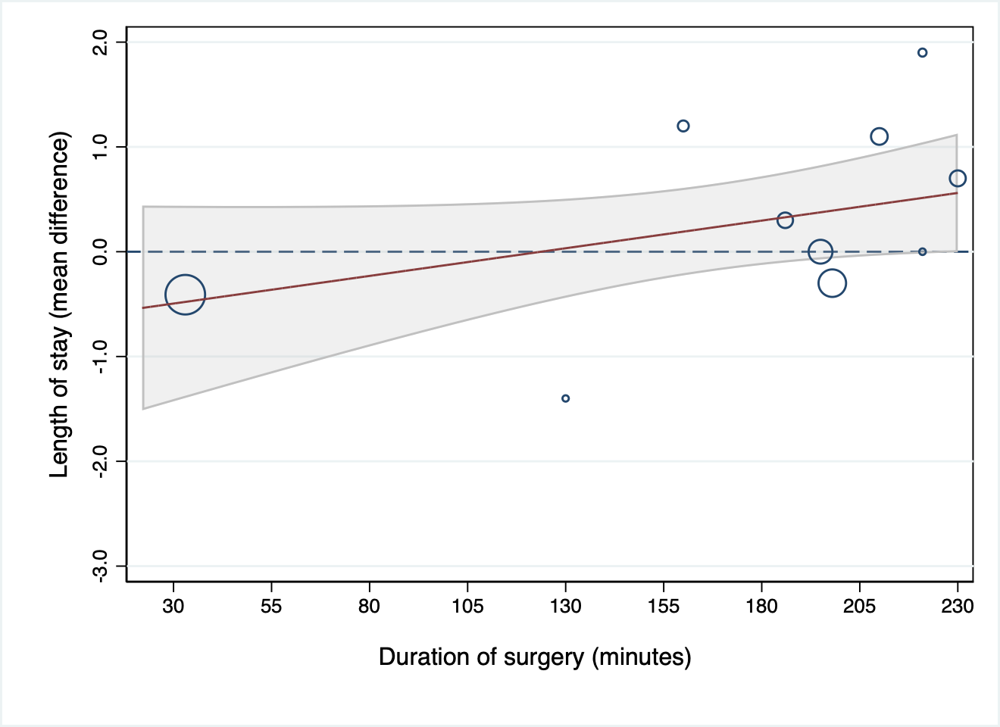
The Y-axis represents mean differences of the outcome. The X-axis represents the moderator. The circles represent the inverse variance of the study effect sizes. The dotted line represents an odds ratio of 1.0. Values above the dotted line favors FiO₂ 30% and values below the dotted line favors FiO₂ 80%. The shaded area represents the 95% confidence intervals.

Figure S16: Bubble plot for meta-regression of length of stay and sample size
The Y-axis represents mean differences of the outcome. The X-axis represents the moderator. The circles represent the inverse variance of the study effect sizes. The dotted line represents a mean difference of zero. Values above the dotted line favors FiO₂ 30% and values below the dotted line favors FiO₂ 80%. The shaded area represents the 95% confidence intervals.

Figure S17: Funnel plot hospital length of stay

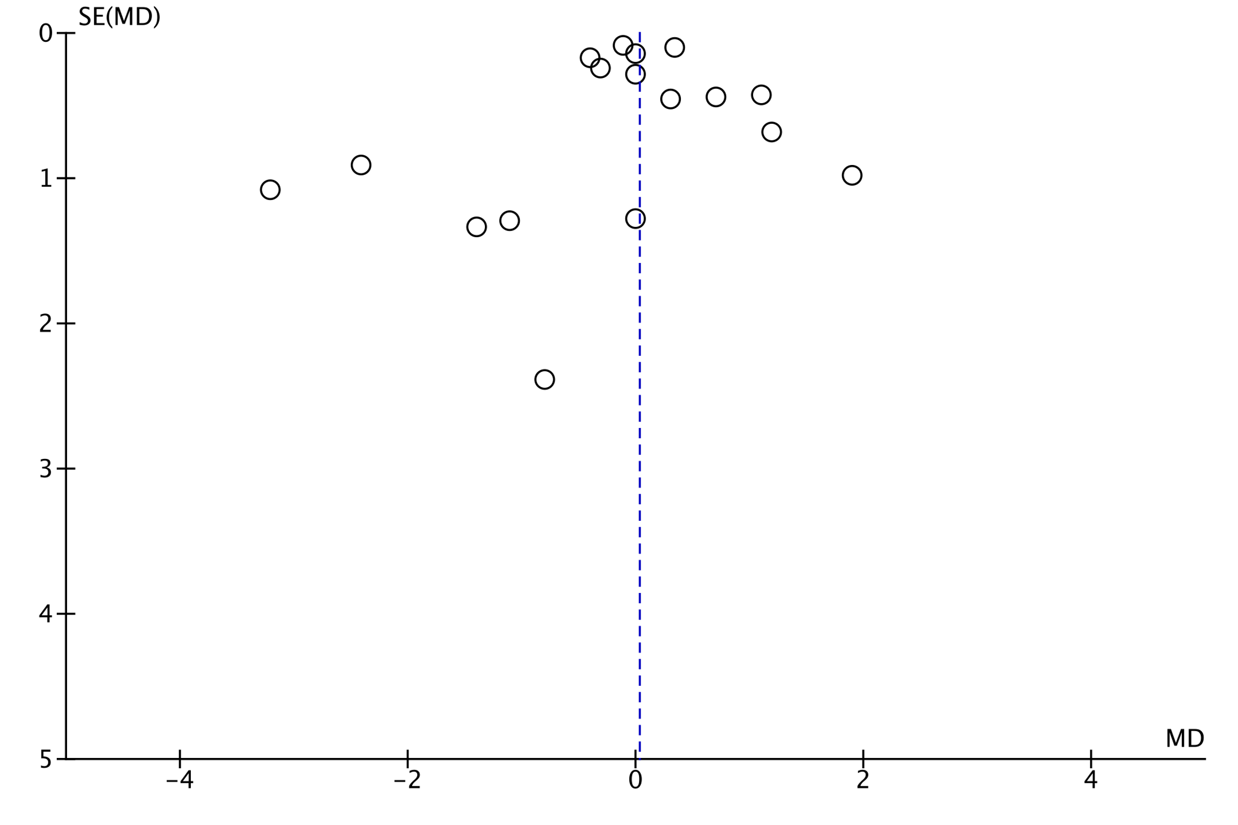
SE: standard error, OR: odds ratio
Funnel plot representing risk of publication bias; a plot of odds ratios for hospital length of stay in high vs. low FiO₂ group against its precision (standard error). Every circle represents one clinical trial.

Figure S18: Surgical site infection, acute surgery subgroup analysis
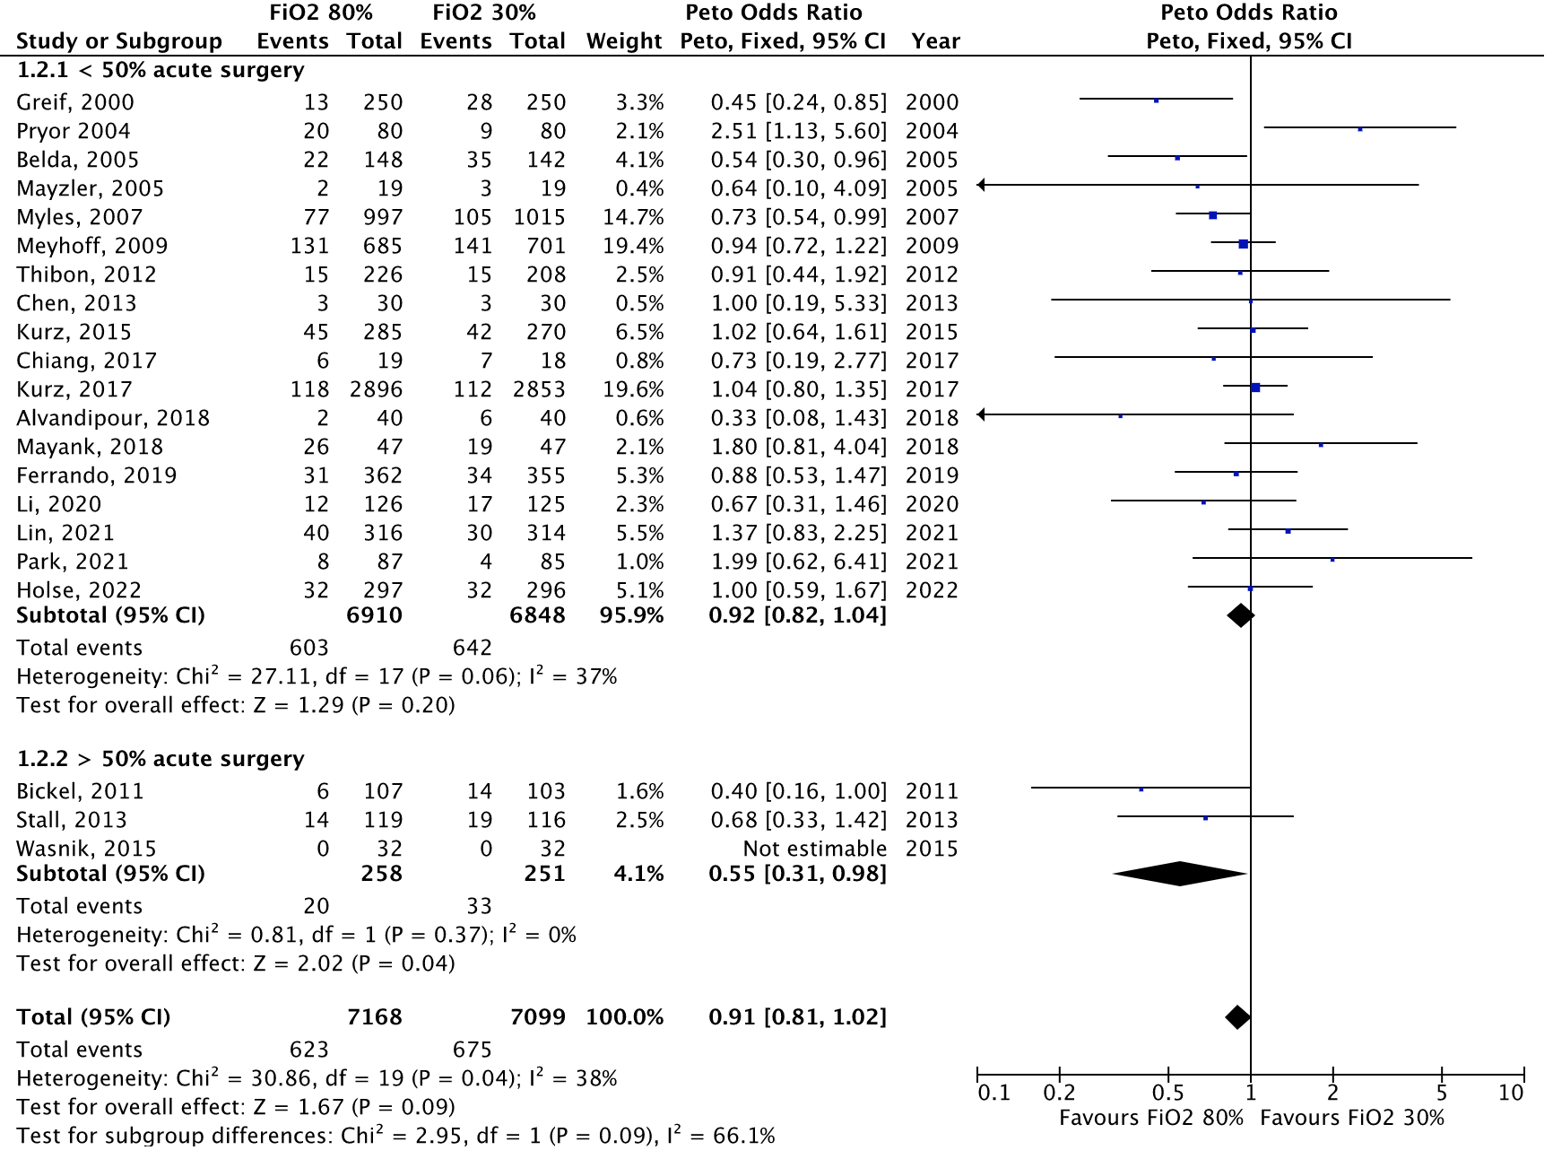
FiO₂: Fraction of inspired oxygen, CI: confidence interval

Figure S19: Surgical site infection, abdominal surgery subgroup analysis
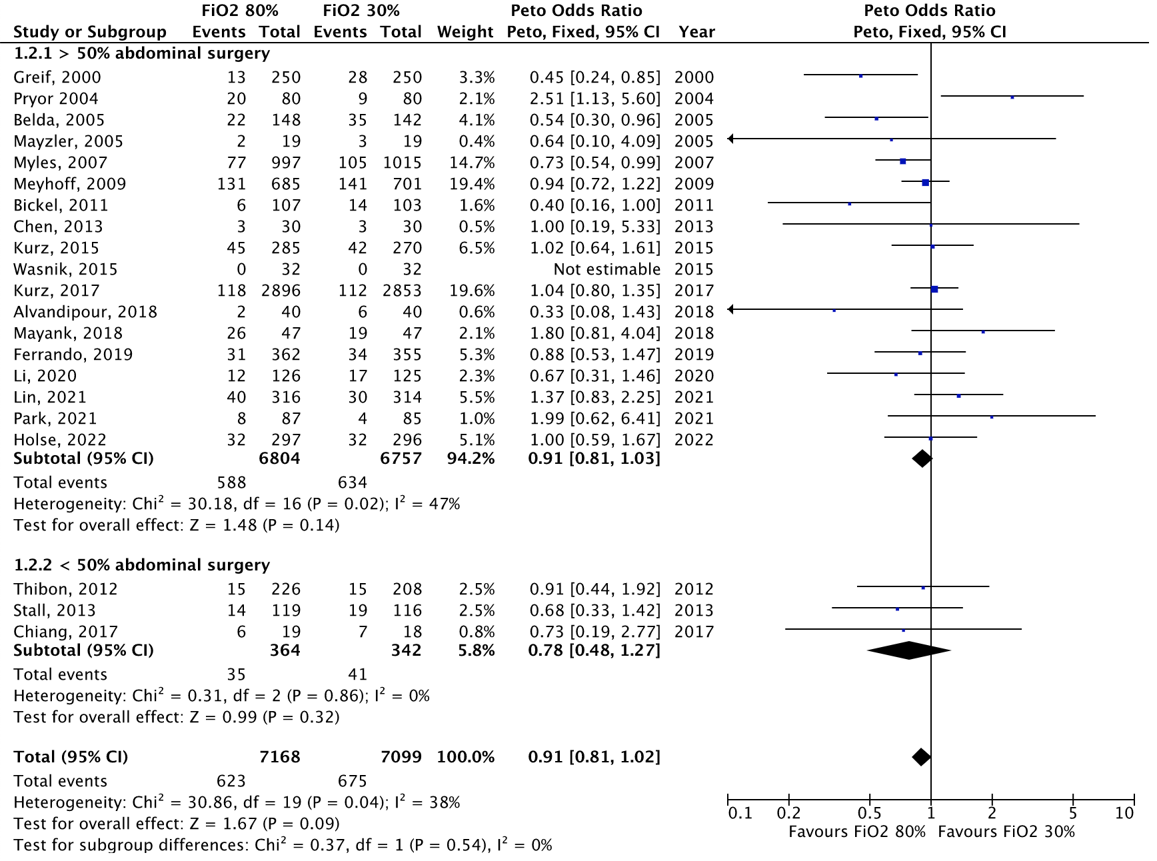
FiO₂: Fraction of inspired oxygen, CI: confidence interval

Figure S20: Bubble plot for meta-regression of surgical site infection and median year of patient inclusion
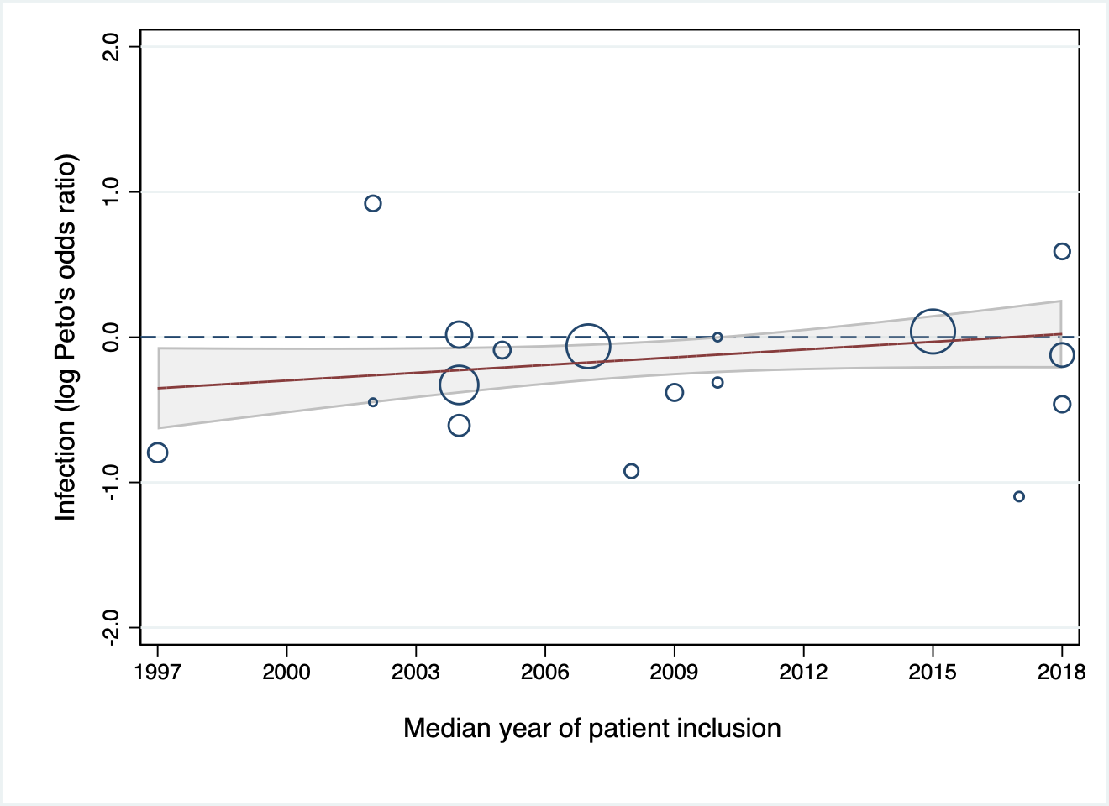
The Y-axis represents logarithmic odds ratios of the outcome. The X-axis represents the moderator. The circles represent the inverse variance of the study effect sizes. The dotted line represents an odds ratio of 1.0. Values above the dotted line favors FiO₂ 30% and values below the dotted line favors FiO₂ 80%. The shaded area represents the 95% confidence intervals.

Figure S21: Bubble plot for meta-regression of surgical site infection and mortality in the control group
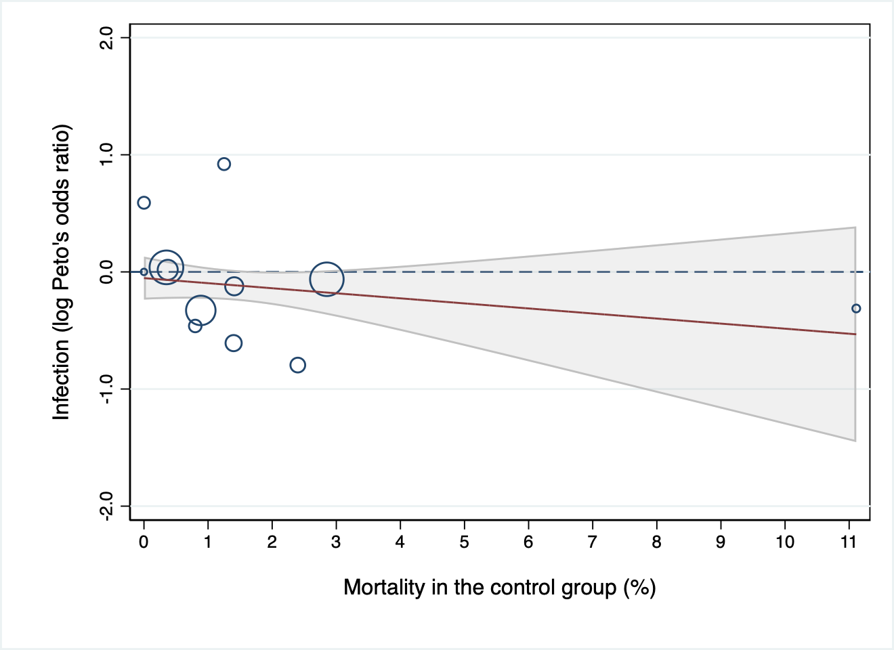
The Y-axis represents logarithmic odds ratios of the outcome. The X-axis represents the moderator. The circles represent the inverse variance of the study effect sizes. The dotted line represents an odds ratio of 1.0. Values above the dotted line favors FiO₂ 30% and values below the dotted line favors FiO₂ 80%. The shaded area represents the 95% confidence intervals.

Figure S22: Bubble plot for meta-regression of surgical site infection and length of stay in the control group
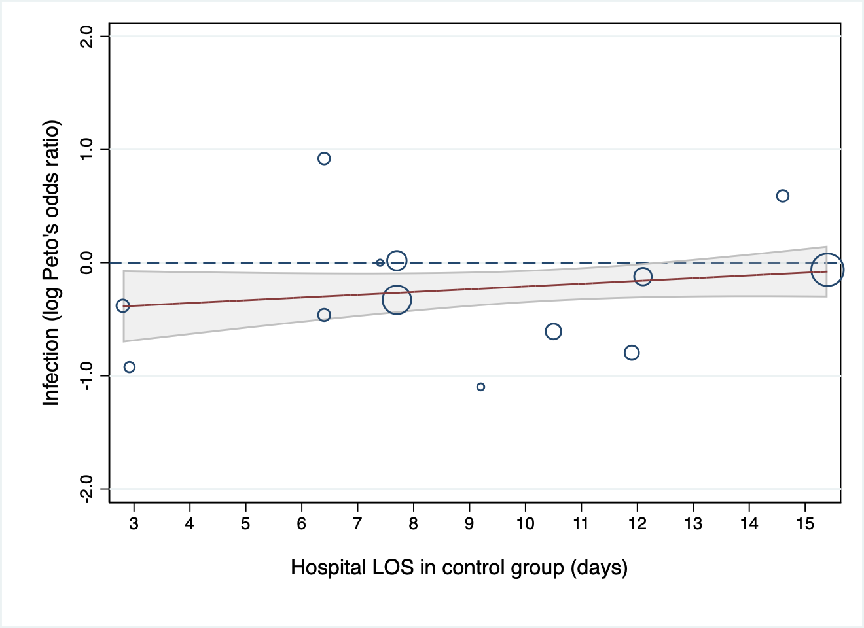
The Y-axis represents logarithmic odds ratios of the outcome. The X-axis represents the moderator. The circles represent the inverse variance of the study effect sizes. The dotted line represents an odds ratio of 1.0. Values above the dotted line favors FiO₂ 30% and values below the dotted line favors FiO₂ 80%. The shaded area represents the 95% confidence intervals.

Figure S23: Bubble plot for meta-regression of surgical site infection and duration of surgery
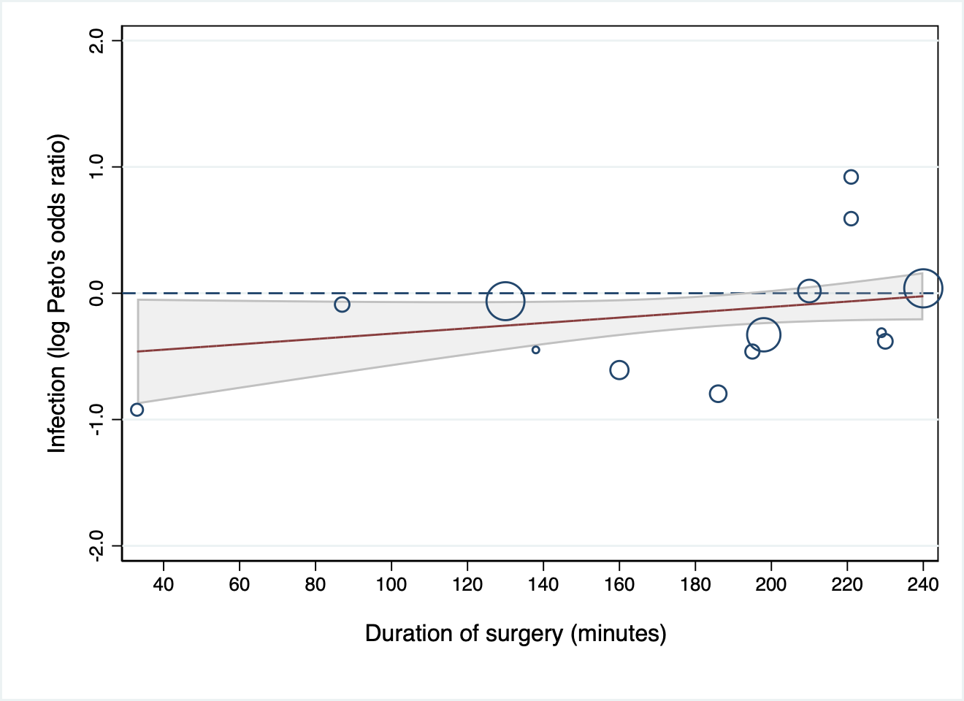
The Y-axis represents logarithmic odds ratios of the outcome. The X-axis represents the moderator. The circles represent the inverse variance of the study effect sizes. The dotted line represents an odds ratio of 1.0. Values above the dotted line favors FiO₂ 30% and values below the dotted line favors FiO₂ 80%. The shaded area represents the 95% confidence intervals.

Figure S24: Bubble plot for meta-regression of surgical site infection and sample size
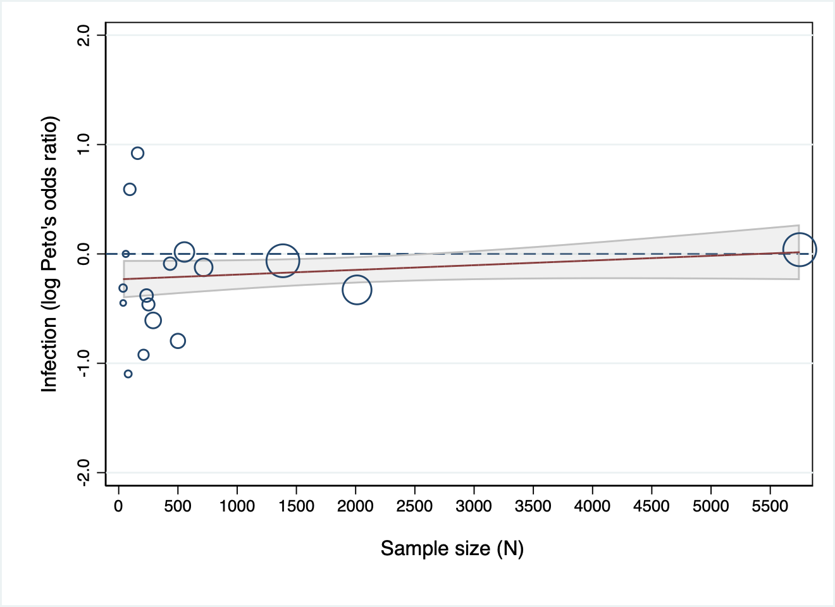
The Y-axis represent logarithmic odds ratios of the outcome. The X-axis represent the moderator. The circles represent the inverse variance of the study effect sizes. The dotted line represents an odds ratio of 1.0. Values above the dotted line favors FiO₂ 80% and values below the dotted line favors FiO₂ 30%. The Shaded area represents the 95% confidence intervals.

Figure S25: Funnel plot surgical site infection

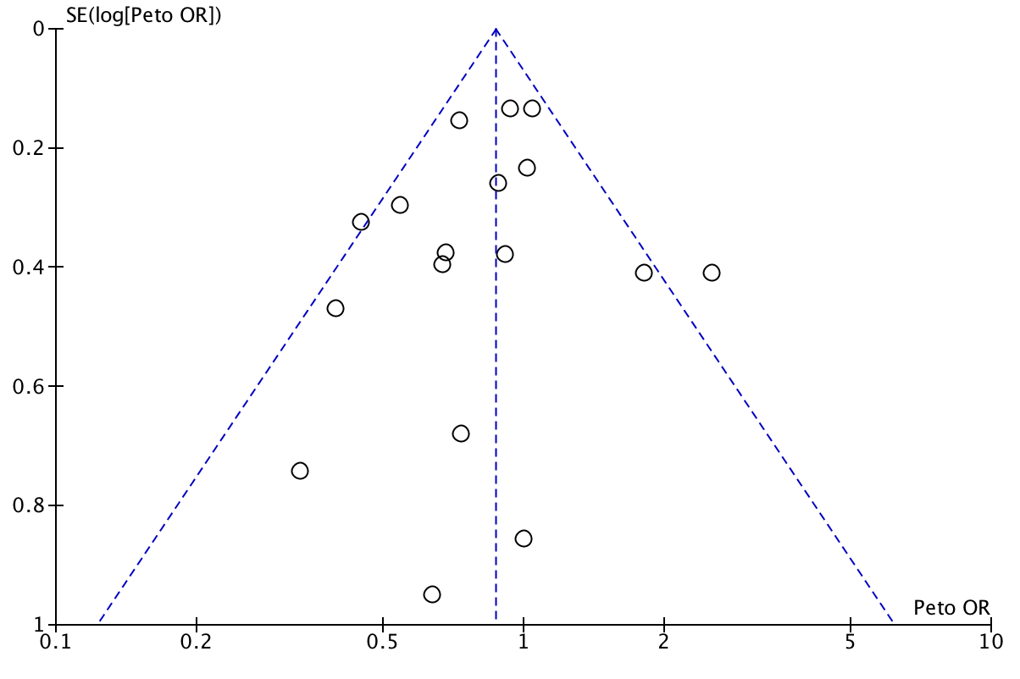

SE: standard error, OR: odds ratio
Funnel plot representing risk of publication bias; a plot of odds ratios for surgical site infection in high vs. low FiO₂ group against its precision (standard error). Every circle represents one clinical trial.

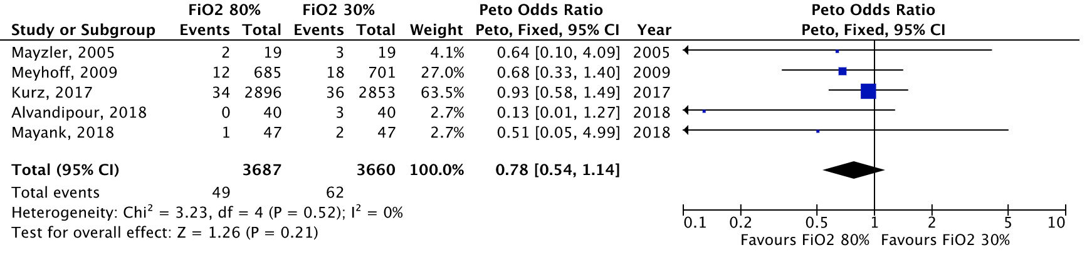
Figure S26: Anastomotic leakage, meta-analysis
FiO₂: Fraction of inspired oxygen, CI: confidence interval

Figure S27: Wound dehiscence, meta-analysis
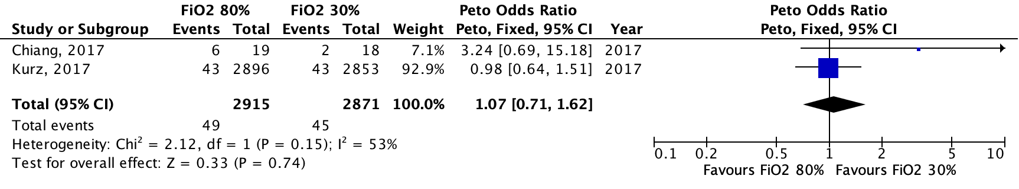
FiO₂: Fraction of inspired oxygen, CI: confidence interval

Figure S28: Reoperation, meta-analysis
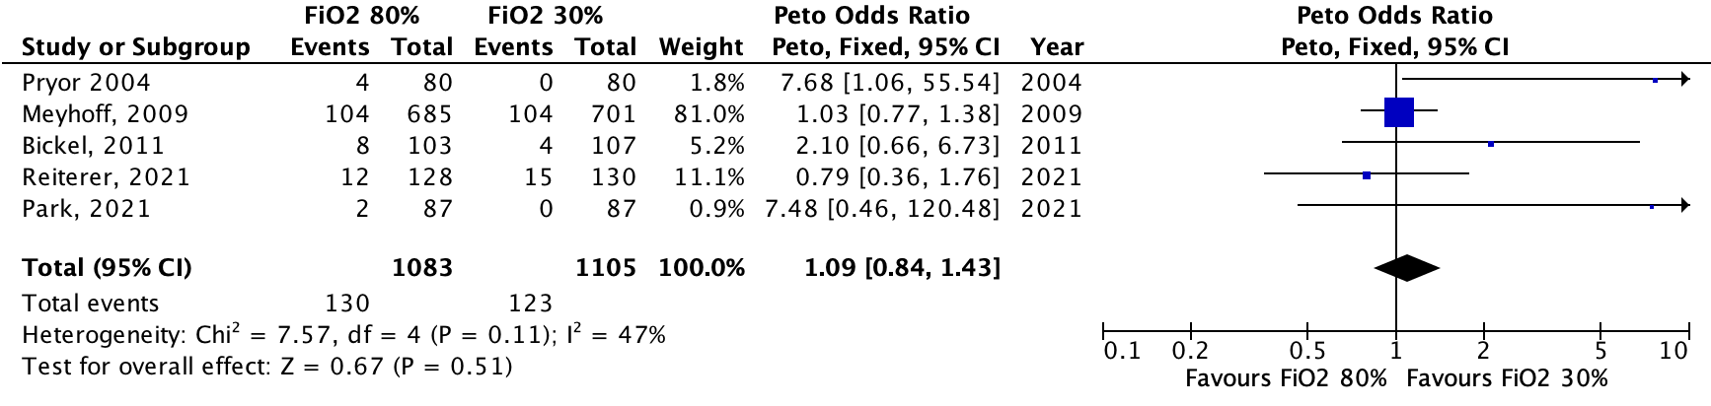
FiO₂: Fraction of inspired oxygen, CI: confidence interval

Figure S29: Reoperation, acute surgery subgroup analysis
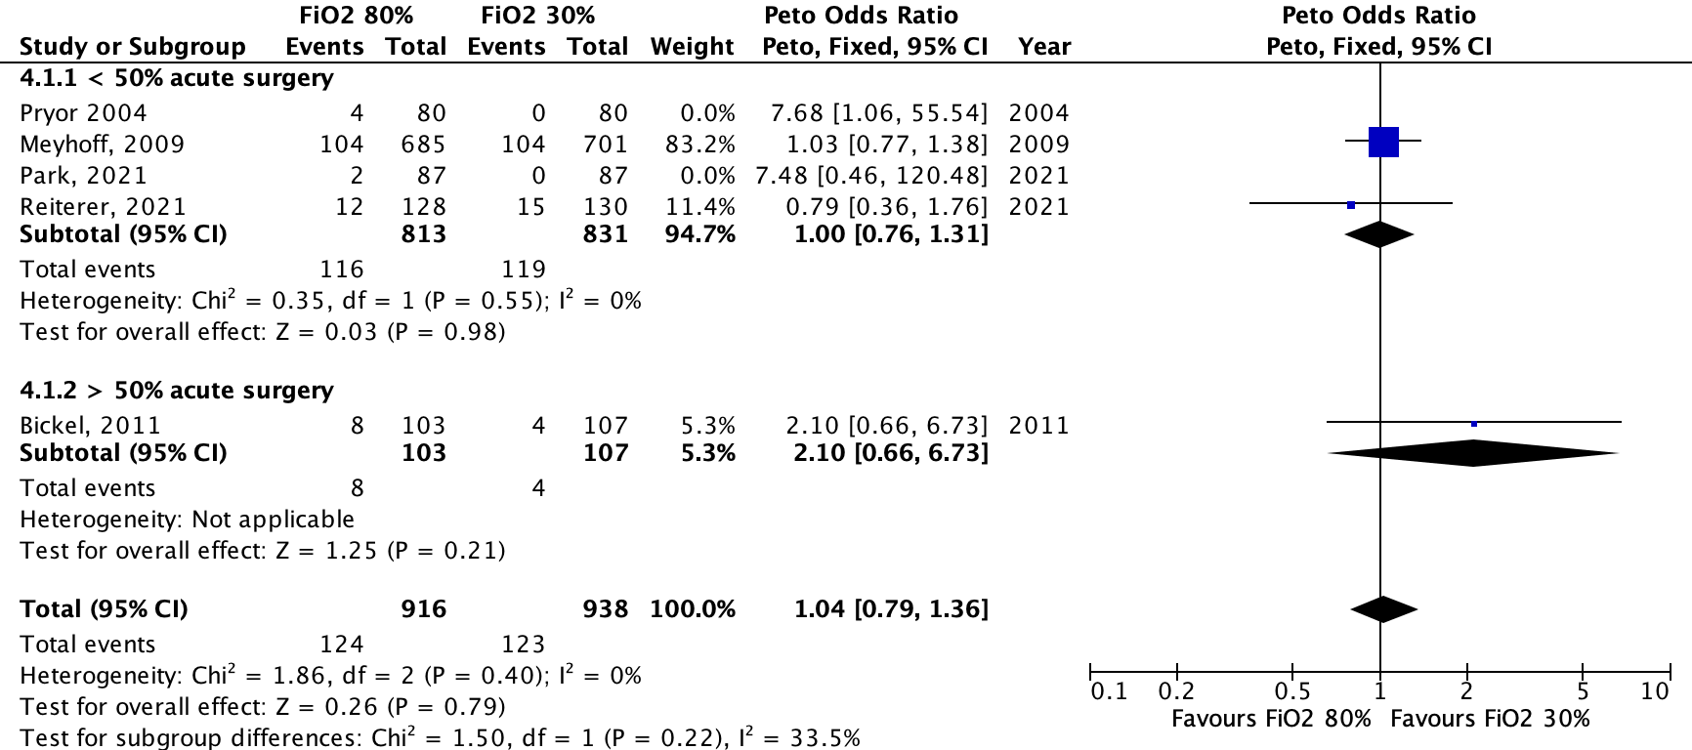
FiO₂: Fraction of inspired oxygen, CI: confidence interval

Figure S30: Atelectasis, meta-analysis
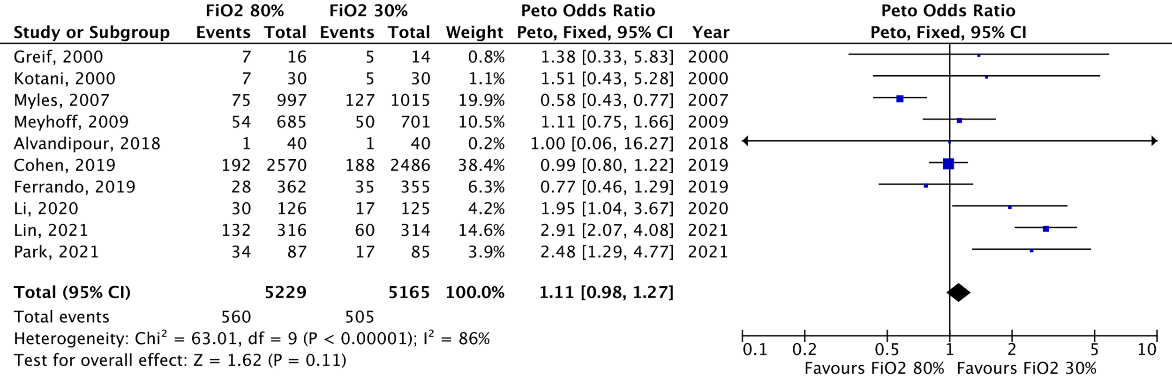
FiO₂: Fraction of inspired oxygen, CI: confidence interval

Figure S31: Pneumonia, meta-analysis
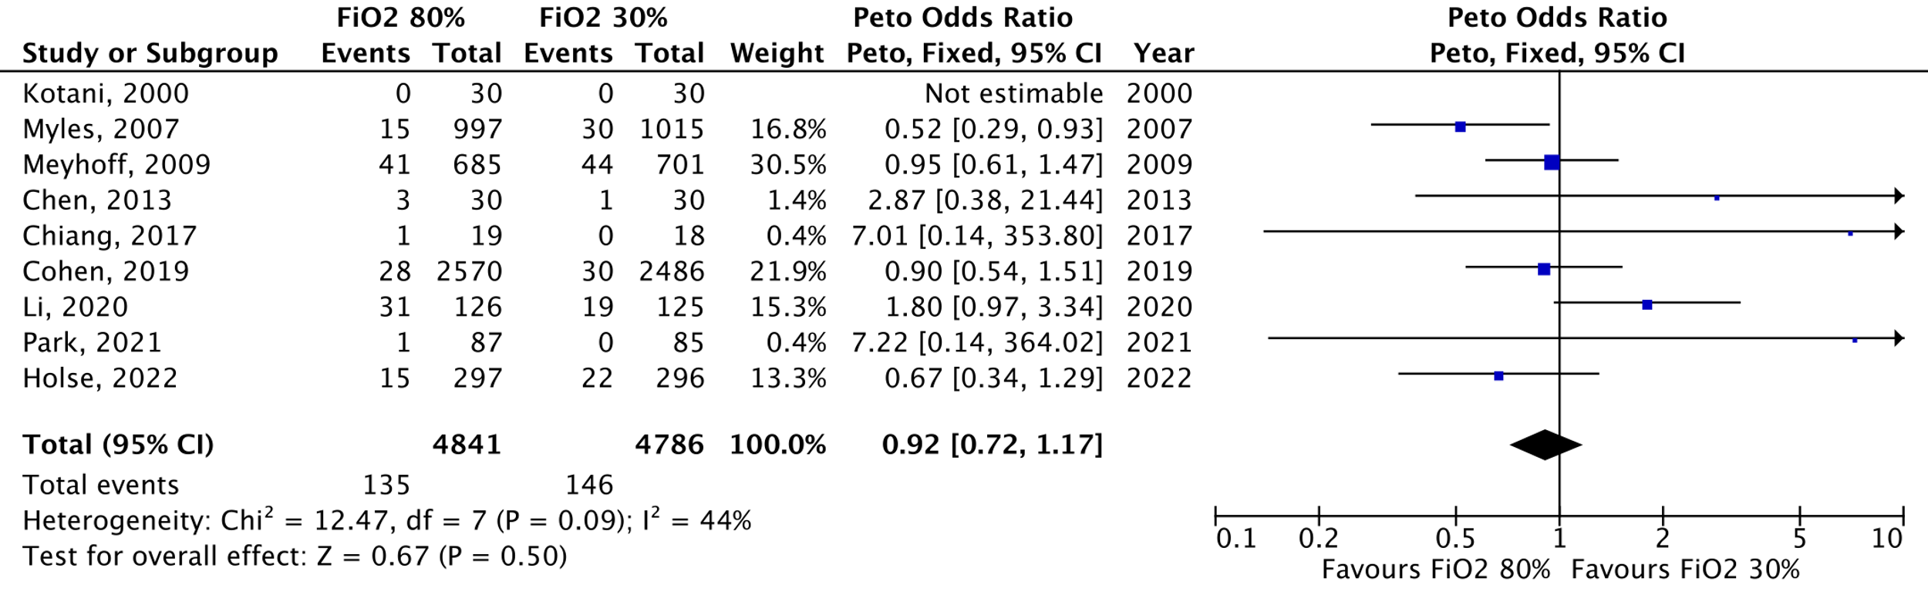
FiO₂: Fraction of inspired oxygen, CI: confidence interval

Figure S32: Atelectasis, abdominal surgery subgroup analysis
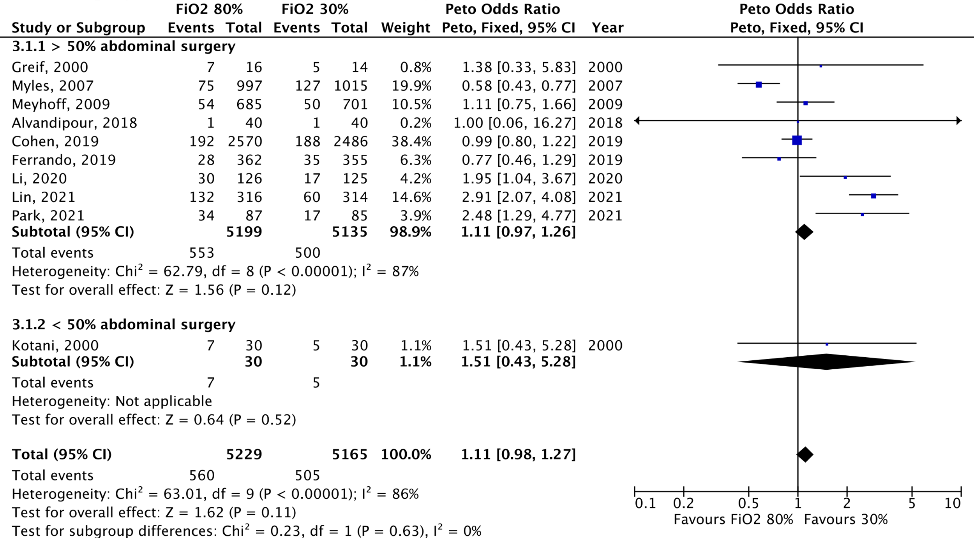
FiO₂: Fraction of inspired oxygen, CI: confidence interval

Figure S33: Pneumonia, abdominal surgery subgroup analysis
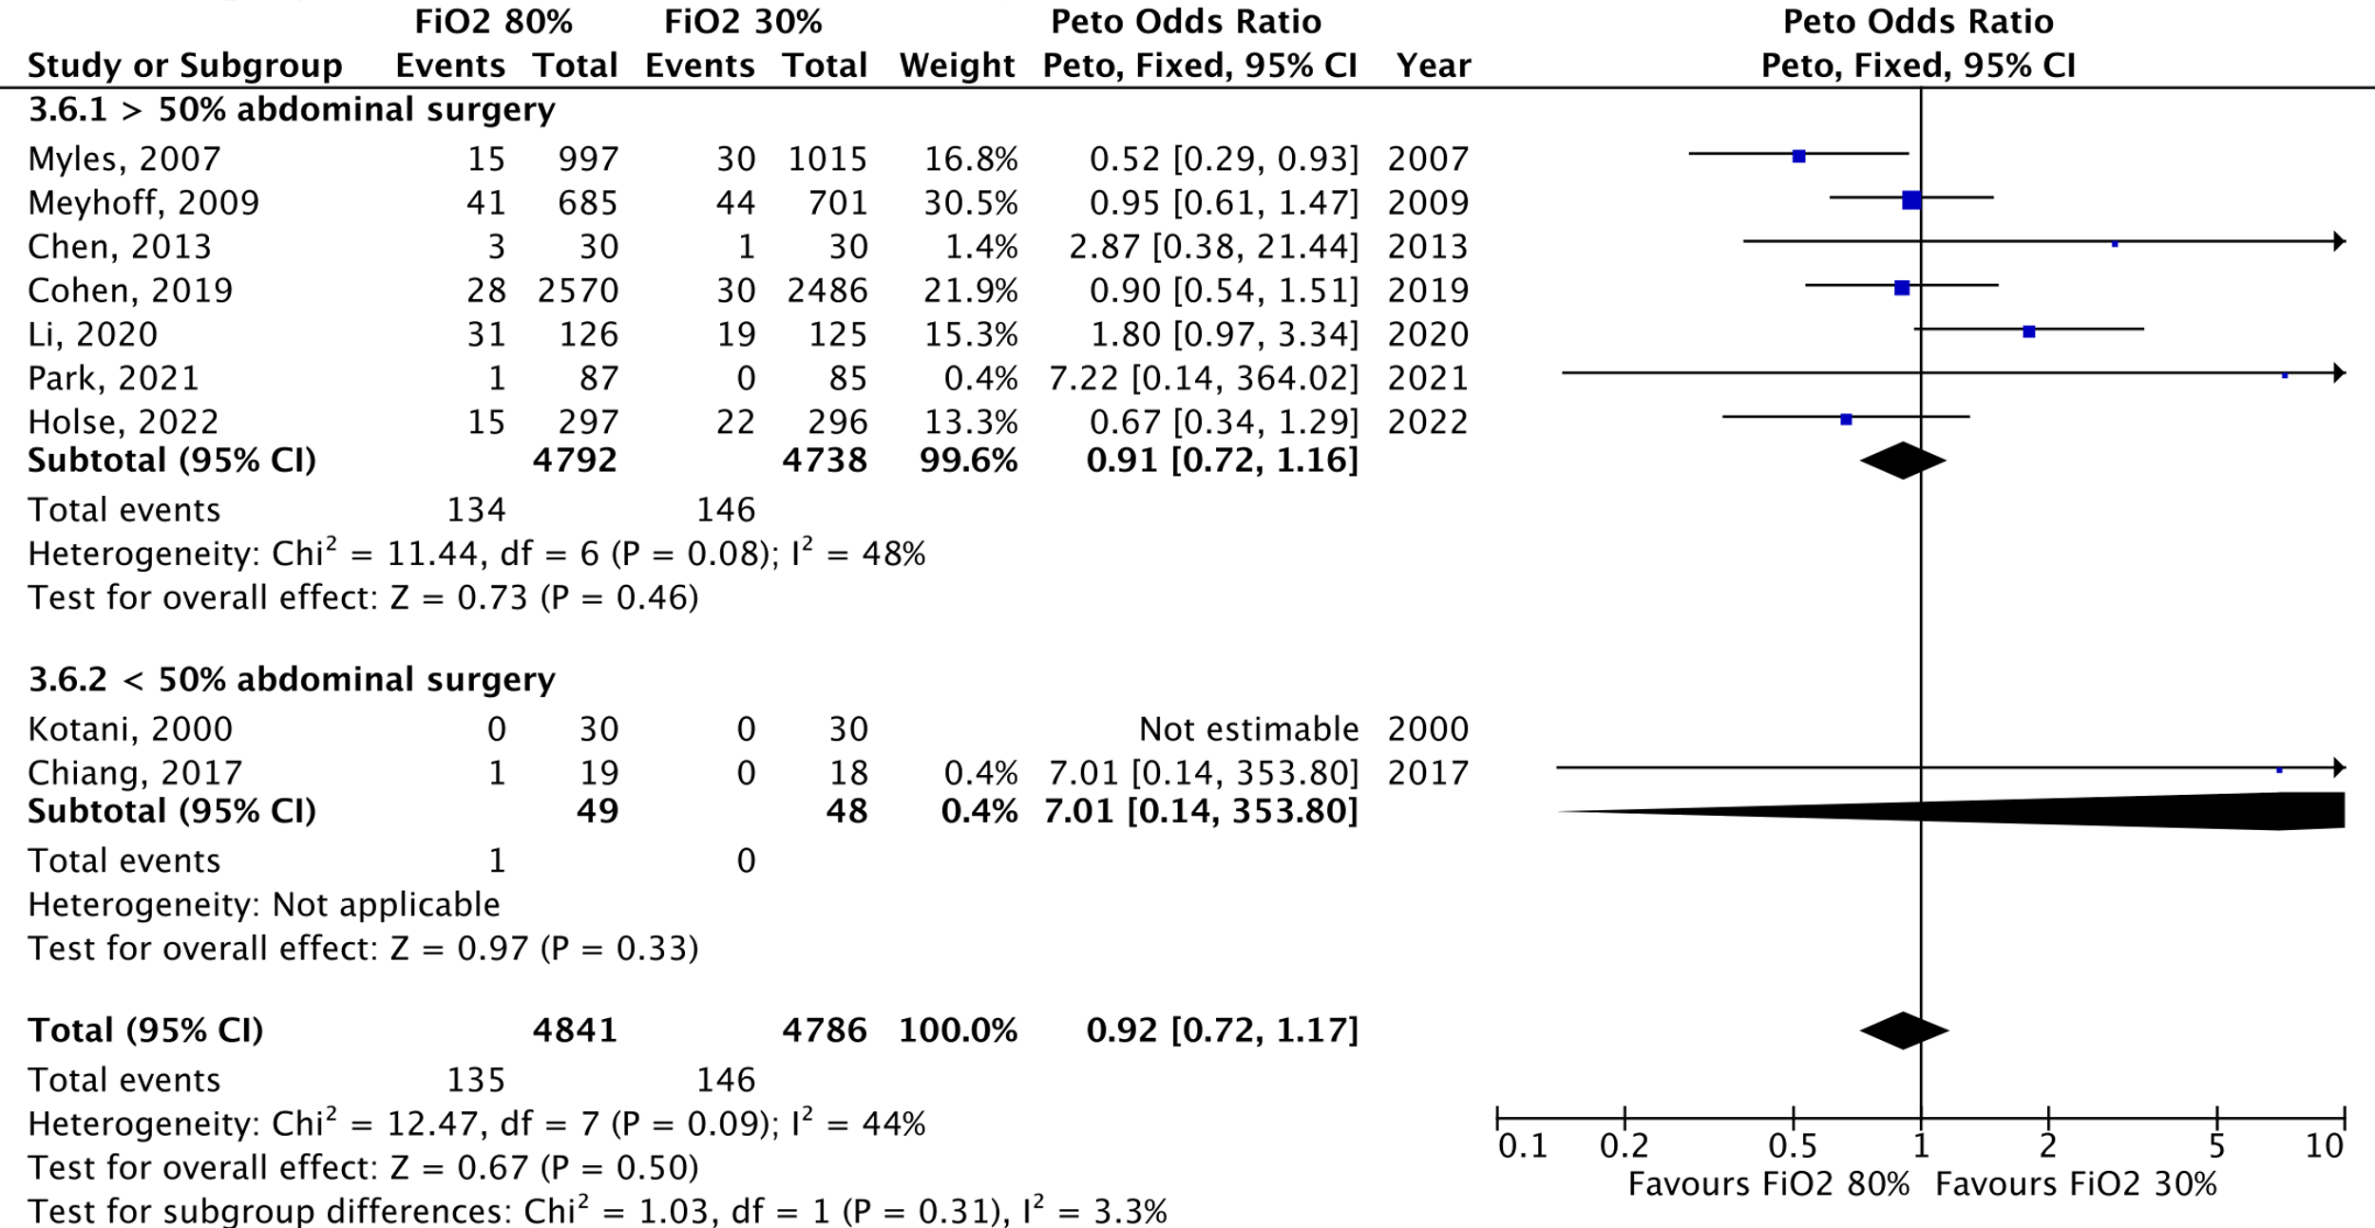

FiO₂: Fraction of inspired oxygen, CI: confidence interval

Figure S34: Myocardial injury/myocardial infarction, meta-analysis
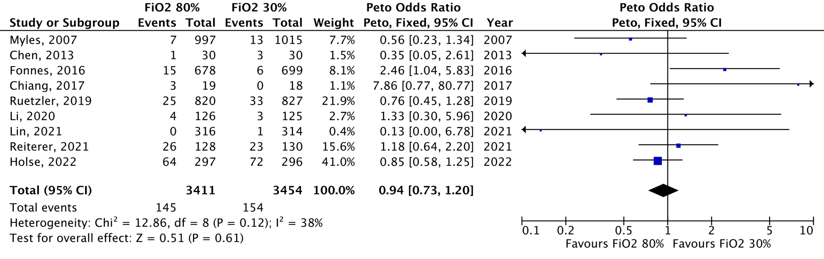
FiO₂: Fraction of inspired oxygen, CI: confidence interval

Figure S35: Myocardial injury/myocardial infarction, abdominal surgery subgroup analysis
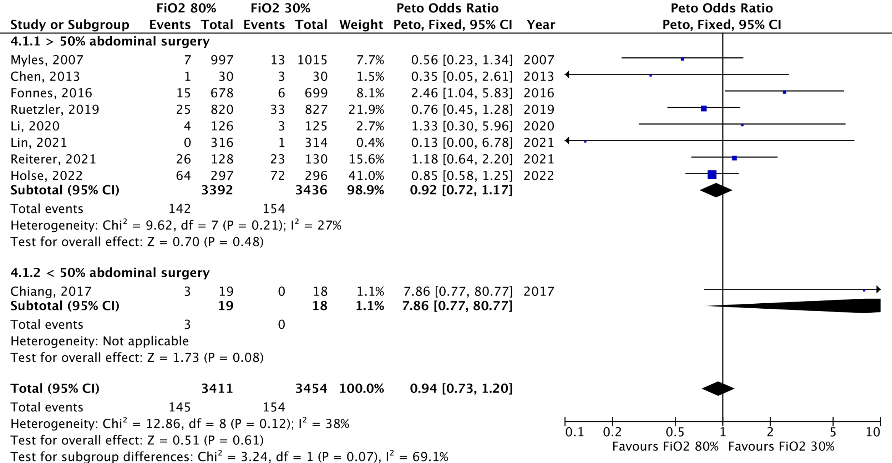
FiO₂: Fraction of inspired oxygen, CI: confidence interval

PRISMA CHECKLIST
Section and Topic | Item # | Checklist item | Location where item is reported
TITLE
Title | 1 | Identify the report as a systematic review. | P1
ABSTRACT
Abstract | 2 | See the PRISMA 2020 for Abstracts checklist. | P3
INTRODUCTION
Rationale | 3 | Describe the rationale for the review in the context of existing knowledge. | P4
Objectives | 4 | Provide an explicit statement of the objective(s) or question(s) the review addresses. | P4
METHODS
Eligibility criteria | 5 | Specify the inclusion and exclusion criteria for the review and how studies were grouped for the syntheses. | P5
Information sources | 6 | Specify all databases, registers, websites, organizations, reference lists and other sources searched or consulted to identify studies. Specify the date when each source was last searched or consulted. | P5
Search strategy | 7 | Present the full search strategies for all databases, registers and websites, including any filters and limits used. | Protocol
Selection process | 8 | Specify the methods used to decide whether a study met the inclusion criteria of the review, including how many reviewers screened each record and each report retrieved, whether they worked independently, and if applicable, details of automation tools used in the process. | P6
Data collection process | 9 | Specify the methods used to collect data from reports, including how many reviewers collected data from each report, whether they worked independently, any processes for obtaining or confirming data from study investigators, and if applicable, details of automation tools used in the process. | P6
Data items | 10a | List and define all outcomes for which data were sought. Specify whether all results that were compatible with each outcome domain in each study were sought (e.g. for all measures, time points, analyses), and if not, the methods used to decide which results to collect. | P4-5  Supplement
Data items | 10b | List and define all other variables for which data were sought (e.g. participant and intervention characteristics, funding sources). Describe any assumptions made about any missing or unclear information. | Supplement
Study risk of bias assessment | 11 | Specify the methods used to assess risk of bias in the included studies, including details of the tool(s) used, how many reviewers assessed each study and whether they worked independently, and if applicable, details of automation tools used in the process. | P6  Supplement
Effect measures | 12 | Specify for each outcome the effect measure(s) (e.g. risk ratio, mean difference) used in the synthesis or presentation of results. | P6-7
Synthesis methods | 13a | Describe the processes used to decide which studies were eligible for each synthesis (e.g. tabulating the study intervention characteristics and comparing against the planned groups for each synthesis (item #5)). | P7
Synthesis methods | 13b | Describe any methods required to prepare the data for presentation or synthesis, such as handling of missing summary statistics, or data conversions. | P6-7
Synthesis methods | 13c | Describe any methods used to tabulate or visually display results of individual studies and syntheses. | Tables and figures
Synthesis methods | 13d | Describe any methods used to synthesize results and provide a rationale for the choice(s). If meta-analysis was performed, describe the model(s), method(s) to identify the presence and extent of statistical heterogeneity, and software package(s) used. | P6-7
Synthesis methods | 13e | Describe any methods used to explore possible causes of heterogeneity among study results (e.g. subgroup analysis, meta-regression). | P7
Synthesis methods | 13f | Describe any sensitivity analyses conducted to assess robustness of the synthesized results. | P7
Reporting bias assessment | 14 | Describe any methods used to assess risk of bias due to missing results in a synthesis (arising from reporting biases). | P7
Certainty assessment | 15 | Describe any methods used to assess certainty (or confidence) in the body of evidence for an outcome. | P7
RESULTS
Study selection | 16a | Describe the results of the search and selection process, from the number of records identified in the search to the number of studies included in the review, ideally using a flow diagram. | P8
Study selection | 16b | Cite studies that might appear to meet the inclusion criteria, but which were excluded, and explain why they were excluded. | Figure S1
Study characteristics | 17 | Cite each included study and present its characteristics. | Table 1
Risk of bias in studies | 18 | Present assessments of risk of bias for each included study. | Table S4
Results of individual studies | 19 | For all outcomes, present, for each study: (a) summary statistics for each group (where appropriate) and (b) an effect estimate and its precision (e.g. confidence/credible interval), ideally using structured tables or plots. | Figures
Results of syntheses | 20a | For each synthesis, briefly summarize the characteristics and risk of bias among contributing studies. | Table 1, Table S2, Table S4
Results of syntheses | 20b | Present results of all statistical syntheses conducted. If meta-analysis was done, present for each the summary estimate and its precision (e.g. confidence/credible interval) and measures of statistical heterogeneity. If comparing groups, describe the direction of the effect. | Figure 1
Results of syntheses | 20c | Present results of all investigations of possible causes of heterogeneity among study results. | Tables and figures
Results of syntheses | 20d | Present results of all sensitivity analyses conducted to assess the robustness of the synthesized results. | Table S6
Reporting biases | 21 | Present assessments of risk of bias due to missing results (arising from reporting biases) for each synthesis assessed.
Certainty of evidence | 22 | Present assessments of certainty (or confidence) in the body of evidence for each outcome assessed. | Table S7
DISCUSSION
Discussion | 23a | Provide a general interpretation of the results in the context of other evidence. | P11
Discussion | 23b | Discuss any limitations of the evidence included in the review. | P13
Discussion | 23c | Discuss any limitations of the review processes used. | P11
Discussion | 23d | Discuss implications of the results for practice, policy, and future research. | P13
OTHER INFORMATION
Registration and protocol | 24a | Provide registration information for the review, including register name and registration number, or state that the review was not registered. | P4
Registration and protocol | 24b | Indicate where the review protocol can be accessed, or state that a protocol was not prepared. | P4
Registration and protocol | 24c | Describe and explain any amendments to information provided at registration or in the protocol. | P5
Support | 25 | Describe sources of financial or non-financial support for the review, and the role of the funders or sponsors in the review. | P14
Competing interests | 26 | Declare any competing interests of review authors. | P14
Availability of data, code and other materials | 27 | Report which of the following are publicly available and where they can be found: template data collection forms; data extracted from included studies; data used for all analyses; analytic code; any other materials used in the review. | NA

REFERENCES
1 Horan, T. C., Gaynes, R. P., Martone, W. J., Jarvis, W. R. & Emori, T. G. CDC definitions of nosocomial surgical site infections, 1992: a modification of CDC definitions of surgical wound infections. Infect Control Hosp Epidemiol 13, 606-608 (1992).
2 Wilson, A. P., Treasure, T., Sturridge, M. F. & Grüneberg, R. N. A scoring method (ASEPSIS) for postoperative wound infections for use in clinical trials of antibiotic prophylaxis. Lancet 1, 311-313, doi:10.1016/s0140-6736(86)90838-x (1986).
3 Prevention, C. f. D. C. a. Guidelines for Prevention of Nosocomial Pneumonia, <https://www.cdc.gov/mmwr/preview/mmwrhtml/00045365.htm> (1997).
4 Canet, J. et al. Prediction of postoperative pulmonary complications in a population-based surgical cohort. Anesthesiology 113, 1338-1350, doi:10.1097/ALN.0b013e3181fc6e0a (2010).
5 Julian Higgins, J. T. Revised Cochrane risk-of-bias tool for randomized trials (RoB 2) (2019).
6 Guyatt, G. H. et al. GRADE guidelines 6. Rating the quality of evidence--imprecision. J Clin Epidemiol 64, 1283-1293, doi:10.1016/j.jclinepi.2011.01.012 (2011).
7 Kotani, N. et al. Supplemental intraoperative oxygen augments antimicrobial and proinflammatory responses of alveolar macrophages. Anesthesiology 93, 15-25, doi:10.1097/00000542-200007000-00008 (2000).
8 Greif, R., Akça, O., Horn, E. P., Kurz, A. & Sessler, D. I. Supplemental perioperative oxygen to reduce the incidence of surgical-wound infection. N Engl J Med 342, 161-167, doi:10.1056/nejm200001203420303 (2000).
9 Purhonen, S., Turunen, M., Ruohoaho, U. M., Niskanen, M. & Hynynen, M. Supplemental oxygen does not reduce the incidence of postoperative nausea and vomiting after ambulatory gynecologic laparoscopy. Anesth Analg 96, 91-96, table of contents, doi:10.1097/00000539-200301000-00020 (2003).
10 Pryor, K. O., Fahey, T. J., 3rd, Lien, C. A. & Goldstein, P. A. Surgical site infection and the routine use of perioperative hyperoxia in a general surgical population: a randomized controlled trial. Jama 291, 79-87, doi:10.1001/jama.291.1.79 (2004).
11 Mayzler, O. et al. Does supplemental perioperative oxygen administration reduce the incidence of wound infection in elective colorectal surgery? Minerva Anestesiol 71, 21-25 (2005).
12 Belda, F. J. et al. Supplemental perioperative oxygen and the risk of surgical wound infection: a randomized controlled trial. Jama 294, 2035-2042, doi:10.1001/jama.294.16.2035 (2005).
13 Myles, P. S. et al. Avoidance of nitrous oxide for patients undergoing major surgery: a randomized controlled trial. Anesthesiology 107, 221-231, doi:10.1097/01.anes.0000270723.30772.da (2007).
14 Meyhoff, C. S. et al. Effect of high perioperative oxygen fraction on surgical site infection and pulmonary complications after abdominal surgery: the PROXI randomized clinical trial. Jama 302, 1543-1550, doi:10.1001/jama.2009.1452 (2009).
15 McKeen, D. M., Arellano, R. & O'Connell, C. Supplemental oxygen does not prevent postoperative nausea and vomiting after gynecological laparoscopy. Can J Anaesth 56, 651-657, doi:10.1007/s12630-009-9136-4 (2009).
16 Bickel, A., Gurevits, M., Vamos, R., Ivry, S. & Eitan, A. Perioperative hyperoxygenation and wound site infection following surgery for acute appendicitis: a randomized, prospective, controlled trial. Arch Surg 146, 464-470, doi:10.1001/archsurg.2011.65 (2011).
17 Thibon, P. et al. Effect of perioperative oxygen supplementation on 30-day surgical site infection rate in abdominal, gynecologic, and breast surgery: the ISO2 randomized controlled trial. Anesthesiology 117, 504-511, doi:10.1097/ALN.0b013e3182632341 (2012).
18 Staehr, A. K., Meyhoff, C. S., Henneberg, S. W., Christensen, P. L. & Rasmussen, L. S. Influence of perioperative oxygen fraction on pulmonary function after abdominal surgery: a randomized controlled trial. BMC Res Notes 5, 383, doi:10.1186/1756-0500-5-383 (2012).
19 Meyhoff, C. S., Jorgensen, L. N., Wetterslev, J., Christensen, K. B. & Rasmussen, L. S. Increased long-term mortality after a high perioperative inspiratory oxygen fraction during abdominal surgery: follow-up of a randomized clinical trial. Anesth Analg 115, 849-854, doi:10.1213/ANE.0b013e3182652a51 (2012).
20 Stall, A. et al. Perioperative supplemental oxygen to reduce surgical site infection after open fixation of high-risk fractures: a randomized controlled pilot trial. J Trauma Acute Care Surg 75, 657-663, doi:10.1097/TA.0b013e3182a1fe83 (2013).
21 Chen, Y. et al. Leukocyte DNA damage and wound infection after nitrous oxide administration: a randomized controlled trial. Anesthesiology 118, 1322-1331, doi:10.1097/ALN.0b013e31829107b8 (2013).
22 Meyhoff, C. S., Jorgensen, L. N., Wetterslev, J., Siersma, V. D. & Rasmussen, L. S. Risk of new or recurrent cancer after a high perioperative inspiratory oxygen fraction during abdominal surgery. Br J Anaesth 113 Suppl 1, i74-i81, doi:10.1093/bja/aeu110 (2014).
23 Kurz, A. et al. Effects of supplemental oxygen and dexamethasone on surgical site infection: a factorial randomized trial‡. Br J Anaesth 115, 434-443, doi:10.1093/bja/aev062 (2015).
24 Wasnik, N. Role of supplemental oxygen in reducing surgical site infection in
acute appendicities: Our experience of sixty four cases. International Journal of Biomedical and Advance Research 6(02), 124-127 (2015).
25 Fonnes, S. et al. Perioperative hyperoxia - Long-term impact on cardiovascular complications after abdominal surgery, a post hoc analysis of the PROXI trial. Int J Cardiol 215, 238-243, doi:10.1016/j.ijcard.2016.04.104 (2016).
26 Chiang, N., Rodda, O. A., Sleigh, J. & Vasudevan, T. Perioperative warming, oxygen, and Ilomedin on oxygenation and healing in infrainguinal bypass surgery. J Surg Res 220, 197-205, doi:10.1016/j.jss.2017.06.043 (2017).
27 Kurz, A. et al. Supplemental oxygen and surgical-site infections: an alternating intervention controlled trial. Br J Anaesth 120, 117-126, doi:10.1016/j.bja.2017.11.003 (2018).
28 Mayank, M., Mohsina, S., Sureshkumar, S., Kundra, P. & Kate, V. Effect of Perioperative High Oxygen Concentration on Postoperative SSI in Elective Colorectal Surgery-A Randomized Controlled Trial. J Gastrointest Surg 23, 145-152, doi:10.1007/s11605-018-3996-2 (2019).
29 Kongebro, E. K., Jorgensen, L. N., Siersma, V. D. & Meyhoff, C. S. Association between perioperative hyperoxia and cerebrovascular complications after laparotomy-A post-hoc follow-up study. Acta Anaesthesiol Scand 63, 164-170, doi:10.1111/aas.13235 (2019).
30 Alvandipour, M., Mokhtari-Esbuie, F., Baradari, A. G., Firouzian, A. & Rezaie, M. Effect of Hyperoxygenation During Surgery on Surgical Site Infection in Colorectal Surgery. Ann Coloproctol 35, 9-14, doi:10.3393/ac.2018.01.16 (2019).
31 Ruetzler, K. et al. Supplemental Intraoperative Oxygen Does Not Promote Acute Kidney Injury or Cardiovascular Complications After Noncardiac Surgery: Subanalysis of an Alternating Intervention Trial. Anesth Analg 130, 933-940, doi:10.1213/ane.0000000000004359 (2020).
32 Cohen, B. et al. Intra-operative high inspired oxygen fraction does not increase the risk of postoperative respiratory complications: Alternating intervention clinical trial. Eur J Anaesthesiol 36, 320-326, doi:10.1097/eja.0000000000000980 (2019).
33 Ferrando, C. et al. Effects of oxygen on post-surgical infections during an individualised perioperative open-lung ventilatory strategy: a randomised controlled trial. Br J Anaesth 124, 110-120, doi:10.1016/j.bja.2019.10.009 (2020).
34 Li, X. F. et al. Comparison of low and high inspiratory oxygen fraction added to lung-protective ventilation on postoperative pulmonary complications after abdominal surgery: A randomized controlled trial. J Clin Anesth 67, 110009, doi:10.1016/j.jclinane.2020.110009 (2020).
35 Jiang, Q. et al. Supplemental Intraoperative Oxygen and Long-term Mortality: Subanalysis of a Multiple Crossover Cluster Trial. Anesthesiology 134, 709-721, doi:10.1097/aln.0000000000003694 (2021).
36 Lin, X. et al. Intraoperative Oxygen Concentration and Postoperative Delirium After Laparoscopic Gastric and Colorectal Malignancies Surgery: A Randomized, Double-Blind, Controlled Trial. Clin Interv Aging 16, 1085-1093, doi:10.2147/cia.S311190 (2021).
37 Park, M. et al. Perioperative high inspired oxygen fraction induces atelectasis in patients undergoing abdominal surgery: A randomized controlled trial. J Clin Anesth 72, 110285, doi:10.1016/j.jclinane.2021.110285 (2021).
38 Reiterer, C. et al. Perioperative supplemental oxygen and NT-proBNP concentrations after major abdominal surgery - A prospective randomized clinical trial. J Clin Anesth 73, 110379, doi:10.1016/j.jclinane.2021.110379 (2021).
39 Holse, C. et al. Hyperoxia and Antioxidants for Myocardial Injury in Noncardiac Surgery: A 2 × 2 Factorial, Blinded, Randomized Clinical Trial. Anesthesiology 136, 408-419, doi:10.1097/aln.0000000000004117 (2022).
40 Akça, O. et al. Comparable postoperative pulmonary atelectasis in patients given 30% or 80% oxygen during and 2 hours after colon resection. Anesthesiology 91, 991-998, doi:10.1097/00000542-199910000-00019 (1999).

