SUPPLEMENTARY MATERIAL
Supplementary Material 1 – Differences between PROSPERO protocol and published review
The PROSPERO protocol outlined two research questions relating to the efficacy of affected other interventions across the addictions, and the content and characteristics of these interventions. This manuscript focusses solely on the first research question, with a review exploring the content and characteristics of these interventions to be published separately (not yet published). Differences between the PROSPERO protocol and the published review include: (1) the search was updated to include articles published to August 2021 instead of October 2019 and was no longer limited to articles published in the last 30 years; (2) given the density of the manuscript, the eligibility criteria were restricted to randomised controlled trials with a passive control group; (3) based on feedback from reviewers, the EMBASE database was also searched, however, due to the restriction to randomised controlled trials the overall search strategy was also amended to only search for randomised controlled study designs; (4) based on reviewer feedback, the proposed subgroup analyses (i.e., addiction type) were changed to sensitivity analyses; and (5) additional sensitivity analyses were included based on their clinical relevance (i.e., mode of intervention delivery, therapist-delivered intervention modality and intervention approach).

Supplementary Material 2 – Search strategy
Search syntax for PsycInfo, Medline and CINAHL (Limiters are English Language and Human and adults)
(TI CSO OR AB CSO) OR (TI AO OR AB AO) OR (TI “significant other*” OR AB “significant other*”) OR (TI “concerned other*” OR AB “concerned other*”) OR (TI “affected other*” OR AB “affected other*) OR (TI “affected by” OR AB “affected by”) OR (TI famil* OR AB famil*) OR (TI relatives OR AB relatives) OR (TI friend OR AB friend) OR (TI partner OR AB partner) OR (TI couple OR AB couple) OR (TI “child* of” OR AB “child* of”) OR (TI parent OR AB parent) OR (TI carer OR AB carer) OR (TI spous* OR AB spous*) OR (TI wife OR AB wife) OR (TI wives OR AB wives) OR (TI husband OR AB husband) OR (TI colleague OR AB colleague) OR (TI caregiver OR AB caregiver) OR (TI co-worker OR AB co-worker) OR (TI sibling OR AB sibling) OR (TI coworker OR AB coworker) OR (TI grandparent OR AB grandparent) OR (TI grandchild* OR AB grandchild*)
AND
(TI treat* OR AB treat*) OR (TI therap* OR AB therap*) OR (TI interven* OR AB interven*) OR (TI program* OR AB program*) OR (TI counsel* OR AB counsel*) OR (TI training OR AB training) OR (TI “self-help” OR AB “self-help”) OR (TI “self help” OR AB “self help”) OR (TI group OR AB group) OR (TI “self-direct*” OR AB “self-direct*”) OR (TI “self-manag*” OR AB “self-manag*”) OR (TI “self-administ*” OR AB “self-administ*”) OR (TI “self-care” OR AB “self-care”) OR (TI “self-monitor*” OR AB “self-monitor*”) OR (TI psychotherapy* OR AB psychotherapy*) OR (TI psychoeducation* OR AB psychoeducation*) OR (TI support OR AB support)
AND
(TI RCT OR AB RCT) OR (TI random* OR AB random*) OR (TI allocat* OR AB allocat*) OR (TI assign* OR AB assign*) OR (TI “clinical trial” OR AB “clinical trial”) OR (TI “control* trial” OR AB “control* trial”) OR (TI “control* stud*” OR AB “control* stud*”) OR (TI “treatment outcome” OR AB “treatment outcome”)
AND
(TI addict* OR AB addict*) OR (TI “substance use” OR AB “substance use”) OR (TI “substance abuse” OR AB “substance abuse”) OR (TI “substance misuse” OR AB “substance misuse”) OR (TI “addict* behav*” OR AB “addict* behav*”) OR (TI “drug abuse” OR AB “drug abuse”) OR (TI “drug dependen*” OR AB “drug dependen*”) OR (TI “drug addict*” OR AB “drug addict*”) OR (TI alcohol* OR AB alcohol*) OR (TI drink* OR AB drink*) OR (TI cocaine OR AB cocaine) OR (TI cannabis OR AB cannabis) OR (TI marijuana OR AB marijuana) OR (TI heroin OR AB heroin) OR (TI opioid OR AB opioid) OR (TI opiate OR AB opiate) OR (TI methamphetamine OR AB methamphetamine) OR (TI amphetamine OR AB amphetamine) OR (TI stimulant OR AB stimulant) OR (TI gambl* OR AB gambl*) OR (TI “video gam*” OR AB “video gam*”) OR (TI “computer gam*” OR AB “computer gam*”) OR (TI “internet gam*” OR AB “internet gam*”) OR (TI “internet addict*” OR AB “internet addict*”)

Search syntax for EMBASE (limiters based on Human, English language, Adult and Published Articles or Articles in Press, and EMBASE)
“CSO”:ti OR “CSO”:ab OR “significant other*”:ti OR “significant other*”:ab OR “concerned other”:ti OR “concerned other”:ab OR “affected other*”:ti OR “affected other*”:ab OR famil*:ti OR famil*:ab OR relative:ti OR relative:ab OR friend:ti OR friend:ab OR partner:ti OR partner:ab OR couple:ti OR couple:ab OR “child* of”:ti OR “child* of”:ab OR parent:ti OR parent:ab OR carer*:ti OR carer*:ab OR spouse:ti OR spouse:ab
AND
treat*:ti OR treat*:ab OR therap*:ti OR therap*:ab OR interven*:ti OR interven*:ab OR program*:ti OR program*:ab OR counsel*:ti OR counsel*:ab OR training:ti OR training:ab OR “self-help”:ti OR “self-help”:ab OR “self help”:ti OR “self help”:ab OR group:ti OR group:ab OR “self-direct*”:ti OR “self-direct*”:ab OR “self-manag*”:ti OR “self-manag*”:ab OR “self-administ*”:ti OR “self-administ*”:ab OR “self-care”:ti OR “self-care”:ab OR “self-monitor*”:ti OR “self-monitor*”:ab
AND
RCT:ti OR RCT:ab OR random*:ti OR random*:ab OR allocat*:ti OR allocat*:ab OR assign*:ti OR assign*:ab OR “clinical trial”:ti OR “clinical trial”:ab OR “control* trial”:ti OR “control* trial”:ab OR “control* stud*”:ti OR “control* stud*”:ab OR “treatment outcome”:ti OR “treatment outcome”:ab
AND
addict*:ti OR addict*:ab OR “substance use”:ti OR “substance use”:ab OR “substance abuse”:ti OR “substance abuse”:ab OR “substance misuse”:ti OR “substance misuse”:ab OR “addict* behav*”:ti OR “addict* behav*”:ab OR “drug abuse”:ti OR “drug abuse”:ab OR “drug dependen*”:ti OR “drug dependen*”:ab OR “drug addict*”:ti OR “drug addict*”:ab OR alcohol*:ti OR alcohol*:ab OR drink*:ti OR drink*:ab OR cocaine:ti OR cocaine:ab OR cannabis:ti OR cannabis:ab OR marijuana:ti OR marijuana:ab OR heroin:ti OR heroin:ab OR opioid:ti OR opioid:ab OR opiate:ti OR opiate:ab OR methamphetamine:ti OR methamphetamine:ab OR amphetamine:ti OR amphetamine:ab OR stimulant:ti OR stimulant:ab OR gambl*:ti OR gambl*:ab OR “video gam*”:ti OR “video gam*”:ab OR “computer gam*”:ti OR “computer gam*”:ab OR “internet gam*”:ti OR “internet gam*”:ab OR “internet add*”:ti OR “internet add*”:ab
Grey literature
("treat*" OR help OR support OR "therap*") AND (alcohol OR drug OR "gambl*" OR gaming) AND (family OR friend OR “affected other” OR “significant other”)
Supplementary Material 3 – Decision Rules for meta-analysis
- When a single study had multiple intervention arms (e.g., therapist-delivered and self-directed, or individually delivered and group delivered) data from these interventions were combined only if the intervention approach was similar (e.g., two CRAFT-based). Where the intervention approaches differed, psychosocial interventions (e.g., CRAFT, CST) were preferred over 12-step facilitated interventions, in which some psychosocial components were also included.
- When a single study had multiple control groups, preference was given to a no intervention or waitlist control group over a control group that included referrals to other interventions.
- When a single study evaluated the same outcome at two time-points within the same timeframe period (e.g., post-intervention [0-3 months follow-up]), the former time-point was included in the meta-analysis.
- When a single study evaluated the same outcome using multiple measures, preference was given to the measure employed more frequently across the included studies
- When an outcome was reported as a continuous variable and a categorical variable across studies (i.e., addicted person frequency of use, in which some studies reported the mean number of days abstinent and others categorised acceptable levels of drinking), all data was extracted, however, only the type of outcome that was most frequently used was included in the meta-analysis. Where studies did not provide sufficient data, they were excluded from that meta-analysis.

Supplementary Material 4 – Excluded studies with reasons
Adolescent sample
Becker, S. J., Helseth, S. A., Janssen, T., Kelly, L. M., Escobar, K. I., Souza, T., Wright, T. & Spirito, A. 2021. Parent SMART (Substance Misuse in Adolescents in Residential Treatment): Pilot randomized trial of a technology-assisted parenting intervention. Journal of Substance Abuse Treatment, Vol. 127.
Busse, A., Kashino, W., Suhartono, S., Narotama, N., Campello, G., Irwanto, Pelupessy, D., Piercy, F. P. & Essau, C. A. 2021. Fidelity Assessment of the Treatnet family (TF): A family-based intervention for adolescents with substance use disorders and their families. Addictive Behaviors Reports, Vol. 14.
Catalano, R. F., Gainey, R. R., Fleming, C. B., Haggerty, K. P. & Johnson, N. O. 1999. An experimental intervention with families of substance abusers: one-year follow-up of the focus on families project. Addiction, Vol. 94, pp.241-254.
Dalziel, K., Dawe, S., Harnett, P. H. & Segal, L. 2015. Cost‐effectiveness analysis of the Parents under Pressure programme for methadone‐maintained parents. Child Abuse Review, Vol. 24, pp.317-331.
Dawe, S., Harnett, P. H., Rendalls, V. & Staiger, P. 2003. Improving family functioning and child outcome in methadone maintained families: the Parents Under Pressure programme. Drug And Alcohol Review, Vol. 22, pp.299-307.
Dembo, R., Wothke, W., Livingston, S. & Schmeidler, J. 2002. The impact of a family empowerment intervention on juvenile offender heavy drinking: A latent growth model analysis. Substance Use & Misuse, Vol. 37, pp.1359-1390.
Doumas, D. M., Turrisi, R., Ray, A. E., Esp, S. M. & Curtis-Schaeffer, A. K. 2013. A randomized trial evaluating a parent based intervention to reduce college drinking. Journal Of Substance Abuse Treatment, Vol. 45, pp.31-37.
Esposito-Smythers, C., Hadley, W., Curby, T. W. & Brown, L. K. 2017. Randomized pilot trial of a cognitive-behavioral alcohol, self-harm, and HIV prevention program for teens in mental health treatment. Behaviour Research and Therapy, Vol. 89, pp.49-56.
Fang, L. & Schinke, S. P. 2013. Two-year outcomes of a randomized, family-based substance use prevention trial for Asian American adolescent girls. Psychology of Addictive Behaviors, Vol. 27, pp.788-798.
Fang, L. & Schinke, S. P. 2014. Mediation effects of a culturally generic substance use prevention program for Asian American adolescents. Asian American Journal of Psychology, Vol. 5, pp.116-125.
Ford, C. A., Mirman, J. H., García-España, J. F., Fisher Thiel, M. C., Friedrich, E., Salek, E. C. & Jaccard, J. 2019. Effect of Primary Care Parent-Targeted Interventions on Parent-Adolescent Communication About Sexual Behavior and Alcohol Use: A Randomized Clinical Trial. JAMA Network Open, Vol. 2, pp.e199535-e199535.
Friedman, A. S., Terras, A. & Kreisher, C. 1995. Family and client characteristics as predictors of outpatient treatment outcome for adolescent drug abusers. Journal Of Substance Abuse, Vol. 7, pp.345-356.
Grossbard, J. R., Mastroleo, N. R., Geisner, I. M., Atkins, D., Ray, A. E., Kilmer, J. R., Mallett, K., Larimer, M. E. & Turrisi, R. 2016. Drinking norms, readiness to change, and gender as moderators of a combined alcohol intervention for first-year college students. Addictive Behaviors, Vol. 52, pp.75-82.
Haggerty, K. P., Skinner, M., Fleming, C. B., Gainey, R. R. & Catalano, R. F. 2008. Long-term effects of the Focus on Families project on substance use disorders among children of parents in methadone treatment. Addiction, Vol. 103, pp.2008-2016.
Haggerty, K. P., Skinner, M. L., Catalano, R. F., Abbott, R. D. & Crutchfield, R. D. 2015. Long-term effects of staying connected with your teen® on drug use frequency at age 20. Prevention Science: The Official Journal Of The Society For Prevention Research, Vol. 16, pp.538-549.
Haggerty, K. P., Skinner, M. L., Mackenzie, E. P. & Catalano, R. F. 2007. A randomized trial of Parents Who Care: Effects on key outcomes at 24-month follow-up. Prevention Science, Vol. 8, pp.249-260.
Hogue, A., Dauber, S., Stambaugh, L. F., Cecero, J. J. & Liddle, H. A. 2006. Early therapeutic alliance and treatment outcome in individual and family therapy for adolescent behavior problems. Journal of Consulting and Clinical Psychology, Vol. 74, pp.121-129.
Horigian, V. E., Feaster, D. J., Brincks, A., Robbins, M. S., Perez, M. A. & Szapocznik, J. 2015. The effects of Brief Strategic Family Therapy (BSFT) on parent substance use and the association between parent and adolescent substance use. Addictive Behaviors, Vol. 42, pp.44-50.
Hyun, M., Nam, K. A. & Kim, M. 2010. Randomized controlled trial of a cognitive-behavioral therapy for at-risk Korean male adolescents. Archives of Psychiatric Nursing, Vol. 24, pp.202-211.
Labrie, J. W., Earle, A. M., Boyle, S. C., Hummer, J. F., Montes, K., Turrisi, R. & Napper, L. E. 2016. A parent-based intervention reduces heavy episodic drinking among first-year college students. Psychology Of Addictive Behaviors: Journal Of The Society Of Psychologists In Addictive Behaviors, Vol. 30, pp.523-535.
Lalonde, B., Rabinowitz, P., Shefsky, M. L. & Washienko, K. 1997. La Esperanza del Valle: alcohol prevention novelas for Hispanic youth and their families. Health Education & Behavior, Vol. 24, pp.587-602.
Latimer, W. W., Winters, K. C., D'zurilla, T., Nichols, M., Latimer, W. W., Winters, K. C., D'zurilla, T. & Nichols, M. 2003. Integrated family and cognitive-behavioral therapy for adolescent substance abusers: a stage I efficacy study. Drug & Alcohol Dependence, Vol. 71, pp.303-317.
Li, A. Y.-L., Chau, C.-L. & Cheng, C. 2019. Development and Validation of a Parent-Based Program for Preventing Gaming Disorder: The Game Over Intervention. International journal of environmental research and public health, Vol. 16.
Liddle, H. A., Dakof, G. A., Parker, K., Diamond, G. S., Barrett, K. & Tejeda, M. 2001. Multidimensional family therapy for adolescent drug abuse: Results of a randomized clinical trial. American Journal of Drug and Alcohol Abuse, Vol. 27, pp.651-688.
Mason, W. A., Kosterman, R., Hawkins, J. D., Haggerty, K. P. & Spoth, R. L. 2003. Reducing adolescents' growth in substance use and delinquency: randomized trial effects of a parent-training prevention intervention. Prevention Science: The Official Journal Of The Society For Prevention Research, Vol. 4, pp.203-212.
Mcgillicuddy, N. B., Rychtarik, R. G., Duquette, J. A. & Morsheimer, E. T. 2001. Development of a skill training program for parents of substance-abusing adolescents. Journal Of Substance Abuse Treatment, Vol. 20, pp.59-68.
Mcgillicuddy, N. B., Rychtarik, R. G. & Papandonatos, G. D. 2015. Skill training versus 12-step facilitation for parents of substance-abusing teens. Journal Of Substance Abuse Treatment, Vol. 50, pp.11-17.
Omkarappa, D. B., Rentala, S. & Nattala, P. 2021. Psychiatric nurse delivered group‐cognitive‐behavioral therapy for internalizing behavior problems among children of parents with alcohol use disorders. Journal of Child and Adolescent Psychiatric Nursing, Vol.
Perrino, T., Estrada, Y., Huang, S., St. George, S., Pantin, H., Cano, M. Á., Lee, T. K. & Prado, G. 2018. Predictors of participation in an eHealth, family-based preventive intervention for Hispanic youth. Prevention Science, Vol. 19, pp.630-641.
Riesch, S. K., Brown, R. L., Anderson, L. S., Wang, K., Canty-Mitchell, J. & Johnson, D. L. 2012. Strengthening families program (10-14): effects on the family environment. Western Journal Of Nursing Research, Vol. 34, pp.340-376.
Robbins, M. S., Feaster, D. J., Horigian, V. E., Rohrbaugh, M., Shoham, V., Bachrach, K., Miller, M., Burlew, K. A., Hodgkins, C., Carrion, I., Vandermark, N., Schindler, E., Werstlein, R. & Szapocznik, J. 2011. Brief strategic family therapy versus treatment as usual: results of a multisite randomized trial for substance using adolescents. Journal Of Consulting And Clinical Psychology, Vol. 79, pp.713-727.
Rowe, C., Rigter, H., Henderson, C., Gantner, A., Mos, K., Nielsen, P. & Phan, O. 2013. Implementation fidelity of Multidimensional Family Therapy in an international trial. Journal of Substance Abuse Treatment, Vol. 44, pp.391-399.
Ryan, S. R., Stanger, C., Thostenson, J., Whitmore, J. J. & Budney, A. J. 2013. The impact of disruptive behavior disorder on substance use treatment outcome in adolescents. Journal of Substance Abuse Treatment, Vol. 44, pp.506-514.
Santisteban, D. A., Coatsworth, J. D., Perez-Vidal, A., Kurtines, W. M., Schwartz, S. J., Laperriere, A. & Szapocznik, J. 2003. Efficacy of brief strategic family therapy in modifying Hispanic adolescent behavior problems and substance use. Journal of Family Psychology, Vol. 17, pp.121-133.
Santisteban, D. A., Mena, M. P. & Mccabe, B. E. 2011. Preliminary results for an adaptive family treatment for drug abuse in Hispanic youth. Journal of Family Psychology, Vol. 25, pp.610-614.
Sheidow, A. J., Zajac, K., Chapman, J. E., Mccart, M. R. & Drazdowski, T. K. 2021. Randomized Controlled Trial of an Integrated Family-Based Treatment for Adolescents Presenting to Community Mental Health Centers. Community Mental Health Journal, Vol. 57, pp.1094-1110.
Shelef, K., Diamond, G. M., Diamond, G. S. & Liddle, H. A. 2005. Adolescent and parent alliance and treatment outcome in multidimensional family therapy. Journal of Consulting and Clinical Psychology, Vol. 73, pp.689-698.
Skinner, M. L., Fleming, C. B., Haggerty, K. P. & Catalano, R. F. 2014. Sex risk behavior among adolescent and young adult children of opiate addicts: outcomes from the focus on families prevention trial and an examination of childhood and concurrent predictors of sex risk behavior. Prevention Science, Vol. 15, pp.70-77.
Skinner, M. L., Haggerty, K. P., Fleming, C. B. & Catalano, R. F. 2009. Predicting functional resilience among young-adult children of opiate-dependent parents. Journal of Adolescent Health, Vol. 44, pp.283-290.
Smeerdijk, M., Keet, R., De Haan, L., Barrowclough, C., Linszen, D. & Schippers, G. 2014. Feasibility of teaching motivational interviewing to parents of young adults with recent-onset schizophrenia and co-occurring cannabis use. Journal Of Substance Abuse Treatment, Vol. 46, pp.340-345.
Smeerdijk, M., Keet, R., Dekker, N., Van Raaij, B., Krikke, M., Koeter, M., De Haan, L., Barrowclough, C., Schippers, G. & Linszen, D. 2012. Motivational interviewing and interaction skills training for parents to change cannabis use in young adults with recent-onset schizophrenia: a randomized controlled trial. Psychological Medicine, Vol. 42, pp.1627-1636.
Smeerdijk, M., Keet, R., Van Raaij, B., Koeter, M., Linszen, D., De Haan, L. & Schippers, G. 2015. Motivational interviewing and interaction skills training for parents of young adults with recent-onset schizophrenia and co-occurring cannabis use: 15-month follow-up. Psychological Medicine, Vol. 45, pp.2839-2848.
Smith, J. M., Bright, K. S., Mader, J., Smith, J., Afzal, A. R., Patterson, C., Dimitropolous, G. & Crowder, R. 2020. A pilot of a mindfulness based stress reduction intervention for female caregivers of youth who are experiencing substance use disorders. Addictive Behaviors, Vol. 103.
Turrisi, R., Larimer, M. E., Mallett, K. A., Kilmer, J. R., Ray, A. E., Mastroleo, N. R., Geisner, I. M., Grossbard, J., Tollison, S., Lostutter, T. W. & Montoya, H. 2009. A randomized clinical trial evaluating a combined alcohol intervention for high-risk college students. Journal of Studies on Alcohol and Drugs, Vol. 70, pp.555-567.
Varvil-Weld, L., Scaglione, N., Cleveland, M. J., Mallett, K. A., Turrisi, R. & Abar, C. C. 2014. Optimizing timing and dosage: does parent type moderate the effects of variations of a parent-based intervention to reduce college student drinking? Prevention Science: The Official Journal Of The Society For Prevention Research, Vol. 15, pp.94-102.
Waldron, H. B., Slesnick, N., Brody, J. L., Turner, C. W. & Peterson, T. R. 2001. Treatment outcomes for adolescent substance abuse at 4- and 7-month assessments. Journal of Consulting and Clinical Psychology, Vol. 69, pp.802-813.

Intervention not targeted to affected other
Bowers, T. G. & Al-Redha, M. R. 1990. A comparison of outcome with group/marital and standard/individual therapies with alcoholics. Journal Of Studies On Alcohol, Vol. 51, pp.301-309.
Brigham, G. S., Slesnick, N., Winhusen, T. M., Lewis, D. F., Guo, X. & Somoza, E. 2014. A randomized pilot clinical trial to evaluate the efficacy of Community Reinforcement and Family Training for Treatment Retention (CRAFT-T) for improving outcomes for patients completing opioid detoxification. Drug & Alcohol Dependence, Vol. 138, pp.240-243.
Choi, S. 2015. Improving Service Utilization for Parents with Substance Abuse Problems: Experimenting with Recovery Coaches in Child Welfare. Journal Of Evidence-Informed Social Work, Vol. 12, pp.547-555.
Clark, R. E. 2001. Family support and substance use outcomes for persons with mental illness and substance use disorders. Schizophrenia Bulletin, Vol. 27, pp.93-101.
Clark, R. E., Teague, G. B., Ricketts, S. K., Bush, P. W., Xie, H., Mcguire, T. G., Drake, R. E., Mchugo, G. J., Keller, A. M. & Zubkoff, M. 1998. Cost-effectiveness of assertive community treatment versus standard case management for persons with co-occurring severe mental illness and substance use disorders. Health Services Research, Vol. 33, pp.1285-1308.
Day, E., Copello, A., Seddon, J. L., Christie, M., Bamber, D., Powell, C., Bennett, C., Akhtar, S., George, S., Ball, A., Frew, E., Goranitis, I. & Freemantle, N. 2018. A pilot feasibility randomised controlled trial of an adjunct brief social network intervention in opiate substitution treatment services. BMC Psychiatry, Vol. 18.
Epstein, E. E., Mccrady, B. S., Miller, K. J. & Steinberg, M. 1994. Attrition from conjoint alcoholism treatment: Do dropouts differ from completers? Journal of Substance Abuse, Vol. 6, pp.249-265.
Fox, J. C., Blank, M., Rovnyak, V. G. & Barnett, R. Y. 2001. Barriers to help seeking for mental disorders in a rural impoverished population. Community Mental Health Journal, Vol. 37, pp.421-436.
Haddock, G., Barrowclough, C., Tarrier, N., Moring, J., O'brien, R., Schofield, N., Quinn, J., Palmer, S., Davies, L., Lowens, I., Mcgovern, J. & Lewis, S. 2003. Cognitive-behavioural therapy and motivational intervention for schizophrenia and substance misuse. 18-month outcomes of a randomised controlled trial. The British Journal Of Psychiatry: The Journal Of Mental Science, Vol. 183, pp.418-426.
Hallgren, K. A., Crotwell, S. M., Muñoz, R. E., Gius, B. K., Mccrady, B. S., Ladd, B. O. & Epstein, E. E. 2016. Assessing treatment integrity in alcohol behavioral couple therapy. Addictive Disorders & Their Treatment, Vol. 15, pp.74-84.
Humphreys, K. 1996. World view change in adult children of Alcoholics/Al-Anon self-help groups: reconstructing the alcoholic family. International Journal Of Group Psychotherapy, Vol. 46, pp.255-263.
Hunter-Reel, D., Witkiewitz, K. & Zweben, A. 2012. Does session attendance by a supportive significant other predict outcomes in individual treatment for alcohol use disorders? Alcoholism, Clinical And Experimental Research, Vol. 36, pp.1237-1243.
Ino, A. & Hayasida, M. 2000. Before-discharge intervention method in the treatment of alcohol dependence. Alcoholism, Clinical And Experimental Research, Vol. 24, pp.373-376.
Jiménez-Murcia, S., Tremblay, J., Stinchfield, R., Granero, R., Fernández-Aranda, F., Mestre-Bach, G., Steward, T., Del Pino-Gutiérrez, A., Baño, M., Moragas, L., Aymamí, N., Gómez-Peña, M., Tárrega, S., Valenciano-Mendoza, E., Giroux, I., Sancho, M., Sánchez, I., Mallorquí-Bagué, N., González, V., Martín-Romera, V. & Menchón, J. M. 2017. The Involvement of a Concerned Significant Other in Gambling Disorder Treatment Outcome. Journal Of Gambling Studies, Vol. 33, pp.937-953.
Kane, J. C., Glass, N., Bolton, P. A., Mayeya, J., Paul, R., Mwenge, M. & Murray, L. K. 2021. Two-year treatment effects of the common elements treatment approach (CETA) for reducing intimate partner violence and unhealthy alcohol use in Zambia. Global Mental Health, Vol.
Kelley, M. L. & Fals-Stewart, W. 2002. Couples- versus individual-based therapy for alcohol and drug abuse: effects on children's psychosocial functioning. Journal Of Consulting And Clinical Psychology, Vol. 70, pp.417-427.
Kidorf, M., King, V. L., Neufeld, K., Stoller, K. B., Peirce, J. & Brooner, R. K. 2005. Involving significant others in the care of opioid-dependent patients receiving methadone. Journal Of Substance Abuse Treatment, Vol. 29, pp.19-27.
Lam, W. K., Fals-Stewart, W., Kelley, M. L., Lam, W. K., Fals-Stewart, W. & Kelley, M. L. 2008. Effects of Parent Skills Training with Behavioral Couples Therapy for alcoholism on children: a randomized clinical pilot trial. Addictive Behaviors, Vol. 33, pp.1076-1080.
Mallett, K. A., Ray, A. E., Turrisi, R., Belden, C., Bachrach, R. L. & Larimer, M. E. 2010. Age of drinking onset as a moderator of the efficacy of parent-based, brief motivational, and combined intervention approaches to reduce drinking and consequences among college students. Alcoholism: Clinical and Experimental Research, Vol. 34, pp.1154-1161.
Mccrady, B. S., Epstein, E. E., Cook, S., Jensen, N. & Hildebrandt, T. 2009. A Randomized Trial of Individual and Couple Behavioral Alcohol Treatment for Women. Journal of Consulting and Clinical Psychology, Vol. 77, pp.243-256.
Mccrady, B. S., Epstein, E. E., Hallgren, K. A., Cook, S. & Jensen, N. K. 2016. Women with alcohol dependence: A randomized trial of couple versus individual plus couple therapy. Psychology of Addictive Behaviors, Vol. 30, pp.287-299.
Mccrady, B. S., Noel, N. E. & Abrams, D. B. 1986. Comparative effectiveness of three types of spouse involvement in outpatient behavioral alcoholism treatment. Journal of Studies on Alcohol, Vol. 47, pp.459-467.
Mccrady, B. S., Psolino, T. J., Longabough, R. & Rossi, J. 1979. Effects of joint hospital admission and couples treatment for hospitalized alcoholics: A pilot study. Addictive Behaviors, Vol. 4, pp.155-165.
Mccrady, B. S., Stout, R., Noel, N., Abrams, D. & Nelson, H. F. 1991. Effectiveness of three types of spouse-involved behavioral alcoholism treatment. British Journal Of Addiction, Vol. 86, pp.1415-1424.
Mckay, J. R., Longabaugh, R., Beattie, M. C., Maisto, S. A. & Noel, N. E. 1993. Does adding conjoint therapy to individually focused alcoholism treatment lead to better family functioning? Journal of Substance Abuse, Vol. 5, pp.45-59.
Monti, P. M., Colby, S. M., Mastroleo, N. R., Barnett, N. P., Gwaltney, C. J., Apodaca, T. R., Rohsenow, D. J., Magill, M., Gogineni, A., Mello, M. J., Biffl, W. L. & Cioffi, W. G. 2014. Individual versus significant-other-enhanced brief motivational intervention for alcohol in emergency care. Journal Of Consulting And Clinical Psychology, Vol. 82, pp.936-948.
Nilsson, A., Magnusson, K., Carlbring, P., Andersson, G. & Gumpert, C. H. 2018. The Development of an Internet-Based Treatment for Problem Gamblers and Concerned Significant Others: A Pilot Randomized Controlled Trial. Journal of Gambling Studies, Vol. 34, pp.539-559.
Nilsson, A., Magnusson, K., Carlbring, P., Andersson, G. & Hellner, C. 2020. Behavioral couples therapy versus cognitive behavioral therapy for problem gambling: A randomized controlled trial. Addiction, Vol. 115, pp.1330-1342.
O'farrell, T. J., Murphy, M., Alter, J. & Fals-Stewart, W. 2008. Brief family treatment intervention to promote continuing care among alcohol-dependent patients in inpatient detoxification: A randomized pilot study. Journal of Substance Abuse Treatment, Vol. 34, pp.363-369.
O'farrell, T. J., Murphy, M., Alter, J., Fals-Stewart, W., O'farrell, T. J., Murphy, M., Alter, J. & Fals-Stewart, W. 2010. Behavioral family counseling for substance abuse: a treatment development pilot study. Addictive Behaviors, Vol. 35, pp.1-6.
Schumm, J. A., O'farrell, T. J., Kahler, C. W., Murphy, M. M. & Muchowski, P. 2014. A Randomized Clinical Trial of Behavioral Couples Therapy Versus Individually Based Treatment for Women With Alcohol Dependence. Journal of Consulting and Clinical Psychology, Vol.
Schumm, J. A., O'farrell, T. J., Murphy, M. M. & Muchowski, P. 2018. Partner violence among drug-abusing women receiving behavioral couples therapy versus individually-based therapy. Journal of Substance Abuse Treatment, Vol. 92, pp.1-10.
Shepard, D. S., Lwin, A. K., Barnett, N. P., Mastroleo, N., Colby, S. M., Gwaltney, C. & Monti, P. M. 2016. Cost-effectiveness of motivational intervention with significant others for patients with alcohol misuse. Addiction, Vol. 111, pp.832-839.
Sobell, M. B., Sobell, L. C. & Leo, G. I. 2000. Does enhanced social support improve outcomes for problem drinkers in guided self-change treatment? Journal Of Behavior Therapy And Experimental Psychiatry, Vol. 31, pp.41-54.
Soyez, V., De Leon, G., Broekaert, E. & Rosseel, Y. 2006. The impact of a social network intervention on retention in Belgian therapeutic communities: a quasi-experimental study. Addiction, Vol. 101, pp.1027-1034.
Varghese, J., Edison, J. S. & Vijayaraghavan, R. 2017. Effectiveness of family focused intervention on perceived stress and quality of life among persons with alcohol dependence syndrome. International Journal of Research in Ayurveda and Pharmacy, Vol. 8, pp.65-69.
Vedel, E., Emmelkamp, P. M. G. & Schippers, G. M. 2008. Individual cognitive-behavioral therapy and behavioral couples therapy in alcohol use disorder: a comparative evaluation in community-based addiction treatment centers. Psychotherapy And Psychosomatics, Vol. 77, pp.280-288.
Walitzer, K., Dermen, K., Shyhalla, K. & Kubiak, A. 2013. Couple communication among problem drinking males and their spouses: A randomized controlled trial. Journal of Family Therapy, Vol. 35, pp.229-251.
Walitzer, K. S. & Dermen, K. H. 2004. Alcohol-focused spouse involvement and behavioral couples therapy: evaluation of enhancements to drinking reduction treatment for male problem drinkers. Journal Of Consulting And Clinical Psychology, Vol. 72, pp.944-955.
Williams, A. V., Marsden, J. & Strang, J. 2014. Training family members to manage heroin overdose and administer naloxone: randomized trial of effects on knowledge and attitudes. Addiction (Abingdon, England), Vol. 109, pp.250-259.
Winters, J., Fals-Stewart, W., O'farrell, T. J., Birchler, G. R. & Kelley, M. L. 2002. Behavioral couples therapy for female substance-abusing patients: Effects on substance use and relationship adjustment. Journal of Consulting and Clinical Psychology, Vol. 70, pp.344-355.
Zhang, J. & Slesnick, N. 2018. Substance Use and Social Stability of Homeless Youth: A Comparison of Three Interventions. Psychology of Addictive Behaviors, Vol. 32, pp.873-884.
Zweben, A., Pearlman, S. & Li, S. 1988. A comparison of brief advice and conjoint therapy in the treatment of alcohol abuse: The results of the Marital Systems Study. British Journal of Addiction, Vol. 83, pp.899-916.

Active control/comparison group
Copello, A., Templeton, L., Orford, J., Velleman, R., Patel, A., Moore, L., Macleod, J. & Godfrey, C. 2009. The relative efficacy of two levels of a primary care intervention for family members affected by the addiction problem of a close relative: A randomized trial. Addiction, Vol. 104, pp.49-58.
Ghasemi, A., Rahimi Foroshani, A., Kheibar, N., Latifi, M., Khanjani, N., Eshagh Afkari, M., Taghdisi, M. H., Ghasemi, F., Shojaeizadeh, D. & Dastoorpour, M. 2014. Effects of family-centered empowerment model based education program on quality of life in methamphetamine users and their families. Iranian Red Crescent Medical Journal, Vol. 16.
Gustafson, D. H., Mctavish, F. M., Schubert, C. J. & Johnson, R. A. 2012. The effect of a computer-based intervention on adult children of alcoholics. Journal Of Addiction Medicine, Vol. 6, pp.24-28.
Halford, W. K., Price, J., Kelly, A. B., Bouma, R. & Young, R. M. 2001. Helping the female partners of men abusing alcohol: a comparison of three treatments. Addiction (Abingdon, England), Vol. 96, pp.1497-1508.
Hansson, H., Rundberg, J., Zetterlind, U., Johnsson, K. O. & Berglund, M. 2006. An intervention program for university students who have parents with alcohol problems: a randomized controlled trial. Alcohol And Alcoholism (Oxford, Oxfordshire), Vol. 41, pp.655-663.
Hansson, H., Rundberg, J., Zetterlind, U., Johnsson, K. O. & Berglund, M. 2007. Two-year outcome of an intervention program for university students who have parents with alcohol problems: a randomized controlled trial. Alcoholism, Clinical And Experimental Research, Vol. 31, pp.1927-1933.
Hansson, H., Zetterlind, U., Aberg-Orbeck, K. & Berglund, M. 2004. Two-year outcome of coping skills training, group support and information for spouses of alcoholics: a randomized controlled trial. Alcohol And Alcoholism (Oxford, Oxfordshire), Vol. 39, pp.135-140.
Kirby, K. C., Benishek, L. A., Kerwin, M. E., Dugosh, K. L., Carpenedo, C. M., Bresani, E., Haugh, J. A., Yukiko, W., Meyers, R. J. & Washio, Y. 2017. Analyzing components of Community Reinforcement and Family Training (CRAFT): Is treatment entry training sufficient? Psychology of Addictive Behaviors, Vol. 31, pp.818-827.
Kirby, K. C., Marlowe, D. B., Festinger, D. S., Garvey, K. A. & Lamonaca, V. 1999. Community reinforcement training for family and significant others of drug abusers: A unilateral intervention to increase treatment entry of drug users. Drug and Alcohol Dependence, Vol. 56, pp.85-96.
Liepman, M. R., Nirenberg, T. D. & Begin, A. M. 1989. Evaluation of a program designed to help family and significant others to motivate resistant alcoholics into recovery. The American Journal Of Drug And Alcohol Abuse, Vol. 15, pp.209-221.
Manuel, J. K., Austin, J. L., Miller, W. R., Mccrady, B. S., Tonigan, J. S., Meyers, R. J., Smith, J. E., Bogenschutz, M. P., Manuel, J. K., Austin, J. L., Miller, W. R., Mccrady, B. S., Tonigan, J. S., Meyers, R. J., Smith, J. E. & Bogenschutz, M. P. 2012. Community Reinforcement and Family Training: a pilot comparison of group and self-directed delivery. Journal of Substance Abuse Treatment, Vol. 43, pp.129-136.
Meyers, R. J., Miller, W. R., Smith, J. E. & Tonigan, J. S. 2002. A randomized trial of two methods for engaging treatment-refusing drug users through concerned significant others. Journal of Consulting and Clinical Psychology, Vol. 70, pp.1182.
Miller, W. R., Meyers, R. J. & Tonigan, J. S. 1999. Engaging the unmotivated in treatment for alcohol problems: a comparison of three strategies for intervention through family members. Journal Of Consulting And Clinical Psychology, Vol. 67, pp.688-697.
Nayoski, N. & Hodgins, D. C. 2016. The efficacy of individual Community Reinforcement and Family Training (CRAFT) for concerned significant others of problem gamblers. Journal of Gambling Issues, Vol. 33, pp.189-212.
Osterndorf, C. L., Enright, R. D., Holter, A. C. & Klatt, J. S. 2011. Treating adult children of alcoholics through forgiveness therapy. Alcoholism Treatment Quarterly, Vol. 29, pp.274-292.
Velleman, R., Orford, J., Templeton, L., Copello, A., Patel, A., Moore, L., Macleod, J. & Godfrey, C. 2011. 12-month follow-up after brief interventions in primary care for family members affected by the substance misuse problem of a close relative. Addiction Research & Theory, Vol. 19, pp.362-374.
Zetterlind, U., Berglund, M. & Åberg-Örbeck, K. 1996. A comparison of two techniques to reach relatives of alcoholics for information of available support. Alcohol and Alcoholism, Vol. 31, pp.359-363.
Zetterlind, U., Hansson, H., Aberg-Orbeck, K. & Berglund, M. 2001. Effects of coping skills training, group support, and information for spouses of alcoholics: a controlled randomized study. Nordic Journal Of Psychiatry, Vol. 55, pp.257-262.

Intervention type
Epstein, E. E., Mccrady, B. S., Morgan, T. J., Cook, S. M., Kugler, G. & Ziedonis, D. 2007. Couples treatment for drug-dependent males: Preliminary efficacy of a stand alone outpatient model. Addictive Disorders & Their Treatment, Vol. 6, pp.21-37.
Fals-Stewart, W., Birchler, G. R. & Kelley, M. L. 2006. Learning sobriety together: A randomized clinical trial examining behavioral couples therapy with alcoholic female patients. Journal of Consulting and Clinical Psychology, Vol. 74, pp.579-591.
Kuenzler, A. & Beutler, L. E. 2003. Couple alcohol treatment benefits patients' partners. Journal of Clinical Psychology, Vol. 59, pp.791-806.
Lee, B. K. & Awosoga, O. 2015. Congruence Couple Therapy for Pathological Gambling: A Pilot Randomized Controlled Trial. Journal Of Gambling Studies, Vol. 31, pp.1047-1068.
Mckay, J. R., Maisto, S. A. & O'farrell, T. J. 1993. End-of-treatment self-efficacy, aftercare, and drinking outcomes of alcoholic men. Alcoholism, Clinical And Experimental Research, Vol. 17, pp.1078-1083.
Mueser, K. T., Glynn, S. M., Cather, C., Xie, H., Zarate, R., Smith, L. F., Clark, R. E., Gottlieb, J. D., Wolfe, R. & Feldman, J. 2013. A randomized controlled trial of family intervention for co-occurring substance use and severe psychiatric disorders. Schizophrenia Bulletin, Vol. 39, pp.658-672.
Timko, C., Laudet, A. & Moos, R. H. 2014. Newcomers to Al-Anon family groups: Who stays and who drops out? Addictive Behaviors, Vol. 39, pp.1042-1049.

Focus was not on addiction or treatment
Green, K. E., Pugh, L. A., Mccrady, B. S. & Epstein, E. E. 2008. Unique aspects of female-primary alcoholic relationships. Addictive Disorders & Their Treatment, Vol. 7, pp.169-176.
Hansen, N. H., Juul, L., Pallesen, K.-J. & Fjorback, L. O. 2021. Effect of a Compassion Cultivation Training Program for Caregivers of People With Mental Illness in Denmark: A Randomized Clinical Trial. JAMA network open, Vol. 4, pp.e211020.
Naghdi, H., Hatami, M., Kiamanesh, A. & Navabinejad, S. 2017. Comparing the effectiveness of the emotionally-focused couple therapy and the problem-centered systems therapy of the family on marital burnout in spouses of recovering addicts. Journal of Kermanshah University of Medical Sciences, Vol. 20, pp.124-129.

Prevention interventions
Donovan, E., Wood, M., Frayjo, K., Black, R. A., Surette, D. A., Donovan, E., Wood, M., Frayjo, K., Black, R. A. & Surette, D. A. 2012. A randomized, controlled trial to test the efficacy of an online, parent-based intervention for reducing the risks associated with college-student alcohol use. Addictive Behaviors, Vol. 37, pp.25-35.
Fernandez, A. C., Wood, M. D., Laforge, R. & Black, J. T. 2011. Randomized trials of alcohol-use interventions with college students and their parents: lessons from the Transitions Project. Clinical Trials (London, England), Vol. 8, pp.205-213.
Grossbard, J. R., Mastroleo, N. R., Kilmer, J. R., Lee, C. M., Turrisi, R., Larimer, M. E. & Ray, A. 2010. Substance use patterns among first-year college students: Secondary effects of a combined alcohol intervention. Journal of Substance Abuse Treatment, Vol. 39, pp.384-390.
Ichiyama, M. A., Fairlie, A. M., Wood, M. D., Turrisi, R., Francis, D. P., Ray, A. E. & Stanger, L. A. 2009. A randomized trial of a parent-based intervention on drinking behavior among incoming college freshmen. Journal Of Studies On Alcohol And Drugs. Supplement, Vol., pp.67-76.
Mallett, K. A., Turrisi, R., Ray, A. E., Stapleton, J., Abar, C., Mastroleo, N. R., Tollison, S., Grossbard, J. & Larimer, M. E. 2011. Do parents know best? Examining the relationship between parenting profiles, prevention efforts, and peak drinking in college students. Journal of Applied Social Psychology, Vol. 41, pp.2904-2927.
Wood, M. D., Fairlie, A. M., Fernandez, A. C., Borsari, B., Capone, C., Laforge, R. & Carmona-Barros, R. 2010. Brief motivational and parent interventions for college students: a randomized factorial study. Journal Of Consulting And Clinical Psychology, Vol. 78, pp.349-361.

Article type
Dominguez, T. P. 2002. Predicting response to community reinforcement training. 62, ProQuest Information & Learning.
Hellum, R., Nielsen, A. S., Bischof, G., Andersen, K., Hesse, M., Ekstrøm, C. T. & Bilberg, R. 2019. Community reinforcement and family training (CRAFT) - design of a cluster randomized controlled trial comparing individual, group and self-help interventions. BMC Public Health, Vol. 19, pp.307-307.
Manuel, J. K. 2011. Treating the concerned family members of alcohol and drug users: A randomized study. 72, ProQuest Information & Learning.
Peden, N. E. 2012. The efficacy of individual Community Reinforcement and Family Training (CRAFT) with concerned significant others of problem gamblers. 73, ProQuest Information & Learning.

Study design
Meyers, R. J., Miller, W. R., Hill, D. E., & Tonigan, J. S. (1998). Community reinforcement and family training (CRAFT): engaging unmotivated drug users in treatment. Journal Of Substance Abuse, 10(3), 291-308.

Supplementary material 5 – Risk of bias

Table S1. Risk of bias of included studies
Study ID | Domain 1ª | Domain 2^{b} | Domain 3^{c} | Domain 4^{d} | Domain 5e | Overall risk of bias
Ager et al., 2020 | High | Some concerns | Some concerns | Some concerns | Some concerns | High
Barber & Crisp, 1995 | Some concerns | High | Low | Low | Some concerns | High
Barber & Gilbertson, 1996 | Some concerns | High | Low | Some concerns | Some concerns | High
Barber & Gilbertson, 1998 | High | High | Low | Some concerns | Some concerns | High
Bischof et al., 2016 | Low | Some concerns | Low | Some concerns | Low | Some concerns
Cruz-Almanza et al. 2006 | High | Some concerns | Low | High | Some concerns | High
Dittrich & Trapold, 1984 | Some concerns | High | High | Some concerns | Some concerns | High
Eek et al., 2020 | Low | Some concerns | Low | Some concerns | Some concerns | Some concerns
Hodgins et al., 2007 | Some concerns | Low | Low | Low | Some concerns | Some concerns
Hojjat et al., 2017 | Some concerns | High | Low | Some concerns | Some concerns | High
Howells & Orford, 2006 | High | High | High | High | Some concerns | High
Karimi et al., 2019 | Some concerns | Some concerns | Some concerns | Some concerns | Some concerns | High
Magnusson et al., 2019 / Magnusson, Nilsson, Gumpert, Andersson, & Carlbring, 2015 | Low | Low | Low | Some concerns | Low | Some concerns
Makarchuk et al., 2002 | Some concerns | High | Low | Low | Some concerns | High
Osilla et al., 2018 / Osilla et al., 2014 / Rodriguez, Osilla, Trail, Gore, & Pedersen, 2018 | Low | Some concerns | Low | Some concerns | Low | Some concerns
Roush & DeBlassie, 1989 | Some concerns | High | Low | High | Some concerns | High
Rychtarik & McGillicuddy, 2005 | Some concerns | Low | Low | Low | Some concerns | Some concerns
Rychtarik & McGillicuddy, 2006 | High | Low | Low | Low | Some Concerns | High
Rychtarik et al., 2015 | Some Concerns | Low | Low | Low | Low | Some concerns
Yoshioka et al. 1992 | High | High | High | High | Some concerns | High
ª Bias arising from the randomisation process^{; b} Bias arising from deviations from intended interventions; ^{c} Bias arising from missing outcome data; ^{d} Bias arising from measurement of the outcome; ^{e} Bias arising from selection of the reported result.

Supplementary material 6 – Forest plots of meta-analyses and subgroup analyses
Post-intervention forest plots
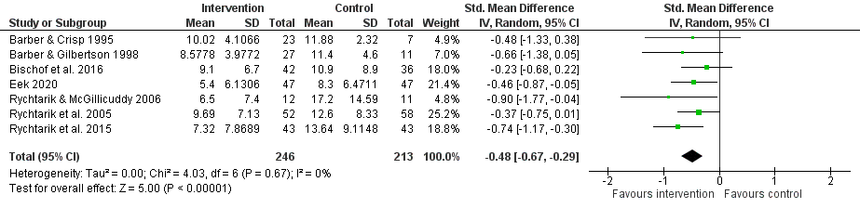
Figure S1. Forest plot of affected other depressive symptomatology at post-intervention

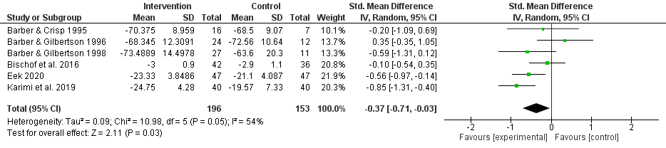
Figure S2. Forest plot of affected other life satisfaction at post-intervention

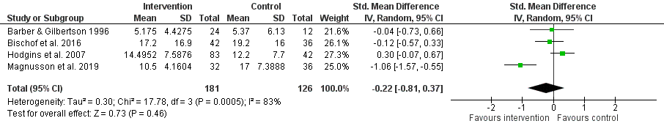
Figure S3. Forest plot of affected other addiction-related harms at post-intervention

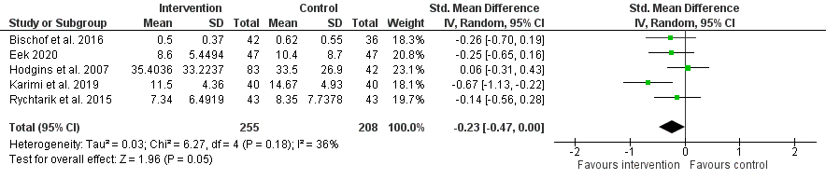
Figure S4. Forest plot of affected other psychological distress at post-intervention

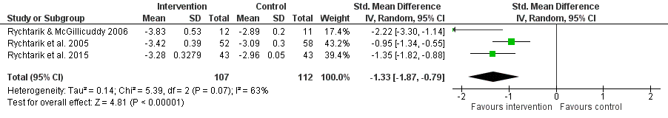
Figure S5. Forest plot of affected other coping at post-intervention

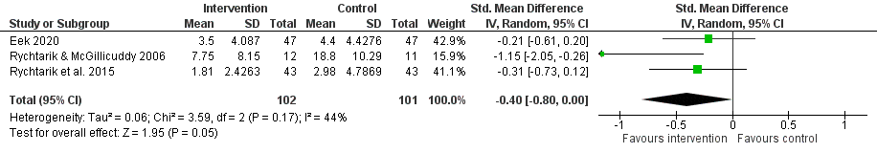
Figure S6. Forest plot of affected other anxiety symptomatology at post-intervention

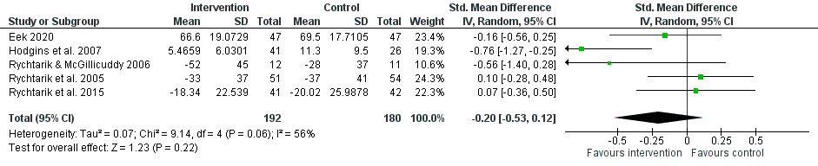
Figure S7. Forest plot of frequency of use by addicted person at post-intervention

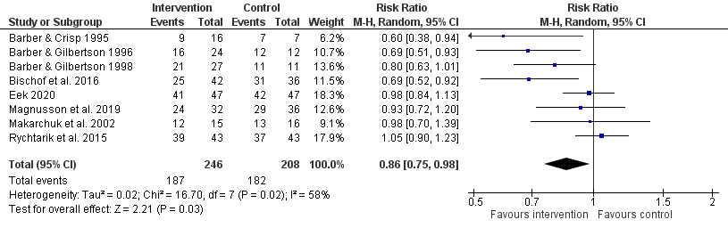
Figure S8. Forest plot of treatment entry by addicted person at post-intervention

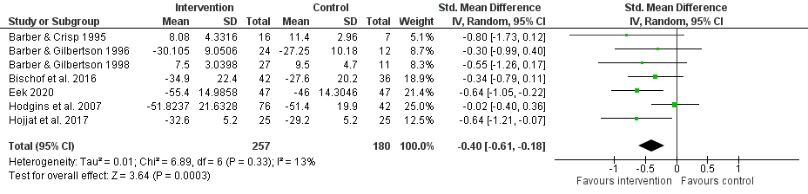
Figure S9. Forest plot of marital/relationship discord at post-intervention

Short-term follow-up forest plots
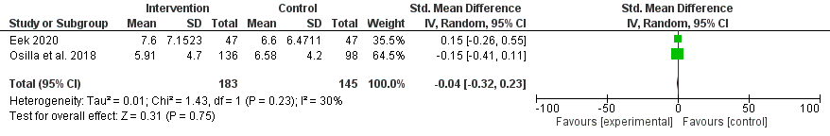
Figure S10. Forest plot of affected other depressive symptomatology at a short-term follow-up

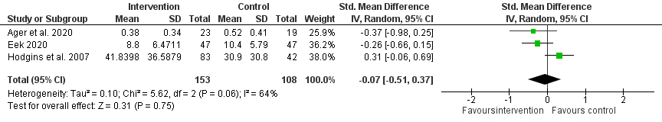
Figure S11. Forest plot of affected other psychological distress at a short-term follow-up

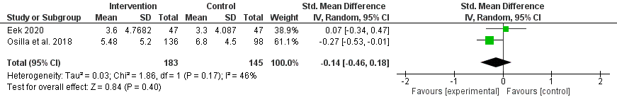
Figure S12. Forest plot of affected other anxiety symptomatology at a short-term follow-up

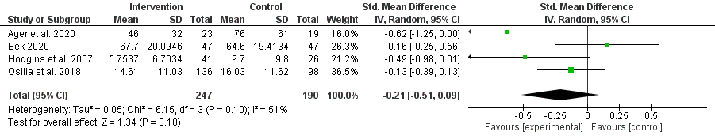
Figure S13. Forest plot of frequency of use by addicted person at a short-term follow-up

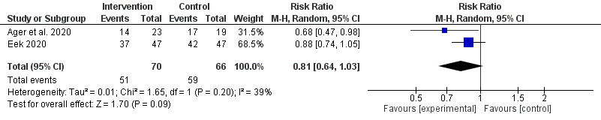
Figure S14. Forest plot of treatment entry by addicted person at a short-term follow-up

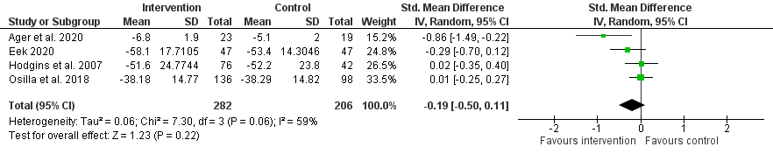
Figure S15. Forest plot of marital/relationship discord at a short-term follow-up

Sensitivity analyses forest plots
Addiction type – Alcohol

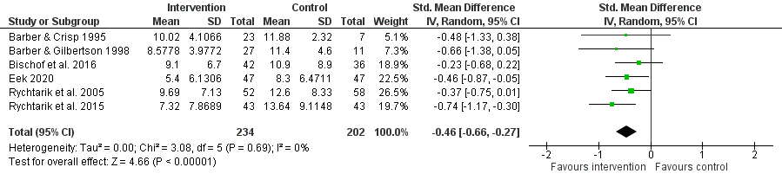
Figure S16. Forest plot of affected other depressive symptomatology – Sensitivity analysis for addiction type

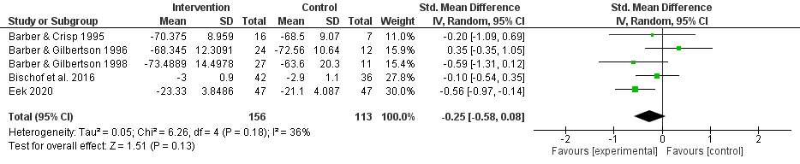
Figure S17. Forest plot of affected other life satisfaction – Sensitivity analysis for addiction type

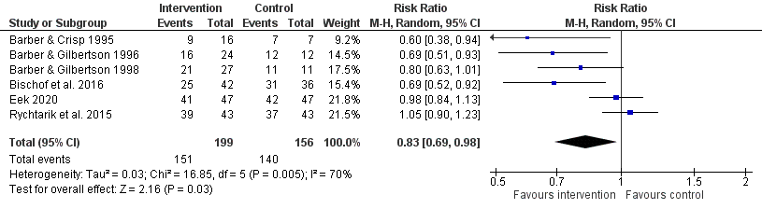
Figure S18. Forest plot of addicted person treatment entry – Sensitivity analysis for addiction type

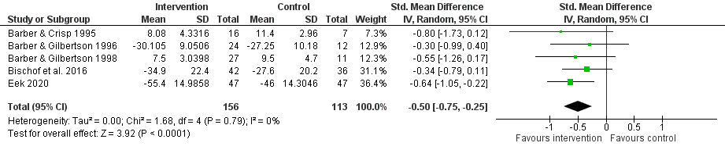
Figure S19. Forest plot of marital/relationship discord – Sensitivity analysis for addiction type

Mode of intervention delivery – Therapist-delivered
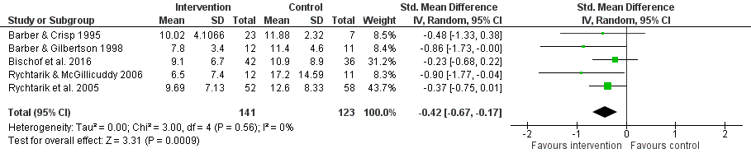
Figure S20. Forest plot of affected other depressive symptomatology – Sensitivity analysis for mode of intervention delivery

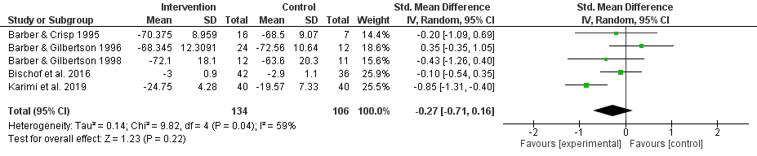
Figure S21. Forest plot of affected other life satisfaction – Sensitivity analysis for mode of intervention delivery

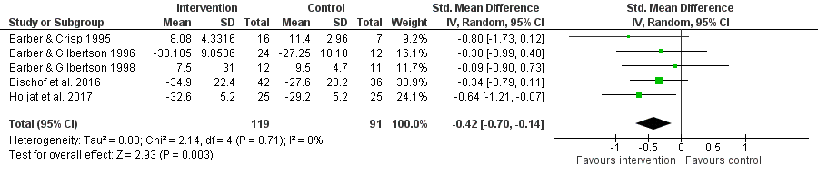
Figure S22. Forest plot of marital/relationship discord – Sensitivity analysis for mode of intervention delivery

