SUPPLEMENT.

Association of Proton Pump Inhibitor Use with Survival Outcomes in Cancer Patients Treated with Immune Checkpoint Inhibitors: A Systematic Review and Meta-analysis

Baoqing Chen M.D., Chen Yang M.D., Mihnea P. Dragomir M.D., Ph.D., Dongmei Chi M.D., Wenyan Chen M.D., David Horst M.D.,
George A. Calin M.D., Ph.D., Qiaoqiao Li M.D.

Supplementary Table 1. The search strategy queries.
Supplementary Table 2. Assessment of the risk of bias in individual studies through the modified Newcastle-Ottawa Quality Assessment Scale (NOS).
Supplementary Table 3. Meta-regression analysis of factors contributing to the studies’ heterogeneity.
Supplementary Figure 1. Schematic diagram of the time window of PPI use.
Supplementary Figure 2. Forest plots for overall and progression-free survival of subgroups by ICI treatment line.
Supplementary Figure 3. Forest plots for overall and progression-free survival of subgroups by patients’ region.
Supplementary Figure 4. Publication bias for included studies on overall and progression-free survival using funnel plots with Egger’s regression tests.
Supplementary Figure 5. Sensitivity analyses for included studies on overall and progression-free survival examined by leaving-one-out approach.
Supplementary Table 1. The search strategy queries.
Sources | Query
PubMed | ("anti-CTLA-4"[All Fields] OR ("ipilimumab"[MeSH Terms] OR "ipilimumab"[All Fields]) OR "anti-PD-1"[All Fields] OR ("atezolizumab"[Supplementary Concept] OR "atezolizumab"[All Fields] OR "anti pdl1"[All Fields]) OR ("toripalimab"[Supplementary Concept] OR "toripalimab"[All Fields]) OR ("pembrolizumab"[Supplementary Concept] OR "pembrolizumab"[All Fields]) OR ("nivolumab"[MeSH Terms] OR "nivolumab"[All Fields] OR "nivolumab s"[All Fields]) OR ("atezolizumab"[Supplementary Concept] OR "atezolizumab"[All Fields]) OR ("avelumab"[Supplementary Concept] OR "avelumab"[All Fields]) OR ("durvalumab"[Supplementary Concept] OR "durvalumab"[All Fields]) OR ("tremelimumab"[Supplementary Concept] OR "tremelimumab"[All Fields]) OR ("sintilimab"[Supplementary Concept] OR "sintilimab"[All Fields]) OR ("camrelizumab"[Supplementary Concept] OR "camrelizumab"[All Fields]) OR "immune checkpoint inhibitor*"[All Fields] OR "ici"[All Fields] OR "anti ctla 4*"[All Fields] OR "anti pd 1*"[All Fields] OR "anti pdl1*"[All Fields]) AND ("proton pump inhibitors"[All Fields] OR ("omeprazole"[MeSH Terms] OR "omeprazole"[All Fields] OR "esomeprazole"[MeSH Terms] OR "esomeprazole"[All Fields] OR "omeprazol"[All Fields]) OR ("lansoprazole"[MeSH Terms] OR "lansoprazole"[All Fields] OR "lansoprazol"[All Fields]) OR ("dexlansoprazole"[MeSH Terms] OR "dexlansoprazole"[All Fields]) OR ("esomeprazole"[MeSH Terms] OR "esomeprazole"[All Fields] OR "esomeprazol"[All Fields]) OR ("pantoprazole"[MeSH Terms] OR "pantoprazole"[All Fields] OR "pantoprazol"[All Fields]) OR ("rabeprazol"[All Fields] OR "rabeprazole"[MeSH Terms] OR "rabeprazole"[All Fields]) OR "ppi"[All Fields] OR "proton pump inhibitor*"[All Fields])
Embase | ('pembrolizumab'/exp OR 'nivolumab'/exp OR 'durvalumab'/exp OR 'ticilimumab'/exp OR 'ipilimumab'/exp OR 'toripalimab'/exp OR 'sintilimab'/exp OR 'camrelizumab'/exp OR 'immune checkpoint inhibitor*' OR 'ici*' OR 'anti-ctla-4*' OR 'anti-pd-1*' OR 'anti-pdcd1*' OR 'anti-pdcd-1*' OR 'anti-pdl1*' ) AND ('proton pump inhibitor'/exp OR 'omeprazole'/exp OR 'lansoprazole'/exp OR 'dexlansoprazole'/exp OR 'esomeprazole'/exp OR 'pantoprazole'/exp OR 'rabeprazole'/exp OR 'ppi*' OR 'proton pump inhibitor*')
Cochrane | #1 MeSH descriptor: [CTLA-4 Antigen] explode all trees  #2 MeSH descriptor: [Nivolumab] explode all trees  #3 MeSH descriptor: [Ipilimumab] explode all trees  #4 'immune checkpoint inhibitor*' OR 'ICI*'  #5 'anti CTLA 4*' OR 'anti PD 1*' OR 'anti PD1*' OR 'anti PDCD1*' OR 'anti PDL1*'  #6 'pembrolizumab' OR 'atezolizumab' OR 'avelumab' OR 'durvalumab' OR 'tremelimumab' OR 'ticilimumab' OR 'toripalimab' OR 'sintilimab' OR 'camrelizumab'  #7 MeSH descriptor: [Proton Pump Inhibitors] explode all trees  #8 MeSH descriptor: [Omeprazole] explode all trees  #9 MeSH descriptor: [Lansoprazole] explode all trees  #10 MeSH descriptor: [Dexlansoprazole] explode all trees  #11 MeSH descriptor: [Esomeprazole] explode all trees  #12 MeSH descriptor: [Pantoprazole] explode all trees  #13 MeSH descriptor: [Rabeprazole] explode all trees  #14 'PPI*' OR 'proton pump inhibitor*'  #15 #1 OR #2 OR #3 OR #4 OR #5 OR #6  #16 #7 OR #8 OR #9 OR #10 OR #11 OR #12 OR #13 OR #14  #17 #15 AND #16
ASCO, ESMO, AACR, SITC Conference Proceedings | Key words:  ((anti-CTLA-4) OR (ipilimumab) OR (anti-PD-1) OR (anti-PDL1) OR (toripalimab) OR (pembrolizumab) OR (nivolumab) OR (atezolizumab) OR (avelumab) OR (durvalumab) OR (tremelimumab) OR (sintilimab) OR (camrelizumab) OR ("immune checkpoint inhibitor*")) AND ("proton pump inhibitors")

ASCO, American Society of Clinical Oncology; ESMO, European Society for Medical Oncology; AACR, American Association for Cancer Research; SITC, Society for Immunotherapy of Cancer.

Supplementary Table 2. Assessment of the risk of bias in individual studies through the modified Newcastle-Ottawa Quality Assessment Scale (NOS).
# | Source | Selection |  |  |  | Comparability | Assessment |  |  | Total stars | Score
# | Source | Representativeness of the exposed cohort | Representativeness of the non-exposed cohort | Ascertainment of exposure | Demonstration that outcome of interest was not present at start of study | Comparable for 1, 2, 3, 4, 5, 6, 7, 8, and 9* | Assessment of outcome | Follow-up long enough for outcomes to occur | Adequacy of follow up of cohorts | Total stars | Score
1 | Afzal et al., 2019 | Yes | Yes | Yes | Yes | 4, 5 | Yes | Unclear | Unclear | ★★★★★ | 5
2 | Araujo et al., 2021 | Yes | Yes | Yes | Yes | 1, 5, 7, 8 | Yes | Yes | Unclear | ★★★★★★★ | 7
3 | Baek et al., 2022 | Yes | Yes | Yes | Yes | 1, 2, 4, 5, 6, 7, 8, 9 | Yes | Yes | Yes | ★★★★★★★★★ | 9
4 | Buti et al., 2021 | Yes | Yes | Yes | Yes | 5 | Yes | Yes | Unclear | ★★★★★★ | 6
5 | Castro Balado et al, 2021 | Yes | Yes | Yes | Yes | 4, 5, 6, 8 | Yes | Yes | Unclear | ★★★★★★★ | 7
6 | Chalabi et al., 2020 | Yes | Yes | Yes | Yes | 1, 2, 4, 5, 6, 7, 8 | Yes | Yes | Yes | ★★★★★★★★★ | 9
7 | Conde-Estévez et al., 2020 | Yes | Yes | Yes | Yes | 4, 5 | Yes | Yes | Unclear | ★★★★★★ | 6
8 | Cortellini et al., 2020 | Yes | Yes | Yes | Yes | 1, 2, 5 | Yes | Yes | Yes | ★★★★★★★★ | 8
9 | Cortellini et al., 2021 | Yes | Yes | Yes | Yes | 4, 5, 6, 8 | Yes | Yes | Unclear | ★★★★★★★ | 7
10 | Failing et al., 2016 | Yes | Yes | Yes | Yes | 1, 2, 4, 5, 6, 8, 9 | Yes | Yes | Yes | ★★★★★★★★★ | 9
11 | Gaucher et al., 2021 | Yes | Yes | Yes | Yes | 1, 2, 8 | Yes | Yes | Yes | ★★★★★★★★ | 8
12 | Giordan et al., 2021 | Yes | Yes | Yes | Yes | 1, 2, 4, 5, 6, 7, 8, 9 | Yes | Yes | Yes | ★★★★★★★★★ | 9
13 | Hopkins et al., 2020 | Yes | Yes | Yes | Yes | 1, 2, 4, 5, 6, 7, 8 | Yes | Yes | Yes | ★★★★★★★★★ | 9
14 | Hopkins et al., 2022 | Yes | Yes | Yes | Yes | 1, 2, 3, 4, 5, 6, 7, 8 | Yes | Yes | Yes | ★★★★★★★★★ | 9
15 | Hossain et al., 2020 | Yes | Yes | Yes | Yes | 4, 5 | Yes | Yes | Unclear | ★★★★★★ | 6
16 | Husain et al., 2021 | Yes | Yes | Yes | Yes | 1, 2, 5, 6, 7, 8 | Yes | Yes | Unclear | ★★★★★★★ | 7
17 | Iglesias-Santamaría et al., 2020 | Yes | Yes | Yes | Yes | 5, 8 | Yes | Yes | Yes | ★★★★★★★ | 7
18 | lida et al., 2021 | Yes | Yes | Yes | Yes | 1, 2, 4, 5, 6, 8, 9 | Yes | Yes | Unclear | ★★★★★★★★ | 8
19 | Jun et al., 2021 | Yes | Yes | Yes | Yes | 1, 2, 4, 5, 8 | Yes | Yes | Yes | ★★★★★★★★ | 8
20 | Kostine et al., 2021 | Yes | Yes | Yes | Yes | 5 | Yes | Yes | Yes | ★★★★★★★ | 7
21 | Kulkarni et al., 2019 | Yes | Yes | Yes | Yes | 4, 5 | Yes | Yes | Unclear | ★★★★★★ | 6
22 | Miura et al., 2021 | Yes | Yes | Yes | Yes | 4, 5, 6, 9 | Yes | Yes | Yes | ★★★★★★★★ | 8
23 | Mollica et al., 2021 | Yes | Yes | Yes | Yes | 1, 2, 4, 5, 6, 8 | Yes | Yes | Yes | ★★★★★★★★★ | 9
24 | Nguyen et al., 2019 | Yes | Yes | Yes | Yes | 6 | Yes | Yes | Unclear | ★★★★★★ | 6
25 | Peng et al., 2022 | Yes | Yes | Yes | Yes | 1, 2, 3, 4, 5, 6, 7, 8, 9 | Yes | Yes | Yes | ★★★★★★★★★ | 9
26 | Routy et al., 2017 | Yes | Yes | Yes | Yes | 8 | Yes | Yes | Unclear | ★★★★★★ | 6
27 | Ruiz-Bañobr et al., 2021 | Yes | Yes | Yes | Yes | 1, 2, 4, 5, 6, 8, 9 | Yes | Yes | Yes | ★★★★★★★★★ | 9
28 | Spakowicz et al., 2020 | Yes | Yes | Yes | Yes | 2 | Yes | Yes | Unclear | ★★★★★★ | 6
29 | Stein et al, 2020 | Yes | Yes | Yes | Yes | 1,2,4,5,6,8 | Yes | Yes | Yes | ★★★★★★★★★ | 9
30 | Stokes et al., 2021 | Yes | Yes | Yes | Yes | 2, 3, 4, 6 | Yes | Yes | Unclear | ★★★★★★★ | 7
31 | Svaton et al., 2020 | Yes | Yes | Yes | Yes | 2,4,5,6,8 | Yes | Yes | Yes | ★★★★★★★★ | 8
32 | Takada et al., 2022 | Yes | Yes | Yes | Yes | 1, 2, 4, 5, 6 | Yes | Yes | Unclear | ★★★★★★★ | 7
33 | Zhao et al., 2019 | Yes | Yes | Yes | Yes | 1,2,3,4,5,6,8 | Yes | Yes | Yes | ★★★★★★★★★ | 9

*1, age; 2, gender; 3, race; 4, tumor type; 5, tumor stage; 6, ICI type; 7, Eastern Cooperative Oncology Group (ECOG)-Performance Status (PS); 8, treatment line of immunotherapy; 9, other concomitant treatment, e. g. antibiotics, corticosteroids. If six to nine characteristic variables of two cohorts were comparable, a score of two as a full score for comparability were assigned; if three to five variables were comparable, a score of one were assigned; otherwise, no score was assigned. Studies assigned with total score of 7 to 9 indicated high methodological quality, while of 5 or 6 indicated moderate quality and of 4 or less indicated low quality. The total score is equal to the total number of stars.

Supplementary Table 3. Meta-regression analysis of factors contributing to the studies’ heterogeneity.
Variable | OS |  |  |  | PFS
Variable | SE | t | Coefficient (95% CI) | P | SE | t | Coefficient (95% CI) | P
Sample size | <.01 | -1.28 | 1.00 (1.00, 1.00) | 0.21 | <.01 | 0.21 | 1.00 (1.00, 1.00) | 0.83
Percentage of patients receiving PPIs | <.01 | -0.69 | 1.00 (0.99 1.01) | 0.50 | -
ICI type
Anti-PD-(L)1 + anti-CTLA-4 | Reference
Anti-PD-1 | 0.75 | 0.32 | 1.22 (0.34, 4.45) | 0.75 | 0.69 | 0.45 | 1.27 (0.41, 3.99) | 0.66
Anti-PD-L1 | 0.83 | 0.47 | 1.34 (0.36, 4.91) | 0.65 | 0.69 | 0.47 | 1.29 (0.41, 4.03) | 0.64
Anti-PD-(L)1 | 0.69 | 0.18 | 1.12 (0.31, 4.05) | 0.86 | 0.69 | 0.45 | 1.28 (0.41, 4.01) | 0.66
Anti-CTLA-4 | 0.32 | -1.14 | 0.39 (0.07, 2.19) | 0.27 | 0.39 | -0.82 | 0.58 (0.14, 2.38) | 0.42
Time window of PPI use
Group A: baseline | Reference
Group B: (-60, NA) | 0.13 | -0.50 | 0.93 (0.69, 1.25) | 0.62 | 0.34 | 0.22 | 1.07 (0.56, 2.08) | 0.83
Group C: (0, NA) | 0.13 | -1.41 | 0.80 (0.58, 1.10) | 0.17 | 0.24 | 0.44 | 1.10 (0.70, 1.73) | 0.67
Cancer type
UC | Reference
NSCLC | 0.14 | -0.95 | 0.85 (0. 60, 1.21) | 0. 35 | 0.16 | -1.06 | 0.82 (0.55, 1.21) | 0.30
RCC | -1.50 | -1.81 | 0.67 (0.42, 1.06) | 0.09 | 0.16 | -1.64 | 0.68 (0.42, 1.11) | 0.12
Melanoma | 0.23 | 0.20 | 1.05 (0.67, 1.63) | 0.84 | 0.17 | -1.68 | 0.65 (0.38, 1.11) | 0.11
Treatment line
First line | Reference
Non-first line | -0.14 | 0.18 | .97 (0.64, 1.49) | 0.89 | 0.18 | -1.20 | 0.75 (0.43, 1.32) | 0.27
Region
Australia | Reference
Europe | 0.15 | -0.66 | 0.90 (0.64, 1.26) | 0.52 | 0.26 | -0.38 | 0.90 (0.50, 1.63) | 0.71
America (USA and Brazil) | 0.13 | -1.59 | 0.76 (0.53, 1.08) | 0.12 | 0.30 | -0.58 | 0.81 (0.37, 1.75) | 0.57
Asia | 0.17 | -0.67 | 0.88 (0.58, 1.32) | 0.51 | 0.44 | 0.38 | 1.16 (0.52, 2.58) | 0.71
Abbreviations: OS, overall survival; PFS, progression-free survival; SE, standard error; CI, confidence interval; NSCLC, non-small cell lung cancer; RCC, renal cell carcinoma; UC, urothelial cancer; ICI, immune checkpoint inhibitor; PPI, proton pump inhibitor; PD-1, programmed cell death protein 1; PD-L1, programmed death-ligand 1; CTLA-4, cytotoxic T lymphocyte–associated antigen 4.

Supplementary Figure 1. Schematic diagram of the time window of PPI use. This is a schematic diagram of the time window of PPI use. The point zero on the timeline means the day when ICI treatment started. Group A, PPI therapy as baseline treatment; group B (-60, NA), PPI therapy begin within 60 days before ICI treatment initiation; group C (0, NA), PPI therapy begin with ICI treatment initiation concomitantly.
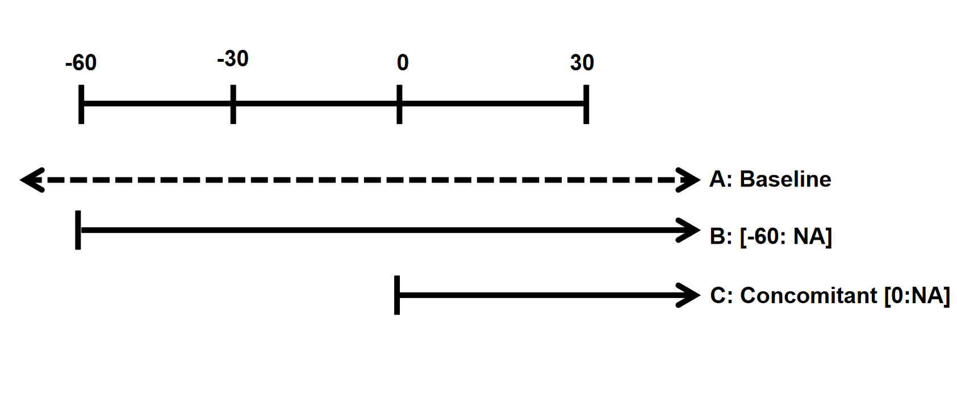

Supplementary Figure 2. Forest plots for overall and progression-free survival of subgroups by ICI treatment line. Sized boxes represent the weight of each study, and horizontal lines represent 95% CIs. Diamonds at the bottom of the plot show the overall effect while the ones under each subgroup show pooled effect for the corresponding subgroup, with the points representing 95% CIs. OS, overall survival; PFS, progression-free survival; CI, confidence interval; PPI, proton pump inhibitor; ICI, immune checkpoint inhibitor.
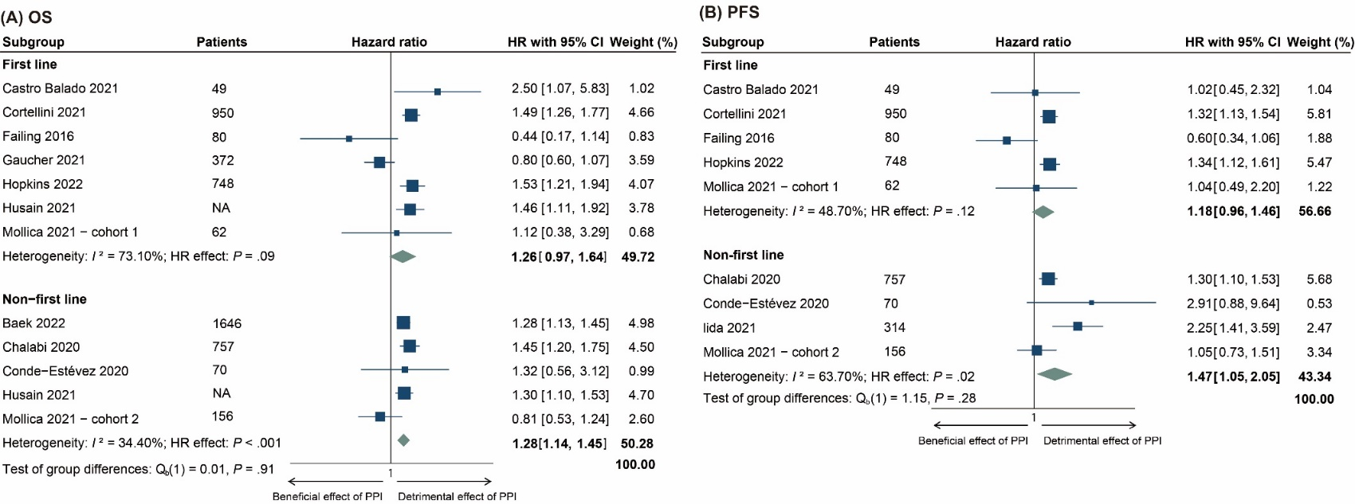

Supplementary Figure 3. Forest plots for overall and progression-free survival of subgroups by patients’ region. Sized boxes represent the weight of each study and horizontal lines represent 95% CIs. Diamonds at the bottom of the plot show the overall effect while the ones under each subgroup show pooled effect for the corresponding subgroup, with the points representing 95% CIs. OS, overall survival; PFS, progression-free survival; CI, confidence interval; PPI, proton pump inhibitor; ICI, immune checkpoint inhibitor.
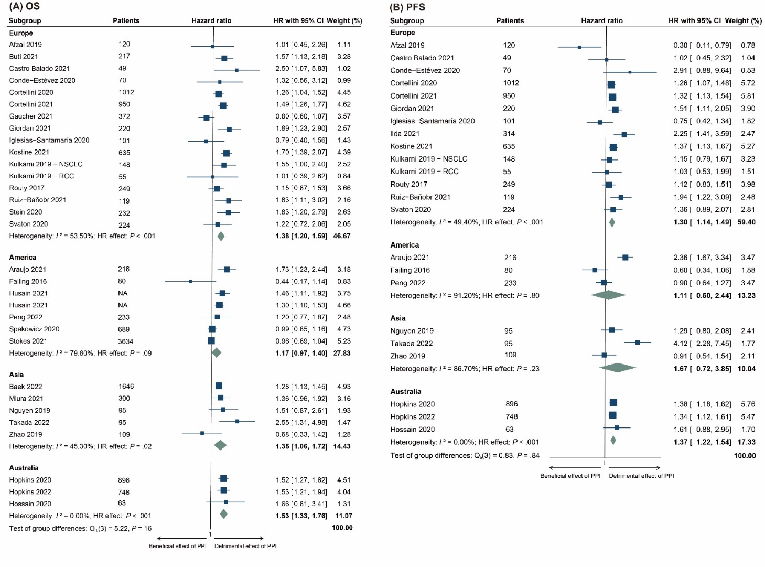

Supplementary Figure 4. Publication bias for included studies on overall and progression-free survival using funnel plots with Egger’s regression tests. Funnel plots (left) and bias plots (right) show the results of Egger’s regression test of publication bias for (A) OS and (B) PFS. Abbreviations: OS, overall survival; PFS, progression-free survival; SE, standardized effect.

A
B

Supplementary Figure 5. Sensitivity analyses for included studies on overall and progression-free survival examined by leaving-one-out approach. Sensitivity analyses examined by the leave-one-out approach showed that no individual study significantly affected the pooled hazard ratios for OS or PFS, indicating results were stable. Circles represent the pooled effect for each study, with the horizontal thin dot and dash lines representing 95% CIs. (A) The line at the position of 1.31 on OS represented the pooled overall effect for OS, with the lines at the position of 1.19 and 1.44 representing 95% CIs. (B) The line at the position of 1.30 on PFS represents the pooled overall effect for PFS, with the lines at the position of 1.17 and 1.46 representing 95% CIs. Abbreviations: OS, overall survival; PFS, progression-free survival.
B
A

