Appendix

Appendix 1: Search Strategy
Search 1: SMS (Intervention)
sms OR "text messag*" OR "mobile messag*" OR "Cell phone messag*" OR mhealth OR m-heath OR “Mobile Health” OR Cell phone OR smartphone OR txt OR “Mobile communication” OR “Mobile phone”
AND
Search 2: Promotion of exercise/exercise-based rehabilitation (Intervention)
“physical activit*" OR Exercis* OR "physical exercis*” OR rehabilitation OR rehab*
AND
Search 3: Qualitative studies/analyses (Outcome / Study Design)
acceptability OR perception OR experience OR views OR opinion OR impression OR feel* OR qualitative OR “Qualitative research” OR “focus groups” OR “focus group” OR interviewed OR interviewing OR interviewer OR interviews OR interview OR perspectives OR perspective OR perceived OR perceives OR perceive OR perceptions OR perception OR thoughts OR narratives OR satisfaction OR feelings OR meanings OR opinions OR opinion OR viewpoints OR viewpoint OR experiences OR narrative OR narratives OR “thematic analysis” OR “thematic analyses” OR “mixed method” OR “mixed methodology” OR expectation OR standpoint OR standpoints OR dissatisfaction OR “conversation analysis” OR “conversational analyses” OR observational methods” OR “participant observation OR ethnology OR ethnological OR “grounded studies” OR “grounded research” OR content analysis” OR “content analyses” OR stories OR story OR “field notes” OR field study” OR “field studies” OR “field research” OR “field work” OR “behavioural research” OR narration OR “behavioural research” OR phenomenology OR phenomenological OR “constant comparative” OR “constant comparison” OR “open-ended” OR “open ended” OR “behavioural research” OR phenomenology OR phenomenological OR “theoretical sample” OR “grounded studies” OR “grounded research” OR “theoretical saturation” OR discourse OR “behavioural research” OR meaning views OR “theoretical sampling” OR “action research” OR “questionnaire” OR “life world” OR “life-world” OR “biographical method” OR “grounded theory” OR view comprehension expectations OR “biographical method” OR meaning views
AND
Search 4: Participant population (Population)
Chronic OR “long-term” OR persistent OR “non-communicable” OR “total knee joint replacement” OR “Knee joint replacement” OR TKJR OR “total hip joint replacement” OR “hip joint replacement” OR THJR OR “total shoulder joint replacement” OR “shoulder joint replacement” OR TSJR OR “back pain” OR “neck pain” OR “spinal surgery” OR “following discharge” OR amputation OR “after discharge” OR “post-discharge” OR “post discharge” OR “physiotherapy” OR “physical therapy” OR respiratory OR “lung disease” OR COPD OR “chronic obstructive pulmonary disease” OR NCFB OR “non-cystic fibrosis bronchiectasis” OR asthma OR “cystic fibrosis“ OR cardiac OR “heart attack” OR “heart disease” OR “myocardial infarct*” OR “cardiovascular disease” OR pulmonary OR Ischemic OR Ischaemic OR osteoarthritis OR “ankylosing spondylitis” OR rheumatoid arthritis” OR “psoriatic arthritis” OR “Inflammatory arthritis” OR neurological OR MS OR “multiple sclerosis” OR stroke OR “cerebrovascular accident” OR CVA OR “cerebral palsy” OR disability OR disabled OR Osteoporosis OR muscular OR joint OR musculoskeletal OR “elective surgery” OR “bariatric surgery” OR kidney disease” OR Renal OR arthritis OR gout OR Cancer OR “sickle cell” OR OA OR Osteoporosis OR RA OR lupus OR “juvenile idiopathic arthritis” OR stress OR “Juvenile chronic arthritis OR “systemic lupus erythematosus OR pain OR fibromyalgia Or diabetes

Appendix 2: CASP Quality Assessment
CASP Questions | 1 | 2 | 3 | 4 | 5 | 6 | 7 | 8 | 9 | 10
Chen et al. (2018) | Yes | Yes | Yes | Yes | Yes | Yes | Yes | Yes | Yes | Clinical implications are discussed, no mention of areas of further research, limited discussion of applicability in similar settings and conditions.
Day et al. (2018) | Yes | Yes | No | Yes | Yes | No | No | Yes | Yes | References made to other studies looking at similar interventions in other surgical populations, areas of further research identified, no mention of implications of this study on further research.
Edbrooke et al. (2020) | Yes | Yes | Yes | Yes | Yes | Yes | Yes | Yes | Yes | Areas of further research identified; references made to studies with other cancers.
Job et al. (2017) | Yes | Yes | Yes | Yes | Yes | Yes | Yes | Yes | Yes | Areas of further research into extended contact interventions identified, states that the intervention may be applicable to other populations.
Leon et al. (2015) | Yes | Yes | Yes | Yes | Yes | No | Yes | Yes | Yes | References made to current literature; states need for research in a larger population.
Lilje et al. (2017) | Yes | Yes | Yes | Yes | Yes | Yes | Yes | Yes | Yes | Only identifies areas of further research.
Pfaeffli Dale et al. (2015) | Yes | Yes | Yes | Yes | Yes | Yes | Yes | Yes | Yes | Limited reference to previous literature, no areas of further research needed, no mention of the applicability of this study in other demographic groups except different ages.
Redfern et al. (2016) | Yes | Yes | Yes | No | Yes | No | Yes | Yes | Yes | References made to previous literature, areas of further research identified, no mention of applicability to other populations.

1: Was there a clear statement of the aims of the research? 2: Is qualitative methodology appropriate? 3: Was the research design appropriate to address the aim of the research? 4: Was the recruitment strategy appropriate to the aims of the research? 5: Was the data collected in a way that addressed the research issue? 6: Has the relationship between the researcher and participants been adequately considered?
7: Have ethical issues been taken into consideration? 8: Was the data analysis sufficiently rigorous? 9: Is there a clear statement of findings? 10: How valuable is the research?

Appendices 3-7: Derivation of each analytical theme

Appendix 3

Analytical theme 1: Taking control of my own health

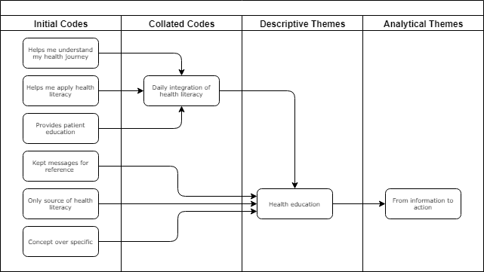

Appendix 4

Analytical theme 2: From information to action
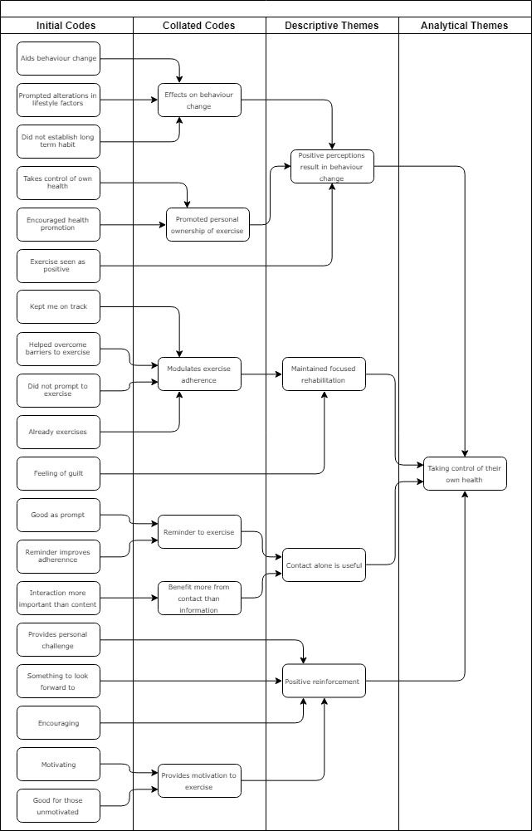

Appendix 5

Analytical theme 3: Relationship with the programme
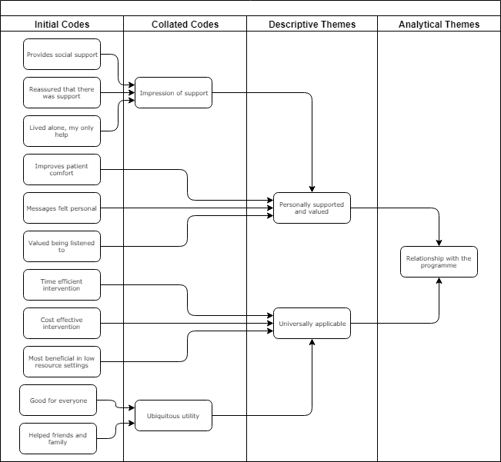

Appendix 6

Analytical theme 4: Perfection required for success.
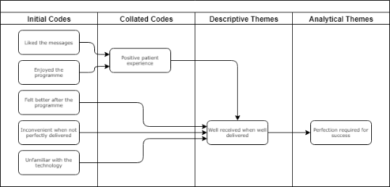
Perfection required for success
Well received when well delivered

Appendix 7

Analytical theme 5: Increased expectations.

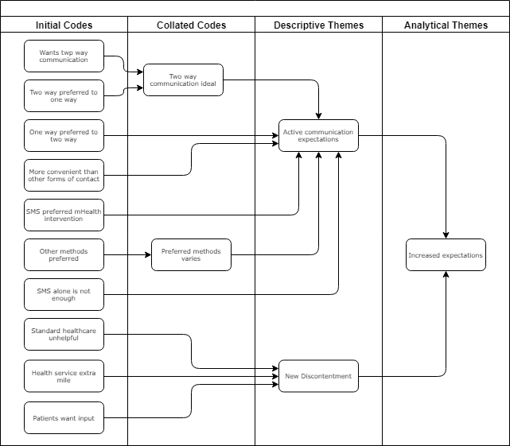

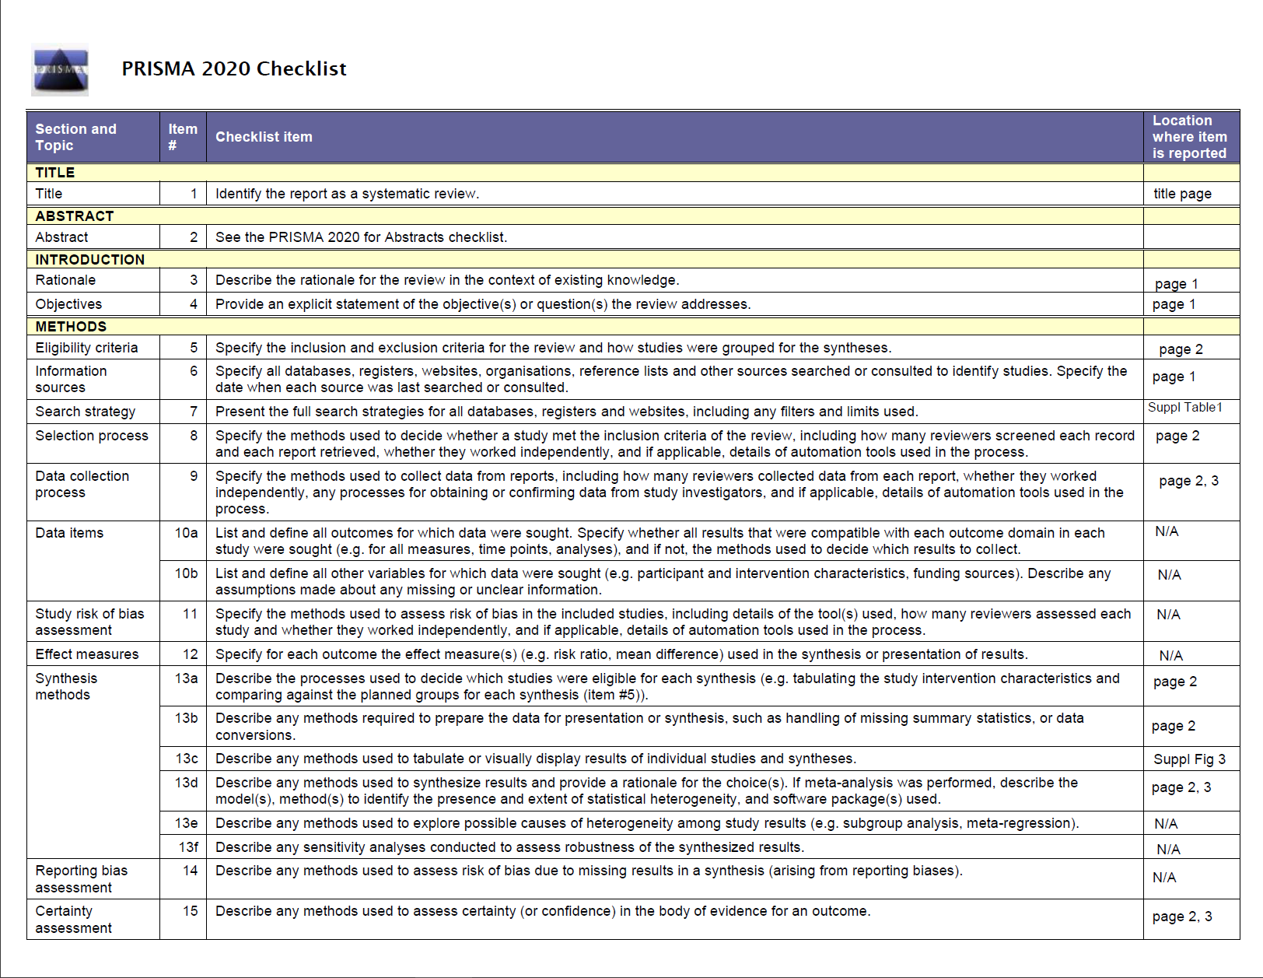
Appendix 8: Prisma Checklists

