Appendices

Prevalence of Cerebral Amyloid Angiopathy: A Systematic Review and Meta-analysis
Lieke Jäkel^{1*}, Anna M. De Kort^{1*}, Catharina J.M. Klijn¹, Floris H.B.M. Schreuder^{1#}, Marcel M. Verbeek^{1,2#}

¹Department of Neurology, Radboud University Medical Center, Donders Institute for Brain, Cognition and Behaviour, Radboud Alzheimer Centre, The Netherlands
²Department of Laboratory Medicine, Radboud University Medical Center, The Netherlands
*These authors contributed equally
# These authors contributed equally

Index

Appendix A: Detailed search strategies
Appendix B: Quality assessment form
Appendix C: Rationale chosen modifiers for modifier analyses
Appendix D: Raw data of included studies
Appendix E: Results quality assessment
Appendix F: Sensitivity analyses: Pooled prevalence estimates of high quality (low risk of bias) studies
Appendix G: Modifier analysis prevalence moderate-to-severe CAA: Univariable scatterplots and box-and-whisker plots
Appendix H: Modifier analysis prevalence strictly lobar microbleeds: Univariable scatterplots and box-and-whisker plots
Appendix I: Funnel plots
Appendix J: Sensitivity analyses: Pooled estimates using generalized linear mixed models
Appendix K: Influence analyses: Leave-one-out and removal-of-outlier analyses
Appendix L: References

Appendix A. Detailed search strategies.

Search strategy PUBMED March 2018

1. CAA
("Cerebral Amyloid Angiopathy" [Mesh:NoExp] OR CAA [Tiab] OR (amyloid [Tiab] AND angiopath* [Tiab]) OR (congophil* [Tiab] AND angiopath* [Tiab]) OR (vascular [Tiab] AND (amyloid [Tiab] OR betaamyloid [Tiab] OR beta-amyloid [Tiab] OR amyloidbeta [Tiab] OR amyloid-beta [Tiab] OR Abeta [Tiab] OR A-beta [Tiab] OR betaA [Tiab] OR beta-A [tiab]) AND patholog* [Tiab]) OR vascular amyloid* [Tiab])

2. BLEEDS
(cerebral hemorrhage [Mesh] OR ((cerebral [Tiab] OR lobar [Tiab] OR brain [Tiab] OR cortical [Tiab] OR intracerebral [Tiab] OR intra-cerebral [Tiab]) AND (microbleed* [Tiab] OR micro-bleed* [Tiab] OR microhaemorrhag* [Tiab] OR micro-haemorrhag* [Tiab] OR microhemorrhag* [Tiab] OR micro-hemorrhag* [Tiab] OR bleed* [Tiab] OR haemorrhag* [Tiab] OR hemorrhag* [Tiab])))

3. IMAGING
(neuroimaging [MeSH] OR magnetic resonance imaging [MeSH] OR "Cerebral Amyloid Angiopathy/diagnostic imaging" [Mesh] OR neuroimag* [Tiab] OR neuro-imag* [tiab] OR MRI [Tiab] OR MRIs [Tiab] OR imag* [Tiab] OR (superficial [Tiab] AND siderosis [Tiab]) OR gradient echo* [tiab] OR echo gradient* [tiab] OR susceptibility weight* [tiab])

4. PATHOLOGY
(neuropathology [MeSH] OR Cerebral Hemorrhage/pathology [mesh] OR Cerebral Amyloid Angiopathy/pathology [mesh] OR pathology [MeSH] OR immunohistochemistry [MeSH] OR Amyloid beta-peptides [Mesh] OR ((Amyloid [tiab] AND beta [tiab])
OR betaamyloid [Tiab] OR beta-amyloid [Tiab] OR amyloidbeta [Tiab] OR amyloid-beta [Tiab] OR Abeta [Tiab] OR A-beta [Tiab] OR betaA [Tiab] OR beta-A [tiab]) OR neuropatholog* [Tiab] OR neuro-patholog* [Tiab] OR patholog* [Tiab] OR immunohistochem* [Tiab] OR immuno-histochem* [Tiab] OR histopatholog* [Tiab] OR histo-patholog* [Tiab] OR post-mortem [Tiab] OR postmortem [Tiab] OR autops* [Tiab] OR biops* [Tiab] OR tissue [Tiab] OR congo red [Tiab] OR Thioflavin [tiab])

5. 2 OR 3

6. 1 AND 5

7. 1 AND 4

8. 6 OR 7

9. animals [MeSH] NOT humans [MeSH]

10. 8 NOT 9

Search strategy EMBASE March 2018

1. CAA
(vascular amyloidosis/ OR CAA.ti,ab,kw. OR (amyloid .ti,ab,kw. AND angiopath*.ti,ab,kw.) OR (congophil*.ti,ab,kw. AND angiopath*.ti,ab,kw.) OR (vascular.ti,ab,kw. AND (amyloid.ti,ab,kw. OR betaamyloid.ti,ab,kw. OR beta-amyloid.ti,ab,kw. OR amyloidbeta.ti,ab,kw. OR amyloid-beta.ti,ab,kw. OR Abeta.ti,ab,kw. OR A-beta.ti,ab,kw. OR betaA.ti,ab,kw. OR beta-A.ti,ab,kw.) AND patholog*.ti,ab,kw.) OR vascular amyloid*.ti,ab,kw.)

2. BLEEDS
(brain hemorrhage/ OR cerebellum hemorrhage/) OR ((cerebral .ti,ab,kw. OR lobar .ti,ab,kw. OR brain .ti,ab,kw. OR cortical .ti,ab,kw. OR intracerebral .ti,ab,kw. OR intra-cerebral.ti,ab,kw.) AND (Microbleed*.ti,ab,kw. OR Micro-bleed*.ti,ab,kw. OR Microhaemorrhag*.ti,ab,kw. OR micro-haemorrhag*.ti,ab,kw. OR microhemorrhag*.ti,ab,kw. OR micro-hemorrhag*.ti,ab,kw. OR bleed*.ti,ab,kw. OR haemorrhag*.ti,ab,kw. OR hemorrhag*.ti,ab,kw.))

3. IMAGING
(neuroimaging/ OR (nuclear magnetic resonance imaging/ OR cardiovascular magnetic resonance/ OR diffusion weighted imaging/ OR echo planar imaging/ OR fluORine magnetic resonance imaging/ OR magnetic resonance angiography/ OR multiparametric magnetic resonance imaging/ OR susceptibility weighted imaging/) OR neuroimag* .ti,ab,kw. OR neuro-imag*.ti,ab,kw. OR MRI .ti,ab,kw. OR MRIs .ti,ab,kw. OR imag* .ti,ab,kw. OR (superficial .ti,ab,kw. AND siderosis .ti,ab,kw.) OR Gradient echo*.ti,ab,kw. OR Echo gradient*.ti,ab,kw. OR Susceptibility weight*.ti,ab,kw.)

4. PATHOLOGY
neuropathology/ OR (pathology/ OR general pathology/ OR exp pathological anatomy/) OR exp immunohistochemistry/ OR amyloid beta protein/ OR ((Amyloid.ti,ab,kw. AND beta.ti,ab,kw.) OR betaamyloid.ti,ab,kw. or beta-amyloid.ti,ab,kw. OR amyloid-beta.ti,ab,kw. OR amyloidbeta .ti,ab,kw.) OR neuropatholog* .ti,ab,kw. OR neuro-patholog* .ti,ab,kw. OR patholog* .ti,ab,kw. OR immunohistochem* .ti,ab,kw. OR immuno-histochem* .ti,ab,kw. OR histopathology*.ti,ab,kw. OR histo-patholog* .ti,ab,kw. OR post-mortem .ti,ab,kw. OR postmortem .ti,ab,kw. OR autops* .ti,ab,kw. OR biops*.ti,ab,kw. OR tissue .ti,ab,kw. OR congo red .ti,ab,kw. OR Thioflavin.ti,ab,kw.

5. 2 OR 3

6. 1 AND 5

7. 1 AND 4

8. 6 OR 7

9. limit 8 to conference abstract

10. 8 not 9

11. exp animals/ NOT exp human/

12. 10 not 11

Search strategy PUBMED June 2019

- CAA
"Cerebral Amyloid Angiopathy" [Mesh:NoExp] OR CAA [Tiab] OR (amyloid [Tiab] AND angiopath* [Tiab]) OR (congophil* [Tiab] AND angiopath* [Tiab]) OR (vascular [Tiab] AND (amyloid* [Tiab] OR betaamyloid* [Tiab] OR beta-amyloid* [Tiab] OR amyloidbeta* [Tiab] OR amyloid-beta* [Tiab] OR Abeta* [Tiab] OR A-beta* [Tiab] OR betaA [Tiab] OR beta-A [tiab]))

- PATHOLOGY
neuropathology [MeSH] OR Cerebral Hemorrhage/pathology [mesh] OR Cerebral Amyloid angiopathy/pathology [mesh] OR pathology [MeSH] OR immunohistochemistry [MeSH] OR Amyloid beta-peptides [Mesh] OR (Amyloid [tiab]AND beta [tiab]) OR betaamyloid [Tiab] OR beta-amyloid [Tiab] OR amyloidbeta [Tiab] OR amyloid-beta [Tiab] OR Abeta [Tiab] OR A-beta [Tiab] OR betaA [Tiab] OR beta-A [tiab] OR neuropatholog* [Tiab] OR neuro-patholog* [Tiab] OR patholog* [Tiab] OR immunohistochem* [Tiab] OR immuno-histochem* [Tiab] OR histopatholog* [Tiab] OR histo-patholog* [Tiab] OR post-mortem [Tiab] OR postmortem [Tiab] OR autops* [Tiab] OR biops* [Tiab] OR tissue [Tiab] OR congo red [Tiab] OR Thioflavin [tiab]

- IMAGING
((lobar [Tiab] OR cortical [Tiab]) AND (cerebral hemorrhage [Mesh] OR microbleed* [Tiab] OR micro-bleed* [Tiab] OR microhaemorrhag* [Tiab] OR micro-haemorrhag* [Tiab] OR microhemorrhag* [Tiab] OR micro-hemorrhag* [Tiab] OR bleed* [Tiab] OR haemorrhag* [Tiab] OR hemorrhag* [Tiab]) OR CMB [tiab] OR LMH [Tiab] OR LMB [Tiab] OR LH [Tiab] OR LB [Tiab] OR (superficial [Tiab] AND siderosis [Tiab]) OR cSS [Tiab]) AND (magnetic resonance imaging [MeSH] OR "Cerebral Amyloid Angiopathy/diagnostic imaging" [Mesh] OR MRI [Tiab] OR MRIs [Tiab] OR gradient echo* [tiab] OR echo gradient* [tiab] OR susceptibility weight* [tiab] OR SWI [tiab] OR GRE [tiab] OR MR imag* [tiab])

- 1 AND 2

- 3 OR 4

- animals [MeSH] NOT humans [MeSH]

- 5 NOT 6

Search strategy EMBASE June 2019

- CAA
vascular amyloidosis/ OR CAA.ti,ab,kw. OR (amyloid .ti,ab,kw. AND angiopath*.ti,ab,kw.) OR (congophil*.ti,ab,kw. AND angiopath*.ti,ab,kw.) OR (vascular.ti,ab,kw. AND (amyloid*.ti,ab,kw. OR betaamyloid*.ti,ab,kw. OR beta-amyloid*.ti,ab,kw. OR amyloidbeta*.ti,ab,kw. OR amyloid-beta*.ti,ab,kw. OR Abeta*.ti,ab,kw. OR A-beta*.ti,ab,kw. OR betaA.ti,ab,kw. OR beta-A.ti,ab,kw.))

- PATHOLOGY
neuropathology/ OR (pathology/ OR general pathology/ OR exp pathological anatomy/) OR exp immunohistochemistry/ OR amyloid beta protein/ OR ((Amyloid.ti,ab,kw. AND beta.ti,ab,kw.) OR betaamyloid.ti,ab,kw. or beta-amyloid.ti,ab,kw. OR amyloid-beta.ti,ab,kw. OR amyloidbeta .ti,ab,kw.) OR neuropatholog* .ti,ab,kw. OR neuro-patholog* .ti,ab,kw. OR patholog* .ti,ab,kw. OR immunohistochem* .ti,ab,kw. OR immuno-histochem* .ti,ab,kw. OR histopathology*.ti,ab,kw. OR histo-patholog* .ti,ab,kw. OR post-mortem .ti,ab,kw. OR postmortem .ti,ab,kw. OR autops* .ti,ab,kw. OR biops*.ti,ab,kw. OR tissue .ti,ab,kw. OR congo red .ti,ab,kw. OR Thioflavin.ti,ab,kw.

- IMAGING
((lobar.ti,ab,kw. OR cortical.ti,ab,kw.) AND (brain hemorrhage/ OR microbleed*.ti,ab,kw. OR micro-bleed*.ti,ab,kw. OR Microhaemorrhag*.ti,ab,kw. OR micro-haemorrhag*.ti,ab,kw. OR microhemorrhag*.ti,ab,kw. OR micro-hemorrhag*.ti,ab,kw. OR bleed*.ti,ab,kw. OR haemorrhag*.ti,ab,kw. OR hemorrhag*.ti,ab,kw.)) OR (superficial.ti,ab,kw. AND siderosis.ti,ab,kw.) OR CMB.ti,ab,kw. OR LMH.ti,ab,kw. OR LMB.ti,ab,kw. OR cSS.ti,ab,kw.) AND (nuclear magnetic resonance imaging/ OR susceptibility weighted imaging/ OR MRI.ti,ab,kw. OR MRIs.ti,ab,kw. OR Gradient echo*.ti,ab,kw. OR Echo gradient*.ti,ab,kw. OR Susceptibility weight*.ti,ab,kw. OR SWI.ti,ab,kw. OR GRE.ti,ab,kw. OR MR imag*.ti,ab,kw.)

- 1 AND 2

- 3 OR 4

- Limit 5 to conference abstract

- 5 NOT 6

- exp animals/ NOT exp human/

- 7 NOT 8

Appendix B. Quality assessment form.
To assess the quality of included studies, we used an adapted and combined version of the quality assessment tools by Hoy and the Newcastle scale-Ottawa scale [60, 161]. All studies were independently scored by two reviewers, any discrepancies were solved through discussion. Every study was scored on six items, each of which was given a score of 0 (high quality, low risk of bias) to 3 (low quality, high risk of bias), resulting in a summary score of 0 to 18.

- Representativeness of the sample Is study cohort representative of domain in terms of age, sex, comorbidities, etc.
- Truly representative (max 40/60% gender) 0 points
- Somewhat representative (e.g. dementia at baseline excluded / only nuns and priests and therefore probably quite healthy / autopsies in hospital populations / inequality of gender / no clinical diagnosis of AD ) 1 point (cumulative to max 3)
- Selected cohort (e.g. hypertensive patients / only males / early onset (but sporadic) AD / AD only combined with vascular dementia / inclusion criterium is 85+ or older) 2 points (cumulative to max 3)
- No description 3 points

- Recruitment Are the cases randomly selected?
- All / consecutive cases of a specific period were included 0 points
- Cases were ‘recruited’ / selected based on presence of specific biological information / were age-and sex-matched controls 1.5 point
- No description 3 points

- Appropriate outcome parameter definition
- Appropriate case definition is provided 0 points
- Case definition is provided, but not adequate 1.5 points
- No description 3 points

- Reliability and validity of the diagnostic tool
- Diagnostic tool is reported and valid (antibody specified, MRI parameters provided) 0 points
- Diagnostic tool reported but without specifications (no antibody name specified, no MRI parameters provided) 1.5 points
- Validity of diagnostic tool is questionable 3 points

- Uniformity in method of data collection,
- All cases have been studied using the same experimental set-up (same antibody, MRI parameters, same number of brain sections/regions studied) 0 points
- Not all cases have been studied using the same experimental set-up (this includes biopsy studies assessing different haemorrhagic sites/brain regions) 3 points

- Appropriate numerators and denominators reported
- There were no errors in the reporting of the numerator(s) AND denominator(s) for the prevalence (except for minor typing errors) 0 points
- There were errors in the reporting of the numerator(s) AND denominator(s) for the prevalence 3 points

Appendix C. A priori chosen modifiers for modifier analyses

Modifier | Rationale
Age | The prevalence of CAA pathology increases with age [10], and the prevalence of strictly lobar microbleeds increases with age [157].
Number of cortical lobes examined | CAA pathology is not homogenously distributed throughout the brain, for example, the occipital lobe is most frequently affected [93]. Studying multiple cortical lobes increases the probability of detecting CAA.
Method of amyloid staining | Amyloid staining is less specific than immunohistochemistry [171].
Study sample (population- or registry-based studies versus clinical sample-based studies) | Hospital populations include generally frail patients with more comorbidities and may therefore not accurately reflect the general population [72].
Method of diagnosis (clinically versus neuropathologically stratified as AD or control case). | Diagnosis of AD based only on neuropathology lacks information on dementia status, and thus may include asymptomatic patients, while clinically diagnosed AD does not always correlate fully with AD neuropathologic changes [110]. The prevalence of CAA may depend on the method of diagnosis: it seems likely that patients selected based on the presence (or absence) of amyloid plaques, have (no) substantial CAA.
History of hypertension | We aim to confirm the hypothesis that hypertension does not substantially affect the occurrence of strictly lobar microbleeds [153, 162].
MRI field strength | Increased magnetic field strength, 3 Tesla or higher, improves microbleeds conspicuity [49].
MRI slice thickness | Smaller section thickness yields substantially increased lesion contrast for microbleeds [108].
MRI sequence | Prevalence and number of microbleeds are reported to be higher on SWI compared with T2* [108, 134].
Publication year | To assess whether more recent papers report higher prevalence (due to improved detection and diagnostic guidelines)

Appendix D. Raw study data

1. Overview of the study characteristics and reported prevalence of CAA pathology in the general population
Author | Year | Country | Definition Domain | Study Acronym / Name of cohort | n | Age: mean (sd) or median (range)* | Fe  male (%) | IHC / AS | Sampled brain region | Prevalence CAA pathology: overall (mild/moderate/  severe/moderate-to-severe) (%) | QA
Alafuzoff [2] | 2009 | Finland | Population that had been under continuous clinical follow-up because of a chronic disease | Kuopio University Hospital | 701 | 74 | 54 | IHC | 2,3,4 | 25 | 2.5
Attems [4] | 2008 | Austria | Hospital population | 3 hospitals in Vienna | 2060 | 79 (7) | 60 | IHC | 1,3,5 | 49 | 4
Brenowitz [16] | 2015 | USA | Population referred to ADC because of health, cognition or behaviour concerns. Ranging from normal to demented | NACC (MDS, UDS, NDS) | 3976 | 83 (8) | 50 | both | nr | 66 (30/21/14/35) | 5.5
Cholerton [24] | 2013 | USA | Population, dementia-free at baseline | ACT | 363 | 87 (7) | 54 | AS | 1,2,3,4,5,6,7 | 31 (16/13/2/15) | 5.5
Erten-Lyons [38] | 2013 | USA | Population, initially free of dementia, chronic diseases and depression at baseline, later, people with chronic disease and dementia (but not depression) were also included | Oregon Brain Aging Study | 71 | 95 (5) | 58 | AS | 1 | 37 | 5.5
Itoh [64] | 1993 | Japan | Hospital population | Yokufukai Geriatric Hospital | 160 | 84 (8) | nr | AS | nr | 48 (26/11/11/22) | 3
Kovacs [75] | 2013 | Austria | Population, born between May 1925 and June 1926 | VITA | 223 | (77-87)* | nr | IHC | 1,2,3,4,5,6,7 | 51 | 3
Kovari [76] | 2015 | Switzerland | Hospital population | University Hospitals Geneva 2012-2014 | 113 | 81 (11) | 57 | IHC | 1,2,3,4,5,7 | 44 | 0
Kovari [77] | 2013 | Switzerland | Hospital population | University Hospitals Geneva 2007 | 91 | 78 (11) | 51 | IHC | 1,2,3,4,5, | 54 | 0
Masuda [93] | 1988 | Japan | Population, ≥40 years | Hisayama residents | 400 | nr | 46 | AS | 1,2,3,4,5,7 | 23 | 0
Matthews [94] | 2009 | UK | Population ≥65 years | MRC CFAS (1989-2004) | 446 | 81*† | 58‡ | nr | nr | 43 (20/19/4/23) | 6
Moghekar [102] | 2012 | USA | Population ≥ 70 years, dementia-free at baseline | BLSA | 50 | 89 (6) | 38 | IHC | 2,5 | 46 | 3.5
Ng [111] | 1991 | China | Hospital population | nr | 210 | 71† | 40 | AS | 1,4,5 | 10 (nr/nr/3/nr) | 2
Oveisgharan [116] | 2018 | USA | ROS: older Catholic nuns, priest and brothers. MAP: population from Chicago area. Dementia-free at baseline | ROS & MAP | 1453 | 89 | 67 | IHC | 1,2,3,4 | 76 (41/22/13/35) | 6
Robinson [128] | 2018 | USA | Population ≥ 90 years | 90+ Study | 185 | 98 (4) | 71 | IHC | 2,3,5,7 | 16 (9/7/0/7) | 6
Robinson [129] | 2018 | UK | Population, dementia-free at baseline | UMLS CNHOA | 97 | 89 (72-104)* | 68 | IHC | 1,2,3,4,5,6,7 | nr (nr/nr/nr/27) | 3.5
Strozyk [140] | 2007 | USA | Japanese-American men, dementia-free at baseline | HAAS | 232 | 85 | 0 | IHC | 1,2,3,4 | 47 | 5
Tanprasertsuk [143] | 2019 | USA | Population ≥ 98 years | Georgia Centenarian study | 49 | 102 (3) | 90 | nr | nr | 59 (35/12/12/24) | 10.5
Tanskanen [144] | 2012 | Finland | Population ≥85 years | Vantaa 85+ Study | 306 | 92 | 83 | both | 1,2,3,4,5,6 | 70 | 1
Vinters [156] | 1983 | Canada | Hospital population | Victoria Hospital | 84 | 78† | 43 | AS | 1,2,3,4,5 | 36 (nr/nr/17/nr) | 1
Vonsattel [158] | 1991 | USA | Hospital population ≥75 years, without ICH | MGH | 66 | 82 | 50 | AS | 1,2,3,4,5,6,7 | 45 (20/24/2/26) | 1
Wijesinghe [164] | 2016 | Sri Lanka | Hospital population | Colombo South Teaching Hospital | 50 | 72 (8) | 42 | IHC | 2,3,4,5,7 | 20 | 1
Xu [168] | 2003 | China | Hospital population ≥60 years | Chinese PLA General Hospital | 362 | 78 | 48 | both | nr | 31 (10/14/7/21) | 5.5
Prevalence of CAA pathology shows the overall prevalence (irrespective of CAA grade), and, if reported, the prevalence of different stages of CAA (mild, moderate, severe, or moderate-to-severe).
Abbreviations cohorts / study acronyms: ACT = Adult Changes in Thought cohort; BLSA = Baltimore Longitudinal Study of Aging; HAAS = Honolulu-Asia Aging Study; MAP = Rush Memory and Aging Project; MGH = Massachusetts General Hospital; MRC CFAS = Medical Research Council Cognitive Function and Ageing Study; NACC = National Alzheimer’s Coordinating Centre; PLA = People Liberation Army; ROS = Religious Orders Study; UMLS CNHOA = University of Manchester Longitudinal Study of Cognition in Normal Healthy Old Age; VITA = Vienna Transdanube Aging
Other abbreviations: ADC = Alzheimer disease centre; AS = amyloid staining; CAA = cerebral amyloid angiopathy; ICH = intracerebral haemorrhage; IHC = immunohistochemistry; QA = total score of quality assessment; UK = United Kingdom; USA = United States of America
Legends: † the exact age was not provided, but an estimation could be made based on the available data; ‡ an exact percentage was not provided, but an estimation could be made based on the available data; * median age and/or age range were reported instead of mean age (sd); sampled brain region(s): 1=occipital; 2=temporal; 3=frontal; 4=parietal; 5=hippocampal, 6=cerebellar; 7=subcortical

2. Overview of the study characteristics and reported prevalence of CAA pathology in cognitively normal elderly
Author | Year | Country | Definition Domain | Study Acronym / Name of cohort | n | Age: mean (sd) or median (range)* | Fe  male (%) | IHC / AS | Sampled brain region | Prevalence mild-to-severe CAA (mild/moderate/  severe/moderate-to-severe) (%) | QA
Bergeron [8] | 1987 | Canada | Clinically non-demented, age-matched | Toronto University Hospital | 30 | 71 (10) | nr | AS | 1,2,3,4,5,6 | 40 (17/13/10/23) | 3.5
Bertrand [9] | 2008 | Poland | No neurodegenerative or psychiatric disease, no dementia, age-matched | Institute of Psychiatry and Neurology, Warsaw | 14 | 75 (10) | 50 | both | 2,3 | 29 (14/14/0/14) | 1.5
Bourassa [13] | 2019 | USA | Absent/low level AD pathologic changes | ROS | 22 | 87 (4) | 59 | IHC | 4 | 27 (18/5/5/9) | 4
Brayne [15] | 2009 | UK | Clinically non-demented | CC75C | 100 | 91 (5) | 61 | AS | 1,2,3,4,5 | 30 (26/3/1/4) | 2
Cartier [19] | 1999 | Chile | Death of non-neurologic cause, age- and sex-matched | Universidad de Chile | 30 | 64 (16) | 53 | AS | nr | 43 | 2
Chalmers [20] | 2003 | UK | No AD pathological change | SWBB | 53 | 75 (8) | 45 | IHC | 2,3,4 | 36 (26/6/4/9) | 3
Cholerton [24] | 2013 | USA | CASI > 86 | ACT | 196 | 86 (7) | 52 | AS | 1,2,3,4,5,6,7 | 21 (12/8/1/9) | 4.5
Cruz-Sanchez [26] | 2000 | nr | No neurological disease | nr | 38 | 67 (18) | 34 | both | 1,2,5,7 | 18 | 7
Davis [27] | 1999 | USA | Cognitively and neurologically normal | Kentucky University Hospital | 59 | 84 (7) | 53 | IHC | 1,2,3,4,5,7 | 76 | 1
DeReuck [28] | 2019 | France | No neurological disease/cognitive decline /stroke | Lille University Hospital | 20 | 66 (12) | 40 | IHC | 1,2,3,4 | 0 (0/0/0/0) | 4.5
DeReuck [29] | 2013 | France | Death not related to brain disease | nr | 14 | 74* | 64 | IHC | 1,2,4,5 | nr (nr/nr/7/nr) | 4
Dickson [32] | 1992 | USA | Non-demented | Bronx Aging Study | 14 | 89 | 71 | both | 1,3 | 36 | 5.5
Dugger [34] | 2014 | USA | No clinico-neuropathological diagnosis | AZSAND, BSHRI, BBDP | 166 | 83 (9) | 44 | AS | nr | 12 | 1
Erten-Lyons [38] | 2013 | USA | No cognitive impairment or dementia, CDR=0 | Oregon Brain Aging Study | 27 | 92 (5) | 56 | AS | 1 | 41 | 5.5
Esiri [39] | 2015 | UK | No AD (CERAD criteria), Braak stage ≤2 | OPTIMA | 70 | 83 (8) | 44 | AS | 1,2,3,4,5 | 51 (nr/nr/0/nr) | 4.0
Esiri [40] | 1986 | UK | No clinicopathological evidence for dementia/CNS disease | Radcliffe Infirmary, Oxford | 26 | 81 | nr | AS | 2,3,5 | 27 (nr/nr/0/nr) | 10.5
Geinisman [43] | 1988 | Russia | Normal cognition, death due to somatic disease | LPRI | 40 | (70-91)*† | nr | AS | 1,2,3,4,5,6,7 | 40 | 12.0
Guidoux [51] | 2018 | France | Non-neurologic patients, age- and sex matched | Hospices Civils de Strasbourg | 59 | 76 (70-91)* | 49 | AS | nr | 15 | 4.0
Haglund [52] | 2002 | Sweden | Non-demented, no AE/ neurodegenerative or vascular pathology | LLDS | 10 | 79 | nr | AS | 3 | 20 | 4.0
Head [56] | 2017 | USA | Non-demented | UCI ADRC | 37 | 80 (10) | 41 | IHC | nr | 19 (11/8/0/8) | 7.0
Honig [59] | 2005 | USA | Clinically non-demented | NACC (1985-2003) | 225 | 83† | 56 | nr | nr | 45 | 7.5
Jellinger [67] | 2010 | Austria | Pathologically and clinically non-demented, age-matched | Institute of Clinical Neurobiology, Vienna | 486 | 79 (8) | 55 | IHC | 1,2,3,5,7 | 30 (nr/nr/20/nr) | 3.0
Kovari [77] | 2013 | Switzerland | Non-demented | University Hospitals Geneva 2007 | 59 | 76 (11) | 49 | IHC | 1,2,3,4,5 | 46 | 2
Lee [81] | 1978 | USA | No cerebral haemorrhage at autopsy, age, sex and ethnicity matched | Kuakini MC | 75 | 62† | nr | AS | nr | 0 (0/0/0/0) | 12
Love [86] | 2003 | UK | Neurologically normal, no pathological evidence of AD (CERAD) | Frenchay Hospital, Bristol | 152 | (60-102)* | 49 | IHC | 2,3 | 32 | 1
Magaki [87] | 2014 | USA | Non-demented | UCLA | 124 | 71 (8) | 41 | nr | nr | 0 (0/0/0/0) | 1
Mastaglia [92] | 2003 | Australia | Non-demented | Queen Elizabeth II MC | 100 | 75 | nr | both | nr | 26 | 9
Matthews [94] | 2009 | UK | Clinically non-demented | MRC CFAS | 178 | nr | nr | nr | nr | 27 (17/10/0/10) | 8
McAleese [95] | 2019 | UK | Non-cognitively impaired, with at least 1 deep WMH | Institute of Neuroscience, Newcastle | 22 | 84 (9) | 50 | IHC | 4 | 36 (23/9/5/14) | 3.5
McKee [96] | 2006 | USA | Cognitively intact, CDR=0 | FHS | 25 | 82 (15) | 48 | IHC | 1,2,3,4,5 | 60 | 3.0
Mountjoy [104] | 1982 | UK | Patients who died whilst under general medical/psychiatric care, no dementia | Newcastle General Hospital | 30 | 76 | 50 | AS | 1,2,3,4 | 40 | 5
Pfeifer [120] | 2002 | USA | Clinically non-demented Japanese-American men | HAAS | 138 | nr | 0 | IHC | 1,2,3,4 | 38 (nr/nr/24/nr) | 3
Premkumar [123] | 1996 | USA | No clinical or histopathological evidence of AD | CWRU | 16 | 70 | 44 | AS | 1,2,3,4 | 0 (0/0/0/0) | 6
Robinson [127] | 2018 | UK | Clinically cognitively unimpaired | UMLS CNHOA | 57 | 89* | 65 | IHC | 1,2,3,4,5,6,7 | nr (nr/nr/nr/16) | 2.5
Serrano-Pozo [133] | 2013 | USA | CDR-SOB of 0 | NACC (2005-2012) | 117 | 87† | nr | nr | nr | 40 (27/9/3/13) | 6
Shim [136] | 2015 | USA | Clinically healthy, cognitively normal | CCCVD | 14 | 91 (6) | 64 | IHC | nr | 79 | 4
Wu [166] | 1992 | USA | Clinically non-demented, age-matched | Albert Einstein College of Medicine, New York | 34 | 79 (10) | 71 | AS | nr | 50 (44/3/3/6) | 6.5
Xu [167] | 2004 | China | No clinical or pathological involvement of CNS | PLA General Hospital, Beijing | 28 | 66 (23) | 18 | IHC | 1,3,5,7 | 25 | 4
Yaiw [170] | 2012 | Malaysia | Non-demented | UMMC | 50 | 70 (11) | 22 | IHC | 2,3,4,5,7 | 8 | 7
Yamada [173] | 2002 | Japan | No AD / neurodegenerative disease | Kanazawa University Hospital | 119 | 86 (8) | nr | both | 1 | 35 | 3
Prevalence of CAA pathology shows the overall prevalence (irrespective of CAA grade), and, if reported, the prevalence of different stages of CAA (mild, moderate, severe, or moderate-to-severe).
Abbreviations cohorts / study acronyms: ACT = Adult Changes in Thought cohort; AZSAND = Arizona Study of Aging and Neurodegenerative Disorders; BBDP = Brain and Body Donation Program; BSHRI = Banner Sun Health Research Institute; CCCVD = Cognitive Change in Cerebrovascular Disease; CC75C = Cambridge City over-75's Cohort; CWRU = Case Western Reserve University; FHS = Framingham Heart Study; HAAS = Honolulu-Asia Aging Study; LLDS = Lund Longitudinal Dementia Study; LPRI = Leningrad Psychoneurological Research Institute; MRC CFAS = Medical Research Council Cognitive Function and Ageing Study; NACC = National Alzheimer’s Coordinating Center; OPTIMA = Oxford Project to Investigate Memory and Ageing; PLA = People Liberation Army; ROS = Religious Orders Study; SWBB = South Western Brain Bank; UCI ADRC = University of California at Irvine Alzheimer's Disease Research Center; UCLA = University of California Los Angeles; UMLS CNHOA = University of Manchester Longitudinal Study of Cognition in Normal Healthy Old Age; UMMC = University Malaya Medical Centre
Other abbreviations: AD = Alzheimer disease; AS = amyloid staining; CAA = cerebral amyloid angiopathy; CASI = cognitive abilities screening instrument; CDR = clinical dementia rating; CDR-SOB = clinical dementia rating – sum of boxes; CERAD = consortium to establish a registry for Alzheimer's disease; CNS = central nervous system; ICH = intracerebral haemorrhage; IHC = immunohistochemistry; MC = medical centre; QA = total score of quality assessment; UK = United Kingdom; USA = United States of America; WMH = white matter hyperintensity
Legends: † the exact age was not provided, but an estimation could be made based on the available data; ‡ an exact percentage was not provided, but an estimation could be made based on the available data; * median age and/or age range were reported instead of mean age (sd); sampled brain region(s): 1=occipital; 2=temporal; 3=frontal; 4=parietal; 5=hippocampal, 6=cerebellar; 7=subcortical

3. Overview of the study characteristics and reported prevalence of CAA pathology in patients with AD
Author | Year | Country | Definition Domain | Study Acronym / Name of cohort | n | Age: mean (sd) or median (range)* | Fe  male (%) | IHC / AS | Sampled brain region | Prevalence mild-to-severe CAA (mild/moderate/  severe/moderate-to-severe) (%) | QA
Attems [4] | 2008 | Austria | Pathologically diagnosed AD (CERAD, Braak, NIA-Reagan) | 3 hospitals in Vienna | 760 | nr | nr | IHC | 1,3,5 | 98 | 1
Bell [6] | 1990 | Canada | Clinically diagnosed AD, pathologically confirmed | nr | 10 | 79 (9) | 50 | AS | 1 | 60 | 4.5
Bergeron [8] | 1987 | Canada | Clinically and pathologically diagnosed AD | Toronto University Hospital | 30 | 73 (8) | nr | AS | 1,2,3,4,5,6 | 87 (3/30/53/83) | 2
Bourassa [13] | 2019 | USA | Pathologically diagnosed, intermediate or high level of AD | ROS | 38 | 88 (6) | 71 | IHC | 4 | 45 (18/13/13/26) | 5
Brayne [15] | 2009 | UK | Clinically diagnosed AD (DSM-IV) | CC75C | 101 | 91 | 77 | AS | 1,2,3,4,5 | 60 (34/19/8/27) | 3
Chalmers [20] | 2003 | UK | Pathologically confirmed AD | SWBB | 125 | 79 (9) | 56 | IHC | 2,3,4 | 95 (63/18/14/32) | 3
Cruz-Sanchez [26] | 2000 | nr | Clinically diagnosed AD (DSM-IV) | nr | 28 | 77 (10) | 50 | both | 1,2,5,7 | 61 | 6
DelSer [31] | 2005 | Canada | Clinically diagnosed AD (DSM-III), pathologically confirmed (Braak stage ≥4, CERAD). 22 cases also had IL | Dementia Study Project | 57 | 79† | 67 | AS | 2,3,4,5,7 | 46 | 1
DeReuck [28] | 2019 | France | Demented, pathologically diagnosed AD (Braak V or VI) | Lille University Hospital | 92 | 76 | 49 | IHC | 1,2,3,4 | 67 (20/15/33/48) | 4.5
Dugger [35] | 2014 | USA | Demented, pathologically diagnosed with probable/ definite AD (CERAD). Life expectancy <6 months at recruitment | Recruited participants from 22 centres in the USA | 38 | 82 (11) | 61 | both | 1,2,3,4 | 92 (34/34/24/58) | 1
Ellis [37] | 1996 | USA | Clinically and pathologically (CERAD) diagnosed (possible, probable, or definite) AD | CERAD study | 117 | 76 | 36 | AS or IHC | 2,3,4,5 | 83 (57/nr/nr/26) | 7
Esiri [39] | 2015 | UK | Pathologically diagnosed AD (CERAD) | OPTIMA | 154 | 78 (8) | 56 | AS | 1,2,3,4,5 | 94 (nr/nr/9/nr) | 4
Esiri [40] | 1986 | UK | AD with or without CVD or other CNS disease | Radcliffe Infirmary, Oxford | 45 | 82 | 67 | AS | 2,3,5 | 82 (nr/nr/24/nr) | 10.5
Fallet-Bianco [41] | 1990 | France | Clinically demented, microscopically diagnosed AD or mixed dementia (AD and VaD) | Charles Richet Study | 42 | 86 | nr | AS | 1,2,3,4,5,7 | 74 | 4
Geinisman [43] | 1988 | Russia | Pathologically diagnosed AD, some with cerebrovascular lesions | LPRI | 60 | (70-91)*† | nr | AS | 1,2,3,4,5,6,7 | 100 | 12
Glenner [45] | 1981 | USA | Clinically demented, pathologically diagnosed AD | AFIP | 45 | 69 | nr | AS | nr | 89 | 10
Haglund [52] | 2002 | Sweden | Clinically diagnosed AD, with pathological correlate of varying degrees of AE (15 had AD and VaD) | LLDS | 52 | 79† | nr | AS | 3 | 69 | 4
Head [56] | 2017 | USA | Pathologically diagnosed AD (Braak stage VI & amyloid plaque stage C, NACC) | UCI ADRC | 79 | 76 (12) | 51 | IHC | nr | 72 (41/14/18/32) | 7
Helman [57] | 2019 | USA | Clinically demented, pathologically confirmed AD | NIH NeuroBioBank | 12 | 81 (8) | 33 | IHC | 1 | 92 (33/8/50/58) | 3
Honig [59] | 2005 | USA | Clinically demented, no other neuropathological diagnosis than AD | NACC (1985-2003) | 791 | 79† | 50 | nr | nr | 41 | 7.5
Itoh [64] | 1993 | Japan | Pathologically diagnosed AD (Khachaturian) | Yokufukai Geriatric Hospital | 33 | 87 (7) | nr | AS | nr | 76 | 3
Jellinger [68] | 2003 | Austria | Clinically diagnosed probable AD (NINCDS-ADRDA), pathologically confirmed definite AD (CERAD) | 3 hospitals in Vienna | 730 | 82 (4) | 65 | IHC | 1,2,3,4,5,6,7 | 98 (nr/nr/nr/24) | 1
Jellinger [66] | 1977 | Austria | Pathologically diagnosed AD | Neurological Institute, Vienna | 92 | nr | nr | AS | nr | 78 | 12
Jicha [69] | 2006 | USA | Clinically demented, pathologically diagnosed AD | Mayo Alzheimer Disease Patient Registry | 24 | 90 | 71 | both | nr | 33 (17/17/0/17) | 1
Joachim [70] | 1988 | USA | Clinically and pathologically diagnosed AD | nr | 131 | 77† | nr | AS | 1 (+ varying others) | 100 | 9.5
Kovacs [75] | 2013 | Austria | Clinically diagnosed dementia (14 possible & 8 probable AD) | VITA | 22 | nr | nr | IHC | 1,2,3,4,5,6,7 | 45 | 4
Kovari [76] | 2015 | Switzerland | Pathologically diagnosed AD (Braak stage ≥ 4; 14 pure AD and 11 associated with vascular encephalopathy) | University Hospitals Geneva 2012-2014 | 25 | 85† | nr | IHC | 1,2,3,4,5,7 | 68 | 1
Kovari [77] | 2013 | Switzerland | Pathologically diagnosed AD (Braak stage ≥ 4) | University Hospitals Geneva 2007 | 10 | 84 (4) | 50 | IHC | 1,2,3,4,5 | 80 | 1
Kurucz [78] | 1981 | USA | Clinically and pathologically diagnosed AD, infarction present in 11 cases | Warren State Hospital | 41 | nr | nr | AS | 2,3,5 | 54 (37/nr/17/nr) | 3
Leech [82] | 2001 | USA | Clinically demented, pathologically confirmed AD (Khachaturian, or NIA-R, or CERAD) | Many hospitals in Oklahoma, Autopsy Assistance Network Oklahoma, Alzheimer's Research Texas Tech University | 79 | nr | nr | IHC | 1,2,3,4,5,6,7 | 32 | 16.5
Liu [84] | 1999 | China | Clinically and pathologically diagnosed AD | Beijing Hospital | 29 | 80 (7) | 38 | IHC | 1,2,3,4,5,7 | 86 | 7.5
Lopez [85] | 1991 | USA | Clinically and pathologically diagnosed AD | PUH & VAMC | 40 | 72 (8) | 48 | AS | nr | 55 | 4
Magaki [87] | 2014 | USA | Clinically and pathologically diagnosed dementia (AD: 123 pure, AD+ LBD, AD + IL: 24 AD + OL) | UCLA ADRC, ECBB | 171 | nr | nr | nr | nr | 73 (19/19/35/54) | 7
Mandybur [88] | 1975 | UK | Clinically and pathologically diagnosed AD | Cincinnati general hospital. | 15 | 69 (10) | 60 | AS | nr | 87 (27/47/13/60) | 7
Mann [89] | 2018 | UK | Clinically diagnosed late onset AD | MBB | 34 | 81 (7) | 47 | IHC | 1,2,3,5,6 | 88 | 3
McAleese [95] | 2019 | UK | Clinico-pathologically diagnosed AD with >1 deep WML | Institute of Neuroscience, Newcastle | 20 | 83 (6) | 55 | IHC | 4 | 80 (nr/10/30/40) | 3.5
McKee [96] | 2006 | USA | Clinically diagnosed probable AD, CDR 1-3. | FHS | 13 | 89 (6) | 62 | IHC | 1,2,3,4,5 | 100 | 4
Mountjoy [104] | 1982 | UK | Clinically diagnosed senile dementia of Alzheimer type | Newcastle General Hospital | 15 | 76 | 80 | AS | 1,2,3,4 | 60 | 1
Nation [109] | 2012 | USA | Clinically diagnosed possible (10) or probable (55) AD (NINDS-ARDRA), confirmed by NIA CERAD criteria for probable or definite AD. No VaD or mixed dementia. | UCSD-ADRC | 65 | 74 (7) | 52 | AS | 2,3,4,5 | 80 | 5
Olichney [114] | 2000 | USA | Clinically and pathologically diagnosed AD (DSM-III, NIH and CERAD). | SD ADRC | 306 | 80 | 47 | AS | 2,3,4,5 | 75 (nr/nr/19/nr) | 3
Parker [118] | 1985 | US | AD (not further specified) | Tenessee University Hospital | 10 | 77 (70-86)* | 40 | AS | nr | 20 | 9
Pfeifer [120] | 2002 | USA | Clinically (NINCDS-ARDA) and pathologically diagnosed AD (n=22) in Japanese-American men, n=14 with AD and CVD | HAAS | 36 | nr | 0 | IHC | 1,2,3,4 | 53 (3/6/50/56) | 3
Pirttila [122] | 1996 | Finland | Clinically diagnosed probable AD (NINCDS-ARDRA), pathologically confirmed definite AD (CERAD). | Kuopo University Hospital | 18 | 84 (10)† | nr | AS | 2,3 | 61 (22/nr/nr/39) | 8
Premkumar [123] | 1996 | USA | Clinically diagnosed probable AD confirmed by pathology (>95% definite AD). | CWRU | 190 | 79 | 57 | AS | 1,2,3,4 | 96 (25/nr/nr/71) | 6
Serrano-Pozo [133] | 2013 | USA | Clinically diagnosed AD, confirmed by pathology, absence of neuropathologic disease. CDR-SOB 3.5-18.0 | NACC (2005-2012) | 623 | 81† | nr | nr | nr | 74 (29/27/17/45) | 6
Shim [136] | 2015 | USA | Clinically diagnosed AD (criteria comparable to NINCDS-ADRDA) | CCCVD | 26 | 81 (9) | 38 | IHC | nr | 85 | 4
Shinohara [137] | 2016 | USA | Pathologically diagnosed AD | Mayo Clinic brain bank for neurodegenerative disorders at Jacksonville | 428 | 81*† | 57 | AS | 1,2,3,4 | 87 | 4
Tian [145] | 2004 | nr | Pathologically diagnosed "pure" AD (CERAD), Braak stage ≥5 | nr | 137 | 73 | 54 | AS | 1,2,3,4 | 100 (22/42/36/78) | 7
Tomimoto [146] | 1999 | nr | Pathologically diagnosed AD (CERAD) | nr | 39 | 79 (9) | nr | both | 3 | 97 (15/33/49/82) | 8
Vik-Mo [155] | 2019 | Norway | Clinically diagnosed AD (NINCDS-ARDRA), pathologically confirmed AD | Demvest | 31 | 81 | 68 | nr | nr | nr (nr/nr/nr/58) | 8
Wu [166] | 1992 | USA | Pathologically diagnosed AD | Albert Einstein College of Medicine, New York | 34 | 81 (7) | 71 | AS | nr | 100 (56/15/29/44) | 5
Yamada [174] | 1988 | Japan | Clinically and pathologically diagnosed AD | Yokufukai Geriatric Hospital | 15 | 83 | nr | AS | 1,2,3,4,6 | 87 (47/27/13/40) | 5
Yamada [173] | 2002 | Japan | Pathologically diagnosed AD (CERAD) | Kanazawa University Hospital | 82 | 86 (8) | nr | both | 1 | 87 | 2
Yip [176] | 2005 | USA | Pathologically diagnosed AD (NIA-R criteria for intermediate/high likelihood of AD). 90% Braak stage≥ 5 | BU ADC Brain Bank | 99 | 75 (7) | 2 | IHC | 1 | 91 | 5
Zarow [179] | 1999 | USA | Clinical-pathologic definite AD (CERAD, Khachaturian) definite AD. | Rancho Los Amigos Medical Center | 101 | 77 (9) | 50 | AS | 1,2,3,4,5 | 81 (nr/nr/29/nr) | 0
Prevalence of CAA pathology shows the overall prevalence (irrespective of CAA grade), and, if reported, the prevalence of different stages of CAA (mild, moderate, severe, or moderate-to-severe).
Abbreviations cohorts / study acronyms: AFIP = Armed Forces Institute of Pathology; BU ADC = Boston University AD Center; CC75C = Cambridge City over-75's Cohort; CCCVD = Cognitive Change in Cerebrovascular Disease; CWRU = Case Western Reserve University; Demvest = Dementia study in Western Norway; ECBB = Easton Center Brain Bank; FHS = Framingham Heart Study; HAAS = Honolulu-Asia Aging Study; LLDS = Lund Longitudinal Dementia Study; LPRI = Leningrad Psychoneurological Research Institute; MBB = Manchester Brain Bank; NACC = National Alzheimer’s Coordinating Center; OPTIMA = Oxford Project to Investigate Memory and Ageing; PUH = Presbyterian University Hospital; ROS = Religious Orders Study; SD ARDC = San Diego Alzheimer's Disease Research Center; SWBB = South Western Brain Bank; UCI ADRC = University of California at Irvine Alzheimer's Disease Research Center; UCLA ADRC = University of California Los Angeles Alzheimer Disease Research Centre; UCSD ADRC = University of California San Diego Alzheimers Disease research center; VAMC = Veterans Administration Medical Center; VITA = Vienna Transdanube Aging
Other abbreviations: AD = Alzheimer disease; AE = Alzheimer’s encephalopathy; AS = amyloid staining; CDR = clinical dementia rating; CDR-SOB = clinical dementia rating – sum of boxes; CERAD = consortium to establish a registry for Alzheimer's disease; CNS = central nervous system; CVD = cerebrovascular disease; DSM = diagnostic and statistical manual of mental disorders; IHC = immunohistochemistry; IL = ischemic lesions; LBD = Lewy body dementia; NIA = national institute on aging; NIA-R = national institute on aging - Reagan; NINCDS-ADRDA = national institute of neurological and communicative disorders and stroke and the Alzheimer's disease and related disorders association; OL = other lesions; QA = total score of quality assessment; UK = United Kingdom; USA = United States of America; VaD = vascular dementia; WML = white matter lesion
Legends: † the exact age was not provided, but an estimation could be made based on the available data; ‡ an exact percentage was not provided, but an estimation could be made based on the available data; * median age and/or age range were reported instead of mean age (sd); sampled brain region(s): 1=occipital; 2=temporal; 3=frontal; 4=parietal; 5=hippocampal, 6=cerebellar; 7=subcortical

4. Overview of the study characteristics and reported prevalence of CAA pathology in patients with intracerebral haemorrhage
Author | Year | Country | Definition Domain | Study Acronym / Name of cohort | n | Age: mean (sd) or median (range)* | Female (%) | IHC / AS | Sampled brain region | Prevalence mild-to-severe CAA (mild/moderate/severe/moderate-to-severe) (%) | QA
Attems [4] | 2008 | Austria | Pathologically diagnosed ICH | 3 hospitals in Vienna | 115 | (62-96)* | 63‡ | IHC | 1,3,5 | 49 (nr/nr/39/39) | 1
Cartier [19] | 1999 | Chile | Death due to non-traumatic ICH | Universidad de Chile | 37 | 65 (10) | 32 | AS | nr | 51 | 8
Dye [36] | 2014 | USA | Evacuation of spontaneous ICH | UCLA | 20 | 67 | 40 | AS or IHC | Biopsy | 40 | 5.5
Fazekas [42] | 1999 | Austria | Fatal ICH | Graz University Hospital | 11 | 72 | 45 | AS | 8 | 18 (0/9/9/nr) | 1
Guidoux [51] | 2018 | France | Fatal ICH | MASS | 81 | 74 (25-91)* | 46 | both | Biopsy | 25 | 4
Holling [58] | 2012 | Germany | Surgically removed spontaneous ICH | Institute of Neuropathology, Münster | 378 | 65 (0-91)* | 47 | both | Biopsy | 10 | 5.5
Ishihara [62] | 1991 | Japan | Spontaneous ICH | Yamaguchi University | 50 | 72 | nr | AS | 1,2,3,4,6,7 | 38 (12/nr/nr/26) | 8
Lee [81] | 1978 | USA | Pathologically diagnosed ICH (cerebrum (3 cm) or brain stem (1.5 cm)) | Kuakini Medical Center | 75 | 65 | 44 | AS | nr | 9 | 10.5
Mendel [97] | 2013 | Poland | Fatal spontaneous ICH | IPN, Warsaw | 189 | nr | nr | both | nr | 22 (2/3/17/nr) | 2
Ng [111] | 1991 | China | Fatal spontaneous ICH | nr | 49 | 67† | 39 | AS | 1,4,5 | 8 | 2
Ritter [126] | 2005 | Hungary | ICH & hypertension | Debrecen University Hospital | 64 | 69 (13) | 36 | AS | 1,3,4,6,7 | 23 | 6
Rodrigues [129] | 2018 | UK | First ever ICH, diagnosed by CT | LINCHPIN | 110 | 83* | 55 | IHC | 1,2,3,4 | 56 (18/nr/nr/38) | 1
Tang [142] | 2013 | China | Spontaneous ICH or multiple ICH that underwent surgery | 71 hospitals in Mainland China | 974 | 56 (12) | 29 | both | Biopsy | 38 (34/2/1/3) | 2
Prevalence of CAA pathology shows the overall prevalence (irrespective of CAA grade), and, if reported, the prevalence of different stages of CAA (mild, moderate, severe, or moderate-to-severe).
Abbreviations cohorts / study acronyms: IPN = Institute of Psychiatry and Neurology; LINCHPIN = Lothian IntraCerebral Haemorrhage, Pathology, Imaging and Neurological Outcome; MASS = Multiple Atherosclerosis Site in Stroke study; UCLA = University of California, Los Angeles
Other abbreviations: AS = amyloid staining; CT = computer tomography; ICH = intracerebral haemorrhage; IHC = immunohistochemistry; QA = total score of quality assessment; UK = United Kingdom; USA = United States of America
Legends: † the exact age was not provided, but an estimation could be made based on the available data; ‡ an exact percentage was not provided, but an estimation could be made based on the available data; * median age and/or age range were reported instead of mean age (sd); sampled brain region(s): 1=occipital; 2=temporal; 3=frontal; 4=parietal; 5=hippocampal, 6=cerebellar; 7=subcortical

5. Overview of the study characteristics and reported prevalence of CAA pathology in patients with intracerebral haemorrhage
Author | Year | Country | Definition Domain | Study Acronym / Name of cohort | n | Age: mean (sd) or median (range)* | Fe  male (%) | IHC / AS | Sampled brain region | Prevalence mild-to-severe CAA (mild/moderate/  severe/moderate-to-severe (%) | QA
Doden [33] | 2016 | Japan | Cases with cortico-subcortical ICH who underwent hematoma evacuation | Aizawa Hospital | 48 | nr | nr | both | Biopsy | nr (nr/nr/nr/46) | 5.5
Guidoux [51] | 2018 | France | Fatal LICH | MASS | 30 | 76 (53-91)* | 60 | both | nr | 50 | 4
Itoh [63] | 1993 | Japan | Pathologically diagnosed LICH | Yokufukai Geriatric Hospital | 29 | nr | nr | AS | nr | nr (nr/nr/nr/31) | 3
Knudsen [74] | 2001 | USA | Spontaneous LICH, clinically & radiographically diagnosed with possible/probable CAA | MGH or SRH | 39 | nr | nr | AS | Autopsy sample or biopt | nr (nr/nr/nr/74) | 6
Lin [83] | 2018 | Japan | Surgically removed LICH | Fukui University Hospital | 29 | 73 | 52 | IHC | Biopsy | 83 (10/7/66/72) | 4
Minakawa [99] | 1995 | Japan | Surgically treated patients with LICH without an angiographic lesion | Kuwana hospital | 19 | nr | nr | AS | Biopsy | 53 | 6
Ritter [126] | 2005 | Hungary | LICH & hypertension | Debrecen University Hospital | 24 | 72 (14) | 42 | AS | 1,3,4,6,7 | 33 | 5
Rodrigues | 2018 | UK | First-ever LICH | LINCHPIN | 62 | 83* | 63 | IHC | 1,2,3,4 | 74 (16/nr/nr/58) | 2
Yoshimura | 1992 | Japan | Autopsy-proven massive LICH | Tokyo Metropolitan Geriatric Medical Center | 38 | nr | nr | AS | 1,2,3,4,5,6,7 | 21 | 6
Prevalence of CAA pathology shows the overall prevalence (irrespective of CAA grade), and, if reported, the prevalence of different stages of CAA (mild, moderate, severe, or moderate-to-severe).
Abbreviations cohorts / study acronyms: LINCHPIN= Lothian IntraCerebral Haemorrhage, Pathology, Imaging and Neurological Outcome; MASS= Multiple Atherosclerosis Site in Stroke study; MGH = Massachusetts General Hospital; SRH= Spaulding Rehabilitation Hospital
Other abbreviations: AS = amyloid staining; CAA= cerebral amyloid angiopathy; ICH = intracerebral haemorrhage; IHC = immunohistochemistry; LICH = lobar intracerebral haemorrhage; QA = total score of quality assessment; UK = United Kingdom; USA = United States of America
Legends: † the exact age was not provided, but an estimation could be made based on the available data; ‡ an exact percentage was not provided, but an estimation could be made based on the available data; * median age and/or age range were reported instead of mean age (sd); sampled brain region(s): 1=occipital; 2=temporal; 3=frontal; 4=parietal; 5=hippocampal, 6=cerebellar; 7=subcortical
6. Overview of the study characteristics and reported prevalence of CAA according to the Boston criteria in cognitively normal elderly
Author | Year | Country | Definition Domain | Study cohort | n | Age: mean (sd) or median (range)* | Female (%) | BC or mBC | MRI parameters (n Tesla / sequence / ST (mm)) | Prevalence CAA (probable/possible) |  | QA
Atri [3] | 2005 | USA | Retired nurses, no stroke or dementia | CANHSMR | 23 | 78 | 100 | BC | 1.5 / T2* / 5 |  | 0 / 4 | 2
Van Rooden [151] | 2014 | The Netherlands | MMSE>25, GDS≤4, no stroke or cognitive impairment | Recruited, LUMC | 18 | 70 | 33 | BC | 7 / T2* / 3 |  | 3 / 2 | 2.5
Prevalence of CAA according to Boston criteria shows the prevalence of probable and possible CAA.
Abbreviations cohorts / study acronyms: CANHSMR = Cognitive Assessment in Nurses Health Study Massachusetts Residents’ cohort; LUMC = Leiden University Medical Center
Other abbreviations: BC = Boston criteria; CAA = cerebral amyloid angiopathy; GDS= geriatric depression scale; mBC = modified Boston criteria; MMSE = mini mental state examination; MRI = magnetic resonance imaging; ST = slice thickness; USA= United States of America

7. Overview of the study characteristics and reported prevalence of CAA according to the Boston criteria in patients with AD
Author | Year | Country | Definition Domain | Study cohort | n | Age: mean (sd) or median (range)* | Female (%) | BC or mBC | MRI parameters (n Tesla / sequence / ST (mm)) | Prevalence CAA (probable/possible) | QA
Van Rooden [151] | 2014 | The Netherlands | Probable AD (NINCDS-ARDRA criteria) | 3 memory clinics in the Netherlands | 14 | 66 | 29 | BC | 7 / T2* / 3 | 2 / 2 | 2.5
Prevalence of CAA according to Boston criteria shows the prevalence of probable and possible CAA.
Abbreviations: AD = Alzheimer’s Disease; BC = Boston criteria; CAA = cerebral amyloid angiopathy; mBC = modified Boston criteria; MRI = Magnetic Resonance Imaging; NINCDS-ARDRA = neurological and communicative disorders and stroke Alzheimer disease and related disorders association; ST = slice thickness; QA = quality assessment score

8. Overview of the study characteristics and reported prevalence of CAA according to the Boston criteria in patients with intracerebral haemorrhage
Author | Year | Country | Definition Domain | Study cohort | n | Age: mean (sd) or median (range)* | Female (%) | BC or mBC | MRI parameters (n Tesla/ sequence / ST (mm)) | Prevalence CAA (probable/possible) | QA
Charidimou [21] | 2013 | UK, Belgium | Spontaneous ICH | 4 stroke centers in UK and Belgium | 121 | 69 | 43 | BC | 1.5 / T2* / 5 | 44 / 19 | 3
Marti-Fabregas [91] | 2016 | Spain | ICH | 5 hospitals in Spain | 439 | 71 (15) | 39 | mBC | nr / T2* / nr | 10 / 20 | 5.5
Pasi [119] | 2018 | USA | Spontaneous non-cerebellar ICH | MGH | 482 | nr | nr | mBC | 1.5 / T2* or SWI / 5 | 40 / 19 | 6
Segal [132] | 1999 | USA | Spontaneous ICH | MGH | 45 | 76 (9) | 49 | Equivalent to BC | nr / T2* / nr | 33 / nr | 8.5
Shoamanesh [138] | 2018 | Multiple | ICH & hypertension (SBP > 179 mmHg) | ATACH-2 | 167 | 62 (13) | 41 | BC | nr / nr / nr | 8 / nr | 6.5
Tsai [147] | 2018 | Taiwan | Spontaneous ICH | National Taiwan University Hospital | 214 | nr | nr | mBC | 3 / SWI / 1.6 | 7 / 4 | 2
Xu [169] | 2019 | China | Spontaneous ICH (139 first-ever, 45 recurrent) | West China Hospital | 184 | 61 (13) | 24 | mBC | 3 / SWI / nr | 14 / nr | 2.5
Prevalence of CAA according to Boston criteria shows the prevalence of probable and possible CAA.
Abbreviations cohorts / study acronyms: ATACH-2 = Antihypertensive Treatment of Acute Cerebral Haemorrhage 2; MGH = Massachusetts General Hospital
Other abbreviations: BC = Boston criteria; CAA = cerebral amyloid angiopathy; ICH = intracerebral haemorrhage; mBC = modified Boston criteria; MRI = Magnetic Resonance Imaging; SBP = Systolic Blood pressure; ST = slice thickness; SWI = Susceptibility Weighted Imaging; UK = United Kingdom; USA = United States of America; QA = quality assessment score

9. Overview of the study characteristics and reported prevalence of CAA according to the Boston criteria in patients with lobar intracerebral haemorrhage
Author | Year | Country | Definition Domain | Study cohort | n | Age: mean (sd) or median (range)* | Female (%) | BC or mBC | MRI parameters (n Tesla/ sequence / ST (mm)) | Prevalence CAA (probable/possible) | QA
Greenberg [48] | 1996 | USA | Spontaneous LICH | 4 hospitals in USA | 45 | 71 | 46 | BC | 1.5 / T2* / nr | 60 / 27 | 1.5
Jamieson [65] | 2012 | UK | Spontaneous LICH | European Basic Stroke Register | 53 | 75 | 51 | BC | nr / nr / nr | 11 / 89 | 3
Renard [125] | 2016 | France | Spontaneous LICH | Stroke database Caremeau Hospital | 35 | 77 (8) | 49 | BC | 1.5 or 3 / T2* / 5 | 69 / 31 | 6
Viguier [154] | 2019 | France | Spontaneous LICH | University Hospital Toulouse | 165 | 75 | 51 | mBC | 1.5 / T2* / 5 | 44 / nr | 4
Prevalence of CAA according to Boston criteria shows the prevalence of probable and possible CAA.
Abbreviations: BC = Boston criteria; CAA = cerebral amyloid angiopathy; LICH = lobar intracerebral haemorrhage; mBC = modified Boston criteria; MRI = magnetic resonance imaging; ST=slice thickness; UK = United Kingdom; USA = United States of America

10. Overview of the study characteristics and reported prevalence of strictly lobar microbleeds in the general population
Author | Year | Country | Definition CMB | Definition Domain | Study Acronym / Name | n | Age: mean (sd) or median (range)* | Female (%) | MRI para  meters  (n Tesla / sequence / ST (mm)) | Prevalence CMB (any / strictly lobar / mixed) | QA
Aarts [1] | 2014 | Netherlands | cerebellar MBs classified as deep/infratentorial | Population, dementia-free | Rotterdam Scan Study | 4945 | 64 (11) | 55 | 1.5 / T2* / nr | 19 / 13 / nr | 1
Chung [25] | 2016 | Taiwan | ≤10 mm; cerebellar MBs classified as infratentorial | Population, free of neuropsychiatric diseases | ILAS | 962 | 63 (9) | 56 | 3 / SWI / 2 | 14 / 5 / 2 | 2
DelBrutto [30] | 2016 | Ecuador | MARS criteria; <5mm; cerebellar MBs classified as deep | Population | Atahualpa Project | 311 | 71 (8) | 57 | 1.5 / T2* / 5 | 13 / 4 / 3 | 0
Graff-Radford [46] | 2019 | USA | Microbleed Study Group guidelines; cerebellar MBs were not considered for strafication of patients | Population, dementia-free at baseline | MSCA | 1215 | 74 (9) | 47 | 3 / T2* / 3.3 | 23 / 16 / 2 | 1
Han [54] | 2018 | China | 2-10 mm; cerebellar MBs classified as deep/infratentorial | Population, stroke-free | Shunyi Study | 1211 | 56 (9) | 63 | 3 / SWI / 1.5 | 11 / 5 / 2 | 2
Kim [73] | 2012 | South Korea | <5mm; cerebellar MBs classified as deep/infratentorial | Population, stroke- and TIA-free | Seoul National University Hospital | 1452 | 70 (4) | 43 | 1.5 / T2* / 6 | 10 / 2 / nr | 0
Miwa [101] | 2014 | Japan | <10 mm; cerebellar MBs classified as infratentorial | Population, free of recent (<3 months) symptomatic vascular event, >1 vascular risk factor, free of MCI and dementia | OSACA2 | 524 | 68 (8) | 42 | 1.5 / T2* / 5 | 22 / 6 / 7 | 3
Paradise [117] | 2019 | Australia | cerebellar MBs classified as deep/infratentorial/mixed | Population, dementia- and psychiatric disorder- free (enriched for MCI, 35%) | Sydney Memory and Ageing Study | 302 | 80 | 53 | 3 / SWI / 1.1 | 20 / 14 / 5 | 4
Qiu [124] | 2012 | Iceland | cerebellar MBs classified as non-lobar | Population | AGES Reykjavik | 4205 | 76 | 58 | 1.5 / T2* / nr | 11 / 6 / nr | 1.5
Romero [130] | 2014 | USA | Microbleed Study Group guidelines; <10 mm; cerebellar MBs classified as deep/mixed | Population | Framingham Original and Offspring | 1965 | 67 (11) | 54 | 1.5 / T2* / 5 | 9 / 6 / 1 | 1.0
Tsushima [149] | 2003 | Japan | <10 mm; cerebellar MBs classified as deep | Hospital population | Gunma University Hospital, | 2019 | 57 (16) | 43 | 1 / T2* / 5 | 10 / 2 / 3 | 2
Wang [160] | 2019 | China | STRIVE criteria; cerebellar MBs classified as deep/mixed | Population, stroke- and cancer-free | Taizhou Imaging Study | 562 | 59 (3) | 54 | 3 / T2* / 5 | 19 / 9 / nr | 1
Wiegman [163] | 2014 | USA | Microbleed Study Group guidelines; cerebellar MBs classified as deep/mixed | Population, dementia-free at baseline | WHICAP | 243 | 85 (5) | 70 | 1.5 / T2* / 2 | 28 / 17 / 5 | 2
Yubi [178] | 2018 | Japan | <10 mm; cerebellar MBs classified as deep/infratentorial | Population | Hisayama Study | 1281 | 75 (7) | 57 | 1.5 / T2* / 5 | 19 / 5 / 4 | 0
Prevalence of microbleeds shows the prevalence of 1) all microbleeds, irrespective of location, 2) strictly lobar microbleeds, and 3) mixed microbleeds.
Abbreviations cohorts / study acronyms: AGES = Age, Gene/Environment Susceptibility; CMBs = cerebral microbleeds; ILAS = I-Lan Longitudinal Aging Study; MSCA = Mayo Clinic Study of Aging; OSACA2 = Osaka Follow-Up Study for Carotid Atherosclerosis, Part 2; WHICAP = Washington Heights Inwood Columbia Aging Project
Other abbreviations: MARS = Microbleed Anatomic Rating Scale; MCI = mild cognitive impairment; MBs = microbleeds; MRI = magnetic resonance imaging; QA = total score of quality assessment; sd = standard deviation; ST=slice thickness; SWI= susceptibility weighted imaging; TIA = transient ischemic attack; USA = United States of America
Legends: † the exact age was not provided, but an estimation could be made based on the available data; ‡ an exact percentage was not provided, but an estimation could be made based on the available data; * median age and/or age range was reported instead of mean age (sd)

11. Overview of the study characteristics and reported prevalence of strictly lobar microbleeds in cognitively normal elderly
Author | Year | Country | Definition CMB | Definition Domain | Study Acronym / Name | n | Age: mean (sd) or median (range)* | Female (%) | MRI para  meters  (n Tesla / sequence / ST (mm) | Prevalence CMB (any / strictly lobar / mixed) | QA
Atri [3] | 2005 | USA | Boston criteria, cerebellar MBs not considered in classification | Retired nurses, no stroke/dementia | CANHSMR | 23 | 78 | 100 | 1.5 / T2* / 5 | nr / 4 / nr | 2
Barnaure [5] | 2017 | Switzerland | <10 mm; cerebellar MBs classified as deep CMBs | Cognitively normal | Geneva University Hospitals | 328 | 74 | 62 | 3 / T2* / 1.1 | 26 / 20 / nr | 2
Brundel [17] | 2014 | Netherlands | Semiautomatic method based on radial symmetry transform, censored visually to select true microbleeds | Clinically healthy, non-diabetic | UDES | 49 | 71 (5) | 39 | 7 / T2* / 0.35 | 41 / 22 / 12 | 1
Chiang [23] | 2015 | USA | <10 mm; cerebellar MBs classified as deep/infratentorial | Clinically normal | ADNI-2, ADNI-GO | 151 | nr | nr | 3 / T2* / 4 | 30 / 22 / 2 | 1
Graff-Radford [47] | 2017 | USA | ≤10 mm; cerebellar MBs classified as non-lobar CMBs (later stratified to " mixed/deep" group) | Cognitively normal | ARIC | 1072 | nr | nr | 3 / T2* / 3.3 | 22 / 14 / nr | 0
Gregg [50] | 2015 | USA | Microbleed Study Group guidelines; cerebellar MBs classified as infratentorial (later stratified to either "deep/infratentorial" or "mixed" group) | 32/55 CDR 0, 13/55 CDR 0.5 | GEMS | 55 | 87 (3) | 40 | 3 / SWI or T2* / 3 (T2*) and 1.5 or 1.2 (SWI) | 38 / 25 / 7 | 4
Ham [53] | 2014 | South Korea | cerebellar MBs classified as infratentorial CMBs | Cognitively normal | Yonsei University Hospital | 49 | 70 (7) | 61 | 3 / T2* / 5 | 12 / 10 / 2 | 2.5
Johansson [71] | 2016 | Sweden | MARS criteria; cerebellar MBs classified as infratentorial | Clinically healthy | University hospital, Umea | 41 | 71 (5) | 44 | 3 / T2* / 5 | 29 / 10 / 0 | 1.5
Kwon [79] | 2016 | South Korea | <5 mm; cerebellar MBs classified as deep | Neurologically healthy; free of strokes/TIA's/neurological symptoms | Seoul National University Hospital | 1737 | 56 (9) | 45 | 1.5 / T2* / 5 | 4 / 2 / nr | 0
Mendes [98] | 2018 | France | MARS criteria; ≤10 mm, cerebellar MBs classified as infratentorial | Clinically healthy | PHRC-CAPP | 19 | 64 (55-76)* | 74 | 3 / SWI or T2* / 2.5 | 16 / 5 / nr | 5.5
Mitaki [100] | 2017 | Japan | 2–10 mm; CMBs in cerebellum classified as deep | Neurologically normal | Shimane University, Izumo | 4024 | 62 (10) | 46 | 1.5 / T2* / 7 | 4 / 1 / 1 | 1.5
Nakata-Kudo [107] | 2006 | Japan | cerebellar MBs classified as non-corticosubcortical | Normal neurological examination and MRI findings (age-matched to AD group in study) | Kyoto University Hospital | 26 | 71 (6) | 62 | 1.5 / T2* / 5 | 0 / 0 / 0 | 3.5
Ochi [113] | 2009 | Japan | 2-5 mm; cerebellar MBs classified as infratentorial (later stratified to "deep" group) | Free of CVD/severe cognitive dysfunction/dementia | Ehime University Hospital | 443 | 67 (8) | 64 | 3 / T2* / 6 | 5 / 2 / nr | 2
Roob [131] | 1999 | Austria | 2-5 mm; cerebellar MBs classified as infratentorial | No history of neuropsychiatric disease, normal neurological examination | ASPS | 280 | 60 | 47 | nr / T2* / 5 | 6 / 3 / 0 | 0
Wang [159] | 2019 | Taiwan | MARS criteria; ≤10 mm; cerebellar MBs classified as infratentorial | Free of stroke/dementia cognitive impairment | ILAS | 659 | 62 (8) | 56 | 3 / SWI / 2 | 13 / 5 / 2 | 0
Wollenweber [165] | 2017 | Austria | STRIVE criteria; cerebellar MBs classified as infratentorial | Population, stroke/dementia-free, normal neurologic examination | ASPFS | 372 | 65 (11) | 43 | 3 / T2* / 4 | 4 / 2 / nr | 3
Yakushiji [172] | 2015 | Japan | MARS criteria; <10 mm; cerebellar MBs classified as infratentorial | Population, free of neurological disorders, normal neurological examination | Kashima Scan Study | 1451 | 58 (22-84)* | 53 | 1.5 / T2* / 7 | 8 / 3 / nr | 0
Zhang [180] | 2018 | China | <10 mm; cerebellar MBs not considered for classification of patients | Hypertensive elderly, free of stroke/dementia/MCI | 3 centers in northern China | 819 | 64 (8) | 45 | 3 / SWI / 1.2 | 13 / 4 / nr | 2
Prevalence of microbleeds shows the prevalence of 1) all microbleeds, irrespective of location, 2) strictly lobar microbleeds, and 3) mixed microbleeds.
Abbreviations cohorts / study acronyms: ADNI-2 = Alzheimer’s Neuro-imaging Initiative 2; ADNI-GO = Alzheimer’s Neuro-imaging Initiative GO; ARIC = Atherosclerosis Risk in Communities; ASPFS = Austrian Stroke Prevention Family Study; ASPS = Austrian Stroke Prevention Study; CANHSMR = Cognitive Assessment in Nurses Health Study Massachusetts Residents’ cohort; CMBs = cerebral microbleeds; GEMS = Ginkgo Evaluation of Memory Study; ILAS = I-Lan Longitudinal Aging Study; PHRC-CAPP = French multicenter investigation on primary progressive aphasias; UDES = Utrecht Diabetic Encephalopathy Study
Other abbreviations: AD = Alzheimer’s disesase; CDR = clinical dementia rating; CMBs = cerebral microbleeds; CVD = cerebrovascular disease; MARS = Microbleed Anatomic Rating Scale; MBs = microbleeds; MCI= mild cognitive impairment; MRI = magnetic resonance imaging; QA = total score of quality assessment; sd = standard deviation; ST = slice thickness; STRIVE = STandards for ReportIng Vascular changes on nEuroimaging; SWI= susceptibility weighted imaging; TIA = transient ischemic attack; USA = United States of America
Legends: † the exact age was not provided, but an estimation could be made based on the available data; ‡ an exact percentage was not provided, but an estimation could be made based on the available data; * median age and/or age range was reported instead of mean age (sd)

12. Overview of the study characteristics and reported prevalence of strictly lobar microbleeds in patients with AD
Author | Year | Country | Definition CMB | Definition Domain | Study Acronym / Name | n | Age: mean (sd) or median (range)* | Female (%) | MRI para  meters  (n Tesla / sequence / ST (mm) | Prevalence CMB (any / strictly lobar / mixed) | QA
Benedictus [7] | 2013 | The Netherlands | < 10mm; cerebellar MBs classified as non-lobar | Probable AD (NINCDS-ADRDA) | ADC | 371 | 69 (9) | 55 | 3 / T2* / 3 | 26 / 18 / 5 | 0
Boyano [14] | 2018 | Spain | <10 mm | AD (NINCDS-ADRDA) | ACRSF | 152 | 81 | nr | 3 / T2* / 2.4 | 51 / 14 / 16 | 1
Charidimou [22] | 2016 | USA | Microbleed Study Group guidelines; cerebellar MBs were not considered for stratifications of patients | Clinically diagnosed AD | Memory clinic, MGH | 86 | nr | nr | 3 / SWI or T2* / 5 | nr / 29 / nr | 3
Chiang [23] | 2015 | USA | <10 mm; cerebellar MBs classified as deep/infratentorial | Probable AD (NINCDS-ADRDA) | ADNI-2 and ADNI-GO | 86 | nr | nr | 3 / T2* / 4 | 42 / 35 / 3 | 1
Inoue [61] | 2016 | Japan | <10 mm; cerebellar MBs classified as deep | AD (NINCDS-ADRDA) | Kumamoto University Hospital | 162 | 75 (9) | 65 | 3 / SWI or T2* / 2 | 47 / 25 / 19 | 1
Nagasawa [106] | 2014 | Japan | <10 mm. cerebellar MBs classified as deep | AD (NINCDS-ADRDA) | Toho University Hospital | 559 | 78 (8) | 57 | 1.5 / T2* / 5 | 24 / 13 / 0 | 0
Nakata-Kudo [107] | 2006 | Japan | Cerebellar MBs classified as non-corticosubcortical | 32 probable AD, 10 possible AD (NINCDS-ARDRA). 42 AD patients without CVD and 8 with CVD | Kyoto University Hospital | 50 | 75 | 66 | 1.5 / T2* / 5 | 16 / 16 / 0 | 1
Noguchi-Shinohara [112] | 2017 | Japan | < 5 mm; MBs in the cerebellar cortex were classified as CAA-related CMB | Probable AD (NINCDS-ADRDA) | Kanazawa University Hospital | 88 | 68 (8) | 42 | 1.5 / T2* / 6 | 39 / 17 / 3 | 2.5
Shams [135] | 2016 | Sweden | Cerebellar MBs in combination with strictly lobar microbleeds classified as CAA, cerebellar MBs in combination with deep microbleeds classified non-CAA. | AD (ICD-10 classification) | KIDS | 423 | 68 (8) | 45 | 1.5 (majority) and 3 / SWI or T2* / 1.6 or 4 or 5 | 28 / 16 / nr | 3
Sparacia [139] | 2017 | Italy | <10 mm; cerebellar MBs classified as non-lobar | Probable AD (NINCDS-ADRDA) | University Hospital Palermo | 54 | 77 (5) | 63 | 1.5 / SWI / 1.2 | 100 / 70 / 6 | 1
vanderVlies [150] | 2012 | Netherlands | <10 mm; cerebellar MBs classified as non-lobar | Probable AD (NINCDS-ADRDA) | VUMC memory clinic | 221 | 68 (9) | 49 | 1 / T2* / 5 | 18 / 10 / 5 | 3
Zhang [181] | 2016 | China | <10 mm | Probable AD (NINCDS-ADRDA) | Weihai Municipal Hospital, China | 146 | 72 (7) | 57 | 3 / SWI / 1.2 | 32 / 20 / 8 | 0
Prevalence of microbleeds shows the prevalence of 1) all microbleeds, irrespective of location, 2) strictly lobar microbleeds, and 3) mixed microbleeds.
Abbreviations cohorts / study acronyms: ACRSF = Alzheimer’s Center Reina Sofia Foundation- CIEN Foundation; ADC = Amsterdam Dementia Cohort; ADNI-2 = Alzheimer’s Disease Neuroimaging Initiative-2; ADNI-GO = Alzheimer’s Disease Neuroimaging Initiative-GO; CMBs = cerebral microbleeds; KIDS = Karolinska Imaging Dementia Study; MGH = Massachusetts General Hospital; VUMC = Vrije Universiteit Medisch Centrum, Amsterdam, the Netherlands
Other abbreviations: AD = Alzheimer’s disesase; CAA = cerebral amyloid angiopathy; CDR = clinical dementia rating; CMBs = cerebral microbleeds; CVD = cerebrovascular disease; ICD-10 = International Statistical Classification of Diseases and Related Health Problems-10; MBs = microbleeds; MRI = magnetic resonance imaging; NINCDS-ARDRA = neurological and communicative disorders and stroke Alzheimer disease and related disorders association; QA = total score of quality assessment; ST = slice thickness; SWI = susceptibility weighted imaging; USA = United States of America
Legends: † the exact age was not provided, but an estimation could be made based on the available data; ‡ an exact percentage was not provided, but an estimation could be made based on the available data; * median age and/or age range was reported instead of mean age (sd)

13. Overview of the study characteristics and reported prevalence of strictly lobar microbleeds in patients with intracerebral haemorrhage
Author | Year | Country | Definition CMB | Definition Domain | Study Acronym / Name | n | Age: mean (sd) or median (range)* | Female (%) | MRI para  meters  (n Tesla / sequence / ST (mm) | Prevalence CMB (any / strictly lobar) | QA
Biffi [11] | 2016 | USA | <5 mm; cerebellar MBs classified as non-lobar | Spontaneous ICH | MGH ICH LS | 522 | nr | nr | nr / nr | 61 / 26 / 10 | 2.5
Fazekas [42] | 1999 | Austria | <5 mm; cerebellar MBs classified as infratentorial | Fatal ICH | University Hospital Graz | 11 | 72 | 45 | 1.5 / T2* / 5 | 64 / 18 / 36 | 1
Ghelmez [44] | 2013 | Romania | Microbleed Study Group guidelines | ICH, not further specified | NINND, Bucharest | 24 | nr | nr | nr / SWI or T2* / nr | 50 / 17 / 21 | 10.5
Haussen [55] | 2012 | USA | 2-10 mm; cerebellar MBs classified as "other MB" | Spontaneous ICH | BIDMC, Boston | 163 | 68 (15) | 40 | nr / T2* / nr | 53 / 24 / 15 | 0
Laible [80] | 2015 | Germany | BOMBS criteria; ≤ 10 mm; cerebellar MBs classified as deep | Spontaneous ICH | University Hospital Heidelberg | 97 | 66 (14) | 44 | 3 / SWI / nr | 58 / 19 / 30 | 3
Marti-Fabregas [90] | 2013 | Spain | ≤ 10 mm | Spontaneous supratentorial ICH | 6 University hospitals in Spain | 44 | 69 (11) | 30 | nr / T2* / nr | 48 / 39 / 30 | 4
Ovbiagele [115] | 2013 | USA | <5-10 mm | Spontaneous ICH | DECIPHER | 197 | 59 | 48 | 1.5 or 3 / SWI or T2* / 3.5 to 7 mm or 1.5 to 2 mm | 58 / 11 / nr | 3
Shoamanesh [138] | 2018 | Many | Microbleed Study Group guidelines; cerebellar MBs not considered for stratification of patients | ICH & hypertension (SBP > 179 mmHg) | ATACH-2 | 167 | 62 (13) | 41 | nr / nr | 72 / 18 / 34 | 6.5
Tsai [148] | 2017 | Taiwan | MARS criteria; < 10 mm; cerebellar MBs classified as deep | Spontaneous ICH | National Taiwan University Hospital | 57 | 66 (13) | 44 | 3 / SWI / 1.6 | 82 / 14 / 49 | 0
Xu [169] | 2019 | China | STRIVE criteria; <10 mm; cerebellar MBs not considered for stratification of patients. | Spontaneous ICH (first-ever (139) or recurrent (45)) | West China Hospital | 184 | 61 (13) | 24 | 3 / SWI / nr | 73 / 15 / 34 | 2.5
Prevalence of microbleeds shows the prevalence of 1) all microbleeds, irrespective of location, 2) strictly lobar microbleeds, and 3) mixed microbleeds.
Abbreviations cohorts / study acronyms: ATACH-2 = Antihypertensive Treatment of Acute Cerebral Haemorrhage 2; BIDMC = Beth Israel Deaconess Medical Center; CMBs = cerebral microbleeds; DECIPHER = DiffErenCes in the Imaging of Primary Haemorrhage based on Ethnicity or Race; MGH ICH LS = Massachusetts General Hospital Intracerebral Haemorrhage Longitudinal Study; NINND = National Institute of Neurology and Neurovascular Diseases
Other abbreviations: BOMBS = Brain Observer MicroBleed Scale; ICH = intracerebral haemorrhage; MARS = Microbleed Anatomical Rating Scale; MBs = microbleeds; MRI = magnetic resonance imaging; QA = total score of quality assessment; ST = slice thickness; SWI = susceptibility weighted imaging; SBP = Systolic Blood Pressure; STRIVE= STandards for ReportIng Vascular changes on nEuroimaging; USA = United States of America
Legends: † the exact age was not provided, but an estimation could be made based on the available data; ‡ an exact percentage was not provided, but an estimation could be made based on the available data; * median age and/or age range was reported instead of mean age (sd)
14. Overview of the study characteristics and reported prevalence of superficial cortical siderosis in the general population
Author | Year | Country | Definition domain | Cohort | n | Age: mean (sd) or median (range)* | Female (%) | MRI parameters (n Tesla / sequence / ST (mm) | Prevalence cSS any (fcSS/dcSS) | QA
Pichler [121] | 2017 | USA | Population | MCSA | 1412 | 68* | 47 | 3 / T2* / 3.3 | 0.9 (0.5 / 0.4) | 0
Vernooij [152] | 2009 | The Netherlands | Population, dementia-free | Rotterdam Scan study | 1062 | 70 (7) | 51 | 1.5 / T2* / nr | 0.7 | 1
Prevalence of cSS shows the prevalence of cSS (irrespective of type), and, if reported, the prevalence of focal cSS and disseminated cSS
Abbreviations cohorts / study acronyms: MCSA = Mayo Clinic Study of Aging
Other abbreviations: cSS = cortical superficial siderosis; dcSS = disseminated cortical superficial siderosis; fcSS = focal cortical superficial siderosis; MRI = magnetic resonance imaging; QA = total score of quality assessment; ST = slice thickness; USA = United States of America
Legends: † the exact age was not provided, but an estimation could be made based on the available data; ‡ an exact percentage was not provided, but an estimation could be made based on the available data; * median age and/or age range are reported instead of mean age (sd)

15. Overview of the study characteristics and reported prevalence of superficial cortical siderosis in cognitively normal elderly
Author | Year | Country | Definition domain | Cohort | n | Age: mean (sd) or median (range)* | Female (%) | MRI parameters (n Tesla / sequence / ST (mm) | Prevalence cSS any (fcSS/dcSS) | QA
Wollenweber [165] | 2017 | Austria | stroke/dementia-free, normal neurologic examination | ASPFS | 372 | 65 (11) | 43 | 3 / T2* / 4 | 0.5 | 3
Yates [175] | 2014 | Australia | free of cognitive complaints and strokes. | AIBL | 97 | 74 (7) | 53 | 3 / SWI / 1.75 | 1 | 0
Prevalence of cSS shows the prevalence of cSS (irrespective of type), and, if reported, the prevalence of focal cSS and disseminated cSS
Abbreviations cohorts / study acronyms: AIBL = Melbourne Neuroimaging Cohort of the Australian Imaging; ASPFS = Austrian Stroke Prevention Family Study
Other abbreviations: cSS = cortical superficial siderosis; dcSS = disseminated cortical superficial siderosis; fcSS = focal cortical superficial siderosis; MRI = magnetic resonance imaging; QA = total score of quality assessment; ST = slice thickness;
Legends: † the exact age was not provided, but an estimation could be made based on the available data; ‡ an exact percentage was not provided, but an estimation could be made based on the available data; * median age and/or age range are reported instead of mean age (sd)

16. Overview of the study characteristics and reported prevalence of superficial cortical siderosis in patients with AD
Author | Year | Country | Definition domain | Cohort | n | Age: mean (sd) or median (range)* | Female (%) | MRI parameters (n Tesla / sequence / ST (mm) | Prevalence cSS any (fcSS/dcSS) | QA
Carmona-Iragui [18] | 2017 | Spain | Probable dementia in EOAD | Barcelona SPIN | 23 | 62* | 61 | 1.5 or 3 / SWI or T2* / nr | 8.7 | 9.5
Charidimou [22] | 2016 | USA | Clinically diagnosed AD | MGH | 86 | nr | nr | 3 / SWI or T2* / 5 | 5.8 | 3
Inoue [61] | 2016 | Japan | AD (NINCDS-ADRDA) | Kumamoto University Hospital | 162 | 75 (9) | 65 | 3 / SWI / 2 | 4.9 | 1
Na [105] | 2015 | South Korea | Probable AD (NINCDS-ADRDA) | Samsung Medical Center | 62 | nr | nr | 3 / T2* / 5 | 4.8 (1.6 / 3.2) | 2
Shams [135] | 2016 | Sweden | AD (ICD-10 classification) | KIDS | 423 | 68 (8) | 45 | 1.5 / SWI or T2* / 4 | 5 (4.3 / 0.7) | 3
Yates [175] | 2014 | Australia | AD (NINCDS-ADRDA) | AIBL | 40 | 75 (8) | 60 | 3 / SWI / 1.75 | 17.5 | 1
Zonneveld [182] | 2014 | The Netherlands | Probable AD (NINCDS-ADRDA) | Amsterdam Dementia Cohort | 249 | 68 (9) | 53 | 3 / SWI / 3 | 4.8 (3.6 / 1.2) | 0
Prevalence of cSS shows the prevalence of cSS (irrespective of type), and, if reported, the prevalence of focal cSS and disseminated cSS
Abbreviations cohorts / study acronyms: AIBL= Melbourne Neuroimaging Cohort of the Australian Imaging, Biomarkers and Lifestyle Study of Ageing; KIDS = Karolinska Imaging Dementia Study; MGH = Massachusetts General Hospital; SPIN = Barcelona Memory Unit of Hospital de Sant Pau from the Sant Pau Initiative on Neurodegeneration
Other abbreviations: AD = Alzheimer’s disease; cSS = cortical superficial siderosis; dcSS = disseminated cortical superficial siderosis; EOAD= Early onset Alzheimer’s disease; fcSS = focal cortical superficial siderosis; ICD-10 = International Statistical Classification of Diseases and Related Health Problems-10; MRI = magnetic resonance imaging; NINCDS-ADRDA = National Institute of Neurological and Communicative Disorders and Stroke and the Alzheimer's Disease and Related Disorders; QA = total score of quality assessment; ST = slice thickness; SWI = Susceptibility Weighted Imaging; USA = United States of America
Legends: † the exact age was not provided, but an estimation could be made based on the available data; ‡ an exact percentage was not provided, but an estimation could be made based on the available data; * median age and/or age range are reported instead of mean age (sd)

17. Overview of the study characteristics and reported prevalence of superficial cortical siderosis in patients with intracerebral haemorrhage
Author | Year | Country | Definition domain | Cohort | n | Age: mean (sd) or median (range)* | Female (%) | MRI parameters (n Tesla / sequence / ST (mm) | Prevalence cSS any (fcSS/dcSS) | QA
Boulouis [12] | 2016 | USA | Spontaneous ICH | MGH | 418 | 72 (13) | 50 | 1.5 / T2* / 5 | 17.7 | 4
Moulin [103] | 2018 | France | Primary ICH | PITCH | 258 | 68 (54-80)* | 42 | 1.5 / T2* / 5 | 49 (29 / 20) | 20
Suda [141] | 2017 | Japan | ICH | Nippon Medical School | 150 | nr | nr | 1.5 / T2* / 5 | 4.7 | 1
Xu [169] | 2019 | China | Spontaneous ICH | West China Hospital | 184 | 61 (13) | 24 | 3 / SWI / nr | 23.9 (13 / 10.9) | 2.5
Prevalence of cSS shows the prevalence of cSS (irrespective of type), and, if reported, the prevalence of focal cSS and disseminated cSS
Abbreviations cohorts / study acronyms: MGH = Massachusetts General Hospital; PITCH = Prrognosis of IntraCerebral Haemorrhage
Other abbreviations: cSS = cortical superficial siderosis; dcSS = disseminated cortical superficial siderosis; fcSS = focal cortical superficial siderosis; ICH = intracerebral haemorrhage; MRI = magnetic resonance imaging; QA = total score of quality assessment; ST = slice thickness; SWI = Susceptibility Weighted Imaging; USA = United States of America
Legends: † the exact age was not provided, but an estimation could be made based on the available data; ‡ an exact percentage was not provided, but an estimation could be made based on the available data; * median age and/or age range are reported instead of mean age (sd)

18. Overview of the study characteristics and reported prevalence of superficial cortical siderosis in patients with lobar intracerebral haemorrhage
Author | Year | Country | Definition domain | Cohort | n | Age: mean (sd) or median (range)* | Female (%) | MRI parameters (n Tesla / sequence / ST (mm) | Prevalence cSS any (fcSS/dcSS) | QA
Boulouis [12] | 2016 | USA | Spontaneous LICH | MGH | 254 | 75 (11) | 55 | 1,5 / T2* / 5 | 28,3 | 4
Renard [125] | 2016 | France | Spontaneous LICH | Stroke database Caremeau Hospital | 35 | 75 | 51 | 1,5 or 3 / T2* / 5 | 48,6  (0 / 48,6) | 6
Viguier [154] | 2019 | France | Spontaneous LICH | Toulouse Hospital stroke center | 165 | 71 (14) | 46 | 1.5 / T2* / 5 | 30,3 | 4
Prevalence of cSS shows the prevalence of cSS (irrespective of type), and, if reported, the prevalence of focal cSS and disseminated cSS
Abbreviations cohorts / study acronyms: MGH = Massachusetts General Hospital
Other abbreviations: cSS = cortical superficial siderosis; dcSS = disseminated cortical superficial siderosis; fcSS = focal cortical superficial siderosis; LICH =lobar intracerebral haemorrhage; MRI = magnetic resonance imaging; ST = slice thickness; QA = total score of quality assessment; USA = United States of America
Legends: † the exact age was not provided, but an estimation could be made based on the available data; ‡ an exact percentage was not provided, but an estimation could be made based on the available data; * median age and/or age range are reported instead of mean age (sd)

Appendix E. Results quality assessment
Consensus scores of two reviewers on the six items of the quality assessment form (Appendix 2) are shown, as well as the summary score. Many studies involved more than one study population; if the different populations received different scores, the study population is specified. In case all study populations in a publications were scored the same, no specification is provided.

Study | Year | Population | Representativeness | Recruitment | Definition outcome parameter | Validity of the diagnostic tool | Uniformity of data collection | No major errors | Summary Score
Aarts [1] | 2014 |  | 1.0 | 0.0 | 0.0 | 0.0 | 0.0 | 0.0 | 1.0
Alafuzoff [2] | 2009 |  | 1.0 | 1.5 | 0.0 | 0.0 | 0.0 | 0.0 | 2.5
Atri [3] | 2005 | Cog. normal | 2.0 | 0.0 | 0.0 | 0.0 | 0.0 | 0.0 | 2.0
 |  | AD | 1.0 | 0.0 | 0.0 | 0.0 | 0.0 | 0.0 | 1.0
Attems [4] | 2008 | Population | 1.0 | 0.0 | 0.0 | 0.0 | 0.0 | 3.0 | 4.0
 |  | AD | 1.0 | 0.0 | 0.0 | 0.0 | 0.0 | 0.0 | 1.0
 |  | ICH | 1.0 | 0.0 | 0.0 | 0.0 | 0.0 | 0.0 | 1.0
Barnaure [5] | 2017 |  | 1.0 | 1.5 | 0.0 | 0.0 | 0.0 | 0.0 | 2.5
Bell [6] | 1990 |  | 0.0 | 3.0 | 1.5 | 0.0 | 0.0 | 0.0 | 4.5
Benedictus [7] | 2013 |  | 0.0 | 0.0 | 0.0 | 0.0 | 0.0 | 0.0 | 0.0
Bergeron [8] | 1987 | Cog. normal | 2.0 | 1.5 | 0.0 | 0.0 | 0.0 | 0.0 | 3.5
 |  | AD | 2.0 | 0.0 | 0.0 | 0.0 | 0.0 | 0.0 | 2.0
Bertrand [9] | 2008 |  | 0.0 | 1.5 | 0.0 | 0.0 | 0.0 | 0.0 | 1.5
Biffi [11] | 2016 |  | 1.0 | 1.5 | 0.0 | 0.0 | 0.0 | 0.0 | 2.5
Boulouis [12] | 2016 |  | 1.0 | 0.0 | 0.0 | 0.0 | 3.0 | 0.0 | 4.0
Bourassa [13] | 2019 | Cog. normal | 1.0 | 3.0 | 0.0 | 0.0 | 0.0 | 0.0 | 4.0
 |  | AD | 2.0 | 3.0 | 0.0 | 0.0 | 0.0 | 0.0 | 5.0
Boyano [14] | 2018 |  | 1.0 | 0.0 | 0.0 | 0.0 | 0.0 | 0.0 | 1.0
Brayne [15] | 2009 | Cog. normal | 2.0 | 0.0 | 0.0 | 0.0 | 0.0 | 0.0 | 2.0
 |  | AD | 3.0 | 0.0 | 0.0 | 0.0 | 0.0 | 0.0 | 3.0
Brenowitz [16] | 2015 |  | 1.0 | 0.0 | 0.0 | 1.5 | 3.0 | 0.0 | 5.5
Brundel [17] | 2014 |  | 1.0 | 1.5 | 0.0 | 0.0 | 0.0 | 0.0 | 2.5
Carmona-Iragui [18] | 2017 |  | 2.0 | 3.0 | 1.5 | 0.0 | 3.0 | 0.0 | 9.5
Cartier [19] | 1999 |  | 2.0 | 1.5 | 1.5 | 0.0 | 3.0 | 0.0 | 8.0
Chalmers [20] | 2003 |  | 0.0 | 3.0 | 0.0 | 0.0 | 0.0 | 0.0 | 3.0
Charidimou [21] | 2013 |  | 0.0 | 0.0 | 0.0 | 0.0 | 3.0 | 0.0 | 3.0
Charidimou [22] | 2016 |  | 0.0 | 0.0 | 0.0 | 0.0 | 3.0 | 0.0 | 3.0
Chiang [23] | 2015 |  | 1.0 | 0.0 | 0.0 | 0.0 | 0.0 | 0.0 | 1.0
Cholerton [24] | 2013 | Population | 1.0 | 1.5 | 0.0 | 3.0 | 0.0 | 0.0 | 5.5
 |  | Cog. normal | 0.0 | 1.5 | 0.0 | 3.0 | 0.0 | 0.0 | 4.5
 |  | AD | 0.0 | 1.5 | 0.0 | 3.0 | 0.0 | 0.0 | 4.5
Chung [25] | 2016 |  | 2.0 | 0.0 | 0.0 | 0.0 | 0.0 | 0.0 | 2.0
Cruz-Sanchez [26] | 2000 | Cog. normal | 1.0 | 3.0 | 3.0 | 0.0 | 0.0 | 0.0 | 7.0
 |  | AD | 0.0 | 3.0 | 3.0 | 0.0 | 0.0 | 0.0 | 6.0
Davis [27] | 1999 |  | 1.0 | 0.0 | 0.0 | 0.0 | 0.0 | 0.0 | 1.0
Del Brutto [30] | 2016 |  | 0.0 | 0.0 | 0.0 | 0.0 | 0.0 | 0.0 | 0.0
Del Ser [31] | 2005 |  | 1.0 | 0.0 | 0.0 | 0.0 | 0.0 | 0.0 | 1.0
De Reuck [28] | 2019 |  | 0.0 | 3.0 | 0.0 | 1.5 | 0.0 | 0.0 | 4.5
De Reuck [29] | 2013 |  | 1.0 | 1.5 | 0.0 | 1.5 | 0.0 | 0.0 | 4.0
Dickson [32] | 1992 |  | 1.0 | 0.0 | 1.5 | 0.0 | 3.0 | 0.0 | 5.5
Doden [33] | 2016 |  | 1.0 | 0.0 | 0.0 | 1.5 | 3.0 | 0.0 | 5.5
Dugger [34] | 2014 |  | 2.0 | 3.0 | 0.0 | 1.5 | 0.0 | 0.0 | 6.5
Dugger [35] | 2014 |  | 1.0 | 0.0 | 0.0 | 0.0 | 0.0 | 0.0 | 1.0
Dye [36] | 2014 |  | 1.0 | 0.0 | 0.0 | 1.5 | 3.0 | 0.0 | 5.5
Ellis [37] | 1996 |  | 1.0 | 3.0 | 0.0 | 0.0 | 3.0 | 0.0 | 7.0
Erten-Lyons [38] | 2013 |  | 1.0 | 1.5 | 3.0 | 0.0 | 0.0 | 0.0 | 5.5
Esiri [39] | 2015 |  | 1.0 | 3.0 | 0.0 | 0.0 | 0.0 | 0.0 | 4.0
Esiri [40] | 1986 |  | 3.0 | 3.0 | 1.5 | 0.0 | 3.0 | 0.0 | 10.5
Fallet-Bianco [41] | 1990 |  | 1.0 | 3.0 | 0.0 | 0.0 | 0.0 | 0.0 | 4.0
Fazekas [42] | 1999 |  | 1.0 | 0.0 | 0.0 | 0.0 | 0.0 | 0.0 | 1.0
Geinisman [43] | 1988 |  | 3.0 | 3.0 | 3.0 | 0.0 | 3.0 | 0.0 | 12.0
Ghelmez [44] | 2013 |  | 3.0 | 0.0 | 3.0 | 1.5 | 3.0 | 0.0 | 10.5
Glenner [45] | 1981 |  | 1.0 | 3.0 | 3.0 | 0.0 | 3.0 | 0.0 | 10.0
Graff-Radford [46] | 2019 |  | 1.0 | 0.0 | 0.0 | 0.0 | 0.0 | 0.0 | 1.0
Graff-Radford [47] | 2017 |  | 0.0 | 0.0 | 0.0 | 0.0 | 0.0 | 0.0 | 0.0
Greenberg [48] | 1996 |  | 0.0 | 0.0 | 0.0 | 1.5 | 0.0 | 0.0 | 1.5
Gregg [50] | 2015 |  | 1.0 | 0.0 | 0.0 | 0.0 | 3.0 | 0.0 | 4.0
Guidoux [51] | 2018 | Cog. normal | 1.0 | 1.5 | 3.0 | 0.0 | 0.0 | 0.0 | 5.5
 |  | ICH | 1.0 | 0.0 | 3.0 | 0.0 | 0.0 | 0.0 | 4.0
 |  | LICH | 1.0 | 0.0 | 3.0 | 0.0 | 0.0 | 0.0 | 4.0
Haglund [52] | 2002 |  | 1.0 | 3.0 | 0.0 | 0.0 | 0.0 | 0.0 | 4.0
Ham [53] | 2013 |  | 1.0 | 1.5 | 0.0 | 0.0 | 0.0 | 0.0 | 2.5
Han [54] | 2018 |  | 2.0 | 0.0 | 0.0 | 0.0 | 0.0 | 0.0 | 2.0
Haussen [55] | 2012 |  | 0.0 | 0.0 | 0.0 | 0.0 | 0.0 | 0.0 | 0.0
Head [56] | 2017 |  | 1.0 | 3.0 | 1.5 | 1.5 | 0.0 | 0.0 | 7.0
Helman [57] | 2019 |  | 0.0 | 3.0 | 0.0 | 0.0 | 0.0 | 0.0 | 3.0
Holling [58] | 2012 |  | 1.0 | 0.0 | 3.0 | 1.5 | 0.0 | 0.0 | 5.5
Honig [59] | 2005 |  | 0.0 | 1.5 | 0.0 | 3.0 | 3.0 | 0.0 | 7.5
Inoue [61] | 2016 |  | 1.0 | 0.0 | 0.0 | 0.0 | 0.0 | 0.0 | 1.0
Ishihara [62] | 1991 |  | 2.0 | 3.0 | 0.0 | 0.0 | 3.0 | 0.0 | 8.0
Itoh [63] | 1993 |  | 3.0 | 0.0 | 0.0 | 0.0 | 0.0 | 0.0 | 3.0
Itoh [64] | 1993 |  | 3.0 | 0.0 | 0.0 | 0.0 | 0.0 | 0.0 | 3.0
Jamieson [65] | 2012 |  | 0.0 | 0.0 | 0.0 | 3.0 | 0.0 | 0.0 | 3.0
Jellinger [66] | 1977 |  | 3.0 | 3.0 | 3.0 | 0.0 | 3.0 | 0.0 | 12.0
Jellinger [67] | 2010 |  | 0.0 | 1.5 | 0.0 | 1.5 | 0.0 | 0.0 | 3.0
Jellinger [68] | 2003 |  | 1.0 | 0.0 | 0.0 | 0.0 | 0.0 | 0.0 | 1.0
Jicha [69] | 2006 |  | 1.0 | 0.0 | 0.0 | 0.0 | 0.0 | 0.0 | 1.0
Joachim [70] | 1988 |  | 2.0 | 1.5 | 3.0 | 0.0 | 3.0 | 0.0 | 9.5
Johansson [71] | 2016 |  | 0.0 | 1.5 | 0.0 | 0.0 | 0.0 | 0.0 | 1.5
Kim [73] | 2012 |  | 0.0 | 0.0 | 0.0 | 0.0 | 0.0 | 0.0 | 0.0
Knudsen [74] | 2001 |  | 3.0 | 0.0 | 0.0 | 0.0 | 3.0 | 0.0 | 6.0
Kovacs [75] | 2013 | Population | 0.0 | 0.0 | 3.0 | 0.0 | 0.0 | 0.0 | 3.0
 |  | AD | 1.0 | 0.0 | 3.0 | 0.0 | 0.0 | 0.0 | 4.0
Kovari [76] | 2015 | Population | 0.0 | 0.0 | 0.0 | 0.0 | 0.0 | 0.0 | 0.0
 |  | AD | 1.0 | 0.0 | 0.0 | 0.0 | 0.0 | 0.0 | 1.0
Kovari [77] | 2013 | Population | 0.0 | 0.0 | 0.0 | 0.0 | 0.0 | 0.0 | 0.0
 |  | Cog. normal | 2.0 | 0.0 | 0.0 | 0.0 | 0.0 | 0.0 | 2.0
 |  | AD | 1.0 | 0.0 | 0.0 | 0.0 | 0.0 | 0.0 | 1.0
Kurucz [78] | 1981 |  | 3.0 | 0.0 | 0.0 | 0.0 | 0.0 | 0.0 | 3.0
Kwon [79] | 2016 |  | 0.0 | 0.0 | 0.0 | 0.0 | 0.0 | 0.0 | 0.0
Laible [80] | 2015 |  | 0.0 | 1.5 | 0.0 | 1.5 | 0.0 | 0.0 | 3.0
Lee [81] | 1978 | Cog. normal | 3.0 | 1.5 | 3.0 | 1.5 | 3.0 | 0.0 | 12.0
 |  | ICH | 3.0 | 0.0 | 3.0 | 1.5 | 3.0 | 0.0 | 10.5
Leech [82] | 2001 |  | 3.0 | 3.0 | 3.0 | 1.5 | 3.0 | 3.0 | 16.5
Lin [83] | 2018 |  | 1.0 | 0.0 | 0.0 | 0.0 | 3.0 | 0.0 | 4.0
Liu [84] | 1999 |  | 3.0 | 0.0 | 3.0 | 1.5 | 0.0 | 0.0 | 7.5
Lopez [85] | 1991 |  | 1.0 | 0.0 | 3.0 | 0.0 | 0.0 | 0.0 | 4.0
Love [86] | 2003 |  | 1.0 | 3.0 | 0.0 | 0.0 | 0.0 | 0.0 | 4.0
Magaki [87] | 2014 |  | 1.0 | 0.0 | 3.0 | 3.0 | 0.0 | 0.0 | 7.0
Mandybur [88] | 1975 |  | 1.0 | 3.0 | 3.0 | 0.0 | 0.0 | 0.0 | 7.0
Mann [89] | 2018 |  | 0.0 | 3.0 | 0.0 | 0.0 | 0.0 | 0.0 | 3.0
Marti-Fabregas [90] | 2013 |  | 1.0 | 1.5 | 0.0 | 1.5 | 3.0 | 0.0 | 7.0
Marti-Fabregas [91] | 2016 |  | 1.0 | 0.0 | 0.0 | 1.5 | 3.0 | 0.0 | 5.5
Mastaglia [92] | 2003 |  | 3.0 | 3.0 | 0.0 | 0.0 | 3.0 | 0.0 | 9.0
Masuda [93] | 1988 |  | 0.0 | 0.0 | 0.0 | 0.0 | 0.0 | 0.0 | 0.0
Matthews [94] | 2009 | Population | 0.0 | 0.0 | 3.0 | 3.0 | 0.0 | 0.0 | 6.0
 |  | Cog. normal | 2.0 | 0.0 | 3.0 | 3.0 | 0.0 | 0.0 | 8.0
McAleese [95] | 2019 |  | 2.0 | 1.5 | 0.0 | 0.0 | 0.0 | 0.0 | 3.5
McKee [96] | 2006 | Cog. normal | 0.0 | 3.0 | 0.0 | 0.0 | 0.0 | 0.0 | 3.0
 |  | AD | 1.0 | 3.0 | 0.0 | 0.0 | 0.0 | 0.0 | 4.0
Mendel [97] | 2013 |  | 2.0 | 0.0 | 0.0 | 0.0 | 0.0 | 0.0 | 2.0
Mendes [98] | 2018 |  | 1.0 | 1.5 | 0.0 | 0.0 | 3.0 | 0.0 | 5.5
Minakawa [99] | 1995 |  | 3.0 | 0.0 | 0.0 | 0.0 | 3.0 | 0.0 | 6.0
Mitaki [100] | 2017 |  | 0.0 | 1.5 | 0.0 | 0.0 | 0.0 | 0.0 | 1.5
Miwa [101] | 2014 |  | 3.0 | 0.0 | 0.0 | 0.0 | 0.0 | 0.0 | 3.0
Moghekar [102] | 2012 |  | 2.0 | 1.5 | 0.0 | 0.0 | 0.0 | 0.0 | 3.5
Moulin [103] | 2018 |  | 1.0 | 0.0 | 0.0 | 0.0 | 0.0 | 0.0 | 1.0
Mountjoy [104] | 1982 | Cog. normal | 2.0 | 3.0 | 0.0 | 0.0 | 0.0 | 0.0 | 5.0
 |  | AD | 1.0 | 3.0 | 0.0 | 0.0 | 0.0 | 0.0 | 4.0
Na [105] | 2015 |  | 2.0 | 0.0 | 0.0 | 0.0 | 0.0 | 0.0 | 2.0
Nagasawa [106] | 2014 |  | 0.0 | 0.0 | 0.0 | 0.0 | 0.0 | 0.0 | 0.0
Nakata-Kudo [107] | 2006 | Cog. normal | 2.0 | 1.5 | 0.0 | 0.0 | 0.0 | 0.0 | 3.5
 |  | AD | 1.0 | 0.0 | 0.0 | 0.0 | 0.0 | 0.0 | 1.0
Nation [109] | 2012 |  | 2.0 | 3.0 | 0.0 | 0.0 | 0.0 | 0.0 | 5.0
Ng [111] | 1991 |  | 2.0 | 0.0 | 0.0 | 0.0 | 0.0 | 0.0 | 2.0
Noguchi-Shinohara [112] | 2017 |  | 1.0 | 1.5 | 0.0 | 0.0 | 0.0 | 0.0 | 2.5
Ochi [113] | 2009 |  | 2.0 | 0.0 | 0.0 | 0.0 | 0.0 | 0.0 | 2.0
Olichney [114] | 2000 |  | 0.0 | 3.0 | 0.0 | 0.0 | 0.0 | 0.0 | 3.0
Ovbiagele [115] | 2013 |  | 0.0 | 0.0 | 0.0 | 0.0 | 3.0 | 0.0 | 3.0
Oveisgharan [116] | 2018 |  | 3.0 | 0.0 | 0.0 | 0.0 | 3.0 | 0.0 | 6.0
Paradise [117] | 2019 |  | 1.0 | 3.0 | 0.0 | 0.0 | 0.0 | 0.0 | 4.0
Parker [118] | 1985 |  | 0.0 | 3.0 | 3.0 | 0.0 | 3.0 | 0.0 | 9.0
Pasi [119] | 2018 |  | 3.0 | 0.0 | 0.0 | 0.0 | 3.0 | 0.0 | 6.0
Pfeifer [120] | 2002 |  | 3.0 | 0.0 | 0.0 | 0.0 | 0.0 | 0.0 | 3.0
Pichler [121] | 2017 |  | 0.0 | 0.0 | 0.0 | 0.0 | 0.0 | 0.0 | 0.0
Pirttila [122] | 1996 |  | 2.0 | 3.0 | 3.0 | 0.0 | 0.0 | 0.0 | 8.0
Premkumar [123] | 1996 |  | 0.0 | 3.0 | 0.0 | 0.0 | 3.0 | 0.0 | 6.0
Qiu [124] | 2012 |  | 0.0 | 1.5 | 0.0 | 0.0 | 0.0 | 0.0 | 1.5
Renard [125] | 2016 |  | 0.0 | 0.0 | 0.0 | 3.0 | 3.0 | 0.0 | 6.0
Ritter [126] | 2005 | ICH | 3.0 | 0.0 | 0.0 | 0.0 | 3.0 | 0.0 | 6.0
 |  | LICH | 2.0 | 0.0 | 0.0 | 0.0 | 3.0 | 0.0 | 5.0
Robinson [127] | 2018 | Population | 2.0 | 1.5 | 0.0 | 0.0 | 0.0 | 0.0 | 3.5
 |  | Cog. normal | 1.0 | 1.5 | 0.0 | 0.0 | 0.0 | 0.0 | 2.5
Robinson [128] | 2018 |  | 3.0 | 0.0 | 3.0 | 0.0 | 0.0 | 0.0 | 6.0
Rodrigues [129] | 2018 | ICH | 1.0 | 0.0 | 0.0 | 0.0 | 0.0 | 0.0 | 1.0
 |  | LICH | 2.0 | 0.0 | 0.0 | 0.0 | 0.0 | 0.0 | 2.0
Romero [130] | 2014 |  | 1.0 | 0.0 | 0.0 | 0.0 | 0.0 | 0.0 | 1.0
Roob [131] | 1999 |  | 0.0 | 0.0 | 0.0 | 0.0 | 0.0 | 0.0 | 0.0
Segal [132] | 1999 |  | 1.0 | 1.5 | 0.0 | 3.0 | 3.0 | 0.0 | 8.5
Serrano-Pozo [133] | 2013 |  | 0.0 | 0.0 | 0.0 | 3.0 | 3.0 | 0.0 | 6.0
Shams [135] | 2016 |  | 0.0 | 0.0 | 0.0 | 0.0 | 3.0 | 0.0 | 3.0
Shim [136] | 2015 |  | 1.0 | 1.5 | 1.5 | 0.0 | 0.0 | 0.0 | 4.0
Shinohara [137] | 2016 |  | 1.0 | 3.0 | 0.0 | 0.0 | 0.0 | 0.0 | 4.0
Shoamanesh [138] | 2018 |  | 2.0 | 0.0 | 0.0 | 1.5 | 3.0 | 0.0 | 6.5
Sparacia [139] | 2017 |  | 1.0 | 0.0 | 0.0 | 0.0 | 0.0 | 0.0 | 1.0
Strozyk [140] | 2007 |  | 2.0 | 1.5 | 0.0 | 1.5 | 0.0 | 0.0 | 5.0
Suda [141] | 2017 |  | 1.0 | 0.0 | 0.0 | 0.0 | 0.0 | 0.0 | 1.0
Tang [142] | 2013 |  | 2.0 | 0.0 | 0.0 | 0.0 | 0.0 | 0.0 | 2.0
Tanprasertsuk [143] | 2019 |  | 3.0 | 3.0 | 1.5 | 3.0 | 0.0 | 0.0 | 10.5
Tanskanen [144] | 2012 |  | 1.0 | 0.0 | 0.0 | 0.0 | 0.0 | 0.0 | 1.0
Tian [145] | 2004 |  | 1.0 | 0.0 | 0.0 | 3.0 | 3.0 | 0.0 | 7.0
Tomimoto [146] | 1999 |  | 2.0 | 3.0 | 0.0 | 0.0 | 3.0 | 0.0 | 8.0
Tsai [147] | 2018 |  | 2.0 | 0.0 | 0.0 | 0.0 | 0.0 | 0.0 | 2.0
Tsai [148] | 2017 |  | 0.0 | 0.0 | 0.0 | 0.0 | 0.0 | 0.0 | 0.0
Tsushima [149] | 2003 |  | 2.0 | 0.0 | 0.0 | 0.0 | 0.0 | 0.0 | 2.0
vanderVlies [150] | 2012 |  | 0.0 | 0.0 | 0.0 | 0.0 | 3.0 | 0.0 | 3.0
vanRooden [151] | 2014 |  | 1.0 | 1.5 | 0.0 | 0.0 | 0.0 | 0.0 | 2.5
Vernooij [152] | 2009 |  | 1.0 | 0.0 | 0.0 | 0.0 | 0.0 | 0.0 | 1.0
Viguier [154] | 2019 |  | 1.0 | 0.0 | 0.0 | 0.0 | 3.0 | 0.0 | 4.0
Vik-Mo [155] | 2019 |  | 2.0 | 0.0 | 3.0 | 3.0 | 0.0 | 0.0 | 8.0
Vinters [156] | 1983 |  | 1.0 | 0.0 | 0.0 | 0.0 | 0.0 | 0.0 | 1.0
Vonsattel [158] | 1991 |  | 1.0 | 0.0 | 0.0 | 0.0 | 0.0 | 0.0 | 1.0
Wang [159] | 2019 |  | 0.0 | 0.0 | 0.0 | 0.0 | 0.0 | 0.0 | 0.0
Wang [160] | 2019 |  | 1.0 | 0.0 | 0.0 | 0.0 | 0.0 | 0.0 | 1.0
Wiegman [163] | 2014 |  | 2.0 | 0.0 | 0.0 | 0.0 | 0.0 | 0.0 | 2.0
Wijesinghe [164] | 2016 |  | 1.0 | 0.0 | 0.0 | 0.0 | 0.0 | 0.0 | 1.0
Wollenweber [165] | 2017 |  | 0.0 | 3.0 | 0.0 | 0.0 | 0.0 | 0.0 | 3.0
Wu [166] | 1992 | - | 2.0 | 1.5 | 0.0 | 0.0 | 3.0 | 0.0 | 6.5
 |  | AD | 2.0 | 0.0 | 0.0 | 0.0 | 3.0 | 0.0 | 5.0
Xu [167] | 2004 |  | 1.0 | 0.0 | 3.0 | 0.0 | 0.0 | 0.0 | 4.0
Xu [168] | 2003 |  | 1.0 | 3.0 | 1.5 | 0.0 | 0.0 | 0.0 | 5.5
Xu [169] | 2019 |  | 1.0 | 0.0 | 0.0 | 1.5 | 0.0 | 0.0 | 2.5
Yaiw [170] | 2012 |  | 1.0 | 3.0 | 3.0 | 0.0 | 0.0 | 0.0 | 7.0
Yakushiji [172] | 2015 |  | 0.0 | 0.0 | 0.0 | 0.0 | 0.0 | 0.0 | 0.0
Yamada [173] | 2002 | Cog. normal | 3.0 | 0.0 | 0.0 | 0.0 | 0.0 | 0.0 | 3.0
 |  | AD | 2.0 | 0.0 | 0.0 | 0.0 | 0.0 | 0.0 | 2.0
Yamada [174] | 1988 |  | 2.0 | 0.0 | 3.0 | 0.0 | 0.0 | 0.0 | 5.0
Yates [175] | 2014 | Cog. normal | 0.0 | 0.0 | 0.0 | 0.0 | 0.0 | 0.0 | 0.0
 |  | AD | 1.0 | 0.0 | 0.0 | 0.0 | 0.0 | 0.0 | 1.0
Yip [176] | 2005 |  | 2.0 | 3.0 | 0.0 | 0.0 | 0.0 | 0.0 | 5.0
Yoshimura [177] | 1992 |  | 3.0 | 0.0 | 3.0 | 0.0 | 0.0 | 0.0 | 6.0
Yubi [178] | 2018 |  | 0.0 | 0.0 | 0.0 | 0.0 | 0.0 | 0.0 | 0.0
Zarow [179] | 1999 |  | 0.0 | 0.0 | 0.0 | 0.0 | 0.0 | 0.0 | 0.0
Zhang [180] | 2018 |  | 2.0 | 0.0 | 0.0 | 0.0 | 0.0 | 0.0 | 2.0
Zhang [181] | 2016 |  | 0.0 | 0.0 | 0.0 | 0.0 | 0.0 | 0.0 | 0.0
Zonneveld [182] | 2014 |  | 0.0 | 0.0 | 0.0 | 0.0 | 0.0 | 0.0 | 0.0

Appendix F. Sensitivity analysis: Pooled prevalence estimates of high quality (low risk of bias) studies
Across neuropathology studies, the median quality assessment score was 4 (IQR: 3-6) four points. Across studies reporting the prevalence of strictly lobar CMB, the median quality assessment score of 1.75 (IQR: 0.75-3) points. Pooled prevalence estimates were calculated including only high-quality studies (with a quality assessment score lower than or equal to the median). Some studies did not provide data on mean age or distribution of gender. The summarizing demographic data are based on the available data. NA = not applicable.

Pooled prevalence estimates of CAA pathology - Low risk studies only
 | degree CAA pathology | studies, n | n individuals | mean age (years) | % female | Prevalence, % (95% CI)
General population | Mild-to-severe CAA | 9 | 7137 | 85.0 | 53.4 | 44.8 (31.9-58.1)
 | Moderate-to-severe CAA | 7 | 6834 | 84.9 | 55.2 | 22.3 (15.6-29.8)
 | Severe CAA | 7 | 6834 | 84.9 | 55.2 | 6.0 (2.6-10.6)
Cognitively normal elderly | Mild-to-severe CAA | 21 | 1602 | 80.0 | 48.4 | 20.6 (12.9-29.5)
 | Moderate-to-severe CAA | 9 | 797 | 80.7 | 48.5 | 3.8 (0.7-8.6)
 | Severe CAA | 10 | 823 | 80.8 | 48.5 | 0.1 (0.0--.9)
AD | Mild-to-severe CAA | 26 | 3052 | 78.4 | 48.4 | 80.2 (69.8-88.9)
 | Moderate-to-severe CAA | 14 | 1599 | 79.0 | 53.2 | 50.7 (40.7-60.6)
 | Severe CAA | 11 | 1288 | 79.3 | 56.6 | 25.8 (19.1-33.2)
ICH | Mild-to-severe CAA | 6 | 624 | 67.6 | 44.1 | 25.9 (12.9-41.4)
 | Moderate-to-severe CAA | 1 | NA | NA | NA | NA
 | Severe CAA | 0 | NA | NA | NA | NA
Lobar ICH | Mild-to-severe CAA | 3 | 81 | 72.1 | 41.7 | 33.8 (17.2-52.6)
 | Moderate-to-severe CAA | 2 | 87 | NA | NA | 60.3 (31.9-85.6)
 | Severe CAA | 0 | NA | NA | NA | NA

Pooled prevalence estimates of CMB - Low risk studies only
 | location CMB | studies, n | n individuals | mean age (years) | % female | Prevalence, % (95% CI)
General population | Strictly lobar | 6 | 5261 | 61.16 | 51.8 | 7.1 (3.7-11.5)
 | Mixed | 6 | 5261 | 61.16 | 51.8 | 3.6 (2.3-5.2)
Cognitively normal elderly | Strictly lobar | 10 | 2183 | 67.6 | 52.1 | 7.59 (3.0-13.7)
 | Mixed | 4 | 179 | 75.7 | 48.6 | 4.68 (0.7-11.0)
AD | Strictly lobar | 4 | 818 | 68 | 46.0 | 17.0 (11.1-23.8)
 | Mixed | 2 | 309 | 68 | 47.2 | 4.1 (2.1-6.7)
ICH | Strictly lobar | 7 | 1235 | 61.84 | 38.3 | 19.4 (13.8-25.7)
 | Mixed | 6 | 1038 | 63.0 | 34.6 | 25.8 (14.2-39.1)
Lobar ICH | Strictly lobar | NA | NA | NA | NA | NA
 | Mixed | NA | NA | NA | NA | NA

Pooled prevalence estimates of cSS - Low risk studies only
 |  | studies, n | n individuals | mean age (years) | % female | Prevalence, % (95% CI)
AD | cSS | 3 | 532 | 68 | 46.0 | 4.7 (2.9-6.8)

Pooled prevalence estimates of probable CAA according to Boston criteria - Low risk studies only
 |  | studies, n | n individuals | mean age (years) | % female | Prevalence, % (95% CI)
ICH | Probable CAA | 4 | 1133 | 68.9 | 40. | 20.8 (6.0-41.3)
Appendix G. Modifier analysis; prevalence of moderate-to-severe CAA- Univariable scatterplots and box-and-whisker plots
The x-axis represents the modifier that was modelled in the univariable meta-regression analysis. The y-axis represents the proportion of patients with of moderate-to-severe CAA pathology in the study population. The solid line indicates the estimated regression line, and the dashed lines indicates the 95% confidence intervals. Subgroup analyses are represented by box-and-whisker plots with horizontal lines representing the median, and whisker representing 95% confidence intervals. Sample sizes of individual studies are represented by sizes of the individual data points. Modifiers that significantly affected pooled prevalence estimates (p<0.05) are indicated by an asterisk (*) preceding the title.

Effect age on prevalence of moderate-to-severe CAA pathology

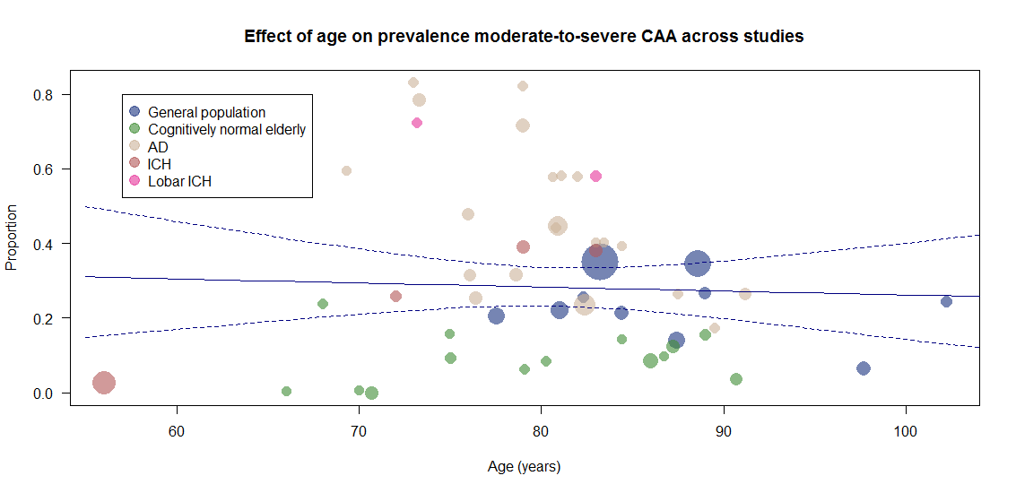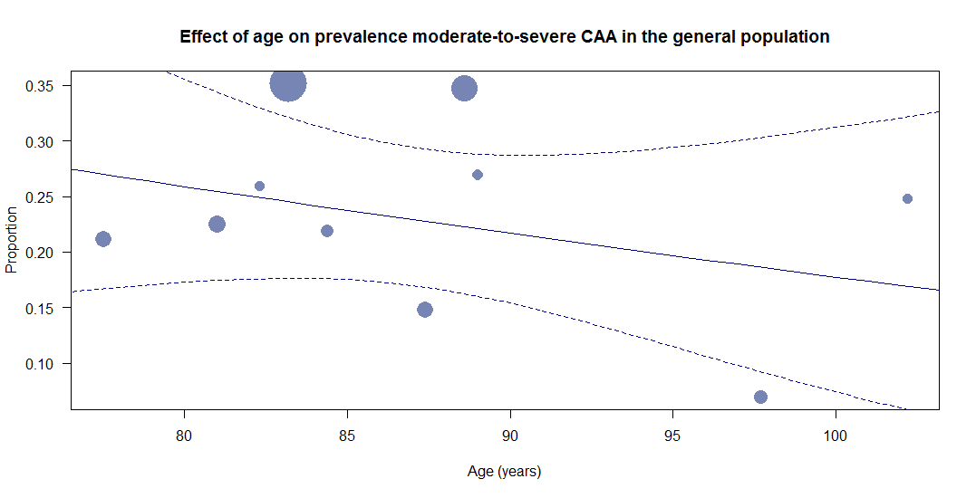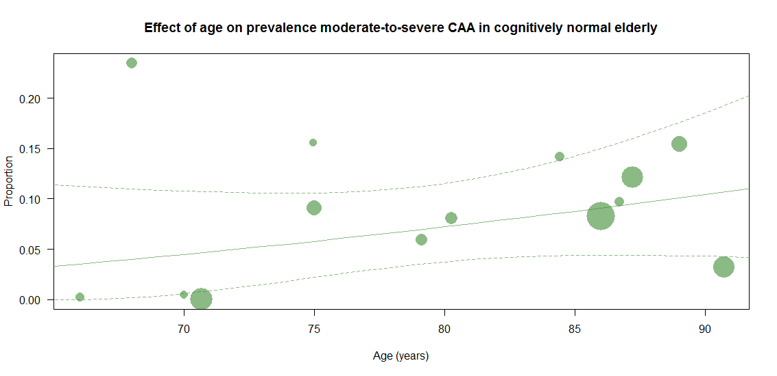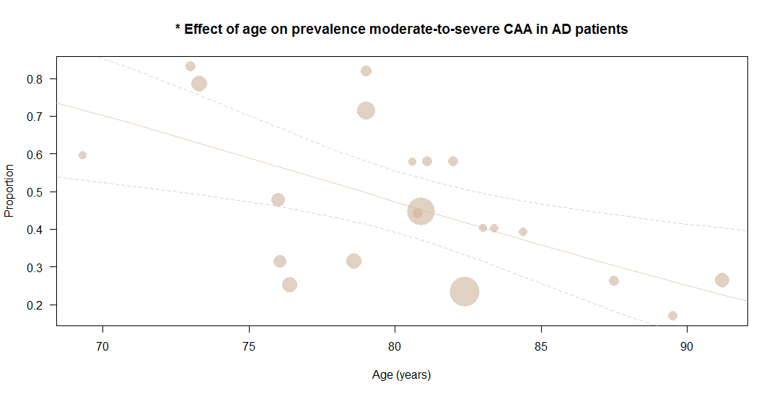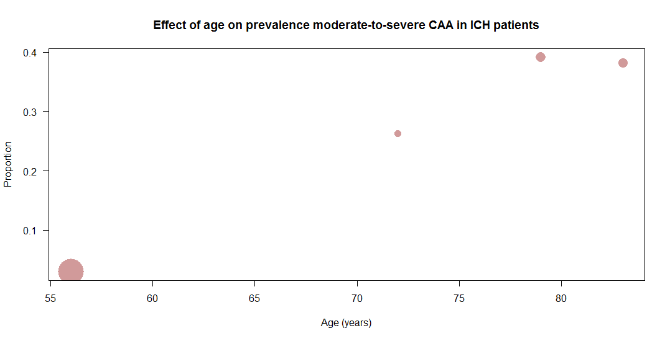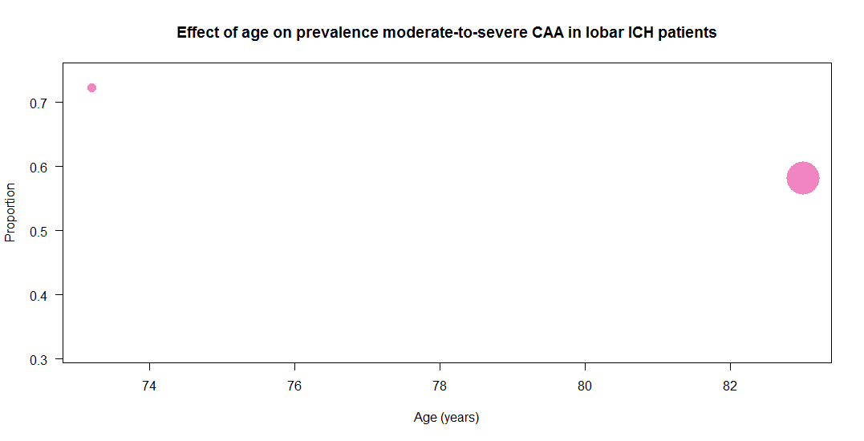

Effect of cortical sampling on prevalence of moderate-to-severe CAA pathology

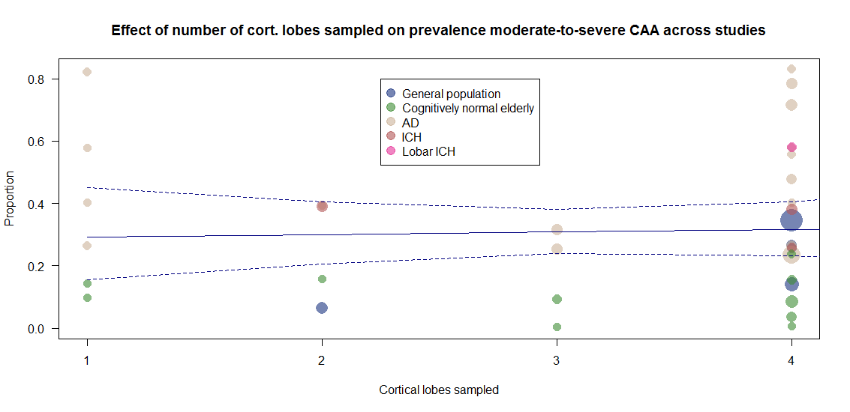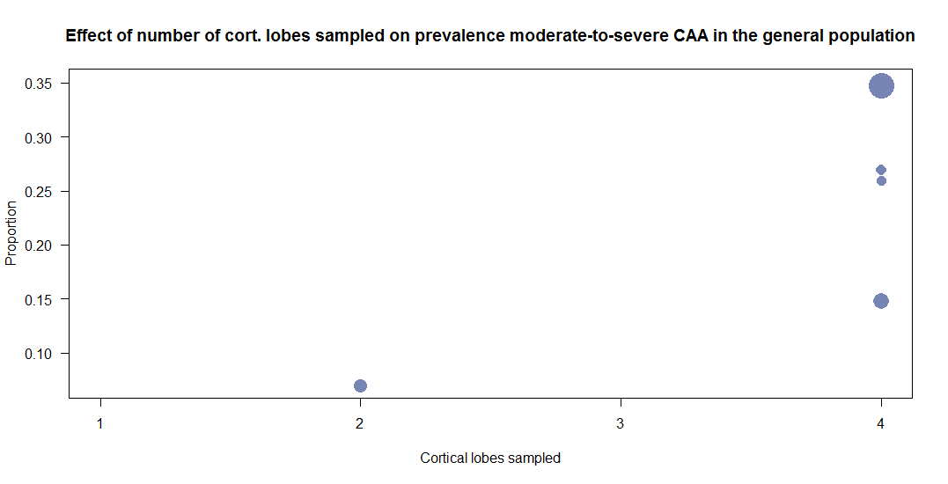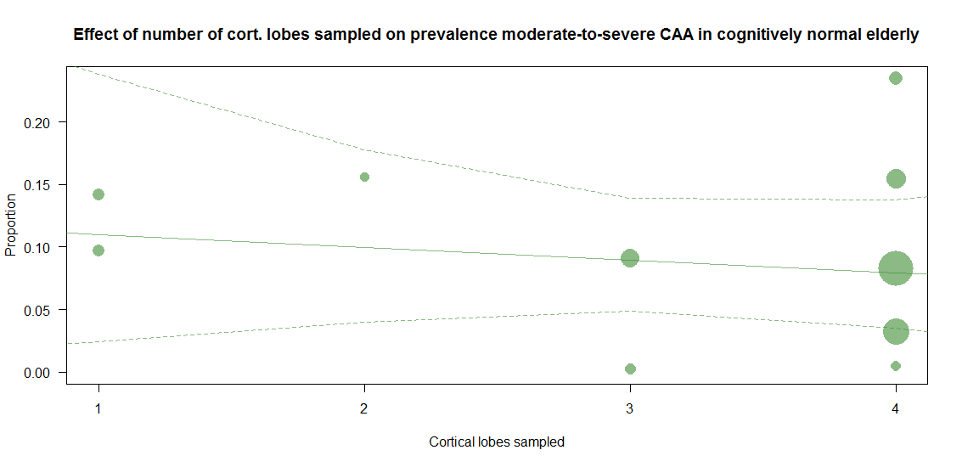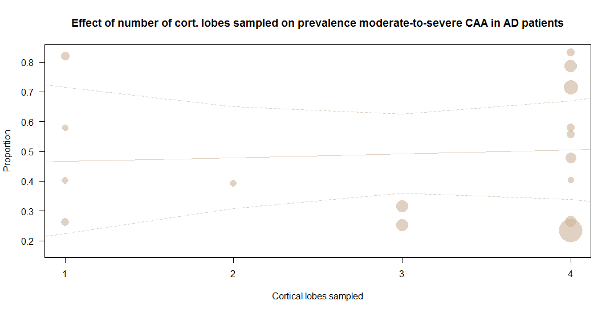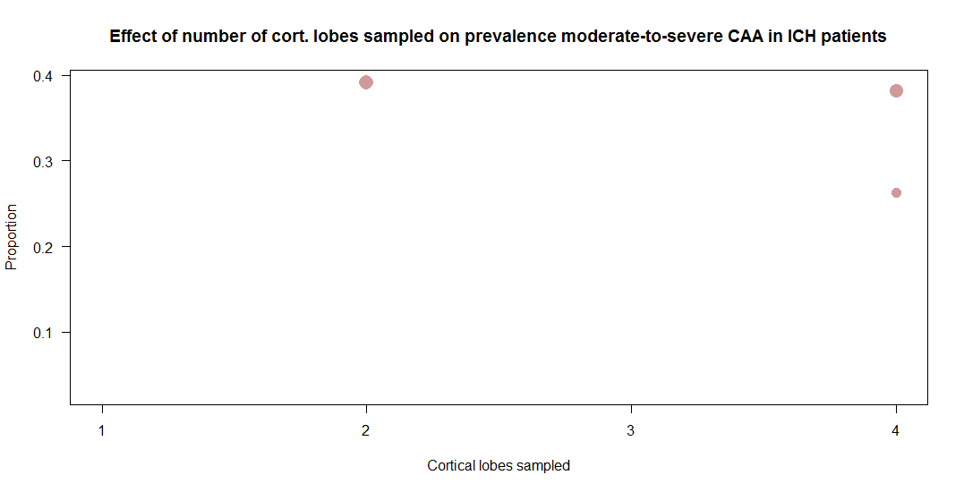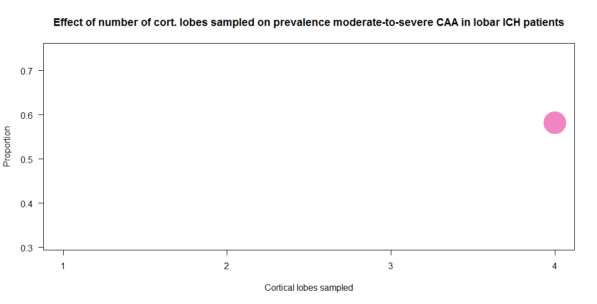

Effect of amyloid staining method on prevalence of moderate-to-severe CAA pathology

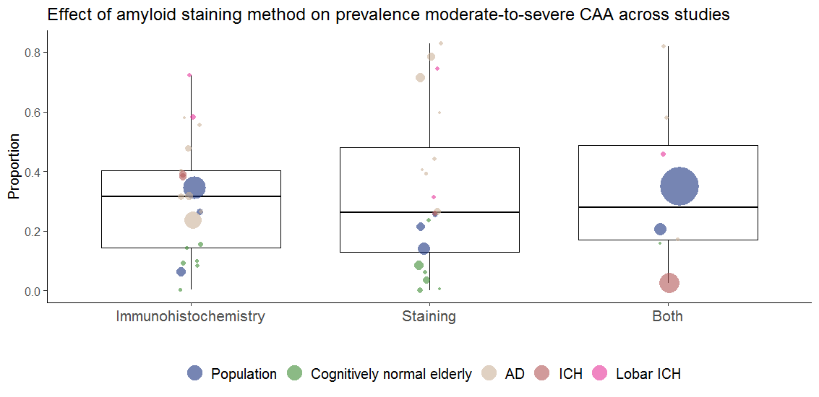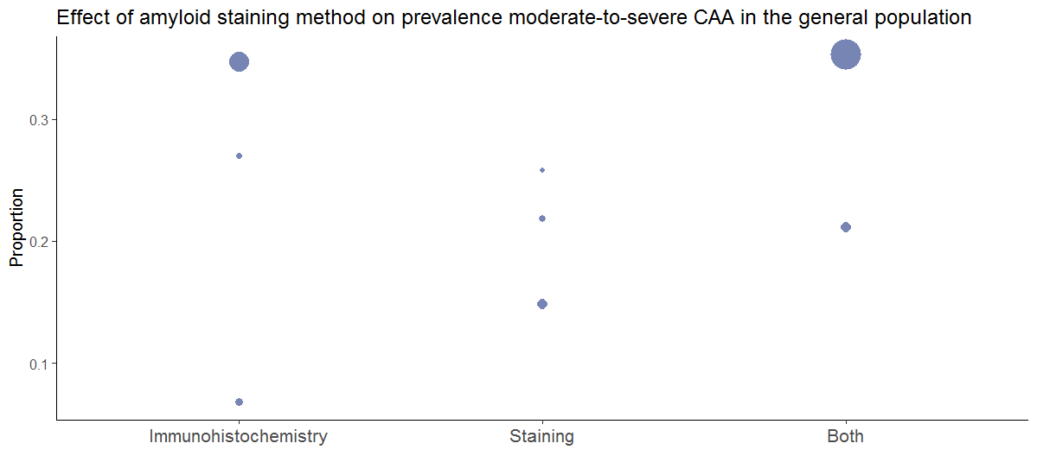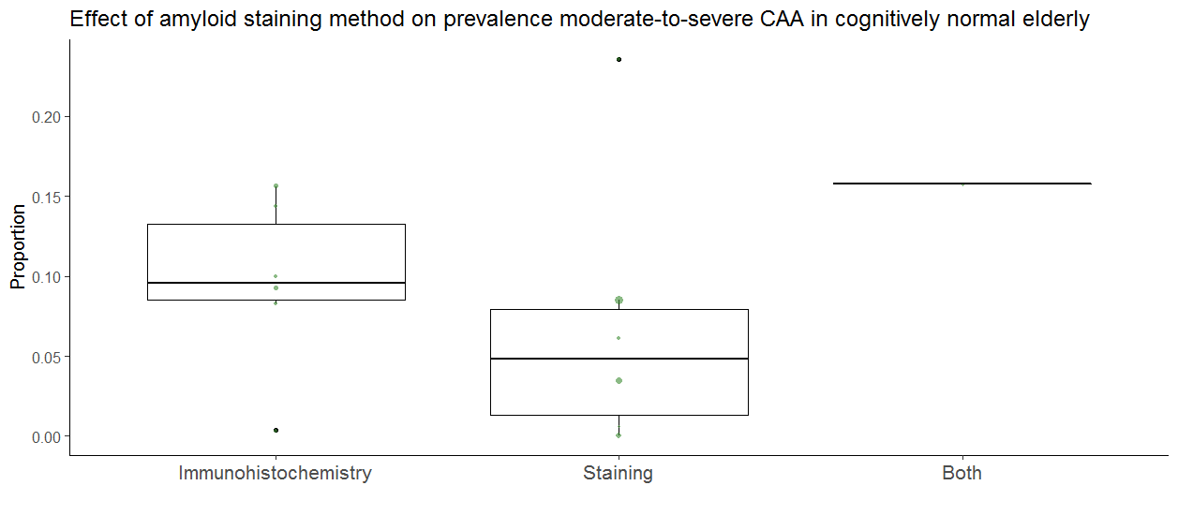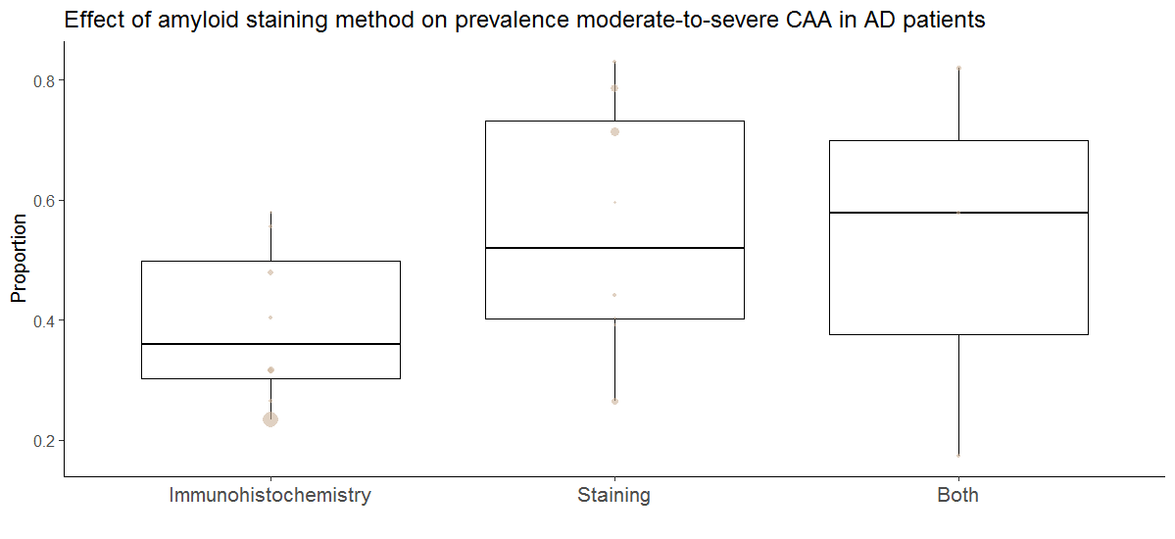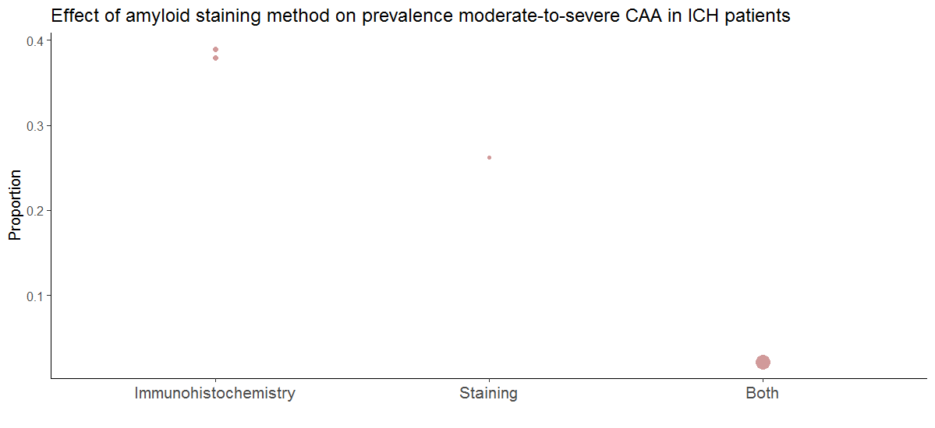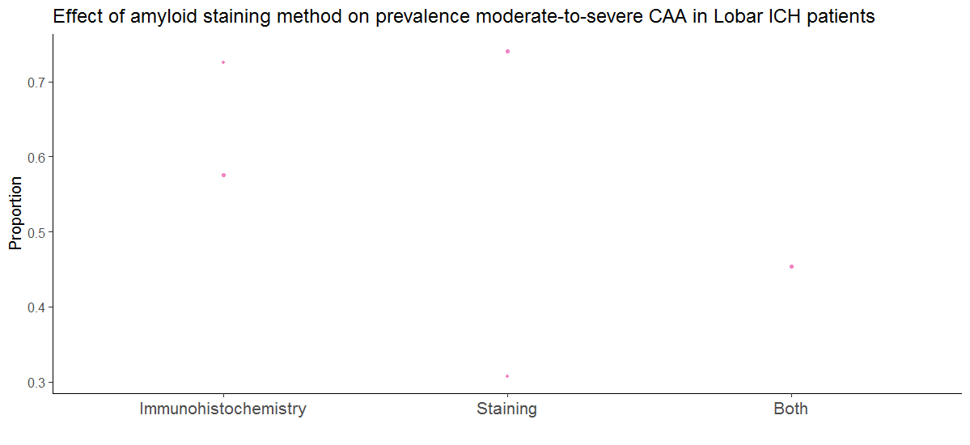
Effect of sampling of general population-based cohorts on prevalence of moderate-to-severe CAA pathology

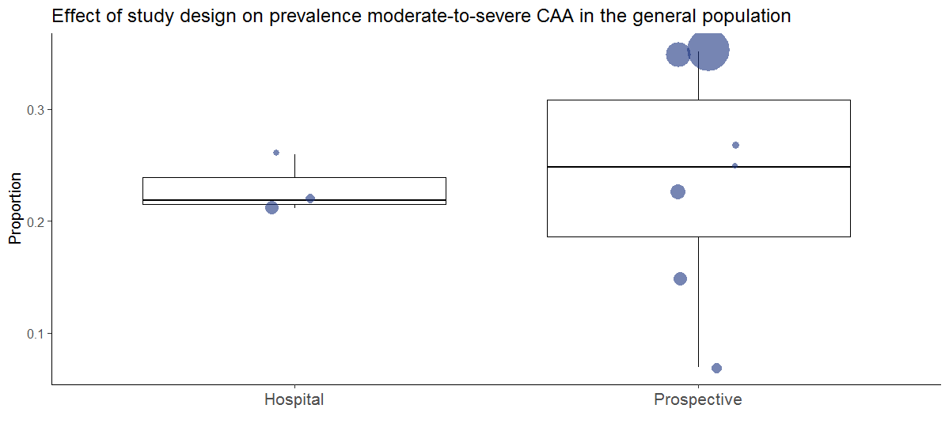
Effect of method diagnosis of AD patients and cognitively normal elderly on prevalence of moderate-to-severe CAA pathology

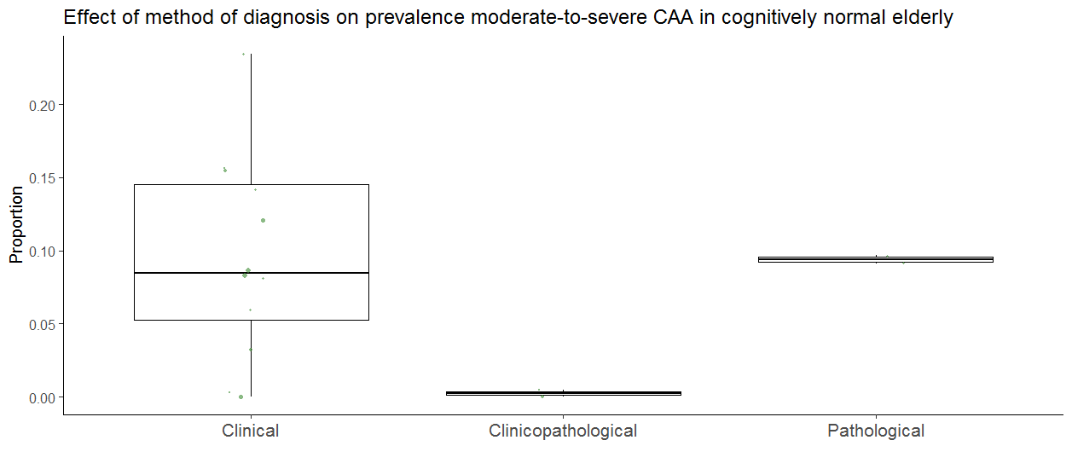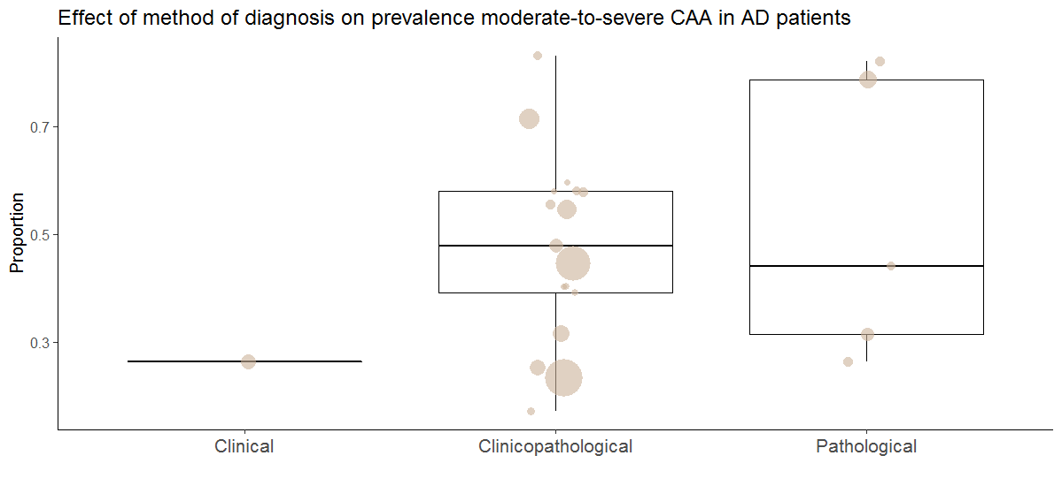

Effect of publication year on prevalence of moderate-to-severe CAA pathology

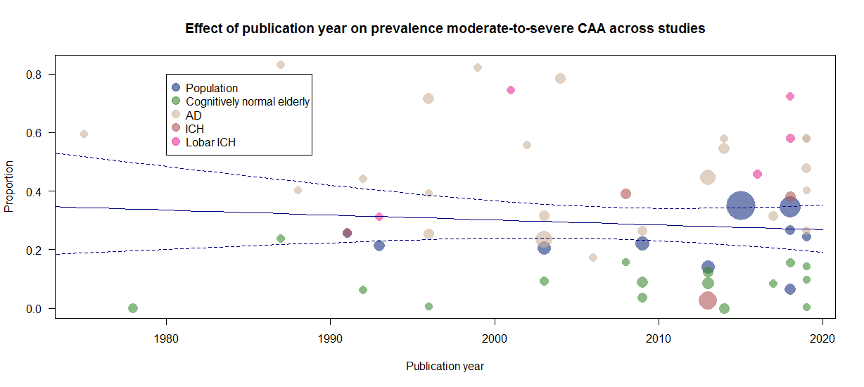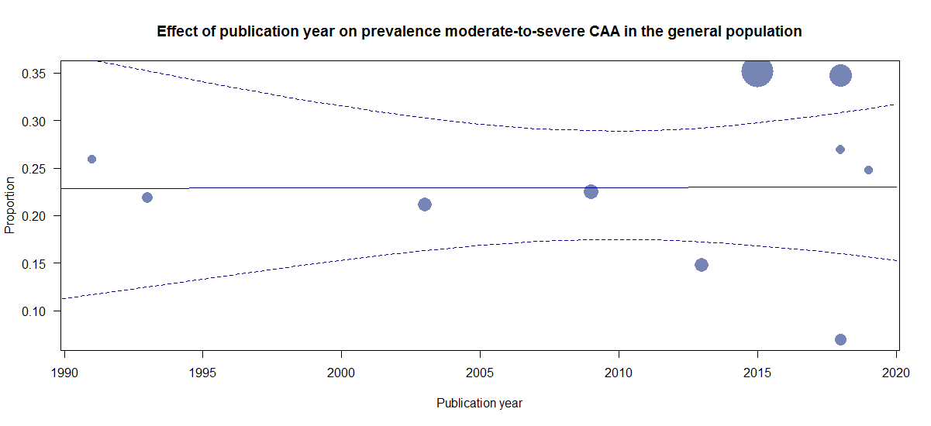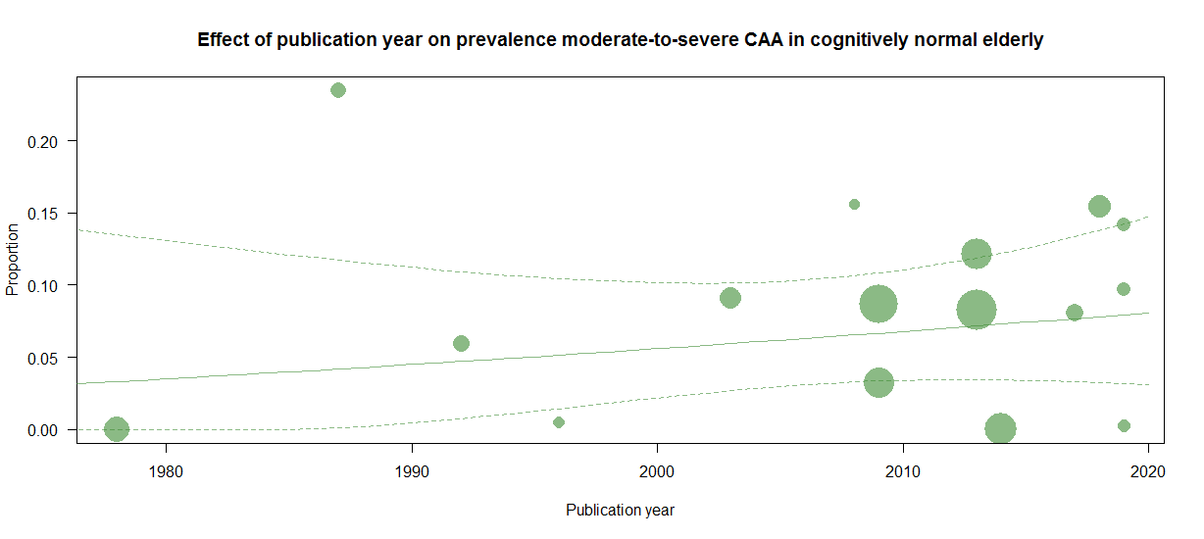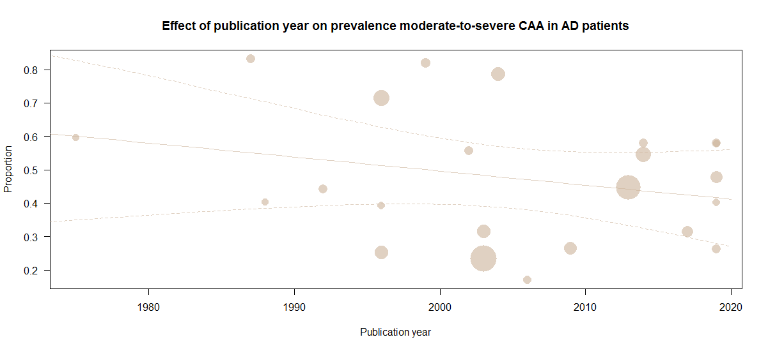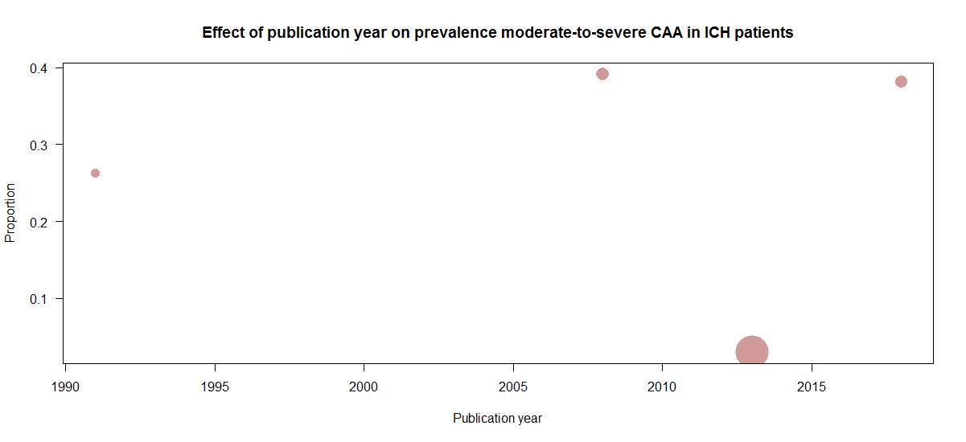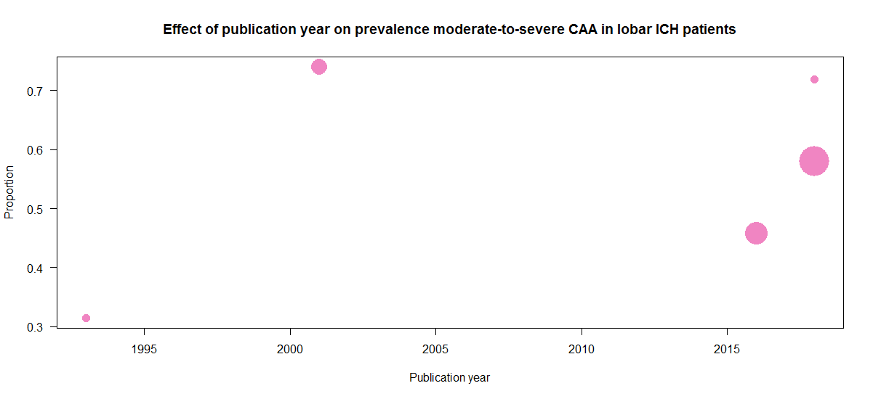

Appendix H. Modifier analysis; prevalence of strictly lobar microbleeds - Univariable scatterplots and box-and-whisker plots
The x-axis represents the modifier that was modelled in the univariable meta-regression analysis. The y-axis represents the proportion of patients with strictly lobar microbleeds the study population. The solid line indicates the estimated regression line, and the dashed lines indicates the 95% confidence intervals. Subgroup analyses are represented by box-and-whisker plots with horizontal lines representing the median, and whisker representing 95% confidence intervals. Sample sizes of individual studies are represented by sizes of the individual data points. Modifiers that significantly affected pooled prevalence estimates (p<0.05) are indicated by an asterisk (*) preceding the title.

Effect age on prevalence strictly lobar CMB
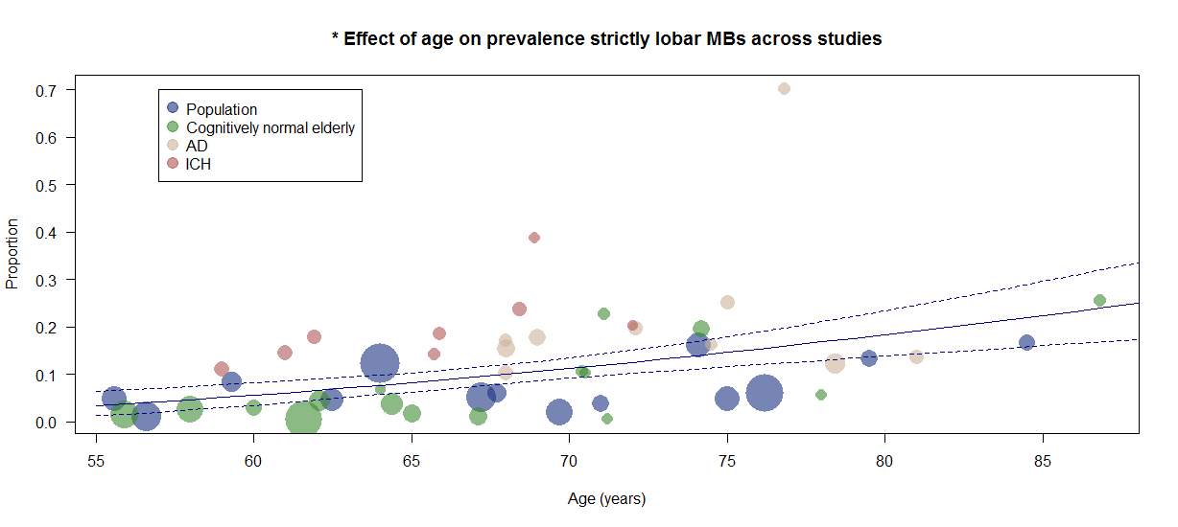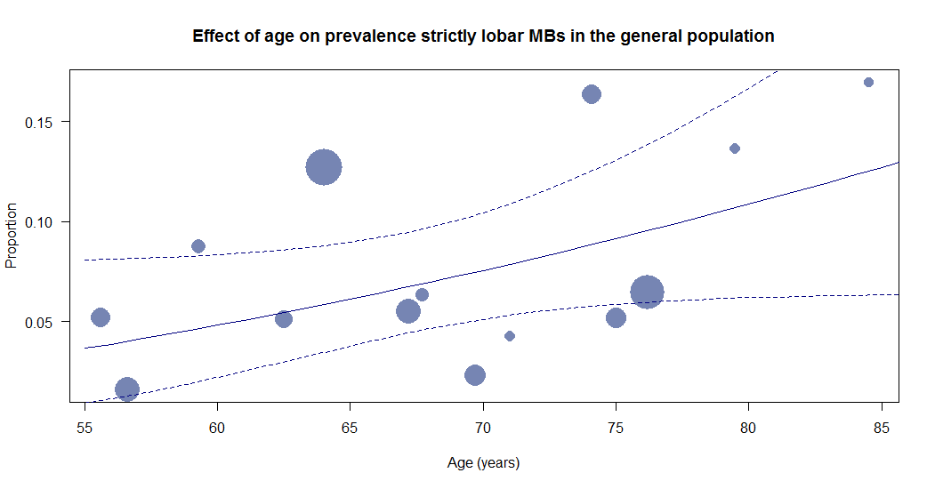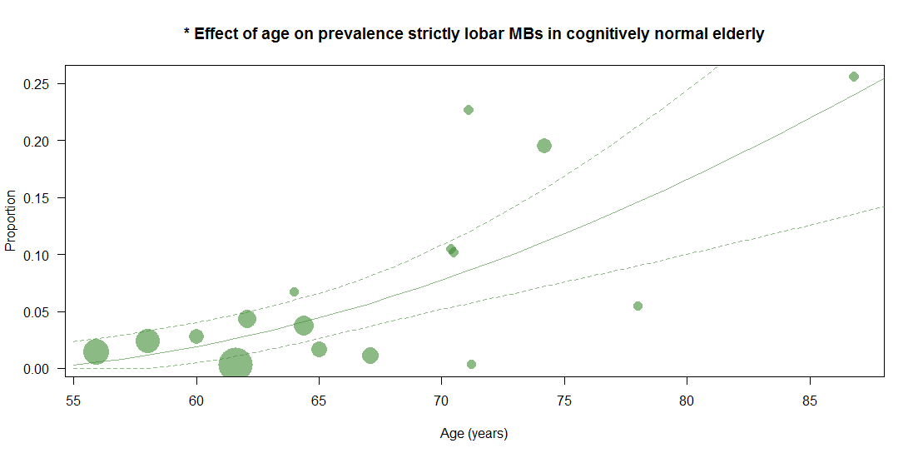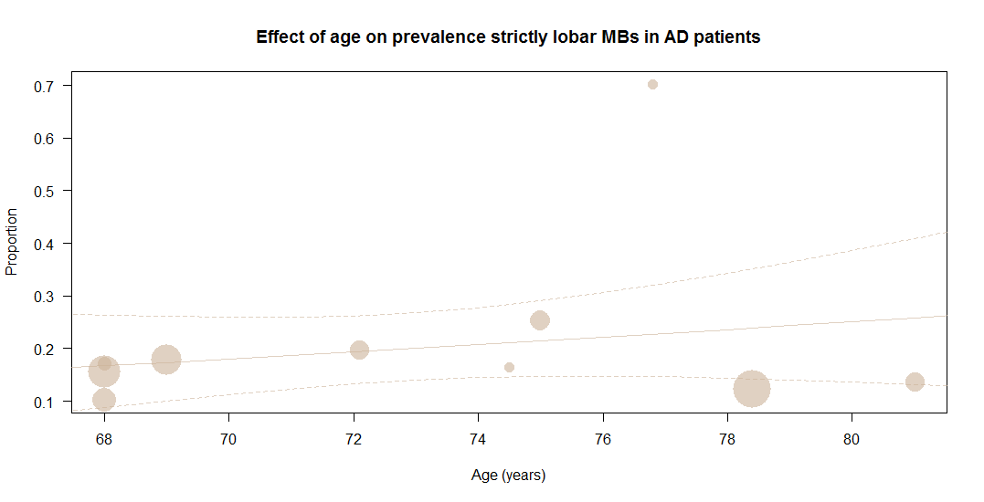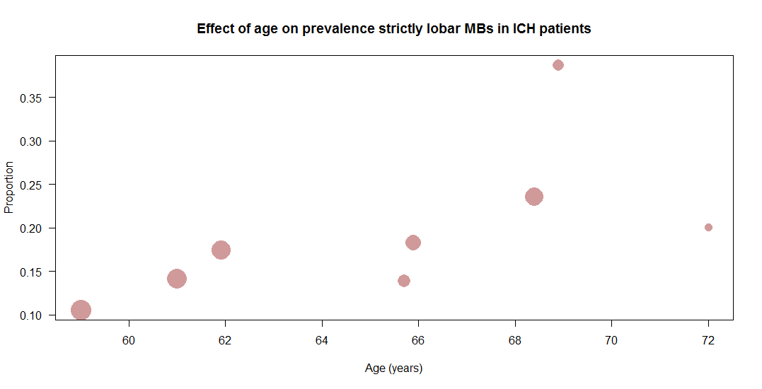
Effect of hypertension on prevalence of strictly lobar CMB
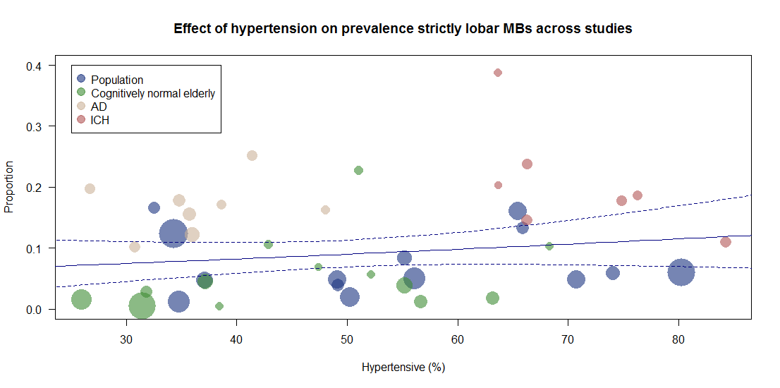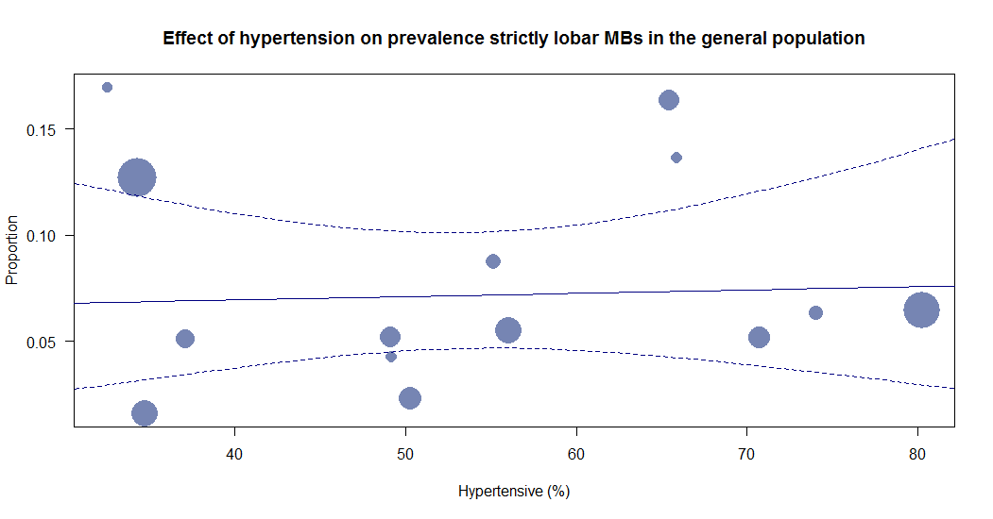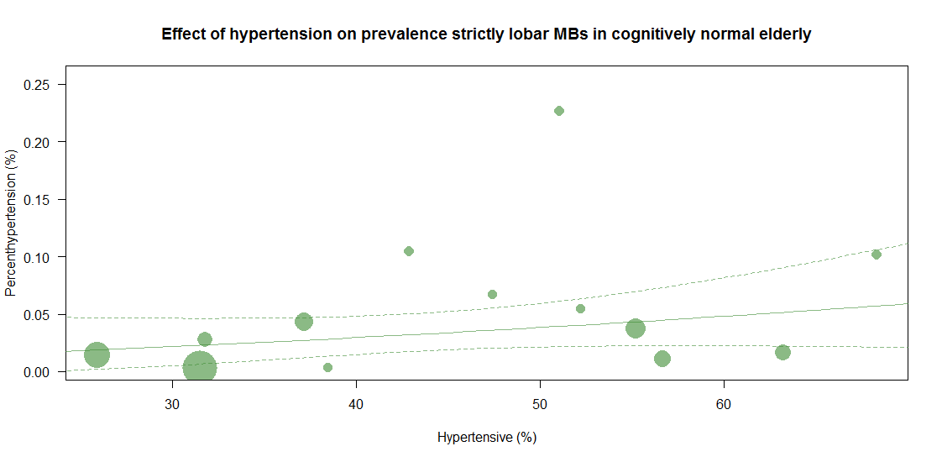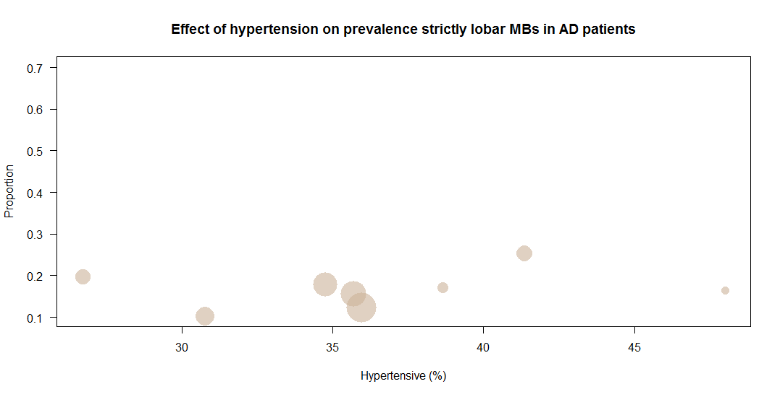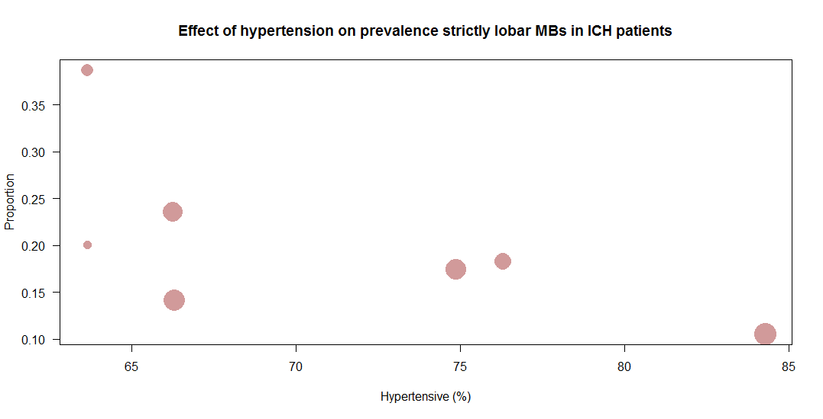

Effect of MRI field strength on prevalence of strictly lobar CMB
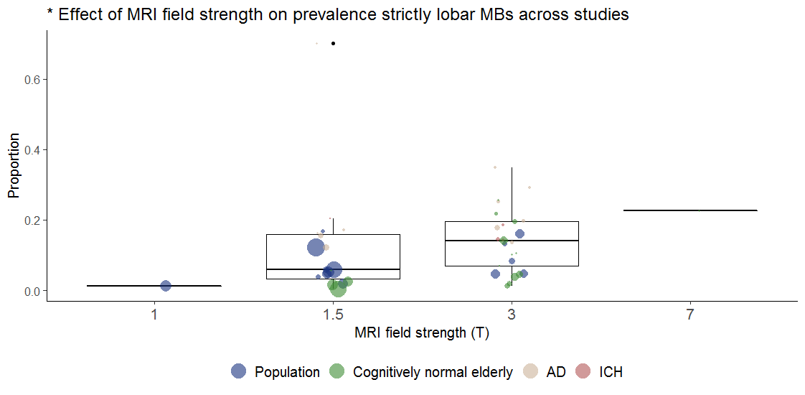

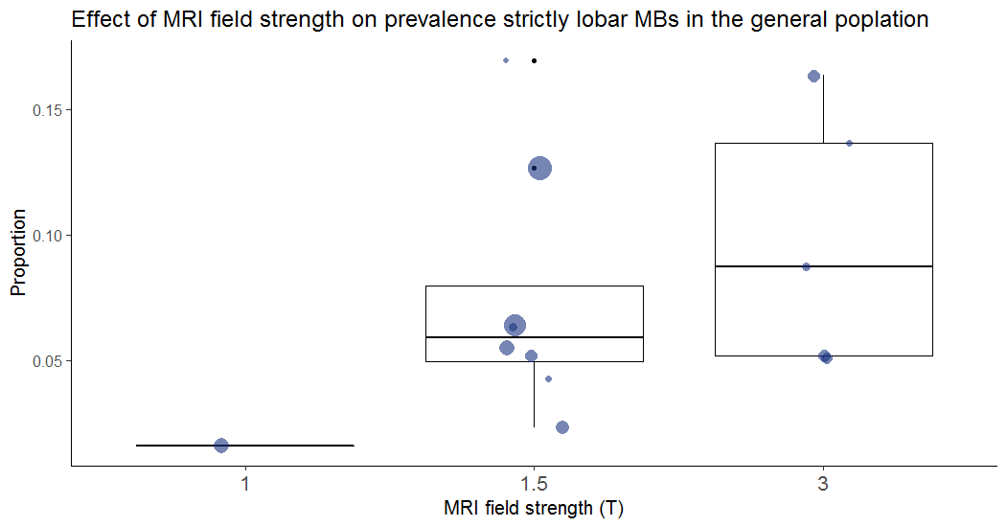

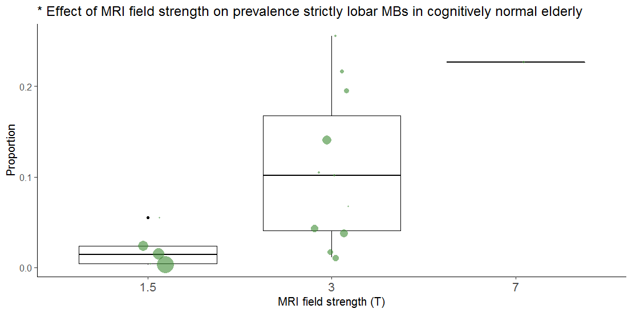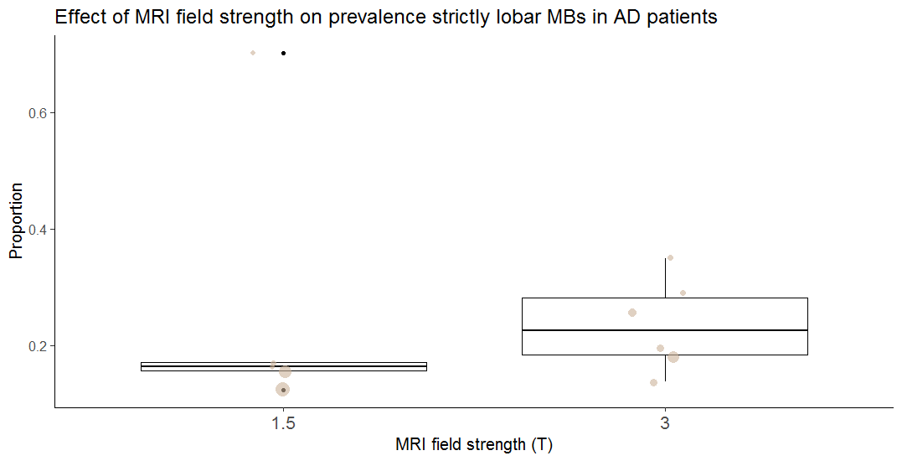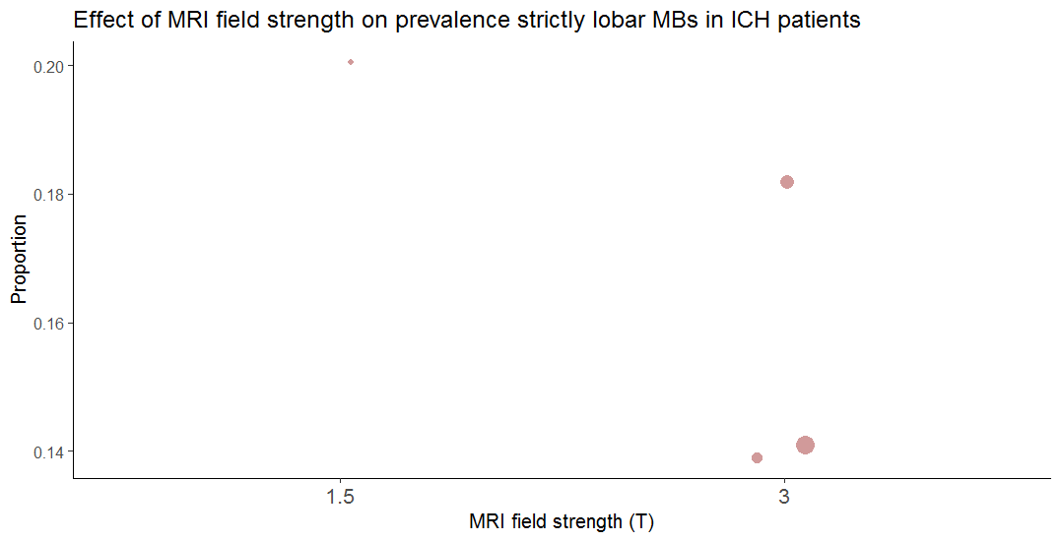

Effect of MRI sequence (SWI versus T2*) on prevalence strictly lobar CMB

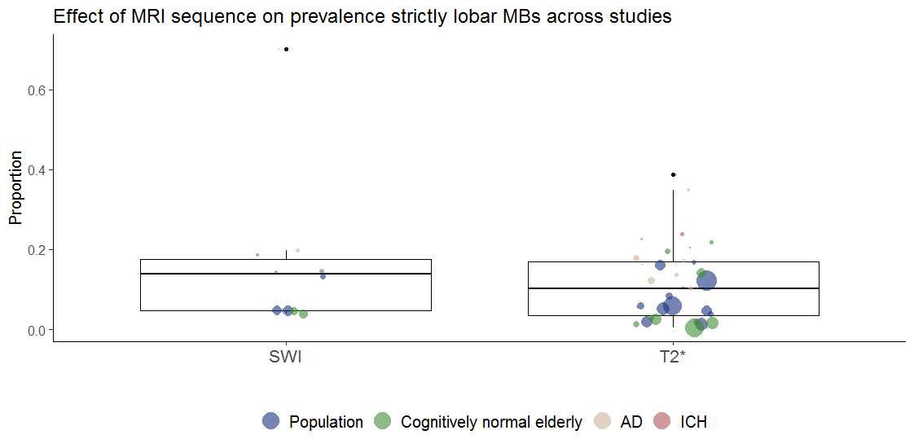
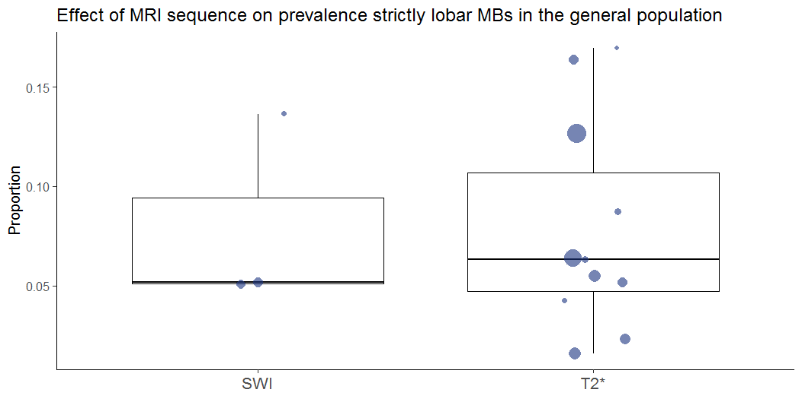/
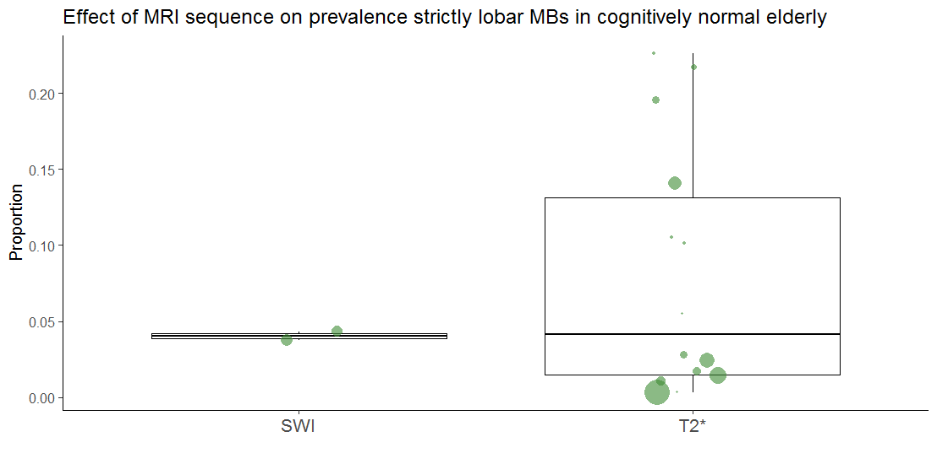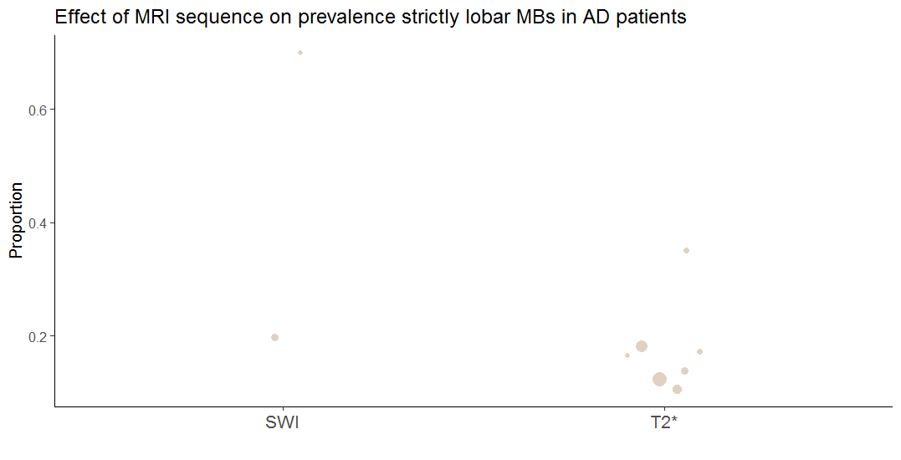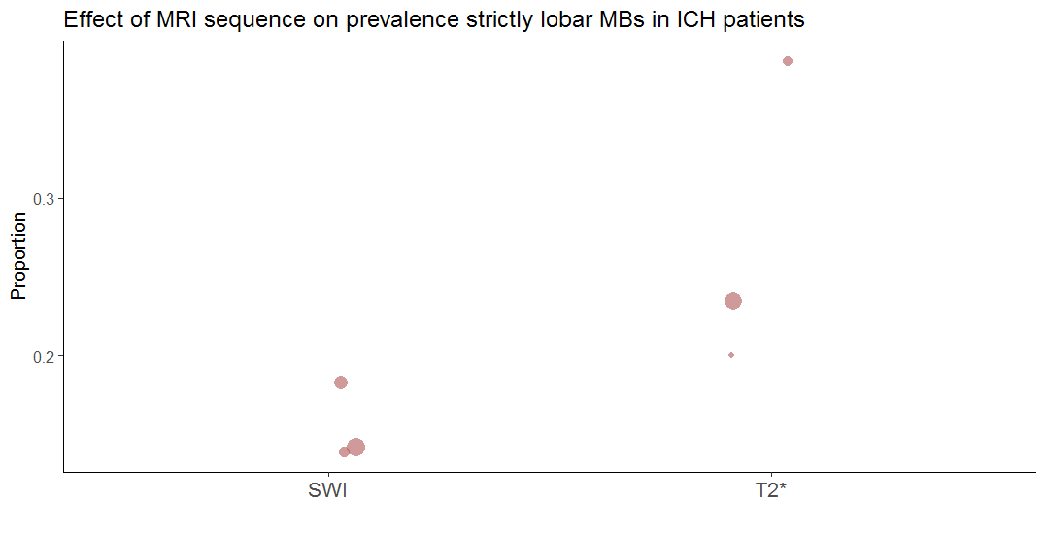

Effect of MRI slice thickness on prevalence of strictly lobar CMB

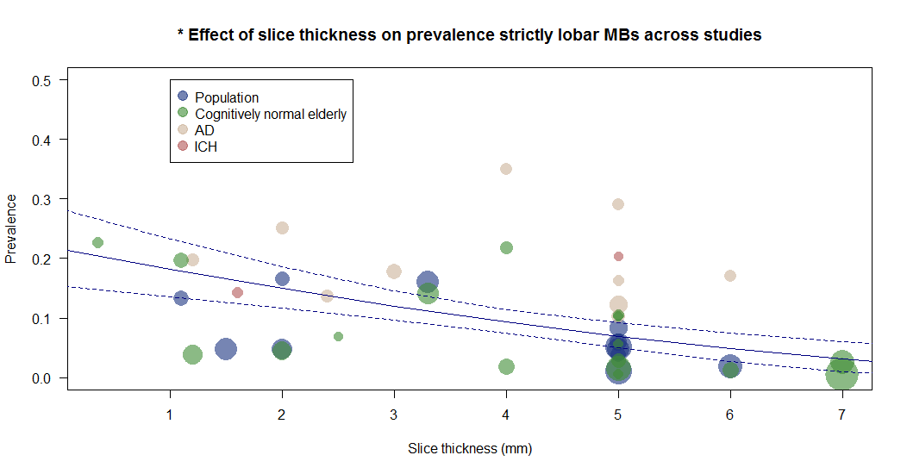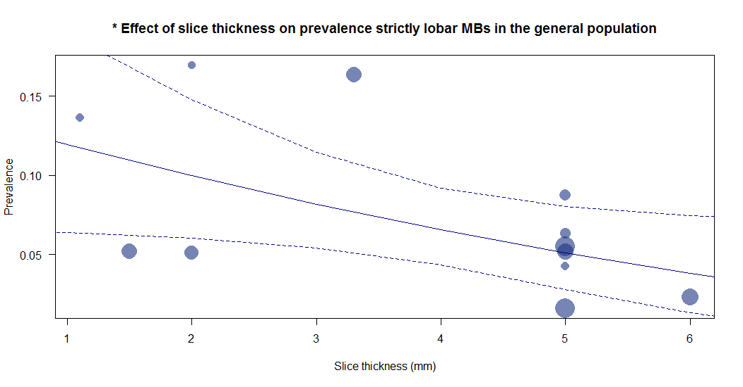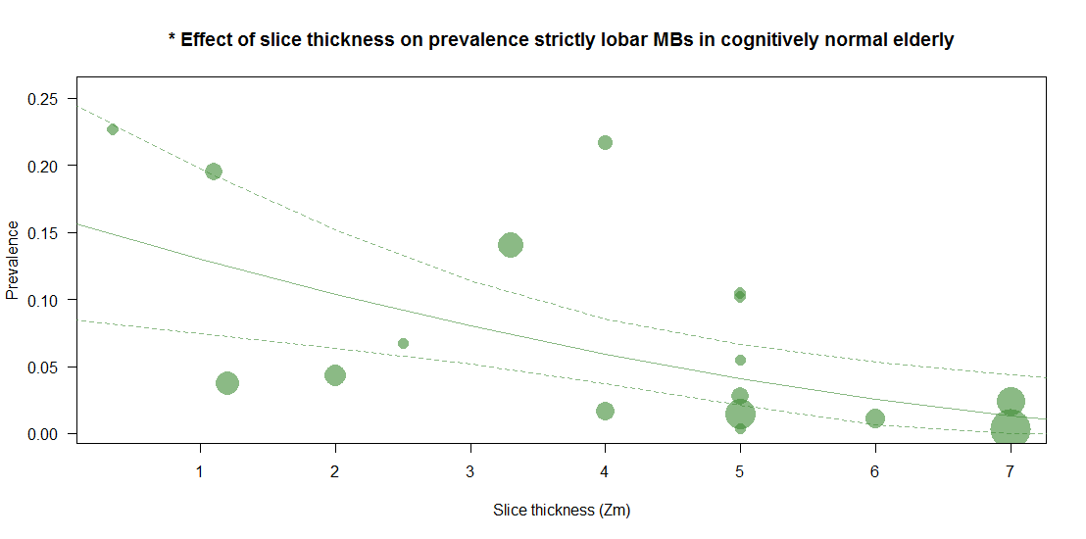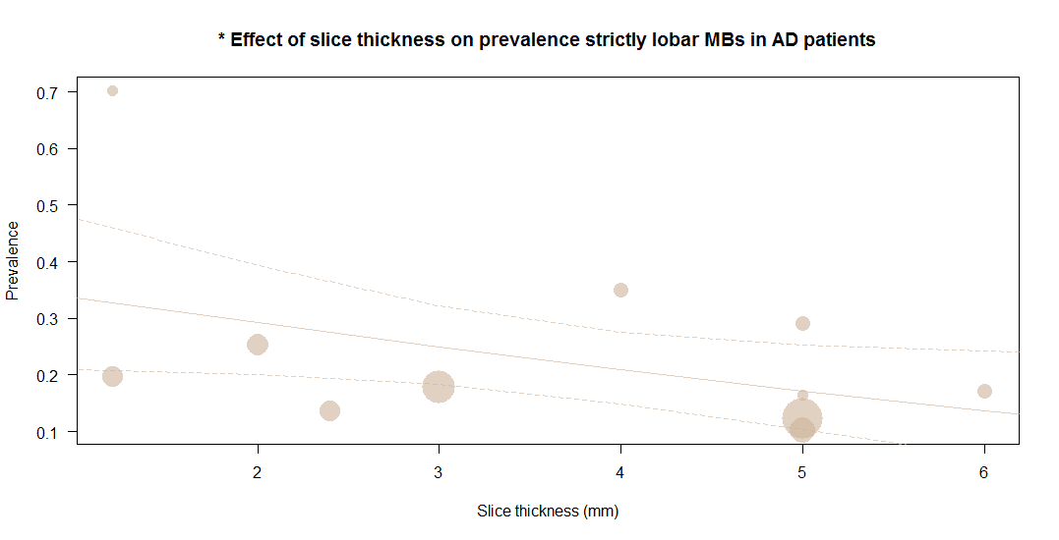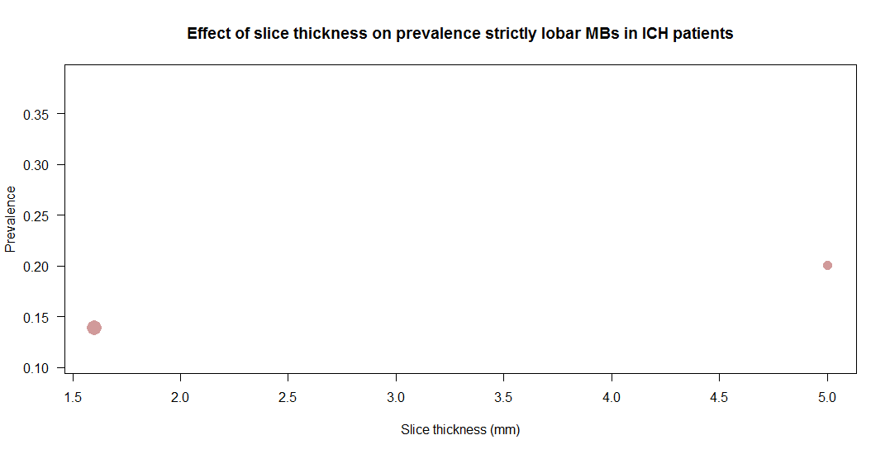

Effect of publication year on prevalence of strictly lobar CMB

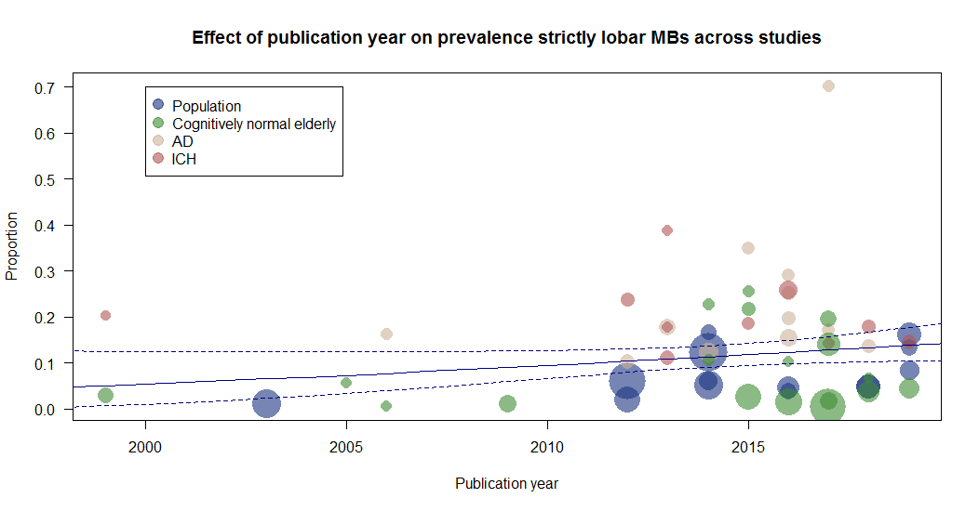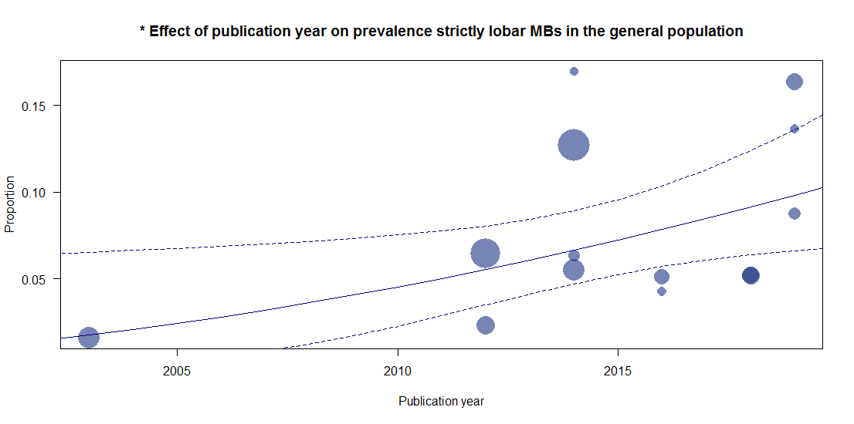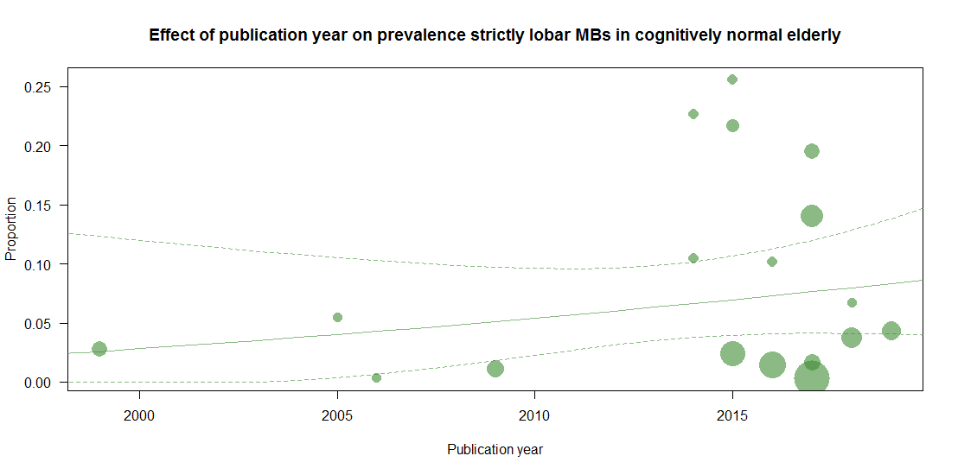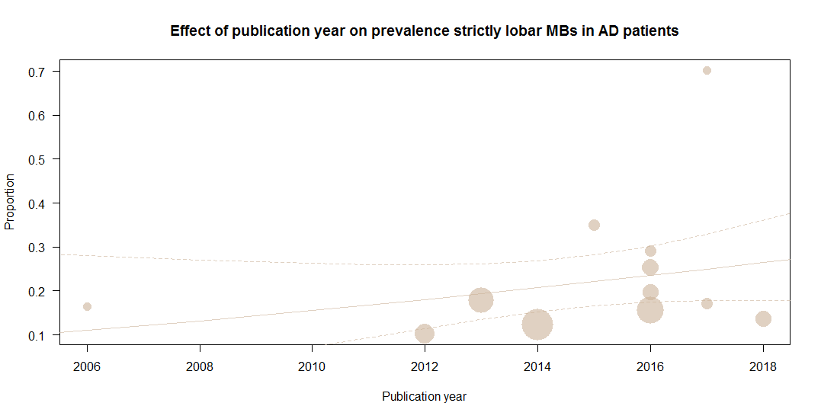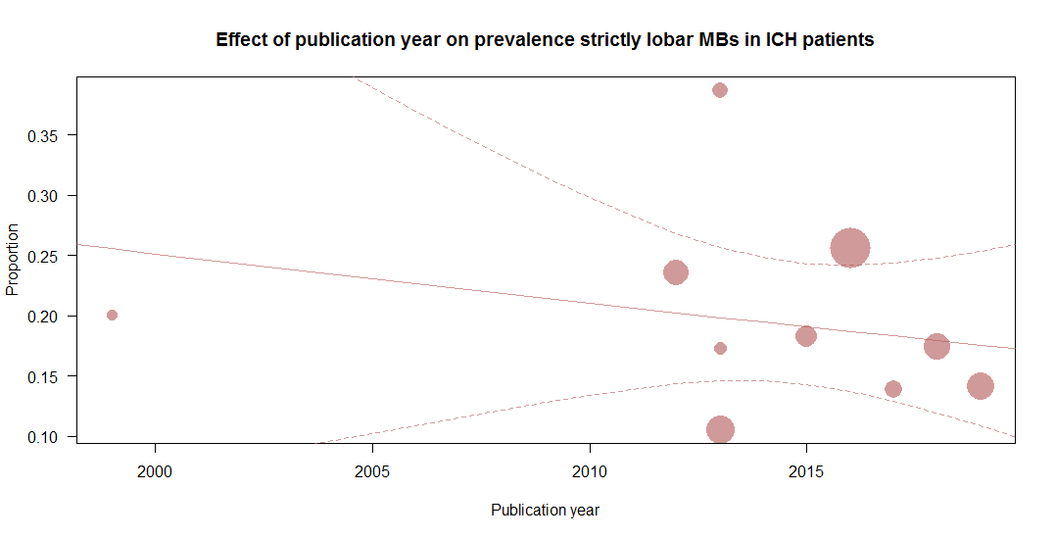
Appendix I. Funnel plots
To examine potential publication bias, funnel plots (x-axes: proportion, y-axes: standard error) were visually inspected and statistical analysis using unweighted regressions tests were used to assess funnel plot asymmetry. Plots with proportion on x-axes and sample size on y-axes were used to visualize whether potential funnel plot asymmetry was due to small study effects. Three outcome parameters were assessed: moderate-to-severe CAA, mild to moderate CAA, and strictly lobar microbleeds. The number of studies reporting on cortical superficial siderosis (2-7 studies) or Boston criteria (4-7 studies) were deemed too low for funnel plots to be informative.

General population
Prevalence moderate-to-severe CAA
test for funnel plot asymmetry: z = -1.0037, p = 0.3155
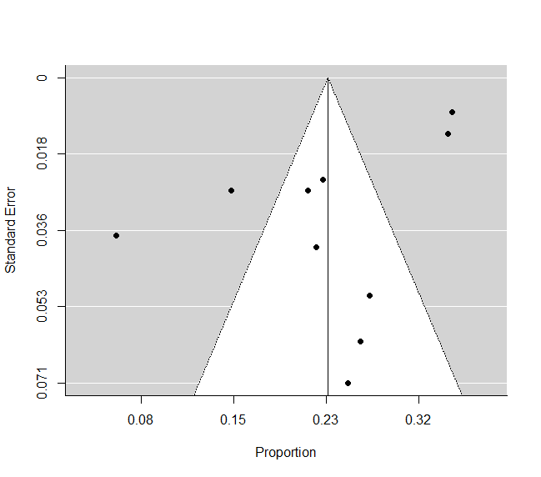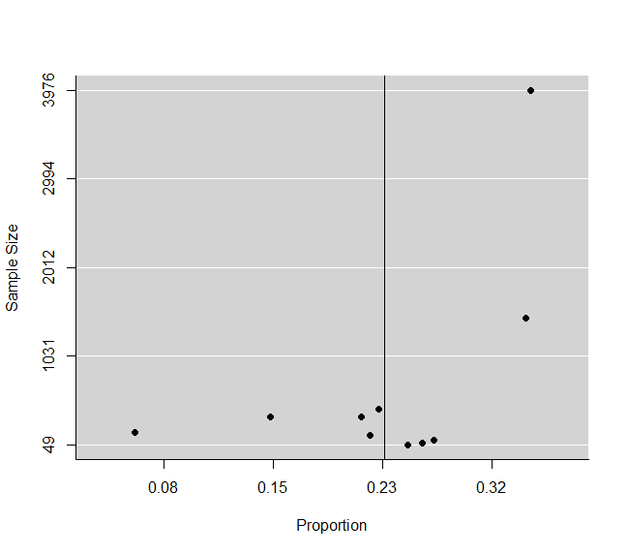

Prevalence strictly lobar CMB
test for funnel plot asymmetry: z = 1.2267, p = 0.2199
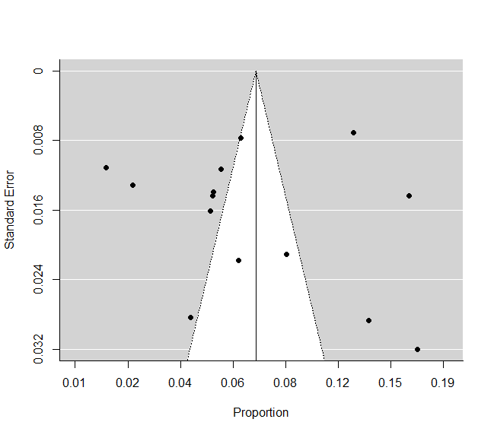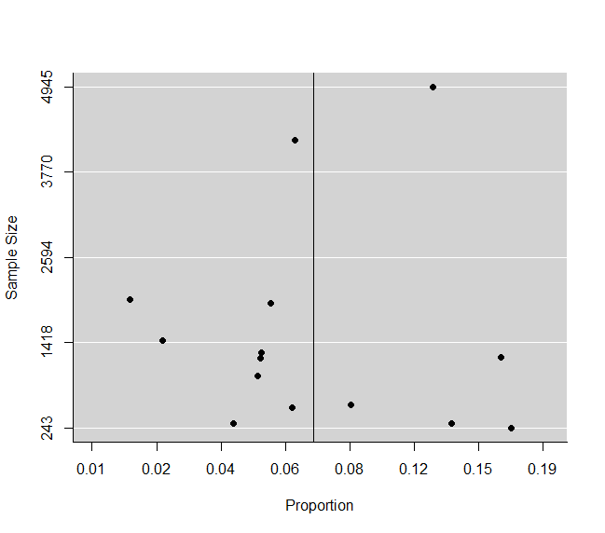

Cognitively normal elderly
Prevalence moderate-to-severe CAA
test for funnel plot asymmetry: z = 0.5883, p = 0.5563

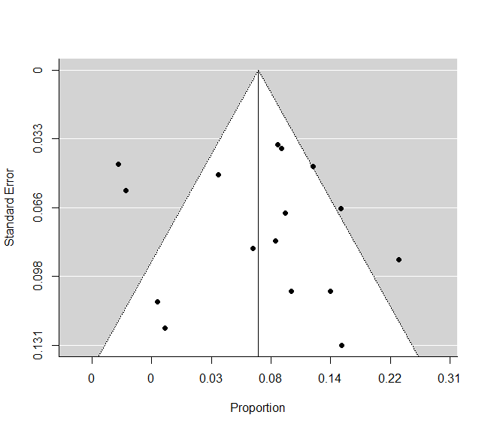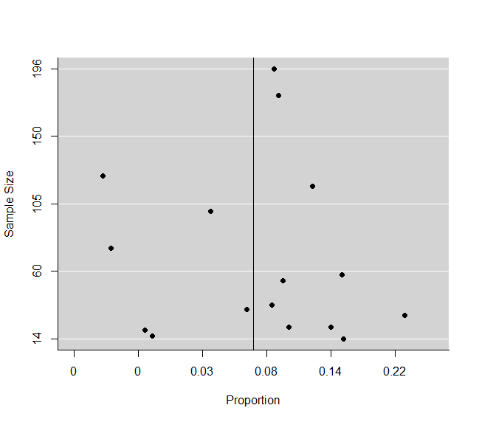
Prevalence strictly lobar CMB
test for funnel plot asymmetry: z = 1.6603, p = 0.0969

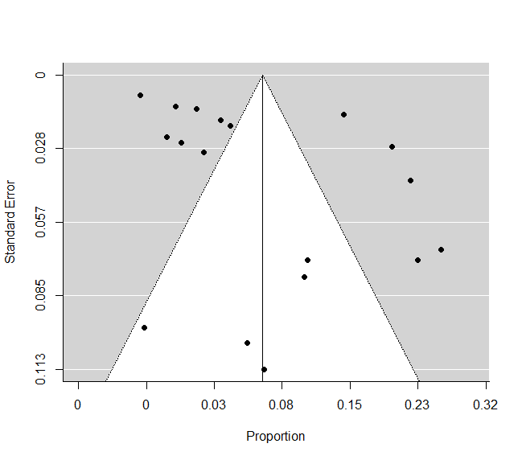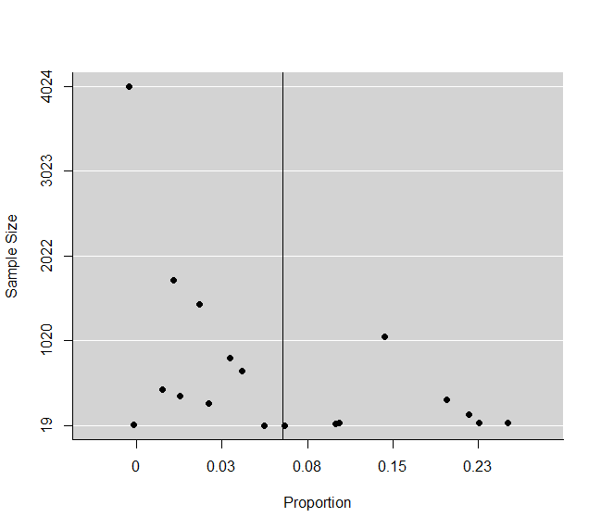

AD patients
Prevalence moderate-to-severe CAA
test for funnel plot asymmetry: z = 0.5192, p = 0.6036
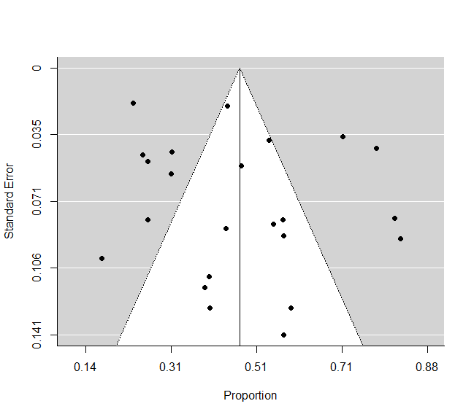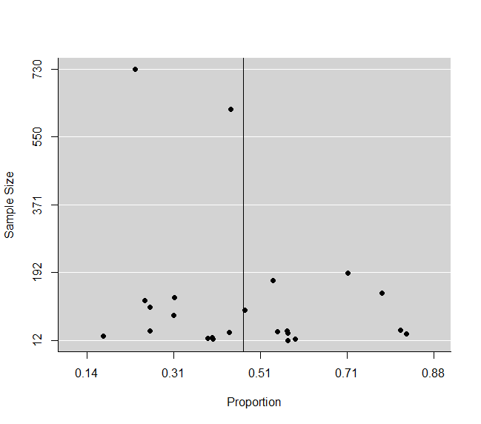

Prevalence strictly lobar CMB
test for funnel plot asymmetry: z = 3.4108, p = 0.0006
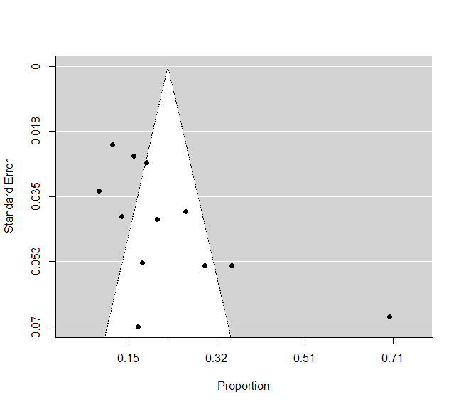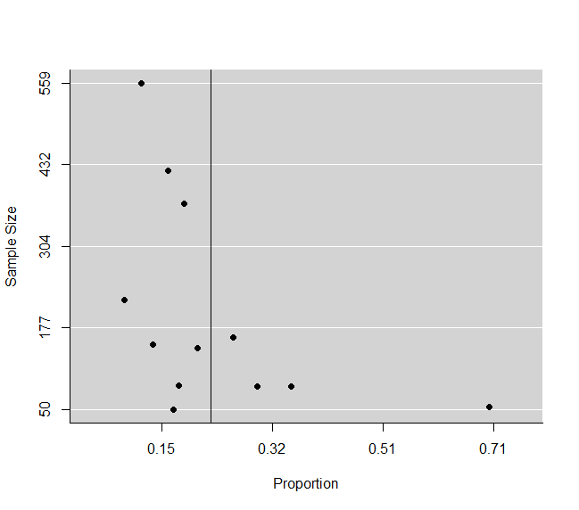
Prevalence cSS
test for funnel plot asymmetry: z = 2.0481, p = 0.0405

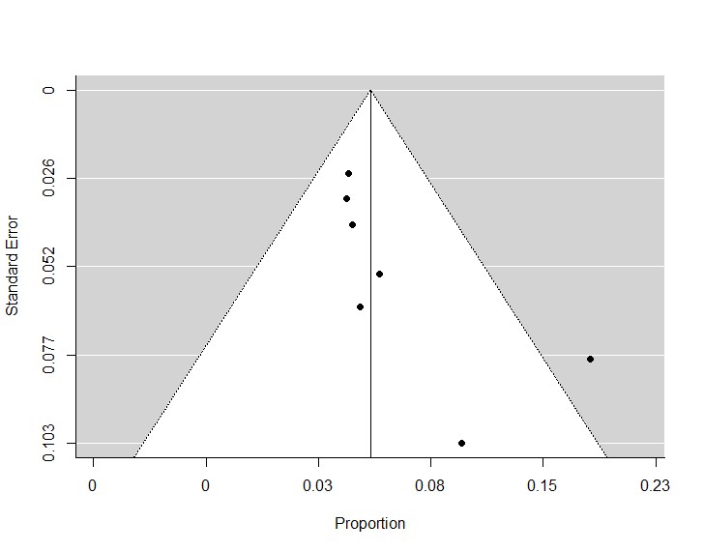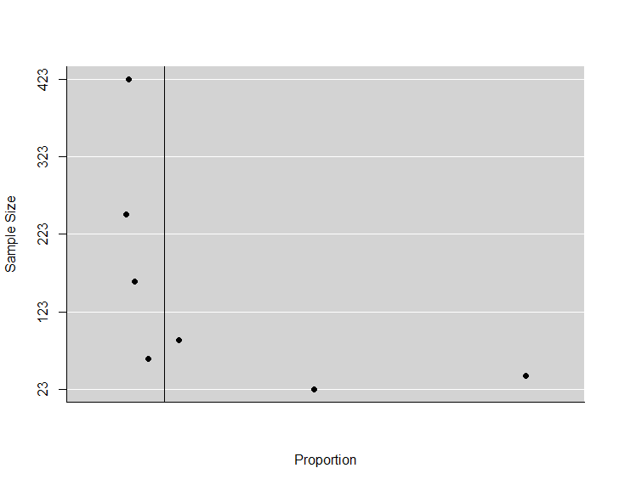

ICH patients
Prevalence moderate-to-severe CAA
test for funnel plot asymmetry: z = 1.5533, p = 0.1204

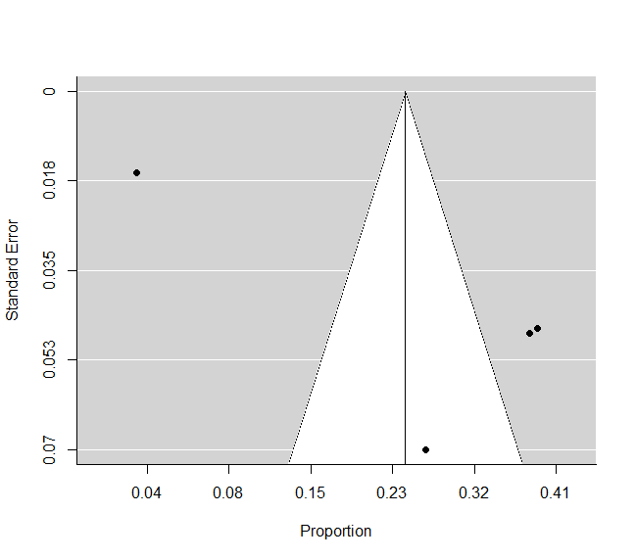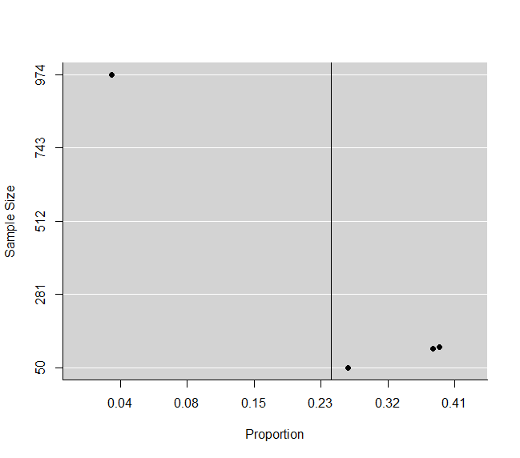
Prevalence probable CAA (Boston criteria)
test for funnel plot asymmetry: z = 0.6987, p = 0.4847

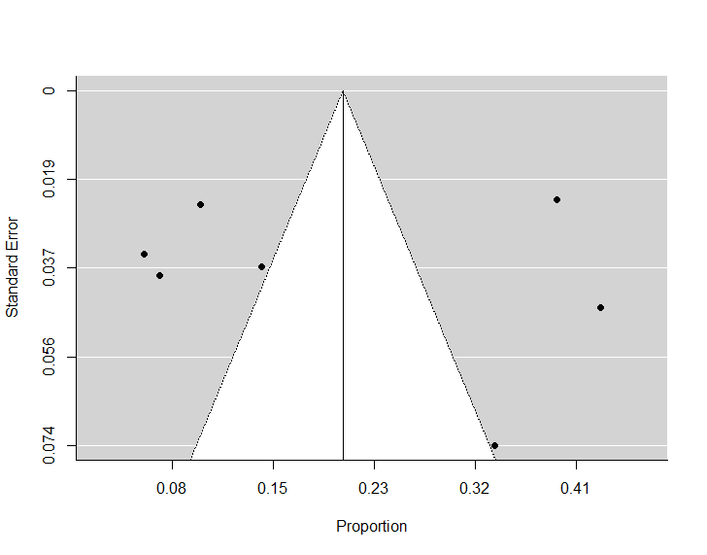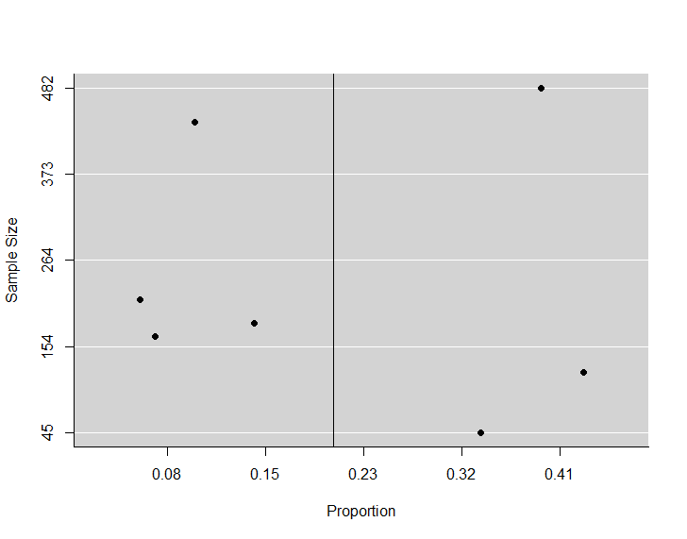
Prevalence strictly lobar CMB
test for funnel plot asymmetry: z = 0.3266, p = 0.7440
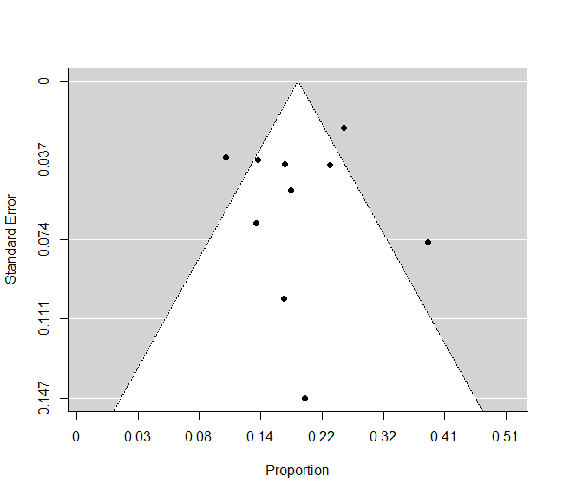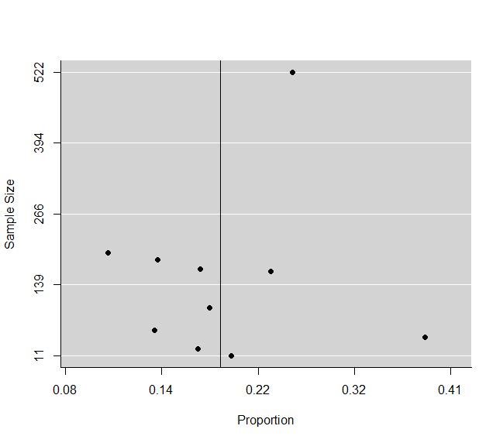

Lobar ICH patients
Prevalence moderate-to-severe CAA
test for funnel plot asymmetry: z = -0.1048, p = 0.9165
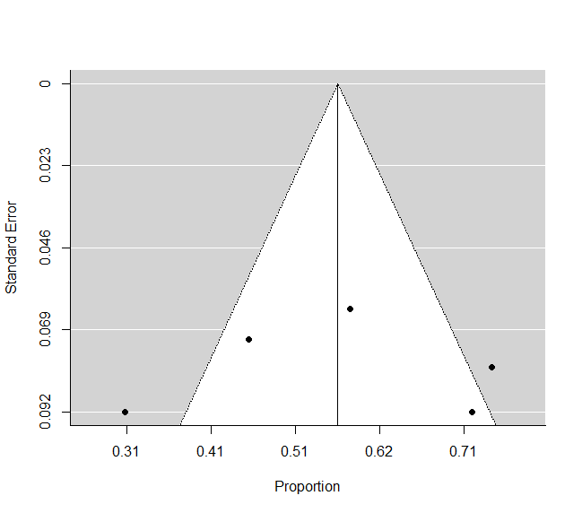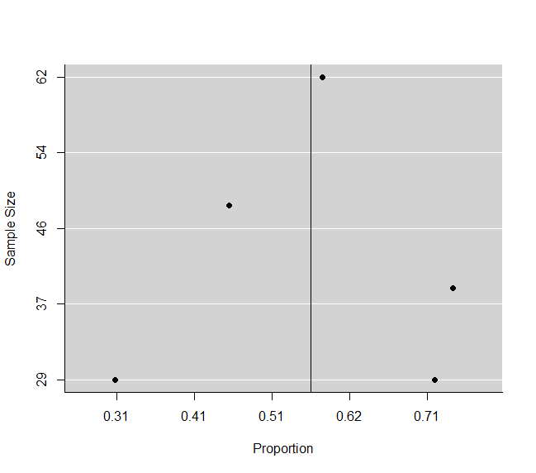

Appendix J. Pooled estimates using generalized linear mixed models
Sensitivity analysis using a different model. Meta-analyses were repeated using generalized linear mixed models to confirm the appropriate use of the Freeman Tukey Double Arcsine transformation. Shown are pooled prevalence estimates with 95% confidence intervals.
NA = not applicable (number of included studies 0 or 1)

Pooled prevalence estimates of CAA pathology
 | General population | Cognitively normal elderly | AD | ICH | Lobar ICH
Mild-to-severe CAA | 40.9 (33.2-49.2) | 27.3 (20.5-35.4) | 82.7 (76.2-87.7) | 27.2 (18.7-37.7) | 53.0 (33.7-71.5)
Moderate-to-severe CAA | 22.4 (17.2-28.7) | 6.5 (3.8-10.8) | 47.4 (38.8-56.1) | 20.6 (7.4-46.0) | 56.9 (42.3-70.4)
Severe CAA | 5.4 (2.8-10.1) | 1.7 (0.6-4.4) | 22.9 (17.6-29.2) | 9.3 (2.0-34.1) | NA
Pooled prevalence estimates of CMB
Population | General population | Cognitively normal elderly | AD | ICH | Lobar ICH
Strictly lobar | 6.5 (4.6-9.2) | 5.5 (3.2-9.1) | 21.2 (14.9-29.2) | 19.2 (15.2-24.1) | NA
Mixed | 3.0 (2.1-4.1) | 1.8 (0.8-3.9) | 4.1 (1.8-9.0) | 26.3 (18.6-35.8) | NA
Pooled prevalence estimates of CAA according to Boston criteria
 | General population | Cognitively normal elderly | AD | ICH | Lobar ICH
Probable CAA | NA | 4.7 (0.3-45.9) | NA | 18.4 (10.1-31.1) | 49.1 (27.8-70.7)
Possible CAA | NA | 7.3 (3.4-20.4) | NA | 14.0 (7.6-24.3) | NA
Pooled prevalence estimates of cSS
 | General population | Cognitively normal elderly | AD | ICH | Lobar ICH
cSS | 0.8 (0.5-1.3) | 0.6 (0.2-2.0) | 5.6 (4.3-7.1) | 15.0 (8.5-25.0) | 30.6 (26.6-35.0)

Appendix K. Influence analysis: Leave-one-out and removal-of-outliers analysis
Leave-one-out analyses shows the pooled prevalence estimates and 95% confidence intervals when a study is not included. Studies with studentized residuals larger than two and studies that appeared in the top right quadrant of Baujat plots (in which the influence of each study on the effect size proportion is plotted against the contribution to the overall heterogeneity) are indicated with asterisks (*) as they are contribute most to heterogeneity and can therefore be considered outliers. When more than one suspected outlier was detected in a set of studies, pooled prevalence estimates were recalculated after removal of all outliers. na = not applicable

Studies in the general population

Moderate-to-severe CAA
Study | Prevalence (95%CI) | SR | Baujat
Brenowitz, 2015 | 21.53 (15.13-28.71)
Cholerton, 2013 | 24.05 (18.51-30.06)
Itoh, 1993 | 23.07 (17.09-29.63)
Matthews, 2009 | 22.99 (16.9-29.7)
Oveisgharan, 2018 | 21.6 (14.67-29.43)
Robinson, 2018 | 25.22 (20.04-30.77) | *
Robinson, 2018 | 22.56 (16.63-29.09)
Tanprasertsuk, 2019 | 22.79 (16.92-29.24)
Vonsattel, 1991 | 22.67 (16.78-29.16)
Xu, 2003 | 23.16 (17.15-29.77)

Strictly lobar CMB
Study | Prevalence (95%CI) | SR | Baujat
Aarts, 2014 | 6.74 (4.68-9.14) |  | *
Chung, 2016 | 7.32 (4.89-10.18)
DelBrutto, 2016 | 7.38 (4.99-10.19)
Graff-Radford, 2019 | 6.55 (4.44-9.05)
Han, 2018 | 7.31 (4.87-10.2)
Kim, 2012 | 7.62 (5.26-10.37)
Miwa, 2014 | 7.21 (4.82-10.03)
Paradise, 2019 | 6.75 (4.48-9.43)
Qiu, 2012 | 7.22 (4.61-10.35)
Romero, 2014 | 7.29 (4.81-10.23)
Tsushima, 2003 | 7.73 (5.52-10.26)
Wang, 2019 | 7.03 (4.67-9.82)
Wiegman, 2014 | 6.59 (4.37-9.22)
Yubi, 2018 | 7.31 (4.87-10.2)

cSS
Study | Prevalence (95%CI) | SR | Baujat
Pichler, 2017 | 0.66 (0.25-1.26) | na | na
Vernooij, 2009 | 0.92 (0.47-1.49) | na | na

Studies in cognitively normal elderly

Moderate-to-severe CAA
Study | Prevalence (95%CI) | SR | Baujat
Bergeron, 1987 | 5.7 (2.67-9.56)
Bertrand, 2008 | 6.13 (2.91-10.23)
Bourassa, 2019 | 6.29 (2.98-10.49)
Brayne, 2009 | 6.75 (3.22-11.23)
Chalmers, 2003 | 6.27 (2.92-10.57)
Cholerton, 2013 | 6.32 (2.8-10.88)
DeReuck, 2019 | 6.89 (3.48-11.16)
Head, 2017 | 6.35 (2.99-10.63)
Lee, 1978 | 7.36 (4.03-11.43)
Magaki, 2014 | 7.51 (4.5-11.11) | * | *
Matthews, 2009 | 6.29 (2.8-10.8)
McAleese, 2019 | 6.11 (2.87-10.23)
Premkumar, 1996 | 6.81 (3.42-11.07)
Robinson, 2018 | 5.9 (2.73-9.97)
Serrano-Pozo, 2013 | 6.04 (2.75-10.25)
Wu, 1992 | 6.48 (3.09-10.78)

Probable CAA (Boston criteria)
Study | Prevalence (95%CI)
Atri | 0.00 (0.00-7.13) | na | na
Van Rooden | 16.84 (2.60-38.06) | na | na

Strictly lobar CMB
Study | Prevalence (95%CI) | SR | Baujat
Atri, 2005 | 6.66 (3.79-10.18)
Barnaure, 2017 | 5.9 (3.35-9.04)
Brundel, 2014 | 6.01 (3.31-9.37)
Chiang, 2015 | 5.89 (3.27-9.15)
Graff-Radford, 2017 | 6.06 (3.63-8.99)
Gregg, 2015 | 5.9 (3.24-9.22) | *
Ham, 2014 | 6.44 (3.61-9.93)
Johansson, 2016 | 6.46 (3.63-9.95)
Kwon, 2016 | 7.13 (3.9-11.14)
Mendes, 2018 | 6.61 (3.76-10.12)
Mitaki, 2017 | 7.27 (4.32-10.84) |  | *
Nakata-Kudo, 2006 | 6.99 (4.05-10.59)
Ochi, 2009 | 7.13 (4.08-10.87)
Roob, 1999 | 6.92 (3.93-10.6)
Wang, 2019 | 6.8 (3.79-10.53)
Wollenweber, 2017 | 7.05 (4.02-10.77)
Yakushiji, 2015 | 7.01 (3.83-10.98)
Zhang, 2018 | 6.86 (3.81-10.64)
All outliers | 6.52 (3.71-9.97)

cSS
Study | Prevalence (95%CI) | SR | Baujat
Wollenweber, 2017 | 1.19 (0-4.54) | na | na
Yates, 2014 | 0.38 (0-1.44) | na | na

Studies in Alzheimer’s disease patients

Moderate-to-severe CAA
Study | Prevalence (95%CI) | SR | Baujat
Bergeron, 1987 | 45.77 (37.12-54.55)
Bourassa, 2019 | 48.45 (39.49-57.45)
Brayne, 2009 | 48.55 (39.52-57.62)
Chalmers, 2003 | 48.27 (39.15-57.45)
DeReuck, 2019 | 47.44 (38.36-56.6)
Dugger, 2014 | 46.98 (38.06-55.99)
Ellis, 1996 | 48.62 (39.6-57.69)
Head, 2017 | 48.26 (39.21-57.37)
Helman, 2019 | 47.09 (38.23-56.04)
Jellinger, 2003 | 48.79 (40.61-56.99) |  | *
Jicha, 2006 | 48.82 (39.93-57.75)
Magaki, 2014 | 47.1 (37.99-56.31)
Mandybur, 1975 | 47 (38.13-55.96)
McAleese, 2019 | 47.74 (38.81-56.74)
Pfeifer, 2002 | 47.09 (38.16-56.11)
Pirttila, 1996 | 47.77 (38.85-56.76)
Premkumar, 1996 | 46.13 (37.75-54.62)
Serrano-Pozo, 2013 | 47.65 (37.63-57.76)
Tian, 2004 | 45.71 (37.56-53.97)
Tomimoto, 1999 | 45.76 (37.14-54.5)
Vik-Mo, 2019 | 46.99 (38.08-55.99)
Wu, 1992 | 47.6 (38.63-56.64)
Yamada, 1988 | 47.71 (38.81-56.69)

Strictly lobar CMB
Study | Prevalence (95%CI) | SR | Baujat
Benedictus, 2013 | 22.28 (16-29.26)
Boyano, 2018 | 22.62 (16.63-29.21)
Charidimou, 2016 | 21.15 (15.54-27.34)
Chiang, 2015 | 20.67 (15.29-26.6)
Inoue, 2016 | 21.46 (15.69-27.84)
Nagasawa, 2014 | 22.91 (16.74-29.71)
Nakata-Kudo, 2006 | 22.2 (16.4-28.59)
Noguchi-Shinohara, 2017 | 22.21 (16.33-28.69)
Shams, 2016 | 22.54 (16.2-29.58)
Sparacia, 2017 | 18.31 (14.73-22.18) | *
vanderVlies, 2012 | 23.06 (17.13-29.55)
Zhang, 2016 | 21.99 (16.06-28.55)

cSS
Study | Prevalence (95%CI) | SR | Baujat
Carmona-Iragui, 2017 | 5.18 (3.43-7.22)
Charidimou, 2016 | 5.39 (3.41-7.74)
Inoue, 2016 | 5.67 (3.52-8.23)
Na, 2015 | 5.47 (3.51-7.79)
Shams, 2016 | 5.91 (3.56-8.75)
Yates, 2014 | 4.64 (3.33-6.13) | * | *
Zonneveld, 2014 | 5.82 (3.57-8.52)

Studies in patients with intracerebral haemorrhage

Moderate-to-severe CAA
Study | Prevalence (95%CI) | SR | Baujat
Attems, 2008 | 19.58 (0.79-52.84)
Ishihara, 1991 | 23.43 (1.24-60.14)
Rodrigues, 2018 | 19.85 (0.72-53.84)
Tang, 2013 | 35.84 (29.01-42.97) | * | *

Probable CAA (Boston criteria)
Study | Prevalence (95%CI) | SR | Baujat
Charidimou, 2013 | 16.89 (6.73-30.34)
Marti-Fabregas, 2016 | 22.24 (9.53-38.31)
Pasi, 2018 | 17.12 (8.61-27.72) |  | *
Segal, 1999 | 18.4 (7.43-32.75)
Shoamanesh, 2018 | 22.74 (10.37-38.13)
Tsai, 2018 | 22.99 (10.69-38.19)
Xu, 2019 | 21.35 (8.84-37.37)

Strictly lobar CMB
Study | Prevalence (95%CI) | SR | Baujat
Biffi, 2016 | 18.05 (13.65-22.88) |  | *
Fazekas, 1999 | 19.14 (14.45-24.29)
Ghelmez, 2013 | 19.29 (14.52-24.53)
Haussen, 2012 | 18.62 (13.6-24.19)
Laible, 2015 | 19.3 (14.28-24.85)
Marti-Fabregas, 2013 | 17.76 (13.53-22.4) | *
Ovbiagele, 2013 | 20.55 (16.28-25.17)
Shoamanesh, 2018 | 19.44 (14.27-25.15)
Tsai, 2017 | 19.72 (14.85-25.06)
Xu, 201 | 19.93 (14.95-25.41)
All outliers | 16.19 (12.88-19.77)

cSS
Study | Prevalence (95%CI) | SR | Baujat
Boulouis, 2016 | 14.85 (5.41-27.8)
Moulin, 2018 | 14.47 (5.76-26.18)
Suda, 2017 | 19.6 (16.31-23.1) | * | *
Xu, 2019 | 13.2 (6.04-22.54)

Studies in patients with lobar intracerebral haemorrhage

Moderate-to-severe CAA
Study | Prevalence (95%CI) | SR | Baujat
Doden, 2016 | 59.49 (41.37-76.42)
Itoh, 1993 | 62.25 (49.05-74.63) |  | *
Knudsen, 2001 | 52.02 (36.64-67.22) |  | *
Lin, 2018 | 52.96 (36.33-69.27)
Rodrigues, 2018 | 56.25 (35.96-75.56)
All outliers | 58.00 (44.05-71.35)

Probable CAA (Boston criteria)
Study | Prevalence (95%CI) | SR | Baujat
Boulouis, 2016 | 37.74 (21.11-55.95)
Renard, 2016 | 28.95 (24.64-33.44) | * | *
Viguier, 2019 | 36.69 (18.48-57.07)

cSS
Study | Prevalence (95%CI) | SR | Baujat
Boulouis, 2016 | 37.74 (21.11-55.95)
Renard, 2016 | 28.95 (24.64-33.44) | * | *
Viguier, 2019 | 36.69 (18.48-57.07)

Appendix L. References
1 Aarts N, Akoudad S, Noordam R, Hofman A, Ikram MA, Stricker BH, Visser LE, Vernooij MW (2014) Inhibition of serotonin reuptake by antidepressants and cerebral microbleeds in the general population. Stroke 45: 1951-1957 Doi 10.1161/strokeaha.114.004990
2 Alafuzoff I, Aho L, Helisalmi S, Mannermaa A, Soininen H (2009) Beta-amyloid deposition in brains of subjects with diabetes. Neuropathol Appl Neurobiol 35: 60-68 Doi 10.1111/j.1365-2990.2008.00948.x
3 Atri A, Locascio JJ, Lin JM, Yap L, Dickerson BC, Grodstein F, Irizarry MC, Growdon JH, Greenberg SM (2005) Prevalence and effects of lobar microhemorrhages in early-stage dementia. Neurodegener Dis 2: 305-312 Doi 10.1159/000092317
4 Attems J, Lauda F, Jellinger KA (2008) Unexpectedly low prevalence of intracerebral hemorrhages in sporadic cerebral amyloid angiopathy: an autopsy study. J Neurol 255: 70-76 Doi 10.1007/s00415-008-0674-4
5 Barnaure I, Montandon ML, Rodriguez C, Herrmann F, Lovblad KO, Giannakopoulos P, Haller S (2017) Clinicoradiologic Correlations of Cerebral Microbleeds in Advanced Age. AJNR Am J Neuroradiol 38: 39-45 Doi 10.3174/ajnr.A4956
6 Bell MA, Ball MJ (1990) Neuritic plaques and vessels of visual cortex in aging and Alzheimer's dementia. Neurobiol Aging 11: 359-370
7 Benedictus MR, Goos JD, Binnewijzend MA, Muller M, Barkhof F, Scheltens P, Prins ND, van der Flier WM (2013) Specific risk factors for microbleeds and white matter hyperintensities in Alzheimer's disease. Neurobiol Aging 34: 2488-2494 Doi 10.1016/j.neurobiolaging.2013.04.023
8 Bergeron C, Ranalli PJ, Miceli PN (1987) Amyloid angiopathy in Alzheimer's disease. The Canadian journal of neurological sciences Le journal canadien des sciences neurologiques 14: 564-569
9 Bertrand E, Lewandowska E, Stepien T, Szpak GM, Pasennik E, Modzelewska J (2008) Amyloid angiopathy in idiopathic Parkinson's disease. Immunohistochemical and ultrastructural study. Folia Neuropathol 46: 255-270
10 Biffi A, Greenberg SM (2011) Cerebral amyloid angiopathy: a systematic review. J Clin Neurol 7: 1-9 Doi 10.3988/jcn.2011.7.1.1
11 Biffi A, Rattani A, Anderson CD, Ayres AM, Gurol EM, Greenberg SM, Rosand J, Viswanathan A (2016) Delayed seizures after intracerebral haemorrhage. Brain 139: 2694-2705 Doi 10.1093/brain/aww199
12 Boulouis G, van Etten ES, Charidimou A, Auriel E, Morotti A, Pasi M, Haley KE, Brouwers HB, Ayres AM, Vashkevich A, Jessel MJ, Schwab KM, Viswanathan A, Greenberg SM, Rosand J, Goldstein JN, Gurol ME (2016) Association of Key Magnetic Resonance Imaging Markers of Cerebral Small Vessel Disease With Hematoma Volume and Expansion in Patients With Lobar and Deep Intracerebral Hemorrhage. JAMA Neurol 73: 1440-1447 Doi 10.1001/jamaneurol.2016.2619
13 Bourassa P, Tremblay C, Schneider JA, Bennett DA, Calon F (2019) Beta-amyloid pathology in human brain microvessel extracts from the parietal cortex: relation with cerebral amyloid angiopathy and Alzheimer's disease. Acta Neuropathol 137: 801-823 Doi 10.1007/s00401-019-01967-4
14 Boyano I, Ramos A, Lopez-Alvarez J, Mendoza-Rebolledo C, Osa-Ruiz E, Rodriguez I, Perez A, Alfayate E, Gonzalez B, Fernandez L, Aguera-Ortiz L, Rabano A, Olazaran J (2018) Cerebral Microbleeds in Advanced Dementia: Clinical and Pathological Correlates. Am J Alzheimers Dis Other Demen 33: 362-372 Doi 10.1177/1533317518770783
15 Brayne C, Richardson K, Matthews FE, Fleming J, Hunter S, Xuereb JH, Paykel E, Mukaetova-Ladinska EB, Huppert FA, O'Sullivan A, Dening T (2009) Neuropathological correlates of dementia in over-80-year-old brain donors from the population-based Cambridge city over-75s cohort (CC75C) study. Journal of Alzheimer's disease : JAD 18: 645-658 Doi 10.3233/JAD-2009-1182
16 Brenowitz WD, Nelson PT, Besser LM, Heller KB, Kukull WA (2015) Cerebral amyloid angiopathy and its co-occurrence with Alzheimer's disease and other cerebrovascular neuropathologic changes. Neurobiol Aging 36: 2702-2708 Doi 10.1016/j.neurobiolaging.2015.06.028
17 Brundel M, Reijmer YD, van Veluw SJ, Kuijf HJ, Luijten PR, Kappelle LJ, Biessels GJ (2014) Cerebral microvascular lesions on high-resolution 7-Tesla MRI in patients with type 2 diabetes. Diabetes 63: 3523-3529 Doi 10.2337/db14-0122
18 Carmona-Iragui M, Balasa M, Benejam B, Alcolea D, Fernandez S, Videla L, Sala I, Sanchez-Saudinos MB, Morenas-Rodriguez E, Ribosa-Nogue R, Illan-Gala I, Gonzalez-Ortiz S, Clarimon J, Schmitt F, Powell DK, Bosch B, Llado A, Rafii MS, Head E, Molinuevo JL, Blesa R, Videla S, Lleo A, Sanchez-Valle R, Fortea J (2017) Cerebral amyloid angiopathy in Down syndrome and sporadic and autosomal-dominant Alzheimer's disease. Alzheimers Dement 13: 1251-1260 Doi 10.1016/j.jalz.2017.03.007
19 Cartier L, Araya F, Avendano R, Vergara C, Garcia M (1999) [Cerebral hemorrhage and angiopathy amyloid]. Rev Med Chil 127: 295-303
20 Chalmers K, Wilcock GK, Love S (2003) APOE epsilon 4 influences the pathological phenotype of Alzheimer's disease by favouring cerebrovascular over parenchymal accumulation of A beta protein. Neuropathol Appl Neurobiol 29: 231-238
21 Charidimou A, Meegahage R, Fox Z, Peeters A, Vandermeeren Y, Laloux P, Baron JC, Jager HR, Werring DJ (2013) Enlarged perivascular spaces as a marker of underlying arteriopathy in intracerebral haemorrhage: a multicentre MRI cohort study. J Neurol Neurosurg Psychiatry 84: 624-629 Doi 10.1136/jnnp-2012-304434
22 Charidimou A, Ni J, Martinez-Ramirez S, Vashkevich A, Ayres A, Rosand J, Gurol EM, Greenberg SM, Viswanathan A (2016) Cortical Superficial Siderosis in Memory Clinic Patients: Further Evidence for Underlying Cerebral Amyloid Angiopathy. Cerebrovasc Dis 41: 156-162 Doi 10.1159/000442299
23 Chiang GC, Cruz Hernandez JC, Kantarci K, Jack CR, Jr., Weiner MW, Alzheimer's Disease Neuroimaging I (2015) Cerebral Microbleeds, CSF p-Tau, and Cognitive Decline: Significance of Anatomic Distribution. AJNR American journal of neuroradiology 36: 1635-1641 Doi 10.3174/ajnr.A4351
24 Cholerton B, Larson EB, Baker LD, Craft S, Crane PK, Millard SP, Sonnen JA, Montine TJ (2013) Neuropathologic correlates of cognition in a population-based sample. J Alzheimers Dis 36: 699-709 Doi 10.3233/jad-130281
25 Chung CP, Chou KH, Chen WT, Liu LK, Lee WJ, Chen LK, Lin CP, Wang PN (2016) Cerebral microbleeds are associated with physical frailty: a community-based study. Neurobiol Aging 44: 143-150 Doi 10.1016/j.neurobiolaging.2016.04.025
26 Cruz-Sanchez FF, Durany N, Thome J, Riederer P, Zambon D (2000) Correlation between Apolipoprotein-E polymorphism and Alzheimer's disease pathology. J Alzheimers Dis 2: 223-229
27 Davis DG, Schmitt FA, Wekstein DR, Markesbery WR (1999) Alzheimer neuropathologic alterations in aged cognitively normal subjects. J Neuropathol Exp Neurol 58: 376-388
28 De Reuck J (2019) The Impact of Cerebral Amyloid Angiopathy in Various Neurodegenerative Dementia Syndromes: A Neuropathological Study. Neurol Res Int 2019: 7247325 Doi 10.1155/2019/7247325
29 De Reuck J, Deramecourt V, Cordonnier C, Leys D, Pasquier F, Maurage CA (2013) Prevalence of cerebrovascular lesions in patients with Lewy body dementia: a neuropathological study. Clin Neurol Neurosurg 115: 1094-1097 Doi 10.1016/j.clineuro.2012.11.005
30 Del Brutto OH, Mera RM, Zambrano M, Feraud S (2016) Presence of Cerebral Microbleeds Is Unrelated to the Body Mass Index in Amerindians. A Population Study in Rural Ecuador (The Atahualpa Project). Eur Neurol 75: 164-168 Doi 10.1159/000445052
31 Del Ser T, Hachinski V, Merskey H, Munoz DG (2005) Alzheimer's disease with and without cerebral infarcts. J Neurol Sci 231: 3-11 Doi 10.1016/j.jns.2004.08.016
32 Dickson DW, Crystal HA, Mattiace LA, Masur DM, Blau AD, Davies P, Yen SH, Aronson MK (1992) Identification of normal and pathological aging in prospectively studied nondemented elderly humans. Neurobiol Aging 13: 179-189
33 Doden T, Sato H, Sasahara E, Murata T, Yako T, Kitazawa K, Higuchi K, Kobayashi S, Hashimoto T (2016) Clinico-Radiological Characteristics and Pathological Diagnosis of Cerebral Amyloid Angiopathy-Related Intracerebral Hemorrhage. J Stroke Cerebrovasc Dis 25: 1736-1745 Doi 10.1016/j.jstrokecerebrovasdis.2016.03.041
34 Dugger BN, Adler CH, Shill HA, Caviness J, Jacobson S, Driver-Dunckley E, Beach TG, Arizona Parkinson's Disease C (2014) Concomitant pathologies among a spectrum of parkinsonian disorders. Parkinsonism Relat Disord 20: 525-529 Doi 10.1016/j.parkreldis.2014.02.012
35 Dugger BN, Clark CM, Serrano G, Mariner M, Bedell BJ, Coleman RE, Doraiswamy PM, Lu M, Fleisher AS, Reiman EM, Sabbagh MN, Sadowsky CH, Schneider JA, Zehntner SP, Carpenter AP, Joshi AD, Mintun MA, Pontecorvo MJ, Skovronsky DM, Sue LI, Beach TG (2014) Neuropathologic heterogeneity does not impair florbetapir-positron emission tomography postmortem correlates. J Neuropathol Exp Neurol 73: 72-80 Doi 10.1097/nen.0000000000000028
36 Dye JA, Rees G, Yang I, Vespa PM, Martin NA, Vinters HV (2014) Neuropathologic analysis of hematomas evacuated from patients with spontaneous intracerebral hemorrhage. Neuropathology 34: 253-260 Doi 10.1111/neup.12089
37 Ellis RJ, Olichney JM, Thal LJ, Mirra SS, Morris JC, Beekly D, Heyman A (1996) Cerebral amyloid angiopathy in the brains of patients with Alzheimer's disease: the CERAD experience, Part XV. Neurology 46: 1592-1596
38 Erten-Lyons D, Dodge HH, Woltjer R, Silbert LC, Howieson DB, Kramer P, Kaye JA (2013) Neuropathologic basis of age-associated brain atrophy. JAMA Neurol 70: 616-622 Doi 10.1001/jamaneurol.2013.1957
39 Esiri M, Chance S, Joachim C, Warden D, Smallwood A, Sloan C, Christie S, Wilcock G, Smith AD (2015) Cerebral amyloid angiopathy, subcortical white matter disease and dementia: literature review and study in OPTIMA. Brain Pathol 25: 51-62 Doi 10.1111/bpa.12221
40 Esiri MM, Wilcock GK (1986) Cerebral amyloid angiopathy in dementia and old age. Journal of Neurology Neurosurgery and Psychiatry 49: 1221-1226
41 Fallet-Bianco C, Roudier M, Lamour Y, Davous P (1990) [Neuropathologic study of 50 cases of senile dementia]. Rev Neurol (Paris) 146: 687-696
42 Fazekas F, Kleinert R, Roob G, Kleinert G, Kapeller P, Schmidt R, Hartung HP (1999) Histopathologic analysis of foci of signal loss on gradient-echo T2*-weighted MR images in patients with spontaneous intracerebral hemorrhage: evidence of microangiopathy-related microbleeds. AJNR Am J Neuroradiol 20: 637-642
43 Geinisman RV, Oksova EE (1988) [Morphologic diagnosis of vascular and senile dementia (the significance of Congophilic angiopathy)]. Zh Nevropatol Psikhiatr Im S S Korsakova 88: 35-39
44 Ghelmez D, Sorin Tuta S, Popa C (2013) Cerebral microbleeds (CMBs) - relevance for mechanisms of cerebral hemorrhage--analysis of 24 MRI evaluated patients. J Med Life 6: 437-439
45 Glenner GG, Henry JH, Fujihara S (1981) Congophilic angiopathy in the pathogenesis of Alzheimer's degeneration. Ann Pathol 1: 120-129
46 Graff-Radford J, Botha H, Rabinstein AA, Gunter JL, Przybelski SA, Lesnick T, Huston J, 3rd, Flemming KD, Preboske GM, Senjem ML, Brown RD, Jr., Mielke MM, Roberts RO, Lowe VJ, Knopman DS, Petersen RC, Kremers W, Vemuri P, Jack CR, Jr., Kantarci K (2019) Cerebral microbleeds: Prevalence and relationship to amyloid burden. Neurology 92: e253-e262 Doi 10.1212/wnl.0000000000006780
47 Graff-Radford J, Simino J, Kantarci K, Mosley TH, Jr., Griswold ME, Windham BG, Sharrett AR, Albert MS, Gottesman RF, Jack CR, Jr., Vemuri P, Knopman DS (2017) Neuroimaging Correlates of Cerebral Microbleeds: The ARIC Study (Atherosclerosis Risk in Communities). Stroke 48: 2964-2972 Doi 10.1161/strokeaha.117.018336
48 Greenberg SM, Briggs ME, Hyman BT, Kokoris GJ, Takis C, Kanter DS, Kase CS, Pessin MS (1996) Apolipoprotein E epsilon 4 is associated with the presence and earlier onset of hemorrhage in cerebral amyloid angiopathy. Stroke 27: 1333-1337
49 Greenberg SM, Vernooij MW, Cordonnier C, Viswanathan A, Al-Shahi Salman R, Warach S, Launer LJ, Van Buchem MA, Breteler MMB (2009) Cerebral microbleeds: a guide to detection and interpretation. The Lancet Neurology 8: 165-174 Doi https://doi.org/10.1016/S1474-4422(09)70013-4
50 Gregg NM, Kim AE, Gurol ME, Lopez OL, Aizenstein HJ, Price JC, Mathis CA, James JA, Snitz BE, Cohen AD, Kamboh MI, Minhas D, Weissfeld LA, Tamburo EL, Klunk WE (2015) Incidental Cerebral Microbleeds and Cerebral Blood Flow in Elderly Individuals. JAMA Neurol 72: 1021-1028 Doi 10.1001/jamaneurol.2015.1359
51 Guidoux C, Hauw JJ, Klein IF, Labreuche J, Berr C, Duyckaerts C, Amarenco P (2018) Amyloid Angiopathy in Brain Hemorrhage: A Postmortem Neuropathological-Magnetic Resonance Imaging Study. Cerebrovasc Dis 45: 124-131 Doi 10.1159/000486554
52 Haglund M, Englund E (2002) Cerebral amyloid angiopathy, white matter lesions and Alzheimer encephalopathy - a histopathological assessment. Dement Geriatr Cogn Disord 14: 161-166 Doi 10.1159/000063606
53 Ham JH, Yi H, Sunwoo MK, Hong JY, Sohn YH, Lee PH (2014) Cerebral microbleeds in patients with Parkinson's disease. J Neurol 261: 1628-1635 Doi 10.1007/s00415-014-7403-y
54 Han F, Zhai F-F, Wang Q, Zhou L-X, Ni J, Yao M, Li M-L, Zhang S-Y, Cui L-Y, Jin Z-Y, Zhu Y-C (2018) Prevalence and Risk Factors of Cerebral Small Vessel Disease in a Chinese Population-Based Sample. Journal of stroke 20: 239-246 Doi 10.5853/jos.2017.02110
55 Haussen DC, Henninger N, Kumar S, Selim M (2012) Statin use and microbleeds in patients with spontaneous intracerebral hemorrhage. Stroke 43: 2677-2681 Doi 10.1161/strokeaha.112.657486
56 Head E, Phelan MJ, Doran E, Kim RC, Poon WW, Schmitt FA, Lott IT (2017) Cerebrovascular pathology in Down syndrome and Alzheimer disease. Acta Neuropathol Commun 5: 93 Doi 10.1186/s40478-017-0499-4
57 Helman AM, Siever M, McCarty KL, Lott IT, Doran E, Abner EL, Schmitt FA, Head E (2019) Microbleeds and Cerebral Amyloid Angiopathy in the Brains of People with Down Syndrome with Alzheimer's Disease. J Alzheimers Dis 67: 103-112 Doi 10.3233/jad-180589
58 Holling M, Jeibmann A, Fischer BR, Albert FK, Ebel H, Paulus W, Stummer W (2012) Histopathological analysis of intracerebral hemorrhage: implications for clinical management. Acta Neurochir (Wien) 154: 439-443 Doi 10.1007/s00701-011-1260-6
59 Honig LS, Kukull W, Mayeux R (2005) Atherosclerosis and AD: analysis of data from the US National Alzheimer's Coordinating Center. Neurology 64: 494-500 Doi 10.1212/01.wnl.0000150886.50187.30
60 Hoy D, Brooks P, Woolf A, Blyth F, March L, Bain C, Baker P, Smith E, Buchbinder R (2012) Assessing risk of bias in prevalence studies: modification of an existing tool and evidence of interrater agreement. Journal of clinical epidemiology 65: 934-939 Doi 10.1016/j.jclinepi.2011.11.014
61 Inoue Y, Nakajima M, Uetani H, Hirai T, Ueda M, Kitajima M, Utsunomiya D, Watanabe M, Hashimoto M, Ikeda M, Yamashita Y, Ando Y (2016) Diagnostic Significance of Cortical Superficial Siderosis for Alzheimer Disease in Patients with Cognitive Impairment. AJNR Am J Neuroradiol 37: 223-227 Doi 10.3174/ajnr.A4496
62 Ishihara T, Takahashi M, Yokota T, Yamashita Y, Gondo T, Uchino F, Iwamoto N (1991) The significance of cerebrovascular amyloid in the aetiology of superficial (lobar) cerebral haemorrhage and its incidence in the elderly population. J Pathol 165: 229-234 Doi 10.1002/path.1711650306
63 Itoh Y, Yamada M, Hayakawa M, Otomo E, Miyatake T (1993) Cerebral amyloid angiopathy: a significant cause of cerebellar as well as lobar cerebral hemorrhage in the elderly. J Neurol Sci 116: 135-141
64 Itoh Y, Yamada M, Hayakawa M, Otomo E, Miyatake T (1993) Subpial beta/A4 peptide deposits are closely associated with amyloid angiopathy in the elderly. Neurosci Lett 155: 144-147
65 Jamieson EI, Newman D, Metcalf AK, Naguib MF, Saada J, Potter JF, Myint PK (2012) Dementia is strongly associated with 90-day mortality in lobar cerebral amyloid angiopathy related intra-cerebral haemorrhage. J Neurol Sci 322: 161-165 Doi 10.1016/j.jns.2012.07.047
66 Jellinger K (1977) Cerebrovascular amyloidosis with cerebral hemorrhage. J Neurol 214: 195-206
67 Jellinger KA (2010) Prevalence and impact of cerebrovascular lesions in Alzheimer and lewy body diseases. Neurodegener Dis 7: 112-115 Doi 10.1159/000285518
68 Jellinger KA, Mitter-Ferstl E (2003) The impact of cerebrovascular lesions in Alzheimer disease--a comparative autopsy study. J Neurol 250: 1050-1055 Doi 10.1007/s00415-003-0142-0
69 Jicha GA, Parisi JE, Dickson DW, Johnson K, Cha R, Ivnik RJ, Tangalos EG, Boeve BF, Knopman DS, Braak H, Petersen RC (2006) Neuropathologic outcome of mild cognitive impairment following progression to clinical dementia. 63: 674-681 Doi 10.1001/archneur.63.5.674
70 Joachim CL, Morris JH, Selkoe DJ (1988) Clinically diagnosed Alzheimer's disease: autopsy results in 150 cases. Ann Neurol 24: 50-56 Doi 10.1002/ana.410240110
71 Johansson E, Ambarki K, Birgander R, Bahrami N, Eklund A, Malm J (2016) Cerebral microbleeds in idiopathic normal pressure hydrocephalus. Fluids Barriers CNS 13: 4 Doi 10.1186/s12987-016-0028-z
72 Keage HA, Carare RO, Friedland RP, Ince PG, Love S, Nicoll JA, Wharton SB, Weller RO, Brayne C (2009) Population studies of sporadic cerebral amyloid angiopathy and dementia: a systematic review. BMC Neurol 9: 3 Doi 10.1186/1471-2377-9-3
73 Kim CK, Kwon HT, Kwon HM (2012) No significant association of aspirin use with cerebral microbleeds in the asymptomatic elderly. J Neurol Sci 319: 56-58 Doi 10.1016/j.jns.2012.05.017
74 Knudsen KA, Rosand J, Karluk D, Greenberg SM (2001) Clinical diagnosis of cerebral amyloid angiopathy: validation of the Boston criteria. Neurology 56: 537-539
75 Kovacs GG, Milenkovic I, Wohrer A, Hoftberger R, Gelpi E, Haberler C, Honigschnabl S, Reiner-Concin A, Heinzl H, Jungwirth S, Krampla W, Fischer P, Budka H (2013) Non-Alzheimer neurodegenerative pathologies and their combinations are more frequent than commonly believed in the elderly brain: a community-based autopsy series. Acta Neuropathol 126: 365-384 Doi 10.1007/s00401-013-1157-y
76 Kovari E, Charidimou A, Herrmann FR, Giannakopoulos P, Bouras C, Gold G (2015) No neuropathological evidence for a direct topographical relation between microbleeds and cerebral amyloid angiopathy. Acta Neuropathol Commun 3: 49 Doi 10.1186/s40478-015-0228-9
77 Kovari E, Herrmann FR, Hof PR, Bouras C (2013) The relationship between cerebral amyloid angiopathy and cortical microinfarcts in brain ageing and Alzheimer's disease. Neuropathol Appl Neurobiol 39: 498-509 Doi 10.1111/nan.12003
78 Kurucz J, Charbonneau R, Kurucz A, Ramsey P (1981) Quantitative clinicopathologic study of cerebral amyloid angiopathy. J Am Geriatr Soc 29: 61-69
79 Kwon HM, Park JH, Park JH, Jeong HY, Lim JS, Jeong HG, Shin DW, Yun JM, Lee H (2016) Visceral Fat Is an Independent Predictor of Cerebral Microbleeds in Neurologically Healthy People. Cerebrovasc Dis 42: 90-96 Doi 10.1159/000445300
80 Laible M, Horstmann S, Mohlenbruch M, Wegele C, Rizos T, Schuler S, Zorn M, Veltkamp R (2015) Renal dysfunction is associated with deep cerebral microbleeds but not white matter hyperintensities in patients with acute intracerebral hemorrhage. J Neurol 262: 2312-2322 Doi 10.1007/s00415-015-7840-2
81 Lee SS, Stemmermann GN (1978) Congophilic angiopathy and cerebral hemorrhage. Arch Pathol Lab Med 102: 317-321
82 Leech RW, Brumback RA, Poduslo SE, Schiffer R, Adesina A (2001) Dementia: the University of Oklahoma autopsy experience. J Okla State Med Assoc 94: 507-511
83 Lin CM, Arishima H, Kikuta KI, Naiki H, Kitai R, Kodera T, Matsuda K, Hashimoto N, Isozaki M, Tsunetoshi K, Neishi H, Higashino Y, Akazawa A, Arai H, Yamada S (2018) Pathological examination of cerebral amyloid angiopathy in patients who underwent removal of lobar hemorrhages. J Neurol 265: 567-577 Doi 10.1007/s00415-018-8740-z
84 Liu D, Hk N, Man K, Luo X, Yang L, Sun Z (1999) [Pathomorphological and amyloid beta-protein immunohistochemical findings in autopsied brains of Alzheimer's disease]. Zhonghua Bing Li Xue Za Zhi 28: 405-408
85 Lopez OL, Claassen D (1991) Cerebral amyloid angiopathy in Alzheimer's disease: Clinicopathological correlations. Dementia 2: 285-290
86 Love S, Nicoll JA, Hughes A, Wilcock GK (2003) APOE and cerebral amyloid angiopathy in the elderly. Neuroreport 14: 1535-1536 Doi 10.1097/01.wnr.0000085694.46774.90
87 Magaki S, Yong WH, Khanlou N, Tung S, Vinters HV (2014) Comorbidity in dementia: update of an ongoing autopsy study. J Am Geriatr Soc 62: 1722-1728 Doi 10.1111/jgs.12977
88 Mandybur TI (1975) The incidence of cerebral amyloid angiopathy in Alzheimer's disease. Neurology 25: 120-126
89 Mann DMA, Davidson YS, Robinson AC, Allen N, Hashimoto T, Richardson A, Jones M, Snowden JS, Pendleton N, Potier MC, Laquerriere A, Prasher V, Iwatsubo T, Strydom A (2018) Patterns and severity of vascular amyloid in Alzheimer's disease associated with duplications and missense mutations in APP gene, Down syndrome and sporadic Alzheimer's disease. Acta Neuropathol 136: 569-587 Doi 10.1007/s00401-018-1866-3
90 Marti-Fabregas J, Delgado-Mederos R, Granell E, Morenas Rodriguez E, Marin Lahoz J, Dinia L, Carrera D, Perez de la Ossa N, Sanahuja J, Sobrino T, De Arce AM, Alonso de Lecinana M (2013) Microbleed burden and hematoma expansion in acute intracerebral hemorrhage. Eur Neurol 70: 175-178 Doi 10.1159/000351246
91 Marti-Fabregas J, Prats-Sanchez L, Martinez-Domeno A, Camps-Renom P, Marin R, Jimenez-Xarrie E, Fuentes B, Dorado L, Purroy F, Arias-Rivas S, Delgado-Mederos R (2016) The H-ATOMIC Criteria for the Etiologic Classification of Patients with Intracerebral Hemorrhage. PLoS One 11: e0156992 Doi 10.1371/journal.pone.0156992
92 Mastaglia FL, Johnsen RD, Byrnes ML, Kakulas BA (2003) Prevalence of amyloid-beta deposition in the cerebral cortex in Parkinson's disease. Mov Disord 18: 81-86 Doi 10.1002/mds.10295
93 Masuda J, Tanaka K, Ueda K, Omae T (1988) Autopsy study of incidence and distribution of cerebral amyloid angiopathy in Hisayama, Japan. Stroke 19: 205-210
94 Matthews FE, Brayne C, Lowe J, McKeith I, Wharton SB, Ince P (2009) Epidemiological pathology of dementia: attributable-risks at death in the Medical Research Council Cognitive Function and Ageing Study. PLoS Med 6: e1000180 Doi 10.1371/journal.pmed.1000180
95 McAleese KE, Graham S, Dey M, Walker L, Erskine D, Johnson M, Johnston E, Thomas AJ, McKeith IG, DeCarli C, Attems J (2019) Extravascular fibrinogen in the white matter of Alzheimer's disease and normal aged brains: implications for fibrinogen as a biomarker for Alzheimer's disease. Brain Pathol 29: 414-424 Doi 10.1111/bpa.12685
96 McKee AC, Au R, Cabral HJ, Kowall NW, Seshadri S, Kubilus CA, Drake J, Wolf PA (2006) Visual association pathology in preclinical Alzheimer disease. J Neuropathol Exp Neurol 65: 621-630 Doi 10.1097/00005072-200606000-00010
97 Mendel TA, Wierzba-Bobrowicz T, Stepien T, Szpak GM (2013) The association between cerebral amyloid angiopathy and atherosclerosis in patients with intracerebral hemorrhages. Folia Neuropathol 51: 243-249
98 Mendes A, Bertrand A, Lamari F, Colliot O, Routier A, Godefroy O, Etcharry-Bouyx F, Moreaud O, Pasquier F, Couratier P, Bennys K, Vercelletto M, Martinaud O, Laurent B, Pariente J, Puel M, Epelbaum S, Belliard S, Kaaouana T, Fillon L, Chupin M, Dubois B, Teichmann M (2018) Cerebral microbleeds and CSF Alzheimer biomarkers in primary progressive aphasias. Neurology 90: e1057-e1065 Doi 10.1212/wnl.0000000000005165
99 Minakawa T, Takeuchi S, Sasaki O, Koizumi T, Honad Y, Fujii Y, Ozawa T, Ogawa H, Koike T, Tanaka R (1995) Surgical experience with massive lobar haemorrhage caused by cerebral amyloid angiopathy. Acta Neurochir (Wien) 132: 48-52
100 Mitaki S, Nagai A, Oguro H, Yamaguchi S (2017) Serum Lipid Fractions and Cerebral Microbleeds in a Healthy Japanese Population. Cerebrovasc Dis 43: 186-191 Doi 10.1159/000456623
101 Miwa K, Tanaka M, Okazaki S, Yagita Y, Sakaguchi M, Mochizuki H, Kitagawa K (2014) Multiple or mixed cerebral microbleeds and dementia in patients with vascular risk factors. Neurology 83: 646-653 Doi 10.1212/wnl.0000000000000692
102 Moghekar A, Kraut M, Elkins W, Troncoso J, Zonderman AB, Resnick SM, O'Brien RJ (2012) Cerebral white matter disease is associated with Alzheimer pathology in a prospective cohort. Alzheimers Dement 8: S71-77 Doi 10.1016/j.jalz.2012.04.006
103 Moulin S, Casolla B, Kuchcinski G, Boulouis G, Rossi C, Henon H, Leys D, Cordonnier C (2018) Cortical superficial siderosis: A prospective observational cohort study. Neurology 91: e132-e138 Doi 10.1212/wnl.0000000000005778
104 Mountjoy CQ, Tomlinson BE, Gibson PH (1982) Amyloid and senile plaques and cerebral blood vessels. A semi-quantitative investigation of a possible relationship. J Neurol Sci 57: 89-103
105 Na HK, Park JH, Kim JH, Kim HJ, Kim ST, Werring DJ, Seo SW, Na DL (2015) Cortical superficial siderosis: a marker of vascular amyloid in patients with cognitive impairment. Neurology 84: 849-855 Doi 10.1212/wnl.0000000000001288
106 Nagasawa J, Kiyozaka T, Ikeda K (2014) Prevalence and clinicoradiological analyses of patients with Alzheimer disease coexisting multiple microbleeds. J Stroke Cerebrovasc Dis 23: 2444-2449 Doi 10.1016/j.jstrokecerebrovasdis.2014.05.036
107 Nakata-Kudo Y, Mizuno T, Yamada K, Shiga K, Yoshikawa K, Mori S, Nishimura T, Nakajima K, Nakagawa M (2006) Microbleeds in Alzheimer disease are more related to cerebral amyloid angiopathy than cerebrovascular disease. Dement Geriatr Cogn Disord 22: 8-14 Doi 10.1159/000092958
108 Nandigam RN, Viswanathan A, Delgado P, Skehan ME, Smith EE, Rosand J, Greenberg SM, Dickerson BC (2009) MR imaging detection of cerebral microbleeds: effect of susceptibility-weighted imaging, section thickness, and field strength. AJNR Am J Neuroradiol 30: 338-343 Doi 10.3174/ajnr.A1355
109 Nation DA, Delano-Wood L, Bangen KJ, Wierenga CE, Jak AJ, Hansen LA, Galasko DR, Salmon DP, Bondi MW (2012) Antemortem pulse pressure elevation predicts cerebrovascular disease in autopsy-confirmed Alzheimer's disease. J Alzheimers Dis 30: 595-603 Doi 10.3233/jad-2012-111697
110 Nelson PT, Alafuzoff I, Bigio EH, Bouras C, Braak H, Cairns NJ, Castellani RJ, Crain BJ, Davies P, Del Tredici K, Duyckaerts C, Frosch MP, Haroutunian V, Hof PR, Hulette CM, Hyman BT, Iwatsubo T, Jellinger KA, Jicha GA, Kövari E, Kukull WA, Leverenz JB, Love S, Mackenzie IR, Mann DM, Masliah E, McKee AC, Montine TJ, Morris JC, Schneider JA, Sonnen JA, Thal DR, Trojanowski JQ, Troncoso JC, Wisniewski T, Woltjer RL, Beach TG (2012) Correlation of Alzheimer disease neuropathologic changes with cognitive status: a review of the literature. J Neuropathol Exp Neurol 71: 362-381 Doi 10.1097/NEN.0b013e31825018f7
111 Ng TH, Leung SY, Wong MP (1991) Cerebral amyloid angiopathy in Chinese: incidence and significance. Clin Neurol Neurosurg 93: 19-23
112 Noguchi-Shinohara M, Komatsu J, Samuraki M, Matsunari I, Ikeda T, Sakai K, Hamaguchi T, Ono K, Nakamura H, Yamada M (2017) Cerebral Amyloid Angiopathy-Related Microbleeds and Cerebrospinal Fluid Biomarkers in Alzheimer's Disease. J Alzheimers Dis 55: 905-913 Doi 10.3233/jad-160651
113 Ochi N, Tabara Y, Igase M, Nagai T, Kido T, Miki T, Kohara K (2009) Silent cerebral microbleeds associated with arterial stiffness in an apparently healthy subject. Hypertens Res 32: 255-260 Doi 10.1038/hr.2009.13
114 Olichney JM, Hansen LA, Hofstetter CR, Lee JH, Katzman R, Thal LJ (2000) Association between severe cerebral amyloid angiopathy and cerebrovascular lesions in Alzheimer disease is not a spurious one attributable to apolipoprotein E4. Arch Neurol 57: 869-874
115 Ovbiagele B, Wing JJ, Menon RS, Burgess RE, Gibbons MC, Sobotka I, German L, Shara NM, Fernandez S, Jayam-Trouth A, Edwards DF, Kidwell CS (2013) Association of chronic kidney disease with cerebral microbleeds in patients with primary intracerebral hemorrhage. Stroke 44: 2409-2413
116 Oveisgharan S, Arvanitakis Z, Yu L, Farfel J, Schneider JA, Bennett DA (2018) Sex differences in Alzheimer's disease and common neuropathologies of aging. Acta Neuropathol 136: 887-900 Doi 10.1007/s00401-018-1920-1
117 Paradise M, Seruga A, Crawford JD, Chaganti J, Thalamuthu A, Kochan NA, Brodaty H, Wen W, Sachdev PS (2019) The relationship of cerebral microbleeds to cognition and incident dementia in non-demented older individuals. 13: 750-761 Doi 10.1007/s11682-018-9883-3
118 Parker JC, Jr., Philpot J (1985) Postmortem evaluation of Alzheimer's disease. South Med J 78: 1411-1413
119 Pasi M, Charidimou A, Boulouis G, Auriel E, Ayres A, Schwab KM, Goldstein JN, Rosand J, Viswanathan A, Pantoni L, Greenberg SM, Gurol ME (2018) Mixed-location cerebral hemorrhage/microbleeds: Underlying microangiopathy and recurrence risk. Neurology 90: e119-e126 Doi 10.1212/wnl.0000000000004797
120 Pfeifer LA, White LR, Ross GW, Petrovitch H, Launer LJ (2002) Cerebral amyloid angiopathy and cognitive function: the HAAS autopsy study. Neurology 58: 1629-1634
121 Pichler M, Vemuri P, Rabinstein AA, Aakre J, Flemming KD, Brown RD, Jr., Kumar N, Kantarci K, Kremers W, Mielke MM, Knopman DS, Jack CR, Jr., Petersen RC, Lowe V, Graff-Radford J (2017) Prevalence and Natural History of Superficial Siderosis: A Population-Based Study. Stroke 48: 3210-3214 Doi 10.1161/strokeaha.117.018974
122 Pirttila T, Mehta PD, Soininen H, Kim KS, Heinonen O, Paljarvi L, Kosunen O, Riekkinen P, Sr., Wisniewski HM (1996) Cerebrospinal fluid concentrations of soluble amyloid beta-protein and apolipoprotein E in patients with Alzheimer's disease: correlations with amyloid load in the brain. Arch Neurol 53: 189-193
123 Premkumar DR, Cohen DL, Hedera P, Friedland RP, Kalaria RN (1996) Apolipoprotein E-epsilon4 alleles in cerebral amyloid angiopathy and cerebrovascular pathology associated with Alzheimer's disease. Am J Pathol 148: 2083-2095
124 Qiu C, Cotch MF, Sigurdsson S, Eiriksdottir G, Jonasson F, Klein R, Klein BE, Harris TB, van Buchem MA, Gudnason V, Launer LJ (2012) Cerebral microbleeds and age-related macular degeneration: the AGES-Reykjavik Study. Neurobiol Aging 33: 2935-2937 Doi 10.1016/j.neurobiolaging.2012.01.012
125 Renard D, Waconge A, Bouly S, Castelli C, Thouvenot E (2016) Density heterogeneity and fluid-blood levels in patients aged over 55 with lobar hematoma. Rev Neurol (Paris) 172: 379-383 Doi 10.1016/j.neurol.2016.05.003
126 Ritter MA, Droste DW, Hegedus K, Szepesi R, Nabavi DG, Csiba L, Ringelstein EB (2005) Role of cerebral amyloid angiopathy in intracerebral hemorrhage in hypertensive patients. Neurology 64: 1233-1237 Doi 10.1212/01.Wnl.0000156522.93403.C3
127 Robinson AC, Davidson YS, Horan MA, Pendleton N, Mann DMA (2018) Pathological Correlates of Cognitive Impairment in The University of Manchester Longitudinal Study of Cognition in Normal Healthy Old Age. J Alzheimers Dis 64: 483-496 Doi 10.3233/jad-180171
128 Robinson JL, Corrada MM, Kovacs GG, Dominique M, Caswell C, Xie SX, Lee VMY, Kawas CH, Trojanowski JQ (2018) Non-Alzheimer's contributions to dementia and cognitive resilience in The 90+ Study. Acta Neuropathol 136: 377-388
129 Rodrigues MA, Samarasekera N, Lerpiniere C, Humphreys C, McCarron MO, White PM, Nicoll JAR, Sudlow CLM, Cordonnier C, Wardlaw JM, Smith C, Al-Shahi Salman R (2018) The Edinburgh CT and genetic diagnostic criteria for lobar intracerebral haemorrhage associated with cerebral amyloid angiopathy: model development and diagnostic test accuracy study. Lancet Neurol 17: 232-240 Doi 10.1016/s1474-4422(18)30006-1
130 Romero JR, Preis SR, Beiser A, DeCarli C, Viswanathan A, Martinez-Ramirez S, Kase CS, Wolf PA, Seshadri S (2014) Risk factors, stroke prevention treatments, and prevalence of cerebral microbleeds in the Framingham Heart Study. Stroke 45: 1492-1494 Doi 10.1161/strokeaha.114.004130
131 Roob G, Schmidt R, Kapeller P, Lechner A, Hartung HP, Fazekas F (1999) MRI evidence of past cerebral microbleeds in a healthy elderly population. Neurology 52: 991-994 Doi 10.1212/wnl.52.5.991
132 Segal AZ, Chiu RI, Eggleston-Sexton PM, Beiser A, Greenberg SM (1999) Low cholesterol as a risk factor for primary intracerebral hemorrhage: A case-control study. Neuroepidemiology 18: 185-193 Doi 10.1159/000026210
133 Serrano-Pozo A, Qian J, Monsell SE, Frosch MP, Betensky RA, Hyman BT (2013) Examination of the clinicopathologic continuum of Alzheimer disease in the autopsy cohort of the National Alzheimer Coordinating Center. J Neuropathol Exp Neurol 72: 1182-1192 Doi 10.1097/nen.0000000000000016
134 Shams S, Martola J, Cavallin L, Granberg T, Shams M, Aspelin P, Wahlund LO, Kristoffersen-Wiberg M (2015) SWI or T2*: Which MRI Sequence to Use in the Detection of Cerebral Microbleeds? The Karolinska Imaging Dementia Study. American Journal of Neuroradiology 36: 1089-1095 Doi 10.3174/ajnr.A4248
135 Shams S, Martola J, Charidimou A, Cavallin L, Granberg T, Shams M, Forslin Y, Aspelin P, Kristoffersen-Wiberg M, Wahlund LO (2016) Cortical superficial siderosis: Prevalence and biomarker profile in a memory clinic population. Neurology 87: 1110-1117 Doi 10.1212/wnl.0000000000003088
136 Shim YS, Yang DW, Roe CM, Coats MA, Benzinger TL, Xiong C, Galvin JE, Cairns NJ, Morris JC (2015) Pathological correlates of white matter hyperintensities on magnetic resonance imaging. Dement Geriatr Cogn Disord 39: 92-104 Doi 10.1159/000366411
137 Shinohara M, Murray ME, Frank RD, Shinohara M, DeTure M, Yamazaki Y, Tachibana M, Atagi Y, Davis MD, Liu CC, Zhao N, Painter MM, Petersen RC, Fryer JD, Crook JE, Dickson DW, Bu G, Kanekiyo T (2016) Impact of sex and APOE4 on cerebral amyloid angiopathy in Alzheimer's disease. Acta Neuropathol 132: 225-234 Doi 10.1007/s00401-016-1580-y
138 Shoamanesh A, Morotti A, Romero JM, Oliveira-Filho J, Schlunk F, Jessel MJ, Ayres AM, Vashkevich A, Schwab K, Afzal MR, Cassarly C, Martin RH, Qureshi AI, Greenberg SM, Rosand J, Goldstein JN (2018) Cerebral Microbleeds and the Effect of Intensive Blood Pressure Reduction on Hematoma Expansion and Functional Outcomes: A Secondary Analysis of the ATACH-2 Randomized Clinical Trial. JAMA Neurol 75: 850-859 Doi 10.1001/jamaneurol.2018.0454
139 Sparacia G, Agnello F, La Tona G, Iaia A, Midiri F, Sparacia B (2017) Assessment of cerebral microbleeds by susceptibility-weighted imaging in Alzheimer's disease patients: A neuroimaging biomarker of the disease. Neuroradiol J 30: 330-335 Doi 10.1177/1971400916689483
140 Strozyk D, White LR, Petrovitch H, Geerlings MI, Remaley AT, Launer LJ (2007) Sex hormones and neuropathology in elderly men: the HAAS. Neurobiol Aging 28: 62-68 Doi 10.1016/j.neurobiolaging.2005.11.010
141 Suda S, Shimoyama T, Suzuki S, Ouchi T, Arakawa M, Aoki J, Suzuki K, Sakamoto Y, Okubo S, Nishiyama Y, Nito C, Mishina M, Kimura K (2017) Prevalence and clinical characteristics of cortical superficial siderosis in patients with acute stroke. J Neurol 264: 2413-2419 Doi 10.1007/s00415-017-8646-1
142 Tang YJ, Li Y, Wang S, Zhu MW, Sun YL, Zhao JZ (2013) The incidence of cerebral amyloid angiopathy in surgically treated intracranial hemorrhage in the Chinese population. Neurosurg Rev 36: 533-539 Doi 10.1007/s10143-013-0474-x
143 Tanprasertsuk J, Johnson EJ, Johnson MA, Poon LW, Nelson PT, Davey A, Martin P, Barbey AK, Barger K, Wang XD, Scott TM (2019) Clinico-Neuropathological Findings in the Oldest Old from the Georgia Centenarian Study. Doi 10.3233/jad-181110
144 Tanskanen M, Makela M, Myllykangas L, Notkola IL, Polvikoski T, Sulkava R, Kalimo H, Paetau A (2012) Prevalence and severity of cerebral amyloid angiopathy: a population-based study on very elderly Finns (Vantaa 85+). Neuropathol Appl Neurobiol 38: 329-336 Doi 10.1111/j.1365-2990.2011.01219.x
145 Tian J, Shi J, Bailey K, Mann DM (2004) Relationships between arteriosclerosis, cerebral amyloid angiopathy and myelin loss from cerebral cortical white matter in Alzheimer's disease. Neuropathol Appl Neurobiol 30: 46-56
146 Tomimoto H, Akiguchi I, Akiyama H, Ikeda K, Wakita H, Lin JX, Budka H (1999) Vascular changes in white matter lesions of Alzheimer's disease. Acta Neuropathol 97: 629-634
147 Tsai HH, Pasi M, Tsai LK, Chen YF, Lee BC, Tang SC, Fotiadis P, Huang CY, Yen RF, Gurol ME, Jeng JS (2018) Distribution of Lacunar Infarcts in Asians With Intracerebral Hemorrhage: A Magnetic Resonance Imaging and Amyloid Positron Emission Tomography Study. Stroke 49: 1515-1517 Doi 10.1161/strokeaha.118.021539
148 Tsai HH, Tsai LK, Chen YF, Tang SC, Lee BC, Yen RF, Jeng JS (2017) Correlation of Cerebral Microbleed Distribution to Amyloid Burden in Patients with Primary Intracerebral Hemorrhage. Sci Rep 7: 44715 Doi 10.1038/srep44715
149 Tsushima Y, Aoki J, Endo K (2003) Brain microhemorrhages detected on T2*-weighted gradient-echo MR images. AJNR Am J Neuroradiol 24: 88-96
150 van der Vlies AE, Goos JD, Barkhof F, Scheltens P, van der Flier WM (2012) Microbleeds do not affect rate of cognitive decline in Alzheimer disease. Neurology 79: 763-769 Doi 10.1212/WNL.0b013e3182661f91
151 van Rooden S, Goos JD, van Opstal AM, Versluis MJ, Webb AG, Blauw GJ, van der Flier WM, Scheltens P, Barkhof F, van Buchem MA, van der Grond J (2014) Increased number of microinfarcts in Alzheimer disease at 7-T MR imaging. Radiology 270: 205-211 Doi 10.1148/radiol.13130743
152 Vernooij MW, Ikram MA, Hofman A, Krestin GP, Breteler MM, van der Lugt A (2009) Superficial siderosis in the general population. Neurology 73: 202-205 Doi 10.1212/WNL.0b013e3181ae7c5e
153 Vernooij MW, van der Lugt A, Ikram MA, Wielopolski PA, Niessen WJ, Hofman A, Krestin GP, Breteler MMB (2008) Prevalence and risk factors of cerebral microbleeds. The Rotterdam Scan Study 70: 1208-1214 Doi 10.1212/01.wnl.0000307750.41970.d9
154 Viguier A, Raposo N, Patsoura S, Calviere L, Albucher JF, Ruidavets JB, Chollet F, Cognard C, Olivot JM, Bonneville F (2019) Subarachnoid and Subdural Hemorrhages in Lobar Intracerebral Hemorrhage Associated With Cerebral Amyloid Angiopathy. Stroke 50: 1567-1569 Doi 10.1161/strokeaha.119.024837
155 Vik-Mo AO, Bencze J, Ballard C, Hortobagyi T, Aarsland D (2019) Advanced cerebral amyloid angiopathy and small vessel disease are associated with psychosis in Alzheimer's disease. J Neurol Neurosurg Psychiatry 90: 728-730 Doi 10.1136/jnnp-2018-318445
156 Vinters HV, Gilbert JJ (1983) Cerebral amyloid angiopathy: incidence and complications in the aging brain. II. The distribution of amyloid vascular changes. Stroke 14: 924-928
157 Viswanathan A, Greenberg SM (2011) Cerebral amyloid angiopathy in the elderly. Ann Neurol 70: 871-880 Doi 10.1002/ana.22516
158 Vonsattel JP, Myers RH, Hedley-Whyte ET, Ropper AH, Bird ED, Richardson EP, Jr. (1991) Cerebral amyloid angiopathy without and with cerebral hemorrhages: a comparative histological study. Ann Neurol 30: 637-649 Doi 10.1002/ana.410300503
159 Wang PN, Chou KH, Peng LN, Liu LK, Lee WJ, Chen LK, Lin CP, Chung CP (2019) Strictly Lobar Cerebral Microbleeds Are Associated with Increased White Matter Volume. Transl Stroke Res: Doi 10.1007/s12975-019-00704-z
160 Wang Y, Jiang Y, Suo C, Yuan Z, Xu K, Yang Q, Tang W, Zhang K, Zhu Z, Tian W, Fan M, Li S, Ye W, Dong Q, Jin L, Cui M, Chen X (2019) Deep/mixed cerebral microbleeds are associated with cognitive dysfunction through thalamocortical connectivity disruption: The Taizhou Imaging Study. Neuroimage Clin 22: 101749 Doi 10.1016/j.nicl.2019.101749
161 Wells G, Shea B, O'Connell D, Peterson j, Welch V, Losos M, Tugwell P (2000) The Newcastle–Ottawa Scale (NOS) for Assessing the Quality of Non-Randomized Studies in Meta-Analysis. ᅟ ᅟ:
162 Wiegman AF, Meier IB, Schupf N, Manly JJ, Guzman VA, Narkhede A, Stern Y, Martinez-Ramirez S, Viswanathan A, Luchsinger JA, Greenberg SM, Mayeux R, Brickman AM (2014) Cerebral microbleeds in a multiethnic elderly community: Demographic and clinical correlates. Journal of the Neurological Sciences 345: 125-130 Doi https://doi.org/10.1016/j.jns.2014.07.024
163 Wiegman AF, Meier IB, Schupf N, Manly JJ, Guzman VA, Narkhede A, Stern Y, Martinez-Ramirez S, Viswanathan A, Luchsinger JA, Greenberg SM, Mayeux R, Brickman AM (2014) Cerebral microbleeds in a multiethnic elderly community: demographic and clinical correlates. Journal of the neurological sciences 345: 125-130 Doi 10.1016/j.jns.2014.07.024
164 Wijesinghe P, Shankar SK, Yasha TC, Gorrie C, Amaratunga D, Hulathduwa S, Kumara KS, Samarasinghe K, Suh YH, Steinbusch HW, De Silva KR (2016) Vascular Contributions in Alzheimer's Disease-Related Neuropathological Changes: First Autopsy Evidence from a South Asian Aging Population. J Alzheimers Dis 54: 1607-1618 Doi 10.3233/jad-160425
165 Wollenweber FA, Baykara E, Zedde M, Gesierich B, Achmuller M, Jouvent E, Viswanathan A, Ropele S, Chabriat H, Schmidt R, Opherk C, Dichgans M, Linn J, Duering M (2017) Cortical Superficial Siderosis in Different Types of Cerebral Small Vessel Disease. Stroke 48: 1404-1407 Doi 10.1161/strokeaha.117.016833
166 Wu E, Lipton RB, Dickson DW (1992) Amyloid angiopathy in diffuse Lewy body disease. Neurology 42: 2131-2135
167 Xu D, Hu YZ, Gui QP, Zhu MW, Zhang HH, Wang LN (2004) Histomorphological features of brain aging: Different types of cerebral amyloid angiopathy and beta-amyloid protein disposition in brain parenchyma. [Chinese]. Chinese Journal of Clinical Rehabilitation 8: 6885-6887
168 Xu D, Yang C, Wang L (2003) Cerebral amyloid angiopathy in aged Chinese: a clinico-neuropathological study. Acta Neuropathol 106: 89-91 Doi 10.1007/s00401-003-0706-1
169 Xu M, Cheng Y, Song Q, Yuan R, Zhang S, Hao Z, Liu M (2019) Total Burden of Cerebral Small Vessel Disease in Recurrent ICH versus First-ever ICH. 10: 570-577 Doi 10.14336/ad.2018.0804
170 Yaiw KC, Eu LC, Fang CM, Ong BB, Qvist R, Wong KT (2012) No apparent association between beta-amyloid deposition and apolipoprotein e genotype in the non-demented aging brain in a Malaysian population. Neurology Asia 17: 325-330
171 Yakupova Elmira IE (2019) Congo Red and amyloids: history and relationship. Bioscience Reports 39:
172 Yakushiji Y, Noguchi T, Charidimou A, Eriguchi M, Nishihara M, Hara M, Nanri Y, Horikawa E, Nishiyama M, Werring DJ, Hara H (2015) Basal ganglia cerebral microbleeds and global cognitive function: the Kashima Scan Study. J Stroke Cerebrovasc Dis 24: 431-439 Doi 10.1016/j.jstrokecerebrovasdis.2014.09.015
173 Yamada M (2002) Risk factors for cerebral amyloid angiopathy in the elderly. Ann N Y Acad Sci 977: 37-44
174 Yamada M, Tsukagoshi H, Otomo E, Hayakawa M (1988) Systemic amyloid deposition in old age and dementia of Alzheimer type: the relationship of brain amyloid to other amyloid. Acta Neuropathol 77: 136-141
175 Yates PA, Desmond PM, Phal PM, Steward C, Szoeke C, Salvado O, Ellis KA, Martins RN, Masters CL, Ames D, Villemagne VL, Rowe CC (2014) Incidence of cerebral microbleeds in preclinical Alzheimer disease. Neurology 82: 1266-1273 Doi 10.1212/wnl.0000000000000285
176 Yip AG, McKee AC, Green RC, Wells J, Young H, Cupples LA, Farrer LA (2005) APOE, vascular pathology, and the AD brain. Neurology 65: 259-265 Doi 10.1212/01.wnl.0000168863.49053.4d
177 Yoshimura M, Yamanouchi H, Kuzuhara S, Mori H, Sugiura S, Mizutani T, Shimada H, Tomonaga M, Toyokura Y (1992) Dementia in cerebral amyloid angiopathy: a clinicopathological study. J Neurol 239: 441-450
178 Yubi T, Hata J, Ohara T, Mukai N, Hirakawa Y, Yoshida D, Gotoh S, Hirabayashi N, Furuta Y, Ago T, Kitazono T, Kiyohara Y, Ninomiya T (2018) Prevalence of and risk factors for cerebral microbleeds in a general Japanese elderly community. Neurol Clin Pract 8: 223-231 Doi 10.1212/cpj.0000000000000464
179 Zarow C, Zaias B, Lyness SA, Chui H (1999) Cerebral amyloid angiopathy in Alzheimer disease is associated with apolipoprotein E4 and cortical neuron loss. Alzheimer Dis Assoc Disord 13: 1-8
180 Zhang J, Liu L, Sun H, Li M, Li Y, Zhao J, Li J, Liu X, Cong Y, Li F, Li Z (2018) Cerebral Microbleeds Are Associated With Mild Cognitive Impairment in Patients With Hypertension. J Am Heart Assoc 7: Doi 10.1161/jaha.117.008453
181 Zhang JB, Li MF, Zhang HX, Li ZG, Sun HR, Zhang JS, Wang PF (2016) Association of serum vascular endothelial growth factor levels and cerebral microbleeds in patients with Alzheimer's disease. Eur J Neurol 23: 1337-1342 Doi 10.1111/ene.13030
182 Zonneveld HI, Goos JD, Wattjes MP, Prins ND, Scheltens P, van der Flier WM, Kuijer JP, Muller M, Barkhof F (2014) Prevalence of cortical superficial siderosis in a memory clinic population. Neurology 82: 698-704 Doi 10.1212/wnl.0000000000000150

