Appendix S1 – Background information bowel preparation fluids
Sodium picosulfate magnesium citrate (SPMC) is a 300ml cathartic in 2 doses, combined of 2 active ingredients. Magnesium citrate is an osmotic laxative that stimulates colon motility in a hyperosmolar environment. Sodium picosulfate is a stimulant laxative, decreasing water and salt resorption while increasing water excretion in the bowel lumen.
Other hyperosmolar bowel preparation fluids include sodium phosphate (NaP) and sodium sulfate solution (OSS). NaP is a laxative consisting of 90mL delivered in 2 doses. Although reports demonstrate a better compliance and efficacy compared to PEG¹, NaP is at risk of causing fluid shifts and electrolyte abnormalities, which has led to a black box warning by the United States Food and Drug Administration (FDA) due to the rare risk of acute phosphate nephropathy caused by tubular calcium phosphate depositions².
OSS is a phosphate-free alternative to NaP. Gut sulfate resorption is easily saturated, which leaves a high concentration in the bowel lumen, hence its osmotic laxative effect. Sulfate does not cause significant fluid shifts, and is delivered in a split dose of a total of 1L solution.
PEG is an iso-osmotic laxative. While its high-volume equivalent exerts bowel cleansing through high-volume lavage, this low-volume counterpart relies more on the use of adjuncts. The resorption of ascorbic acid is easily saturated, and thus remains in the gut lumen in high doses, increasing osmolarity³ and thereby stimulating colon cleansing with a lower volume needed. Other adjuncts include the contact laxatives bisacodyl and lubiprostone, and the prokinetic drug prucalopride.
Less frequently used low-volume cathartics include sennosides. Sennosides are contact stimulant laxative, stimulating colon motility and water and electrolyte excretion. Senna is taken as a syrup of 1mL/kg bodyweight.
Appendix S2
– Search strategy 17 April 2020
Pubmed:
Search | Query | Items found
#3 | Search (#1 NOT (Animals[MeSH] NOT Humans[MeSH])) Filters: Publication date from 2015/01/01 to 2020/12/31 | 1237
#2 | Search (#1 NOT (Animals[MeSH] NOT Humans[MeSH])) | 3489
#1 | Search ((“colonoscopy” [MeSH] OR endoscop*[tiab] OR colonoscop*[tiab]) AND (“Laxatives” [MeSH] OR “Laxatives” [Pharmacological Action] OR “Cathartics” [MeSH] OR “Cathartics” [Pharmacological Action] OR “therapeutic irrigation” [MeSH] OR laxative* [tiab] OR laxan*[tiab] OR laxat*[tiab] OR prepar* [tiab] OR clean* [tiab] OR cathartic* [tiab] OR Bowel Evacuant*[tiab] OR Purgative*[tiab] OR Bowel Preparation Solution*[tiab] OR bowel clean*[tiab] OR bowel preparation*[tiab] OR colon clean*[tiab] OR Low volume *[tiab] OR visualization*[tiab] OR visualisation*[tiab] OR lavage*[tiab] OR prepared colonoscop*[tiab] OR prepared bowel[tiab ]) AND (randomized controlled trial[pt] OR controlled clinical trial[pt] OR randomized[tiab] OR randomised[tiab] OR placebo[tiab] OR drug therapy[sh] OR randomly[tiab] OR trial[tiab] OR groups[tiab] OR Aronchick Scale[tiab] OR Aronchick[tiab] OR “Boston Bowel Preparation Scale”[tiab] OR BPPS[tiab] OR Bowel preparation scale*[tiab] OR Boston[tiab] OR “Ottawa Bowel Preparation Scale”[tiab] OR OBPS[tiab] OR scale*[tiab])) | 3656

Embase:
Search |  | Results
1 | exp colonoscopy/ or intestine endoscopy/ or *gastrointestinal endoscopy/ or *rectoscopy/ or *sigmoidoscopy/ or (endoscop* or colonoscop*).ti,ab,kw. | 384649
2 | exp intestine preparation/ or exp intestine contraction stimulating agent/ or exp intestine lavage/ or (laxative* or laxan* or laxat* or prepar* or clean* or cathartic* or Bowel Evacuant* or Purgative* or Bowel Preparation Solution* or bowel clean* or bowel preparation* or colon clean* or inadequate bowel preparation or inadequate bowel clean* or Low volume* or visualization* or visualisation* or lavage*).ti,ab,kw. | 1533557
3 | Randomized controlled trial/ or Controlled clinical study/ or ((random$.ti,ab. or randomization/ or intermethod comparison/ or placebo.ti,ab. or (compare or compared or comparison).ti. or ((evaluated or evaluate or evaluating or assessed or assess) and (compare or compared or comparing or comparison)).ab. or (open adj label).ti,ab. or ((double or single or doubly or singly) adj (blind or blinded or blindly)).ti,ab. or double blind procedure/ or parallel group$1.ti,ab. or (crossover or cross over).ti,ab. or ((assign$ or match or matched or allocation) adj5 (alternate or group$1 or intervention$1 or patient$1 or subject$1 or participant$1)).ti,ab. or (assigned or allocated).ti,ab. or (controlled adj7 (study or design or trial)).ti,ab. or (volunteer or volunteers).ti,ab. or human experiment/ or trial.ti.) not (Randomized controlled trial/ or Controlled clinical study/) not (((random$ adj sampl$ adj7 ("cross section$" or questionnaire$1 or survey$ or database$1)).ti,ab. not (comparative study/ or controlled study/ or randomi?ed controlled.ti,ab. or randomly assigned.ti,ab.)) or (Cross-sectional study/ not (randomized controlled trial/ or controlled clinical study/ or controlled study/ or randomi?ed controlled.ti,ab. or control group$1.ti,ab.)) or (((case adj control$) and random$) not randomi?ed controlled).ti,ab. or (Systematic review not (trial or study)).ti. or (nonrandom$ not random$).ti,ab. or "Random field$".ti,ab. or (random cluster adj3 sampl$).ti,ab. or ((review.ab. and review.pt.) not trial.ti.) or ("we searched".ab. and (review.ti. or review.pt.)) or "update review".ab. or (databases adj4 searched).ab. or ((rat or rats or mouse or mice or swine or porcine or murine or sheep or lambs or pigs or piglets or rabbit or rabbits or cat or cats or dog or dogs or cattle or bovine or monkey or monkeys or trout or marmoset$1).ti. and animal experiment/) or (Animal experiment/ not (human experiment/ or human/)))) | 4442189
4 | (Aronchick Scale or Aronchick or Boston Bowel Preparation Scale or BPPS or Bowel preparation scale* or Boston or Ottawa Bowel Preparation Scale or OBPS or scale*).ti,ab,kw. | 1094799
5 | 3 or 4 | 5196395
6 | 1 and 2 and 5 | 8897
7 | limit 6 to conference abstract | 4099
8 | 6 not 7 | 4798
9 | 8 not ((exp animal/ or exp invertebrate/ or nonhuman/ or animal experiment/ or animal tissue/ or animal model/ or exp plant/ or exp fungus/) not (exp human/ or human tissue/)) | 4662
10 | limit 9 to yr="2015 -Current" | 1402

Cochrane – CENTRAL:
(([mh colonoscopy] OR (endoscop* OR colonoscop*):ti,ab,kw) AND ([mh Laxatives] OR [mh Cathartics] OR [mh “therapeutic irrigation”] OR (laxative* OR laxan* OR laxat* OR prepar* OR clean* OR cathartic* OR Bowel Evacuant* OR Purgative* OR Bowel Preparation Solution* OR bowel clean* OR bowel preparation* OR colon clean* OR inadequate bowel preparation OR inadequate bowel clean* OR Low volume* OR visualization* OR visualisation* OR lavage*):ti,ab,kw)) NOT ([mh animals] NOT [mh humans])
Limits: publication date from Jan 2015 to Dec 2020
Results: 20 Cochrane reviews, 2438 trials, 1 Cochrane protocol

Appendix S3 – Subgroup and heterogeneity analyses

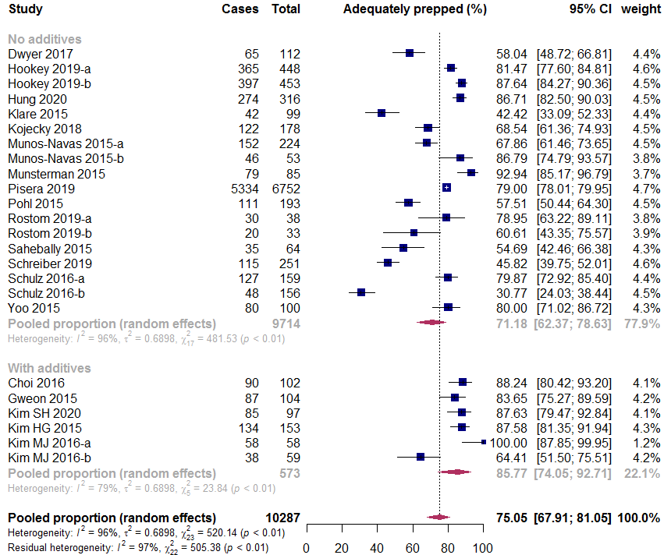
Figure S1. Subgroup analysis based on additive use, sodium picosulfate/magnesium citrate (SPMC).
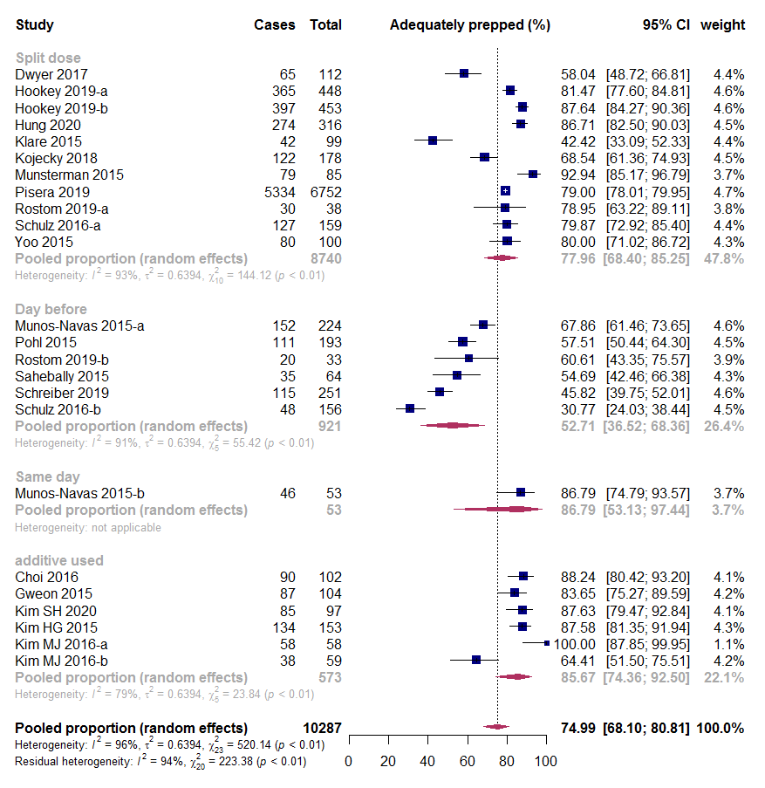
Figure S2. Subgroup analysis based on dosing schedule, sodium picosulfate/magnesium citrate (SPMC).
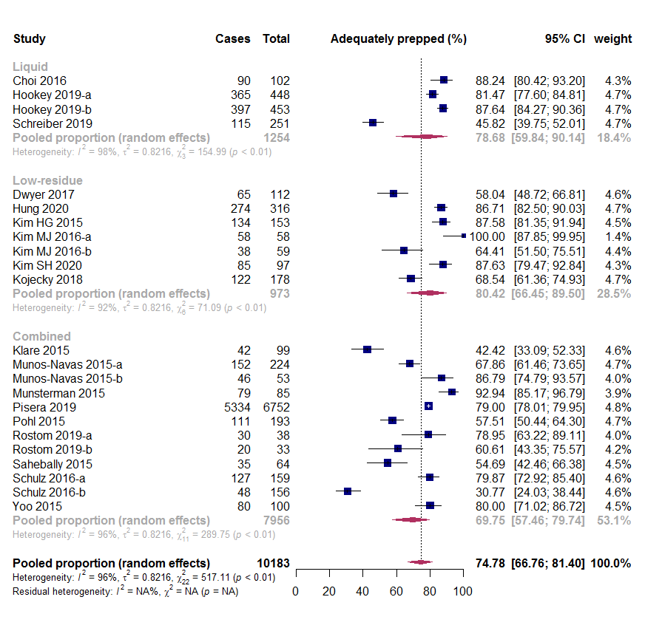
Figure S3. Subgroup analysis based on diet, sodium picosulfate/magnesium citrate (SPMC)

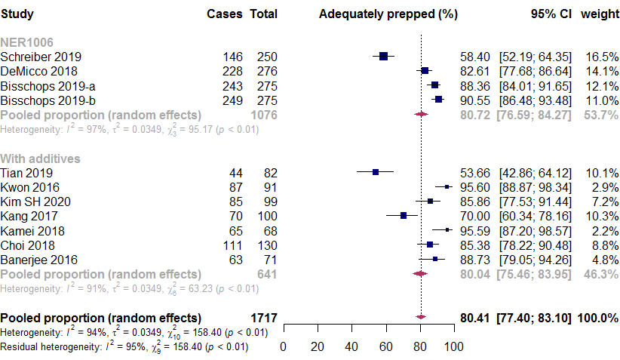
Figure S4. Pooled efficacy 1L PEG with ascorbate (PEGA), additives subgroups.

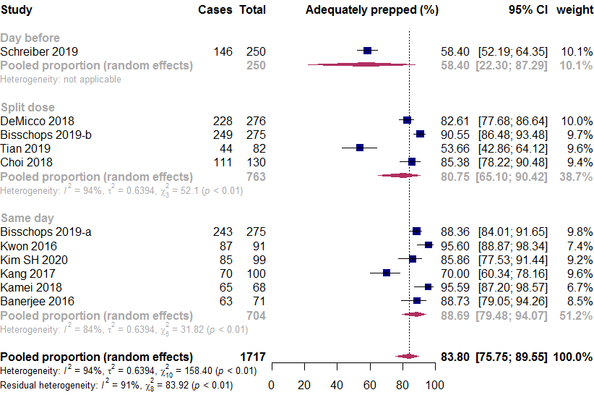
Figure S5. Pooled efficacy of 1L PEG with ascorbate (PEGA), dosing subgroups.
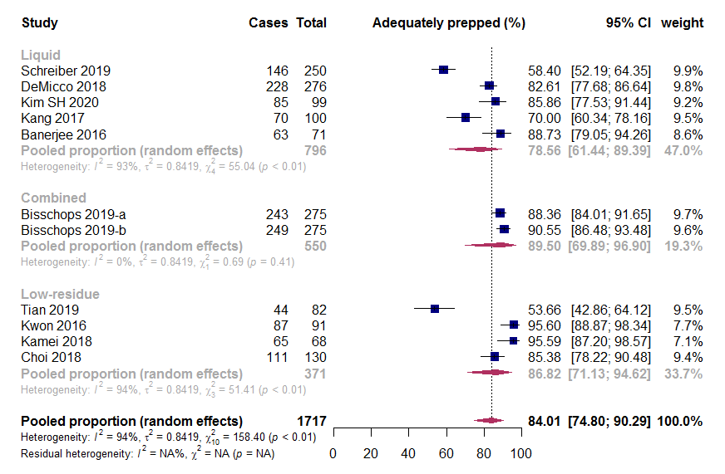
Figure S6. Pooled efficacy of 1L PEG with ascorbate (PEGA), diet subgroups.

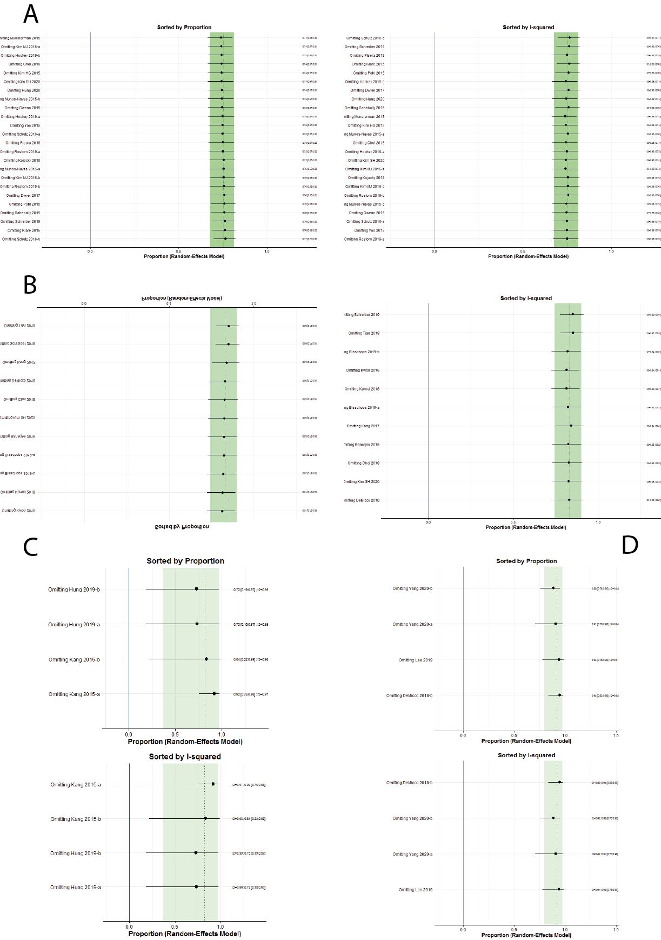
Figure S6 – leave-1-out analyses for pooled efficacy and heterogeneity. A – Sodium picosulfate with magnesium citrate, B – 1L-PEG with ascorbate, C – Sodium phosphate solution, D – Sodium sulfate solution.
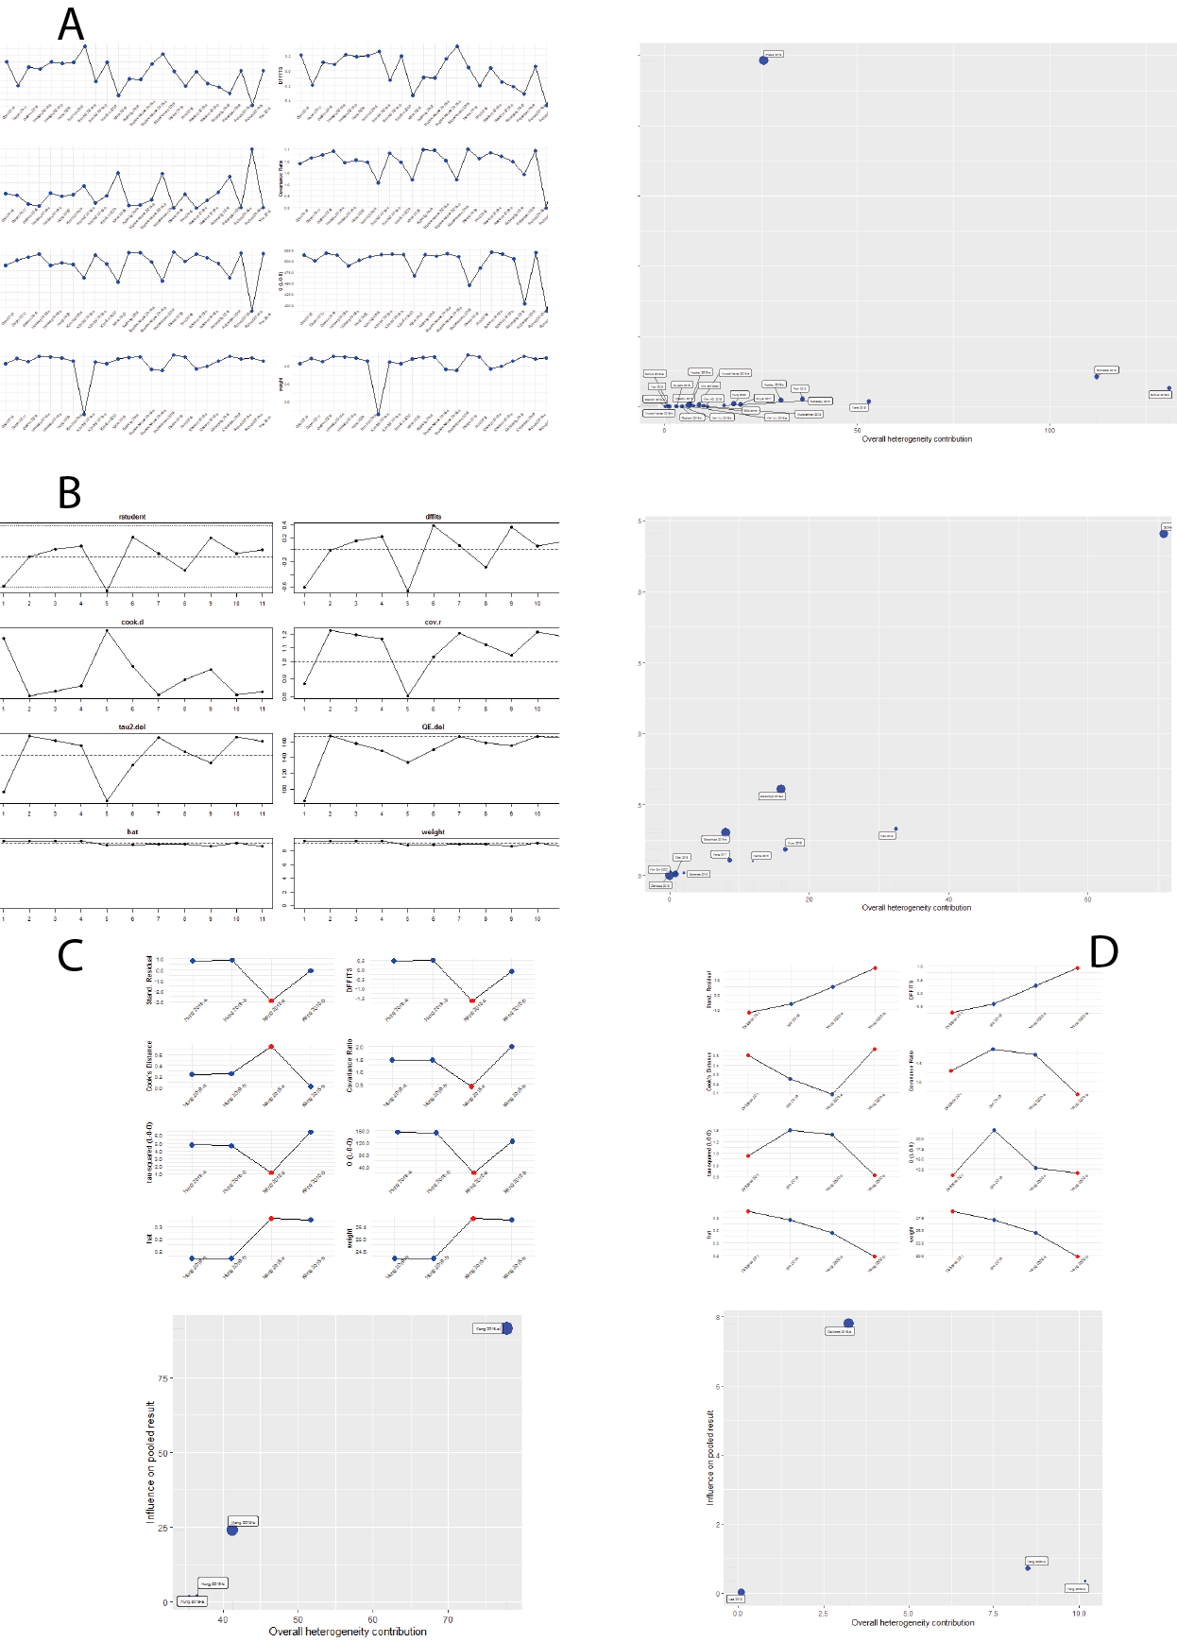
Figure S8 – influence analyses and Baujat-plots for identifying outliers. A – Sodium picosulfate with magnesium citrate, B – 1L-PEG with ascorbate, C – Sodium phosphate solution, D – Sodium sulfate solution.
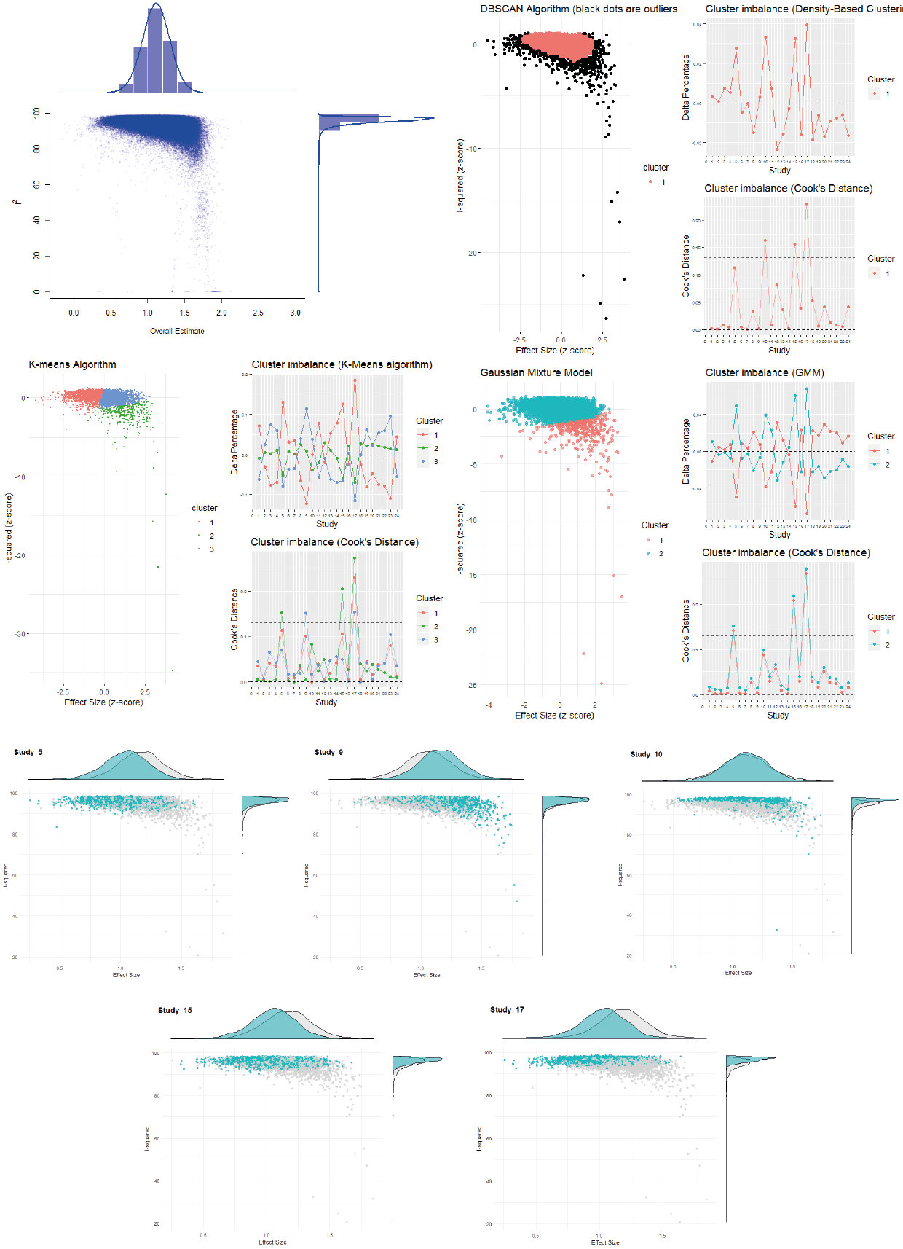
Figure S9 – Graphic display of study heterogeneity (GOSH) plot analysis for identifying outliers, Sodium Picosulfate with Magnesium Citrate (SPMC)

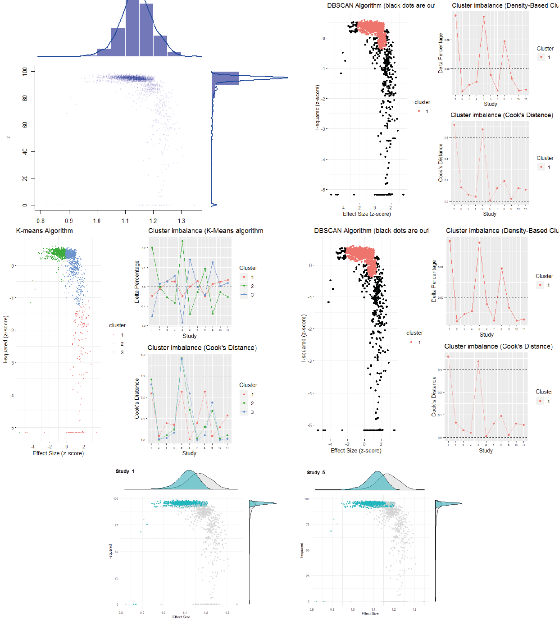
Figure S10 – Graphic display of study heterogeneity (GOSH) plot analysis for identifying outliers, 1L PEG with ascorbate

D – Risk of bias
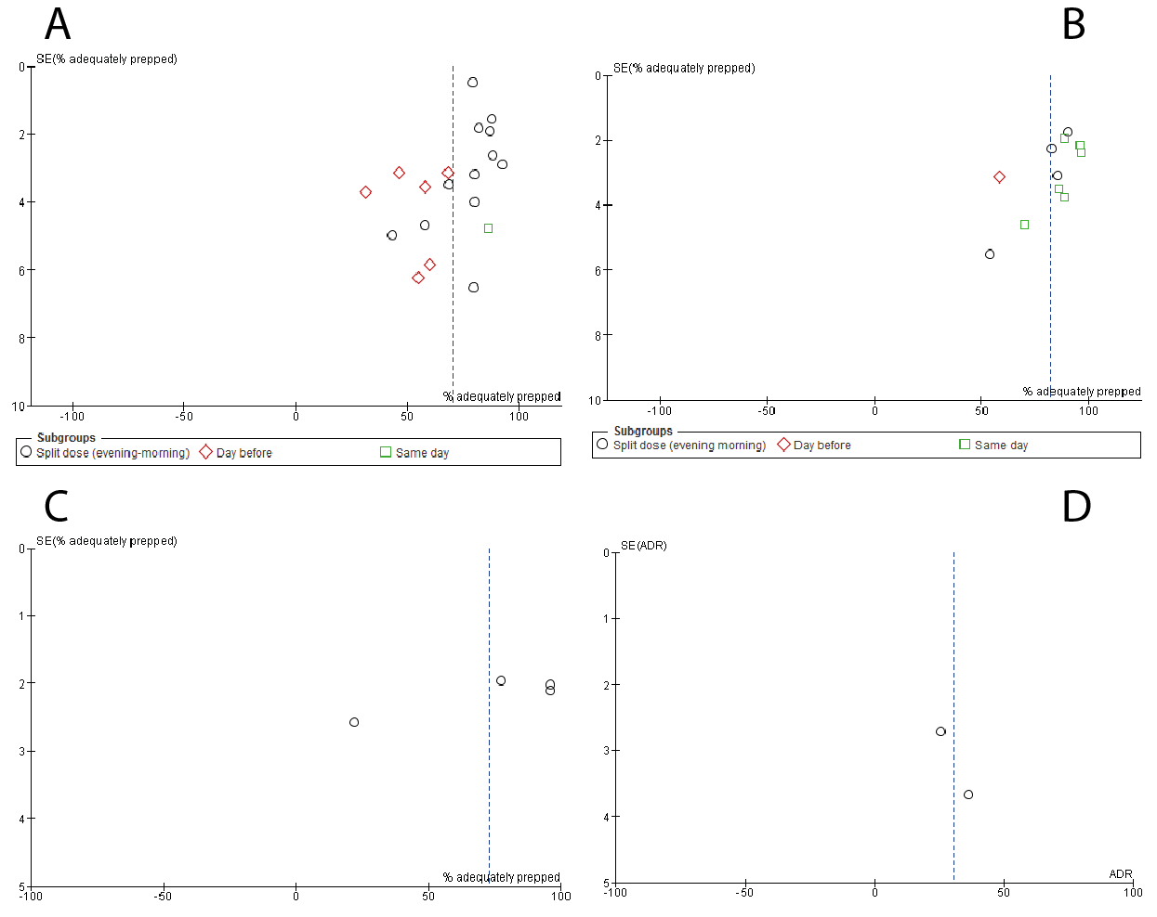
Figure S11 – funnel plots of percentage adequately prepped patients per fluid. A – Sodium picosulfate with magnesium citrate, B – 1L-PEG with ascorbate, C – Sodium phosphate solution, D – Sodium sulfate solution.

Figure S12 – Traffic light plot for individual risk of bias of included studies, Cochrane RoB2 tool

Supplementary files references
1. Tan JJ, Tjandra JJ. Which is the optimal bowel preparation for colonoscopy - a meta-analysis. Colorectal Dis. 2006; 8: 247-58.
2. Markowitz GS, Stokes MB, Radhakrishnan J, D'Agati VD. Acute phosphate nephropathy following oral sodium phosphate bowel purgative: an underrecognized cause of chronic renal failure. J Am Soc Nephrol. 2005; 16: 3389-96.
3. Fujita I, Akagi Y, Hirano J, et al. Distinct mechanisms of transport of ascorbic acid and dehydroascorbic acid in intestinal epithelial cells (IEC-6). Research communications in molecular pathology and pharmacology. 2000; 107: 219-31.

