Supplementary Appendix
This appendix has been provided by the authors to give readers additional information about this work.

Cardiac markers as a tool for predicting mortality and severity in COVID-19 patients: A systematic review and meta-analysis
Supplementary Appendix
Wen An¹, Ju-seop Kang^{1*}, Qiuyang Wang², Tea-un Kim³
1. Department of Pharmacology & Clinical Pharmacology Lab, College of Medicine, Hanyang University Seoul, Korea
2. Department of Central China Research Institute of Health, Xinxiang Medical University, Xinxiang, China
3. Department of Clinical Pharmacology, Konkuk University Hospital, Seoul, Korea

Table of contents
Supplementary Figures 3
Figure S 1. Sensitivity analysis of cTnI severity. 3
Figure S 2. Sensitivity analysis of cTnI mortality. 4
Figure S 3. Sensitivity analysis of cTnT mortality. 5
Figure S 4. Sensitivity analysis of hs-cTn mortality. 6
Figure S 5. Sensitivity analysis of hs-cTnI severity. 7
Figure S 6. Sensitivity analysis of hs-cTnI mortality. 8
Figure S 7. Sensitivity analysis of hs-cTnT severity. 9
Figure S 8. Sensitivity analysis of CK-MB severity. 10
Figure S 9. Sensitivity analysis of CK-MB mortality. 11
Figure S 10. Sensitivity analysis of Mb severity. 12
Figure S 11. Publication bias analysis of cTnI mortality. 13
Figure S 12. Publication bias analysis of hs-cTnI mortality. 14
Figure S 13. Publication bias analysis of CK-MB severity. 15
Figure S 14. Publication bias analysis of CK-MB mortality. 16
Figure S 15. Publication bias analysis of Mb mortality. 17
Figure S 16. Prisma checklist of this meta-analysis. 18

Supplementary Figures
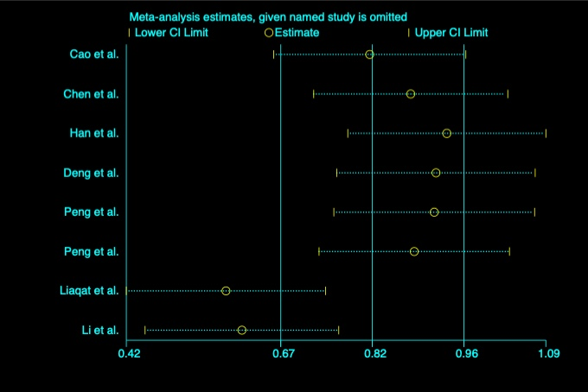
Figure S 1. Sensitivity analysis of cTnI severity.
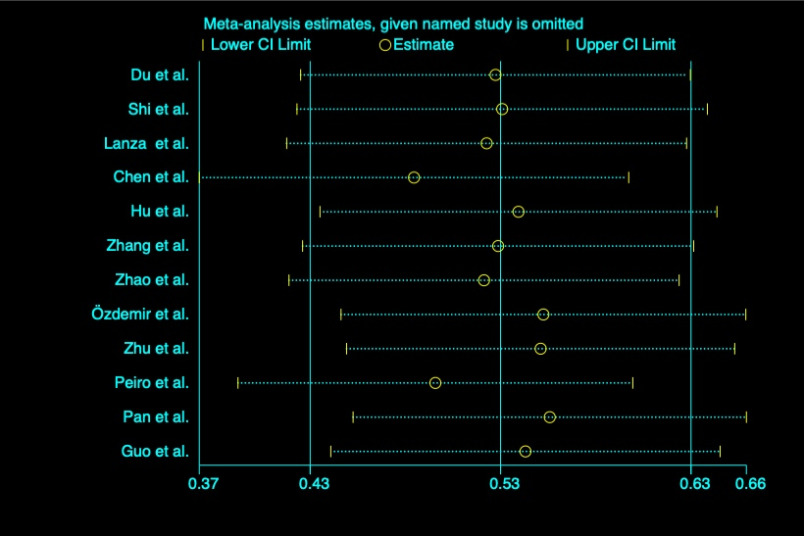
Figure S 2. Sensitivity analysis of cTnI mortality.
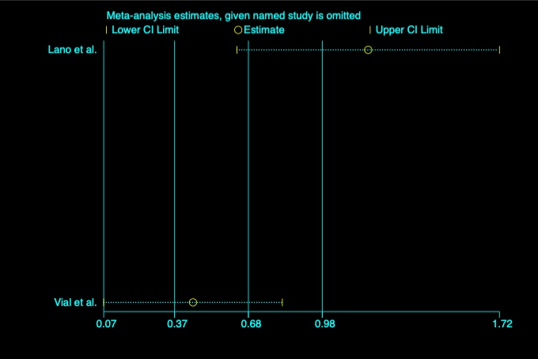
Figure S 3. Sensitivity analysis of cTnT mortality.
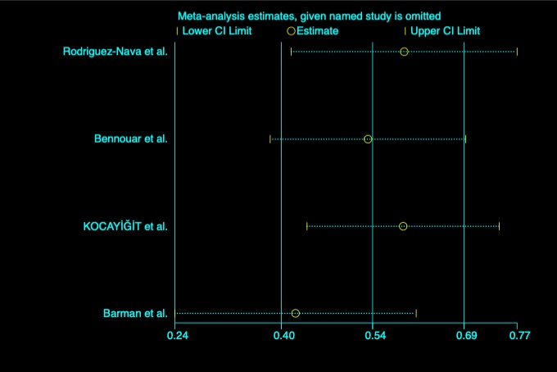
Figure S 4. Sensitivity analysis of hs-cTn mortality.
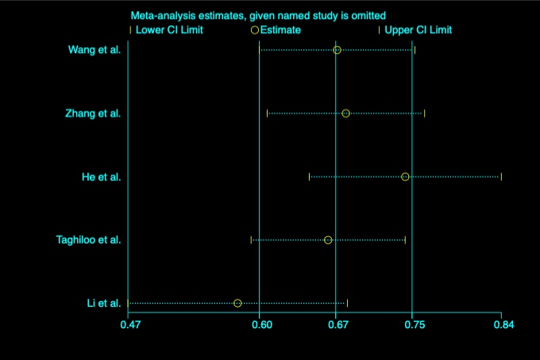
Figure S 5. Sensitivity analysis of hs-cTnI severity.
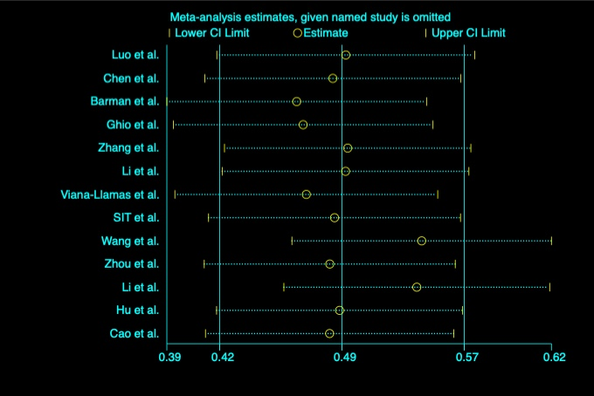
Figure S 6. Sensitivity analysis of hs-cTnI mortality.
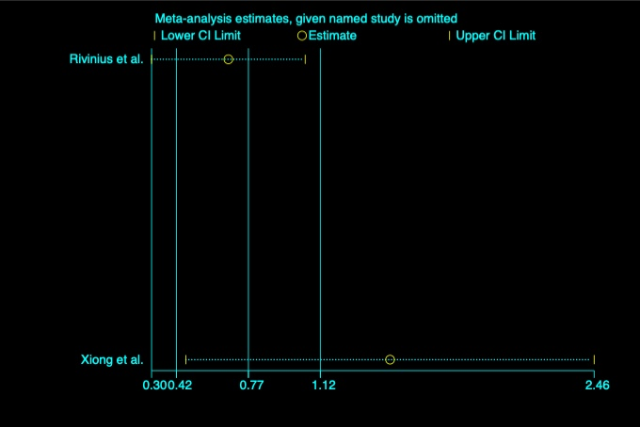
Figure S 7. Sensitivity analysis of hs-cTnT severity.
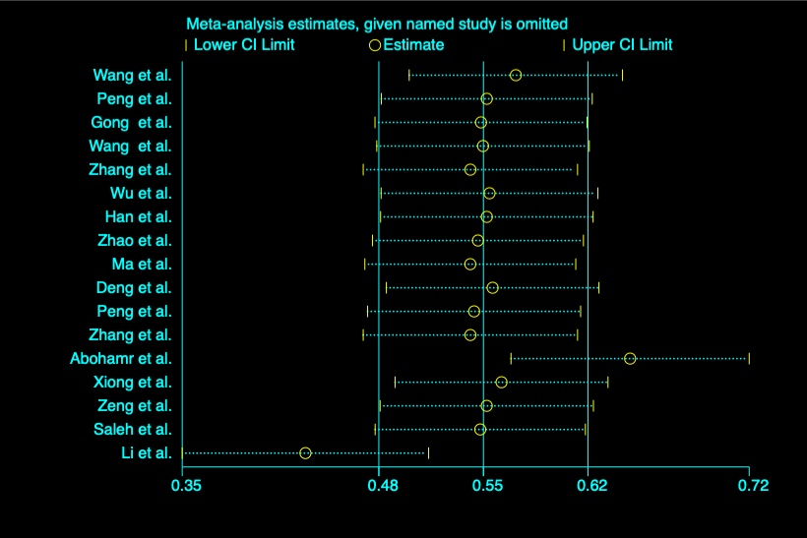
Figure S 8. Sensitivity analysis of CK-MB severity.
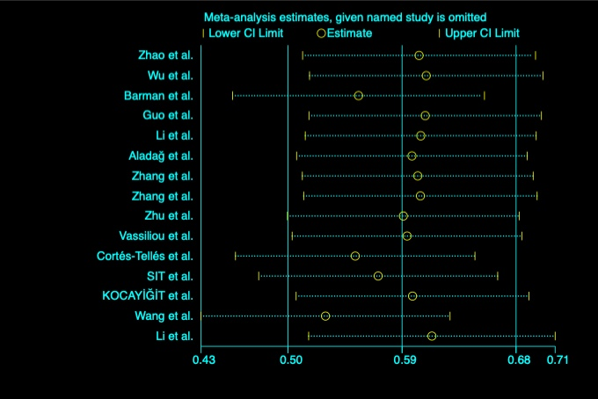
Figure S 9. Sensitivity analysis of CK-MB mortality.
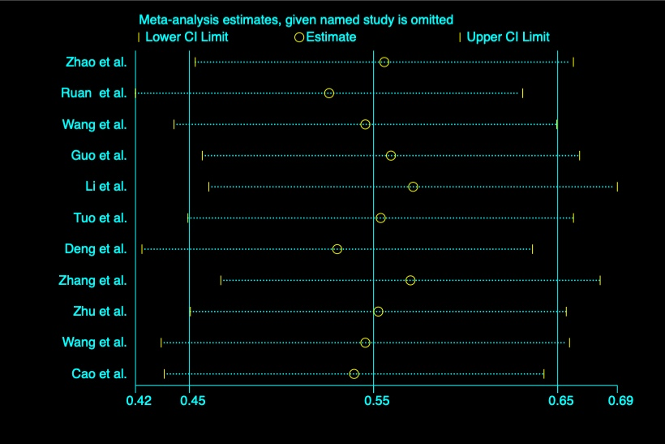
Figure S 10. Sensitivity analysis of Mb severity.
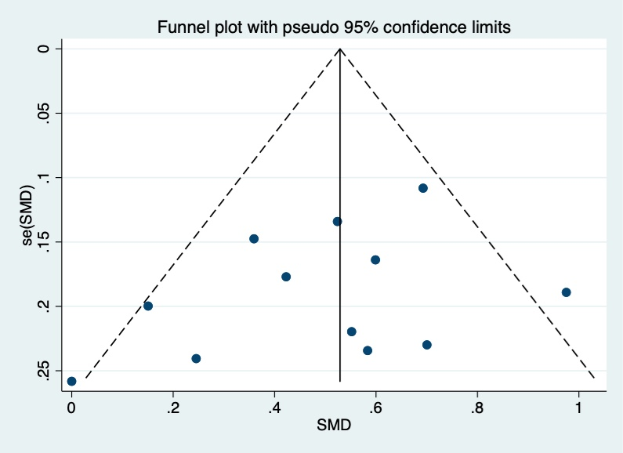
Figure S 11. Publication bias analysis of cTnI mortality.
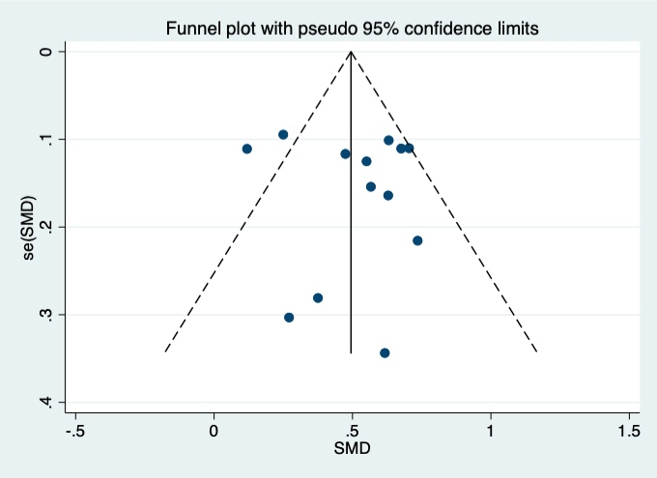
Figure S 12. Publication bias analysis of hs-cTnI mortality.
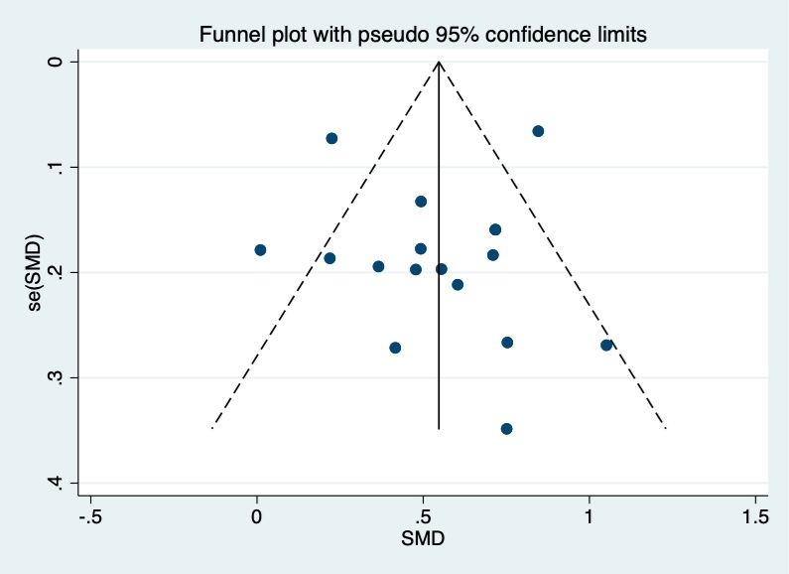
Figure S 13. Publication bias analysis of CK-MB severity.
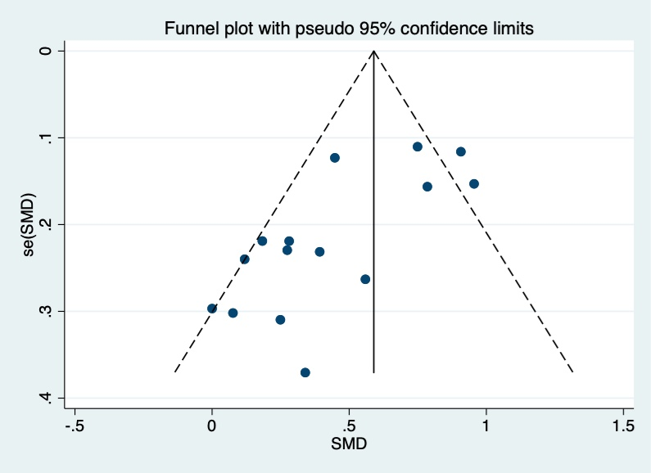
Figure S 14. Publication bias analysis of CK-MB mortality.
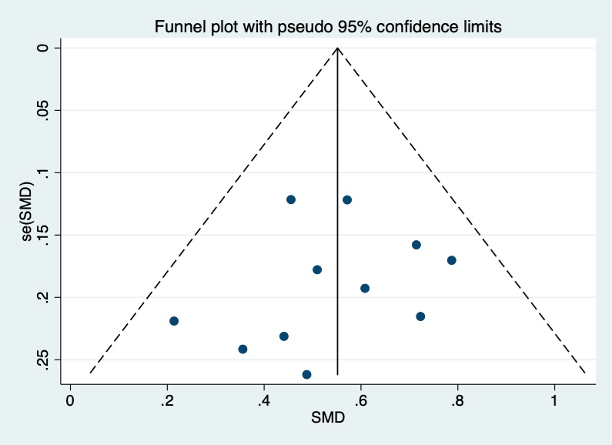
Figure S 15. Publication bias analysis of Mb mortality.
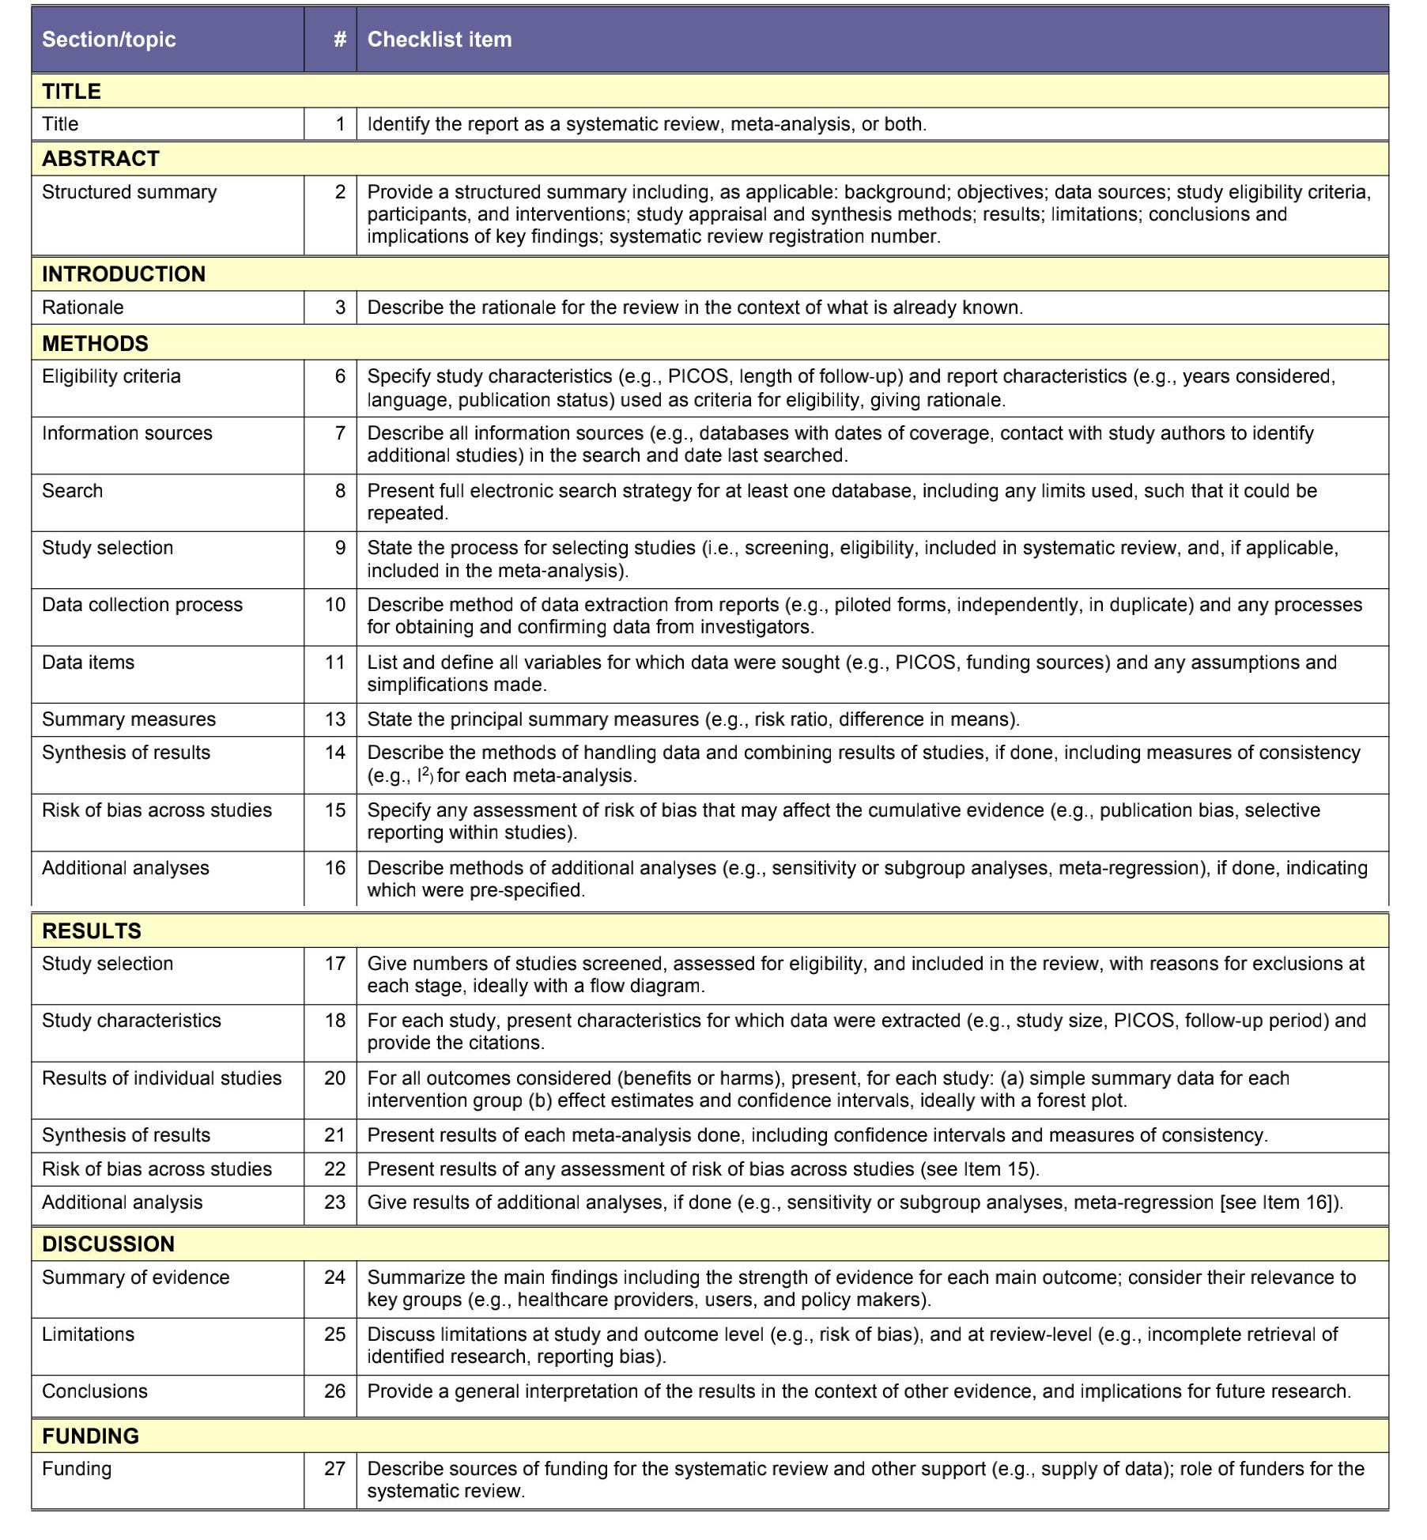
Figure S 16. Prisma checklist of this meta-analysis.

