Supplements

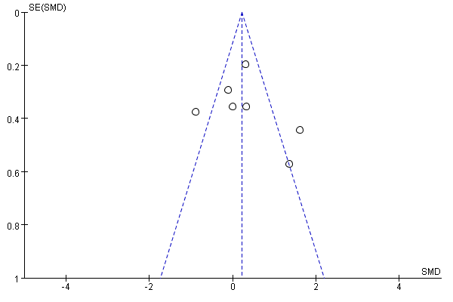s Fig 1. VO2 peak Funnel plots for assessing publication bias.
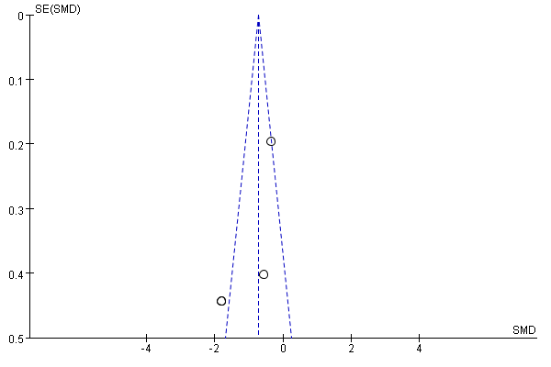s Fig 2. BMI Funnel plots for assessing publication bias
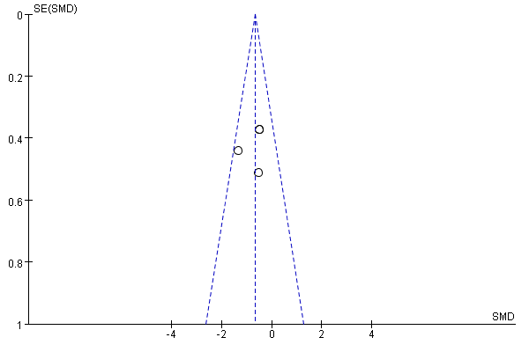s Fig 3. (FM, in %) Funnel plots for assessing publication bias
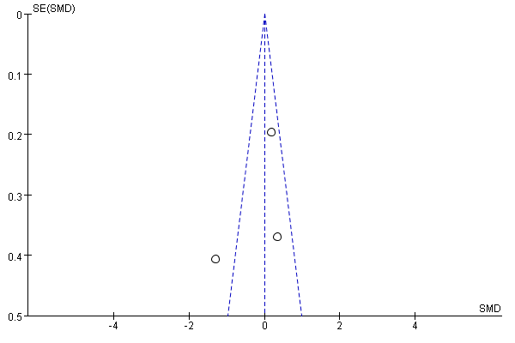s Fig 4. SBP Funnel plots for assessing publication bias.
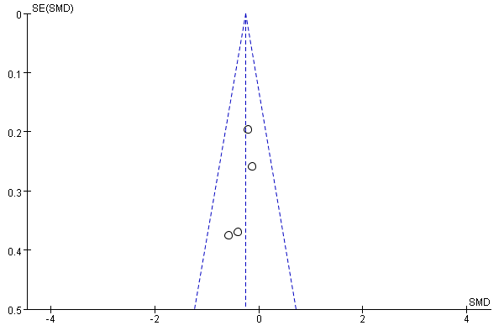s Fig 5. CHO Funnel plots for assessing publication bias
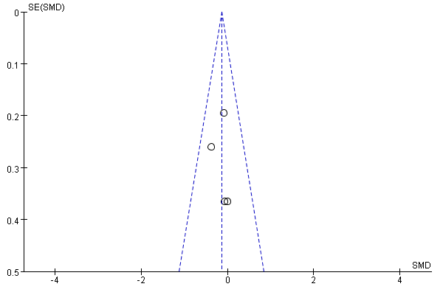s Fig 6. TG Funnel plots for assessing publication bias.

