Supplementary Appendix

Pulse versus Non-pulse Steroid Regimens in Patients with Coronavirus Disease 2019: A Systematic Review and Meta-Analysis

Waleed Khokher MD, Azizullah Beran MD, Saffa Iftikhar MD, Saif-Eddin Malhas MD, Omar Srour MD, Mohammed Mhanna MD, Sapan Bhuta MD, Dipen Patel MD, Nithin Kesireddy MD, Cameron Burmeister MD, Elizabeth Borchers MS3, Ragheb Assaly MD, Fadi Safi MD

Supplementary tables
Title | Page
Supplementary table 1: Search strategy used in each database searched. | 2
Supplementary table 2: The Newcastle-Ottawa Scale (NOS) for assessing the quality of observational studies. | 3

Supplementary figures:
Title | Page
Supplementary figure 1: Leave-one-out sensitivity analysis for: A) mortality, B) need for endotracheal intubation, C) length of hospital stay, and D) adverse events. | 4
Supplementary figure 2: Funnel plot showing publication bias analysis for mortality. | 5

Supplementary table 1: Search strategy used in each database searched.
Database | Search Strategy | Articles retrieved
PubMed/MEDLINE | ("glucocorticoids"[All Fields] OR "steroids"[All Fields] OR "hydrocortisone"[All Fields] OR "methylprednisolone"[All Fields] OR "dexamethasone"[All Fields]) AND ("pulse dose"[All Fields] OR "high dose"[All Fields] OR "pulse"[All Fields] OR "short term”[All Fields] OR "long term"[All Fields]) AND ("COVID"[All Fields] OR "COVID-19 pneumonia"[All Fields] OR "SARS-CoV"[All Fields] OR "Viral COVID pneumonia"[All Fields] OR "Viral Pneumonia"[All Fields]) AND ("clinical deterioration"[All Fields] OR "hospitalization"[All Fields] OR "shortness of breath"[All Fields] OR "supplemental oxygen"[All Fields] OR "hospital stay"[All Fields] OR "intensive care unit"[All Fields] OR "ICU admission"[All Fields]) AND ("intubated"[All Fields] OR "non-intubated” [All Fields] OR "mechanically ventilated"[All Fields] OR "ventilated"[All Fields]) AND ("ARDS"[All Fields] OR "acute respiratory distress syndrome"[All Fields] OR “respiratory distress syndrome"[All Fields]) AND ("mortality” [All Fields] OR "death"[All Fields] OR “ICU mortality"[All Fields] OR "hospital mortality”[All Fields]) | 2516
Embase | (‘glucocorticoids OR ‘methylprednisolone’ OR ‘hydrocortisone’ OR ‘dexamethasone’ OR ‘steroids’) AND ('coronavirus' OR 'COVID-19' OR 'SARS-CoV 2’) AND (‘pulse dose’ OR 'high dose’) AND ('intensive care unit' OR 'intensive care’ OR ‘mechanical ventilation' OR “intubated’ OR ‘mortality OR ‘death’) | 4092
Web of Science | (‘glucocorticoids OR ‘methylprednisolone’ OR ‘hydrocortisone’ OR ‘dexamethasone’ OR ‘steroids’) AND ('coronavirus' OR 'COVID-19' OR 'COVID’ OR ‘SARS-CoV 2’) AND (‘pulse dose’ OR 'high dose’) | 2753
Cochrane CENTRAL | "Mortality" in Title Abstract Keyword AND "Coronavirus" in Title Abstract Keyword AND “steroids” in Title Abstract Keyword AND “high dose” in Title Abstract Keyword | 769
Supplementary table 2: The Newcastle-Ottawa Scale (NOS) for assessing the quality of observational studies.

 | Selection |  |  |  |  | Outcome
Study, Year | Representativeness of the exposed cohort | Selection of the non-exposed cohort | Ascertainment of exposure | Outcome not present at baseline | Comparability of the cohort | Assessment of outcome | Enough follow up duration | Adequate follow-up | Total score
Batirel 2021 | * | * | * | * | * | * | * | * | 8
Cruz 2020 | * | * | * | * | * | * | * | * | 8
El mezzeoui 2021 | * | * | * | * | * | * | * | * | 8
Gundogdu 2021 | * | * | * | * | 0 | * | * | * | 7
Jamil 2021 | * | * | * | * | * | * | * | * | 8
Monreal 2021 | * | * | * | * | * | * | * | * | 8
Pinzon 2021 | * | * | * | * | * | * | * | * | 8
Toda 2021 | * | * | * | * | 0 | * | * | * | 7
Umbrello 2021 | * | * | * | * | 0 | * | * | * | 7
Yaqoob 2021 | * | * | * | * | * | * | * | * | 8

Each asterisk represents one star in the Newcastle-Ottawa Scaling System (NOS). The maximum stars are 2 for comparability and 1 are for all other categories. Each star counts towards the total score. Score of 5 to 6 considered as moderate quality and 7 to 9 as high quality.

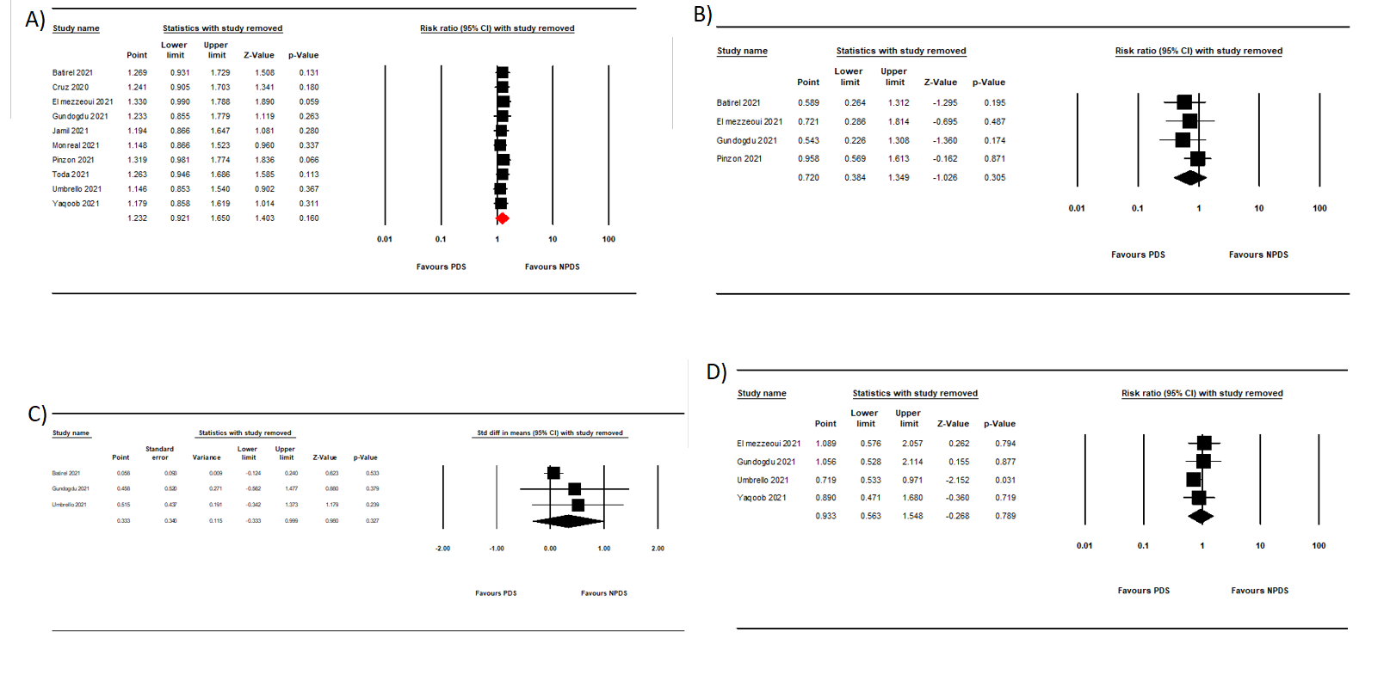Supplementary figure 1: Leave-one-out sensitivity analysis for: A) mortality, B) need for endotracheal intubation, C) length of hospital stay, and D) adverse events.

Supplementary figure 2: Funnel plot showing publication bias analysis for mortality.

