A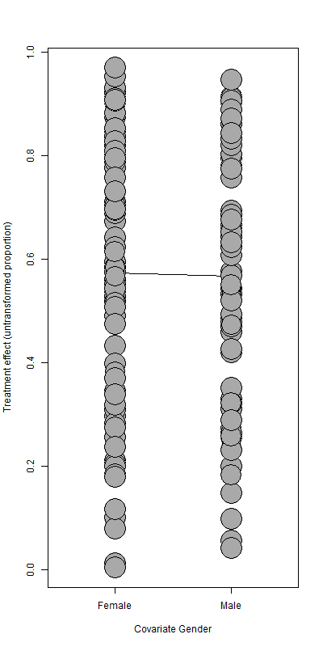B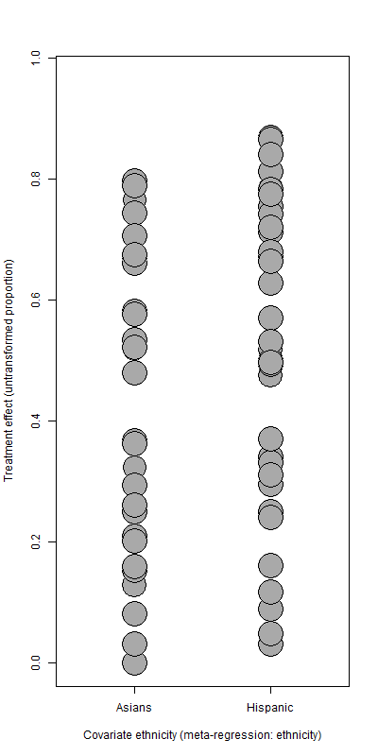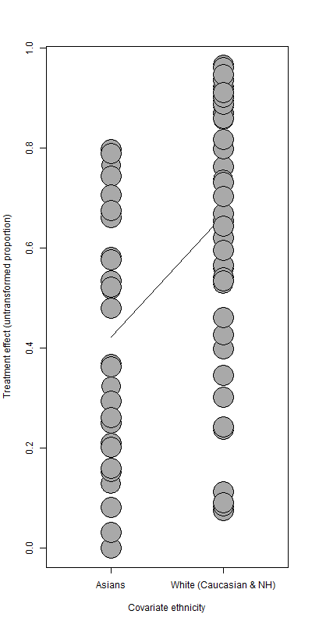
Supplementary Figure 1. Meta regression analysis of prevalence of awareness of symptoms of myocardial infarction in different of gender (A) and ethnicity (B).

