A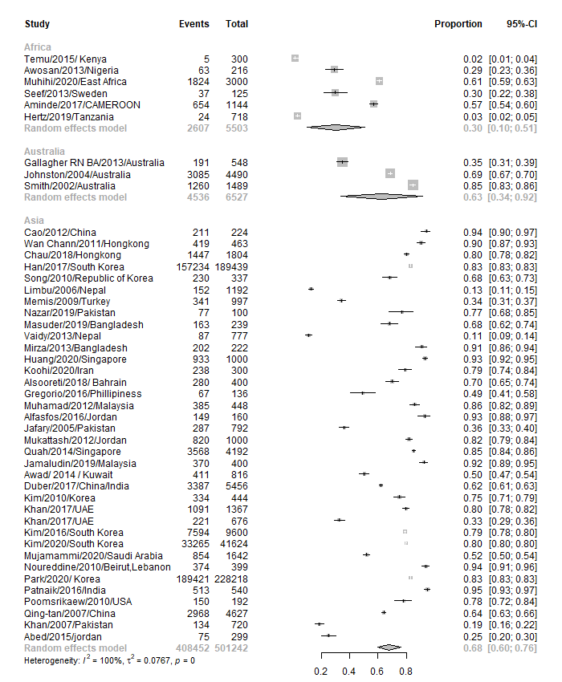
B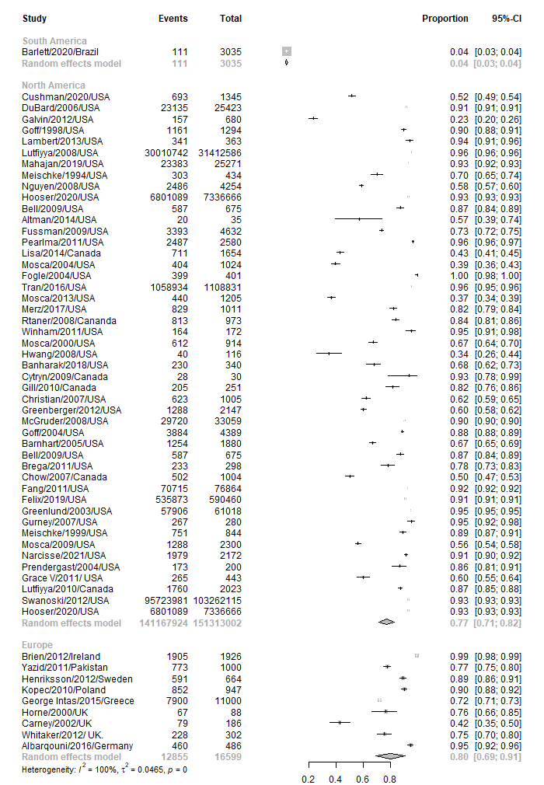
Supplementary Figure 2. Forest plot of prevalence of awareness of chest pain as symptom of myocardial infarction in different continents, random effects model (A, B). For each continent the prevalence with 95% CI is given with grey rhombus presenting the pooled results.
CI = confidence interval.

