A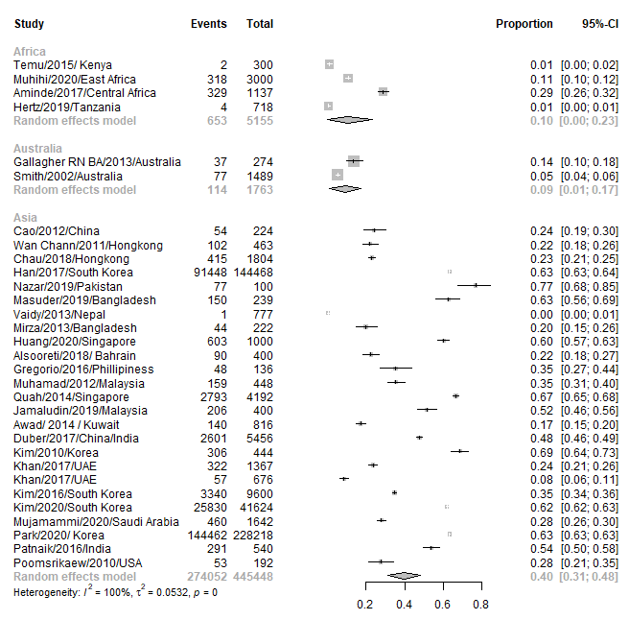
B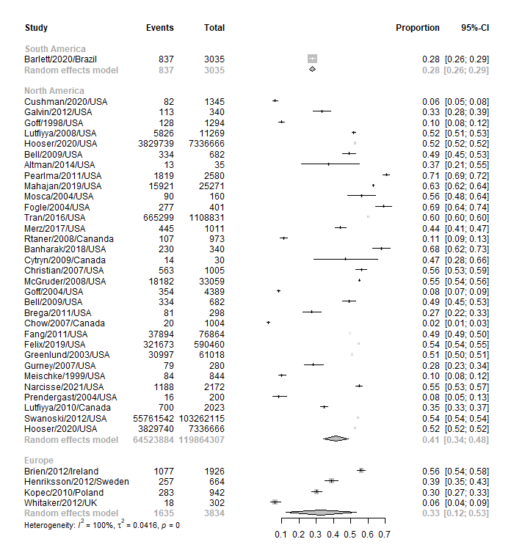
Supplementary Figure 5. Forest plot of prevalence of awareness of pain in jaw, neck and back as symptom of myocardial infarction in different continents, random effects model (A, B). For each continents the prevalence with 95% CI is given with grey rhombus presenting the pooled results.
CI = confidence interval.

