Supplementary data
Table S1. Search terms
“ototoxicity”, “hearing loss”, “cochleotoxicity”, “vestibulotoxicity”, “tinnitus”, “vertigo”, “dizziness”, “deaf”
“glycopeptides”, “bleomycin”, “peplomycin”, “phleomycin”, “lipoglycopeptide”, “teicoplanin”, “oritavancin”, “televancin”, “dalbavancin”, “vancomycin”
“aminoglycosides, “gentamicin”, “sisomicin”, “amikacin”, “dibekacin”, “nebramycin”, “neomycin”, “framycetin”, “ribostamycin”, “paromycin”, “puromycin”, sepctinomycin”, streptomycin”, “streptothricin”, streptozocin”, “tobramycin”,
“child”, “infant”, “paediatric”, “adolescent”, “minors”, “kids”, “toddler”, “puber”, “prepuber”, “preadolescent”, survivor”

Table S2. Literature search
Literature search, initial search July 16, 2020 (last updated April 2021)
Pubmed
- "Child"[Mesh] OR "Infant"[Mesh] OR "Infant, Newborn"[Mesh:NoExp] OR "Pediatrics"[Mesh] OR "Adolescent"[Mesh] OR "Minors"[Mesh] OR child*[tiab] OR infan*[tiab] OR adolescen*[tiab] OR pediatric*[tiab] OR paediatric*[tiab] OR teenager*[tiab] OR youth*[tiab] OR kids[tiab] OR kid[tiab] OR toddler*[tiab] OR puber*[tiab] OR prepuber*[tiab] OR preadolescen*[tiab] OR survivor*[tiab] OR surviving[tiab]) OR "Survival"[Mesh]
- Ototoxicity[Mesh] OR ototox*[tiab] OR “otological toxicit*”[tiab] OR cochleotox*[tiab] OR vestibulotox*[tiab] OR “cochlear toxic*”[tiab] OR “vestibular toxic*”[tiab] OR tinnitus[mesh] OR tinnitus[tiab] OR “hearing impair*”[tiab] OR “hearing loss”[mesh] OR “hearing loss*”[tiab] OR deaf*[tiab] OR vertigo[mesh] OR vertigo[tiab] OR dizziness[tiab] OR dizzy[tiab] OR audiolog*[tiab]
- Glycopeptides[Mesh] OR glycopeptid*[tiab] OR bleomycin*[tiab] OR peplomycin*[tiab] OR phleomycin*[tiab] OR lipoglycopeptid*[tiab] OR teicoplanin*[tiab] OR oritavancin*[tiab] OR televancin*[tiab] OR dalbavancin*[tiab] OR vancomycin*[tiab]
- Aminoglycosides[Mesh] OR gentamicin*[tiab] OR Sisomicin*[tiab] OR amikacin*[tiab] OR dibekacin*[tiab] OR Nebramycin*[tiab] OR neomycin*[tiab] OR framycetin*[tiab] OR ribostamycin*[tiab]OR paromomycin*[tiab] OR puromycin*[tiab] OR spectinomycin*[tiab] OR streptomycin*[tiab] OR streptothricin*[tiab] OR streptozocin*[tiab] OR tobramycin*[tiab]
Embase
- 'pediatrics'/exp OR 'pediatrics' OR 'child'/exp OR 'child' OR 'minor (person)'/exp OR 'minor (person)' OR 'adolescent'/exp OR 'adolescent' OR infan*:ab,ti,kw OR pediatric*:ab,ti,kw OR adolescen*:ab,ti,kw OR minor*:ab,ti,kw OR child*:ab,ti,kw OR paediatric*:ab,ti,kw OR teenager*:ab,ti,kw OR youth*:ab,ti,kw OR toddler*:ab,ti,kw OR puber*:ab,ti,kw OR prepuber*:ab,ti,kw OR preadolescen*:ab,ti,kw OR survivor*:ab,ti,kw
- 'audiology'/exp OR 'audiometry'/exp OR 'ototoxicity'/exp OR 'tinnitus'/exp OR 'vertigo'/exp OR 'inner ear hearing loss'/exp OR 'hearing loss':ab,ti,kw OR ototox*:ab,ti,kw OR 'otological*':ab,ti,kw OR cochleotox*:ab,ti,kw OR vestibulotox*:ab,ti,kw OR cochlear*:ab,ti,kw OR vestibular*:ab,ti,kw OR tinnitus:ab,ti,kw OR 'hearing impair*':ab,ti,kw OR deaf*:ab,ti,kw OR vertigo:ab,ti,kw OR dizziness:ab,ti,kw OR dizzy:ab,ti,kw
- 'aminoglycoside antibiotic agent'/exp OR gentamicin*:ab,ti,kw OR sisomicin*:ab,ti,kw OR amikacin*:ab,ti,kw OR dibekacin*:ab,ti,kw OR nebramycin*:ab,ti,kw OR neomycin*:ab,ti,kw OR framycetin*:ab,ti,kw OR ribostamycin*:ab,ti,kw OR paromomycin*:ab,ti,kw OR puromycin*:ab,ti,kw OR spectinomycin*:ab,ti,kw OR streptomycin*:ab,ti,kw OR streptothricin*ab,ti,kw OR streptozocin*ab,ti,kw OR tobramycin*:ab,ti,kw
- 'glycopeptide'/exp OR glycopeptid*:ab,ti,kw OR bleomycin*:ab,ti,kw OR peplomycin*:ab,ti,kw OR phleomycin*:ab,ti,kw OR lipoglycopeptid*:ab,ti,kw OR teicoplanin*:ab,ti,kw OR oritavancin*:ab,ti,kw OR televancin*:ab,ti,kw OR dalbavancin*:ab,ti,kw OR vancomycin*:ab,ti,kw
- Search conditions/ filter: #34 AND ('Article'/it OR 'Article in Press'/it OR 'Conference Abstract'/it OR 'Conference Paper'/it OR 'Editorial'/it OR 'Letter'/it OR 'Note'/it OR 'Short Survey'/it
Cochrane library
- (pediatric* or child* or minors or adolesc* or infan* or pediatric* or paediatri* or boy* or boyhood or teenager* or youth* or postneonat* or kids or toddler* or puber* or prepuber* or preadolescen* or 'junior high*' or 'young people' or survivor*):ti,ab,kw AND Mesh descriptor [pediatrics] [minors] [adolescent] [child] or [survivor]
- (audiol* OR 'audiomet* or 'ototox* or tinnitus or vertigo or 'inner ear hearing loss' or 'hearing loss' or otological* or cochleotox* or vestibulotox* or cochlear* or vestibular* or 'hearing impair*' or deaf* or vertigo or dizziness or dizzy):ti,ab,kw AND Mesh descriptor [audiology] [audiometry] [ototoxicity][hearing loss] [tinnitus] [vertigo]
- ('aminoglycoside antibiotic' or aminoglycoside or gentamicin* or sisomicin* or amikacin* or dibekacin* or nebramycin* or neomycin* or framycetin* or ribostamycin* or paromomycin* or puromycin* or spectinomycin* or streptomycin* or streptothricin* or streptozocin* or tobramycin*):ti,ab,kw AND Mesh descriptor [aminoglycosides]
- ('polypeptide antibiotic or glycopeptid* or bleomycin* or peplomycin* or phleomycin* or lipoglycopeptid* or teicoplanin* or oritavancin* or televancin* OR dalbavancin* OR vancomycin*):ti,ab,kw AND mesh descriptor [glycopeptides]

Table S3. Overview of randomised controlled trials on ototoxicity after aminoglycoside/ glycopeptide administration
Author (year) | N | Groups/ RM | Diagnosis | Age at study (year) | AG/ GP | Other  medication | Dose (mg/kg/day) | Diagnostic test | HL definition | MVA | Ototoxicity |  |  | Reversible | PK monitoring
 |  |  |  |  |  |  |  |  |  |  | Hearing loss (%) | Tinnitus (%) | Vertigo (%)
Carapetis et al. (2001)¹ | 179 | OD (n=90)  TTD (n=89) | UTI | Median 1.0 (range 0.1-12) | GM | NA | 4.5-7.5 Duration 3.0 (OD) and 2.5 (TTD) days | PTA, BA, BERA | ≥20 dB HL at any freq. | No | 1/72 (1%) | NS | NS | NA | Trough/ peak levels
Chong et al. (2003)² | 172 | OD (n=84)  TTD (n=88) | UTI | Mean 0.92 (1.30 SD) | GM | CMZ, CFL | 5.0 (OD), 6.0 (TTD) | OAE, BERA | ≥30 dB HL in ≥1 freq. in any ear BERA confirmed | No | 0/161 (0%) | NS | NS | NA | Trough/ peak levels
Elhanan et al. (1995)³ | 63 | OD (n=32)  TTD (n=31) | Diverse infections (gram negative) | Mean  6.6 (4.7 SD) (OD) 4.7 (4.2 SD) (TTD) | GM | APC,  MNZ | 4.5 duration OD 6.8, TTD 5.8 days | BERA, EHF- PTA | ≥15 dB HL in≥2 freq., in 1 ear, or ≥ 10 dB HL in ≥2 freq., both ears | No | 4/50 (8%) | NS | NS | yes | Trough/ peak levels
Frazier et al. (1984)⁴ | 100 | NM (n=50)  GM (n=50) | CCP | Mean 7.6 (2.8 SD) | NM, GM | Ticarcillin,  cis | NM 8.0,  GM 8.0 | PTA | >15 dB HL at 2 freq. in one or both ears | No | 4/75 (5%) | NS | NS | NS | Trough/ peak levels
Mulheran et al. (2006)⁵ | 168 (102 children) | OD (n=83), TTD (n=85) | CF | NS (children range 5-16) | TM | MCL, AZM, IPF, NPX, PMX, CIT | OD 9.4, TTD 9.3 | EHF-PTA, questionnaire | >20 dB HL in ≥1 ears ≥2 freq. (2-8 kHz) | No | 0/168 (0%) | NS | NS | NA | Trough/ peak levels
Perez et al. (2011)⁶ | 100 | OD (n=50)  TTD (n=50) | Perforated appendicitis | Mean  7.8 (3.0 SD) (OD), 8.2 (2.8 SD) (TTD) | AK | clindamycin | 22.5 | OAE, FFA,BA, CPA | >10-15 dB HL ≥1 freq. with respect to baseline values | No | 2/81 (2%) | NS | NS | NS | Trough/ peak levels
Smyth et al. (2005)⁷* | 219 (125 children) | OD n=107 total, 61 children)  TTD n=112 total, 64 children) | CF | Median 14.8 (range 5.1-50.4) (OD), 14.9 (range 5.5-43.4) (TTD) | TM | CFZ | 10, duration 14 days | PTA | >20 dB HL ≥2 freq. at 2-8 kHz in either ear | No | 0/219 (0%) | NS | 2/219 (0.9%) | NS | Trough/ peak levels
Abbreviations: AG=aminoglycoside; AK= amikacin; APC= ampicillin; AZM= azithromycin; BA= behaviour audiometry; BERA=brainstem evoked response audiometry; CCP= childhood cancer patient; CF= cystic fibrosis; CFL=cephalexin; CFZ=ceftazidim; CIT= colistin; cis=cisplatin;; CMZ=cotrimoxazol; CPA=conditioned play audiometry; EHF= extended high-frequency; FFA=free-field audiometry; Freq.=frequency; GM= gentamicin; GP=glycopeptide; HL=hearing loss; IPF=ibuprofen MCL=macrolide; MNZ=metronidazole; MVA= multivariate analysis; N=Number; NA= not applicable; NM= netilmicin; NPX=naproxen; NS= not specified/reported; OAE= otoacoustic emissions; OD= once daily; PK=pharmacokinetic; PMX= polymyxin; PTA=pure tone audiometry; RM= randomisation; SD= standard deviation; TM= tobramycin; TTD= three times a day; UTI= urinary tract infections. *Separate analyses for children

Table S4. Overview of cohort studies on ototoxicity after aminoglycoside/ glycopeptide administration
Author (years) | N | Groups | Diagnosis | Age at study (year) | AG/GP | Other medication | Dose (mg/kg/day) | Diagnostic test | HL definition | MVA | Ototoxicity |  |  | Reversible |  | PK monitoring
 |  |  |  |  |  |  |  |  |  |  | Hearing loss (%) | Tinnitus (%) | Vertigo (%)
Al-Malky et al. (2015)⁸ | 70 | No (n=7)  Low (n=38)  High (n=25) AG exposure | CF | Mean 10.7 (3.5 SD) | AK, GM, TM | VM | NS | EHF-PTA;  DPOAE | ≥20 dB HL at one or more freq.  BSA/Brock grading | No | 15/63 (24%) | 5/63 (8%) | NS | NS |  | Trough levels
Best et al. (2011)⁹ | 79 | One treatment group | Sepsis | Median 5.6 (range 0.1-16) | GM | VM, Cis | 6.9, duration 5.0 days | PTA, OAE | ≥15 dB HL at any freq. in either ear | No | 2/79 (3%) | NS | NS | no |  | TDM Hartford nomogram
Blankenship et al. (2021)¹⁰ | 118 | CF group (n=57)  Controls (n=61) | CF | Mean CF 15.0 (3.6 SD)  Controls 14.6 (2.9 SD) | TM, AK | VM | NS | EHF-PTA, SA, MEMR, QNR | >15 dB HL at any freq. | No | 33/57 (57%) | 30/57 (53%) | 18/57 (32%) | NS |  | NS
Buckingham et al. (2005)¹¹ | 114 | One treatment group | Pneumococcal meningitis | Median 10 (range 5-20) | VM | CFX,  CFT | NS | NS | ≥50 dB HL in ≥1 ear | Yes | 37/67 (55%) | NS | NS | NS |  | NS
Bucuvalas et al. (2003)¹² | 74 | One treatment group | Liver transplantation | 4.2 (4.9 SD) | NS | VCR, carbo, cis, diuretics | NS | ABR, DPOAE, RA, CPA, PTA | >15 dB HL | Yes | 11/74 (15%) | NS | NS | NS |  | NS
Camarda et al. (1981)¹³ | 52 | One treatment group | Diverse infections | Range 2-26 | SM, KM | NS | NS | CA, RB, GT, IFPT, CS, RAT- ENG | NS | No | 52/52 (100%) incl. criteria | NS | 36/52 (69%) | NS |  | NS
Cheng et al. (2009)¹⁴ | 50 | 1: ≤10 AG,  2: > 10 AG courses | CF | Mean 11.4 (range 1-35) | NS | MCL, topical AG | NS | PTA | ≥15 dB HL at ≥2 freq. | Yes | 7/50 (14%) | 1/50 (2%) | NS | NS |  | NS
Clemens et al. (2016)¹⁵ | 451 | One treatment group | CCS | Median 4.9 (range 0.01-19) | TM, GM,  VM | Cis, carbo, FSM | NS | PTA | ≥ Muenster 2B | Yes | 16/53 (30%) TM, 49/109 (45%) GM, 97/181 (54%) VM | NS | NS | no |  | NS
Deutsch et al. (1998)¹⁶ | 125 | One treatment group | Liver transplantation | NS | AK, TM, GM | FSM, salicylates, VM | TCD range (mg/kg)  AK 0-350 GM 0-650 TM 0-250 | NS | ≥35 dB HL in ≥ 1 freq. | No | 15/125 (12%) | NS | NS | NS |  | Trough/ peak levels
Handelsman et al. (2017)¹⁷ | 71 | One treatment group | CF | Median 17 (range 8-56) | GM, TM, AK | NS | NS | PTA., DPOAE, DVA, VNG, SRST | ≥25 dB HL in standard freq. | No | 16/71 (23%) | NS | 56/71 (79%) | NS |  | NS
Hesseling et al. (1990)¹⁸ | 816 | One treatment group | Diverse indications | NS | AK | NS | 15, except  neonate <1000 g, 7.5 mg/kg every 18h | BRA, ABR | NS | No | 4/816 (0.5%) | NS | NS | NS |  | Trough/ peak levels EMIT method
Kafetzis et al. (1991)¹⁹ | 56 | One treatment group | Diverse infections  (gram negative) | Mean 6.8 | AK | MNZ., VM, CFZ, CFX, CMZ, CPS, AZO, PC, AZC, CFN, IPM | 20, duration range 6-23 days | NS | NS | No | 0/56 (0%) | NA | NA | NA |  | Amikacin serum levels
Li et al. (2017)²⁰ | 599 | One treatment group | TBC | Median without AR 7.0 (range 0.03-18) with AR 6.3 (range 0.3-15.7) | SM, AK | Ison, RAP, PZA, EB | SM 15,  AK NS | NS | NS | No | 1/ 599 (0.2%) | 1/599 (0.2%) | 1/599 (0.2%) | yes |  | NS
Mancini et al. (1996)²¹ | 68 | One treatment group | CRF | Median 3.6 (range 0-18) | NS | FSM | NS | PTA | >20 dB HL, BIAP classification | No | 26/68 (38%) | NS | NS | NS |  | Plasma levels were measured occasionally
Martins et al. (2010)²² | 120 | AG (n= 44)  No AG (n=59)  Unavailable (n=17) | CF | Mean 8.5 (4.3 SD) | GM, AK | Inhaled AG | NS | OAE, PTA | >25 dB HL in ≥ 2 freq. | No | 10/90 (11%) | NS | NS | NS |  | NS
Olgun et al. (2016)²³ | 72 | One treatment group | CCP | Mean 10.2 (range 1-17) | NS | Cis, carbo, FSM | NS | DPOAE, ABR, PTA | ≥ grade 2 Muenster/ Brock | Yes | Brock 24/72 (30%) Muenster 30/72 (42%) | 8/72 (11%) | NS | NS |  | NS
Piltcher et al. (2003)²⁴ | 107 | One treatment group | CF | Mean 7.87 (4.49 SD) | TM, AK, GM | NS | NS | NS | NS | No | 12/42 (29%) | NS | NS | NS |  | NS
Prazic et al. (1975)²⁵ | 975 | SM (n=813), no SM (n=162) | TBC | Range 3- 14 | SM | TBC medication | NS | PTA, CS | NS | No | 100/ 512 (20%) | 0/512 (0%) | 259/ 512 (51%), caloric inexcit. | NS |  | NS
Tomlinson et al. (1999)²⁶ | 59 | One treatment group | Febrile neutropenia, CCP | Median 5.7 (range 0.5-16) | GM | CFT, CFZ , APT | 7, duration 2-7 days | PTA | >20 dB HL at any freq. in ≥1 ear | No | 3/30 (10%) | 0/59 (0%) | 0/59 (0%) | NS |  | Hartford Nomogram
Zagolski et al. (2007)²⁷ | 68 | AG treated n=28, healthy controls n=40 | Sepsis,  RTI | Range 0.2-0.3 | AK | NS | 15, duration 10 to 14 days | OAE, ABR, CS | Healthy control group | No | 0/28 (0%) | NA | 6/28 (21%) | NS |  |  | NS
Abbreviations: ABR= auditory brainstem response; AG= aminoglycoside; AK=amikacin; AMC=amoxicillin; APT= amphotericin; AR= adverse reactions; AZC= azlocillin; AZO= Aztreonam; BEPTA= better ear pure tone average; BIAP= Bureau International d’Audiophonologie; BRA=behaviour response audiometry; BSA= British Society of Audiology; CA=conventional audiometry; carbo=carboplatin; CCP= childhood cancer patients; CCS=childhood cancer survivor; CF= cystic fibrosis; CFN=cefoxitin; CFT=ceftriaxone; CFX= cefotaxim; CFZ=ceftazidim; cis=cisplatin; CMZ=cotrimoxazol; CPA=conditioned play audiometry; CPS=cephalosporin’s CRF= chronic renal failure; CS=caloric stimulation; DPOAE=distortion product otoacoustic emissions; DVA=dynamic visual acuity; EB=ethambutol; EHF-PTA=extended high-frequency pure tone audiometry; EMIT=enzyme-multiplied immunoassay technique; ENG=electronystagmography; Freq.=frequency; FSM= furosemide; GM= gentamicin; GP=glycopeptide; GT= gait test; HL=hearing loss; IFPT= index finger point test; IPM=imipenem; Ison=isoniazid; KM=kanamycin; MCL=macrolide; MEMR=Middle Ear Muscle Reflexes; MNZ= metronidazole; MVA=multivariate analysis; N=Number; NH= normal hearing; NM=netilmicin; NS= not specified/ reported; OAE= otoacoustic emissions; PC= penicillin; PK= pharmacokinetic; PTA=pure tone audiometry; PZA=pyrazinamide; QNR=questionnaire; RA=reaction audiometry; RAT= roto-acceleration test; RAP=rifampicin; RB=Romberg; RTI=respiratory tract infections; SA= speech audiometry; SD= standard deviation; SM= streptomycin; SRST= Sinusoidal and rotational step testing; TBC= tuberculosis; TCD=total cumulative dose; TDM=therapeutic drugs monitoring; TM= tobramycin; VCR=vincristine; VM= vancomycin; VNG=videonystagmography; VRA= visual reinforcement audiometry

Table S5. Overview of cross sectional studies on ototoxicity after aminoglycoside/ glycopeptide administration
Author  (year) | N | Groups | Diagnosis | Age at study (year) | AG/GP | Other medication | Dose (mg/kg/day) |  | Diagnostic test | HL definition |  | MVA | Ototoxicity |  |  |  |  | Reversible | PK monitoring
 |  |  |  |  |  |  |  |  |  |  |  |  | Hearing loss | Tinnitus |  | Vertigo
Freeland et al. (2010)²⁸ | 418 | HL (n=200)  NH (n=218) | HL children | Mean 7.5 (HL)  8.2 (NH)  (range 5-12) | GM | NS |  | NS | PTA, QNR |  | Anamnestic HL | No | 200/200 (100%) (by inclusion) |  | NS |  | NS | NS | NS
Judge et al. (2019)²⁹ | 441 | HL (n=307)  NH (n=134) | HL children | Mean 3.4 (HL) (1.8 SD), 3.7 (NH) (1.7 SD) | GM, other AG | Diuretics, cis |  | NS | PTA, VRA, CPA |  | BEPTA of 25 through 75 dB HL | No | 307/307(100%) (by inclusion) |  | NS |  | NS | NS | NS
Morioka et al. (1996)³⁰ | 282 | Chinese (n=282), Japanese ears (controls) (n=1477) | HL children | Range 7-17 | SM, KM, other | NS |  | NS | PTA |  | >35 dB HL, anamnestic | No | 56/282 (20%) |  | 9/282 (3%) |  | 21/282 (7%) | NS | NS
Abbreviations: AG= aminoglycoside; BEPTA= better ear pure tone average; cis= cisplatin; CPA= conditioned play audiometry; GM= gentamycin; GP= glycopeptide; HL= hearing loss; KM= kanamycin; MVA= multivariate analysis; N= number; NH= normal hearing; NS= not specified/reported; PK= pharmacokinetic; PTA= pure tone audiometry; QNR= questionnaire; SD= standard deviation; SM= streptomycin; VRA= visual reinforcement audiometry

Table S6. The Cochrane Collaboration’s tool for assessing risk of bias for randomised controlled trials.
 | Random sequence generation | Allocation concealment | Blinding of participants and personnel | Blinding of outcome assessment | Incomplete outcome data | Selective reporting | Other bias
Carapetis et al. (2001)¹
Chong et al. (2003)²
Elhanan et al. (1995)³
Frazier et al. (1984)⁴
Mulheran et al. (2006)⁵
Pérez et al. (2011)⁶
Smyth et al. (2005)⁷
= high risk of bias, =low risk of bias, =unclear risk of bias

Table S7. Quality of studies on ototoxicity in children treated with aminoglycosides or glycopeptides, assessed by the QUIPS tool for risk of bias in case-control and cohort studies.
 | Study participation | Study attrition | Prognostic factor Measurement | Outcome measurement | Study confounding | Statistical analysis and reporting
Al. Malky et al. (2015)⁸
Best et al. (2011)⁹
Blankenship et al. (2021)¹⁰
Buckingham et al. (2005)¹¹
Bucuvalas et al. (2003)¹²
Camarda et al. (1981)¹³
Cheng et al. (2009)¹⁴
Clemens et al. (2016)¹⁵
Deutsch et al. (1998)¹⁶
Freeland et al. (2010)²⁸
Handelsman et al. (2017)¹⁷
Hesseling et al. (1990)¹⁸
Judge et al. (2019)²⁹
Kafetzis et al. (1991)¹⁹
Li et al (2017)²⁰
Mancini et al. (1996)²¹
Martins et al. (2010)²²
Morioka et al. (1996)³⁰
Olgun et al. (2016)²³
Piltcher et al. (2003)²⁴
Prazic et al. (1975)²⁵
Tomlinson et al. (1999)²⁶
Zagolski et al. (2007)²⁷
= high risk of bias, =low risk of bias, = medium risk of bias.

Table S8. Criteria for grading the total body of evidence (based on GRADE³¹)
Initial score based on type of evidence (total 10 points)
- +4: RCTs/ SR or RCTs
- +2: CCTs or observational evidence (e.g., cohort, case-control) for intervention questions
- +4: Observational evidence for etiologic, prognostic and diagnostic questions
Factors that might decrease the quality of the body of evidence (total -6 points)
- Study limitations: risk of bias based on selection bias, attrition bias, detection bias and confounding as defined in the risk of bias table.
- 0: No problems
- -1: Problem with 1 element
- -2: Problem with 2 elements
- -3: Problem with 3 or more elements
- Consistency: degree of consistency of effect between or within studies
- 0: All/most studies show similar results
- -1: Lack of agreement between studies (statistical heterogeneity / conflicting result, e.g. effect sizes in different directions)
- Directness: the generalizability of population and outcomes from each study to the population of interest
- 0: Population and outcomes broadly generalizable
- -1: Problem with 1 element (population different from the defined inclusion criteria OR outcomes different from the defined inclusion)
- -2: Problem with 2 elements (population and outcomes)
- Precision: the precision of the results
- 0: No important imprecision when studies include many patients and many events and thus have narrow confidence intervals; Determine with the chairs and advisors what is seen as many patients, many events and narrow confidence intervals
- -1: Important imprecision when studies include relatively few patients and few events and thus have wide confidence intervals (especially when the confidence interval cross the 0). Another criteria to consider is the clinical decision threshold. This is the threshold of the effect size that would change the decision whether or not to adopt a clinical action. Downgrade if the effect estimate and confidence intervals cross the clinical decision threshold. Determine with the chairs and advisors the clinical decision threshold.
OR if only one study has been identified
- -2: If there is important imprecision (see -1) AND if only one study has been identified
- Publication bias: if investigators fail to report studies and outcomes (typically those that show no effect)
- 0: Publication bias unlikely
- -1: Risk of publication bias when for example published evidence is limited to industry funded trials
Factors that might increase the quality of the body of evidence
- Magnitude of effect (bot options are not applicable):
- +1: Large magnitude of effect; all studies show significant effect sizes (point estimate) >2 or <0.5
- +2: Very large magnitude of effect; all studies show significant effect sizes (point estimate) >5 or <0.2
- Dose response gradient:
- +1: Evidence of clear relation with increases in the outcome with higher exposure levels across or within studies
- Plausible confounding (not applicable):
- +1: If adjustment for confounders would have increased the effect size; for example the estimate of effect is not controlled for the following possible confounders: smoking, degree of education, but the distribution of these factors in the studies is likely to lead to an underestimate of the true effect
Total score
⊕⊕⊕⊕ High quality evidence (A)
⊕⊕⊕⊖ Moderate quality evidence (B)
⊕⊕⊖⊖ Low quality evidence (C)
⊕⊖⊖⊖ Very low quality evidence (D)

Author | Study objective
Carapetis et al. (2001)¹ | To undertake population pharmacokinetic modelling and to determine the safety and efficacy of once daily gentamicin dosing in children with severe urinary tract infections.
Chong et al. (2003)² | To examine the safety and efficacy of once daily gentamicin treatment compared with conventional 8-hourly dosing for urinary tract infections.
Elhanan et al. (1995)³ | Gentamicin once-daily versus thrice-daily in children
Frazier et al. (1984)⁴ | The study was undertaken to evaluate and compare the efficacy, pharmacokinetic parameters and toxicities of netilmicin and gentamicin in febrile paediatric patients with cancer who received either aminoglycoside plus ticarcillin as initial empiric therapy for potentially life-threatening infections.
Mulheran et al. (2005)⁵ | To undertake assessment of hearing in patients with cystic fibrosis who were taking part in a large randomized controlled trial of once- versus three-times daily tobramycin for pulmonary exacerbations of cystic fibrosis.
Perez et al. (2011)⁶ | A double-blind, controlled study to compare the effectiveness and safety of once-daily versus multiple daily doses of amikacin in patients with perforated appendicitis in a patients population in a middle-income country.
Smyth et al. (2005)⁷ | Double-blind, randomised controlled trial to assess the safety and efficacy of once versus three-times daily tobramycin in patients with cystic fibrosis who have chronic Pseudomonas aeruginosa infection.
Table S9. Study objectives of the randomized controlled trials

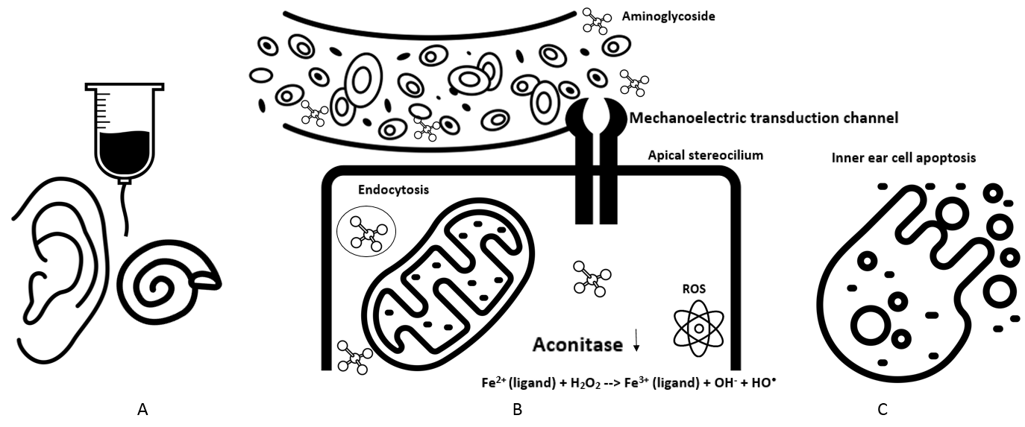
Figure S1. Schematic simplified overview of the pathophysiological mechanism of aminoglycoside-induced ototoxicity. Systemically administrated aminoglycosides (A) enter the inner ear via the bloodstream, and are taken up by inner ear cells via mechanoelectric transduction channels and apical endocytosis (B). Aminoglycosides interfere with mitochondrial ribosomes and perturb cell respiration by damage of aconitase leading to superoxide overproduction and free ferrous iron (Fenton reaction) (B). Reactive oxygen species (ROS) resulting from this reaction contribute to cell apoptosis (C). Icons are used from The Noun Project³².

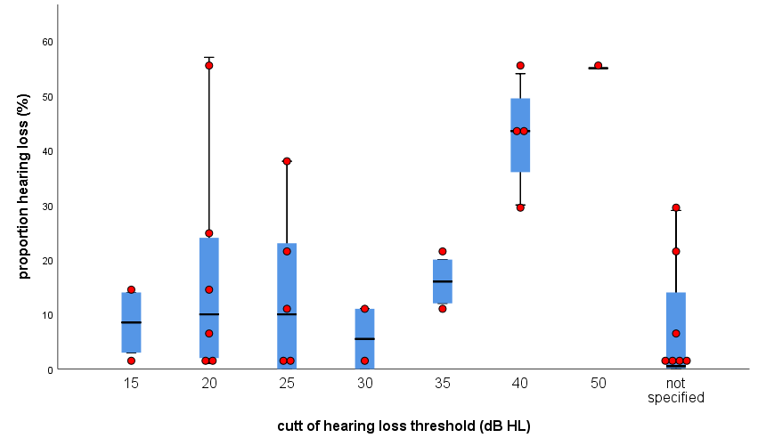

Figure S2. Boxplots with overlaid dot plot showing proportion hearing loss (%) for different values of minimum dB hearing loss. Three studies with a 100% hearing loss prevalence were excluded. Clemens et al (2016) determined separate frequencies for gentamicin, tobramycin and vancomycin.

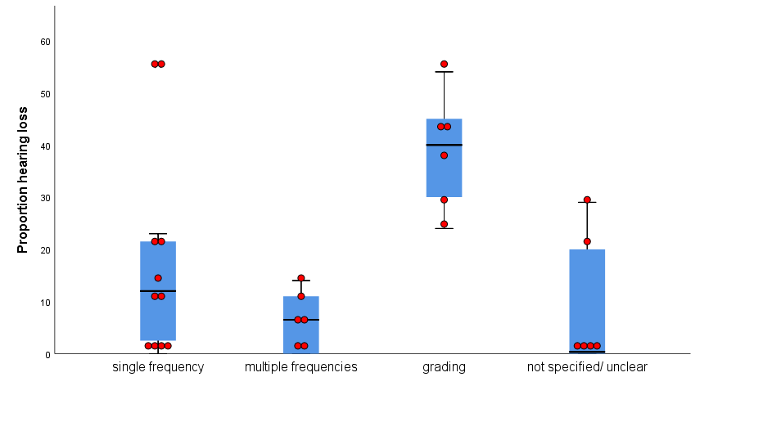
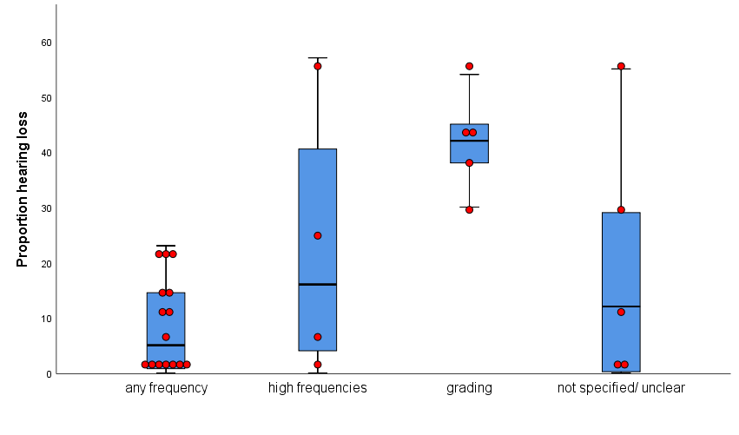

Figure S3: Boxplots showing the proportion hearing loss for different groups. Left figure: single frequency vs multi frequency vs grading criterion; right figure any frequency vs high frequencies vs grading. Brock and Muenster ototoxicity grading classifications were used in included studies. Three studies with a 100% hearing loss prevalence at time of inclusion were excluded. Clemens et al (2016) determined separate hearing loss proportions for gentamicin, tobramycin and vancomycin.
References

1. Carapetis JR, Jaquiery AL, Buttery JP et al. Randomized, controlled trial comparing once daily and three times daily gentamicin in children with urinary tract infections. Pediatr Infect Dis J 2001; 20: 240‐6.
2. Chong CY, Tan AS, Ng W et al. Treatment of urinary tract infection with gentamicin once or three times daily. Acta Paediatr 2003; 92: 291-6.
3. Elhanan K, Siplovich L, Raz R. Gentamicin once-daily versus thrice-daily in children. J Antimicrob Chemother 1995; 35: 327-32.
4. Frazier JP, Kramer WG, Pickering LK et al. Antimicrobial therapy of febrile children with malignancies and possible sepsis. Pediatr Infect Dis 1984; 3: 40-5.
5. Mulheran M, Hyman-Taylor P, Tan KH et al. Absence of cochleotoxicity measured by standard and high-frequency pure tone audiometry in a trial of once- versus three-times-daily tobramycin in cystic fibrosis patients. Antimicrob Agents Chemother 2006; 50: 2293‐9.
6. Pérez V, Saénz D, Madriz J et al. A double-blind study of the efficacy and safety of multiple daily doses of amikacin versus one daily dose for children with perforated appendicitis in Costa Rica. Int J Infect Dis 2011; 15: e569-e75.
7. Smyth A, Tan KH, Hyman-Taylor P et al. Once versus three-times daily regimens of tobramycin treatment for pulmonary exacerbations of cystic fibrosis--the TOPIC study: a randomised controlled trial. Lancet 2005; 365: 573-8.
8. Al-Malky G, Dawson SJ, Sirimanna T et al. High-frequency audiometry reveals high prevalence of aminoglycoside ototoxicity in children with cystic fibrosis. J Cyst Fibros 2015; 14: 248-54.
9. Best EJ, Gazarian M, Cohn R et al. Once-daily gentamicin in infants and children: A prospective cohort study evaluating safety and the role of therapeutic drug monitoring in minimizing toxicity. Pediatr Infect Dis J 2011; 30: 827-32.
10. Blankenship CM, Hunter LL, Feeney MP et al. Functional Impacts of Aminoglycoside Treatment on Speech Perception and Extended High-Frequency Hearing Loss in a Pediatric Cystic Fibrosis Cohort. Am J Audiol 2021; 30(3S):834-853
11. Buckingham SC, McCullers JA, Lujan-Zilbermann J et al. Early vancomycin therapy and adverse outcomes in children with pneumococcal meningitis. Pediatrics 2005; 117: 1688-94.
12. Bucuvalas JC, O'Connor A, Buschle K et al. Risk of hearing impairment in pediatric liver transplant recipients: A single center study. Pediatr Transplant 2003; 7: 265-9.
13. Camarda V, Moreno AM, Boschi V. Vestibular ototoxicity in children: A retrospective study of 52 cases. Int J Pediatr Otorhinolaryngol 1981; 3: 195-8.
14. Cheng AG, Johnston PR, Luz J et al. Sensorineural hearing loss in patients with cystic fibrosis. Otolaryngol Head Neck Surg 2009; 141: 86-90.
15. Clemens E, De Vries ACH, Van Dulmen-den Broeder E et al. Determinants of ototoxicity in 451 platinum-treated Dutch survivors of childhood cancer: A DCOG late-effects study. Eur J Cancer 2016; 62: S170.
16. Deutsch ES, Bartling V, Lawenda B et al. Sensorineural hearing loss in children after liver transplantation. Arch Otolaryngol Head Neck Surg 1998; 124: 529-33.
17. Handelsman JA, Nasr SZ, Pitts C et al. Prevalence of hearing and vestibular loss in cystic fibrosis patients exposed to aminoglycosides. Pediatr Pulmonol 2017; 52: 1157-62.
18. Hesseling PB, Mouton WL, Henning PA et al. A prospective study of long-term use of amikacin in a paediatrics department. Indications, administration, side-effects, bacterial isolates and resistance. S Afr Med J 1990; 78: 192-5.
19. Kafetzis DA, Sianidou L, Vlachos E et al. Clinical and pharmacokinetic study of a single daily dose of amikacin in paediatric patients with severe Gram-negative infections. J Antimicrob Chemother 1991; 27: 105-12.
20. Li Y, Zhu Y, Zhong Q et al. Serious Adverse Reactions From Anti-tuberculosis Drugs Among 599 Children Hospitalized for Tuberculosis. Pediatr Infect Dis J 2017; 36: 720-5.
21. Mancini ML, Dello Strologo L, Bianchi PM et al. Sensorineural hearing loss in patients reaching chronic renal failure in childhood. Pediatr Nephrol 1996; 10: 38-40.
22. Martins LM, Camargos PA, Becker HM et al. Hearing loss in cystic fibrosis. Int J Pediatr Otorhinolaryngol 2010; 74: 469-73.
23. Olgun Y, Aktas S, Altun Z et al. Analysis of genetic and non genetic risk factors for cisplatin ototoxicity in pediatric patients. Int J Pediatr Otorhinolaryngol 2016; 90: 64-9.
24. Piltcher OB, Teixeira VN, De Oliveira MW et al. The prevalence of neurosensorial hearing loss among cystic fibrosis patients from Hospital de Clínicas de Porto Alegre. Int J Pediatr Otorhinolaryngol 2003; 67: 939-41.
25. Prazic M, Salaj B. Ototoxicity with children caused by streptomycin. Audiology 1975; 14: 173-6.
26. Tomlinson RJ, Ronghe M, Goodbourne C et al. Once daily ceftriaxone and gentamicin for the treatment of febrile neutropenia. Arch Dis Child 1999; 80: 125-31.
27. Zagolski O. Vestibular system in infants after systemic aminoglycoside therapy. Int J Pediatr Otorhinolaryngol 2007; 71: 1797-802.
28. Freeland A, Jones J, Mohammed NK. Sensorineural deafness in Tanzanian children-Is ototoxicity a significant cause? A pilot study. Int J Pediatr Otorhinolaryngol 2010; 74: 516-9.
29. Judge PD, Jorgensen E, Lopez-Vazquez M et al. Medical Referral Patterns and Etiologies for Children With Mild-to-Severe Hearing Loss. Ear Hear 2019; 40: 1001-8.
30. Morioka I, Luo WZ, Miyashita K et al. Hearing impairment among young Chinese in a rural area. Public Health 1996; 110: 293-7.
31. Aguayo-Albasini JL, Flores-Pastor B, Soria-Aledo V. GRADE System: Classification of Quality of Evidence and Strength of Recommendation. Cirugía Española (English Edition) 2014; 92: 82-8.
32. S. Palyakov EB, J. Kocherhans. The Noun Project https://thenounproject.com/2010, date last accessed).

