Supplementary Appendix

Supplement to: Cardiac mortality in patients randomised to elective coronary revascularisation plus medical therapy or medical therapy alone: A systematic review and meta-analysis

Contents
Table 1s. Electronic search in Medline. 3
Table 2s. Study main inclusion and exclusion criteria. 4
Table 3s. Study risk of bias. 15
Table 4s. Patterns of drug therapy at randomisation across trials reporting cardiac death. 16
Table 5s. Egger’s test for the explored outcomes. 18
Figure 1s. Funnel plot for cardiac mortality. 19
Figure 2s. Fixed effect model for cardiac mortality. 20
Figure 3s. Analysis without studies that could enrol by protocol within two months post-ACS. 21
Figure 4s. Leave-one-out sensitivity analysis for cardiac mortality. 22
Figure 5s. Cardiac mortality without studies reporting cardiovascular mortality. 23
Figure 6s. Cardiac mortality without studies at risk of bias. 24
Figure 7As. Meta-regression of multivessel disease on cardiac mortality. 25
Figure 7Bs. Meta-regression of antithrombotic agents on cardiac mortality. 26
Figure 7Cs. Meta-regression of statins on cardiac mortality. 27
Figure 7Ds. Meta-regression of beta-blockers on cardiac mortality. 28
Figure 7Es. Meta-regression of ACE-inhibitors/ARBs on cardiac mortality. 29
Figure 7Fs. Meta-regression of study year on cardiac mortality. 30
Figure 8s. Trial sequential meta-analysis. 31
Figure 9s. Funnel plot for all-cause mortality. 32
Figure 10s. Random-effects model for all-cause mortality. 33
Figure 11s. Fixed effect model for all-cause mortality. 34
Figure 12s. All-cause mortality without the VA trial. 35
Figure 13s. Funnel plot for spontaneous myocardial infarction. 36
Figure 14s. Fixed effect model for spontaneous myocardial infarction. 37
Figure 15s. Funnel plot for any myocardial infarction. 38
Figure 16s. Random-effects model for any myocardial infarction. 39
Figure 17s. Meta-regression of absolute difference of procedural MI on cardiac mortality. 40
Figure 18s. Random-effects model for stroke. 41
Figure 19s. Fixed effect model for stroke. 42
Figure 20s. Funnel plot for stroke. 43

Table 1s. Electronic search in Medline.

Search | Query | Items found
#10 | Search ((ischemic heart disease disease) AND revascularization and medical therapy) Filters: Clinical Trial | 2243
#9 | Search ((ischemic heart disease) AND medical therapy) Filters: Clinical Trial | 12394
#8 | Search ((ischemic heart disease disease) AND revascularisation) Filters: Clinical Trial | 5332
#7 | Search ((coronary artery disease) AND revascularization AND medical therapy) Filters: Clinical Trial | 1138
#6 | Search ((coronary artery disease) AND medical therapy) Filters: Clinical Trial | 456
#5 | Search ((coronary artery disease) AND revascularisation) Filters: Clinical Trial | 2566
#4 | Search ((coronary) AND revascularization AND medical therapy) Filters: Clinical Trial | 2474
#3 | Search ((coronary) AND medical therapy) Filters: Clinical Trial | 32044
#2 | Search ((coronary) AND revascularisation) Filters: Clinical Trial | 5987
#1 | Search ((revascularisation) AND medical therapy) Filters: Clinical Trial | 2954

Table 2s. Study main inclusion and exclusion criteria.
Trial | Inclusion criteria | Exclusion criteria | Primary outcome | Definition of MI | Proportion of subjects in the revascularisation+MT arm actually revascularised in the intended time frame
ACIP | Asymptomatic ischemia on 48h ambulatory ECG and on treadmill stress test. CAD at angiography (>50% diameter stenosis in ≥1 major vessel) | MI <4 weeks; angioplasty within the previous 6 months | Suppression of ischemic episodes on the 48h ambulatory ECG | NR | 90.2%
ACME-1 | Men with stable angina, positive stress test or MI in previous 3 months or filling defect on thallium scan. Single-vessel CAD at angiography (70-99% stenosis) | Female sex, medically refractory unstable angina, previous coronary artery revascularisation, primary cardiac diagnosis other than CAD, left main stenosis, stenosis of more than one major coronary artery, left ventricular ejection fraction <30% | Death, myocardial infarction, unstable angina | New Q wave on ECG or increase in CK level above normal with typical clinical signs. Procedural MI defined likewise around the time of the procedure | 95.2%
ACME-2 | Men with stable angina, positive stress test (horizontal or down-sloping ST-segment depression ≥1 mm) or filling defect on thallium scan, or MI in previous 3 months. Double-vessel CAD at angiography (70-99% stenosis) | Female sex, medically refractory unstable angina, previous coronary artery revascularisation, primary cardiac diagnosis other than CAD, left main stenosis, stenosis of more than two major coronary arteries (three-vessel disease), left ventricular ejection fraction <30% | Death, myocardial infarction, unstable angina | New Q wave (≥0.04 s duration or ≥25% total QRS voltage) in any anterior or lateral lead or in ≥2 contiguous inferior leads on a follow-up ECG or hospital admission for chest pain accompanied by serum biomarker changes meeting local hospital criteria for MI. Procedural MI defined likewise around the time of the procedure | 96.9%
AVERT | ≥50% stenosis of at least 1 coronary artery for which PCI was recommended, asymptomatic or CCS class I or II angina, completion of at least 4 min of stress test without ischemia, LDL-cholesterol ≥115 mg/dL, and triglycerides <500 mg/dL | Left main disease, 3 vessel CAD, unstable angina, MI in prior 2 weeks, left ventricular ejection fraction <40% | Composite ofischemicevents, which included cardiac death, resuscitated cardiac arrest, nonfatal MI, stroke, PCI, CABG, and worsening angina requiring hospitalisation | NR | 93.7%
BARI 2D | Type II diabetes mellitus, ≥50% stenosis of major coronary artery with positive stress test or ≥70% stenosis of major coronary artery with typical angina | Need for immediate revascularisation, left main disease, creatinine >2 mg/dL, glycated haemoglobin >13%, class III or IV heart failure, hepatic dysfunction, PCI or CABG in previous 12 months | All-cause mortality | Spontaneous MI as doubling of cardiac biomarkers (CK-MB or troponin) and evidence of ischemia on the basis of symptoms, ECG or imaging. Silent MI as a Q-wave change of two grades on routine ECG. Procedural MI as CK-MB elevation of 3 x and 10 x above normal for PCI and CABG respectively | 96%
CASS | Stable, mildly symptomatic patients, 65 years of age or younger, presence of significant CAD at angiography, with either ≥70% left anterior descending or left circumflex stenosis or >50% stenosis of the left main stem | Unstable or progressive angina, CCS class III or IV, ≥70% left main stem stenosis, congestive heart failure (New York Heart Association class III or IV), prior CABG, left ventricular ejection fraction <35% | All-cause mortality | NR | NR
COURAGE | ≥70% coronary stenosis in at least 1 proximal artery, inducible ischemia on stress testing or ST-segment depression or T wave inversion on resting ECG | CCS class IV angina, substantial ST-segment depression or hypotension during Bruce protocol stage 1 stress test, refractory heart failure or cardiogenic shock, left ventricular ejection fraction <30%, revascularisation in prior 6 months, unsuitable coronary anatomy for PCI | Composite of all-cause death or nonfatal MI | Clinical presentation consistent with an ACS and either new abnormal Q waves in ≥2 ECG leads or positive results in cardiac biomarkers; silent MI if abnormal Q waves confirmed by a core laboratory; procedural MI similarly defined | 99.4%
DECISION-CTO | Age >18 yrs; silent ischemia or stable angina or post-ACS; de novo proximal to midepicardial CTO with a reference vessel diameter of ≥2.5 mm | Distal CTO, 3 different vessel CTOs at any location, 2 proximal CTOs in separate coronary arteries, CTO in the left main stem, in-stent restenosis, graft vessel, MI requiring primary PCI, complex CAD more appropriate for CABG, serum creatinine ≥2.0 mg/dl, left ventricular ejection fraction <30% | Composite of all-cause death, MI, stroke, any revascularisation | Periprocedural MI: in case of normal baseline CK-MB, elevations >5 x upper normal limit. In case of elevated CK-MB, increase >5 x upper normal limit as well as a rise >20% relative to baseline with documentation that values were decreasing or at nadir before PCI.  Spontaneous MI: typical rise and gradual fall of troponin or more rapid rise and fall of CK-MB for detecting myocardial necrosis with at least one of:  1. typical or atypicalischemicsymptoms;  2. development of pathologic Q waves, or new LBBB; OR  3. ECG changes indicative of ischemia (ST-segment elevation or depression) | 92.9%
DEFER | >50% coronary stenosis in native artery at angiography, FFR ≥0.75 and no evidence of reversible ischemia on noninvasive testing performed within 2 months | Total occlusion of the target artery, Q-wave infarction, unstable angina, or small target arteries | Composite of all-cause death, MI, CABG, PCI, and any procedure-related complication requiring major intervention or prolonged hospital stay | New pathological Q-waves on ECG or increase of serum CK levels >2 x the normal value. Procedural MI: in-hospital post procedural MI similarly defined | 100%
ECSS | Angina, ≥50% coronary stenosis of at least two major vessels and absence of left ventricular dysfunction | Marked ventricular dysfunction | All-cause mortality. Cardiac mortality also reported | NR | NR
EURO-CTO | Symptomatic patients with at least one CTO suitable for PCI in a major coronary artery (diameter ≥2.5 mm). Prior ACS related to a non-CTO lesion successfully treated more than 4 weeks before enrolment | Contraindication to DES (e.g., patient not tolerating dual antiplatelet therapy or requiring elective non-cardiac surgery within 6 months) | Health status subscales as assessed by Seattle angina questionnaire | Universal definition of MI: rise of cardiac biomarker (preferably troponin with at least one value > 99th percentile of upper reference limit) combined with either symptoms of ischemia, new or presumed new significant ST-segment T-wave changes, new LBBB, development of pathological Q-waves, new regional wall motion abnormality, or identification of intracoronary thrombus by angiography or autopsy | 98%
FAME-2 | Stable angina or documented silent ischemia and at least one ≥50% stenosis in a large epicardial artery suitable for PCI | Preferred CABG, left main disease, recent (less than 1 week) ST-segment or non-ST-segment elevation MI, prior CABG, left ventricular ejection fraction <30%, left ventricular hypertrophy | Composite of death from any cause, MI, urgent revascularisation | A. Within 24h after randomization or any PCI:  I. single CK-MB >10 x 99th percentile upper reference limit, OR  II. single CK-MB >5 x 99th percentile upper reference limit PLUS at least one of:  new pathological Q waves in at least 2 contiguous leads or new persistent nonrate related LBBB, or angiographically documented native coronary artery occlusion, or imaging evidence of new loss of viable myocardium  B. More than 24h after  randomization:  I. rise and/or fall of CK-MB or troponin with at least one value > 99th percentile of upper reference limit together with evidence of myocardial ischemia with at least one of the following:  symptoms of ischemia, or ECG changes indicative of new ischemia (new ST-T changes or new LBBB), OR  II. development of pathological Q waves (≥0.03 s in duration and ≥1 mm in depth) in ≥2 contiguous precordial leads or ≥2 adjacent limb leads) of the ECG, OR  III. imaging evidence of loss of viable myocardium or new regional wall motion abnormality | 100%
INSPIRE | Recent MI and large total (≥20%) andischemic(≥10%) adenosine-induced left ventricular perfusion defect, with left ventricular ejection fraction ≥35% | Cardiogenic shock, recurrent chest pain, decompensated congestive heart failure, sustained ventricular tachycardia, LBBB, contraindication to adenosine |  | NR | 81%
ISCHEMIA | Stableischemicheart disease and moderate to severe ischemia on noninvasive stress testing | Left ventricular ejection fraction <35%, ≥50% left main stenosis, advanced CKD (eGFR <30 ml/min/1.73m²), MI within 2 months, unacceptable angina at baseline, NYHA class III-IV heart failure, prior PCI or CABG within the last year | Composite of cardiovascular death, MI, resuscitated cardiac arrest, or hospitalization for unstable angina or heart failure | Primary definition based on the universal definition of MI, but relying on site-reported limits (which may or may not be the same as the manufacturer’s 99% upper limit of normal).  Peri-PCI MI: rise in CK-MB to >5 x upper reference limit (or rise in troponin to >35 x the MI decision limit, when  CK-MB unavailable) within 48h post-PCI and at least one of:  a) angiographic findings; b) new EKG changes.  Peri-CABG MI: rise in CK-MB to >10 x the upper limit of normal (or rise in troponin to >70 x MI decision limit when CK-MB unavailable) within 48 hrs post-CABG and at least one:  a) substantial wall motion abnormality by imaging; b) new pathological Q waves  or new persistent LBBB | 79%
ISCHEMIA-CKD | Advanced kidney disease (eGFR <30 ml/min/1.73m²) and moderate or severe myocardial ischemia | Left ventricular ejection fraction <35%, ≥50% left main stenosis; ACS within 2 months, PCI within 12 months, stroke within 6 months or spontaneous intracranial haemorrhage at any time, ventricular tachycardia, NYHA class III-IV | Composite of death or nonfatal MI | Same as ISCHEMIA | 49%
JSAP | Inducible ischemia on stress test or ST depression or T-wave inversion on resting ECG and ≥75% (or ≥60% on quantitative angiography) coronary stenosis of 1 or 2 vessels, | Three vessel or left main or ostial LAD disease, total occlusion, ACS, left ventricular ejection fraction <50%, bleeding tendency, disseminated intravascular coagulation, severe pneumonia, creatinine >1.5 mg/ dL, graft stenosis, low-risk CAD where PCI or medical therapy had already been prescribed | Composite of all-cause death, ACS, stroke, emergent hospitalisation requiring intensive care | New abnormal Q waves in ≥2 ECG leads during follow-up, or convincing clinical history associated with ECG changes compatible with non–Q-wave infarction, and serum level of ≥2 cardiac biomarkers greater than twice normal | 100%
MASS-1 | ≥80% LAD stenosis before takeoff of first diagonal branch, single vessel CAD | Total occlusion, lesion length >12 mm, involvement of the ostium, heavy calcification, severe tortuosity, left main disease, unstable angina, prior MI, significant valvular disease, cardiomyopathy, left ventricular dysfunction, prior PCI or CABG | Composite of cardiac death, MI, or refractory angina requiring revascularisation; surgical revascularisation in PCI group | Significant new Q waves in ≥2 ECG leads or symptoms compatible with an MI associated with CK-MB elevation greater than 3 x the upper limit of normal | 100%
MASS-2 | ≥70% proximal multivessel stenosis and documented ischemia by stress testing or CCS angina class II or III | Unstable angina, acute MI requiring emergent revascularisation, ventricular aneurysm requiring surgical repair, left ventricular ejection fraction <40%, prior PCI or CABG, single vessel CAD, congenital heart disease, valvular heart disease, cardiomyopathy, left main stenosis ≥50%, unable to comply with protocol or follow-up, suspected or known pregnancy | Composite of cardiac death, MI, or refractory angina requiring revascularisation | Significant new Q waves in ≥2 ECG leads or symptoms compatible with an MI associated with CK-MB elevation greater than 3 x the upper limit of normal | 96%
Mathur | Men with chronic angina refractory to at least 3 months of intensive medical treatment and with significant  (>70%) coronary artery stenosis in ≥1 major coronary artery | Cardiac operation in conjunction with the bypass procedure, critical stenosis of the left main stem, severe distal arterial disease rendering bypass impractical, left ventricular ejection fraction <15% | Cardiac death, all-cause death, MI, revascularisation, exercise tolerance, angina | NR | 100%
ORBITA | Stable angina and anatomically (>70%) and haemodynamically severe coronary stenosis | Angiographic stenosis greater than or equal to 50% in a non-target vessel, ACS, previous CABG, left main disease, contraindications to DES, CTO, severe valvular disease, severe left ventricular systolic impairment, moderate-to severe pulmonary hypertension, life expectancy less than 2 years, inability to give consent | Difference in exercise time increment | NR | 99%
REVASC | CTO candidates for PCI defined as vessels with 100% stenosis, TIMI flow grade 0 >3 months, vessel diameter of 2.5 to 4.0 mm | Left ventricular ejection fraction <25%, recent ACS, contraindications to cardiac magnetic resonance imaging | Change in segmental wall thickening in the CTO territory | Third universal definition of MI | 100%
RITA-2 | ≥50% (2 views) or ≥70% (1 view) stenosis in at least 1 major artery amenable to PTCA, unstable angina at least 7 days before randomization | Revascularisation necessary for symptom relief or prognostic benefit, prior revascularisation, significant left main disease, ACS in the previous 7 days, haemo- dynamically significant valve disease, life-threatening noncardiac disease | Composite of all-cause death and nonfatal MI | New pathological Q waves (>30 ms in duration) on an ECG within 7 days of any myocardial revascularisation procedure (procedural infarction) or during subsequent follow-up or typical clinical history associated with ECG changes compatible with non-Q-wave infarction and serum levels of ≥2 cardiac biomarkers above twice normal | 93.4%
SWISSI-2 | Prior MI within 3 months; maximal exercise test with silent ST-depression confirmed by stress imaging, no malignancy, 1–2 vessel CAD on angiography | 3 vessel CAD, coronary lesions not technically amenable to PCI | Composite of cardiac death, nonfatal recurrent MI (including silent MI) and symptom-driven revascularisation with PCI or CABG | Typical chest pain, ST-segment elevation on ECG,  and/or typical rise  and fall of cardiac enzymes. Silent MI diagnosed by new Q waves on resting ECG documented by new distinct wall motion abnormalities on resting echocardiogram with a fall in left ventricular ejection fraction >5% and/or >10% vs a previous echocardiogram | 100%
TIME | Age >75 yrs with chronic CCS class II angina or higher, refractory to at least 2 antianginal drugs | Acute MI within 10 days | Quality of life, freedom from major adverse cardiac events (death, MI, ACS) after 6 months | Clinical event with significant  ECG and enzyme changes.  In the context of revascularisation: infarct-typical ECG changes with rise of  CK-MB, troponin, or both, twice the upper limit of normal | 70.3%
VA | Symptomatic patients with stable angina, electrocardiographic evidence of ischemia and >1 major coronary artery stenosis >50% at angiography | Acute MI within six months or refractory systemic diastolic hypertension | Survival | NR | 93.9%
ACIP=Asymptomatic Cardiac Ischemia Pilot Study; ACME=Angioplasty Compared to Medicine; AVERT=Atorvastatin versus Revascularization Treatment; BARI 2D=Bypass Angioplasty Revascularization Investigation 2 Diabetes; CASS= Coronary Artery Surgery Study; COURAGE=Clinical Outcomes Utilizing Revascularization and Aggressive Drug Evaluation; DECISION-CTO= Randomised Trial Evaluating Percutaneous Coronary Intervention for the Treatment of Chronic Total Occlusion; DEFER= Fractional Flow Reserve to Determine the Appropriateness of Angioplasty in Moderate Coronary Stenosis; ECSS= European Coronary Surgery Study; EURO-CTO= A randomised multicentre trial to compare revascularization with optimal medical therapy for the treatment of chronic total coronary occlusions; FAME 2= Fraction flow reserve versus Angiography for Multivessel Evaluation 2; INSPIRE=Adenosine Sestamibi Post-Infarction Evaluation; ISCHEMIA=International Study of Comparative Health Effectiveness with Medical and Invasive Approaches; ISCHEMIA-CKD=International Study of Comparative Health Effectiveness with Medical and Invasive Approaches- Chronic Kidney Disease; JSAP=Japanese Stable Angina Pectoris; MASS=Medicine, Angioplasty, or Surgery Study; RITA=Randomised Intervention Treatment of Angina; SWISSI II=Swiss Interventional Study on Silent Ischemia Type II; TIME= Trial of Invasive Versus Medical Therapy in Elderly Patients; VA= Veterans Administration Cooperative Study.
ACS, acute coronary syndrome; CABG, coronary artery bypass grafting; CAD, coronary artery disease; CCS, Canadian Cardiovascular Society; CKD, chronic kidney dysfunction, CK-MB, creatine kinase-MB; CTO, chronic total occlusion; DES, drug eluting stent; ECG, electrocardiogram; FFR, fractional flow reserve; LAD, left anterior descending; LDL, low-density lipoprotein; LBBB, left bundle branch block; MI, myocardial infarction; MT= medical therapy; NYHA, New York Heart Association; NR, not reported; OMT, optimal medical therapy; PCI, percutaneous coronary intervention; PTCA, percutaneous transluminal coronary angioplasty.

Table 3s. Study risk of bias.
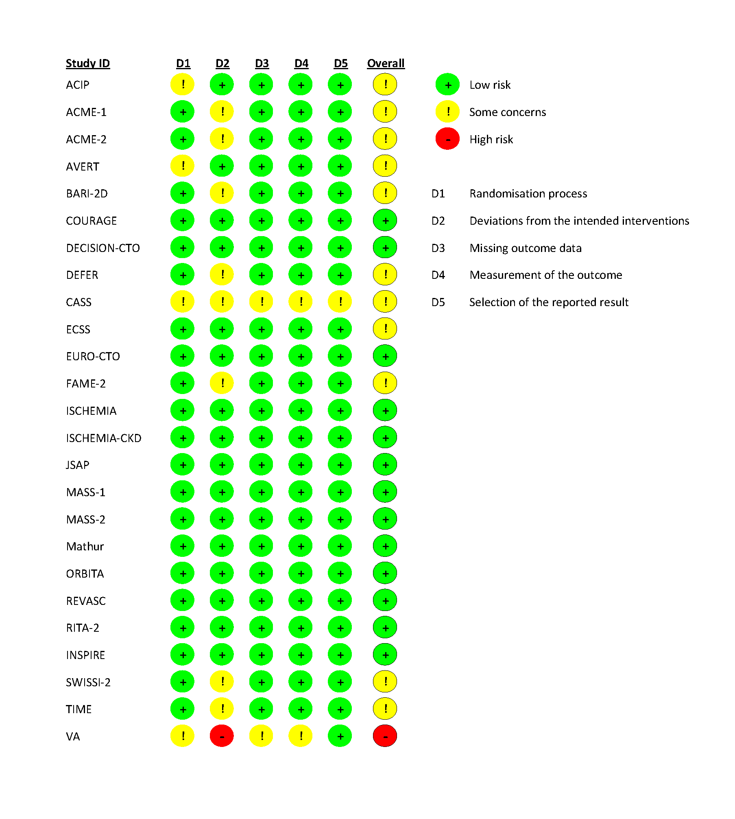

Table 4s. Patterns of drug therapy at randomisation across trials reporting cardiac death.
 | Statins (%) |  | Beta-blockers (%) |  | Antithrombotic agents (%) |  | ACE-inhibitors/ARBs (%)
Study | Revasc | Medical therapy | Revasc | Medical therapy | Revasc | Medical therapy | Revasc | Medical therapy
AVERT | 71 | 93* | 69 | 62 | NR | NR | 8 | 9
BARI 2D | 74.9** |  | 72.9** |  | 88** |  | 77.1**
COURAGE | 86 | 89 | 85 | 89 | 95 | 95 | 66.23 | 64.5
DECISION-CTO | 95.1 | 95.1 | 64.4 | 63 | 98.8 | 96.4 | 48.5 | 45.3
DEFER | 37 | 37 | 62 | 71 | 92 | 92 | 0 | 0
ECSS | 0 | 0 | 75 | 74 | NR | NR | 0 | 0
EURO-CTO | 90.7 | 91.2 | 76.1 | 81.8 | 100 | 94.9 | 54.7 | 55.2
FAME-2 | 82.8 | 81.9 | 77.8 | 75.6 | 100 | 100 | 69.8 | 68.7
INSPIRE | 77 | 84 | 86 | 93 | 95 | 100 | 77 | 57
ISCHEMIA | 94.3 | 95 | 80 | 79 | 100 | 100 | 66.9 | 65.2
ISCHEMIA-CKD | 81.7 | 80.5 | NR | NR | 84.2 | 82.3 | 47.8 | 47.5
JSAP | 52 | 52 | 43.6 | 52 | 91.7 | 91.4 | 38 | 39.6
MASS-1 | NR | NR | NR | NR | NR | NR | NR | NR
MASS-2 | NR | NR | NR | NR | NR | NR | NR | NR
Mathur | 0 | 0 | NR | NR | NR | NR | 0 | 0
ORBITA | 97 | 96 | 81 | 76 | 99 | 97 | 81 | 79
REVASC | 98 | 99 | 83.2 | 76 | 97 | 96.2 | 76.9 | 82.2
RITA-2 | 13.8 | 11.7 | 68.2 | 65.2 | 87.1 | 86.9 | 9.1 | 10.9
SWISSI-2 | 100 | 100 | NR | NR | 100 | 100 | NR | NR
TIME | 25 | 22 | 82 | 72 | 85 | 82 | 23 | 35
* High dose by protocol; **average reported; ACE= angiotensin converting enzyme; ARB= angiotensin II receptor blocker; NR= not reported; Revasc= revascularisation.

Table 5s. Egger’s test for the explored outcomes.

Outcome | Intercept | P value
Cardiac mortality | - 0.30 | 0.48
All-cause mortality | - 0.71 | 0.05
Spontaneous myocardial infarction | 0.48 | 0.28
Any myocardial infarction | - 0.25 | 0.66
Stroke | - 0.282 | 0.70

Figure 1s. Funnel plot for cardiac mortality.

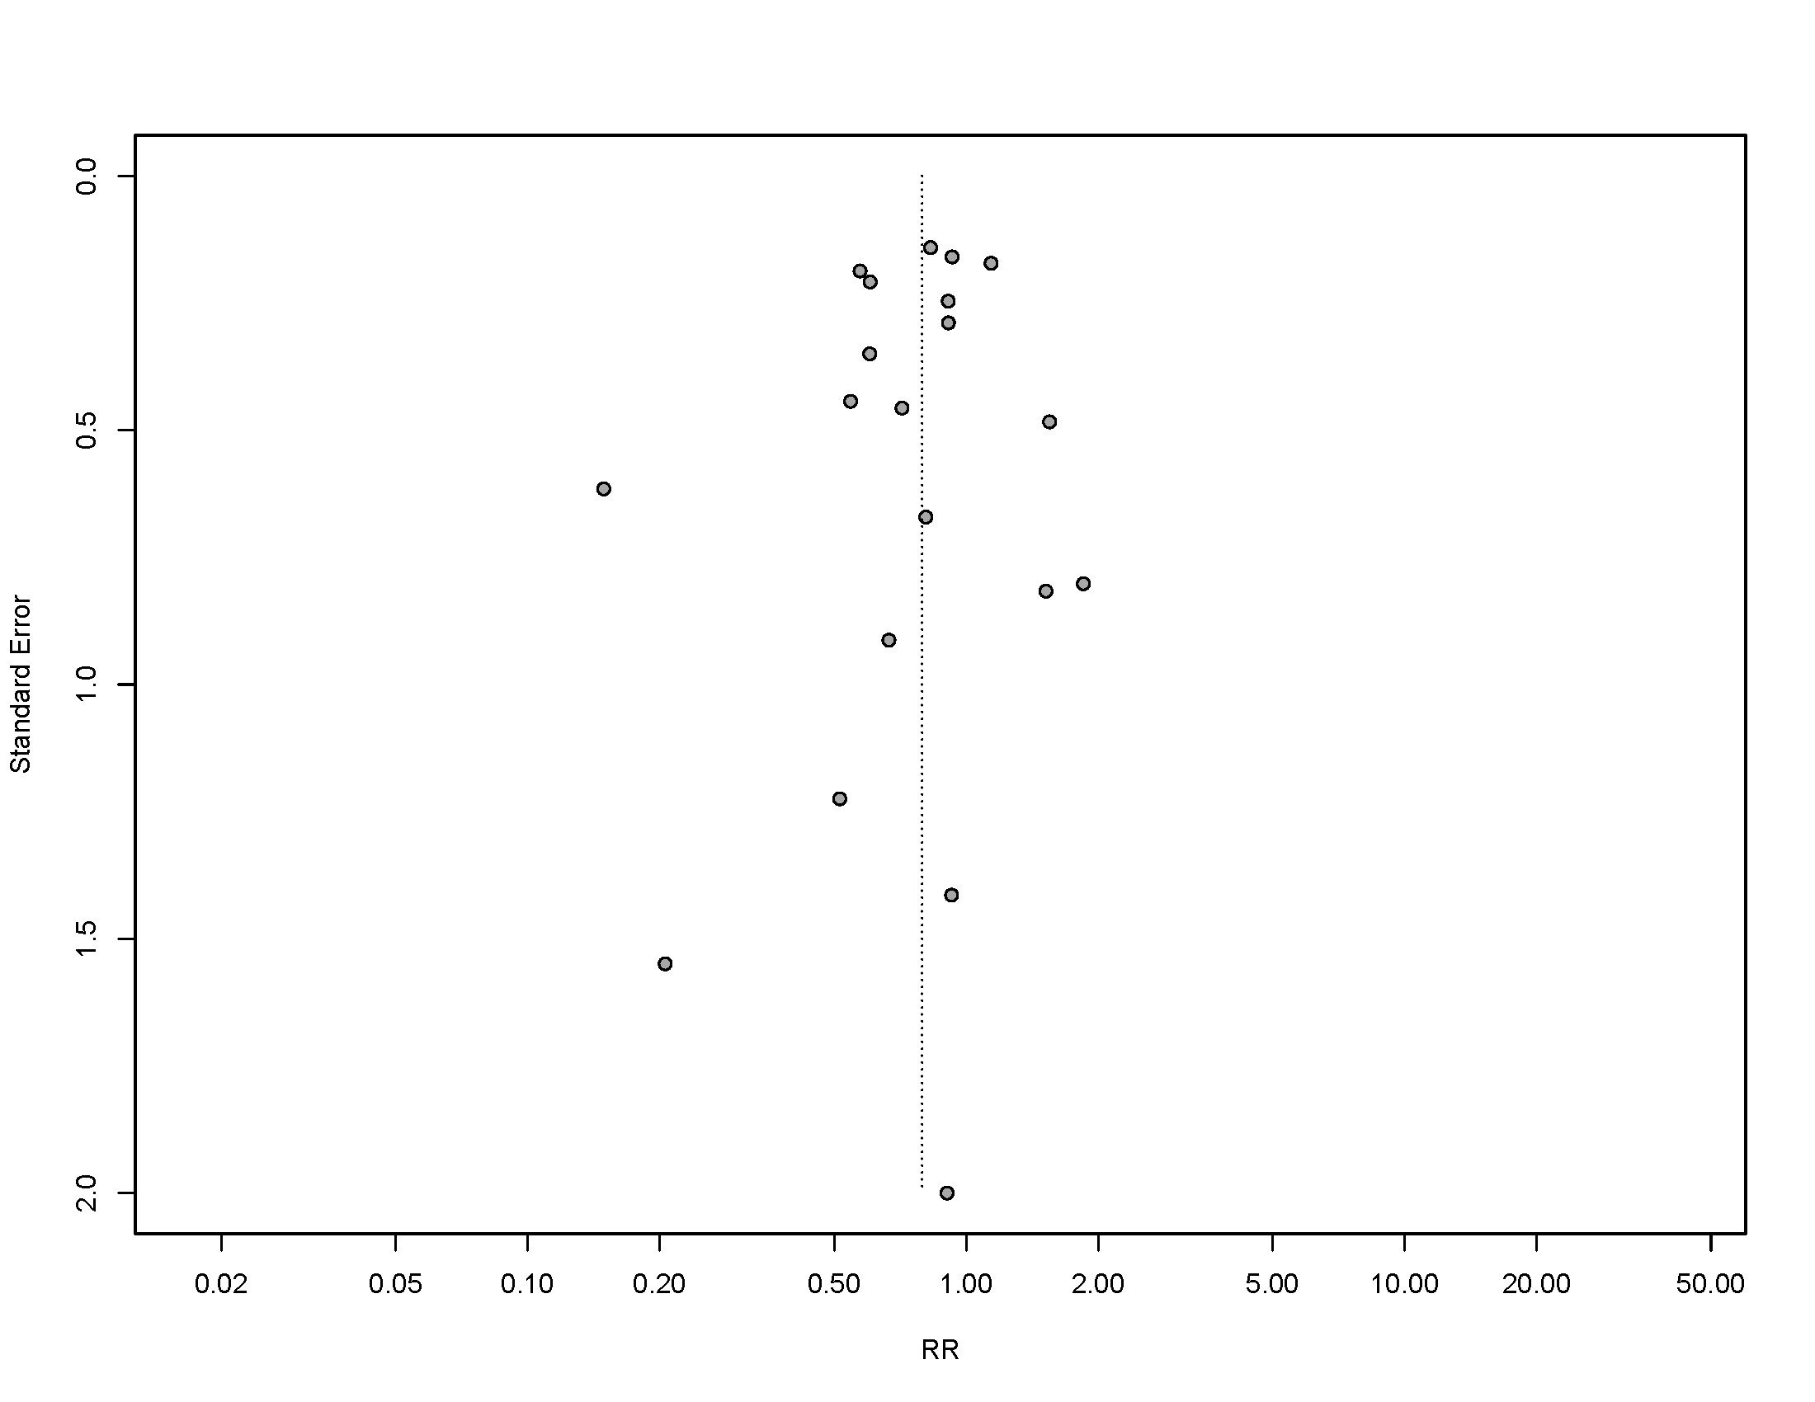

Figure 2s. Fixed effect model for cardiac mortality.

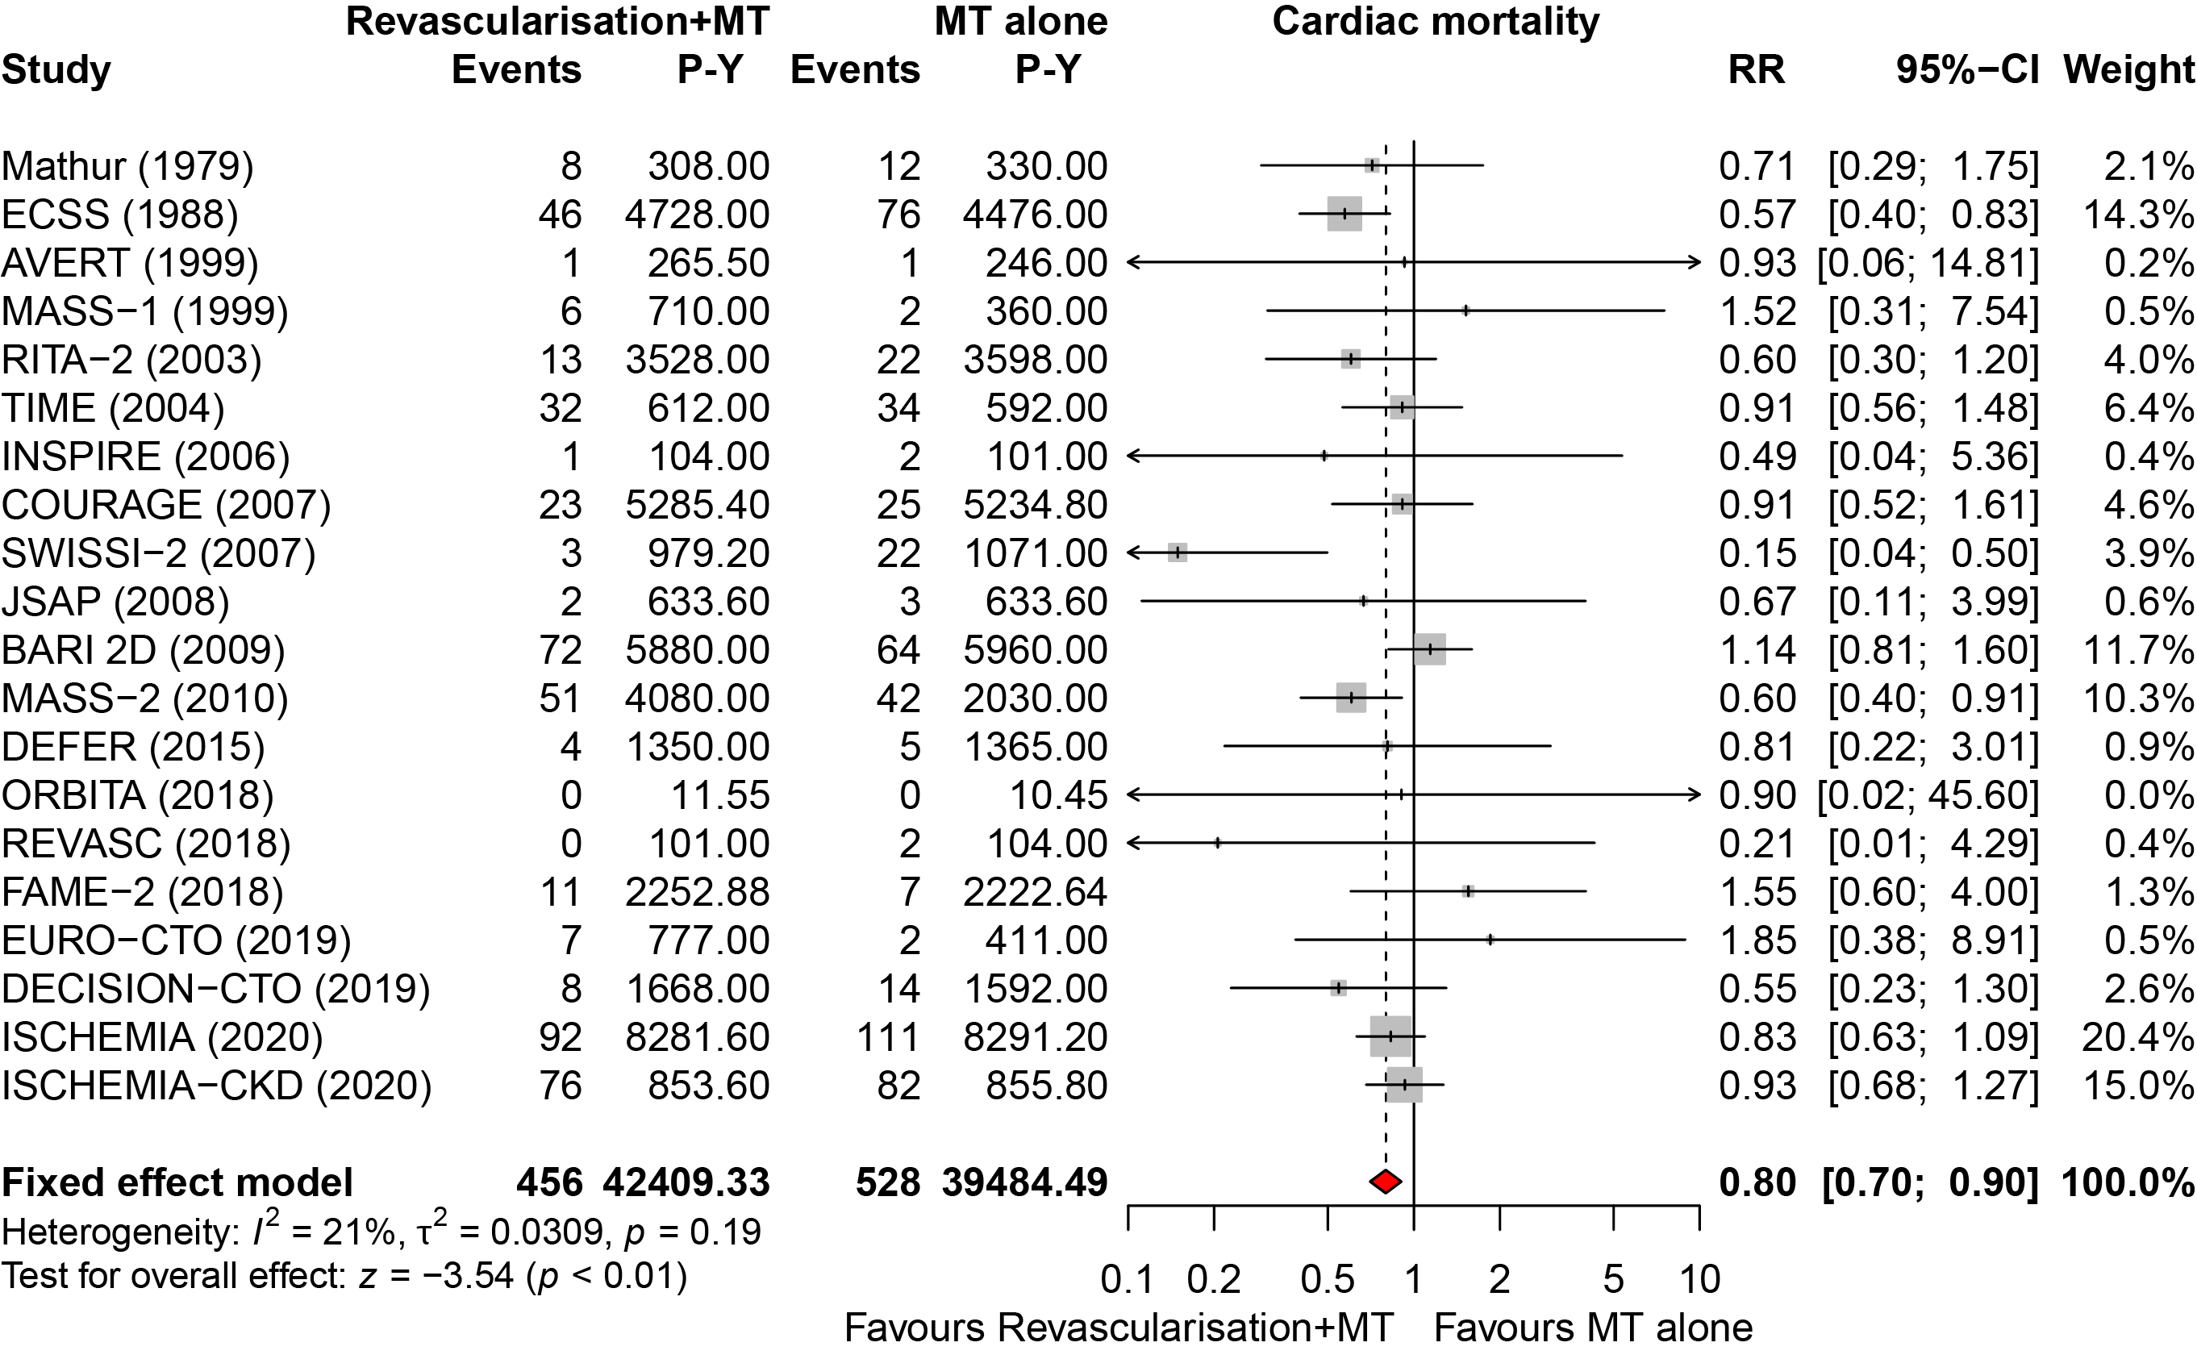

Figure 3s. Analysis without studies that could enroll by protocol within two months post-ACS.
ACS= acute coronary syndrome.
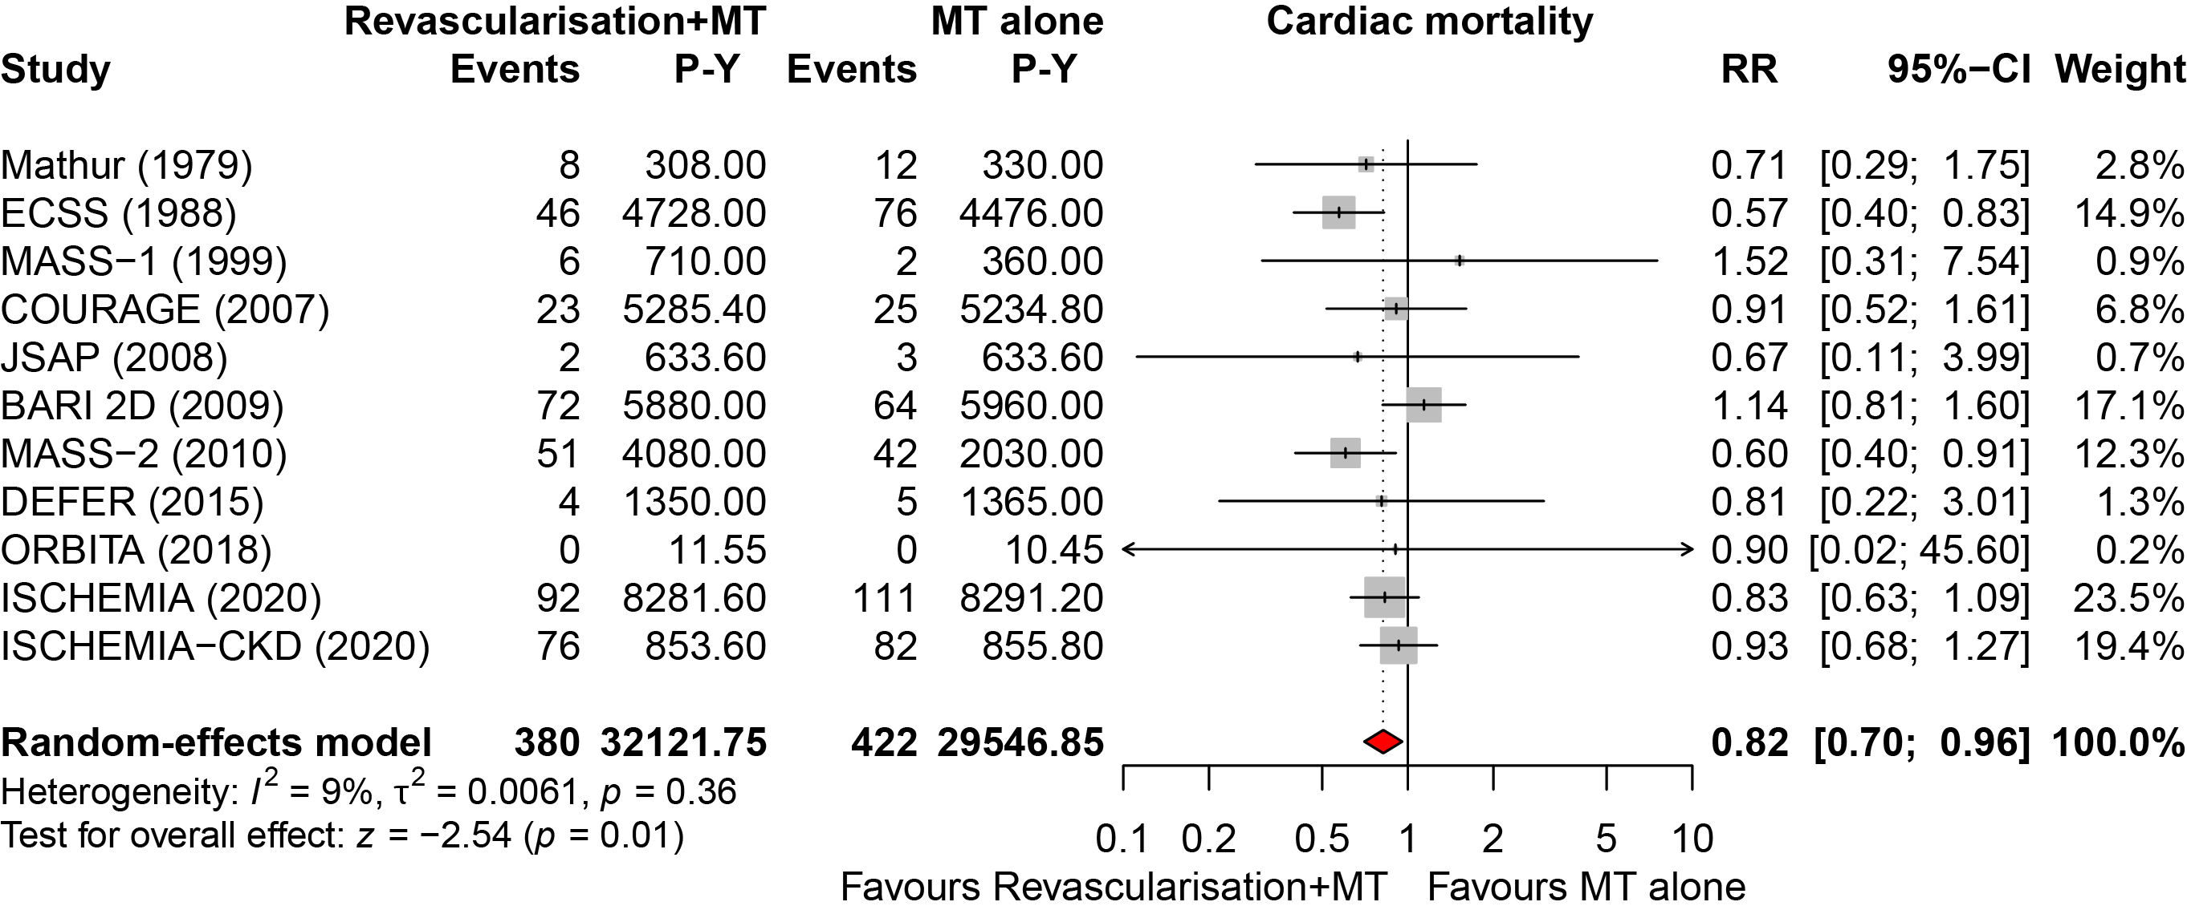

Figure 4s. Leave-one-out sensitivity analysis for cardiac mortality.
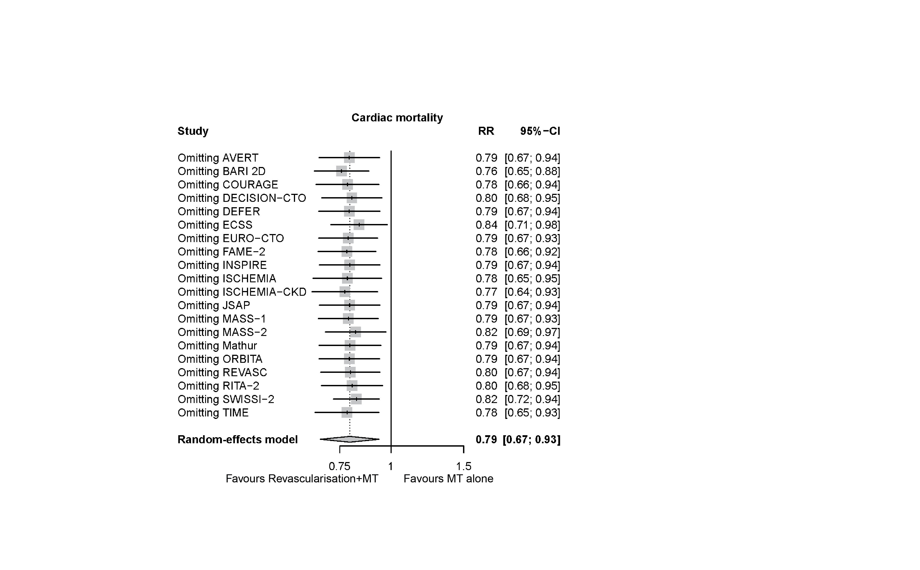

Figure 5s. Cardiac mortality without studies reporting cardiovascular mortality.

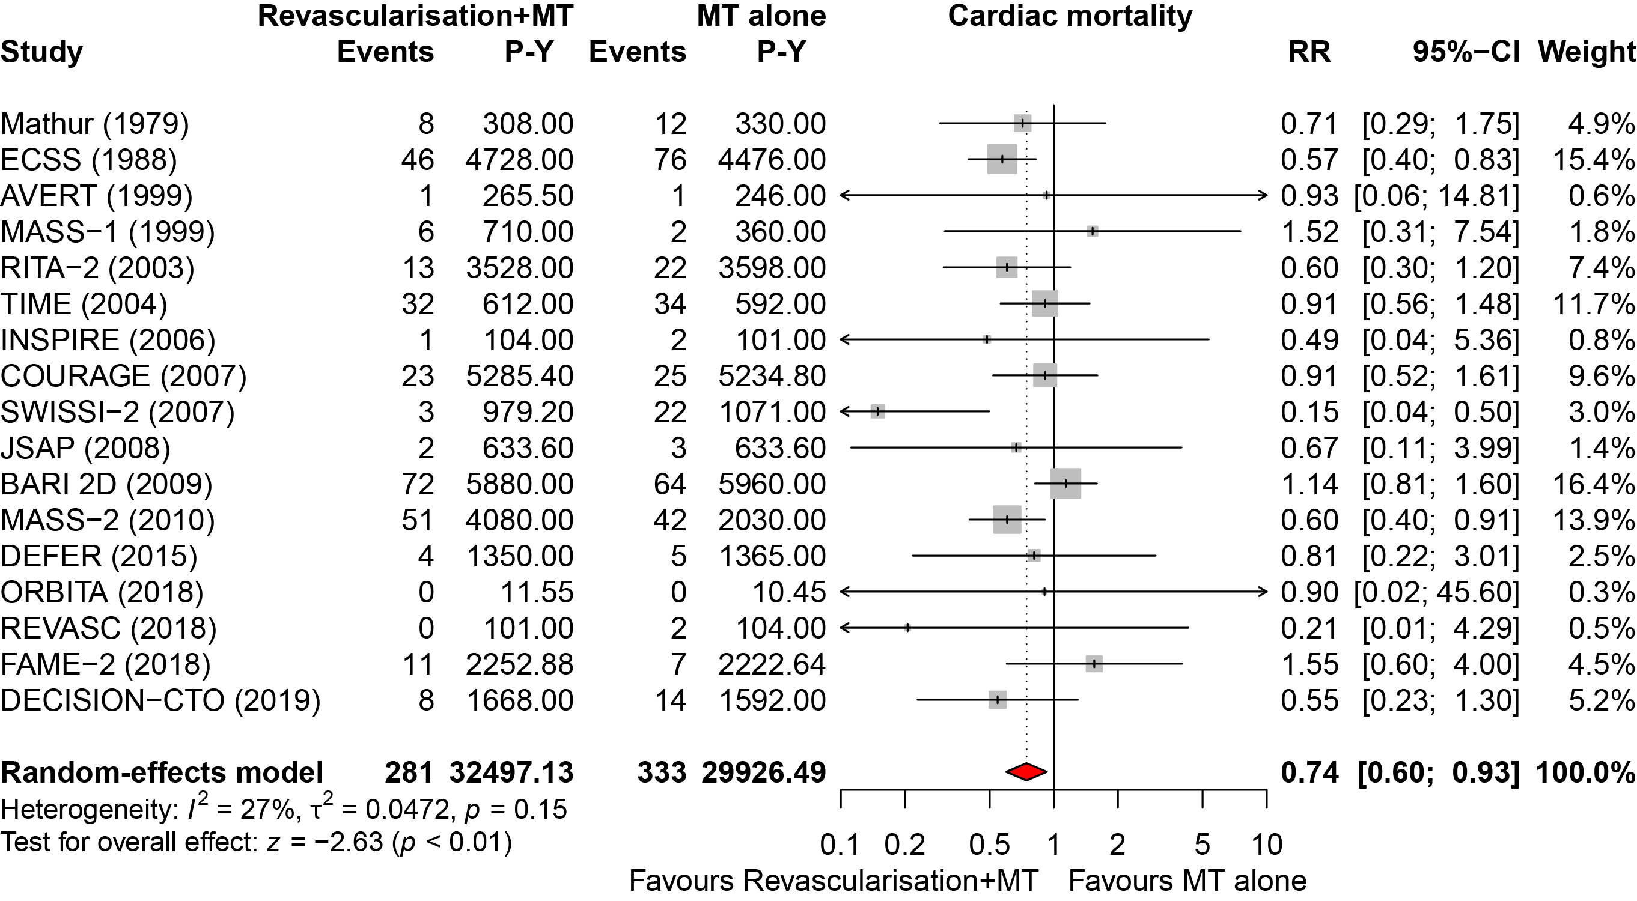

Figure 6s. Cardiac mortality without studies at risk of bias.

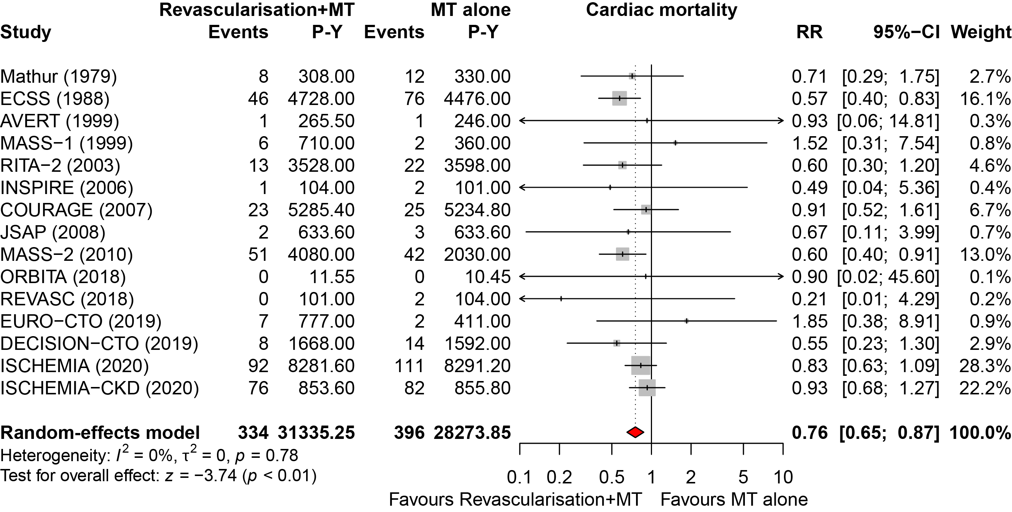

Figure 7As. Meta-regression of multivessel disease on cardiac mortality.

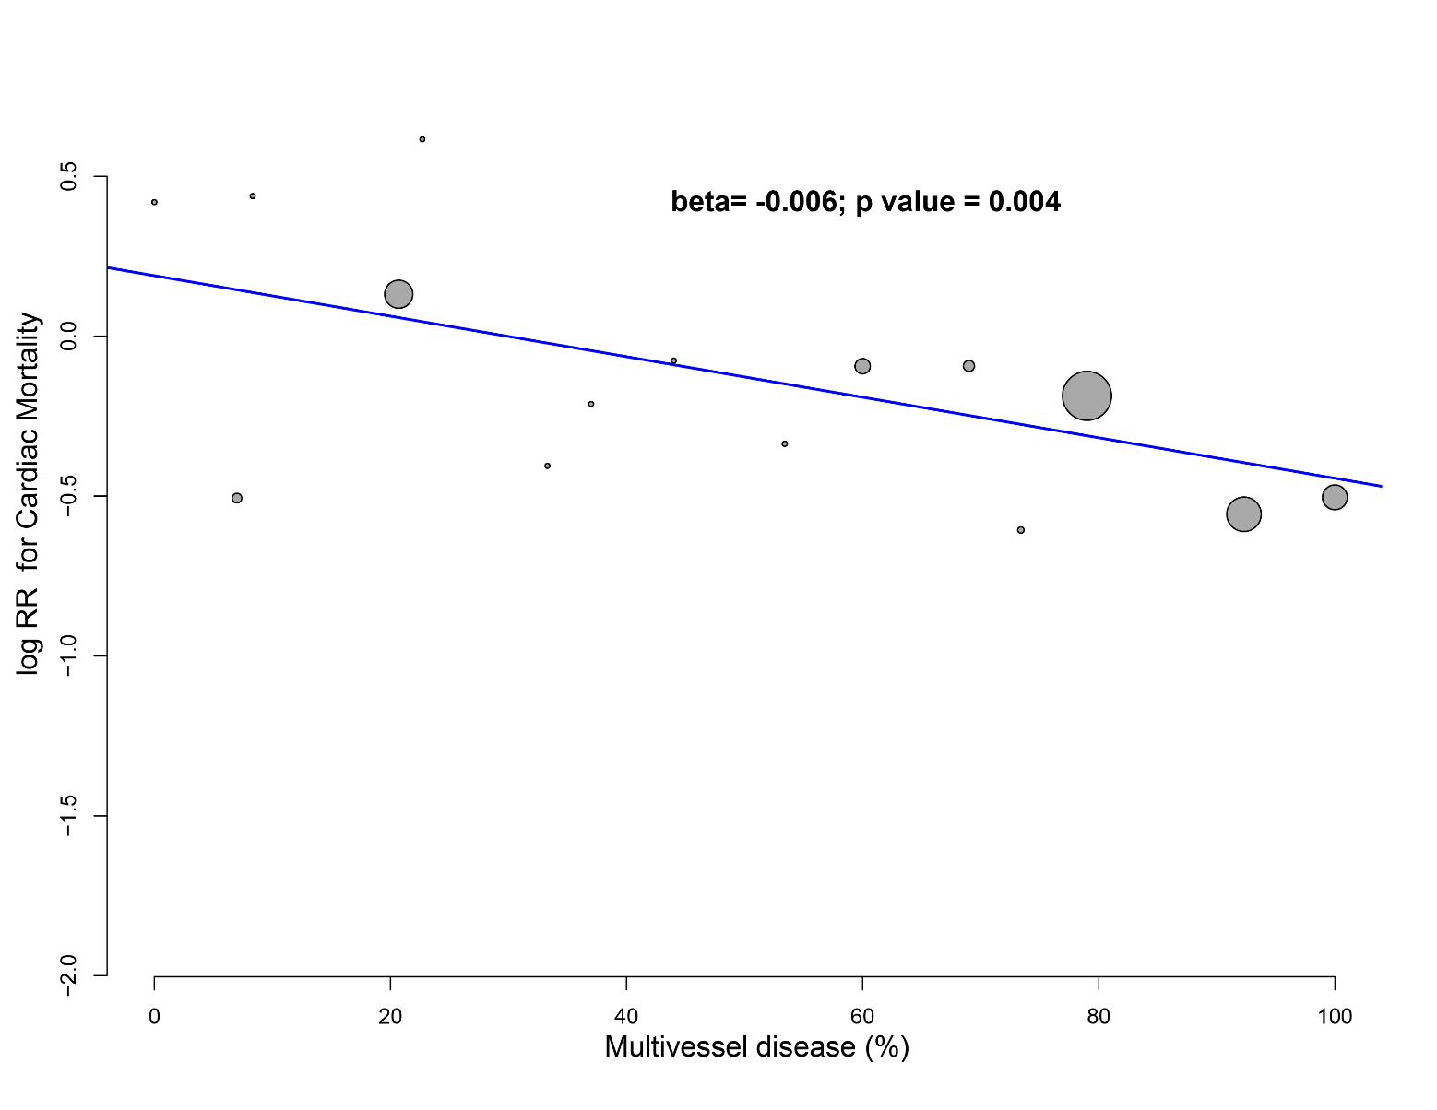

Figure 7Bs. Meta-regression of antithrombotic agents on cardiac mortality.
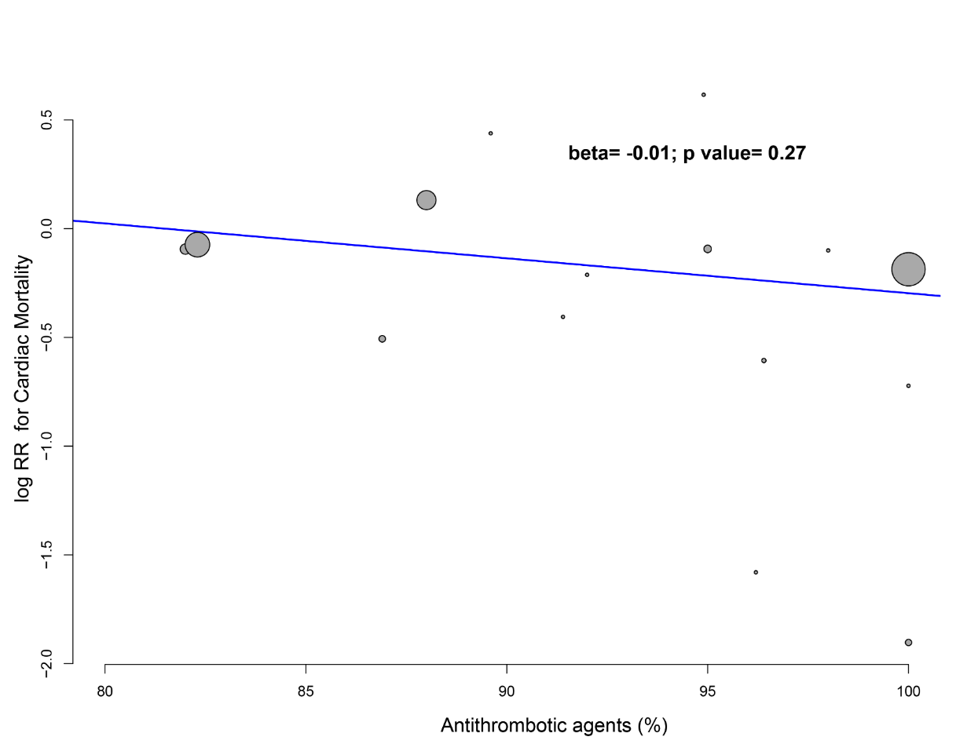

Figure 7Cs. Meta-regression of statins on cardiac mortality.

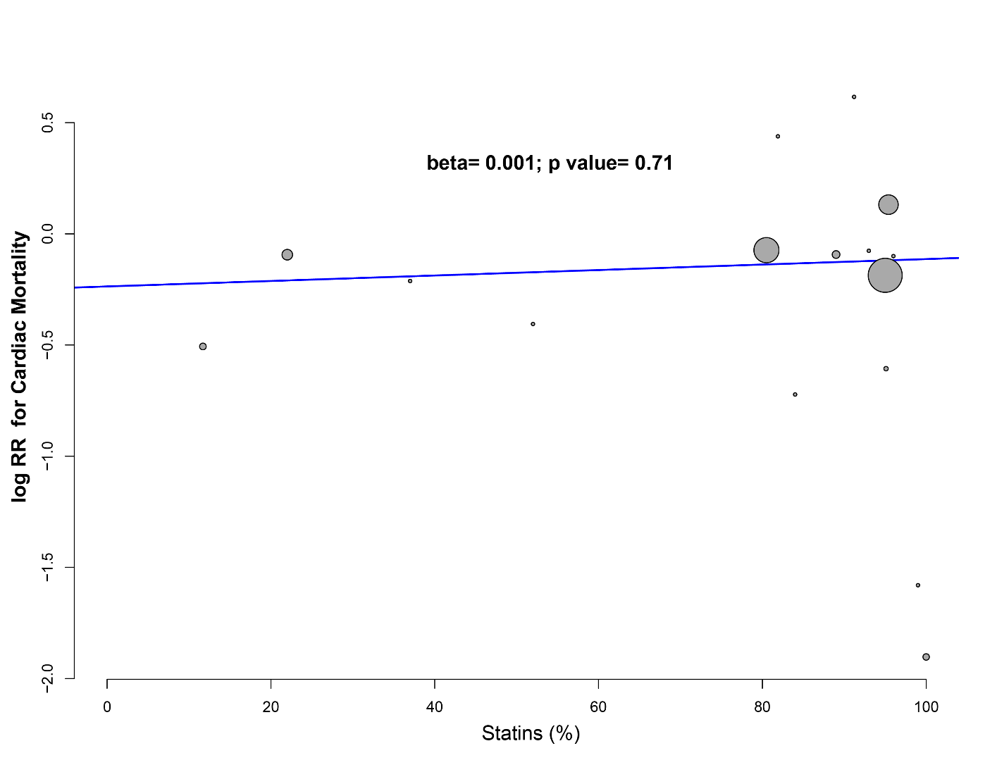

Figure 7Ds. Meta-regression of beta-blockers on cardiac mortality.

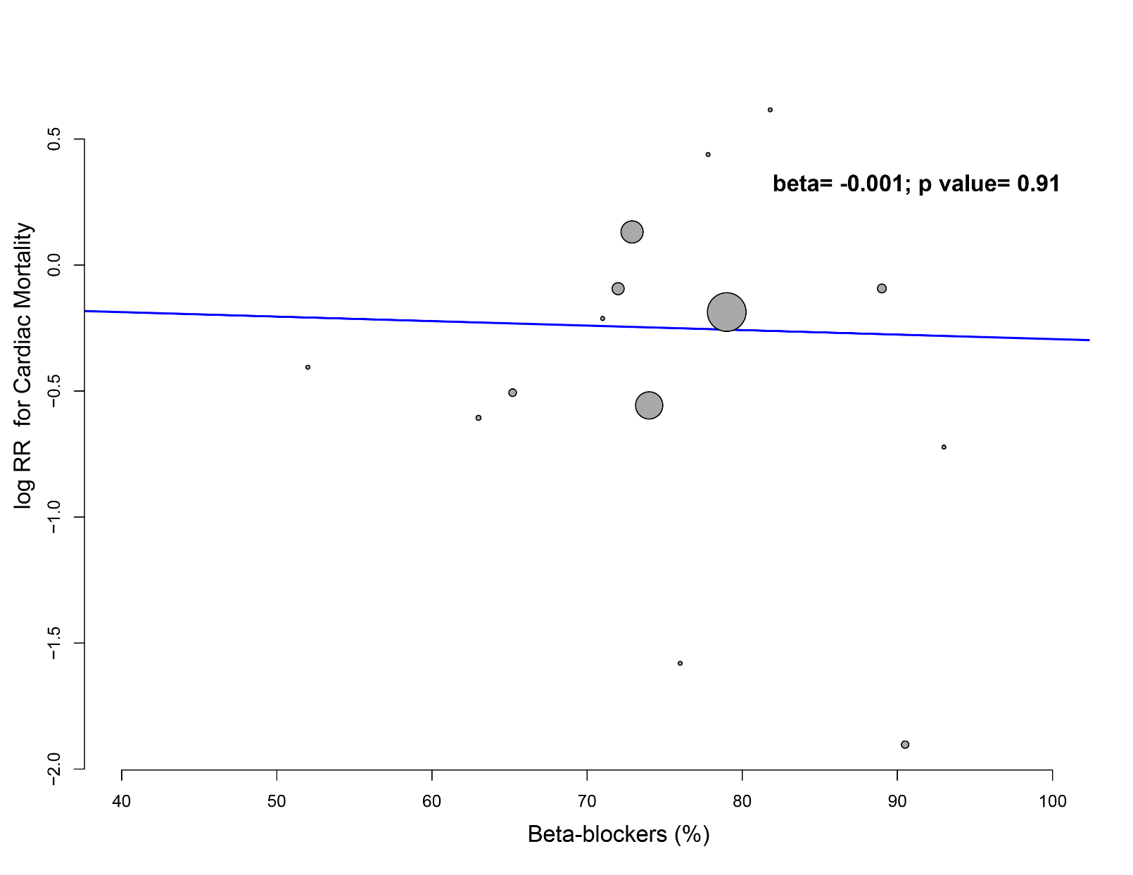

Figure 7Es. Meta-regression of ACE-inhibitors/ARBs on cardiac mortality.

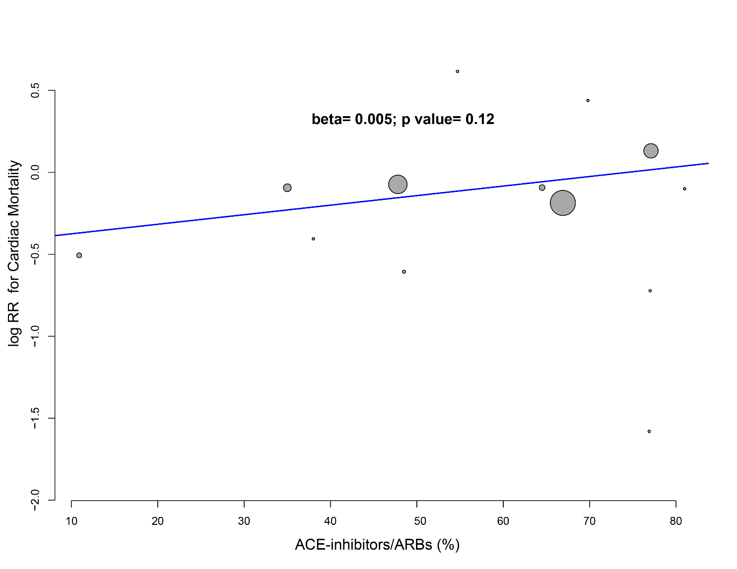

Figure 7Fs. Meta-regression of study year on cardiac mortality.
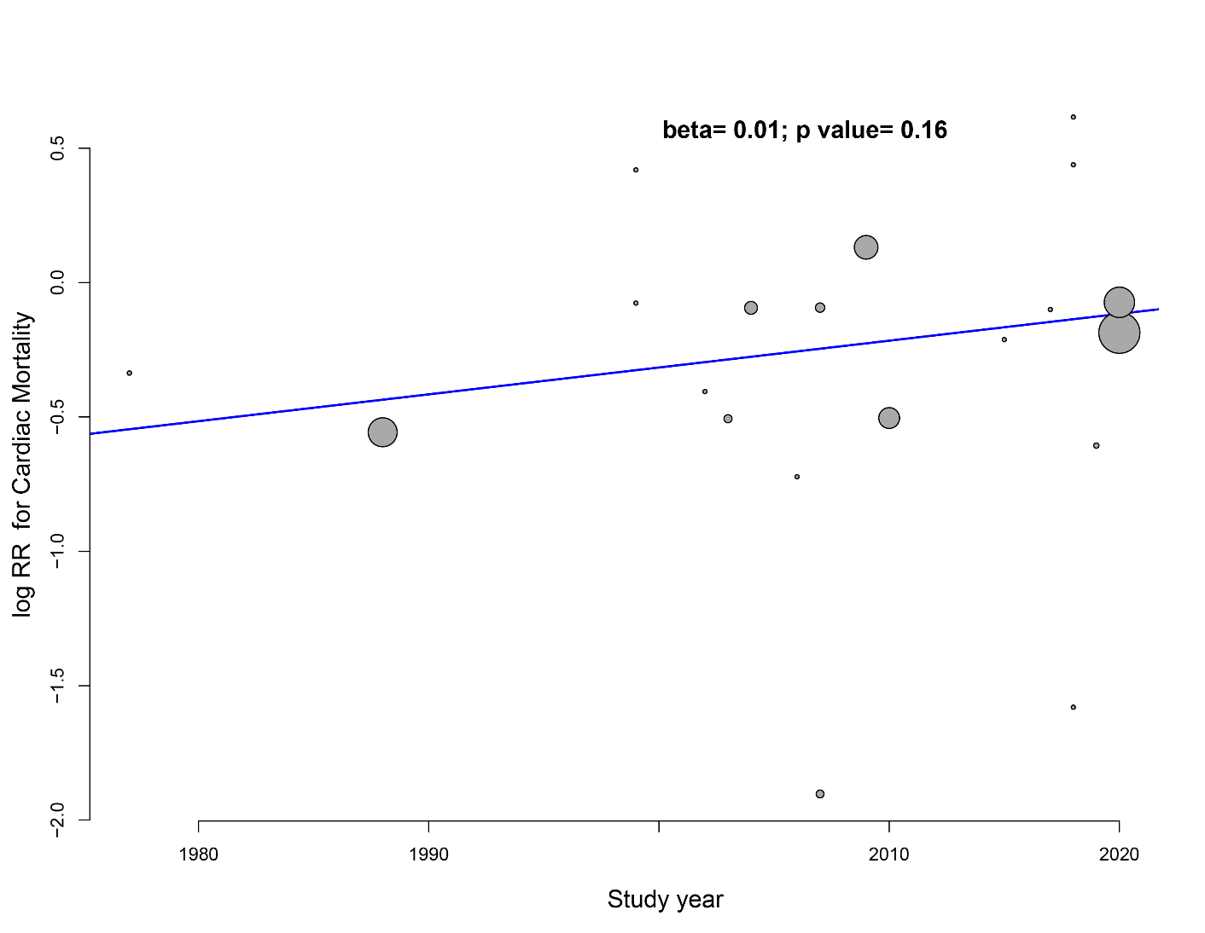

Figure 8s. Trial sequential meta-analysis.

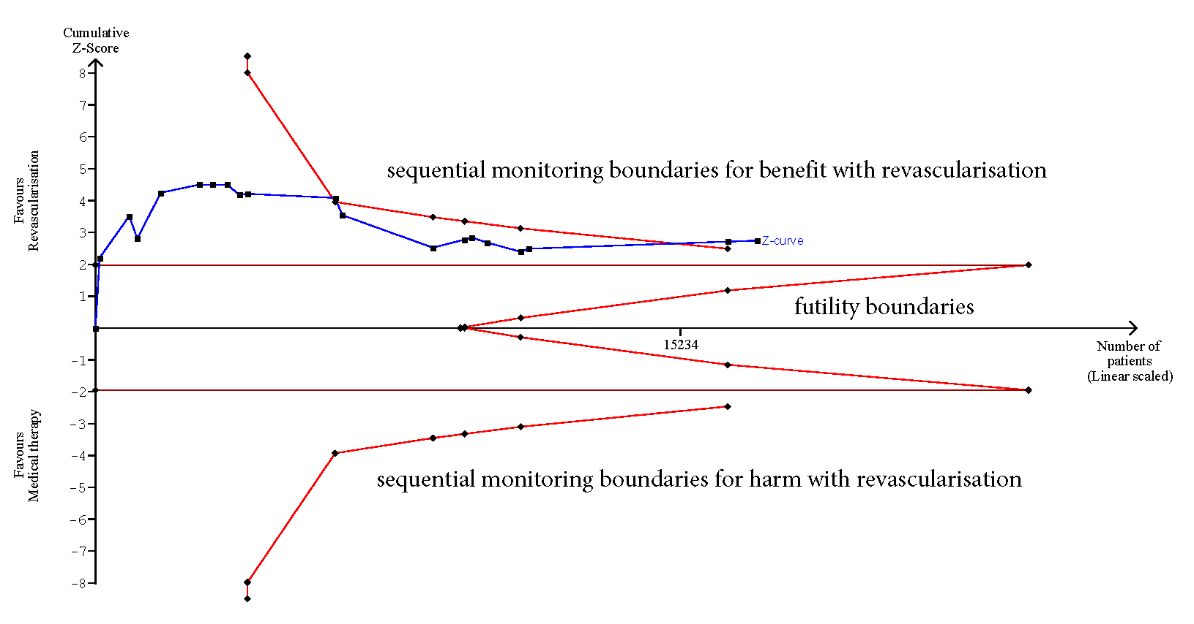

Figure 9s. Funnel plot for all-cause mortality.

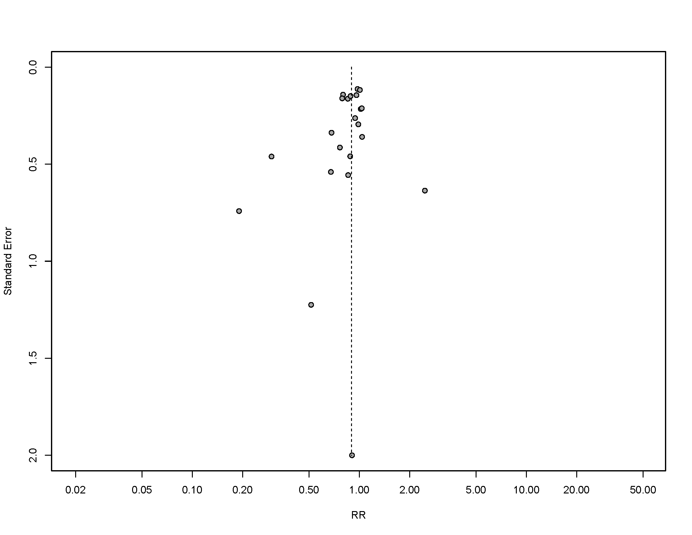

Figure 10s. Random-effects model for all-cause mortality.

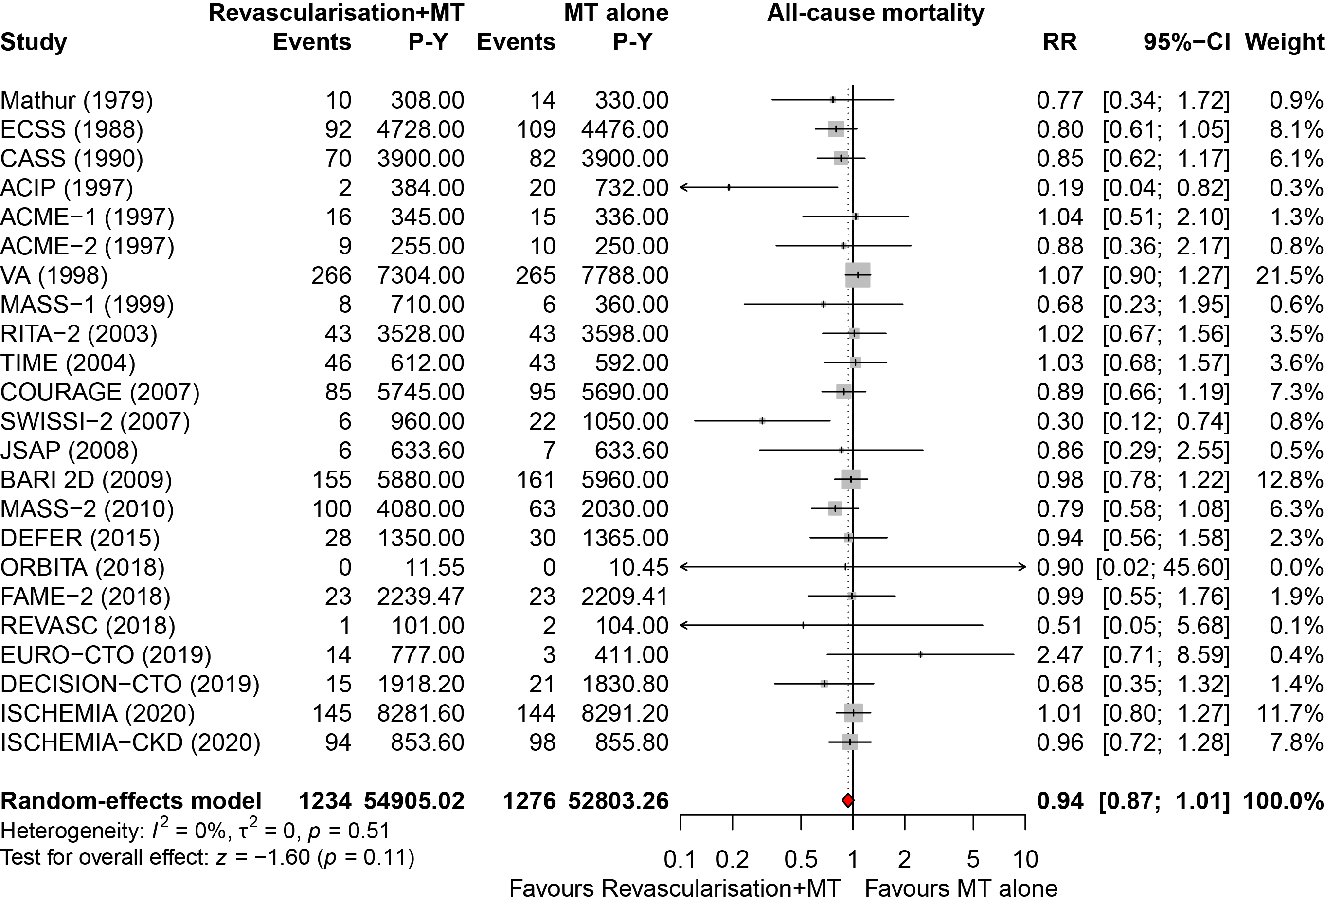

Figure 11s. Fixed effect model for all-cause mortality.

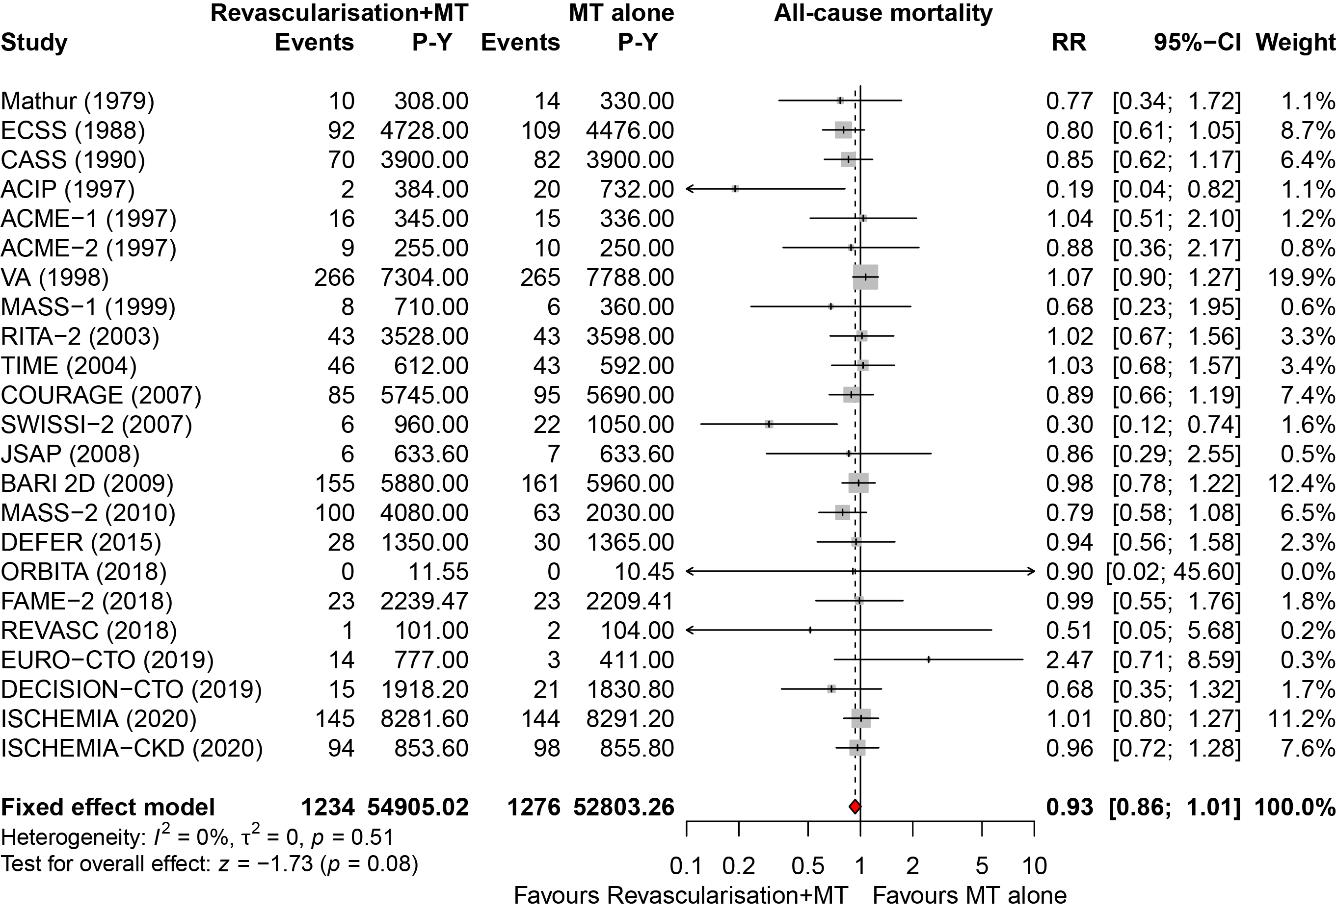

Figure 12s. All-cause mortality without the VA trial.
VA= Veterans Administration Cooperative Study.
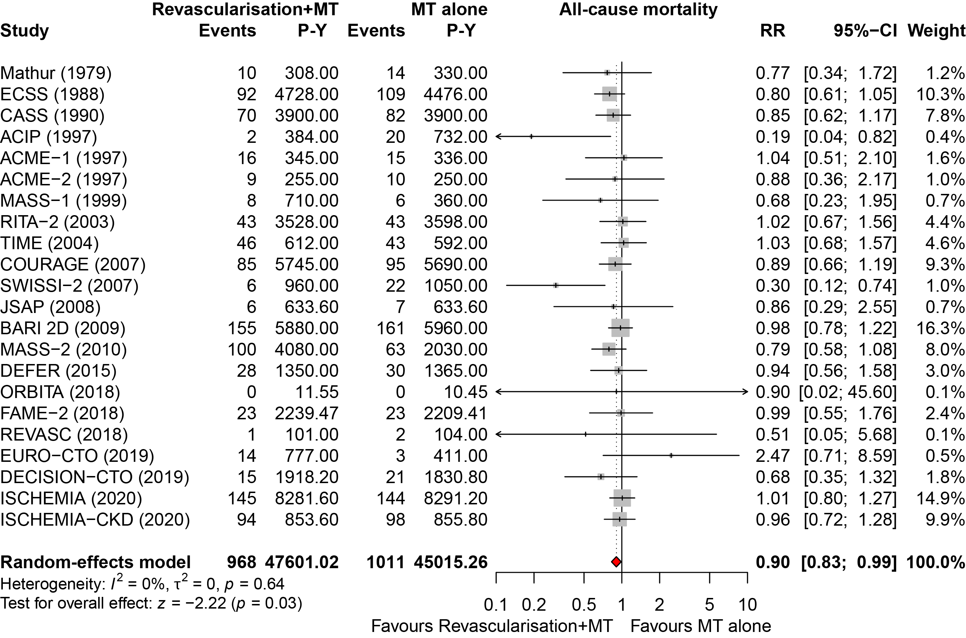

Figure 13s. Funnel plot for spontaneous myocardial infarction.

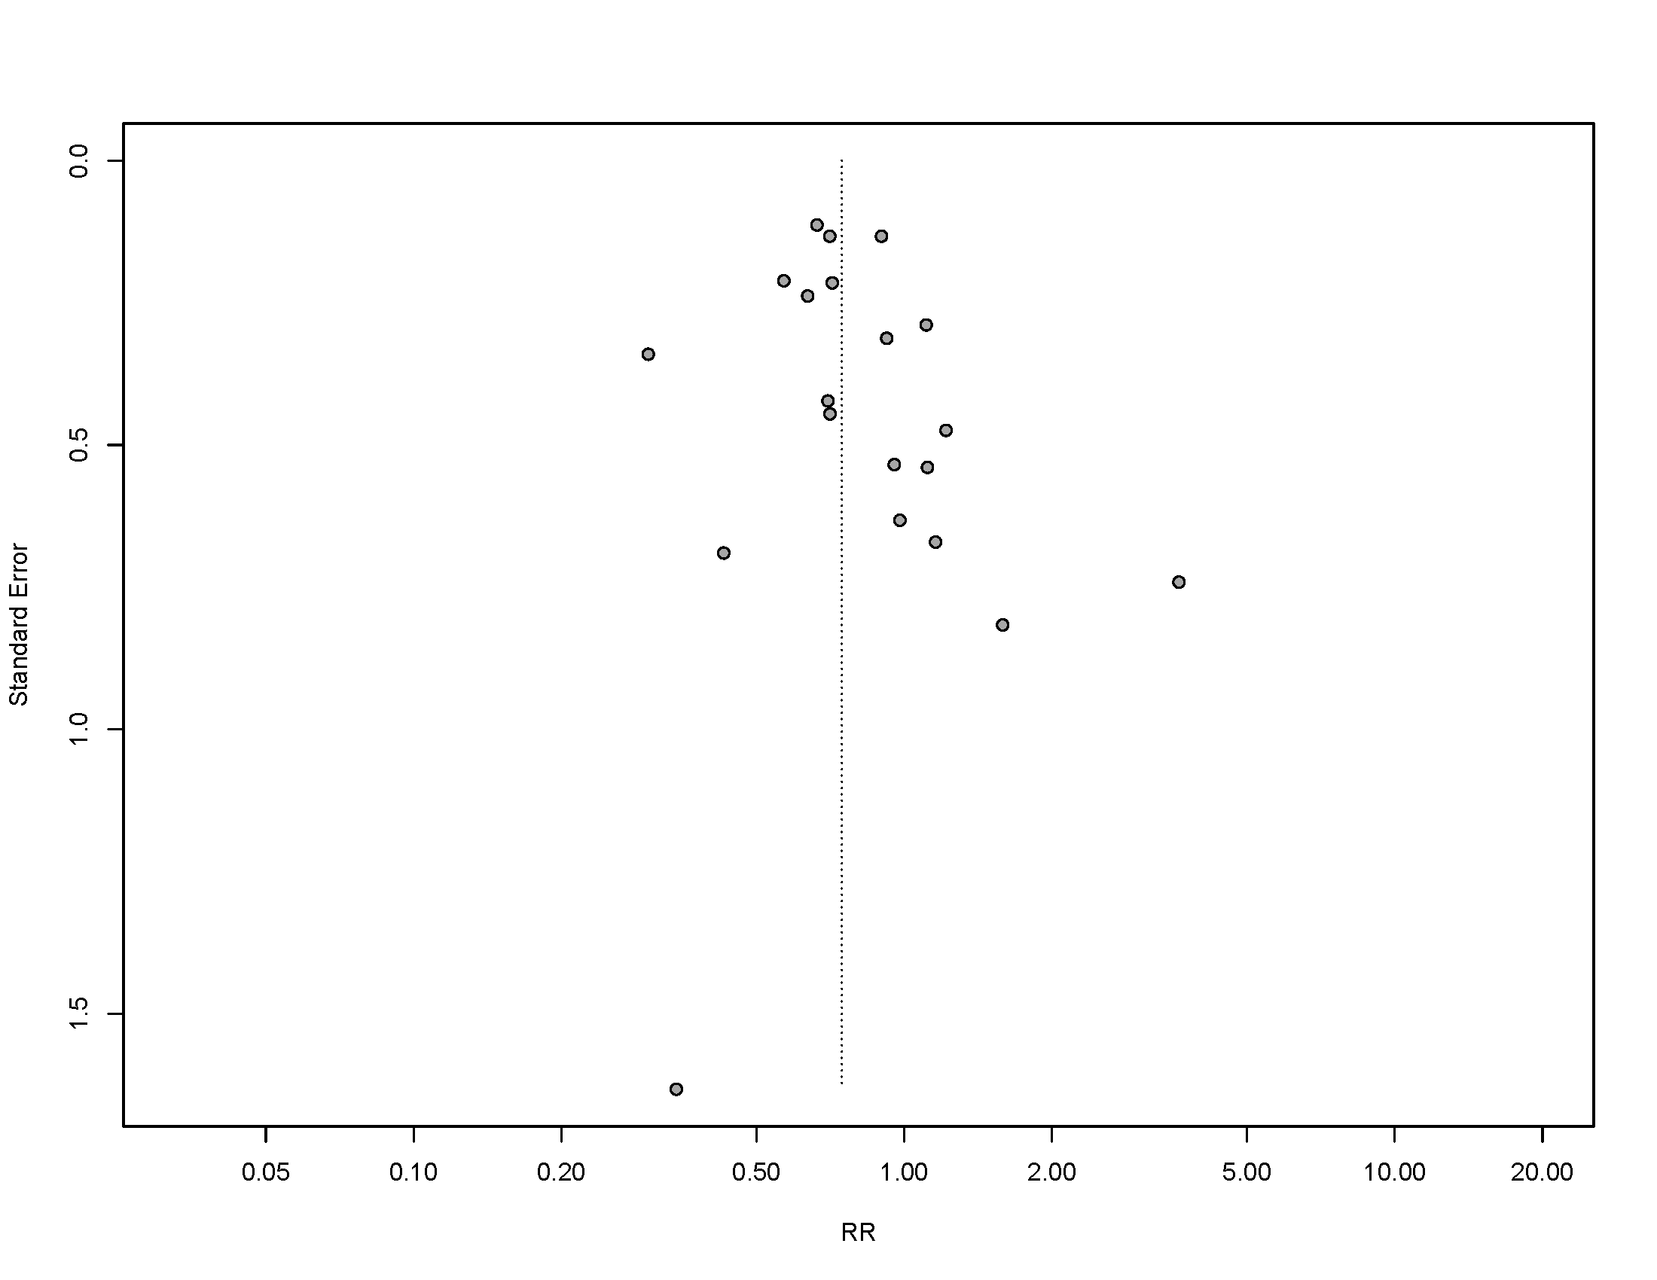

Figure 14s. Fixed effect model for spontaneous myocardial infarction.

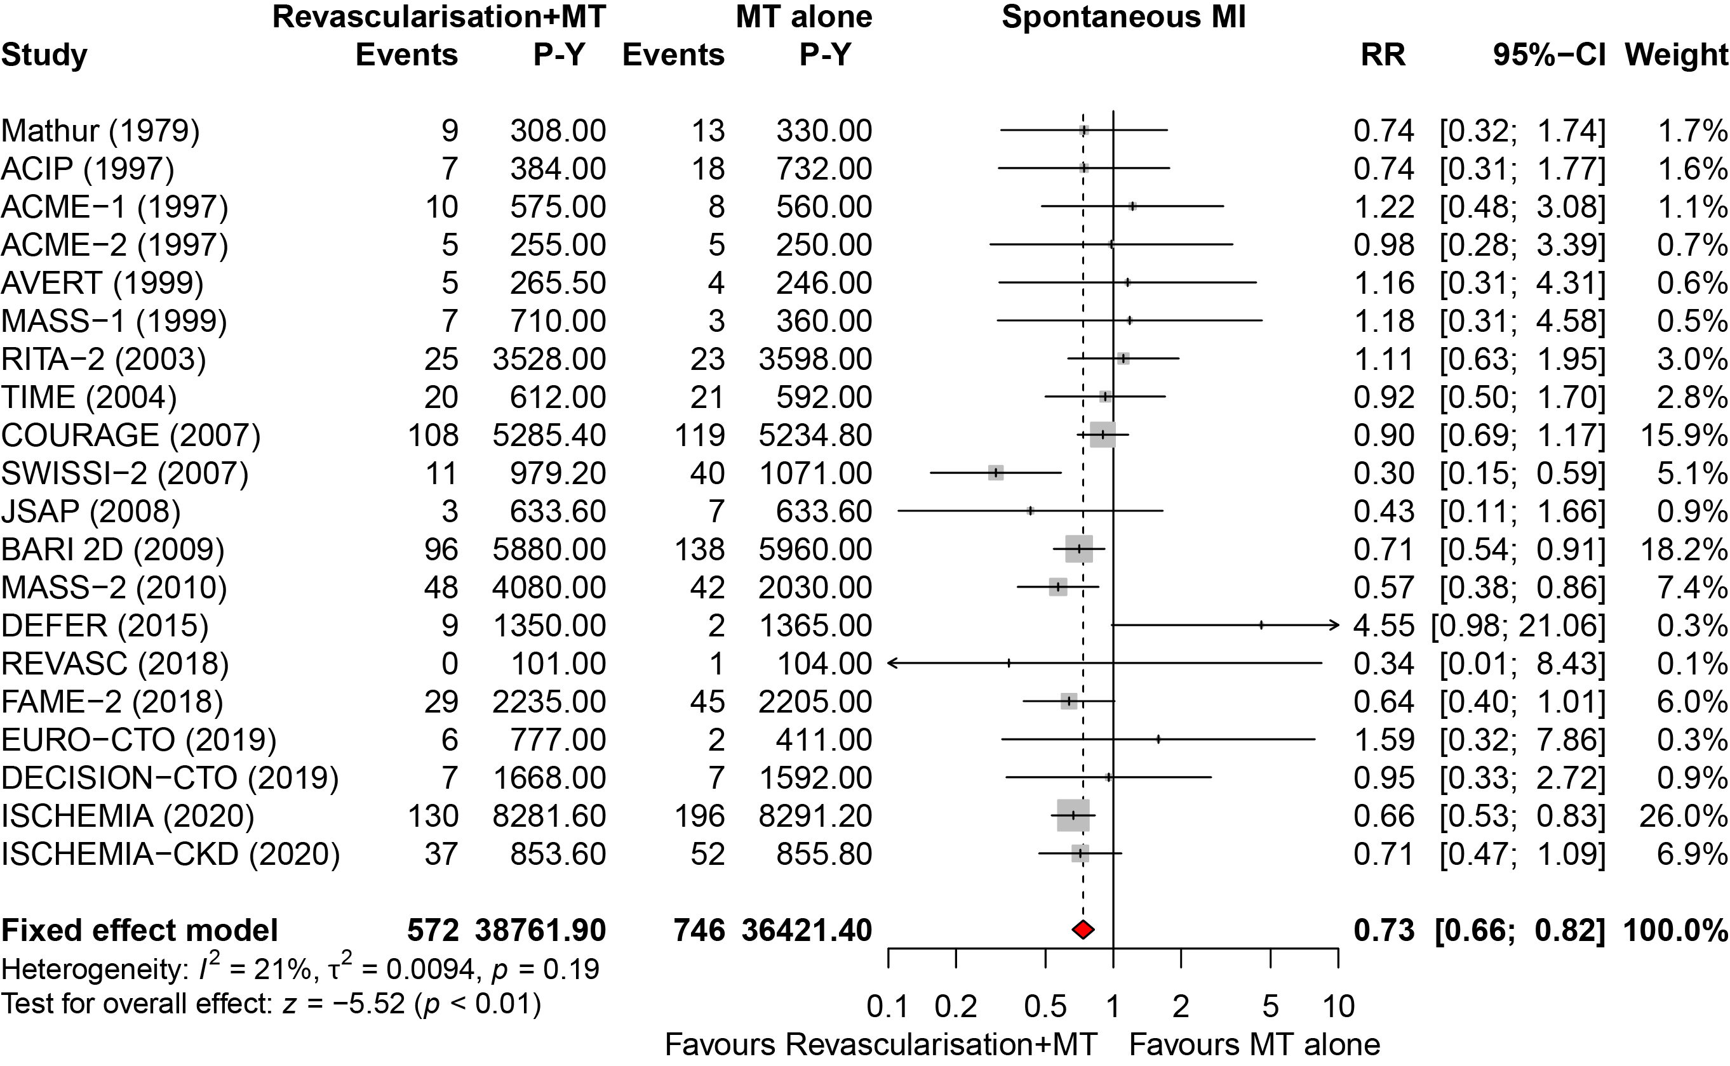

Figure 15s. Funnel plot for any myocardial infarction.

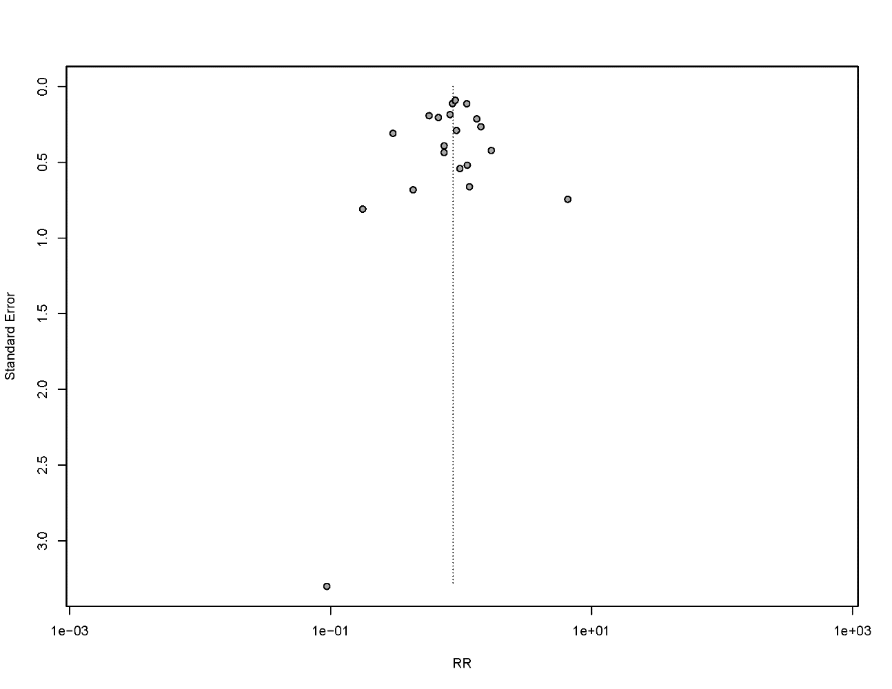

Figure 16s. Random-effects model for any myocardial infarction.

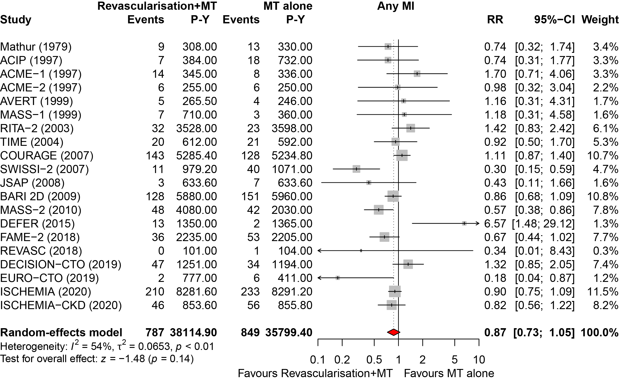

Figure 17s. Meta-regression of absolute difference of procedural MI on cardiac mortality.

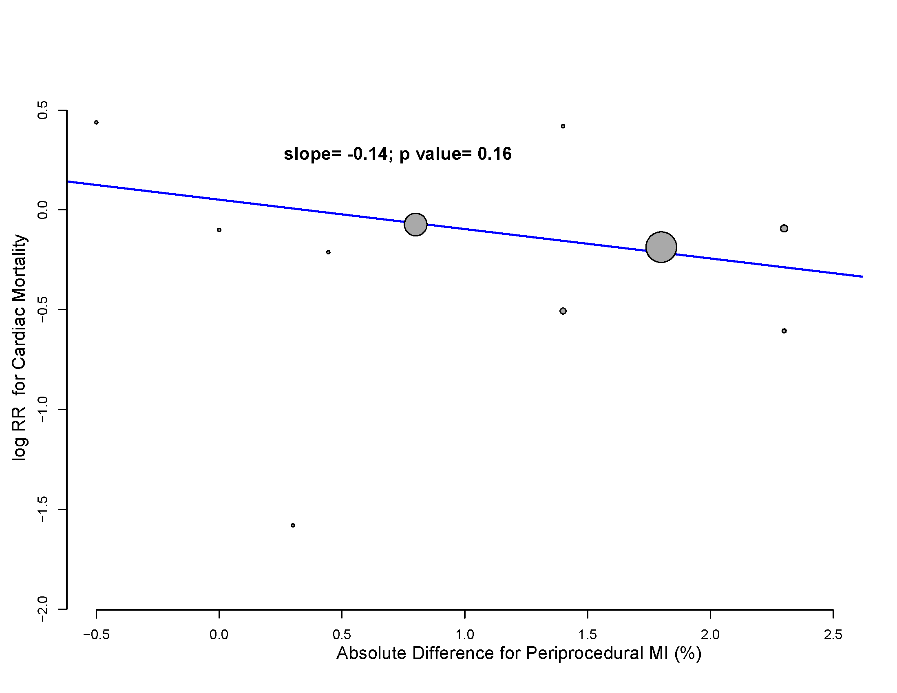

Figure 18s. Random-effects model for stroke.

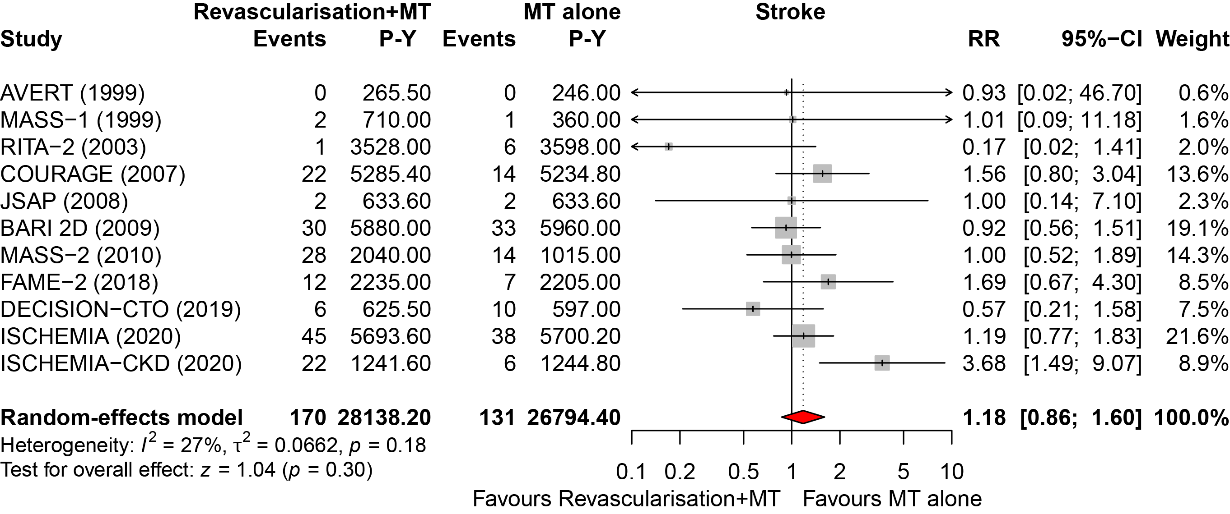

Figure 19s. Fixed effect model for stroke.

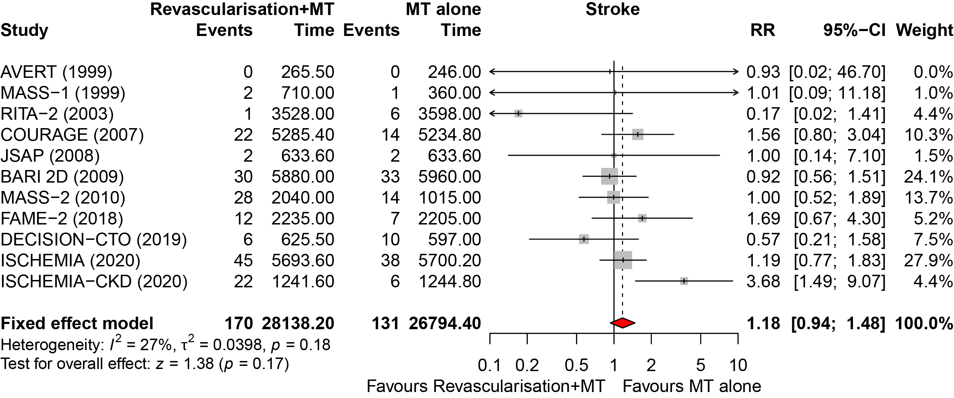

Figure 20s. Funnel plot for stroke.



