Supplementary Figures

Figure 1. Quality assessment charts for risk factor studies included in the review
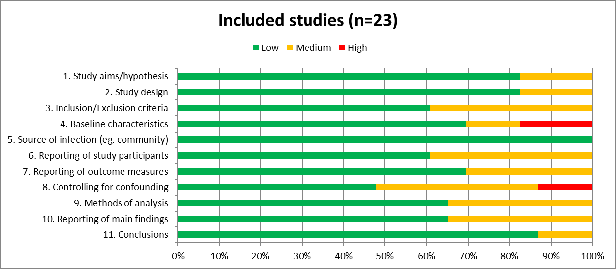

Figure 2. Non-pooled demographic risk factor data from included studies
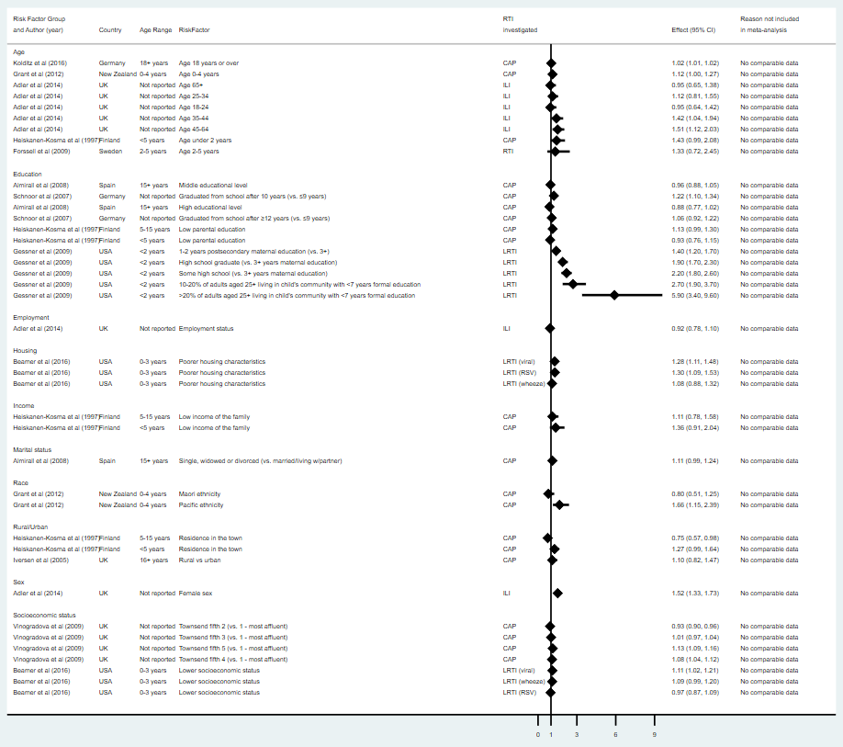
Where OR = odds ratio; 95% CI = 95% confidence interval; CAP = community-acquired pneumonia; ILI = influenza-like-illness; LRTI = lower respiratory tract infection; RSV = respiratory syncytial virus

Figure 3. Non-pooled environmental risk factor data from included studies
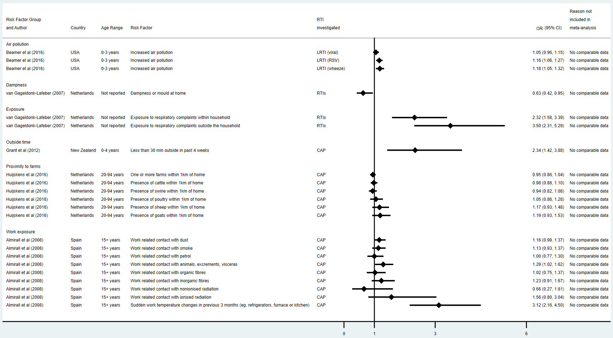
Where OR = odds ratio; 95% CI = 95% confidence interval; CAP = community-acquired pneumonia; LRTI = lower respiratory tract infection; RSV = respiratory syncytial virus; RTI = respiratory tract infection

Figure 4. Non-pooled lifestyle and health related risk factor data from included studies measured using non-odds ratio estimates
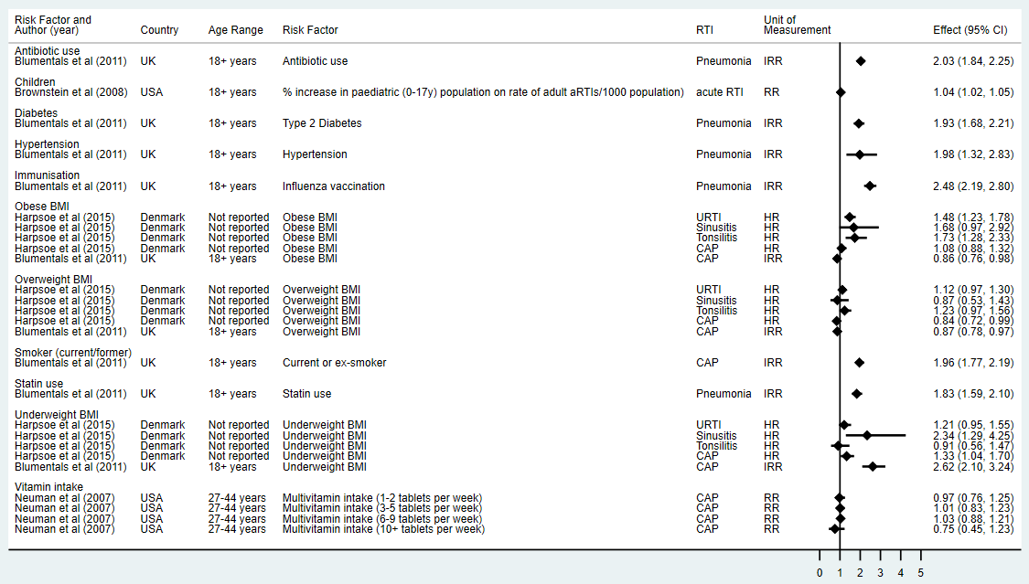
Where BMI = Body Mass Index; URTI = upper respiratory tract infection; CAP = community-acquired pneumonia; ; IRR = incidence rate ratio; HR = hazard ratio; RR = risk ratio; ES = effect size; 95% CI = 95% confidence interval

Figure 5. Non-pooled lifestyle-related risk factor data from included studies
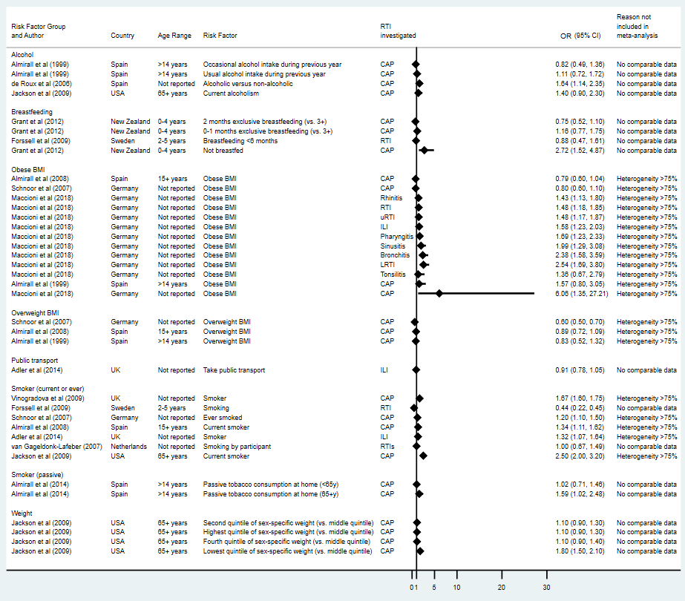
Where OR = odds ratio; 95% CI = 95% confidence intervals; CAP = community-acquired pneumonia; RTI = respiratory tract infection; ILI = influenza-like-illness

Figure 6. Non-pooled social risk factor data from included studies
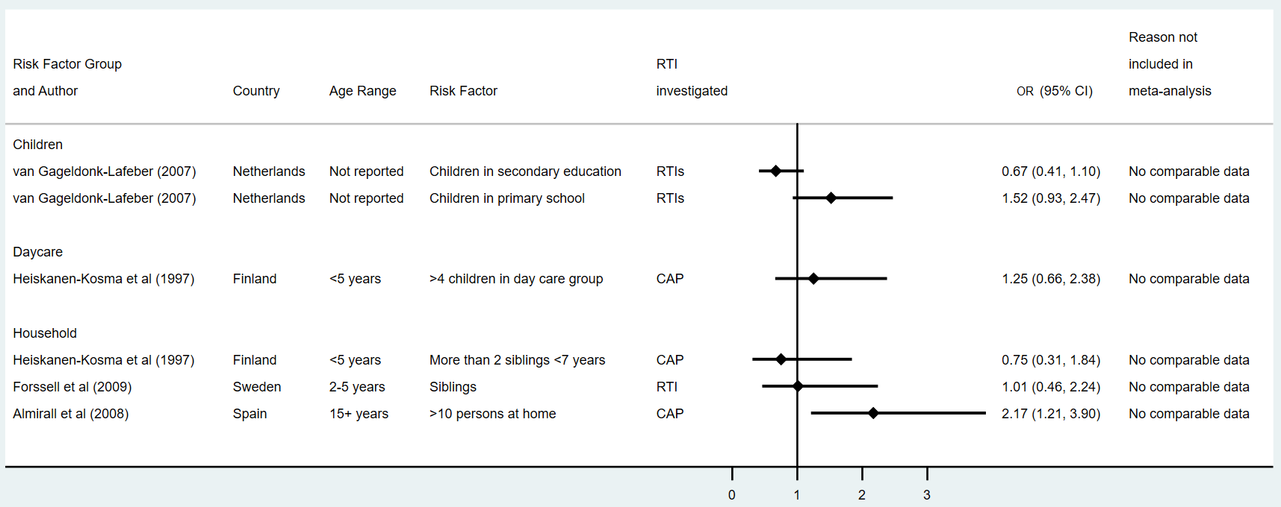
Where OR = odds ratio; 95% CI = 95% confidence intervals; RTI = respiratory tract infection; CAP = community-acquired pneumonia

Figure 7. Non-pooled health condition-related risk factor data from included studies
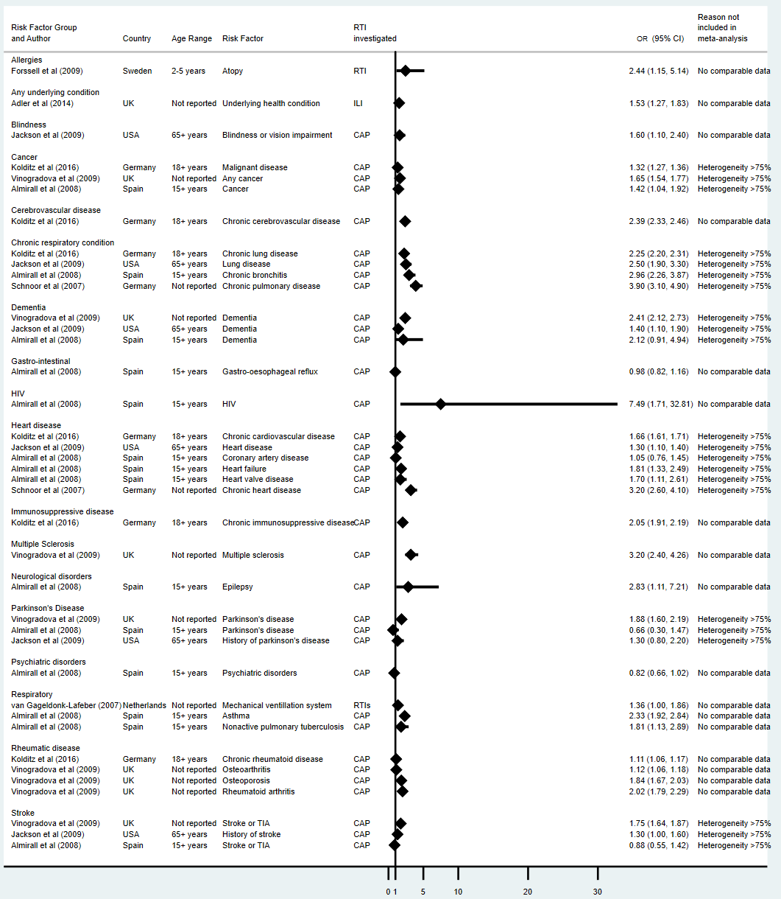
Where OR = odds ratio; 95% CI = 95% confidence intervals; RTI = respiratory tract infection; ILI = influenza-like illness; CAP = community-acquired pneumonia

Figure 8. Non-pooled medical history-related risk factor data from included studies
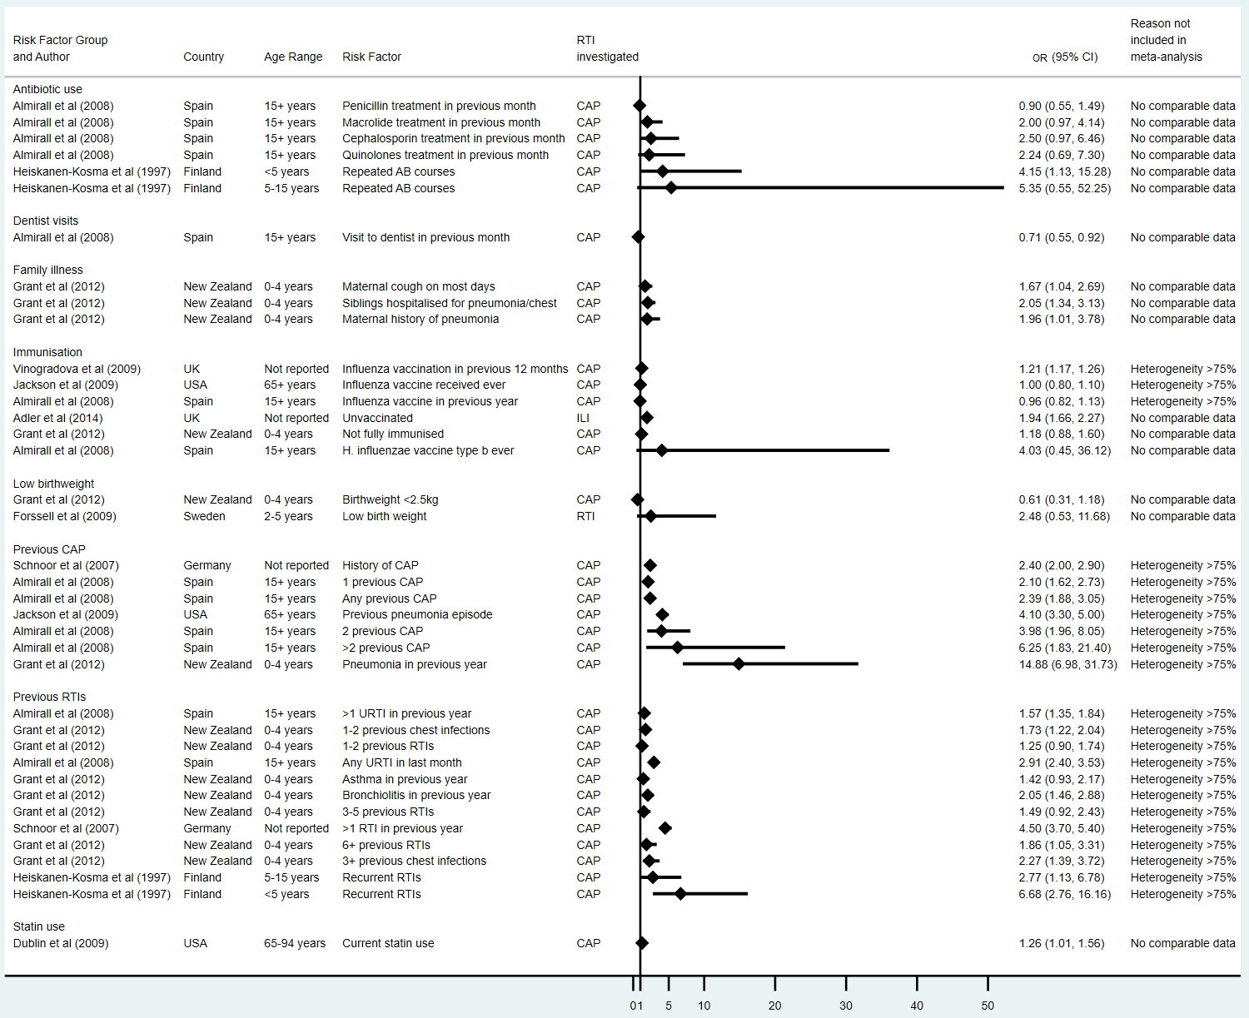
Where OR = odds ratio; 95% CI = 95% confidence intervals; CAP = community-acquired pneumonia; ILI = influenza-like illness; RTI = respiratory tract infection.

