Supplemental Materials

Table S1: Search strategy
1-PubMed

((("17-alpha-hydroxyprogesterone"[MeSH Terms] OR "17-alpha-hydroxyprogesterone"[All Fields] OR "17 hydroxyprogesterone"[All Fields]) AND ("premature birth"[MeSH Terms] OR ("premature"[All Fields] AND "birth"[All Fields]) OR "premature birth"[All Fields] OR ("preterm"[All Fields] AND "birth"[All Fields]) OR "preterm birth"[All Fields] OR “preterm delivery” "[All Fields] OR “preterm labor” "[All Fields]) AND singleton [All Fields] AND Placebo)))

2- SCOPUS

( ( 'hydroxyprogesterone AND caproate' OR 'hydroxyprogesterone' OR '17 AND alpha AND hydroxyprogesterone' OR '17 AND alphahydroxyprogesterone' OR '17 AND hydroxyprogesterone' ) AND ( 'prematurity' OR 'preterm AND birth' OR 'premature AND labor' OR 'premature AND birth' OR 'preterm AND labor' OR 'preterm AND delivery' ) AND "placebo" AND ( 'singleton AND pregnancy' OR 'singleton' ) )

3- EMBASE

No.
Query
Results
229
#31
#15 AND #22 AND #27 AND #29
229
#30
#15 AND #22 AND #27
1,103
#29
#15 AND #22
42,554
#28
#23 OR #24
474,854
#27
#25 OR #26
474,854
#26
placebo
369,179
#25
'placebo'/exp
42,554
#24
singleton
185
#23
'singleton pregnancy'/exp
10,053
#22
#16 OR #17 OR #18 OR #19 OR #20 OR #21
3,151
#21
'17 hydroxyprogesterone'
539
#20
'17 -alpha-hydroxyprogesterone'
539
#19
'17 -alpha hydroxyprogesterone'
555
#18
17 AND 'alpha hydroxyprogesterone'
1,775
#17
'hydroxyprogesterone caproate'/exp
7,504
#16
'hydroxyprogesterone'/exp
196,457
#15
#1 OR #2 OR #3 OR #4 OR #5 OR #6 OR #7 OR #8 OR #9 OR #10 OR #11 OR #12 OR #13 OR #14
36,861
#14
preterm AND labor
34,582
#13
preterm AND delivery
15,905
#12
'preterm delivery'
9,241
#11
'preterm labor'
49,850
#10
'premature labor'
4,371
#9
'premature delivery'
36,364
#8
premature AND delivery
53,735
#7
premature AND labor
56,464
#6
premature AND birth
63,665
#5
preterm AND birth
119,510
#4
'premature birth'/exp
49,021
#3
'premature labor'/exp
27,045
#2
'preterm birth'
119,510
#1
'prematurity'/exp

Table S2: Excluded studies after full-text assessment
 | Study | Reason
1 | Combs, C. Andrew, et al. "17-Hydroxyprogesterone caproate to prolong pregnancy after preterm rupture of the membranes: early termination of a double-blind, randomized clinical trial." BMC research notes 4.1 (2011): 1-9. | used other population ( premature rupture of membrane)
2 | Langen, Elizabeth, et al. "291: A double-blind, randomized, placebo controlled trial of 17 alpha-hydroxy-progesterone caproate (17-OHP) in the management of preterm, premature rupture of membranes." American Journal of Obstetrics & Gynecology 214.1 (2016): S167. | used other population ( premature rupture of membrane)
3 | ClinicalTrials.gov [Internet]. Bethesda (MD): National Library of Medicine (US). Identifier: NCT01119963, Progesterone (17P, Makena®) for Prolongation of Pregnancy in Women With Preterm Rupture of the Membranes (PROM) (17PinPROM), https://clinicaltrials.gov/ct2/show/NCT01119963 | used other population ( premature rupture of membrane)
4 | Mirzaei, Fatemeh, and Parvin Moradi. "Effects of progesterone on latency period in patients with preterm premature rupture of membranes during 24-34 weeks of pregnancy." Journal of Kerman University of Medical Sciences 22.3 (2015): 240-248. | used other population ( premature rupture of membrane)
5 | Combs, C. Andrew, et al. "17-hydroxyprogesterone caproate for preterm rupture of the membranes: a multicenter, randomized, double-blind, placebo-controlled trial." American journal of obstetrics and gynecology 213.3 (2015): 364-e1. | used other population ( premature rupture of membrane)
6 | Briery, Christian M., et al. "Women with preterm premature rupture of the membranes do not benefit from weekly progesterone." American journal of obstetrics and gynecology 204.1 (2011): 54-e1. | used other population ( premature rupture of membrane)
7 | Lim, Arianne C., et al. "17α-hydroxyprogesterone caproate for the prevention of adverse neonatal outcome in multiple pregnancies: a randomized controlled trial." Obstetrics & Gynecology 118.3 (2011): 513-520. | used other population (multiple pregnancy)
8 | Price, Joan T., et al. "Intramuscular 17-hydroxyprogesterone caproate to prevent preterm birth among HIV-infected women in Zambia: study protocol of the IPOP randomized trial." BMC pregnancy and childbirth 19.1 (2019): 1-9. | used other population (HIV)
9 | Aflatoonian, Abbas, Hoora Amouzegar, and Razieh Dehghani Firouzabadi. "Efficacy of 17α-hydroxy progestrone on decreasing preterm labor in ART pregnancies: A randomized clinical trial." International Journal of Reproductive BioMedicine 11.10 (2013): 785-0. | used other population (Assisted  reproductive technology)
10 | Briery, Christian M., et al. "The use of 17-hydroxy progesterone in women with arrested preterm labor: a randomized clinical trial." The Journal of Maternal-Fetal & Neonatal Medicine 27.18 (2014): 1892-1896. | used other population (arrested preterm labor)
11 | Winer, Norbert, et al. "17 alpha-hydroxyprogesterone caproate does not prolong pregnancy or reduce the rate of preterm birth in women at high risk for preterm delivery and a short cervix: a randomized controlled trial." American journal of obstetrics and gynecology 212.4 (2015): 485-e1. | did not include injectable placebo
12 | Jafarpour, Hamed, et al. "Effect of 17 α-Hydroxyprogesterone Caproate on the Prevention of Preterm Labor: A Randomized Controlled Trial Study." Journal of Midwifery and Reproductive Health 8.3 (2020): 2317-2323. | did not include injectable placebo
13 | Saghafi, Nafiseh, et al. "Efficacy of 17α‐hydroxyprogesterone caproate in prevention of preterm delivery." Journal of Obstetrics and Gynaecology Research 37.10 (2011): 1342-1345. | did not include injectable placebo
14 | Rozenberg, Patrick, et al. "Prevention of preterm delivery after successful tocolysis in preterm labor by 17 alpha-hydroxyprogesterone caproate: a randomized controlled trial." American journal of obstetrics and gynecology 206.3 (2012): 206-e1. | did not include injectable placebo
15 | Shaamash, Ayman H., Mohammed K. Ali, and Khalid M. Attyia. "Intramuscular 17α-hydroxyprogesterone caproate to decrease preterm delivery in women with placenta praevia: a randomised controlled trial." Journal of Obstetrics and Gynaecology 40.5 (2020): 633-638. | did not include injectable placebo
16 | Winer, Norbert, et al. "4: Prevention of preterm delivery by 17 alpha-hydroxyprogesterone caproate in high risk asymptomatic singleton gestations with a short cervix: a randomized controlled trial." American Journal of Obstetrics & Gynecology 210.1 (2014): S3. | did not include injectable placebo
17 | Facchinetti, Fabio, et al. "Progestogens for maintenance tocolysis in women with a short cervix: a randomized controlled trial." Obstetrics & Gynecology 130.1 (2017): 64-70. | did not include injectable placebo
18 | Ndoni, E., et al. "Treatment with different types of progesterone in prevention of preterm delivery." J Matern Neonatal Med 23.suppl (2010): 305. | did not include injectable placebo
19 | Deeks, Emma D. "17 α-Hydroxyprogesterone Caproate (Makena™)." Pediatric Drugs 13.5 (2011): 337-345. | not RCTs
20 | Meis, Paul J. "17 Hydroxyprogesterone for the prevention of preterm delivery." Obstetrics & Gynecology 105.5 (2005): 1128-1135. | not RCTs
21 | O'Brien, John M. "17α-Hydroxyprogesterone Caproate for the Prevention of Adverse Neonatal Outcome in Multiple Pregnancies: A Randomized Controlled Trial." Obstetrics & Gynecology 119.2 (2012): 384-385. | not RCTs
22 | Petrini, Joann R., et al. "Estimated effect of 17 alpha-hydroxyprogesterone caproate on preterm birth in the United States." Obstetrics & Gynecology 105.2 (2005): 267-272. | not RCTs
23 | Brancazio, Leo, et al. “Prevention of Recurrent Preterm Delivery by 17 Alpha-Hydroxyprogesterone Caproate.” N Engl J Med, vol. 349, no. 11, 2003, pp. 1087–88 | not RCTs
24 | Meis, Paul J. "The role of 17 α-hydroxyprogesterone caproate in the prevention of preterm birth." Women’s health 2.6 (2006): 819-824. | not RCTs
25 | Legardeur, H., L. Mandelbrot, and G. Kayem. "What use of progesterone to prevent preterm birth?." Gynecologie, obstetrique & fertilite 41.7-8 (2013): 459-464. | not RCTs
26 | Koontz, Gretchen. "Does gestational age at randomization affect the efficacy of alpha hydroxyprogesterone caproate (17-OHCP) in preventing recurrent preterm delivery?." American Journal of Obstetrics and Gynecology 6.193 (2005): S55. | not RCTs
27 | ClinicalTrials.gov [Internet]. Bethesda (MD): National Library of Medicine (US). Identifier: NCT01004029, Confirmatory Study of 17P vs Vehicle for Prevention of Preterm Birth in Women w/ Previous Spontaneous Preterm Delivery (PROLONG) https://clinicaltrials.gov/ct2/show/NCT01004029 | Protocols of studies
28 | ClinicalTrials.gov [Internet]. Bethesda (MD): National Library of Medicine (US). Identifier: NCT03297216, Improving Pregnancy Outcomes With Progesterone (IPOP)  https://clinicaltrials.gov/ct2/show/NCT03297216 | Protocols of studies
29 | International Clinical Trials Registry, World Health Organization (WHO), A Phase 3B, Multi-Center, Randomized, Double-Blind Study of Hydroxyprogesterone Caproate Injection, 250 mg/mL, Versus Vehicle for the Prevention of Preterm Birth in Women with a Previous Singleton Spontaneous Preterm Delivery  http://www.who.int/trialsearch/Trial2.aspx?TrialID=EUCTR2009-014696-52-IT | Protocols of studies
30 | Lim, Arianne C., et al. "Progesterone for the prevention of preterm birth in women with multiple pregnancies: the AMPHIA trial." BMC pregnancy and childbirth 7.1 (2007): 1-6. | Protocols of studies
31 | Blackwell, Sean C., et al. "PROLONG clinical study protocol: hydroxyprogesterone caproate to reduce recurrent preterm birth." American journal of perinatology 35.12 (2018): 1228-1234. | Protocols of studies
32 | ClinicalTrials.gov [Internet]. Bethesda (MD): National Library of Medicine (US). Identifier: NCT00120640, Treatment of Preterm Labor With 17 Alpha-hydroxyprogesterone Caproate  https://clinicaltrials.gov/ct2/show/NCT00120640 | Protocols of studies
33 | Facchinetti, Fabio, et al. "17α-hydroxy-progesterone effects on cervical proinflammatory agents in women at risk for preterm delivery." American Journal of Perinatology 25.08 (2008): 503-506. | different outcome
34 | Northe, Allison. “Determinants of Compliance in a Randomized Trial in High Risk Pregnancy.” Clinical Trials, vol. 7, no. 4, 2010, p. 454 | different outcome
35 | Ndoni, E., et al. "Treatment with different types of progesterone in prevention of preterm delivery." J Matern Neonatal Med 23.suppl (2010): 305. | different dosing frequency
36 | Tan, Peng Chiong, et al. "Single dose 17 alpha-hydroxyprogesterone caproate in preterm labor: a randomized trial." Archives of gynecology and obstetrics 285.3 (2012): 585-590. | different dosing frequency
37 | Johnson, John, et al. “The Efficacy of 17α Hydroxyprogesterone Caproate in Preventing Premature Labor.” GYNEC.INVEST., vol. 5, no. 1, 1974 | abstract of published study

Table S3: Risk of bias assessment

Study | D1 | D2(A) | D2(B) | D3 | D4 | D5 | Overall
Johnson1975 | Low | Low | Some concerns | Low | Low | Low | Low
Yemini1985 | Low | Low | Low | Low | Low | Low | Low
Meis2003 | Some concerns | Low | Low | Low | Low | Low | Low
ibrahim2010 | Some concerns | Some concerns | Some concerns | Low | Some concerns | Low | Some concerns
Shahgheibi 2016 | Low | Low | Low | Low | Low | Low | Low
Blackwell 2019 | Low | Low | Low | Low | Low | Low | Low
Domain 1(D1): Risk of bias arising from the randomization process
Domain 2 A (D2A): Risk of bias due to deviations from the intended interventions (effect of assignment to intervention)
Domain 2 B (D2B): Risk of bias due to deviations from the intended interventions (effect of adhering to intervention)
Domain 3 (D3): Missing outcome data
Domain 4 (D4): Risk of bias in measurement of the outcome
Domain 5 (D5): Risk of bias in selection of the reported result

Subgroup Analysis based on study location

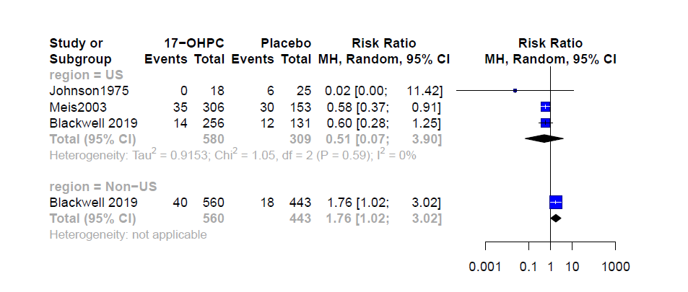
Figure S1: Forest plots of the risk of recurrent preterm birth bellow 32 weeks

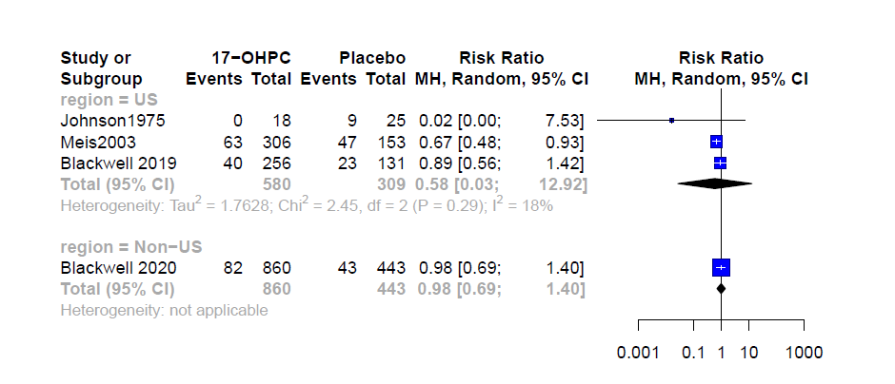
Figure S2: Forest plots of the risk of recurrent preterm birth bellow 35 weeks

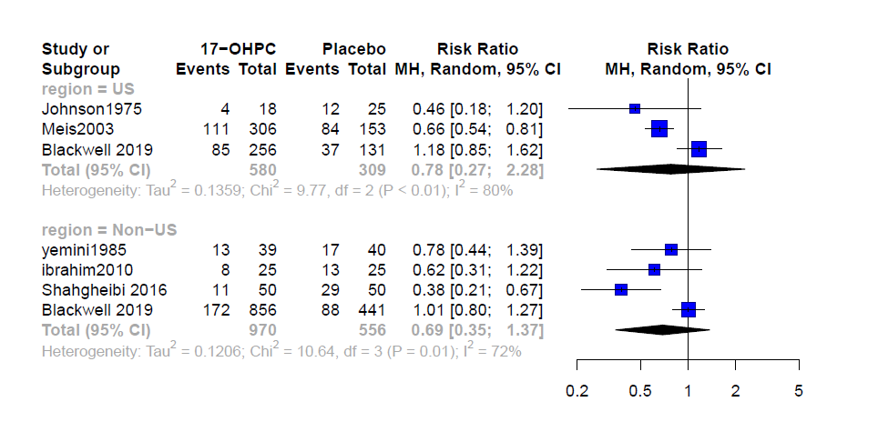
Figure S3: Forest plots of the risk of recurrent preterm birth bellow 37 weeks

Sensitivity Analyses:

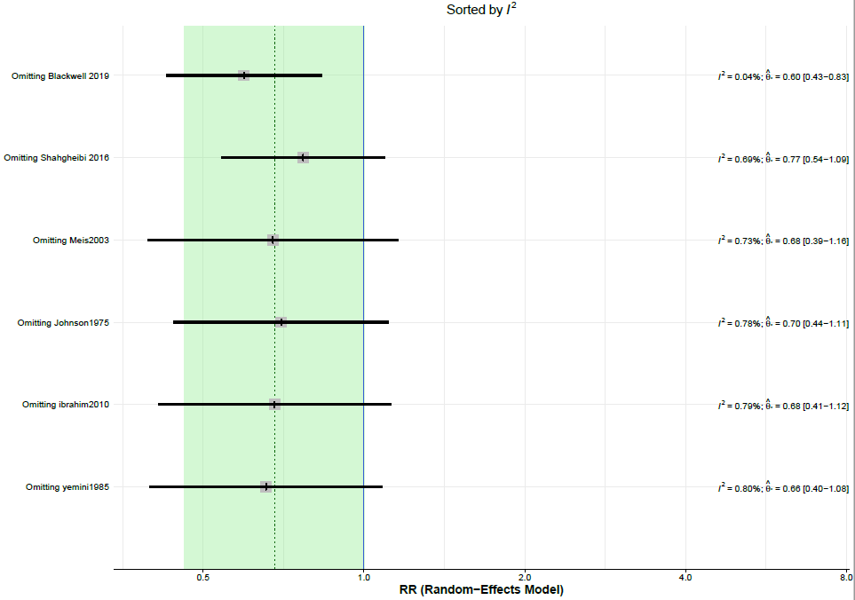
Figure S4: Effect of removing one study at a time on the heterogeneity for the risk of preterm < 37 weeks

