Supplement 2. Forest plots of the pairwise meta-analysis
HM plus GH vs. GH
(1) GV per year
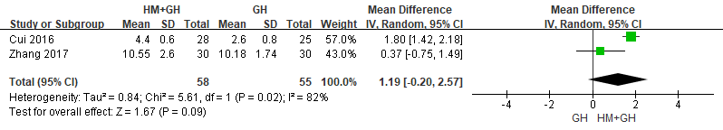
(2) GV per 6 months
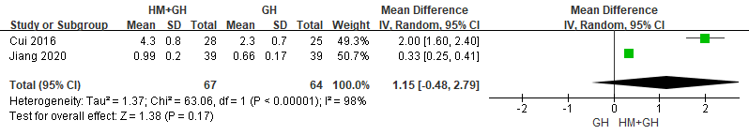
(3) GV per year change (after 6 months)
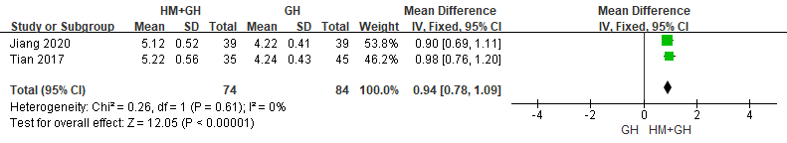
(4) Height (after 1 year)
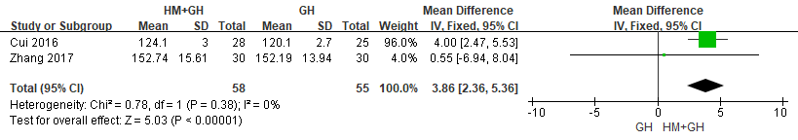
(5) Height (after 6 months)
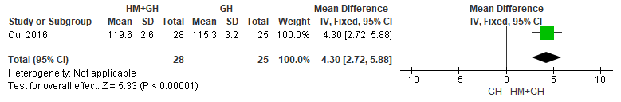

(6) HtSDS change (after 6 months)
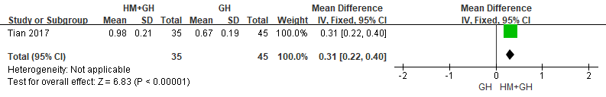
(7) Bone age (after 6 months)
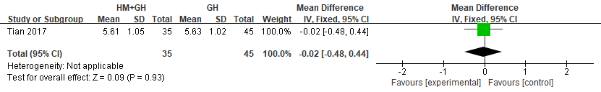
(8) Bone age change (after 1 year)
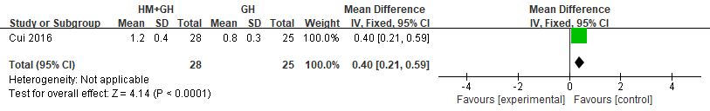
(9) Bone age change (after 6 months)
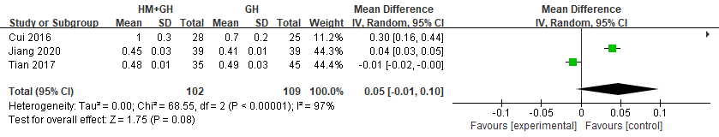
(10) IGF-1 (after 1 year)
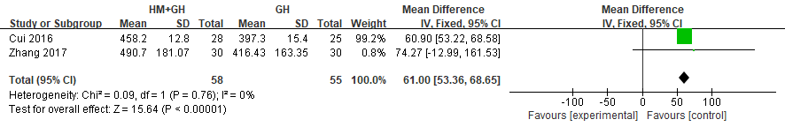
(11) IGF-1 (after 6 months)
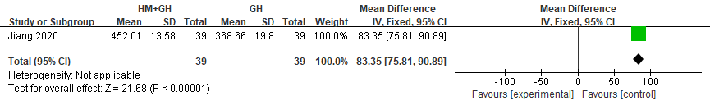

(12) IGF-1 change (after 6 months)
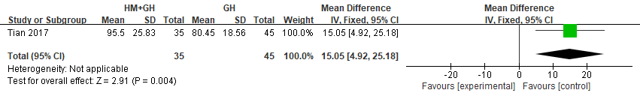(13) IGFBP-3 (after 1 year)
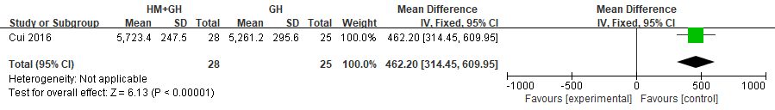
(14) IGFBP-3 (after 6 months)
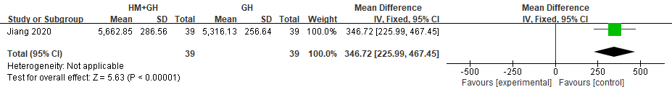
(15) IGFBP-3 change (after 6 months)
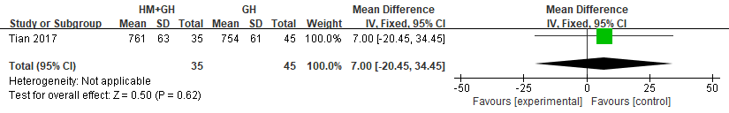
(16) adverse events
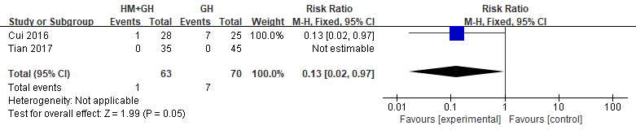

HM vs. no medical treatment
- GV per year
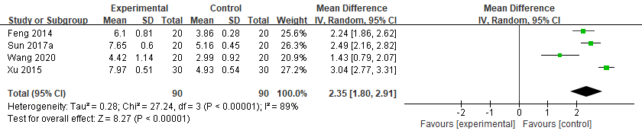
- GV per 6 months
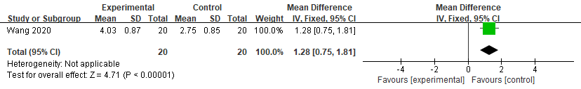
- GV per year change (after 6 months)
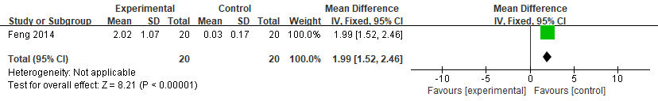
- Height (after 1 year)
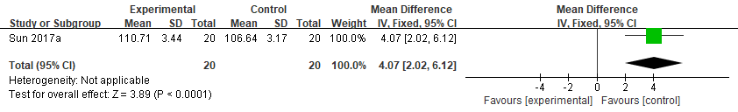
- PAH (after 1 year)
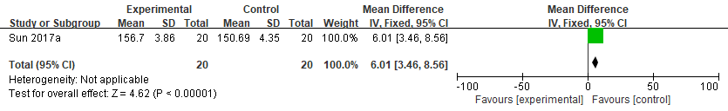
- PAH (after 6 months)
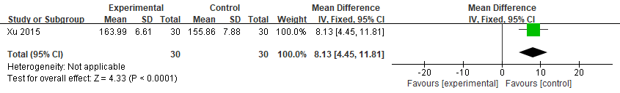

- PAH change (after 6 months)
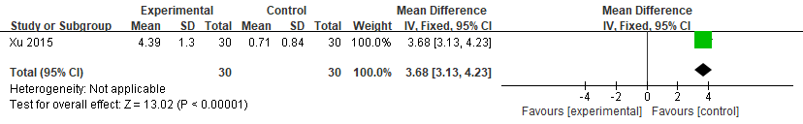
- HtSDS (after 1 year)
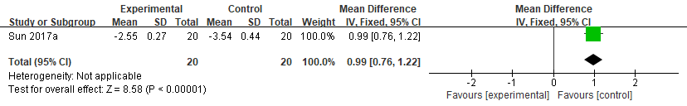
- HtSDS (after 6 months)
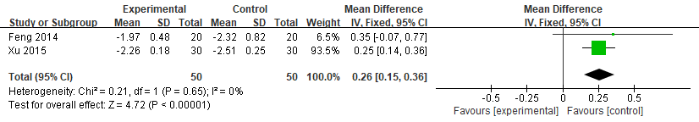
- HtSDS change (after 6 months)
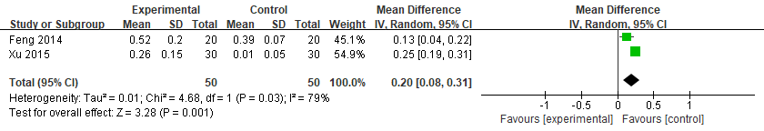
- Bone age (after 6 months)
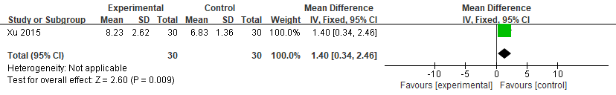
- Bone age change (after 1 year)
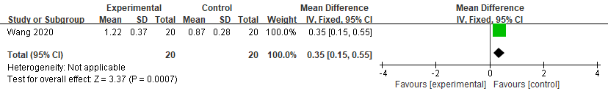
- Bone age change (after 6 months)
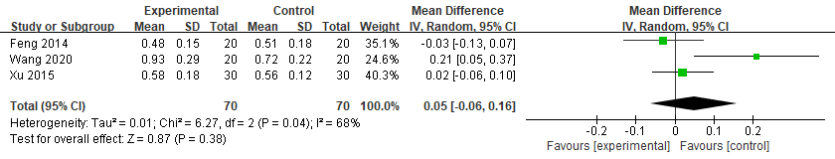
- IGF-1 (after 1 year)
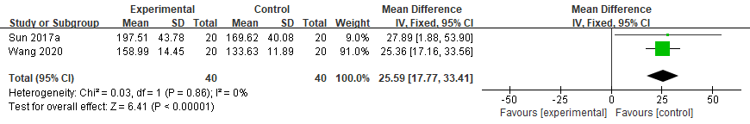
- IGF-1 (after 6 months)
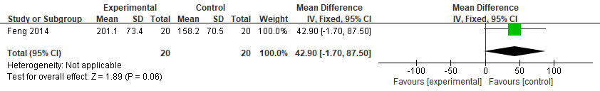
- IGFBP-3 (after 1 year)
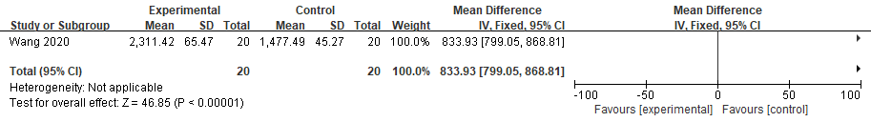
- Peak GH (after 1 year)
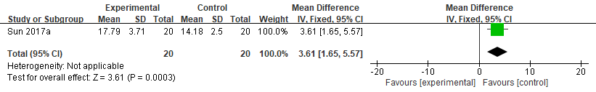
- Peak GH (after 6 months)
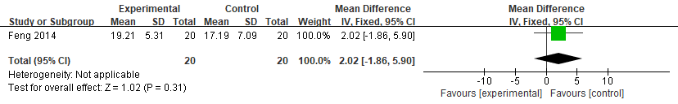
HM vs. nutritional supplement
(1) GV per year
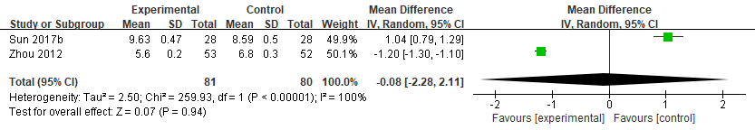
(2) GV per 6 months
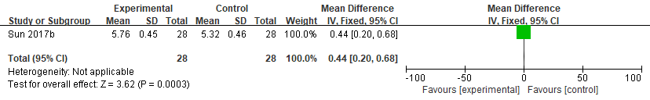
(3) Height (after 1 year)
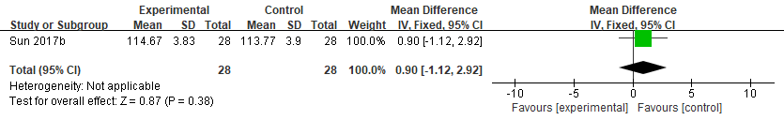
(4) Height (after 6 months)
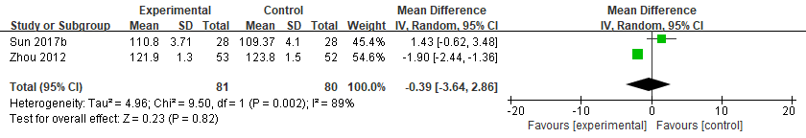
(5) PAH (after 1 year)
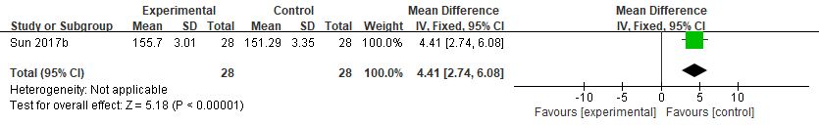
(6) PAH (after 6 months)
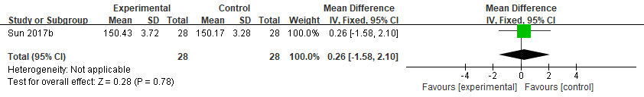
(7) PAH change (after 6 months)
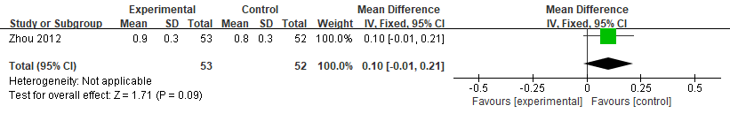
(8) HtSDS (after 1 year)
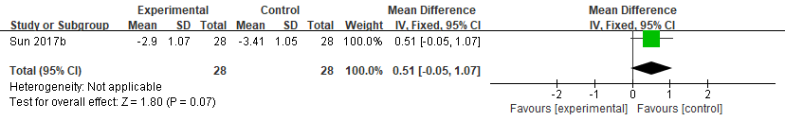
(9) HtSDS (after 6 months)
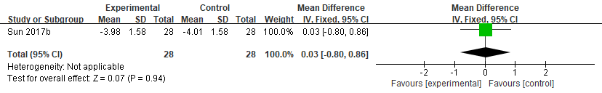
(10) HtSDS change (after 6 months)
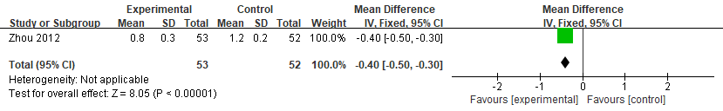
(11) IGF-1 (after 1 year)
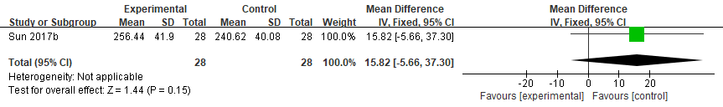
(12) IGF-1 (after 6 months)
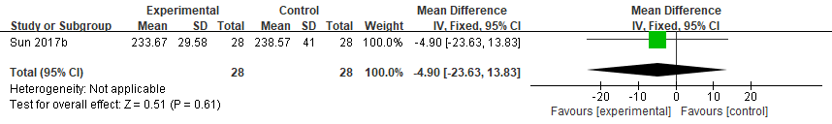
(13) peak GH (after 1 year)
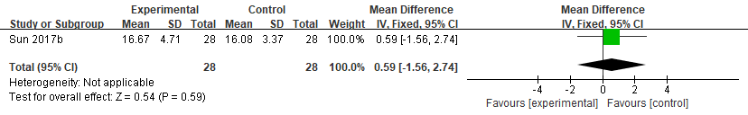
(14) peak GH (after 6 months)
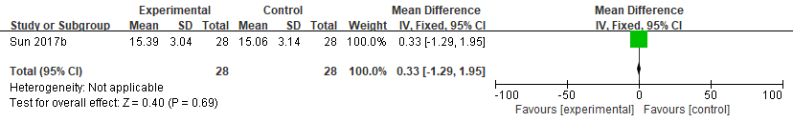
(15) Adverse event
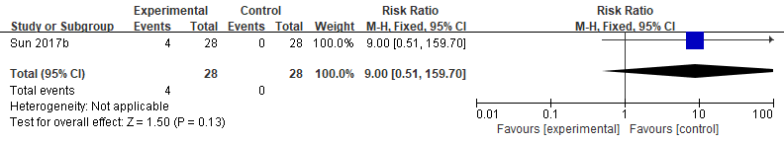
HM plus acupressure vs. GH
(1) Adverse event
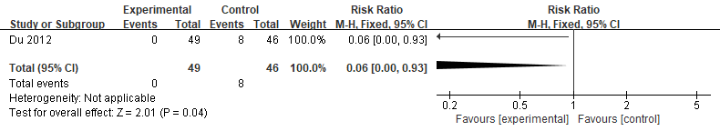Abbreviations: CI, confidence interval; GH, growth hormone; GV, growth velocity; HM, herbal medicine; HtSDS, height standard deviation score; IGF-1, insulin-like growth factor 1; IGFBP-3, insulin-like growth factor binding protein 3; MD, mean difference; NA, not applicable; PAH, predicted adult height; RR, risk ratio.

