Supplemental data

COVID-19 related cardiovascular comorbidities and complications in critically ill patients – a systematic review and meta-analysis.
Koeppen, Michael MD; Rosenberger, Peter MD, PhD; Magunia, Harry MD.

Page

2 Chart showing Covid-19 cases and published literature (red line) in the same time periods of 6 days

3 World maps with origin of included studies and cases

4 Calculation of quality score of included papers for quality-effects meta-analyses

5 - 6 Supplemental Table: Results of the quality scoring of the included studies

7 - 8 Funnel plots for publication bias assessment: Prevalence of Cardiovascular
Comorbidities

9 - 10 Funnel plots for publication bias assessment: Prevalence of cardiovascular complications and therapy during ICU therapy.

11 Results for the Quality-Effects Models

12 – 15 Forrest plots for the Quality-Effects Models

Supplemental Figure 1

Chart showing Covid-19 cases (black line) and published literature (red line) in the same time periods of 6 days

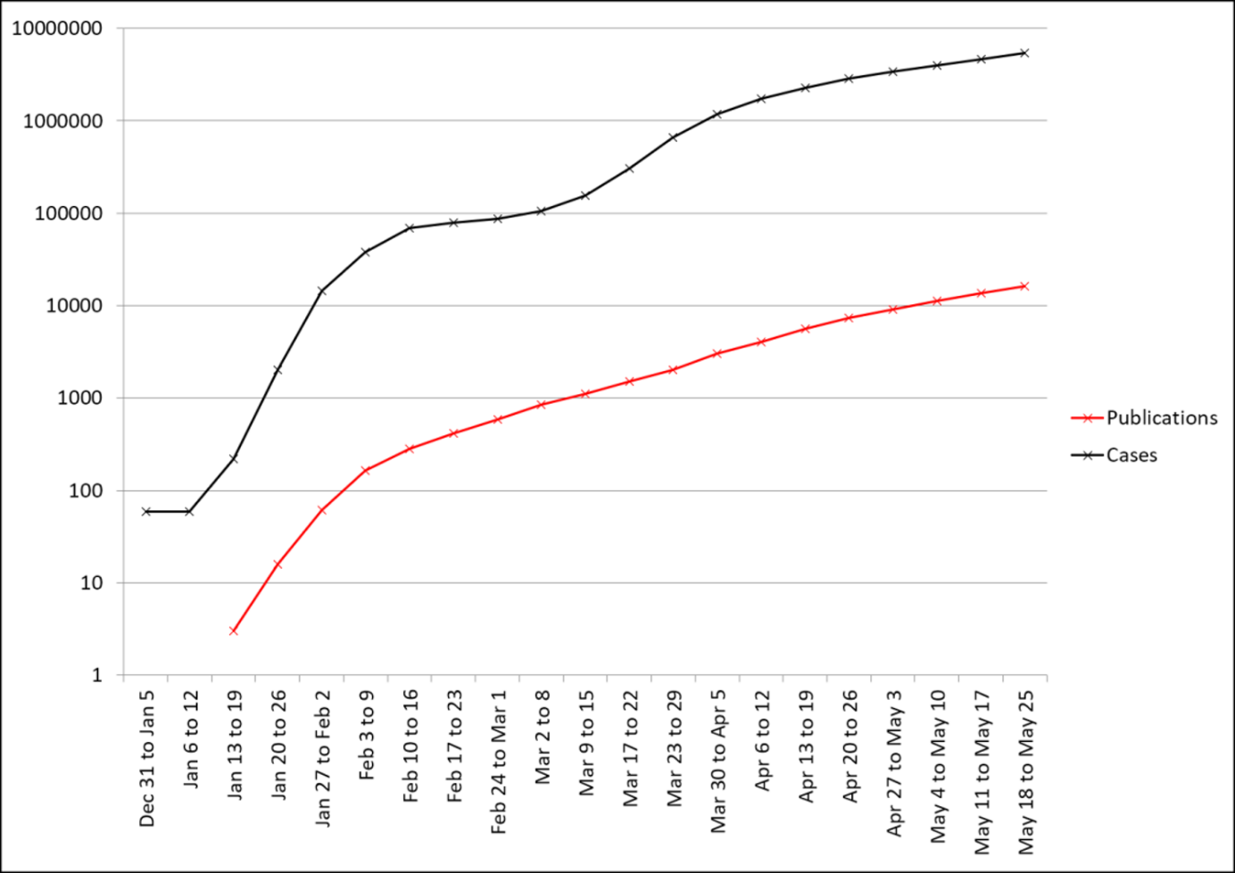

Supplemental Figure 2

Origin of the analyzed studies

Total number of studies by country

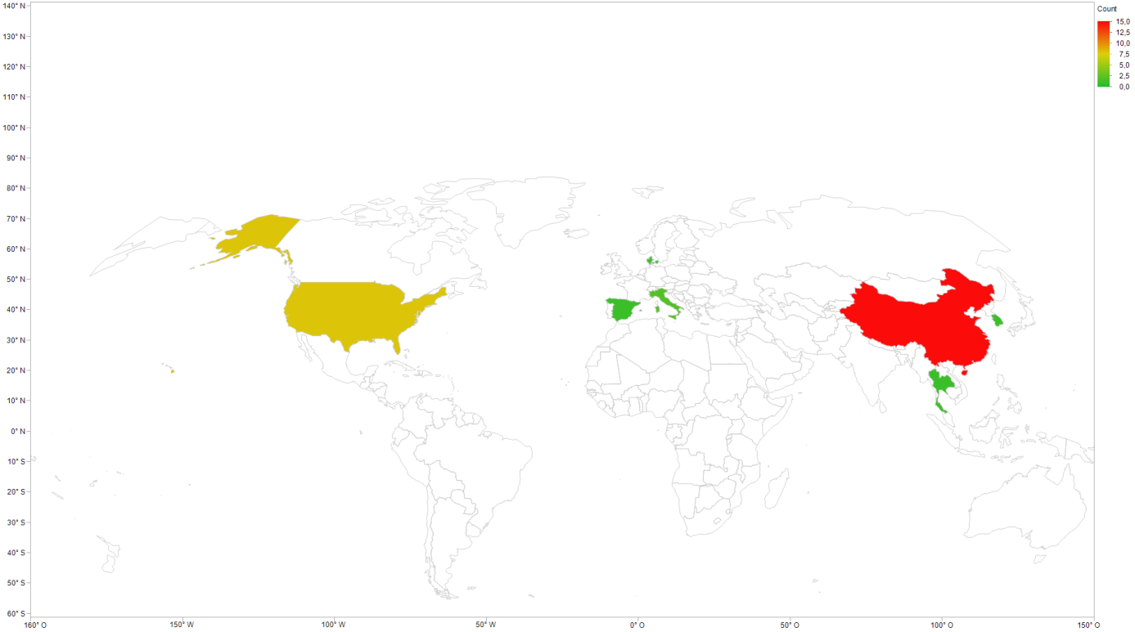

Total number of cases by country

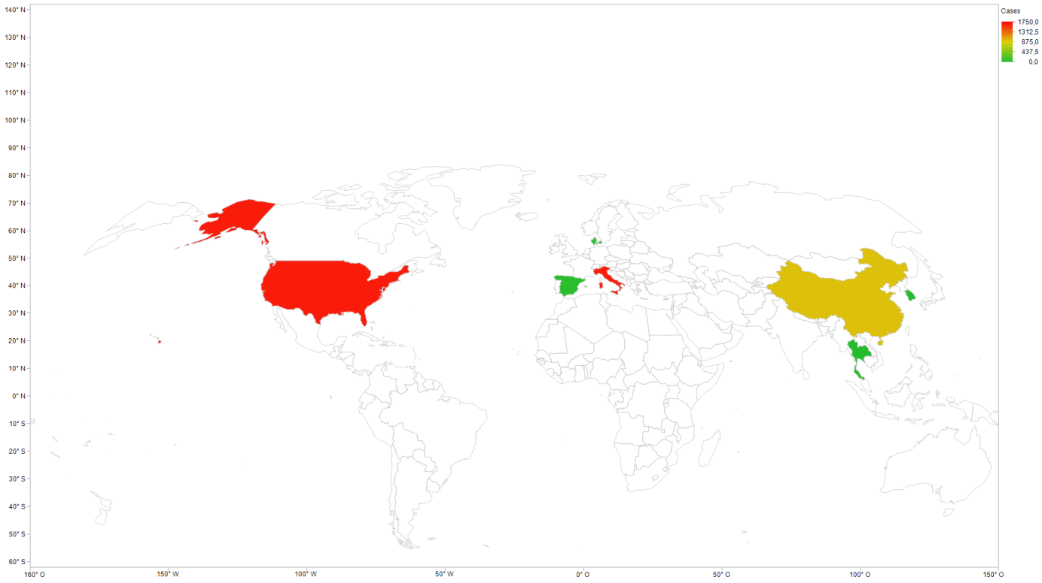

Calculation of quality score of included papers for quality-effects meta-analyses
[Doi SA, Barendregt JJ, Khan S et al., Contemp Clin Trials 2005(45): 123-129].

- Were the target population and the observation period well defined?
Yes = 1
No = 0

- Diagnostic criteria?
Use of diagnostic system reported (DSM, ICD, RDC) = 1
Own system /symptoms described/no system/not specified = 0

- Method of case ascertainment?
Community survey/multiple institutions = 2
Inpatient/inpatients and outpatients/case registers = 1
Not specified = 0

- Administration of measurement protocol?
Administered interview = 3
Systematic case-note review = 2
Chart diagnosis/case records = 1
Not specified = 0

- Catchment Area?
Broadly representative (national or multi-site survey) = 2
Small area/not representative (single community, single university) = 1
Convenience sampling/ other (primary care sample/treatment group) = 0

- Prevalence measure?
Point prevalence (e.g. one month) = 2
12-month prevalence = 1
Lifetime prevalence = 0

Calculation of quality score:
- Each study is awarded the corresponding points in each category.
- To calculate the quality score all points of each study are summed up and divided through the maximum number of points of all studies.

Supplemental table 1: Results of the quality scoring of the included studies

Study | Cat. 1 | Cat. 2 | Case  definition | Cat. 3 | Cat. 4 | Cat. 5 | Cat. 6 | Total  (Max: 11) | 9
Arentz et al., 2020, JAMA | 1 | 1 | PCR | 0 | 3 | 1 | 2 | 8 | 0.88888889
Barrasa et al., 2020, Anaesth Crit Care Pain Med | 1 | 1 | PCR | 0 | 3 | 1 | 2 | 8 | 0.88888889
Bhatraju et al., 2020, NEJM | 1 | 1 | PCR | 0 | 2 | 2 | 2 | 8 | 0.88888889
Cao et al, 2020, Intensive Care Med | 1 | 1 | PCR | 0 | 2 | 1 | 2 | 7 | 0.77777778
Chu et al., 2020, J Infect | 1 | 0 | nr | 0 | 2 | 1 | 2 | 6 | 0.66666667
Cummings et al., 2020, Lancet | 1 | 1 | PCR | 0 | 3 | 2 | 2 | 9 | 1
Du et al., 2020, Ann Am Thorac Suc | 1 | 1 | PCR | 0 | 2 | 2 | 2 | 8 | 0.88888889
Ferguson et al., 2020, Emerg Infect Dis | 1 | 1 | PCR | 0 | 2 | 2 | 2 | 8 | 0.88888889
Gold et al., 2020, MMWR | 1 | 1 | PCR | 0 | 1 | 2 | 2 | 7 | 0.77777778
Goyal et al, 2020, NEJM,* | 1 | 1 | PCR | 0 | 2 | 2 | 2 | 8 | 0.88888889
Grasselli et al, 2020, JAMA | 1 | 1 | PCR | 0 | 2 | 2 | 2 | 8 | 0.88888889
Hong et al., 2020, YMI | 1 | 1 | PCR | 0 | 2 | 1 | 2 | 7 | 0.77777778
Huang et al., 2020, Lancet | 1 | 1 | PCR | 0 | 3 | 1 | 2 | 8 | 0.88888889
Ling et al., 2020, Crit Care Resusc | 1 | 1 | PCR | 0 | 2 | 2 | 2 | 8 | 0.88888889
Myers et al., 2020, JAMA | 1 | 1 | PCR | 0 | 2 | 2 | 2 | 8 | 0.88888889
Pedersen et al., 2020, Dan Med J | 1 | 0 | nr | 0 | 2 | 1 | 2 | 6 | 0.66666667
Petrilli et al., 2020, BMJ,+ | 1 | 1 | PCR | 0 | 3 | 1 | 2 | 8 | 0.88888889
Ratanarat et al., 2020, Am J Trop Med Hyg | 0 | 0 | nr | 0 | 0 | 1 | 2 | 3 | 0.33333333
Sun et al., 2020, J Autoimmun,+ | 0 | 1 | PCR | 0 | 0 | 0 | 2 | 5 | 0.55555556
Wang et al., 2020, JAMA | 1 | 1 | PCR | 0 | 2 | 1 | 2 | 7 | 0.77777778
Wang et al., 2020, AJRCCM | 1 | 1 | PCR | 0 | 1 | 2 | 2 | 7 | 0.77777778
Yang et al., 2020, Lancet | 1 | 1 | PCR | 0 | 2 | 1 | 2 | 7 | 0.77777778
Yu et al., 2020, Crit Care | 1 | 1 | PCR | 0 | 3 | 2 | 2 | 9 | 1
Zangrillo et al., Crit Care Resusc | 1 | 1 | PCR | 0 | 3 | 1 | 2 | 8 | 0.88888889
Zhang J et al., 2020, J Publ Health | 1 | 0 | nr | 0 | 2 | 1 | 2 | 6 | 0.66666667
Zhang et al., 2020, Clin Microbiol Infect,+ | 1 | 1 | PCR | 0 | 2 | 1 | 2 | 7 | 0.77777778
Zheng et al., 2020. J Zheijang Univ Sci N | 1 | 1 | PCR | 0 | 2 | 1 | 2 | 7 | 0.77777778
Zheng et al., 2020, J Clin Virol | 1 | 1 | PCR | 0 | 2 | 1 | 2 | 7 | 0.77777778
Zhou et al., 2020, Clin Transl Sci | 1 | 1 | PCR | 0 | 2 | 1 | 2 | 7 | 0.77777778

nr: not retrievable

Modifications made:
Category 2: All studies using a positive SARS-CoV-2 PCR for case definition were awarded 1 point.
Category 3: All studies were awarded 0 points in this category as this question did not fit
Category 4: All prospective cohorts were awarded 3 points
all clearly defined retrospective cohorts were awarded 2 points
case series were awarded 1 point
reports not reporting on study design were awarded 0 points.

Funnel plots for publication bias assessment

Prevalence of Cardiovascular Comorbidities

- Arterial Hypertension

- Cardiovascular Diseases

- Coronary Heart Disease

- Congestive heart failure

Prevalence of cardiovascular complications and therapy during ICU therapy.

- Shock of any cause

- Vasopressor use

- Arrhythmia

- Acute Cardiac Injury

Results for the Quality-Effects Models

 | Number of studies included | Pooled prevalence | Heterogeneity
 | Number of studies included | Pooled prevalence | I² | Cochran’s Q | Chi², P
Prevalence of cardiovascular comorbidities in critically ill
Hypertension | 22 | 0.476 (95%CI 0.321 to 0.634) | 94.8% (95%CI 93.2% to 96.0%) | 404.6 | 0.000
Cardiovascular diseases in general | 16 | 0.275 (95%CI 0.008 to 0.667) | 98.9% (95%CI 98.7% to 99.1%) | 1,390.8 | 0.000
Coronary Heart Disease | 5 | 0.228 (95%CI 0.113 to 0.367) | 87.9% (95%CI 74.3% to 94.3%) | 33.074 | 0.000
Congestive Heart Failure | 5 | 0.034 (95% 0.000 to 0.119) | 86.3% (95%CI 70.1% to 93.7%) | 29.16 | 0.000
Prevalence of cardiovascular complications and therapy during ICU therapy
Shock | 6 | 0.319 (95%CI 0.108 to 0.574) | 95.6% (95%CI 92.7% to 97.4%) | 113.679 | 0.000
Vasopressor use | 8 | 0.757 (95%CI 0.527 to 0.932) | 93.6% (95%CI 89.7% to 96.1%) | 110.051 | 0.000
Arrhythmia | 6 | 0.161 (95%CI 0.06 to 0.295) | 84.8% (95%CI 66.6% to 92.6%) | 32.795 | 0.000
Acute Cardiac Injury | 14 | 0.283 (95% 0.137 to 0.456) | 91% (95%CI 86.6% to 93.9%) | 143.699 | 0.000

Forrest Plots for the Quality-Effects Models: Prevalence of cardiovascular comorbidities in critically ill

a) Hypertension

b) Cardiovascular diseases in general

c) Coronary Heart Disease

c) Congestive Heart Failure

Forrest Plots for the Quality-Effects Models: Prevalence of cardiovascular complications and therapy during ICU therapy

a) Shock

b) Vasopressor use

c) Arrhythmia

d) Acute Cardiac Injury

