Supporting Information – contains all the supporting tables and figures
S1 Text. Search strategy
S1 Table. Quality analyses of the trials included in the systematic review and meta-analysis
S2 Table. PRISMA checklist
S1 Fig. Pooled complication rate of extended resection versus tumour resection alone
S2 Fig. Pooled mortality rate of extended resection versus tumour resection alone
S3 Fig. Pooled disease-free survival of extended resection versus tumour resection alone
S4 Fig. Subgroup analysis disease-free survival of extended resection versus tumour resection alone (primary RPS)
S5 Fig. Subgroup analysis disease-free survival of extended resection versus tumour resection alone (recurrent RPS)
S6 Fig. Pooled over-all survival of extended resection versus tumour resection alone
S7 Fig. Subgroup analysis over-all survival of extended resection versus tumour resection alone (primary RPS)
S8 Fig. Subgroup analysis over-all survival of extended resection versus tumour resection alone (recurrent RPS)
S9 Fig. Pooled over-all survival of R0 vs R1
S10 Fig. Subgroup analysis of over-all survival of R0 vs R1 (primary RPS)
S11 Fig. Pooled over-all survival of R1 vs R2
S12 Fig. Subgroup analysis of over-all survival of R1 vs R2 (primary RPS)
S13 Fig. Pooled over-all survival of R2 vs no surgery
S14 Fig. Subgroup analysis of over-all survival of R2 vs no surgery (primary RPS)
Text S1: Search strategy
Medline search strategy
- exp retroperitoneal sarcoma/
- exp RPS /
- exp retroperitoneal tumour /
- exp retroperitoneal neoplasm/
- (rps* or (retroperit$ adj8 sarcoma$ adj8).mp. [mp=title, original title, abstract, name of substance word, subject heading word, unique identifier]
- 1 or 2 or 3 or 4 or 5
- surgery/
- surg$.tw.
- resect$.tw.
- operati$.tw.
- intervent$.tw.
- 7 or 8 or 9 or 10 or 11 or 12
- 6 and 12
- limit 13 to humans
Table S1: Quality analyses of the trials included in the systematic review and meta-analysis
Studies | Selection | Comparability | Outcome | Total
Abdelfatah 2016¹⁷ | 4 | 0 | 3 | 7
Bagaria 2018¹⁸ | 4 | 0 | 3 | 7
Bengmark 1990¹⁹ | 4 | 2 | 3 | 9
Bonvalot 2008²⁰ | 4 | 0 | 3 | 7
Bremjit 2014²¹ | 4 | 0 | 3 | 7
Chiappa 2006²² | 4 | 0 | 3 | 7
Chiappa 2018²³ | 4 | 1 | 3 | 8
Doepker 2016²⁴ | 4 | 0 | 3 | 7
Erzen 2005²⁵ | 4 | 0 | 3 | 7
Fujimoto 2018²⁶ | 4 | 0 | 3 | 7
Garcı´a-Aceituno 2010²⁷ | 4 | 0 | 3 | 7
Gilbeau 2002²⁸ | 4 | 0 | 3 | 7
Grobmyer 2010²⁹ | 4 | 0 | 3 | 7
Gronchi 2014³⁰ | 4 | 0 | 3 | 7
Ikoma 2017³¹ | 4 | 0 | 3 | 7
Ikoma 2018¹⁰ | 4 | 2 | 3 | 9
Ishii 2020³² | 4 | 0 | 3 | 7
Jaques 1989³³ | 4 | 1 | 3 | 8
Karakousis 1985³⁴ | 4 | 0 | 3 | 7
Lehnert 2009³⁵ | 4 | 0 | 3 | 7
Lewis 1998³⁶ | 4 | 0 | 3 | 7
Lochan 2011³⁷ | 4 | 0 | 3 | 7
Lu 2013³⁸ | 4 | 1 | 3 | 8
MacNeill 2017³⁹ | 4 | 0 | 3 | 7
Martin 2020⁴⁰ | 4 | 0 | 3 | 7
McGrath 1984⁴¹ | 4 | 0 | 3 | 7
Milone 2011⁴² | 4 | 1 | 3 | 8
Miura 2015⁴³ | 4 | 0 | 3 | 7
Morizawa 2006⁴⁴ | 4 | 1 | 3 | 8
Mussi 2011⁴⁵ | 4 | 0 | 3 | 7
Nathenson 2018⁴⁶ | 4 | 0 | 3 | 7
Pinson 1989⁴⁷ | 4 | 0 | 3 | 7
Rhu 2019⁴⁸ | 4 | 0 | 3 | 7
Roeder 2017⁴⁹ | 4 | 0 | 3 | 7
Rossi 2013⁵⁰ | 4 | 0 | 3 | 7
Santos 2010⁵¹ | 4 | 2 | 3 | 9
Shibata 2001¹² | 4 | 0 | 3 | 7
Shiloni 1993⁵² | 4 | 0 | 3 | 7
Singer 2003⁵³ | 4 | 0 | 3 | 7
Tan 2016⁵⁴ | 4 | 0 | 3 | 7
Thalji 2020⁵⁵ | 4 | 0 | 3 | 7
Tropea 2020⁵⁶ | 4 | 0 | 3 | 7
Tseng 2010⁵⁷ | 4 | 0 | 3 | 7
van Houdt 2020⁵⁸ | 4 | 1 | 3 | 8
Villano 2020⁵⁹ | 4 | 2 | 3 | 9
Yang 2014⁶⁰ | 4 | 0 | 3 | 7
Zhao 2015⁶¹ | 4 | 0 | 3 | 7

Table S2: PRISMA checklist
Section/topic | # | Checklist item | Reported on page #
TITLE
Title | 1 | Identify the report as a systematic review, meta-analysis, or both. | #1
ABSTRACT
Structured summary | 2 | Provide a structured summary including, as applicable: background; objectives; data sources; study eligibility criteria, participants, and interventions; study appraisal and synthesis methods; results; limitations; conclusions and implications of key findings; systematic review registration number. | #2
INTRODUCTION
Rationale | 3 | Describe the rationale for the review in the context of what is already known. | #3
Objectives | 4 | Provide an explicit statement of questions being addressed with reference to participants, interventions, comparisons, outcomes, and study design (PICOS). | #3
METHODS
Protocol and registration | 5 | Indicate if a review protocol exists, if and where it can be accessed (e.g., Web address), and, if available, provide registration information including registration number. | NS
Eligibility criteria | 6 | Specify study characteristics (e.g., PICOS, length of follow-up) and report characteristics (e.g., years considered, language, publication status) used as criteria for eligibility, giving rationale. | #3,4
Information sources | 7 | Describe all information sources (e.g., databases with dates of coverage, contact with study authors to identify additional studies) in the search and date last searched. | #3
Search | 8 | Present full electronic search strategy for at least one database, including any limits used, such that it could be repeated. | #3
Study selection | 9 | State the process for selecting studies (i.e., screening, eligibility, included in systematic review, and, if applicable, included in the meta-analysis). | #3,4
Data collection process | 10 | Describe method of data extraction from reports (e.g., piloted forms, independently, in duplicate) and any processes for obtaining and confirming data from investigators. | #4
Data items | 11 | List and define all variables for which data were sought (e.g., PICOS, funding sources) and any assumptions and simplifications made. | #4
Risk of bias in individual studies | 12 | Describe methods used for assessing risk of bias of individual studies (including specification of whether this was done at the study or outcome level), and how this information is to be used in any data synthesis. | #4
Summary measures | 13 | State the principal summary measures (e.g., risk ratio, difference in means). | #4
Synthesis of results | 14 | Describe the methods of handling data and combining results of studies, if done, including measures of consistency (e.g., I²) for each meta-analysis. | #4

Page 1 of 2
Section/topic | # | Checklist item | Reported on page #
Risk of bias across studies | 15 | Specify any assessment of risk of bias that may affect the cumulative evidence (e.g., publication bias, selective reporting within studies). | #4
Additional analyses | 16 | Describe methods of additional analyses (e.g., sensitivity or subgroup analyses, meta-regression), if done, indicating which were pre-specified. | #4
RESULTS
Study selection | 17 | Give numbers of studies screened, assessed for eligibility, and included in the review, with reasons for exclusions at each stage, ideally with a flow diagram. | #4
Study characteristics | 18 | For each study, present characteristics for which data were extracted (e.g., study size, PICOS, follow-up period) and provide the citations. | #4,5,Appendix
Risk of bias within studies | 19 | Present data on risk of bias of each study and, if available, any outcome level assessment (see item 12). | #4
Results of individual studies | 20 | For all outcomes considered (benefits or harms), present, for each study: (a) simple summary data for each intervention group (b) effect estimates and confidence intervals, ideally with a forest plot. | #4,5
Synthesis of results | 21 | Present results of each meta-analysis done, including confidence intervals and measures of consistency. | #5,6,Appendix
Risk of bias across studies | 22 | Present results of any assessment of risk of bias across studies (see Item 15). | #5
Additional analysis | 23 | Give results of additional analyses, if done (e.g., sensitivity or subgroup analyses, meta-regression [see Item 16]). | #5,6
DISCUSSION
Summary of evidence | 24 | Summarize the main findings including the strength of evidence for each main outcome; consider their relevance to key groups (e.g., healthcare providers, users, and policy makers). | #6
Limitations | 25 | Discuss limitations at study and outcome level (e.g., risk of bias), and at review-level (e.g., incomplete retrieval of identified research, reporting bias). | #8
Conclusions | 26 | Provide a general interpretation of the results in the context of other evidence, and implications for future research. | #8
FUNDING
Funding | 27 | Describe sources of funding for the systematic review and other support (e.g., supply of data); role of funders for the systematic review. | #8
From: Moher D, Liberati A, Tetzlaff J, Altman DG, The PRISMA Group (2009). Preferred Reporting Items for Systematic Reviews and Meta-Analyses: The PRISMA Statement. PLoS Med 6(6): e1000097. doi:10.1371/journal.pmed1000097
For more information, visit: www.prisma-statement.org. Page 2 of 2

Figure S1: Pooled complication rate of extended resection versus tumour resection alone
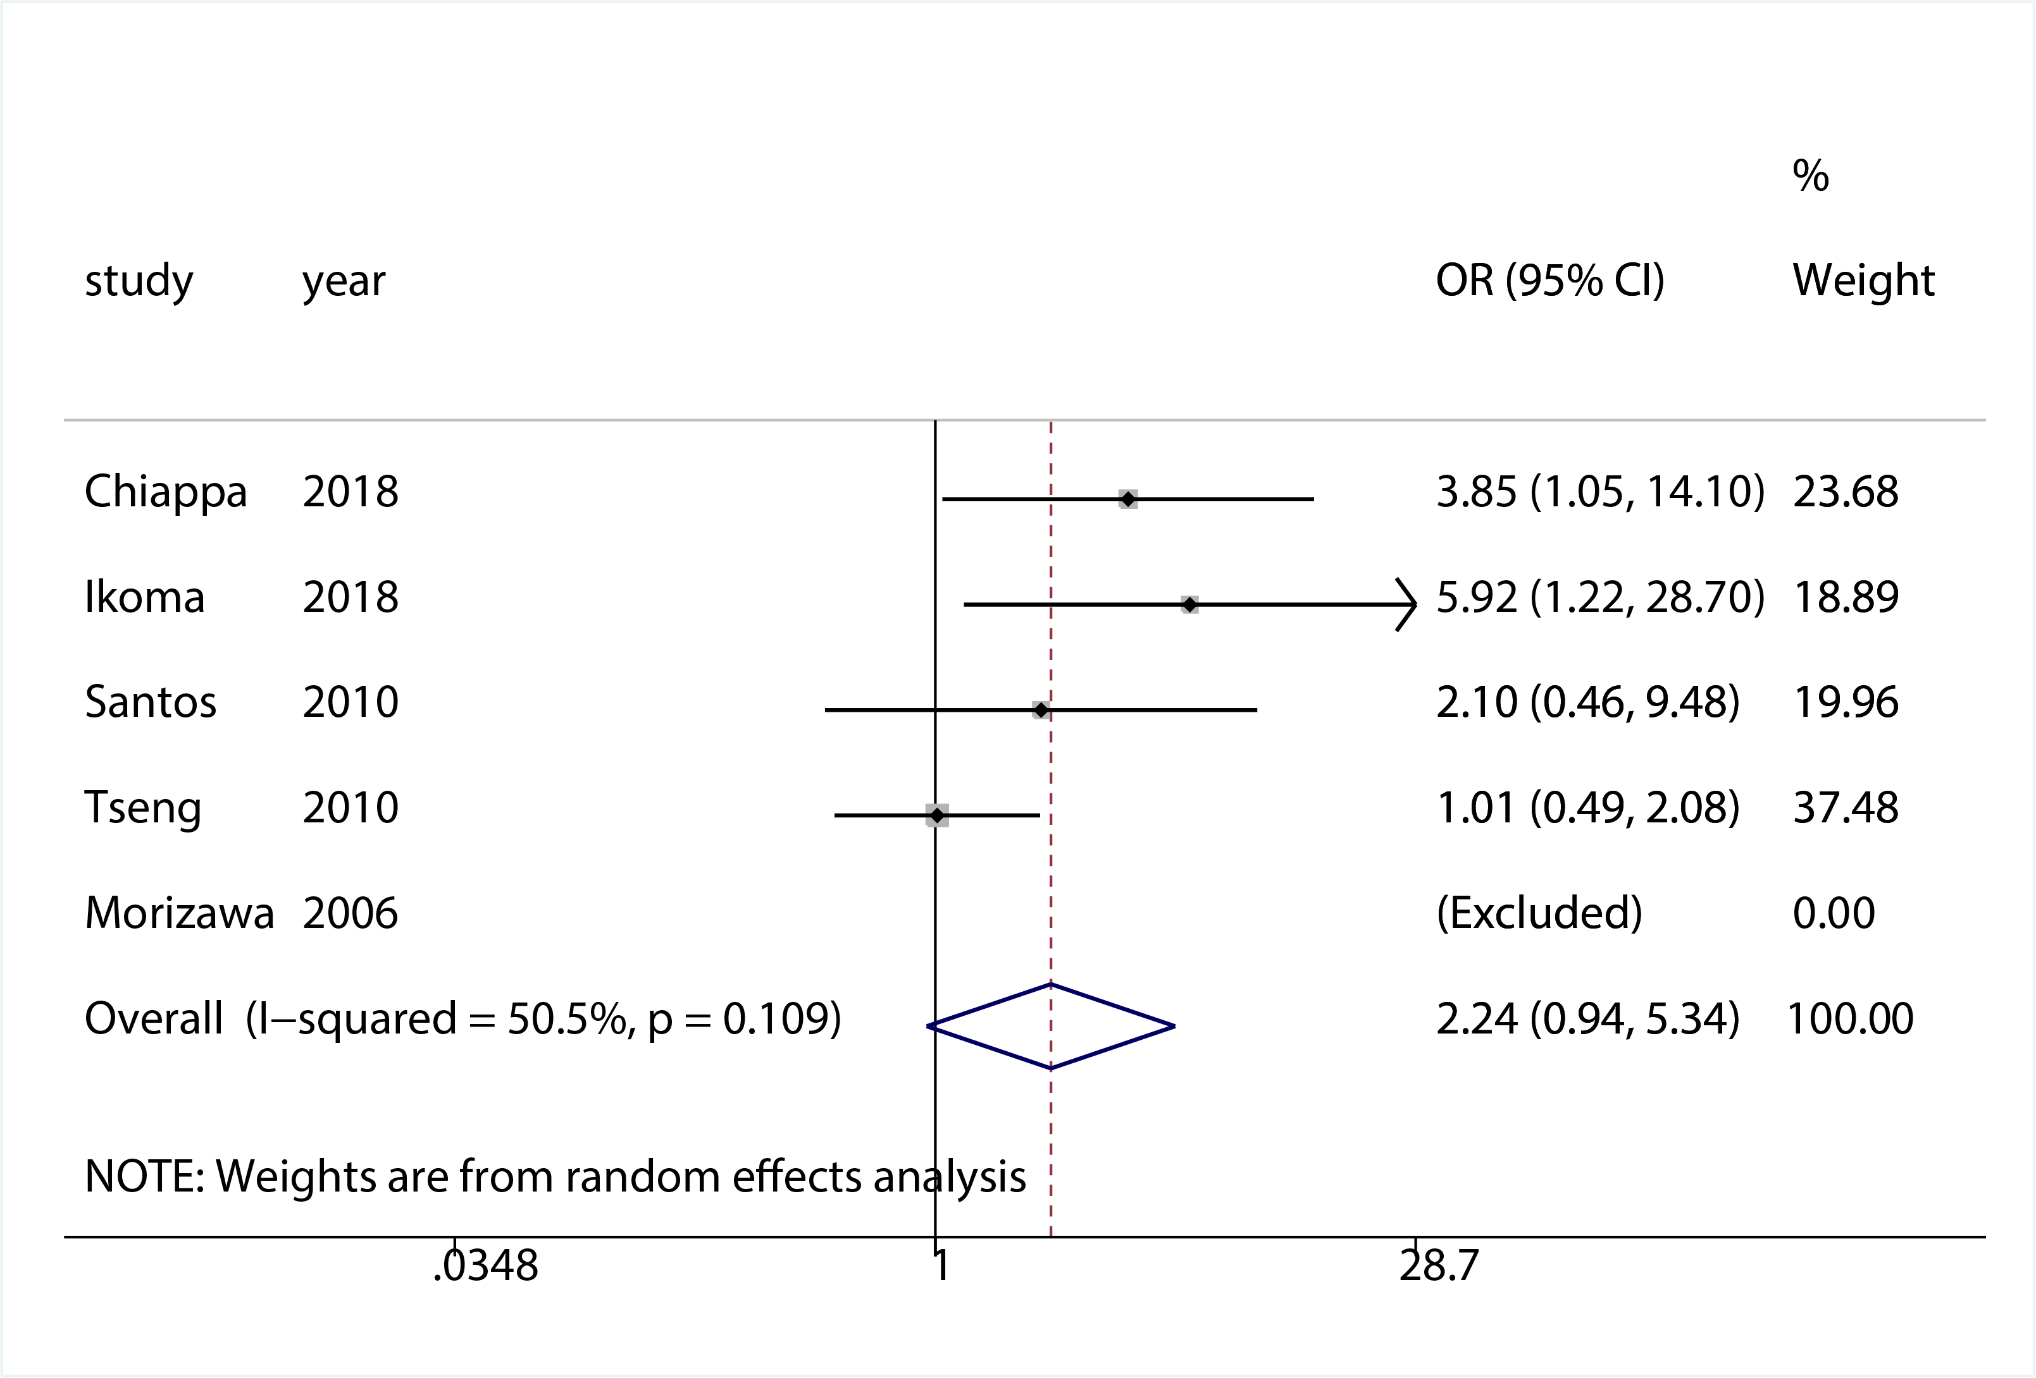
Figure S2: Pooled mortality rate of extended resection versus tumour resection alone
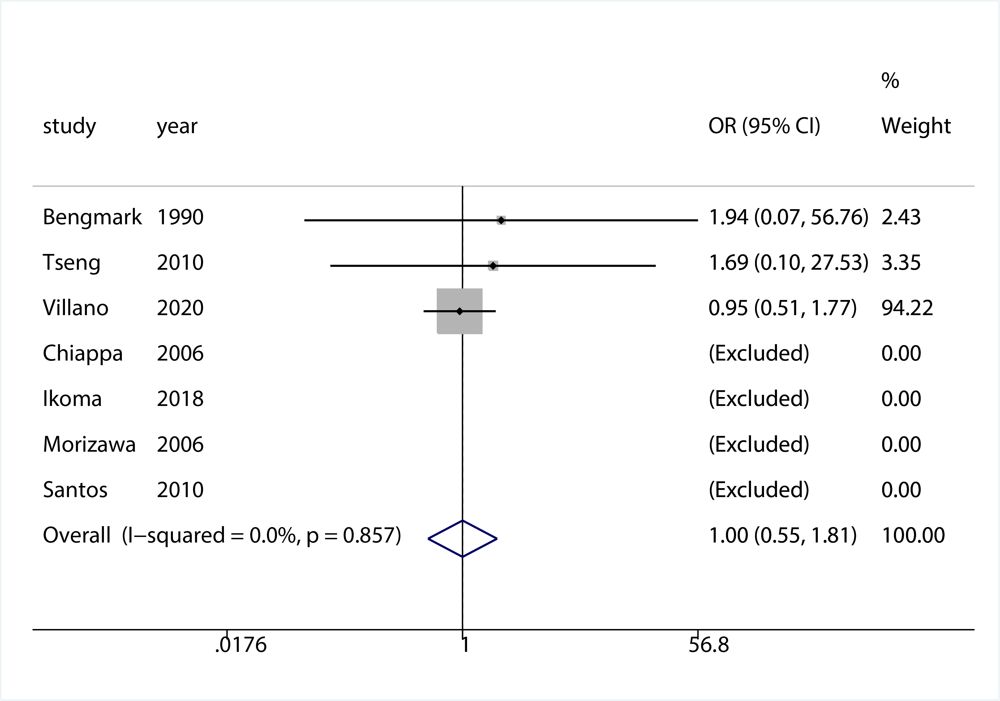
Figure S3: Pooled disease-free survival of extended resection versus tumour resection alone
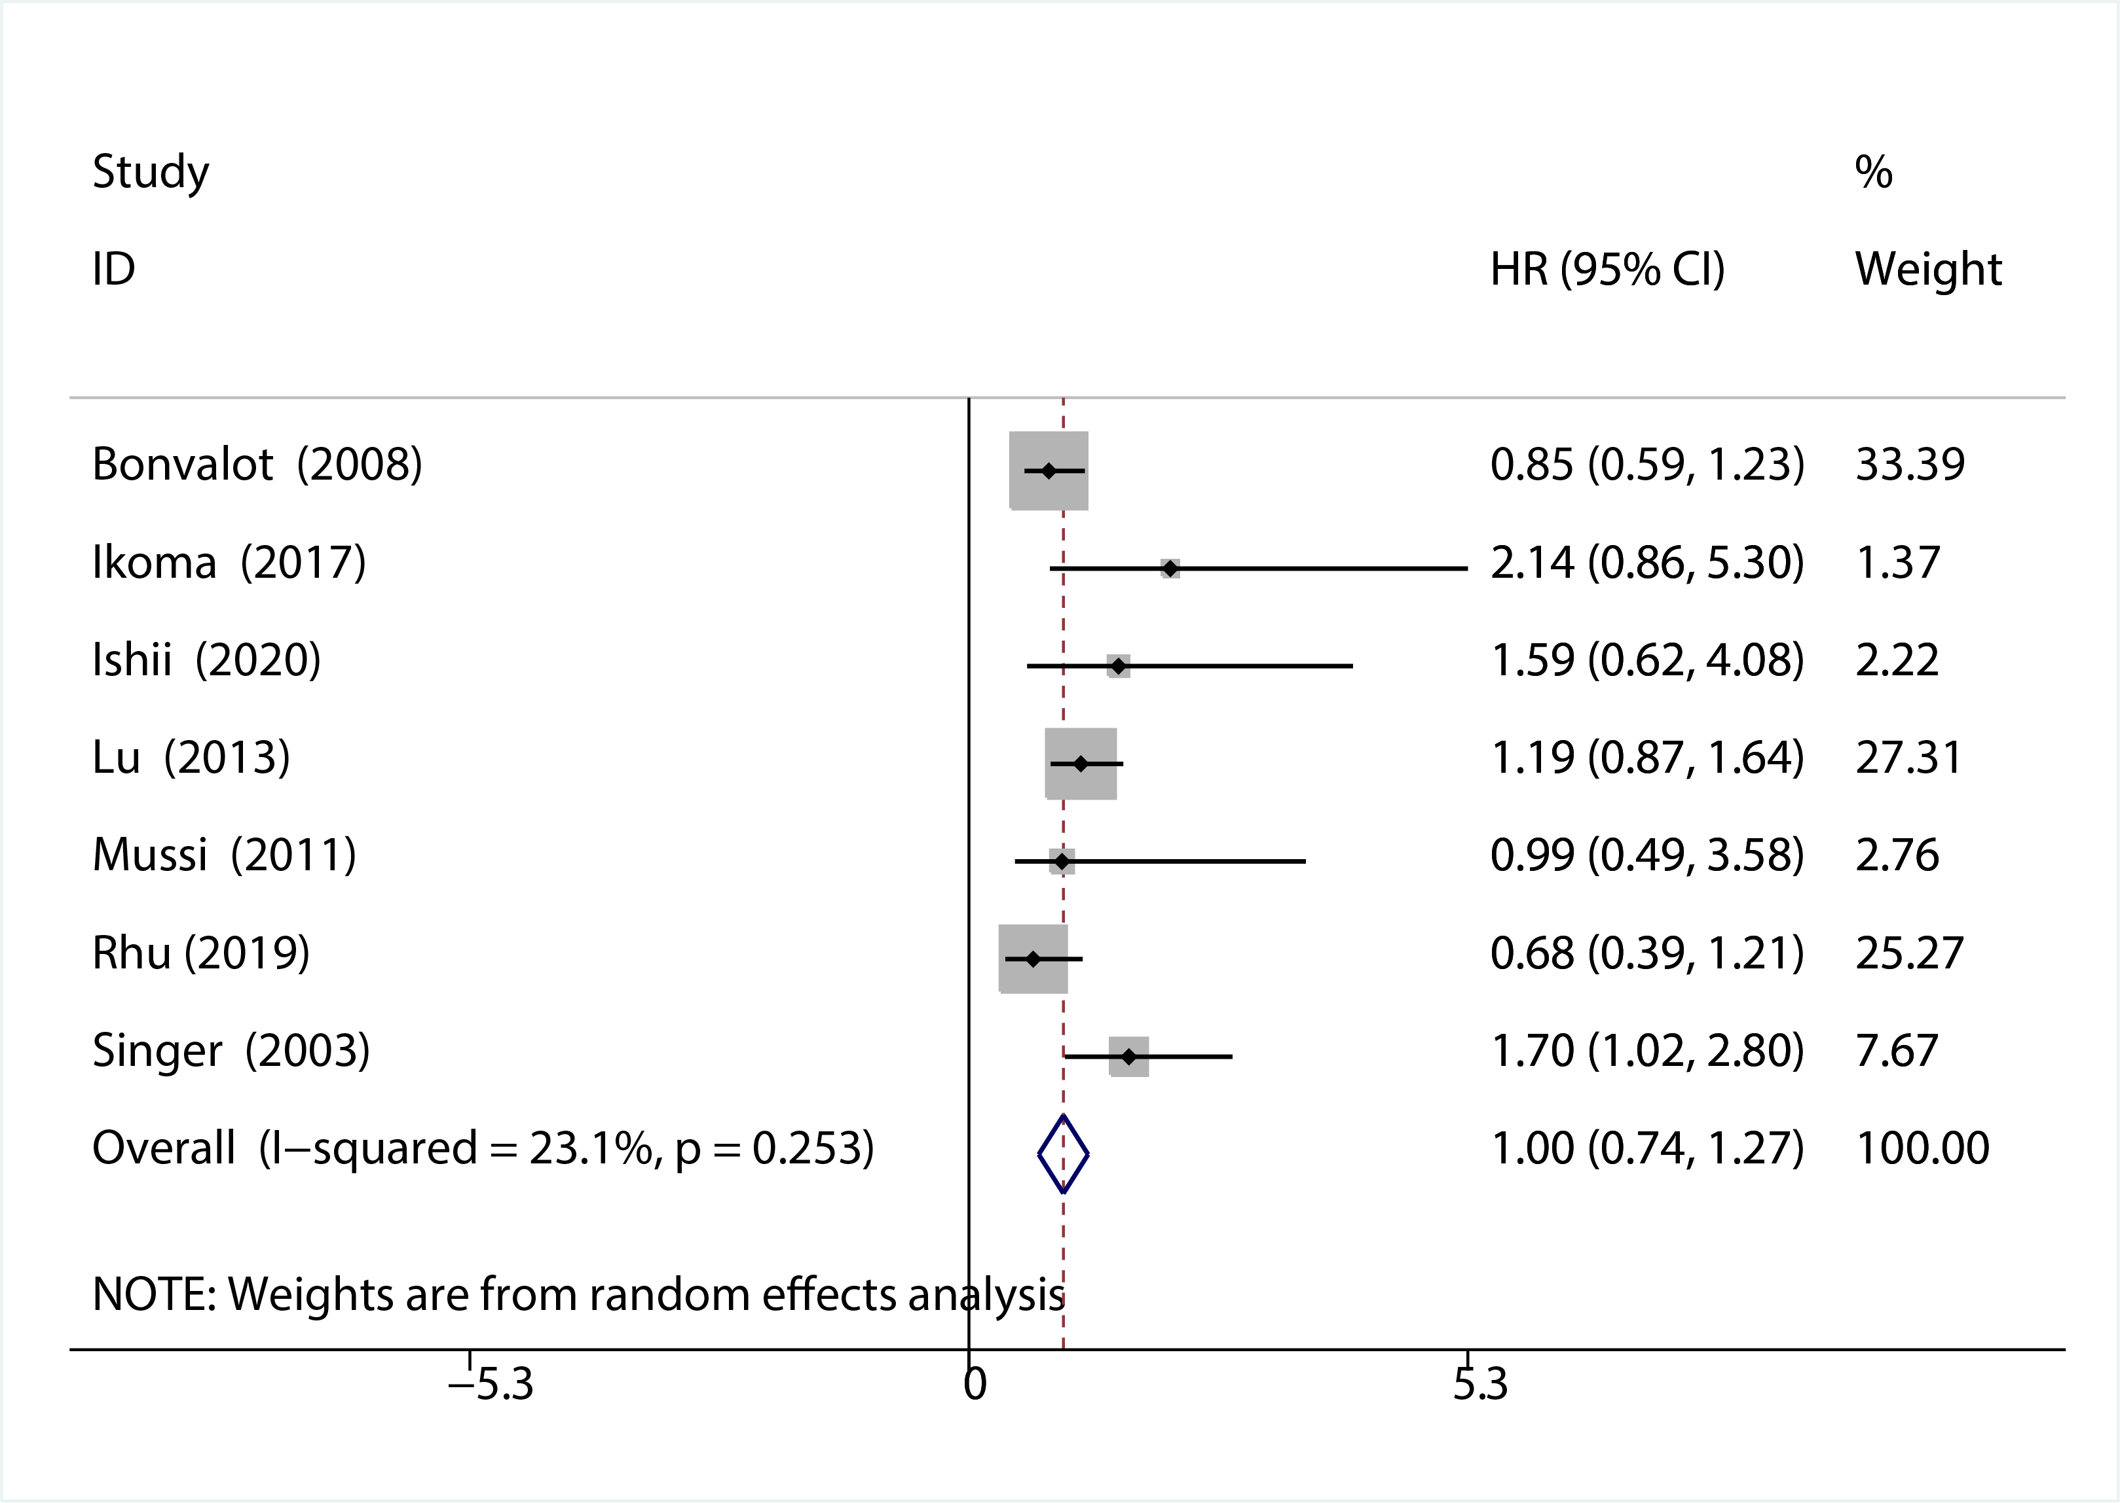
Figure S4: Subgroup analysis disease-free survival of extended resection versus tumour resection alone (primary RPS)
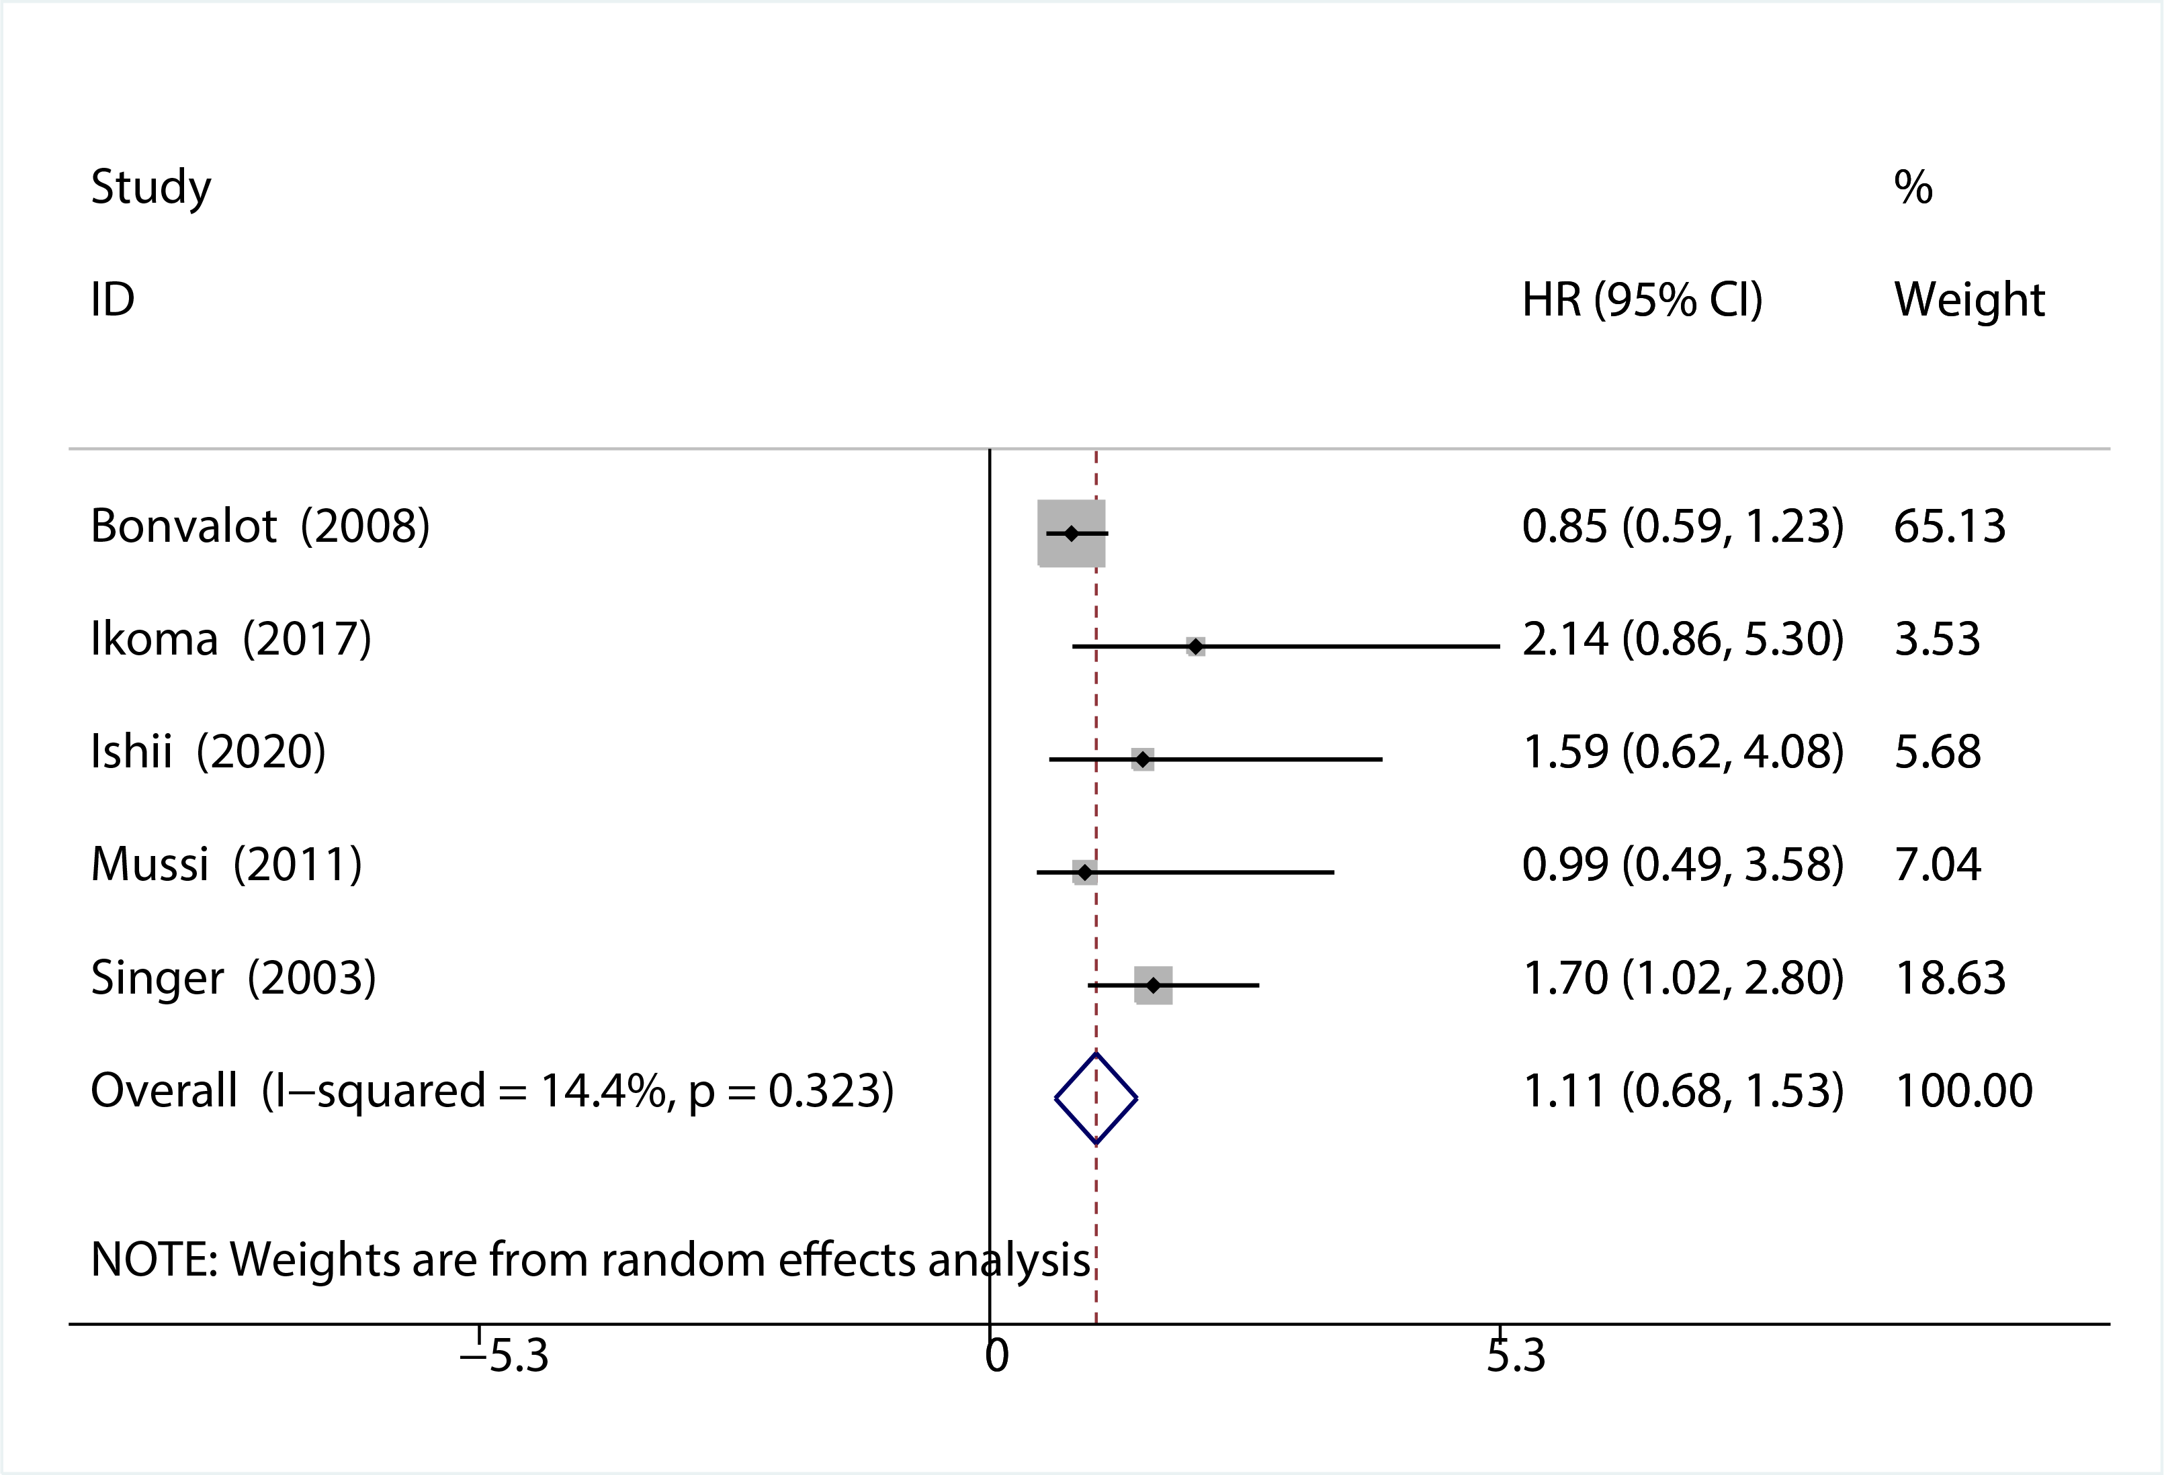
Figure S5: Subgroup analysis disease-free survival of extended resection versus tumour resection alone (recurrent RPS)
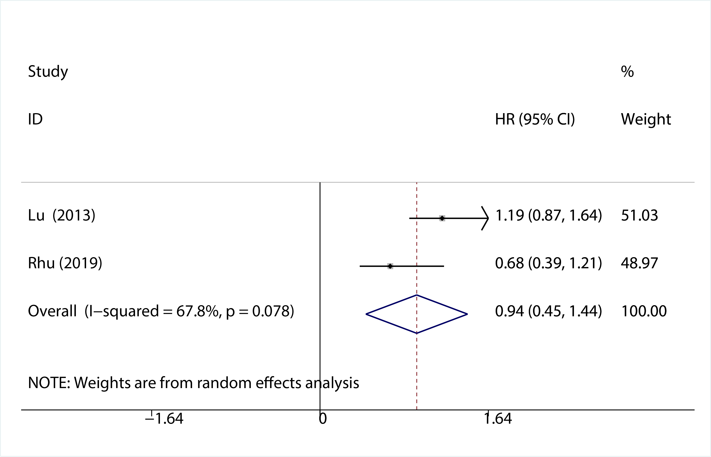
Figure S6: Pooled over-all survival of extended resection versus tumour resection alone
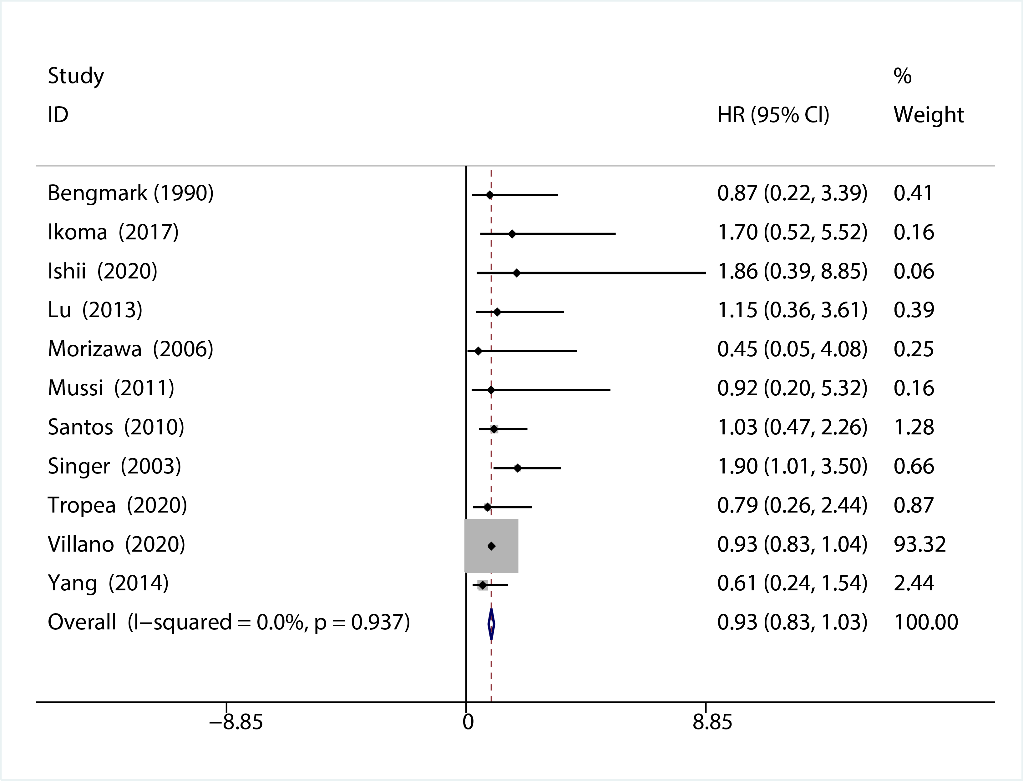
Figure S7: Subgroup analysis over-all survival of extended resection versus tumour resection alone (primary RPS)
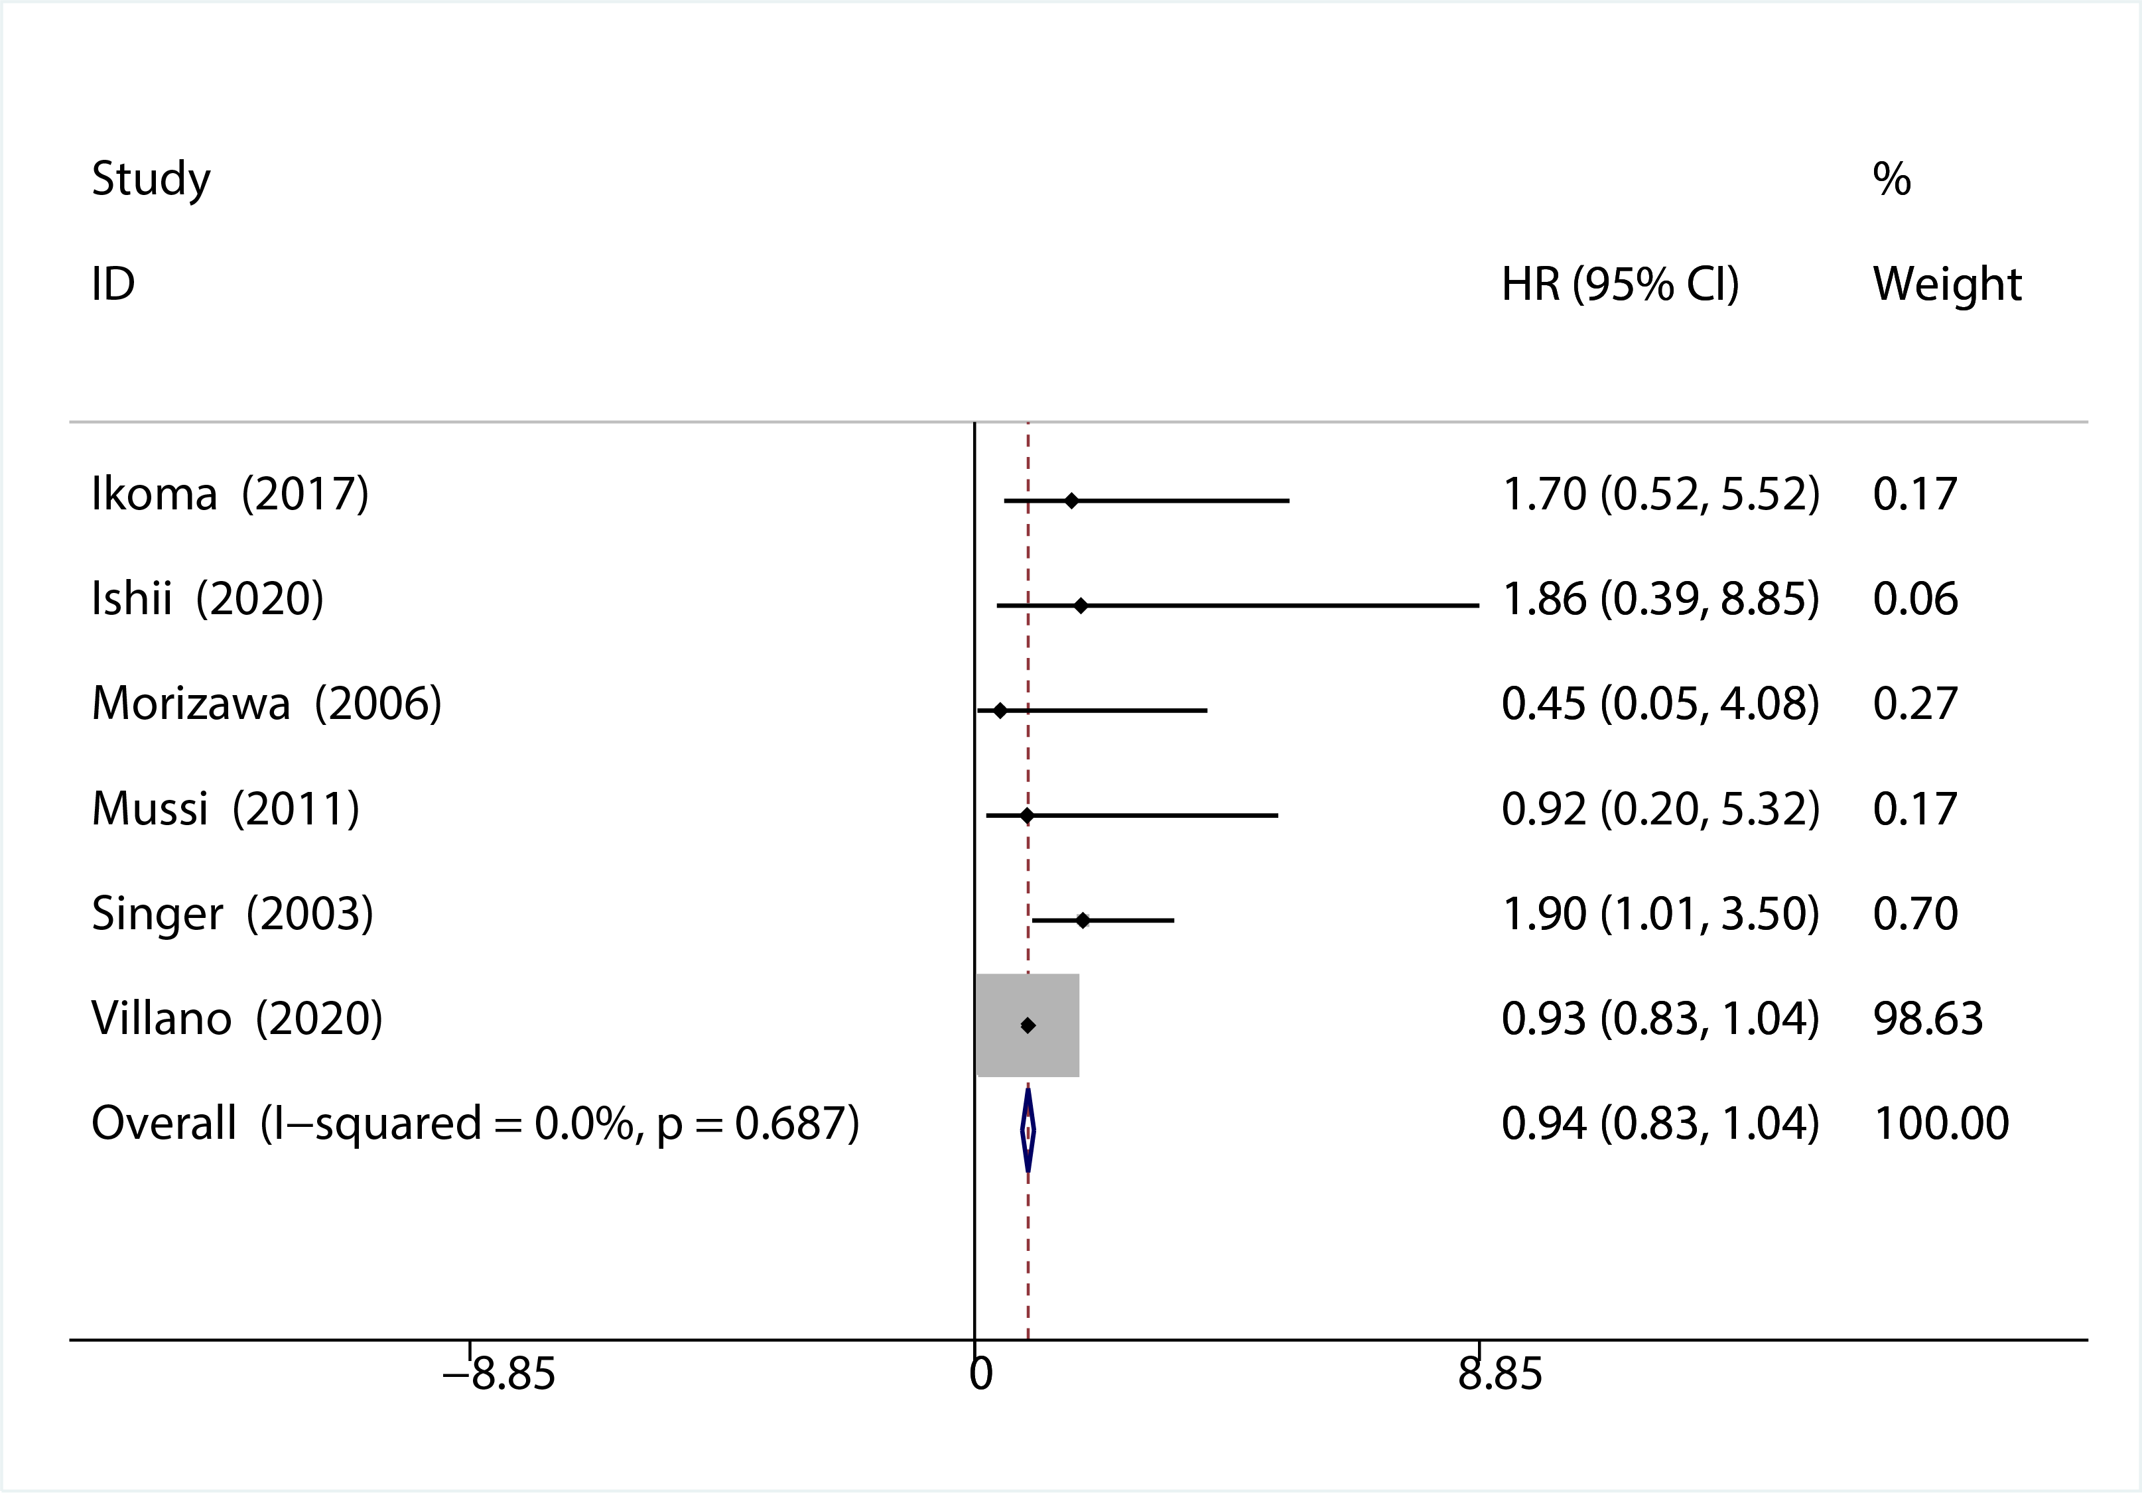
Figure S8: Subgroup analysis over-all survival of extended resection versus tumour resection alone (recurrent RPS)
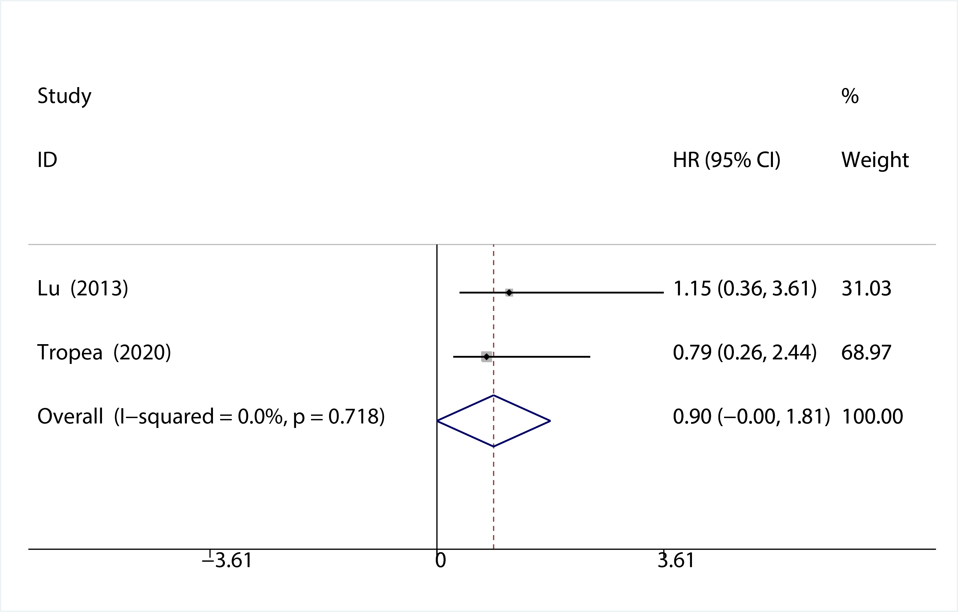
Figure S9: Pooled over-all survival of R0 vs R1
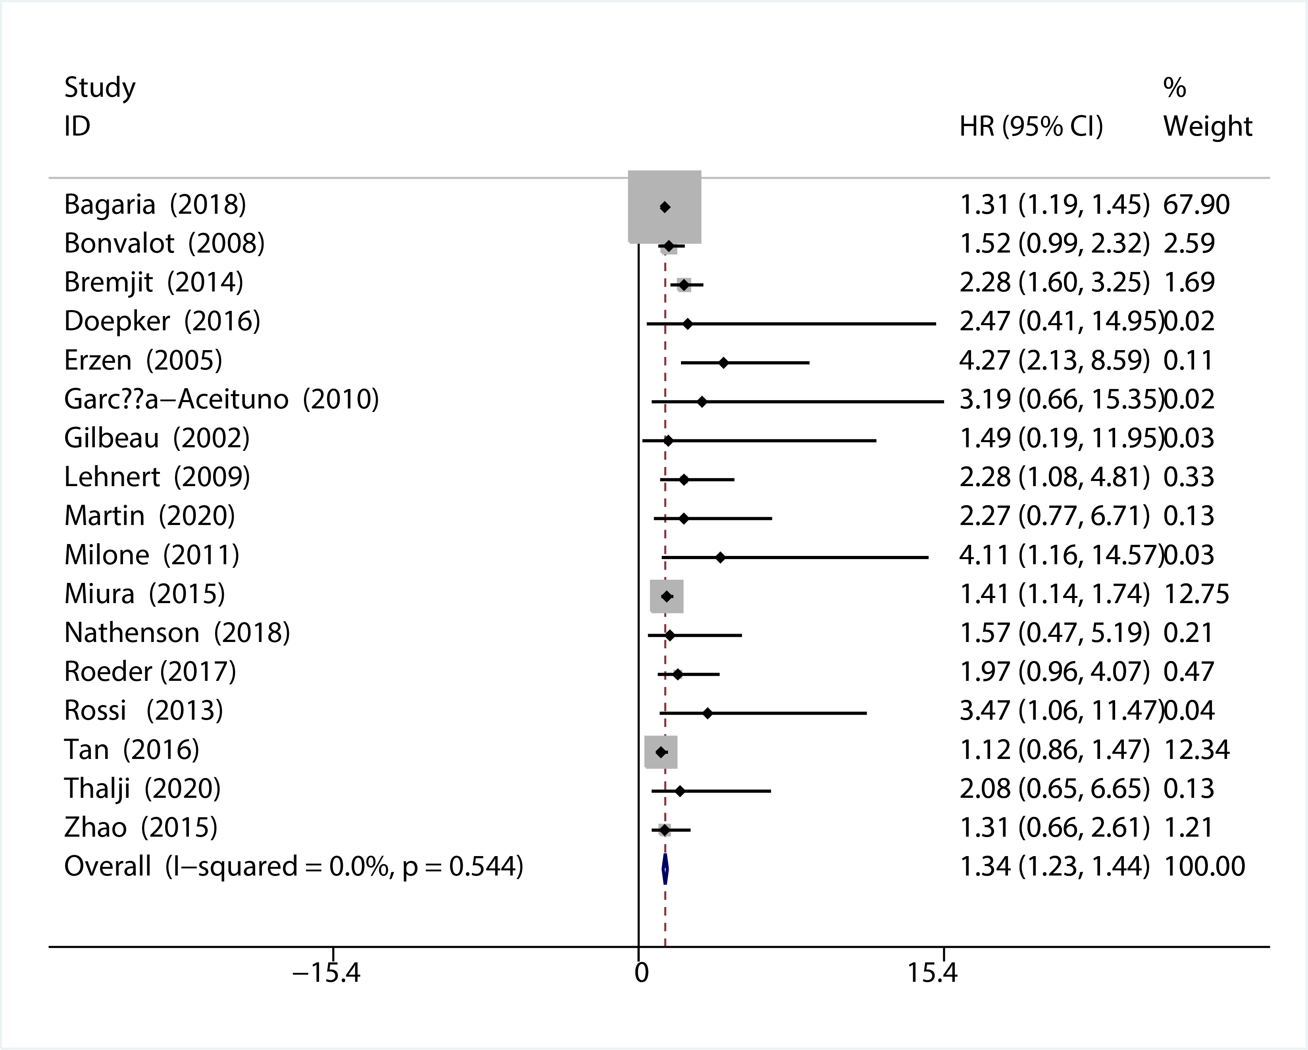
Figure S10: Subgroup analysis of over-all survival of R0 vs R1 (primary RPS)
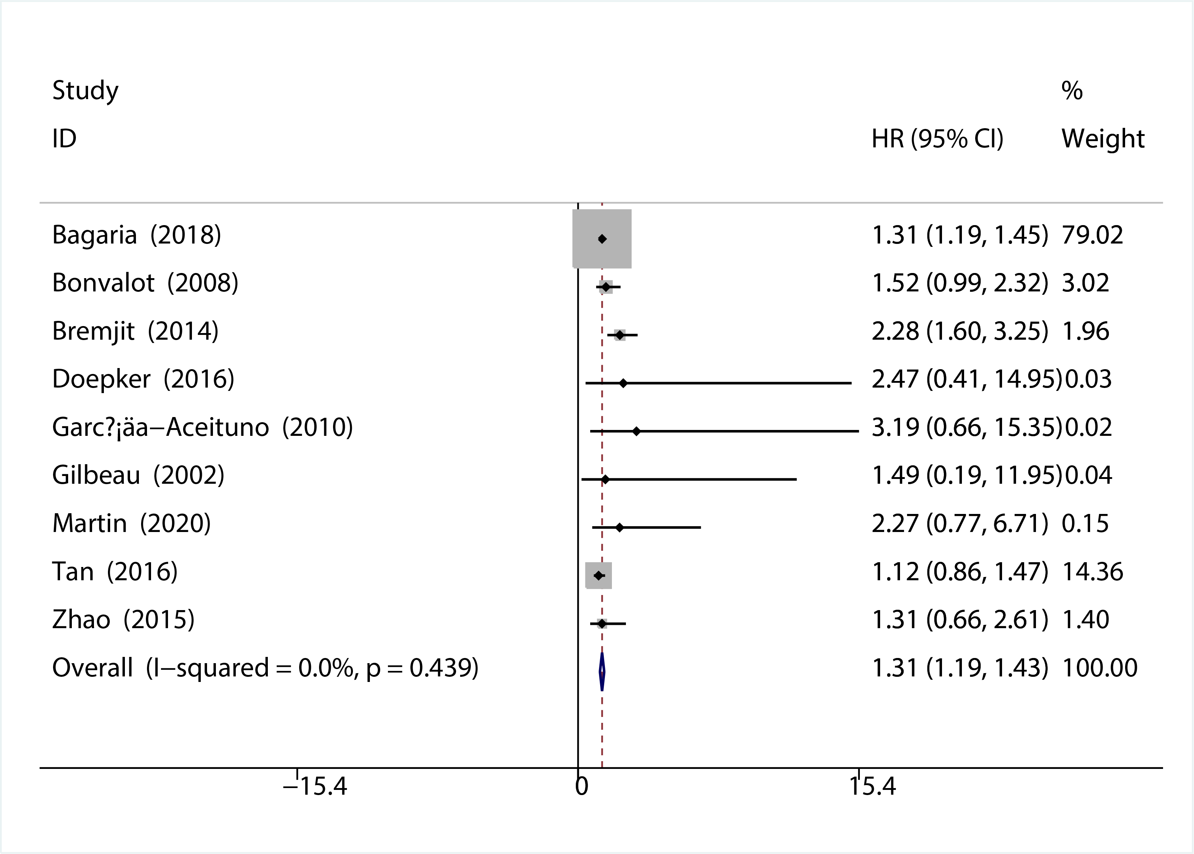
Figure S11: Pooled over-all survival of R1 vs R2
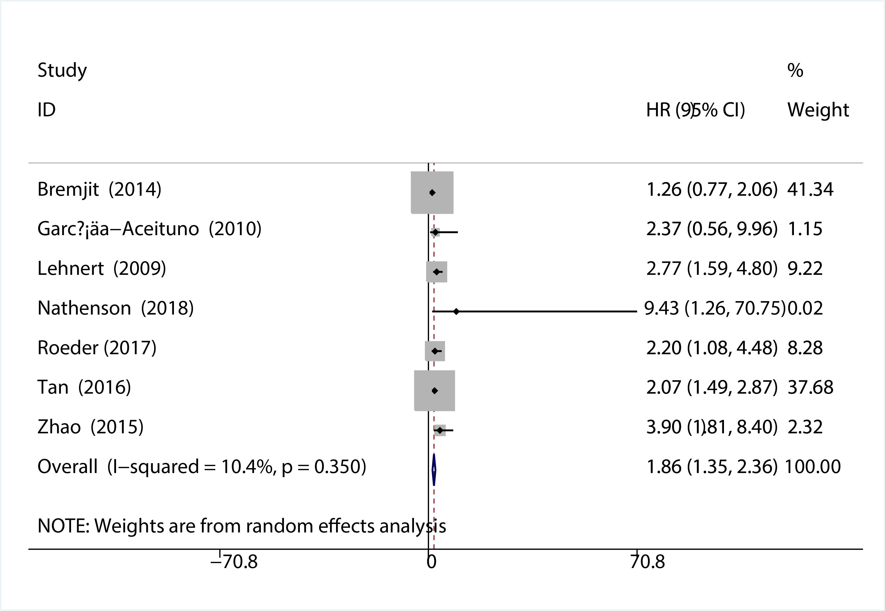
Figure S12: Subgroup analysis of over-all survival of R1 vs R2 (primary RPS)
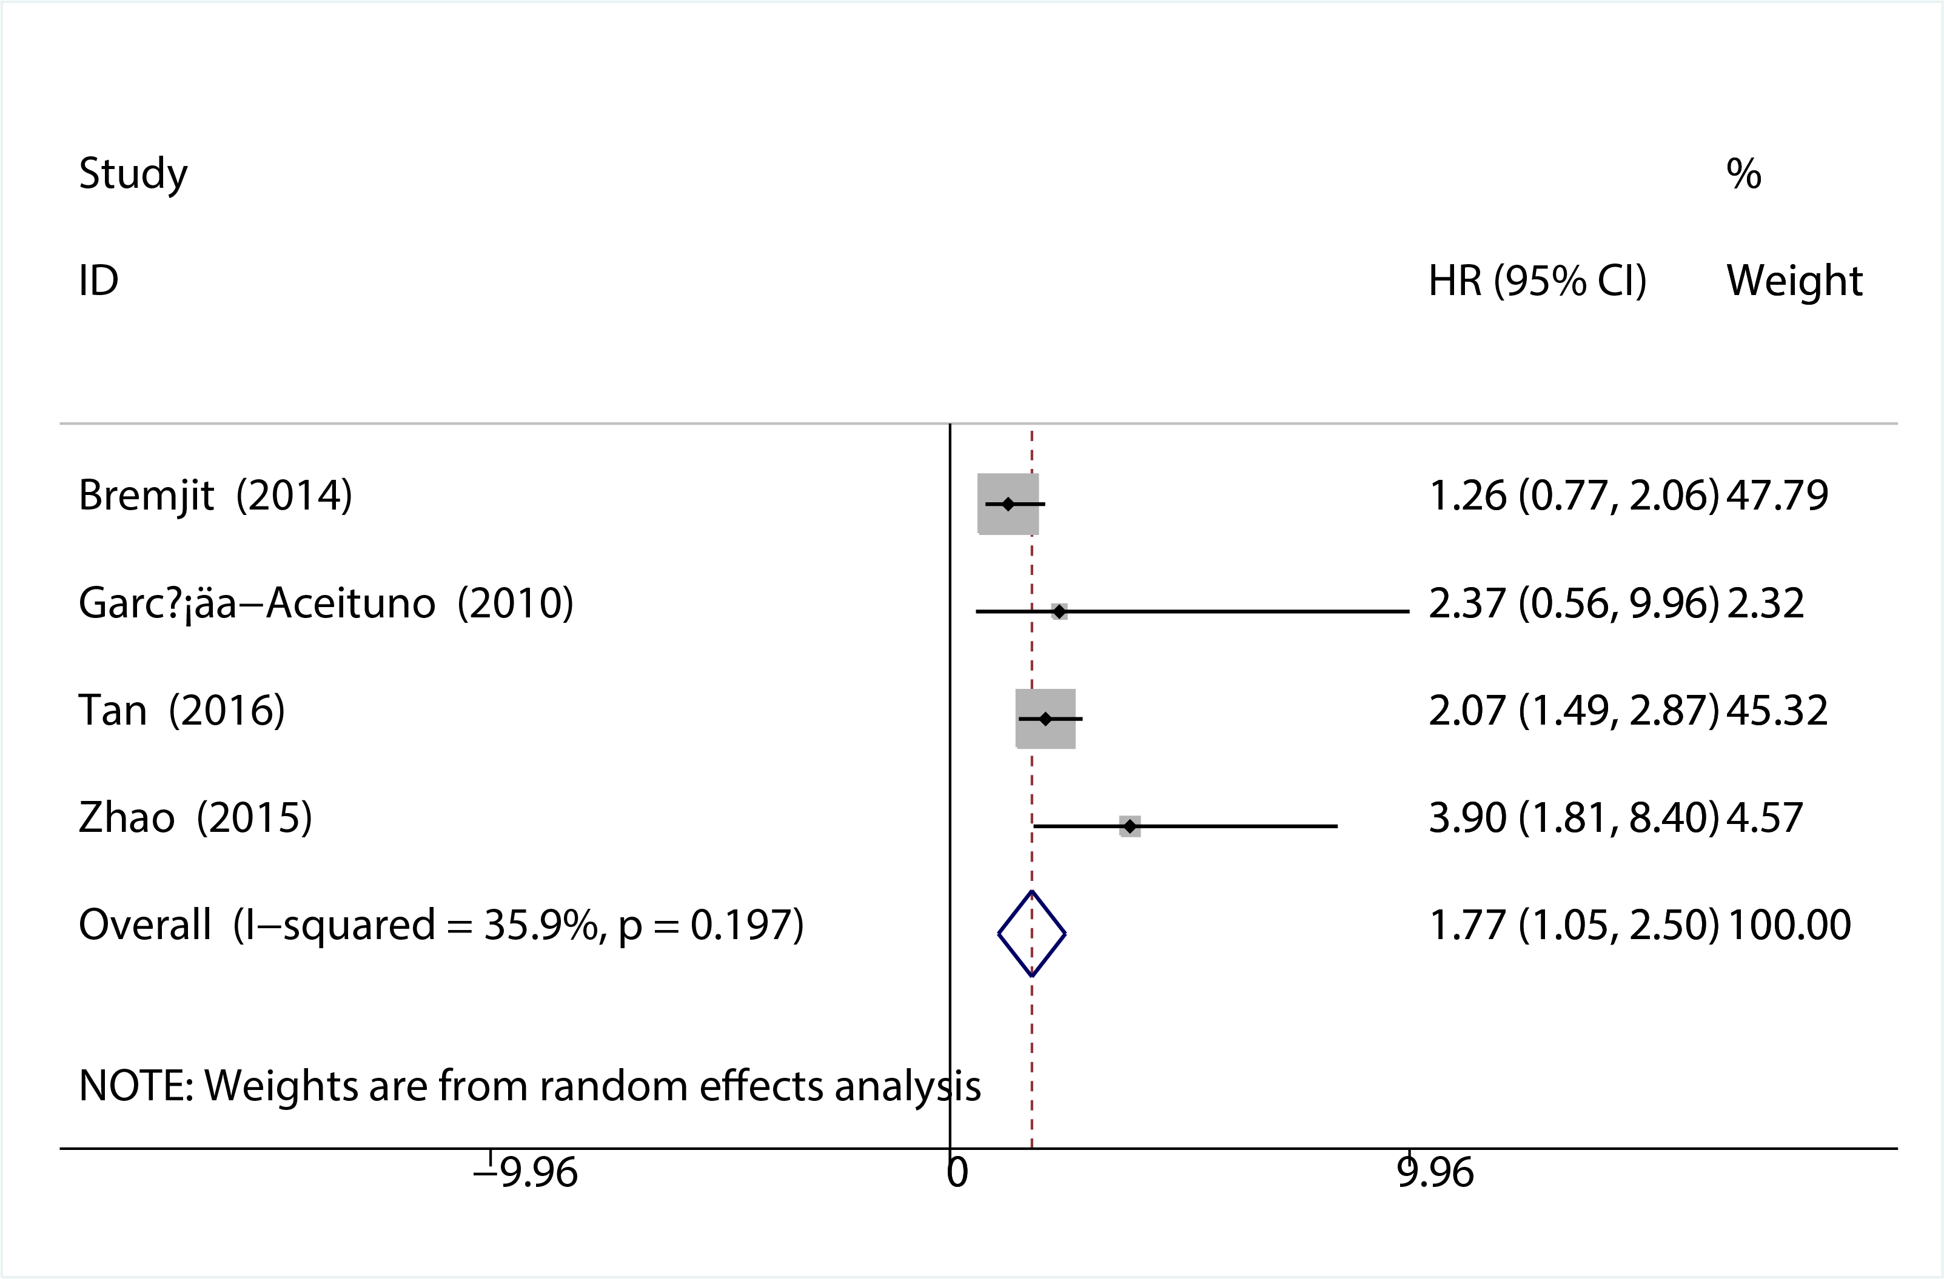
Figure S13: Pooled over-all survival of R2 vs no surgery
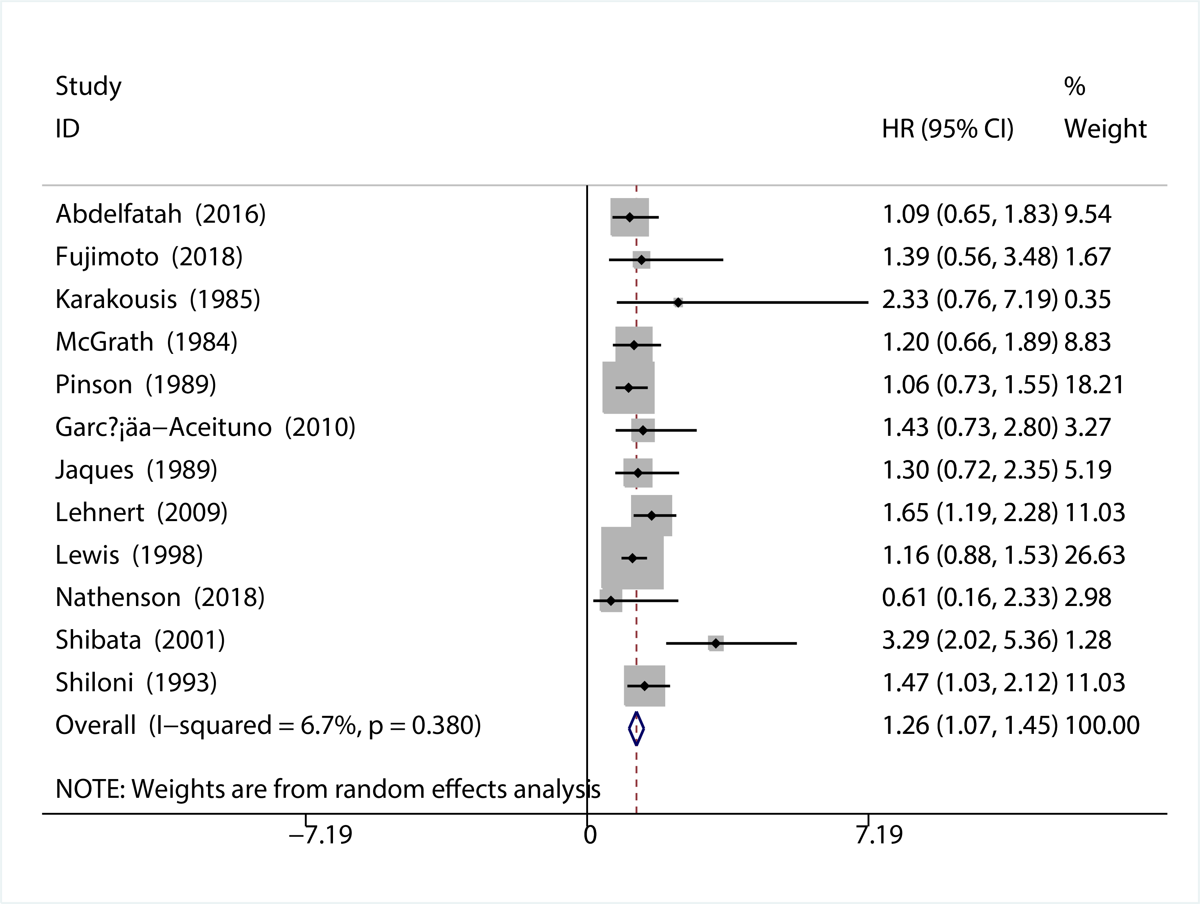
Figure S14: Subgroup analysis of over-all survival of R2 vs no surgery (primary RPS)


