Supplementary Material

Supplementary Figures
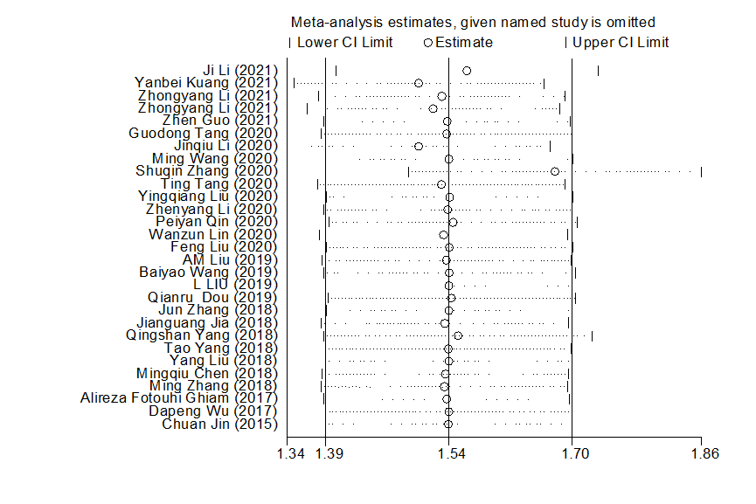

Supplementary Figure 1. The sensitivity analysis of the included articles.

Supplementary Figure 2. The publication bias assessment of the included articles.

Supplementary Tables

Supplementary Table 2. Details of study quality evaluation via the Newcastle-Ottawa Scale.
Study | Representativeness  of the exposed  cohort | Selection of the non-exposed  cohort | Ascertainment  of exposure | Outcome  not present  at baseline | Control for age  and gender | Control for other con-founding  factors | Assessment  of outcome | Enough long follow-up duration | Adequacy of follow-up of cohorts | Total
Ji Li | 1 | 1 | 1 | 0 | 0 | 0 | 1 | 1 | 1 | 6
Yanbei Kuang | 0 | 1 | 1 | 1 | 0 | 0 | 0 | 1 | 1 | 5
Zhongyang Li | 1 | 1 | 1 | 0 | 0 | 0 | 1 | 1 | 1 | 6
Zhen Guo | 1 | 1 | 1 | 1 | 0 | 0 | 1 | 1 | 1 | 7
Wanzun Lin | 1 | 1 | 0 | 0 | 0 | 0 | 1 | 1 | 1 | 5
Feng Liu | 1 | 1 | 1 | 0 | 0 | 0 | 1 | 1 | 1 | 6
Peiyan Qin | 1 | 1 | 1 | 0 | 0 | 0 | 1 | 1 | 1 | 6
Guodong Tang | 1 | 1 | 1 | 0 | 1 | 0 | 1 | 1 | 1 | 7
Jinqiu Li | 1 | 1 | 1 | 0 | 0 | 0 | 1 | 1 | 1 | 6
Ming Wang | 1 | 1 | 1 | 0 | 1 | 0 | 1 | 1 | 1 | 7
Shuqin Zhang | 1 | 1 | 1 | 1 | 1 | 1 | 1 | 1 | 1 | 9
Ting Tang | 1 | 1 | 1 | 0 | 1 | 0 | 1 | 1 | 1 | 7
Yingqiang Liu | 0 | 1 | 0 | 1 | 0 | 1 | 1 | 1 | 1 | 6
Zhenyang Li | 1 | 0 | 1 | 0 | 1 | 0 | 1 | 1 | 1 | 6
AM Liu | 1 | 1 | 1 | 1 | 0 | 1 | 1 | 1 | 1 | 8
Baiyao Wang | 1 | 1 | 1 | 1 | 0 | 0 | 1 | 1 | 1 | 7
L LIU | 1 | 1 | 1 | 0 | 0 | 1 | 1 | 1 | 1 | 7
Qianru Dou | 1 | 1 | 1 | 1 | 1 | 0 | 0 | 1 | 1 | 7
Jianguang Jia | 1 | 1 | 1 | 0 | 0 | 1 | 1 | 1 | 1 | 7
Jun Zhang | 1 | 1 | 1 | 0 | 0 | 0 | 1 | 1 | 1 | 6
Qingshan Yang | 1 | 1 | 1 | 1 | 1 | 0 | 1 | 1 | 1 | 8
Tao Yang | 1 | 1 | 1 | 0 | 0 | 0 | 1 | 1 | 1 | 6
Yang Liu | 1 | 0 | 1 | 0 | 0 | 1 | 1 | 1 | 1 | 6
Mingqiu Chen | 1 | 1 | 1 | 0 | 0 | 0 | 1 | 1 | 1 | 6
Ming Zhang | 1 | 1 | 1 | 0 | 0 | 1 | 1 | 1 | 1 | 7
Alireza F Ghiam | 1 | 1 | 1 | 1 | 1 | 0 | 1 | 1 | 1 | 8
Dapeng Wu | 1 | 1 | 0 | 1 | 1 | 0 | 1 | 1 | 1 | 8
Chuan Jin | 1 | 1 | 1 | 0 | 0 | 0 | 1 | 1 | 1 | 6

