Electronic Supplementary Table S6a Effect sizes ± 95% confidence intervals of pre to post intervention between group changes in studies observing HIMT vs. passive or habitual activity control
 |  |  | Effect size (Hedge's g) | 95% Confidence Interval
Reference | Comparator group | Outcome measure | Effect size (Hedge's g) | Lower | Upper
Aerobic Fitness
Paoli et al. [44] | CHG vs. CG | Submax HR | 1.411 | 0.431 | 2.390
Schmidt et al. [58] | CT-7 vs. CG (M) | VO₂max | -0.256 | -0.975 | 0.462
Schmidt et al. [58] | CT-7 vs. CG (F) | VO₂max | 0.773 | 0.110 | 1.436
Schmidt et al. [58] | CT-14 vs. CG (M) | VO₂max | 0.339 | -0.409 | 1.087
Schmidt et al. [58] | CT-14 vs. CG (F) | VO₂max | 1.146 | 0.433 | 1.860
Batrakoulis et al. [18] | TR vs. CG | VO₂max | 3.042 | 2.060 | 4.025
Batrakoulis et al. [18] | TRD vs. CG | VO₂max | 1.016 | 0.299 | 1.733
Ajjimaporn et al. [43] | HICTBW vs. CG | VO₂peak (absolute) | 1.745 | 0.805 | 2.685
Ajjimaporn et al. [43] | HICTBW vs. CG | VO₂peak (relative) | 1.436 | 0.539 | 2.334
Ajjimaporn et al. [43] | HICTBW vs. CG | HR | 0.898 | 0.058 | 1.737
Engel et al. [41] | Functional HIIT vs. CON | HRmax | 0.731 | -0.174 | 1.636
Islam et al. [66] | Tabata vs. CTL | VO₂peak | 0.000 | -0.635 | 0.635
McWeeny et al. [36] | HIFT vs. FE | VO₂max | 3.555 | 2.147 | 4.963
Muscular Fitness
Muscular Strength
Paoli et al. [44] | CHG vs. CG | 6RM bench press | 6.877 | 4.572 | 9.181
Paoli et al. [44] | CHG vs. CG | 6RM leg press | 15.192 | 10.403 | 19.980
Meier et al. [47] | HIIT vs. CG | R grip strength | 0.229 | -0.543 | 1.000
Meier et al. [47] | HIIT vs. CG | L grip strength | 0.196 | -0.574 | 0.967
Schmidt et al. [58] | CT-7 vs. CG (M) | R grip strength | 0.303 | -0.416 | 1.023
Schmidt et al. [58] | CT-7 vs. CG (M) | L grip strength | 0.490 | -0.236 | 1.217
Schmidt et al. [58] | CT-7 vs. CG (F) | R grip strength | -0.050 | -0.689 | 0.590
Schmidt et al. [58] | CT-7 vs. CG (F) | L grip strength | -0.271 | -0.913 | 0.372
Schmidt et al. [58] | CT-14 vs. CG (M) | R grip strength | 0.927 | 0.146 | 1.709
Schmidt et al. [58] | CT-14 vs. CG (M) | L grip strength | 0.012 | -0.731 | 0.754
Schmidt et al. [58] | CT-14 vs. CG (F) | R grip strength | -0.400 | -1.069 | 0.269
Schmidt et al. [58] | CT-14 vs. CG (F) | L grip strength | 0.363 | -0.304 | 1.031
Batrakoulis et al. [18] | TR vs. CG | 1RM leg press | 1.673 | 0.892 | 2.455
Batrakoulis et al. [18] | TRD vs. CG | 1RM leg press | 0.796 | 0.094 | 1.497
Romero-Arenas et al. [46] | HIPT vs. CG | 1RM bench press | 0.286 | -0.595 | 1.167
Romero-Arenas et al. [46] | HIPT vs. CG | 1RM high pull | 0.778 | -0.131 | 1.687
Engel et al. [41] | Functional HIIT vs. CG | Bourban test (ventral) | 0.254 | -0.627 | 1.134
Engel et al. [41] | Functional HIIT vs. CG | Bourban test (R) | 0.636 | -0.262 | 1.535
Engel et al. [41] | Functional HIIT vs. CG | Bourban test (L) | 0.772 | -0.137 | 1.680
McWeeny et al. [36] | HIFT vs. FE | 1RM back squat | 1.151 | 0.204 | 2.097
McWeeny et al. [36] | HIFT vs. FE | 1RM bench press | 0.733 | -0.173 | 1.638
McWeeny et al. [36] | HIFT vs. FE | 1RM leg extension | 4.750 | 3.037 | 6.464
McWeeny et al. [36] | HIFT vs. FE | 1RM pull up | 1.238 | 0.282 | 2.195
McWeeny et al. [36] | HIFT vs. FE | 1RM leg curl | 0.442 | -0.445 | 1.329
Batrakoulis et al. [39] | TR vs. CG | 1RM chest press | 2.095 | 1.260 | 2.931
Batrakoulis et al. [39] | TR vs. CG | 1RM lat pull down | 2.664 | 1.744 | 3.584
Batrakoulis et al. [39] | TR vs. CG | 1RM leg extension | 3.528 | 2.460 | 4.596
Batrakoulis et al. [39] | TR vs. CG | 1RM leg curl | 3.435 | 2.383 | 4.486
Batrakoulis et al. [39] | TRD vs. CG | 1RM chest press | 1.784 | 0.989 | 2.579
Batrakoulis et al. [39] | TRD vs. CG | 1RM lat pull down | 3.031 | 2.051 | 4.012
Batrakoulis et al. [39] | TRD vs. CG | 1RM leg extension | 3.179 | 2.173 | 4.185
Batrakoulis et al. [39] | TRD vs. CG | 1RM leg curl | 2.890 | 1.933 | 3.847
Muscular Endurance
Schmidt et al. [58] | CT-7 vs. CG (M) | Push-up | 0.352 | -0.369 | 1.073
Schmidt et al. [58] | CT-7 vs. CG (F) | Push-up | 0.828 | 0.162 | 1.494
Schmidt et al. [58] | CT-14 vs. CG (M) | Push-up | 0.466 | -0.286 | 1.219
Schmidt et al. [58] | CT-14 vs. CG (F) | Push-up | 1.197 | 0.479 | 1.914
Engel et al. [41] | Functional HIIT vs. CG | Leg press | 0.452 | -0.436 | 1.339
Engel et al. [41] | Functional HIIT vs. CG | Chest press | 0.597 | -0.299 | 1.493
Engel et al. [41] | Functional HIIT vs. CG | Pull down | 1.351 | 0.380 | 2.323
Engel et al. [41] | Functional HIIT vs. CG | Back extension | 0.812 | -0.100 | 1.724
Eather et al. [25] | Work-HIIT vs. CG | Push-up | 0.841 | 0.244 | 1.438
Islam et al. [66] | Tabata vs. CTL | Back extension | 0.429 | -0.213 | 1.072
Islam et al. [66] | Tabata vs. CTL | Push-up | 1.272 | 0.579 | 1.965
Islam et al. [66] | Tabata vs. CTL | Sit up | 0.450 | -0.193 | 1.093
Islam et al. [66] | Tabata vs. CTL | R plank | 0.464 | -0.179 | 1.107
Islam et al. [66] | Tabata vs. CTL | L plank | 0.969 | 0.300 | 1.638
McWeeny et al. [36] | HIFT vs. FE | BW squat | -0.198 | -1.077 | 0.680
McWeeny et al. [36] | HIFT vs. FE | Leg extension | 5.732 | 3.751 | 7.713
McWeeny et al. [36] | HIFT vs. FE | Bench press | -0.180 | -1.058 | 0.699
McWeeny et al. [36] | HIFT vs. FE | Leg curl | -0.398 | -1.284 | 0.487
McWeeny et al. [36] | HIFT vs. FE | Bent arm hang | 0.177 | -0.701 | 1.055
Batrakoulis et al. [39] | TR vs. CG | 60s curl up | 6.282 | 4.662 | 7.901
Batrakoulis et al. [39] | TR vs. CG | 60s chair squat | 10.168 | 7.692 | 12.644
Batrakoulis et al. [39] | TR vs. CG | 60s push-up | 4.968 | 3.622 | 6.314
Batrakoulis et al. [39] | TRD vs. CG | 60s curl up | 3.957 | 2.810 | 5.105
Batrakoulis et al. [39] | TRD vs. CG | 60s chair squat | 5.810 | 4.290 | 7.330
Batrakoulis et al. [39] | TRD vs. CG | 60s push-up | 2.443 | 1.557 | 3.329
Muscular Power
Romero-Arenas et al. [46] | HIPT vs. CG | PP bench press | 0.611 | -0.285 | 1.508
Romero-Arenas et al. [46] | HIPT vs. CG | PP high pull | 1.463 | 0.476 | 2.450
Romero-Arenas et al. [46] | HIPT vs. CG | CMJ height | 0.681 | -0.220 | 1.583
Romero-Arenas et al. [46] | HIPT vs. CG | CMJ PP | 0.258 | -0.622 | 1.138
Romero-Arenas et al. [46] | HIPT vs. CG | Pmax | 0.777 | -0.132 | 1.686
Romero-Arenas et al. [46] | HIPT vs. CG | PmaxR | 1.410 | 0.431 | 2.390
Romero-Arenas et al. [46] | HIPT vs. CG | Pmean | 0.878 | -0.039 | 1.796
Romero-Arenas et al. [46] | HIPT vs. CG | PmeanR | 1.332 | 0.363 | 2.301
Eather et al. [25] | Work-HIIT vs. CG | Standing jump | 0.618 | 0.033 | 1.204
McWeeny et al. [36] | HIFT vs. FE | CMJ height | -1.037 | -1.971 | -0.104
McWeeny et al. [36] | HIFT vs. FE | MB toss | -2.441 | -3.598 | -1.283
McWeeny et al. [36] | HIFT vs. FE | LBPP | -3.548 | -4.955 | -2.142
McWeeny et al. [36] | HIFT vs. FE | LBMP | -3.101 | -4.402 | -1.800
McWeeny et al. [36] | HIFT vs. FE | UBPP | 1.060 | 0.124 | 1.996
McWeeny et al. [36] | HIFT vs. FE | UBMP | 0.713 | -0.191 | 1.617
Subjective Responses
Batrakoulis et al. [40] | TR vs. CG | Psychological distress | 3.434 | 2.383 | 4.485
Batrakoulis et al. [40] | TR vs. CG | Subjective vitality | 1.861 | 1.057 | 2.666
Batrakoulis et al. [40] | TR vs. CG | Amotivation | 0.887 | 0.180 | 1.595
Batrakoulis et al. [40] | TR vs. CG | External regulation | 1.190 | 0.459 | 1.922
Batrakoulis et al. [40] | TR vs. CG | Introjected regulation | 1.690 | 0.907 | 2.474
Batrakoulis et al. [40] | TR vs. CG | Intrinsic regulation | 1.849 | 1.046 | 2.653
Batrakoulis et al. [40] | TR vs. CG | Identified regulation | 4.043 | 2.879 | 5.207
Batrakoulis et al. [40] | TRD vs. CG | Psychological distress | 1.095 | 0.372 | 1.818
Batrakoulis et al. [40] | TRD vs. CG | Subjective vitality | 1.817 | 1.018 | 2.616
Batrakoulis et al. [40] | TRD vs. CG | Amotivation | 0.693 | -0.003 | 1.388
Batrakoulis et al. [40] | TRD vs. CG | External regulation | 0.237 | -0.441 | 0.916
Batrakoulis et al. [40] | TRD vs. CG | Introjected regulation | -0.517 | -1.204 | 0.170
Batrakoulis et al. [40] | TRD vs. CG | Intrinsic regulation | 0.945 | 0.234 | 1.657
Batrakoulis et al. [40] | TRD vs. CG | Identified regulation | 1.334 | 0.589 | 2.079
Eather et al. [25] | Work-HIIT vs. CG | HIIT self-efficacy | 1.656 | 0.993 | 2.319
Eather et al. [25] | Work-HIIT vs. CG | Autonomous motivation | 0.469 | -0.111 | 1.048

HIMT High-Intensity Multimodal Training, CHG circuit high-intensity group, CG control group, CT-7 7 minute circuit group, M male, F female, CT-14 14 minute circuit group, TR 40 week training group, TRD 20 week training – 20 week de-training group, HICTBW High-Intensity circuit training with bodyweight, CON control group, CTL control group, HIFT High-Intensity Functional Training, FE free exercise, HIPT High-Intensity power training, HR heart rate, VO₂max maximal oxygen uptake, VO₂peak peak oxygen uptake, HRmax heart rate maximum, 6RM 6 repetition maximum, R right, L left, 1RM 1 repetition maximum, PP peak power, CMJ counter movement jump, Pmax maximum power, PmaxR relative maximum power, Pmean mean power, PmeanR relative mean power, MB medicine ball, LBPP lower body peak power, LBMP lower body mean power, UBPP upper body peak power, UBMP upper body mean power, HIIT high-intensity interval training

Electronic Supplementary Table S6b Effect sizes ± 95% confidence intervals of pre to post intervention between group changes in studies observing HIMT vs. structured activity (concurrent training)
 |  |  | Effect size (Hedge's g) | 95% Confidence Interval
Reference | Comparator group | Outcome measure | Effect size (Hedge's g) | Lower | Upper
Aerobic Fitness
Davis et al. [32] | Integrated CE vs. Serial CE (M) | VO₂max | NR | NR | NR
Davis et al. [32] | Integrated CE vs. Serial CE (M) | RHR | NR | NR | NR
Davis et al. [32] | Integrated CE vs. Serial CE (M) | Submax HR | 0.106 | -0.771 | 0.983
Davis et al. [32] | Integrated CE vs. Serial CE (F) | VO₂max | 0.535 | -0.250 | 1.320
Davis et al. [32] | Integrated CE vs. Serial CE (F) | RHR | NR | NR | NR
Davis et al. [32] | Integrated CE vs. Serial CE (F) | Submax HR | 0.677 | -0.224 | 1.578
Bahremand et al. [34] | CF vs. CT | VO₂max | 0.980 | 0.221 | 1.739
Hovsepian et al. [67] | HIFT vs. CSCT | VO₂max | 0.541 | -0.351 | 1.434
Muscular Fitness
Davis et al. [33] | Integrated CE vs. Serial CE | LB 1RM | 0.509 | -0.258 | 1.276
Davis et al. [33] | Integrated CE vs. Serial CE | UB 1RM | -0.017 | -0.786 | 0.752
Davis et al. [33] | Integrated CE vs. Serial CE | Leg press repetitions | 0.195 | -0.562 | 0.951
Davis et al. [33] | Integrated CE vs. Serial CE | UB repetitions | -0.304 | -1.077 | 0.469
Mirzaei et al. [45] | Integrated CE vs. Serial CE | LB strength | -0.098 | -0.999 | 0.804
Mirzaei et al. [45] | Integrated CE vs. Serial CE | UB strength | 0.150 | -0.752 | 1.052
Mirzaei et al. [45] | Integrated CE vs. Serial CE | Trunk endurance | -0.557 | -1.475 | 0.360
Mirzaei et al. [45] | Integrated CE vs. Serial CE | MB throw | 0.320 | -0.587 | 1.226
Mirzaei et al. [45] | Integrated CE vs. Serial CE | MB chest throw | 0.081 | -0.819 | 0.982
Mirzaei et al. [45] | Integrated CE vs. Serial CE | MB supine throw | 0.015 | -0.886 | 0.915
Carneiro et al. [35] | HIBWT vs. CT | R knee extensor | -0.699 | -1.523 | 0.124
Carneiro et al. [35] | HIBWT vs. CT | L knee extensor | -1.017 | -1.866 | -0.169
Carneiro et al. [35] | HIBWT vs. CT | Total knee extensor | -0.838 | -1.671 | -0.005
Nunes et al. [42] | HIIT vs. CT | Muscle strength | -0.735 | -1.561 | 0.092
Nunes et al. [42] | HIIT vs. CT | Muscle quality index | -0.060 | -0.861 | 0.740
Bahremand et al. [34] | CF vs. CT | LB strength | -0.564 | -1.296 | 0.167
Bahremand et al. [34] | CF vs. CT | UB strength | 0.873 | 0.123 | 1.624
Bahremand et al. [34] | CF vs. CT | LBPPO | 0.082 | -0.636 | 0.799
Bahremand et al. [34] | CF vs. CT | LBMPO | -0.919 | -1.673 | -0.165
Bahremand et al. [34] | CF vs. CT | UBPPO | -0.537 | -1.267 | 0.193
Bahremand et al. [34] | CF vs. CT | UBMPO | 0.287 | -0.434 | 1.008
Hovsepian et al. [67] | HIFT vs. CSCT | Vertical jump | 0.269 | -0.611 | 1.150
Subjective Responses
Heinrich et al. [24] | CF vs. ART | Exercise Enjoyment | 2.709 | 1.430 | 3.989

CE concurrent exercise, M male, F female, CF CrossFit®, CT combined training, HIFT High-Intensity Functional Training, CSCT common strength and conditioning training, HIBWT High-Intensity bodyweight training, ART aerobic and resistance training, VO2max maximal oxygen uptake, RHR resting heart rate, HR heart rate, LB lower body, UB upper body, 1RM 1 repetition maximum, MB medicine ball, R right, L left, LBPPO lower body peak power output, LBMPO lower body mean power output, UBPPO upper body peak power output, UBMPO upper body mean power output, NR not reported

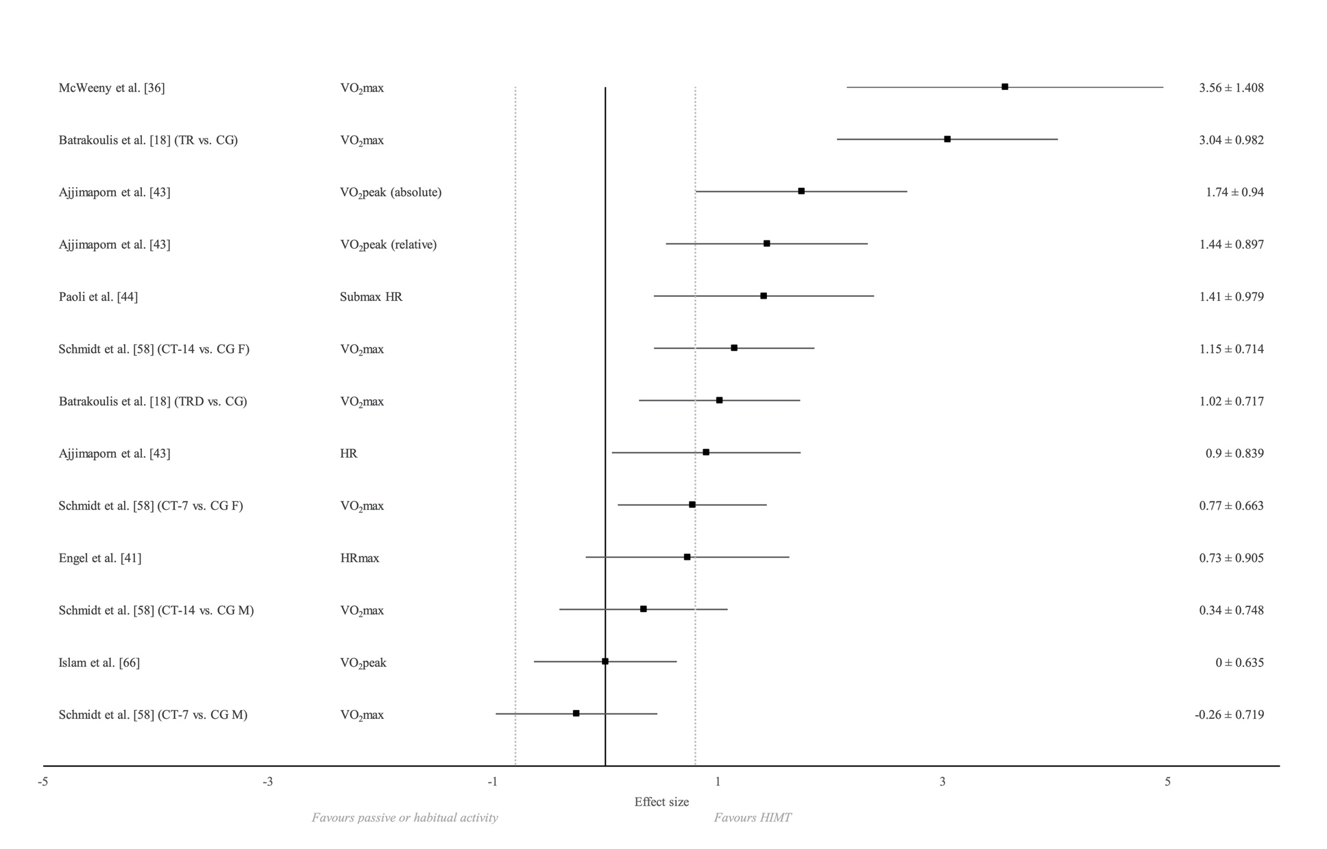
Favours HIMT
Favours non-structured exercise

Electronic Supplementary Fig. S1a Effect sizes ± 95% confidence intervals of pre to post intervention between group changes in aerobic fitness for studies observing HIMT vs. passive or habitual activity control HIMT High-Intensity Multimodal Training, TR 40 week training group, TRD 20 week training: 20 week detraining group, CT-7 7 minute circuit training group, CT-14 14 minute circuit training group, CG control group F female, M male, VO₂max maximal oxygen uptake, VO₂peak peak oxygen uptake, HR heart rate, HRmax heart rate maximum

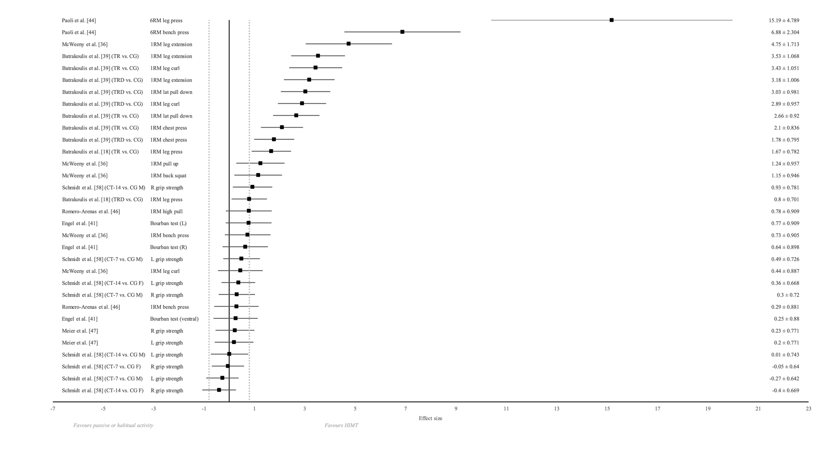

Electronic Supplementary Fig. S1b Effect sizes ± 95% confidence intervals of pre to post intervention between group changes in muscular strength for studies observing HIMT vs. passive or habitual activity control HIMT High-Intensity Multimodal Training, TR 40 week training group, TRD 20 week training: 20 week detraining group, CT-7 7 minute circuit training group, CT-14 14 minute circuit training group, CG control group F female, M male, 6RM 6 repetition maximum, 1RM 1 repetition maximum, R right, L left
Favours HIMT
Favours non-structured exercise

Favours HIMT
Favours non-structured exercise

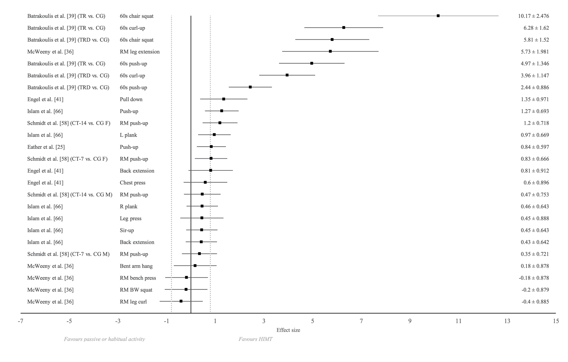

Electronic Supplementary Fig. S1c Effect sizes ± 95% confidence intervals of pre to post intervention between group changes in muscular endurance for studies observing HIMT vs. passive or habitual activity control HIMT High-Intensity Multimodal Training, TR 40 week training group, TRD 20 week training: 20 week detraining group, CT-7 7 minute circuit training group, CT-14 14 minute circuit training group, CG control group F female, M male, RM repetition maximum, reps repetitions, R right, L left, BW bodyweight

Favours HIMT
Favours non-structured exercise
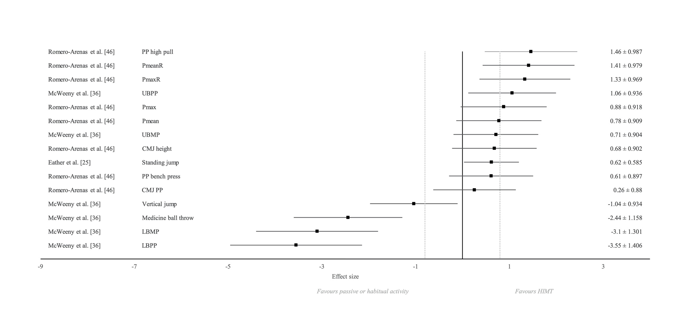

Electronic Supplementary Fig. S1d Effect sizes ± 95% confidence intervals of pre to post intervention between group changes in muscular power for studies observing HIMT vs. passive or habitual activity control HIMT High-Intensity Multimodal Training, PP peak power, PmeanR relative mean power, PmaxR relative maximum power, UBPP upper body peak power, Pmax maximum power, Pmean mean power, UBMP upper body mean power, CMJ counter movement jump, LBMP lower body mean power, LBPP lower body peak power

Favours HIMT
Favours non-structured exercise

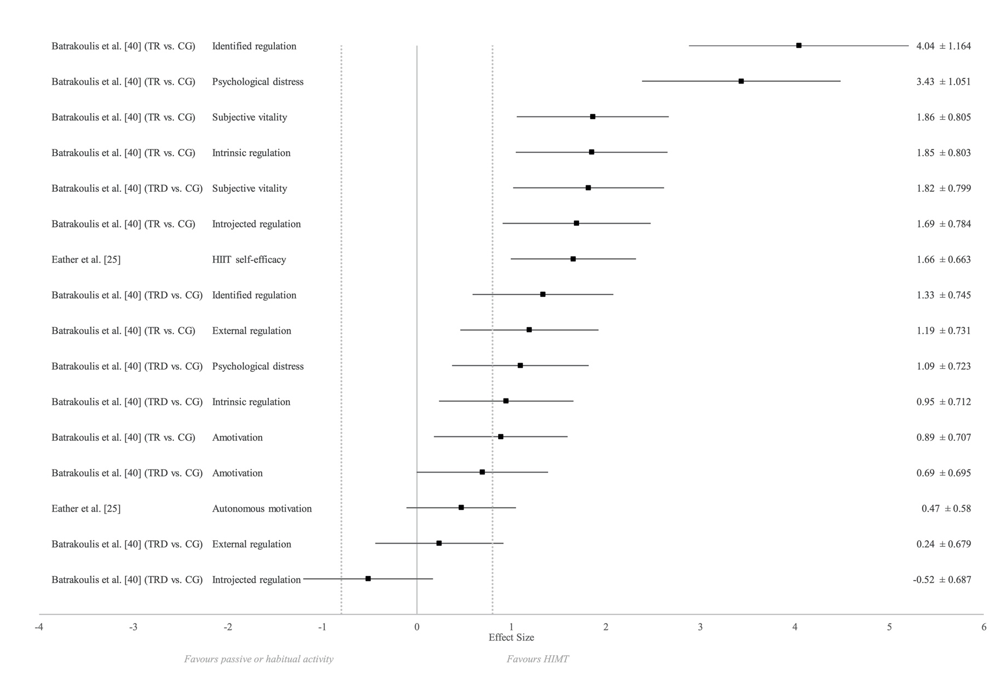
Electronic Supplementary Fig. S1e Effect sizes ± 95% confidence intervals of pre to post intervention between group changes in subjective responses for studies observing HIMT vs. passive or habitual activity control HIMT High-Intensity Multimodal Training, TR 40 week training group, TRD 20 week training: 20 week detraining group, CG control group. HIIT high-intensity interval training

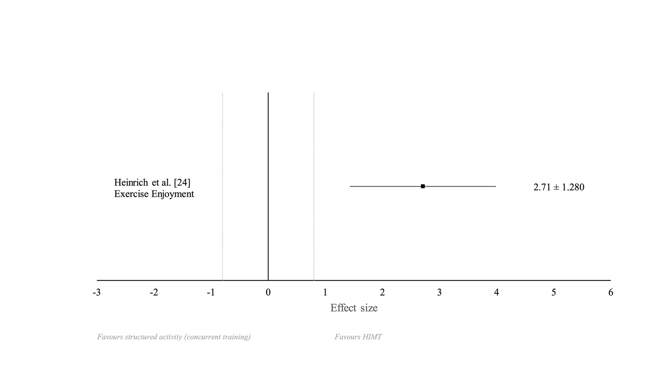

Electronic Supplementary Fig. S1f Effect sizes ± 95% confidence intervals of pre to post intervention between group changes in exercise enjoyment for studies observing HIMT vs. structured activity (concurrent training).

The Effects of High-Intensity Multimodal Training in Apparently Healthy Populations.
A Systematic Review.
Sports Medicine - Open
Tijana Sharp¹, Clementine Grandou¹, Aaron J. Coutts¹, Lee Wallace¹
¹Sport and Exercise Discipline Group, University of Technology, Human Performance Research Centre, Moore Park, Sydney, Australia
Corresponding author: Tijana Sharp (tijana.sharp@uts.edu.au)

