Supplementary Figure 1. Analysis of the influence of sesame consumption on serum CRP concentrations in humans. CI, confidence interval; CRP, C-reactive protein

Supplementary Figure 2. Analysis of the influence of sesame consumption on serum IL-6 concentrations in humans. CI, confidence interval; IL-6, interleukin-6

Supplementary Figure 3. Analysis of the influence of sesame consumption on serum TNF concentrations in humans. CI, confidence interval; TNF, tumor necrosis factor

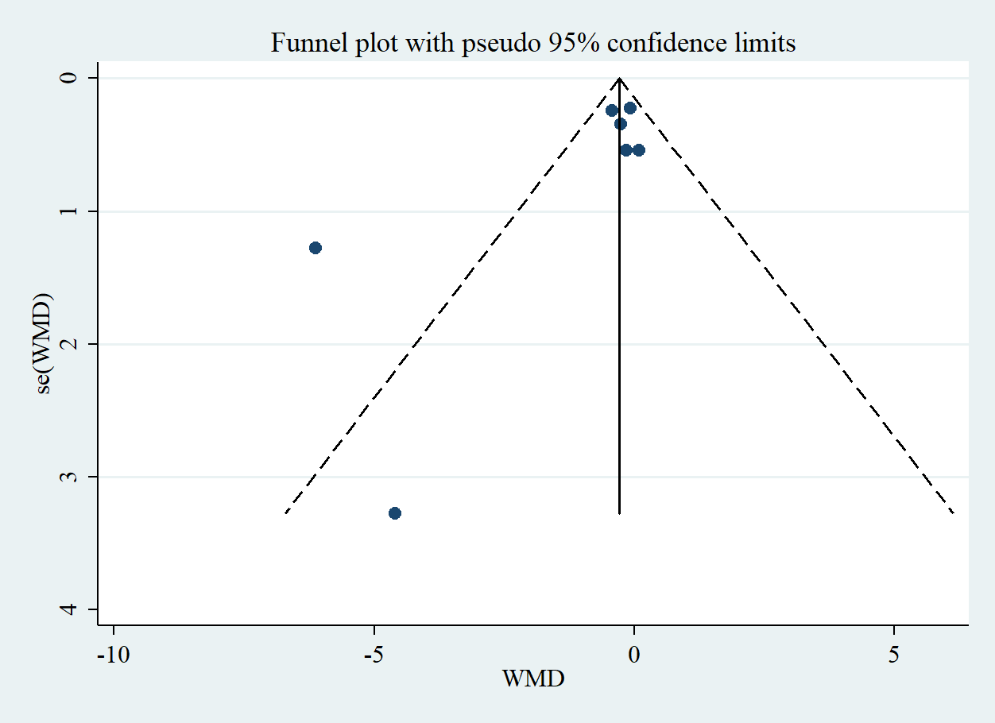

Supplementary Figure 4. Funnel plot for assessing publication bias in the studies reporting the effects of sesame consumption on serum CRP concentrations in humans. CRP, C-reactive protein; SE, standard error; WMD, weighted mean difference

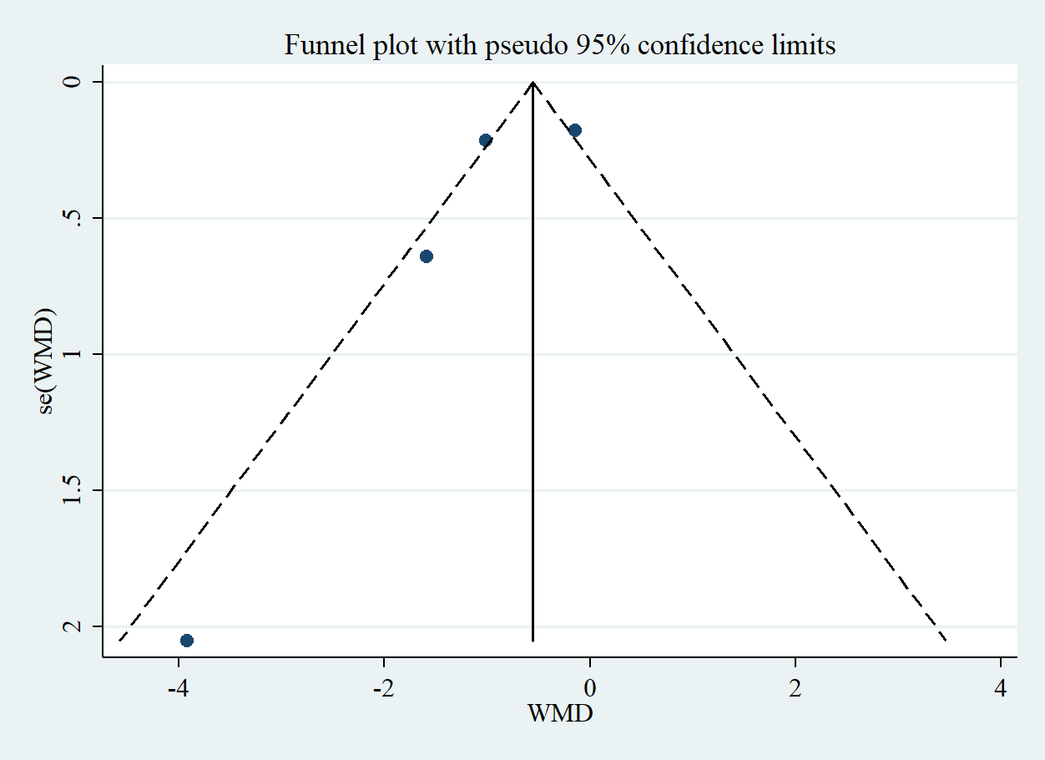

Supplementary Figure 5. Funnel plot for assessing publication bias in the studies reporting the effects of sesame consumption on serum IL-6 concentrations in humans IL-6, interleukin-6 SE, standard error; WMD, weighted mean difference

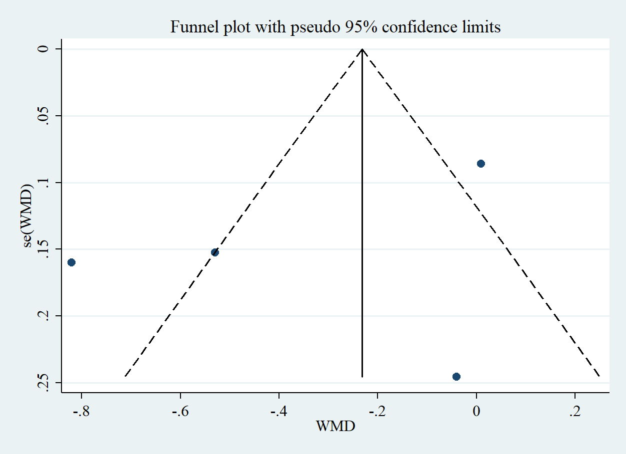

Supplementary Figure 6. Funnel plot for assessing publication bias in the studies reporting the effects of sesame consumption on serum TNF concentrations in humans. TNF, tumor necrosis factor SE, standard error; WMD, weighted mean difference

;;;

