Supporting Information S1 File. Database searches.
Figure A. CINAHL Plus with full-text.
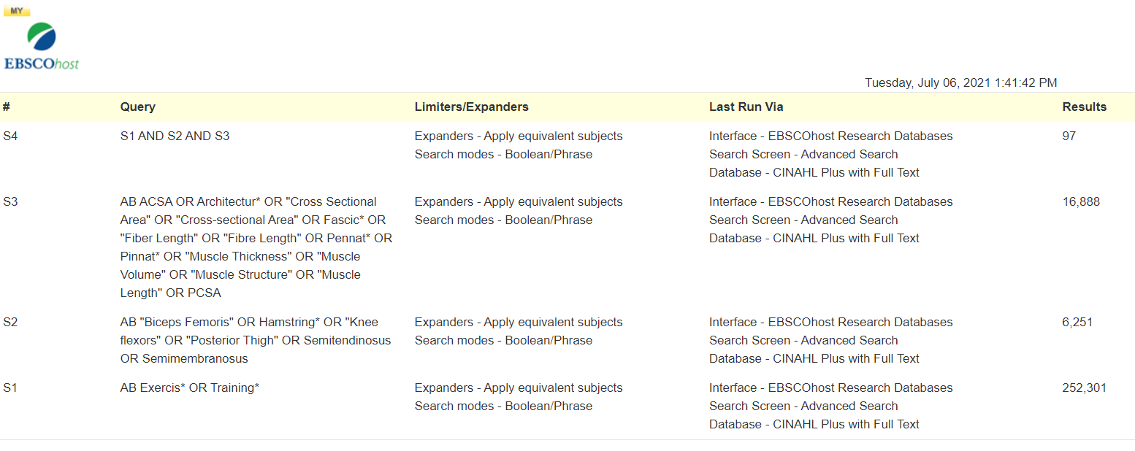
Table A. The Cochrane Central Register of Controlled Trials (CENTRAL).
Search Name:
Date Run: 06/07/2021 13:44:44
Comment:

ID Search Hits
#1 MeSH descriptor: [Exercise] explode all trees 25883
#2 Exercis* OR Training* 177668
#3 "Biceps Femoris" OR Hamstring* OR "Knee Flexors" OR "Posterior Thigh" OR Semitendinosus OR Semimembranosus 3185
#4 ACSA OR Architectur* OR "Cross Sectional Area" OR "Cross-sectional Area" OR Fascic* OR "Fiber Length" OR "Fibre Length" OR Pennat* OR Pinnat* OR "Muscle Thickness" OR "Muscle Volume" OR "Muscle Structure" OR "Muscle Length" OR PCSA 6018
#5 #1 AND #2 24238
#6 #3 AND #4 AND 5 in Trials 94
Table B. PubMed.
Search number | Query | Sort By | Filters | Results | Time
6 | #3 AND #4 AND #5 | Most Recent |  | 229 | 09:03:44
5 | #1 OR #2 | Most Recent |  | 813,191 | 09:02:35
4 | ACSA OR Architectur* OR "Cross Sectional Area"[Title/Abstract] OR "Cross-sectional Area"[Title/Abstract] OR Fascic* OR "Fiber Length"[Title/Abstract] OR "Fibre Length"[Title/Abstract] OR Pennat* OR Pinnat* OR "Muscle Thickness"[Title/Abstract] OR "Muscle Volume"[Title/Abstract] OR "Muscle Structure"[Title/Abstract] OR "Muscle Length"[Title/Abstract] OR PCSA | Most Recent |  | 243,366 | 09:01:44
3 | "Biceps Femoris"[Title/Abstract] OR Hamstring*[Title/Abstract] OR "Knee flexors"[Title/Abstract] OR "Posterior Thigh"[Title/Abstract] OR Semitendinosus[Title/Abstract] OR Semimembranosus[Title/Abstract] | Most Recent |  | 16,555 | 08:59:55
2 | Exercis*[Title/Abstract] OR Training*[Title/Abstract] | Most Recent |  | 716,114 | 08:51:32
1 | "Exercise"[Mesh] | Most Recent |  | 212,935 | 08:50:22
Figure B. OpenGrey.


