Supporting Information S4 File. Comparisons.

Comparisons between this meta-analysis and previous meta-analyses¹ ²

Figure A. Funnel plot for mean difference (cm), 95% confidence interval, fixed effect.
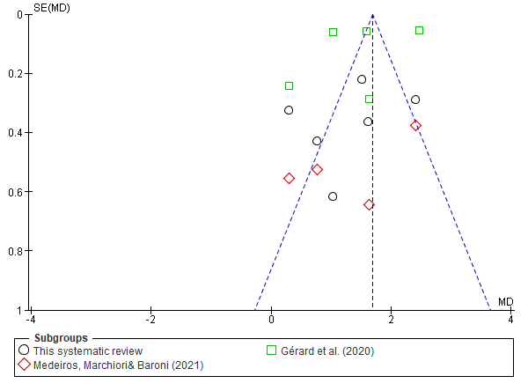
Figure B. Forest plot for mean difference (cm), 95% confidence interval, fixed effect.
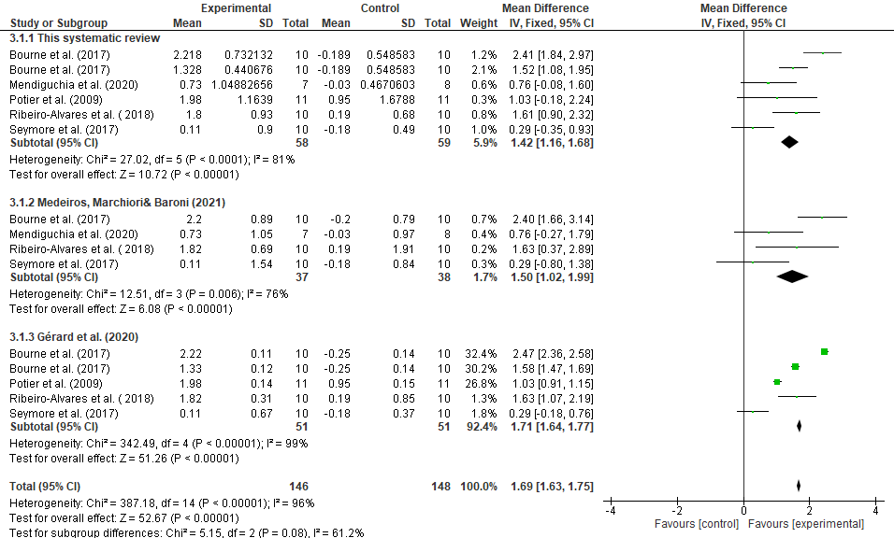
Figure C. Funnel plot for mean difference (cm), 95% confidence interval, random effect.
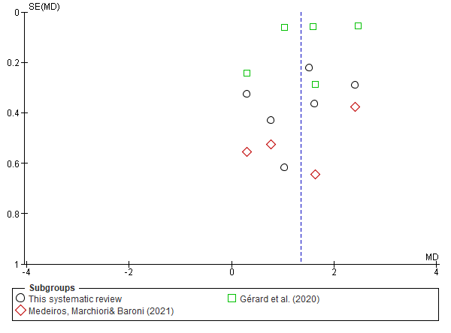
Figure D. Forest plot for mean difference (cm), 95% confidence interval, random effect.
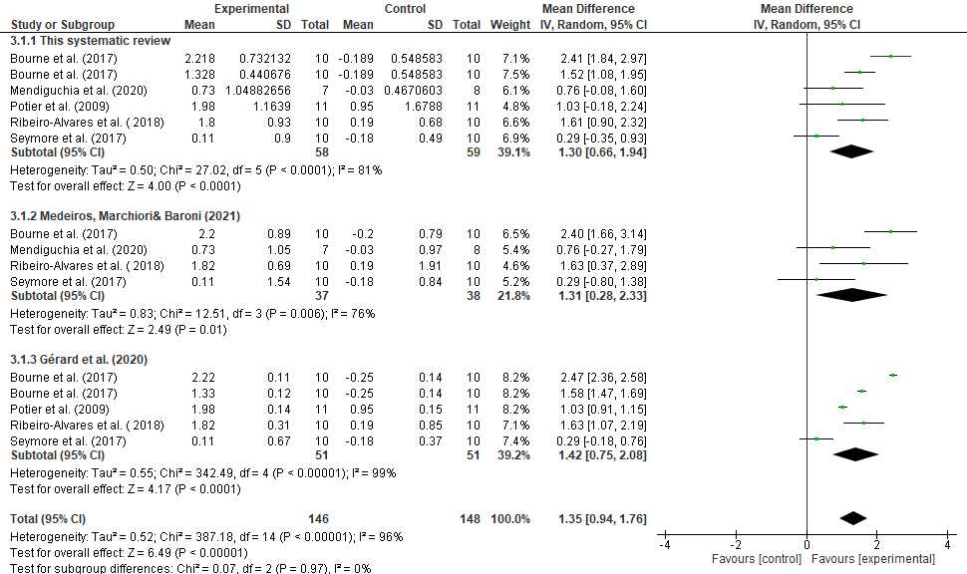
Figure E. Funnel plot for standardised mean difference (effect size (Hedge's (adjusted) g)), 95% confidence interval, fixed effect.
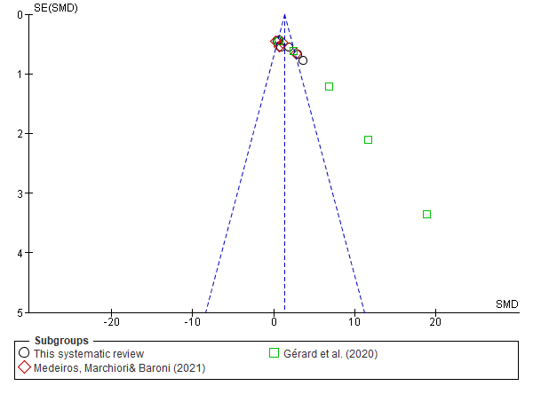
Figure F. Forest plot for standardised mean difference (effect size (Hedge's (adjusted) g)), 95% confidence interval, fixed effect.
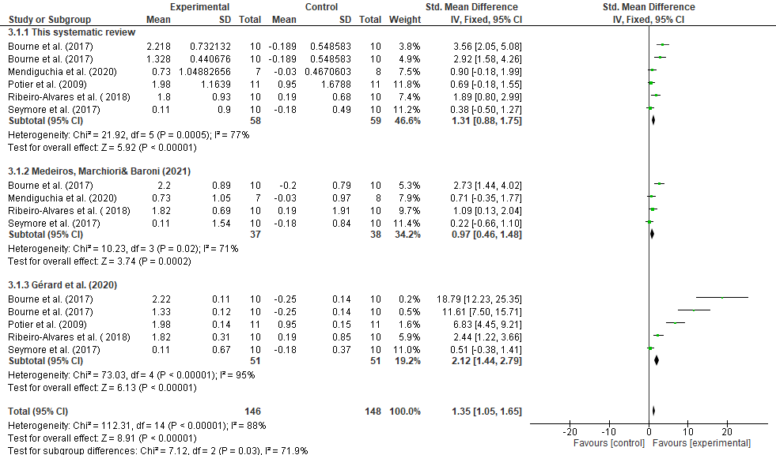

Figure G. Funnel plot for standardised mean difference (effect size (Hedge's (adjusted) g)), 95% confidence interval, random effect.
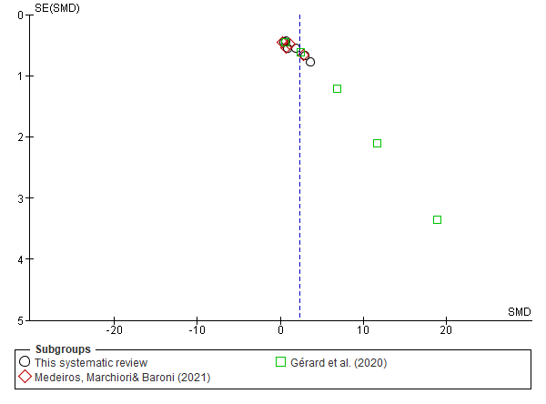
Figure H. Forest plot for standardised mean difference (effect size (Hedge's (adjusted) g)), 95% confidence interval, random effect.
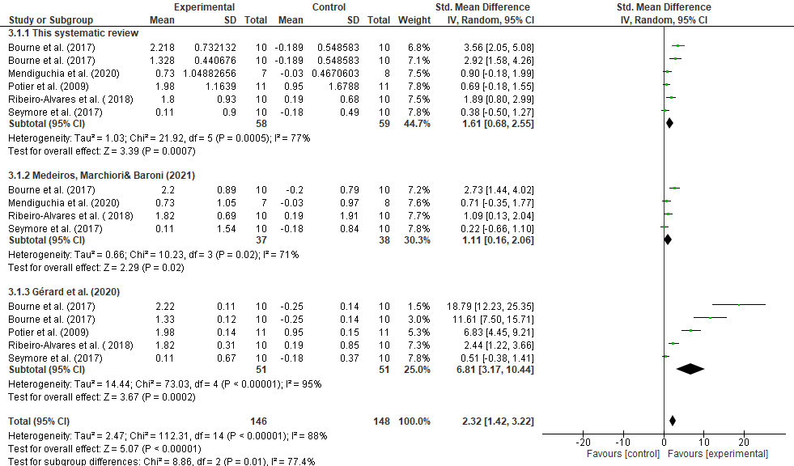
References
1. Gérard R, Gojon L, Decleve P, et al. The Effects of Eccentric Training on Biceps Femoris Architecture and Strength: A Systematic Review With Meta-Analysis. J Athl Train 2020;55(5):501-14. doi: 10.4085/1062-6050-194-19 [published Online First: 2020/03/29]
2. Medeiros DM, Marchiori C, Baroni BM. Effect of Nordic Hamstring Exercise Training on Knee Flexors Eccentric Strength and Fascicle Length: A Systematic Review and Meta-Analysis. J Sport Rehabil 2020:1-10. doi: 10.1123/jsr.2019-0388 [published Online First: 2020/10/14]

