Sulodexide for diabetic-induced disabilities: a systematic review and meta-analysis
Online only additional material

Table S1 Profile of the patients monitored in the studies on retinopathy
Ref.  No.ª | Study | Sulodexide arm |  |  |  |  |  |  | Control arm
Ref.  No.ª | Study | N/eyes | Diabetes type 1/2 | Mean duration (years) | Mean age (years) | Males, n (%) | Dose (LRU) | Observation period (months) | N/eyes | Diabetes type 1/2 | Mean duration (years) | Mean age (years) | Males, n (%)
62 | Rubbi et al. 2000 | 30/NA | NA | NA | NA | NA | 600x1 im +  500x2 os | 4 | Non-comparative
65 | Belcaro et al. 2019 | 38/NA | NA | NA | NA | NA | 250x2 os | 12 | 269/NA | NA | NA | NA | NA
63 | Shadrichev 2009 | 86/129 | NA | NA | NA | NA | 600x1 im +500x1 os | 3 | 63/77 | NA | NA | NA
64 | Song et al. 2015 | 59/82 | 0/59 | 15.4 | 59.1 | 29 (51) | 250x2 os | 12 | 57/83 | 0/57 | 14.2 | 59.9 | 19 (67)
 | Total | 213/211 | 0/59 | 15.4 | 59.1 | 29 |  |  | 389/160 | 0/57 | 14.2 | 59.9 | 19
ªRefers to the reference number in the main paper
im intramuscular, LRU lipase-releasing unit, NA not applicable, os oral

Table S2 Profile of the patients monitored in the studies on peripheral arterial disease and ulcers
Ref.  No.ª | Study | Sulodexide arm |  |  |  |  |  |  | Control arm
Ref.  No.ª | Study | N | Diabetes type 1/2 | Mean duration (years) | Mean age (years) | Males, n (%) | Dose (LRU) | Observation period | N | Diabetes type 1/2 | Mean duration (years) | Mean age (years) | Males, n (%) | Comparator
 | PERIPHERAL ARTERIAL DISEASE
66 | Utratová et al. 1993 | 9 | NA | NA | 63.7 | NA | 600x1 im | 3 weeks | Non-comparative study |  |  |  |  | NA
67 | Bregovsky et al. 1998 | 20 | NA | NA | NA | NA | 600x1 im +  250x2 os | 14 weeks | Non-comparative study |  |  |  |  | NA
69 | Coccheri et al. 2002 | 36 | 0/36 | NA | 64.7 | NA | 600x1 im +  500x2 os | 27 weeks | 34 | 0/34 | NA | 66.2 | NA | Placebo
70 | Moldovan et al. 2011 | 30 | 0/30 | NA | 60.0 | NA | 600x1 im +  250x2 os | 6 months | 30 | 0/30 | NA | 60.0 | NA | Placebo
74 | Velussi et al. 1996^{b} | 24 | 0/24 | NA | 67.0 | 16 (66.7) | 500x2 os | 6 months | 12 | 0/12 | NA | 64.0 | 9 (75.0) | SoC
 | Total | 119 | 0/90 | NA | 63.7 | NA |  |  | 76 | 0/76 | NA | 63.3 | NA
 | ULCERS AND DIABETIC FOOT
68 | Koblik et al. 2001^{c} | 12 | 2/10 | 16.2 | 62.6 | 8 (66.7) | 600x1 im +  500x2 os | 10 weeks | 6 | 2/4 | 13.3 | 57.5 | 3 (50.0) | Placebo
71 | Katorkin 2015 | 31 | 0/31 | NA | 59.8 | 9 (29.0) | 600x1 im +  250x2 os | 7 weeks | 31 | 0/31 | NA | 59.1 | 10 (32.3) | SoC
72 | Zakharova et al 2017 | 26 | 0/26 | NA | 69.8 | 8 (30.8) | 600x1 im +  250x2 os | 7 weeks | 26 | 0/26 | NA | 69.8 | 8 (30.8) | SoC
 | Total | 69 | 2/67 | NA | 63.7 | 25/69 |  |  | 63 | 2/61 | NA | 63.4 | 21/63
ªRefers to reference number in the main paper
^{b}Listed also among the studies on renal complications; being the study a cross-over, sulodexide data were taken from the first period on sulodexide and from the second period on sulodexide; SoC data were taken only from the first period
^{c}The study was designed to examine patients with monolateral foot ulcer
LRU lipase-releasing unit, NA not applicable, SoC standard of care

Table S3 Profile of the patients monitored in the studies on diabetic nephropathy
Ref No.ª | Study | Sulodexide arm |  |  |  |  |  |  |  |  |  | Control arm
Ref No.ª | Study | N | Diabetes type 1/2 | Mean duration (years) | Mean age (years) | Males, n/N (%) | ACEI/ARB yes (%) | Micro/macro albuminuria | Dose | Obs period | Notes | N | Diabetes type 1/2 |  | Mean duration (years) | Mean age (years) |  | Males, n/N (%) | ACEI/ARB yes (%) | Micro/macro albuminuria | Notes
73 | Solini et al. 1994 | 11 | 0/11 | NA | 52.3 | 6/11 | NA | 6/5 | 500x2 os | 8 wks |  | Non-comparative study
73 | Solini et al. 1994 | 5 | 0/5 | NA | 45.0 | 1/5 | NA | 3/2 | 600x1 im | 3 wks |  | Non-comparative study
76 | Perušičová and Škrha 1997 | 35 | 20/15 | 15.9 | 48.2 | 18/35 | NA | NA | 600x1 im | 3 wks | 5 days/wk | Non-comparative study
77 | Poplawska et al. 1997 | 14 | 14/0 | 11.3 | 29.3 | 4/14 | NA | 7/7 | 600x1 im + 250x2 os | 31 dd |  | Non-comparative study
78 | Shestakova et al. 1997 | 18 | 18/0 | 15.0 | 28.9 | 6/18 | NA | 9/9 | 600x1 im | 3 wks | 5 days/wk | Non-comparative study
79 | Škrha et al. 1997 | 53 | 26/27 | 18.0 | 48.1 | 33/53 | 6/53 | 24/29 | 600x1 im | 3 wks | 5 days/wk | Non-comparative study
81 | Sorrenti et al. 1997 | 15 | 2/13 | 12.5 | 59.3 | 9/15 | 7/15 | 13/2 | 600x1 im | 4 wks |  | Non-comparative study
82 | Szelachowska et al. 1997 | 15 | 15/0 | NA | 38.8 | 7/15 | NA | NA | 600x1 im | 3 wks |  | Non-comparative study
83 | Rasovskiĭ et al. 1998 | 20 | 20/0 | 9.3 | 40.8 | 7/20 | NA | 20/0 | 600x1 im | 3 wks | 5 days/wk | Non-comparative study
85 | Zalevskaia et al. 1998 | 20 | 3/17 | 18.8 | 36.6 | 5/20 | NA | 14/6 | 600x1 im | 3 wks | 5 days/wk | Non-comparative study
86 | Oksa et al. 1999 | 20 | 12/8 | 15.5 | 45.0 | 12/20 | NA | 12/8 | 600x1 im | 3 wks |  | Non-comparative study
86 | Oksa et al. 1999 | 19 | 11/8 | 17.0 | 46.0 | 12/19 | NA | NA | 500x2 os | 8 wks |  | Non-comparative study
45 | Peterkova et al. 1999 | 17 | 17/0 | 11.0 | 15.0 | 10/17 | NA | 11/6 | 600x1 im + 250x2 os | 4 wks |  | Non-comparative study
87 | Sun et al. 1999 | 36 | 0/36 | 11.9 | 57.9 | 25/36 | NA | NA | 600x1 im | 3 wks | 5 days/wk | Non-comparative study
88 | Lichiardopol et al. 2001 | 31 | 21/10 | NA | 54.4 | 21/31 | NA | 17/14 | 600x1 im | 3 wks |  | Non-comparative study
93 | Blouza et al. 2010 | 216 | 24/191 | 11.0 | 55.4 | 118/216 | NA | 144/42 | 250x2 os | 6 mo |  | Non-comparative study
105 | Li et al. 2017b | 20 | 0/20 | NA | NA | NA | NA | NA | 500x2 os | 3 mo |  | Non-comparative study
105 | Li et al. 2017b | 20 | 0/20 | NA | NA | NA | NA | NA | 1200x1 iv + 500x2 os | 3 mo |  | Non-comparative study
74 | Velussi et al. 1996^{b,c} | 24 | 0/24 | NA | 67.0 | 16/24 | NA | 24/0 | 500x2 os | 6 mo |  | 12 |  | 0/12 | NA | 68.0 | 9/12 |  | NA | 12/0 | Placebo
75 | Dedov et al. 1997 | 18 | 18/0 | NA | 28.9 | 6/18 | NA | 9/9 | 600x1 im | 3 wks | 5 days/wk | 18 |  | 18/0 | NA | 34.4 | 9/18 |  | NA | 9/9 | Placebo
80 | Solini et al. 1997^{c} | 12 | 0/12 | 7.3 | 52.0 | NA | 2/12 | NA | 500x2 os | 4 mo |  | 6 |  | 0/6 | 7.3 | 52.0 | NA |  | NA | NA | Placebo
89 | Gambaro et al. 2002 | 56 | 30/26 | 16.0 | 49.0 | 32/56 | 27/56 | 40/16 | 250x2 os | 4 mo |  | 56 |  | 30/26 | 17.2 | 47.0 | 33/56 |  | 30/56 | 30/26 | Placebo
89 | Gambaro et al. 2002 | 56 | 33/23 | 15.8 | 47.4 | 41/56 | 27/56 | 39/17 | 500x2 os | 4 mo
89 | Gambaro et al. 2002 | 55 | 31/24 | 16.2 | 46.9 | 40/55 | 32/55 | 27/28 | 1000x2 os | 4 mo
90 | Achour et al. 2005 | 30 | 15/15 | 14.0 | 48.0 | 16/30 | NA | 15/15 | 250x2 os | 12 mo |  | 30 |  | 15/15 | 14.0 | 48.0 | 16/30 |  | NA | 15/15 | Untreated
91 | Sulikowska et al. 2006 | 30 | 30/0 | 17.8 | 34.6 | 23/30 | 11/30 | NA | 500x2 os | 4 mo |  | 13 |  | 13/0 | 18.0 | 36.8 | 10/13 |  | 4/13 | NA | Untreated
92 | Heerspink et al. 2008 | 50 | 0/50 | NA | 64.1 | 36/50 | 50/50 | 50/0 | 1000x2 os | 6 mo |  | 47 |  | 0/47 | NA | 60.3 | 33/47 |  | 47/47 | 47/0 | Placebo
92 | Heerspink et al. 2008 | 52 | 0/52 | NA | 61.1 | 38/52 | 52/52 | 52/0 | 2000x2 os | 6 mo
94 | Mao and Zhong 2010 | 30 | 0/30 | 9.0 | 59.0 | 20/30 | 30/30 | NA | 600x1 im + 250x2 os | 6 mo | + Benazepril 10 mg/day | 30 |  | 0/30 | 11.0 | 61.0 | 19/30 |  | 30/30 | NA | Benazepril
95 | Ren et al. 2010 | 23 | 0/23 | NA | 55.2 | NA | 14/23 | 23/0 | 600x1 iv + 1000x2 os | 4 wks |  | 18 |  | 0/18 | NA | 55.2 | NA |  | 10/18 | 18/0 | Untreated
96 | Wang 2010 | 13 | 0/13 | NA | NA | NA | NA | NA | 500x2 os | 4 wks |  | 13 |  | 0/13 | NA | NA | NA |  | NA | NA | Untreated
97 | Lewis et al. 2011 | 524 | 0/524 | NA | 62.0 | 394/524 | 524/524 | 524/0 | 1000x2 os | 26 wks |  | 532 |  | 0/532 | NA | 62.3 | 408/532 |  | 532/532 | 532/0 | Placebo
98 | He and Ge 2012 | 33 | NA | NA | 42.0 | 19/33 | NA | 33/0 | 600x1 im + 250x2 os | 8 wks |  | 33 |  | NA | NA | 42.0 | 19/33 |  | NA | 33/0 | Untreated
99 | Packham et al. 2012^{d} | 619 | 0/619 | NA | 62.3 | 383/619 | 432/619 | 0/619 | 1000x2 os | up to 24 mo |  | 623 |  | 0/623 | NA | 63.6 | 370/623 |  | 457/623 | NA | Placebo
100 | Kang 2013 | 33 | 0/33 | NA | 57.6 | NA | NA | 33/0 | 600x1 im + 250x2 os | 8 wks |  | 29 |  | 0/29 | NA | 57.6 | NA |  | NA | 29/0 | Untreated
 |  |  |  |  |  |  |  |  |  |  |  | 31 |  | 0/31 | NA | 57.6 | NA |  | NA | 33/0 | Fosenopril
101 | Xiong 2014 | 35 | 0/35 | 7.7 | 50.0 | 21/35 | 35/35 | 35/0 | 600x1 iv + 1000x2 os | 8 wks | + Losartan 50 mg/day | 30 |  | 0/30 | 7.5 | 51.7 | 18/30 |  | 30/30 | 30/0 | Losartan
102 | Satirapoj et al. 2015 | 20 | 0/20 | 9.4 | 62.9 | 13/20 | 15/20 | NA | 500x2 os | 14 wks | Normo-albuminuric | 20 |  | 0/20 | 6.2 | 63.7 | 12/20 |  | 14/20 | NA | Placebo;  normo-albuminuric
104 | Dakhli et al. 2016 | 53 | 3/49 | 12.0 | 52.2 | 38/53 | NA | 37/8 | 250x2 os | 6 mo |  | 42 |  | 2/40 | 14.8 | 52.5 | 26/42 |  | 42/42 | 26/16 | Captopril
104 | Dakhli et al. 2016 | 28 | 6/22 | 16.4 | 50.3 | 19/28 | 28/28 | 8/18 | 250x2 os | 6 mo | + Captopril 25 mgx2/day
 | Total | 2378 | 369/1975 | 13.3 | 56.3 | 1449/  2258 (64.2) | 1292/1658  (78.0) | 1229/860 |  |  |  | 1583 |  | 78/1472 | 13 | 60.3 | 982/  1486 (66.0) |  | 1196/1411 (84.8%) | 814/695
ªRefers to reference number in the main paper
^{b}Listed also among the studies on vascular complications
^{c}Being the study a cross-over, sulodexide data were taken from the first and second period; control data were taken only from the first period due to an evident carry-over effect.
^{d}Final data available only for 144 treated and 142 controls
ACEI angiotensin-converting enzyme inhibitor, ARB angiotensin receptor II blocker, im intramuscular, mo months, NA not applicable, Obs observation, os oral, wks weeks

Table S4 Risk of bias in each of the comparative study
Outcome | Reference | Randomization process | Deviations from intended interventions | Missing outcome data | Measurement of the outcome | Selection of the reported result | Overall Bias
Ocular | Shadrichev 2009 | High | Low | Low | Low | Some concern | High
Ocular | Song et al. 2015 | Low | Low | Low | Low | Low | Low
Ocular | Belcaro et al. 2019 | High | High | High | High | Some concern | High
Renal | Dedov et al. 1997 | Low | Low | Low | Low | Some concern | Some concern
Renal | Solini et al. 1997 | Low | Low | Low | Low | Low | Low
Renal | Gambaro et al. 2002 | Low | Low | Low | Low | Low | Low
Renal | Achour et al. 2005 | High | Low | Low | Some concern | Some concern | High
Renal | Sulikowska et al. 2006 | Some concern | Low | Low | Low | Some concern | Some concern
Renal | Heerspink et al. 2008 | Low | Low | Some concern | Low | Low | Some concern
Renal | Mao and Zhong 2010 | High | Low | Low | Low | Some concern | High
Renal | Ren et al. 2010 | High | Low | Low | Low | Some concern | High
Renal | Wang 2010 | Some concern | Low | Low | Low | Some concern | Some concern
Renal | Lewis et al. 2011 | Low | Low | Some concern | Low | Low | Some concern
Renal | He and Ge 2012 | Low | Low | Low | Low | Some concern | Some concern
Renal | Packham et al. 2012 | Low | Low | High | Low | Low | High
Renal | Kang 2013 | High | Low | Low | Low | Some concern | High
Renal | Xiong 2014 | Some concern | Low | Low | Some concern | Some concern | Some concern
Renal | Satirapoj et al. 2015 | Low | Low | Low | Low | Low | Low
Renal | Dakhli et al. 2016 | High | Low | Low | Low | Some concern | High
Vascular | Velussi et al. 1996ª | Low | Low | Low | Low | Some concern | Some concern
Vascular | Koblik et al. 2001 | Low | Low | Low | Low | Low | Low
Vascular | Coccheri et al. 2002 | Low | Low | Low | Low | Low | Low
Vascular | Moldovan et al. 2011 | Low | Low | Low | Low | Some concern | Some concern
Vascular | Katorkin 2015 | Some concern | Low | Low | Low | Some concern | Some concern
Vascular | Zakharova et al 2017 | High | Low | Low | Low | Some concern | High
ªStudy reporting renal and vascular outcomes

Table S5 Number of patients with adverse events specifically indicated in the studies
Ref.  No.ª | Study | Sulodexide |  | Controls |  | Notes
Ref.  No.ª | Study | Patients with AEs | Patients monitored | Patients with AEs | Patients monitored | Notes
73 | Solini et al. 1994 | 0 | 16 | –
74 | Velussi et al. 1996 | 0 | 24 | –
75 | Dedov et al. 1997 | 0 | 18 | 0 | 18
76 | Perušičová and Škrha 1997 | 0 | 35 | –
79 | Škrha et al. 1997 | 0 | 53 | –
80 | Solini et al. 1997 | 0 | 12 | 0 | 12
81 | Sorrenti et al. 1997 | 0 | 15 | –
82 | Szelachowska et al. 1997 | 0 | 15 | –
89 | Gambaro et al. 2002 | 11 | 167 | 5 | 56 | Number of events
90 | Achour et al. 2005 | 0 | 30 | 0 | 30
92 | Heerspink et al. 2008 | 20 | 102 | 4 | 47 | Number of patients with serious AEs
93 | Blouza et al. 2010 | 13 | 237 | –
97 | Lewis et al. 2011 | 57 | 524 | 65 | 532 | Number of patients with serious AEs
70 | Moldovan et al. 2011 | 5 | 30 | 4 | 30
102 | Satirapoj et al. 2015 | 1 | 20 | 2 | 20
64 | Song et al. 2015 | 7 | 63 | 11 | 64
104 | Dakhli et al. 2016 | 14 | 81 | 9 | 42
ªRefers to reference number in the main paper
AE adverse event

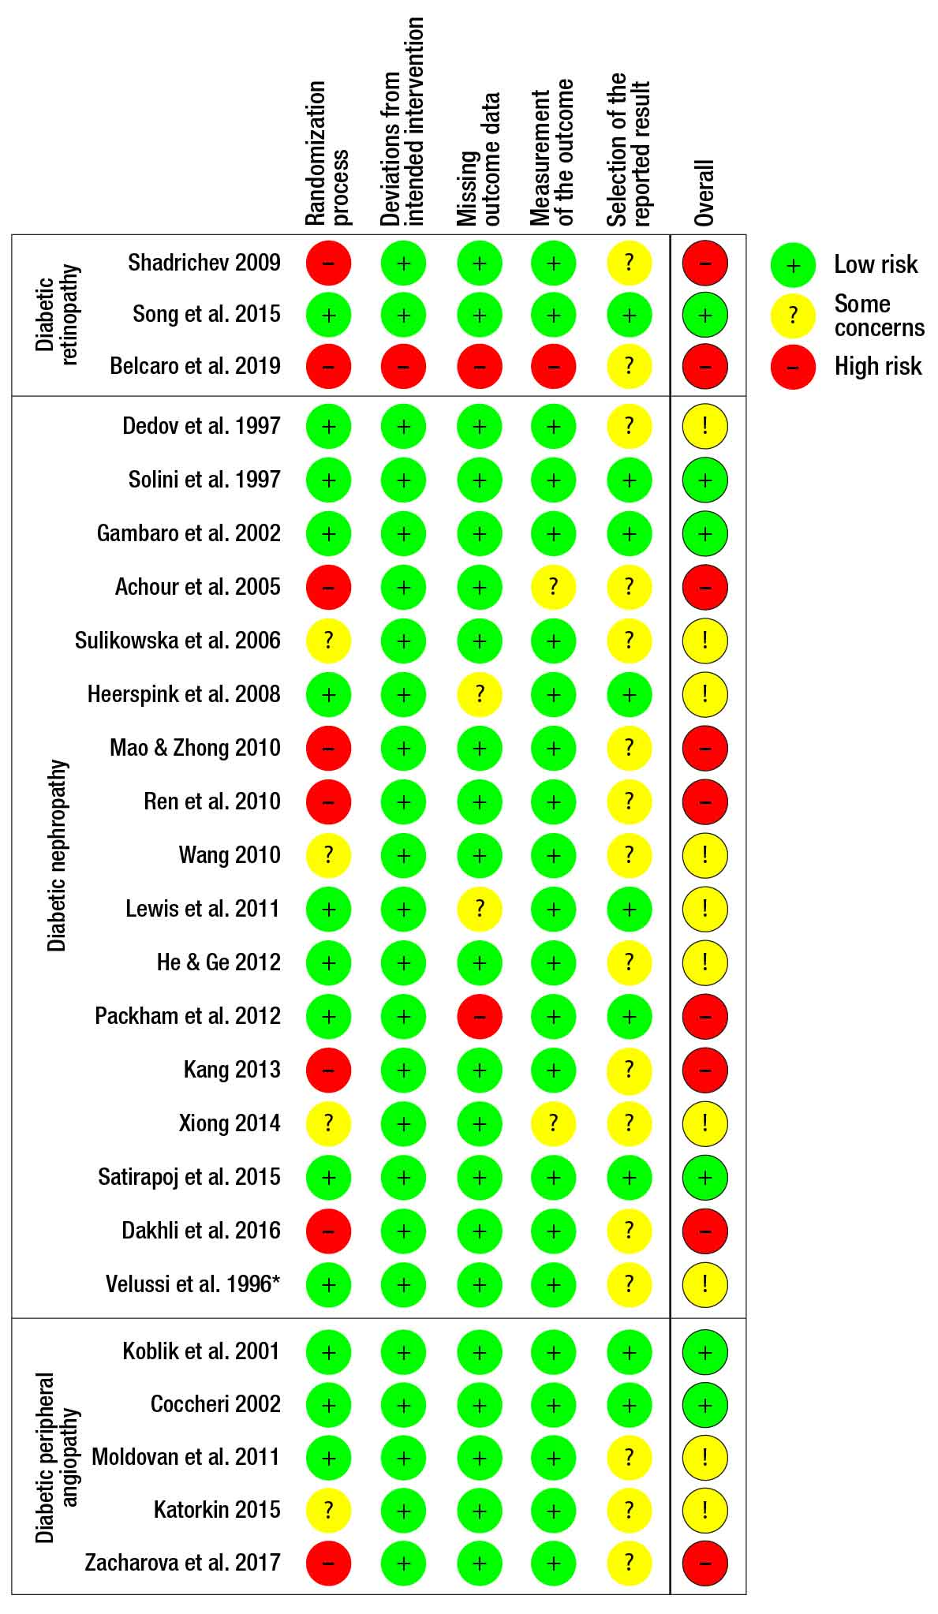
Fig. S1 Assessment of the risk of bias for each study considered in the quantitative synthesis. The asterisk denotes a study included in both, nephropathy and vasculopathy evaluations

Fig. S2 Forest plot of comparison between sulodexide versus controls in diabetes-associated ulcers, including the study in patients with diabetic foot (Koblik 2001). Outcome = mean gain in time to healing
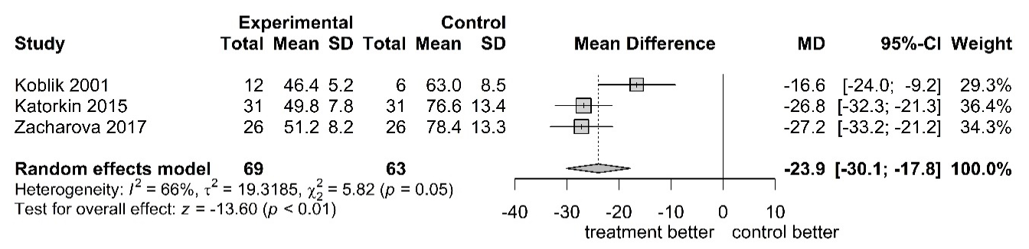

Fig. S3 Forest plot of comparison between sulodexide versus controls in diabetes-associated ulcers, including the study in patients with diabetic foot (Koblik 2001). Outcome = healing proportion after 2 months of treatment (2.5 months in the Koblik 2001 study)
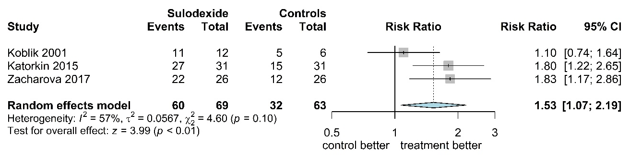

Fig. S4 Forest plot of comparison between sulodexide versus controls in diabetes-associated and non-diabetes-associated ulcers. Outcome = healing proportion after 2–2.5 months of treatment, compared among diabetics and general patients using the random effects model
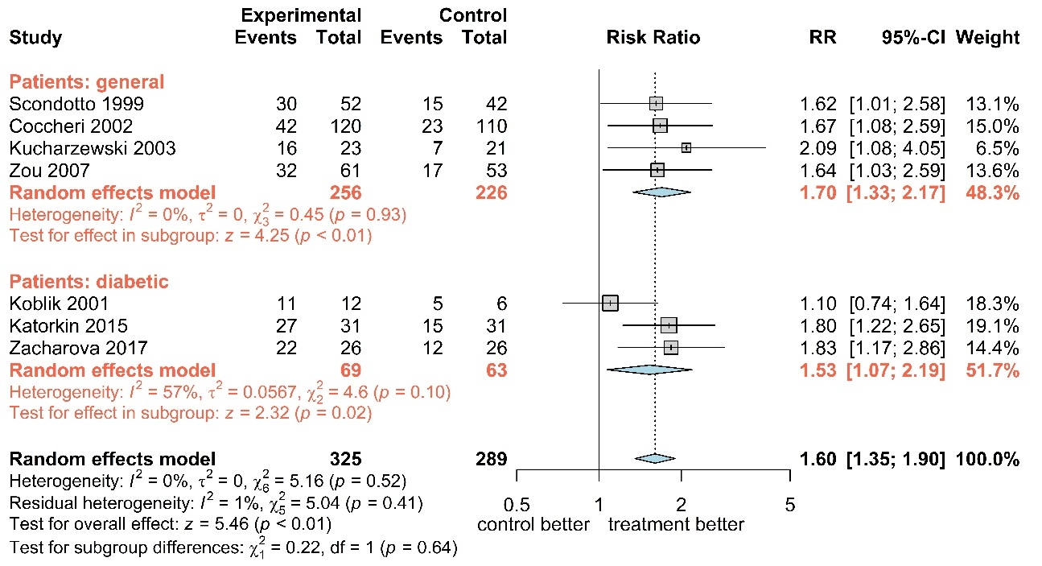

Fig. S5 Forest plot of comparison between sulodexide versus controls in diabetes-associated and non-diabetes-associated ulcers. Outcome = healing proportion in 2–2.5 months of treatment, compared among diabetics and general patients using the random effects model with exclusion of the study in patients with diabetic foot


