Content
Appendix 1 Search strategy 2
Appendix 2 The measurement tools for different outcomes 3
Appendix 3 Transformation formulas for estimating the mean and standard deviation 5
Appendix 4 The classifications of exercise interventions 7
Appendix 5 Study characteristics 9
Appendix 6 The list for the included studies 27
Appendix 7 Risk of bias 33
Appendix 8 the analysis for primary outcomes 39
8.1 Global cognition 39
8.1.1 pairwise analysis for global cognition 40
8.1.2 Network analysis for global cognition: 41
8.1.3 Subgroup analysis for global cognition in MCI group 43
8.1.4 Subgroup analysis for global cognition in dementia group 48
8.1.5 The results of meta regression analysis 52
8.2 Executive function 53
8.2.1 Pairwise analysis for executive function 53
8.2.2 Network analysis for executive function 54
8.2.3 Subgroup analysis for Executive function in MCI group 56
8.2.4 Subgroup analysis for executive function in dementia group 61
8.3 Memory function 65
8.3.1 Pairwise analysis for memory function 65
8.3.2 Network analysis for memory function: 66
8.3.3 subgroup analysis for memory function in MCI group 68
8.3.4 subgroup analysis for memory function in dementia group 72
Appendix 9 Results for secondary analysis 76

Appendix 1 Search strategy
Table 1 Search strategy in PubMed
Step | Search strategy
#1 | Search ((((Dementia[MeSH Terms]) OR cognition disorders[MeSH Terms]) OR Alzheimer∗[Title/Abstract]) OR cognitive impairment[Title/Abstract]
#2 | Search (exercise[MeSH Terms]) OR ((((((((((exercises[Title/Abstract]) OR physical activit*[Title/Abstract]) OR training*[Title/Abstract]) OR danc*[Title/Abstract]) OR yoga[Title/Abstract]) OR taichi[Title/Abstract]) OR wuqinxi[Title/Abstract]) OR baduanjin[Title/Abstract]) OR yijinjing[Title/Abstract])
#3 | Search ((randomized controlled trial [pt] OR controlled clinical trial [pt] OR randomized [tiab] OR placebo [tiab] OR  clinical trials as topic [mesh: noexp] OR randomly [tiab] OR trial [ti]) NOT (animals [mh] NOT humans [mh]))
#4 | #4 #1 AND #2 AND #3

Appendix 2 The measurement tools for different outcomes
Table 2 The measurement tools for different outcomes
Primary outcomes
Global cognition | Mini-Mental State Examination (MMSE); The Montreal cognitive assessment (MoCA); Alzheimer’s Disease Assessment Scale-Cognitive Subscale (ADAS-Cog,); General Practitioner Assessment of Cognition (GPCOG); Rapid Evaluation of Cognitive Function (the French ERFC);
Executive cognition | Trial mark test (TMT-B, TMT-A); Stroop color word test (SCWT); Frontal Assessment Battery (FAB); Symbol digit modalities test (SDMT); Clock-Drawing test; the Rule Shift Cards; the Wechsler Adult Intelligence Scale 3rd Edition (WAISIII); EXIT 25- Executive Interview. (If a composite score for executive function was reported, it would be a priority for extraction.)
Memory function | Digit span test (backward, forward); Rey’s Auditory Verbal Learning Test (RAVLT); the Wechsler memory scale-revised-Logical memory (WMS-LM); Benton Visual Retention Test-Revised 5th Edition (BVRT-R); Rivermead Behavioral Memory Test (RBMT); The Cambridge Neuropsychological Test Automated Battery (CANTAB)-Matching to sample delayed; the California Verbal Learning Test-second edition (CVLT-II); The fuld object memory evaluation (FOME). (If a composite score for memory function was reported, it would be a priority for extraction.)
Secondary outcomes
Activities of daily living | Activities of Daily Living (ADLs); Instrumental Activities of Daily Living (IADL); The Alzheimer’s Disease Cooperative Study Activities of Daily Living Inventory (ADCS-ADL); Katz index (KI), Barthel index (BI); Functional independence measure (FIM); Disability Assessment of Dementia; The Revised Elderly Disability Scale (REPDS); Functional and Cognitive Assessment Test (FUCAS)
Neuropsychiatric symptoms | Neuropsychiatric inventory (NPI)
Neuropsychiatric symptoms | Depressive symptoms: Cornell scale for depression in dementia (CSDD), Geriatric Depression Scale (GDS); Hamilton Depression Rating Scale; Montgomery-Asberg Depression Rating Scale (MADRS)
Quality of life | Quality of Life-AD (QOL-AD); Quality of life (QoL); The quality of life in late-stage dementia scale (QUALID); the Assessment of Quality of Life (AQOL); DemQOL; The European Quality of Life–5 Dimensions (EQ-5D).

Appendix 3 Transformation formulas for estimating the mean and standard deviation
(1) When calculating SD from M (confidence interval) for intervention or control group
a. the sample size in each group＞100
• SE= (upper limit-lower limit)/3.92
• SD=SE*N^ (1/2)
b. the sample size in each group≤100
• Input “tinv (1-0.95, N₁-1)” in Microsoft Excel to obtain t
• SE= (upper limit-lower limit)/ t
• SD=SE*N^(1/2)
(2) When calculating SD from MD and P value between intervention or control group
a. reporting the exact p value
• Input “tinv (p, N₁+N₂-2)” in Microsoft Excel to obtain t
• SE=MD/t
• SD1=SE/N₁^(1/2)
b. reporting only significant levels (e.g. P＜0.05 or P＞0.05)
• The conservative calculation is to take the upper bound P. (e.g. P＜0.05 is replaced 0.05)
(3) When calculating M (SD) from the m (interquartile range) for intervention or control group
a. the sample size＞25, M=m;
the sample size≤25, M=(𝑎+2m+𝑏)/4
b. the sample size≤15, SD=(((𝑎−2𝑚+𝑏)²/4+(𝑏−𝑎)²)/12) ^ (1/2)
the sample size 15<n≤70, SD=(𝑏−𝑎)/4
the sample size＞70, SD=(𝑏−𝑎)/6
(4) When calculating M (SD) from the m (interquartile range) for intervention or control group
a. M= (𝑞₁ +𝑚+𝑞₃)/3
b. calculation of SD
• Z=(0.25𝑁₁+0.375)/(𝑁1+0.25)
• Input “norm. inv(1-z,0,1)” obtain μ
• SD=(𝑞₃−𝑞₁)/(2∗𝜇)

Note:
M= mean; SE=standard error of mean; SD=standard deviation; N=sample size; MD= mean difference; m=median; a= minimum value; b = maximum value; q1= first quartile; q3= third quartile

Appendix 4 The classifications of exercise interventions
To compare the effects of different types of exercise, we classified exercise interventions into the following broad categories: aerobic exercise (AE, aiming to improve cardiovascular fitness including walking, running, or cycling), resistance exercise (RE, with the intent of increasing muscular strength and power using elastic bands, weight-machines), multicomponent exercise (ME, the combination of at least two types of exercise such as AE, RE, balance training), and mind-body exercise (MBE, aiming to improve participants’ mind-body coordination and awareness by practicing a series of controlled movements and focusing on interactions among the brain, body, mind, and behavior, such as Tachi, yoga, and dance). Different types of exercise were further classified and encoded according to the frequency, intensity, duration per session, and the length of intervention (see table 3).

Table 3 The classifications for exercise according to the frequency, intensity, duration per session, and the length of intervention.
Frequency
Low | 1-2 times/week
Moderate | 3-4 times/week
High | 3=≥5 times/week
Duration per session
Short | <30 minutes
Moderate-1 | 30-44 minutes
Moderate-2 | 45-59 minutes
long | ≥60 minutes
Length of intervention
Short | <13 weeks (3 months)
Moderate | 14-25 weeks (3 months-6 months)
long | ≥60 minutes (≥6 months)
Intensity
Low | Aerobic exercise:  < 60%HR max/ 60% V̇O₂max  Resistance exercise: < 50% of 1 RM
Moderate | Aerobic exercise: 60%-85% HR max/60–80% V̇O₂max  Resistance exercise: 60–80% of 1 RM
High | Aerobic exercise: >85% HR max/80% V̇O₂max,  Resistance exercise: 80–100% of 1 RM
References: (Jarstad & Mamen, 2019; Morris et al., 2017; Ramirez-Velez et al., 2017; Zhou et al., 2019)

Appendix 5 Study characteristics
Table 4 Study characteristics
study | Participants (exercise vs control) |  |  |  | interventions |  |  |  | comparator | Outcomes  (GC=global cognition; Ex=executive function; Mem=memory function)
study | Dementia/MCI | Sample size | Age | Female/male | type | duration | frequency | Length | comparator
Van de Winckel. 2004 | dementia | 15 vs 10 | 81.33±4.24 vs 81.90±4.18 | NA | Strengthening, balance, trunk movements and flexibility training, supported by music | 30 | 7 | 13 | Attention control | GC (MMSE) 15.53±4.44 vs 11±4.3  Mem (Free call) 12.83±8.59 vs 10.67±6.88
Scherder, E. J. 2005 | MCI | 15 vs 13 vs 15 | 84±6.38 vs 89 ±2.40 vs 86 ±5.05 | 13/2 vs 11/2 vs 14/1 | (1) self-paced slow walking.  (2) hand exercises | 30 | 3 | 6 | social visit  and normal social activity | Ex (TMT A+B) 339.67±207.41vs 273.15±139.85 vs 253.73±150.03  Mem (Digit Span) 10.8±3.1 vs 10.31±2.78 vs 10.93±2.69
Stevens, J.2006 | dementia | 24 vs 30 | 79 vs 81 | 23/1vs 23/7 | gentle aerobic exertion | 30 | 3 | 12 | usual care | Ex (Clock-drawing) 0.125±0.91 vs -0.1333±0.91
Rolland, Y.2007 | AD | 56 vs 54 | 82.8±7.8 vs 83.1±7.0 | 48/19 vs 53/14 | The exercise program included aerobic, strength, flexibility, and balance training. | 60 | 2 | 52 | usual care | NPI 8.3±8.9vs 8.9 ±10.4  ADL (Katz) 2.6±1.5 vs 2.2±1.5  Depression (MADRS) 13.4±8 vs 14.8±7.2
Kwak,Y.-S. 2008 | dementia | 15 vs15 | 79.67 ± 6.64 vs 82.27 ± 7.09 | all female | resistance exercise | 45 | 3 | 52 | placebo activity | GC (MMSE) 19.07±6.53 vs 12.27±6.68  ADL 19.8±4.75 vs 12.13±4.75
Hokkanen, L. 2008 | dementia | 19 vs 10 | 79.9 ±7.7 vs 84.5±3.3 | NA | dance and movement therapy | 30-45 | 1 | 9 | Usual care | GC (CDT) 1.05 ±1.27 vs 0.30±0.48  ADL 20.5±3.3 vs 22.9±1.5
Eggermont, L. H. P.2009 | dementia | 51 vs 46 | 85.4 | 79 vs 18 | walked at a self-selected speed | 30 | 5 | 6 | social visits | Mem (Digit span) 3.69±1.28 vs3.89±1.25
Littbrand, H.2009 | dementia | 47 vs 53 | NA | NA | HIFE Program: strength, balance | 45 | 2.5 | 13 | activities while sitting | ADL (BI) 13.07±0.37 vs 11.94±0.35
Kemoun, G.2010 | AD | 16 vs 15 | 82.0± 5.8 vs 81.7± 5.1 | 12 /4 vs 11 /4 | exercises in walking, equilibrium and stamina | 60 | 3 | 15 | usual care | GC (ERFC) 30.38±7.66 vs 23.23±8.37
Venturelli, M.2010 | dementia | 12 vs 11 | 83.3±6.7 vs 84.1±5.8 | NA | resistant circuit training | 45 | 3 | 12 | usual care | GC (MMSE) 23±1.4 vs 17.5±2.1  ADL(BI) 34.8±14.9 vs 19.3±11.9
Conradsson, M. 2011 | dementia | 41 vs 49 | NA | NA | HIFE Program：high-intensity functional weight-bearing exercise，strength and balance | 45 | 2.5 | 13 | watching films, singing, reading, conversation. | Depression (GDS) 3.92±0.32 vs 4.25±0.3
Varela, S.2011 | MCI | 17 vs 16 vs 15 | 79.24±10.07 vs 76.44±11.38 vs 79.40±6.72 | 27/21 | (1) aerobic exercise at  40% of HRR;  (2) aerobic exercise at 60% of HRR | 30 | 3 | 13 | recreational activities. | GC (MMSE) 20.40±4.15 vs 20.98±5.4 vs 19.53±5.5
Venturelli, M.2011 | AD | 12 vs 12 | 83±6 vs 85±5 | NA | aerobic walking activity | 30 | 4 | 26 | daily organized activities | GC (MMSE) 12±2 vs 6±2  ADL (BI) 42±4 vs 32±6
Yaguez, L.2011 | AD | 15 vs 12 | 70.5±8 vs 75.7±6.90 | 9/6 vs 7/5 | Brain Gym：non-aerobic exercises consisting stretching different parts of the body, circular movements of the extremities and isometric tensions of muscles groups. | 120 | 1 | 6 | Standard Care | Mem (Matching to sample delayed) 67.56±20.76 vs 65.58±11.74
Lam, L. C.2012 | MCI | 92 vs 169 | 77.2±6.3 vs 78.3±6.6 | 125/46 vs 172/46 | Taichi | 30 | 3 | 52 | stretching  and toning | GC (MMSE) 25.4±3.3 vs 24.2±3.4  Ex (TMT)102.3±51.6 vs 125.2±69.5  Mem (Digit span) 2.4±1.2 vs 2.4±1.1  NPI 1.7±3.2 vs 1.6±3.1  Depression (CSDD) 0.12±0.5 vs 0.16±0.6
Suzuki, T.2012 | aMCI | 25 vs 25 | 75.3±7.5 vs 76.8±6.8 | 13/12 vs 14/11 | The exercises included aerobic exercises, muscle strength training, and postural balance retraining | 90 | 2 | 52 | education control | GC (MMSE) -0.47±3.1 vs -0.44±3.15  Ex (SCWT-III) -2.61±19.45 vs -4.57±19.74  Mem (WMS-LM II) 5.13±5.58 vs 6.2±5.67
Vreugdenhil, A.2012 | AD | 20 vs 20 | 70.25±8 vs 74.1±7.75 | 9/11 vs 15/5 | daily home-based exercises: walking, focusing on body strength and balance training in addition to brisk walking | 30 | 7 | 17 | usual care | GC (MMSE) 23.9±5 vs 19±7.7  ADL (BI )99.6±1.2 vs 94.2±12.6  Depression (GDS) 2±1.5 vs 2.3±1.4
Nagamatsu, L. S.2013 | MCI | 28 vs 30  vs 28 | 73.9±3.4 vs 75.6±3.6 vs 75.1±3.6 | all women | (1) resistance training  (2) walking program | 60 | 2 | 26 | balance and tone | Mem (RAVLT) 44.36±11.29 vs 43.38±10.95 vs 43±9.61
Pitkälä, Kaisu H. 2013 | AD | 68 vs 61 vs 65 | 77.7±5.4 vs 78.3±5.1 vs 78.1±5.3 | 30/40 vs 25/45 vs 26/44 | (1) home-based exercise [HE] individually tailored training addressing the daily functioning or mobility  (2) group-based exercise [GE]: consisted of endurance, balance, and strength training | 60 | 2 | 52 | Education control | AD (FIM)10.3±9 vs 14.4±8.89
Suttanon, P.2013 | AD | 19 vs 21 | 83.42±5.10 vs  80.52±6.01 | 13/6 vs 12/9 | The Otago Program individualized home-based exercise, standing balance and strengthening exercises and a graduated walking programme | 15 | 5 | 26 | Education control | QOL 25.63±4.5 vs 25.43±6.31
Davis JC 2013 | MCI | 28 vs30 vs 28 | 74.1±3.6 vs 75.5±3.5 vs 75.0±3.7 | NA | (1) resistance training,：progressive, high intensity,  6-8 repetitions (two sets)  (2) aerobic training:40% HRR progressed 60% of HRR | 60 | 2 | 26 | balance and tone | Ex (Stroop Test) 44.61±25.8 vs 48.27±31.3 vs 54.69±31.3
Arcoverde, C. 2014 | AD | 10 vs10 | 79 (74.7- 82.2) vs 78.5 (64- 81.2) | 5/5 vs 6/4 | an exercise group (EG) on a treadmill (moderate intensity of 60% VO2max) | 30 | 2 | 16 | usual care | GC (MMSE) 0.3±2.4 vs -2.1±0.8  Ex (TMT) -6±18.87 vs 6.5±17.47  Mem (Digit span) -0.8±1.9 vs -1.9±3.1
Fiatarone Singh, M. A.2014 | MCI | 22 vs 27 | NA | NA | Progressive resistance  training: at high intensity, for most major muscle groups | 75 | 2 | 52 | Placebo control | GC(ADAs-cog) -5.56±3.06 vs -7.14±2.94 Ex -0.484±0.65 vs 0.053±0.64  Mem 0.056±0.72 vs -0.333±0.7  ADL -0.2±0.11 vs -0.1±0.13
Lowery, D. 2014 | dementia | 67 vs 64 | 79±6.8 vs 78±7.4 | 35/32 vs 39/25 | an individually tailored walking progressively more intensive | 25 | 5 | 12 | usual care | NPI 23.9±20.6 vs 25.6±16.6  Qol 104±10 vs 101±13.5
Wei, XH. 2014 | MCI | 30 vs 30 | 66.73±5.48 vs 65.27±4.63 | 9/21 vs 19/11 | Handball training program | 30 | 5 | 26 | usual care | GC(MMSE) 25.53±0.82 vs 24.67±1.42  ADL -15.47±1.66 vs -14.43±0.63
Bossers, W. J.2015 | dementia | 37 vs 36 vs 36 | 85.7±5.1 vs 85.4±5.4 vs 85.4±5.0 | 29/8 vs 28/8 vs 25/11 | (1) combined group: two strength and two walking sessions per week,  (2) aerobic group: four walking sessions, a moderate to high intensity exercise  AR: 50–85% HRmax;  ST: 60–100% 1RM | 30 | 4 | 9 | social visits | GC(MMSE) 17.16±4.33 vs 15.5±5.51 vs 15.17±4.48  Ex (TMT)161.85±38.52 vs 179.60±127.88 vs 185.83±117.03  Mem (Digit span) 5.44 ±2.43 vs 5.05±3.22 vs 3.97±2.56
Holthoff, V. A. 2015 | AD | 15 vs 15 | 72.40±4.34 vs 70.67±5.41 | 8/7 vs 7/8 | homebased resistance | 30 | 3 | 12 | Usual care | GC (MMSE) 21.99 ±0.54 vs 21.28±0.54  Ex (semantic word fluency) -15.27±0.65 vs -12.46±0.65  NPI 15.71±1.26 vs 10.05±1.26  ADL (ADCS  -ADL) 62.35±0.91 vs 57.47±0.91
Lü, J. 2015 | MCI | 22 vs 23 | 69.00±3.83 vs  70.43±5.53 | 16/6 vs 16/7 | dumbbell-training | 60 | 3 | 12 | usual care | GC (ADAS-Cog) -7.85±2.80 vs -12.87±4.80  Ex (TMT-B) 95.45±45.00 vs 117.85±54.01  Mem (Digit Span) 3.82±0.91 vs 4.00 ±1.13
Telenius, E. W. 2015 | dementia | 87 vs 83 | 87.3±7.0 vs 86.5±7.7 | 63/24 vs 62/21 | High Intensity Functional Exercises (HIFE) – ‘high intensity’ | 55 | 2 | 12 | stretching and relaxing activities | GC (MMSE) 15.4±4.22 vs 15.3±3.43  NPI 4.8±4.92 vs 5.6±6.87  QoL 18.1±5.86 vs 17.7±5.95  Depression (Cornell Scala) 4.0±6.57 vs 3.8±4.35
Yang, SY 2015 | AD | 25 vs 25 | 72.00±6.69 vs 71.92±7.28 | 15/10 vs 18/7 | cycling training at 70% of  maximal intensity | 40 | 3 | 13 | heath education | GC (MMSE) 22.83±2.75 vs 19.54±3.43  NPI 7.96±8.15 vs 12.54±14.40  QoL 30.67±4.84 vs 30.19±4.53
ten Brinke LF,2015 | Probable MCI | 10 vs 8 vs 11 | 76.1±3.4 vs 73.8±3.7 vs 75.5±3.9 | All women | (1) AT: outdoor walking, RPE 13–15, 40–80% HRR, progressed to 70% to 80% of HRR, RPE 13–15; 2)  (2) RT: whole-body strength exercises with and without machines, 60–80% 1RM corresponding to RPE 13–15, 2 sets of 6–8 repetitions | 60 | 2 | 26 | Balance and Tone Training | Mem (RAVLT) 8.16±2.68 vs 9.68±1.55 vs 8.04±1.72
Bossers, W. J. R. 2016 | dementia | 35 vs 35 vs 35 | 85.7±5.2 vs 85.5±5.4 vs 85.7±4.8 | 27/8 vs 27/8 vs 24/11 | (1) aerobic and strength exercise  (2) aerobic only: walking moderate- to high-intensity | 30 | 4 | 9 | social visit | ADL (Katz index) -9.9±1.7 vs -11.1±2.9 vs-11.1±3.1
Cancela, J. M.2016 | dementia | 73 vs 116 | 80.63±8.32 vs 82.90±7.42 | 32/41 vs 94/22 | The aerobic physical activity program consisted of daily cycling. | 15 | 7 | 65 | sedentary recreational activities | GC (MMSE) 0.09±1.97 vs -2.11±4.29  Mem (FOME) 1.99±13.42 vs -1.31±31.32  NPI -0.84±12.52 vs 4.6±14.35  ADL(KI) 0.22±1.16 vs -0.25±0.6  Depression (CSDD) 1.84±11.32 vs -2.71±4.38
Dawson, N. T.2016 | dementia | 13 vs 10 | 73.78±8.50 vs 73.96±10.37 | NA | home-based moderate-intensity, functional exercise program, strength and balance | NA | 2 | 12 | usual care | Ex (TMT-B) 462±335 vs 351±312  ADL 6.83±5.13 vs 5.40±6.72
Hoffmann, K 2016 | AD | 102 vs 88 | 69.8±7.4 vs 71.3±7.3 | 51/56 vs 36/57 | moderate-to-high intensity supervised aerobic exercise： target HR 70–80% of maximal HR | 60 | 3 | 16 | usual care | GC (MMSE) 23.9±3.4 vs 23.9±3.9  Ex (Stroop test) -17.5±10.4 vs -18.3±9.9  Mem (Delay recall) 1.5±2 vs 1.6±1.9  Depression (HAMD) 1.7±2.5 vs 1.8±2.3  NPI 8.8±8.5 vs 11.4±11.0  QoL 82.5±15.5 vs 80.7±16.6  ADL (ADCS-ADL) 64.4±9.4 vs 62.7±10.4
Liu-Ambrose, T. 2016 | dementia | 35 vs 35 | 74.8±8.4 vs 73.7±8.3 | 19/16 vs 17/18 | walking, progressive aerobic exercise training, 60%–70% of HRR. | 60 | 3 | 26 | Usual care plus education | GC (ADAs-Cog) 1.61±2.96 vs -0.1±3.14  Ex (EXIT-25) -0.34 (0.69) vs 1.11 (0.74)  ADL (ADCS-ADL) 0.77 (0.65) vs -0.49 (0.69)
Phoemsapthawee, J.2016 | MCI | 12 vs 12 | 65 to 87 yrs | All women | supervised ASE for 5 d·wk-1. The intensity of is approximately 23% of peak oxygen consumption (VO2 peak). | 30 | 5 | 12 | usual care | GC(MMSE) 20.9±5.1 vs 19.1±4.8
Toots, A. 2016 | dementia | 83 vs 88 | 84.4±6.2 vs 85.9±7.8 | 70 /23 vs 71/22 | high-intensity functional exercise (HIFE) | 45 | 2.5 | 17 | social activity | ADL(BI) -0.79±0.31 vs -1.39±0.30
Bürge, E. 2017 | dementia | 78 vs 82 | 81.7±7.7 vs 81.1±7.7 | 38/40 vs 44/38 | exercise program± strength, flexibility, walking, and balance training), moderate intensity, five sessions per week, each lasting 30 minutes, 4 weeks | 30 | 5 | 4 | social activity | ADL (BI) 13.44 (3.989) vs 12.48 (4.897)
Chen, KM 2017 | dementia | 65 vs 62. | 80.7 ±8.0 vs 81.6 ± 6.7 | 38 /27 vs 34/28 | resistance band exercises: volunteer-led sessions for the first 6 months(Stage I) followed by DVD-guided sessions for the next 9 months (Stage II). | 40 | 3 | 65 | usual care | Depression (CSDD) 2.8 ±2.82 vs 3.9±2.82
Greblo Jurakic, Z. 2017 | MCI | 14 vs 14. | 70.4± 3.93 (Total) | all women | HUBER: combined balance and core resistance training group with 50%-75% of maximum voluntary contraction (MVC) | 30 | 3 | 8 | Pilates：  3 times / week.  8 weeks.  1h /session | GC (MoCA) 25.79 ± 1.53 vs 24.29 ± 1.98  Ex (Visuospatial/executive) 3.50 ± 1.23 vs 2.57 ± 1.16  Memory (Delayed recall )3.64 ± 1.01 vs 3.93 ± 0.92
Kohanpour, M. A.2017 | MCI 40 | 10 vs 10 | 60-70  (range) | all men | running aerobic exercise ,, 21-39 minutes / session, intensity of 75%- 85% of HRR Max, | 21-39 | 3 | 12 | usual care | GC (MMSE) 24.4±1.42 vs 24.2±0.63
Lazarou, I.2017 | aMCI 129 | 66vs 63 | 65.89±10.76) VS 67.92±9.47) | 53/13 vs 48/16 | dance | 60 | 2 | 43 | usual care | GC(MMSE) 28.00 (2.39) VS 25.65 (3.27)  Ex (ROCFT) 16.18±6.02 vs 11.10±6.50  Mem (RBMT2) 11.09±4.38 vs 8.38±4.28  NPI 1.78± 2.28 vs 3.76 ± 4.84  GDS 1.26 1.73 vs 2.22 ±2.03  ADL(FUCAS) -44.74±3.05 vs -45.88±3.71
Morris, J. K. 2017 | MCI or dementia | 39 vs 37 | 74.4±6.7 vs 71.4±8.4 | 18/21 vs 21/16 | aerobic exercise : 150 minutes (distributed over 3-5 sessions) per week , 60±75% of HR reserve | 35 | 4 | 26 | stretching and toning control | Ex(composite) -1.20±0.90 vs -1.33 ±0.97  Mem (composite) -2.3±1.7 vs -2.7 ±1.7  Depression (CSDD) 7.8 (5.2) vs 7.8 (4.4)  ADL 89.5 (13.7) vs 86.7 (13.3)
Ohmana, H.2017 | AD | 57 vs 63 vs 59 | 77.9±5.2 vs 77.4±5.3 vs 78.1±5.3 | 20/37 vs 24/39 vs 25/34 | (1) group-based exercise  (2) home-based exercise  The exercise sessions consisted of aerobic exercise, strength training, balance training, and dual-tasking. | 60 | 2 | 52 | usual care | NPI 0.88 ±7.80 vs 2.73 ±7.88 vs 0.64 ±10.92  Depression (CSDD) 1.35 ±4.75 VS 0.5 ±4.39 VS 0.04 ±5.68
Padala, K. P. 2017 | AD | 15 vs 15 | 72.1±5.3 vs 73.9±7.1 | 5/10 vs 6/9 | Wii-Fit: exercise under caregiver supervision, including yoga, strength training, aerobics, balance games, and training plus, which includes more complex exercise tasks | 30 | 5 | 8 | walk for 30min at self-selected pace,  5 days /week. | GC(MMSE) 0.7 (3.61) vs -0.1 (3.61)  ADL 0.2(1.26) vs 0.1(1.26)  QOL-AD 1.7 ±3.97 vs 1.1±4.15
Shimizu, N. 2017 | MCI | 30 vs 9 | 74.90±4.29 vs 73.33±7.31 | 28/6 vs 10/1 | movement music therapy, exercise completed in synchronization with background music. | 60 | 1 | 12 | the same exercises without music or clapper | Ex (FAB) -15.87 ± 1.66 vs -15.25 ± 1.16
Toots, A.2017 | dementia | 93 vs 93 | 84.4±6.2 vs 85.9±7.8 | 70/23 vs 71/22 | strength, balance, and mobility | 2.5 | 17 | 93 | attention control | GC(MMSE) -1.15 ±3.69 vs -0.93 ±3.69  Ex(verbal fluency)-0.74 ±2.86vs-0.21 ±2.88
Yoon DH 2017 | MCI | 14 vs 9 vs 7 | 75.0 ± 0.9 vs 76.0 ± 1.3 vs78.0 ± 1.0 | NA | elastic exercise bands | 60 | 2 | 12 | balance and tone exercises | GC(MMSE) 25.36 ± 1.78 vs 24.56 ± 3.21 vs 21.14 ± 1.57
de Souto Barreto 2017 | dementia | 44 vs 47 | 88.3 ±5.1 vs 86.9± 5.8 | 41/3 vs 36 /11 | multicomponent training: balance，strengthening，aerobic exercise，moderate intensity | 60 | 2 | 24 | social activity | GC(MMSE) -1.0 ±0.51 vs - 0.5 ±(0.47)
Doi,2017 | MCI | 67 vs 67 | 75.7±4.1) vs 76.0±4.9 | 34/33 vs 31/36 | dance | 60 | 1 | 40 | health education | GC(MMSE) 0.29 ±2.6 vs -0.36 ±2.3  Ex (TMT) 0.02 ±11.2 vs -1.5 ±11.8  Mem (word memory) 0.06 ±1.6vs0.27 ±1.7
Choi, W.2018 | MCI | 30 vs 30 | 74.90±5.10 vs 74.23±4.38 | 24/5 vs 25/5 | ground kayak paddling | 60 | 2 | 6 | home exercise: curl-ups, leg lifts, prone | GC (MoCA) 25.13±2.78 vs 21.46 ±3.11
Combourieu DL. 2018 | MCI | 18 vs 14 | 77.1±1.44 vs 79.2±4 | NA | aerobic training on bikes moderate intensity | 60 | 2 | 12 | usual care | Ex (Stroop test) 30.94±6.24vs 26.42 ± 6.53  Mem (Digit span) 4.72 ± 1.18 vs 3.79 ± 0.97
Henskens, M.2018 | dementia | 22 vs 22 | 85.14±4.64 vs 84.73±4.55 | 17/5 vs 17/5 | strength and aerobic exercises (moderate to intensive intensity) | 37.5 | 3 | 26 | social activity | ADL: -0.3 (1.5) VS -0.1 (1.9)  QOL: -2.6 (6.0) VS -0.9 (4.9)
Hong， 2018 | MCI | 10 vs 12 | 77.71±3.40/ 78.33 ± 3.21 vs 75.11± 4.45/ 78.33±5.50  (Female/Male) | 7/3 vs 9/3 | resistance exercises ： Elastic band 15RM, about 65% of maximum | 60 | 2 | 12 | usual care | GC(MoCA) 21.70 ± 3.05 vs 20.50 ± 5.05  Ex (Stroop test) 9.90 ± 3.21 vs 10.83 ± 4.98  Mem (Digit span) 2.17 ± 1.52 vs 1.08 ±0.91
Lam, Freddy M. H.2018 | dementia | 27 vs 27 | 79.7±5.5 vs 79.9±6.7 | 19/8 vs 21/6 | whole‐body vibration | 5 | 2 | 9 | exercise tailored by physiotherapist (30–60 min ) | QoL33.8 ±3.8 vs 34 ±3.4
Lamb, S. E. 2018 | dementia | 329 vs 165 | NA | NA | supervised static cycling， moderate to hard intensity ， and hand held dumb bells | 75 | 2 | 52 | usual care | GC(ADAs-cog)-25.2±11.3 vs -23.8±10.4  Mem (ADAs-cog memory)-18.5±6.7 vs -18.1±5.6  NPI 13±14.18 vs 13.5±13.1  QoL-AD 38.4±5.8 vs 39.1±5.7  ADL(BADL) -17±10.2 vs -15.9±9.7
Liu, B. B.2018 | dementia | 1 8vs 18 | 80.72±7.29 vs 79.72±9.43 | 13/5 vs 11/7 | passive finger exercises | 25 | 7 | 12 | usual care | ADL(BI) 76.11 ±25 vs 67.22±31.02
Sungkarat, S.2018 | MCI | 33vs 33 | 68.3 ± 6.7 vs 67.5 ± 7.3 | 31/2 vs 26/7 | Tai chi | 50 | 3 | 26 | educational control | Ex (TMT) -76.2 ± 46.7 vs -101.1 ± 60.8  Mem (Digit span) 12.9 ± 2.7 vs 12.5 ± 1.8
Zhu, Y. 2018 | MCI | 29vs31 | 70.3±6.7 vs 69.0±7.3 | 15 /14 vs 21/10 | dance, 60-80%Hrmax moderate intensity | 35 | 3 | 13 | usual care | GC(MoCA) 24.7±2.2vs 23.6 ±1.8  Ex (TMT) -158 ±49 VS -177±48  Mem (Digit span) 16.9 ±2.3 vs 17.0 ±2.9
Amjad, I.2019 | MCI | 21vs 19 | 58 ± 2 vs 60 ± 3 | 10/11 vs 9/10 | stationary bicycle，40 min，three days per week ，six weeks，60% and 80% of the maximum heart rate | 30 | 3 | 6 | gentle movement and body stretching | GC(MMSE) 26.353±0.469 vs24.177± 0.849  Ex (TMT) -2.803 ± 0.282 vs -3.811 ± 0.205
Bademli, K. 2019 | MCI | 30vs30 | 72.24±7.16 vs 70.67±8.34 | 18/12 vs 17/13 | Physical Activity Program: included 10‐minute of warm‐up activities, 20‐minute of rhythmic exercises, 10‐minute of cool down exercises and 40‐minute of free walking | 80 | 4 | 20 | usual care | GC(MMSE) 26.542±1.84 vs 22.24±1.15
Cardalda, I. M.2019 | mild to moderate cognitive impairment | 25 vs 23 vs 29 | 85.54±8.09 vs 83.76±8.33 vs 85.17±7.38 | NA | (1) TG：resistance elastic bands, strength-based physical exercise, by means of resistance elastic bands，  (2) MG calisthenics exercises | 60 | 2 | 12 | Usual care  (social activities) | GC(MMSE) 19.32±7.10 vs 20.68±7.68 vs 15.44±7.55
Choi, W. 2019 | 60 | 30 vs 30 | 77.27 ± 4.37 vs  75.37 ± 3.97 | 25/5 vs 26/4 | virtual kayak paddling (VKP) exercise; participants were seated on a chair while practicing the exercise, observing a video | 60 | 2 | 6 | home exercises: William flexion exercise, curl-ups, leg lifts, et al. | GC(MoCA) 23.22 ± 4.48 vs 20.12 ± 3.53
de Oliveira Silva, F. 2019 | AD and MCI | AD  7 vs 12  MC  I 7 vs 12 | AD  81.22 ± 8.88 vs 77.54 ± 8.05  MCI  71.85 ± 5.69 vs 78.20 ± 5.26 | AD  5/8 vs 11/3  MCI  6/1vs5/7 | Supervised multimodal physical exercises (aerobic, strength, balance and flexibility) of moderate intensity | 60 | 2 | 13 | usual care | AD  GC(MMSE) 20.31 ± 4.68 vs 19.50 ± 5.37  Ex(Stroop test)-56.99±28.39vs-55.65±23.68  MCI  GC(MMSE) 28.25± 0.88 vs 28± 1.83  Ex (Stroop test)-32.83±8.23vs-38.06± 11.99
Fonte, C.2019 | AD and MCI | AD  20vs21  MCI  7 VS 9 | AD  79±9 vs 80±7  MCI  75±5 vs 79±3 | AD  14/6 vs 13/8  MCI  3/4vs7/2 | physical activity : cycling , walking, arm cranking，and stretching exercises,， 70%Hrmax | 90 | 3 | 26 | usual care | AD:  GC(ADAS-Cog) -30.1±16.1 vs -34±9.3  Ex (FAB) -9.9±2.4 VS -7.3±2.9  IADL 50.5±32.9 VS 34±25.5  NPI 9.5±6.8 VS 29.7±9.7  MCI:  Ex(TMT)-190.1±30.6 vs -297.3±71  Mem (RBMT) 93.6±35.6 vs 51.6±25.4  IADL 86.4±22.1 VS 73.1±34.3  NPI 7±4.2 VS 13.8±11.2
Karssemeijer, E. G. A.2019 | dementia | 39vs38 | 80.9±6.1 vs 79.8±6.5 | 18/21 vs 17/21 | aerobic bicycle training cycling on a stationary bike, 65–75% of heart rate reserve | 40 | 3 | 12 | relaxation and flexibility exercises | Ex(TMT) -124.9 (97.9) vs -170.1 (106.8)  Mem (Digit span) 10.8 (2.8) vs 10.8 (4.0)
Langoni, C. D. S. 2019 | MCI | 26 vs 26 | NA | NA | Strength exercise (ankle weights, elastic bands, and dumbbells) and aerobic exercises (walking)，60% - 75% of maximal heart rate | 60 | 2 | 24 | usual care | Depression (GDS) -2.5±2.33 vs -3.77±2.57
Langoni, C. D. S. 2019 | MCI | 26 vs 26 | 72.6±7.8  vs 71.9±7.9) | 20/6 vs20/6 | strength exercises (Elastic band, ankle weights, resistance latex bands, and dumbbells) and Aerobic training involved (walking) at 60% to 75% HR max | 60 | 2 | 24 | usual care | GC(MMSE) 25.0±4.7 vs 20.4±4.1
Qi M 2019 | MCI | 26 vs16 | 70.6±6.2 vs 69.1±8.1 | 11/5 vs 12/4 | aerobic dance, three times a week together, HRmax of 60-80% | 35 | 3 | 13 | usual care | GC(MMSE). 28.2 ±1.0 vs 27.3 1.7  Ex(TMT) -161.6 ±53.8 vs -181.6 ±46.7  Mem (Digit span) 16.4 ±2.6 vs 17.1± 2.9
Song D 2019 | MCI | 60vs60 | 76.22±5.76 vs 75.33±6.78 | 48/12 vs 42/18 | aerobic exercise, stepping exercise （stepping up and down on a 10cm stable , moderate-intensity（the Borg Scale 10-14 point ） | 60 | 3 | 16 | health education | GC(MoCA) 23.66±1.92 VS 21.40±2.27  QOL 30.29 ±3.41 VS 28.97 ±2.72  Depression (GDS) -4.87 ±3.22 vs -5.70 ±3.60
Tao, J. 2019 | MCI | 20 vs 17vs 20 | 66.17±4.17vs 64.32±2.60vs 65.97±5.66 | 15/5 vs 10/7 vs 14/6 | (1) Baduanjin group;  (2) brisk walking group，55–75% of HRR | 60 | 3 | 24 | non exercise -health education | GC(MoCA) 2.10±2.25 vs 0.88±1.96 vs 1.10±1.48
Tarumi, T. 2019 | MCI | 30 vs 39 | 64.0±5.9 VS 65.3±6.6 | 19/11 VS 24/15 | AET: aerobic exercise treadmile, started with 25–30 minutes per session, 75–85% of maximal heart rate;  After week 26, participants performed 4-5 exercise sessions per week for 30–40 minutes, including two high intensity sessions | 35 | 4.5 | 52 | stretching and toning | Mem (CVLT-II) 47.9±9.65vs 48±9.9  Ex (D-KEFS -TMT) -11.9±2.11 vs -12.4±2.13
Note: NA: not available; BI: Barthel Index; MMSE: Mini-Mental State Examination; MoCA: The Montreal cognitive assessment; Alzheimer’s Disease Assessment Scale-Cognitive Subscale (ADAS-Cog,); General Practitioner Assessment of Cognition (GPCOG); ERFC: Rapid Evaluation of Cognitive Function; TMT: Trial mark test; SCWT: Stroop color word test; FAB: Frontal Assessment Battery; CDT: Clock-Drawing test; the Rule Shift Cards; the Wechsler Adult WAIS-III: Intelligence Scale 3rd Edition; EXIT-25: Executive Interview; RAVLT : Rey’s Auditory Verbal Learning Test; WMS-LM : the Wechsler memory scale-revised-Logical memory; BVRT-R: Benton Visual Retention Test-Revised 5th Edition; RBMT: Rivermead Behavioral Memory Test; CANTAB : The Cambridge Neuropsychological Test Automated Battery; CVLT-II: the California Verbal Learning Test-second edition; FOME:The fuld object memory evaluation; ADCS-ADL: The Alzheimer’s Disease Cooperative Study Activities of Daily Living Inventory; KI: Katz index; BI: Barthel index; FIM: Functional independence measure; REPDS :The Revised Elderly Disability Scale); FUCAS: Functional and Cognitive Assessment Test; CSDD : Cornell scale for depression in dementia; GDS : Geriatric Depression Scale; MADRS: Montgomery-Asberg Depression Rating Scale.
For all the outcomes, higher score means better function.

Appendix 6 The list for the included studies
1. Van de Winckel A, Feys H, De Weerdt W, Dom R. Cognitive and behavioural effects of music-based exercises in patients with dementia. Clinical rehabilitation. 2004;18(3):253-60. doi:10.1191/0269215504cr750oa.
2. Scherder EJ, Van Paasschen J, Deijen JB, Van Der Knokke S, Orlebeke JF, Burgers I et al. Physical activity and executive functions in the elderly with mild cognitive impairment. Aging & mental health. 2005;9(3):272‐80. doi:10.1080/13607860500089930.
3. Stevens J, Killeen M. A randomised controlled trial testing the impact of exercise on cognitive symptoms and disability of residents with dementia. Contemporary nurse. 2006;21(1):32‐40. doi:10.5555/conu.2006.21.1.32.
4. Rolland Y, Pillard F, Klapouszczak A, Reynish E, Thomas D, Andrieu S et al. Exercise program for nursing home residents with Alzheimer's disease: A 1-year randomized, controlled trial. Journal of the American Geriatrics Society. 2007;55(2):158-65. doi:10.1111/j.1532-5415.2007.01035.x.
5. Kwak YS, Um SY, Son TG, Kim DJ. Effect of regular exercise on senile dementia patients. International journal of sports medicine. 2008;29(6):471-4. doi:10.1055/s-2007-964853.
6. Hokkanen L, Rantala L, Remes AM, Hakonen B, Viramo P, Winblad I. Dance and movement therapeutic methods in management of dementia: A randomized, controlled study. Journal of the American Geriatrics Society. 2008;56(4):771-2. doi:10.1111/j.1532-5415.2008.01611.x.
7. Eggermont LHP, Swaab DF, Hol EM, Scherder EJA. Walking the line: A randomised trial on the effects of a short term walking programme on cognition in dementia. Journal of Neurology, Neurosurgery and Psychiatry. 2009;80(7):802-4. doi:10.1136/jnnp.2008.158444.
8. Littbrand H, Lundin-Olsson L, Gustafson Y, Rosendahl E. The effect of a high-intensity functional exercise program on activities of daily living: A randomized controlled trial in residential care facilities. Journal of the American Geriatrics Society. 2009;57(10):1741-9. doi:10.1111/j.1532-5415.2009.02442.x.
9. Kemoun G, Thibaud M, Roumagne N, Carette P, Albinet C, Toussaint L et al. Effects of a physical training programme on cognitive function and walking efficiency in elderly persons with dementia. Dementia and Geriatric Cognitive Disorders. 2010;29(2):109-14. doi:10.1159/000272435.
10. Venturelli M, Lanza M, Muti E, Schena F. Positive effects of physical training in activity of daily living-dependent older adults. Experimental aging research. 2010;36(2):190‐205. doi:10.1080/03610731003613771.
11. Conradsson M, Littbrand H, Lindelöf N, Gustafson Y, Rosendahl E. Effects of a high-intensity functional exercise program on mental health among older people in residential care facilities: Cluster-randomized controlled trial. Physiotherapy (United Kingdom). 2011;97:eS232-eS3. doi:10.1016/j.physio.2011.04.002.
12. Varela S, Ayán C, Cancela JM, Martín V. Effects of two different intensities of aerobic exercise on elderly people with mild cognitive impairment: a randomized pilot study. Clinical rehabilitation. 2011;26:442–50.
13. Venturelli M, Scarsini R, Schena F. Six-month walking program changes cognitive and ADL performance in patients with Alzheimer. American Journal of Alzheimer's Disease and other Dementias. 2011;26(5):381-8. doi:10.1177/1533317511418956.
14. Yaguez L, Shaw KN, Morris R, Matthews D. The effects on cognitive functions of a movement-based intervention in patients with Alzheimer's type dementia: a pilot study. International journal of geriatric psychiatry. 2011;26(2):173‐81. doi:10.1002/gps.2510.
15. Lam LC, Chau RC, Wong BM, Fung AW, Tam CW, Leung GT et al. A 1-year randomized controlled trial comparing mind body exercise (Tai Chi) with stretching and toning exercise on cognitive function in older Chinese adults at risk of cognitive decline. Journal of the american medical directors association. 2012;13(6):568.e15‐20. doi:10.1016/j.jamda.2012.03.008.
16. Suzuki T, Shimada H, Makizako H, Doi T, Yoshida D, Tsutsumimoto K et al. Effects of multicomponent exercise on cognitive function in older adults with amnestic mild cognitive impairment: A randomized controlled trial. BMC Neurology. 2012;12. doi:10.1186/1471-2377-12-128.
17. Vreugdenhil A, Cannell J, Davies A, Razay G. A community-based exercise programme to improve functional ability in people with Alzheimer's disease: a randomized controlled trial. Scandinavian journal of caring sciences. 2012;26(1):12‐9. doi:10.1111/j.1471-6712.2011.00895.x.
18. Nagamatsu LS, Chan A, Davis JC, Beattie BL, Graf P, Voss MW et al. Physical activity improves verbal and spatial memory in older adults with probable mild cognitive impairment: A 6-month randomized controlled trial. Journal of Aging Research. 2013;2013. doi:10.1155/2013/861893.
19. Pitkälä KH, Pöysti MM, Laakkonen M-L, Tilvis RS, Savikko N, Kautiainen H et al. Effects of the Finnish Alzheimer disease exercise trial (FINALEX): a randomized controlled trial. JAMA Internal Medicine. 2013;173(10):894-901. doi:10.1001/jamainternmed.2013.359.
20. Suttanon P, Hill KD, Said CM, Williams SB, Byrne KN, LoGiudice D et al. Feasibility, safety and preliminary evidence of the effectiveness of a home-based exercise programme for older people with Alzheimer's disease: a pilot randomized controlled trial. Clinical rehabilitation. 2013;27(5):427‐38. doi:10.1177/0269215512460877.
21. Davis JC, Bryan S, Marra CA, Sharma D, Chan A, Beattie BL et al. An economic evaluation of resistance training and aerobic training versus balance and toning exercises in older adults with mild cognitive impairment. PLoS One. 2013;8(5):e63031. doi:10.1371/journal.pone.0063031.
22. Arcoverde C, Deslandes A, Moraes H, Almeida C, Araujo NB, Vasques PE et al. Treadmill training as an augmentation treatment for Alzheimer's disease: a pilot randomized controlled study. Arquivos de neuro-psiquiatria. 2014;72(3):190‐6. doi:10.1590/0004-282X20130231.
23. Fiatarone Singh MA, Gates N, Saigal N, Wilson GC, Meiklejohn J, Brodaty H et al. The Study of Mental and Resistance Training (SMART) study—resistance training and/or cognitive training in mild cognitive impairment: a randomized, double-blind, double-sham controlled trial. Journal of the american medical directors association. 2014;15(12):873‐80. doi:10.1016/j.jamda.2014.09.010.
24. Lowery D, Cerga-Pashoja A, Iliffe S, Thune-Boyle I, Griffin M, Lee J et al. The effect of exercise on behavioural and psychological symptoms of dementia: the EVIDEM-E randomised controlled clinical trial. International Journal of Geriatric Psychiatry. 2014;29(8):819-27. doi:10.1002/gps.4062.
25. Wei X-h, Ji L-l. Effect of handball training on cognitive ability in elderly with mild cognitive impairment. Neuroscience Letters. 2014;566:98-101. doi:10.1016/j.neulet.2014.02.035.
26. Bossers WJ, van der Woude LH, Boersma F, Hortobagyi T, Scherder EJ, van Heuvelen MJ. A 9-Week Aerobic and Strength Training Program Improves Cognitive and Motor Function in Patients with Dementia: A Randomized, Controlled Trial. Am J Geriatr Psychiatry. 2015;23(11):1106-16. doi:10.1016/j.jagp.2014.12.191.
27. Holthoff VA, Marschner K, Scharf M, Steding J, Meyer S, Koch R et al. Effects of physical activity training in patients with alzheimer's dementia: Results of a pilot RCT study. PLoS ONE. 2015;10(4). doi:10.1371/journal.pone.0121478.
28. Lü J, Sun M, Liang L, Feng Y, Pan X, Liu Y. Effects of momentum-based dumbbell training on cognitive function in older adults with mild cognitive impairment: A pilot randomized controlled trial. Clinical Interventions in Aging. 2015;11:9-16. doi:10.2147/CIA.S96042.
29. Telenius EW, Engedal K, Bergland A. Long-term effects of a 12 weeks high-intensity functional exercise program on physical function and mental health in nursing home residents with dementia: a single blinded randomized controlled trial. BMC geriatrics. 2015;15:158. doi:10.1186/s12877-015-0151-8.
30. Yang S-Y, Shan C-L, Qing H, Wang W, Zhu Y, Yin M-M et al. The Effects of Aerobic Exercise on Cognitive Function of Alzheimer's Disease Patients. CNS & Neurological Disorders Drug Targets. 2015;14(10):1292-7.
31. ten Brinke LF, Bolandzadeh N, Nagamatsu LS, Hsu CL, Davis JC, Miran-Khan K et al. Aerobic exercise increases hippocampal volume in older women with probable mild cognitive impairment: a 6-month randomised controlled trial. Brit J Sport Med. 2015;49(4):248-U63. doi:10.1136/bjsports-2013-093184.
32. Bossers WJR, van der Woude LHV, Boersma F, Hortobágyi T, Scherder EJA, van Heuvelen MJG. Comparison of Effect of Two Exercise Programs on Activities of Daily Living in Individuals with Dementia: A 9-Week Randomized, Controlled Trial. Journal of the American Geriatrics Society. 2016;64(6):1258-66. doi:10.1111/jgs.14160.
33. Cancela JM, Ayán C, Varela S, Seijo M. Effects of a long-term aerobic exercise intervention on institutionalized patients with dementia. Journal of Science and Medicine in Sport. 2016;19(4):293-8. doi:10.1016/j.jsams.2015.05.007.
34. Dawson NT. Examining the effects of a moderate-intensity home-based functional exercise intervention on cognition and function in individuals with dementia. Dissertation abstracts international section A: humanities and social sciences. 2016;76(12‐A(E)).
35. Hoffmann K, Sobol NA, Frederiksen KS, Beyer N, Vogel A, Vestergaard K et al. Moderate-to-high intensity physical exercise in patients with Alzheimer’s disease: A randomized controlled trial. Journal of Alzheimer's Disease. 2016;50(2):443-53. doi:10.3233/JAD-150817.
36. Liu-Ambrose T, Best JR, Davis JC, Eng JJ, Lee PE, Jacova C et al. Aerobic exercise and vascular cognitive impairment A randomized controlled trial. Neurology. 2016;87(20):2082-90. doi:10.1212/wnl.0000000000003332.
37. Phoemsapthawee J, Ammawat W, Leelayuwat N. The Benefit of Arm Swing Exercise on Cognitive Performance in Older Women with Mild Cognitive Impairment. Journal of Exercise Physiology Online. 2016;19(6):123-36.
38. Toots A, Littbrand H, Lindelöf N, Wiklund R, Holmberg H, Nordström P et al. Effects of a high‐intensity functional exercise program on dependence in activities of daily living and balance in older adults with dementia. Journal of the American Geriatrics Society. 2016;64(1):55-64. doi:10.1111/jgs.13880.
39. Bürge E, Berchtold A, Maupetit C, Bourquin NMP, Von Gunten A, Ducraux D et al. Does physical exercise improve ADL capacities in people over 65 years with moderate or severe dementia hospitalized in an acute psychiatric setting? A multisite randomized clinical trial. International Psychogeriatrics. 2017;29(2):323-32. doi:10.1017/S1041610216001460.
40. Chen K-M, Kuo C-C, Chang Y-H, Huang H-T, Cheng Y-Y. Resistance Band Exercises Reduce Depression and Behavioral Problems of Wheelchair-Bound Older Adults with Dementia: A Cluster-Randomized Controlled Trial. Journal Of The American Geriatrics Society. 2017;65(2):356-63. doi:10.1111/jgs.14526.
41. Greblo Jurakic Z, Krizanic V, Sarabon N, Markovic G. Effects of feedback-based balance and core resistance training vs. Pilates training on cognitive functions in older women with mild cognitive impairment: a pilot randomized controlled trial. Aging Clinical and Experimental Research. 2017;29(6):1295-8. doi:10.1007/s40520-017-0740-9.
42. Kohanpour MA, Peeri M, Azarbayjani MA. The effects of aerobic exercise with lavender essence use on cognitive state and serum brain-derived neurotrophic factor levels in elderly with mild cognitive impairment. Journal of HerbMed Pharmacology. 2017;6(2):80-4.
43. Lazarou I, Parastatidis T, Tsolaki A, Gkioka M, Karakostas A, Douka S et al. International Ballroom Dancing Against Neurodegeneration: A Randomized Controlled Trial in Greek Community-Dwelling Elders With Mild Cognitive impairment. American Journal of Alzheimer's Disease and other Dementias. 2017;32(8):489-99. doi:10.1177/1533317517725813.
44. Morris JK, Vidoni ED, Johnson DK, Van Sciver A, Mahnken JD, Honea RA et al. Aerobic exercise for Alzheimer's disease: a randomized controlled pilot trial. PloS one. 2017;12(2):e0170547. doi:10.1371/journal.pone.0170547.
45. Ohmana H, Savikko NRN, Strandberg TE, Kautiainen H, Raivio MM, Laakkonen ML et al. Effects of frequent and long-term exercise on neuropsychiatric symptoms in patients with Alzheimer's disease - Secondary analyses of a randomized, controlled trial (FINALEX). European Geriatric Medicine. 2017;8(2):153-7. doi:10.1016/j.eurger.2017.01.004.
46. Padala KP, Padala PR, Lensing SY, Dennis RA, Bopp MM, Roberson PK et al. Home-Based Exercise Program Improves Balance and Fear of Falling in Community-Dwelling Older Adults with Mild Alzheimer's Disease: A Pilot Study. Journal of Alzheimer's Disease. 2017;59(2):565-74. doi:10.3233/JAD-170120.
47. Shimizu N, Umemura T, Matsunaga M, Hirai T. Effects of movement music therapy with a percussion instrument on physical and frontal lobe function in older adults with mild cognitive impairment: a randomized controlled trial. Aging & mental health. 2017:1‐13.
48. Toots A, Littbrand H, Boström G, Hörnsten C, Holmberg H, Lundin-Olsson L et al. Effects of Exercise on Cognitive Function in Older People with Dementia: a Randomized Controlled Trial. Journal of Alzheimer's disease. 2017;60(1):323‐32. doi:10.3233/JAD-170014.
49. Yoon Dong H, Kang D, Kim H-J, Kim J-S, Song Han S, Song W. Effect of elastic band-based high-speed power training on cognitive function, physical performance and muscle strength in older women with mild cognitive impairment. Geriatrics & gerontology international. 2017;17(5):765‐72. doi:10.1111/ggi.12784.
50. de Souto Barreto P, Cesari M, Denormandie P, Armaingaud D, Vellas B, Rolland Y. Exercise or Social Intervention for Nursing Home Residents with Dementia: A Pilot Randomized, Controlled Trial. J Am Geriatr Soc. 2017;65(9):E123-E9. doi:10.1111/jgs.14947.
51. Doi T, Verghese J, Makizako H, Tsutsumimoto K, Hotta R, Nakakubo S et al. Effects of Cognitive Leisure Activity on Cognition in Mild Cognitive Impairment: Results of a Randomized Controlled Trial. J Am Med Dir Assoc. 2017;18(8):686-91. doi:10.1016/j.jamda.2017.02.013.
52. Choi W, Lee S. Ground kayak paddling exercise improves postural balance, muscle performance, and cognitive function in older adults with mild cognitive impairment: A randomized controlled trial. Medical Science Monitor. 2018;24:3909-15. doi:10.12659/MSM.908248.
53. Donnezan LC, Perrot A, Belleville S, Bloch F, Kemoun G. Effects of simultaneous aerobic and cognitive training on executive functions, cardiovascular fitness and functional abilities in older adults with mild cognitive impairment. Mental Health and Physical Activity. 2018;15:78-87. doi:10.1016/j.mhpa.2018.06.001.
54. Henskens M, Nauta IM, Drost KT, Scherder EJA. The effects of movement stimulation on activities of daily living performance and quality of life in nursing home residents with dementia: A randomized controlled trial. Clinical Interventions in Aging. 2018;13:805-17. doi:10.2147/CIA.S160031.
55. Hong SG, Kim JH, Jun TW. Effects of 12-Week Resistance Exercise on Electroencephalogram Patterns and Cognitive Function in the Elderly With Mild Cognitive Impairment: A Randomized Controlled Trial. Clin J Sport Med. 2018;28(6):500-8. doi:10.1097/JSM.0000000000000476.
56. Lam FMH, Liao LR, Kwok TCY, Pang MYC. Effects of adding whole‐body vibration to routine day activity program on physical functioning in elderly with mild or moderate dementia: A randomized controlled trial. International Journal of Geriatric Psychiatry. 2018;33(1):21-30. doi:10.1002/gps.4662.
57. Lamb SE, Sheehan B, Atherton N, Nichols V, Collins H, Mistry D et al. Dementia And Physical Activity (DAPA) trial of moderate to high intensity exercise training for people with dementia: randomised controlled trial. Bmj-British Medical Journal. 2018;361. doi:10.1136/bmj.k1675.
58. Liu BB, Chen XP, Li Y, Liu H, Guo SS, Yu P. Effect of passive finger exercises on grip strength and the ability to perform activities of daily living for older people with dementia: a 12-week randomized controlled trial. Clinical Interventions in Aging. 2018;13:2169-77. doi:10.2147/cia.S174756.
59. Sungkarat S, Boripuntakul S, Kumfu S, Lord SR, Chattipakorn N. Tai Chi Improves Cognition and Plasma BDNF in Older Adults With Mild Cognitive Impairment: A Randomized Controlled Trial. Neurorehabilitation and Neural Repair. 2018;32(2):142-9. doi:10.1177/1545968317753682.
60. Zhu Y, Wu H, Qi M, Wang S, Zhang Q, Zhou L et al. Effects of a specially designed aerobic dance routine on mild cognitive impairment. Clinical Interventions in Aging. 2018;13:1691-700. doi:10.2147/cia.S163067.
61. Amjad I, Toor H, Niazi IK, Afzal H, Jochumsen M, Shafique M et al. Therapeutic effects of aerobic exercise on EEG parameters and higher cognitive functions in mild cognitive impairment patients. International Journal of Neuroscience. 2019;129(6):551-62. doi:10.1080/00207454.2018.1551894.
62. Bademli K, Lok N, Canbaz M, Lok S. Effects of Physical Activity Program on cognitive function and sleep quality in elderly with mild cognitive impairment: A randomized controlled trial. Perspectives in Psychiatric Care. 2019;55(3):401-8. doi:10.1111/ppc.12324.
63. Cardalda IM, Lopez A, Carral JMC. The effects of different types of physical exercise on physical and cognitive function in frail institutionalized older adults with mild to moderate cognitive impairment. A randomized controlled trial. Archives of Gerontology and Geriatrics. 2019;83:223-30. doi:10.1016/j.archger.2019.05.003.
64. Choi W, Lee S. The effects of virtual kayak paddling exercise on postural balance, muscle performance, and cognitive function in older adults with mild cognitive impairment: a randomized controlled trial. Journal of aging and physical activity. 2019:1‐10.
65. de Oliveira Silva F, Ferreira JV, Plácido J, Sant'Anna P, Araújo J, Marinho V et al. Three months of multimodal training contributes to mobility and executive function in elderly individuals with mild cognitive impairment, but not in those with Alzheimer's disease: A randomized controlled trial. Maturitas. 2019;126:28-33. doi:10.1016/j.maturitas.2019.04.217.
66. Fonte C, Smania N, Pedrinolla A, Munari D, Gandolfi M, Picelli A et al. Comparison between physical and cognitive treatment in patients with MCI and Alzheimer's disease. Aging-Us. 2019;11(10):3138-55. doi:10.18632/aging.101970.
67. Karssemeijer EGA, Aaronson JA, Bossers WJR, Donders R, Rikkert M, Kessels RPC. The quest for synergy between physical exercise and cognitive stimulation via exergaming in people with dementia: a randomized controlled trial. Alzheimers Research & Therapy. 2019;11. doi:10.1186/s13195-018-0454-z.
68. Langoni CDS, Resende TL, Barcellos AB, Cecchele B, da Rosa JN, Knob MS et al. The effect of group exercises on balance, mobility, and depressive symptoms in older adults with mild cognitive impairment: a randomized controlled trial. Clinical rehabilitation. 2019;33(3):439‐49. doi:10.1177/0269215518815218.
69. Langoni CDS, Resende TL, Barcellos AB, Cecchele B, Knob MS, Silva TDN et al. Effect of exercise on cognition, conditioning, muscle endurance, and balance in older adults with mild cognitive impairment: a randomized controlled trial. Journal of geriatric physical therapy (2001). 2019;42(2):E15‐E22. doi:10.1519/JPT.0000000000000191.
70. Qi M, Zhu YI, Zhang L, Wu T, Wang JIE. The effect of aerobic dance intervention on brain spontaneous activity in older adults with mild cognitive impairment: A resting-state functional MRI study. Experimental and Therapeutic Medicine. 2019;17(1):715-22. doi:10.3892/etm.2018.7006.
71. Song D, Yu DSF. Effects of a moderate-intensity aerobic exercise programme on the cognitive function and quality of life of community-dwelling elderly people with mild cognitive impairment: a randomised controlled trial. International journal of nursing studies. 2019;93:97‐105. doi:10.1016/j.ijnurstu.2019.02.019.
72. Tao J, Liu J, Chen X, Xia R, Li M, Huang M et al. Mind-body exercise improves cognitive function and modulates the function and structure of the hippocampus and anterior cingulate cortex in patients with mild cognitive impairment. NeuroImage: Clinical. 2019;23. doi:10.1016/j.nicl.2019.101834.
73. Tarumi T, Rossetti H, Thomas BP, Harris T, Tseng BY, Turner M et al. Exercise Training in Amnestic Mild Cognitive Impairment: A One-Year Randomized Controlled Trial. J Alzheimers Dis. 2019. doi:10.3233/jad-181175.

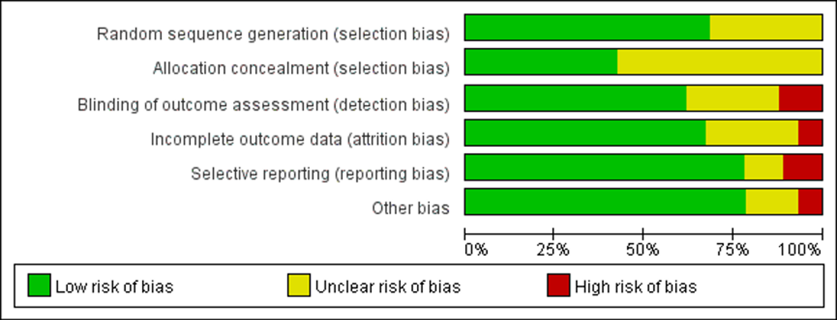
Appendix 7 Risk of bias
Figure 1 The overall risk of bias for all included studies

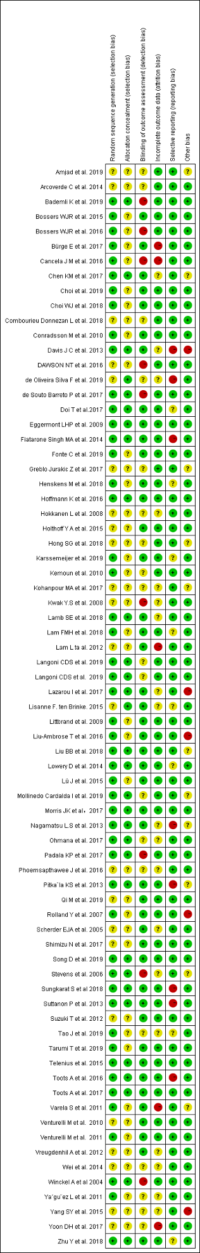
Figure 2 The risk of bias for each study
Table 5 Risk of bias assessment
Study | Random sequence generation | Allocation concealment | blinding of outcome assessors | incomplete outcome | selective outcome reporting, | other risks of bias.
Winckel A,et al 2004 | low | low | high | low | low | low
Scherder EJA,et al 2005 | unclear | unclear | low | unclear | low | low
Stevens et al 2006 | low | low | high | unclear | low | unclear
Rolland Y et al 2007 | low | unclear | low | low | low | high
Kwak Y.S et al 2008 | unclear | unclear | high | unclear | low | low
Hokkanen L et al 2008 | unclear | unclear | unclear | unclear | low | low
Eggermont LHP et al 2009 | low | low | low | low | low | low
Littbrand et al 2009 | low | unclear | low | low | low | low
Kemoun et al 2010 | low | unclear | unclear | low | low | low
Venturelli M et al 2010 | unclear | unclear | low | low | low | low
Conradsson M et al 2010 | low | unclear | low | low | low | low
Varela S et al 2011 | low | unclear | low | high | low | unclear
Venturelli M et al 2011 | low | unclear | low | low | low | low
Ya´gu¨ez L et al 2011 | low | unclear | unclear | unclear | low | low
Lam L ta al 2012 | unclear | unclear | low | high | low | low
Suzuki T et al 2012 | unclear | unclear | low | low | low | low
Vreugdenhil A et al 2012 | unclear | unclear | low | unclear | low | low
Nagamatsu L.S et al 2013 | low | low | low | unclear | high | unclear
Pitka¨la KS et al 2013 | low | low | low | low | high | unclear
Suttanon P et al 2013 | low | low | low | low | high | low
Davis J C et al 2013 | low | low | low | unclear | high | high
Arcoverde C et al 2014 | unclear | unclear | unclear | low | low | low
Fiatarone Singh MA et al,2014 | low | low | low | low | high | low
Lowery D et al, 2014 | low | low | low | low | unclear | low
Wei et al,2014 | unclear | unclear | unclear | unclear | low | low
Bossers WJR et al,2015 | low | unclear | low | low | low | low
Holthoff Y A et al,2015 | unclear | unclear | low | low | low | low
Lü J et al ,2015 | low | unclear | low | low | low | low
Telenius et al，2015 | low | low | low | low | low | low
Yang SY et al,2015 | unclear | unclear | unclear | unclear | low | high
Lisanne F. ten Brinke,2015 | unclear | low | low | unclear | unclear | low
Liu-Ambrose T et al，2016 | low | unclear | low | low | low | high
Phoemsapthawee J et al,2016 | unclear | unclear | unclear | unclear | low | low
Bossers WJR et al,2016 | low | unclear | high | low | low | low
Toots A et al,2016 | low | low | low | low | high | low
Cancela J M et al,2016 | low | unclear | high | high | low | low
DAWSON NT et al 2016 | unclear | unclear | high | low | low | low
Hoffmann K et al. 2016 | low | low | low | low | low | low
Morris JK et al，2017 | low | low | low | low | low | low
Bürge E et al, 2017 | low | unclear | low | high | low | low
Yoon DH, et al. 2017 | unclear | unclear | unclear | high | low | low
Doi T et al.2017 | low | low | low | low | unclear | low
Toots A et al. 2017 | low | low | low | low | low | low
Ohmana et al. 2017 | low | low | unclear | unclear | low | low
Shimizu N et al. 2017 | unclear | unclear | low | low | low | low
Greblo Jurakic Z, et al. 2017 | unclear | unclear | unclear | low | low | unclear
de Souto Barreto P et al. 2017 | low | low | high | low | low | low
Padala KP, et al. 2017 | low | low | high | low | low | low
Lazarou I et al. 2017 | low | low | low | unclear | low | high
Chen KM，et al 2017 | low | low | low | unclear | low | unclear
Kohanpour MA，et al 2017 | unclear | unclear | unclear | unclear | low | unclear
Lamb SE et al. 2018 | low | low | low | unclear | low | low
Liu BB et al. 2018 | low | low | low | low | low | unclear
Hong SG et al. 2018 | unclear | unclear | unclear | low | low | unclear
Zhu Y et al. 2018 | low | low | low | low | unclear | low
Lam FMH et al. 2018 | low | unclear | low | low | unclear | low
Combourieu Donnezan L，et al 2018 | unclear | unclear | unclear | low | low | low
Choi WJ, et al 2018 | low | unclear | low | low | low | low
Sungkarat S et al 2018 | low | low | low | low | high | low
Henskens M et al. 2018 | low | unclear | low | low | unclear | low
Qi M et al. 2019 | unclear | unclear | low | low | low | low
Fonte C et al. 2019 | low | unclear | low | low | low | low
Langoni CDS. Et al 2019 | low | low | unclear | low | low | low
Song D et al. 2019 | low | low | low | low | low | low
Bademli K et al. 2019 | low | low | high | low | low | low
Tarumi T et al. 2019 | low | unclear | low | low | low | low
Tao J. et al. 2019 | low | unclear | unclear | unclear | unclear | low
Langoni CDS et al 2019 | low | low | unclear | low | low | low
Mollinedo Cardalda I et al. 2019 | low | low | unclear | low | low | unclear
Choi et al. 2019 | low | unclear | low | low | low | low
Karssemeijer et al. 2019 | low | unclear | low | low | unclear | low
Amjad et al. 2019 | unclear | unclear | unclear | low | low | unclear
de Oliveira Silva F et al. 2019 | unclear | low | unclear | unclear | high | low
Total
Low n (%) | 50(68.5%） | 31(42.5%) | 45(61.6%) | 49(67.1%) | 57(78.1%) | 57(78.1%)
unclear n (%) | 23(31.5%) | 42(57.5%) | 19(26.0%) | 19(26.0%) | 8(11.0%) | 11(15.1%)
high n (%) | 0 | 0 | 9(12.3%) | 5(6.8%) | 8(11.0%) | 5(6.8%)

Appendix 8 the analysis for primary outcomes

8.1 Global cognition

8.1.1 pairwise analysis for global cognition
Figure 3 Forest plot of pairwise meta-analysis for global cognitive function
Note. B means aerobic exercise; C means resistance exercise; D means multicomponent exercise; E means mind-body exercise.

8.1.2 Network analysis for global cognition:

Global inconsistency test
χ² =6.09, p =0.637
No evidence for the existence of significant global inconsistency

Local inconsistency test
Figure 4 Loop-specific heterogeneity for global cognition
Note. A means non-exercise control; B means aerobic exercise; C means resistance exercise; D means multicomponent exercise; E means mind-body exercise

The contributions of direct and indirect estimates for the overall estimates of effect sizes
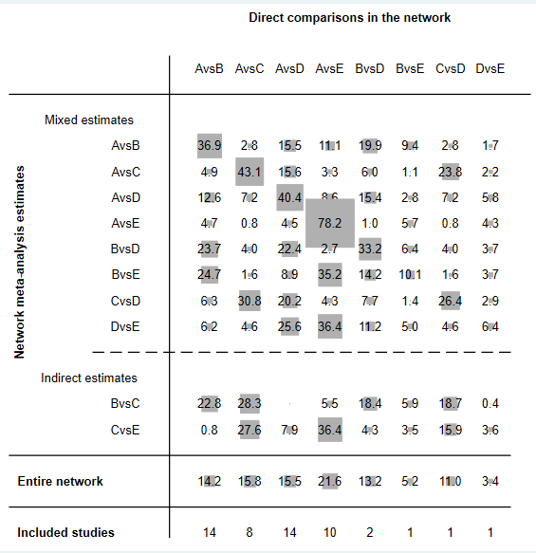
Figure 5 Contribution plot for global cognition
Note. A means non-exercise control; B means aerobic exercise; C means resistance exercise; D means multicomponent exercise; E means mind-body exercise

8.1.3 Subgroup analysis for global cognition in MCI group
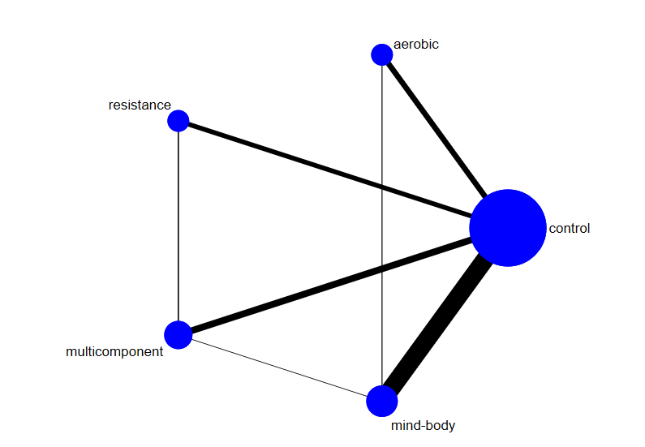
Figure 6 Network of eligible comparisons for global cognition in MCI group

Global inconsistency test in MCI group
χ² = 2.44, p = 0.785
No evidence for the existence of significant global inconsistency

Local inconsistency test
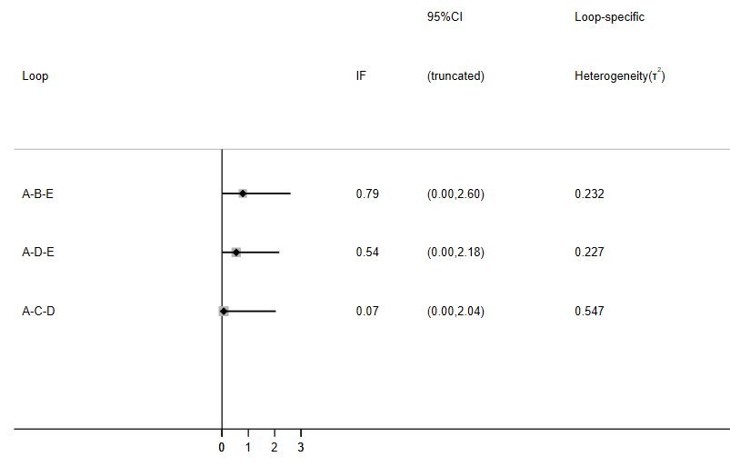
Figure 7 Loop-specific heterogeneity for Global cognitive function in MCI group
Note. A means non-exercise control; B means aerobic exercise; C means resistance exercise; D means multicomponent exercise; E means mind-body exercise

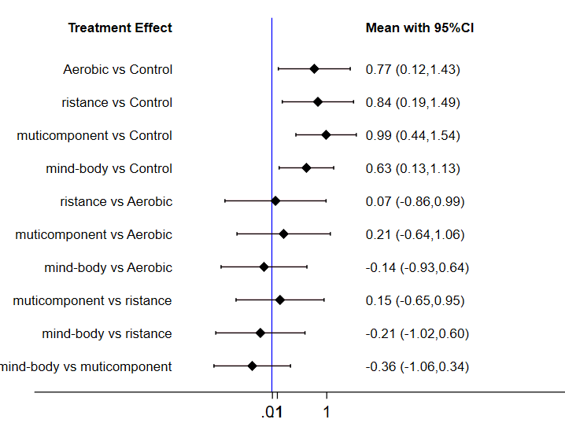
The comparisons for different kinds of exercise interventions and non-exercise control
Figure 8 Interval plot of network meta-analysis for global cognition in MCI group

The contributions of direct and indirect estimates for the network in MCI group
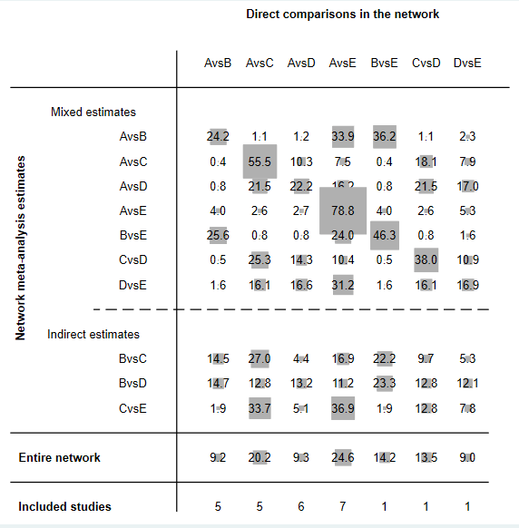
Figure 9 Contribution plot for global cognition in MCI group
Note. A means non-exercise control; B means aerobic exercise; C means resistance exercise; D means multicomponent exercise; E means mind-body exercise

The ranking of effects for global cognition in MCI group
Figure 10 Ranking plot for global cognition in MCI group

Table 6 The ranking of effects of different exercise on global cognition in MCI group
Treatment | SUCRA | Mean Rank | Probability of Best (%)
Multicomponent exercise | 79.1 | 1.8 | 46.4
Resistance exercise | 64.8 | 2.4 | 26.1
Aerobic exercise | 59.9 | 2.6 | 21.7
Mind-body exercise | 45.6 | 3.2 | 5.8
control | 0.6 | 5.0 | 0.0

8.1.4 Subgroup analysis for global cognition in dementia group
Global inconsistency test
χ² = 3.76
p = 0.289

Local inconsistency test
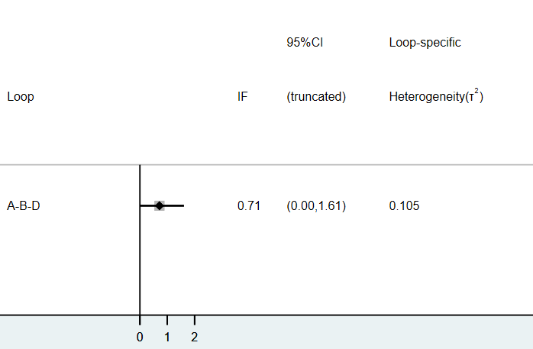
Figure 11 Local inconsistency for global cognition in dementia group

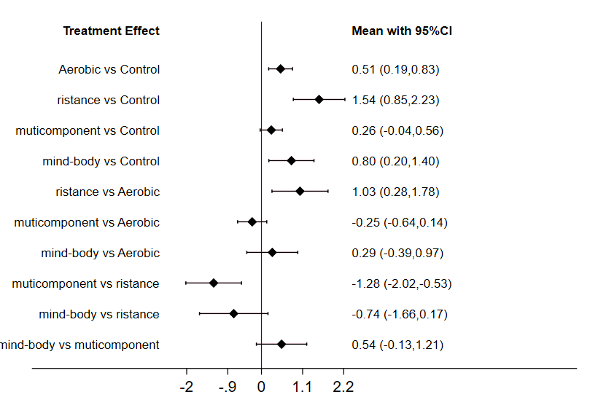
The comparisons for different kinds of exercise interventions and non-exercise control

Figure 12 Interval plot of network meta-analysis for global cognition in dementia group

The contributions of direct and indirect estimates for the network in dementia group
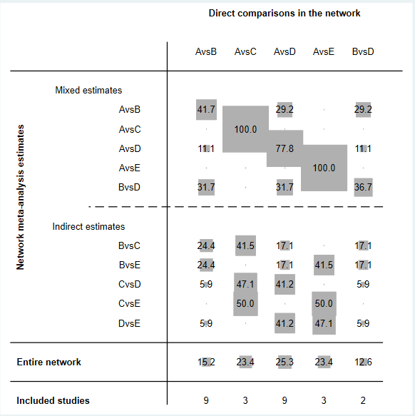

Figure 13 Contribution plot for global cognition in dementia group
Note. A means non-exercise control; B means aerobic exercise; C means resistance exercise; D means multicomponent exercise; E means mind-body exercise
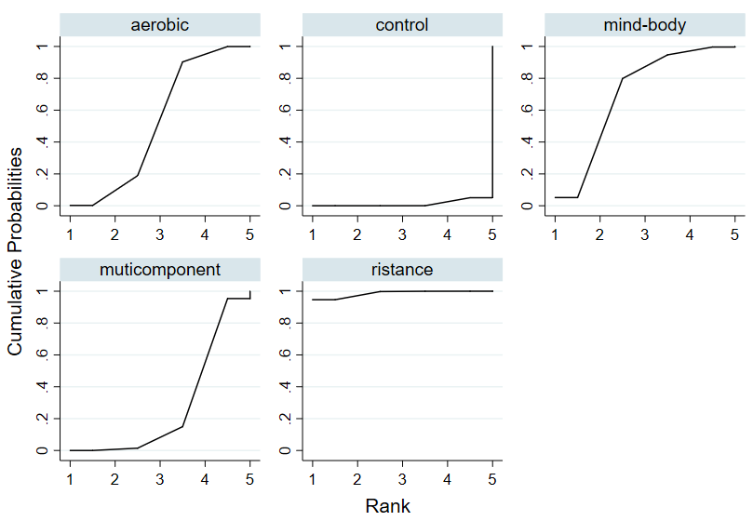
The ranking of effects for global cognition in dementia group

Figure 14 Cumulative ranking plot for global cognition in dementia group

Table 7 The ranking of effects of different exercise on global cognition in dementia group
Treatment | SUCRA | Mean Rank | Probability of Best (%)
Resistance exercise | 98.6 | 1.1 | 94.7
Mind-body exercise | 69.8 | 2.2 | 5.1
Aerobic exercise | 52.3 | 2.9 | 0.2
Multicomponent exercise | 28.0 | 3.9 | 0.0
Control | 1.3 | 4.9 | 0.0

8.1.5 The results of meta regression analysis
Table 8 the results of meta regression
Exercise types | Covariates | Coef. | p | 95% CI
Aerobic exercise | frequency | -0.58 | 0.38 | -1.98-0.82
Aerobic exercise | intensity | 0.44 | 0.50 | -0.94-1.82
Aerobic exercise | duration | -0.28 | 0.33 | -0.53-1.20
Aerobic exercise | length | 0.33 | 0.41 | -0.88-0.33
Resistance exercise | frequency | 0.80 | 0.40 | -1.55-3.14
Resistance exercise | intensity | -0.70 | 0.44 | -2.77-1.38
Resistance exercise | duration | 0.04 | 0.95 | -1.20-0.71
Resistance exercise | length | -0.25 | 0.51 | -1.70-1.62
Component exercise | frequency | 1.11 | 0.015 | 0.27-1.94
Component exercise | intensity | -0.33 | 0.29 | -0.99-0.33
Component exercise | duration | -0.51 | 0.035 | 0.07-1.55
Component exercise | length | 0.81 | 0.087 | -1.10-0.88

8.2 Executive function

8.2.1 Pairwise analysis for executive function
Figure 15 Forest plot of pairwise meta-analysis for executive function
Note. B means aerobic exercise; C means resistance exercise; D means multicomponent exercise; E means mind-body exercise; F means finger exercise

8.2.2 Network analysis for executive function
Global inconsistency test
χ² = 3.48
p = 0.747

Local inconsistency test
Figure 16 Local inconsistency for executive cognition
Note. A means non-exercise control; B means aerobic exercise; C means resistance exercise; D means multicomponent exercise; E means mind-body exercise; F means finger exercise

The contributions of direct and indirect estimates for the network
Figure 17 Contribution plot for executive cognition
Note. A means non-exercise control; B means aerobic exercise; C means resistance exercise; D means multicomponent exercise; E means mind-body exercise; F means finger exercise

8.2.3 Subgroup analysis for Executive function in MCI group
Figure 18 Network of eligible comparisons for executive cognition in MCI group

Global inconsistency test
χ² = 2.06
p = 0.724

Local inconsistency test

Figure 19 Local inconsistency in MCI group
Note. A means non-exercise control; B means aerobic exercise; C means resistance exercise; D means multicomponent exercise; E means mind-body exercise; F means finger exercise

The comparisons for different kinds of exercise interventions and non-exercise control

Figure 20 Interval plot of network meta-analysis for executive cognition in MCI group

The contributions of direct and indirect estimates for the network in MCI group

Figure 21 contribution plot for executive function in MCI group
Note. A means non-exercise control; B means aerobic exercise; C means resistance exercise; D means multicomponent exercise; E means mind-body exercise; F means finger exercise

Figure 22 Cumulative ranking plot for executive cognition in MCI group

Table 9 The ranking of effects of different exercise on executive cognition in MCI group
Treatment | SUCRA | Mean Rank | Probability of Best (%)
Multicomponent exercise | 73.4 | 2.3 | 33.4
Aerobic exercise | 65.4 | 2.7 | 16.7
Finger exercise | 64.0 | 2.8 | 38.4
Resistance exercise | 49.1 | 3.5 | 9.0
Mind-body exercise | 42.0 | 3.9 | 2.5
Control | 6.1 | 5.7 | 0.0

8.2.4 Subgroup analysis for executive function in dementia group
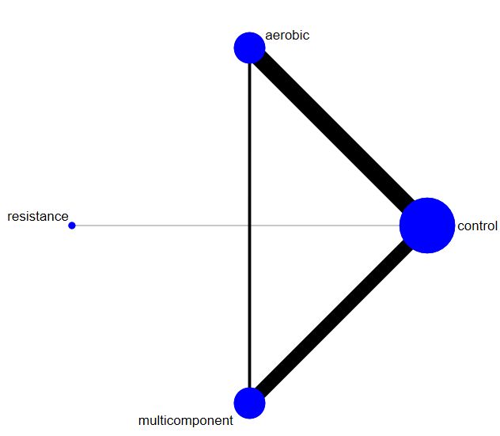

Figure 23 Network of eligible comparisons for executive cognition in dementia group

Global inconsistency test
χ² = 0.42
p = 0.811

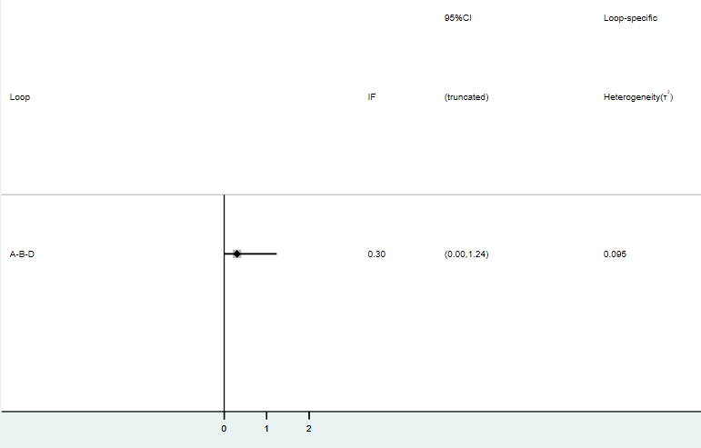
Local inconsistency test

Figure 24 Local inconsistency in dementia group
Note. A means non-exercise control; B means aerobic exercise group; D means multicomponent exercise group.

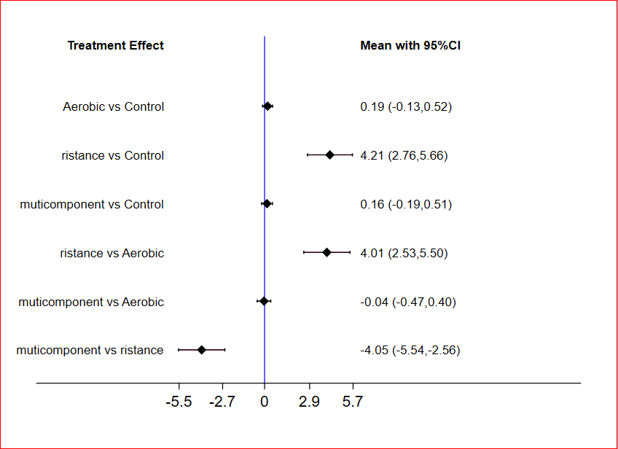
The comparisons for different kinds of exercise interventions and non-exercise control
Figure 25 Interval plot of network meta-analysis for executive function in dementia group

The contributions of direct and indirect estimates for the network in dementia group
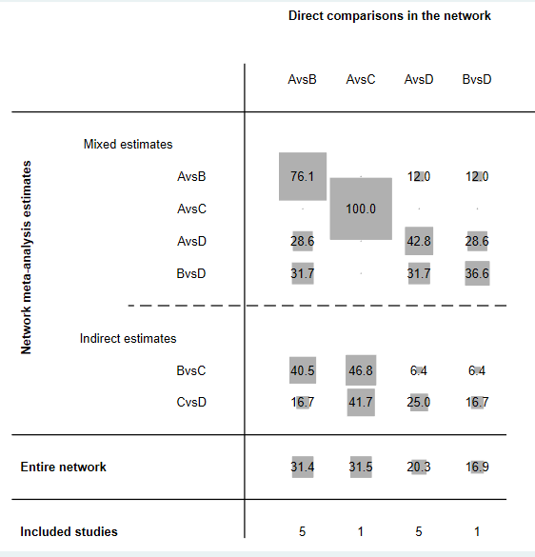
Figure 26 Contribution plot for executive function in dementia group
Note. A means non-exercise control; B means aerobic exercise group; C means resistance exercise group; D means multicomponent exercise group.

8.3 Memory function

8.3.1 Pairwise analysis for memory function
Figure 27 Forest plot of pairwise analysis for memory function
Note. B means aerobic exercise; C means resistance exercise; D means multicomponent exercise; E means mind-body exercise; F means finger exercise

8.3.2 Network analysis for memory function:

Global inconsistency test
χ² = 3.28
p = 0.773

Local inconsistency test
Figure 28 Local inconsistency for memory function
Note. A means non-exercise control; B means aerobic exercise; C means resistance exercise; D means multicomponent exercise; E means mind-body exercise; F means finger exercise

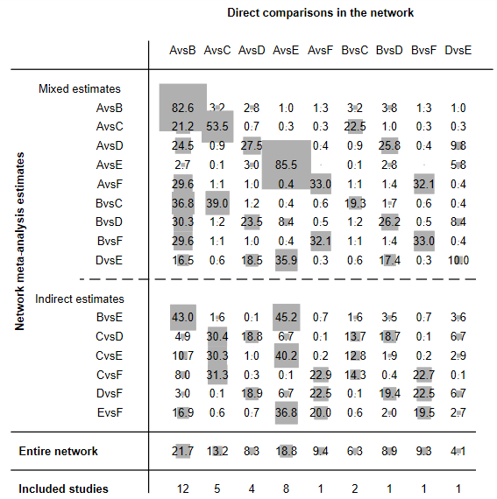
The contributions of direct and indirect estimates for the network
Figure 29 Contribution plot for memory cognition
Note. A means non-exercise control; B means aerobic exercise; C means resistance exercise; D means multicomponent exercise; E means mind-body exercise; F means finger exercise

8.3.3 subgroup analysis for memory function in MCI group
Figure 30 Network of eligible comparisons for memory cognition in MCI group

Global inconsistency test
χ² = 1.15
p = 0.886

Local inconsistency test
Figure 31 Local inconsistency for memory function in MCI group
Note. A means non-exercise control; B means aerobic exercise; C means resistance exercise; D means multicomponent exercise; E means mind-body exercise; F means finger exercise

The comparisons for different kinds of exercise interventions and non-exercise control
Figure 32 Interval plot of network meta-analysis for memory function in MCI group

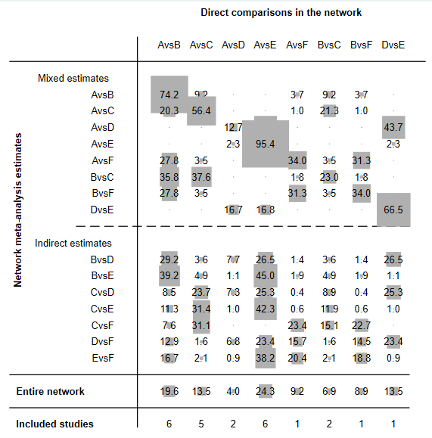
The contributions of direct and indirect estimates for the network in MCI group
Figure 33 contribution plot for memory cognition in MCI group
Note A means non-exercise control; B means aerobic exercise; C means multicomponent exercise; D means mind-body exercise; E means mind-body exercise; F means finger exercise

8.3.4 subgroup analysis for memory function in dementia group

Figure 34 Network of eligible comparisons for memory cognition in dementia group

dementia memory
Global inconsistency test
χ² = 5.65
p = 0.059

Local inconsistency test
Figure 35 Local inconsistency for memory function in dementia group
Note A means non-exercise control; B means aerobic exercise; C means multicomponent exercise;

The comparisons for different kinds of exercise interventions and non-exercise control
Figure 36 Interval plot of network meta-analysis for memory function in dementia group

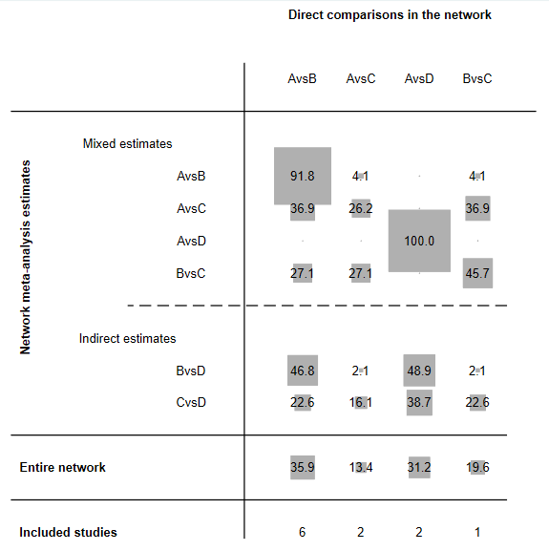
The contributions of direct and indirect estimates for the network in dementia group
Figure 37 Contribution plot for memory cognition in dementia group
Note A means non-exercise control; B means aerobic exercise; C means multicomponent exercise; D means mind-body exercise

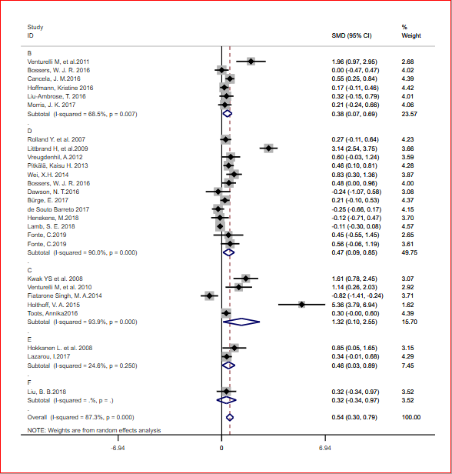
Appendix 9 Results for secondary analysis
Figure 38 Forest plot of pairwise analysis for ADLs
Note B means aerobic exercise; C means resistance exercise; D means multicomponent exercise; E means mind-body exercise; F means finger exercise.

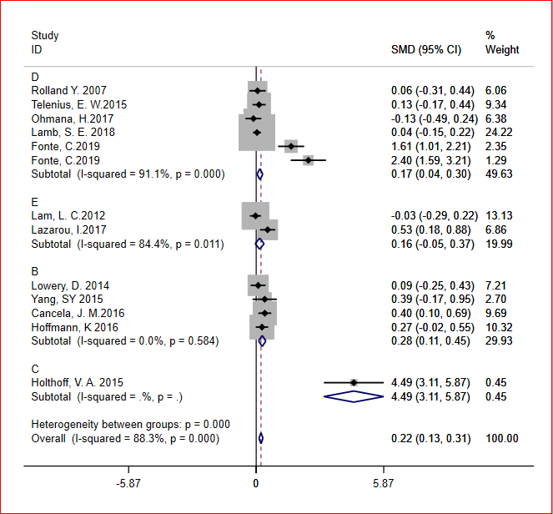
Figure 39 Forest plot of pairwise analysis for NPI
Note B means aerobic exercise; C means resistance exercise; D means multicomponent exercise; E means mind-body exercise.

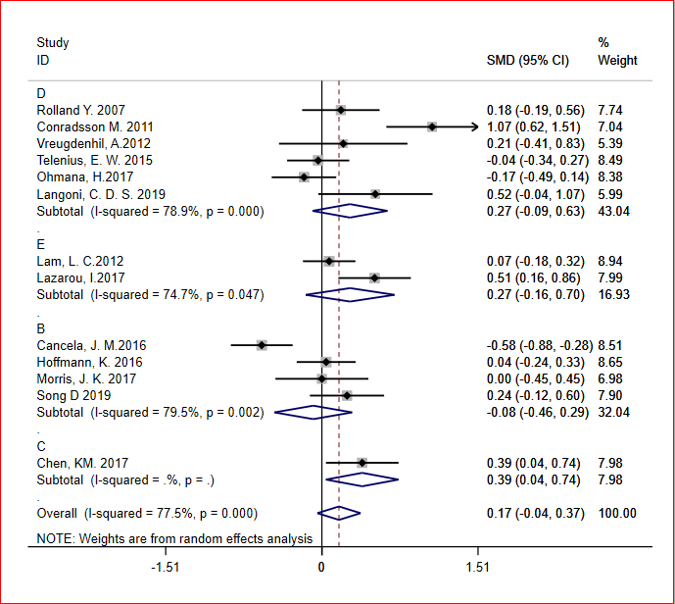
Figure 40 Forest plot of pairwise analysis for depressive symptoms
Note B means aerobic exercise; C means resistance exercise; D means multicomponent exercise; E means mind-body exercise

Figure 41 Forest plot of pairwise analysis for QoL
Note B means aerobic exercise; C means multicomponent exercise.

Jarstad, E., & Mamen, A. (2019). The performance and aerobic endurance effects of high-intensity versus moderate-intensity continuous running. Appl Physiol Nutr Metab, 44(9), 990-996. doi:10.1139/apnm-2018-0575
Morris, J. K., Vidoni, E. D., Johnson, D. K., Van Sciver, A., Mahnken, J. D., Honea, R. A., . . . Burns, J. M. (2017). Aerobic exercise for Alzheimer's disease: A randomized controlled pilot trial. PLoS One, 12(2), e0170547. doi:10.1371/journal.pone.0170547
Ramirez-Velez, R., Tordecilla-Sanders, A., Tellez, T. L., Camelo-Prieto, D., Hernandez-Quinonez, P. A., Correa-Bautista, J. E., . . . Izquierdo, M. (2017). Effect of Moderate Versus High-Intensity Interval Exercise Training on Heart Rate Variability Parameters in Inactive Latin-American Adults: A Randomised Clinical Trial. J Strength Cond Res. doi:10.1519/JSC.0000000000001833
Zhou, Y., Lu, Y., Jin, X., Liu, J., Finlayson, G., & Zhou, C. (2019). Effects of moderate- and high-intensity acute aerobic exercise on food reward and appetite in individuals with methamphetamine dependence. Physiol Behav, 211, 112649. doi:10.1016/j.physbeh.2019.112649

