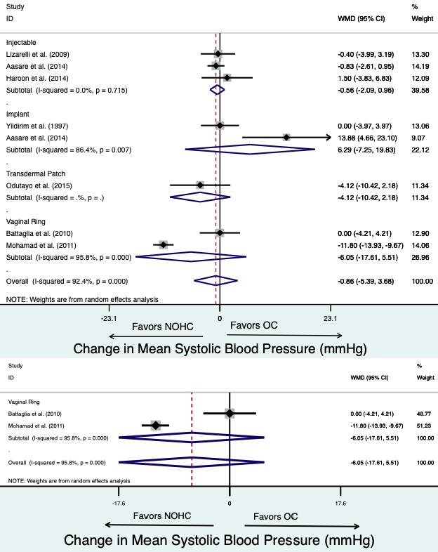A

B

Figure 2. Forest plot of weighted mean difference (WMD) of the systolic blood pressure between non-oral hormonal contraceptives (NOHC) compared to oral contraceptive users in (A) observational studies and (B) randomized controlled trials. The study specific WMD is denoted by black diamonds and the black lines indicate the 95% CI. The combined WMD by NOHC type and overall is represented by a blue diamond,
the diamond width indicates the 95% CI.

