SUPPLEMENTARY MATERIALS

Boolean Search String:
(((PSMA-11) OR (PSMA-I&T) OR (THP-PSMA) OR (PSMA-HBEDD)) AND (PSMA-1007)) OR (((PSMA-11) OR (PSMA-I&T) OR (THP-PSMA) OR (PSMA-HBEDD)) AND (DCPFyl)) OR (((PSMA-11) OR (PSMA-I&T) OR (THP-PSMA) OR (PSMA-HBEDD)) AND (JK-PSMA-7)) OR (((PSMA-11) OR (PSMA-I&T) OR (THP-PSMA) OR (PSMA-HBEDD)) AND ((Fluclovine) OR (Fluorocholine) OR (FECH) OR (Fluciclovine) OR (FABC) OR (Choline) OR (Choline))) OR (((PSMA-11) OR (PSMA-I&T) OR (THP-PSMA) OR (PSMA-HBEDD)) AND (Choline)) OR (((PSMA-11) OR (PSMA-I&T) OR (THP-PSMA) OR (PSMA-HBEDD)) AND (RM2)) OR ((PSMA-1007) AND (DCPFyl)) OR ((PSMA-1007) AND (JK-PSMA-7)) OR ((PSMA-1007) AND ((Fluclovine) OR (Fluorocholine) OR (FECH) OR (Fluciclovine) OR (FABC) OR (Choline) OR (Choline))) OR ((PSMA-1007) AND (Choline)) OR ((PSMA-1007) AND (RM2)) OR ((DCPFyl) AND (JK-PSMA-7)) OR ((DCPFyl) AND ((Fluclovine) OR (Fluorocholine) OR (FECH) OR (Fluciclovine) OR (FABC) OR (Choline) OR (Choline))) OR ((DCPFyl) AND (Choline)) OR ((DCPFyl) AND (RM2)) OR ((JK-PSMA-7) AND ((Fluclovine) OR (Fluorocholine) OR (FECH) OR (Fluciclovine) OR (FABC) OR (Choline) OR (Choline))) OR ((JK-PSMA-7) AND ((Fluclovine) OR (Choline)) OR ((JK-PSMA-7) AND (RM2)) OR (((Fluclovine) OR (Fluorocholine) OR (FECH) OR (Fluciclovine) OR (FABC) OR (Choline)) AND (RM2)) OR (((Fluclovine) OR (Fluorocholine) OR (FECH) OR (Fluciclovine) OR (FABC) OR (Choline)) and (Choline)) OR ((Choline)) AND (RM2))

QUADAS-2 tool:
 | Risk Of BIAS |  |  |  | Risk of APPLICABILITY
Study | PATIENT SELECTION | INDEX TEST | REFERENCE STANDARD | FLOW AND TIMING | PATIENT SELECTION | INDEX TEST | REFERENCE STANDARD
Cantiello 2018 | Unclear | High | High | Unclear | Low | Low | Low
Dietlein 2015 | High | High | High | Unclear | Low | Low | Low
Pernthaler 2019 | Unclear | Unclear | Unclear | Unclear | Low | Low | Low
Witkowska 2019 | Unclear | High | High | Unclear | Low | Low | Low
Morigi 2015 | Unclear | High | High | Unclear | Low | Low | Low
Afshar-Oromieh 2014 | High | Low | Unclear | Unclear | Low | Low | Low
Calais 2019 | Low | Low | Low | Low | Low | Low | Low
Schwenck 2017 | Unclear | High | High | Unclear | Low | Low | Low
Emmett 2019 | Low | Low | Low | Low | Low | Low | Low
Nanni 2015 | Low | Low | Low | Unclear | Low | Low | Low
Nanni 2016 | Low | Low | Low | Unclear | Low | Low | Low
Bluemel 2017 | Unclear | High | High | High | Unclear | Unclear | Low

Table S1: Risk of bias by domain as judged according to QUADAS-2 criteria.

Radiotracer | SUCRA
18F-PSMA-1007 | 0.9997
68Ga-PSMA-11 | 0.7385
18F-DCFPyl | 0.6607
64Cu-PSMA-617 | 0.5626
18F-Fluciclovine | 0.4242
68Ga-PSMA-I&T | 0.3303
11C-Choline | 0.2518
18F-FCH | 0.03219

Table S2: SUCRA values

Convergence for the random effects informative model:

Fig S1: Convergence for the random effects (informative) model using the Brooks-Gelman-Rubin method.

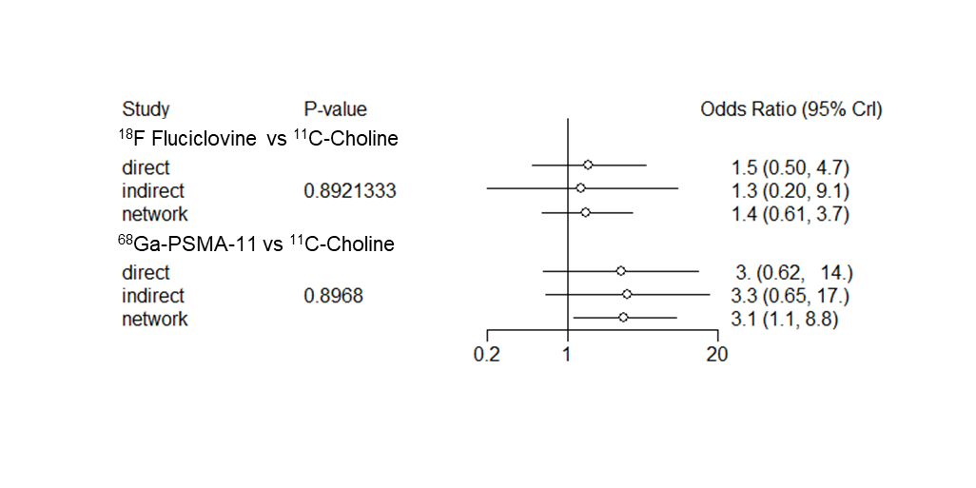
Fig S2: Split forest node. Using a closed loop within the network, direct and indirect evidence can be compared as a means of assessing confidence in the network results. Comparing results from the NMA with and without the direct evidence for each of the edges reveals no evidence of statistical inconsistency in any of the investigated contrasts

