APPENDIX (SUPPLEMENTARY MATERIAL)

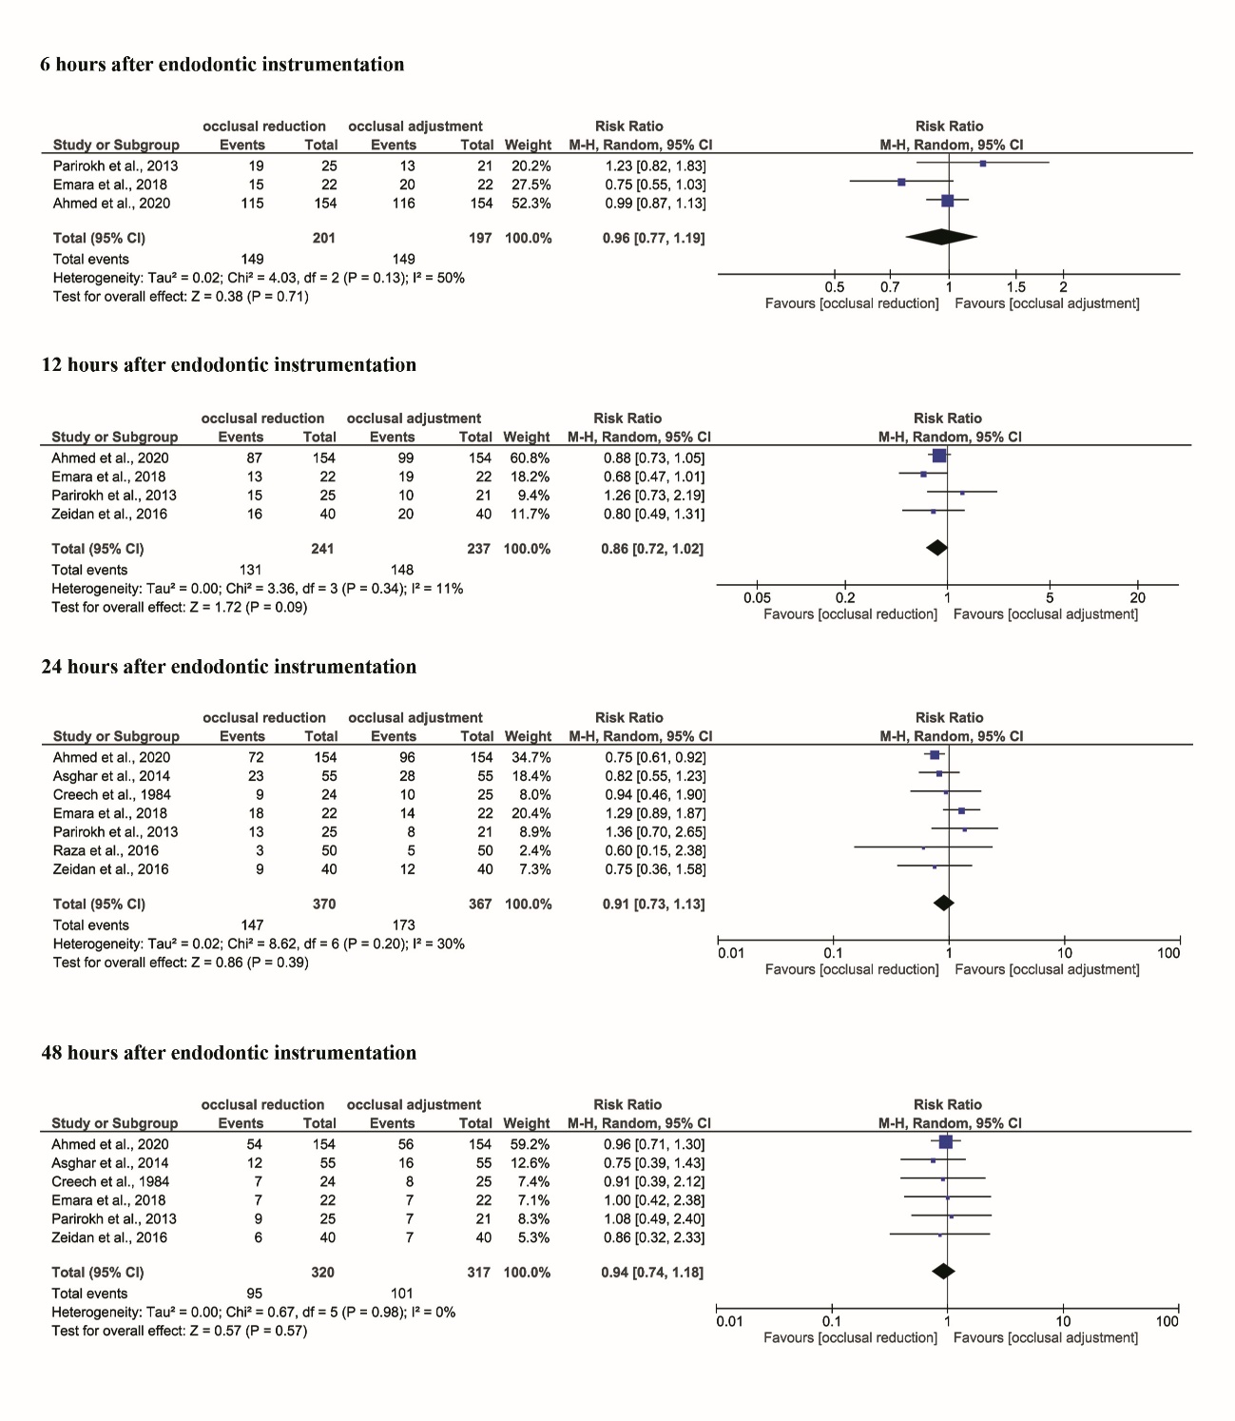
Image 1. Forest plots of comparison were constructed for 6, 12, 24 and 48 hours after endodontic instrumentation.

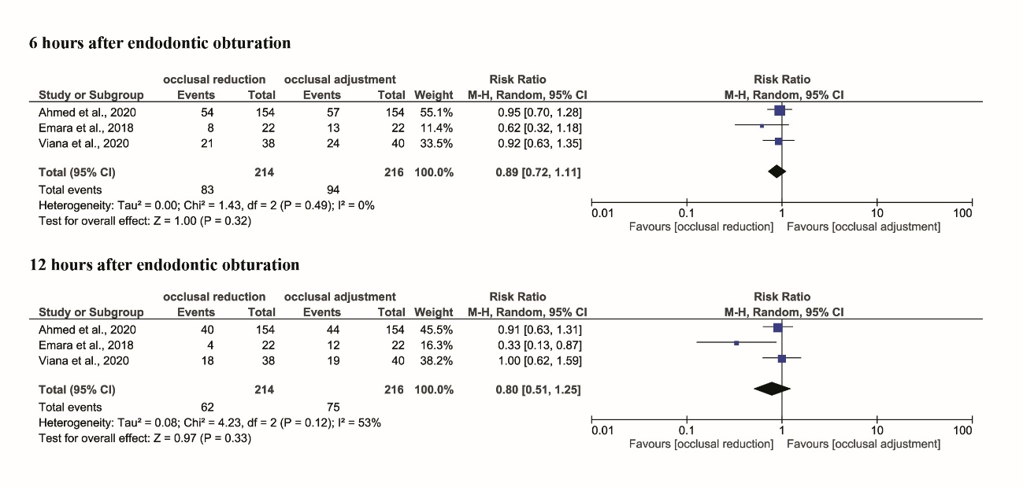
Image 2. Forest plots of comparison were constructed for 6 and 12 hours after endodontic obturation.

