Supplementary Figures

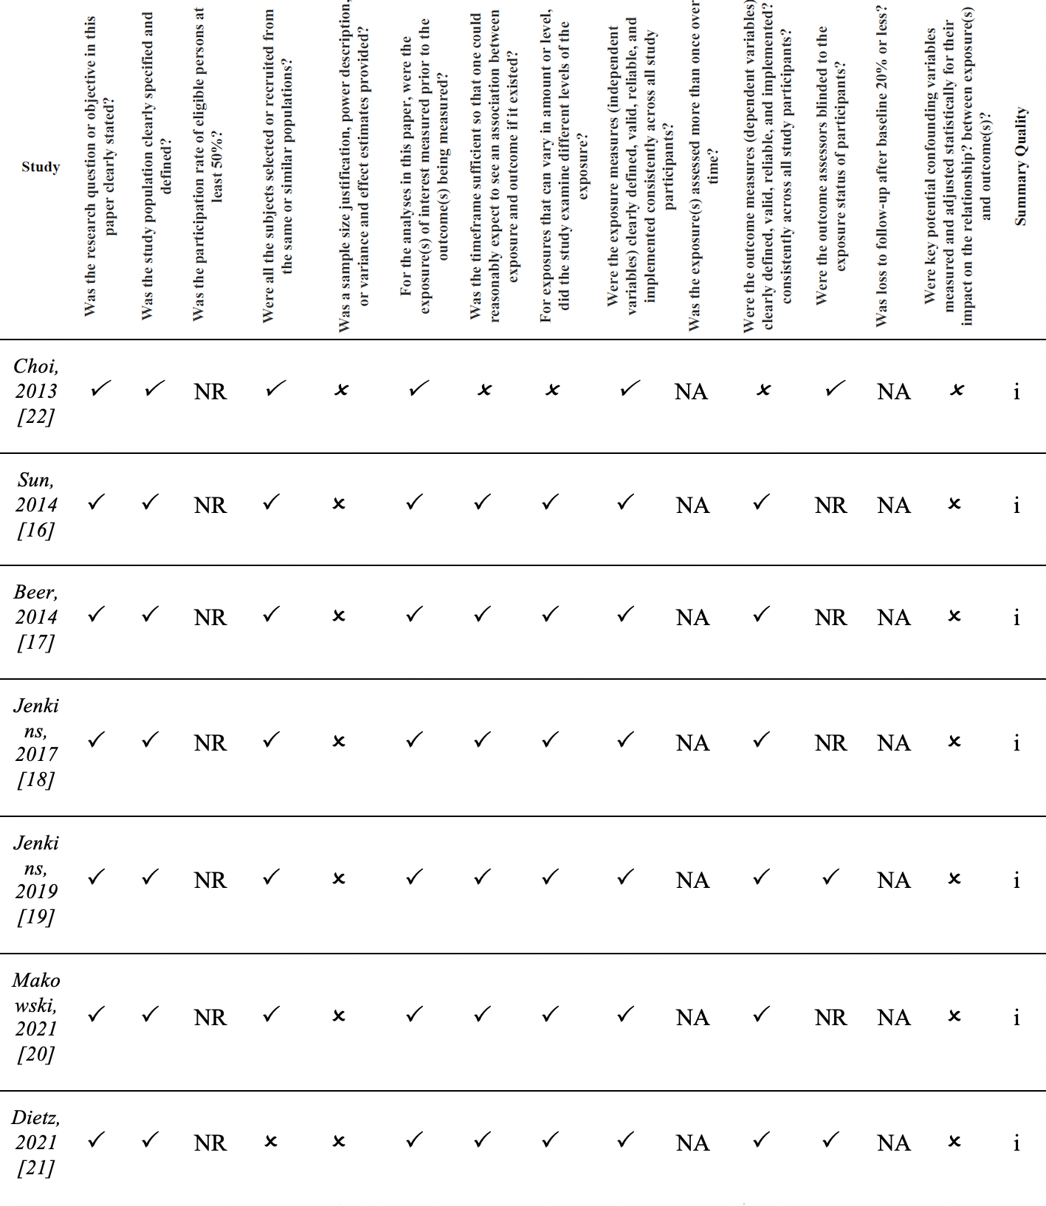
Supplementary Figure 1. NIH quality assessment tool. Quality was rated as 0 for poor (0–4 out of 14 questions), i for fair (5–10 out of 14 questions), or ii for good (11–14 out of 14 questions); NA: not applicable, NR: not reported.

