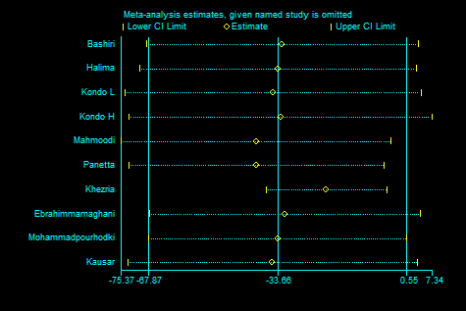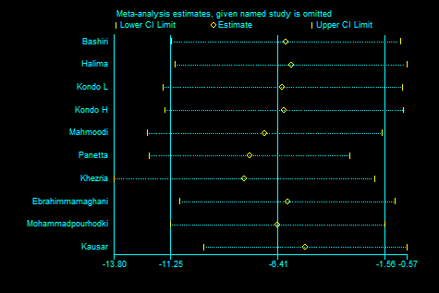
A) TG B) TC
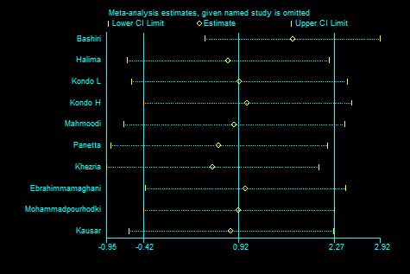
C) HDL-C D) LDL-C
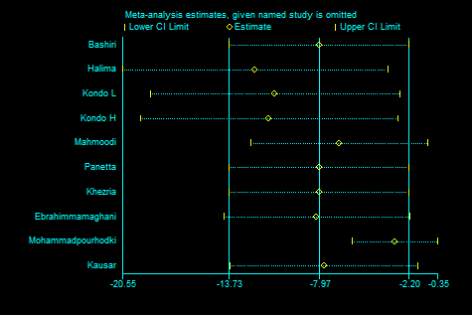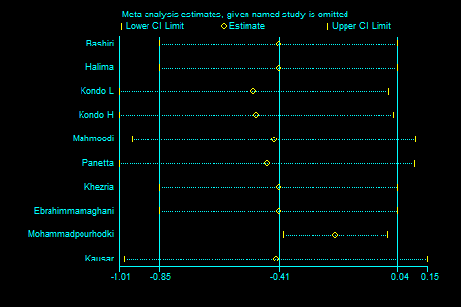
E) FBS F) HbA1C
Supplemental Figure 1. Sensitivity analysis. Abbreviations: TG: Triacylglycerol; TC: Total-Cholesterol; LDL-C: Low-density Lipoprotein Cholesterol; HDL-C: High-density Lipoprotein Cholesterol; FBS: Fasting Blood Glucose.

