Takotsubo syndrome and respiratory diseases: A systematic review

Pengyang Li¹ Yanxuan Wang² Jing Liang² Xinyu Zuo² Qiuyue Li² Akil Adrian Sherif³ Jingyi Zhang² Yidan Xu² Zirui Huang² Man Dong⁴ Catherine Teng⁵ Su Pan⁶ Richard A. F. Dixon⁶ Xin Wei¹ Lingling Wu⁷ Chengyue Jin⁸ Peng Cai⁹ Qiying Dai³ Jianjun Ma^{2*} Qi Liu^{6*}

*Corresponding authors. Qi Liu, Texas Heart Institute, 6770 Bertner Avenue, MC 2-255, Houston, Texas, 77030. Email: qliu@texasheart.org. Jianjun Ma, Xinxiang Medical University, Henan, China. E-mail:1065617920@qq.com
Figure S1. Flow diagram showing the selection process for cases of TTS with COPD

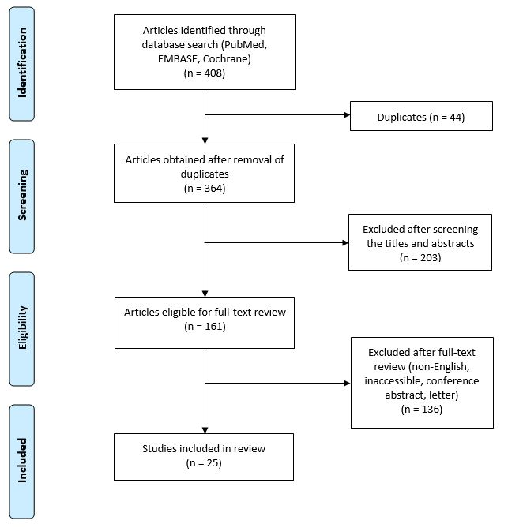
Figure S2. Flow diagram showing the selection process for cases of TTS with asthma.
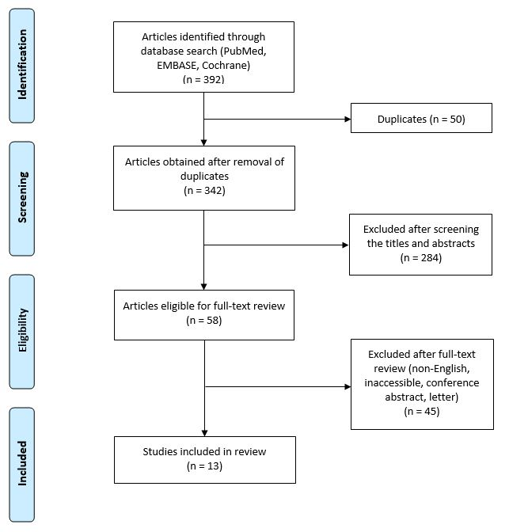
Figure S3. Flow diagram showing the selection process for cases of TTS with pneumonia.
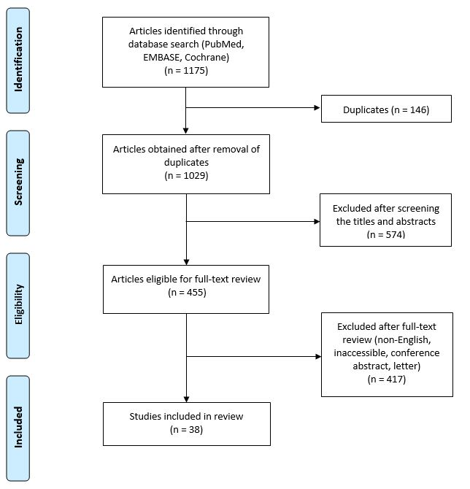
Figure S4. Flow diagram showing the selection process for cases of TTS with lung cancer.
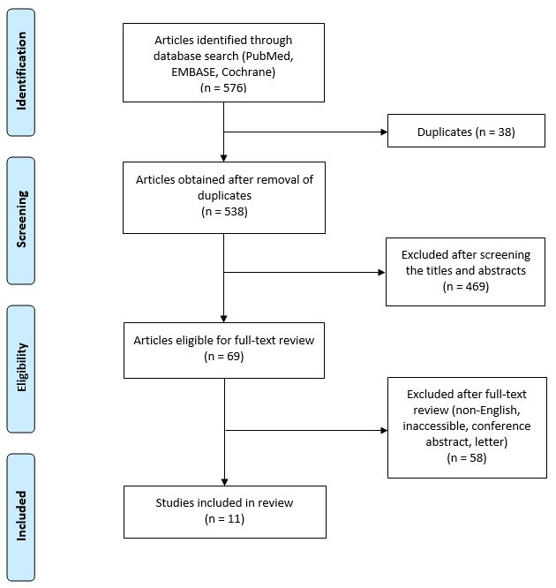
Figure S5. Flow diagram showing the selection process for cases of TTS with PE.
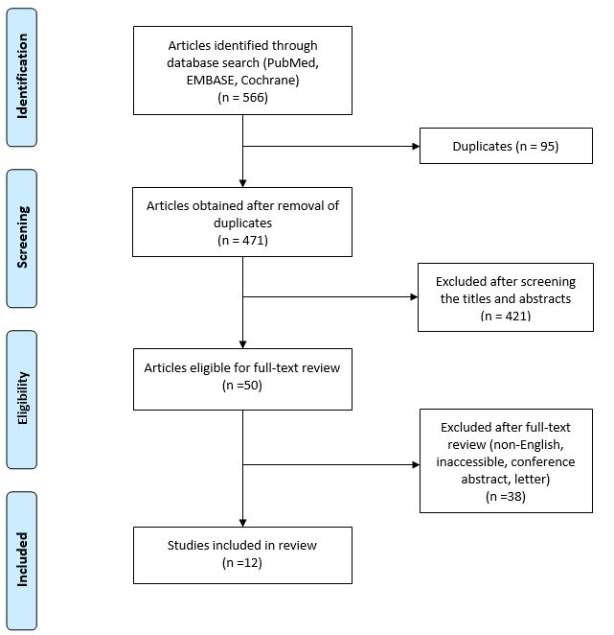
Table S1. Case report review of patients with COPD and TTS
Year | Gender | Age | Medical history | Presentation | ECG | Left ventriculogram/TTE | LVEF | Triggering factor | Outcome | Reference
2005 | Female | 80 | NA | Angina pectoris | ST-elevation in II, aVL, and V1-V5 | Apical ballooning | NA | COPD exacerbation | Favorable | S1
2006 | Female | 63 | NA | Dyspnea | Sinus tachycardia, diffuse T-wave inversion | Midventricular lateral and basal wall dyskinesis and apical hypercontractility | 31% | COPD exacerbation | Favorable | S2
2009 | Female | 57 | COPD, pulmonary hypertension, anemia | Dyspnea | Diffuse ST-T wave abnormalities | Severe hypokinesis in the mid and apical segments of the left ventricle | 10% | COPD exacerbation | Favorable | S3
2009 | Female | 57 | COPD | Dyspnea | ST-elevation in V1 and V2, T-wave inversion in all precordial leads | LV systolic function was severely reduced | 10% to 15% | COPD exacerbation | Favorable | S4
2009 | Female | 59 | Smoker, hyperthyroidism, Graves-Basedow disease, COPD | Dyspnea | Ventricular ectopic beats, small ST-elevation in V4-V6 | Akinesis of the apical and mid ventricular segments, hyperkinesis in parabasal segments | 35% | NA | Favorable | S5
2010 | Female | 64 | Hypertension, DM, severe COPD | Dyspnea | Diffuse T-wave inversion in the precordial leads | Apical and mid segment hypokinesis | 25% | COPD exacerbation | Favorable | S6
2011 | Female | 66 | Peripheral arterial disease, COPD | First attack:  dyspnea, productive cough | Slight ST-elevation in the anterior leads and T-wave inversion | Moderately depressed systolic function with hypokinesia of the anterior and basal segments sparing the apex of the heart | NA | COPD exacerbation | Recurrence | S7
2011 | Male | 52 | COPD | Dyspnea | Sinus tachycardia and T wave inversions in anterior leads | Midanterior and apical segment hypokinesis with a hypercontractile base | 25% | COPD exacerbation, social stress | Favorable | S8
2012 | Female | 63 | Smoker, COPD | Dyspnea, wheeze | Inferolateral ST-elevation, which evolved into widespread deep T-wave inversion and QT prolongation | Apical hypokinesis | NA | COPD exacerbation | Favorable | S9
2012 | Male | 59 | Ex-smoker, COPD | Dyspnea, wheeze, tachypneic, drowsy | Sinus tachycardia | Akinesis of the midinferior and midanterolateral LV walls and increased contraction of the basal segments | NA | COPD exacerbation | Favorable | S9
2013 | Female | 82 | Hypertension, DM, obesity, psoriasis, COPD | Dyspnea, lower-limb edema, weariness, chest pain | Diffuse ST-elevation in both anterior and inferior leads with concomitant ST-depression in aVR and V1 | LV systolic dysfunction, apical ballooning, systolic anterior motion of mitral leaflet, mild mitral regurgitation, LV outflow tract obstruction | 38% | COPD exacerbation | Favorable | S10
2014 | Male | 64 | NA | NA | ST-elevation in V1-V3, I, aVL;  ST depression in the inferior leads | Hypokinetic-akinetic mid apical segments with severe systolic dysfunction | NA | COPD exacerbation | Favorable | S11
2014 | Male | 56 | COPD | Dyspnea, cough with sputum, fever | Sinus tachycardia, incomplete right bundle branch block, ST-elevation in V1-V3, Q-wave in V3-V6, T-wave inversion in precordial leads | Compromise of LV systolic function, with akinesia of the mid apical segments and an aneurysm-like dilatation | 27% | Emotional stress, ipratropium administration | Favorable | S12
2014 | Female | 72 | COPD | Dyspnea, angina pectoris | Progressive loss of R wave amplitude in precordial leads | Akinesia of the apical region of LV, reduced  LV function | 42% | COPD exacerbation | Favorable | S13
2015 | Female | 49 | COPD | Dyspnea, productive cough | Sinus tachycardia, ST-elevation, diffuse T-wave inversion, QT-interval prolongation | Akinesis of apical and anterolateral walls | 25% to 30% | COPD exacerbation, ipratropium bromide, β2 agonist, and aminophylline administration | Favorable | S14
2015 | Female | 80 | Ex-smoker | Syncope, dyspnea, wheeze | ST-elevation, T-wave inversion, QTc-interval prolongation, Q-wave | Apical regional wall motion abnormalities | NA | COPD exacerbation, β2 agonist, corticosteroids administration | Favorable | S15
2015 | Female | 55 | Smoker | Dyspnea, wheeze | ST-elevation, T-wave inversion, QTc-interval prolongation | Apical and mid regional wall motion abnormalities | NA | COPD exacerbation, β2 agonist, corticosteroids administration | Favorable | S15
2015 | Female | 65 | Ex-smoker | Dyspnea, wheeze | Minimal ST elevation, T-wave inversion, QTc-interval prolongation, Q-wave | Apical and mid regional wall motion abnormalities | NA | COPD exacerbation, β2 agonist, corticosteroids, anticholinergic agent administration | Recurrence | S15
2015 | Female | 77 | NA | Dyspnea, wheeze | ST elevation, T-wave inversion, QTc-interval prolongation | Apical and mid regional wall motion abnormalities | NA | COPD exacerbation, β2 agonist, corticosteroids, anticholinergic agent, theophylline administration | Favorable | S15
2015 | Female | 71 | Smoker | Dyspnea, wheeze | ST elevation, Q-wave | Apical and mid regional wall motion abnormalities | NA | COPD exacerbation, β2 agonist, corticosteroids, anticholinergic agent administration | Favorable | S15
2016 | Female | 62 | COPD, hypertension, hypothyroidism, smoker | Dyspnea, fever, tachypneic, hypoxemic, wheeze | Sinus tachycardia, atrial fibrillation with rapid ventricular response | Apical ballooning during systole and mildly reduced LV function | 45% | COPD exacerbation β2 agonist, ipratropium bromide and corticosteroids administration | Favorable | S16
2017 | Female | 71 | NA | Dyspnea, chest pain | Diffuse ST-elevation, diffuse T-wave inversion, particularly prominent in V3-V5 | Akinesia of the apical segments, a hypercontractile base | NA | COPD exacerbation | Favorable | S17
2017 | Female | 51 | Smoker, COPD, prior alcohol use | Syncope, dyspnea | First attack: NA  Recurrence:  Sinus tachycardia, PR-depression in II, III, aVF, Q-wave in V1-V3 without subsequent dynamic changes, repolarization abnormalities in inferior leads | First attack: Apical ballooning of the left ventricle  Recurrence:severely reduced LV systolic function, severe diffuse LV hypokinesis | 22% | COPD exacerbation | Recurrence | S18
2018 | Female | 60 | COPD, hypothyroidism, rheumatoid arthritis, depression, hypertension | Dyspnea, cough, fever | ST-depression in V2 and V3 | Depressed systolic function and akinesis in the mid and basal segments | NA | β2 agonist administration | Favorable | S19
2018 | Female | 67 | NA | Dyspnea | Deep T-wave inversion, QTc interval prolongation | Akinesis of the mid walls but preserved contractility of the basal and apical wall segments | 40% to 45% | COPD exacerbation | Recurrence | S20
2019 | Female | 63 | Coronary artery disease, smoker, subarachnoid hemorrhage, COPD | Dyspnea, productive cough | Sinus tachycardia, ST-elevation in V3-V6, low voltage QRS complexes | Hyperkinetic basal segments and akinesis of the apex and periapical segments | NA | COPD exacerbation | Favorable ª | S21
2019 | Male | 52 | COPD, biventricular TCM, smoker, daily alcohol use | Dyspnea, wheeze, drowsy | Broad-complex tachycardia with right bundle branch block, left-axis deviation, sinus rhythm with anterior Q-waves | Systolic dysfunction, preserved basal posterior, lateral, anterior-septal, and infero-septal contractility with apical ballooning | 28% | Recurrent exacerbation of COPD, smoking, alcohol, marijuana, cocaine | Favorable ^{b} | S22
2019 | Female | 70 | Smoker, bipolar disorder, endometrial cancer, stroke, hypothyroidism, fibromyalgia | First attack:  dyspnea;  32 months after FMC:  exhaustion, dyspnea, leg swelling;  40 months after FMC:  dyspnea, cough;  46 months after FMC:  dyspnea | First attack:  T-wave inversion in several leads;  32 months after FMC:  T-wave inversion in several leads without QT interval prolongation;  40 months after FMC:  T-wave inversion;  46 months after FMC:  T-wave inversion in AVL and I | First attack: normal;  32 months after FMC:  severe LV hypokinesia, most prominent in the inferolateral wall and the septum. Subsequent analysis revealed severe midventricular hypokinesia instead of inferolateral; 40 months after FMC:  severe LV hypokinesia in apical and mid ventricular segments;  46 months after FMC:  severe generalized LV hypokinesia with midventricular akinesia | First attack:60%;  32 months after FMC:  30%;  40 months after FMC:  20%;  46 months after FMC:  <20% | COPD exacerbation, psychiatric disease, emotional stress | Recurrence | S23
2020 | Male | 84 | Smoker, hypertension, atherosclerosis, chronic kidney disease | Sustained angina | ST-depression with negative T-wave in II, III, aVF, V4-V6 | Apical akinesis and hypokinesis of the apical and mid LV segments | 40% | COPD exacerbation | Favorable | S24
2020 | Male | 85 | COPD, Type II DM | Productive cough, dyspnea | Anterior ST-elevation | Akinesia of all 5 apical segments of the left ventricle with hyperdynamic contractility of the basal and mid ventricular segments | NA | COPD exacerbation | Death | S25
ª This patient was discharged home but died due to worsened pulmonary disease.
^{b} Three days after being discharged home, this patient was found deceased at home.
Abbreviations: COPD, chronic obstructive pulmonary disease; DM, diabetes mellitus; ECG, electrocardiogram; FMC, first medical contact; LV, left ventricular; LVEF, left ventricular ejection fraction; NA, not available; TTE, transthoracic echocardiogram; TTS, takotsubo syndrome.
Table S2. Case report review of patients with asthma and TTS
Year | Gender | Age | Medical history | Presentation | ECG | Left ventriculogram/TTE | LVEF | Triggering factor | Outcome | Reference
2006 | Female | 64 | Asthma | Exertional dyspnea | ST elevation and Q waves in V2-V6, I, II, and aVF | Diffuse akinesis with normokinesis only of the basal regions | 35% | Dopamine and corticosteroids administration | Favorable | S26
2009 | Female | 46 | Asthma | Dyspnea, nausea, vomiting | ST elevation in the inferior and lateral leads | LV wall abnormalities with anteroapical akinesis to dyskinesis, proximal basal septal hyperkinesis | 10% | Epinephrine and ketamine administration | Favorable | S27
2010 | Female | 66 | Hypertension, breast cancer, PE, long history of heavy tobacco abuse, COPD | Chest pain | Abnormal Q-waves and ST elevation in V1-V4 | First attack: apical dyskinesis and LV dysfunction  Recurrence: coronary arteries and severe apical ballooning | 15% | β2 agonists administration | Recurrence | S28
2011 | Male | 72 | Asthma | Dyspnea | Negative T-waves in precordial leads and QT-interval prolongation | Apical ballooning | 37% | Acute asthmatic exacerbation | Favorable | S29
2013 | Male | 53 | Asthma, depression, polysubstance abuse | Acute chest pain | NA | Apical ballooning | 25% | Severe asthma exacerbation | Favorable | S30
2015 | Female | 29 | Asthma | Consciousness disorders | ST depression | A large and global hypokinesia and thin right cavities with normal wall motion | 20% | Severe asthma exacerbation | NA | S31
2015 | Female | 80 | Asthma, hypertension, hyperlipidemia | Dyspnea, wheezing, chest pain | Left atrial enlargement, new left bundle branch block | Apical ballooning | 60%-65% | Salbutamol administration | Favorable | S32
2016 | Female | 72 | Mild hypertension | Chest pain | ST elevation in V1-V6, I and aVL | Depressed apical segment systolic function | 35% | β2 agonists due to asthma exacerbation | Favorable | S33
2016 | Female | 45 | Asthma | Severe dyspnea, wheezing | Nonspecific T-wave inversion, troponin | Global wall motion abnormality of the left ventricle | 15% | Severe asthma exacerbation | Favorable | S34
2016 | Female | 51 | Multiple myeloma of IgG type, bronchial asthma | Dyspnea | ST elevation, T-wave inversions | Apical akinesia, basal segment hyperkinesia | 30% | β2 agonists and  aminophylline administration | Favorable | S35
2016 | Male | 63 | Asthma, lung abscess | Wheezing, dyspnea | ST elevation in V2-V6 | Depressed LV systolic function, apical ballooning pattern without coronary stenosis | 49% | Acute asthmatic exacerbation | Favorable | S36
2017 | Female | 43 | Asthma | Dyspnea, chest tightness, dry cough | Inverted T waves in the II, III, and avF lead, as well as in V4-V6 | Elevated left cardiac chamber size, hypokinesia of the apical-septal segments of LV walls with apical ballooning, wall involvement | 45% | Acute asthmatic attack | Favorable | S37
2020 | Male | 58 | Schizoaffective disorder, asthma, hypertension | Dyspnea | T wave inversions on the anterolateral leads | LV apical ballooning, hyperkinesis of the basal segments | >55% | Psychiatric illness, asthma exacerbation, repeated β2 agonists administration | Favorable | S38
Abbreviations: COPD, chronic obstructive pulmonary disease; ECG, electrocardiogram; LV, left ventricular; LVEF, left ventricular ejection fraction; NA, not available; PE, pulmonary embolism; TTE, transthoracic echocardiogram; TTS, takotsubo syndrome.
Table S3. Case report review of patients with pneumonia and TTS
Year | Gender | Age | Medical history | Presentation | ECG | Left ventriculogram/TTE | LVEF | Outcome | Reference
2009 | Male | 70 | Asthma | NA | T-wave inversion in II, III, aVL, and V1-V6 | LV dysfunction with akinesis of the apex and hyperkinesis of the basal wall  Recurrence: akinesis of the LV apex with ballooning during systole | NA | Favorable | S39
2009 | Male | 52 | Hypertension,  alcoholic hepatitis | Fatigue, weakness, dizziness, subjective fever, chills, night sweats, nausea, vomiting, chest pain | Diffuse ST-elevation in multiple leads | Severe reduction of LV systolic function with dyskinesis of the anterior and apical wall | NA | Favorable | S40
2010 | Male | 78 | NA | Dyspnea | T-wave inversion in V2-V6, abnormal Q formations in V1-V3 | LV akinesis except in the basal region | NA | Favorable | S41
2012 | Female | 75 | NA | Severe cough, dyspnea, fever | ST-elevation in V4-V6 and QT-interval prolongation | Concentric LV hypertrophy with severe hypokinesis of the apical wall and anterior wall of the left ventricle with mild LV dysfunction | 43% | Favorable | S42
2012 | Male | 90 | Smoking | Chest pain, cough, dyspnea, fever | ST-elevation in II, III, aVF, V2-V9 | Apical dyskinesis and basal hypercontractility | 29% | Death | S43
2015 | Female | 82 | Hypertension | Altered mental status, fever | ST-elevation in II, II, aVF, V3-V6, ST-depression in V1 and V2 | Prominent LV dilatation | NA | Favorable | S44
2016 | Female | 87 | Dementia | Dyspnea | AF, QR in V1, discrete ST-elevation in V1 and V2, low QRS complex in the limb leads | Isolated right apical ballooning with significantly reduced 2-dimesional longitudinal strain | NA | Death | S45
2016 | Female | 72 | Stroke, COPD, claustrophobia | Dyspnea | T-waves reversible inversion in I, II, III, aVF, V1-V6 | Ballooning of the LV apex, midventricular segments, compensatory hyperkinesia of the basal segments | NA | NA | S46
2017 | Male | 86 | Hypertension, DM, pulmonary tuberculosis, hydrocephalus | Dyspnea | Deep inverted T-waves appeared widely from chest and limb leads | Weakness of wall motion around the LV apex | NA | NA | S47
2018 | Female | 82 | Dementia, hypertension, hyperlipidemia, coronary artery disease | Chest pain, fever, cough | ST-elevation in I, avL, and V3-V6 | Hypercontractile base and apical akinesis | 20% | Favorable | S48
2019 | Female | 51 | Cryoglobulinemic vasculitis, Sjögren syndrome, chronic lymphocytic leukemia | Fever, fatigue, tachycardia, dyspnea, cough | Sinus tachycardia, nonspecific ST-segment changes | Severe LV dysfunction | 25% | Favorable | S49
2020 | Female | 58 | Hypertension | Headache, sore throat | T-wave inversion | Dysfunction of the left ventricle with apical ballooning | 26% | Favorable | S50
2020 | Female | 32 | Gestational hypertension | NA | ST-elevation in inferolateral leads | Hypokinetic mid and akinetic apical LV segments and hypercontractile basal segments with prominent apical ballooning | NA | Favorable | S51
2020 | Male | 49 | NA | Fever, cough | Narrow QRS, precordial T-wave inversion, QTc of 467 ms. Three days later: right bundle branch block, prolonged QTc, mild diffuse ST elevation | Hypokinesis of basal and mid segments, preserved wall motion of apical segments | 40% | Favorable | S52
2020 | Female | 59 | Hypertension, smoking, COPD | Dyspnea, cough, wheezing, fever, chills, myalgias, poor oral intake, diarrhea | Sinus tachycardia, nonspecific T-wave abnormality in the lateral leads | Apical ballooning | 26% | Death | S53
2020 | Female | 93 | NA | Chest pain, productive cough | Inferior ST-elevation in AF with rapid ventricular response | Apical ballooning with basal sparing, severe hypokinesis of the apical segments | NA | Favorable | S54
2020 | Female | 57 | Crohn’s disease, emphysema, morbid obesity | Fever, chills, sore throat, rhinorrhea, productive cough, dyspnea | Sinus tachycardia, prolonged QTc interval, low voltage QRS in the precordial leads | Severe hypokinesis of the mid-to-apical segments, preserved basal myocardial function | 25%-30% | Favorable | S55
2020 | Female | 72 | Obesity, diabetes, hypertension, hyperlipidemia, penicillin allergy | Stroke, dry cough, loss of appetite | ST-elevation V3, V4, V5; T-wave inversion in V6 | Diffuse hypokinesis with distinct regional wall motion abnormalities, apical dyskinesis, apical ballooning | NA | Death | S56
2020 | Male | 82 | Hypertension, DM, dyslipidemia, peripheral artery disease, chronic renal failure | Chest pain | ST-elevation in V2 and V3 and DI-AVL | Extensive apical akinesia | NA | Favorable | S57
2020 | Female | 71 | Hypertension, hypercholesterol-emia, hydrocephalus | Dyspnea, fever | Prolonged QT interval | Regional wall motion abnormality | NA | NA | S58
2020 | Female | 43 | NA | Chest pain, dyspnea | Low atrial ectopic rhythm, mild ST-elevation in leads V1, V2, and aVR,  reciprocal ST depression in V4-V6,  prolonged QT interval with diffuse U-waves | Mild left ventricular systolic dysfunction with inferolateral wall hypokinesis | 43% | NA | S59
2020 | Female | 67 | Nonischemic cardiomyopathy | Cough, dyspnea, left shoulder pain | T-wave inversion in V2-V6 | Hypokinesis of the apical and periapical walls | 40% | Favorable | S60
2020 | Male | 74 | Hypertension, dyslipidemia, impaired fasting blood sugar | Fever, dyspnea, cough, chest pain | ST-elevation in anterolateral leads | Dilated left ventricle with akinesis of the mid and apical ventricle segments with hyperkinesis of the basal segments and severe systolic dysfunction | 30% | Favorable | S61
2020 | Female | 59 | Obesity | Fever, chills, fatigue, myalgias, cough | ST-elevation diffusely with nonspecific T-wave inversions | Severe hypokinesis of the mid-LV cavity, with normal-to-hyperdynamic contractility of basal and apical LV segments | 36% | Favorable | S62
2020 | Male | 52 | Schizophrenia, DM, hypertension | Fever, dyspnea, hypoxia | ST-elevation in inferior leads | Apical ballooning | 45% | Favorable | S63
2020 | Female | 87 | Breast cancer | Fever, fatigue, dyspnea | Negative T-waves, repolarization phase alterations | Apical ballooning, hypokinesia of the midventricular segments with slightly reduced systolic function | 48% | Favorable | S64
2020 | Female | 76 | NA | Dyspnea, fever, cough | Slight ST-elevation with loss of R-waves in V2-V4 | Apex ballooning, hyperkinesis of the basal segments, LV systolic dysfunction | 25% | Favorable | S65
2020 | Female | 83 | Hypertension | Chest pain, dry cough, dyspnea | ST-elevation in all precordial leads, T-wave inversions | Apical ballooning, hyperkinesis of the basal segments | NA | Favorable | S66
2020 | Male | 40 | NA | Dry cough, chest pain, myalgias, mild tachypnea, fatigue | Sinus tachycardia,  nonspecific ST and T-wave abnormalities in the precordial leads | LV basal and midventricular akinesia | 30% | Favorable | S67
2020 | Male | 84 | Hypertension, diabetes | Dyspnea, chest pain | Diffuse negative T-waves on precordial leads with QT-interval prolongation | Dyskinesia of the left ventricle apex and basal wall hypercontractility with systolic dysfunction | 53% | Favorable | S68
2020 | Female | 85 | Hypertension | Fever, cough | NA | NA | 30% | Death | S68
2020 | Male | 81 | Hypertension | NA | NA | NA | 42% | Favorable | S68
2020 | Female | 72 | AF | Fever, dyspnea | Negative T-waves,  prolonged QTc interval | Poor LV systolic function with apical ballooning | 30% | Favorable | S69
2020 | Female | 58 | Rheumatoid arthritis, interstitial lung disease, COPD, hypertension | Fever, dyspnea | Loss of anterior septal forces | Severely reduced LV systolic function | NA | Death | S70
2020 | Male | 50 | Benign mediastinal tumor | Cough, dyspnea, fever | ST elevation in the inferior and lateral leads | Akinesia of all basal segments | NA | Favorable | S71
2021 | Male | 83 | COPD, systemic hypertension, DM, dyslipidemia | Dyspnea, fever, diarrhea | Diffuse ST elevation more evident in V3-V5,  Q-waves in precordial and peripheral inferior leads | LV severe dysfunction with hypercontractile ventricular bases, mid-apical ballooning | NA | Death | S72
2021 | Female | 54 | Type 2 DM, hypertension | Dry cough, fever, dyspnea | Prolonged QTc interval,  poor R-wave progression,  giant inverted T-waves at V2- V6, DI, and AVL,  and Q waves at DII and AVF | Apical ballooning, decreased in the mid and apical segments | NA | Favorable | S73
2021 | Male | 79 | Type 2 DM, hypertension, chronic kidney disease | Dyspnea, fever | Diffuse T-wave inversion | Apical ballooning | 40% | Death | S74
2021 | Female | 67 | Hypertension, smoking, hyperlipidemia | Chest pain | T-wave inversions in I, aVL, V2-V6 | Severe akinesia in parts of the apical and inferoapical wall with hypercontractility of the basal segments of the heart | 65% | Favorable | S75
2021 | Female | 60 | Smoking | Dyspnea | T-wave inversion in II, III, aVF, V2-V6 | Reduced systolic function and apical, anterior, and posterolateral akinesia | NA | Favorable | S75
2021 | Female | 73 | Hypertension | NA | Hyperacute T-waves followed by pronounced negative T waves in the lateral leads | Apical akinesia with hyperkinesia of the basal segments | 20% | Favorable | S75
2021 | Female | 73 | Hypertension, hyperlipidemia, transient ischemic attack | Productive cough, clear sputum | ST depression in II, III, avF, and V3 | Extensive inferolateral LV akinesis extending to both the interior and anterolateral walls | 35% | Favorable | S76
Abbreviations: AF, atrial fibrillation; COPD, chronic obstructive pulmonary disease; DM, diabetes mellitus; ECG, electrocardiogram; LV, left ventricular; LVEF, left ventricular ejection fraction; NA, not available; TTE, transthoracic echocardiogram; TTS, takotsubo syndrome.
Table S4. Case report review of patients with lung cancer and TTS
Year | Gender | Age | Type of lung cancer | Presentation | ECG | Left ventriculogram/TTE | LVEF | Triggering factor | Outcome | Reference
2008 | Male | 61 | Non-small cell lung cancer | Hemoptysis, palpitations | Q-waves in the inferior and precordial leads, diffuse ST elevation | Depressed LV function | NA | Chemotherapy: bevacizumab | Favorable | S77
2011 | Male | 51 | Squamous carcinoma | NA | ST depression in II, III, V4-V6 | Apical ballooning and dysfunction | NA | Surgery: left upper lobe resection | Favorable | S78
2011 | Female | 68 | Squamous carcinoma | Pneumonia | ST-elevation in anterolateral leads | Apical akinesis with preserved basal wall motion, mobile LV apical thrombus, pericardial effusion | NA | NA | Death | S79
2012 | Male | 72 | Adenocarcinomas | Fatigue, hypotension | T-wave inversion in II, III, aVF, V3-V6 | Apical akinesis, basal hyperkinesis | 30% | Chemotherapy: docetaxel, cisplatin;  Surgery: a right upper lobectomy with systemic lymph node dissection | Favorable | S80
2014 | Female | 59 | Non-small cell lung cancer | Dyspnea, chest pain | ST elevation in V2-V5 | Apical ballooning | 35% | Opioid toxicity  cancer-related pain crisis | NA | S81
2015 | Female | 72 | Adenocarcinomas | Dizziness, nausea, emesis | T-wave inversion in all leads | Apical dyskinesis | 56% | NA | Favorable | S82
2017 | Female | 53 | Non-small cell lung cancer | Chest pain | ST elevation in V2 and V3, T-wave inversion in V1-V3 | Apical hyperkinesis and hypokinesis in the mid-ventricular wall | 25% | Chemotherapy: ibrutinib | Favorable | S83
2018 | Male | 30 | Adenocarcinoma | Dyspnea, fatigue | Negative T-wave in precordial leads | Contractility disturbances | NA | Chemotherapy: cisplatin, gemcitabine, paclitaxel, carboplatin | Death | S84
2018 | Female | 71 | Adenocarcinoma | NA | ST elevation in V2-V5 | Apical systolic dysfunction | NA | Surgery: right middle lobectomy | Favorable | S85
2020 | Female | 72 | Non-small cell lung cancer | Dyspnea | ST elevation in V2-V4 | Apical akinesis, basal hyperkinesis | 30% | Chemotherapy: regorafenib | Favorable | S86
2020 | Female | 57 | Adenocarcinoma | Chest pain, palpitations, tachypnea | Sinus tachycardia | Severe mid inferior septum, mid inferolateral, mid anterolateral, mid anterior septum, mid inferior and mid anterior wall hypokinesis | 40-45% | Chemotherapy: carboplatin, pemetrexed, pembrolizumab | Favorable | S87
Abbreviations: ECG, electrocardiogram; LV, left ventricular; LVEF, left ventricular ejection fraction; NA, not available; TTE, transthoracic echocardiogram; TTS, takotsubo syndrome.
Table S5. Case report review of patients with PE and TTS
Year | Gender | Age | Medical history | Presentation | ECG | Left ventriculogram/TTE | LVEF | Outcome | Reference
2011 | Female | 79 | Hypertension, stage I breast cancer | Polypnea, pain in left lower limb | Nonspecific T-wave changes, premature ventricular contractions | Akinesis of ventricular apex | 45% | Favorable | S88
2011 | Female | 68 | Stage IV squamous-cell carcinoma of the lung with bone metastasis | Dyspnea, right lower extremity pain | Poor R-wave progression | Global hypokinesis, apical ballooning | 20% | Favorable | S89
2012 | Female | 65 | Type 2 diabetes, hypertension, hemorrhagic cystitis | Chest pain, flank pain, vomiting, profuse perspiration | ST elevation in D1, aVL, V1-V3 | Akinesis of ventricular apex | NA | Favorable | S90
2013 | Female | 38 | NA | Chest discomfort, dyspnea | ST depression in V3-V5 | LV/basal segment movement slowed, apical segment excessive contraction | 47% | Favorable | S91
2014 | Female | 58 | Asthma, ethanol abuse, chronic constipation, chronic low back pain, early menopause, laxative abuse, allergic to penicillin | Dyspnea, palpitations | No ischemic ST-T changes, atrial fibrillation | Acute dilatation of the middle and apex of the left ventricle, large right atrial thrombus extending into the right ventricle | 15-20% | Favorable | S92
2014 | Female | 79 | Hypertension | Syncope, ventricular fibrillation | NA | Biventricular dysfunction,  mild atherosclerotic changes | NA | Death | S93
2014 | Female | 82 | Obesity, diabetes, hypertension, pulmonary embolism,  carrier of a congenital  thrombophilic mutation | Abdominal pain, fatigue, persistent diarrhea, dehydration | QT-interval prolongation | Severe systolic dysfunction, apical dyskinesis, basal hyperkinesis,the presence of thrombus in the right  segmental lower lobe artery | 25％ | Favorable | S94
2016 | Female | 77 | NA | Dyspnea, chest tightness | Anterolateral T-wave inversion | Akinesia of the LV apex | 48% | Favorable | S95
2018 | Female | 86 | Tuberculosis, smoking | Chest tightness, dyspnea, back pain | Pathologic Q wave, ST segment elevation, T-wave inversion | Decreased motion of the LV anterior, anteroseptal, and anterolateral wall and apex, mild tricuspid regurgitation | 36% | Favorable | S96
2019 | Female | 75 | NA | Chest pain, dyspnea | Sinus tachycardia | Akinesis of the mid and apical segments of the left ventricle, hyperkinesis of the proximal segments | NA | Favorable | S97
2019 | Female | 86 | Pulmonary tuberculosis, smoking | Chest tightness, dyspnea, back pain | Pathologic Q-waves I, aVL and V2-V9, ST-segment elevation in leads V2-V9, biphasic, inverted T-waves | Regional hypokinesia of the left ventricle, enlarged left ventricle | 36％ | Favorable | S98
2020 | Female | 23 | Migraines, palpitations | Nausea, vomiting, pain in the pleura, dyspnea | ST depression in the lateral leads, ST elevations in aVL | Akinesia of one-half to two-thirds of the proximal left ventricle, hyperdynamic functioning of the distal one-third of the left ventricle | 31% | Death | S99
Abbreviations: DVT, deep venous thrombosis; ECG, electrocardiogram; LV, left ventricular; LVEF, left ventricular ejection fraction; NA, not available; PE, pulmonary embolism; TTE, transthoracic echocardiogram; TTS, takotsubo syndrome.
Supplementary References
1. Dichtl, W., et al., Apical ballooning syndrome. Wiener Klinische Wochenschrift, 2005. 117(13-14): p. 456.
2. Bonnemeier, H., U. Schäfer, and H. Schunkert, Apical ballooning without apical ballooning. European Heart Journal, 2006. 27(18): p. 2246.
3. Khouri, S. and N. Imran, Stress cardiomyopathy (takotsubo cardiomyopathy). Clinical Medicine: Cardiology, 2009. 2009(3): p. 93-99.
4. Pezzo, S.P., G. Hartlage, and C.M. Edwards, Takotsubo cardiomyopathy presenting with dyspnea. Journal of Hospital Medicine, 2009. 4(3): p. 200-202.
5. Bilan, A., et al., Dyspnea as a dominant clinical manifestation in a patient with takotsubo cardiomyopathy treated for chronic obstructive pulmonary disease and hyperthyroidism. Polskie Archiwum Medycyny Wewnetrznej, 2009. 119(4): p. 265-268.
6. Junor, C., K. Delcour, and A. Chockalingam, Therapeutic challenges in combined apical ballooning syndrome and acute pulmonary decompensation. American Journal of Therapeutics, 2010. 17(4): p. e126-e130.
7. Sager, H.B., H. Schunkert, and V. Kurowski, Recurrent mid-ventricular Tako-Tsubo cardiomyopathy: Three episodes of a uniform cardiac response to varying stressors. International Journal of Cardiology, 2011. 152(1): p. e22-e24.
8. Pham, J.L., S.R. Bruhl, and M. Sheikh, COPD exacerbation with concurrent stress cardiomyopathy: A case of double dyspnoea. British Journal of Medical Practitioners, 2011. 4(1): p. a407.
9. White, J.M. and R.A. Stewart, Troponin elevation during exacerbations of chronic obstructive airways disease due to stress cardiomyopathy. Int J Cardiol, 2012. 160(3): p. 206-7.
10. Santoro, F., et al., Diffuse ST-elevation following J-wave presentation as an uncommon electrocardiogram pattern of Tako-Tsubo cardiomyopathy. Heart and Lung: Journal of Acute and Critical Care, 2013. 42(5): p. 375-378.
11. Shah, R., M.R. Shelton, and K.B. Ramanathan, Lesson of the month 1: Broken heart in the intensive care unit. Clinical Medicine, Journal of the Royal College of Physicians of London, 2014. 14(4): p. 447-448.
12. Melao, F., et al., Stress-induced cardiomyopathy associated with ipratropium bromide therapy in a patient with chronic obstructive pulmonary disease. Rev Port Cardiol, 2014. 33(3): p. 175 e1-4.
13. Peters, S., Association between chronic obstructive pulmonary disease and tako tsubo cardiomyopathy - A case report. International Journal of Cardiology, 2014. 176(3): p. e101.
14. Landefeld, K., Q. Saleh, and G.E. Sander, Stress cardiomyopathy in the setting of COPD exacerbation. Journal of Investigative Medicine High Impact Case Reports, 2015. 3(4).
15. Rajwani, A., Z. Adam, and J.A. Hall, Bronchogenic stress cardiomyopathy: A case series. Cardiology (Switzerland), 2015. 130(2): p. 106-111.
16. Patel, N.S., S.I. Negi, and A. Anand, Case of takotsubo cardiomyopathy in a patient with COPD. New Zealand Medical Journal, 2016. 129(1432): p. 80-83.
17. Schlossbauer Susanne, A., et al., The challenge of takotsubo syndrome: Heterogeneity of clinical features. Swiss Medical Weekly, 2017. 147(41-42).
18. Katsa, I., et al., Recurrent stress cardiomyopathy during COPD exacerbation: Are beta-adrenergic agonists only to blame? Cureus, 2017. 9(4): p. e1166.
19. de Sousa, M., et al., Inverted variant of Takotsubo Syndrome caused by inhaled adrenergic beta-2 agonists. European Journal of Case Reports in Internal Medicine, 2018. 5(4).
20. Korabathina, R., et al., Three episodes of takotsubo cardiomyopathy with variant ballooning patterns in 2 elderly women. Texas Heart Institute Journal, 2018. 45(4): p. 247-251.
21. Khan, M., et al., Utility of recognizing early electrocardiogram changes in bronchogenic Takotsubo cardiomyopathy: A case report. World Journal of Cardiology, 2019. 11(3): p. 120-125.
22. Luo, E.L.C. and A. Kardos, Case report: recurrent biventricular Takotsubo cardiomyopathy in a middle-aged man with fatal outcome after full recovery. Eur Heart J Case Rep, 2019. 3(4): p. 1-6.
23. Vaz, J., R. Berggren, and B. Eriksson, Frequently recurrent takotsubo syndrome in COPD. Case Reports in Cardiology, 2019. 2019.
24. Zalewska-Adamiec, M., et al., Effectiveness of levosimendan in an 84-year-old patient with Takotsubo syndrome complicated by acute heart failure. American Journal of Case Reports, 2020. 21: p. e927081-1-e927081-.
25. Biswas, S. and D.J. Hammersley, Takotsubo cardiomyopathy associated with myasthenic crisis: An illustrative case. Clinical Neurophysiology Practice, 2020. 5: p. 139-141.
26. Ripa, S., C. Scaglione, and L.C. Rusconi, Transient left ventricular apical ballooning at the onset of multiple system atrophy. Journal of Cardiovascular Medicine, 2006. 7(8): p. 631-636.
27. Osuorji, I., et al., Acute stress cardiomyopathy following treatment of status asthmaticus. Southern Medical Journal, 2009. 102(3): p. 301-303.
28. Rennyson, S.L., et al., Recurrent, severe, and rapidly reversible apical ballooning syndrome in status asthmaticus. Heart and Lung: Journal of Acute and Critical Care, 2010. 39(6): p. 537-539.
29. Pontillo, D., N. Patruno, and R. Stefanoni, The tako-tsubo syndrome and bronchial asthma: The chicken or the egg dilemma. Journal of Cardiovascular Medicine, 2011. 12(2): p. 149.
30. Sarkar, S., E. Arguelles, and C. De Elia, Takosubo cardiomyopathy presenting as a non-ST segment elevation myocardial infarction in the setting of cocaine use and asthma exacerbation. International Journal of Cardiology, 2013. 168(1): p. e1-e2.
31. Badouin, A. and O. Bastien, ECLS indication for a case of stress myocardiopathy associated with severe asthma. Anaesthesia Critical Care and Pain Medicine, 2015. 34(3): p. 179-181.
32. Marmoush, F.Y., et al., Takotsubo cardiomyopathy: A new perspective in asthma. Case Reports in Cardiology, 2015. 2015.
33. Parsa SA, K.I., Memaryan M, Naderian M., Takotsubo cardiomyopathy following recurrent doses of albuterol due to asthma attack: a very rare case report. 2016.
34. Jeon, Y.J., et al., Successful application of veno-venoarterial extracorporeal membrane oxygenation for acute exacerbation of asthma followed by stress cardiomyopathy. Yonsei Medical Journal, 2016. 57(2): p. 536-537.
35. Khwaja, Y.H. and J.M. Tai, Takotsubo cardiomyopathy with use of salbutamol nebulisation and aminophylline infusion in a patient with acute asthma exacerbation. BMJ Case Reports, 2016. 2016.
36. Saito, N., et al., Asthmatic attack complicated with takotsubo cardiomyopathy after frequent inhalation of inhaled corticosteroids/long-acting beta2-adrenoceptor agonists. Internal Medicine, 2016. 55(12): p. 1615-1620.
37. Kotsiou Ourania S, D.A., Makris Demosthenes et al., Takotsubo cardiomyopathy: a known unknown foe of asthma. 2017.
38. Kansara, T., et al., Rare association of Takotsubo cardiomyopathy with right bundle branch block in the dual setting of asthma exacerbation and psychiatric illness. Am J Case Rep, 2020. 21: p. e920461.
39. Gotyo, N., et al., Torsade de pointes associated with recurrent ampulla cardiomyopathy in a patient with idiopathic ACTH deficiency. Endocrine Journal, 2009. 56(6): p. 807-815.
40. Palacio, C., et al., Severe reversible myocardial depression in a patient with Pseudomonas aeruginosa sepsis suggesting tako-tsubo cardiomyopathy. Int J Cardiol, 2009. 135(1): p. e16-9.
41. Izumo, M., et al., Recurrent takotsubo cardiomyopathy with variant forms of left ventricular dysfunction. Journal of Cardiology Cases, 2010. 2(1): p. e37-e40.
42. Lai, Y.C. and P.F. Hsu, Torsades de pointes in an elderly patient with "broken heart syndrome". International Journal of Gerontology, 2012. 6(2): p. 137-139.
43. Xu, R.H., et al., Takotsubo cardiomyopathy in a 90-year-old chinese man. Chinese Medical Journal, 2012. 125(5): p. 957-960.
44. Heller, M., et al., Takotsubo's cardiomyopathy: The spectrum expands. American Journal of Emergency Medicine, 2015. 33(9): p. 1326e1-1326e2.
45. Elikowski, W., et al., Isolated right ventricular takotsubo cardiomyopathy: a case report and literature review. Polski merkuriusz lekarski : organ Polskiego Towarzystwa Lekarskiego, 2016. 41(246): p. 283-286.
46. Finsterer, J., C. Stöllberger, and W.B. Winkler, Metabolic myopathy facilitating the development of Takotsubo syndrome. International Journal of Cardiology, 2016. 214: p. 262-264.
47. Taniguchi, K., et al., Takotsubo cardiomyopathy caused by acute respiratory stress from extubation. Medicine (United States), 2017. 96(48).
48. Ahmed, N., H. Gandhi, and D. Sims, My lung broke my heart!: Takotsubo cardiomyopa-thy due to pneumonia. Journal of General Internal Medicine, 2018. 33(2): p. 567-568.
49. Elikowski, W., et al., Severe transient left ventricular dysfunction in a patient with Legionella pneumophila pneumonia. Pol Merkur Lekarski, 2019. 47(277): p. 19-24.
50. Beom, J., et al., Early rehabilitation in a critically ill inpatient with COVID-19. Eur J Phys Rehabil Med, 2020. 56(6): p. 858-861.
51. Bhattacharyya, P.J., P.K. Attri, and W. Farooqui, Takotsubo cardiomyopathy in early term pregnancy: a rare cardiac complication of SARS-CoV-2 infection. BMJ Case Rep, 2020. 13(9).
52. Chao, C.J., et al., Reversible cardiac dysfunction in severe COVID-19 infection, mechanisms and case report. Echocardiography, 2020. 37(9): p. 1465-1469.
53. Dave, S., et al., Takotsubo cardiomyopathy in a coronavirus disease-2019-positive patient: A case report. A A Pract, 2020. 14(11): p. e01304.
54. Ganes, A. and L. Segan, Takotsubo Cardiomyopathy in Dextrocardia with Situs Inversus. Case Reports in Cardiology, 2020. 2020.
55. Gomez, J.M.D., et al., COVID-19-associated takotsubo cardiomyopathy. BMJ Case Reports, 2020. 13(12).
56. Kariyanna, P.T., et al., Apical Takotsubo cardiomyopathy in a COVID-19 patient presenting with stroke: A case report and pathophysiologic insights. Am J Med Case Rep, 2020. 8(10): p. 350-357.
57. Oyarzabal, L., J.A. Gómez-Hospital, and J. Comin-Colet, Tako-tsubo syndrome associated with COVID-19. Rev Esp Cardiol (Engl Ed), 2020. 73(10): p. 846.
58. Nguyen, D., et al., A case of Takotsubo cardiomyopathy with COVID 19. Eur Heart J Cardiovasc Imaging, 2020. 21(9): p. 1052.
59. Sala, S., et al., Acute myocarditis presenting as a reverse Tako-Tsubo syndrome in a patient with SARS-CoV-2 respiratory infection. European Heart Journal, 2020. 41(19): p. 1861-1862.
60. Dabbagh, M.F., et al., Cardiac tamponade secondary to COVID-19. JACC: Case Reports, 2020. 2(9): p. 1326-1330.
61. Bernardi, N., et al., COVID-19 pneumonia, Takotsubo syndrome, and left ventricle thrombi. JACC: Case Reports, 2020. 2(9): p. 1359-1364.
62. Tsao, C.W., et al., COVID-19-associated stress (Takotsubo) cardiomyopathy. Circ Cardiovasc Imaging, 2020. 13(7): p. e011222.
63. Taza, F., et al., Takotsubo cardiomyopathy triggered by SARS-CoV-2 infection in a critically ill patient. BMJ Case Reports, 2020. 13(6).
64. Roca, E., et al., Takotsubo syndrome associated with COVID-19. European Journal of Case Reports in Internal Medicine, 2020. 7(5).
65. Bottiroli, M., et al., Takotsubo syndrome as a complication in a critically ill COVID-19 patient. ESC Heart Failure, 2020. 7(6): p. 4297-4300.
66. Meyer, P., et al., Typical takotsubo syndrome triggered by SARS-CoV-2 infection. European Heart Journal, 2020. 41(19): p. 1860.
67. Faqihi, F., et al., Reverse takotsubo cardiomyopathy in fulminant COVID-19 associated with cytokine release syndrome and resolution following therapeutic plasma exchange: A case-report. BMC Cardiovascular Disorders, 2020. 20(1).
68. Pasqualetto, M.C., et al., Stress cardiomyopathy in COVID-19 disease. European Journal of Case Reports in Internal Medicine, 2020. 7(6).
69. van Osch, D., F.W. Asselbergs, and A.J. Teske, Takotsubo cardiomyopathy in COVID-19: a case report. Haemodynamic and therapeutic considerations. Eur Heart J Case Rep, 2020. 4(Fi1): p. 1-6.
70. Sang, C.J., et al., Stress-induced cardiomyopathy precipitated by COVID-19 and influenza a coinfection. JACC: Case Reports, 2020. 2(9): p. 1356-1358.
71. Solano-López, J., A. Sánchez-Recalde, and J.L. Zamorano, SARS-CoV-2, a novel virus with an unusual cardiac feature: inverted takotsubo syndrome. Eur Heart J, 2020. 41(32): p. 3106.
72. Titi, L., et al., Fatal Takotsubo Syndrome in critical COVID-19 related pneumonia. Cardiovasc Pathol, 2020: p. 107314.
73. Manzur-Sandoval, D., P. Carmona-Levario, and E. García-Cruz, Giant inverted T waves in a patient with COVID-19 infection. Ann Emerg Med, 2021. 77(2): p. 264-267.
74. Ortuno, S., et al., Case report: Takotsubo syndrome associated with novel coronavirus disease 2019. Front Cardiovasc Med, 2021. 8: p. 614562.
75. Hoepler, W., et al., Clinical and angiographic features in three COVID-19 patients with Takotsubo cardiomyopathy. Case report. SN Comprehensive Clinical Medicine, 2021. 3(1): p. 263-268.
76. Parekh, M., Change of heart: Reverse takotsubo's cardiomyopathy – A case report. Clinical Imaging, 2021. 69: p. 219-222.
77. Franco, T.H., et al., Takotsubo cardiomyopathy in two men receiving bevacizumab for metastatic cancer. Therapeutics and Clinical Risk Management, 2008. 4(6): p. 1367-1370.
78. Lee, S., et al., Stress-induced cardiomyopathy during pulmonary resection (Takotsubo syndrome) - a case report. Korean J Thorac Cardiovasc Surg, 2011. 44(4): p. 294-7.
79. Vinales, K.L., M.Q. Najib, and H.P. Chaliki, Takotsubo cardiomyopathy complicated by left-ventricular apical thrombus. Heart Asia, 2011. 3(1): p. 42.
80. Toyooka, S., et al., Takotsubo cardiomyopathy associated with pulmonary resections after induction chemoradiotherapy for non-small cell lung cancer. General Thoracic and Cardiovascular Surgery, 2012. 60(9): p. 599-602.
81. Singh, S.B. and I.A. Harle, Takotsubo cardiomyopathy secondary in part to cancer-related pain crisis: A case report. Journal of Pain and Symptom Management, 2014. 48(1): p. 137-142.
82. Kim, J.T., et al., Stress-induced cardiomyopathy associated with non-small cell lung cancer presenting as hyponatremia. EWHA Medical Journal, 2015. 38(2): p. 90-93.
83. Giza, D.E., et al., Association between ibrutinib and mid-cavitary Takotsubo cardiomyopathy: a case report and a review of chemotherapy-induced Takostubo's cardiomyopathy. Eur Heart J Case Rep, 2017. 1(2): p. ytx006.
84. Elikowski, W., et al., Takotsubo cardiomyopathy in a young male with lung cancer and neoplastic embolization of the coronary microcirculation. Polski merkuriusz lekarski : organ Polskiego Towarzystwa Lekarskiego, 2018. 44(260): p. 54-59.
85. Kinoshita, F., et al., Takotsubo cardiomyopathy developed after two-stage surgery for double primary lung cancer. Anticancer Research, 2018. 38(5): p. 2957-2960.
86. Arunachalam, K., S. Gnanaguruparan, and J. Paulowski, Takotsubo cardiomyopathy and LV outflow tract obstruction after initiation of novel oral chemotherapy. R I Med J (2013), 2020. 103(10): p. 40-43.
87. Khan, N.A.J., T. Pacioles, and M. Alsharedi, Atypical Takotsubo cardiomyopathy secondary to combination of chemo-immunotherapy in a patient with non-small cell lung cancer. Cureus, 2020. 12(7): p. e9429.
88. Challa, S., et al., Takotsubo cardiomyopathy in a patient with pulmonary embolism. Eur J Echocardiogr, 2011. 12(10): p. E39.
89. Yu, V.Y., et al., Subsegmental pulmonary embolus as a precipitating factor for takotsubo cardiomyopathy. Radiol Case Rep, 2011. 6(3): p. 531.
90. Fedele, F. and M.C. Gatto, Pulmonary embolism in a patient with apical ballooning syndrome. J Cardiovasc Med (Hagerstown), 2012. 13(1): p. 56-9.
91. Lee, S.H., et al., Inverted-takotsubo cardiomyopathy in a patient with pulmonary embolism. Korean Circ J, 2013. 43(12): p. 834-8.
92. Baydoun, H., et al., From right to left heart failure: an unexpected transition. Heart Lung, 2014. 43(1): p. 41-4.
93. Núñez Gil, I.J., et al., Takotsubo syndrome and sudden death: beyond angiography. Int J Cardiol, 2014. 174(3): p. e114-5.
94. Santoro, F., et al., Hereditary hypercoagulable state and Takotsubo cardiomyopathy: a possible link. Int J Cardiol, 2014. 174(3): p. e108-9.
95. Ioannou, A., S. Tanner, and C.G. Missouris, Takotsubo cardiomyopathy after acute pulmonary embolus. J Emerg Med, 2016. 51(3): p. e55-6.
96. Jin, Q., et al., Takotsubo syndrome with pulmonary embolism: a case report and literature review. BMC Cardiovasc Disord, 2018. 18(1): p. 229.
97. Spoladore, R., et al., An unusual trigger of Tako-Tsubo cardiomyopathy. J Cardiovasc Med (Hagerstown), 2019. 20(9): p. 619-620.
98. Jin, Q., et al., Takotsubo syndrome with pulmonary embolism: A case report and literature review. American Journal of Respiratory and Critical Care Medicine, 2019. 199(9).
99. Sakul, N.F.N., et al., Reverse Takotsubo pattern in the setting of undiagnosed pheochromocytoma and pulmonary embolism: A rare presentation. Am J Case Rep, 2020. 21: p. e920231.

