Forest plots and detailed figures for meta-analysis
Antidepressants
Total medical cost excluding pharmacy cost
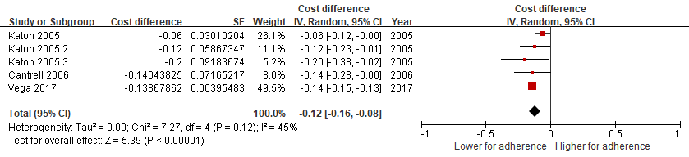
Hospitalisation cost
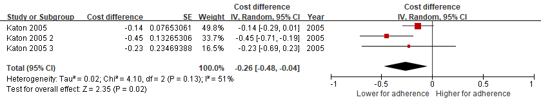
Outpatient cost
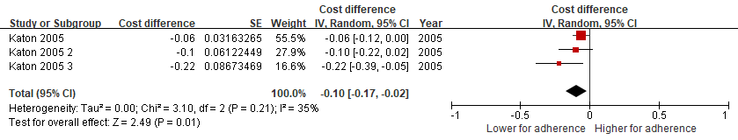
Total healthcare cost
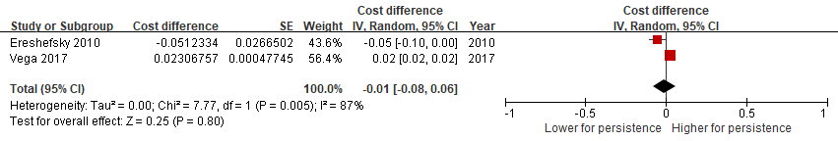

Bisphosphonates
Total healthcare cost


