Supplemental Table S1. PEDro scale for assessing the methodological quality of the included studies.
Items | Ang et al. ³⁷ | Ang et al. ⁹ | Ang et al.¹⁰ | Biasiucci et al. ¹⁷ | Cheng et al. ⁴² | Frolov  et al. ³⁹ | Kim et al. ⁴⁰ | Li  et al. ⁸ | Mihara  et al. ¹² | Pichiorri et al.⁴¹ | Ramos et al. ¹¹ | Wu et al. ¹³
1. Eligibility Criteria Specified | Yes | Yes | Yes | Yes | Yes | Yes | Yes | Yes | Yes | Yes | Yes | Yes
2.Randomly allocated | Yes | Yes | Yes | No | Yes | Yes | Yes | Yes | Yes | Yes | Yes | Yes
3.Allocation was concealed | No | No | No | No | No | No | Yes | No | Yes | Yes | Yes | No
4.Baseline comparability | Yes | Yes | Yes | Yes | Yes | Yes | Yes | Yes | Yes | Yes | Yes | Yes
5.Blinding of subjects | No | No | No | Yes | NO | No | No | No | No | No | Yes | No
6.Blinding of therapists | No | No | No | Yes | No | No | No | No | Yes | No | Yes | No
7.Blinding of assessors | Yes | Yes | Yes | Yes | Yes | Yes | Yes | Yes | Yes | Yes | No | Yes
8.Adequate follow up | Yes | Yes | Yes | Yes | Yes | No | Yes | Yes | Yes | Yes | Yes | Yes
9. Intention of treat analysis | No | No | No | No | No | No | No | No | No | No | No | No
10.Between group comparisons | Yes | Yes | Yes | Yes | Yes | Yes | Yes | Yes | Yes | Yes | Yes | Yes
11.Points Estimates and variability | Yes | Yes | Yes | Yes | Yes | Yes | Yes | Yes | Yes | Yes | Yes | Yes
Total score | 6/10 | 6/10 | 6/10 | 7/10 | 6/10 | 5/10 | 7/10 | 6/10 | 8/10 | 7/10 | 8/10 | 6/10

Supplemental Table S2: The mean and standard deviation (SD) of the changes in Fugl-Meyer Assessment scores between the pre- to the post-intervention for the selected randomized controlled trials. N refers to the number of participants.
Study | Experimental (i.e. BCI) |  |  | Control
 | N | Mean | SD | N | Mean | SD
Ang et al.³⁷ | 6 | 7.2 | 2.3 | 15 | 6.18 | 4.78
Ang et al. ⁹ | 11 | 4.5 | 5.19 | 14 | 6.3 | 7.6
Ang et at. ¹⁰ | 10 | 0.9 | 3 | 9 | 2.8 | 4
Biasiucci et al.¹⁷ | 14 | 6.7 | 5.6 | 13 | 2.1 | 3
Cheng et al.⁴² | 5 | 3.8 | 5.36 | 5 | 5.6 | 2.61
Frolov et al. ³⁹ | 36 | 5.29 | 4.5 | 11 | 4.09 | 2.91
Kim et al. ⁴⁰ | 15 | 7.87 | 2.42 | 15 | 2.93 | 2.74
Li et al. ⁸ | 7 | 12.7 | 11.3 | 7 | 6.7 | 4.1
Mihara et al. ¹² | 10 | 4.8 | 2.6 | 10 | 2.3 | 1.8
Pichiorri et al. ⁴¹ | 14 | 13.6 | 8.9 | 14 | 6.5 | 7
Ramos et al. ¹¹ | 16 | 3.4 | 2.2 | 16 | 0.36 | 4.2
Wu et al. ¹³ | 14 | 16.93 | 2.56 | 11 | 8.36 | 2.21

Supplemental Table S3: The mean and standard deviation (SD) of the changes in Fugl-Meyer Assessment scores from the first to the follow up session which was a number of weeks after finishing the intervention. The studies without a follow up session were excluded from this table. N refers to the number of participants.
Study | Experimental (i.e. BCI) |  |  | Control
 | N | Mean | SD | N | Mean | SD
Ang et al. ³⁷ | 6 | 9.7 | 2.6 | 15 | 6.1 | 5.26
Ang et al. ⁹ | 11 | 5.2 | 5.12 | 14 | 7.4 | 7.6
Ang et at. ¹⁰ | 10 | 5 | 4.4 | 9 | 5.4 | 5.7
Biasiucci et al. ¹⁷ | 13 | 6.9 | 4.1 | 12 | 2.8 | 4.97
Cheng et al. ⁴² | 5 | 4.6 | 4.77 | 5 | 2 | 4.64
Mihara et al. ¹² | 10 | 6.6 | 4.4 | 10 | 4.2 | 2.8
Ramos et al. ¹¹ | 16 | 2.28 | 2.59 | 16 | 1.46 | 2.52

Supplemental Figure 1. Funnel plot as a visual aid for investigating publication bias in our meta-analysis, assessing the immediate effect of BCI intervention.

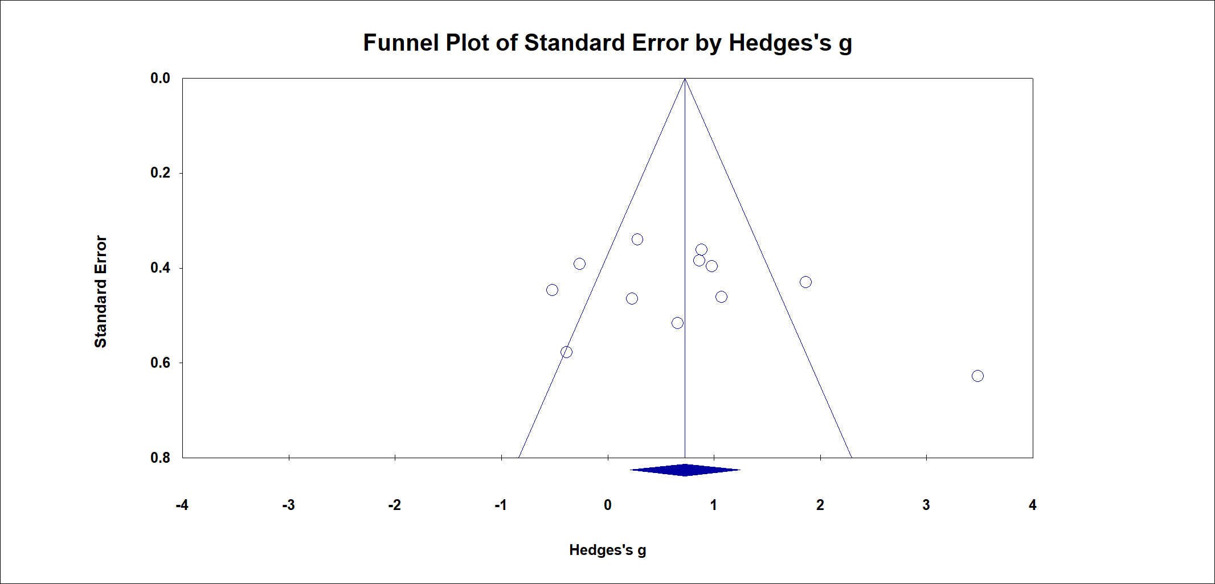

Supplemental Figure 2. Funnel plot of the meta-analysis for investigating publication bias in the long-term effects of BCI on upper-limb motor function rehabilitation after stroke.

Supplemental Appendix 1. Search strategy used in the considered databases
#1 Search: stroke rehabilitation
#2 Search: (Brain-computer Interface) OR (Brain-machine Interface)
#3 Search: (BCI) OR (BMI)
#4 Search: ((((Randomized controlled trial) OR (randomized controlled trials)) OR (controlled clinical trial)) OR (random allocation)) OR (double-blind method)
#5 Search: ((#1) AND ((#2) OR (#3) AND (#4 ))

