SUPPORTING INFORMATION

Effect of comorbid pulmonary disease on severity of COVID-19: a systematic review and meta-analysis

Askin Gülsen¹, Inke R. König², Uta Jappe¹, Daniel Drömann³

¹ Division of Clinical and Molecular Allergology, Research Center Borstel, Leibniz Lung Center, Airway Research Center North (ARCN), Member of the German Center for Lung Research (DZL), Borstel, Germany; Interdisciplinary Allergy Outpatient Clinic, Department of Pneumology, University of Luebeck, Germany
² Institute of Medical Biometry and Statistics, University of Luebeck, Germany, Airway Research Center North (ARCN), Member of the German Center for Lung Research (DZL), University of Luebeck, Germany
³ Department of Pneumology, Airway Research Center North (ARCN), Member of the German Center for Lung Research (DZL), University of Luebeck, Germany

Figure S1. Funnel plots with pseudo 95% confidence limits

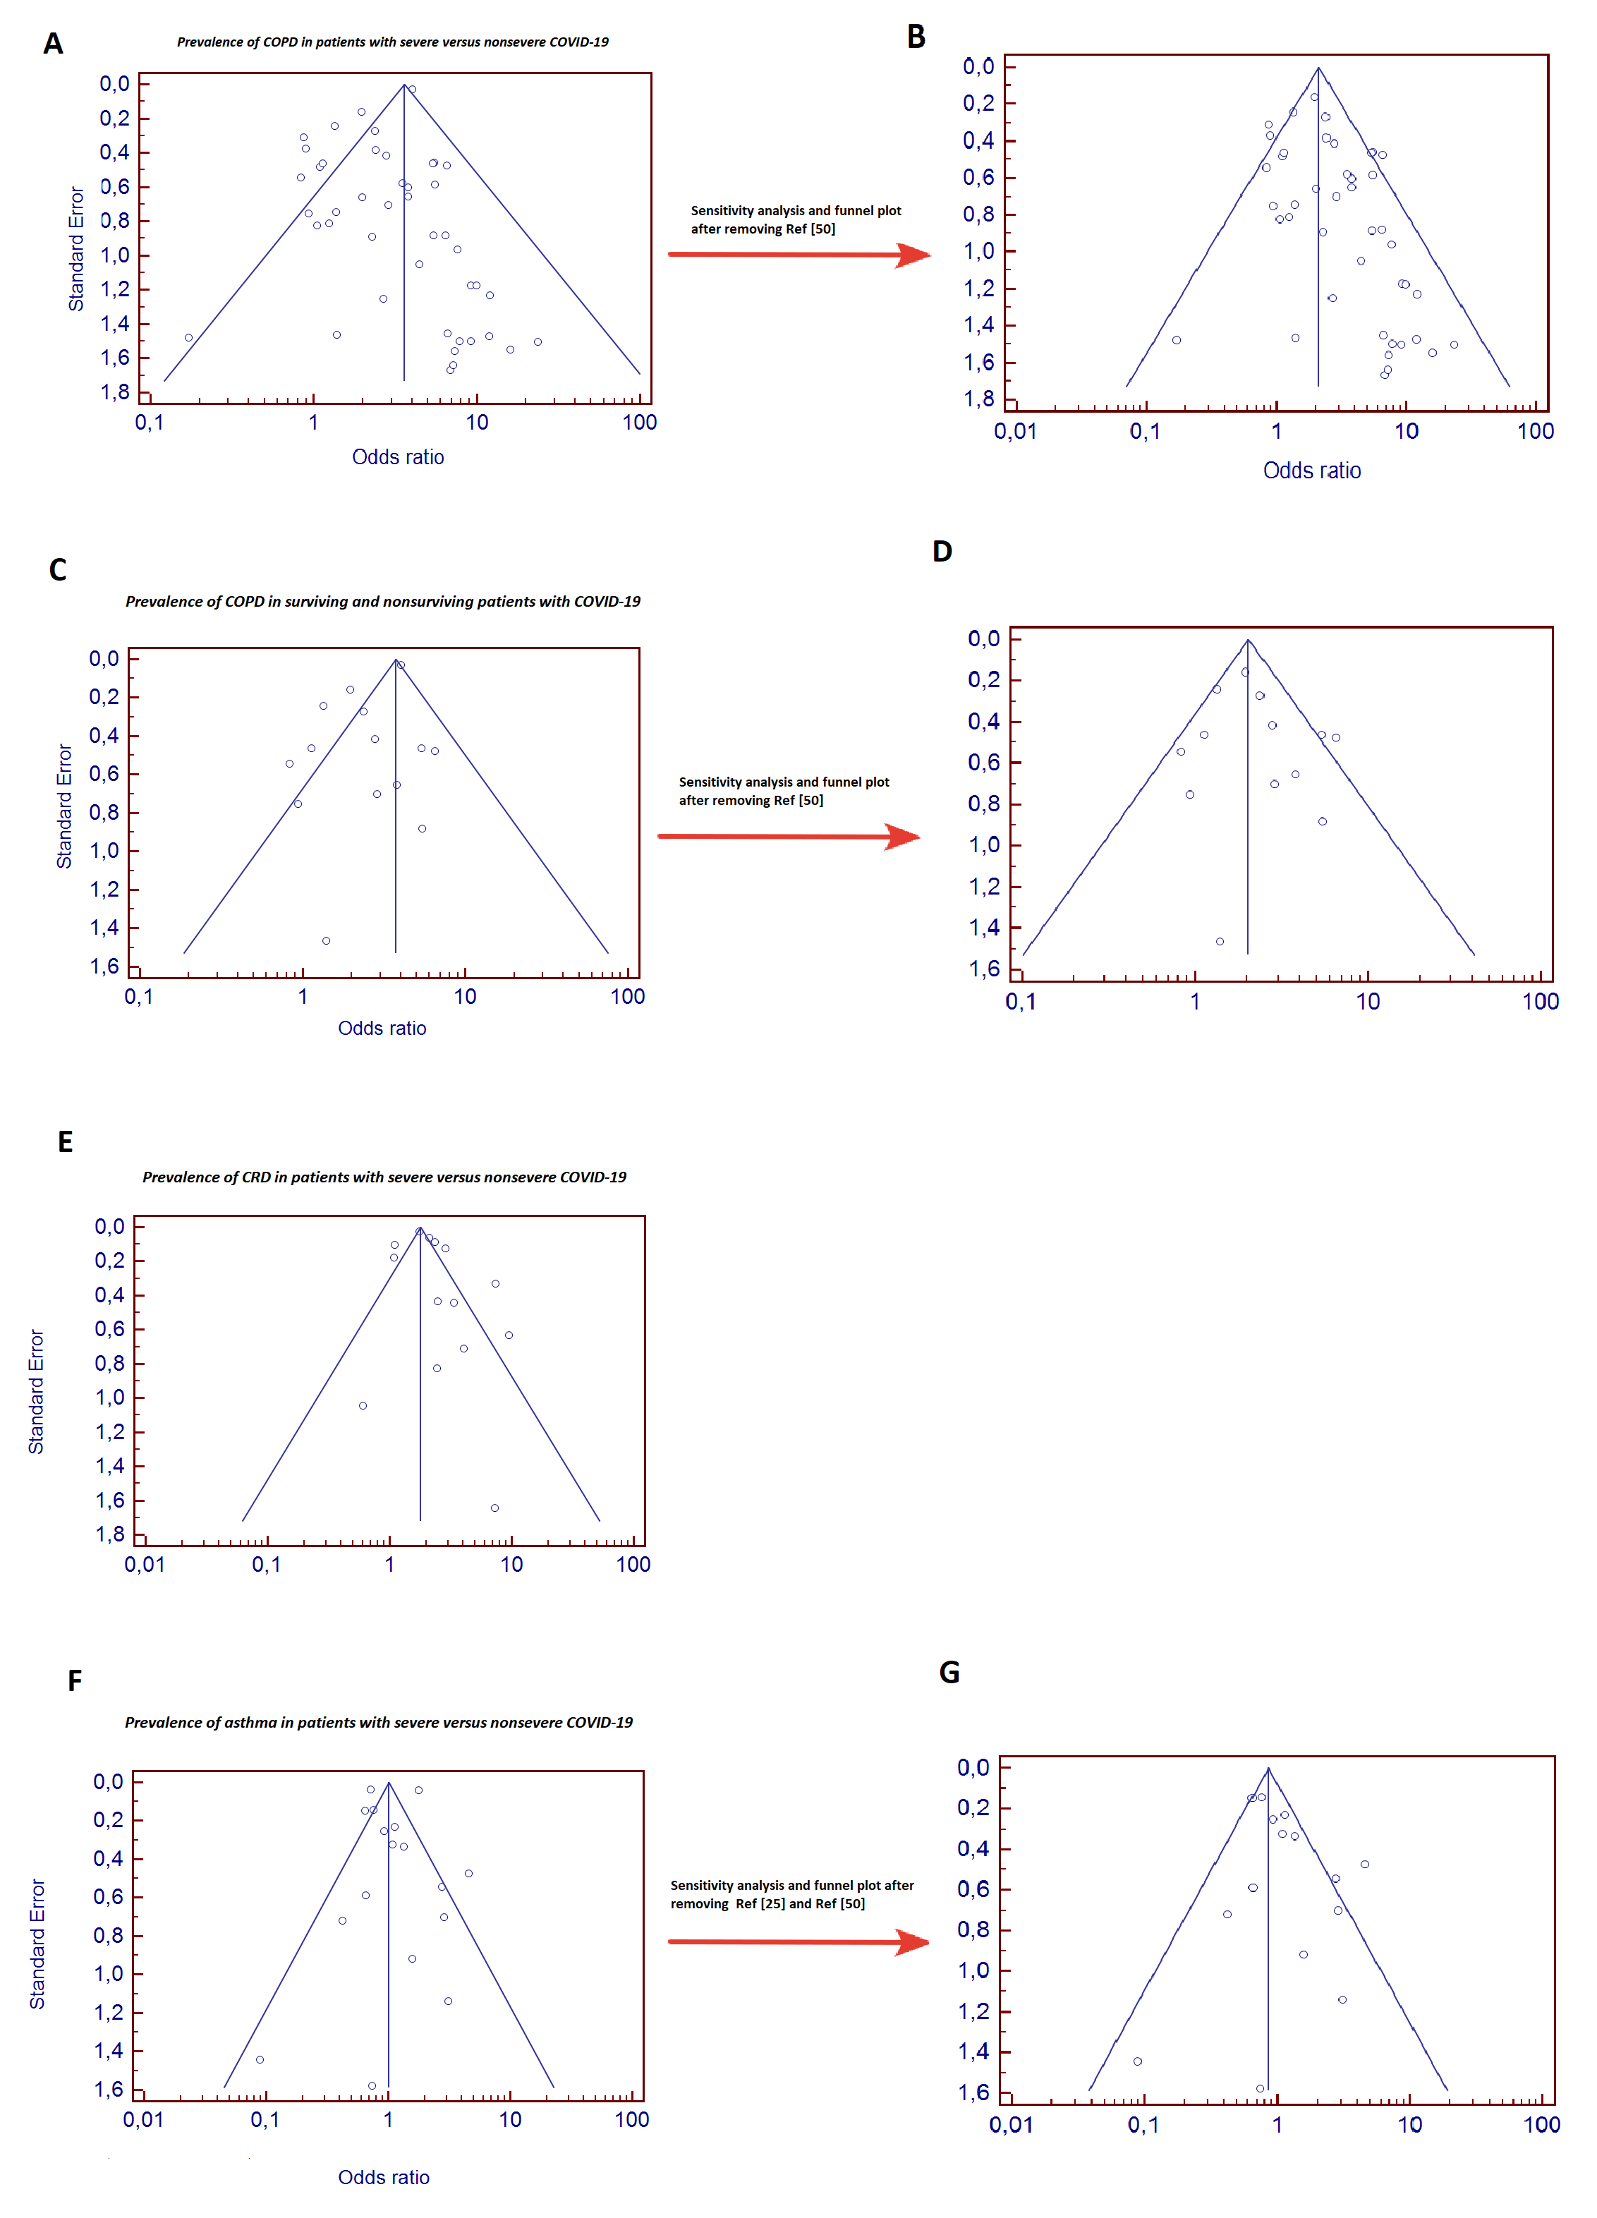

Table S1- Systematic search strategy

Line # | Mesh terms and text words
#1 | (COVID-19) OR (2019-nCoV) OR (SARS-CoV-2) OR (novel coronavirus)
#2 | #1 AND (Asthma)
#3 | #1 AND (COPD)
#4 | #1 AND (Respiratory Disease)
#5 | #2, OR #3, OR #4 AND (clinical characteristics)
#6 | #2, OR #3, OR #4 AND (risk factor)

Table S2. Prevalence of COPD in patients with severe versus non-severe COVID-19
 | Severe COVID-19 patients with COPD |  |  | Non-severe COVID-19 patients with COPD |  |  |  | Results
First Author | Event | Total | % | Event | Total |  | % | OR | P*
Almazeedi S. ^{[19]} | 2 | 42 | 4.8 | 37 | 1,054 |  | 3.5 | 1.37 | -
Argenziano MG. ^{[20]} | 14 | 236 | 5.9 | 52 | 764 |  | 6.8 | 0.86 | -
Auld SC. ^{[21]} | 5 | 62 | 8.1 | 14 | 147 |  | 9.5 | 0.83 | 0.737
Buckner FS. ^{[23]} | 7 | 51 | 13.7 | 4 | 54 |  | 7.4 | 1.98 | -
Caratozzolo S. ^{[26]} | 8 | 41 | 19.5 | 65 | 807 |  | 8.0 | 2.76 | 0.019
Chen Q. ^{[13]} | 0 | 43 | 0 | 6 | 102 |  | 5.9 | 0.17 | 0.18
Cai Q. ^{[24]} | 13 | 91 | 14.3 | 19 | 292 |  | 6.5 | 2.39 | 0.03
Feng X. ^{[30]} | 2 | 20 | 10.0 | 9 | 94 |  | 9.5 | 1.04 | >0.99
Feng Y. ^{[31]} | 14 | 124 | 11.3 | 8 | 352 |  | 2.3 | 5.47 | <0.001
Gao Y. ^{[32]} | 3 | 15 | 20.0 | 0 | 28 |  | 0 | 15.9 | 0.037
Giorgi Rossi P. ^{[33]} | 24 | 217 | 11.0 | 91 | 1,075 |  | 8.5 | 1.34 | -
Goyal P. ^{[34]} | 7 | 130 | 5.3 | 13 | 263 |  | 4.9 | 1.09 | -
Guan WJ. ^{[36]} | 6 | 173 | 3.4 | 6 | 926 |  | 0.6 | 5.50 | -
Gupta S. ^{[37]} | 87 | 784 | 11.1 | 86 | 1,431 |  | 6.0 | 1.95 | -
Güner R. ^{[38]} | 6 | 50 | 12.0 | 6 | 172 |  | 3.5 | 3.77 | 0.019
He Y. ^{[40]} | 22 | 133 | 16.5 | 6 | 203 |  | 3.0 | 6.50 | <0.001
Hu L. ^{[41]} | 6 | 172 | 3.5 | 0 | 151 |  | 0 | 11.8 | 0.033
Huang C. ^{[42]} | 1 | 13 | 7.6 | 0 | 28 |  | 0 | 6.84 | 0.14
Israelsen SB. ^{[43]} | 2 | 27 | 7.4 | 9 | 148 |  | 6.1 | 1.23 | 1.00
Javanian M. ^{[44]} | 5 | 19 | 26.3 | 7 | 81 |  | 8.6 | 3.77 | 0.032
Lagi F. ^{[45]} | 3 | 16 | 18.7 | 2 | 68 |  | 2.9 | 7.61 | 0.045
Liu W. ^{[46]} | 1 | 11 | 9.1 | 1 | 67 |  | 1.5 | 6.60 | 0.264
Li X. ^{[47]} | 13 | 269 | 4.8 | 4 | 279 |  | 1.4 | 3.49 | 0.26
Li YK. ^{[48]} | 4 | 9 | 44.4 | 1 | 16 |  | 6.2 | 12.0 | 0.038
Mo P. ^{[49]} | 4 | 85 | 4.7 | 0 | 70 |  | 0 | 7.78 | 0.489
Parra-Bracamonte GM. ^{[50]} | 1,839 | 38,310 | 4.7 | 3,619 | 292,988 |  | 1.2 | 4.03 | -
Parantje I. ^{[51]} | 28 | 310 | 9.0 | 31 | 768 |  | 4.0 | 2.36 | -
Salacup G. ^{[53]} | 7 | 52 | 13.5 | 23 | 190 |  | 12.1 | 1.12 | 0.813
Shi S. ^{[54]} | 2 | 62 | 3.2 | 21 | 609 |  | 3.4 | 0.93 | 1.000
Tomlins S. ^{[55]} | 4 | 20 | 20.0 | 6 | 75 |  | 8.0 | 2.87 | 0.20
Wan S. ^{[56]} | 4 | 40 | 10.0 | 0 | 95 |  | 0 | 23.5 | --
Wang D. ^{[57]} | 3 | 36 | 8.3 | 1 | 102 |  | 0.9 | 9.18 | 0.054
Wang L. ^{[58]} | 11 | 65 | 16.9 | 10 | 274 |  | 3.6 | 5.37 | <0.001
Wang Z. ^{[59]} | 2 | 14 | 14.2 | 2 | 55 |  | 3.6 | 4.41 | 0.181
Wu J. ^{[60]} | 1 | 83 | 1.2 | 0 | 197 |  | 0 | 7.18 | -
Yan X. ^{[61]} | 0 | 40 | 0 | 8 | 964 |  | 8.3 | 1.38 | 0.563
Yang P. ^{[62]} | 4 | 68 | 5.8 | 0 | 65 |  | 0 | 9.14 | 0.047
Zhang JJ. ^{[64]} | 2 | 58 | 3.4 | 0 | 82 |  | 0 | 7.30 | 0.170
Zhang G. ^{[65]} | 4 | 55 | 7.2 | 2 | 166 |  | 1.2 | 6.43 | 0.035
Zhang J ^{[66]} | 1 | 18 | 5.6 | 2 | 93 |  | 2.2 | 2.67 | 0.415
Zhang R. ^{[67]} | 3 | 30 | 10.0 | 1 | 90 |  | 1.1 | 9.88 | 0.048
Zhao Z. ^{[68]} | 11 | 195 | 5.6 | 25 | 398 |  | 6.3 | 0.89 | 0.76
Zheng F. ^{[69]} | 2 | 30 | 6.7 | 4 | 131 |  | 3.1 | 2.26 | 0.346
Zhou F. ^{[70]} | 4 | 54 | 7.4 | 2 | 137 |  | 1.4 | 5.40 | 0.047
Total (random) | 2,191 | 42,373 | 5.2% | 4,203 | 306,151 | 1.4% |  | 2.58 | p<0.001
Total (fixed) |  |  |  |  |  |  |  | 3.61 | p<0.001
Test for heterogeneity: Tau²: Q=131.5, DF=43 (p<0.001); I²=67.31%
Test for overall effect: z=7.15 (p<0.001)
*The p values given in the table were taken from the studies. W, weight; OR, odds ratio; CI, confidence interval.

Table S3. Prevalence of CRD in patients with severe versus non-severe COVID-19

 | Severe COVID-19 patients with CRD |  |  | Non-severe COVID-19  patients with CRD |  |  | Results
First Author | Event | Total | % | Event | Total | % | OR | P*
Argenziano MG. ^{[20]} | 55 | 236 | 23.3 | 168 | 764 | 22.0 |  | -
Berenguer J. ^{[22]} | 310 | 1,116 | 28.8 | 405 | 2,879 | 14.1 |  | <0.001
Cao J. ^{[25]} | 4 | 17 | 23.5 | 6 | 85 | 7.1 | 4.05 | 0.101
CDC report ^{[27]} | 94 | 457 | 20.5 | 515 | 6,180 | 8.3 | 2.85 | -
Deng Y. ^{[28]} | 22 | 109 | 20.1 | 3 | 116 | 2.5 | 9.52 | <0.001
ECDC, Week42 ^{[29]} | 2,649 | 39,609 | 6.7 | 9,350 | 237,188 | 3.9 |  | -
Gupta S. ^{[37]} | 197 | 784 | 25.1 | 334 | 1,431 | 23.3 |  | -
Harrison SL. ^{[39]} | 391 | 1,296 | 30.1 | 5,122 | 30,165 | 17.0 |  | -
Hu L. ^{[41]} | 21 | 172 | 12.2 | 8 | 151 | 5.3 |  | 0.010
Qi D. ^{[52]} | 10 | 50 | 20.0 | 15 | 217 | 6.9 | 3.37 | 0.009
Wan S. ^{[56]} | 1 | 40 | 2.5 | 0 | 95 | 0 | 7.25 | -
Wu J. ^{[60]} | 3 | 83 | 3.6 | 3 | 197 | 1.5 | 2.42 | -
Yan X. ^{[61]} | 21 | 40 | 52.5 | 126 | 964 | 13.1 |  | <0.001
Yang X. ^{[63]} | 2 | 32 | 6.2 | 2 | 20 | 10 | 0.60 | -
Total (random) | 3,780 | 44,041 | 8.6% | 16,057 | 280,447 | 5.7% | 2.14 | p<0.001
Total (fixed) |  |  |  |  |  |  | 1.80 | p<0.001
Test for heterogeneity: Q=93.2, DF=13 (p<0.001); I²=86.0%
Test for overall effect: z=7.1 (p<0.001)
*The p values given in the table were obtained from the studies.
CRD, chronic respiratory diseases; W, weight; OR, odds ratio; CI, confidence interval.

Table S4. Prevalence of asthma in patients with severe versus non-severe COVID-19

 | Severe COVID-19 patients with Asthma |  |  | Non-severe COVID-19 patients with Asthma |  |  | Results
First Author | Event | Total | % | Event | Total | % | OR | P*
Almazeedi S. ^{[19]} | 6 | 42 | 14.3 | 37 | 1,054 | 3.5 | 4.58 | <0.0001
Argenziano MG. ^{[20]} | 29 | 236 | 12.3 | 84 | 764 | 11.0 | 1.13 | -
Auld SC. ^{[21]} | 4 | 62 | 6.4 | 14 | 147 | 9.5 | 0.65 | 0.470
Berenguer J. ^{[22]} | 69 | 1,116 | 6.2 | 230 | 2,884 | 8.0 | 0.76 | 0.053
Buckner FS. ^{[23]} | 3 | 51 | 5.9 | 7 | 54 | 13.0 | 0.42 | -
ECDC, Week42 ^{[29]} | 841 | 39,609 | 2.1 | 2,869 | 237,188 | 12.1 | 1.77 | -
Goyal P. ^{[34]} | 17 | 130 | 13.0 | 32 | 263 | 12.1 | 1.08 | -
Grein J. ^{[35]} | 5 | 34 | 14.7 | 1 | 19 | 5.2 | 3.10 | -
Gupta S. ^{[37]} | 70 | 784 | 8.9 | 188 | 1,431 | 13.1 | 0.64 | -
Israelsen SB. ^{[43]} | 6 | 27 | 22.2 | 14 | 148 | 9.4 | 2.73 | 0.11
Li X. ^{[47]} | 3 | 269 | 1.1 | 2 | 279 | 0.7 | 1.56 | 0.681
Parra-Bracamonte GM. ^{[50]} | 777 | 38,310 | 2.0 | 8,206 | 292,988 | 2.8 | 0.71 | -
Parantje I. ^{[51]} | 23 | 310 | 7.4 | 61 | 768 | 7.9 | 0.92 | -
Salacup G. ^{[53]} | 0 | 52 | 0 | 18 | 190 | 9.5 | 0.08 | 0.021
Tomlins S. ^{[55]} | 4 | 20 | 20.0 | 6 | 75 | 8.0 | 2.87 | >0.9
Wang Z. ^{[59]} | 0 | 14 | 0 | 2 | 55 | 3.6 | 0.73 | 0.633
Zhang JJ. ^{[64]} | 0 | 58 | 0 | 0 | 82 | 0 | 1.41 | -
Zhao Z. ^{[68]} | 16 | 195 | 8.2 | 25 | 398 | 6.3 | 1.33 | 0.76
Total (random) | 1,873 | 81,319 | 2.3% | 11,796 | 538,787 | 2.2% | 1.13 | 0.50
Total (fixed) |  |  |  |  |  |  | 1.01 | 0.59
Test for heterogeneity: Q=317.1, DF=16 (p<0.001); I²=94.5%
Test for overall effect: z=-0.66 (p=0.50)
*The p values given in the table were obtained from the studies.
W, weight; OR, odds ratio; CI, confidence interval.

