Influence of PM₁ Exposure on Total and Cause-Specific Respiratory Diseases: A Systematic Review and Meta-Analysis
Yaoyu Hu^{1, #}, Mengqiu Wu^{1, #}, Yutong Li¹, Xiangtong Liu^{1, 2, *}
¹ School of Public Health, Capital Medical University, Beijing, 100069, China.
² Beijing Municipal Key Laboratory of Clinical Epidemiology, Beijing, 100069, China.
# Yaoyu Hu and Mengqiu Wu contributed equally to this work.
Corresponding author:
Xiangtong Liu
Department of Epidemiology and Health Statistics
School of Public Health, Capital Medical University
No. 10 Xitoutiao, Youanmen, Fengtai District, Beijing 100069, P.R. China
Tel: (+86-010)83911778, Fax: (+86-010)83911778
E-mail: xiangtongl@ccmu.edu.cn

Supplementary Data
Table of contents
Appendix1 Literature search strategy of our study.
Table S1 Quality assessment of articles included in our study.
Fig. S1 Assessment of the risk of bias in the included studies.
Appendix 1 Literature search strategy of our study.
Searched Database: PubMed, Embase, Cochrane library

1) PubMed search strategy
#1. COPD
1) PubMed search strategy
#1. Respiratory Tract Infections
"Bronchitis"[Mesh] OR "Respiratory Tract Infection" [Mesh] OR "Common Cold"[Mesh] OR "Influenza, Human"[Mesh] OR " Rhinitis " [Mesh] OR " Tracheitis " [Mesh] OR " Pharyngitis "[Mesh] OR "Laryngitis"[Mesh] OR "Respiratory Tract Infection" [tiab]
#2. Asthma
“asthma”[Mesh] OR “Asthma, Aspirin-Induced”[Mesh] OR “Asthma, Exercise-Induced”[Mesh] OR “Asthma, Occupational”[Mesh] OR “Status Asthmaticus”[Mesh] OR “Asthma, Bronchial”[Mesh] OR “asthma”[tiab] OR “bronchial asthma”[tiab] OR “bronchial disorder”[tiab] OR “airway inflammation”[tiab] OR “wheeze”[tiab] OR “wheezing”[tiab] OR “allergy”[tiab] OR “allergic disorder”[tiab]
#3. COPD
"Lung Diseases, Obstructive"[Mesh:noexp] OR "Pulmonary Disease, Chronic Obstructive"[Mesh] OR "Pulmonary Emphysema"[Mesh] OR “Bronchitis, chronic”[Mesh] OR “Chronic obstructive pulmonary disease"[tiab] OR "Emphysema"[tiab] OR "Chronic bronchitis"[tiab] OR "Chronic obstructive lung disease"[tiab] OR "COPD"[tiab]
#4. Pneumonias
"Pneumonia"[Mesh] OR "Bronchopneumonia"[Mesh] OR "Pneumonia, Bacterial"[Mesh] OR "Pneumonia, Necrotizing"[Mesh] OR "Pneumonia, Viral"[Mesh] OR "Pneumonia"[tiab]
#5. Human Influenzas
" Human Influenzas "[Mesh] OR “Influenza”[Mesh] OR “Human Flu”[Mesh]
#6. PM₁
"PM1"[tiab] OR "PM(1)"[tiab] OR "sub-micrometric Particulate Matter"[tiab]
# Final search strategy: (#1 OR #2 OR #3 OR #4 OR #5) AND #6

2) Embase search strategy
#1. Respiratory Tract Infections
'Bronchitis'/exp OR 'Respiratory Tract Infection'/exp OR 'Common Cold'/exp OR 'Influenza, Human'/exp OR 'Rhinitis'/exp OR 'Tracheitis'/exp OR 'Pharyngitis'/exp OR 'Laryngitis'/exp OR 'Respiratory Tract Infection':ab,ti
#2. Asthma
'asthma'/exp OR 'Asthma, Aspirin-Induced'/exp OR 'Asthma, Exercise-Induced'/exp OR 'Asthma, Occupational'/exp OR 'Status Asthmaticus'/exp OR 'Asthma, Bronchial'/exp OR 'asthma'/exp OR 'bronchial asthma'/exp OR 'bronchial disorder'/exp OR 'airway inflammation':ab,ti OR 'wheeze':ab,ti OR 'wheezing':ab,ti OR 'allergy':ab,ti OR 'allergic disorder':ab,ti
#3. COPD
'Chronic obstructive lung disease'/exp OR 'Chronic bronchitis'/exp OR 'Lung emphysema'/exp OR 'Chronic obstructive pulmonary disease':ab,ti OR 'Emphysema':ab,ti OR 'Chronic bronchitis':ab,ti OR 'Chronic obstructive lung disease':ab,ti OR 'COPD':ab,ti
#4. Pneumonias
'Pneumonia'/exp OR 'Bronchopneumonia'/exp OR 'Pneumonia, Bacterial'/exp OR 'Pneumonia, Necrotizing'/exp OR 'Pneumonia, Viral'/exp OR 'Pneumonia':ab,ti
#5. Human Influenzas
'Human Influenzas '/exp OR “Influenza'/exp OR “Human Flu'/exp
#6. PM₁
'PM1/exp OR PM(1):ab,ti OR 'sub-micrometric Particulate Matter:ab,ti
# Final search strategy: (#1 OR #2 OR #3 OR #4 OR #5) AND #6

3) Cochrane Library search strategy
#1. Respiratory Tract Infections
MeSH descriptor: [Influenza, Human] explode all trees
OR
Bronchitis:ti,ab,kw OR Respiratory Tract Infection:ti,ab,kw OR Common Cold:ti,ab,kw OR Influenza, Human:ti,ab,kw OR Rhinitis:ti,ab,kw OR Tracheitis:ti,ab,kw OR Pharyngitis:ti,ab,kw OR Laryngitis:ti,ab,kw OR Respiratory Tract Infection:ti,ab,kw
#2. Asthma
MeSH descriptor: [Asthma] explode all trees
OR
asthma:ti,ab,kw OR bronchial asthma:ti,ab,kw OR bronchial disorder:ti,ab,kw OR airway inflammation:ti,ab,kw OR wheeze:ti,ab,kw OR wheezing:ti,ab,kw OR allergy:ti,ab,kw OR allergic disorder:ti,ab,kw
#3. COPD
MeSH descriptor: [Pulmonary Disease, Chronic Obstructive] explode all trees
OR
Chronic obstructive pulmonary disease:ti,ab,kw OR Emphysema:ti,ab,kw OR Chronic bronchitis:ti,ab,kw OR Chronic obstructive lung disease:ti,ab,kw OR COPD:ti,ab,kw
#4. Pneumonias
MeSH descriptor: [Pneumonia, Necrotizing] explode all trees
OR
Pneumonia:ti,ab,kw OR Bronchopneumonia:ti,ab,kw OR Pneumonia, Viral:ti,ab,kw OR Pneumonia:ti,ab,kw
#5. Human Influenzas
MeSH descriptor: [Human Influenzas] explode all trees
OR
Influenza:ti,ab,kw OR Human Flu:ti,ab,kw
#6. PM₁
PM1:ti,ab,kw OR PM(1):ti,ab,kw OR sub-micrometric Particulate Matter:ti,ab,kw
# Final search strategy : (#1 OR #2 OR #3 OR #4 OR #5) AND #6
Table S1 Quality assessment of articles included in our study.
Criteria |  | Question | Score | Max Score | Wang et al. | Zhang et al. | Zhang et al. | Yu et al. | Luong et al. | Michaud et al.
 |  |  |  |  | 2021 | 2021 | 2020 | 2020 | 2016 | 2004
Source of the Information | 1 | Published in a peer review journal | 3 | 3 | 3 | 3 | 3 | 3 | 3 | 3
Source of the Information | 2 | Not peer review but reviewed by some other groups | 2 |  | 0 | 0 | 0 | 0 | 0 | 0
Source of the Information | 3 | Not reviewed journal or groups | 1 |  | 0 | 0 | 0 | 0 | 0 | 0
Source of the Information | 4 | Unpublished
Source of the Information | 4 | If the study is unpublished, is the investigator willing to assure that this final, clean data? Y/N | 0 | 0 | 0 | 0 | 0 | 0 | 0 | 0
Source of the Information | 5 | Are the investigators and all institutional affiliations identified? Y/N | 1 | 1 | 1 | 1 | 1 | 1 | 1 | 1
Source of the Information | 6 | When were information collected
Source of the Information | 6 | Recent 5 years | 3 | 3 | 3 | 3 | 3 | 3 | 3 | 0
Source of the Information | 6 | Recent 10 years | 2 |  | 0 | 0 | 0 | 0 | 0 | 0
Source of the Information | 6 | More than 10 years | 1 |  | 0 | 0 | 0 | 0 | 0 | 1
Study Design | 7 | Is the design described clearly? | 1 | 1 | 1 | 1 | 1 | 1 | 1 | 1
Study Design | 8 | Is the design appropriate to the study questions? |  | 4
Study Design | 8 | Case reports and case series | 0
Study Design | 8 | Cross-sectional studies | 1 |  | 1 | 1 |  | 1 |  | 1
Study Design | 8 | Case-control studies | 2
Study Design | 8 | Cohort /Panel studies | 3
Study Design | 8 | Time series / Case-crossover studies | 4 |  |  |  | 4 |  | 4
Study Design | 9 | Are there exposure indicators (ambient air pollutants) clearly defined, including methods of measurement?
Study Design | 9 | Clearly definition | 1 | 1 | 1 | 1 | 1 | 1 | 1 | 1
Study Design | 9 | Change in one unit of air pollutants | 1 | 1 | 1 | 1 | 1 | 1 | 1 | 1
Study Design | 10 | Are there appropriate statistical packages for data analysis? | 1 | 1 | 1 | 1 | 1 | 1 | 1 | 1
Study Design | 11 | Are there controlling for potential confounding factors (e.g. temperature, relative humidity, season, trend, DOW, etc.)? | 1 | 1 | 1 | 1 | 1 | 1 | 0 | 0
Study Design | 12 | Are the outcome (wheezing symptom diseases) clearly defined using ICD9 or ICD10? | 2 | 2 | 2 | 0 | 2 | 0 | 2 | 0
Study Design | 12 | General group of wheeze associated disorder | 1 | 1 | 1 | 1 | 1 | 1 | 1 | 1
Study Design | 12 | Cause-specific Wheeze associated disorder | 1 | 1 | 1 | 1 | 1 | 1 | 0 | 1
Study Results | 13 | Are baseline characteristics of research location, ambient air pollutants, and outcome well described? | 1 | 1 | 1 | 1 | 1 | 1 | 1 | 1
Study Results | 14 | Is the main question/hypothesis answered properly? | 1 | 1 | 1 | 1 | 1 | 1 | 1 | 1
Study Results | 15 | Are PC/OR/Effect/HR, 95%CI, P value presented? | 2 | 2 | 2 | 2 | 2 | 2 | 2 | 2
Study Results | 16 | Are potential confounding factors presented? | 1 | 1 | 1 | 1 | 1 | 1 | 1 | 1
Study Results | 17 | How high sensitivity of analysis was presented?
Study Results | 17 | Degrees of freedom (for season and trend) | 1 | 1 | 1 | 1 | 1 | 0 | 1 | 0
Study Results | 17 | Other factor classification (gender, etc.) | 1 | 1 | 1 | 1 | 0 | 1 | 0 | 1
Study Discussion | 18 | Discuss in limitations/innovation of the study? | 1 | 1 | 1 | 1 | 1 | 1 | 1 | 1
Study Discussion | 19 | Comparison with previous work? | 1 | 1 | 1 | 1 | 1 | 1 | 1 | 1
Study Discussion | 20 | Discuss in plausibility? | 1 | 1 | 1 | 1 | 1 | 1 | 1 | 1
Total score |  |  |  | 30 | 27 | 25 | 29 | 24 | 27 | 21

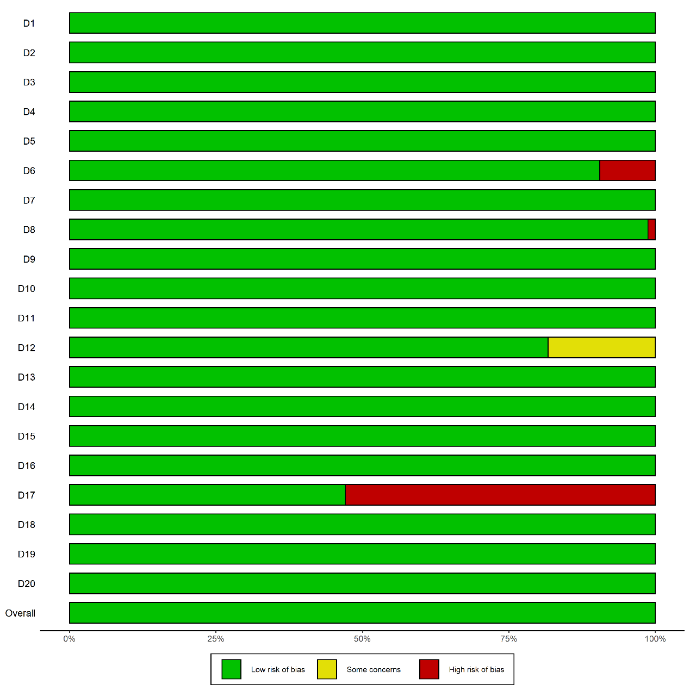
Fig. S1. Assessment of the risk of bias in the included studies.

