Six domain of lifestyle modification adherence
Adherence of recommended regular physical exercise
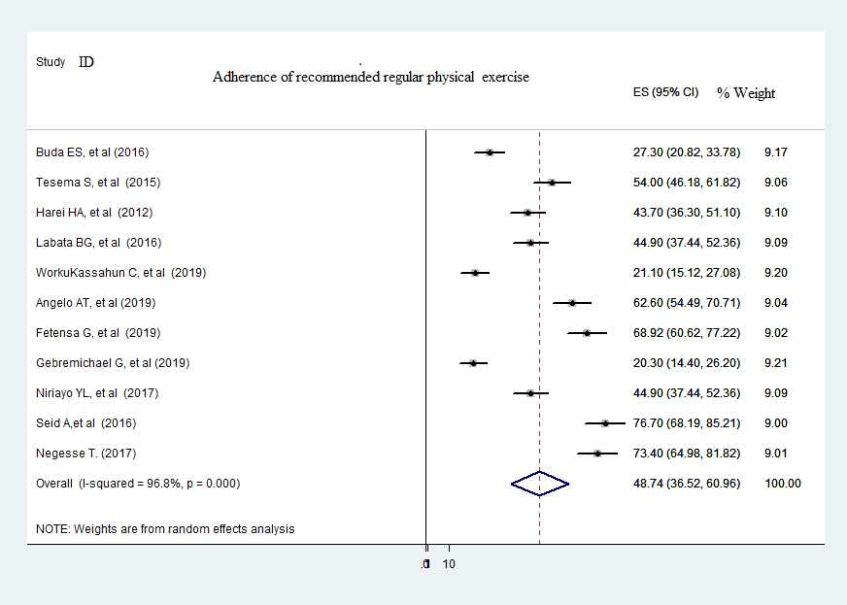
Figure 1: Meta-analysis (forest plot) of the proportion of recommended regular physical exercise adherence among people with hypertension in Ethiopia
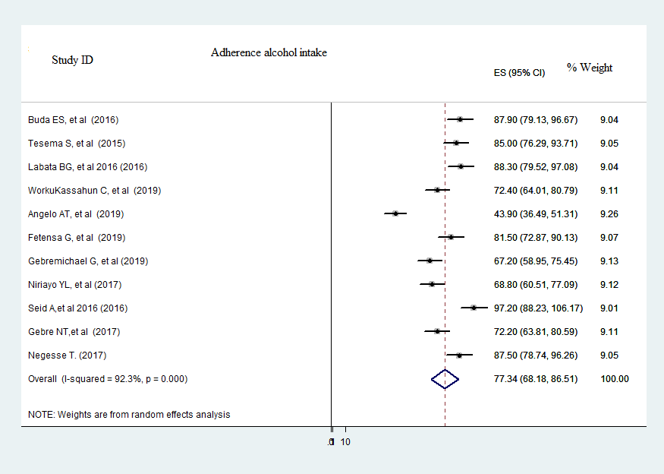
Figure 2: Meta-analysis (forest plot) of the proportion of recommended alcohol intake adherence among people with hypertension in Ethiopia

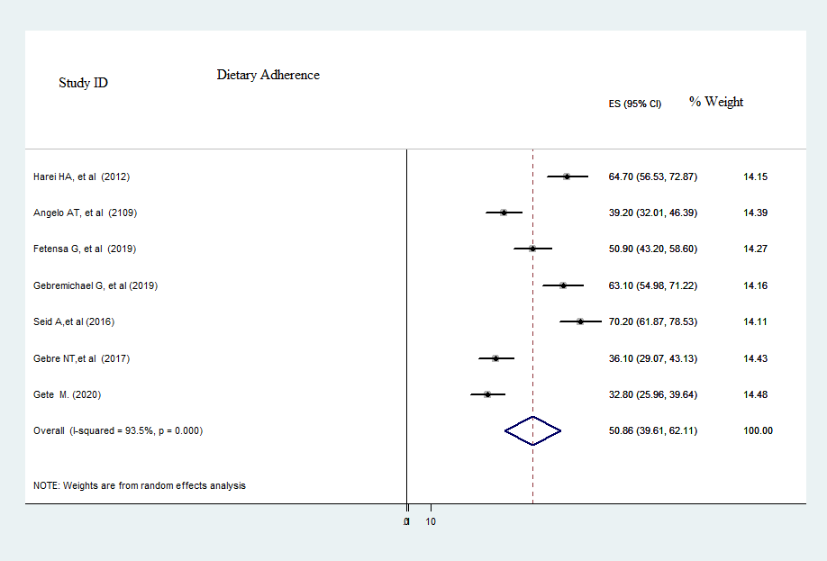
Figure 3: Meta-analysis (forest plot) of the proportion of healthy dietary adherence among people with hypertension in Ethiopia
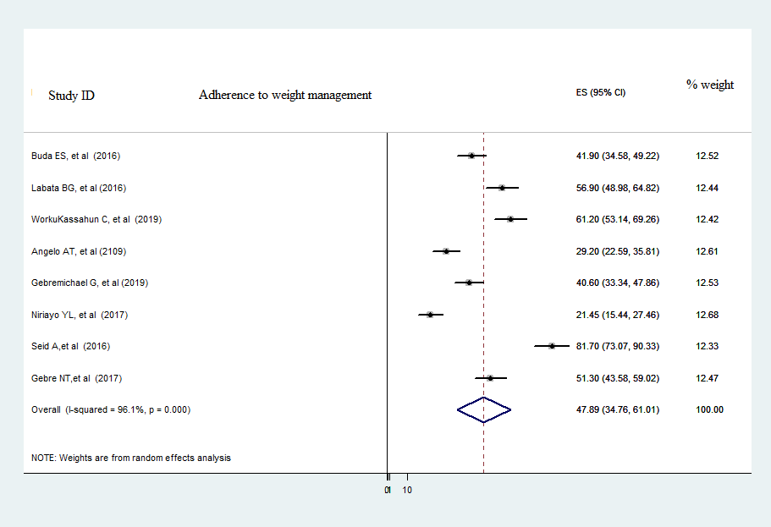
Figure 4: Meta-analysis (forest plot) of the proportion of weight management adherence among people with hypertension in Ethiopia
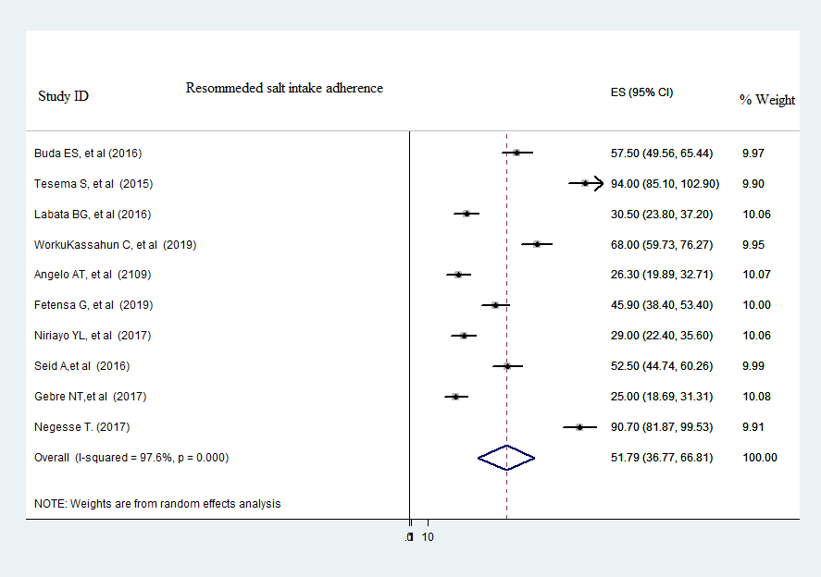
Figure 5: Meta-analysis (forest plot) of the proportion of salt intake adherence among people with hypertension in Ethiopia

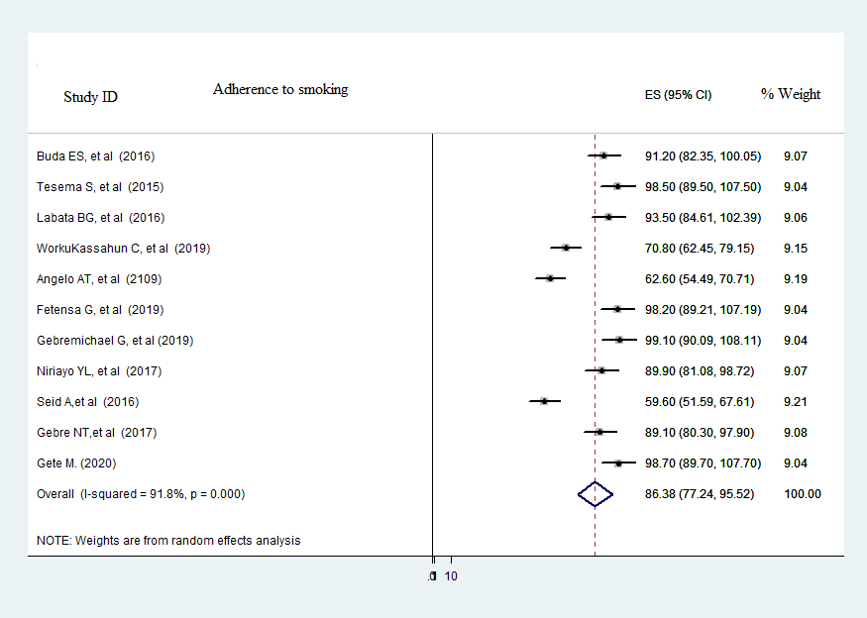
Figure 6: Meta-analysis (forest plot) of the proportion of smoking/no smoke adherence among people with hypertension in Ethiopia

