Supplementary date
Supplementary Figure 1. Cochrane Handbook for Systematic Reviews of Interventions of the RCTs
Supplementary Figure 2. Funnel Plots for Main Outcome Comparisons
Supplementary Table 1. Number of Citations by Each Database and Trial Register Searched
Supplementary Table 2. Subgroup Analysis of Potential Heterogeneity Factors for Acute GI Toxicity
Supplementary Table 3. Subgroup Analysis of Potential Heterogeneity Factors for Acute Rectal Toxicity
Supplementary Table 4. Subgroup Analysis of Potential Heterogeneity Factors for Survival Outcomes
Supplementary Table 5. Newcastle-Ottawa Scale for Risk of Bias Assessment of the CRS
Supplementary Table 6. One-Study-Removed Sensitivity Analyses of IGRT for Prostate Cancer
Supplementary Table 7. Egger’s Test for Binary Variable

Supplementary Table 1. Number of Citations by Each Database and Trial Register Searched

Databases and Trial registers | Citations
Databases：
PubMed | 2876
Cochrane | 282
Embase | 3953
MEDLINE | 2953
Total (databases) | 10064
Trial registers:
USA (ClinicalTrials.gov) | 218

Search Strategy of Cochrane, PubMed, Embase, Medline databases and ClinicalTrials.gov

Cochrane

#1 MeSH descriptor: [Prostatic Neoplasms] explode all trees

#2 (Prostate Neoplasms):ti,ab,kw OR (Neoplasms, Prostate):ti,ab,kw OR (Neoplasm, Prostate):ti,ab,kw OR (Prostate Neoplasm):ti,ab,kw OR (Prostate Cancer):ti,ab,kw

#3 #1 or #2

#4 MeSH descriptor: [Radiotherapy] explode all trees

#5 (Radiotherapies):ti,ab,kw OR (Radiation Therapy):ti,ab,kw OR (Radiation Therapies):ti,ab,kw OR (Therapies, Radiation):ti,ab,kw OR (Radiation Treatment):ti,ab,kw

#6 #4 or #5

#7 MeSH descriptor: [Radiotherapy, Image-Guided] explode all trees

#8 (Image-Guided Radiotherapies):ti,ab,kw OR (Image-Guided Radiotherapy):ti,ab,kw OR (Radiotherapies, Image-Guided):ti,ab,kw OR (Radiotherapy, Image Guided):ti,ab,kw OR (Image-Guided Radiation Therapy):ti,ab,kw

#9 #7 or #8

#10 MeSH descriptor: [Cone-Beam Computed Tomography] explode all trees

#11 (Computed Tomography, Cone-Beam):ti,ab,kw OR (Cone Beam Computed Tomography):ti,ab,kw OR (CT Scan, Cone-Beam):ti,ab,kw OR (CT Scan, Cone Beam):ti,ab,kw OR (CT Scans, Cone-Beam):ti,ab,kw

#12 #10 or #11

#13 (Kilovoltage x-ray imaging):ti,ab,kw OR (Megavoltage x-ray imaging):ti,ab,kw OR (Kilovoltage imaging):ti,ab,kw OR (Megavoltage imaging):ti,ab,kw OR (kV x-ray imaging):ti,ab,kw

#14 (ExacTrac):ti,ab,kw OR (On board imager):ti,ab,kw OR (OBI):ti,ab,kw OR (X‐ray volume imaging):ti,ab,kw OR (XVI):ti,ab,kw

#15 MeSH descriptor: [Fiducial Markers] explode all trees

#16 (Fiducial Marker):ti,ab,kw OR (Marker, Fiducial):ti,ab,kw OR (Markers, Fiducial):ti,ab,kw OR (Fiducial Targets):ti,ab,kw OR (Fiducial Target):ti,ab,kw

#17 #15 or #16

#18 MeSH descriptor: [Magnetic Resonance Imaging, Cine] explode all trees

#19 (Cine MRI):ti,ab,kw OR (Cine MRIs):ti,ab,kw OR (MRI, Cine):ti,ab,kw OR (MRIs, Cine):ti,ab,kw OR (Cine Magnetic Resonance Imaging):ti,ab,kw

#20 #18 or #19

#21 (Calypso 4D):ti,ab,kw OR (Calypso 4D Localisation System):ti,ab,kw OR (Calypso System):ti,ab,kw

#22 (Ultrasound):ti,ab,kw OR (phonophoresis):ti,ab,kw OR (radiation, ultrasonic):ti,ab,kw OR (sonication):ti,ab,kw OR (ultra sound):ti,ab,kw OR (ultrasonic):ti,ab,kw OR (ultrasonic sound):ti,ab,kw OR (ultrasonic wave):ti,ab,kw

#23 #9 or #12 or #13 or #14 or #17 or #20 or #21 or #22

#24 #3 and #6 and #23

PubMed
#1 ((("Prostatic Neoplasms"[Mesh]) OR (((((((((((((((((Prostate Neoplasms[Title/Abstract]) OR (Neoplasms, Prostate[Title/Abstract])) OR (Neoplasm, Prostate[Title/Abstract])) OR (Prostate Neoplasm[Title/Abstract])) OR (Neoplasms, Prostatic[Title/Abstract])) OR (Neoplasm, Prostatic[Title/Abstract])) OR (Prostatic Neoplasm[Title/Abstract])) OR (Prostate Cancer[Title/Abstract])) OR (Cancer, Prostate[Title/Abstract])) OR (Cancers, Prostate[Title/Abstract])) OR (Prostate Cancers[Title/Abstract])) OR (Cancer of the Prostate[Title/Abstract])) OR (Prostatic Cancer[Title/Abstract])) OR (Cancer, Prostatic[Title/Abstract])) OR (Cancers, Prostatic[Title/Abstract])) OR (Prostatic Cancers[Title/Abstract])) OR (Cancer of Prostate[Title/Abstract]))))

#2 (("Radiotherapy"[Mesh]) OR ((((((((((((((((((Radiotherapies[Title/Abstract]) OR (Radiation Therapy[Title/Abstract])) OR (Radiation Therapies[Title/Abstract])) OR (Therapies, Radiation[Title/Abstract])) OR (Therapy, Radiation[Title/Abstract])) OR (Radiation Treatment[Title/Abstract])) OR (Radiation Treatments[Title/Abstract])) OR (Treatment, Radiation[Title/Abstract])) OR (Radiotherapy, Targeted[Title/Abstract])) OR (Radiotherapies, Targeted[Title/Abstract])) OR (Targeted Radiotherapies[Title/Abstract])) OR (Targeted Radiotherapy[Title/Abstract])) OR (Targeted Radiation Therapy[Title/Abstract])) OR (Radiation Therapies, Targeted[Title/Abstract])) OR (Targeted Radiation Therapies[Title/Abstract])) OR (Therapies, Targeted Radiation[Title/Abstract])) OR (Therapy, Targeted Radiation[Title/Abstract])) OR (Radiation Therapy, Targeted[Title/Abstract])))

#3 (((((((("Radiotherapy, Image-Guided"[Mesh]) OR (((((((((((((Image-Guided Radiotherapies[Title/Abstract]) OR (Image-Guided Radiotherapy[Title/Abstract])) OR (Radiotherapies, Image-Guided[Title/Abstract])) OR (Radiotherapy, Image Guided[Title/Abstract])) OR (Image-Guided Radiation Therapy[Title/Abstract])) OR (Image Guided Radiation Therapy[Title/Abstract])) OR (Image-Guided Radiation Therapies[Title/Abstract])) OR (Radiation Therapies, Image-Guided[Title/Abstract])) OR (Radiation Therapy, Image-Guided[Title/Abstract])) OR (Therapies, Image-Guided Radiation[Title/Abstract])) OR (Therapy, Image-Guided Radiation[Title/Abstract])) OR (Radiotherapy Target Organ Alignment[Title/Abstract])) OR (Target Organ Alignment, Radiotherapy[Title/Abstract]))) OR (("Cone-Beam Computed Tomography"[Mesh]) OR (((((((((((((((((((((((((((((((((((((((Computed Tomography, Cone-Beam[Title/Abstract]) OR (Cone Beam Computed Tomography[Title/Abstract])) OR (CT Scan, Cone-Beam[Title/Abstract])) OR (CT Scan, Cone Beam[Title/Abstract])) OR (CT Scans, Cone-Beam[Title/Abstract])) OR (Cone-Beam CT Scan[Title/Abstract])) OR (Cone-Beam CT Scans[Title/Abstract])) OR (Scan, Cone-Beam CT[Title/Abstract])) OR (Scans, Cone-Beam CT[Title/Abstract])) OR (Tomography, Cone-Beam Computed[Title/Abstract])) OR (Tomography, Cone Beam Computed[Title/Abstract])) OR (Tomography, Volume Computed[Title/Abstract])) OR (Computed Tomography, Volume[Title/Abstract])) OR (Volume Computed Tomography[Title/Abstract])) OR (Volumetric CT[Title/Abstract])) OR (CT, Volumetric[Title/Abstract])) OR (Volumetric Computed Tomography[Title/Abstract])) OR (Computed Tomography, Volumetric[Title/Abstract])) OR (Tomography, Volumetric Computed[Title/Abstract])) OR (CAT Scan, Cone-Beam[Title/Abstract])) OR (CAT Scan, Cone Beam[Title/Abstract])) OR (CAT Scans, Cone-Beam[Title/Abstract])) OR (Cone-Beam CAT Scan[Title/Abstract])) OR (Cone-Beam CAT Scans[Title/Abstract])) OR (Scan, Cone-Beam CAT[Title/Abstract])) OR (Scans, Cone-Beam CAT[Title/Abstract])) OR (Cone-Beam Computer-Assisted Tomography[Title/Abstract])) OR (Computer-Assisted Tomography, Cone-Beam[Title/Abstract])) OR (Cone Beam Computer Assisted Tomography[Title/Abstract])) OR (Tomography, Cone-Beam Computer-Assisted[Title/Abstract])) OR (Cone-Beam Computerized Tomography[Title/Abstract])) OR (Computerized Tomography, Cone-Beam[Title/Abstract])) OR (Cone Beam Computerized Tomography[Title/Abstract])) OR (Tomography, Cone-Beam Computerized[Title/Abstract])) OR (Cone-Beam CT[Title/Abstract])) OR (CT, Cone-Beam[Title/Abstract])) OR (Cone Beam CT[Title/Abstract])) OR (Volume CT[Title/Abstract])) OR (CT, Volume[Title/Abstract])))) OR ("Fiducial Markers"[Mesh])) OR (((((((((((((((Fiducial Marker[Title/Abstract]) OR (Marker, Fiducial[Title/Abstract])) OR (Markers, Fiducial[Title/Abstract])) OR (Fiducial Targets[Title/Abstract])) OR (Fiducial Target[Title/Abstract])) OR (Target, Fiducial[Title/Abstract])) OR (Targets, Fiducial[Title/Abstract])) OR (Anatomic Fiducials[Title/Abstract])) OR (Anatomic Fiducial[Title/Abstract])) OR (Fiducial, Anatomic[Title/Abstract])) OR (Fiducials, Anatomic[Title/Abstract])) OR (Implanted Fiducials[Title/Abstract])) OR (Fiducial, Implanted[Title/Abstract])) OR (Fiducials, Implanted[Title/Abstract])) OR (Implanted Fiducial[Title/Abstract]))) OR ("Magnetic Resonance Imaging, Cine"[Mesh])) OR (((((Cine MRI[Title/Abstract]) OR (Cine MRIs[Title/Abstract])) OR (MRI, Cine[Title/Abstract])) OR (MRIs, Cine[Title/Abstract])) OR (Cine Magnetic Resonance Imaging[Title/Abstract]))) OR (((((((((((((Kilovoltage x-ray imaging[Title/Abstract]) OR (Megavoltage x-ray imaging[Title/Abstract])) OR (Kilovoltage imaging[Title/Abstract])) OR (Megavoltage imaging[Title/Abstract])) OR (kV x-ray imaging[Title/Abstract])) OR (MV x-ray imaging[Title/Abstract])) OR (kV imaging[Title/Abstract])) OR (MV imaging[Title/Abstract])) OR (KV-KV[Title/Abstract])) OR (KV-MV[Title/Abstract])) OR (ExacTrac[Title/Abstract])) OR (On board imager[Title/Abstract])) OR (X-ray volume imaging[Title/Abstract]))) OR (((((((((((((((((((Calypso 4D[Title/Abstract]) ) OR (Calypso 4D Localisation System[Title/Abstract])) OR (Calypso System[Title/Abstract])) OR (Ultrasound[Title/Abstract])) OR (phonophoresis[Title/Abstract])) OR (radiation, ultrasonic[Title/Abstract])) OR (sonication[Title/Abstract])) OR (sonification[Title/Abstract])) OR (ultra sound[Title/Abstract])) OR (ultrasonic[Title/Abstract])) OR (ultrasonic energy[Title/Abstract])) OR (ultrasonic irradiation[Title/Abstract])) OR (ultrasonic measurement[Title/Abstract])) OR (ultrasonic sound[Title/Abstract])) OR (ultrasonic wave[Title/Abstract])) OR (ultrasonic waves[Title/Abstract])) OR (ultrasonics[Title/Abstract])) OR (ultrasound radiation[Title/Abstract]))

#4 #1 and #2 and #3

Embase

#1 'radiotherapy'/exp OR radiotherapies:ab,ti OR 'radiation therapy':ab,ti OR 'radiation therapies':ab,ti OR 'therapies, radiation':ab,ti OR 'therapy, radiation':ab,ti OR 'radiation treatment':ab,ti OR 'radiation treatments':ab,ti OR 'treatment, radiation':ab,ti OR 'radiotherapy, targeted':ab,ti OR 'radiotherapies, targeted':ab,ti OR 'targeted radiotherapies':ab,ti OR 'targeted radiotherapy':ab,ti OR 'targeted radiation therapy':ab,ti OR 'radiation therapies, targeted':ab,ti OR 'targeted radiation therapies':ab,ti OR 'therapies, targeted radiation':ab,ti OR 'therapy, targeted radiation':ab,ti OR 'radiation therapy, targeted':ab,ti

#2 'prostate neoplasms'/exp OR 'prostate cancer'/exp OR 'prostate neoplasms':ab,ti OR 'neoplasms, prostate':ab,ti OR 'neoplasm, prostate':ab,ti OR 'prostate neoplasm':ab,ti OR 'neoplasms, prostatic':ab,ti OR 'neoplasm, prostatic':ab,ti OR 'prostatic neoplasm':ab,ti OR 'prostate cancer':ab,ti OR 'cancer, prostate':ab,ti OR 'cancers, prostate':ab,ti OR 'prostate cancers':ab,ti OR 'cancer of the prostate':ab,ti OR 'prostatic cancer':ab,ti OR 'cancer, prostatic':ab,ti OR 'cancers, prostatic':ab,ti OR 'prostatic cancers':ab,ti OR 'cancer of prostate':ab,ti

#3 'image guided radiotherapy'/exp OR 'image-guided radiotherapies':ti,ab,kw OR 'image-guided radiotherapy':ti,ab,kw OR 'radiotherapies, image-guided':ti,ab,kw OR 'radiotherapy, image guided':ti,ab,kw OR 'image-guided radiation therapy':ti,ab,kw OR 'image guided radiation therapy':ti,ab,kw OR 'image-guided radiation therapies':ti,ab,kw OR 'radiation therapies, image-guided':ti,ab,kw OR 'radiation therapy, image-guided':ti,ab,kw OR 'therapies, image-guided radiation':ti,ab,kw OR 'therapy, image-guided radiation':ti,ab,kw OR 'radiotherapy target organ alignment':ti,ab,kw OR 'target organ alignment, radiotherapy':ti,ab,kw

#4 'cone beam computed tomography'/exp OR 'computed tomography, cone-beam':ti,ab,kw OR 'cone beam computed tomography':ti,ab,kw OR 'ct scan, cone-beam':ti,ab,kw OR 'ct scan, cone beam':ti,ab,kw OR 'ct scans, cone-beam':ti,ab,kw OR 'cone-beam ct scan':ti,ab,kw OR 'cone-beam ct scans':ti,ab,kw OR 'scan, cone-beam ct':ti,ab,kw OR 'scans, cone-beam ct':ti,ab,kw OR 'tomography, cone-beam computed':ti,ab,kw OR 'tomography, cone beam computed':ti,ab,kw OR 'tomography, volume computed':ti,ab,kw OR 'computed tomography, volume':ti,ab,kw OR 'volume computed tomography':ti,ab,kw OR 'volumetric ct':ti,ab,kw OR 'ct, volumetric':ti,ab,kw OR 'volumetric computed tomography':ti,ab,kw OR 'computed tomography, volumetric':ti,ab,kw OR 'tomography, volumetric computed':ti,ab,kw OR 'cat scan, cone-beam':ti,ab,kw OR 'cone-beam cat scan':ti,ab,kw OR 'scan, cone-beam cat':ti,ab,kw OR 'cone-beam computer-assisted tomography':ti,ab,kw OR 'computer-assisted tomography, cone-beam':ti,ab,kw OR 'tomography, cone-beam computer-assisted':ti,ab,kw OR 'cone-beam computerized tomography':ti,ab,kw OR 'cone beam computerized tomography':ti,ab,kw

#5 'kilovoltage x-ray imaging':ti,ab,kw OR 'megavoltage x-ray imaging':ti,ab,kw OR 'kilovoltage imaging':ti,ab,kw OR 'megavoltage imaging':ti,ab,kw OR 'kv x-ray imaging':ti,ab,kw OR 'mv x-ray imaging':ti,ab,kw OR 'kv imaging':ti,ab,kw OR 'mv imaging':ti,ab,kw OR 'kv kv':ti,ab,kw OR 'kv mv':ti,ab,kw

#6 exactrac:ti,ab,kw OR 'on board imager':ti,ab,kw OR obi:ti,ab,kw OR 'x‐ray volume imaging':ti,ab,kw OR xvi:ti,ab,kw

#7 'fiducial marker'/exp OR 'fiducial marker':ti,ab,kw OR 'marker, fiducial':ti,ab,kw OR 'markers, fiducial':ti,ab,kw OR 'fiducial targets':ti,ab,kw OR 'fiducial target':ti,ab,kw OR 'target, fiducial':ti,ab,kw OR 'targets, fiducial':ti,ab,kw OR 'anatomic fiducials':ti,ab,kw OR 'anatomic fiducial':ti,ab,kw OR 'fiducial, anatomic':ti,ab,kw OR 'fiducials, anatomic':ti,ab,kw OR 'implanted fiducials':ti,ab,kw OR 'fiducial, implanted':ti,ab,kw OR 'fiducials, implanted':ti,ab,kw OR 'implanted fiducial':ti,ab,kw

#8 'cine magnetic resonance imaging'/exp OR 'cine mri':ti,ab,kw OR 'cine mris':ti,ab,kw OR 'markers, fiducial':ti,ab,kw OR 'mri, cine':ti,ab,kw OR 'mris, cine':ti,ab,kw OR 'cine magnetic resonance imaging':ti,ab,kw

#9 'ultrasound'/exp OR phonophoresis:ti,ab,kw OR 'radiation, ultrasonic':ti,ab,kw OR sonication:ti,ab,kw OR 'ultra sound':ti,ab,kw OR ultrashell:ti,ab,kw OR ultrasonic:ti,ab,kw OR sonification:ti,ab,kw OR 'ultrasonic energy':ti,ab,kw OR 'ultrasonic irradiation':ti,ab,kw OR 'ultrasonic measurement':ti,ab,kw OR 'ultrasonic sound':ti,ab,kw OR 'ultrasonic wave':ti,ab,kw OR ultrasonics:ti,ab,kw OR 'ultrasound radiation':ti,ab,kw

#10 'calypso 4d':ti,ab,kw OR 'calypso 4d localisation system':ti,ab,kw OR 'calypso system':ti,ab,kw

#11 #3 OR #4 OR #5 OR #6 OR #7 OR #8 OR #9 OR #10

#12 #1 AND #2 AND #3

MEDLINE

Query #1
prostate neoplasms (Topic) or prostate cancer (Topic) or Neoplasms, Prostatic (Topic) or Prostatic Cancer (Topic)

Query #2
((((((TS=(Radiotherapy)) OR TS=(Radiotherapies)) OR TS=(Radiation Therapy)) OR TS=(Radiation Therapies)) OR TS=(Radiation Treatment)) OR TS=(Radiotherapy, Targeted)) OR TS=(Radiation Therapy, Targeted)

Query #3
Radiotherapy, Image-Guided (Topic) or Image-Guided Radiotherapies (Topic) or Image-Guided Radiotherapy (Topic) or Radiotherapies, Image-Guided (Topic) or Radiotherapy, Image Guided (Topic) or Image-Guided Radiation Therapies (Topic) or Radiotherapy Target Organ Alignment (Topic)

Query #4
Cone-Beam Computed Tomography (Topic) or Computed Tomography, Cone-Beam (Topic) or CT Scan, Cone-Beam (Topic) or Tomography, Cone-Beam Computed (Topic) or Tomography, Volume Computed (Topic) or Volumetric CT (Topic) or Volumetric Computed Tomography (Topic) or CAT Scan, Cone-Beam (Topic) or Cone-Beam Computer-Assisted Tomography (Topic) or Cone Beam Computerized Tomography (Topic) or Cone-Beam CT (Topic) or Volume CT (Topic)

Query #5
Kilovoltage x-ray imaging (Topic) or Megavoltage x-ray imaging (Topic) or Kilovoltage imaging (Topic) or Megavoltage imaging (Topic) or kV x-ray imaging (Topic) or MV x-ray imaging (Topic) or kV imaging (Topic) or MV imaging (Topic) or KV-KV (Topic) or KV-MV (Topic)

Query #6
ExacTrac (Topic) or On board imager (Topic) or OBI (Topic) or X‐ray volume imaging (Topic) or XVI (Topic)

Query #7
fiducial markers (Topic) or Fiducial Marker (Topic) or Marker, Fiducial (Topic) or Fiducial Targets (Topic) or Anatomic Fiducials (Topic) or Implanted Fiducials (Topic) or Fiducial, Implanted (Topic) or Implanted Fiducial (Topic)

Query #8
Calypso 4D (Topic) or Calypso 4D Localisation System (Topic) or Calypso System (Topic)

Query #9
cine magnetic resonance imaging (Topic) or Cine MRI (Topic) or Cine MRIs (Topic) or MRI, Cine (Topic) or MRIs, Cine (Topic)

Query #10
Ultrasound (Topic) or phonophoresis (Topic) or sonication (Topic) or sonification (Topic) or ultra sound (Topic) or ultrasonic (Topic) or ultrasonic energy (Topic) or ultrasonic sound (Topic) or ultrasonic wave (Topic) or ultrasound radiation (Topic)

Query #11
#3 OR #4 OR #5 OR #6 OR #7 OR #8 OR #9 OR #10

Query #12
safety (Topic) or toxicity (Topic) or survival (Topic) or efficacy (Topic) or survival (Topic) or toxicities (Topic) or Secondary malignancies (Topic) or secondary malignancy (Topic) or multicentric malignancies (Topic) or multiple malignancies (Topic) or second cancer (Topic) or radiation mutagenesis (Topic) and radiation induced neoplasm (Topic)

Query #13
#1 AND #2 AND #11 AND #12

clinicaltrials.gov/

('prostate cancer'/exp OR 'prostate cancer') AND ('radiotherapy'/exp OR radiotherapy) AND ('image guided radiotherapy'/exp OR 'cone beam computed tomography'/exp OR 'fiducial marker'/exp OR 'cine magnetic resonance imaging'/exp OR 'ultrasound'/exp OR 'calypso 4D'/exp OR 'kilovoltage x-ray imaging' OR 'megavoltage x-ray imaging')

Supplementary Table 2. Subgroup Analysis of Potential Heterogeneity Factors for Acute GI Toxicity
Heterogeneity factors | No. Studies | Hazard ratio (95% CI)  IGRT vs non-IGRT | P Value | P Value for  Interaction | I²(%)
Imaging technology
2D imaging + FMs | 1 | 0.45 [0.19, 1.09] | P=0.08 | P=0.55 | 0
3D imaging | 1 | 0.59 [0.47, 0.75] | P<0.001
Mixed use | 2 | 0.42 [0.21, 0.81] | P=0.009
Reduced margins in IGRT
Yes | 2 | 0.44 [0.22, 0.87] | P=0.02 | P=0.60 | 0
No | 2 | 0.54 [0.35, 0.84] | P=0.006
Radiotherapy volume
PORT | 3 | 0.35 [0.26, 0.48] | P<0.001 | P=0.41 | 0
WPRT for high risk | 1 | 0.48 [0.25, 0.93] | P=0.03
Radiotherapy volume
Dose escalation in IGRT
Yes | 2 | 0.54 [0.35, 0.84] | P=0.006 | P=0.60 | 0
No | 2 | 0.44 [0.22, 0.87] | P=0.02
Radiotherapy technology
IMRT | 1 | 0.30 [0.17, 0.50] | P<0.001 | P=0.07 | 63.1
Mixed use | 2 | 0.54 [0.35, 0.84] | P=0.006
IMRT vs 3D-CRT | 1 | 0.59 [0.47, 0.75] | P<0.001
Abbreviations: GI=gastrointestinal; FMs=fiducial markers; IGRT=image-guided radiotherapy; WPRT=whole-pelvic radiotherapy; PORT=prostate-only radiotherapy; 3D-CRT=three-dimensional conformal radiotherapy; IMRT=intensity-modulated radiation therapy; Arc=volumetric modulated arc therapy

Supplementary Table 3. Subgroup Analysis of Potential Heterogeneity Factors for Acute Rectal Toxicity
Heterogeneity factors | No. Studies | Hazard ratio (95% CI)  IGRT vs non-IGRT | P Value | P Value for  Interaction | I²(%)
Imaging technology
2D imaging + FMs | 2 | 0.32 [0.07, 1.59] | P=0.16 | P=0.17 | 46.8
3D imaging | 2 | 1.40 [0.35, 5.56] | P=0.63
Reduced margins in IGRT
Yes | 2 | 0.64 [0.03, 11.74] | P=0.76 | P=0.99 | 0
No | 2 | 0.66 [0.19, 2.29] | P=0.51
Radiotherapy volume
PORT | 2 | 1.47 [0.40, 5.42] | P=0.56 | P=0.13 | 56
WPRT for high risk | 2 | 0.31 [0.07, 1.45] | P=0.14
Radiotherapy technology
IMRT | 3 | 0.42 [0.15, 1.21] | P=0.11 | P=0.05 | 74.6
3D-CRT | 1 | 2.61 [0.60, 11.27] | P=0.2
Abbreviations: FMs=fiducial markers; IGRT=image-guided radiotherapy; WPRT=whole-pelvic radiotherapy; PORT=prostate-only radiotherapy; 3D-CRT=three-dimensional conformal radiotherapy; IMRT=intensity-modulated radiation therapy; Arc=volumetric modulated arc therapy

Supplementary Table 4. Subgroup Analysis of Potential Heterogeneity Factors for Survival Outcomes
Heterogeneity factors | No. Studies | Hazard ratio (95% CI)  IGRT vs Control | P Value | P Value for  Interaction | I²
IGRT frequency for PRFS
Daily vs Non | 1 | 0.33 [0.11, 0.99] | P=0.03 | P=0.52 | 0%
Weekly vs Non | 1 | 0.54 [0.19, 1.59] | P=0.27
IGRT frequency for BFFS
Daily vs Non | 2 | 0.68 [0.41, 1.12] | P=0.13 | P=0.29 | 9.4%
Daily vs Weekly | 1 | 0.45 [0.25, 0.80] | P=0.007
PTV margins for BFFS
Same | 2 | 0.51 [0.32, 0.79] | P=0.003 | P=0.32 | 0%
Reduced | 1 | 0.78 [0.38, 1.62] | P=0.50
Risk goup for BFFS
Intermediate risk | 1 | 0.37 [0.11, 1.21] | P=0.10 | P=0.21 | 36.1%
High-risk | 2 | 0.86 [0.48, 1.52] | P=0.60
RCT for OS
Yes | 1 | 2.12 [1.03, 4.37] | P=0.04 | P=0.06 | 70.8%
No | 1 | 0.93 [0.57, 1.51] | P=0.77
RCT for SCM
Yes | 1 | 3.28 [0.93, 11.63] | P=0.07 | P=0.06 | 72.6%
No | 1 | 0.71 [0.28, 1.80] | P=0.47
Abbreviations: IGRT=image-guided radiotherapy; PRFS=prostate specific antigen relapse free survival; BFFS=biochemical failure-free survival; OS=overall survival; SCM=second cancer mortality;

Supplementary Figure 1. Cochrane Handbook for Systematic Reviews of Interventions of the RCTs

Fig. A Risk of Bias Graphs: Review Authors’ Judgments About Each Risk of Bias Item Presented as Percentages Across All 2 3 Randomized Trials
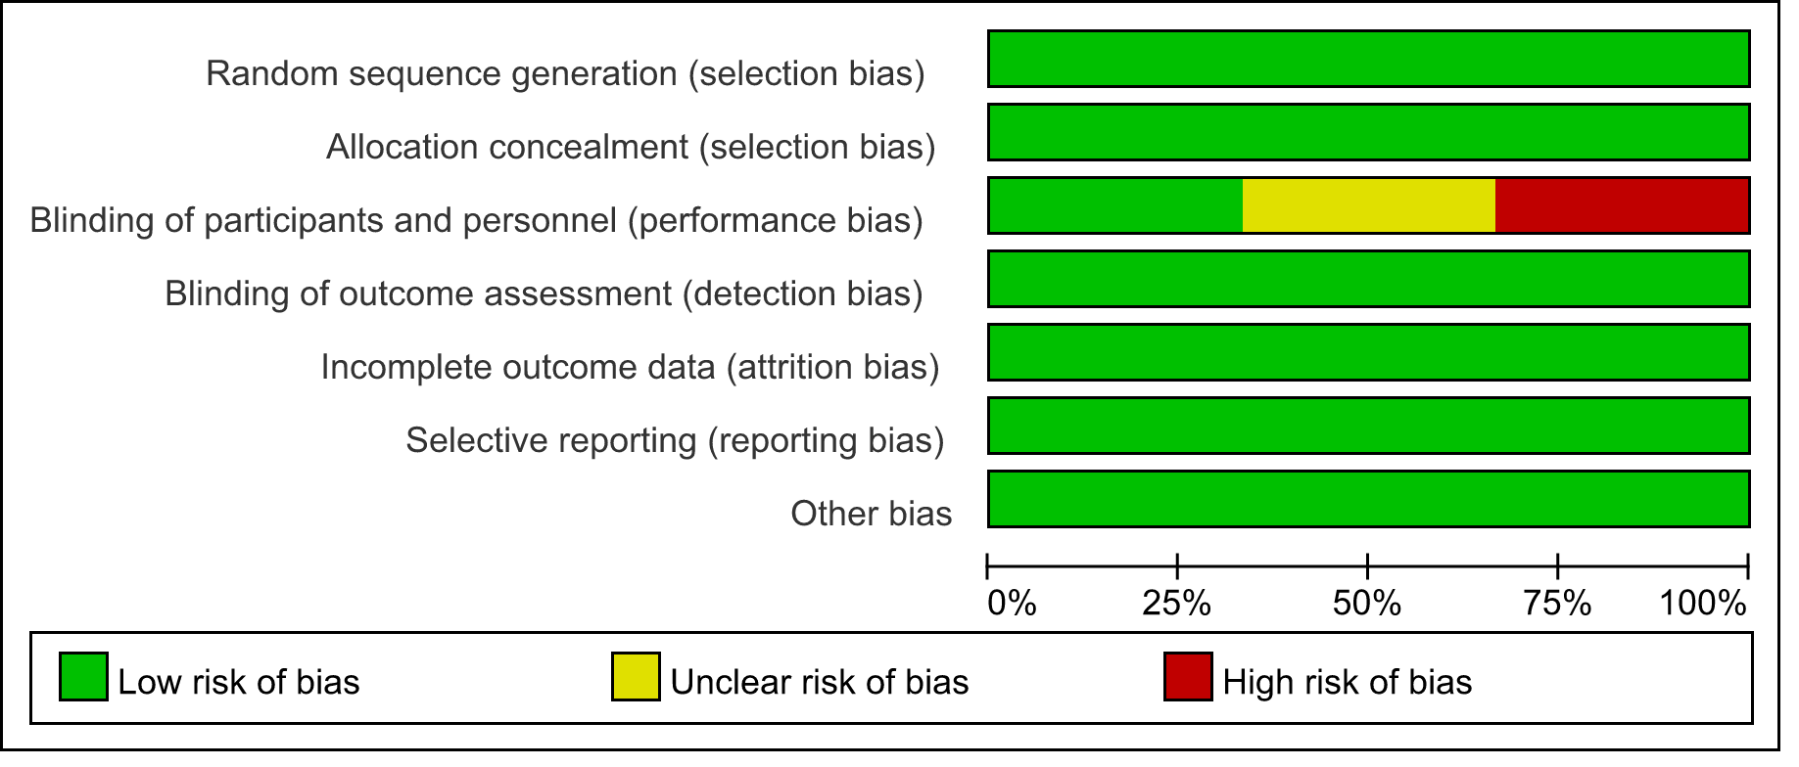

Fig. B Risk of Bias Summary: Review Authors’ Judgments About Each Risk of Bias Item for Each Included Study
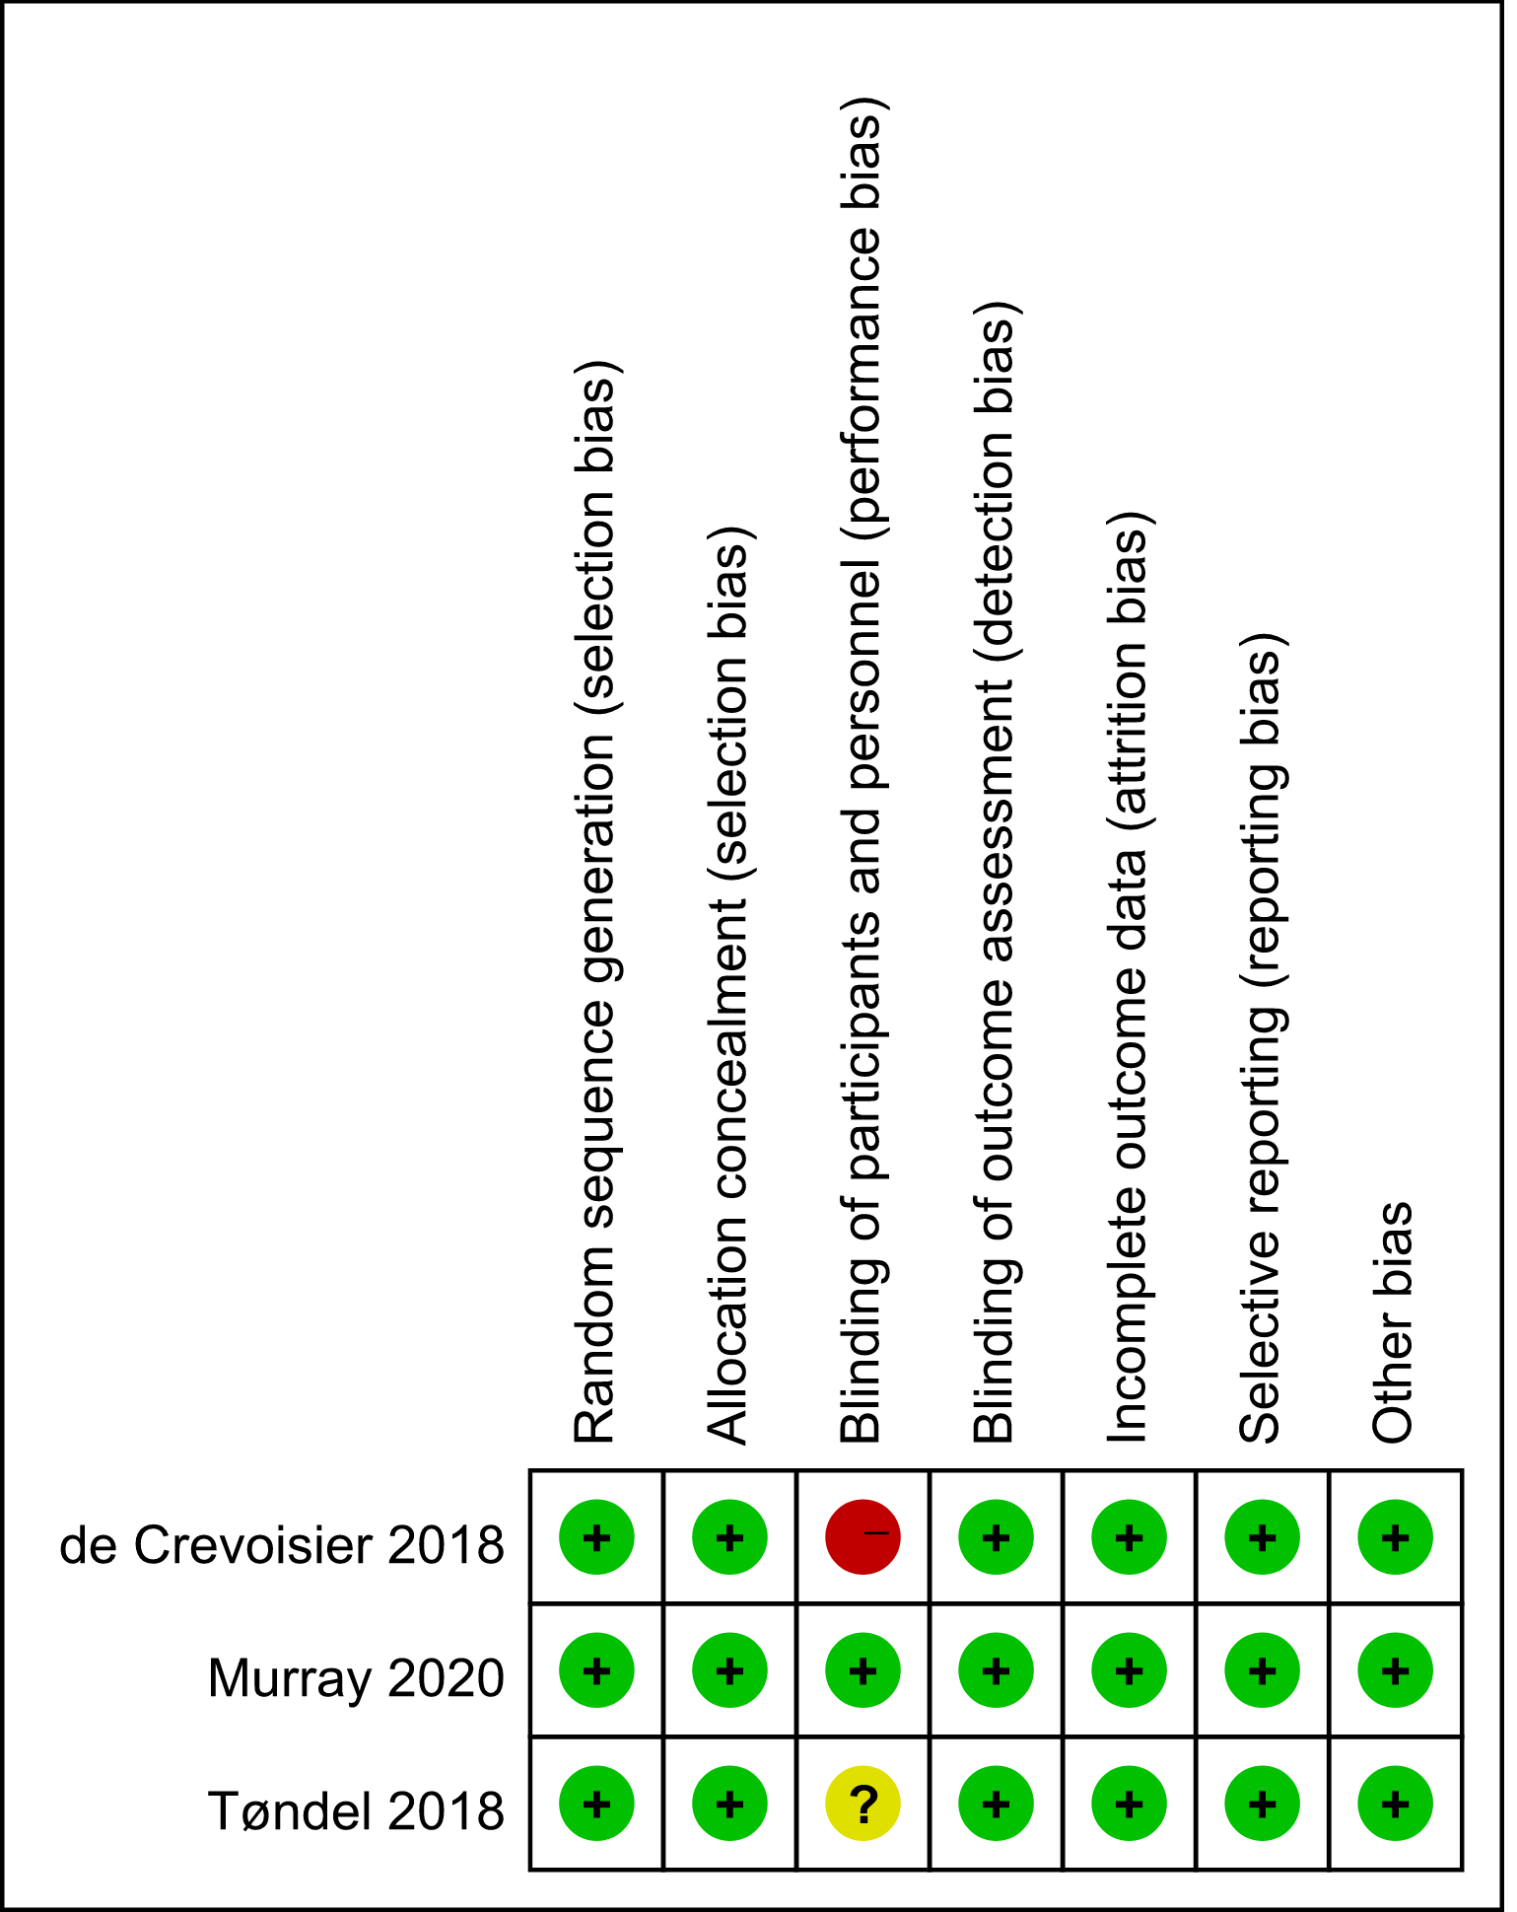

Supplementary Table 5. Newcastle-Ottawa Scale for Risk of Bias Assessment of the CRS
Study | Selection |  |  |  | Comparability | Outcome |  |  | Overall
Study | Representativeness  of exposed Cohort | Selection of  nonexposed | Ascertainment  of exposure | Outcome not present at start |  | Assessment of Outcome | Adequate follow-up length | Adequacy of  follow-up | Overall
Becker-Schiebe 2016 | ☆ | ☆ | ☆ | ☆ | ☆ | ☆ |  | ☆ | 7
Chung 2009 | ☆ |  | ☆ | ☆ | ☆ | ☆ | ☆ | ☆ | 7
Ghanem 2021 |  |  | ☆ | ☆ | ☆ | ☆ |  | ☆ | 5
Gill 2011 |  | ☆ | ☆ | ☆ | ☆☆ | ☆ | ☆ | ☆ | 8
Jereczek-fossa 2018 | ☆ | ☆ | ☆ | ☆ |  | ☆ | ☆ | ☆ | 7
Kok 2013 | ☆ | ☆ | ☆ | ☆ | ☆ | ☆ |  | ☆ | 7
Kuo 2021 | ☆ | ☆ | ☆ | ☆ | ☆ | ☆ |  | ☆ | 7
Rosenschold 2018 |  | ☆ | ☆ | ☆ | ☆ | ☆ |  | ☆ | 6
Singh 2013 | ☆ | ☆ | ☆ | ☆ | ☆ | ☆ |  | ☆ | 7
Stuk 2021 |  | ☆ | ☆ | ☆ | ☆ | ☆ |  | ☆ | 6
Sveistrup 2014 | ☆ |  | ☆ | ☆ | ☆ | ☆ |  | ☆ | 6
Valeriani 2013 | ☆ | ☆ | ☆ | ☆ | ☆ | ☆ |  | ☆ | 7
Wortel 2016 | ☆ | ☆ | ☆ | ☆ | ☆ | ☆ | ☆ | ☆ | 8
Zapatero 2017 | ☆ |  | ☆ | ☆ | ☆ | ☆ | ☆ | ☆ | 7
Zelefsky 2012 | ☆ |  | ☆ | ☆ | ☆ | ☆ |  | ☆ | 6
Zhong 2014 | ☆ |  | ☆ | ☆ | ☆ | ☆ | ☆ | ☆ | 7

Supplementary Table 6. One-Study-Removed Sensitivity Analyses of IGRT for Prostate Cancer
Outcome | Statistic | No. Studies | Main Analysis |  | One Study Removed*
Outcome | Statistic | No. Studies | Estimate | P-value | Worst Estimate | P-value | Best Estimate | P-value
Acute GU toxicity | Risk ratio | 9 | 0.78 | <0.001 | 0.84 | 0.01 | 0.76 | <0.01
Late GU toxicity | Risk ratio | 9 | 0.89 | 0.59 | 1.01 | 0.97 | 0.76 | 0.11
Acute GI toxicity | Risk ratio | 4 | 0.49 | <0.001 | 0.58 | <0.001 | 0.42 | <0.001
Late GI toxicity | Hazard ratio | 3 | 0.25 | 0.03 | 0.45 | 0.02 | 0.15 | 0.002
Acute rectal toxicity | Risk ratio | 4 | 0.70 | 0.56 | 1.18 | 0.74 | 0.40 | 0.07
PRFS | Hazard ratio | 2 | 0.43 | 0.03 | 0.54 | 0.27 | 0.33 | 0.05
BFFS | Hazard ratio | 3 | 0.57 | 0.003 | 0.68 | 0.13 | 0.51 | 0.003
OS | Hazard ratio | 2 | 1.34 | 0.47 | 2.12 | 0.04 | 0.93 | 0.77
SCM | Hazard ratio | 2 | 1.43 | 0.64 | 3.28 | 0.07 | 0.71 | 0.47
*Data derived from a one-study removed sensitivity analysis in which we iteratively removed one study at a time to determine whether conclusions were influenced by any single study. The worst (most favorable to controls) and best (most favorable to hydrogel spacer) estimates demarcate the range of values derived from the analysis of each outcome.

Supplementary Figure 2. Funnel Plots for Main Outcome Comparisons

Supplementary Fig. 2A Funnel Plot of the Meta-analysis for Acute GU
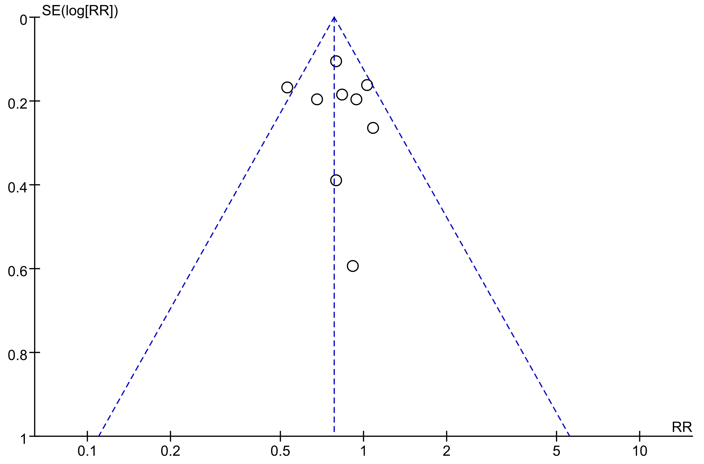

Supplementary Fig. 2B Funnel Plot of the Meta-analysis for Late GU
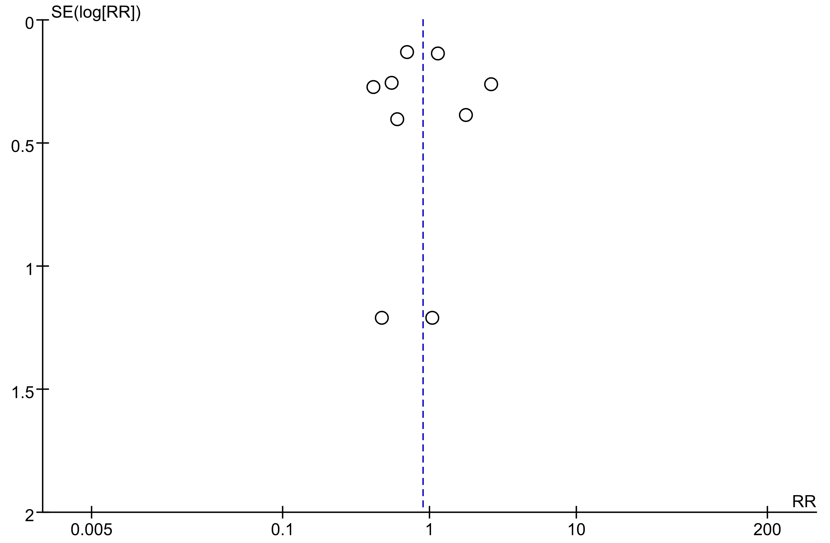

Supplementary Fig. 2C Funnel Plot of the Meta-analysis for Acute GI
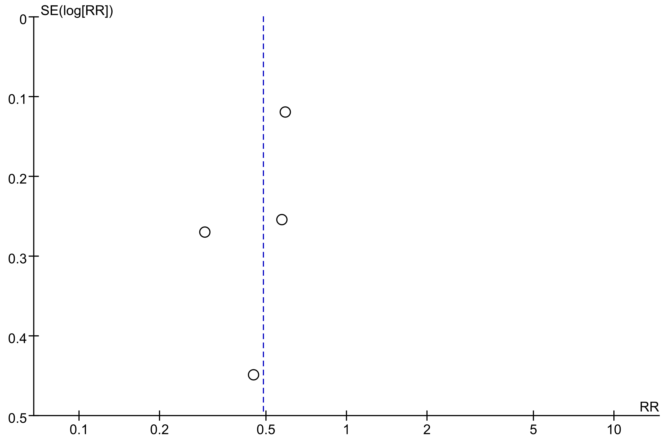

Supplementary Fig. 2D Funnel Plot of the Meta-analysis for Late GI
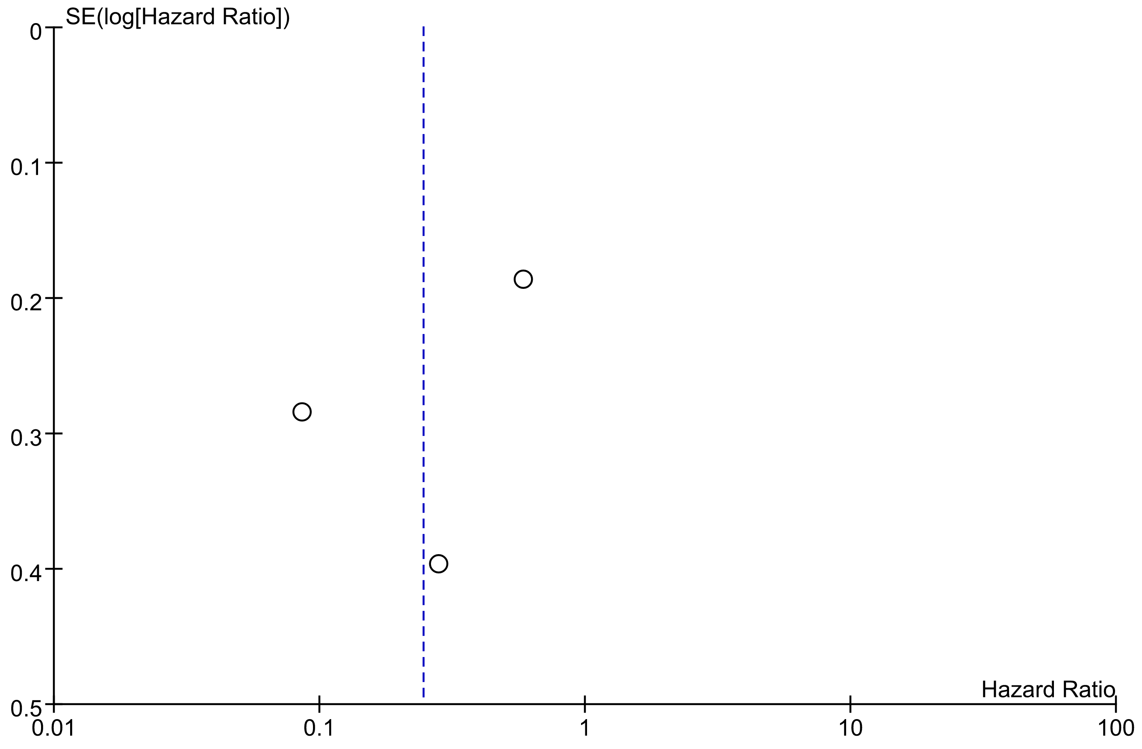

Supplementary Fig. 2E Funnel Plot of the Meta-analysis for Acute rectal
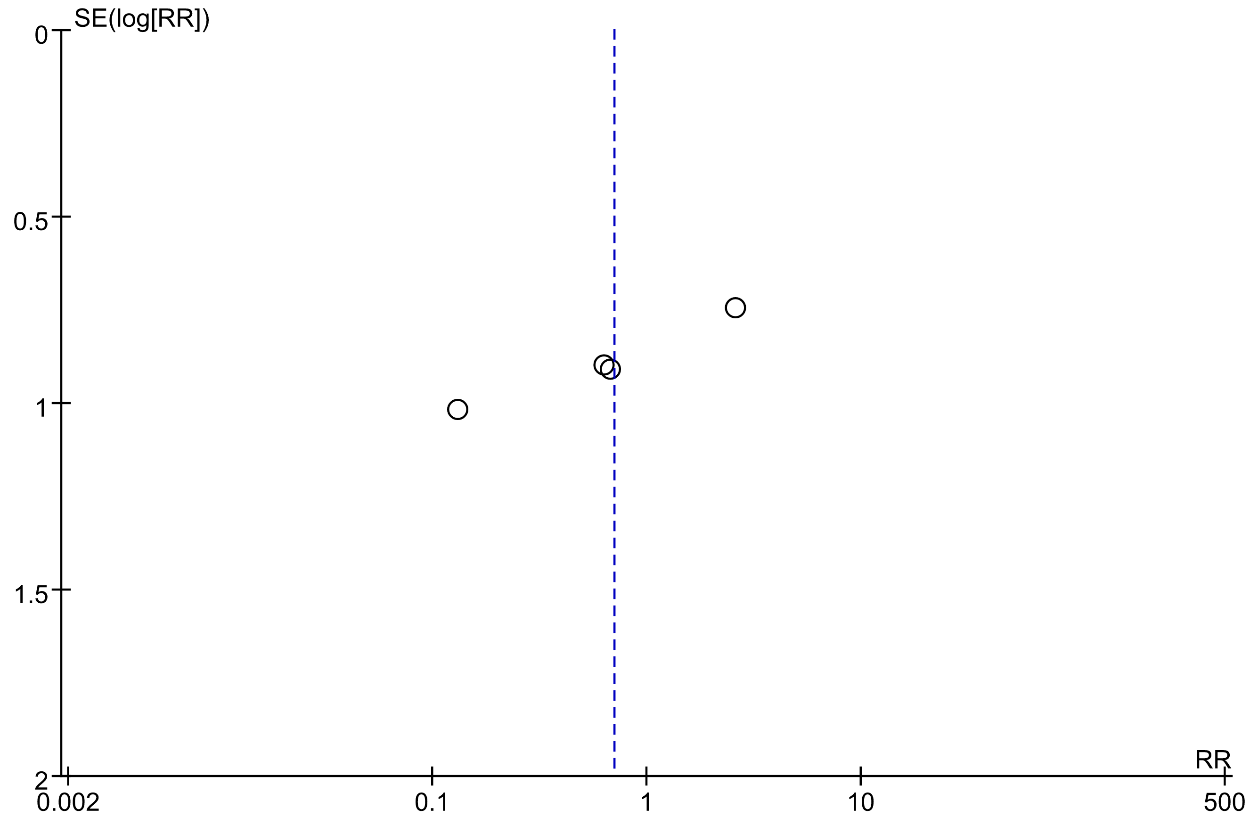

Supplementary Fig. 2F Funnel Plot of the Meta-analysis for PRFS
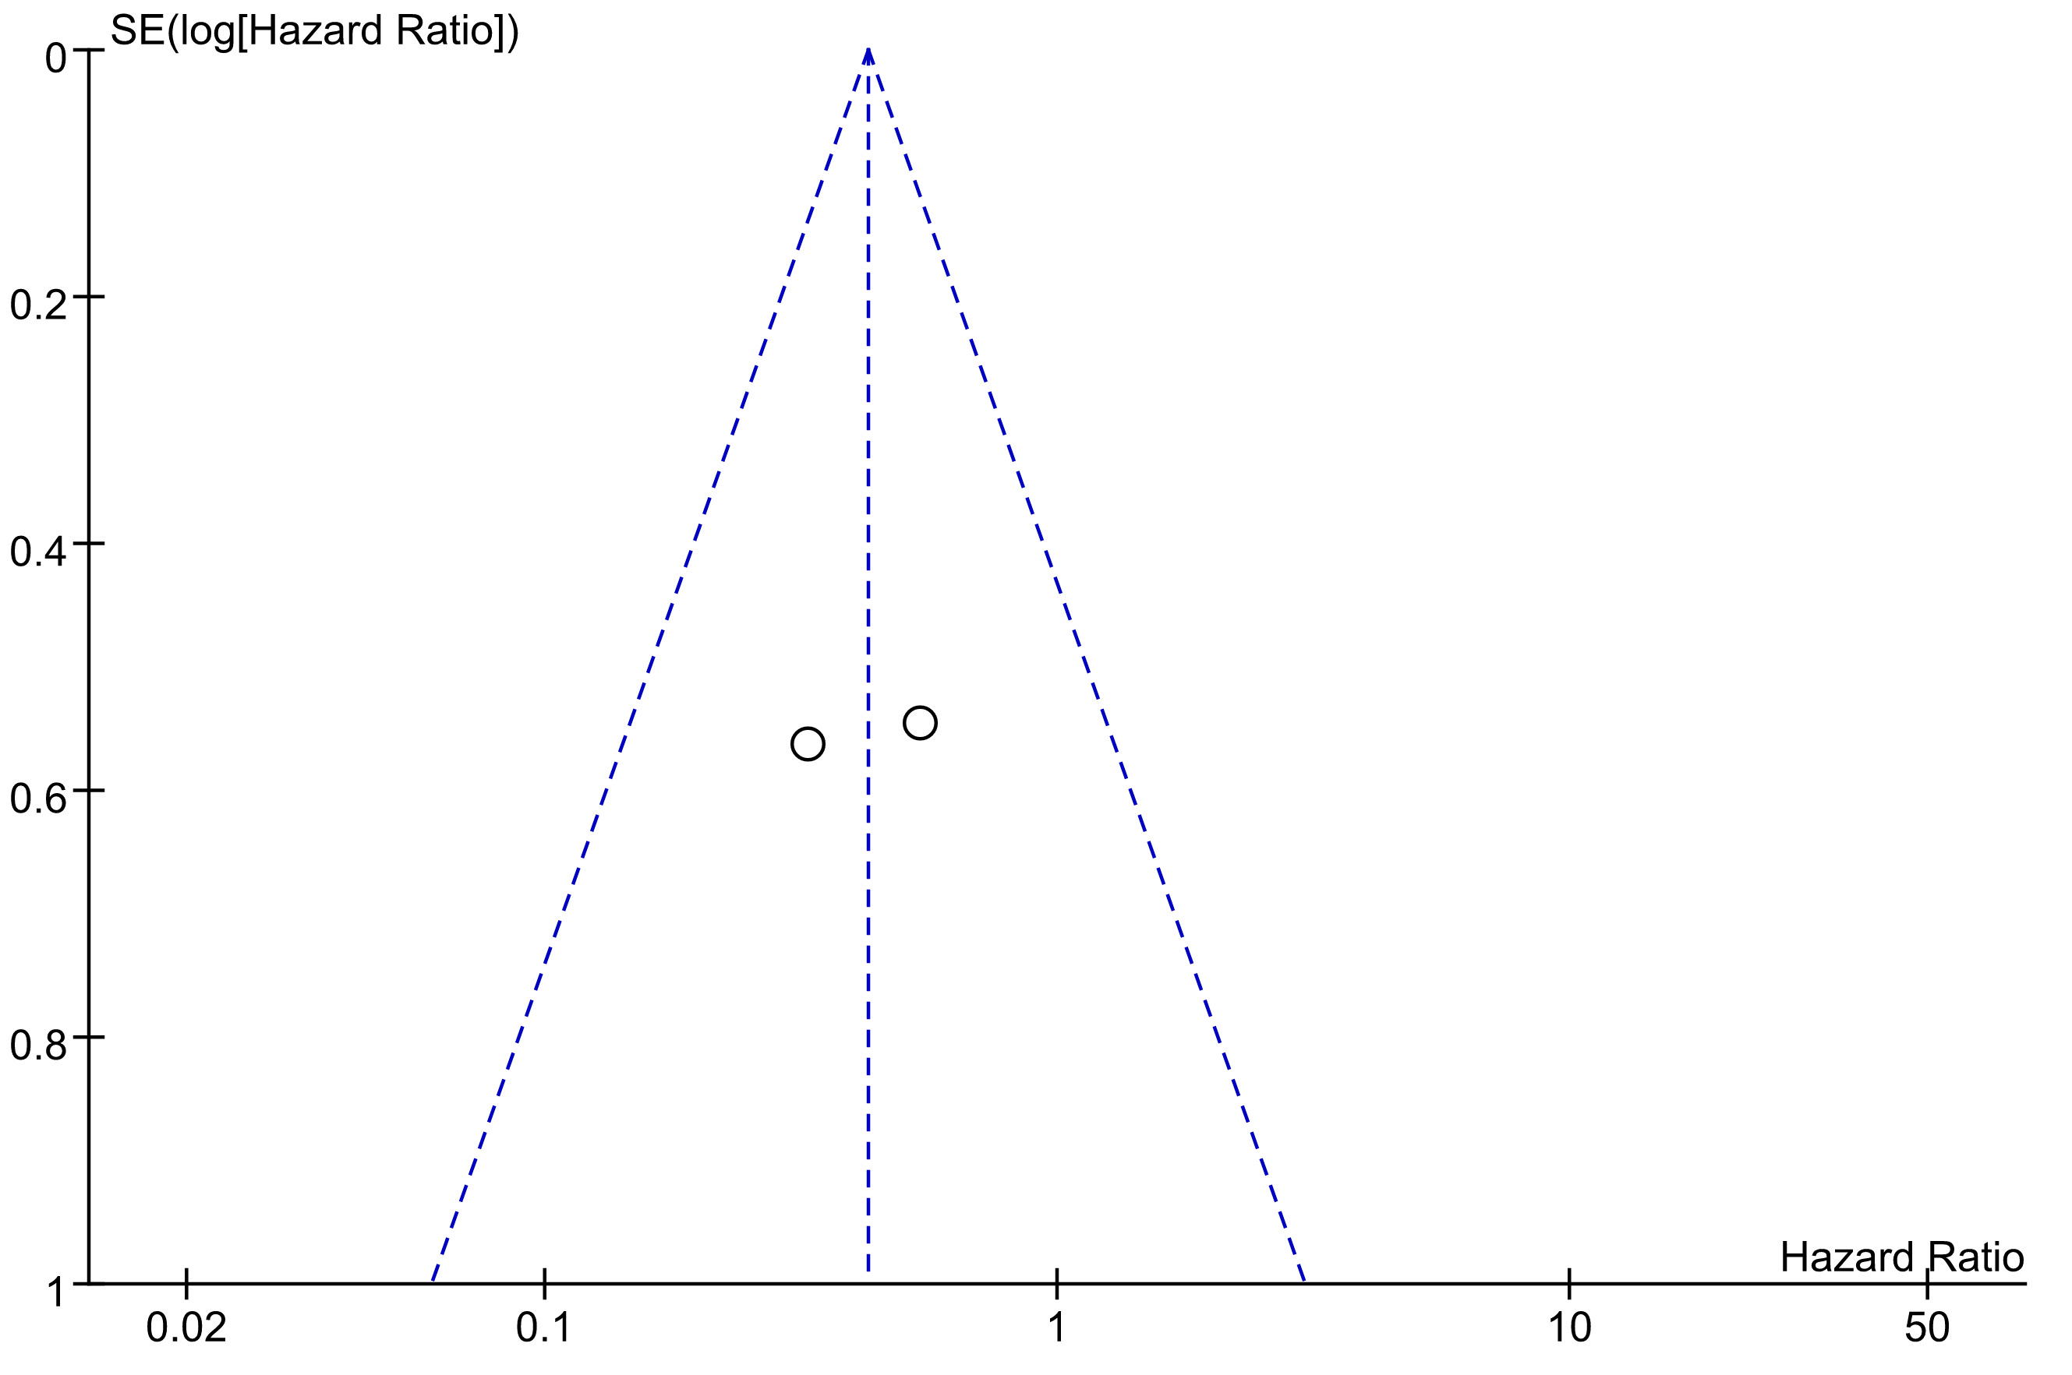

Supplementary Fig. 2G Funnel Plot of the Meta-analysis for BFFS
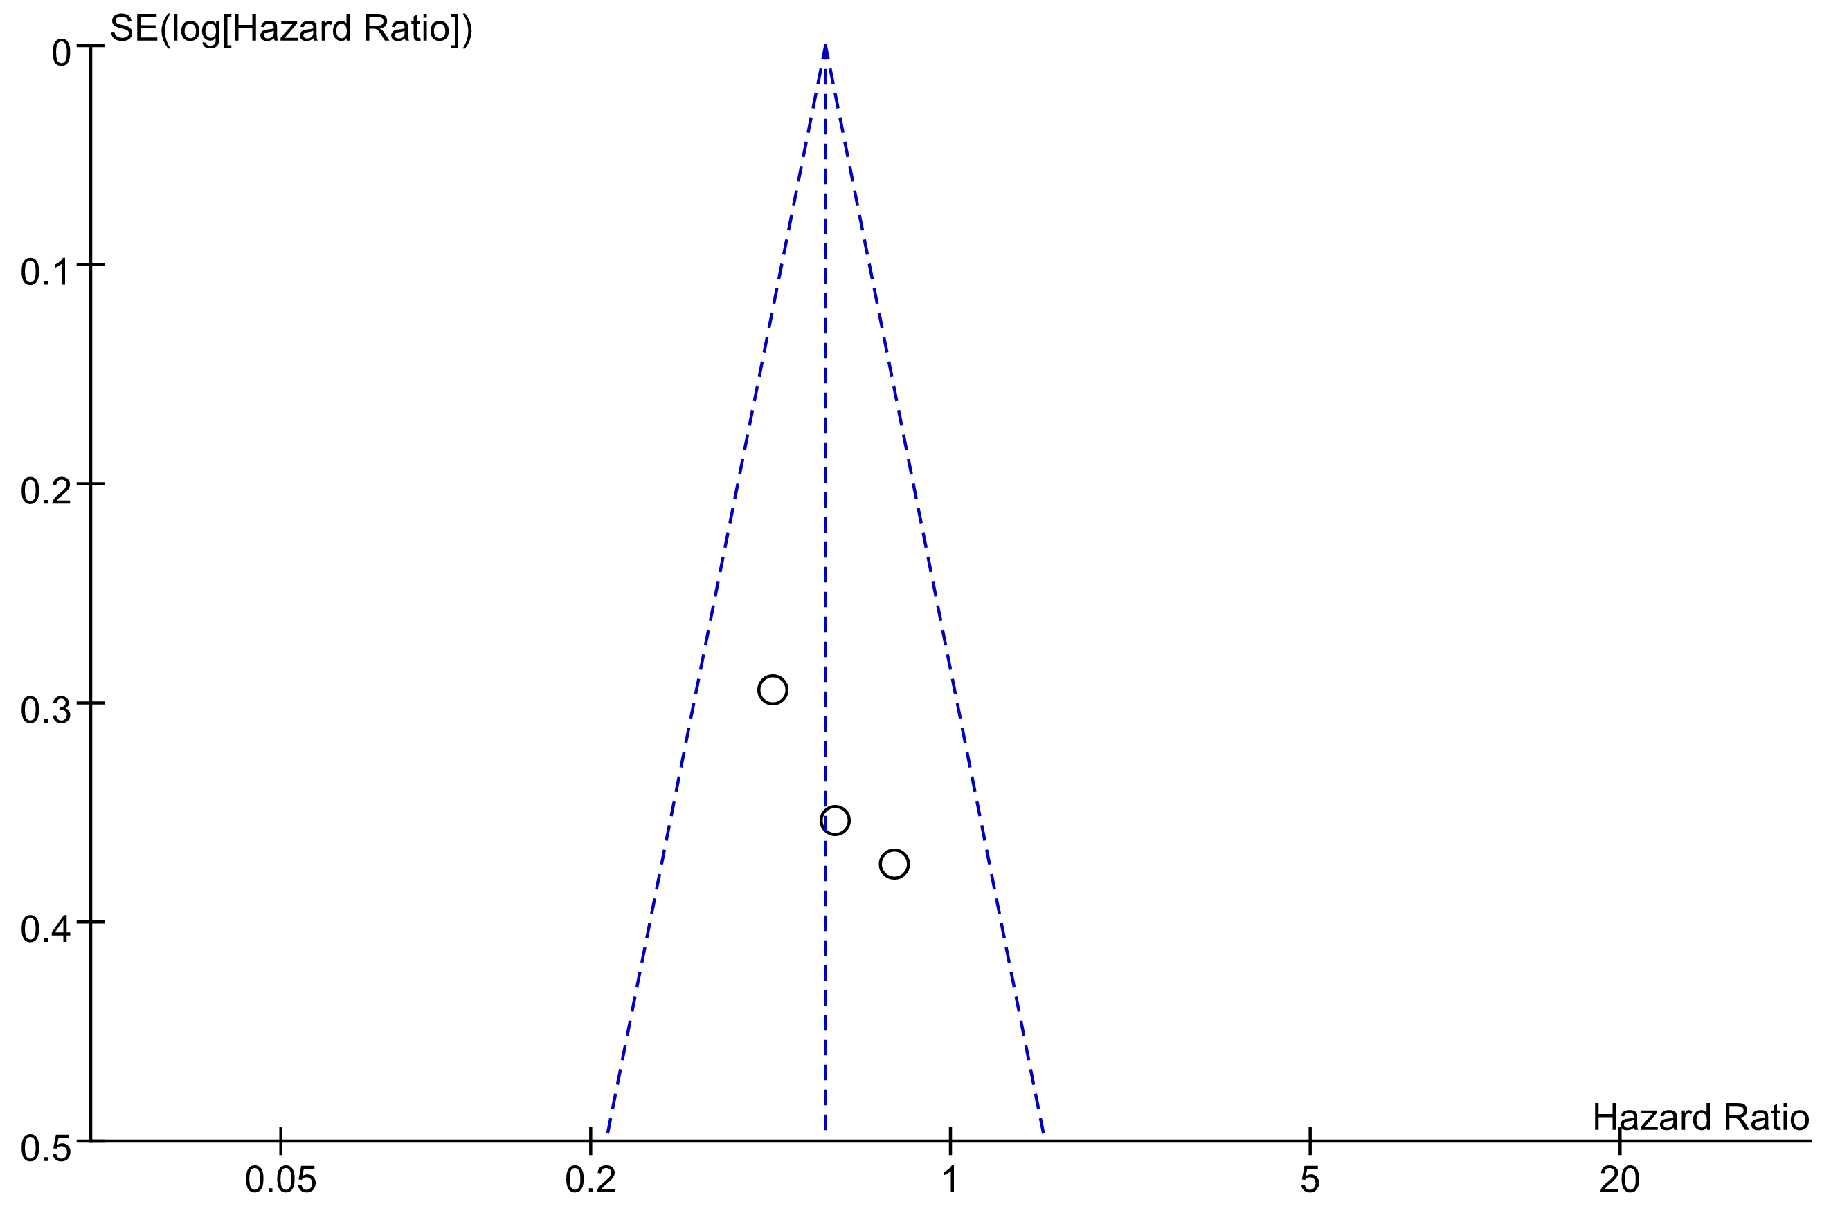

Supplementary Fig. 2H Funnel Plot of the Meta-analysis for OS
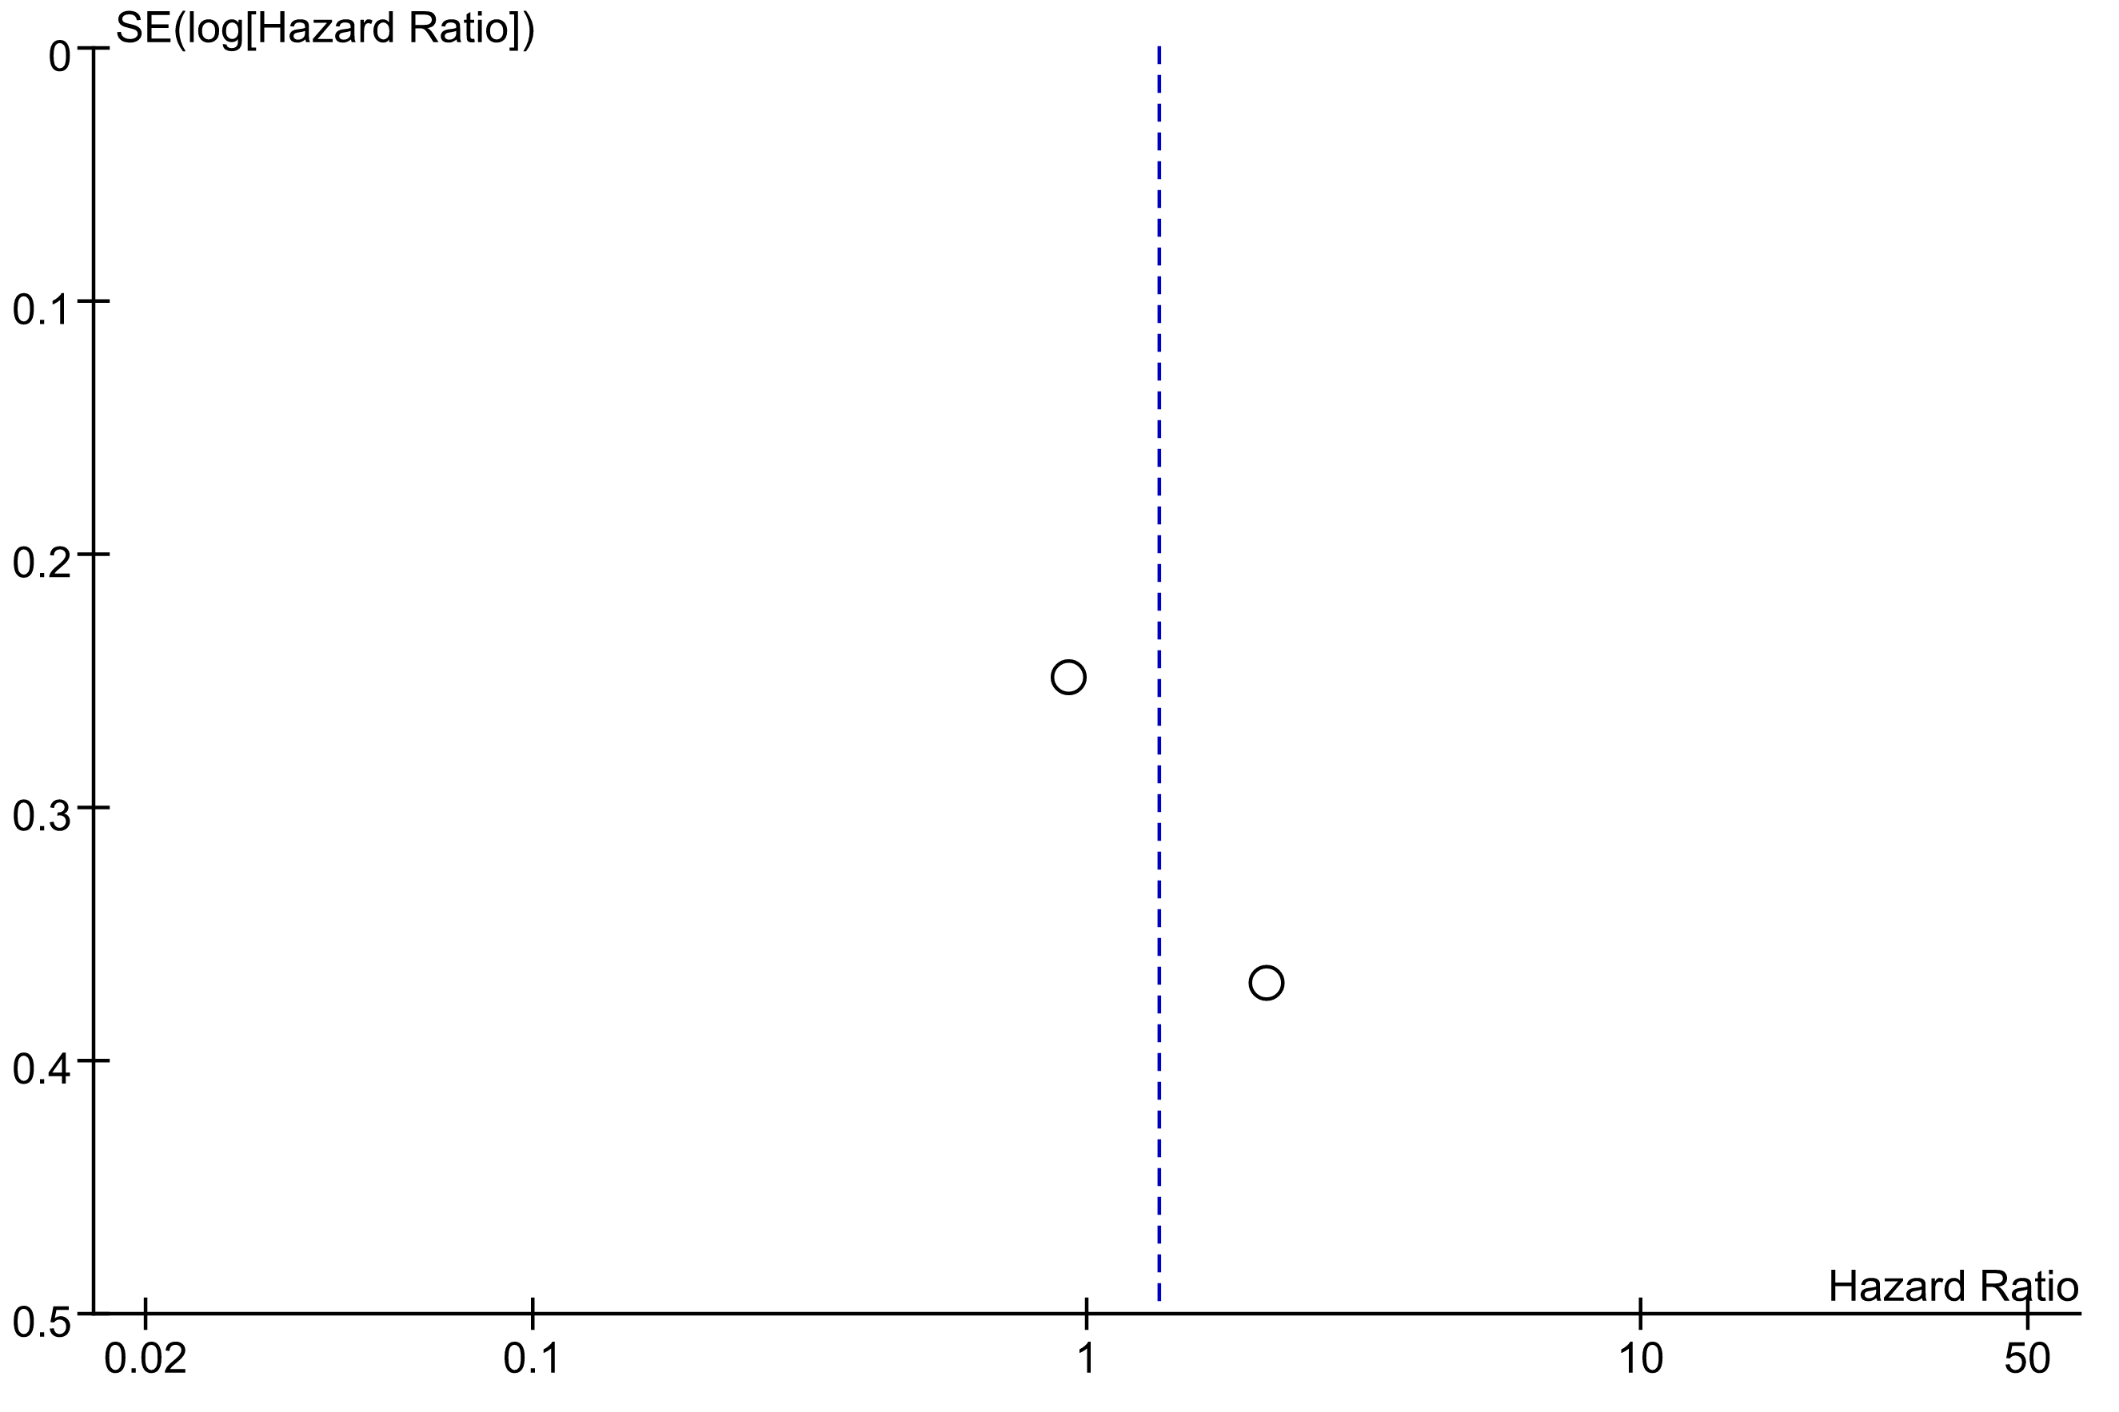

Supplementary Fig. 2I Funnel Plot of the Meta-analysis for SCM
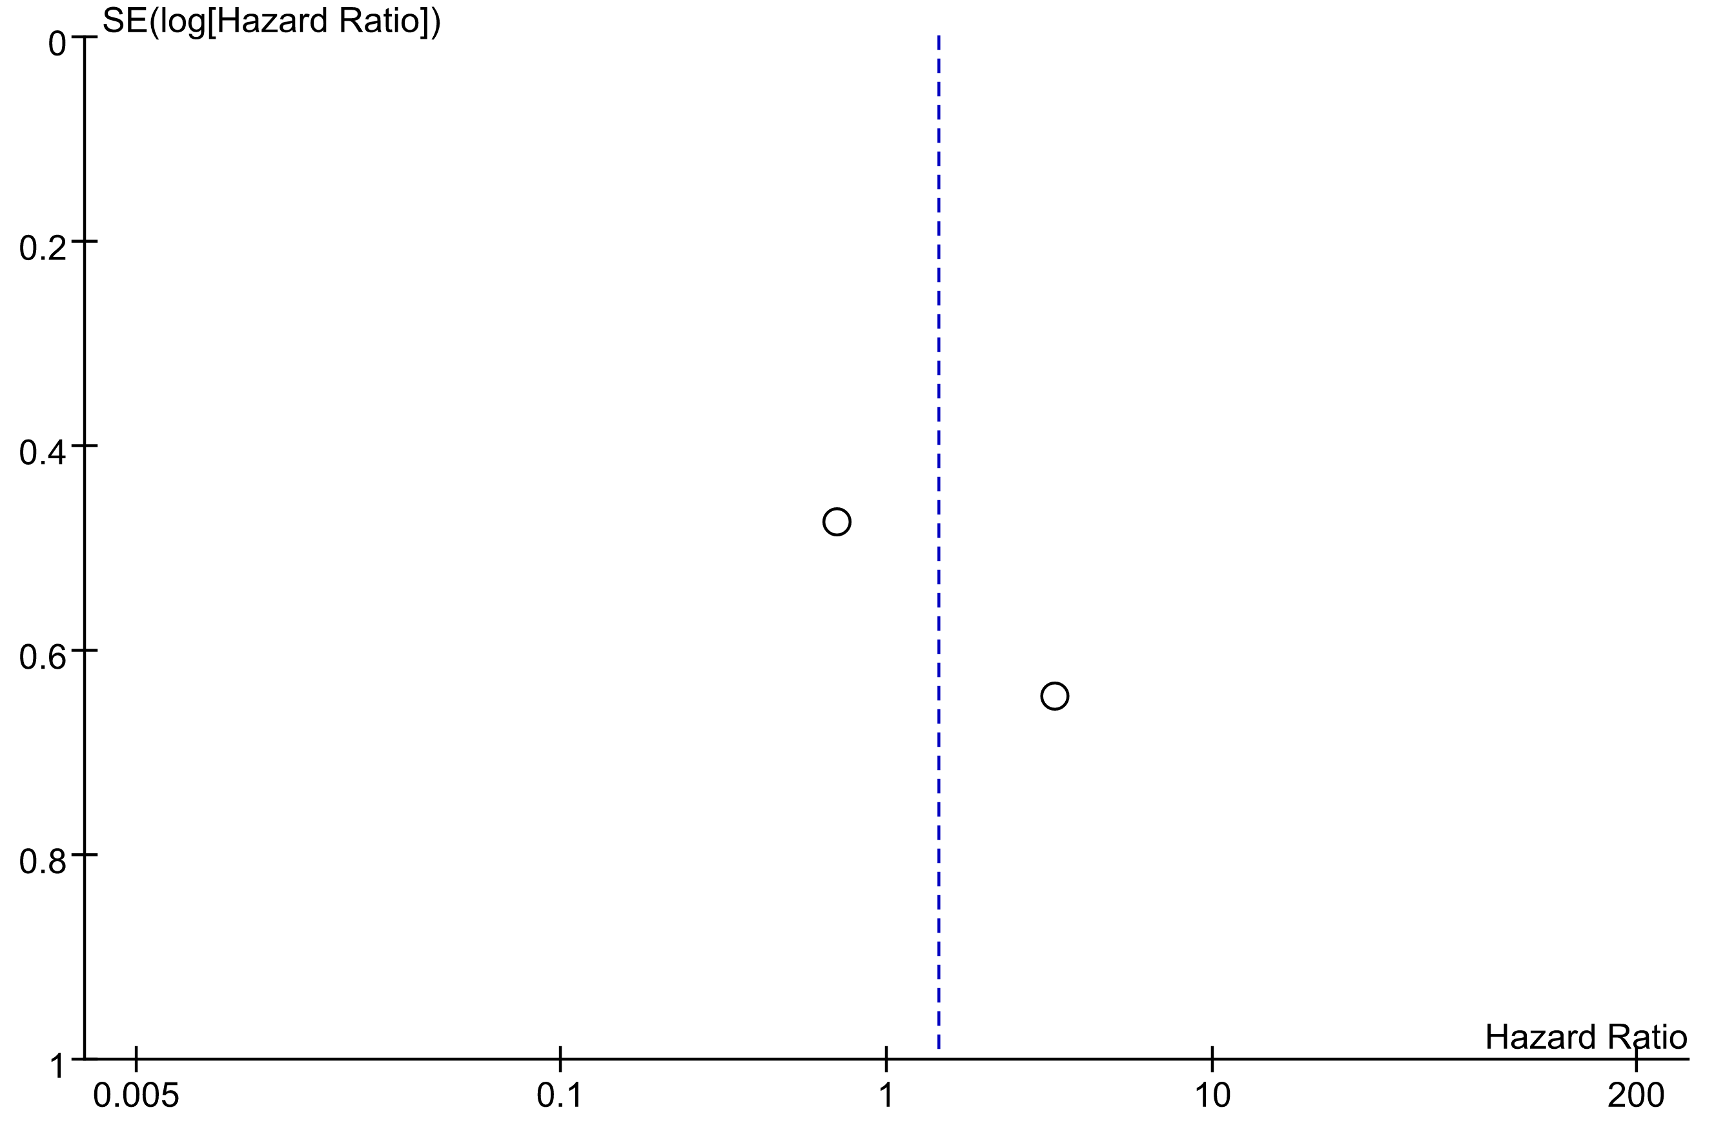

Supplementary Table 7. Egger’s Test for Binary Variables
Outcome | No. Studties | Bias (95% CI) | P Value
Acute GU | 9 | 0.240 (-2.307 to 2.787) | 0.830
Late GU | 9 | -0.964 (-5.341 to 3.413) | 0.619
Acute GI | 4 | -0.432 (-8.482 to 7.617) | 0.839
Acute rectal | 4 | 0.422 (-5.048 to 5.893) | 0.771
Interpretation: no evidence of publication bias

