Additional file 5: Forest plots of comparisons between antipsychotics (D2 blockers) and Placebo

RESTRICTED AND REPETITIVE INTERESTS AND BEHAVIORS 2
HYPERACTIVITY, INATTENTION, OPPOSITIVENESS, DISRUPTIVE BEHAVIOR. 3
SELF-HARM 3
SOCIAL COMMUNICATION, SOCIAL INTERACTION 4
EMOTIONAL DYSREGULATION/IRRITABILITY 5
ANXIETY 6
GLOBAL FUNCTIONING, GLOBAL IMPROVEMENT 7
OBSESSIONS, COMPULSIONS 8
SEVERE ADVERSE EVENTS 9
ADVERSE EVENTS 10
DROPOUT DUE TO ANY CAUSE 11
DROPOUT DUE TO ADVERSE EVENTS 12

RESTRICTED AND REPETITIVE INTERESTS AND BEHAVIORS
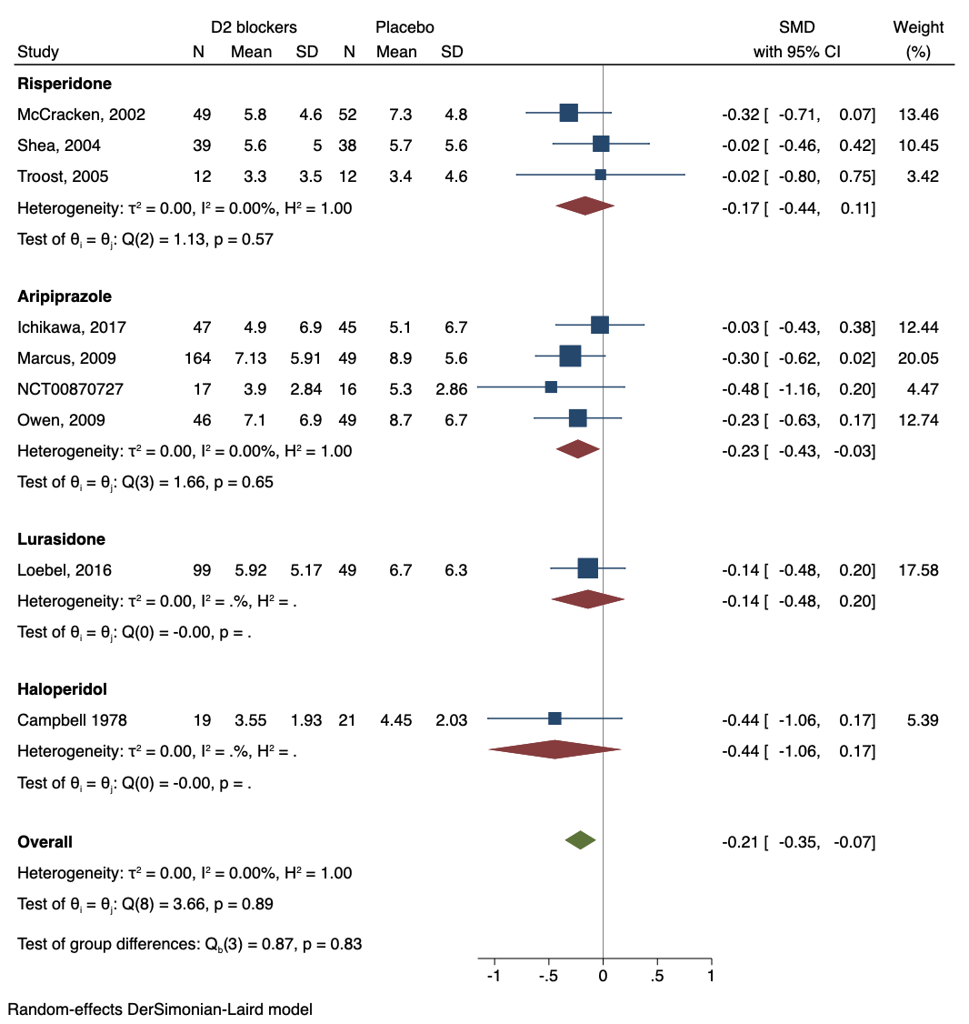

HYPERACTIVITY, INATTENTION, OPPOSITIVENESS, DISRUPTIVE BEHAVIOR.
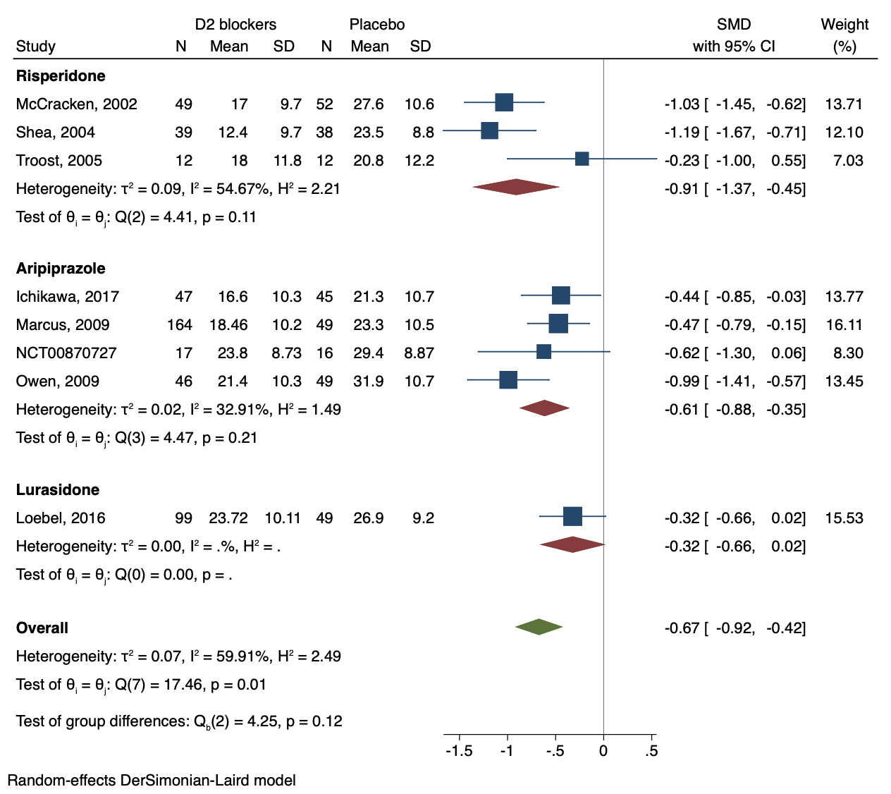

SELF-HARM
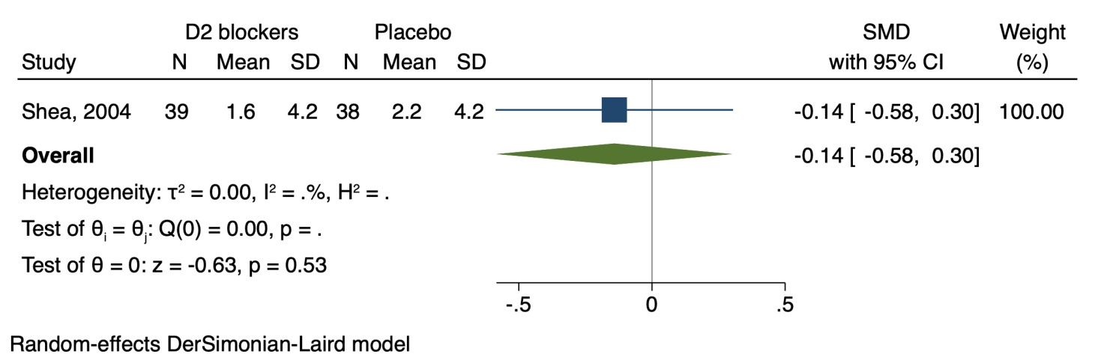

SOCIAL COMMUNICATION, SOCIAL INTERACTION
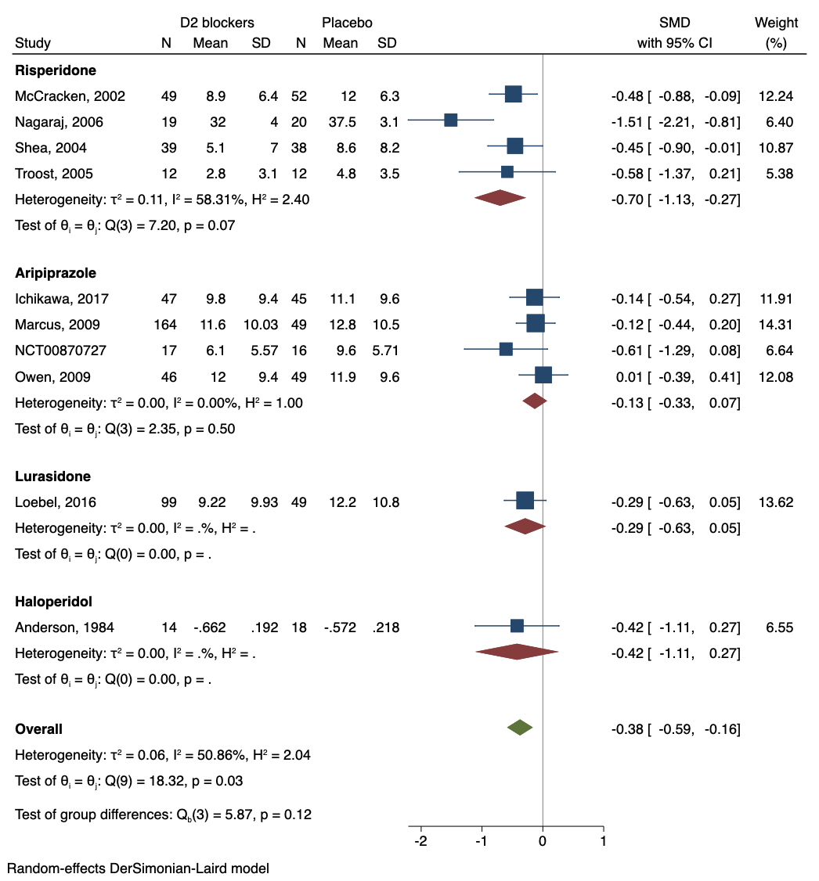

EMOTIONAL DYSREGULATION/IRRITABILITY
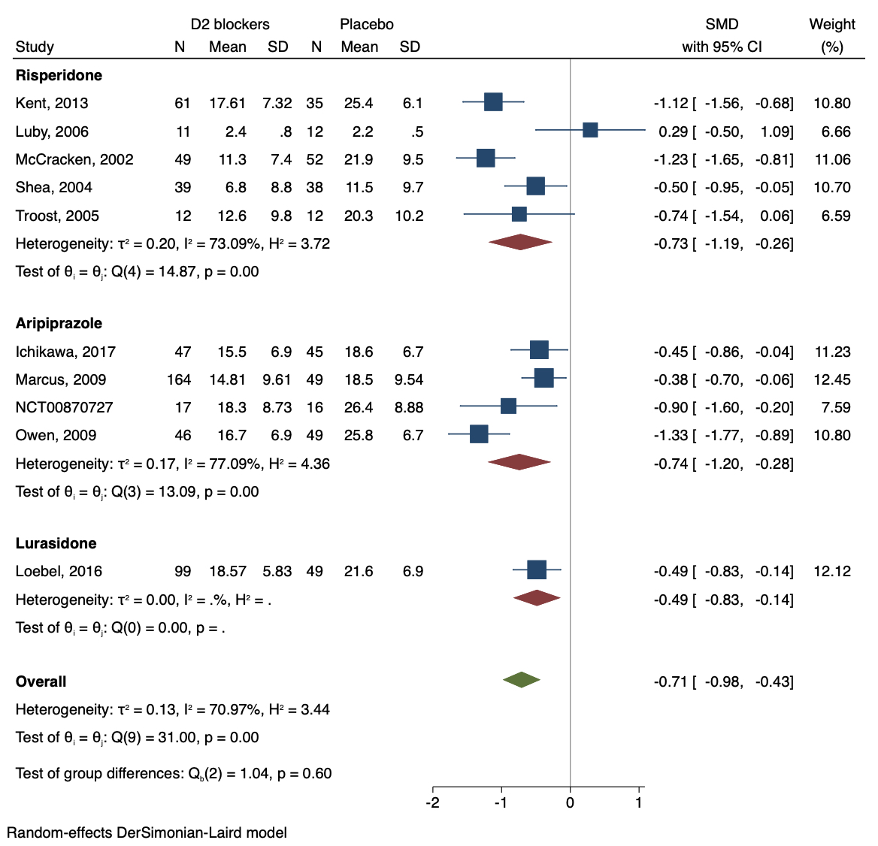

ANXIETY
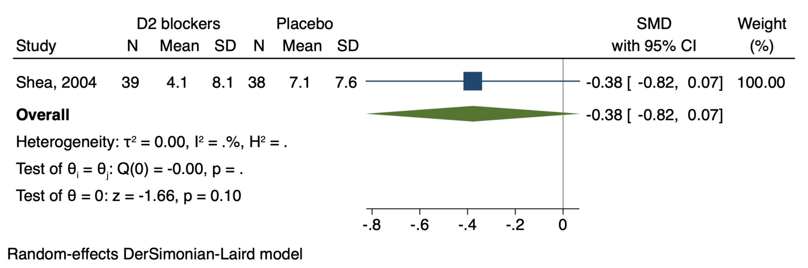

GLOBAL FUNCTIONING, GLOBAL IMPROVEMENT
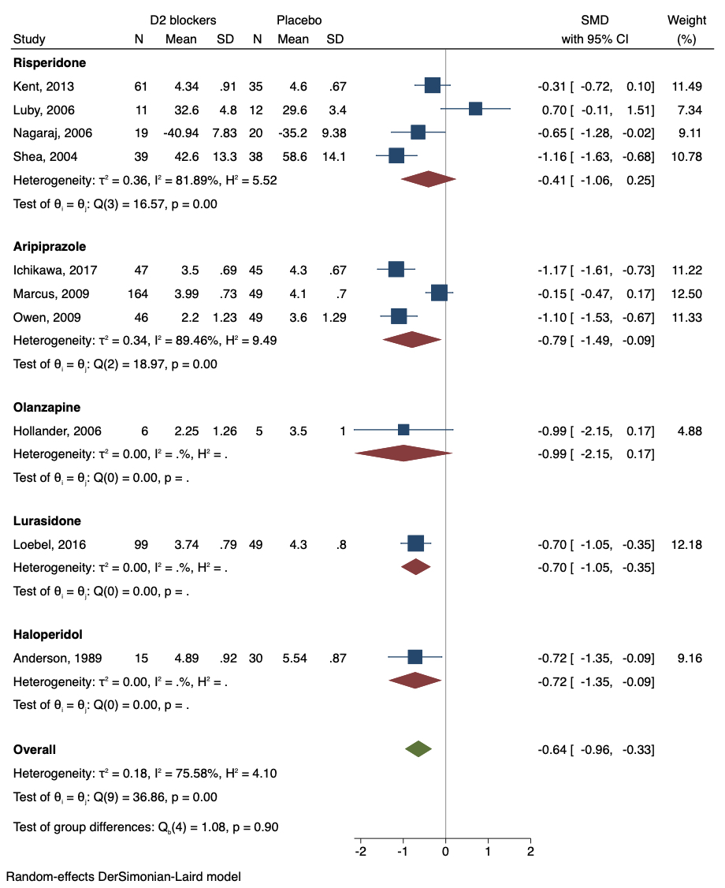

OBSESSIONS, COMPULSIONS
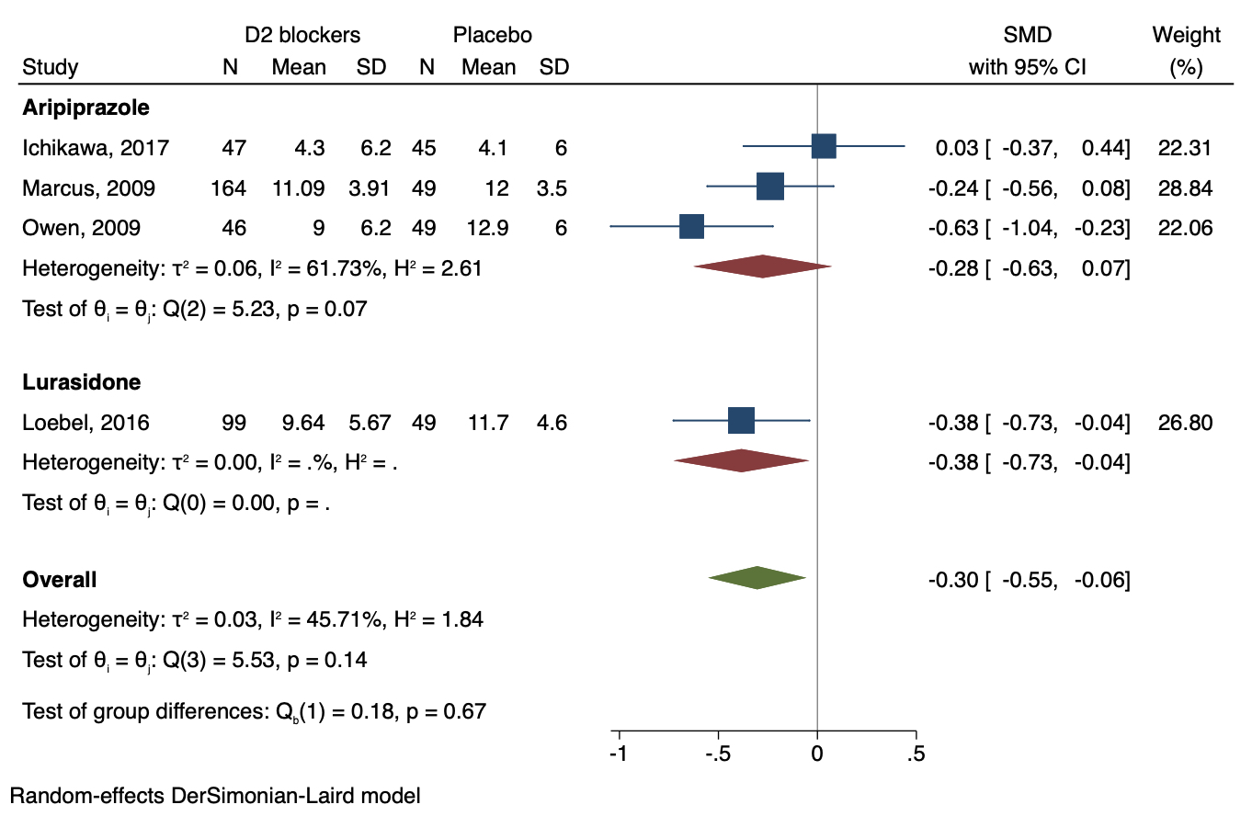

SEVERE ADVERSE EVENTS
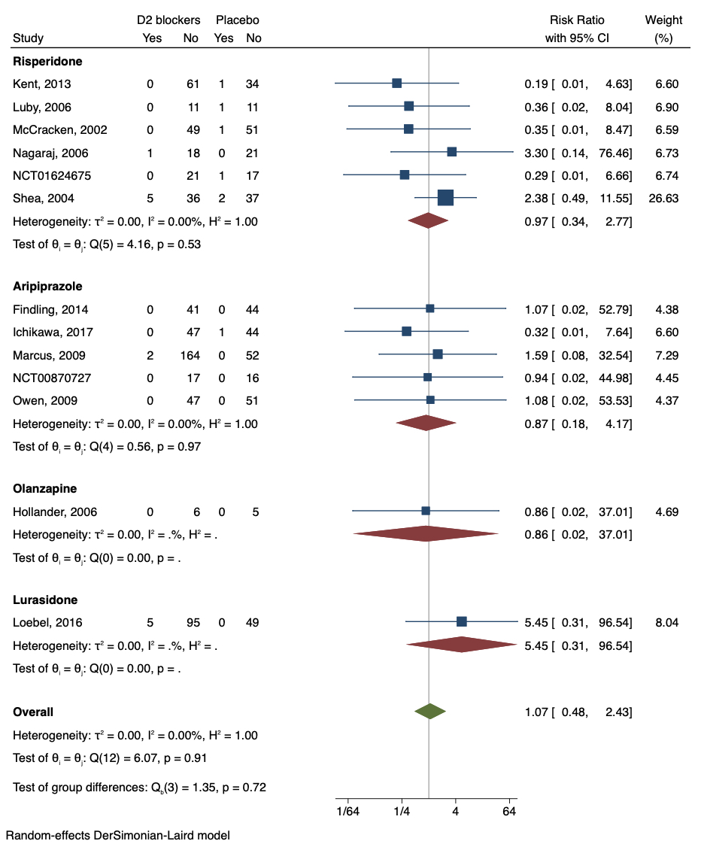

ADVERSE EVENTS
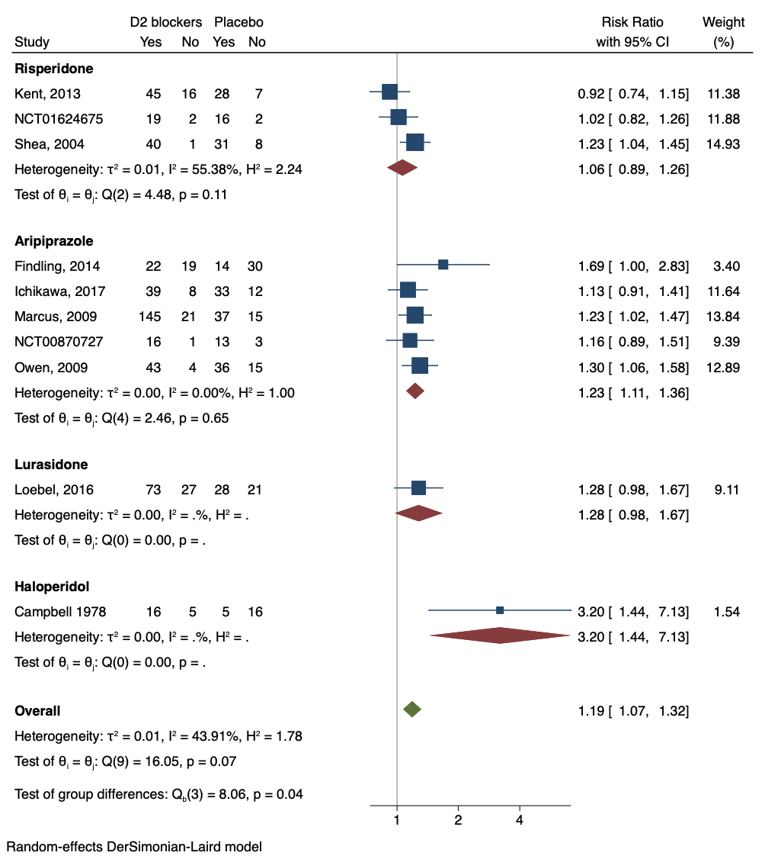

DROPOUT DUE TO ANY CAUSE
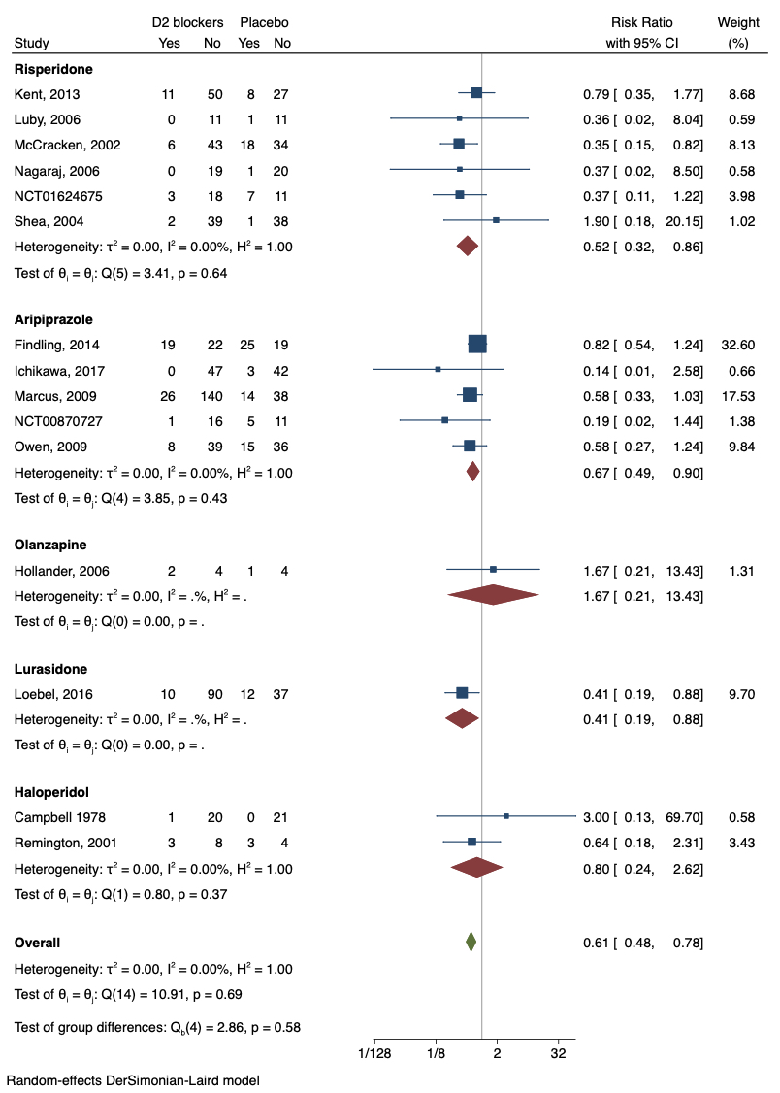

DROPOUT DUE TO ADVERSE EVENTS


