Additional file 6: Forest plots of comparisons between antipsychotics (D2 blockers) and Placebo – subgroup analyses (ABC-Irritability ≥18 vs All ASDs).

RESTRICTED AND REPETITIVE INTERESTS AND BEHAVIORS 2
HYPERACTIVITY, INATTENTION, OPPOSITIVENESS, DISRUPTIVE BEHAVIOR. 3
SELF-HARM 3
SOCIAL COMMUNICATION, SOCIAL INTERACTION 4
EMOTIONAL DYSREGULATION/IRRITABILITY 5
ANXIETY 5
GLOBAL FUNCTIONING, GLOBAL IMPROVEMENT 6
OBSESSIONS, COMPULSIONS 7
SEVERE ADVERSE EVENTS 8
ADVERSE EVENTS 9
DROPOUT DUE TO ANY CAUSE 10
DROPOUT DUE TO ADVERSE EVENTS 11

RESTRICTED AND REPETITIVE INTERESTS AND BEHAVIORS
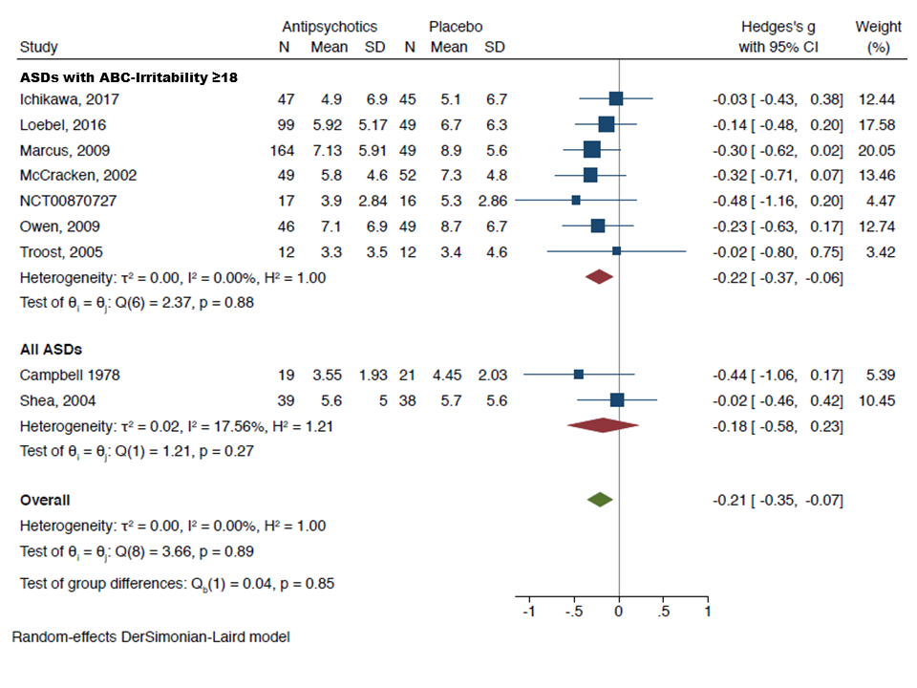

HYPERACTIVITY, INATTENTION, OPPOSITIVENESS, DISRUPTIVE BEHAVIOR.
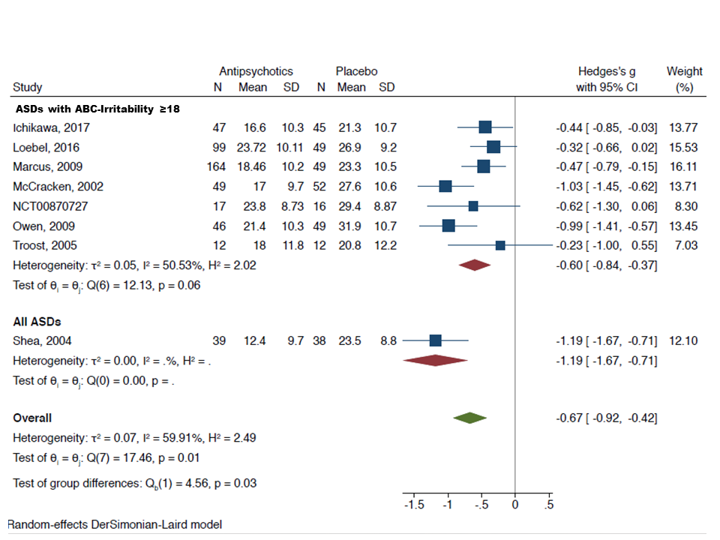

SELF-HARM (All ASDs)
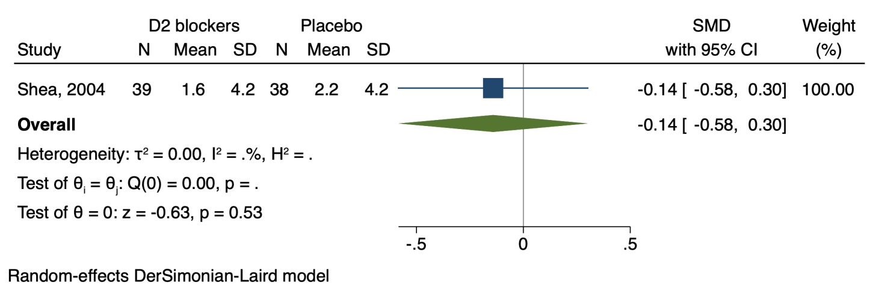

SOCIAL COMMUNICATION, SOCIAL INTERACTION
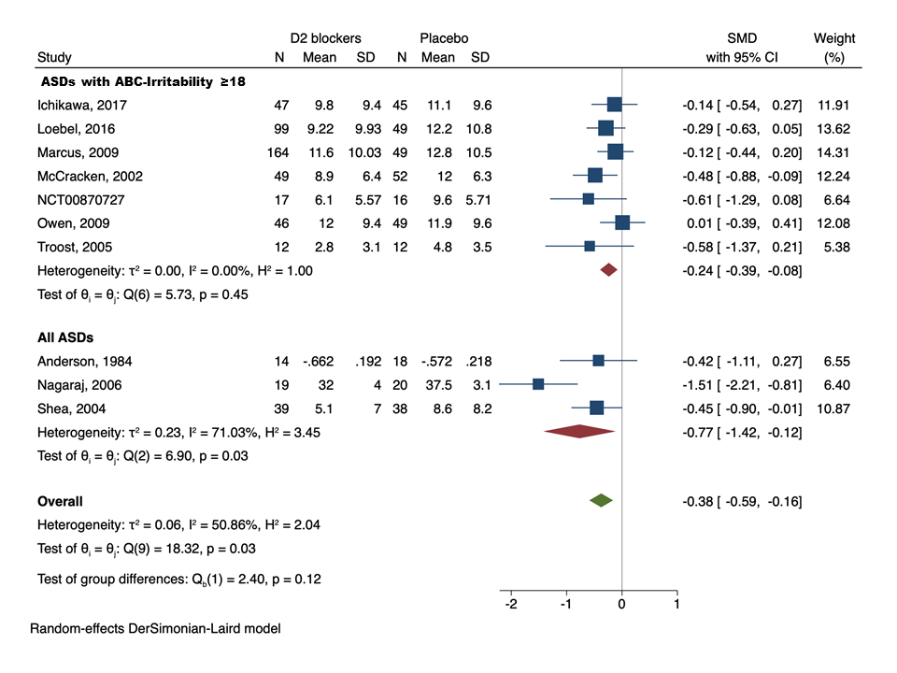

EMOTIONAL DYSREGULATION/IRRITABILITY
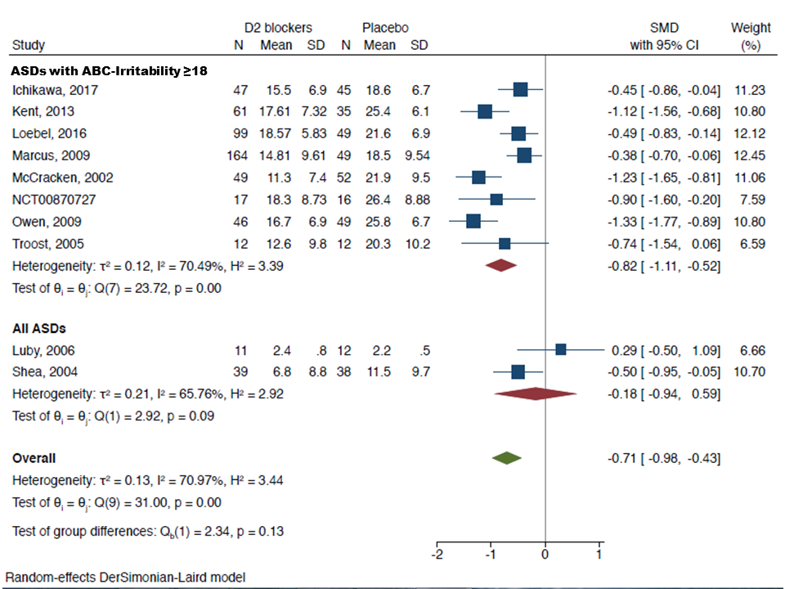

ANXIETY (All ASDs)
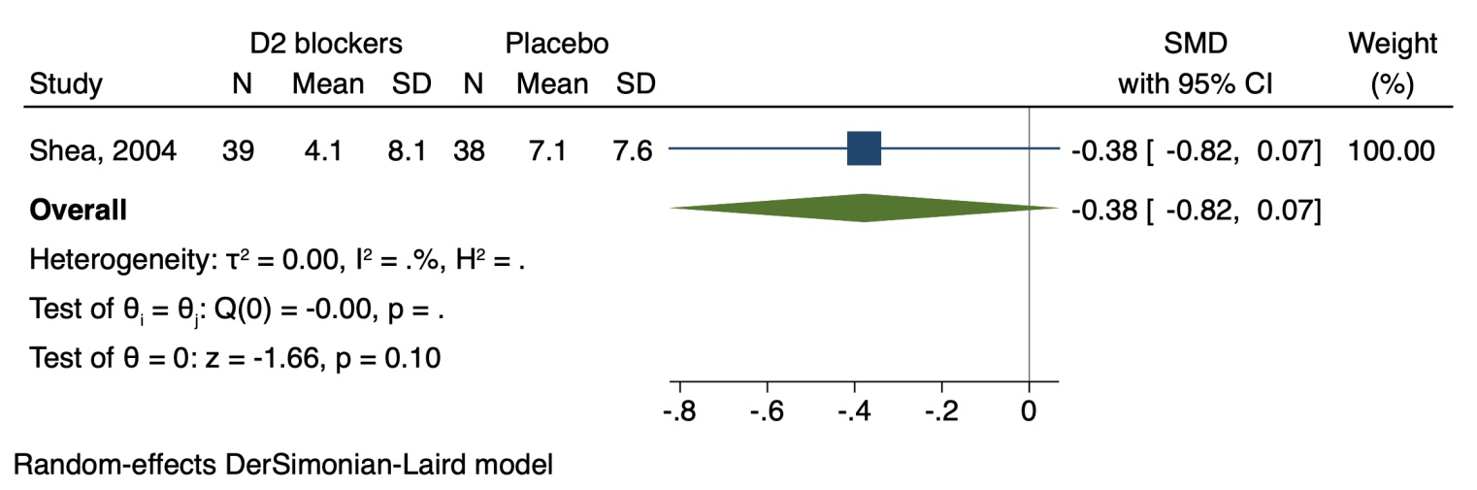

GLOBAL FUNCTIONING, GLOBAL IMPROVEMENT
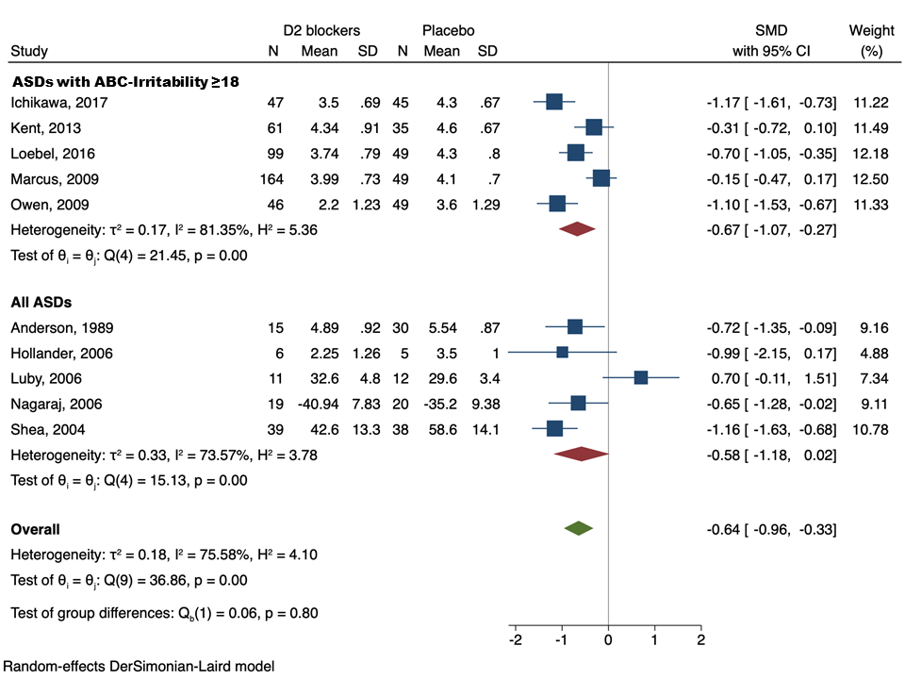

OBSESSIONS, COMPULSIONS
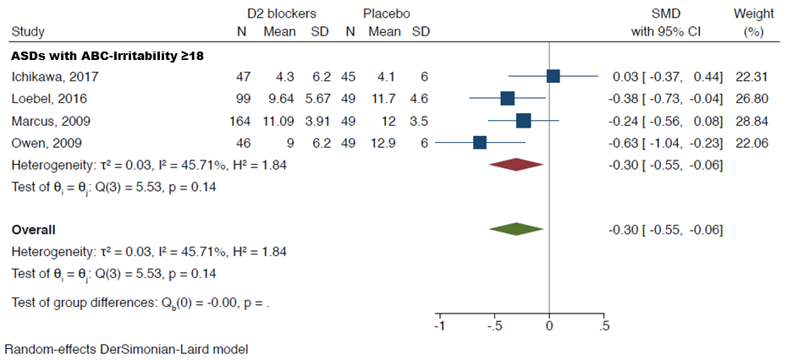

SEVERE ADVERSE EVENTS
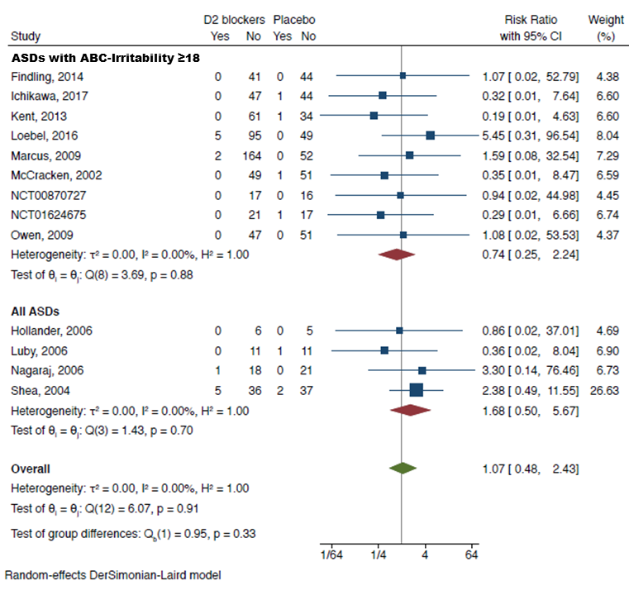

ADVERSE EVENTS
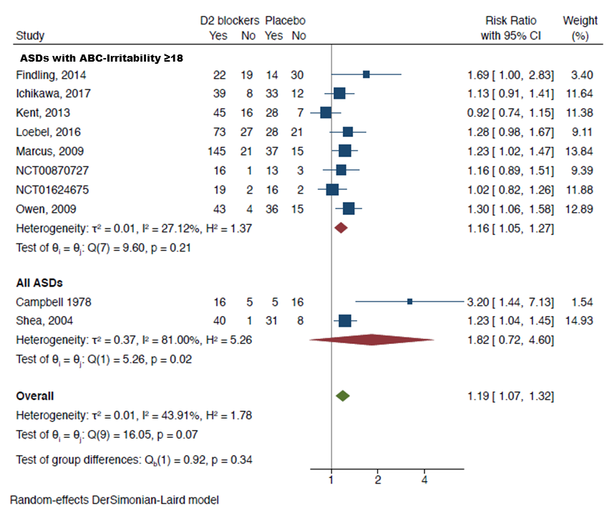

DROPOUT DUE TO ANY CAUSE
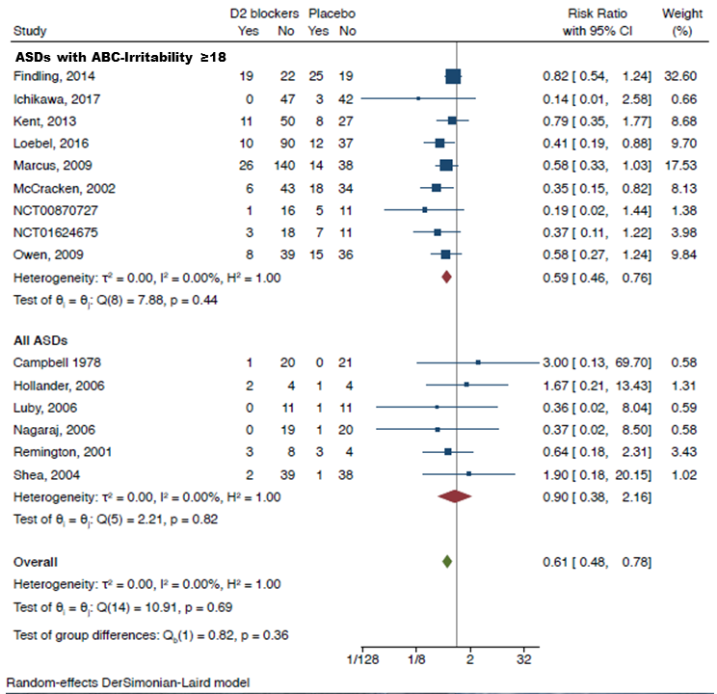

DROPOUT DUE TO ADVERSE EVENTS


