Additional file 7. Funnel Plots for outcome with estimates for at least 8 studies.

RESTRICTED AND REPETITIVE INTERESTS AND BEHAVIORS 2
HYPERACTIVITY, INATTENTION, OPPOSITIVENESS, DISRUPTIVE BEHAVIOR. 3
SOCIAL COMMUNICATION, SOCIAL INTERACTION 4
EMOTIONAL DYSREGULATION/IRRITABILITY 5
GLOBAL FUNCTIONING, GLOBAL IMPROVEMENT 6
SEVERE ADVERSE EVENTS 7
ADVERSE EVENTS 8
DROPOUT DUE TO ANY CAUSE 9
DROPOUT DUE TO ADVERSE EVENTS 10

RESTRICTED AND REPETITIVE INTERESTS AND BEHAVIORS

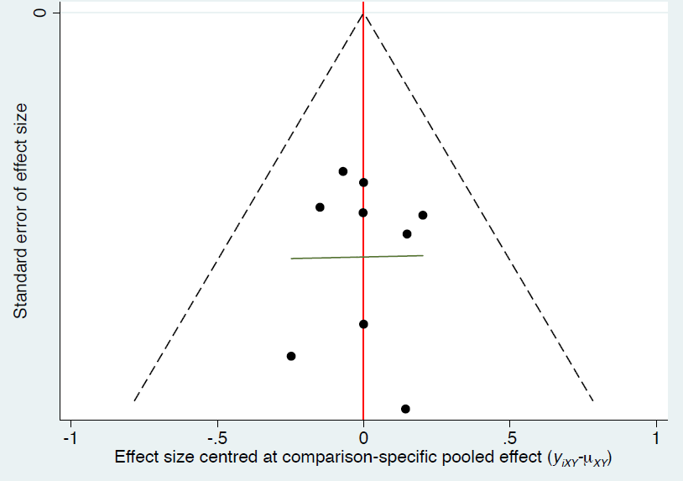

HYPERACTIVITY, INATTENTION, OPPOSITIVENESS, DISRUPTIVE BEHAVIOR.
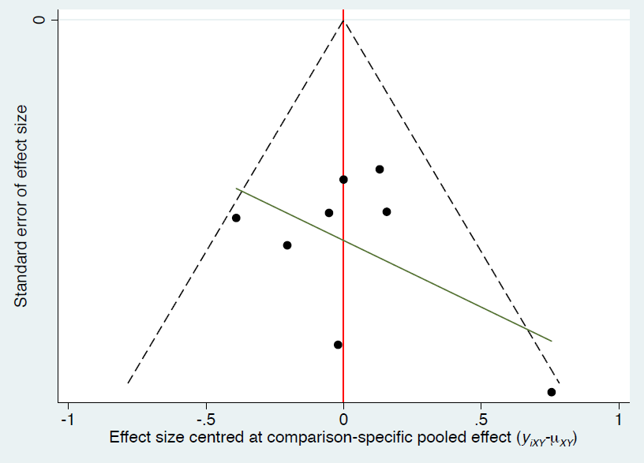

SOCIAL COMMUNICATION, SOCIAL INTERACTION
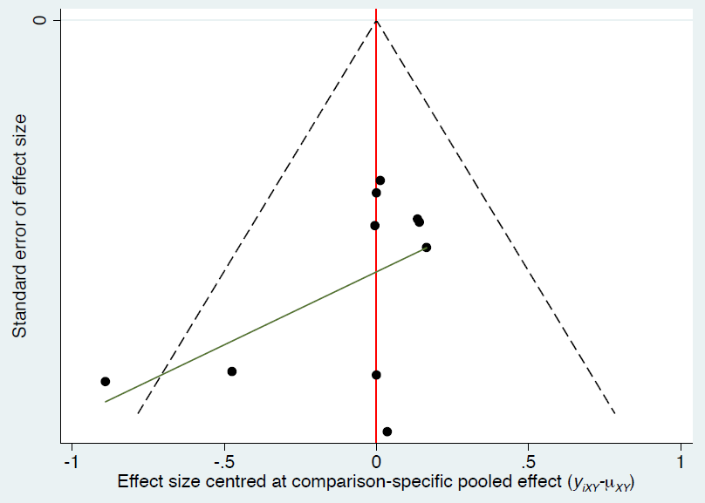

EMOTIONAL DYSREGULATION/IRRITABILITY
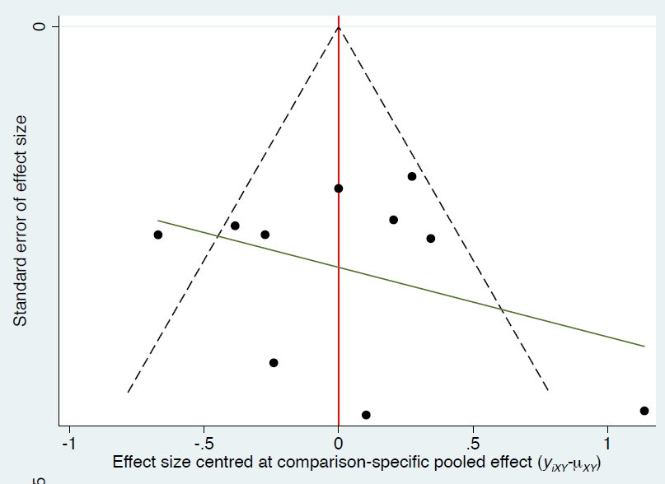

GLOBAL FUNCTIONING, GLOBAL IMPROVEMENT
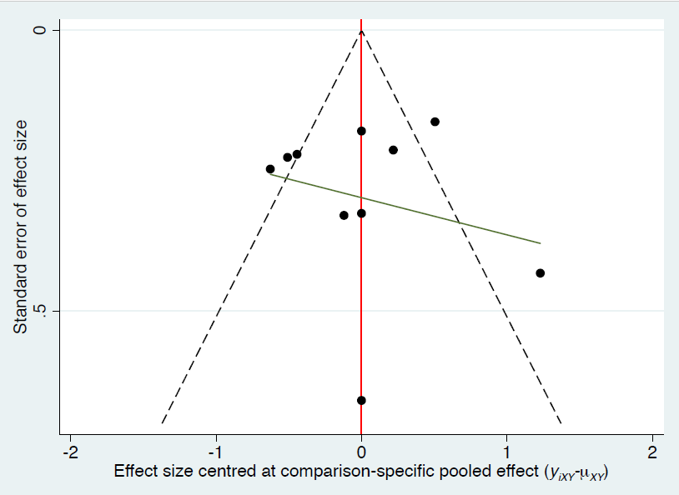

SEVERE ADVERSE EVENTS
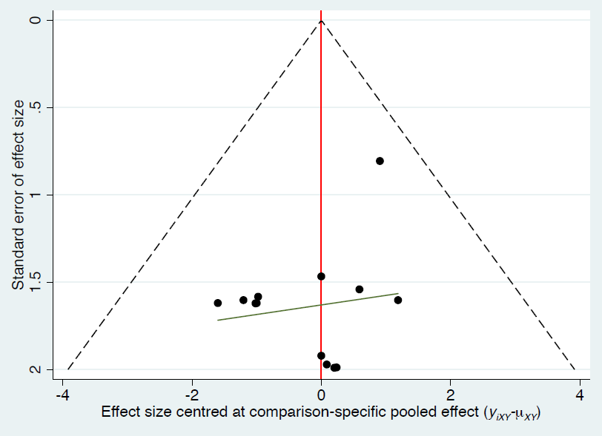

ADVERSE EVENTS
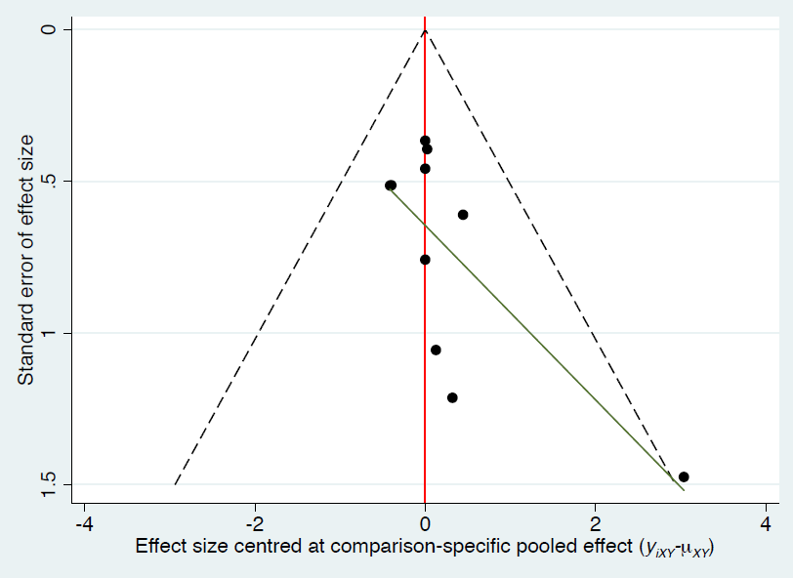

DROPOUT DUE TO ANY CAUSE

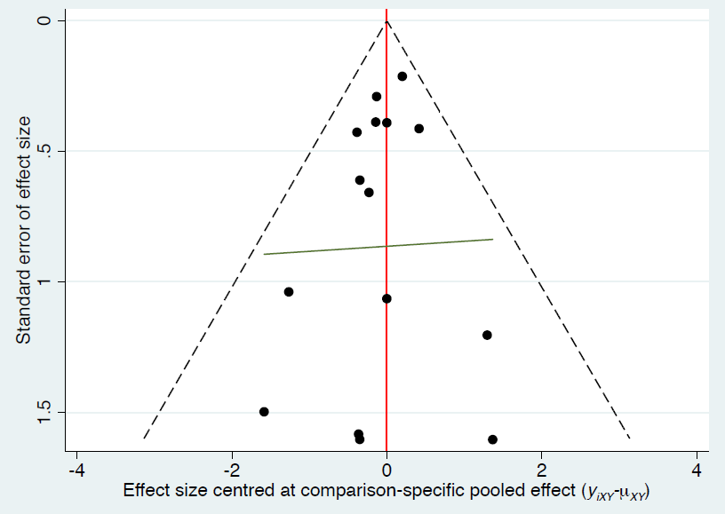

DROPOUT DUE TO ADVERSE EVENTS


