Additional file 2

A meta-analysis of host genetic factors associated with influenza severity

Nina Van Goethem^{1,2, *}, Célestin Danwang², Nathalie Bossuyt¹, Herman Van Oyen^{1,3}, Nancy H. C. Roosens^{4,£}, Annie Robert^{2,£}

¹Scientific Directorate of Epidemiology and public health, Sciensano, J. Wytsmanstraat 14, 1050 Brussels, Belgium.
²Department of Epidemiology and Biostatistics, Institut de recherche expérimentale et clinique, Faculty of Public Health, Université catholique de Louvain, Clos Chapelle-aux-champs 30, 1200 Brussels, Belgium.
³Department of Public Health and Primary Care, Ghent University, De Pintelaan 185, 9000 Ghent, Belgium.
⁴Transversal activities in Applied Genomics, Sciensano, J. Wytsmanstraat 14, 1050 Brussels, Belgium.

£Shared last author
Results meta-analysis IFITM3 – rs12252
- Study characteristics
Study | Ethnicity | Assessment of severity | Cases (n) | Controls (n) | rs12252 cases |  |  |  | rs12252 controls |  |  |  | $$P_{HWE}*$$
 |  |  |  |  | CC | CT | TT | MAF | CC | CT | TT | MAF | $$P_{HWE}*$$
David et al., 2018 | Caucasian | Severity indicators among H and non-H patients | 22 | 19 | 0 | 4 | 18 | 0.09 (C) | 1 | 2 | 16 | 0.11 (C) | 0.16
Randolph et al., 2017 | African American | Severity indicators among H and non-H patients | 56 | 54 | 4 | 21 | 31 | 0.26 (C) | 1 | 19 | 34 | 0.19 (C) | 0.66
Pan et al., 2017 | Asian | Hospital admission among H and non-H patients | 164 | 81 | 101 | 49 | 14 | 0.23 (T) | 22 | 45 | 14 | 0.45 (T) | 0.37
Lee et al., 2017 | Asian | Mortality among H and non-H patients | 33 | 242 | 18 | 9 | 6 | 0.32 (T) | 79 | 108 | 55 | 0.45 (T) | 0.12
Mills et al., 2014 | Admixed | Severity indicators among H and non-H patients | 34 | 259 | 0 | 3 | 31 | 0.04 (C) | 2 | 22 | 235 | 0.05 (C) | 0.12
Zhang et al., 2013 | Asian | Severity indicators (e.g. ICU, ventilation, mortality) among H patients | 32 | 51 | 22 | 8 | 2 | 0.19 (T) | 13 | 31 | 7 | 0.44 (T) | 0.16
Wang et al., 2014 | Asian | Mortality among H patients | 4 | 12 | 2 | 2 | 0 | 0.25 (T) | 4 | 5 | 3 | 0.46 (T) | 0.59
Gaio et al., 2016 | Caucasian | Hospital admission among H and non-H patients | 84 | 184 | 2 | 9 | 73 | 0.08 (C) | 0 | 32 | 152 | 0.09 (C) | 0.37
Lopez-Rodriguez et al., 2016 | Caucasian | Hospital admission among H and non-H patients | 60 | 58 | 0 | 7 | 53 | 0.06 (C) | 1 | 6 | 51 | 0.07 (C) | 0.23
Lopez-Rodriguez et al., 2016 | Caucasian | Severity indicators (e.g. ICU, ventilation, mortality) among H patients | 34 | 26 | 0 | 5 | 29 | 0.07 (C) | 0 | 2 | 24 | 0.04 (C) | >0.99
Martins et al., 2020 | Admixed | Severity indicators among H and non-H patients | 222 | 92 | 9 | 57 | 156 | 0.17 (C) | 3 | 22 | 67 | 0.15 (C) | 0.43
Martins et al., 2020 | Admixed | Mortality among H and non-H patients | 82 | 232 | 0 | 27 | 55 | 0.16 (C) | 12 | 52 | 168 | 0.16 (C) | 0.01
*HWE calculated within controls.
H: hospitalized; HWE: Hardy-Weinberg Equilibrium; MAF: minor allele frequency.

- Meta-analysis of the main outcome per study (main analysis)
Allelic model (C vs T)
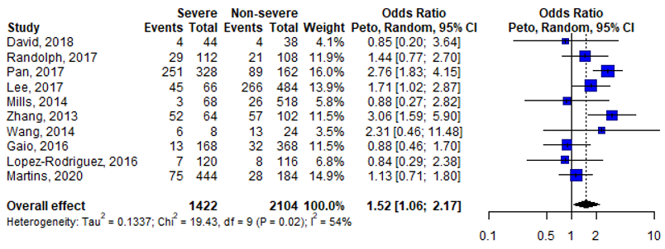
Dominant model (CC/CT vs TT)
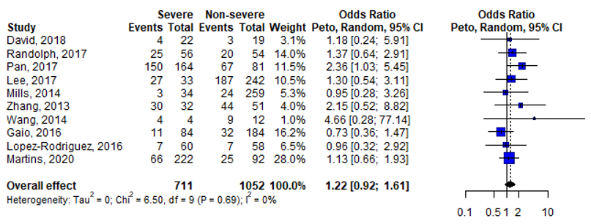
Homozygous model (CC vs TT)
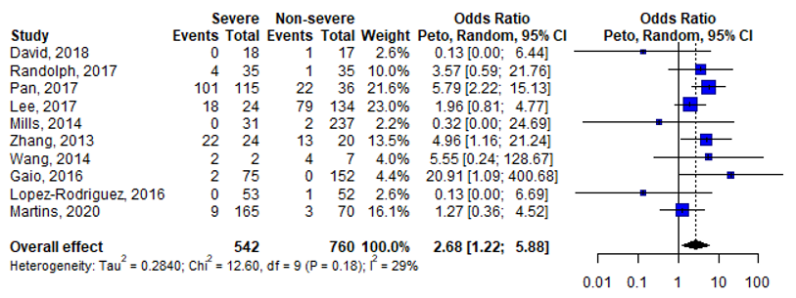

Heterozygous model (CT vs TT)
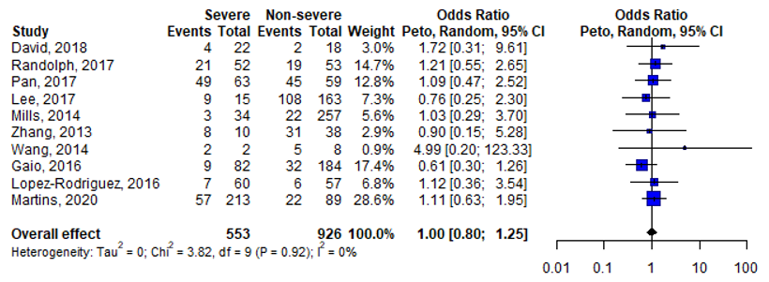
- Meta-analysis of the main outcome per study (main analysis) stratified per ethnicity
Allelic model (C vs T)
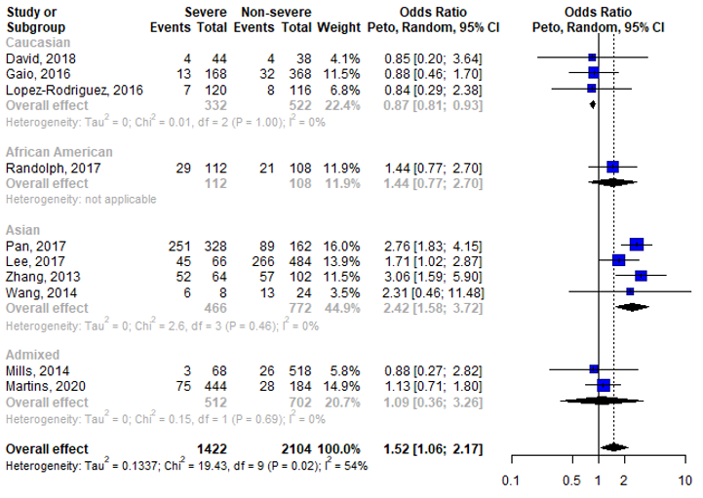

Dominant model (CC/CT vs TT)
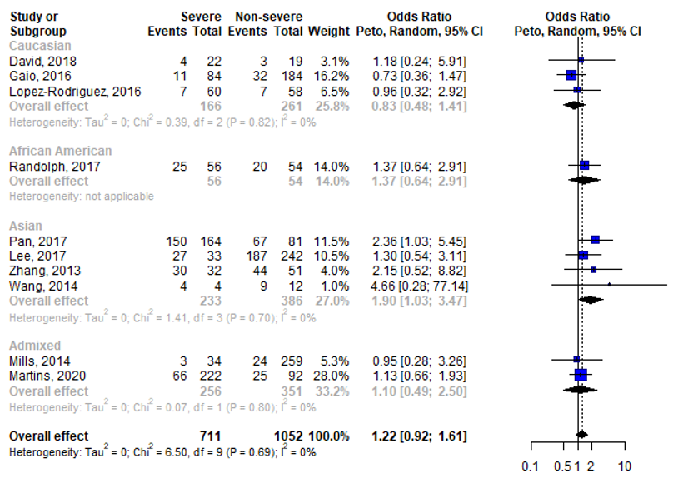
Homozygous model (CC vs TT)
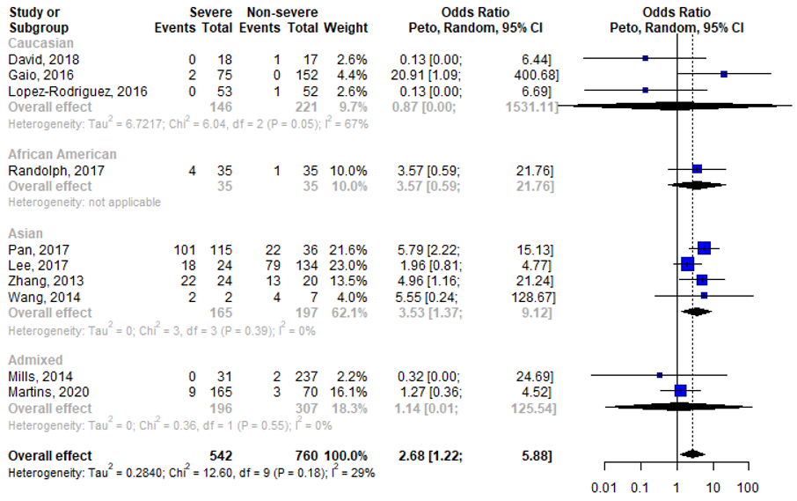

Heterozygous model (CT vs TT)
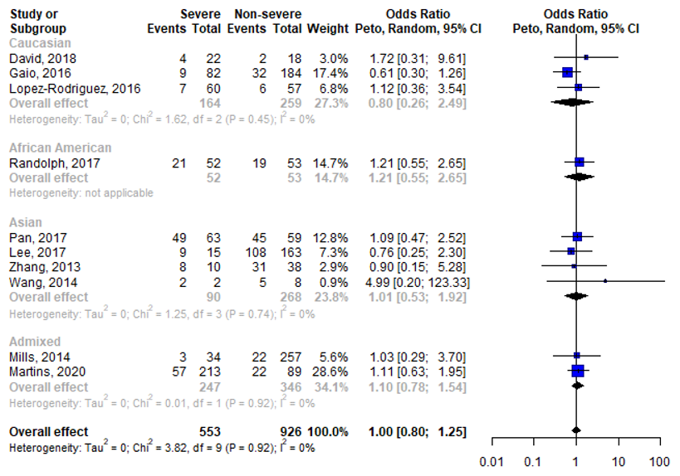
- Meta-analysis stratified per study population and/or assessment of severity
Allelic model (C vs T)
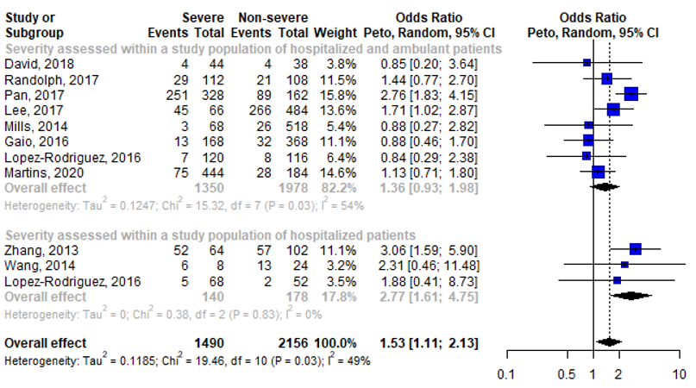

Dominant model (CC/CT vs TT)
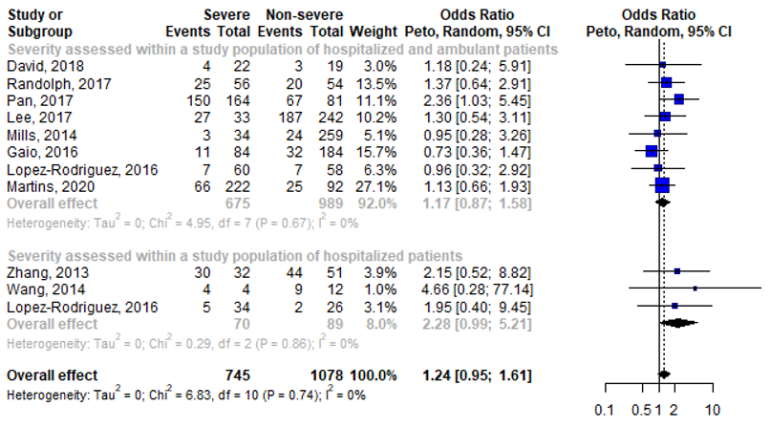
Homozygous model (CC vs TT)
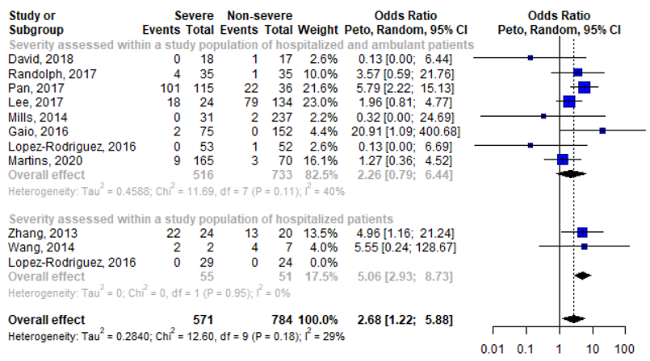

Heterozygous model (CT vs TT)
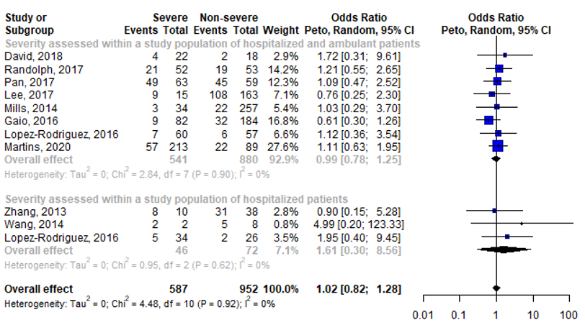

- Leave-one-out analysis (sensitivity analysis)
Allelic model (C vs T)
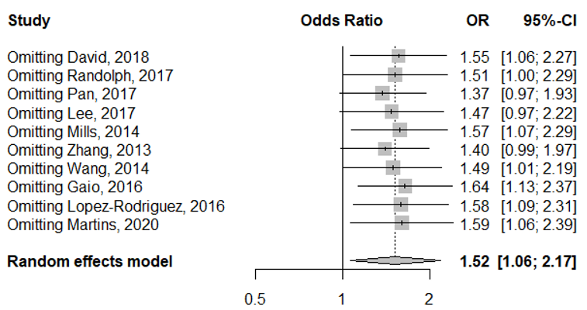
Dominant model (CC/CT vs TT)
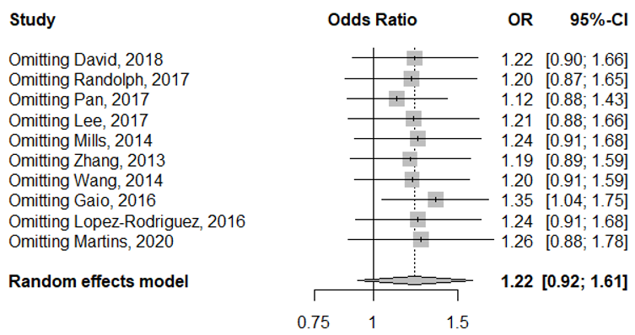
Homozygous model (CC vs TT)
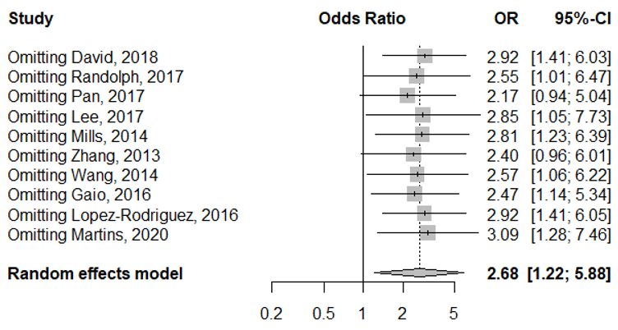
Heterozygous model (CT vs TT)
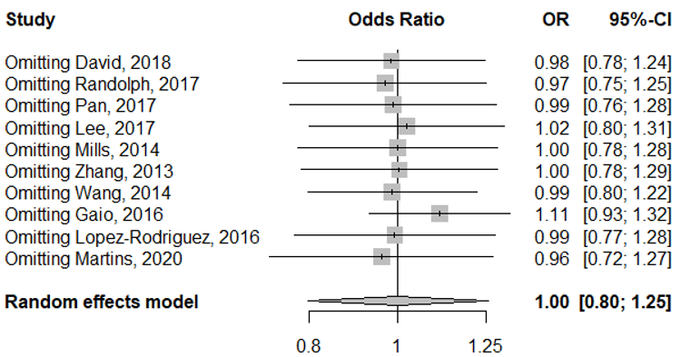
- Funnel plots
Allelic model (C vs T)
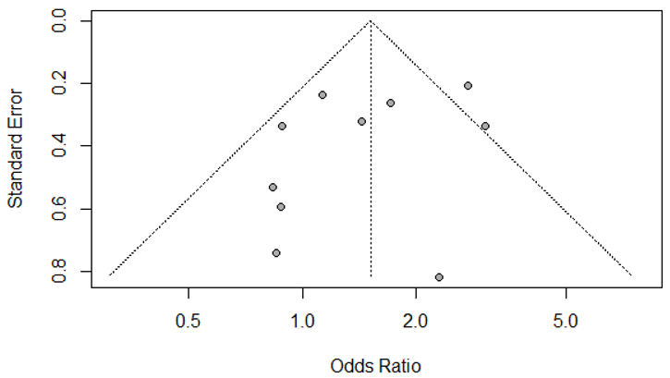
Dominant model (CC/CT vs TT)
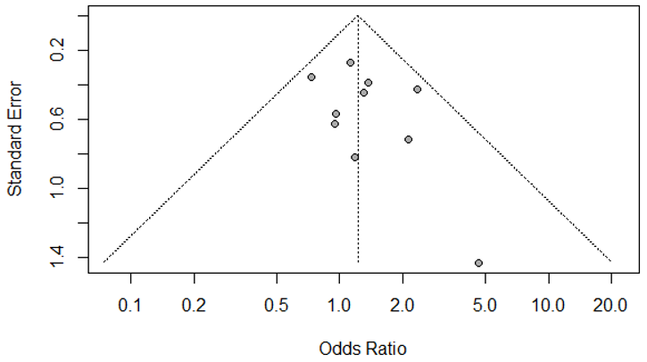
Homozygous model (CC vs TT)
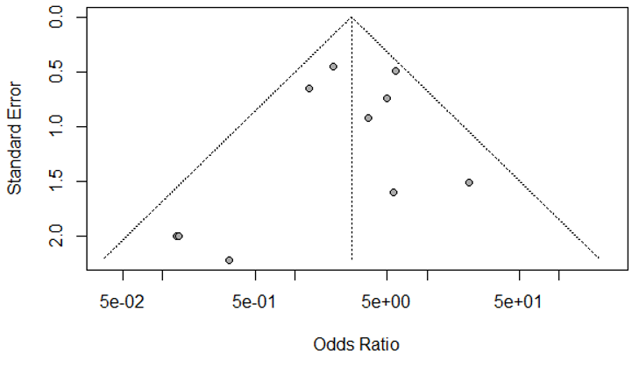
Heterozygous model (CT vs TT)
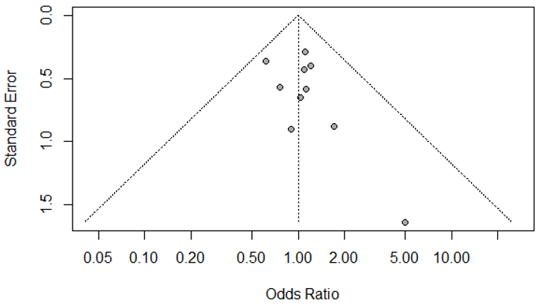

Results meta-analysis CCR5 – rs333
- Study characteristics
Study | Ethnicity | Assessment of severity | Cases (n) | Controls (n) | rs333 cases |  |  |  | rs333 controls |  |  |  | $$P_{HWE}*$$
 |  |  |  |  | -/- | -/+ | +/+ | MAF | -/- | -/+ | +/+ | MAF | $$P_{HWE}*$$
Matos et al., 2019 | Hispanic | Severity indicators among H and non-H patients | 279 | 153 | 0 | 29 | 250 | 0.05 (-) | 0 | 12 | 141 | 0.04 (-) | >.99
Matos et al., 2019 | Hispanic | Mortality among H and non-H patients | 106 | 326 | 0 | 8 | 98 | 0.04 (-) | 0 | 33 | 293 | 0.05 (-) | >.99
Falcon et al., 2015 | Caucasian | Mortality among H and non-H patients | 11 | 160 | 1 | 3 | 7 | 0.23 (-) | 2 | 17 | 141 | 0.07 (-) | 0.13
Maestri et al., 2015 | Admixed | Hospital admission among H and non-H patients | 156 | 174 | 0 | 8 | 148 | 0.03 (-) | 1 | 13 | 160 | 0.04 (-) | 0.27
Sironi et al., 2014 | Caucasian | Hospital admission among H and non-H patients | 21 | 8 | 0 | 0 | 21 | 0.00 (-) | 0 | 1 | 7 | 0.06 (-) | >.99
*HWE calculated within controls.
H: hospitalized; HWE: Hardy-Weinberg Equilibrium; MAF: minor allele frequency.

- Meta-analysis of the main outcome per study (main analysis)
Allelic model (- vs +)
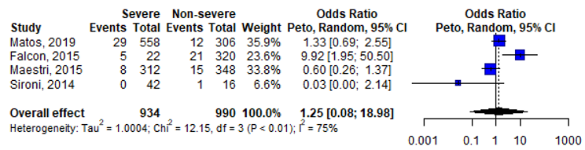
Dominant model (--/-+ vs ++)
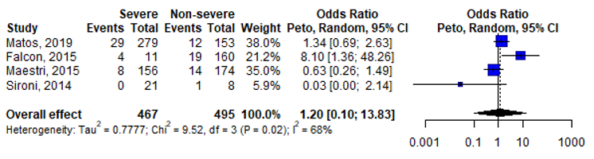
Homozygous model (-- vs ++)
NA
Heterozygous model (-+ vs ++)
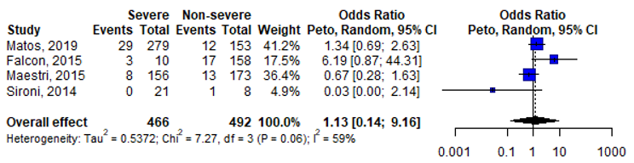

- Leave-one-out analysis (sensitivity analysis)
Allelic model (- vs +)
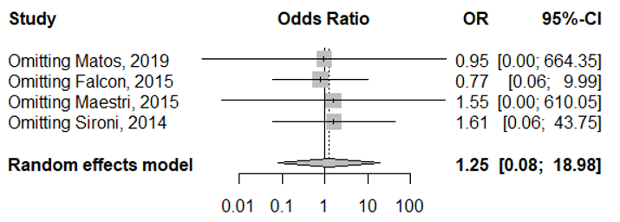
Dominant model (--/-+ vs ++)
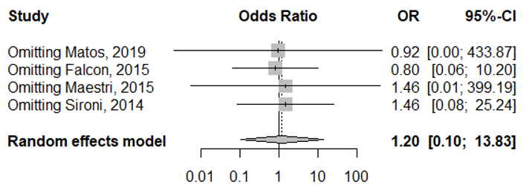
Homozygous model (-- vs ++)
NA
Heterozygous model (-+ vs ++)
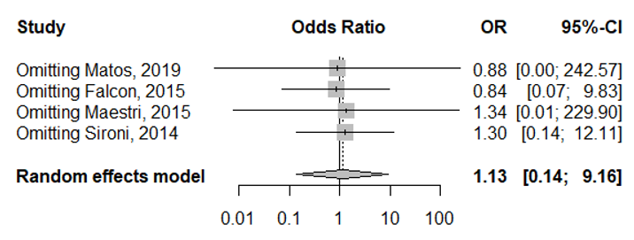

- Funnel plots
Allelic model (- vs +)
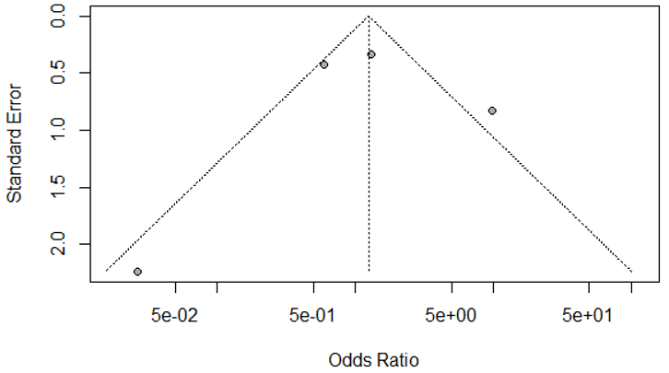
Dominant model (--/-+ vs ++)
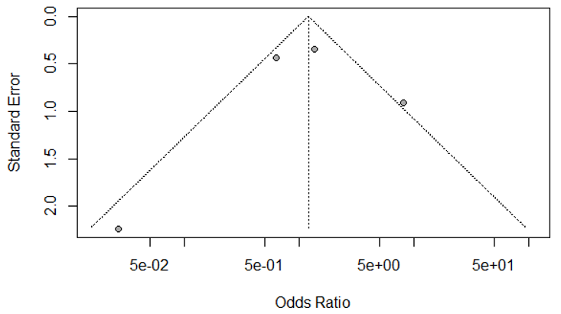
Homozygous model (-- vs ++)
NA
Heterozygous model (-+ vs ++)
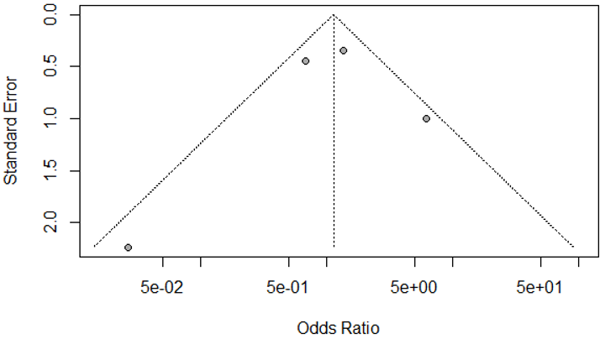

Results meta-analysis FCGR2A – rs1801274
- Study characteristics
Study | Ethnicity | Assessment of severity | Cases (n) | Controls (n) | rs1801274 cases |  |  |  | rs1801274 controls |  |  |  | $$P_{HWE}*$$
 |  |  |  |  | AA | AG | GG | MAF | AA | AG | GG | MAF | $$P_{HWE}*$$
Chatzopoulou et al., 2019 | Caucasian | Severity indicators (e.g. ICU, ventilation, mortality) among H patients | 59 | 51 | 19 | 28 | 12 | 0.44 (G) | 19 | 24 | 8 | 0.39 (G) | >.99
Chatzopoulou et al., 2019 | Caucasian | Mortality among H patients | 19 | 91 | 4 | 10 | 5 | 0.53 (G) | 34 | 42 | 15 | 0.40 (G) | 0.83
Maestri et al., 2016 | Admixed | Hospital admission among H and non- H patients | 244 | 192 | 84 | 115 | 45 | 0.42 (G) | 73 | 80 | 39 | 0.41 (G) | 0.05
Maestri et al., 2016 | Admixed | Mortality among H patients | 100 | 144 | 37 | 41 | 22 | 0.42 (G) | 45 | 74 | 23 | 0.43 (G) | 0.61
Chan et al., 2011 | Asian | Severity indicators (e.g. ICU, ventilation, mortality) among H patients | 37 | 36 | 23 | 9 | 5 | 0.26 (G) | 16 | 17 | 3 | 0.32 (G) | >.99
*HWE calculated within controls.
H: hospitalized; HWE: Hardy-Weinberg Equilibrium; MAF: minor allele frequency.

- Meta-analysis of the main outcome per study (main analysis)
Main outcome per study – allelic model (G vs A)
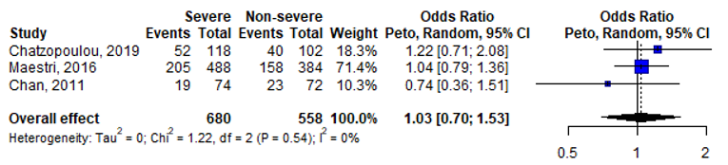
Main outcome per study – dominant model (GG/AG vs AA)
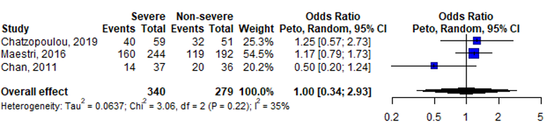
Main outcome per study – homozygous model (GG vs AA)
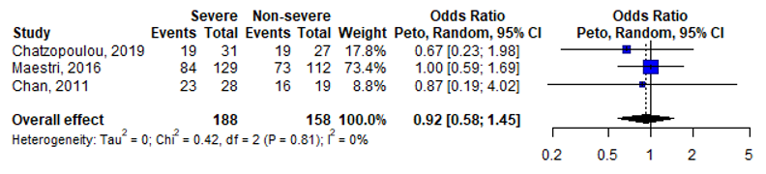
Main outcome per study – heterozygous model (AG vs AA)
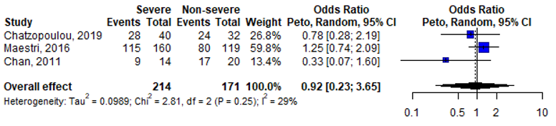

- Leave-one-out analysis (sensitivity analysis)
Allelic model (G vs A)
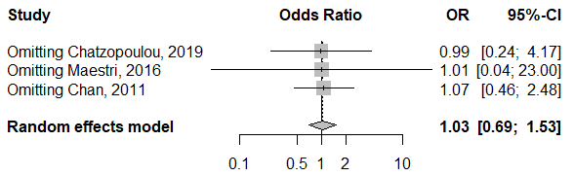
Dominant model (GG/AG vs AA)
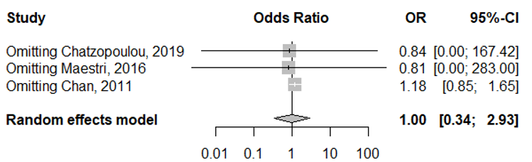
Homozygous model (GG vs AA)
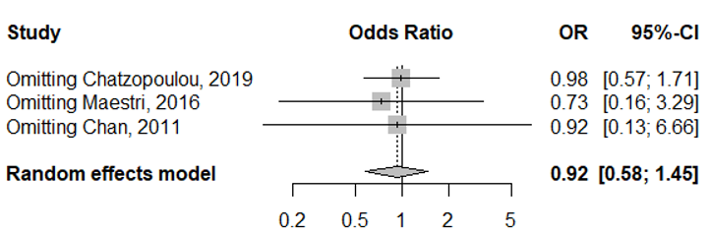
Heterozygous model (AG vs AA)
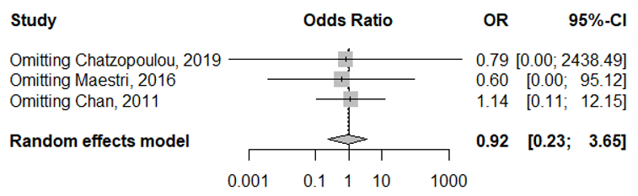

- Funnel plots
Allelic model (G vs A)
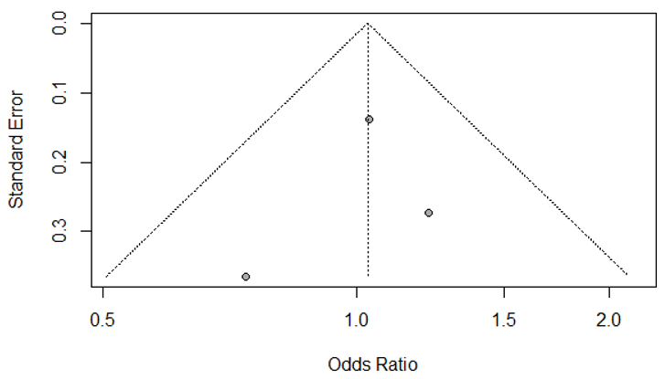
Dominant model (GG/AG vs AA)
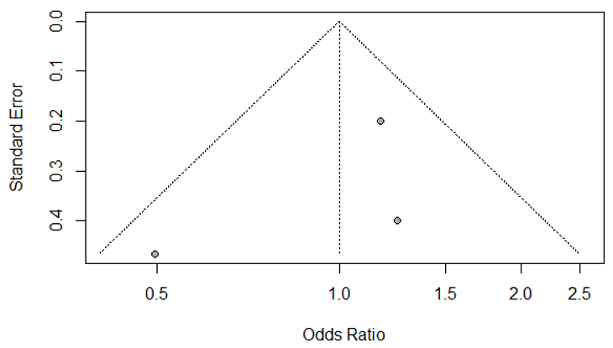
Homozygous model (GG vs AA)
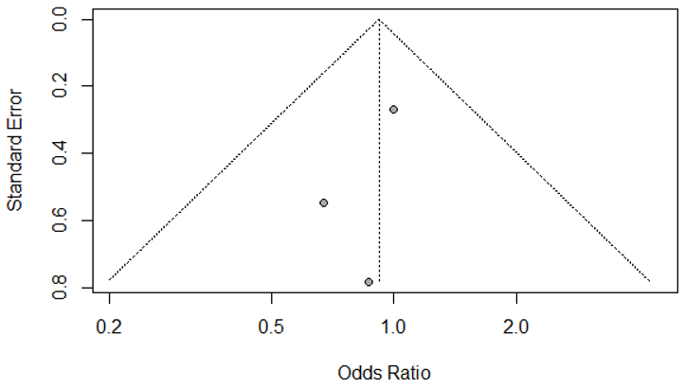
Heterozygous model (AG vs AA)
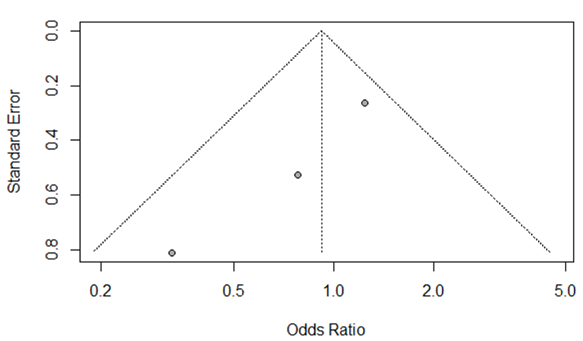

Results meta-analysis IFITM3 – rs34481144
- Study characteristics
Study | Ethnicity | Assessment of severity | N cases | N controls | rs34481144 cases |  |  |  | rs34481144 controls |  |  |  | $$P_{HWE}*$$
 |  |  |  |  | AA | AG | GG | MAF | AA | AG | GG | MAF | $$P_{HWE}*$$
David et al., 2018 | Caucasian | Severity indicators among H and non-H patients | 22 | 19 | 2 | 6 | 14 | 0.23 (A) | 2 | 11 | 6 | 0.39 (A) | 0.63
Allen et al., 2017 | Admixed | Mortality among H patients | 17 | 248 | 3 | 11 | 3 | 0.50 (A) | 35 | 95 | 118 | 0.33 (A) | 0.03
Allen et al., 2017 | Admixed | Severity indicators among H and non-H patients | 9 | 77 | 3 | 3 | 3 | 0.50 (A) | 1 | 24 | 52 | 0.17 (A) | 0.68
Martins et al., 2020 | Admixed | Severity indicators among H and non-H patients | 222 | 92 | 20 | 95 | 107 | 0.30 (A) | 11 | 38 | 43 | 0.33 (A) | 0.64
Martins et al., 2020 | Admixed | Mortality among H and non-H patients | 82 | 232 | 7 | 37 | 38 | 0.31 (A) | 24 | 96 | 112 | 0.31 (A) | 0.65
*HWE calculated within controls.
H: hospitalized; HWE: Hardy-Weinberg Equilibrium; MAF: minor allele frequency.

- Meta-analysis of the main outcome per study (main analysis)
Main outcome per study – allelic model (A vs G)
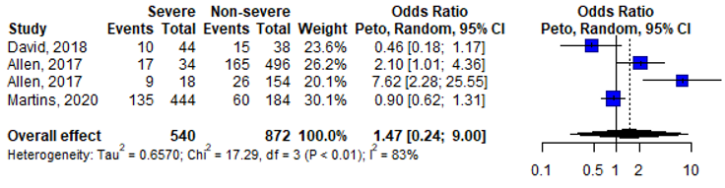
Main outcome per study – dominant model (AA/AG vs GG)
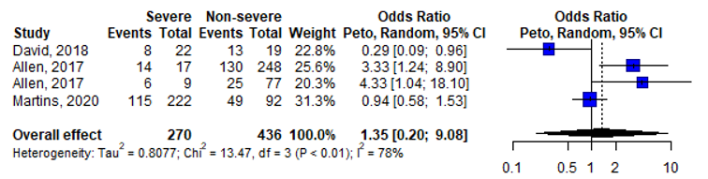
Main outcome per study – homozygous model (AA vs GG)
NA
Main outcome per study – heterozygous model (AG vs GG)
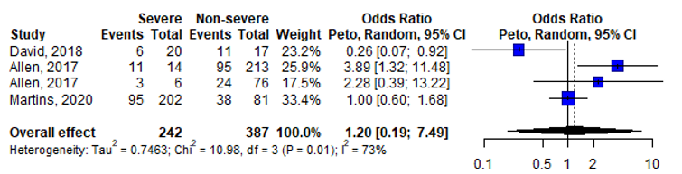

- Leave-one-out analysis (sensitivity analysis)
Allelic model (A vs G)
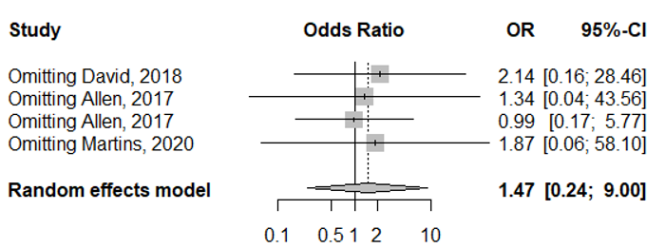
Dominant model (AA/AG vs GG)
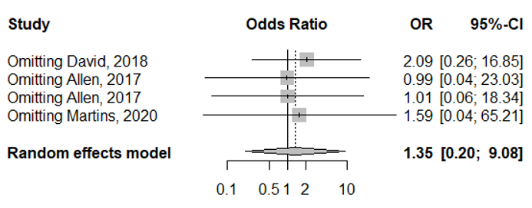
Homozygous model (AA vs GG)
NA
Heterozygous model (AG vs GG)
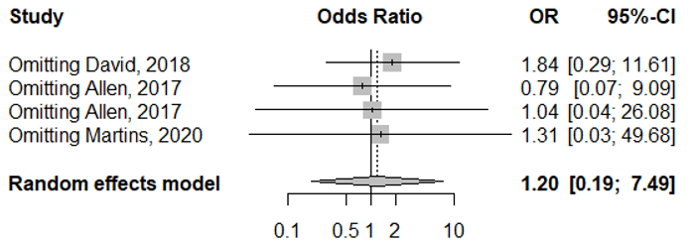

- Funnel plots
Allelic model (A vs G)
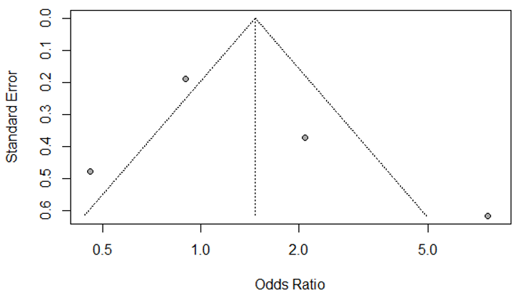
Dominant model (AA/AG vs GG)
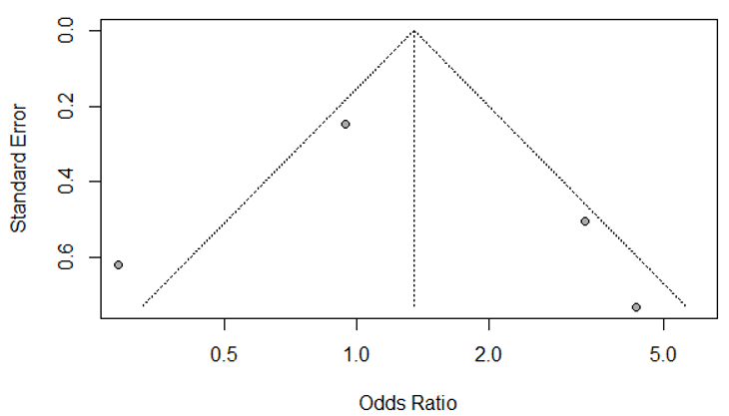
Homozygous model (AA vs GG)
NA
Heterozygous model (AG vs GG)


