Supplemental Files for:
A Systematic Review of Methods used to Conduct Decentralised Clinical Trials.
Amy Rogers, Giorgia De Paoli, Selvarani Subbarayan, Rachel Copland, Kate Harwood, Joanne Coyle, Lyn Mitchell, Thomas M MacDonald, Isla S Mackenzie, on behalf of the Trials@Home Consortium

Contents
1. Search terms 4
2. Study Eligibility Form 5
3. Data extraction tool 6
4. Modified Risk-of-Bias (mRoB) tool 11
5. Source documents for trials in focused review 12
5.1 Summary Tables for Focused Review 19
5.1.1 Recruitment Methods 19
Table S1. Recruitment methods reported 19
Table S2. Number of recruitment methods used in each trial 20
Table S3. Use of routinely collected data for recruitment 20
5.1.2 Participant Identity Verification 21
Table S4. Methods used to verify participant identity 21
Table S5. Number of identity verification methods used by each trial 21
Table S6. Forms of evidence used to verify identity 22
5.1.3 Intervention delivery 23
Table S7. Mode of intervention delivery 23
Table S8. Number of intervention delivery methods used in each trial 23
5.1.4 Comparators 24
Table S9. Types of comparators used 24
Table S10. Delivery of comparators 24
Table S11. Number of comparator delivery methods used by each trial 25
5.1.5 Reconciliation and Adherence Checking 26
Table S12. Methods used for medicines reconciliation or adherence checking 26
Table S13. Number of reconciliation or adherence checking methods used by each trial 26
5.1.6 Routine Data Collection Methods 27
Table S14 Routine Data Collection Methods 27
5.1.7 Sample Collection techniques 28
Table S15. Blood sample collection methods 28
Table S16. Urine sample collection methods 28
Table S17. Other physical sample types 29
Table S18. Other physical sample collection methods and locations 29
5.1.8 Participant reported outcome collection methods 30
Table S19. Methods used to collect participant-reported outcomes 30
5.1.9 Vendor Usage 30
Table S20. Vendors used in included trials 30
6. Summary of Risk of Bias Assessments 31
Figure S1. Overall Risk of Bias - parallel group trials (n=23) 31
Figure S2. Overall Risk of Bias - crossover trials (n=1) 32
Figure S3. Risk of Bias - parallel group comparisons with methodological outcomes (n=2) 32
6.3 Reviewer responses to RoB 33
6.3.1 RoB assessments for the primary outcomes of completed trials 33
Table S21. Risk of bias arising from randomisation process, parallel group trials (n=23) 33
Table S21a. Risk of bias arising from randomisation process, crossover trial (n=1) 34
Table S22. Risk of bias due to deviations from intended interventions, parallel group trials (n=23) 35
Table S22a. Risk of bias due to deviations from intended interventions (crossover trial n=1) 36
Table S23. Risk of bias due to missing outcome data, parallel group trials (n=23) 37
Table S23a. Risk of bias due to missing outcome data, crossover trials (n=1) 38
Table S24. Risk of bias in measurement of outcome, parallel group trials (n=23) 39
Table S24a. Risk of bias due in measurement of outcome, crossover trials (n=1) 40
Table S25. Risk of bias in selection of the reported result, parallel group trials (n=23) 41
Table S25a. Risk of bias in selection of reported result, crossover trials (n=1) 42
6.3.2 RoB assessments of methodological outcomes 43
Table S26 Risk of bias (methodological outcomes) arising from randomisation process (n=2) 43
Table S27. Risk of bias (methodological outcomes) due to deviations from intended interventions, (n=2) 43
Table S28. Risk of bias (methodological outcomes) due to missing outcome data (n=2) 44
Table S29. Risk of bias (methodological outcomes) in measurement of the outcome, (n=2) 44
Table S30. Risk of bias (methodological outcomes) in selection of reported result (n=2) 45
6.4 Modified risk of bias assessment 46
Figure S4. Modified risk of bias assessment (n=17) for ongoing trials 46
6.5 Reviewer responses to mRoB 47
Table S31. Risk of bias arising from the randomisation process (n=17) 47
Table S32. Risk of bias due to deviations from intended intervention (n=17) 48
Table S33. Risk of bias in measurement of outcome (n=17) 49
7. Qualitative Analysis 50
7.1 List of Sources 50
7.2 Table S34. Advantages of DCTs – representative quotations 56
7.3 Table S35. Disadvantages of DCTs – representative quotations 60

Search terms

 | Technical search terms | Search terms for study design
 | remote | clinical trial
 | remote trial | randomised trial
 | decentralised trial | randomized trial
 | decentralized trial | randomised controlled trial
 | hybrid trial | randomized controlled trial
 | site-less trial | interventional study
 | direct-to-patient | cluster-randomised trial
 | direct-to-participant | cluster-randomized trial
 | direct-to-subject | non-interventional study
 | patient-centric trial | augmented clinical trial
 | patient-centric study
 | patient centered trial
 | patient centered study
 | patient centred trial
 | patient centred study
 | home-based trial
 | virtual trial
 | digital trial
 | digital medicine
 | e-medicine
 | emedicine
 | online trial
 | internet based trial
 | web-based trial
 | tele-visit
 | e-health
 | ehealth
 | electronic health
 | m-health
 | mobile health
 | mobile application
 | mobile applications
 | e-clinical
 | eclinical
 | e-clinical health
 | eclinical health
 | electronic clinical health
 | e-clinical technology
 | eclinical technology
 | e-clinical technologies
 | eclinical technologies
 | electronic clinical technologies
 | wearable electronic device
 | wearable electronic devices
 | e-consent
 | econsent
 | electronic consent

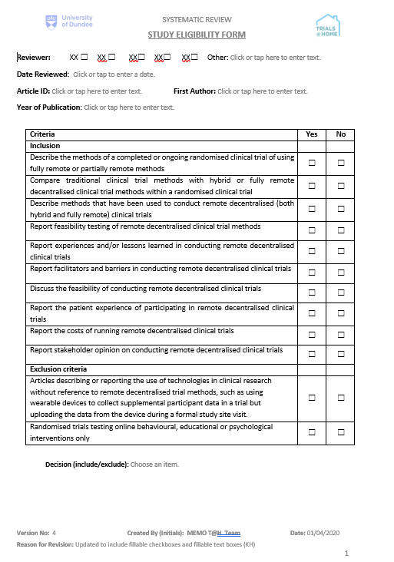
Study Eligibility Form

Data extraction tool
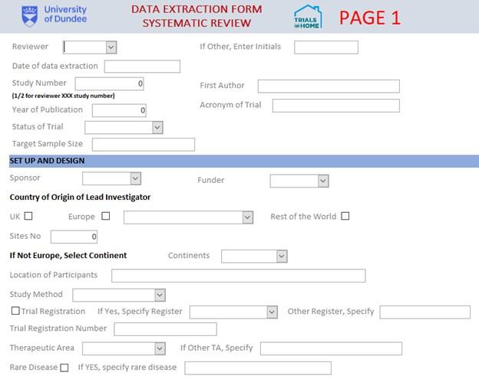

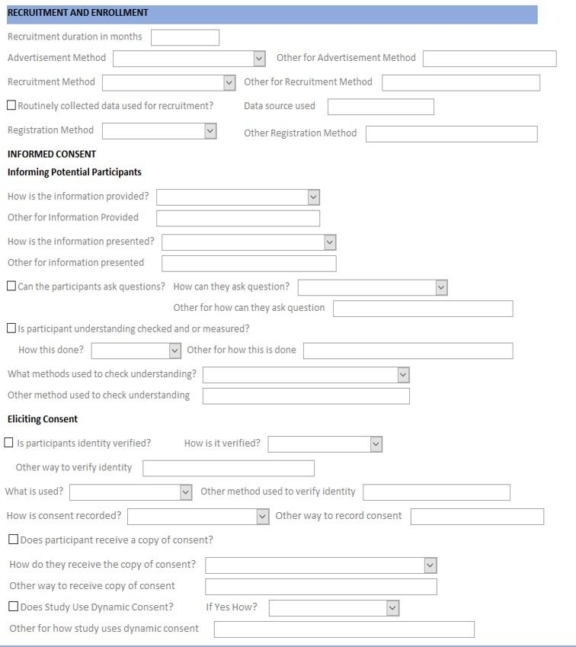
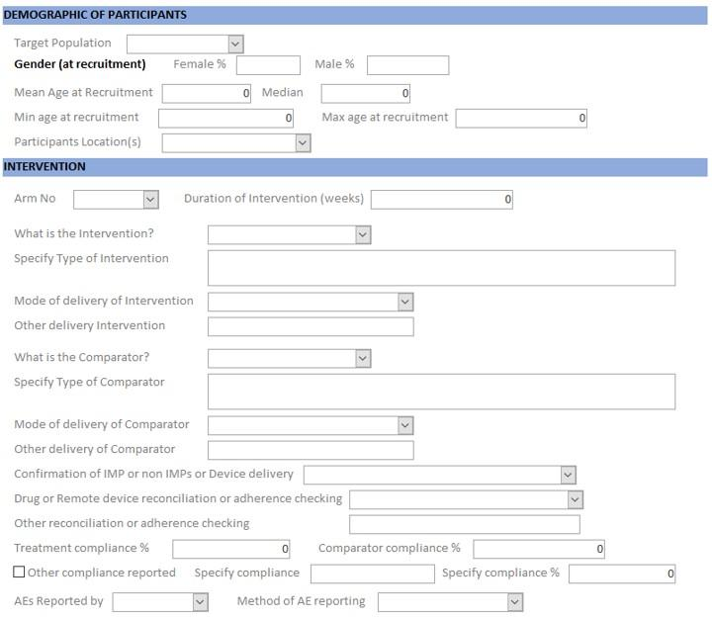
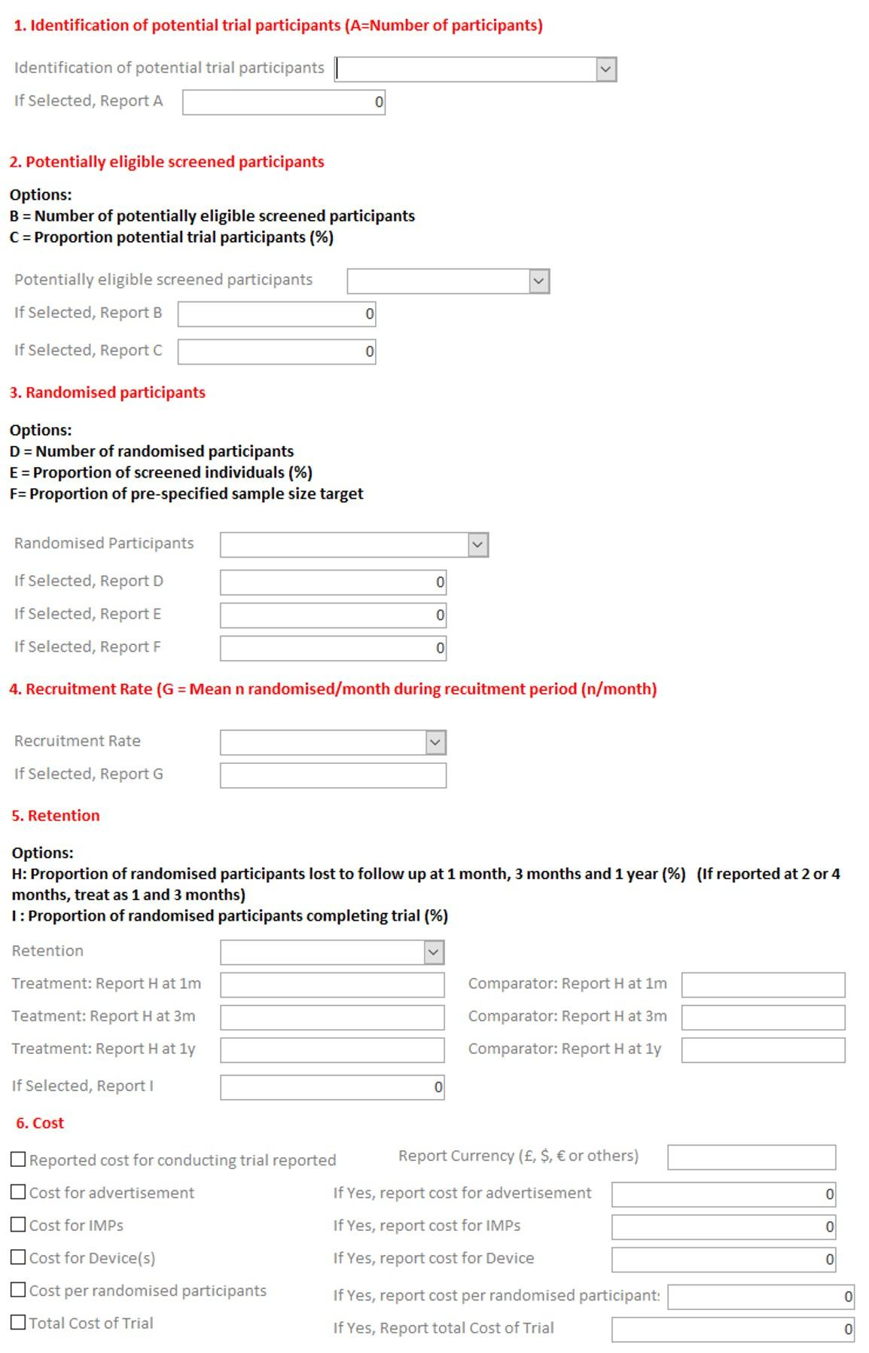
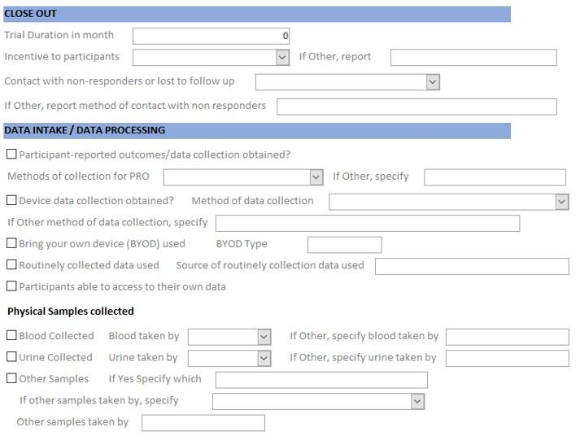
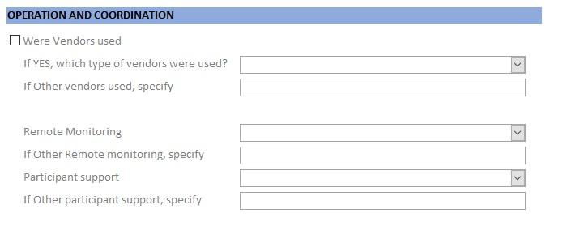

Modified Risk-of-Bias (mRoB) tool
All domains and signalling questions that depended upon final trial results were omitted to create a tool appropriate for assessing the quality of ongoing trials.

Risk of bias arising from the randomisation process | Signalling Question | Reviewer Response
Risk of bias arising from the randomisation process | Was the allocation sequence random?
Risk of bias arising from the randomisation process | Was the allocation sequence concealed until participants were enrolled and assigned to interventions?
Risk of bias arising from the randomisation process | Did baseline differences between intervention groups suggest a problem with the randomization process? (if applicable)
Risk of bias arising from the randomisation process | Risk of bias judgement
Risk of bias due to deviations from the intended interventions | Were participants aware of their assigned intervention during the trial?
 | Were carers and people delivering the interventions aware of participants' assigned intervention during the trial?
 | Risk of bias judgement
Risk of bias in measurement of the outcome | Was the method of measuring the outcome inappropriate?
Risk of bias in measurement of the outcome | Could measurement or ascertainment of the outcome have differed between intervention groups?
Risk of bias in measurement of the outcome | Were outcome assessors aware of the intervention received by study participants?
Risk of bias in measurement of the outcome | Could assessment of the outcome have been influenced by knowledge of intervention received?
Risk of bias in measurement of the outcome | Is it likely that assessment of the outcome was influenced by knowledge of intervention received?
Risk of bias in measurement of the outcome | Risk of bias judgement

Source documents for trials in focused review

Trial Identifier (acronym or short title, where available)) | Sources Used (click on hyperlinks to access online resources)
Marquis-Gravel et al.  (ADAPTABLE) | Trial registration NCT02697916
Marquis-Gravel et al.  (ADAPTABLE) | Marquis-Gravel G, Roe MT, Robertson HR, et al. Rationale and Design of the Aspirin Dosing-A Patient-Centric Trial Assessing Benefits and Long-term Effectiveness (ADAPTABLE) Trial. JAMA Cardiol. Published online 18 March 2020. doi:10.1001/jamacardio.2020.0116
Marquis-Gravel et al.  (ADAPTABLE) | Kochar A, Roe M, Robertson H, Rothman R, Harrington R, Larsen B, Munoz D, Crenshaw D, Haynes K, McCormick‐Ricket I, Hernandez A, Jones S. Adaptable-a patient-centered, pragmatic randomized clinical trial. In: Abstracts from the SCT 39th Annual Meeting. Vol 15. SAGE; 2018. doi:10.1002/central/CN-01646651
Marquis-Gravel et al.  (ADAPTABLE) | Pfaff E, Lee A, Bradford R, et al. Recruiting for a pragmatic trial using the electronic health record and patient portal: successes and lessons learned. J Am Med Inform Assoc. 2019;26(1):44-49.
Marquis-Gravel et al.  (ADAPTABLE) | Faulkner M, Alikhaani J, Brown L, et al. Exploring Meaningful Patient Engagement in ADAPTABLE (Aspirin Dosing: A Patient-centric Trial Assessing Benefits and Long-term Effectiveness). Med Care. 2018;56 Suppl 10 Suppl 1:S11-S15.
Marquis-Gravel et al.  (ADAPTABLE) | Audio recorded interview Rationale and Design of the ADAPTABLE Trial
Marquis-Gravel et al.  (ADAPTABLE) | Press release  ADAPTABLE Team Finishes Enrollment, Reflects on Lessons Learned
Marquis-Gravel et al.  (ADAPTABLE) | Webinar  June 9, 2017: ADAPTABLE, the Aspirin Study: Embracing Patient-Partnered Research
Bowman et al.  (ASCEND) | Trial Registration NCT00135226
Bowman et al.  (ASCEND) | Bowman L, Mafham M, Stevens W, et al. ASCEND: A Study of Cardiovascular Events iN Diabetes: Characteristics of a randomized trial of aspirin and of omega-3 fatty acid supplementation in 15,480 people with diabetes. Am Heart J. 2018;198:135-144.
Bowman et al.  (ASCEND) | Protocol  ASCEND (A Study of Cardiovascular Events iN Diabetes): A randomised 2x2 factorial design study of aspirin versus placebo, and of omega-3 fatty acid supplementation versus placebo, for the primary prevention of cardiovascular events in people with diabetes
Bowman et al.  (ASCEND) | Mafham MM, Bowman LJ, Haynes RJ, Armitage JM. Streamlined mail-based methods for large randomised trials: lessons learnt from the ASCEND study. Diabetologia. Published online 30 November 2019. doi:10.1007/s00125-019-05049-8
Bowman et al.  (ASCEND) | Aung T, Haynes R, Barton J, et al. Cost-effective recruitment methods for a large randomised trial in people with diabetes: A Study of Cardiovascular Events iN Diabetes (ASCEND). Trials. 2016;17(1):286.
Bowman et al.  (ASCEND) | Bowman L, Mafham M, Wallendszus K, et al. ASCEND Study Collaborative Group. Effects of aspirin for primary prevention in persons with diabetes mellitus. N Engl J Med. 2018;379(16):1529-1539.
Bowman et al.  (ASCEND) | Data Analysis Plan
Blis Probiotics | Trial Registration NCT04297878
Sanofi  (eSTUDY) | Trial Registration NCT03260868
Sanofi  (eSTUDY) | Clinical Trial Protocol
Sanofi  (eSTUDY) | Statistical Analysis Plan
Spartano et al.  (FHS-HeH) | Spartano NL, Sun F, Lunetta KL, et al. Comparison of on-site versus Remote Support for a Mobile-Device Pilot Study: A Collaboration Between the Framingham Heart Study and Health eHeart Study (FHS-HeH). In: Circulation. Vol 137. American Heart Association; 2018.
Spartano et al.  (FHS-HeH) | Spartano NL, Lin H, Sun F, et al. Comparison of On-Site Versus Remote Mobile Device Support in the Framingham Heart Study Using the Health eHeart Study for Digital Follow-up: Randomized Pilot Study Set Within an Observational Study Design. JMIR Mhealth Uhealth. 2019;7(9):e13238.
Dumbleton et al.  (HEAT) | Trial Registration NCT01506986
Dumbleton et al.  (HEAT) | Protocol
Dumbleton et al.  (HEAT) | Dumbleton JS, Avery AJ, Coupland C, et al. The Helicobacter Eradication Aspirin Trial (HEAT): A Large Simple Randomised Controlled Trial Using Novel Methodology in Primary Care. EBioMedicine. 2015;2(9):1200-1204.
Dumbleton et al.  (HEAT) | Stevenson, DJ. Dumbleton, JS. Avery, AJ. Coupland, C. Hobbs, FDR. Kendrick, D. Moore, MV. Morris, C. Rubin, G. Smith, MD. Hawkey, CJ. The helicobacter eradication aspirin trial (HEAT): Recruitment and demographics of the randomised patient population (Abstract P1213). In: United European Gastroenterology Journal. ; 2018:6 (Supplement 1)
Steinhubl et al.  (mSToPS) | Trial Registration NCT02506244
Steinhubl et al.  (mSToPS) | Protocol
Steinhubl et al.  (mSToPS) | Statistical Analysis Plan
Steinhubl et al.  (mSToPS) | Steinhubl SR, Mehta RR, Ebner GS, et al. Rationale and design of a home-based trial using wearable sensors to detect asymptomatic atrial fibrillation in a targeted population: The mHealth Screening To Prevent Strokes (mSToPS) trial. Am Heart J. 2016;175:77-85.
Steinhubl et al.  (mSToPS) | Steinhubl SR, Waalen J, Edwards AM, et al. A nationwide trial of screening for undiagnosed atrial fibrillation in an at-risk population using a self-applied ECG recording patch sensor: results of the randomized component of the mHealth Screening To Prevent Strokes (mSToPS) trial. Circulation. 2017;136(suppl_1):A13757-A13757
Steinhubl et al.  (mSToPS) | Steinhubl SR, Baca-Motes K, Edwards A, et al. Remote digital recruitment and enrollment in a nationwide trial of screening for undiagnosed atrial fibrillation using a self-applied ECG recording patch sensor: Lessons from the MSTOPS trial. In: Journal of the American College of Cardiology, ed. Journal of the American College of Cardiology. Vol 69, Issue 11. American College of Cardiology Foundation; 2017:2512.
Steinhubl et al.  (mSToPS) | Galarnyk M, Quer G, McLaughlin K, Ariniello L, Steinhubl SR. Usability of a Wrist-Worn Smartwatch in a Direct-to-Participant Randomized Pragmatic Clinical Trial. Digit Biomark. 2019;3(3):176-184.
Steinhubl et al.  (mSToPS) | Baca-Motes K, Edwards AM, Waalen J, et al. Digital recruitment and enrollment in a remote nationwide trial of screening for undiagnosed atrial fibrillation: Lessons from the randomized, controlled mSToPS trial. Contemp Clin Trials Commun. 2019;14:100318.
Steinhubl et al.  (mSToPS) | Steinhubl SR, Waalen J, Edwards AM, et al. Effect of a Home-Based Wearable Continuous ECG Monitoring Patch on Detection of Undiagnosed Atrial Fibrillation: The mSToPS Randomized Clinical Trial. JAMA. 2018;320(2):146-155.
Steinhubl et al.  (mSToPS) | Quer G, Nikzad N, Lanka S, van Mourik R, Dur O, Steinhubl SR. Preliminary Evaluation of a Wrist Wearable Heart Rate Sensor for the Detection of Undiagnosed Atrial Fibrillation in a Real-World Setting. Circulation. 2017;136(suppl_1):A18610-A18610.
Pepine et al.  (INVEST) | Trial Registration NCT00133692
Pepine et al.  (INVEST) | Pepine CJ, Handberg-Thurmond E, Marks RG, et al. Rationale and design of the International Verapamil SR/Trandolapril Study (INVEST): an Internet-based randomized trial in coronary artery disease patients with hypertension. J Am Coll Cardiol. 1998;32(5):1228-1237.
Pepine et al.  (INVEST) | Cooper-DeHoff R, Handberg E, Heissenberg C, Johnson K. Electronic prescribing via the internet for a coronary artery disease and hypertension megatrial. Clin Cardiol. 2001;24(11 Suppl):V14-V16.
Pepine et al.  (INVEST) | Pepine CJ, Handberg EM, Cooper-DeHoff RM, et al. A calcium antagonist vs a non-calcium antagonist hypertension treatment strategy for patients with coronary artery disease. The International Verapamil-Trandolapril Study (INVEST): a randomized controlled trial. JAMA. 2003;290(21):2805-2816.
Pepine et al.  (INVEST) | Marks R, Bristol H, Conlon M, Pepine CJ. Enhancing clinical trials on the internet: lessons from INVEST. Clin Cardiol. 2001;24(11 Suppl):V17-V23.
NightWare | Trial Registration NCT03934658
Pfizer  (Baseline Skin) | Trial Registration NCT04091087
Pfizer  (Baseline Skin) | Study website Project Baseline by verily
Pfizer  (Baseline Skin) | Patient facing study overview Project Baseline by verily Skin Study
Tarolli et al.  (REACT-PD, sub-study of STEADY-PD III)) | Trial Registration NCT02168842
Tarolli et al.  (REACT-PD, sub-study of STEADY-PD III)) | Protocol
Tarolli et al.  (REACT-PD, sub-study of STEADY-PD III)) | Statistical Analysis Plan
Tarolli et al.  (REACT-PD, sub-study of STEADY-PD III)) | Tarolli C, Andrzejewski K, Bull M, et al. Virtual research visits in individuals with Parkinson disease enrolled in a clinical trial: REACT-PD Study Interim Analysis. Neurology. 2017;88(16 Supplement):P4.005.
Tarolli et al.  (REACT-PD, sub-study of STEADY-PD III)) | Tarolli C, Andrzejewski K, Zimmerman G, et al. Virtual research visits in individuals with Parkinson disease enrolled in a clinical trial: REACT-PD Study (P3.038). Neurology. 2018;90(15 Supplement). Accessed April 1, 2021. https://n.neurology.org/content/90/15_Supplement/P3.038.abstract
Tarolli et al.  (REACT-PD, sub-study of STEADY-PD III)) | Andrzejewski KL, Tarolli CG, Zimmerman G, et al. Interim analysis of the REACT-PD study, evaluating the use of virtual research visits in a clinical trial in individuals with Parkinson’s disease. In: Movement Disorders. Vol 32. ; 2017:E2-E3.
Tarolli et al.  (REACT-PD, sub-study of STEADY-PD III)) | Adams J, Biemiller R, Andrzejewski K, et al. Utilizing remote blood pressure monitoring in a phase III clinical drug trial for Parkinson’s disease: 2082. Mov Disord. 2016;31.
Orri et al.  (REMOTE) | Trial Registration NCT01302938
Orri et al.  (REMOTE) | Orri M, Lipset CH, Jacobs BP, Costello AJ, Cummings SR. Web-based trial to evaluate the efficacy and safety of tolterodine ER 4 mg in participants with overactive bladder: REMOTE trial. Contemp Clin Trials. 2014;38(2):190-197.
Woodcock et al.  (Salford Lung Study) | Trial Registration NCT01706198
Woodcock et al.  (Salford Lung Study) | Woodcock A, Bakerly ND, John P. New, et al. The Salford Lung Study protocol: a pragmatic, randomised phase III real-world effectiveness trial in asthma. BMC Pulmonary Medicine. 2015;15(1). doi:10.1186/s12890-015-0150-8
Woodcock et al.  (Salford Lung Study) | New JP, Bakerly ND, Leather D, Woodcock A. Obtaining real-world evidence: the Salford Lung Study. Thorax. 2014;69(12):1152-1154.
Woodcock et al.  (Salford Lung Study) | Woodcock A, Vestbo J, Bakerly ND, et al. Effectiveness of fluticasone furoate plus vilanterol on asthma control in clinical practice: an open-label, parallel group, randomised controlled trial. Lancet. 2017;390(10109):2247-2255.
Bailey et al.  (Sexunzipped) | Trial Registration ISRCTN 55651027
Bailey et al.  (Sexunzipped) | Bailey JV, Pavlou M, Copas A, et al. The Sexunzipped trial: optimizing the design of online randomized controlled trials. J Med Internet Res. 2013;15(12):e278.
Bailey et al.  (Sexunzipped) | Bailey J, McCarthy O, Carswell K, et al. The Sexunzipped Website for Sexual Wellbeing for Young People: Early Results of a Pilot Online RCT. In: The Journal of Sexual Medicine. Vol 8. Elsevier; 2011:126-126.
Bailey et al.  (Sexunzipped) | Nicholas A, Bailey JV, Stevenson F, Murray E. The Sexunzipped trial: young people’s views of participating in an online randomized controlled trial. J Med Internet Res. 2013;15(12):e276.
AOBiome | Trial Registration NCT02832063
AOBiome | AOBiome. AOBiome Therapeutics Reports Positive Efficacy Results from Phase 2b Clinical Trial of Ammonia Oxidizing Bacteria (AOB) for the Treatment of Acne Vulgaris. Published 19 October 2017. Accessed April 5, 2021. https://www.aobiome.com/pressreleases/aobiome-therapeutics-reports-positive-efficacy-results-from-phase-2b-clinical-trial-of-ammonia-oxidizing-bacteria-aob-for-the-treatment-of-acne-vulgaris/
Krischer et al.  (TAPIR) | Trial Registration NCT01933724
Krischer et al.  (TAPIR) | Krischer J, Cronholm PF, Burroughs C, et al. Experience With Direct-to-Patient Recruitment for Enrollment Into a Clinical Trial in a Rare Disease: A Web-Based Study. J Med Internet Res. 2017;19(2):e50.
Rorie et al.  (TIME) | Trial Registration ISRCTN 18157641
Rorie et al.  (TIME) | Rorie DA, Rogers A, Mackenzie IS, et al. Methods of a large prospective, randomised, open-label, blinded end-point study comparing morning versus evening dosing in hypertensive patients: the Treatment In Morning versus Evening (TIME) study. BMJ Open. 2016;6. doi:10.1136/bmjopen-2015-010313
Rorie et al.  (TIME) | Rorie DA, MacDonald TM, Rogers A, Flynn RWV. Assessing Clinical Trial Technology: Evaluating the TIME Study. Journal of Clinical Trials. 2018;8(1):1-7.
Rorie et al.  (TIME) | Rorie DA, Flynn RWV, Mackenzie IS, MacDonald TM, Rogers A. The Treatment In Morning versus Evening (TIME) study: analysis of recruitment, follow-up and retention rates post-recruitment. Trials. 2017;18(1):557.
Esserman et al.  (WISDOM) | Trial Registration NCT02620852
Esserman et al.  (WISDOM) | Theiner S, Kaplan C, Sarrafan S, et al. The WISDOM study pilot: Evaluating a preference-tolerant RCT of risk-based vs. annual breast cancer screening. J Clin Orthod. 2016;34(15_suppl):e13035-e13035.
Esserman et al.  (WISDOM) | Shieh Y, Eklund M, Madlensky L, et al. Breast cancer screening in the precision medicine era: risk-based screening in a population-based trial. J Natl Cancer Inst. 2017;109(5):djw290.
Esserman et al.  (WISDOM) | Fiscalini AS, Theiner S, Kaplan C, et al. Evaluating the feasibility of a web-based preference tolerant randomized trial of risk-based vs. annual breast cancer screening: WISDOM study pilot. In: Cancer Research. Vol 77. American Association for Cancer Research; 2017.
Esserman et al.  (WISDOM) | Esserman LJ, WISDOM Study and Athena Investigators. The WISDOM Study: breaking the deadlock in the breast cancer screening debate. NPJ Breast Cancer. 2017;3:34.
Esserman et al.  (WISDOM) | Eklund M, Broglio K, Yau C, Connor JT, Stover Fiscalini A, Esserman LJ. The WISDOM Personalized Breast Cancer Screening Trial: Simulation Study to Assess Potential Bias and Analytic Approaches. JNCI Cancer Spectr. 2018;2(4):ky067.
Esserman et al.  (WISDOM) | Study website
Brophy et al. | Trial Registration ISRCTN 36133252
Brophy et al. | Brophy S, Burrows CL, Brooks C, Gravenor MB, Siebert S, Allen SJ. Internet-based randomised controlled trials for the evaluation of complementary and alternative medicines: probiotics in spondyloarthropathy. BMC Musculoskelet Disord. 2008;9:4.
Eilenberg et al. | Eilenberg KL, Hoover AM, Rutherford ML, Melfi CA, Segal S. From Informed Consent through Database Lock: An Interactive Clinical Trial Conducted Using the Internet. Drug information journal : DIJ / Drug Information Association. 2004;38(3):239-251.
Formica et al. | Formica M, Kabbara K, Clark R, McAlindon T. Can clinical trials requiring frequent participant contact be conducted over the Internet? Results from an online randomized controlled trial evaluating a topical ointment for herpes labialis. J Med Internet Res. 2004;6(1):e6.
Formica et al. | Multimedia Appendix
Gelfand et al.  (BRAiN-M) | Trial Registration NCT02344316
Gelfand et al.  (BRAiN-M) | Gelfand AA, Qubty W, Patniyot I, et al. Home-Based Trials in Adolescent Migraine: A Randomized Clinical Trial. JAMA Neurol. 2017;74(6):744-745.
Jacobs et al.  (KALM) | Jacobs BP, Bent S, Tice JA, Blackwell T, Cummings SR. An internet-based randomized, placebo-controlled trial of kava and valerian for anxiety and insomnia. Medicine . 2005;84(4):197-207.
McAlindon et al. | McAlindon T, Formica M, Kabbara K, LaValley M, Lehmer M. Conducting clinical trials over the internet: feasibility study. BMJ. 2003;327(7413):484-487.
McAlindon et al. | McAlindon T, Formica M, LaValley M, Lehmer M, Kabbara K. Effectiveness of glucosamine for symptoms of knee osteoarthritis: results from an internet-based randomized double-blind controlled trial. Am J Med. 2004;117(9):643-649.
Olden et al. | Trial Registration NCT00875342
Olden et al. | Olden M, Wyka K, Cukor J, et al. Pilot Study of a Telehealth-Delivered Medication-Augmented Exposure Therapy Protocol for PTSD. The Journal of Nervous and Mental Disease. 2017;205(2):154-160. doi:10.1097/nmd.0000000000000563
Pasman et al. | Trial Registration NCT02061982
Pasman et al. | Pasman WJ, Boessen R, Donner Y, Clabbers N, Boorsma A. Effect of Caffeine on Attention and Alertness Measured in a Home-Setting, Using Web-Based Cognition Tests. JMIR Res Protoc. 2017;6(9):e169.
Redzic et al. | Redzic N, Benoy I, Vanden Broeck D, Bogers JP. Efficacy of AV2-Salicylic acid combination therapy for cutaneous warts: Study protocol for a single-center randomized controlled trial. Contemp Clin Trials Commun. 2020;17:100534.
Sharma et al. | Sharma K, Agarwal S, Mania D, et al. Remotely-Supervised Non-Invasive Brain Stimulation for Remediation of Fatigue in Parkinson’s Patients. Brain Stimulation: Basic, Translational, and Clinical Research in Neuromodulation. 2019;12(4):e149-e150.
Sharma et al. | Agarwal S, Pawlak N, Cucca A, et al. Remotely-supervised transcranial direct current stimulation paired with cognitive training in Parkinson’s disease: An open-label study. J Clin Neurosci. 2018;57:51-57.
Charvet et al. | Kasschau M, Sherman K, Haider L, et al. A Protocol for the Use of Remotely-Supervised Transcranial Direct Current Stimulation (tDCS) in Multiple Sclerosis (MS). J Vis Exp. 2015;(106):e53542.
Charvet et al. | Charvet LE, Dobbs B, Shaw MT, Bikson M, Datta A, Krupp LB. Remotely supervised transcranial direct current stimulation for the treatment of fatigue in multiple sclerosis: Results from a randomized, sham-controlled trial. Mult Scler. 2018;24(13):1760-1769.
Charvet et al. | Shaw M, Dobbs B, Pawlak N, Pau W, Charvet L. At-home transcranial direct current stimulation (tDCS) improves mood in multiple sclerosis: results from a randomized, sham-controlled trial. In: Multiple Sclerosis Journal. Vol 23. ; 2017:962-962.
Brophy et al.  (TOPAZ) | Trial Registration NCT03924414
Brophy et al.  (TOPAZ) | Tanner CM. Prevention of Fractures in Parkinson’s Disease (PD) with a Single Infusion of Zoledronic Acid (ZA). In: Movement Disorders. Vol 34. ; 2019:S13-S13.
Ulrich et al. | Ulrich U, Browning M, Gaffney EV, Schöter KH, Chesnut CH 3rd. Implementation of an osteoporosis research program with a mobile dual-energy X-ray absorptiometry unit: the Montana/Wyoming experience. Osteoporos Int. 1997;7(6):583-588.
MacDonald et al.  (FAST) | Trial registration ISRCTN 72443728
MacDonald et al.  (FAST) | MacDonald TM, Ford I, Nuki G, et al. Protocol of the Febuxostat versus Allopurinol Streamlined Trial (FAST): a large prospective, randomised, open, blinded endpoint study comparing the cardiovascular safety of allopurinol and febuxostat in the management of symptomatic hyperuricaemia. BMJ Open. 2014;4:e005354.
MacDonald et al.  (FAST) | Rogers A, Flynn RW, McDonnell P, Mackenzie IS, MacDonald TM. A novel drug management system in the Febuxostat versus Allopurinol Streamlined Trial: A description of a pharmacy system designed to supply medications directly to patients within a prospective multicenter randomised clinical trial. Clin Trials. Published online 2 July 2016. doi:10.1177/1740774516657048
Mackenzie et al.  (ALL-HEART) | Trial Registration ISRCTN 32017426
Mackenzie et al.  (ALL-HEART) | Mackenzie IS, Ford I, Walker A, et al. Multicentre, prospective, randomised, open-label, blinded end point trial of the efficacy of allopurinol therapy in improving cardiovascular outcomes in patients with ischaemic heart disease: protocol of the ALL-HEART study. BMJ Open. 2016;6(9):e013774.
Preiss et al.  (LENS) | Trial registration NCT03439345
Preiss et al.  (LENS) | Preiss D, Armitage J, Olson J, et al. LENS-a clinical trial embedded in routine clinical practice to reduce the burden of diabetic eye disease. Published online 2017. https://ora.ox.ac.uk/objects/uuid:23b7c1fb-2cc1-4a82-b369-297a355fc57f
Preiss et al.  (LENS) | Study website
Janssen Scientific Affairs  (CHIEF-HF) | Trial Registration NCT04252287
Janssen Scientific Affairs  (CHIEF-HF) | Janssen Scientific Affairs. Janssen Leverages Wearable Technology to Reimagine Clinical Trial Design. Published online 16 November 2019. Press Release
Bent et al. | Trial Registration NCT01694667
Bent et al. | Bent S, Hendren RL, Zandi T, et al. Internet-based, randomized, controlled trial of omega-3 fatty acids for hyperactivity in autism. J Am Acad Child Adolesc Psychiatry. 2014;53(6):658-666.
Blake et al.  (MICT) | Trial registration NCT02061280
Blake et al.  (MICT) | Comparison Trial NCT01437995
Blake et al.  (MICT) | Statistical Analysis Plan
Blake et al.  (MICT) | Manual of Procedures
Blake et al.  (MICT) | Blake K, Holbrook JT, Antal H, et al. Use of mobile devices and the internet for multimedia informed consent delivery and data entry in a pediatric asthma trial: Study design and rationale. Contemp Clin Trials. 2015;42:105-118.
Blake et al.  (MICT) | Antal H, Bunnell HT, McCahan SM, Pennington C, Wysocki T, Blake KV. A cognitive approach for design of a multimedia informed consent video and website in pediatric research. J Biomed Inform. 2017;66:248-258.
Ridker et al.  (Women's Health Study) | Trial registration NCT00000479
Ridker et al.  (Women's Health Study) | Ridker PM, Cook NR, Lee I-M, et al. A randomized trial of low-dose aspirin in the primary prevention of cardiovascular disease in women. N Engl J Med. 2005;352(13):1293-1304.
Peto et al.  (British Doctor's Study) | Peto R, Gray R, Collins R, et al. Randomised trial of prophylactic daily aspirin in British male doctors. Br Med J . 1988;296(6618):313-316.
Peto et al.  (British Doctor's Study) | Flossmann E, Rothwell PM, British Doctors Aspirin Trial and the UK-TIA Aspirin Trial. Effect of aspirin on long-term risk of colorectal cancer: consistent evidence from randomised and observational studies. Lancet. 2007;369(9573):1603-1613.
Steering Committee of the Physicians' Health Study Research Group | Trial registration NCT00000500
 | The Steering Committee of the Physicians’ Health Study Research Group. Preliminary Report: Findings from the Aspirin Component of the Ongoing Physicians’ Health Study. New England Journal of Medicine. 1988;318(4):262-264. doi:10.1056/nejm198801283180431
 | Steering Committee of the Physicians’ Health Study Research Group. Final report on the aspirin component of the ongoing Physicians’ Health Study. N Engl J Med. 1989;321(3):129-135.
 | Hennekens CH, Buring JE, Manson JE, et al. Lack of effect of long-term supplementation with beta carotene on the incidence of malignant neoplasms and cardiovascular disease. N Engl J Med. 1996;334(18):1145-1149.
Sesso et al.  (PHS II) | Trial Registration NCT00270647
Sesso et al.  (PHS II) | Christen WG, Gaziano JM, Hennekens CH. Design of Physicians’ Health Study II--a randomized trial of beta-carotene, vitamins E and C, and multivitamins, in prevention of cancer, cardiovascular disease, and eye disease, and review of results of completed trials. Ann Epidemiol. 2000;10(2):125-134.
Sesso et al.  (PHS II) | Gaziano JM, Glynn RJ, Christen WG, et al. Vitamins E and C in the prevention of prostate and total cancer in men: the Physicians’ Health Study II randomized controlled trial. JAMA. 2009;301(1):52-62.
Sesso et al.  (PHS II) | Sesso HD, Buring JE, Christen WG, et al. Vitamins E and C in the prevention of cardiovascular disease in men: the Physicians’ Health Study II randomized controlled trial. JAMA. 2008;300(18):2123-2133.
Cook et al.  (WACS) | Trial Registration NCT00000541
Cook et al.  (WACS) | Bassuk SS, Albert CM, Cook NR, et al. The Women’s Antioxidant Cardiovascular Study: design and baseline characteristics of participants. J Womens Health . 2004;13(1):99-117.
Cook et al.  (WACS) | Manson JE, Gaziano JM, Spelsberg A, et al. A secondary prevention trial of antioxidant vitamins and cardiovascular disease in women. Rationale, design, and methods. The WACS Research Group. Ann Epidemiol. 1995;5(4):261-269.
Cook et al.  (WACS) | Cook NR, Albert CM, Gaziano JM, et al. A randomized factorial trial of vitamins C and E and beta carotene in the secondary prevention of cardiovascular events in women: results from the Women’s Antioxidant Cardiovascular Study. Arch Intern Med. 2007;167(15):1610-1618.
Manson et al.  (VITAL) | Trial Registration NCT01169259
Manson et al.  (VITAL) | Manson JE, Bassuk SS, Lee I-M, et al. The VITamin D and OmegA-3 TriaL (VITAL): rationale and design of a large randomized controlled trial of vitamin D and marine omega-3 fatty acid supplements for the primary prevention of cancer and cardiovascular disease. Contemp Clin Trials. 2012;33(1):159-171.
Manson et al.  (VITAL) | Manson JE, Cook NR, Lee I-M, et al. Marine n-3 Fatty Acids and Prevention of Cardiovascular Disease and Cancer. N Engl J Med. 2019;380(1):23-32.
Manson et al.  (VITAL) | Manson JE, Cook NR, Lee I-M, et al. Vitamin D Supplements and Prevention of Cancer and Cardiovascular Disease. N Engl J Med. 2019;380(1):33-44.
Liu et al.  (RADIANT) | Trial Registration ACTRN 12619000835145
Liu et al.  (RADIANT) | Liu X, Robbins S, Eyles J, et al. Efficacy and safety of a supplement combination for hand osteoarthritis pain: protocol for an internet-based randomised placebo-controlled trial (The RADIANT study). BMJ Open. 2020;10(2):e035672.
Oxman et al. | Trial Registration ISRCTN 72748991
Oxman et al. | Oxman AD, Flottorp S, Håvelsrud K, et al. A televised, web-based randomised trial of an herbal remedy (valerian) for insomnia. PLoS One. 2007;2(10):e1040.

5.1 Summary Tables for Focused Review

5.1.1 Recruitment Methods

Table S1. Recruitment methods reported

Recruitment method (n=40)
Number of trials reporting this, %ª
Method | Freq | %
Recruitment through GP | 1 | 2.5
Participants of current/ previous trial | 3 | 7.5
Professional organizations/ register | 2 | 5
Health/ research networks | 2 | 5
Charity | 1 | 2.5
Email | 5 | 12.5
Primary Care | 11 | 27.5
Secondary Care | 5 | 12.5
Printed media/ newspapers | 2 | 5
Self-referrals by study advert | 2 | 5
Social Media | 5 | 12.5
Local media | 2 | 5
Recommendation/ word of mouth | 1 | 2.5
Patient Advocacy Group/ study group | 4 | 10
Phone | 3 | 7.5
Letter/ mailing | 11 | 27.5
Study website | 2 | 5
Public facing website | 14 | 35
Radio | 1 | 2.5
Magazine subscription lists | 1 | 2.5
Mobile clinic | 1 | 2.5
Health Fairs | 1 | 2.5
Patient Registry | 5 | 12.5
Digital connectedness survey | 1 | 2.5
Fox Trialfinder | 1 | 2.5
PF Helpline | 1 | 2.5
Care centre | 1 | 2.5
Large integrated delivery networks (IDN) | 1 | 2.5
ª % from non-missing; not mutually exclusive

Table S2. Number of recruitment methods used in each trial

Total number of recruitment methods used (n=40)
N | Freq. | %
1 | 20 | 50
2-4 | 13 | 32.5
5+ | 7 | 17.5

Table S3. Use of routinely collected data for recruitment

Routinely collected data used for recruitment? (n=45)
Type | Freq. | %
No | 35 | 77.8
Yes | 10 | 22.2

5.1.2 Participant Identity Verification

Table S4. Methods used to verify participant identity

Verification methods (n=15)
Number of trials reporting this, %ª
Method | Freq | %
Face-to-face | 2 | 13.33
Health system | 1 | 6.66
Online | 4 | 26.66
Postal | 2 | 13.33
Third Party Verification Service | 2 | 13.33
EHR | 1 | 6.66
Practitioner to confirm diagnosis | 1 | 6.66
Medical records | 2 | 13.33
Primary care practice lists and screening visit | 1 | 6.66
Not reported | 1 | 6.66
ª % from non-missing; not mutually exclusive

Table S5. Number of identity verification methods used by each trial

Total number of verification methods used (n=15)
N | Freq. | %
1 | 12 | 80
2 | 2 | 13.33
Not reported | 1 | 6.67

Table S6. Forms of evidence used to verify identity

Information used to verify the identity (n=9)
Number of trials reporting this, %ª
Method | Freq | %
Administrative ID Number | 1 | 6.67
Email Address | 3 | 20
Healthcare system identifier | 1 | 6.67
Home Address | 1 | 6.67
Birth and gender at baseline | 1 | 6.67
Photo identification | 1 | 6.67
Medical records | 2 | 13.33
Telephone (no additional detail) | 1 | 6.67
Public Record based service | 1 | 6.67
Postal (no additional detail) | 1 | 6.67
Repeat questioning | 1 | 6.67
Manual checks for duplicate registration | 1 | 6.67
Confirmation of health plan membership | 1 | 6.67
ª % from non-missing; not mutually exclusive

5.1.3 Intervention delivery

Table S7. Mode of intervention delivery

Mode of delivery of intervention (n=45)
Number of trials reporting this, %*
Method | Freq | %
Courier | 16 | 43.24
Hospital Pharmacy | 1 | 2.70
F2F Handover | 2 | 5.40
Local Clinic | 2 | 5.40
Prescribed by GP | 2 | 5.40
Postal | 11 | 29.73
Online | 2 | 5.14
Overnight mail | 1 | 2.70
Study Centre | 1 | 2.70
Study staff administer first treatment, supply and instruct how to apply treatment at home. | 1 | 2.70
Home nurse visit (for IV) | 1 | 2.70
Participant supplies own study drug | 1 | 2.70
Telehealth | 1 | 2.70
Usual prescribing | 1 | 2.70
Participant collect from local pharmacist | 1 | 2.70
ª % from non-missing; not mutually exclusive

Table S8. Number of intervention delivery methods used in each trial
Total number of delivery methods used (n=45)
N | Freq. | %
1 | 30 | 66.67
2 | 8 | 17.78
Not reported | 7 | 15.55

5.1.4 Comparators

Table S9. Types of comparators used

Type of comparator (n=45)
Number of trials reporting this, %
Method | Freq | %
placebo | 26 | 58%
usual care/no additional treatment | 6 | 13%
active drug | 5 | 11%
sham device | 3 | 7%
alternative dosing schedule | 2 | 4%
attention control (access to study website without intervention) | 1 | 2%
delayed screening intervention | 1 | 2%
face-to-face mobile health set-up | 1 | 2%

Table S10. Delivery of comparators

Mode of delivery of comparator (n=45)
Number of trials reporting this, %ª
Method | Freq | %
Courier | 13 | 34.21
Hospital Pharmacy | 2 | 5.26
F2F Handover | 4 | 10.53
Local Clinic | 3 | 7.89
Prescribed by GP | 1 | 5.26
Postal | 11 | 31.57
Online | 2 | 10.52
Study Centre | 1 | 5.26
Study staff administer first treatment, supply, and instruct how to apply treatment at home. | 1 | 5.26
Home nurse visit | 1 | 5.26
Participant supplies study drug | 1 | 5.26
Telehealth | 1 | 5.26
Participant collects from local pharmacist | 1 | 5.26
ª % from non-missing; not mutually exclusive

Table S11. Number of comparator delivery methods used by each trial

Total number of delivery methods used (n=45)
N | Freq. | %
1 | 30 | 66.67
2 | 6 | 13.33
Not reported | 9 | 20

5.1.5 Reconciliation and Adherence Checking

Table S12. Methods used for medicines reconciliation or adherence checking

Drug or remote device reconciliation or adherence checking (n=32)
Number of trials reporting this, %ª
Method | Freq | %
Returned to site | 9 | 26.47
Self-reported | 24 | 70.59
F2F | 1 | 2.94
Photographs | 1 | 2.94
Reported by parent via email & online platform | 1 | 2.94
Online daily diary entries/forms | 2 | 5.88
Blood/plasma samples | 2 | 5.88
Pharmacy data on collected prescriptions | 1 | 2.94
Visual check of returned IMP | 1 | 2.94
ª % from non-missing; not mutually exclusive

Table S13. Number of reconciliation or adherence checking methods used by each trial

Total number of adherence checking methods used (n=45)
N | Freq. | %
1 | 24 | 53.33
2 | 9 | 20
Not reported | 12 | 26.67

5.1.6 Routine Data Collection Methods

Table S14 Routine Data Collection Methods

Routinely collected data sources (n=11) | Freq ª
General Medical Council records, NHS | 1
Healthcare provider | 1
NHS Central Database | 2
NHS retinal screening | 1
PCORnet, Medicare, Private Health Plans | 1
Primary Care Records | 1
US National Death Index | 2
US National Death Index Plus | 1
Primary and secondary care electronic health records | 1
Not reported | 1
ª not mutually exclusive

5.1.7 Sample Collection techniques

Table S15. Blood sample collection methods

Blood collected by (n=13))
Number of trials reporting this, % ª
Method | Freq | %
Study nurse | 5 | 41.67
Study team | 3 | 25
Local laboratory | 1 | 8.33
Own practitioner | 1 | 8.33
Study doctor | 1 | 8.33
Home phlebotomy service | 1 | 8.33
NHS primary care nurse | 1 | 8.33
Phlebotomist | 1 | 8.33
Not specified | 1 | 8.33
ª % from non-missing; not mutually exclusive

Table S16. Urine sample collection methods

Method (n=6) | Freq ª
Independent collection by participant  - Mailed to study site  - Handed in to local primary healthcare site | 2  1  1
Supported collection at study site | 2
Supported collection at home (mobile health visit) | 2
Supported collection at local independent lab | 1
ª not mutually exclusive

Table S17. Other physical sample types

Other samples collected: (n=8)
Number of trials reporting this, %
Method | Freq | %
Breath test | 1 | 11.11
Exhaled Nitric Oxide | 1 | 11.11
Saliva | 3 | 22.22
Swab | 4 | 33.33

Table S18. Other physical sample collection methods and locations

Other samples collected by: | Freq
Participants (using postal sample kit) | 6
Research nurse (face to face study site visit) | 2

5.1.8 Participant reported outcome collection methods

Table S19. Methods used to collect participant-reported outcomes
Participant-reported outcome methods used (n=37)
Method of collection | Freq, n | Proportion, %
web-based | 21 | 57%
post | 8 | 22%
smartphone | 2 | 5%
smartphone app + wearable | 1 | 3%
other device | 3 | 8%
telephone | 1 | 3%

5.1.9 Vendor Usage

Table S20. Vendors used in included trials
Which type of vendors were used?
Number of trials reporting this, % ª
Method | Freq | %
Device Manufacturer | 4 | 20
IMP Manufacturer | 8 | 40
IMP management | 5 | 25
Mobile Health | 2 | 10
eCRF | 5 | 25
Participant-facing portal/app | 6 | 30
Device consumer-facing websites | 1 | 5
Genomic testing | 1 | 5
Digital health application | 1 | 5
Telehealth smartphone app | 1 | 5
Non-IMP management | 1 | 5
Non-IMP manufacturer | 1 | 5
ª % from non-missing; not mutually exclusive

Summary of Risk of Bias Assessments

Figure S1. Overall Risk of Bias - parallel group trials (n=23)
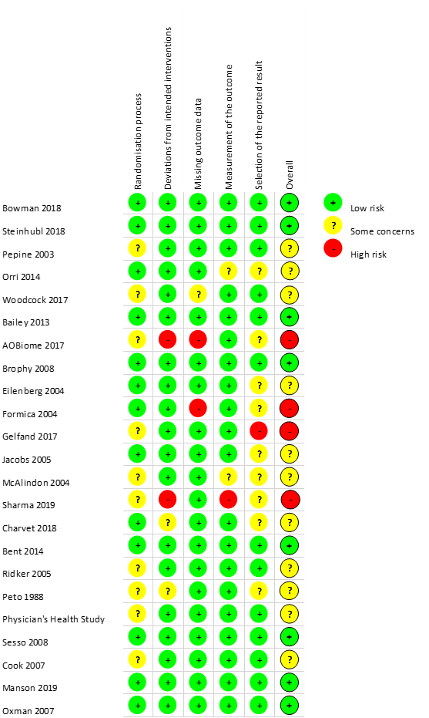

Figure S2. Overall Risk of Bias - crossover trials (n=1)
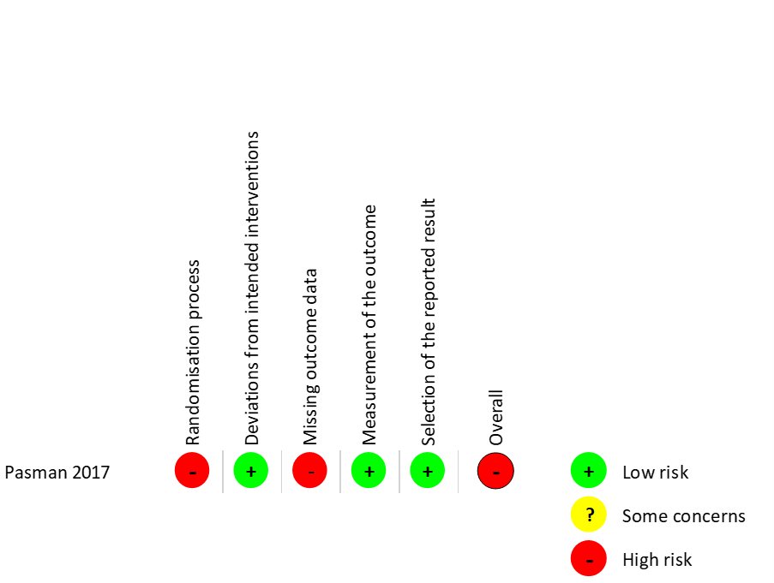

Figure S3. Risk of Bias - parallel group comparisons with methodological outcomes (n=2)
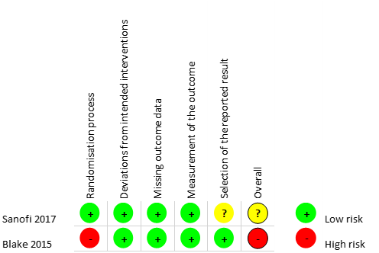

6.3 Reviewer responses to RoB

6.3.1 RoB assessments for the primary outcomes of completed trials
Parallel group and crossover trial assessments are reported in separate tables for each domain.

Table S21. Risk of bias arising from randomisation process, parallel group trials (n=23)
Y = yes; PY = probably yes; NI = no information; PN = probably no; N = no; NA = non-applicable; L = low; SC = some concerns; H = high
 | Was the allocation sequence random? | Was the allocation sequence concealed until participants were enrolled and assigned to interventions? | Did baseline differences between intervention groups suggest a problem with the randomisation process? | Risk of bias judgement
Trial | Risk of bias arising from randomisation process
Bowman et al. | Y | PY | N | L
Steinhubl et al. | Y | PY | N | L
Pepine et al. | Y | NI | N | SC
Orri et al. | Y | PY | PN | L
Woodcock et al. | Y | NI | N | SC
Bailey et al. | Y | Y | NI | L
AOBiome | NI | NI | NI | SC
Brophy et al. | Y | Y | PN | L
Eilenberg et al. | Y | NI | PN | L
Formica et al. | Y | PY | PN | L
Gelfand et al. | NI | NI | PN | SC
Jacobs et al. | Y | Y | PN | L
McAlindon et al. | PY | PY | PY | SC
Sharma et al. | NI | NI | N | SC
Charvet et al. | Y | PY | PN | L
Bent et al. | Y | PY | N | L
Ridker et al. | PY | NI | N | SC
Peto et al. | PY | NI | PN | SC
Physician's Health Study | Y | NI | N | SC
Sesso et al. | Y | PY | N | L
Cook et al. | PY | NI | PN | SC
Manson et al. | Y | PY | N | L
Oxman et al. | Y | PY | PN | L

Table S21a. Risk of bias arising from randomisation process, crossover trial (n=1)
Y = yes; PY = probably yes; NI = no information; N = no; H = high
 | Was the allocation sequence random? | Was the allocation sequence concealed until participants were enrolled and assigned to interventions? | Were there baseline imbalances that suggest a problem with the randomisation process? | Is a roughly equal proportion of participants allocated to each of the two groups? | Are period effects included in the analysis? | Risk of bias judgement
Crossover Trial | Risk of bias arising from randomisation process
Pasman 2017 | N | PY | NI | Y | PY | H

Table S22. Risk of bias due to deviations from intended interventions, parallel group trials (n=23)
Y = yes; PY = probably yes; NI = no information; PN = probably no; N = no; NA = non-applicable; L = low; SC = some concerns; H = high
 | Were participants aware of their assigned intervention during the trial? | Were carers and people delivering the interventions aware of participants assigned intervention during the trial? | Were there deviation from the intended intervention that arose because of the trial context? | Were these deviations likely to have affected the outcome? | Were these deviations from intended interventions balanced between groups? | Was an appropriate analysis used to estimate the effect of assignment to intervention? | Was there potential for a substantial impact (on the result) of the failure to analyse participants in the group to which they were randomised? | Risk of bias judgement
Trial | Risk of bias due to deviations from intended interventions
Bowman et al. | N | N | NA | NA | NA | Y | NA | L
Steinhubl et al. | Y | Y | PN | NA | NA | NA | NA | L
Pepine et al. | Y | Y | PN | NA | NA | NA | NA | L
Orri et al. | PN | PN | NA | NA | NA | NA | NA | L
Woodcock et al. | Y | Y | PN | NA | NA | NA | NA | L
Bailey et al. | N | PN | NA | NA | NA | NA | NA | L
AOBiome | N | N | NA | NA | NA | NA | NI | H
Brophy et al. | N | N | NA | NA | NA | NA | NA | L
Eilenberg et al. | N | N | NA | NA | NA | NA | NA | L
Formica et al. | N | N | NA | NA | NA | NA | NA | L
Gelfand et al. | N | N | NA | NA | NA | NA | NA | L
Jacobs et al. | N | N | NA | NA | NA | NA | NA | L
McAlindon et al. | N | N | NA | NA | NA | NA | NA | L
Sharma et al. | N | PN | NA | NA | NA | NA | NI | H
Charvet et al. | N | PN | NA | NA | NA | NA | PN | SC
Bent et al. | N | N | NA | NA | NA | NA | NA | L
Ridker et al. | N | N | NA | NA | NA | NA | NA | L
Peto et al. | Y | Y | Y | PN | NA | NA | NA | SC
Physician's Health Study | N | PN | NA | NA | NA | PY | NA | L
Sesso et al. | N | N | NA | NA | NA | Y | NA | L
Cook et al. | N | N | NA | NA | NA | Y | NA | L
Manson et al. | N | N | NA | NA | NA | Y | NA | L
Oxman et al. | N | N | NA | NA | NA | Y | NA | L

 | Were participants aware of their assigned intervention during each period of the trial? | Were carers and trial personnel aware of participants' assigned intervention during each period of the trial? | Were there deviations from the intended interventions beyond what would be expected in usual practice? | Were these deviations from intended interventions unbalanced between the two interventions and likely to have affected the outcome? | Was there sufficient time for any carry-over effects to have disappeared before outcome assessment in the second period? | Risk of bias judgement
Crossover Trial | Risk of bias due to deviations from intended interventions
Pasman 2017 | N | N | NA | NA | PY | L

Table S22a. Risk of bias due to deviations from intended interventions (crossover trial n=1)
PY = probably yes; N = no; NA = non-applicable; L = low;

Table S23. Risk of bias due to missing outcome data, parallel group trials (n=23)
Y = yes; PY = probably yes; NI = no information; PN = probably no; N = no; NA = non-applicable; L = low; SC = some concerns; H = high
 | Were data for this outcome available for all, or nearly all, participants randomised? | Is there evidence that the result was not biased by missing outcome data? | Could missingness in the outcome depend on its true value? | Is it likely that missingness in the outcome depended on its true value? | Risk of bias judgement
Trial | Risk of bias due to missing outcome data
Bowman et al. | PY | NA | NA | NA | L
Steinhubl et al. | PY | NA | NA | NA | L
Pepine et al. | PY | NA | NA | NA | L
Orri et al. | Y | NA | NA | NA | L
Woodcock et al. | PN | PN | NI | NI | SC
Bailey et al. | Y | NA | NA | NA | L
AOBiome | NI | N | NI | NI | H
Brophy et al. | Y | NA | NA | NA | L
Eilenberg et al. | PY | NA | NA | NA | L
Formica et al. | N | N | Y | PY | H
Gelfand et al. | PY | NA | NA | NA | L
Jacobs et al. | PY | NA | NA | NA | L
McAlindon et al. | PY | NA | NA | NA | L
Sharma et al. | PY | NA | NA | NA | L
Charvet et al. | PY | NA | NA | NA | L
Bent et al. | Y | NA | NA | NA | L
Ridker et al. | Y | NA | NA | NA | L
Peto et al. | PY | NA | NA | NA | L
Physician's Health Study | Y | NA | NA | NA | L
Sesso et al. | Y | NA | NA | NA | L
Cook et al. | Y | NA | NA | NA | L
Manson et al. | Y | NA | NA | NA | L
Oxman et al. | PY | NA | NA | NA | L

 | Were outcome data available for all, or nearly all, participants randomised? | Are the proportions of missing outcome data and reasons for missing outcome data similar across interventions? | Is there evidence that results were robust to the presence of missing outcome data? | Risk of bias judgement
Trial | Risk of bias due to missing outcome data
Pasman 2017 | PN | NI | NI | H

Table S23a. Risk of bias due to missing outcome data, crossover trials (n=1)
NI = no information; PN = probably no; H = high

Table S24. Risk of bias in measurement of outcome, parallel group trials (n=23)
Y = yes; PY = probably yes; NI = no information; PN = probably no; N = no; NA = non-applicable; L = low; SC = some concerns; H = high
 | Was the method of measuring the outcome inappropriate? | Could measurement or ascertainment of the outcome have differed between intervention groups? | Were outcome assessors aware of the intervention received by study participants? | Could assessment of the outcome have been influenced by knowledge of intervention received? | Is it likely that assessment of the outcome was influenced by knowledge of intervention received? | Risk of bias judgement
Trial | Risk of bias in measurement of the outcome
Bowman et al. | PN | N | N | NA | NA | L
Steinhubl et al. | N | PN | PN | NA | NA | L
Pepine et al. | PN | PN | N | NA | NA | L
Orri et al. | PN | PN | NI | NI | PN | SC
Woodcock et al. | PN | PN | N | NA | NA | L
Bailey et al. | N | N | NI | PN | NA | L
AOBiome | PN | PN | N | NA | NA | L
Brophy et al. | PN | N | N | NA | NA | L
Eilenberg et al. | PN | PN | PN | NA | NA | L
Formica et al. | N | N | NI | PN | NA | L
Gelfand et al. | PN | PN | N | NA | NA | L
Jacobs et al. | N | N | PN | NA | NA | L
McAlindon et al. | PN | PN | NI | NI | NI | SC
Sharma et al. | N | N | NI | NI | NI | H
Charvet et al. | N | PN | NI | PN | NA | L
Bent et al. | N | N | N | NA | NA | L
Ridker et al. | N | PN | N | NA | NA | L
Peto et al. | N | PN | Y | N | NA | L
Physician's Health Study | N | N | N | NA | NA | L
Sesso et al. | N | PN | N | NA | NA | L
Cook et al. | N | PN | N | NA | NA | L
Manson et al. | N | PN | N | NA | NA | L
Oxman et al. | PN | PN | PN | NA | NA | L

 | Were outcome assessors aware of the intervention received by study participants? | Was the assessment of the outcome likely to be influenced by knowledge of intervention received? | Risk of bias judgement
Trial | Risk of bias in measurement of the outcome
Pasman 2017 | N | NA | L

Table S24a. Risk of bias due in measurement of outcome, crossover trials (n=1)
N = no; NA = non-applicable; L = low

Table S25. Risk of bias in selection of the reported result, parallel group trials (n=23)
Y= yes; PY = probably yes; NI = no information; PN = probably no; N = no; NA = non-applicable; L = low; SC = some concerns; H = high
 | Were the data that produced this result analysed in accordance with a pre-specified analysis plan that was finalised before unblinded outcome data were available for analysis? | Is the numerical result being assessed likely to have been selected, on the basis of the results, from… | i) …multiple eligible outcome measurements (e.g. scales, definitions, time points) within the outcome domain? | ii) … multiple eligible analyses of the data? | Risk of bias judgement
Trial | Risk of bias in selection of the reported result
Bowman et al. | PY | PN |  | PN | L
Steinhubl et al. | Y | PN |  | PN | L
Pepine et al. | Y | PN |  | PN | L
Orri et al. | NI | PN |  | PN | SC
Woodcock et al. | PY | PN |  | PN | L
Bailey et al. | PY | PN |  | PN | L
AOBiome | NI | NI |  | NI | SC
Brophy et al. | PY | PN |  | N | L
Eilenberg et al. | NI | PN |  | NI | SC
Formica et al. | NI | PN |  | PN | SC
Gelfand et al. | NI | PN |  | PY | H
Jacobs et al. | NI | NI |  | NI | SC
McAlindon et al. | NI | PN |  | PN | SC
Sharma et al. | NI | PN |  | NI | SC
Charvet et al. | PY | NI |  | NI | SC
Bent et al. | Y | PN |  | PN | L
Ridker et al. | PY | PN |  | PN | L
Peto et al. | NI | PN |  | PN | SC
Physician's Health Study | PY | N |  | N | L
Sesso et al. | PY | PN |  | PN | L
Cook et al. | PY | N |  | N | L
Manson et al. | PY | PN |  | PN | L
Oxman et al. | PY | PN |  | PN | L

Table S25a. Risk of bias in selection of reported result, crossover trials (n=1)
 | Are the reported outcome data likely to have been selected, on the basis of the results, from... | … multiple outcome measurements  (e.g. scales, definitions, time points) within the outcome domain? | ... multiple analyses of the data? | … the outcome of a statistical test for carry-over? | Risk of bias judgement
Trial | Risk of bias in selection of the reported result
Pasman 2017 | PN |  | N | PN | L
PN = probably no; N = no; L = low

6.3.2 RoB assessments of methodological outcomes

Table S26 Risk of bias (methodological outcomes) arising from randomisation process (n=2)
 |  | Sanofi | Blake et al.
Risk of bias arising from randomisation process | Was the allocation sequence random? | PY | NI
Risk of bias arising from randomisation process | Was the allocation sequence concealed until participants were enrolled and assigned to interventions? | PY | NI
Risk of bias arising from randomisation process | Did baseline differences between intervention groups suggest a problem with the randomisation process? | PN | NI
Risk of bias arising from randomisation process | Risk of bias judgement | L | H
PY = probably yes; NI = no information; PN = probably no; L = low; H = high

Table S27. Risk of bias (methodological outcomes) due to deviations from intended interventions, (n=2)
Y = yes; PY = probably yes; PN = probably no NA = non-applicable; L = low;
 |  | Sanofi | Blake et al.
Risk of bias due to deviations from intended interventions | Were participants aware of their assigned intervention during the trial? | Y | Y
Risk of bias due to deviations from intended interventions | Were carers and people delivering the interventions aware of participants assigned intervention during the trial? | Y | Y
Risk of bias due to deviations from intended interventions | Were there deviation from the intended intervention that arose because of the trial context? | PN | PN
Risk of bias due to deviations from intended interventions | Were these deviations likely to have affected the outcome? | NA | NA
Risk of bias due to deviations from intended interventions | Were these deviations from intended interventions balanced between groups? | NA | NA
Risk of bias due to deviations from intended interventions | Was an appropriate analysis used to estimate the effect of assignment to intervention? | Y | PY
Risk of bias due to deviations from intended interventions | Was there potential for a substantial impact (on the result) of the failure to analyse participants in the group to which they were randomised? | NA | NA
Risk of bias due to deviations from intended interventions | Risk of bias judgement | L | L

Table S28. Risk of bias (methodological outcomes) due to missing outcome data (n=2)
PY = probably yes; NA = non-applicable; L = low
 |  | Sanofi | Blake et al.
Risk of bias due to missing outcome data | Were data for this outcome available for all, or nearly all, participants randomised? | PY | PY
Risk of bias due to missing outcome data | Is there evidence that the result was not biased by missing outcome data? | NA | NA
Risk of bias due to missing outcome data | Could missingness in the outcome depend on its true value? | NA | NA
Risk of bias due to missing outcome data | Is it likely that missingness in the outcome depended on its true value? | NA | NA
Risk of bias due to missing outcome data | Risk of bias judgement | L | L

Table S29. Risk of bias (methodological outcomes) in measurement of the outcome, (n=2)
NI = no information; PN = probably no; N = no; NA = non-applicable; L = low
 |  | Sanofi | Blake et al.
Risk of bias in measurement of the outcome | Was the method of measuring the outcome inappropriate? | N | PN
Risk of bias in measurement of the outcome | Could measurement or ascertainment of the outcome have differed between intervention groups? | N | PN
Risk of bias in measurement of the outcome | Were outcome assessors aware of the intervention received by study participants? | PN | NI
Risk of bias in measurement of the outcome | Could assessment of the outcome have been influenced by knowledge of intervention received? | NA | PN
Risk of bias in measurement of the outcome | Is it likely that assessment of the outcome was influenced by knowledge of intervention received? | NA | NA
Risk of bias in measurement of the outcome | Risk of bias judgement | L | L

Table S30. Risk of bias (methodological outcomes) in selection of reported result (n=2)
Y = yes; PY = probably yes; PN = probably no; L = low; SC = some concerns
 |  | Sanofi | Blake et al.
Risk of bias in selection of the reported result | Were the data that produced this result analysed in accordance with a pre-specified analysis plan that was finalised before unblinded outcome data were available for analysis? | Y | PY
Risk of bias in selection of the reported result | Is the numerical result being assessed likely to have been selected, on the basis of the results, from…
Risk of bias in selection of the reported result | i) …multiple eligible outcome measurements (e.g. scales, definitions, time points) within the outcome domain? | PN | PN
Risk of bias in selection of the reported result | ii) … multiple eligible analyses of the data? | Y | PN
Risk of bias in selection of the reported result | Risk of bias judgement | SC | L

6.4 Modified risk of bias assessment

Figure S4. Modified risk of bias assessment (n=17) for ongoing trials
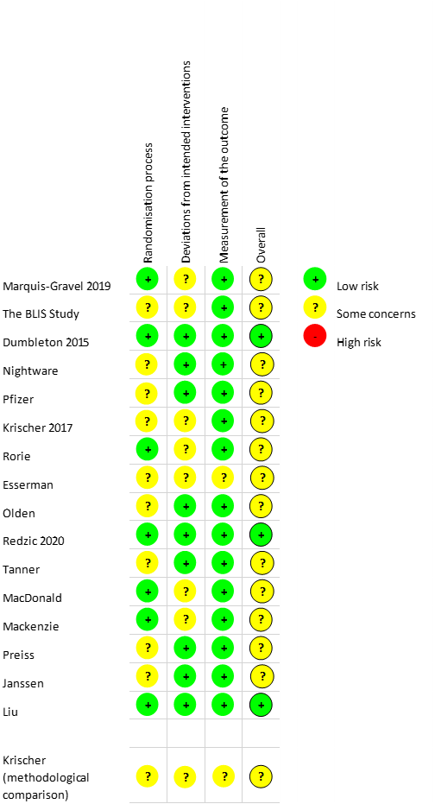
The first sixteen reports above summarise the primary outcomes assessments using the mROB tool; the final summary is of a planned methodological comparison within the named trial.

6.5 Reviewer responses to mRoB

Table S31. Risk of bias arising from the randomisation process (n=17)
Y = yes; PY = probably yes; NI = no information; PN = probably no; N = no; NA = non-applicable; L = low; SC = some concerns; H = high
 | Was the allocation sequence random? | Was the allocation sequence concealed until participants were enrolled and assigned to interventions? | Did baseline differences between intervention groups suggest a problem with the randomization process? (if applicable) | Risk of bias judgement
Trial | Risk of bias arising from the randomisation process
Marquis-Gravel et al. | Y | PY | NI | L
Blis Probiotics | NI | NI | NI | SC
Dumbleton et al. | Y | Y | NI | L
Nightware | NI | NI | NI | SC
Pfizer | NI | NI | NI | SC
Krischer et al. | NI | NI | NI | SC
Rorie et al. | Y | Y | NI | L
Esserman et al. | PY | NI | NI | SC
Olden et al. | NI | NI | NI | SC
Redzic et al. | Y | Y | NI | L
Tanner et al. | NI | NI | NI | SC
MacDonald et al. | Y | Y | NI | L
Mackenzie et al. | Y | Y | NI | L
Preiss et al. | NI | NI | NI | SC
Janssen Scientific Affairs | NI | NI | NI | SC
Liu et al. | Y | Y | NI | L
Krischer (methodological) | NI | NI | NI | SC

Table S32. Risk of bias due to deviations from intended intervention (n=17)
Y = yes; PY = probably yes; NI = no information; PN = probably no; N = no; NA = non-applicable; L = low; SC = some concerns; H = high

 | Were participants aware of their assigned intervention during the trial? | Were carers and people delivering the interventions aware of participants' assigned intervention during the trial? | Risk of bias judgement
Trial | Risk of bias due to deviations from the intended interventions
Marquis-Gravel et al. | Y | Y | SC
Blis Probiotics | Y | Y | SC
Dumbleton et al. | N | N | L
Nightware | N | N | L
Pfizer | N | N | L
Krischer et al. | Y | PY | SC
Rorie et al. | Y | PY | SC
Esserman et al. | PY | PY | SC
Olden et al. | N | N | L
Redzic et al. | N | N | L
Tanner et al. | N | N | L
MacDonald et al. | Y | Y | SC
Mackenzie et al. | Y | Y | SC
Preiss et al. | N | N | L
Janssen Scientific Affairs | N | N | L
Liu et al. | N | N | L
Krischer (methodological) | Y | Y | SC

Table S33. Risk of bias in measurement of outcome (n=17)
Y = yes; PY = probably yes; NI = no information; PN = probably no; N = no; NA = non-applicable; L = low; SC = some concerns; H = high
 | Was the method of measuring the outcome inappropriate? | Could measurement or ascertainment of the outcome have differed between intervention groups? | Were outcome assessors aware of the intervention received by study participants? | Could assessment of the outcome have been influenced by knowledge of intervention received? | Is it likely that assessment of the outcome was influenced by knowledge of intervention received? | Risk of bias judgement
Trial | Risk of bias in measurement of the outcome
Marquis-Gravel et al. | PN | N | N | NA | NA | L
Blis Probiotics | N | PN | NI | PN | NA | L
Dumbleton et al. | PN | PN | N | NA | NA | L
Nightware | PN | PN | N | NA | NA | L
Pfizer | N | N | N | NA | NA | L
Krischer et al. | PN | N | NI | PN | NA | L
Rorie et al. | PN | PN | N | NA | NA | L
Esserman et al. | NI | NI | NI | NI | NI | SC
Olden et al. | PN | PN | N | NA | NA | L
Redzic et al. | PN | PN | N | NA | NA | L
Tanner et al. | PN | N | N | NA | NA | L
MacDonald et al. | PN | N | N | NA | NA | L
Mackenzie et al. | PN | PN | N | NA | NA | L
Preiss et al. | PN | N | N | NA | NA | L
Janssen Scientific Affairs | PN | PN | N | NA | NA | L
Liu et al. | PN | PN | N | NA | NA | L
Krischer (methodological) | N | N | NI | PY | PN | SC

Qualitative Analysis

7.1 List of Sources
Citations for all sources used in wider qualitative review
Adams J, Biemiller R, Andrzejewski K, et al. Utilizing remote blood pressure monitoring in a phase III clinical drug trial for Parkinson’s disease: 2082. Mov Disord. 2016;31.
Alsumidaie M. The Evolution of Patient Centricity. Appl Clin Trials. 2019;28(3):26-27.
Andrews L, Kostelecky K, Spritz S, Franco A. Virtual clinical trials: one step forward, two steps back. J Health Care L & Pol’y. 2016;19:189.
Andrzejewski KL, Tarolli CG, Zimmerman G, et al. Interim analysis of the REACT-PD study, evaluating the use of virtual research visits in a clinical trial in individuals with Parkinson’s disease. In: MOVEMENT DISORDERS. Vol 32; 2017:E2-E3.
Apostolaros M, Babaian D, Corneli A, et al. Legal, Regulatory, and Practical Issues to Consider When Adopting Decentralized Clinical Trials: Recommendations From the Clinical Trials Transformation Initiative. Therapeutic Innovation & Regulatory Science. Published online 2019:1-9.
Araujo D. Measuring The Financial Impact Of Remote (Digital) Clinical Trials. Clinical Leader. Accessed April 27, 2021. https://www.clinicalleader.com/doc/measuring-the-financial-impact-of-remote-digital-clinical-trials-0001
Baca-Motes K, Edwards AM, Waalen J, et al. Digital recruitment and enrollment in a remote nationwide trial of screening for undiagnosed atrial fibrillation: Lessons from the randomized, controlled mSToPS trial. Contemp Clin Trials Commun. 2019;14:100318.
Bailey J, McCarthy O, Carswell K, et al. The Sexunzipped Website for Sexual Wellbeing for Young People: Early Results of a Pilot Online RCT. In: The Journal of Sexual Medicine. Vol 8. Elsevier; 2011:126-126.
Bailey JV, Pavlou M, Copas A, et al. The Sexunzipped trial: optimizing the design of online randomized controlled trials. J Med Internet Res. 2013;15(12):e278.
Barron D. Siteless: The Future of Clinical Trials? Published 17 November 2016. Accessed April 1, 2021. https://www.reutersevents.com/pharma/clinical/siteless-future-clinical-trials
Bent S, Hendren RL, Zandi T, et al. Internet-based, randomized, controlled trial of omega-3 fatty acids for hyperactivity in autism. J Am Acad Child Adolesc Psychiatry. 2014;53(6):658-666.
Blake K, Holbrook JT, Antal H, et al. Use of mobile devices and the internet for multimedia informed consent delivery and data entry in a pediatric asthma trial: Study design and rationale. Contemp Clin Trials. 2015;42:105-118.
Bowman L, Mafham M, Stevens W, et al. ASCEND: A Study of Cardiovascular Events iN Diabetes: Characteristics of a randomized trial of aspirin and of omega-3 fatty acid supplementation in 15,480 people with diabetes. Am Heart J. 2018;198:135-144.
Brophy S, Burrows CL, Brooks C, Gravenor MB, Siebert S, Allen SJ. Internet-based randomised controlled trials for the evaluation of complementary and alternative medicines: probiotics in spondyloarthropathy. BMC Musculoskelet Disord. 2008;9:4.
Chan Y-FY, Wang P, Rogers L, et al. The Asthma Mobile Health Study, a large-scale clinical observational study using ResearchKit. Nat Biotechnol. 2017;35(4):354-362.
Cohen S, Waks Z, Elm JJ, et al. Characterizing patient compliance over six months in remote digital trials of Parkinson’s and Huntington disease. BMC Med Inform Decis Mak. 2018;18(1):138.
Comstock J. The year for mobile-enabled clinical trials: 2013 or 2030? trialx.com. Published 2012. https://trialx.com/wp-content/uploads/2012/11/The-year-for-mobile-enabled-clinical-trials_-2013-or-2030_-_-MobiHealthNews.pdf
Coravos A, Khozin S, Mandl KD. Developing and adopting safe and effective digital biomarkers to improve patient outcomes. NPJ digital medicine. 2019;2(1):1-5.
Coravos A. Decentralized clinical trials – Andrea’s Blog. Andrea’s Blog. Published 15 October 2018. Accessed October 17, 2018. https://blog.andreacoravos.com/decentralized-clinical-trials-e9dbde90ea95
Coravos A. Software-Enabled Clinical Trials – Andrea’s Blog. Andrea’s Blog. Published 4 September 2017. Accessed October 17, 2018. https://blog.andreacoravos.com/software-enabled-clinical-trials-8da53f4cd271
Covington D. The Remote Patient-Centered Study Approach in Clinical Research. Published 2014. Accessed April 27, 2021. https://www.appliedclinicaltrialsonline.com/view/remote-patient-centered-study-approach-clinical-research
Crouthamel M, Quattrocchi E, Watts S, et al. Using a ResearchKit Smartphone App to Collect Rheumatoid Arthritis Symptoms From Real-World Participants: Feasibility Study. JMIR Mhealth Uhealth. 2018;6(9):e177.
Deloitte Centre for Health Solutions. Intelligent Clinical Trials Transforming through AI-Enabled Engagement. Deloitte Centre for Health Solutions https://www2.deloitte.com/content/dam/insights/us/articles/22934_intelligent-clinical-trials/DI_Intelligent-clinical-trials.pdf
Donnelly S, Reginatto B, Kearns O, et al. The Burden of a Remote Trial in a Nursing Home Setting: Qualitative Study. J Med Internet Res. 2018;20(6):e220.
Dorsey ER, Darwin KC, Mohammed S, et al. Virtual research visits and direct-to-consumer genetic testing in Parkinson’s disease. Digit Health. 2015;1:2055207615592998.
Dorsey ER, Venuto C, Venkataraman V, Harris DA, Kieburtz K. Novel methods and technologies for 21st-century clinical trials: a review. JAMA Neurol. 2015;72(5):582-588.
Dorsey ER, Wagner JD, Bull MT, et al. Feasibility of Virtual Research Visits in Fox Trial Finder. J Parkinsons Dis. 2015;5(3):505-515.
Druce KL, McBeth J, van der Veer SN, et al. Recruitment and Ongoing Engagement in a UK Smartphone Study Examining the Association Between Weather and Pain: Cohort Study. JMIR Mhealth Uhealth. 2017;5(11):e168.
Dumbleton JS, Avery AJ, Coupland C, et al. The Helicobacter Eradication Aspirin Trial (HEAT): A Large Simple Randomised Controlled Trial Using Novel Methodology in Primary Care. EBioMedicine. 2015;2(9):1200-1204.
eClinicalHealth Ltd. eClinicalHealth Announces Successful Results for an Entirely Remote Online Clinical Trial. Published online 21 June 2016. Accessed April 27, 2021. https://www.businesswire.com/news/home/20160621005604/en/eClinicalHealth-Announces-Successful-Results-for-an-Entirely-Remote-Online-Clinical-Trial
eClinicalHealth Ltd. Europe’s First Fully Remote Diabetes Trial Approved. Published online 10 February 2015. Accessed April 27, 2021. https://www.prnewswire.com/news-releases/europes-first-fully-remote-diabetes-trial-approved-291395161.html
eClinicalHealth Ltd. Streamlining Diabetes Research With A Remote Study Model.; 2019. https://www.clinpal.com/wp-content/uploads/2019/04/White-Paper-Streamlining-Diabetes-Research-Virtual-Study.pdf
Eilenberg KL, Hoover AM, Rutherford ML, Melfi CA, Segal S. From Informed Consent through Database Lock: An Interactive Clinical Trial Conducted Using the Internet. Drug information journal : DIJ / Drug Information Association. 2004;38(3):239-251.
Fanaroff AC, Califf RM, Lopes RD. New Approaches to Conducting Randomized Controlled Trials. J Am Coll Cardiol. 2020;75(5):556-559.
Faulkner M, Alikhaani J, Brown L, et al. Exploring Meaningful Patient Engagement in ADAPTABLE (Aspirin Dosing: A Patient-centric Trial Assessing Benefits and Long-term Effectiveness). Med Care. 2018;56 Suppl 10 Suppl 1:S11-S15.
Fiscalini AS, Theiner S, Kaplan C, et al. Evaluating the feasibility of a web-based preferencetolerant randomized trial of risk-based vs. annual breast cancer screening: WISDOM study pilot. In: CANCER RESEARCH. Vol 77; 2017.
Formica M, Kabbara K, Clark R, McAlindon T. Can clinical trials requiring frequent participant contact be conducted over the Internet? Results from an online randomized controlled trial evaluating a topical ointment for herpes labialis. J Med Internet Res. 2004;6(1):e6.
Galarnyk M, Quer G, McLaughlin K, Ariniello L, Steinhubl SR. Usability of a Wrist-Worn Smartwatch in a Direct-to-Participant Randomized Pragmatic Clinical Trial. Digit Biomark. 2019;3(3):176-184.
Galsky MD, Shahin M, Jia R, et al. Telemedicine-Enabled Clinical Trial of Metformin in Patients With Prostate Cancer. JCO Clinical Cancer Informatics. 2017;(1):1-10.
Gelfand AA, Qubty W, Patniyot I, et al. Home-Based Trials in Adolescent Migraine: A Randomized Clinical Trial. JAMA Neurol. 2017;74(6):744-745.
Hand S. Virtual Clinical Trials – Can Remote Trials Change The Clinical Trial Landscape? Published 10 May 2018. Accessed April 1, 2021. https://xtalks.com/virtual-clinical-trials-1/
Hirsch IB, Martinez J, Dorsey ER, et al. Incorporating Site-less Clinical Trials Into Drug Development: A Framework for Action. Clin Ther. 2017;39(5):1064-1076.
Jacobs BP, Bent S, Tice JA, Blackwell T, Cummings SR. An internet-based randomized, placebo-controlled trial of kava and valerian for anxiety and insomnia. Medicine . 2005;84(4):197-207.
Jadhav S. Virtual Clinical Trials: The Future of Patient Engagement? Published 2016. Accessed April 27, 2021. https://www.appliedclinicaltrialsonline.com/view/virtual-clinical-trials-future-patient-engagement
Janssen Scientific Affairs. Janssen Leverages Wearable Technology to Reimagine Clinical Trial Design. Published online 16 November 2019. https://www.janssen.com/us/sites/www_janssen_com_usa/files/janssen_leverages_wearable_technology_to_reimagine_clinical_trial_design_0.pdf
Kershner A. Breaking Down the Keys to Decentralized Clinical Trials. Published 4 April 2019. Accessed April 1, 2021. https://clarkstonconsulting.com/insights/decentralized-clinical-trials/
Kochar A, Roe M, Robertson H, Rothman R, Harrington R, Larsen B, Munoz D, Crenshaw D, Haynes K, McCormick‐Ricket I, Hernandez A, Jones S. Adaptable-a patient-centered, pragmatic randomized clinical trial. Cochrane Library. doi:10.1002/central/CN-01646651
Koester A, Barnes-Weise J, Hoyt K, et al. How one pharmaceutical company is reinventing the clinical trial. Published 21 September 2018. Accessed April 1, 2021. https://www.statnews.com/2018/09/21/clinical-trials-reinvention-janssen/
Krischer J, Cronholm PF, Burroughs C, et al. Experience With Direct-to-Patient Recruitment for Enrollment Into a Clinical Trial in a Rare Disease: A Web-Based Study. J Med Internet Res. 2017;19(2):e50.
Kumar S. Virtual clinical trials. SlideShare. Published 2018. Accessed April 27, 2021. https://www.slideshare.net/DrSahilKumar/virtual-clinical-trials-90154223
Langel K. The Future of Patient Engagement: Applying What We Know Now. Applied Clinical Trials Online. Published 2017. Accessed April 1, 2021. https://www.appliedclinicaltrialsonline.com/view/future-patient-engagement
Levine H. Clinical Trials 2.0: 5 Ways Johnson & Johnson Is Helping Revamp—and Revolutionize—How They’re Conducted. Published online 2 September 2019. Accessed April 1, 2021. https://www.jnj.com/innovation/5-ways-johnson-johnson-is-helping-revolutionize-clinical-trials
Liu X, Robbins S, Eyles J, et al. Efficacy and safety of a supplement combination for hand osteoarthritis pain: protocol for an internet-based randomised placebo-controlled trial (The RADIANT study). BMJ Open. 2020;10(2):e035672.
MacDonald TM, Ford I, Nuki G, et al. Protocol of the Febuxostat versus Allopurinol Streamlined Trial (FAST): a large prospective, randomised, open, blinded endpoint study comparing the cardiovascular safety of allopurinol and febuxostat in the management of symptomatic hyperuricaemia. BMJ Open. 2014;4:e005354.
Mackenzie IS, Ford I, Walker A, et al. Multicentre, prospective, randomised, open-label, blinded end point trial of the efficacy of allopurinol therapy in improving cardiovascular outcomes in patients with ischaemic heart disease: protocol of the ALL-HEART study. BMJ Open. 2016;6(9):e013774.
Manson JE, Bassuk SS, Lee I-M, et al. The VITamin D and OmegA-3 TriaL (VITAL): rationale and design of a large randomized controlled trial of vitamin D and marine omega-3 fatty acid supplements for the primary prevention of cancer and cardiovascular disease. Contemp Clin Trials. 2012;33(1):159-171.
Mantel B. To Boost Patient Participation, Clinical Trials Come Home. Undark. Published 24 September 2018. Accessed November 26, 2018. https://undark.org/article/clinical-trials-virtual-participation/
Marken. How companies are realizing the potential of virtual and hybrid clinical trials. Published 24 October 2018. Accessed April 1, 2021. https://www.outsourcing-pharma.com/Headlines/Promotional-Features/How-companies-are-realizing-the-potential-of-virtual-and-hybrid-clinical-trials
Marquis-Gravel Guillaume, Roe Matthew T., Turakhia Mintu P., et al. Technology-Enabled Clinical Trials. Circulation. 2019;140(17):1426-1436.
Mathieu E, Barratt A, Carter SM, Jamtvedt G. Internet trials: participant experiences and perspectives. BMC Med Res Methodol. 2012;12:162.
McAdams P. ADAPTABLE Team Finishes Enrollment, Reflects on Lessons Learned - Adaptable. Published 1 July 2019. Accessed April 27, 2021. https://theaspirinstudy.org/2019/07/adaptable-team-finishes-enrollment-reflects-on-lessons-learned/
McAlindon T, Formica M, Kabbara K, LaValley M, Lehmer M. Conducting clinical trials over the internet: feasibility study. BMJ. 2003;327(7413):484-487.
McAlindon T, Formica M, LaValley M, Lehmer M, Kabbara K. Effectiveness of glucosamine for symptoms of knee osteoarthritis: results from an internet-based randomized double-blind controlled trial. Am J Med. 2004;117(9):643-649.
Mengden T, Ewald S, Kaufmann S, vor dem Esche J, Uen S, Vetter H. Telemonitoring of blood pressure self measurement in the OLMETEL study. Blood Press Monit. 2004;9(6):321-325.
Messmer K. Wearable Devices and Mobile Technology in Clinical Trials. The Evidence Forum; 2017. https://www.evidera.com/wp-content/uploads/2017/11/Wearable-Devices-and-Mobile-Technology-in-Clinical-Trials.pdf
Nicholas A, Bailey JV, Stevenson F, Murray E. The Sexunzipped trial: young people’s views of participating in an online randomized controlled trial. J Med Internet Res. 2013;15(12):e276.
Novartis Global Drug Development. Decentralized Clinical Trials. Presented at the: Japan Pharmaceutical Manufacturers Association’s Pharmaceutical Evaluation Committee; February 2019. http://www.jpma.or.jp/medicine/shinyaku/tiken/symposium/pdf/20190222/20190222_02.pdf
Olden M, Wyka K, Cukor J, et al. Pilot Study of a Telehealth-Delivered Medication-Augmented Exposure Therapy Protocol for PTSD. The Journal of Nervous and Mental Disease. 2017;205(2):154-160. doi:10.1097/nmd.0000000000000563
Orri M, Lipset CH, Jacobs BP, Costello AJ, Cummings SR. Web-based trial to evaluate the efficacy and safety of tolterodine ER 4 mg in participants with overactive bladder: REMOTE trial. Contemp Clin Trials. 2014;38(2):190-197.
Oxman AD, Flottorp S, Håvelsrud K, et al. A televised, web-based randomised trial of an herbal remedy (valerian) for insomnia. PLoS One. 2007;2(10):e1040.
Papapetropoulos S, Fine S, Taylor S, et al. Implementation and Validation of a Biometric Solution for Remote Monitoring of Motor Symptoms in Patients with Huntington’s Disease in a Phase II Clinical Trial. In: 69th American Academy of Neurology Annual Meeting. Vol 88. American Academy of Neurology; 2017:P2.013.
Pasman WJ, Boessen R, Donner Y, Clabbers N, Boorsma A. Effect of Caffeine on Attention and Alertness Measured in a Home-Setting, Using Web-Based Cognition Tests. JMIR Res Protoc. 2017;6(9):e169.
Pepine CJ, Handberg-Thurmond E, Marks RG, et al. Rationale and design of the International Verapamil SR/Trandolapril Study (INVEST): an Internet-based randomized trial in coronary artery disease patients with hypertension. J Am Coll Cardiol. 1998;32(5):1228-1237.
Perez MV, Mahaffey KW, Hedlin H, et al. Large-Scale Assessment of a Smartwatch to Identify Atrial Fibrillation. N Engl J Med. 2019;381(20):1909-1917.
Peto R, Gray R, Collins R, et al. Randomised trial of prophylactic daily aspirin in British male doctors. Br Med J . 1988;296(6618):313-316.
Pfaff E, Lee A, Bradford R, et al. Recruiting for a pragmatic trial using the electronic health record and patient portal: successes and lessons learned. J Am Med Inform Assoc. 2019;26(1):44-49.
Pletcher MJ, Fontil V, Carton T, et al. The PCORnet Blood Pressure Control Laboratory: A Platform for Surveillance and Efficient Trials. Circ Cardiovasc Qual Outcomes. 2020;13(3):e006115.
Quer G, Nikzad N, Lanka S, van Mourik R, Dur O, Steinhubl SR. Preliminary Evaluation of a Wrist Wearable Heart Rate Sensor for the Detection of Undiagnosed Atrial Fibrillation in a Real-World Setting. Circulation. 2017;136(suppl_1):A18610-A18610.
Redzic N, Benoy I, Vanden Broeck D, Bogers JP. Efficacy of AV2-Salicylic acid combination therapy for cutaneous warts: Study protocol for a single-center randomized controlled trial. Contemp Clin Trials Commun. 2020;17:100534.
Ridker PM, Cook NR, Lee I-M, et al. A randomized trial of low-dose aspirin in the primary prevention of cardiovascular disease in women. N Engl J Med. 2005;352(13):1293-1304.
Roe MT. ADAPTABLE, the Aspirin Study: Embracing Patient-Partnered Research - Rethinking Clinical Trials. Presented at the: Grand Rounds; June 9, 2017; Rethinking Clinical Trials. Accessed April 27, 2021. https://rethinkingclinicaltrials.org/news/grand-rounds-6-9-17/
Rogers A, Morrison I, Rorie DA, Mackenzie IS, MacDonald TM. Protocol for assessment of sleep quality and duration in the Treatment In Morning versus Evening (TIME) study: a randomised controlled trial using online patient-reported outcome measures. BMJ Open. 2018;8(6):e021890.
Rosa C, Campbell ANC, Miele GM, Brunner M, Winstanley EL. Using e-technologies in clinical trials. Contemp Clin Trials. 2015;45(Pt A):41-54.
Rose J. Virtual Trials – A more direct path to patients. Published 6 June 2018. Accessed April 1, 2021. https://www.iqvia.com/blogs/2018/06/virtual-trials-a-more-direct-path-to-patients
Russell C, Ammour N, Wells T, et al. A Pilot Study to Assess the Feasibility of Collecting and Transmitting Clinical Trial Data with Mobile Technologies. Digital Biomarkers. 2018;2(3):126-138.
Rutkove SB, Qi K, Shelton K, Liss J, Berisha V, Shefner JM. ALS longitudinal studies with frequent data collection at home: study design and baseline data. Amyotroph Lateral Scler Frontotemporal Degener. 2019;20(1-2):61-67.
Sablinski T. Open Innovation and Mobile Health Technology to Improve and Accelerate Clinical Development. In: NEUROPSYCHOPHARMACOLOGY. Vol 38; 2013:S75-S75.
Sharma K, Agarwal S, Mania D, et al. Remotely-Supervised Non-Invasive Brain Stimulation for Remediation of Fatigue in Parkinson’s Patients. Brain Stimulation: Basic, Translational, and Clinical Research in Neuromodulation. 2019;12(4):e149-e150.
Shaw M, Dobbs B, Pawlak N, Pau W, Charvet L. At-home transcranial direct current stimulation (tDCS) improves mood in multiple sclerosis: results from a randomized, sham-controlled trial. In: MULTIPLE SCLEROSIS JOURNAL. Vol 23; 2017:962-962.
Shefner J. RS. Displaced reality: The challenges of creating an ALS clinical study in which all data collection takes place in the patient’s home. In: Abstracts from the 28th International Symposium on ALS/MND. Theme 11: Improving Diagnosis, Prognosis and Disease Progression. Vol 18. ; 2017:261-279.
Shefner, J. Liss, J. Berisha, V.Shelton, Qi, K. Rutkove, S. ALS at home: Measuring longitudinal patient outcomes without study visits. In: Degeneration ALSA, ed. Abstracts from the 28th International Symposium on ALS/MND. Theme 9 Clinical Trials. Vol 18. ; 2017:228-244.
Shprecher D, Noyes K, Biglan K, et al. Willingness of Parkinson’s Disease Patients to Participate in Research Using Internet-Based Technology. Telemedicine and e-Health. 2012;18(9):684-687. doi:10.1089/tmj.2011.0276
Silva de Lima AL, Hahn T, Evers LJW, et al. Feasibility of large-scale deployment of multiple wearable sensors in Parkinson’s disease. PLoS One. 2017;12(12):e0189161.
Sisk S. Home-Based Clinical Studies – A Paradigm Shift? Published 23 March 2018. Accessed April 1, 2021. https://www.clinicaltrialsarena.com/comment/home-based-clinical-studies-a-paradigm-shift-6094192-2/
Smalley E. Clinical trials go virtual, big pharma dives in. Nat Biotechnol. 2018;36(7):561-562.
Sommer C, Zuccolin D, Arnera V, et al. Building clinical trials around patients: Evaluation and comparison of decentralized and conventional site models in patients with low back pain. Contemp Clin Trials Commun. 2018;11:120-126.
Spartano NL, Lin H, Sun F, et al. Comparison of On-Site Versus Remote Mobile Device Support in the Framingham Heart Study Using the Health eHeart Study for Digital Follow-up: Randomized Pilot Study Set Within an Observational Study Design. JMIR Mhealth Uhealth. 2019;7(9):e13238.
Spartano NL, Sun F, Lunetta KL, et al. Comparison of on-site versus Remote Support for a Mobile-Device Pilot Study: A Collaboration Between the Framingham Heart Study and Health eHeart Study (FHS-HeH). In: CIRCULATION. Vol 137; 2018.
Steering Committee of the Physicians’ Health Study Research Group. Final report on the aspirin component of the ongoing Physicians’ Health Study. N Engl J Med. 1989;321(3):129-135.
Steinhubl SR, Baca-Motes K, Edwards A, et al. Remote digital recruitment and enrollment in a nationwide trial of screening for undiagnosed atrial fibrillation using a self-applied ECG recording patch sensor: Lessons from the MSTOPS trial. In: Journal of the American College of Cardiology, ed. Journal of the American College of Cardiology. Vol 69, Issue 11. American College of Cardiology Foundation; 2017:2512.
Steinhubl SR, McGovern P, Dylan J, Topol EJ. The digitised clinical trial. Lancet. 2017;390(10108):2135.
Steinhubl SR, Mehta RR, Ebner GS, et al. Rationale and design of a home-based trial using wearable sensors to detect asymptomatic atrial fibrillation in a targeted population: The mHealth Screening To Prevent Strokes (mSToPS) trial. Am Heart J. 2016;175:77-85.
Steinhubl SR, Waalen J, Edwards AM, et al. A nationwide trial of screening for undiagnosed atrial fibrillation in an at-risk population using a self-applied ECG recording patch sensor: results of the randomized component of the mHealth Screening To Prevent Strokes (mSToPS) trial. Circulation. 2017;136(suppl_1):A13757-A13757.
Steinhubl SR, Waalen J, Edwards AM, et al. Effect of a Home-Based Wearable Continuous ECG Monitoring Patch on Detection of Undiagnosed Atrial Fibrillation: The mSToPS Randomized Clinical Trial. JAMA. 2018;320(2):146-155.
Steinhubl SR, Wolff-Hughes DL, Nilsen W, Iturriaga E, Califf RM. Digital clinical trials: creating a vision for the future. NPJ Digit Med. 2019;2:126.
Stevenson, DJ. Dumbleton, JS. Avery, AJ. Coupland, C. Hobbs, FDR. Kendrick, D. Moore, MV. Morris, C. Rubin, G. Smith, MD. Hawkey, CJ. The helicobacter eradication aspirin trial (HEAT): Recruitment and demographics of the randomised patient population. In: United European Gastroenterology Journal; 2018:6 (Supplement 1).
Stircu S. New technologies allow decentralisation of clinical trials. Published 26 February 2019. Accessed April 1, 2021. http://www.medtechviews.eu/article/new-technologies-allow-decentralisation-clinical-trials
Sweeney M, Redding S. The Growth of Direct-to-Patient Trials. Appl Clin Trials. 2016;25(10/11):22.
Tanner CM. Prevention of Fractures in Parkinson’s Disease (PD) with a Single Infusion of Zoledronic Acid (ZA). In: MOVEMENT DISORDERS. Vol 34; 2019:S13-S13.
Tarolli C, Andrzejewski K, Bull M, et al. Virtual research visits in individuals with Parkinson disease enrolled in a clinical trial: REACT-PD Study Interim Analysis. Neurology. 2017;88(16 Supplement):P4.005.
Tarolli CG, Zimmerman GA, Goldenthal S, et al. Video research visits for atypical parkinsonian syndromes among Fox Trial Finder participants. Neurol Clin Pract. 2020;10(1):7-14.
Theiner S, Kaplan C, Sarrafan S, et al. The WISDOM study pilot: Evaluating a preference-tolerant RCT of risk-based vs. annual breast cancer screening. J Clin Orthod. 2016;34(15_suppl):e13035-e13035.
Ulrich U, Browning M, Gaffney EV, Schöter KH, Chesnut CH 3rd. Implementation of an osteoporosis research program with a mobile dual-energy X-ray absorptiometry unit: the Montana/Wyoming experience. Osteoporos Int. 1997;7(6):583-588.
Vogel MME, Combs SE, Kessel KA. mHealth and Application Technology Supporting Clinical Trials: Today’s Limitations and Future Perspective of smartRCTs. Front Oncol. 2017;7:37.
Williams R, Quattrocchi E, Watts S, Wang S, Berry P, Crouthamel M. Patient Rheumatoid Arthritis Data from the Real World (PARADE) Study: Preliminary Results from an Apple Researchkit T Mobile App-Based Real World Study in the United States. In: 2017 ACR/ARHP Annual Meeting. Arthritis Rheumatol. Vol 69. American College of Rheumatology; 2017:69 (suppl 10).
Woodcock A, Bakerly ND, John P. New, et al. The Salford Lung Study protocol: a pragmatic, randomised phase III real-world effectiveness trial in asthma. BMC Pulmonary Medicine. 2015;15(1). doi:10.1186/s12890-015-0150-8
Zhu M, Sridhar S, Hollingsworth R, et al. Hybrid clinical trials to generate real-world evidence: design considerations from a sponsor’s perspective. Contemp Clin Trials. 2020;94:105856.

7.2 Table S34. Advantages of DCTs – representative quotations

Major Themes | Narrow themes | Advantages | Representative Quotations | Source
Value | Improving research quality | Generalisability of trial results (real-world data, representative cohorts) | "A key advantage of a hybrid design is that the data collected is representative of real-world health-seeking behavior, medical practice, and outcomes. This is significantly advantageous for the external generalizability of the study outcomes." | Zhu 2020
Value | Improving research quality |  | " As it is possible to recruit large, diverse samples, including participants who would otherwise be difficult to access. Internet trials may also increase transferability of findings. This is an important advantage as conventional trials commonly recruit highly selected groups of participants, thus limiting the transferability of their results and the overall relevance and value of the research" | Mathieu 2012
Value | Improving research quality | Data quality (more data, timeliness, sensitivity, objectivity) | "By harnessing wearable technologies and mHealth, such trials offer the allure of not just enhanced data quality but better data volume through continuous monitoring" | Barron 2016
Value | Improving research quality |  | "completeness and timeliness of the data are increased, because the course of the disease is monitored longitudinally and not only cross-sectional as it is the case with classical periodical visits" | Vogel 2017
Value | Improving research quality |  | "these sensors may be more sensitive to change than conventional clinical ratings." | Dorsey 2015
Value | Improving research quality |  | "Home-based monitoring may also be more objective from the patient perspective owing to white cloak phenomena, muddying response in the clinic-setting" | Cohen 2018
Value | Improving research quality | Novel biomarkers (new endpoints, multidimensional data) | “Mobile technology offers new ways to capture objective measurements as clinical trial participants go about their daily lives by utilizing novel endpoints.” | Apostolaros 2019
Value | Improving research quality | Novel biomarkers (new endpoints, multidimensional data) | “Smartphone apps for health monitoring can potentially deliver frequent and regular self-reported symptoms, whereas sensors on smartphones can aid collection of new data types, including position, movement, and environmental exposures" | Druce 2017
Value | Better participant engagement | Enabling self-management | "participants are likely to derive greater individual value [from integrated devices] ... this additional value might enhance patient engagement, enabling long-term use of the device" | Galarnyk 2019
Value | Better participant engagement | Enabling self-management | “Participants using the.... wearable platform, other than reporting their medication intake when reminded by the alarm (which was widely perceived as a service, instead of a burden) …” | Silva de Lima 2017
Value | Better participant engagement | Improved communication between participants and research personnel | “these connected apps and devices allow patients to stay informed and supported in real time, which can enhance engagement and retention” | Deloittelnsights 2020
Value | Better participant engagement | Building trust | “by bringing me in the process and sharing information with me, I feel like I am a more valuable contributor because I can see that what I am doing is making a difference and that the data is valuable to the people who are gathering it.” | Alsumidaie 2019
Value | Enabling otherwise infeasible research | Permitting data-driven trial designs | "Remote monitoring capabilities could thus facilitate an adaptive clinical trial approach, allowing improvements in trial design based on the accumulating data " | Jadhav 2016
Value | Enabling otherwise infeasible research | Allows trials in rare diseases with geographically dispersed patients | “especially powerful for rare conditions for which typical studies involve air travel to research centers" | Dorsey 2015
Value | Knowledge generation | Improving scientific understanding of disease (new data types, real-world data collection, longitudinal and multidimensional data) | “Using smartphones to enroll, obtain consent, and gather self-reported data from patients has the potential to enhance our understanding of disease burden and quantify physiological impact in the real world." | Crouthamel 2018
Value | Knowledge generation |  | "Furthermore, wearable sensor data may improve our scientific understanding of disease progression by showing changes in motor and non-motor symptoms over time, furthering the development of digital biomarkers for disease progression" | Silva de Lima 2017
Value | Improving healthcare | Better evidence for decision making | '"Payers will benefit too, as studies produce measurable data to support the value proposition of therapies, while sponsors benefit from condensed timelines and accelerated time to market." | Stircu 2019
Value | Improving healthcare | Generating useful individual patient data | "The process is popular with GPs because it is minimally intrusive upon their time, and the recruitment process can also generate patient health data that returns to the GP record" | Dumbleton 2015
Value | Improving healthcare | Faster answers to clinical questions | "Novel ideas to reach a larger and perhaps less preselected population could reduce the time and cost of clinical trials, increase the generalizability and social value of their findings, and increase the likelihood that important clinical questions could be addressed more quickly and successfully to better support advancing new beneficial therapies to affected individuals. Even more importantly, such methods would revolutionize clinical research in rare diseases" | Krischer 2017
Value | Improving healthcare | Better understanding of patient experience | “Using smartphones to enroll, obtain consent, and gather self-reported data from patients has the potential to enhance our understanding of disease burden and quantify physiological impact in the real world." | Crouthamel 2018
Value | Improving healthcare | Promoting remote health care delivery | In addition, the use of the home delivery of treatment can offer a bridge to real-world clinical use.” | Shaw 2018
Value | Commercial advantage | Faster drug development timelines | "Faster drug development, also means a company can have a product on the market sooner, extending the time before patents run out" | Smalley 2018
Burden | Reducing burden of trial participation | Offering participants choice/flexibility in how to participate | "I can choose the time of the day I'll answer the questions, and the environment is familiar (I do it at home or work, and not a hospital or clinic)." | Mathieu 2012
Burden | Reducing burden of trial participation | Fewer in-person study visits | "companies studying pediatric drugs spare parents the burden of taking their children to sites." | Marken 2018
Burden | Reducing burden of trial participation | Passive data collection | "monitoring can occur passively without any addition work required of the participant beyond wearing and occasionally charging the device." | Galarnyk 2019
Burden | Reducing burden of trial conduct | Less costly training (of staff and participants) | E- technology-based interventions can reduce resource requirements related to staff training and ongoing supervision, maintain consistent delivery of an intervention, increase accessibility across space and time, and potentially increase staff time to focus on more complex treatment delivery. | Rosa 2015
Burden | Reducing burden of trial conduct | Fewer staff required to run each trial | "the entire study was mainly managed between a single investigator and a study nurse." | VERKKO 2016
Burden | Reducing burden of trial conduct | Fewer staff required to run each trial | "many of the procedures being conducted directly by the patient alone without the need for oversight by site staff. This has a direct impact on costs for site staff time and effort and overhead associated with such procedures.” | Araujo 2019
Burden | Reducing burden of trial conduct | Fewer investigative sites | "The sheer reduction in the number of investigator sites is one of the biggest, if not the biggest, driver of cost savings when conducting remote clinical trials" | Araujo 2019
Burden | Reducing burden of trial conduct | Reduced monitoring costs | "remote site monitoring is likely used, which further reduces the need for site monitors and all the travel, hourly rates, and expenses associated with this type of personnel.” | Araujo 2019
Burden | Reducing burden of trial conduct | Reduced monitoring costs | "Very few data points, however, needed to be source data verified because of the direct electronic submission by the patients and study center personnel" | Eilenberg 2004
Burden | Reducing burden of trial conduct | Automation of tasks | "Investigators also benefit from technology to support tasks such as issuing alerts and notifications, scheduling, and reporting, freeing up their time to focus on research." | Rose 2018
Burden | Reducing waste (efficiency) | Data-informed trial management | '"The digital format for outreach, recruitment, and enrollment also enables researchers to capture metrics and measure effectiveness, tracking candidates at every step of the process (receipt, opening email, etc.) through to enrollment." Baca-Motes 2019 | Baca-Motes 2019
Burden | Reducing burden of trials on healthcare professionals | Easier identification of eligible patients | "EHR systems can facilitate clinician engagement and minimize the time burden for study screening and patient recruitment" | Marquis-Gravel 2019
Safety | Maintaining privacy | Confidential nature of online interactions | "The ability to participate in research without disclosing involvement to others was considered particularly important when the topic was of a sensitive nature" | Mathieu 2012
Safety | Preventing physical harm | Continuous monitoring of potential adverse events | "'Remote monitoring of implantable cardiac devices, such as defibrillators and pacemakers, has led to more rapid detection of potential adverse events" | Dorsey 2015
Safety | Preventing physical harm | Continuous monitoring of potential adverse events | "real-time monitoring may enable early identification of safety, operational, and compliance issues."
Equity | Broadening access to clinical trials | Removing barriers to participation (geographical, time, travel) | "Digital outreach and participant-centred monitoring with a wearable sensor, even in this population with a mean age of 74 years, allowed for siteless, nationwide enrollment and the inclusion of individuals who otherwise would likely have no access to clinical trials." | Steinhubl 2018
Equity | Broadening access to clinical trials |  | "Permitting participation from home, while still maintaining clinical trial standards, can resolve accessibility barriers” | Sharma 2019

7.3 Table S35. Disadvantages of DCTs – representative quotations
Major Themes | Narrow themes | Disadvantages | Representative Quotations | Source
Value | Suitability for research question | Not suitable for all research questions | "Many studies need to perform MRIs, biopsies and other assessments that cannot take place at a patient’s home, meaning only a subset of protocols are suitable for the fully-virtual model.” | Marken 2018
Value | Suitability for research question | Not suitable for all research questions | "It should be understood that studies that are related to acute care, in-patient procedures, or measurements that have to be made on very short notice would not be appropriate for this approach.” | Sisk 2018
Value | Risk to research quality | Difficulty ensuring eligibility | "This study did not include direct clinical observation, which potentially impacts the validity of both the diagnosis of ASD and the outcome assessments." | Bent 2014
Value | Risk to research quality | Lack of suitable devices to collect data remotely | "'issues due to the high variability in the device usage and the characteristics of the sensor limiting the amount of useful data for the analysis." | Quer 2017
Value | Risk to research quality | Lack of researcher control over data collection | "'issues due to the high variability in the device usage and the characteristics of the sensor limiting the amount of useful data for the analysis." | Quer 2017
Value | Risk to research quality | Lack of researcher control over data collection | “Data reliability and integrity can be a concern in DCTs” | Apostolaros 2019
Value | Risk to research quality | Risk of poor comprehension of study purpose by participants | "Inability to comprehend the purpose of the trial—particularly the relationship between the intervention and wearable device—was a substantial challenge and may have contributed to a lack of motivation and engagement to participate in trial activities. Thus, the need for participants to understand and “buy in” to the concept of the study is arguably paramount " | Donnelly 2018
Value | Commercial value of research to pharmaceutical companies | Lack of involvement of prescribing physicians in research may reduce familiarity of product and post-approval sales | '"from a commercial perspective, it is very important that physicians remain engaged throughout the drug development process, even within remote clinical trials where the number of investigator sites and, as a result, the number of physicians are drastically reduced. If physicians do not feel involved throughout the clinical development process, they may not feel comfortable enough with what they know about the drug itself to recommend it to their patients once the drug goes to market. This is something that, if not well-planned by study sponsors, may have a negative budgetary impact post-approval." | Araujo 2019
Burden | Increasing the burden of trial participation | Reduced patient choice | “The aspiration of tailoring clinical research to individual participants to create net efficiencies may seem incompatible with the elimination of in-person visits with a single investigator at a local investigative site in a nearby central location.” | Apostolaros 2019
Burden | Increasing the burden of trial participation | Limited communication opportunities | "Many participants were frustrated by the limited ability to qualify individual responses in Internet-based trials" | Mathieu 2012
Burden | Increasing the burden of trial participation | Financial cost of technology use | "Outcome data collected via mobile phone may incur a cost for participants and there is more of a limit on the number of questions that can be asked." | Bailey 2013
Burden | Increasing the burden of trial participation | Volume of trial activities | "Burden factors unique to remote study protocols include, for example, the imposition of recurrent performance of home-based tasks or requirement for consistent reporting on symptoms and drug intake times" | Cohen 2018
Burden | Increasing the burden of trial participation | Complexity of trial activities | "We acknowledge that providing four devices might have been burdensome for some participants, especially as participants needed to visit three different consumer-facing websites/apps to create accounts for each device (iHealth, Fitbit, and AliveCor) to connect the devices to the HeH platform, adding complexity to the initial user experience." | Spartano 2019
Burden | Increasing the burden of trial participation | Burden of wearing and charging devices | "I didn’t mind it at the start...as the weeks went on, I was getting a bit “ughh,” I have to keep doing it...then [I kept] forgetting the watches and then you're like “ughh, obviously not on" | Donnelly 2018
Burden | Increasing the burden of trial participation | Burden of wearing and charging devices | "Participants having to activate, charge and wear the digital sensors for long hours may be a significant obstacle to success of the virtual trials" | Galarnyk 2019
Burden | Increasing the burden of trial participation | Emotional burden of responsibility for trial conduct | "...feelings of shame, embarrassment, and stress are often related to noncompletion of research tasks. In relation to charging the watch, one HCA remarked, “I was afraid to forget about them."" | Donnelly 2018
Burden | Increasing the burden of trial participation | Lack of in-person support | "Despite the establishment of dedicated support staff who are available by email or live chat, patients in virtual clinical trials can also find participation difficult due to the lack of in-person support" | Hand 2015
Burden | Increased burden on trial staff | Challenges in providing technical support to participants | "burden was likely amplified by persistent problems with connectivity at the research site. This resulted in the research team frequently phoning and emailing ... to conduct localized troubleshooting" | Donnelly 2018
Burden | Increased burden on trial staff | Learning to manage trials using new technologies | "Further, while incorporating new technology can automate and expedite R&D processes, it can also introduce unforeseen issues. For example, inconsistent temperature monitoring can raise false positives and unnecessary alerts, which may stall patient care, waste drugs, and increase overall costs. Confirming ongoing patient adherence and consistent data capture continue to be obstacles as well.” | Kershner 2019
Burden | Higher cost of trial conduct | Initial investments | "Significant time and resources were spent on developing an identity-tracking method (to avoid transmitting medical record number via Internet), designing workflow, testing and troubleshooting." | Pfaff 2019
Burden | Higher cost of trial conduct | Unforeseen costs | "Logistics issues that took longer time to retrieve the study equipment from the participants/local post office which in turn increased the duration of decentralised trial; some participants did not return the study equipment.” | Sommer 2018
Safety | Risk of physical harm to participants | Potential for inappropriate/unsafe administration of trial medicines | "When a research subject is not only recruited online, but also participates in the study without the involvement of a traditional research facility, there is an increased likelihood of physical harm and inaccurate conclusions about the experimental treatment. People who do not actually suffer from the conditions at issue-or who are minors participating without their parents' knowledge or consent-and are lured by monetary payment or a free smartphone, may be tempted to take an inappropriate drug which might be harmful to them." | Andrews 2016
Safety | Risk of harm to autonomy | Loss of protective doctor-patient relationship | "When trial recruitment occurs outside of the fiduciary relationship between physician and patient, the ethical imperative of acting consistently with the patient's best interest is removed." | Andrews 2016
Safety | Risk of harm to autonomy | Lack of face-to-face interaction to check understanding | "interviewer may not be able to ensure participant understanding of the consent form in the same way they can in a face-to-face interaction." | Rosa 2015
Safety | Potential for breach of confidentiality | Home delivery of trial materials may be identifiable | 'A small number of interview participants thought that receiving the chlamydia test by post was too intrusive. In such cases, it might be useful to offer an alternative method of testing, such as attending a sexual health clinic." Nicholas 2013 | Nicholas 2013
Safety | Potential for breach of confidentiality | Vulnerability of electronic data transmission | "Using apps, wearable devices, or any program that automatically “pushes” data to another online source makes people increasingly vulnerable to data leaks and threats of fraud". | Rosa 2015
Safety | Potential for breach of confidentiality | Vulnerability of electronic data transmission | "concerns and misconceptions by the participants in mHealth studies, such as the type of information that would be tracked by mobile technology, legal risks that might be introduced through participation, a lack of familiarity with certain devices, and unwanted attention from others when wearing or using devices in public" | Spartano 2019
 | Risk to patients | Implementation of healthcare based on inaccurate research findings | "If pharmaceutical companies begin marketing treatments based on the results of clinical trials completed entirely remotely, dangers arise not only to the research subjects, but also to patients taking the drug after it receives approval as being safe and effective" based on misrepresentations by deceptive participants." | Andrews 2016
Equity | Excluding groups of potential participants | Differential technological barriers | "strong age and educational differential in the adoption of and comfort with using technologies. Such differences in access to mobile technology can potentially lead to systematic exclusion of important patient sub- groups" | Marquis-Gravel2019

