SUPPLEMENTAL MATERIAL
Extracorporeal cardiopulmonary resuscitation in out-of-hospital cardiac arrest: A systematic review and meta-analysis of randomized and propensity-matched studies

Authors
Tommaso Scquizzato, Alessandra Bonaccorso, Michela Consonni, Anna Mara Scandroglio, Justyna Swol, Giovanni Landoni, Alberto Zangrillo

Table of contents

Search strategy for systematic literature review | 3
Supplemental Figure 1. Subgroup analysis for survival with favourable neurological outcome (primary outcome) at the longest follow-up available by study design (randomized or observational study with paired-matched analysis). | 4
Supplemental Figure 2. Funnel plots for survival with good neurological outcome at the longest follow-up available (primary outcome). | 5
Supplemental Figure 3. Forest plot for survival with neurological impairments at the longest follow-up available. | 6
Supplemental Figure 4. Forest plot for survival at hospital discharge or 30 days. | 7
Supplemental Figure 5. Baseline characteristics of patients in the two groups (extracorporeal and conventional cardiopulmonary resuscitation): A) age, B) male sex, C) shockable rhythm, D) response time of emergency medical services. | 8
Supplemental Table 1. Major exclusions with reason for exclusion. | 10
Supplemental Table 2. Risk of bias assessment. | 12
Supplemental Table 3. List of ongoing or completed randomized clinical trials | 13
Supplemental Table 4. GRADE evaluation. | 14
Supplemental Table 5. PRISMA 2020 checklist. | 16

SEARCH STRATEGY for systematic literature review
PubMed search strategy
("out of hospital cardiac arrest"[tiab] OR "out of hospital circulatory arrest"[tiab] OR "cardiac arrest"[Title] OR "in hospital cardiac arrest"[ti] OR "cardiopulmonary resuscitation"[ti] OR "Resuscitation"[ti] OR "Out-of-Hospital Cardiac Arrest"[MAJR] OR "Cardiopulmonary Resuscitation"[MAJR] OR "ihca"[tiab] OR "ohca"[tiab] OR ("refractory"[tiab] AND ("ventricular arrhythmia"[tiab] OR "tachycardia"[tiab] OR "fibrillation"[tiab]))) AND ("ECMO"[tiab] OR "extracorporeal oxygenation"[tiab] OR "extracorporeal life support*"[tiab] OR "ECLS"[tiab] OR "ECPR"[tiab] OR "extracorporeal"[tiab] OR "Mechanical circulatory support"[tiab] OR "MCS"[tiab]) OR ("Extracorporeal Cardiopulmonary Resuscitation"[tiab]) AND Humans[Mesh] AND adult[MeSH] AND ("2000/01/01"[PDat] : "2021/11/28"[PDat])

Supplemental Figure 1. Subgroup analysis for the primary outcome of survival with favourable neurological outcome at the longest follow-up available by study design (randomized or observational study with paired-matched analysis).

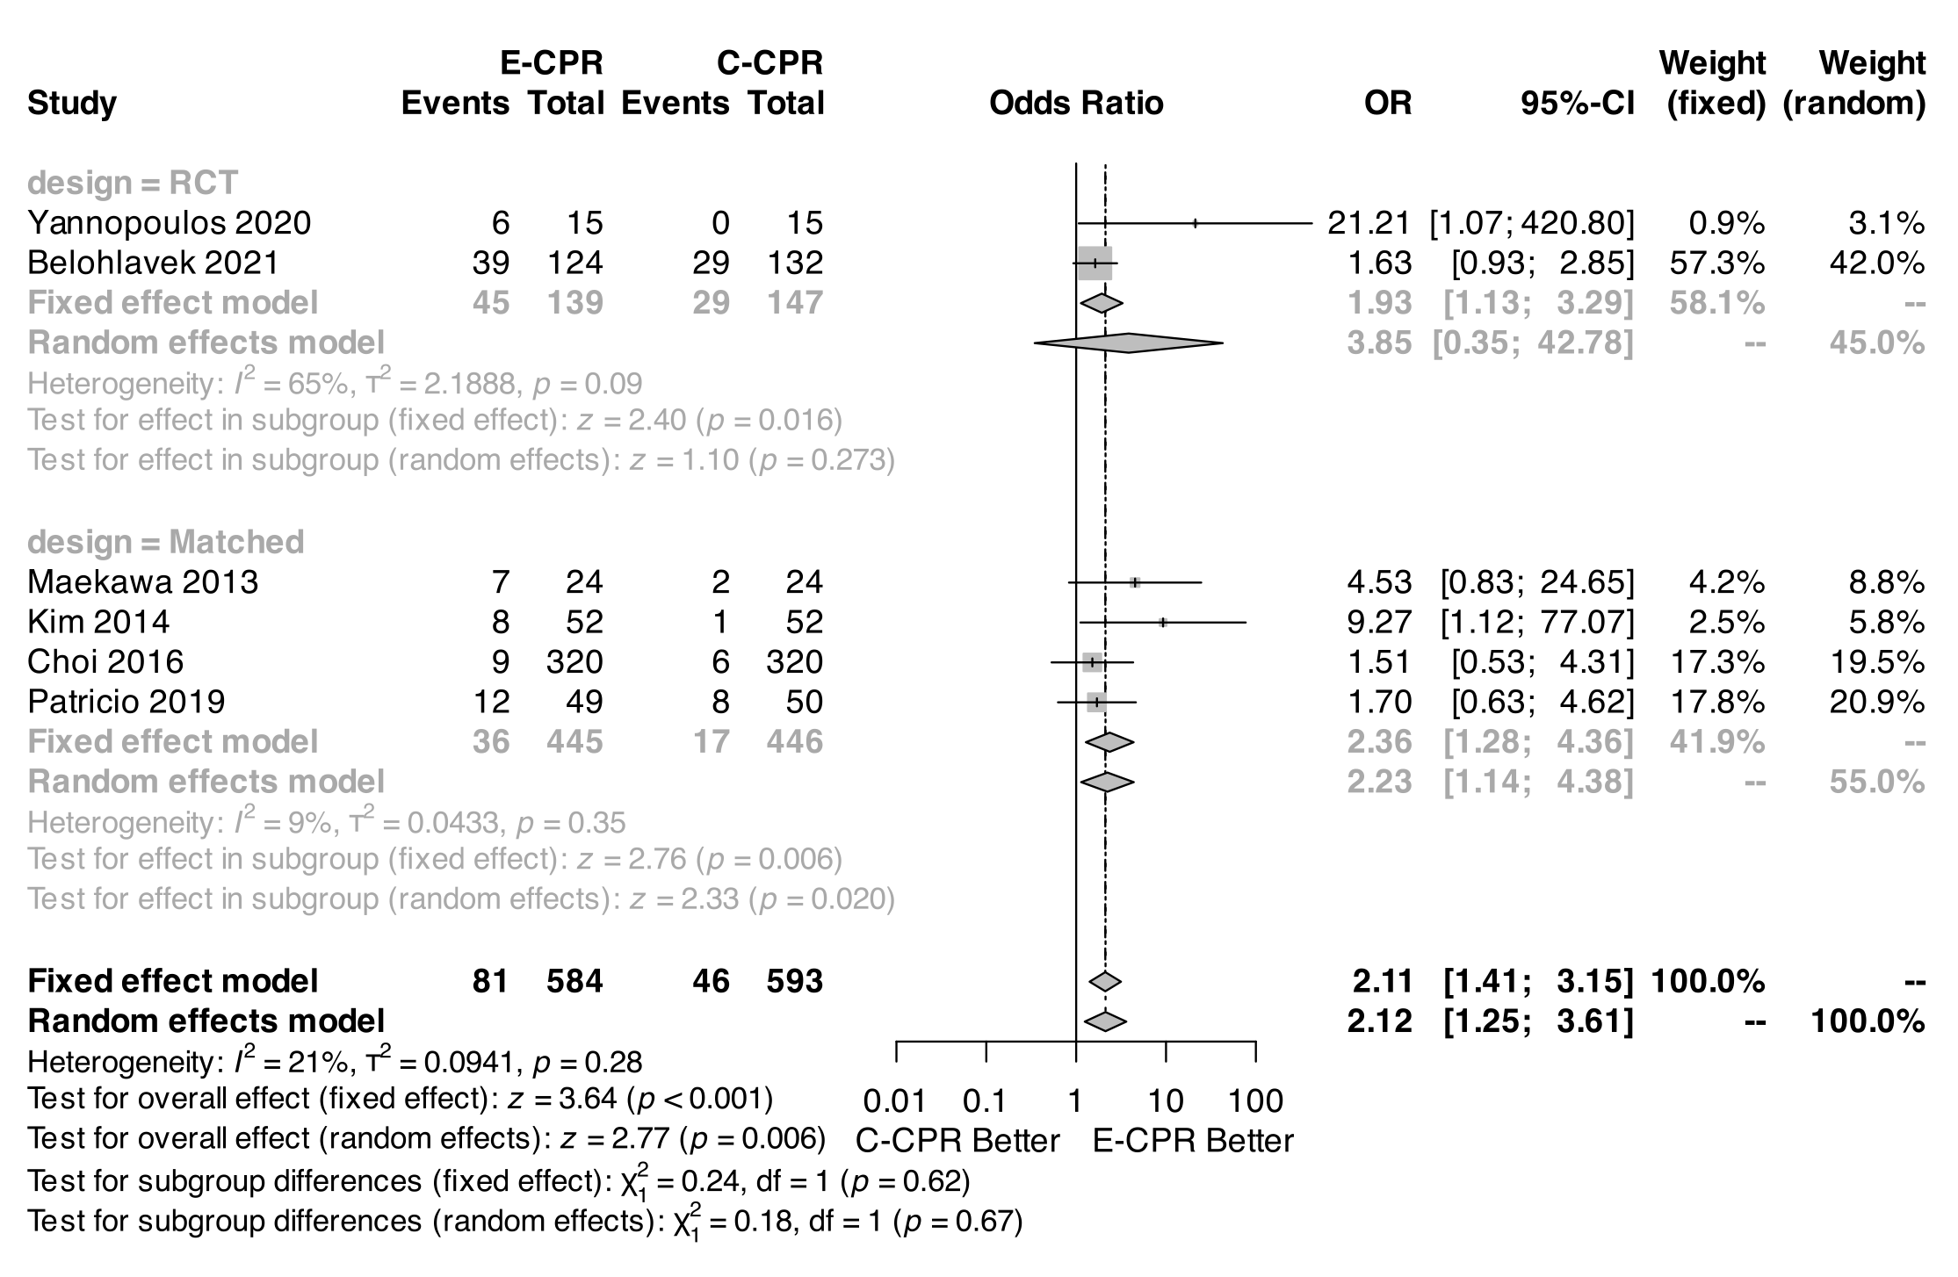

Supplemental Figure 2. Funnel plots for survival with good neurological outcome at the longest follow-up available (primary outcome).

A) Funnel plot B) Funnel plot after trim and fill
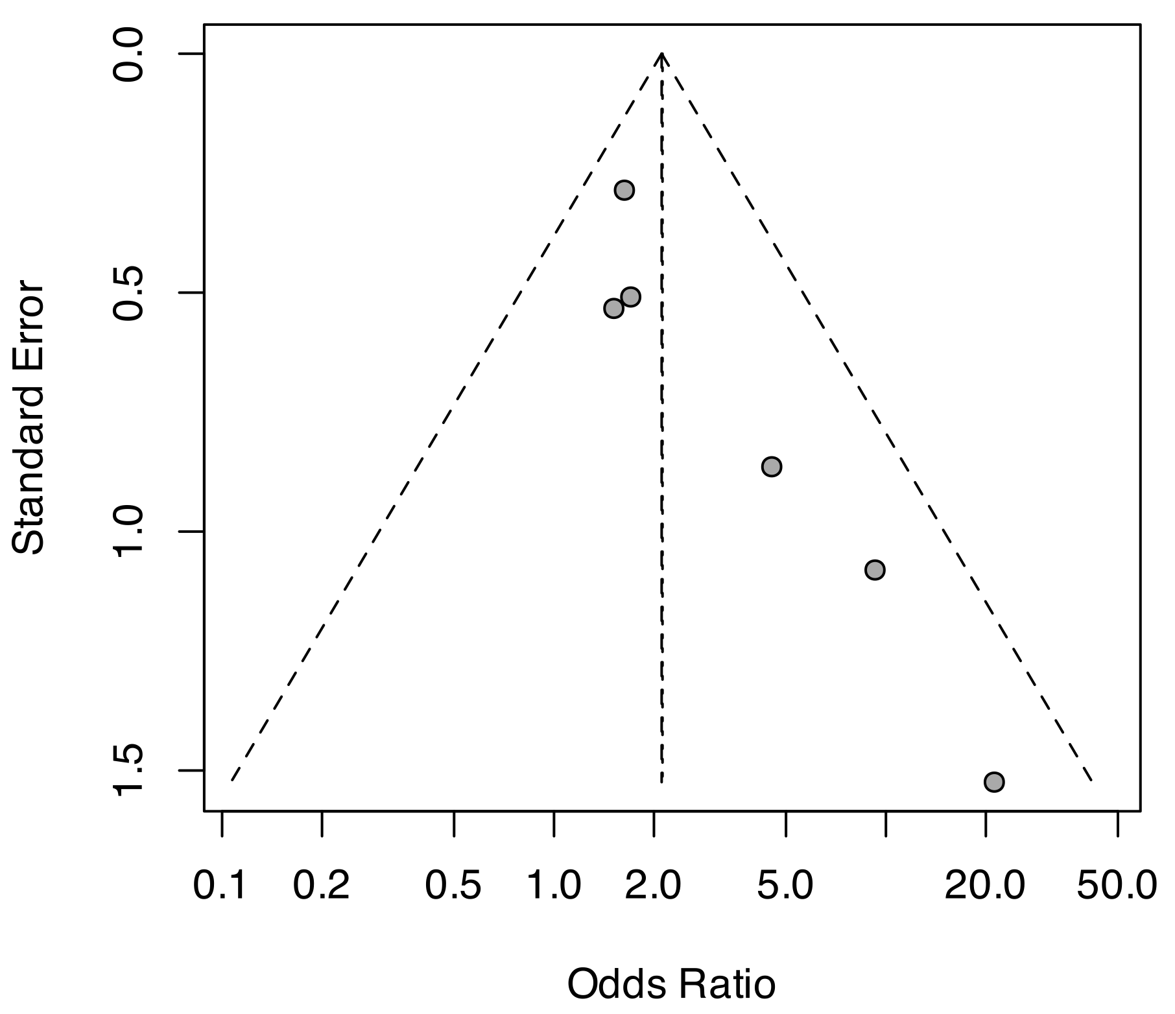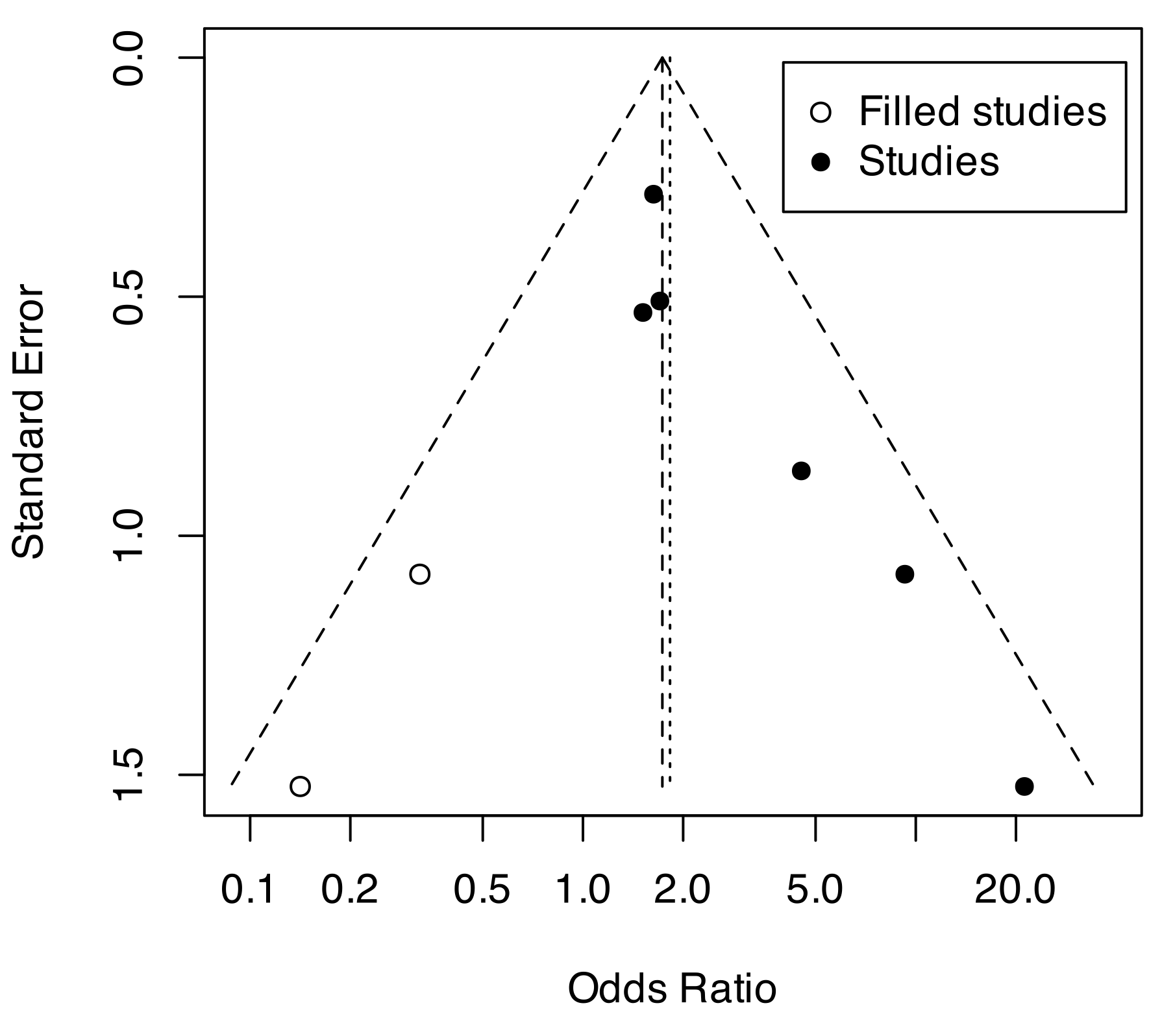

Supplemental Figure 3. Forest plot for survival with neurological impairments at the longest follow-up available.
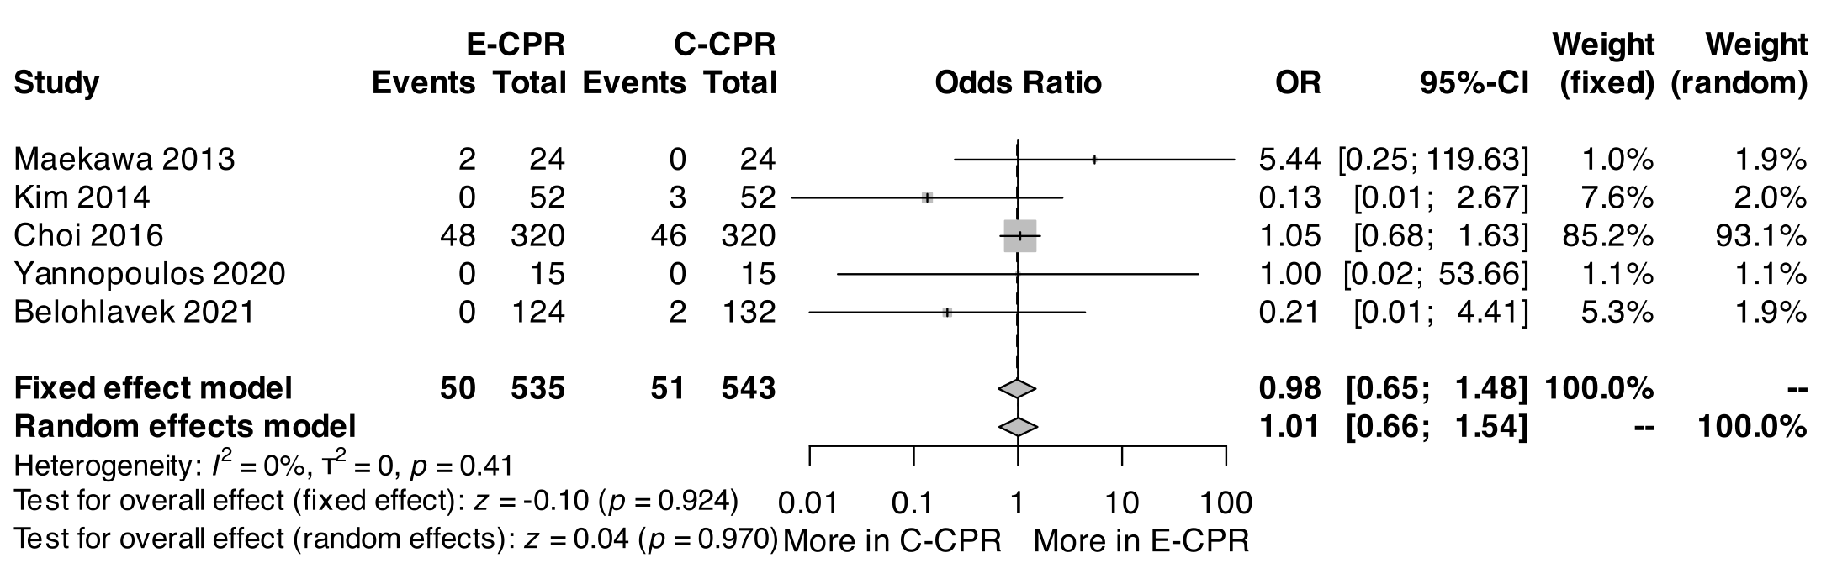

Supplemental Figure 4. Forest plot for survival at hospital discharge or 30 days.
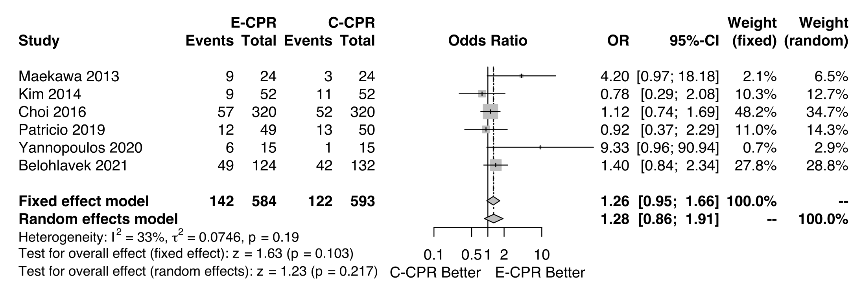

Supplemental Figure 5. Baseline characteristics of patients in the two groups (extracorporeal and conventional cardiopulmonary resuscitation): A) age, B) male sex, C) shockable rhythm, D) response time of emergency medical services.
A) age
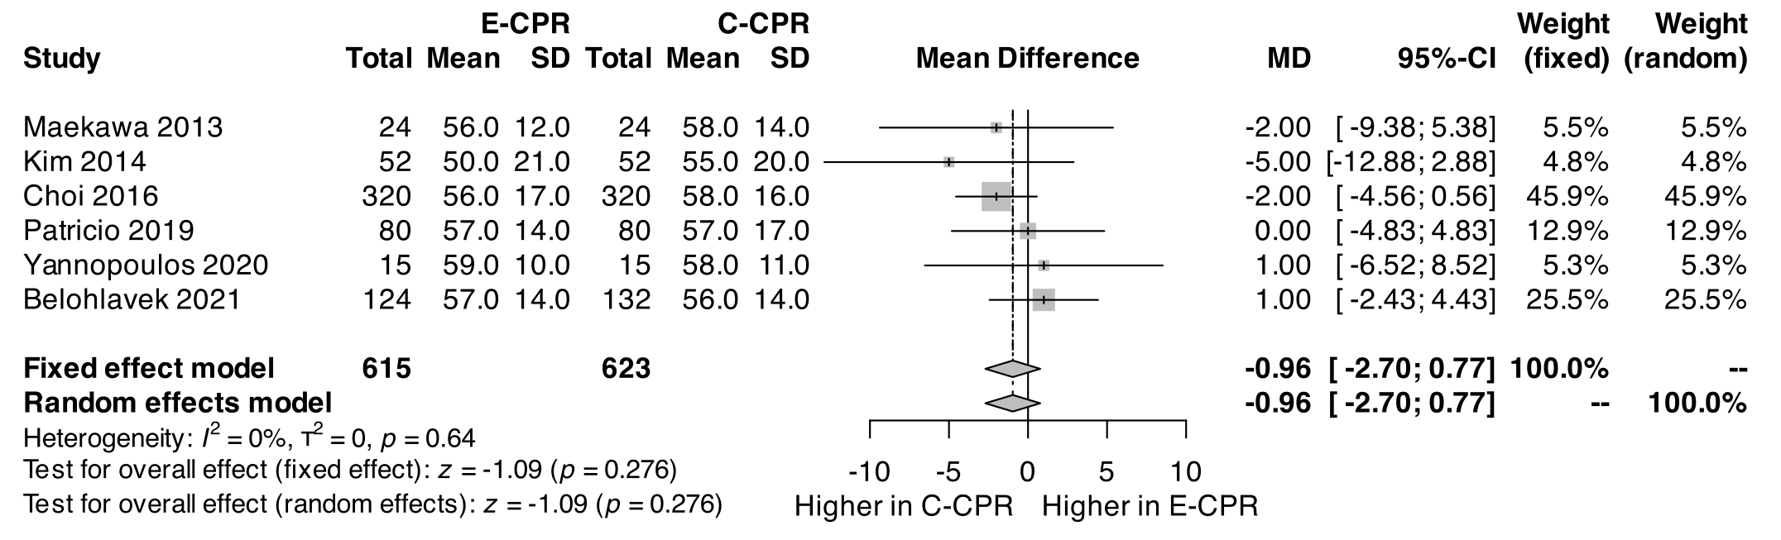
B) male sex
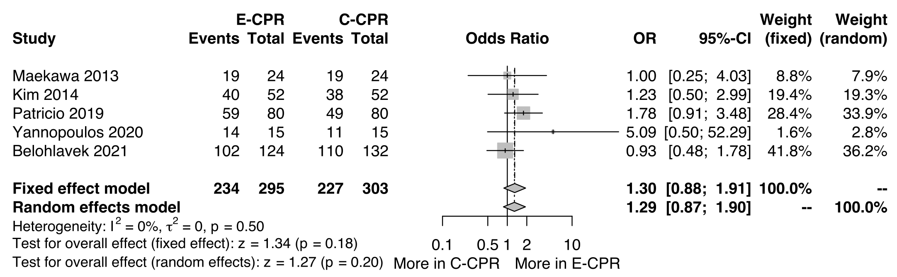
C) rate of bystander-initiated CPR
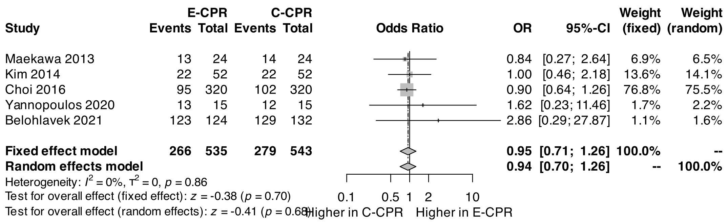
D) shockable rhythm
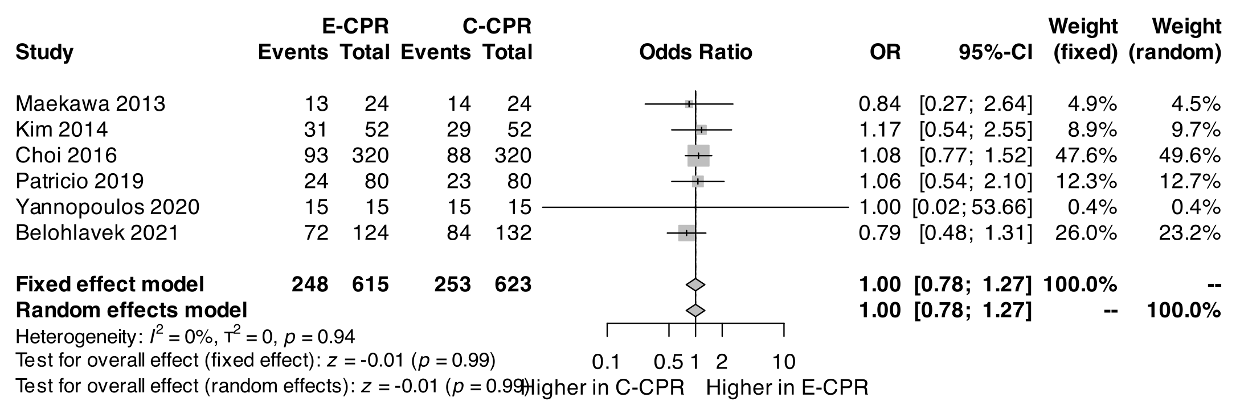

E) response time of emergency medical services
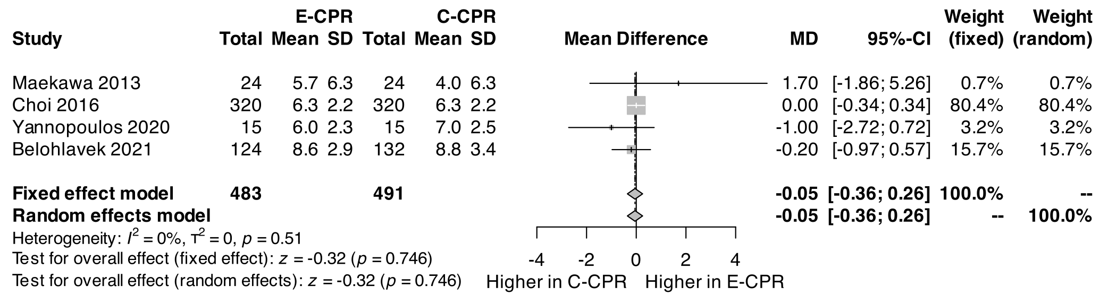

Supplemental Table 1. Major exclusions with reason for exclusion.
Study | Journal | Year | Reason for major exclusion
Chen 2008 | Crit Care Med | 2008 | Without randomization or propensity-matched analysis
Kagawa 2010 | Resuscitation | 2010 | Without randomization or propensity-matched analysis
Avalli 2012 | Resuscitation | 2012 | Without randomization or propensity-matched analysis
Bellezzo 2012 | Resuscitation | 2012 | Without randomization or propensity-matched analysis
Haneya 2012 | Resuscitation | 2012 | Without randomization or propensity-matched analysis
Kagawa 2012 | Circulation | 2012 | Without randomization or propensity-matched analysis
Fagnoul 2013 | Resuscitation | 2013 | Without randomization or propensity-matched analysis
Johnson 2014 | Resuscitation | 2014 | Without randomization or propensity-matched analysis
Han 2015 | Journal of Cardiothoracic Surgery | 2015 | Without randomization or propensity-matched analysis
Ha 2016 | Emerg Med J | 2016 | Without randomization or propensity-matched analysis
Conrad 2017 | Clinical Critical Care | 2017 | Without randomization or propensity-matched analysis
Dennis 2017 | International Journal of Cardiology | 2017 | Without randomization or propensity-matched analysis
Fjølner 2017 | Acta Anaesthesiologica Scandinavica | 2017 | Without randomization or propensity-matched analysis
Haas 2017 | European Resuscitation Council | 2017 | Without randomization or propensity-matched analysis
Jouffroy 2017 | Resuscitation | 2017 | Without randomization or propensity-matched analysis
Kashiura 2017 | BMC Anesthesiology | 2017 | Without randomization or propensity-matched analysis
Goto 2018 | BMJ Open | 2018 | Without randomization or propensity-matched analysis
Gregers 2018 | Critical Care | 2018 | Without randomization or propensity-matched analysis
Hutin 2018 | Resuscitation | 2018 | Without randomization or propensity-matched analysis
Mandigers et al | J Crit Care | 2019 | Without randomization or propensity-matched analysis
Matsuoka et al | Resuscitation | 2019 | Without randomization or propensity-matched analysis
Chang 2019 | Critical Care Medicine | 2019 | Without randomization or propensity-matched analysis
Dennis 2019 | Resuscitation | 2019 | Without randomization or propensity-matched analysis
Han 2019 | Preventive Cardiology | 2019 | Without randomization or propensity-matched analysis
Jung 2019 | Journal of Clinical Medicine | 2019 | Without randomization or propensity-matched analysis
Hsu et al | Ann Emerg Med | 2020 | < 20 patients enrolled
Ohbe et al | Resuscitation | 2020 | Without randomization or propensity-matched analysis
Yoshida et al | J Emerg Med | 2020 | Without randomization or propensity-matched analysis
Dalia 2020 | JCVA | 2020 | Without randomization or propensity-matched analysis
Daou 2020 | Journal of Thoracic Disease | 2020 | Without randomization or propensity-matched analysis
Duerschmied 2020 | Nature Scientific Reports | 2020 | Without randomization or propensity-matched analysis
Iwashita 2020 | Emergency Medicine Australasia | 2020 | Without randomization or propensity-matched analysis
Grunau et al | Resuscitation | 2021 | Without randomization or propensity-matched analysis

Supplemental Table 2. Risk of bias assessment.
RANDOMIZED STUDIES using RoB-2
Study | Randomization | Adherence to intervention | Missing outcome data | Measurement of the outcome | Selective reporting | Overall
Yannopoulos et al., 2020 | Low | Low | Low | Low | Low | Low
Belohlavek et al., 2021 | Low | Low | Low | Low | Low | Low

OBSERVATIONAL STUDIES using ROBINS-I
Study | Confounding | Participant selection | Classification of interventions | Deviation from interventions | Missing data | Outcome measurement | Selection of reported results | Overall
Maekawa et al., 2013 | Moderate | Low | Low | Low | Low | Moderate | Low | Moderate
Kim et al., 2014 | Moderate | Low | Low | Low | Low | Moderate | Low | Moderate
Choi et al., 2016 | Moderate | Low | Low | Low | Low | Moderate | Low | Moderate
Patricio et al., 2019 | Moderate | Low | Low | Low | Low | Moderate | Low | Moderate

Supplemental Table 3. List of ongoing or completed randomized clinical trials.
Study | ClinicalTrials.gov | Country | Estimated enrolment | Expected completion year | Status
INCEPTION | NCT03101787 | The Netherlands | 110 | 2021 | Unknown
APACAR2 | NCT02527031 | France | 210 | 2020 | Active, not recruiting
ECPB4OHCA | NCT01605409 | Austria | 40 | 2021 | Unknown
ON-SCENE | NCT04620070 | The Netherlands | 390 | 2024 | Not yet recruiting

Supplemental Table 4. GRADE evaluation.

Certainty assessment |  |  |  |  |  |  | № of patients |  | Effect |  | Certainty | Importance
№ of studies | Study design | Risk of bias | Inconsistency | Indirectness | Imprecision | Other considerations | ECPR | CCPR | Relative  (95% CI) | Absolute  (95% CI) | Certainty | Importance
Survival with favourable neurological outcome at the longest follow-up available
2 | randomised trials | not serious | not serious | not serious | not serious | none | 45/139 (32.4%) | 29/147 (19.7%) | OR 1.93  (1.13 to 3.29) | 124 more per 1,000  (from 20 more to 250 more) | ⨁⨁⨁◯  Moderate | CRITICAL
Survival with favourable neurological outcome at the longest follow-up available
4 | observational studies | serious | not serious | not serious | not serious | none | 36/445 (8.1%) | 17/446 (3.8%) | OR 2.36  (1.28 to 4.36) | 47 more per 1,000  (from 10 more to 109 more) | ⨁◯◯◯  Very low | CRITICAL
Survival at the longest follow-up available
2 | randomised trials | not serious | not serious | not serious | not serious | none | 45/139 (32.4%) | 31/147 (21.1%) | OR 1.78  (1.05 to 3.01) | 111 more per 1,000  (from 8 more to 235 more) | ⨁⨁⨁◯  Moderate | CRITICAL
Survival at the longest follow-up available
4 | observational studies | serious | not serious | not serious | not serious | none | 86/445 (19.3%) | 71/446 (15.9%) | OR 1.27  (0.90 to 1.79) | 35 more per 1,000  (from 14 fewer to 94 more) | ⨁◯◯◯  Very low | CRITICAL
Survival at hospital discharge or 30 days
2 | randomised trials | not serious | not serious | not serious | not serious | none | 55/139 (39.6%) | 43/147 (29.3%) | OR 1.59  (0.97 to 2.60) | 104 more per 1,000  (from 6 fewer to 226 more) | ⨁⨁⨁◯  Moderate | CRITICAL
Survival at hospital discharge or 30 days
4 | observational studies | serious | not serious | not serious | not serious | none | 87/445 (19.6%) | 79/446 (17.7%) | OR 1.13  (0.81 to 1.58) | 19 more per 1,000  (from 29 fewer to 77 more) | ⨁◯◯◯  Very low | CRITICAL

Supplemental Table 5. PRISMA 2020 checklist.

Section and Topic | Item # | Checklist item | Location where item is reported
TITLE
Title | 1 | Identify the report as a systematic review. | 1
ABSTRACT
Abstract | 2 | See the PRISMA 2020 for Abstracts checklist. | 2
INTRODUCTION
Rationale | 3 | Describe the rationale for the review in the context of existing knowledge. | 3
Objectives | 4 | Provide an explicit statement of the objective(s) or question(s) the review addresses. | 4
METHODS
Eligibility criteria | 5 | Specify the inclusion and exclusion criteria for the review and how studies were grouped for the syntheses. | 4
Information sources | 6 | Specify all databases, registers, websites, organisations, reference lists and other sources searched or consulted to identify studies. Specify the date when each source was last searched or consulted. | 4
Search strategy | 7 | Present the full search strategies for all databases, registers and websites, including any filters and limits used. | Suppl
Selection process | 8 | Specify the methods used to decide whether a study met the inclusion criteria of the review, including how many reviewers screened each record and each report retrieved, whether they worked independently, and if applicable, details of automation tools used in the process. | 4
Data collection process | 9 | Specify the methods used to collect data from reports, including how many reviewers collected data from each report, whether they worked independently, any processes for obtaining or confirming data from study investigators, and if applicable, details of automation tools used in the process. | 5
Data items | 10a | List and define all outcomes for which data were sought. Specify whether all results that were compatible with each outcome domain in each study were sought (e.g. for all measures, time points, analyses), and if not, the methods used to decide which results to collect. | 5
Data items | 10b | List and define all other variables for which data were sought (e.g. participant and intervention characteristics, funding sources). Describe any assumptions made about any missing or unclear information. | 5
Study risk of bias assessment | 11 | Specify the methods used to assess risk of bias in the included studies, including details of the tool(s) used, how many reviewers assessed each study and whether they worked independently, and if applicable, details of automation tools used in the process. | 5
Effect measures | 12 | Specify for each outcome the effect measure(s) (e.g. risk ratio, mean difference) used in the synthesis or presentation of results. | 6
Synthesis methods | 13a | Describe the processes used to decide which studies were eligible for each synthesis (e.g. tabulating the study intervention characteristics and comparing against the planned groups for each synthesis (item #5)). | 6
Synthesis methods | 13b | Describe any methods required to prepare the data for presentation or synthesis, such as handling of missing summary statistics, or data conversions. | 6
Synthesis methods | 13c | Describe any methods used to tabulate or visually display results of individual studies and syntheses. | 6
Synthesis methods | 13d | Describe any methods used to synthesize results and provide a rationale for the choice(s). If meta-analysis was performed, describe the model(s), method(s) to identify the presence and extent of statistical heterogeneity, and software package(s) used. | 6
Synthesis methods | 13e | Describe any methods used to explore possible causes of heterogeneity among study results (e.g. subgroup analysis, meta-regression). | 6
Synthesis methods | 13f | Describe any sensitivity analyses conducted to assess robustness of the synthesized results. | 6
Reporting bias assessment | 14 | Describe any methods used to assess risk of bias due to missing results in a synthesis (arising from reporting biases). | 6
Certainty assessment | 15 | Describe any methods used to assess certainty (or confidence) in the body of evidence for an outcome. | 6
RESULTS
Study selection | 16a | Describe the results of the search and selection process, from the number of records identified in the search to the number of studies included in the review, ideally using a flow diagram. | 6
Study selection | 16b | Cite studies that might appear to meet the inclusion criteria, but which were excluded, and explain why they were excluded. | 6
Study characteristics | 17 | Cite each included study and present its characteristics. | 6
Risk of bias in studies | 18 | Present assessments of risk of bias for each included study. | Suppl
Results of individual studies | 19 | For all outcomes, present, for each study: (a) summary statistics for each group (where appropriate) and (b) an effect estimate and its precision (e.g. confidence/credible interval), ideally using structured tables or plots. | 7-8
Results of syntheses | 20a | For each synthesis, briefly summarise the characteristics and risk of bias among contributing studies. | 7-8
Results of syntheses | 20b | Present results of all statistical syntheses conducted. If meta-analysis was done, present for each the summary estimate and its precision (e.g. confidence/credible interval) and measures of statistical heterogeneity. If comparing groups, describe the direction of the effect. | 7-8
Results of syntheses | 20c | Present results of all investigations of possible causes of heterogeneity among study results. | 7-8
Results of syntheses | 20d | Present results of all sensitivity analyses conducted to assess the robustness of the synthesized results. | 7-8
Reporting biases | 21 | Present assessments of risk of bias due to missing results (arising from reporting biases) for each synthesis assessed. | 7-8
Certainty of evidence | 22 | Present assessments of certainty (or confidence) in the body of evidence for each outcome assessed. | 7-8
DISCUSSION
Discussion | 23a | Provide a general interpretation of the results in the context of other evidence. | 8-9
Discussion | 23b | Discuss any limitations of the evidence included in the review. | 10
Discussion | 23c | Discuss any limitations of the review processes used. | 10
Discussion | 23d | Discuss implications of the results for practice, policy, and future research. | 8-10
OTHER INFORMATION
Registration and protocol | 24a | Provide registration information for the review, including register name and registration number, or state that the review was not registered. | 4
Registration and protocol | 24b | Indicate where the review protocol can be accessed, or state that a protocol was not prepared. | 4
Registration and protocol | 24c | Describe and explain any amendments to information provided at registration or in the protocol. | 4
Support | 25 | Describe sources of financial or non-financial support for the review, and the role of the funders or sponsors in the review. | 12
Competing interests | 26 | Declare any competing interests of review authors. | 12
Availability of data, code and other materials | 27 | Report which of the following are publicly available and where they can be found: template data collection forms; data extracted from included studies; data used for all analyses; analytic code; any other materials used in the review. | 12

