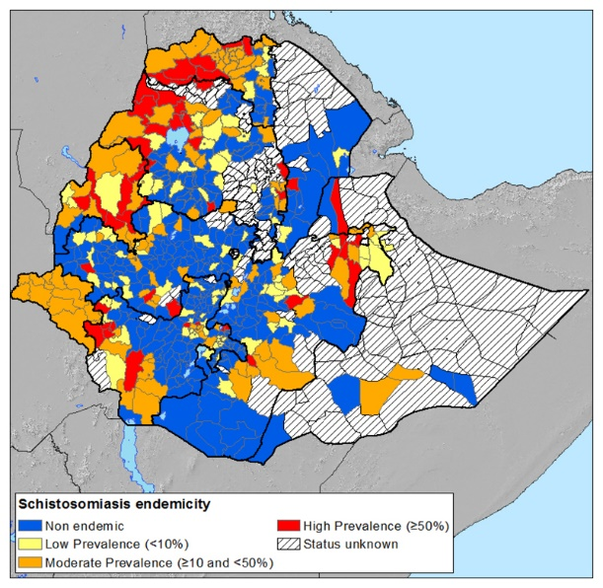
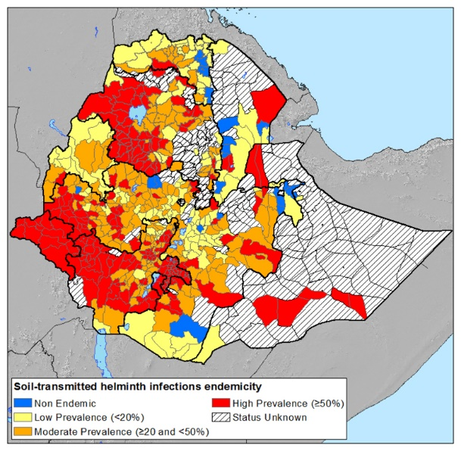
Fig. S2 STH and SCH national mapping data, 2013-2014

National Mapping data showing the distribution of STH and SCH categorised according to the WHO guidelines, taken from Negussu et al, 2017[4]. STH and SCH infections are shown at higher prevalence predominantly in south-west and north-westerly regions. Note the large number of regions (depicted as striped grey areas) in which no data is recorded. In part this can reflect both desert areas and districts in which conflict has prohibited data collection (e.g. regions bordering Eritrea, Sudan and Somalia).

