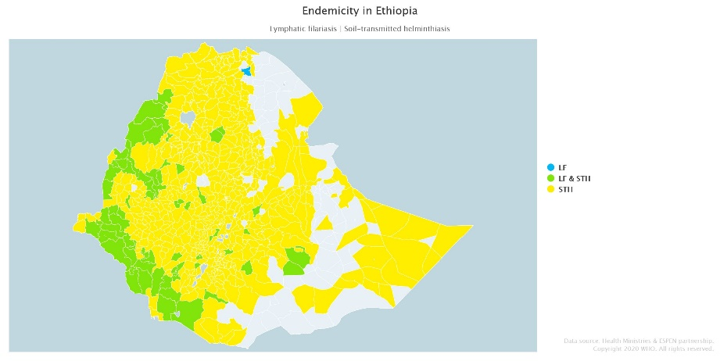
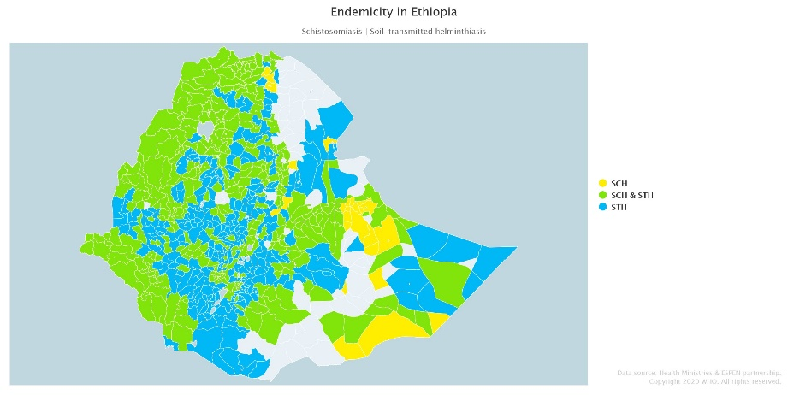
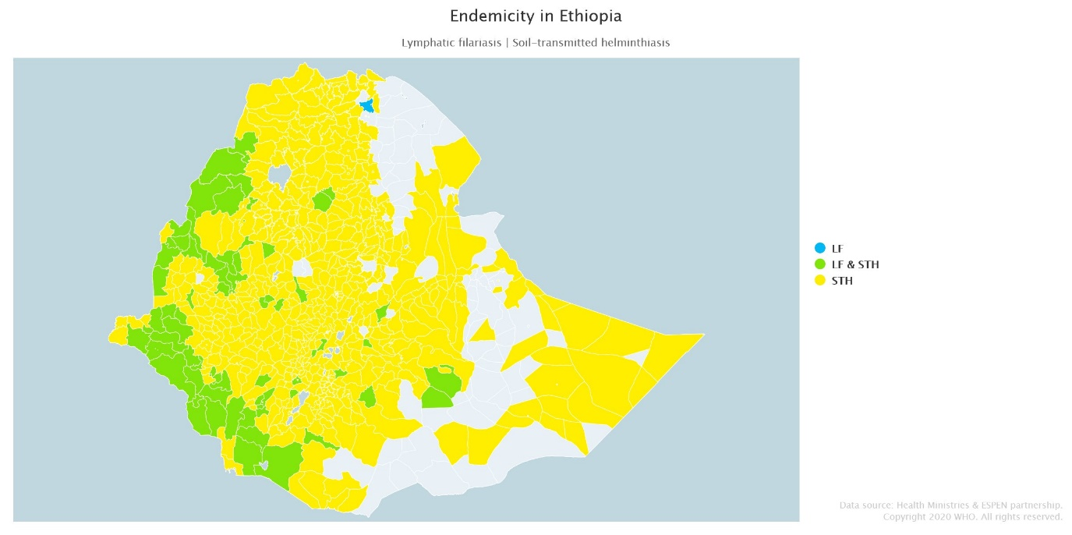
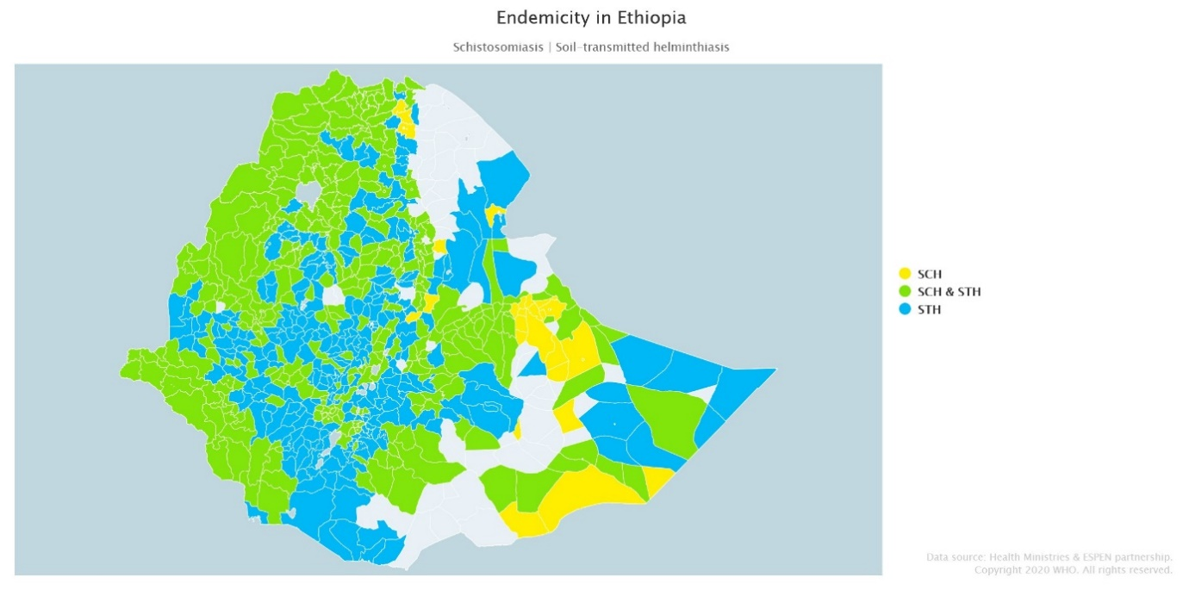
Fig. S3 Co-endemicity of STH with SCH and LF

Co-endemicity of STH with LF (left) and SCH (right), demonstrating the heavy co-infection impacting namely western and central regions of Ethiopia. This will have implications not only on individual’s health, but control programme delivery of preventative chemotherapy. Green regions in the LHS map demonstrate LF and STH co-endemic areas, where community-wide treatment with ALB will take place to the benefit of STH control. Data from Health Ministries and ESPEN partnership copyright 2020 WHO [22].

