Supplementary File 1.
Search strategy
MEDLINE/PubMed
((("Glycemic Index"[Mesh] OR "Glycemic Load"[Mesh] OR glycaemic[tiab] OR glycemic[tiab])

AND ("Area Under Curve"[Mesh] OR "Postprandial Period"[Mesh] OR area under curve*[tiab] OR area under the curve[tiab] OR AUC[tiab] OR meal test*[tiab] OR postprandial[tiab] OR post-prandial[tiab] OR post meal[tiab] OR post-breakfast[tiab] OR post-lunch[tiab] OR daytime[tiab] OR continuous glucose monitoring[tiab] OR interstitial glucose[tiab] OR glucose profile[tiab] OR insulin profile[tiab])

AND (intervention*[tiab] OR randomized controlled trial[pt] OR controlled clinical trial[pt] OR randomized controlled trials[mh] OR random allocation[mh] OR double-blind method[mh] OR single-blind method[mh] OR clinical trial[pt] OR clinical trials[mh] OR "clinical trial"[tw] OR ((singl*[tw] OR doubl*[tw] OR trebl*[tw] OR tripl*[tw]) AND (mask*[tw] OR blind*[tw])) OR "latin square"[tw] OR placebos[mh] OR placebo*[tw] OR random*[tw] OR research design[mh:noexp] OR comparative study[pt] OR evaluation studies[pt] OR cross-over studies[mh] OR control[tw] OR controll*[tw] OR prospectiv*[tw] OR volunteer*[tw]))

NOT (animals[mh] NOT humans[mh])) NOT (animal*[tiab] OR mice[tiab] OR mouse[tiab] OR rats[tiab] OR rat[tiab] OR dog[tiab] OR pig[tiab] OR dogs[tiab] OR animal*[tiab] OR pigs[tiab])

EMBASE
(('glycemic index'/exp OR 'glycemic load'/exp OR glycaemic:ab,ti OR glycemic:ab,ti)

AND ('area under the curve'/exp OR 'postprandial state'/exp OR ‘area under curve*’:ab,ti OR ‘area under the curve*’:ab,ti OR AUC:ab,ti OR ‘meal test*’:ab,ti OR postprandial:ab,ti OR ‘post-prandial’:ab,ti OR ‘post meal’:ab,ti OR ‘post-breakfast’:ab,ti OR ‘post-lunch’:ab,ti OR daytime:ab,ti OR ‘continuous glucose monitoring’:ab,ti OR ‘interstitial glucose’:ab,ti OR ‘glucose profile’:ab,ti OR ‘insulin profile’:ab,ti)

AND ('clinical trial'/exp OR 'triple blind procedure'/exp OR 'double blind procedure'/exp OR 'single blind procedure'/exp OR 'randomization'/exp OR 'placebo'/exp OR 'methodology'/de OR 'comparative study'/de OR 'evaluation study'/de OR 'crossover procedure'/exp OR 'clinical trial':ab,ti OR (singl*:ab,ti OR doubl*:ab,ti OR trebl*:ab,ti OR tripl*:ab,ti)) AND ((mask*:ab,ti OR blind*:ab,ti) OR 'latin square':ab,ti OR placebo*:ab,ti OR random*:ab,ti OR control:ab,ti OR controll*:ab,ti OR prospectiv*:ab,ti OR volunteer*:ab,ti))

NOT (animal*:ab,ti OR mice:ab,ti OR mouse:ab,ti OR rats:ab,ti OR rat:ab,ti OR dog:ab,ti OR pig:ab,ti OR dogs:ab,ti OR animal*:ab,ti OR pigs:ab,ti)

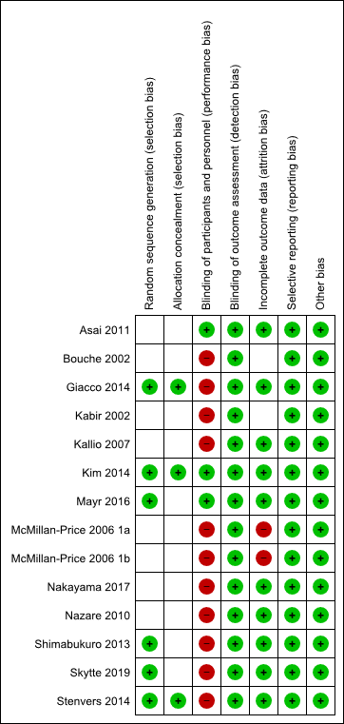
Supplementary Figure 1. Risk of bias summary: review authors' judgements about each risk of bias item for each included study. Red dot, high risk of bias. Green dot, low risk of bias.

Supplementary Figure 2. Correlation plot. Pearson’s r = 0.55, P = 0.10

A
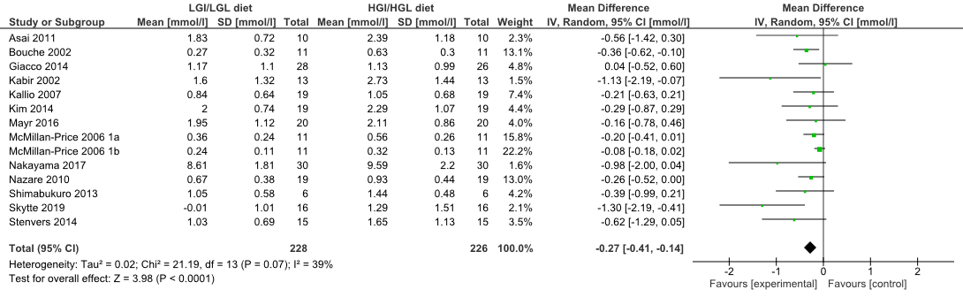
B
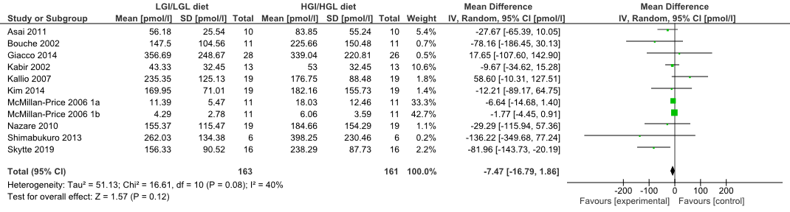
Supplementary Figure 3. Forest plots of meta-analysis of PPG-lowering dietary intervention on acute (A) mean PPG and (B) mean PPI.

A
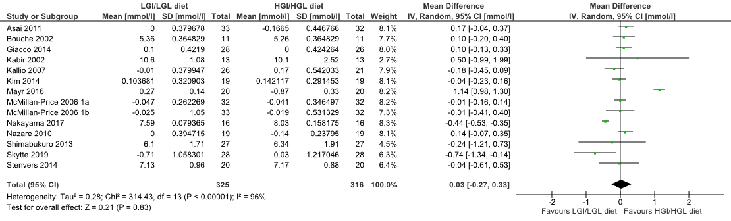
B
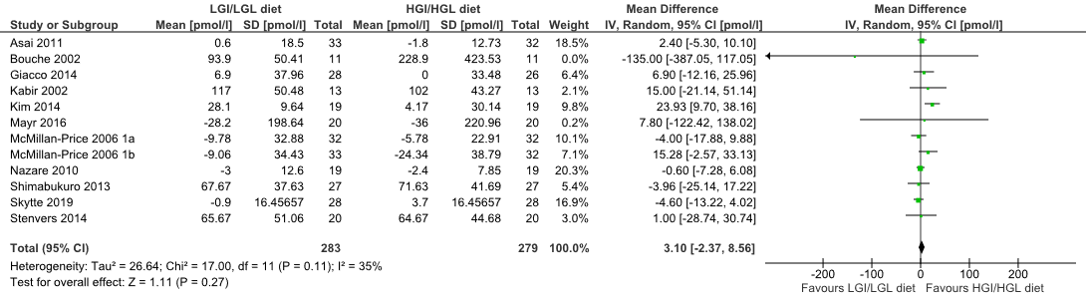
C
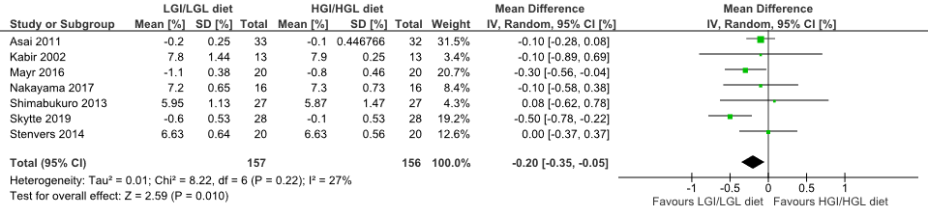
Supplementary Figure 4. Forest plots of meta-analysis of PPG-lowering dietary interventions and (A) fasting plasma glucose; (B) fasting insulin; (C) HbA_{1c}

A
B
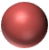
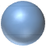
C
Normal glucose metabolism
Abnormal glucose metabolism
Bubble size: Weight of study (inverse variance)

Supplementary Figure 5. Bubble charts of the relationship between % relative change in PPG and absolute change in (a) HbA_{1c} and the relationship between % relative change in PPI and absolute change in (b) insulin (c) HbA_{1c}.

