Animals as Potential Reservoirs for Dengue Transmission: A Systematic Review
Sylvia Xiao Wei GWEE^{1,2}*, Ashley Lauren ST JOHN³, Gregory C. GRAY^{3,4,5,6}, Junxiong PANG^{1,2}*#

1. Saw Swee Hock School of Public Health, National University of Singapore, Singapore
2. Centre of Infectious Disease Epidemiology and Research, National University of Singapore, Singapore
3. Duke-NUS Medical School, Singapore
4. Division of Infectious Diseases, School of Medicine, Duke University, USA
5. Global Health Institute, Duke University, USA
6. Duke Kunshan University, China

*These authors contributed equally.
# Corresponding author
Pang Junxiong
pangv@hotmail.com

Table 1: Dengue positivity in bats – species specific
Animal Types | Country | Location | Study Period | Species | Biological Samples | Dengue Positivity |  |  |  |  |  | Dengue Serotype | Human Cases | References
 |  |  |  |  |  | ELISA | NS1 | RT-PCR | PRNT | HI/CF | Virus Isolation | Dengue Serotype | Human Cases | References
Bats | Mexico | Pacific Coast (Colima & Jialisco) | 2005 | Natalus stramineus | Blood (ELISA & NS1) | 1/4 (25%) | 1/4 (25%) | N.S. | N.S. | N.S. | N.S. | D2 | 2339 due to D2 (between 2005 and 2006) | [1]
 |  |  |  | Pteronotus parnelli | Blood (ELISA & NS1) | 3/19 (15.8%) | 0/9 | N.S.
 |  |  |  | Artibeus jamaicensis | Blood (ELISA & NS1) | 1/17 (6.5%) | 0/10 | N.S.
Bats | Mexico | Gulf Coast (Veracruz) | 2006 | Pteronotus parnelli | Blood (ELISA & NS1)  Heart tissue (RT-PCR) | N.S. | N.S. | 0/1 |  |  |  |  | 7272 due to D2 (between 2005 and 2006) | [1]
 |  |  |  | Artibeus jamaicensis | Blood (ELISA & NS1)  Heart tissue (RT-PCR) | 0/18 | 0/20 | 2/9 (22.2%)
 |  |  |  | Carollia brevicauda | Blood (ELISA & NS1)  Heart tissue (RT-PCR) | 0/5 | 0/23 | 1/2 (50%)
 |  |  |  | Myotis nigricans | Blood (ELISA & NS1)  Heart tissue (RT-PCR) | 4/12 (33.3%) | 2/14 (14.3%) | 1/11 (9%)
 |  |  |  | Sturnira lilium | Blood (ELISA & NS1)  Heart tissue (RT-PCR) | 0/11 | 1/14 (7.1%) | 0/7
Bats | Southeastern Mexico | Calakmul  Biosphere Reserve  (Undisturbed & Disturbed Forest) | 2010-2011 | Artibeus jamaicensis | Spleen Tissue | N.S. | N.S. | 1/22 (4.54%) | N.S. | N.S. | N.S. | D2 | At least 20 km from significant human populations where dengue has been reported (Xpujil in Campeche State and Beneme ́ rito de la Ame ́ ricas in Chiapas State) | [2]
 |  |  |  | Artibeus lituratus | Spleen Tissue | N.S. | N.S. | 1/18 (5.56%) | N.S. | N.S. | N.S. | D2 |  | [2]
 |  |  |  | Artibeus phaeotis | Spleen Tissue | N.S. | N.S. | 0/1 | N.S. | N.S. | N.S. | N.A. |  | [2]
 |  |  |  | Carollia perspicillata | Spleen Tissue | N.S. | N.S. | 0/1
 |  |  |  | Glossophaga commissarisi | Spleen Tissue | N.S. | N.S. | 0/1
 |  |  |  | Glossophaga soricina | Spleen Tissue | N.S. | N.S. | 2/29 (6.90%) | N.S. | N.S. | N.S. | D2 |  | [2]
 |  |  |  | Pteronotus davyi | Spleen Tissue | N.S. | N.S. | 0/1 | N.S. | N.S. | N.S. | N.A. |  | [2]
 |  |  |  | Pteronotus parnelli | Spleen Tissue | N.S. | N.S. | 0/6
 |  |  |  | Sturnira lilium | Spleen Tissue | N.S. | N.S. | 0/6
Bats | Southeastern Mexico | Montes Azules Biosphere Reserve (Undisturbed & Disturbed Forest) | 2010-2011 | Artibeus jamaicensis | Spleen Tissue | N.S. | N.S. | 0/7
 |  |  |  | Artibeus lituratus | Spleen Tissue | N.S. | N.S. | 2/20 (10%) | N.S. | N.S. | N.S. | D2 |  | [2]
 |  |  |  | Carolllia sowelli | Spleen Tissue | N.S. | N.S. | 0/14 | N.S. | N.S. | N.S. | N.A. |  | [2]
 |  |  |  | Desmodus rotundus | Spleen Tissue | N.S. | N.S. | 0/1
 |  |  |  | Glossophaga commissarisi | Spleen Tissue | N.S. | N.S. | 0/1
 |  |  |  | Glossophaga soricina | Spleen Tissue | N.S. | N.S. | 0/6
 |  |  |  | Hylonycteris underwoodi | Spleen Tissue | N.S. | N.S. | 0/1
 |  |  |  | Platyrrhinus helleri | Spleen Tissue | N.S. | N.S. | 0/1
 |  |  |  | Saccopteryx bilineata | Spleen Tissue | N.S. | N.S. | 0/1
 |  |  |  | Sturnira lilium | Spleen Tissue | N.S. | N.S. | 0/6
 |  |  |  | Sturnira ludovici | Spleen Tissue | N.S. | N.S. | 0/2
 |  |  |  | Uroderma bilobatum | Spleen Tissue | N.S. | N.S. | 0/1
Bats | Mexico | Morelos,  Central Mexico & Campeche, South-east Mexico | 2011-2012 | Artibeus jamaicensis | Liver or Spleen Tissue | N.S. | N.S. | 0/152 | 0/202 (D2)  0/174 (D4) | N.S. | N.S. | N.A. | 196 (Morelos, 2011- 2012) & 764 (Campeche, 2012); Both endemic with D1,2
 |  |  |  | Artibeus lituratus | Liver or Spleen Tissue | N.S. | N.S. | 0/25
 |  |  |  | Artibeus watsoni | Liver or Spleen Tissue | N.S. | N.S. | 0/1 |  |  |  |  |  | [3]
 |  |  |  | Balantiopterix plicata | Liver or Spleen Tissue | N.S. | N.S. | 0/11
 |  |  |  | Carollia perspicillata | Liver or Spleen Tissue | N.S. | N.S. | 0/19
 |  |  |  | Carollia sowelli | Liver or Spleen Tissue | N.S. | N.S. | 0/3
 |  |  |  | Chiroderma villosum | Liver or Spleen Tissue | N.S. | N.S. | 0/1
 |  |  |  | Choeroniscus godmani | Liver or Spleen Tissue | N.S. | N.S. | 0/6
 |  |  |  | Desmodus rotundus | Liver or Spleen Tissue | N.S. | N.S. | 0/2
 |  |  |  | Glossofaga commissaris | Liver or Spleen Tissue | N.S. | N.S. | 0/3
 |  |  |  | Glossofaga sp | Liver or Spleen Tissue | N.S. | N.S. | 0/3
 |  |  |  | Hylonycteris godmani | Liver or Spleen Tissue | N.S. | N.S. | 0/1
 |  |  |  | Hylonicteris underwoodi | Liver or Spleen Tissue | N.S. | N.S. | 0/1
 |  |  |  | Pipistrellus hesperus | Liver or Spleen Tissue | N.S. | N.S. | 0/1
 |  |  |  | Rhogeessa parvula | Liver or Spleen Tissue | N.S. | N.S. | 0/1
 |  |  |  | Rhogeessa tumida | Liver or Spleen Tissue | N.S. | N.S. | 0/1
 |  |  |  | Sturnira lilium | Liver or Spleen Tissue | N.S. | N.S. | 0/4
 |  |  |  | Sturnira ludovici | Liver or Spleen Tissue | N.S. | N.S. | 0/4
 |  |  |  | Unknown | Liver or Spleen Tissue | N.S. | N.S. | 0/1
Bats | Mexico | Progreso, Hidalgo (Cave roost) | 2014-2015 | Desmondus rotundus | Liver or Spleen Tissue | N.S. | N.S. | 8/16 (50%) | N.S. | N.S. | 1/6 positive but species to which it belongs is unknown | N.A. |  | [4]
Bats | China | Hainan Island, Shankouxiang, Mei Wen Village  Dengue cases area | 1995 | Brown Fruit Bat | Brain cells | 16/20  Imprint with D2 monoclonal fluorescent antibody | N.S. | 20/35 (57.14%) | N.S. | N.S. | N.S. | D2 | 1978-1990 epidemic  1980-1982 and 1986-1991 coastal region dengue epidemic, hundreds of thousands affected in each outbreak. | [5]
 |  |  |  |  | Blood Sample | N.S. | N.S. | 3/18 (16.7%) | N.S. | N.S. | N.S. | N.A.
Bats | China | Hainan Island  non-dengue cases area | 1995 | Not Specified | Brain cells | N.S. | N.S. | 0/3 | N.S. | N.S. | N.S. | N.A.
Bats | French Guiana | le Camp du Tigre, secondary forest fragment in periurban area near Cayenne | 2001, 2006, 2007 | Artibeus planirostris | Blood serum & liver samples | N.S. | N.S. | 14/42 (33.3%) | N.S. | N.S. | N.S. | D1/D2/D3/D4 |  | [6]
 |  |  |  | Carollia perspicillata | Blood serum & liver samples | N.S. | N.S. | 5/60 (8.3%) |  |  |  |  |  | [6]
 |  |  |  | Cormura brevirostris | Blood serum & liver samples | N.S. | N.S. | 0/1 |  |  |  |  |  | [6]
 |  |  |  | Eptesicus chiriquinus | Blood serum & liver samples | N.S. | N.S. | 0/1 |  |  |  |  |  | [6]
 |  |  |  | Platyrrhins brachicephalus | Blood serum & liver samples | N.S. | N.S. | 0/1 |  |  |  |  |  | [6]
 |  |  |  | Platyrrhinus helleri | Blood serum & liver samples | N.S. | N.S. | 0/3 |  |  |  |  |  | [6]
 |  |  |  | Sturnira lilium | Blood serum & liver samples | N.S. | N.S. | 0/10 |  |  |  |  |  | [6]
 |  |  |  | Uroderma bilobatum | Blood serum & liver samples | N.S. | N.S. | 0/6 |  |  |  |  |  | [6]
 |  |  |  | Vampyressa brocki | Blood serum & liver samples | N.S. | N.S. | 0/1 |  |  |  |  |  | [6]
Bats | French Guiana | Site of Sain Georges de l'pyapock (between the edge of a primary forest and a rural area) | 2006, 2007 | Carollia perspeicillata | Blood serum & liver samples | N.S. | N.S. | 0/3 |  |  |  |  |  | [6]
 |  |  |  | Cormura brevirostris | Blood serum & liver samples | N.S. | N.S. | 0/1 |  |  |  |  |  | [6]
 |  |  |  | Eumops maurus | Blood serum & liver samples | N.S. | N.S. | 0/1 |  |  |  |  |  | [6]
 |  |  |  | Lasiurus blossevillii | Blood serum & liver samples | N.S. | N.S. | 0/1 |  |  |  |  |  | [6]
 |  |  |  | Lonchophylla thomasi | Blood serum & liver samples | N.S. | N.S. | 0/2 |  |  |  |  |  | [6]
 |  |  |  | Molossus molossus | Blood serum & liver samples | N.S. | N.S. | 0/7 |  |  |  |  |  | [6]
 |  |  |  | Rhinolophus sp | Blood serum & liver samples | N.S. | N.S. | 0/1 |  |  |  |  |  | [6]
Bats | Costa Rica (Households) | All locations | 2013 & 2014 | Balantiopteryx plicata | Blood & Organs | N.S. | N.S. | 0/5 | 51/241 (21.2%) | N.S. | N.S. | D1/2/3/4 |  | [7]
 |  |  |  | Eptesicus fuscus | Blood & Organs | N.S. | N.S. | 0/3 |  |  |  |  |  | [7]
 |  |  |  | Eumops glaucinus | Blood & Organs | N.S. | N.S. | 1/3 (33.3%) |  |  |  |  |  | [7]
 |  |  |  | Glossophaga soricina | Blood & Organs | N.S. | N.S. | 1/10 (10%) |  |  |  |  |  | [7]
 |  |  |  | Molossus pretiosus | Blood & Organs | N.S. | N.S. | 1/10 (10%) |  |  |  |  |  | [7]
 |  |  |  | Molossus rufus | Blood & Organs | N.S. | N.S. | 4/54 (7.4%) |  |  |  |  |  | [7]
 |  |  |  | Molossus sinaloae | Blood & Organs | N.S. | N.S. | 15/207 (7.2%) |  |  |  |  |  | [7]
 |  |  |  | Myotis elegans | Blood & Organs | N.S. | N.S. | 0/1 |  |  |  |  |  | [7]
 |  |  |  | Myotis nigricans | Blood & Organs | N.S. | N.S. | 0/3 |  |  |  |  |  | [7]
 |  |  |  | Rhogeessa io | Blood & Organs | N.S. | N.S. | 0/1 |  |  |  |  |  | [7]
 |  |  |  | Rhogeessa bickhami | Blood & Organs | N.S. | N.S. | 6/20 (30%) |  |  |  |  |  | [7]
 |  |  |  | Uroderma convexum | Blood & Organs | N.S. | N.S. | 0/1 |  |  |  |  |  | [7]
Bats | Mexico | Parque Hundido (public park with numerous trees,  native grasses, and several ponds) | 2010 | Artibeus jamaicensis  Artibeus lituratus  Glossophaga soricina | Blood Sample | N.S. | N.S. | 0/59 | 14/59 (23.7%) | N.S. | N.S. | D1/2/3/4 | All 4 serotypes present in the Yucatan Peninsula of Mexico | [8]
Bats | Mexico | Parque Metropolitano (public park with  abundant trees and other vegetation and  three small caves) |  |  |  |  |  | 0/42 | 2/42 (4.76%) | N.S. | N.S. | D1/2/3/4 |  | [8]
Bats | Mexico | Acuaparque (public park containing a manmade  lake, recreational facilities, low scrub, and  native grasses) |  |  |  |  |  | 0/21 | 2/21 (9.52%) | N.S. | N.S. | D1/2/3/4 |  | [8]
Bats | Mexico | Merida zoo (in CBD) |  |  |  |  |  | 0/14 | 8/14 (57.1%) | N.S. | N.S. | D1/2/3/4 |  | [8]
Bats | Mexico | Santa Gertrudis Copo (private property containing a sheep pen,  an enclosure of chickens, low scrub, and  sparse trees) |  |  |  |  |  | 0/4 | 0/4 | N.S. | N.S. | D1/2/3/4 |  | [8]
Bats | Trinidad | Trinidad | 1972-1974 | Anoura geoffroyi | Blood Sample | N.S. | N.S. | N.S. | N.S. | 2/33 (6.06%) | N.S. | D2 |  | [9]
 |  |  |  | Artibeus cinereus |  |  |  |  |  | 3/14 (21.4%) | N.S. | D2 |  | [9]
 |  |  |  | Artibeus jamaicensis |  |  |  |  |  | 12/42 (28.6%) | N.S. | D2 |  | [9]
 |  |  |  | Artibeus lituratus |  |  |  |  |  | 9/36 (25%) | N.S. | D2 |  | [9]
 |  |  |  | Carollia perspicillata |  |  |  |  |  | 35/185 (18.9%) | N.S. | D2 |  | [9]
 |  |  |  | Glossophaga soricina |  |  |  |  |  | 0/46 | N.S. | D2 |  | [9]
 |  |  |  | Molossus ater |  |  |  |  |  | 8/165 (4.8%) | N.S. | D2 |  | [9]
 |  |  |  | Molossus molossus |  |  |  |  |  | 4/26 (15.4%) | N.S. | D2 |  | [9]
 |  |  |  | Natalus tumidirostris |  |  |  |  |  | 0/10 | N.S. | D2 |  | [9]
 |  |  |  | Phyllostomus hastatus |  |  |  |  |  | 33/170 (19.4%) | N.S. | D2 |  | [9]
 |  |  |  | Pteronotus davyi |  |  |  |  |  | 2/18 (11.1%) | N.S. | D2 |  | [9]
 |  |  |  | Pteronotus parnellii |  |  |  |  |  | 3/24 (12.5%) | N.S. | D2 |  | [9]
 |  |  |  | Sturnira spp |  |  |  |  |  | 4/18 (22.2%) | N.S. | D2 |  | [9]
 |  |  |  | Vampyrops helleri |  |  |  |  |  | 0/17 | N.S. | D2 |  | [9]
 |  |  |  | Others |  |  |  |  |  | 11/53 (20.8%) | N.S. | D2 |  | [9]
Bats | Grenada | Parishes of Greneda; St George, St John, St David, St Patrick, St Mark. | 2015 | Artibeus jamaicensis | Blood Sample | N.S. | N.S. | N.S. | 0/50 | N.S. | N.S. | N.A. | Endemic in Greneda, all four serotypes have been documented on the island at various times between 2000 and 2013 | [10]
 |  |  |  | Artibeus lituratus
Bats | Costa Rica | Cities of Puntarenas & Liberia | 1998 | Artibeus  Urodera  Carollia  Molossus | Blood Sample | N.S. | N.S. | N.S. | 12/53 (22.6%) | N.S. | N.S. | D1/2 | Active dengue outbreaks | [11]
Bats | Ecuador | Tena | 1998 | Artibeus  Urodera  Desmodus rotundus |  |  |  |  | 3/10 (30%) | N.S. | N.S. | D2/3 |  | [11]
Bats | Mexico | Cuitzmala River Basin - Pacific coast of Jalisco state. Deciduous and sub-deciduous dry tropical forest, crops and pastures mainly. Biosphere Reserve Chamela-Cuizmala lcoated in the lower section of the basin. | 2014 | Artibeus jamaicensis | Liver & Spleen | N.S. | N.S. | 0/6 (Spleen sample: Tested against pan-flavivirus) | N.S. | N.S. | N.S. | N.A. |  | [12]
 |  |  |  | Artibeus phaeotis | Liver & Spleen | N.S. | N.S. | 0/1 |  |  |  |  |  | [12]
 |  |  |  | Artibeus watsoni | Liver & Spleen | N.S. | N.S. | 0/1 |  |  |  |  |  | [12]
 |  |  |  | Centurio senex | Liver & Spleen | N.S. | N.S. | 0/1 |  |  |  |  |  | [12]
 |  |  |  | Choeroniscus godmani | Liver & Spleen | N.S. | N.S. | 0/1 |  |  |  |  |  | [12]
 |  |  |  | Desmodus rotundus | Liver & Spleen | N.S. | N.S. | 0/55 |  |  |  |  |  | [12]
 |  |  |  | Glossophaga commissarisi | Liver & Spleen | N.S. | N.S. | 0/3 |  |  |  |  |  | [12]
 |  |  |  | Glossophaga soricina | Liver & Spleen | N.S. | N.S. | 0/4 |  |  |  |  |  | [12]
 |  |  |  | Leptonycteris curasoae | Liver & Spleen | N.S. | N.S. | 0/1 |  |  |  |  |  | [12]
 |  |  |  | Pteronotus parnellii | Liver & Spleen | N.S. | N.S. | 0/3 |  |  |  |  |  | [12]
 |  |  |  | Sturnira lilium | Liver & Spleen | N.S. | N.S. | 0/3 |  |  |  |  |  | [12]
 |  |  |  | Sturnira ludovici | Liver & Spleen | N.S. | N.S. | 0/4 |  |  |  |  |  | [12]
Bats | Brazil | São Jose ́ do Rio Preto (periurban area surrounded by Atlantic forest fragment, urban area, metropolitan urban area, rural area with predominance of Braziian cerrado (savanna) and surrounded by agricultural fields, urban area with fragment of atlantic forest, perurban area between pastures and atlantic forest fragment) | 2014-2017 | Eumops glaucinus  Molossops temminckii  Molossus molossus  Molossus rufus  Eptesicus furinalis  Eptesicus sp  Myotis nigricans  Artibeus lituratus  Artibeus planirostris  Carollia perspicillata  Desmodus rotundus  Diphylla ecaudata  Glossophaga soricina  Phyllostomus discolor  Phyllostomus hastatus  Platyrrhinus lineatus  Sturnira lilum  Vampyressa pussilla  Peropteryx leucoptera | Blood from Liver, Intestine and Lungs | N.S. | N.S. | 0/64 (Tested against Flavivirus) | N.S. | 0/46 | N.S. | N.A. |  | [13]
Bats | Brazil | Barreiras (urban area, periurban area with [reddominance of brazilian cerrado (savanna)) |  |  |  |  |  | 0/39 (Tested against Flavivirus) | N.S. | 0/27 | N.S. | N.A. |  | [13]
Bats | Colombia | Córdoba & Sucre  (DENV detected in bats from San Carlos & Ayapel)  Departments located in the Caribbean area of Colombia | Published in 2019 | Phyllostomus discolor | Brain, Lung, Liver, Kidney & Spleen | N.S. | N.S. | 1/42 (2.38%) | N.S. | N.S. | N.S. | D2 |  | [14]
 |  |  |  | Molossus molossus | Brain, Lung, Liver, Kidney & Spleen | N.S. | N.S. | 0/14 | N.S. | N.S. | N.S. |  |  | [14]
 |  |  |  | Saccopteryx bilineata | Brain, Lung, Liver, Kidney & Spleen | N.S. | N.S. | 0/4 | N.S. | N.S. | N.S. |  |  | [14]
 |  |  |  | Eptesicus brasilensis | Brain, Lung, Liver, Kidney & Spleen | N.S. | N.S. | 0/1 | N.S. | N.S. | N.S. |  |  | [14]
 |  |  |  | Rhogeessa yo | Brain, Lung, Liver, Kidney & Spleen | N.S. | N.S. | 0/2 | N.S. | N.S. | N.S. |  |  | [14]
 |  |  |  | Eumops glaucinus | Brain, Lung, Liver, Kidney & Spleen | N.S. | N.S. | 0/1 | N.S. | N.S. | N.S. |  |  | [14]
 |  |  |  | Lasiurus ega | Brain, Lung, Liver, Kidney & Spleen | N.S. | N.S. | 0/1 | N.S. | N.S. | N.S. |  |  | [14]
 |  |  |  | Micronycteris microtis | Brain, Lung, Liver, Kidney & Spleen | N.S. | N.S. | 0/1 | N.S. | N.S. | N.S. |  |  | [14]
 |  |  |  | Myotis nigricans | Brain, Lung, Liver, Kidney & Spleen | N.S. | N.S. | 0/1 | N.S. | N.S. | N.S. |  |  | [14]
 |  |  |  | Saccopteryx leptur | Brain, Lung, Liver, Kidney & Spleen | N.S. | N.S. | 0/1 | N.S. | N.S. | N.S. |  |  | [14]
 |  |  |  | Molossops temmincki | Brain, Lung, Liver, Kidney & Spleen | N.S. | N.S. | 0/1 | N.S. | N.S. | N.S. |  |  | [14]
 |  |  |  | Trachops cirrhosus | Brain, Lung, Liver, Kidney & Spleen | N.S. | N.S. | 0/1 | N.S. | N.S. | N.S. |  |  | [14]
 |  |  |  | Artibeus planirostris | Brain, Lung, Liver, Kidney & Spleen | N.S. | N.S. | 0/99 | N.S. | N.S. | N.S. |  |  | [14]
 |  |  |  | Carollia perspicillata | Brain, Lung, Liver, Kidney & Spleen | N.S. | N.S. | 1/38 (2.63%) | N.S. | N.S. | N.S. | D2 |  | [14]
 |  |  |  | Artibeus lituratus | Brain, Lung, Liver, Kidney & Spleen | N.S. | N.S. | 0/30 | N.S. | N.S. | N.S. |  |  | [14]
 |  |  |  | Sturnira lilium | Brain, Lung, Liver, Kidney & Spleen | N.S. | N.S. | 0/20 | N.S. | N.S. | N.S. |  |  | [14]
 |  |  |  | Carollia brevicauda | Brain, Lung, Liver, Kidney & Spleen | N.S. | N.S. | 0/1 | N.S. | N.S. | N.S. |  |  | [14]
 |  |  |  | Carollia castanea | Brain, Lung, Liver, Kidney & Spleen | N.S. | N.S. | 0/1 | N.S. | N.S. | N.S. |  |  | [14]
 |  |  |  | Uroderma bilobatum | Brain, Lung, Liver, Kidney & Spleen | N.S. | N.S. | 0/11 | N.S. | N.S. | N.S. |  |  | [14]
 |  |  |  | Noctilio albiventris | Brain, Lung, Liver, Kidney & Spleen | N.S. | N.S. | 0/3 | N.S. | N.S. | N.S. |  |  | [14]
 |  |  |  | Noctilio leporinus | Brain, Lung, Liver, Kidney & Spleen | N.S. | N.S. | 0/3 | N.S. | N.S. | N.S. |  |  | [14]
 |  |  |  | Glossophaga soricina | Brain, Lung, Liver, Kidney & Spleen | N.S. | N.S. | 0/6 | N.S. | N.S. | N.S. |  |  | [14]
 |  |  |  | Desmidus rotundus | Brain, Lung, Liver, Kidney & Spleen | N.S. | N.S. | 0/4 | N.S. | N.S. | N.S. |  |  | [14]
Bats | Singapore | Singapore | Published in 2019 | Eonycteris spelaea | Serum | N.S. | 14/106 (13.2%) | N.S. | N.S. | N.S. | N.S. | D2 |  | [15]
 |  |  |  | Cynopterus brachyotis |  |  |  |  |  |  |  |  |  | [15]
Bats | Australia | Townsville, Northern Queensland | 1954 | Pteropus gouldi | Brain, Heart, Blood | N.S. | N.S. | N.S. | 4/8 (50%)  Presence of antibody concluded by <2/6 mice innoculated with each serum and virus dead | N.S. | N.S. | D1 | 1953-54 Epidemic prior to collection, only a few sporadic cases recorded ove the months following collection | [16]
 |  |  |  | Pteropus scapulatus |  |  |  |  | 0/9 | N.S. | N.S. | N.A. |  | [16]
Bats | Australia | Townsville, Northern Queensland (Mangrove swamps, sea shore, mudflats and sandpits) | 1955 (retest) | Pteropus gouldi | Blood Sample | N.S. | N.S. | N.S. | 2/23 (8.70%) | N.S. | N.S. | D1/2 | Dengue outbreak in Townsville in the early months of 1954. | [17]
 |  |  |  | Pteropus scapulatus |  |  |  |  | 2/5 (40%) | N.S. | N.S. | D1 | Dengue outbreak in Townsville in the early months of 1954. | [17]
Bats | India | West Bengal, Bankura Distict | 1973 | Megaderma lyra | Blood Sample | N.S. | N.S. | N.S. | N.S. | 0/70 | N.S. | N.A. |  | [18]
 |  |  |  | Cynopterus sphinx |  |  |  |  |  | 1/17 (5.88%) | N.S. | D3 |  | [18]
 |  |  |  | Rousettus leschenaulti |  |  |  |  |  | 0/4 | N.S. | N.A. |  | [18]

Table 2: Dengue positivity in non-human primates – species specific
Animal Types | Country | Location | Study Period | Species | Biological Samples | Dengue Positivity |  |  |  |  |  | Dengue Serotype | Human Cases | References
 |  |  |  |  |  | ELISA | NS1 | RT-PCR | PRNT | HI/CF | Virus Isolation | Dengue Serotype | Human Cases | References
NHP, Monkey | Philippines | Animal Breeding Facility | 2010 | Macaca fascicularis | Blood Sample | 21/100 (21%) IgM  19/100 (19%) IgG  5/100 (5%) Both  35/100 (positive for either one or both) | N.S. | 2/9 (22.2%) | D1 - 3/35 (8.57%)  D2 - 5/35 (14.3%)  D3-1/35 (2.86%) | N.S. | N.S. | D1/2/3 | Remarkably high number of DENV cases reported in 2010, more than triple the number reported in 2009 &  number of cases exceeded the Alert and Epidemic thresholds. DENV epidemic has started by Apr 2010 when collection for study was done | [19]
NHP, Monkey | Asia | Samples of imported source | Study published in 1984 | Macaca iris | Blood Sample | N.S. | N.S. | N.S. | 145/358 (40.5%)  35/145 (24.1%) - 4 serotypes  33/145 (22.8%) - 3 serotypes  35/145 (24.1%) - 2 serotypes  42/145 (29.0%) - 1 serotype  Freqency of positivity according to country of origin  87.2% Malaysian  49.5% Vietnamese  34.3% Cambodian  34.2% Indonesian  14.9% Filipino | N.S. | N.S. | D1/2/3/4  D1 most frequent in Malaysia and Indonesia  D2 most frequent in Vietnam  D3/4 generally less frequent |  | [20]
NHP, Monkey | India | Samples of imported source | Study published in 1984 | Macaca radiata |  |  |  |  | 0/33 | N.S. | N.S. | N.A. |  | [20]
NHP, Monkey | Japan | Japanese | Study published in 1984 | Macaca fuscata |  |  |  |  | 1/37 (2.7%) | N.S. | N.S. | N.A. |  | [20]
NHP, Monkey | Philippines | Luzon Island, Monkey Farm | 1999 | Macaca fascicularis | Blood Sample | 2/54 (3.7%) IgM for DENV  54/54 (100%) IgG for flavivirus in general | N.S. | N.S. | N.S. | N.S. | N.S. | N.A. | 35.2% and 16.9% of confirmed DENV and probable DENV cases in 770 patients in a recent serological study by authors | [21]
NHP, Monkey | Sri Lanka | Natural dry evergreen forest within the Nature & Archaeological Reserve at Polonnaruwa | 1986 | Macaca sinica | Serum | 2/16 (12%) | N.S. | N.S. | N.S. | N.S. | N.S. | N.A. | 1986–1987 epizootic | [22]
NHP, Monkey | Sri Lanka |  | 1987 | Macaca sinica | Serum | 41/44 (94%)
NHP, Monkey | Sri Lanka |  | 1995 | Macaca sinica | Serum | 52/244 (21%) |  |  |  |  |  | D2 | 1986–1987 epizootic | [22]
NHP, Monkey | Puerto Rico | Southwestern Region | 2010 & 2012 | Erythrocebus patas  (Free-ranging) | Blood Sample | N.S. | N.S. | N.S. | 21/21 (100%) | N.S. | N.S. | D1/3/4 | Circulation of all 4 DENV types during 1992 to 2012. | [23]
 |  |  |  | Macaca mulatta  (Free-ranging) |  |  |  |  | 2/2 (100%) | N.S. | N.S. | D3/4
NHP, Monkey | Sri Lanka | Natural dry evergreen forest within the Nature & Archaeological Reserve at Polonnaruwa | 1987 | Macaca sinica | Blood Sample | N.S. | N.S. | N.S. | 64/68 (94%) | N.S. | N.S. | D2 | All 4 serotypes isolated from humans before | [24]
NHP, Orang Utans | Malaysia | Sabah  Translocation from forest fragments or degraded habitat to protected Tabin Wildlife Reserve) | 1996-1998 | Pongo pygmaeus  (Free ranging) | Blood Sample | 11/40 (28%) | N.S. | N.S. | N.S. | N.S. | N.S. | N.A. |  | [25]
NHP, Orang Utans | Malaysia | Orang Utan Rehabilitation Center on the northern edge of Sepilok Forest Reserve. A reserve of protected primary and secondary forest outside Sandakan, Sabah | 1996-1998 | Pongo pygmaeus  (Semi Captive) | Blood Sample | 10/31 (32%) |  |  |  |  |  |  |  | [25]
NHP, Orang Utans | Malaysia | Sabah, Translocation from forest fragments in Eastern Sabah to Tabin Wildlife Reserve. | 1996-1997 | Wild (Not specified) | Blood Sample | N.S. | N.S. | N.S. | 11/40 (28%) | N.S. | N.S. | D2 | Denv-2 seroprevalence in native Bornean and migrants at 11/30 (37) and 59/80 (74) respectively. Humans sampled lived or worked on the boundaries of the Sepilok Forest Reserve. | [26]
NHP, Orang Utans | Malaysia | Spilok Orangutan Rehabilitation Center, Northern edge of Sepilok Forest Reserve, a protected primary and secondary forest outside of Sandakan, Sabah. | 1996-1997 | Semi Captive (Not specified) |  |  |  |  | 10/31 (32%)
Monkeys | Nigeria | Gallery forests along upper middle Niger River at Nupeko | Nupeko monkeys collected 1971-1972  Lowland monkeys collected 1969 | Not specified | Blood Sample | N.S. | N.S. | N.S. | 21/29 (74%) | N.S. | N.S. | D2 | 486/1275 (38%) and 811/1816 (45%) seropositivity in humans by HI (D1) and PRNT (D2) respectively. | [27]
Monkeys | Nigeria | Mature lowland forests of southern Nigeria |  |  |  |  |  |  | 24/63 (38%)
Galagos | Nigeria | Nupeko forest or mature lowland forests from former Western State |  |  |  |  |  |  | 3/12 (25%) | N.S. | N.S. | D2
NHP | Kenya | Western (Kitale, Mt Elgon, Kakamega, Buyngu), Central (Mitto Andei) & Coastal (Tana, Watumu, Lamu) | 1985-2000 | Papio anubis  Chlorocebus aethiops  Cercopithecus mitis | Blood Sample | N.S. | N.S. | N.S. | N.S. | N.S. | N.S. | N.A. |  | [28]
NHP | Kenya | Kakamega forest province of Western Kenya & Shimba Hills (Kwale) region of coastal Kenya | 2014 | Papio anubis (+ve)  Cercopithecus ascanius  Ceropithecus mitis  Papio cynocephalus (+ve) | Blood Sample | DENV IgG Testing  14/34 (41%) (Coastal)  5/33 (15%) (Western) |  |  |  |  |  | D1/2/3/4 |  | [28]
Primates | Brazil | Bahia Atlantic Forest, Northeast Brazil, municipalities of Ilhéus and Una  Una (free-ranging animals); Una Biological Reserve and rural private ares around Rebio  Ilhéus (semi-captive animals); Zoobotanical Reserve Rehabilitation Center | 2006-2014 | Sapajus xanthosternos  Leontopithecus chrysomelas | Blood Sample | N.S. | N.S. | N.S. | N.S. | 31/110 (28.2%) | N.S. | D1  9/110 (8.18%)  D2  17/110 (15.5%)  D3  1/110 (0.9%)  D4  4/110 (3.64%) | D1,2,3,4 are endemic to both municipalities with sporadic outbreaks | [29]
NHP, Monkey | Brazil | Free living animals - Atlantic forest in Pernambuco & border with State of Paraiba;  Semicaptive animals - Zoo and wildlife screening and recovery centre in Recife | 2015-2016 | Sapajus flavius | Blood Sample | N.S. | N.S. | N.S. | 7/26 (26.9%) | N.S. | N.S. | D1/2/3 | DENV-1, DENV-2, DENV-3 and DENV-4 are endemic to the human population in the studied region | [30]
 |  |  |  | Sapajus libidinosus |  |  |  |  | 7/23 (30.4%) | N.S. | N.S. | D1/2/3/4 |  | [30]
NHP, Monkeys | Brazil | Zoos in Salvador, Brasília, Itapetinga;  National primate centre in Cabedelo, Salvador, Vitória da Conquista & Barreiras.; Urban & Peri Urban sites in northeastern and central-western Brazil; Lucena, Sapé & Santa Rita, | 2012-2017 | Aotus nigriceps | Blood Sample | N.S. | N.S. | 0/4 (Tested against flavivirus) | 2/6 (33.3%) | N.S. | N.S. | N.A. |  | [31]
 |  |  |  | Alouatta caraya | Blood Sample | N.S. | N.S. | 0/7 |  |  |  |  |  | [31]
 |  |  |  | Alouatta belzebul (Both +ve) | Blood Sample | N.S. | N.S. | 0/6 | 2/6 (33.3%) | N.S. | N.S. | D1 |  | [31]
 |  |  |  | Alouatta seniculus | Blood Sample | N.S. | N.S. | 0/4 | 2/6 (33.3%) | N.S. | N.S. | N.A. |  | [31]
 |  |  |  | Ateles marginatus | Blood Sample | N.S. | N.S. | 0/3 |  |  |  |  |  | [31]
 |  |  |  | Lagothrix cana | Blood Sample | N.S. | N.S. | 0/2 |  |  |  |  |  | [31]
 |  |  |  | Lagothrix sp. | Blood Sample | N.S. | N.S. | 0/2 |  |  |  |  |  | [31]
 |  |  |  | Callithrix geoffroyi | Blood Sample | N.S. | N.S. | 0/1 |  |  |  |  |  | [31]
 |  |  |  | Callithrix jacchus | Blood Sample | N.S. | N.S. | 0/9 |  |  |  |  |  | [31]
 |  |  |  | Callithrix kuhlii | Blood Sample | N.S. | N.S. | 0/4 |  |  |  |  |  | [31]
 |  |  |  | Callithrix penicillata | Blood Sample | N.S. | N.S. | 0/11 |  |  |  |  |  | [31]
 |  |  |  | Callithrix sp. | Blood Sample | N.S. | N.S. | 0/1 |  |  |  |  |  | [31]
 |  |  |  | Leontopithecus chrysomelas | Blood Sample | N.S. | N.S. | 0/3 |  |  |  |  |  | [31]
 |  |  |  | Leontopithecus rosalia | Blood Sample | N.S. | N.S. | 0/1 |  |  |  |  |  | [31]
 |  |  |  | Mico chrysoleucus | Blood Sample | N.S. | N.S. | 0/1 |  |  |  |  |  | [31]
 |  |  |  | Saguinus imperator | Blood Sample | N.S. | N.S. | 0/1 |  |  |  |  |  | [31]
 |  |  |  | Saguinus niger | Blood Sample | N.S. | N.S. | 0/2 |  |  |  |  |  | [31]
 |  |  |  | Cebus albifrons | Blood Sample | N.S. | N.S. | 0/1 |  |  |  |  |  | [31]
 |  |  |  | Saimiri boliviensis | Blood Sample | N.S. | N.S. | 0/1 |  |  |  |  |  | [31]
 |  |  |  | Sapajus flavius | Blood Sample | N.S. | N.S. | 0/29 |  |  |  |  |  | [31]
 |  |  |  | Sapajus libidinosus | Blood Sample | N.S. | N.S. | 0/6 |  |  |  |  |  | [31]
 |  |  |  | Sapajus nigritus | Blood Sample | N.S. | N.S. | 0/2 |  |  |  |  |  | [31]
 |  |  |  | Sapajus robustus | Blood Sample | N.S. | N.S. | 0/3 |  |  |  |  |  | [31]
 |  |  |  | Sapajus sp. | Blood Sample | N.S. | N.S. | 0/73 |  |  |  |  |  | [31]
 |  |  |  | Sapajus xanthosternos | Blood Sample | N.S. | N.S. | 0/27 |  |  |  |  |  | [31]
 |  |  |  | Callicebus cupreus | Blood Sample | N.S. | N.S. | 0/1 |  |  |  |  |  | [31]
 |  |  |  | Chiropotes sagulatus | Blood Sample | N.S. | N.S. | 0/1 |  |  |  |  |  | [31]
 |  |  |  | Chiropotes satanas | Blood Sample | N.S. | N.S. | 0/1 |  |  |  |  |  | [31]
Non-Human Primate | Venezuela | Parque Zoológico Bararida, Barquisimeto & Parque Zoológico El Pinar, Caracas & Guri dick | Study published in 2006 | Cebus apella | Serum | N.S. | N.S. | N.S. | N.S. | 0/2 | N.S. | N.A. | Dengue highly endemic in Venezuela since 1989.
 |  |  |  | Lagothurix lagothricha |  |  |  |  |  | 0/3 | N.S. | N.A. | Dengue highly endemic in Venezuela since 1989.
 |  |  |  | Alouatta seniculus |  |  |  |  |  | 1/12 (8.33%) | N.S. | D2 | Dengue highly endemic in Venezuela since 1989.
 |  |  |  | Aotus lemurinus |  |  |  |  |  | 0/1 | N.S. | N.A. | Dengue highly endemic in Venezuela since 1989.
 |  |  |  | Saimiri sp. |  |  |  |  |  | 0/1 | N.S. | N.A. | Dengue highly endemic in Venezuela since 1989.
 |  |  |  | Cercopithecus pygerytrus |  |  |  |  |  | 0/3 | N.S. | N.A. | Dengue highly endemic in Venezuela since 1989. | [32]
 |  |  |  | Ceropithecus neglectus |  |  |  |  |  | 0/1 | N.S. | N.A. | Dengue highly endemic in Venezuela since 1989.
 |  |  |  | Chlorocebus aethiops |  |  |  |  |  | 0/8 | N.S. | N.A. | Dengue highly endemic in Venezuela since 1989.
 |  |  |  | Papio hamadryas |  |  |  |  |  | 0/6 | N.S. | N.A. | Dengue highly endemic in Venezuela since 1989.
 |  |  |  | Pan troglodytes |  |  |  |  |  | 1/5 (20%) | N.S. | D2 | Dengue highly endemic in Venezuela since 1989.
 |  |  |  | Lemur catta |  |  |  |  |  | 0/2 | N.S. | N.A. | Dengue highly endemic in Venezuela since 1989.
 |  |  |  | Aotus nancymaae |  |  |  |  |  | 0/1 | N.S. | N.A. | Dengue highly endemic in Venezuela since 1989.
 |  |  |  | Ateles belzebuth |  |  |  |  |  | 0/7 | N.S. | N.A. | Dengue highly endemic in Venezuela since 1989.
 |  |  |  | Ateles paniscus |  |  |  |  |  | 0/1 | N.S. | N.A. | Dengue highly endemic in Venezuela since 1989.
 |  |  |  | Cebus albifrons |  |  |  |  |  | 0/1 | N.S. | N.A. | Dengue highly endemic in Venezuela since 1989.
 |  |  |  | Cebus capucinus |  |  |  |  |  | 0/6 | N.S. | N.A. | Dengue highly endemic in Venezuela since 1989.
 |  |  |  | Cebus olivaceus |  |  |  |  |  | 0/1 | N.S. | N.A. | Dengue highly endemic in Venezuela since 1989.
 |  |  |  | Macaca fasicularis |  |  |  |  |  | 0/1
Non-Human Primate | Argentina |  | Study published in 2006 | Cebus apella |  |  |  |  |  | 0/4 | N.S. | N.A.
Non-Human Primate | Costa Rica | 31 Lowlands location  Fragmented & Non-fragmented forests | 1993-1996, 2000-2012 | Alouatta palliata | Whole blood, plasma and serum | 30/171 (17.5%) (Tested against Flavivirus) | N.S. | 4/111 (3.6%) | N.S. | N.S. | N.S. | D2 | Co-circulation of D1,2,3,4 since re-emergence in 1993. | [33]
 |  |  |  | Ateles geoffroyi | Whole blood, plasma and serum | 0/1 | N.S. | 0/2 | N.S. | N.S. | N.S. |  |  | [33]
 |  |  |  | Cebus imitator | Whole blood, plasma and serum | 22/34 (64.7%) | N.S. | 4/34 (11.8%) | N.S. | N.S. | N.S. | D2 (1/34)  D3 (1/34)  D4 (2/34) |  | [33]
 |  |  |  | Saimiri oerstedii | Whole blood, plasma and serum | 1/3 (33.3%) | N.S. | 0/8 | N.S. | N.S. | N.S. |  |  | [33]
Non-human primate | Malaysia | Different parts of Malaysia (NHP; Primary dipterocarp forest, fresh water peat swamp forest and mangrove swamp forest) | 1962-1964 | Macaca irus | Serum | N.S. | N.S. | N.S.+K80 | 106/154 (68.8%) | 64/69 (92.8%) | N.S. | D2 |  | [34]
 |  |  |  | Presbytis cristatus |  |  |  |  | 30/63 (47.6%) | 26/39 (66.7%) | N.S. | D2 |  | [34]
 |  |  |  | Presbytis melalophos |  |  |  |  | 2/2 (100%) | 3/4 (75%) | N.S. | D2 |  | [34]
 |  |  |  | Macaca nemestrina |  |  |  |  | 1/2 (50%) | 1/2 (50%) | N.S. | D2 |  | [34]
Non-Human Primate | French Guiana | Petit Saut Hydroelectric Dam; Pristine high rainforest | Sample collection- 1994-1995  Actual study period unknown | Alouatta seniculus | Blood Sample | N.S. | N.S. | N.S. | 0/98 | N.S. | N.S. |  | 3000 cases recorded in an epidemic in 1991—92 | [35]
 |  |  |  | Pithecia pithecia |  |  |  |  | 0/5 | N.S. | N.S. |  | 3000 cases recorded in an epidemic in 1991—92
 |  |  |  | Saguinus midas |  |  |  |  | 0/42 | N.S. | N.S. |  | 3000 cases recorded in an epidemic in 1991—92
Mandrill | Gabon | Lope National Park, Gabon | 1998-2006 | Mandrillus sphinx | Blood Sample | N.S. | N.S. | N.S. | 2/25 (8%) | N.S. | N.S. | D2 |  | [36]
Non-Human Primates | Uganda, Democratic Republic of Congo & Rwanda | Bwindi forest, Park National of the Volcanoes, Kinigi & Unknown locations | 2001-2009 | Gorilla beringei beringei |  |  |  |  | 0/44 | N.S. | N.S. | N.A. |  | [36]
 |  |  |  | Gorilla beringei graueri |  |  |  |  |  |  |  |  |  | [36]
 |  |  |  | Cercopithecus lhoesti |  |  |  |  |  |  |  |  |  | [36]
 |  |  |  | Cercopithecus kandti |  |  |  |  |  |  |  |  |  | [36]
 |  |  |  | Pan troglodytes |  |  |  |  |  |  |  |  |  | [36]
Non-Human Primate, Monkey | Panama | Localities near the Canal zone (unknown setting) | 1954-1955 | Cebus capucinus | Serum | N.S. | N.S. | N.S. | N.S. | 0/22 | N.S. | N.A. | Dengue epidemic in 1904 and 1912. Extensive epidemic also occurred in late 1941 to early 1942. At least one local outbreak occurred during 1934-1936. Sporadic cases observed in 1946.  57/213 (27%) residents of Caledonia (non-forested area) with D1/2 HI antibodies  195/892 (22%) residents of forested areas of Panama with D1/2 HI antibodies
 |  |  |  | Alouatta palliata |  |  |  |  |  | 0/3 | N.S. | N.A.
 |  |  |  | Atele geoffroyi |  |  |  |  |  | 0/8 | N.S. | N.A. |  | [37]
 |  |  |  | Ateles fusciceps |  |  |  |  |  | 0/15 | N.S. | N.A.
 |  |  |  | Saimiri orstedii |  |  |  |  |  | 0/7 | N.S. | N.A.
 |  |  |  | Marikina geoffroyi |  |  |  |  | 0/2 | 2/46 (4.3%) | N.S. | D1/2 (only tested against D1 & D2)
 |  |  |  | Aotus trivirgatus |  |  |  |  | N.S. | 0/4 | N.S. | N.A.
Non-Human Primate, Monkey | Senegal | Forest Gallery near Ngari | 2000 | Chlorocebus sabaeus | Blood sample | 0/17 for D2 IgM  58% for D2 IgG  (10/17) | N.S. | N.S. | N.S. | N.S. | N.S. | D2 | Mosquito sampling in 1999; Aedes furcifer (male (0/7 pools positive), female (35/133 pools positive), e. taylori male (0/13), female (11/36), Ae. Luteocephalus female (16/70), Ae. Aegypti female (2/14), others (0/638)  64 strains of D2 isolated. | [38]
Non-Human Primate, Monkey | Thailand | Chiang Mai (Captive Monkey) | 2008-2009 | Macaca nemestrina leonina | Serum | N.S. | N.S. | N.S. | 7/21 (33%) | N.S. | N.S. | All 4 tested, serotype unknown | 6,052 cases of DHF | [39]
Non-Human Primate, Monkey | Thailand | Chiang Rai (Captive Monkey) |  |  |  |  |  |  | 1/12 (8.3%) | N.S. | N.S. |  | 1974 cases of DHF | [39]
Non-Human Primate, Monkey | Thailand | Maehongsorn (Captive Monkey) |  |  |  |  |  |  | 1/5 (20%) | N.S. | N.S. |  | 942 cases of DHF | [39]
Non-Human Primate, Monkey | Argentina | San Cayetano, Corrientes province; savanna with degraded and fragmented deciduous forest; overlapping human population & agricultural activities | 2010 | Alouatta caraya | Serum | N.S. | N.S. | 0/51 (Tested against flavivirus; NS5) | 36/108 (33.3%) | N.S. | N.S. | D1/3 (Tested against D1/3 only) | Indigenous DENV circulation in Northern and Central Argentina since 1998. | [40]
Non-Human Primate, Monkey | Argentina | Isla del Cerrito; continuous flooded forest; overlapping human population & agricultural activities |  |  |  |  |  |  |  |  |  |  |  | [40]
Non-Human Primate, Monkey | Argentina | Isla Brasilera; continuous flooded forest; rare human contact |  |  |  |  |  |  |  |  |  |  |  | [40]

Table 3. Dengue positivity in birds – species specific
Animal Types | Country | Location | Study Period | Species | Biological Samples | Dengue Positivity |  |  |  |  |  | Dengue Serotype | Human Cases | References
 |  |  |  |  |  | ELISA | NS1 | RT-PCR | PRNT | HI/CF | Virus Isolation | Dengue Serotype | Human Cases | References
Cockatoo | Australia | Unknown | 1959 | Kakatoe galerita | Serum | N.S. | N.S. | N.S. | 1/2 (50%) | N.S. | N.S. | D1 | 7/14 (50) Seropositivity in Neutralization Test. 110/142 (77.5) and 103/141 (73) seropositivity by to D1 & D2 respectively Individuals had been screened for Group B virus using MVE HI. | [41]
Ducks | India | Ranchi viz. Kanke | 1981 | Ducks (Not specified) | Serum | N.S. | N.S. | N.S. | N.S. | 34/64 (53.1%)  CF: 7/64 (10.9%) | N.S. | D2 |  | [42]
Fowls | India | Ranchi viz. Kanke | 1981 | Fowls (White Leghorn) |  |  |  |  |  | 30/81 (37.0%)  CF: 11/81 (13.6%) | N.S. | D2 |  | [42]
Sparrows | India | Poultry Farm, Kanke | 1981 | Sparrows (Not specified) |  |  |  |  |  | 1/16 (6/25%) to 16/16 (100%)  CF: 0/1 | N.S. | D2 |  | [42]
Fowls | India | Hotwar | 1981 | Fowls (Not specified) |  |  |  |  |  | 26/63 (41.3%)  CF: 10/63 (15.87%) | N.S. | D2 |  | [42]
Fowls | India | Daily Market | 1981 | Fowls (Not specified) |  |  |  |  |  | 33/68 (48.52%)  CF: 14/68 (20.6%) | N.S. | D2 |  | [42]
Birds | Czechoslovakia | South Morovia, 6 different kinds of environment; Nesyt, Starý, Novoveský, Hlohovecký, Dyje-river, Nesyt (breakwind) | 1973 | Anas platyrhynchos | Blood Sample | N.S. | N.S. | N.S. | N.S. | 0/69 | N.S. | N.A. |  | [43]
 |  |  |  | Anas querquedula |  |  |  |  |  | 0/1 | N.S. | N.A. |  | [43]
 |  |  |  | Anas strepera |  |  |  |  |  | 0/1 | N.S. | N.A. |  | [43]
 |  |  |  | Anser anser |  |  |  |  |  | 0/64 | N.S. | N.A. |  | [43]
 |  |  |  | Aythya ferina |  |  |  |  |  | 0/16 | N.S. | N.A. |  | [43]
 |  |  |  | Cygnus olor |  |  |  |  |  | 0/3 | N.S. | N.A. |  | [43]
 |  |  |  | Netta rufina |  |  |  |  |  | 0/14 | N.S. | N.A. |  | [43]
 |  |  |  | Circus aeruginosus |  |  |  |  |  | 0/1 | N.S. | N.A. |  | [43]
 |  |  |  | Fulica atra |  |  |  |  |  | 0/9 | N.S. | N.A. |  | [43]
 |  |  |  | Sterptopelia turtur |  |  |  |  |  | 0/1 | N.S. | N.A. |  | [43]
 |  |  |  | Ficedula albicollis |  |  |  |  |  | 0/1 | N.S. | N.A. |  | [43]
 |  |  |  | Acrocephalus arundinaceus |  |  |  |  |  | 0/8 | N.S. | N.A. |  | [43]
 |  |  |  | Acrocephalus palustris |  |  |  |  |  | 0/7 | N.S. | N.A. |  | [43]
 |  |  |  | Acrocephalus scirpaceus |  |  |  |  |  | 0/27 | N.S. | N.A. |  | [43]
 |  |  |  | Acrocephalus schoenobaenus |  |  |  |  |  | 0/16 | N.S. | N.A. |  | [43]
 |  |  |  | Locustella fluviatilis |  |  |  |  |  | 0/1 | N.S. | N.A. |  | [43]
 |  |  |  | Locustella lucinioides |  |  |  |  |  | 0/1 | N.S. | N.A. |  | [43]
 |  |  |  | Phylloscopus collybita |  |  |  |  |  | 0/2 | N.S. | N.A. |  | [43]
 |  |  |  | Sylvia atricapilla |  |  |  |  |  | 0/4 | N.S. | N.A. |  | [43]
 |  |  |  | Erithacus rubecula |  |  |  |  |  | 0/1 | N.S. | N.A. |  | [43]
 |  |  |  | Turdus merula |  |  |  |  |  | 0/1 | N.S. | N.A. |  | [43]
 |  |  |  | Parus caeruleus |  |  |  |  |  | 0/5 | N.S. | N.A. |  | [43]
 |  |  |  | Parus major |  |  |  |  |  | 0/1 | N.S. | N.A. |  | [43]
 |  |  |  | Carduelis carduelis |  |  |  |  |  | 0/12 | N.S. | N.A. |  | [43]
 |  |  |  | Cardeulis chloris |  |  |  |  |  | 0/1 | N.S. | N.A. |  | [43]
 |  |  |  | Fringilla coelebs |  |  |  |  |  | 0/4 | N.S. | N.A. |  | [43]
 |  |  |  | Serinus serinus |  |  |  |  |  | 0/2 | N.S. | N.A. |  | [43]
 |  |  |  | Passer montanus |  |  |  |  |  | 0/2 | N.S. | N.A. |  | [43]
 |  |  |  | Emberiza schoeiclus |  |  |  |  |  | 0/5 | N.S. | N.A. |  | [43]
Birds | Czechoslovakia | South Morovia, poultry farms | 1972 | Geese (Not specified) | Blood Sample | N.S. | N.S. | N.S. | N.S. | 0/196 | N.S. | N.A. |  | [44]
 |  |  |  | Ducks (Not specified) |  |  |  |  |  | 0/141 | N.S. | N.A. |  | [44]
 |  |  |  | Hens (Not specified) |  |  |  |  |  | 0/100 | N.S. | N.A. |  | [44]
Birds (seashore) | Australia | Townsville, Northern Queensland (Mangrove swamps, sea shore, mudflats and sandpits) | 1954 | Anas superciliosa | Blood Sample | N.S. | N.S. | N.S. | 0/13 | N.S. | N.S. | D1 | Dengue outbreak in Townsville in the early months of 1954. | [17]
 |  |  |  | Querquedula gibberifrons |  |  |  |  | 0/3
 |  |  |  | Leucopolius alexandrinus ruficapillus |  |  |  |  | 1/3 (33.3%)
 |  |  |  | Larus novaehollandiae |  |  |  |  | 1/1 (100%)
 |  |  |  | Callidris ruficollis minuta |  |  |  |  | 4/14 (28.6%)
 |  |  |  | Callidris acuminata |  |  |  |  | 1/3 (33.3%)
 |  |  |  | Heteroscelus brevipes |  |  |  |  | 1/1 (100%)
Birds | India | West Bengal, Bankura Distict | 1973 | Phalacrocorax niger | Blood Sample | N.S. | N.S. | N.S. | N.S. | 2/5 (40%) | N.S. | D1 |  | [18]
 |  |  |  | Ardeola grayii |  |  |  |  |  | 0/21 | N.S. | N.A. |  | [18]
 |  |  |  | Bubulcus ibis |  |  |  |  |  | 1/6 (16.7%) | N.S. | D1 |  | [18]
 |  |  |  | Egretta garzetta |  |  |  |  |  | 0/11 | N.S. | N.A. |  | [18]
 |  |  |  | Nycticorax nycticorax |  |  |  |  |  | 0/2 | N.S. | N.A. |  | [18]
 |  |  |  | Ciconia episcopus |  |  |  |  |  | 0/3 | N.S. | N.A. |  | [18]
 |  |  |  | Anas clypeata |  |  |  |  |  | 0/3 | N.S. | N.A. |  | [18]
 |  |  |  | Milvus migrans |  |  |  |  |  | 0/1 | N.S. | N.A. |  | [18]
 |  |  |  | Halistur indus |  |  |  |  |  | 0/1 | N.S. | N.A. |  | [18]
 |  |  |  | Aquila rapax |  |  |  |  |  | 0/1 | N.S. | N.A. |  | [18]
 |  |  |  | Francolinus pondicerianus |  |  |  |  |  | 0/1 | N.S. | N.A. |  | [18]
 |  |  |  | Metopidius indicus |  |  |  |  |  | 0/1 | N.S. | N.A. |  | [18]
 |  |  |  | Columba livia |  |  |  |  |  | 0/1 | N.S. | N.A. |  | [18]
 |  |  |  | Centropus sinensis |  |  |  |  |  | 0/3 | N.S. | N.A. |  | [18]
 |  |  |  | Athene brama |  |  |  |  |  | 0/4 | N.S. | N.A. |  | [18]
 |  |  |  | Merop orientalis |  |  |  |  |  | 0/1 | N.S. | N.A. |  | [18]
 |  |  |  | Coracias benghalensis |  |  |  |  |  | 0/2 | N.S. | N.A. |  | [18]
 |  |  |  | Megalaima Haemacephala |  |  |  |  |  | 0/1 | N.S. | N.A. |  | [18]
 |  |  |  | Dinopium benghalense |  |  |  |  |  | 0/1 | N.S. | N.A. |  | [18]
 |  |  |  | Dicrurus adsimilis |  |  |  |  |  | 0/2 | N.S. | N.A. |  | [18]
 |  |  |  | Sturnus contra |  |  |  |  |  | 0/9 | N.S. | N.A. |  | [18]
 |  |  |  | Sturnus malabaricus |  |  |  |  |  | 0/3 | N.S. | N.A. |  | [18]
 |  |  |  | Acridotheres tristis |  |  |  |  |  | 0/11 | N.S. | N.A. |  | [18]
 |  |  |  | Dendrocitta vegabunda |  |  |  |  |  | 0/1 | N.S. | N.A. |  | [18]
 |  |  |  | Corvus splendens |  |  |  |  |  | 0/6 | N.S. | N.A. |  | [18]
 |  |  |  | Pyconotus cafer |  |  |  |  |  | 0/1 | N.S. | N.A. |  | [18]
 |  |  |  | Copsychus saularis |  |  |  |  |  | 0/1 | N.S. | N.A. |  | [18]
 |  |  |  | Unknown bird |  |  |  |  |  | 0/1 | N.S. | N.A. |  | [18]
Birds | India | Kyasanur Forest Disease Area, Shimoga district Karnataka | 1959-1962 | Mirafra erythroptera | Serum | N.S. | N.S. | N.S. | 3/17 (17.6%)  Some HI +ve sera selected for neutralization test | 0/1 | N.S. | D1/2/3/4 |  | [45]
 |  |  |  | Alcedo atthis |  |  |  |  |  | 0/6 | N.S. | D1/2/3/4 |  | [45]
 |  |  |  | Halcyon smyrnensis |  |  |  |  |  | 0/2 | N.S. | D1/2/3/4 |  | [45]
 |  |  |  | Pelargopsis capensis |  |  |  |  |  | 0/3 | N.S. | D1/2/3/4 |  | [45]
 |  |  |  | Ardeola grayii |  |  |  |  |  | 0/1 | N.S. | D1/2/3/4 |  | [45]
 |  |  |  | Bubulcus ibis |  |  |  |  |  | 0/2 | N.S. | D1/2/3/4 |  | [45]
 |  |  |  | Tockus griseus |  |  |  |  |  | 0/1 | N.S. | D1/2/3/4 |  | [45]
 |  |  |  | Coracina novaehollandiae |  |  |  |  |  | 1/2 (D1) (50%)  1/2 (D2) (50%)  1/2 (D4) (50%) | N.S. | D1/2/3/4 |  | [45]
 |  |  |  | Coracina melanoptera |  |  |  |  |  | 0/5 | N.S. | D1/2/3/4 |  | [45]
 |  |  |  | Hemipus picatus |  |  |  |  |  | 0/5 | N.S. | D1/2/3/4 |  | [45]
 |  |  |  | Irena puella |  |  |  |  |  | 0/2 | N.S. | D1/2/3/4 |  | [45]
 |  |  |  | Pericrocotus flammeus |  |  |  |  |  | 0/3 | N.S. | D1/2/3/4 |  | [45]
 |  |  |  | Pericrocotus cinnamomeus |  |  |  |  |  | 0/2 | N.S. | D1/2/3/4 |  | [45]
 |  |  |  | Tephrodornis pondicerianus |  |  |  |  |  | 1/23 (D3) (4.35%)  2/23 (D4) (8.70%) | N.S. | D1/2/3/4 |  | [45]
 |  |  |  | Tephrodornis virgatus |  |  |  |  |  | 2/5 (D1) (40%)  1/5 (D2) (20%)  1/5 (D4) (20%) | N.S. | D1/2/3/4 |  | [45]
 |  |  |  | Megalaima viridis |  |  |  |  |  | 0/29 | N.S. | D1/2/3/4 |  | [45]
 |  |  |  | Megalaima zeylanica |  |  |  |  |  | 1/2 (D1) (50%)  1/2 (D2) (50%)  1/2 (D3) (50%)  1/2 (D4) (50%) | N.S. | D1/2/3/4 |  | [45]
 |  |  |  | Chalcophaps indica |  |  |  |  |  | 1/7 (D2) 14.3%)  1/7 (D4) 14.3%) | N.S. | D1/2/3/4 |  | [45]
 |  |  |  | Columba livia |  |  |  |  |  | 0/1 | N.S. | D1/2/3/4 |  | [45]
 |  |  |  | Treron phoenicoptera |  |  |  |  |  | 1/1 (D1,2,3,4) (100%) | N.S. | D1/2/3/4 |  | [45]
 |  |  |  | Treron pompadora |  |  |  |  |  | 1/2 (D4) (50%) | N.S. | D1/2/3/4 |  | [45]
 |  |  |  | Streptopelia chinensis |  |  |  |  |  | 0/4 | N.S. | D1/2/3/4 |  | [45]
 |  |  |  | Streptopella orientalis |  |  |  |  |  | 0/1 | N.S. | D1/2/3/4 |  | [45]
 |  |  |  | Corvus macrorhynchos |  |  |  |  |  | 0/1 | N.S. | D1/2/3/4 |  | [45]
 |  |  |  | Centropus sinensis |  |  |  |  |  | 1/3 (D1) (33.3%)  1/3 (D4) (33.3%) | N.S. | D1/2/3/4 |  | [45]
 |  |  |  | Clamator jacobinus |  |  |  |  |  | 0/1 | N.S. | D1/2/3/4 |  | [45]
 |  |  |  | Rhopodytes viridirostris |  |  |  |  |  | 0/1 | N.S. | D1/2/3/4 |  | [45]
 |  |  |  | Dicaeum agile |  |  |  |  |  | 1/2 (D4) (50%) | N.S. | D1/2/3/4 |  | [45]
 |  |  |  | Dicrurus caerulescens |  |  |  |  |  | 0/3 | N.S. | D1/2/3/4 |  | [45]
 |  |  |  | Dicrurus leucophaeus |  |  |  |  |  | 0/1 | N.S. | D1/2/3/4 |  | [45]
 |  |  |  | Dicrurus adsimilis |  |  |  |  |  | 0/1 | N.S. | D1/2/3/4 |  | [45]
 |  |  |  | Dicrurus paradiseus |  |  |  |  |  | 0/3 | N.S. | D1/2/3/4 |  | [45]
 |  |  |  | Hirundo smithii |  |  |  |  |  | 0/2 | N.S. | D1/2/3/4 |  | [45]
 |  |  |  | Aegithina tiphia |  |  |  |  |  | 0/21 | N.S. | D1/2/3/4 |  | [45]
 |  |  |  | Lanius cristatus |  |  |  |  |  | 0/1 | N.S. | D1/2/3/4 |  | [45]
 |  |  |  | Lanius excubitor |  |  |  |  |  | 0/1 | N.S. | D1/2/3/4 |  | [45]
 |  |  |  | Lanius schach |  |  |  |  |  | 2/19 (D1) (10.5%)  1/19 (D4) (5.26%) | N.S. | D1/2/3/4 |  | [45]
 |  |  |  | Lanius vittatus |  |  |  |  |  | 0/1 | N.S. | D1/2/3/4 |  | [45]
 |  |  |  | Nyctyornis athertoni |  |  |  |  |  | 0/1 | N.S. | D1/2/3/4 |  | [45]
 |  |  |  | Merops leschenaulti |  |  |  |  |  | 0/15 | N.S. | D1/2/3/4 |  | [45]
 |  |  |  | Merops orientalis |  |  |  |  |  | 0/8 | N.S. | D1/2/3/4 |  | [45]
 |  |  |  | Anthus novaeseelandiae |  |  |  |  |  | 0/1 | N.S. | D1/2/3/4 |  | [45]
 |  |  |  | Motacilla caspica |  |  |  |  |  | 0/5 | N.S. | D1/2/3/4 |  | [45]
 |  |  |  | Acrocephalus dumetorum |  |  |  |  |  | 1/39 (D1) (2.56%)  1/39 (D2) (2.56%)  1/39 (D3) (2.56%)  1/39 (D4) (2.56%) | N.S. | D1/2/3/4 |  | [45]
 |  |  |  | Turodoides subrufus |  |  |  |  |  | 0/2 | N.S. | D1/2/3/4 |  | [45]
 |  |  |  | Copsychus malabaricus |  |  |  |  |  | 0/14 | N.S. | D1/2/3/4 |  | [45]
 |  |  |  | Copsychus saularis |  |  |  |  |  | 1/27 (D2) (3.7%)  1/27 (D3) (3.7%)  3/27 (D4) (11.1%) | N.S. | D1/2/3/4 |  | [45]
 |  |  |  | Culicicapa ceylonensis |  |  |  |  |  | 0/1 | N.S. | D1/2/3/4 |  | [45]
 |  |  |  | Zoothera citrina |  |  |  |  |  | 1/13 (D1) (7.69%)  1/13 (D2) (7.69%)  1/13 (D3) (7.69%)  1/13 (D4) (7.69%) | N.S. | D1/2/3/4 |  | [45]
 |  |  |  | Zoothera dauma |  |  |  |  |  | 0/2 | N.S. | D1/2/3/4 |  | [45]
 |  |  |  | Erithacus brunneus |  |  |  |  |  | 0/1 | N.S. | D1/2/3/4 |  | [45]
 |  |  |  | Muscicapa tickelliae |  |  |  |  |  | 0/13 | N.S. | D1/2/3/4 |  | [45]
 |  |  |  | Monarcha azurea |  |  |  |  |  | 0/3 | N.S. | D1/2/3/4 |  | [45]
 |  |  |  | Orthotomus sutorius |  |  |  |  |  | 0/22 | N.S. | D1/2/3/4 |  | [45]
 |  |  |  | Pellorneum ruficeps |  |  |  |  |  | 0/10 | N.S. | D1/2/3/4 |  | [45]
 |  |  |  | Pomatorhinus schisticeps |  |  |  |  |  | 1/5 (D1) (20%)  1/5 (D2) (20%)  1/5 (D3) (20%)  1/5 (D4) (20%) | N.S. | D1/2/3/4 |  | [45]
 |  |  |  | Prinia sylvlatica |  |  |  |  |  | 0/1 | N.S. | D1/2/3/4 |  | [45]
 |  |  |  | Schoenicola platyura |  |  |  |  |  | 0/1 | N.S. | D1/2/3/4 |  | [45]
 |  |  |  | Sylvia hortensis |  |  |  |  |  | 0/11 | N.S. | D1/2/3/4 |  | [45]
 |  |  |  | Terpsiphone paradisi |  |  |  |  |  | 0/1 | N.S. | D1/2/3/4 |  | [45]
 |  |  |  | Turdoides stratius |  |  |  |  |  | 0/18 | N.S. | D1/2/3/4 |  | [45]
 |  |  |  | Turdoides affinis |  |  |  |  |  | 2/4 (D4) (50%) | N.S. | D1/2/3/4 |  | [45]
 |  |  |  | Turdus merula |  |  |  |  |  | 2/9 (D1) (22.2%)  2/9 (D2) (22.2%)  2/9 (D3) (22.2%)  2/9 (D4) (22.2%) | N.S. | D1/2/3/4 |  | [45]
 |  |  |  | Rhoppocichla atriceps |  |  |  |  |  | 1/6 (D1) (16.7%)  1/6 (D2) (16.7%)  3/6 (D3) (50%)  1/6 (D4) (16.7%) | N.S. | D1/2/3/4 |  | [45]
 |  |  |  | Arachnothera longirostris |  |  |  |  |  | 0/3 | N.S. | D1/2/3/4 |  | [45]
 |  |  |  | Nectarinia asiatica |  |  |  |  |  | 1/4 (D4) (25%) | N.S. | D1/2/3/4 |  | [45]
 |  |  |  | Nectarinia zeylonica |  |  |  |  |  | 0/23 | N.S. | D1/2/3/4 |  | [45]
 |  |  |  | Oriolus oriolus |  |  |  |  |  | 0/4 | N.S. | D1/2/3/4 |  | [45]
 |  |  |  | Oriolus xanthornus |  |  |  |  |  | 0/1 | N.S. | D1/2/3/4 |  | [45]
 |  |  |  | Parus xanthogenys |  |  |  |  |  | 0/8 | N.S. | D1/2/3/4 |  | [45]
 |  |  |  | Gallus sonneratii |  |  |  |  |  | 1/4 (D1) (25%)  1/4 (D3) (25%)  2/4 (D4) (50%) | N.S. | D1/2/3/4 |  | [45]
 |  |  |  | Galloperdix spadicea |  |  |  |  |  | 1/1 (D1,3) (100%) | N.S. | D1/2/3/4 |  | [45]
 |  |  |  | Hemicircus canente |  |  |  |  |  | 0/3 | N.S. | D1/2/3/4 |  | [45]
 |  |  |  | Dendrocopos nanus |  |  |  |  |  | 0/1 | N.S. | D1/2/3/4 |  | [45]
 |  |  |  | Dinopium benghalense |  |  |  |  |  | 0/3 | N.S. | D1/2/3/4 |  | [45]
 |  |  |  | Dryocopus javensis |  |  |  |  |  | 1/1 (D3) (100%) | N.S. | D1/2/3/4 |  | [45]
 |  |  |  | Jynx torquilla |  |  |  |  |  | 1/1 (D1,2,4) (100%) | N.S. | D1/2/3/4 |  | [45]
 |  |  |  | Pitta brachyura |  |  |  |  |  | 0/4 | N.S. | D1/2/3/4 |  | [45]
 |  |  |  | Petronia xanthocollis |  |  |  |  |  | 0/4 | N.S. | D1/2/3/4 |  | [45]
 |  |  |  | Lonchura kelaarti |  |  |  |  |  | 0/1 | N.S. | D1/2/3/4 |  | [45]
 |  |  |  | Lonchura malacca |  |  |  |  |  | 0/10 | N.S. | D1/2/3/4 |  | [45]
 |  |  |  | Lonchura striata |  |  |  |  |  | 1/13 (D4) (7.69%) | N.S. | D1/2/3/4 |  | [45]
 |  |  |  | Loriculus vernalis |  |  |  |  |  | 0/1 | N.S. | D1/2/3/4 |  | [45]
 |  |  |  | Psittacula columboides |  |  |  |  |  | 0/5 | N.S. | D1/2/3/4 |  | [45]
 |  |  |  | Pycnonotus jocosus |  |  |  |  |  | 4/183 (D1) (2.19%)  6/183 (D2) (3.28%)  9/183 (D3) (4.92%)  7/183 (D4) (3.83%) | N.S. | D1/2/3/4 |  | [45]
 |  |  |  | Pycnonotous cafer |  |  |  |  |  | 1/18 (D4) (5.56%) | N.S. | D1/2/3/4 |  | [45]
 |  |  |  | Pycnonotus priocephalus |  |  |  |  |  | 1/3 (D4) (33.3%) | N.S. | D1/2/3/4 |  | [45]
 |  |  |  | Pycnonotus melanicterus |  |  |  |  |  | 0/3 | N.S. | D1/2/3/4 |  | [45]
 |  |  |  | Pycnonotus luteolus |  |  |  |  |  | 0/10 | N.S. | D1/2/3/4 |  | [45]
 |  |  |  | Hypsipetes indicus |  |  |  |  |  | 1/17 (D3) (5.88%) | N.S. | D1/2/3/4 |  | [45]
 |  |  |  | Acridotheres tristis |  |  |  |  |  | 0/1 | N.S. | D1/2/3/4 |  | [45]
 |  |  |  | Acridotheres fuscus |  |  |  |  |  | 0/9 | N.S. | D1/2/3/4 |  | [45]
 |  |  |  | Gracula religiosa |  |  |  |  |  | 1/2 (D4) (50%) | N.S. | D1/2/3/4 |  | [45]
 |  |  |  | Sturnus malabaricus |  |  |  |  |  | 0/7 | N.S. | D1/2/3/4 |  | [45]
 |  |  |  | Sturnus pagodarum |  |  |  |  |  | 0/1 | N.S. | D1/2/3/4 |  | [45]
 |  |  |  | Harpactes fasciatus |  |  |  |  |  | 0/1 | N.S. | D1/2/3/4 |  | [45]
 |  |  |  | Upupa epops |  |  |  |  |  | 0/3 | N.S. | D1/2/3/4 |  | [45]
 |  |  |  | Zosterops palpebrosa |  |  |  |  |  | 0/2 | N.S. | D1/2/3/4 |  | [45]
Birds | Uganda | Bunyoro, Karamoja, Acholi, Ankole, West Mengo. Vegetation covered include lowland and montane forests, and grassland savannah. | 1970 | Streptopelia capicola | Serum | N.S. | N.S. | N.S. | N.S. | 0/2 | N.S. | N.A. |  | [46]
 |  |  |  | Tympanistria tympanistria |  |  |  |  |  | 0/3 | N.S. | N.A. |  | [46]
 |  |  |  | Cercococcyx mechowi |  |  |  |  |  | 0/1 | N.S. | N.A. |  | [46]
 |  |  |  | Chrysococcyx caprius |  |  |  |  |  | 0/1 | N.S. | N.A. |  | [46]
 |  |  |  | Inspidina picta |  |  |  |  |  | 1/5 (20%) | N.S. | N.A. |  | [46]
 |  |  |  | Halcyon malimbicus |  |  |  |  |  | 0/1 | N.S. | N.A. |  | [46]
 |  |  |  | Halcyon leucocephala |  |  |  |  |  | 0/1 | N.S. | N.A. |  | [46]
 |  |  |  | Merops superciliosus |  |  |  |  |  | 1/1 (100%) | N.S. | N.A. |  | [46]
 |  |  |  | Colius striatus |  |  |  |  |  | 1/5 (20%) | N.S. | N.A. |  | [46]
 |  |  |  | Buccanodon duchailui |  |  |  |  |  | 0/1 | N.S. | N.A. |  | [46]
 |  |  |  | Pogoniulus scolopaceus |  |  |  |  |  | 0/1 | N.S. | N.A. |  | [46]
 |  |  |  | Trachyphonus darnaudii |  |  |  |  |  | 0/3 | N.S. | N.A. |  | [46]
 |  |  |  | Trachylaemus purpuratus |  |  |  |  |  | 0/1 | N.S. | N.A. |  | [46]
 |  |  |  | Indicator minor |  |  |  |  |  | 0/1 | N.S. | N.A. |  | [46]
 |  |  |  | Indicator conirostris |  |  |  |  |  | 0/1 | N.S. | N.A. |  | [46]
 |  |  |  | Turdoides melanops |  |  |  |  |  | 0/1 | N.S. | N.A. |  | [46]
 |  |  |  | Malacocincla fulvescens |  |  |  |  |  | 0/1 | N.S. | N.A. |  | [46]
 |  |  |  | Pycnonotus tricolor |  |  |  |  |  | 5/39 (12.8%) | N.S. | N.A. |  | [46]
 |  |  |  | Bleda syndactyla |  |  |  |  |  | 0/1 | N.S. | N.A. |  | [46]
 |  |  |  | Pyrrhurus flavicollis |  |  |  |  |  | 0/2 | N.S. | N.A. |  | [46]
 |  |  |  | Phyllastrephus albigularis |  |  |  |  |  | 0/8 | N.S. | N.A. |  | [46]
 |  |  |  | Andropadus curvirostris |  |  |  |  |  | 0/2 | N.S. | N.A. |  | [46]
 |  |  |  | Eurillas virens |  |  |  |  |  | 0/27 | N.S. | N.A. |  | [46]
 |  |  |  | Stelgidocichla latirostris |  |  |  |  |  | 0/4 | N.S. | N.A. |  | [46]
 |  |  |  | Alseonax griseigularis |  |  |  |  |  | 0/1 | N.S. | N.A. |  | [46]
 |  |  |  | Chloropeta natalensis |  |  |  |  |  | 0/1 | N.S. | N.A. |  | [46]
 |  |  |  | Stizorhina fraseri |  |  |  |  |  | 0/1 | N.S. | N.A. |  | [46]
 |  |  |  | Batis minor |  |  |  |  |  | 0/1 | N.S. | N.A. |  | [46]
 |  |  |  | Platysteira cyanea |  |  |  |  |  | 0/1 | N.S. | N.A. |  | [46]
 |  |  |  | Turdue pelios |  |  |  |  |  | 0/1 | N.S. | N.A. |  | [46]
 |  |  |  | Cossypha heuglini |  |  |  |  |  | 0/2 | N.S. | N.A. |  | [46]
 |  |  |  | Alethe castanea |  |  |  |  |  | 0/2 | N.S. | N.A. |  | [46]
 |  |  |  | Sylvietta brachyura |  |  |  |  |  | 0/1 | N.S. | N.A. |  | [46]
 |  |  |  | Camaroptera brevicaudata |  |  |  |  |  | 0/1 | N.S. | N.A. |  | [46]
 |  |  |  | Cisticola cantans |  |  |  |  |  | 0/1 | N.S. | N.A. |  | [46]
 |  |  |  | Cisticola erythrops |  |  |  |  |  | 0/2 | N.S. | N.A. |  | [46]
 |  |  |  | Cisticola galactotes |  |  |  |  |  | 0/2 | N.S. | N.A. |  | [46]
 |  |  |  | Prinia subflava |  |  |  |  |  | 0/1 | N.S. | N.A. |  | [46]
 |  |  |  | Hirundo angolensis |  |  |  |  |  | 0/1 | N.S. | N.A. |  | [46]
 |  |  |  | Hirundo smithii |  |  |  |  |  | 0/1 | N.S. | N.A. |  | [46]
 |  |  |  | Campephaga sulphurata |  |  |  |  |  | 0/2 | N.S. | N.A. |  | [46]
 |  |  |  | Dicrurus adsimilis |  |  |  |  |  | 0/2 | N.S. | N.A. |  | [46]
 |  |  |  | Lanius excubitorius |  |  |  |  |  | 0/6 | N.S. | N.A. |  | [46]
 |  |  |  | Lanius collaris |  |  |  |  |  | 0/2 | N.S. | N.A. |  | [46]
 |  |  |  | Laniarius erythrogaster |  |  |  |  |  | 0/4 | N.S. | N.A. |  | [46]
 |  |  |  | Laniarius aethiopicus |  |  |  |  |  | 0/2 | N.S. | N.A. |  | [46]
 |  |  |  | Laniarus funebris |  |  |  |  |  | 0/5 | N.S. | N.A. |  | [46]
 |  |  |  | Dryoscopus gambensis |  |  |  |  |  | 1/1 (100%) | N.S. | N.A. |  | [46]
 |  |  |  | Tchagra australis |  |  |  |  |  | 0/1 | N.S. | N.A. |  | [46]
 |  |  |  | Nectarinia kilimensis |  |  |  |  |  | 1/1 (100%) | N.S. | N.A. |  | [46]
 |  |  |  | Nectarinia pulchella |  |  |  |  |  | 0/1 | N.S. | N.A. |  | [46]
 |  |  |  | Cinnyris cupreus |  |  |  |  |  | 0/2 | N.S. | N.A. |  | [46]
 |  |  |  | Cinnyris mariquensis |  |  |  |  |  | 0/1 | N.S. | N.A. |  | [46]
 |  |  |  | Chalcomitra senegalensis |  |  |  |  |  | 0/1 | N.S. | N.A. |  | [46]
 |  |  |  | Cyanomitra olivacea |  |  |  |  |  | 0/3 | N.S. | N.A. |  | [46]
 |  |  |  | Hylia prasina |  |  |  |  |  | 0/2 | N.S. | N.A. |  | [46]
 |  |  |  | Plocepasser superciliosus |  |  |  |  |  | 0/2 | N.S. | N.A. |  | [46]
 |  |  |  | Passer griseus |  |  |  |  |  | 0/3 | N.S. | N.A. |  | [46]
 |  |  |  | Ploceus cucullatus |  |  |  |  |  | 0/9 | N.S. | N.A. |  | [46]
 |  |  |  | Ploceus velatus |  |  |  |  |  | 2/3 (66.6%) | N.S. | N.A. |  | [46]
 |  |  |  | Hyphanturgus nigricollis |  |  |  |  |  | 1/5 (20%) | N.S. | N.A. |  | [46]
 |  |  |  | Hyphanturgus ocularis |  |  |  |  |  | 0/1 | N.S. | N.A. |  | [46]
 |  |  |  | Hyphanturgus alienus |  |  |  |  |  | 0/2 | N.S. | N.A. |  | [46]
 |  |  |  | Icteropsis pelzelni |  |  |  |  |  | 1/2 (50%) | N.S. | N.A. |  | [46]
 |  |  |  | Othyphantes emini |  |  |  |  |  | 0/2 | N.S. | N.A. |  | [46]
 |  |  |  | Quelea quelea |  |  |  |  |  | 0/2 | N.S. | N.A. |  | [46]
 |  |  |  | Euplectes hordeacea |  |  |  |  |  | 0/1 | N.S. | N.A. |  | [46]
 |  |  |  | Euplectes gierowii |  |  |  |  |  | 0/1 | N.S. | N.A. |  | [46]
 |  |  |  | Coliuspasser axillaris |  |  |  |  |  | 1/12 (8.33%) | N.S. | N.A. |  | [46]
 |  |  |  | Coliuspasser macrourus |  |  |  |  |  | 0/1 | N.S. | N.A. |  | [46]
 |  |  |  | Spermestes cucullatus |  |  |  |  |  | 0/1 | N.S. | N.A. |  | [46]
 |  |  |  | Nigrita canicapilla |  |  |  |  |  | 0/1 | N.S. | N.A. |  | [46]
 |  |  |  | Spermophaga ruficapilla |  |  |  |  |  | 0/1 | N.S. | N.A. |  | [46]
 |  |  |  | Anomalospiza imberbis |  |  |  |  |  | 0/1 | N.S. | N.A. |  | [46]
 |  |  |  | Serinus sulphuratus |  |  |  |  |  | 0/2 | N.S. | N.A. |  | [46]
Birds (Pigeons) | Brazil | Mangal das Garças Natural Park in Belém, state of Pará | 2015 | Columba livia | Serum (Brain) | N.S. | N.S. | N.S. | N.S. | 0/85 | N.S. | N.A. |  | [47]

Table 4. Dengue positivity in bovids – species specific
Animal Types | Country | Location | Study Period | Species | Biological Samples | Dengue Positivity |  |  |  |  |  | Dengue Serotype/Genotype | Human Cases | References
 |  |  |  |  |  | ELISA | NS1 | RT-PCR | PRNT | HI/CF | Virus Isolation | Dengue Serotype/Genotype | Human Cases | References
Buffalo | Democratic Republic of Congo & Gabon | Garamaba National Park & Lope National Park | 1994-2002 | Syncerus caffer nanus | Blood Sample | N.S. | N.S. | N.S. | 1/24 (4.17%) | N.S. | N.S. | D2 |  | [36]
Duiker | Democratic Republic of Congo | Ituri Rain Forest | 1991-1992 | Cephalophus dorsalis |  |  |  |  | 0/33 | N.S. | N.S. | N.A. |  | [36]
 |  |  |  | Cephalophus nigrifrons |  |  |  |  |  |  |  |  |  | [36]
 |  |  |  | Philantomba monticola |  |  |  |  |  |  |  |  |  | [36]
 |  |  |  | Cephalophus weynsi |  |  |  |  |  |  |  |  |  | [36]
 |  |  |  | Cephalophus leucogaster |  |  |  |  |  |  |  |  |  | [36]
 |  |  |  | Cephalophus silvicultor |  |  |  |  |  |  |  |  |  | [36]
Sheep | Brazil | Nhecolândia Sub-region of Pantanal, Mato Grosso do Sul state | 2009-2010 | Sheep (Not specified) | Blood Sample | Total 238 samples tested again flavivirus in general | N.S. | N.S. | N.S. | N.S. | N.S. | N.A. | Dengue endemic | [48]
Buffalo | India | Uttar Pradesh, Bareilly | Published in 1995 | Buffalo (Not Specified) | Serum | N.S. | N.S. | N.S. | N.S. | 26/333 (7.81%) | N.S. | D2 |  | [49]
Goat | India | Uttar Pradesh, Bareilly | Published in 1995 | Goat (Not Specified) |  |  |  |  |  | 10/252 (3.97%) | N.S. | D2 |  | [49]
Cattle | India | Uttar Pradesh, Bareilly | Published in 1995 | Cattle (Not Specified) |  |  |  |  |  | 0/252 | N.S. | N.A. |  | [49]
Sheep | India | Uttar Pradesh, Bareilly | Published in 1995 | Sheep (No Specified) |  |  |  |  |  | 0/168 | N.S. | N.A. |  | [49]
Cattle | Sicily, Italy | Madonie, Mazara del Vallo, Casteltermini, Castelvetrano, Acamo, Canicattì & Palermo | 1969 | Bovine (Not specified) | Serum | N.S. | N.S. | N.S. | N.S. | 1/410 (0.244%) | N.S. | D1 |  | [50]
Sheep | Sicily, Italy |  | 1969 | Ovine (Not specified) |  |  |  |  |  | 1/130 (0.769%) | N.S. | D1 |  | [50]
Goat | Sicily, Italy |  | 1969 | Caprine (Not specified) |  |  |  |  |  | 0/27 | N.S. | N.A. |  | [50]
Cattle | Australia | Innisfail | 1954 | Not Specified | Serum | N.S. | N.S. | N.S. | 2/5 (40%) | N.S. | N.S. | D1 | 7/14 (50) Seropositivity in Neutralization Test. 110/142 (77.5) and 103/141 (73) seropositivity by to D1 & D2 respectively Individuals had been screened for Group B virus using MVE HI. | [41]
Cattle | Australia | Tambo | 1958 |  |  |  |  |  | 0/1 | N.S. | N.S. | N.A. |  | [41]
Cattle | Sicily | Near Simeto and S. Leonardo Rivers | 1974 | Bovine (Not specified) | Serum | N.S. | N.S. | N.S. | N.S. | 41/165 (24.8%) | N.S. | D1 | Human serological survey done too | [51]
Sheep | Sicily | Near Simeto and S. Leonardo Rivers | 1974 | Ovine (Not specified) |  |  |  |  |  | 3/45 (6.6%)

Table 5. Dengue positivity in dogs – species specific
Animal Types | Country | Location | Study Period | Species | Biological Samples | Dengue Positivity |  |  |  |  |  | Dengue Serotype | Human Cases | References
 |  |  |  |  |  | ELISA | NS1 | RT-PCR | PRNT | HI/CF | Virus Isolation | Dengue Serotype | Human Cases | References
Dog (Domestic) | Thailand | Nakhon Sawan Province (Urban City) | 2008-2009 | Not Specified | Blood Sample | N.S. | N.S. | 6/1057 (0.6%) | N.S. | N.S. | C6/36 Cell line  4/7 (D2/3)  MDCK Cell line  2/7 (D3) | D2/3 | Dengue endemic | [52]
Dog (Domestic) | Thailand | Rayong Province (Rubber Plantation) | 2009-2010 |  |  |  |  | 1/174 (0.6%) | N.S. | N.S. | C6/36 Cell line  4/7 (D2/3)  MDCK Cell line  2/7 (D3) | D3 | Dengue endemic | [52]
Dog (Domestic) | Thailand | Koh Chang (Tourist Island) | 2012 |  |  |  |  | 0/71 | N.S. | N.S. | C6/36 Cell line  4/7 (D2/3)  MDCK Cell line  2/7 (D3) | N.A. | Dengue endemic | [52]
Dog | India | Uttar Pradesh, Bareilly | Published in 1995 | Dog (Not specified) | Serum | N.S. | N.S. | N.S. | N.S. | 16/104 (15.4%) | N.S. | D2 |  | [49]

Table 6. Dengue positivity in flies – species specific
Animal Types | Country | Location | Study Period | Species | Biological Samples | Dengue Positivity |  |  |  |  |  | Dengue Serotype | Human Cases | References
 |  |  |  |  |  | ELISA | NS1 | RT-PCR | PRNT | HI/CF | Virus Isolation | Dengue Serotype | Human Cases | References
Bat Flies | Mexico | Progreso, Hidalgo (Cave roost) | 2014-2015 | Strebla wiedemanni | RNA Extraction | N.S. | N.S. | 38/557 (6.82%) to 342/557 (61.4%) | N.S. | N.S. | 1/6 positive but species to which it belongs is unknown | N.A. |  | [4]
 |  |  |  | Trichobius parasiticus |  |  |  |  |  |  |  |  |  | [4]

Table 7. Dengue positivity in horses – species specific
Animal Types | Country | Location | Study Period | Species | Biological Samples | Dengue Positivity |  |  |  |  |  | Dengue Serotype | Human Cases | References
 |  |  |  |  |  | ELISA | NS1 | RT-PCR | PRNT | HI/CF | Virus Isolation | Dengue Serotype | Human Cases | References
Equine | Brazil | Nhecolândia Sub-region of Pantanal, Mato Grosso do Sul state | 2009-2010 | Equine (Not specified) | Blood Sample | Total 760 samples tested again flavivirus in general | N.S. | N.S. | D1 - 4/396 (1.01%)  D2 - 3/396 (0.758%)  D3 - 0/396  D4 - 1/396 (0.253%)  0/396 for all serotypes for 4x titre criteria | N.S. | N.S. | D1/2/4 | Dengue endemic | [48]
Horse | India | Uttar Pradesh, Bareilly | Published in 1995 | Horse (Not Specified) | Serum | N.S. | N.S. | N.S. | N.S. | 27/170 (15.9%) | N.S. | D2 |  | [49]
Horse | Australia | Junee | 1954 | Not Specified | Serum | N.S. | N.S. | N.S. | 2/4 (50%) | N.S. | N.S. | D1/D2 | 7/14 (50) Seropositivity in Neutralization Test. 110/142 (77.5) and 103/141 (73) seropositivity by to D1 & D2 respectively Individuals had been screened for Group B virus using MVE HI. | [41]
Horse | Australia | Rockhampton | 1955 |  |  |  |  |  | 4/14 (28.6%) | N.S. | N.S. | D1 |  | [41]
Horse | Australia | Mt Surprise | 1955 |  |  |  |  |  | 2/2 (100%) | N.S. | N.S. | D1 |  | [41]
Horse | Australia | Gympie | 1960 |  |  |  |  |  | 1/1 (100%) | N.S. | N.S. | D1/2 |  | [41]
Horses | South Pacific | New Caledonia | 2015-2016 | Not Specified | Serum | 27/163 (16.6%) (Tested against flavivirus) | N.S. | N.S. | 10/163 (6.1%)  6/163 (3.68%) (Account for Zika) | N.S. | N.S. | D1 | Outbreaks in 2008-2009, 2012-2013 (>10, 000 cases); D1, Circulation of all 4 serotypes in 2013. | [53]
Horses | South Pacific | French Polynesia (Marquesas Islands) | 2015-2016 | Not Specified | Serum | 40/130 (30.8%) (Tested against flavivirus) | N.S. | N.S. | 10/130 (7.7%)  8/130 (6.15%) (Account for Zika) | N.S. | N.S. | D1 | D1 epidemic in 2006-2007 (circulation in 2013-2017)  D3 circulation in 2013 | [53]

Table 8. Dengue positivity in marsupials – species specific
Animal Types | Country | Location | Study Period | Species | Biological Samples | Dengue Positivity |  |  |  |  |  | Dengue Serotype | Human Cases | References
 |  |  |  |  |  | ELISA | NS1 | RT-PCR | PRNT | HI/CF | Virus Isolation | Dengue Serotype | Human Cases | References
Marsupial | French Guiana | le Camp du Tigre, secondary forest fragment in periurban area near Cayenne | 2001, 2006, 2007 | Caluromys Philander | Blood serum & liver samples | N.S. | N.S. | 1/13 (7.7%) | N.S. | N.S. | N.S. | D1/D2/D3/D4 |  | [6]
 |  |  |  | Micoureus demararae | Blood serum & liver samples | N.S. | N.S. | 4/40 (10%) |  |  |  |  |  | [6]
 |  |  |  | Didelphis marsupialis | Blood serum & liver samples | N.S. | N.S. | 12/87 13.8%) |  |  |  |  |  | [6]
 |  |  |  | Marmosops parvidens | Blood serum & liver samples | N.S. | N.S. | 3/7 (42.9%) |  |  |  |  |  | [6]
 |  |  |  | Marmosa murina | Blood serum & liver samples | N.S. | N.S. | 16/89 (18.0%) |  |  |  |  |  | [6]
 |  |  |  | Philander opossum | Blood serum & liver samples | N.S. | N.S. | 3/37 (8.1%) |  |  |  |  |  | [6]
Marsupials | French Guiana | Site of Sain Georges de l'pyapock (between the edge of a primary forest and a rural area) | 2006-2007 | Caluromys Philander | Blood serum & liver samples | N.S. | N.S. | 0/1 |  |  |  |  |  | [6]
 |  |  |  | Micoureus demerarae | Blood serum & liver samples | N.S. | N.S. | 0/5 |  |  |  |  |  | [6]
 |  |  |  | Didelphos marsupialis | Blood serum & liver samples | N.S. | N.S. | 0/1 |  |  |  |  |  | [6]
 |  |  |  | Marmosa murina | Blood serum & liver samples | N.S. | N.S. | 0/7 |  |  |  |  |  | [6]
 |  |  |  | Philander opossum | Blood serum & liver samples | N.S. | N.S. | 0/1 |  |  |  |  |  | [6]
Opossum | French Guiana | Petit Saut Hydroelectric Dam; Pristine high rainforest | Sample collection- 1994-1995  Actual study period unknown | Didelphis marsuplialis | Blood Sample | N.S. | N.S. | N.S. | 0/29 | N.S. | N.S. | N.A. | 3000 cases recorded in an epidemic in 1991—92 | [35]
 |  |  |  | Didelphis albiventris |  |  |  |  | 0/19
 |  |  |  | Metachirus nudicaudatus |  |  |  |  | 1/19 (5.26%) | N.S. | N.S. | D2 | 3000 cases recorded in an epidemic in 1991—92 | [35]
 |  |  |  | Philander possum |  |  |  |  | 0/27 | N.S. | N.S. | N.A. | 3000 cases recorded in an epidemic in 1991—92 | [35]
 |  |  |  | Caluromys philander |  |  |  |  | 0/5
Kangeroo | Australia | Western Queensland | 1958 | Macropus major | Serum | N.S. | N.S. | N.S. | 5/12 (41.7%) | N.S. | N.S. | D1 | 7/14 (50) Seropositivity in Neutralization Test. 110/142 (77.5) and 103/141 (73) seropositivity by to D1 & D2 respectively Individuals had been screened for Group B virus using MVE HI. | [41]
Kangeroo | Australia | Muckadilla | 1958 | Macropus rufus |  |  |  |  | 1/1 (100%) | N.S. | N.S. | D1 |  | [41]
Kangeroo | Australia | Tambo | 1958 | Not Specified |  |  |  |  | 1/1 (100%) | N.S. | N.S. | D1 |  | [41]
Wallaby | Australia | South-east Queensland | 1960 | Wallabia rufogrisea |  |  |  |  | 5/6 (83.3%) | N.S. | N.S. | D1/2 |  | [41]
Wallaby | Australia | South-east Queensland | 1960 | Wallabia elegans |  |  |  |  | 1/2 (50%) | N.S. | N.S. | D1 |  | [41]

Table 9. Dengue positivity in pigs – species specific
Animal Types | Country | Location | Study Period | Species | Biological Samples | Dengue Positivity |  |  |  |  |  | Dengue Serotype | Human Cases | References
 |  |  |  |  |  | ELISA | NS1 | RT-PCR | PRNT | HI/CF | Virus Isolation | Dengue Serotype | Human Cases | References
Pigs | Malaysia | Different parts of Malaysia | 1962-1964 | Pigs (Unspecified) | Serum | N.S. | N.S. | N.S. | 7/34 (20.6%) | 19/20 (95%) | N.S. | D2 |  | [34]
Pig | India | Darbhanga | 1978-1979 | Not specified | Blood Sample | N.S. | N.S. | N.S. | N.S. | 5/16 (31.3%)  CF: 2/16 (12.5%) | N.S. | D2 |  | [54]
Pig | India | Patna |  |  |  |  |  |  |  | 26/40 (65%)  CF: 13/40 (32.5%) | N.S. | D2 |  | [54]
Pig | India | Begusarai |  |  |  |  |  |  |  | 8/16 (50%)  CF: 7/16 (43.8%) | N.S. | D2 |  | [54]
Pig | India | Nawada |  |  |  |  |  |  |  | 13/35 (37.1%)  CF: 3/35 (8.57%) | N.S. | D2 |  | [54]
Pig | India | Dhanbad |  |  |  |  |  |  |  | 11/32 ( 34.4%)  CF: 3/32 (9.37%) | N.S. | D2 |  | [54]
Pig | India | Singhbhum |  |  |  |  |  |  |  | 3/14 (21.4%)  CF: 0/14 | N.S. | D2 |  | [54]
Pig | India | Hazaribagh |  |  |  |  |  |  |  | 50/111 (45.04%)  CF: 21/111 (18.9%) | N.S. | D2 |  | [54]
Pig | India | Ranchi |  |  |  |  |  |  |  | 64/140 (45.7%)  CF: 33/140 (23.6%) | N.S. | D2 |  | [54]
Pig | India | Uttar Pradesh, Bareilly | Published in 1995 | Pig (Not Specified) | Serum | N.S. | N.S. | N.S. | N.S. | 20/170 (11.8%) | N.S. | D2 |  | [49]

Table 10. Dengue positivity in rodents – species specific
Animal Types | Country | Location | Study Period | Species | Biological Samples | Dengue Positivity |  |  |  |  |  | Dengue Serotype | Human Cases | References
 |  |  |  |  |  | ELISA | NS1 | RT-PCR | PRNT | HI/CF | Virus Isolation | Dengue Serotype | Human Cases | References
Rodents | French Guiana | le Camp du Tigre, secondary forest fragment in periurban area near Cayenne | 2001, 2006, 2007 | Dasyprocta leporina | Blood serum & liver samples | N.S. | N.S. | 0/1 | N.S. | N.S. | N.S. | D1/D2/D3/D4 |  | [6]
 |  |  |  | Holochilus sciureus | Blood serum & liver samples | N.S. | N.S. | 0/2 |  |  |  |  |  | [6]
 |  |  |  | Makalata didelphoides | Blood serum & liver samples | N.S. | N.S. | 0/6 |  |  |  |  |  | [6]
 |  |  |  | Mesomys hispidus | Blood serum & liver samples | N.S. | N.S. | 1/4 (25%) |  |  |  |  |  | [6]
 |  |  |  | Oecomys spp | Blood serum & liver samples | N.S. | N.S. | 13/28 (46.4%) |  |  |  |  |  | [6]
 |  |  |  | Oryzomys megacephalus | Blood serum & liver samples | N.S. | N.S. | 2/8 (25%) |  |  |  |  |  | [6]
 |  |  |  | Proechimys cayennensis | Blood serum & liver samples | N.S. | N.S. | 7/44 (15.9%) |  |  |  |  |  | [6]
 |  |  |  | Zygodontomys brevicaudata | Blood serum & liver samples | N.S. | N.S. | 5/16 (31.3%) |  |  |  |  |  | [6]
Rodents | French Guiana | Site of Sain Georges de l'pyapock (between the edge of a primary forest and a rural area) | 2006-2007 | Mesomys hispidus | Blood serum & liver samples | N.S. | N.S. | 0/1 |  |  |  |  |  | [6]
 |  |  |  | Neacomys paracou | Blood serum & liver samples | N.S. | N.S. | 0/1 |  |  |  |  |  | [6]
 |  |  |  | Proechimys cayennensis | Blood serum & liver samples | N.S. | N.S. | 0/1 |  |  |  |  |  | [6]
 |  |  |  | Proechimys cuvieri | Blood serum & liver samples | N.S. | N.S. | 5/15 (33.3%) |  |  |  |  |  | [6]
 |  |  |  | Rattus rattus | Blood serum & liver samples | N.S. | N.S. | 0/1 |  |  |  |  |  | [6]
 |  |  |  | Rhipidomys nitela | Blood serum & liver samples | N.S. | N.S. | 0/2 |  |  |  |  |  | [6]
Rodent | Mexico | Cuitzmala River Basin - Pacific coast of Jalisco state. Deciduous and sub-deciduous dry tropical forest, crops and pastures mainly. Biosphere Reserve Chamela-Cuizmala lcoated in the lower section of the basin. | 2014 | Baiomys musculus | Liver & Spleen | 0/161 | N.S. | 0/162 (Liver Samples: Tested against flavivirus) | N.S. | N.S. | N.S. | N.A. | DENV reported in humans | [12]
 |  |  |  | Hodomys alleni | Liver & Spleen | 0/8 | N.S. | 0/3 |  |  |  |  |  | [12]
 |  |  |  | Liomys pictus | Liver & Spleen | 0/199 | N.S. | 0/193 |  |  |  |  |  | [12]
 |  |  |  | Mus musculus | Liver & Spleen | 0/8 | N.S. | 0/22 |  |  |  |  |  | [12]
 |  |  |  | Oryzomys couesi | Liver & Spleen | 0/50 | N.S. | 0/84 |  |  |  |  |  | [12]
 |  |  |  | Oryzomys melanotis | Liver & Spleen | 0/61 | N.S. | 0/57 |  |  |  |  |  | [12]
 |  |  |  | Osgoodomys banderanus | Liver & Spleen | 0/73 | N.S. | 0/37 |  |  |  |  |  | [12]
 |  |  |  | Peromyscus perfulvus | Liver & Spleen | 0/59 | N.S. | 0/46 |  |  |  |  |  | [12]
 |  |  |  | Rattus norvegicus | Liver & Spleen | 0/2 | N.S. | 0/4 |  |  |  |  |  | [12]
 |  |  |  | Rattus rattus | Liver & Spleen | 0/2 | N.S. | 0/14 |  |  |  |  |  | [12]
 |  |  |  | Reithrodontomys fulvescens | Liver & Spleen | 0/29 | N.S. | 0/31 |  |  |  |  |  | [12]
 |  |  |  | Sigmodon alleni | Liver & Spleen | 0/14 | N.S. | 0/15 |  |  |  |  |  | [12]
 |  |  |  | Sigmodon mascotensis | Liver & Spleen | 0/38 | N.S. | 0/45 |  |  |  |  |  | [12]
 |  |  |  | Spermophilus annulatus | Liver & Spleen | 0/4 | N.S. | N.S. |  |  |  |  |  | [12]
Acouchy | French Guiana | Petit Saut Hydroelectric Dam; Pristine high rainforest | Sample collection- 1994-1995  Actual study period unknown | Myoprocta acouchy | Blood Sample | N.S. | N.S. | N.S. | 0/29 | N.S. | N.S. | N.A. | 3000 cases recorded in an epidemic in 1991—92
Agouti | French Guiana | Petit Saut Hydroelectric Dam; Pristine high rainforest | Sample collection- 1994-1995  Actual study period unknown | Dasyprocta leporina |  |  |  |  | 1/29 (3.45%) | N.S. | N.S. | D2 | 3000 cases recorded in an epidemic in 1991—92 | [35]
Porcupine | French Guiana | Petit Saut Hydroelectric Dam; Pristine high rainforest | Sample collection- 1994-1995  Actual study period unknown | Coendou spp. |  |  |  |  | 2/42 (4.76%) | N.S. | N.S. | D2 | 3000 cases recorded in an epidemic in 1991—92
Paca | French Guiana | Petit Saut Hydroelectric Dam; Pristine high rainforest | Sample collection- 1994-1995  Actual study period unknown | Agouti paca |  |  |  |  | 0/17 | N.S. | N.S. | N.A. | 3000 cases recorded in an epidemic in 1991—92
Rat | French Guiana | Petit Saut Hydroelectric Dam; Pristine high rainforest | Sample collection- 1994-1995  Actual study period unknown | Proechumys sp. |  |  |  |  | 0/18 | N.S. | N.S. | N.A. | 3000 cases recorded in an epidemic in 1991—92
Rat | French Guiana | Petit Saut Hydroelectric Dam; Pristine high rainforest | Sample collection- 1994-1995  Actual study period unknown | Echimys spp. |  |  |  |  | 0/21 | N.S. | N.S. | N.A. | 3000 cases recorded in an epidemic in 1991—92
Rodents | Mexico | Merida, Residential Housings | 2011-2012 | Mus Musculus | Blood Sample | N.S. | N.S. | N.S. | 3/86 (3.5%) | N.S. | N.S. | D2 | Dengue endemic with outbreaks | [55]
 |  |  |  | Rattus rattus |  |  |  |  | 2//75 (2.7%) | N.S. | N.S. | D2 |  | [55]
Rodent | India | West Bengal, Bankura Distict | 1973 | Rattas rattas arboreus | Blood Sample | N.S. | N.S. | N.S. | N.S. | 0/31 | N.S. | N.A. |  | [18]
 |  |  |  | Rattas blanfordi |  |  |  |  |  | 0/1 | N.S. | N.A. |  | [18]

Table 11. Dengue positivity in other animals – species specific
Animal Types | Country | Location | Study Period | Species | Biological Samples | Dengue Positivity |  |  |  |  |  | Dengue Serotype | Human Cases | References
 |  |  |  |  |  | ELISA | NS1 | RT-PCR | PRNT | HI/CF | Virus Isolation | Dengue Serotype | Human Cases | References
Sloths | Brazil | Bahia Atlantic Forest, Northeast Brazil, municipalities of Ilhéus and Una  Una (free-ranging animals); Una Biological Reserve and rural private ares around Rebio  Ilhéus (semi-captive animals); Zoobotanical Resesrve Rehabilitation Center | 2006-2014 | Bradypus torquatus  Bradypus variegatus | Blood Sample | N.S. | N.S. | N.S. | N.S. | 14/29 (48.3%) | N.S. | D1  2/29 (6.90%)  D2  5/29 (17.2%)  D3  5/29 (17.2%)  D4  2/29 (6.90%) | D1,2,3,4 are endemic to both municipalities with sporadic outbreaks | [29]
House Shrew | Malaysia | Different parts of Malaysia | 1962-1964 | Suncus murinus | Serum | N.S. | N.S. | N.S. | 1/18 (5.56%) | N.S. | N.S. | D2 |  | [34]
Sloth | French Guiana | Petit Saut Hydroelectric Dam; Pristine high rainforest | Sample collection- 1994-1995  Actual study period unknown | Choloepus didactylus | Blood Sample | N.S. | N.S. | N.S. | 0/26 | N.S. | N.S. | N.A. | 3000 cases recorded in an epidemic in 1991—92 | [35]
 |  |  |  | Bradypus tridactylus |  |  |  |  | 0/29
Armadillo | French Guiana | Petit Saut Hydroelectric Dam; Pristine high rainforest | Sample collection- 1994-1995  Actual study period unknown | Dasypus spp |  |  |  |  | 3/60 (5%) | N.S. | N.S. | D2 | 3000 cases recorded in an epidemic in 1991—92 | [35]
Anteater | French Guiana | Petit Saut Hydroelectric Dam; Pristine high rainforest | Sample collection- 1994-1995  Actual study period unknown | Tamandua tetradactyla |  |  |  |  | 0/26 | N.S. | N.S. | N.A. | 3000 cases recorded in an epidemic in 1991—92 | [35]
Kinkajou | French Guiana | Petit Saut Hydroelectric Dam; Pristine high rainforest | Sample collection- 1994-1995  Actual study period unknown | Potos flavus |  |  |  |  | 0/9 | N.S. | N.S. | D2 | 3000 cases recorded in an epidemic in 1991—92 | [35]
Coati | French Guiana | Petit Saut Hydroelectric Dam; Pristine high rainforest | Sample collection- 1994-1995  Actual study period unknown | Nasua nasua |  |  |  |  | 0/4 | N.S. | N.S. | D2 | 3000 cases recorded in an epidemic in 1991—92 | [35]
Tayra | French Guiana | Petit Saut Hydroelectric Dam; Pristine high rainforest | Sample collection- 1994-1995  Actual study period unknown | Eira barbara |  |  |  |  | 0/3 | N.S. | N.S. | D2 | 3000 cases recorded in an epidemic in 1991—92 | [35]
Collared peccary | French Guiana | Petit Saut Hydroelectric Dam; Pristine high rainforest | Sample collection- 1994-1995  Actual study period unknown | Tayassu tajacu |  |  |  |  | 0/3 | N.S. | N.S. | D2 | 3000 cases recorded in an epidemic in 1991—92 | [35]
Brocket deer | French Guiana | Petit Saut Hydroelectric Dam; Pristine high rainforest | Sample collection- 1994-1995  Actual study period unknown | Mazama spp. |  |  |  |  | 1/10 (10%) | N.S. | N.S. | D2 | 3000 cases recorded in an epidemic in 1991—92 | [35]
Elephant | Zambia, Democratic Republic of Congo, Chad & Central African Republic | Lungunya, Garamba National Park, Odzala National Park, Zakouma National Park, Gobounga Bai, Dzanga-Sangha National Park | 1991-2002 | Loxodonta africansa | Blood Sample | N.S. | N.S. | N.S. | 0/31 | N.S. | N.S. | N.A. |  | [32]
Caiman | Brazil | Nhecolândia Sub-region of Pantanal, Mato Grosso do Sul state | 2009-2010 | Caiman (Not specified) | Blood Sample | Total 61 samples tested again flavivirus in general | N.S. | N.S. | N.S. | N.S. | N.S. | N.A. | Dengue endemic | [48]
Domestic Animals (Buffalo, Cow, Calf, Camel, Sheep, Pig, Rabbit, Donkey, Horse, Mule, Turkey, Chicken, Pigeon) | Egypt | Cairo Slaughter Abattoir | 1969 | Not Specified | Serum | N.S. | N.S. | N.S. | N.S. | 74/964 (7.7%) (1:10)  0/964 (Dengue Specific after accounting for WNV, negative to WNV or titer exceeds WNV by 4 folds at least) | N.S. | D1 | 159/1133 (14%); 4/1133 (0.3) (accounted for WNV) seropositivity against D1. Dengue epidemics in 1927, 1928 and 1937. | [56]
Grey Musk Shrew | India | West Bengal, Bankura Distict | 1973 | Suncus murinus | Blood Sample | N.S. | N.S. | N.S. | N.S. | 0/4 | N.S. | N.A. |  | [18]

Table 12. Compilation of dengue positivity in animals by RT-PCR or serology (Double-counts in bats, NHPS & rodents as multiple diagnostic modes employed in a single study)
 | Animal Tested Positive | Total Animals Tested | Percentage |  | Positive by Serology | Animals Tested by Serology | Percentage |  | Positive by RT-PCR | Animals Tested by RT-PCR | Percentage
Bats | 285 | 2827 | 10.08% |  | 266 | 1974 | 13.48% |  | 90 | 1559 | 5.77%
NHPs | 684 | 2509 | 27.26% |  | 679 | 2362 | 28.75% |  | 10 | 422 | 2.37%
Pigs | 207 | 608 | 34.05% |  | 207 | 608 | 34.05% |  | 0 | 0 | 0.00%
Rodents | 41 | 1187 | 3.45% |  | 8 | 1057 | 0.76% |  | 33 | 843 | 3.91%
Dogs | 23 | 1406 | 1.64% |  | 16 | 104 | 15.38% |  | 7 | 1302 | 0.54%
Bovids | 85 | 2083 | 4.08% |  | 85 | 2083 | 4.08% |  | 0 | 0 | 0.00%
Horses | 64 | 1244 | 5.14% |  | 64 | 1244 | 5.14% |  | 0 | 0 | 0.00%
Marsupials | 53 | 409 | 12.96% |  | 14 | 121 | 11.57% |  | 39 | 288 | 13.54%
Birds | 244 | 2218 | 11.00% |  | 244 | 2218 | 11.00% |  | 0 | 0 | 0.00%
Flies | 38 | 557 | 6.82% |  | 0 | 0 | 0.00% |  | 38 | 557 | 6.82%
Others | 93 | 1277 | 7.28% |  | 93 | 1277 | 7.28% |  | 0 | 0 | 0.00%
Total | 1817 | 16325 | 11.13% |  | 1676 | 13048 | 12.84% |  | 217 | 4971 | 4.37%

Table 13: Compilation of dengue positivity in animals (One diagnostic mode most representative of study sample size selected to estimate total number of animals tested)
 | Animal Tested Positive | Total Animals Tested | Percentage Positive by Any Diagnostic Method | Animal Positive by Serology | Animal Tested by Serology | Percentage Positive by Serology | Animal Positive by RT-PCR | Animal Tested by RT-PCR | Percentage Positive by RT-PCR
Bats | 285 | 2827 | 10.08% | 199 | 1438 | 13.84% | 86 | 1389 | 6.19%
NHPs | 684 | 2509 | 27.26% | 676 | 2354 | 28.72% | 8 | 155 | 5.16%
Pigs | 207 | 608 | 34.05% | 207 | 608 | 34.05% | 0 | 0 | 0.00%
Rodents | 41 | 1187 | 3.45% | 8 | 1057 | 0.76% | 33 | 130 | 25.38%
Dogs | 23 | 1406 | 1.64% | 16 | 104 | 15.38% | 7 | 1302 | 0.54%
Bovids | 85 | 2083 | 4.08% | 85 | 2083 | 4.08% | 0 | 0 | 0.00%
Horses | 64 | 1244 | 5.14% | 64 | 1244 | 5.14% | 0 | 0 | 0.00%
Marsupials | 53 | 409 | 12.96% | 14 | 121 | 11.57% | 39 | 288 | 13.54%
Birds | 244 | 2218 | 11.00% | 244 | 2218 | 11.00% | 0 | 0 | 0.00%
Flies | 38 | 557 | 6.82% | 0 | 0 | 0.00% | 38 | 557 | 6.82%
Others | 93 | 1277 | 7.28% | 93 | 1277 | 7.28% | 0 | 0 | 0.00%
Total | 1817 | 16325 | 11.13% | 1606 | 12504 | 12.84% | 211 | 3821 | 5.52%

Table 14: Meta-analysis results for dengue prevalence in different animal types
Animals | Serology | RT-PCR | Overall
Bats | 0.11 (0.06, 0.17)  I²: 84.84%, p=0.00 | 0.07 (0.01,0.14)  I²: 95.21%, p=0.00 | 0.09 (0.04, 0.14)  Heterogeneity: 0.309  I²: 94.44%, p=0.00
NHPs | 0.25 (0.14, 0.38)  I²: 97.82%, p=0.00 | NA | 0.24 (0.13, 0.36)  Heterogeneity: 0.000  I²: 97.82%, p=0.00
Pigs | 0.25 (0.05, 0.52)  I²: 97.18%, p=0.00 | - | -
Dogs | NA | NA | 0.01 (0.00, 0.01)  Heterogeneity: 0.000  I²: - , p= -
Rodents | 0.01 (0.00, 0.04)  I²: 84.93%, p=0.00 | NA | 0.03 (0.00, 0.13)  Heterogeneity T²: 0.000  I²: 96.67%, p=0.00
Bovids | 0.03 (0.00, 0.10)  I²: 96.14%, p=0.00 | - | -
Horses | 0.11 (0.02, 0.25)  I²: 96.51%, p=0.00 | - | -
Marsupials | 0.05 (0.02, 0.11)  I²: - , p= - | NA | 0.18 (0.01, 0.44)  Heterogeneity: 0.028  I²: - , p= -
Birds | 0.06 (0.00, 0.18)  I²: 98.22%, p=0.00 | - | -
Other Animals | 0.05 (0.00, 0.13)  I²: 88.46%, p=0.00 | - | -

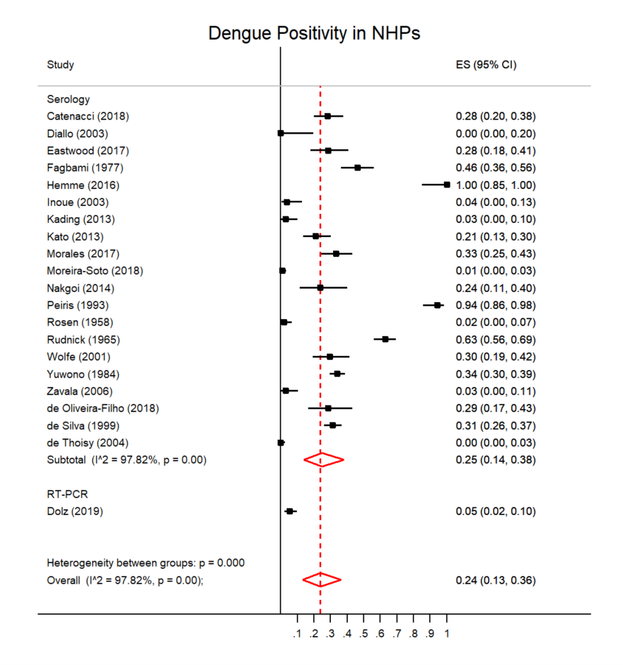
Figure 1: Forest plot of dengue prevalence in NHPs

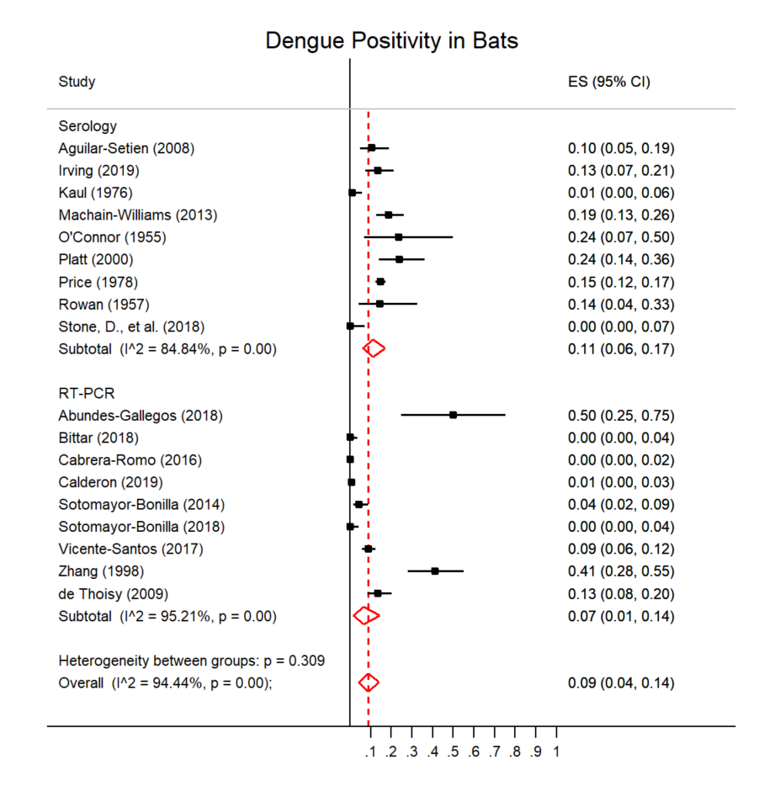
Figure 2: Forest plot of dengue prevalence in bats

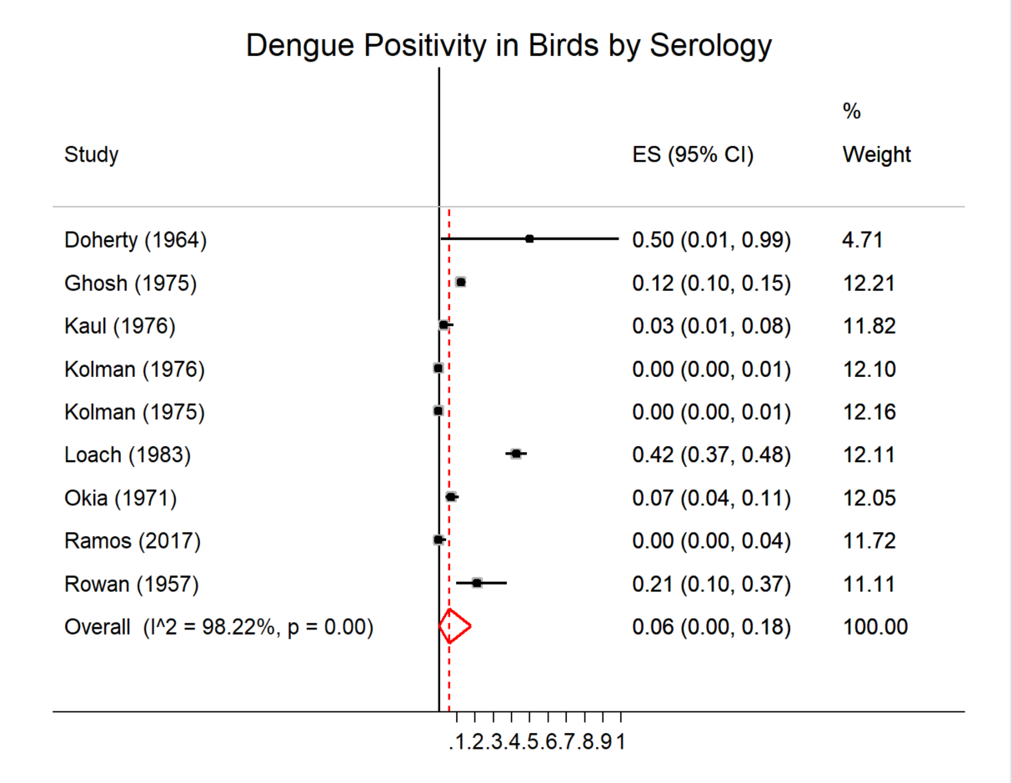
Figure 3: Forest plot of dengue prevalence in birds

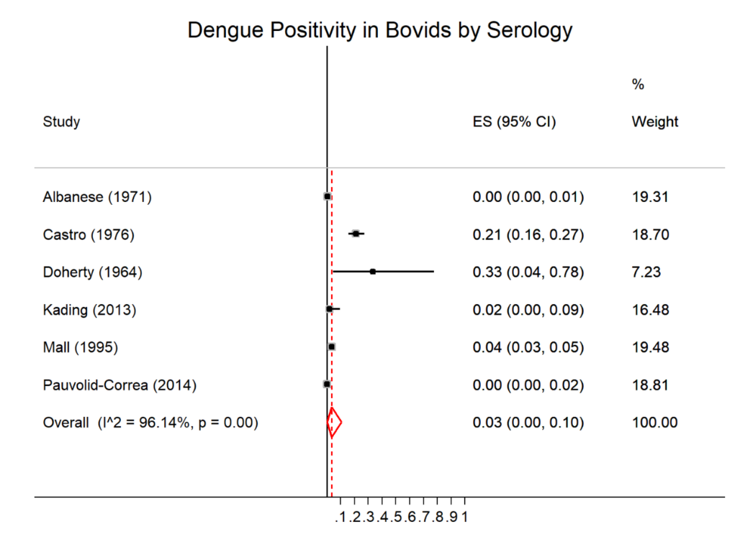
Figure 4: Forest plot of dengue prevalence in bovids

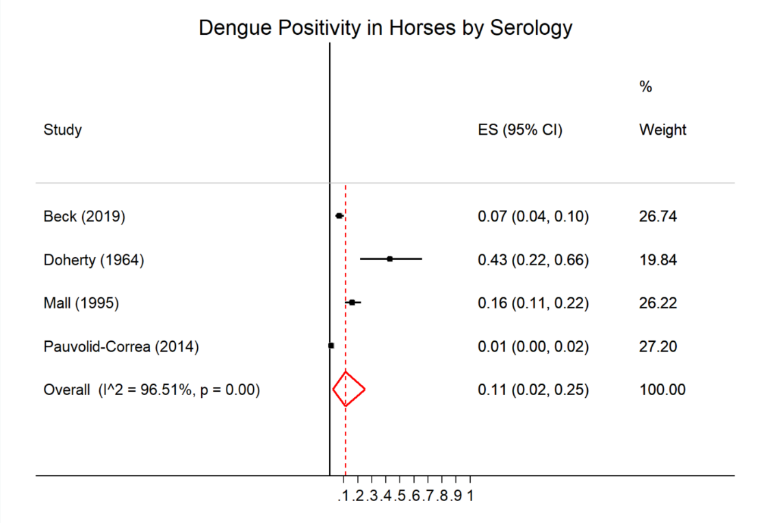
Figure 5: Forest plot of dengue prevalence in bovids

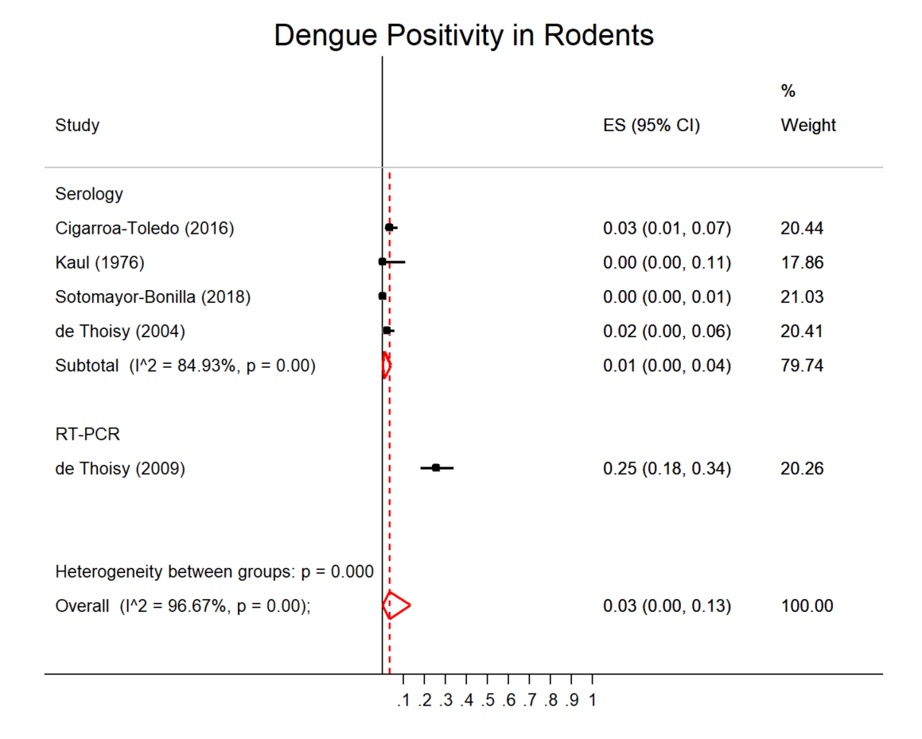
Figure 6: Forest plot of dengue prevalence in rodents
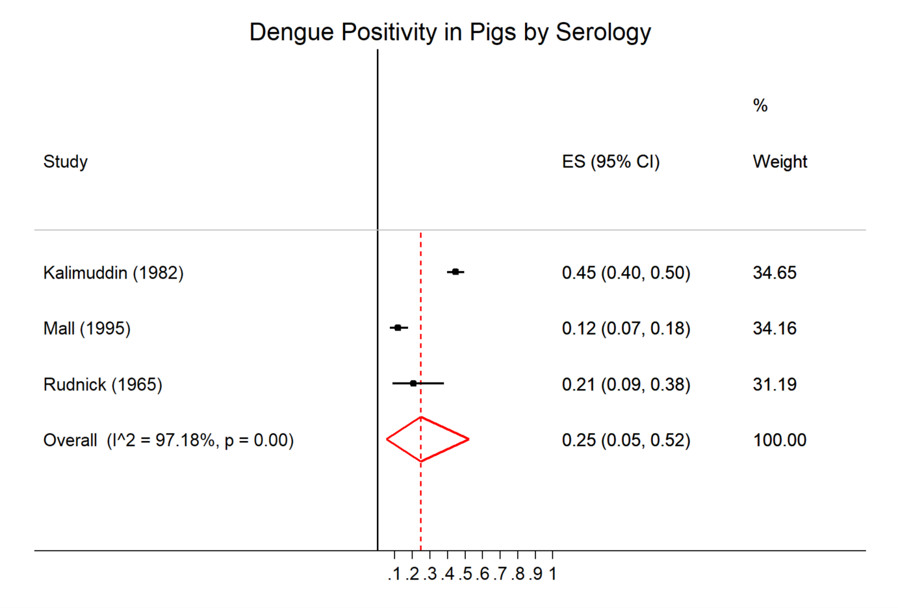
Figure 7: Forest plot of dengue prevalence in pigs

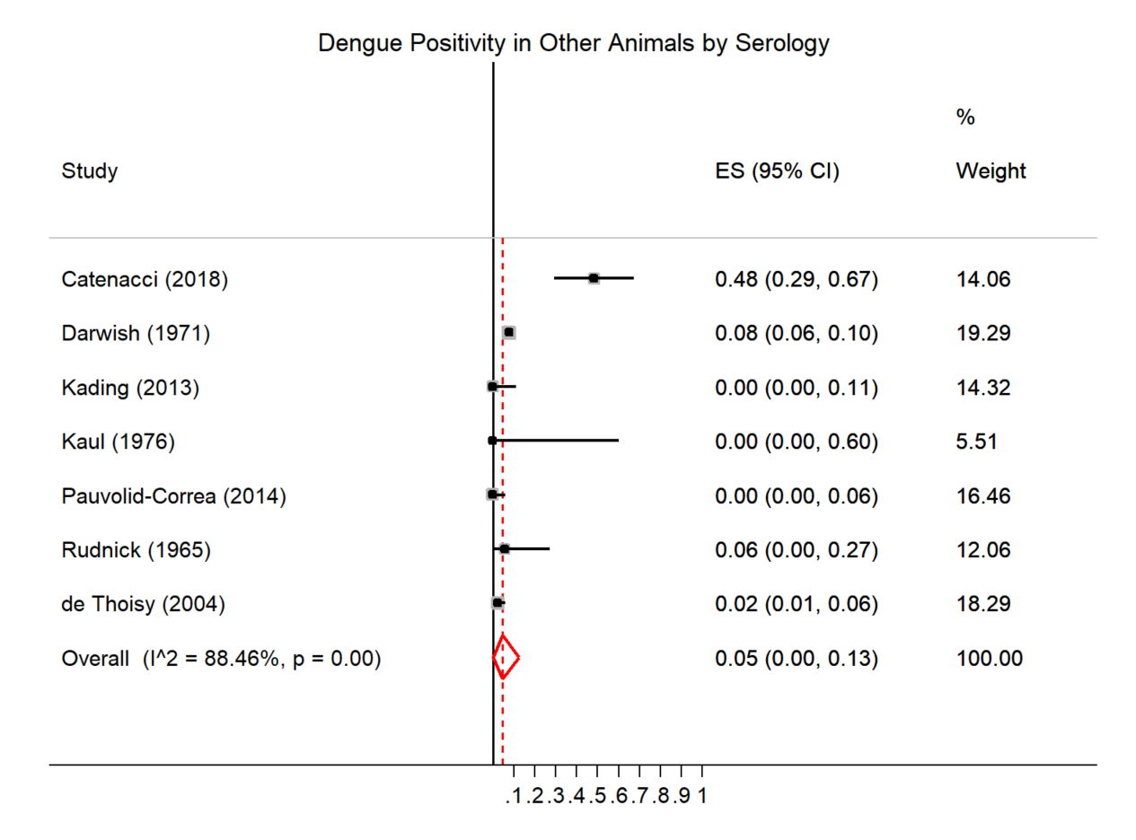
Figure 8: Forest plot of dengue prevalence in other animals

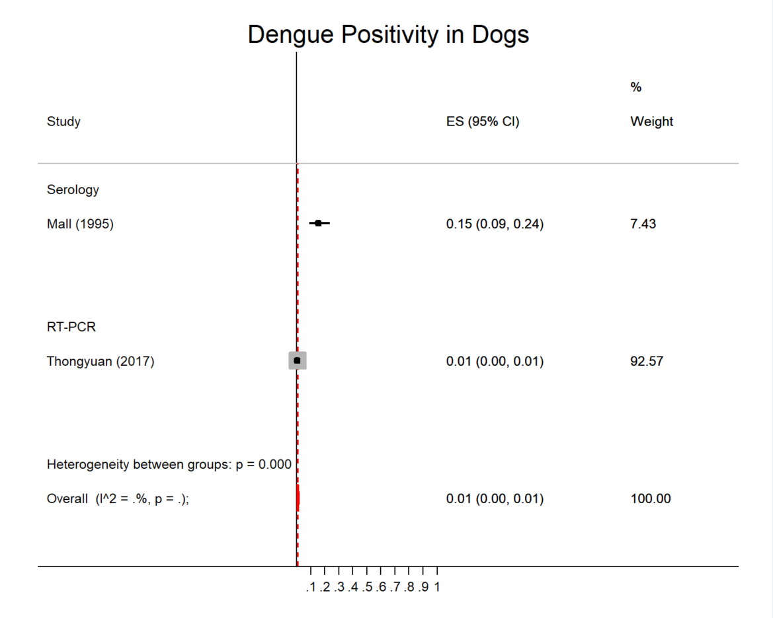
Figure 9: Forest plot of dengue prevalence in dogs

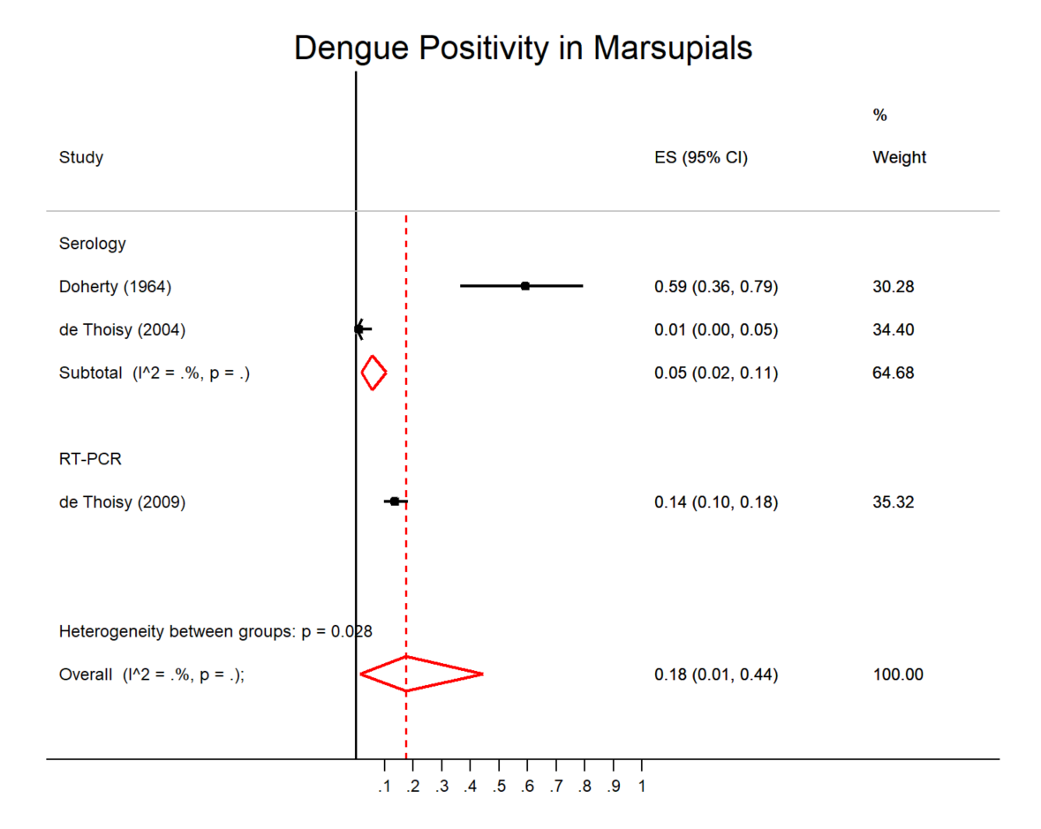
Figure 10: Forest plot of dengue prevalence in marsupials

References
1. Aguilar-Setien, A., et al., Dengue virus in Mexican bats. Epidemiol Infect, 2008. 136(12): p. 1678-83.
2. Sotomayor-Bonilla, J., et al., Dengue virus in bats from southeastern Mexico. Am J Trop Med Hyg, 2014. 91(1): p. 129-31.
3. Cabrera-Romo, S., et al., No Evidence of Dengue Virus Infections in Several Species of Bats Captured in Central and Southern Mexico. Zoonoses Public Health, 2016. 63(8): p. 579-583.
4. Abundes-Gallegos, J., et al., Detection of Dengue Virus in Bat Flies (Diptera: Streblidae) of Common Vampire Bats, Desmodus rotundus, in Progreso, Hidalgo, Mexico. Vector Borne Zoonotic Dis, 2018. 18(1): p. 70-73.
5. Zhang, H., X. Yang, and G. Li, [Detection of dengue virus genome RNA in some kinds of animals caught from dengue fever endemic areas in Hainan Island with reverse transcription-polymerase chain reaction]. Zhonghua Shi Yan He Lin Chuang Bing Du Xue Za Zhi, 1998. 12(3): p. 226-8.
6. de Thoisy, B., et al., Dengue infection in neotropical forest mammals. Vector Borne Zoonotic Dis, 2009. 9(2): p. 157-70.
7. Vicente-Santos, A., et al., Neotropical bats that co-habit with humans function as dead-end hosts for dengue virus. PLoS Negl Trop Dis, 2017. 11(5): p. e0005537.
8. Machain-Williams, C., et al., Serologic evidence of flavivirus infection in bats in the Yucatan Peninsula of Mexico. J Wildl Dis, 2013. 49(3): p. 684-9.
9. Price, J.L., Serological evidence of infection of Tacaribe virus and arboviruses in Trinidadian bats. Am J Trop Med Hyg, 1978. 27(1 Pt 1): p. 162-7.
10. Stone, D., et al., Serological evidence of widespread exposure of Grenada fruit bats to chikungunya virus. Zoonoses Public Health, 2018. 65(5): p. 505-511.
11. Platt, K.B., et al., Detection of dengue virus neutralizing antibodies in bats from Costa Rica and Ecuador. J Med Entomol, 2000. 37(6): p. 965-7.
12. Sotomayor-Bonilla, J., et al., Survey of mosquito-borne flaviviruses in the Cuitzmala River Basin, Mexico: do they circulate in rodents and bats? Trop Med Health, 2018. 46: p. 35.
13. Bittar, C., et al., Lack of serological and molecular evidence of arbovirus infections in bats from Brazil. PLoS One, 2018. 13(11): p. e0207010.
14. Calderon, A., et al., Dengue Virus in Bats from Cordoba and Sucre, Colombia. Vector Borne Zoonotic Dis, 2019. 19(10): p. 747-751.
15. Irving, A.T., et al., Robust dengue virus infection in bat cells and limited innate immune responses coupled with positive serology from bats in IndoMalaya and Australasia. Cell Mol Life Sci, 2019.
16. O'Connor, J.L., L.C. Rowan, and J.J. Lawrence, Relationships between the flying fox (genus Pteropus) and arthropod-borne fevers of North Queensland. Nature, 1955. 176(4479): p. 472.
17. Rowan, L.C. and J.L. O'Connor, Relationship between some coastal fauna and arthropod-borne fevers of North Queensland. Nature, 1957. 179(4563): p. 786-7.
18. Kaul, H.N., et al., Serological evidence of arbovirus activity in birds and small mammals in Japanese encephalitis affected areas of Bankura district, West Bengal. Indian J Med Res, 1976. 64(12): p. 1735-9.
19. Kato, F., et al., Natural infection of cynomolgus monkeys with dengue virus occurs in epidemic cycles in the Philippines. J Gen Virol, 2013. 94(Pt 10): p. 2202-7.
20. Yuwono, J., et al., Seroepidemiological survey on dengue and Japanese encephalitis virus infections in Asian monkeys. Southeast Asian J Trop Med Public Health, 1984. 15(2): p. 194-200.
21. Inoue, S., et al., Distribution of three arbovirus antibodies among monkeys (Macaca fascicularis) in the Philippines. J Med Primatol, 2003. 32(2): p. 89-94.
22. de Silva, A.M., et al., Serologic evidence for an epizootic dengue virus infecting toque macaques (Macaca sinica) at Polonnaruwa, Sri Lanka. American Journal of Tropical Medicine and Hygiene, 1999. 60(2): p. 300-306.
23. Hemme, R.R., et al., Serological Evidence of Infection with Endemic Human Pathogens Among Free-Ranging Old World Monkeys in Puerto Rico. Am J Trop Med Hyg, 2016. 94(5): p. 1095-9.
24. Peiris, J.S., W.P. Dittus, and C.B. Ratnayake, Seroepidemiology of dengue and other arboviruses in a natural population of toque macaques (Macaca sinica) at Polonnaruwa, Sri Lanka. Journal of medical primatology, 1993. 22(4): p. 240-245.
25. Kilbourn, A.M., et al., Health evaluation of free-ranging and semi-captive orangutans (Pongo pygmaeus pygmaeus) in Sabah, Malaysia. J Wildl Dis, 2003. 39(1): p. 73-83.
26. Wolfe, N.D., et al., Sylvatic transmission of arboviruses among Bornean orangutans. Am J Trop Med Hyg, 2001. 64(5-6): p. 310-6.
27. Fagbami, A.H., T.P. Monath, and A. Fabiyi, Dengue virus infections in Nigeria: a survey for antibodies in monkeys and humans. Trans R Soc Trop Med Hyg, 1977. 71(1): p. 60-5.
28. Eastwood, G., et al., Enzootic Circulation of Chikungunya Virus in East Africa: Serological Evidence in Non-human Kenyan Primates. Am J Trop Med Hyg, 2017. 97(5): p. 1399-1404.
29. Catenacci, L.S., et al., Surveillance of Arboviruses in Primates and Sloths in the Atlantic Forest, Bahia, Brazil. Ecohealth, 2018. 15(4): p. 777-791.
30. de Oliveira-Filho, E.F., et al., Seroprevalence of selected flaviviruses in free-living and captive capuchin monkeys in the state of Pernambuco, Brazil. Transbound Emerg Dis, 2018. 65(4): p. 1094-1097.
31. Moreira-Soto, A., et al., Limited Evidence for Infection of Urban and Peri-urban Nonhuman Primates with Zika and Chikungunya Viruses in Brazil. mSphere, 2018. 3(1).
32. Zavala, R., et al., Prevalence of antibodies to dengue virus, hepadnavirus and rotavirus in non-human primates. Acta Cientifica Venezolana, 2006. 57: p. 22-27.
33. Dolz, G., et al., Detection of antibodies against flavivirus over time in wild non-human primates from the lowlands of Costa Rica. PLoS One, 2019. 14(7): p. e0219271.
34. Rudnick, A., Studies of the ecology of dengue in Malaysia: a preliminary report. J Med Entomol, 1965. 2(2): p. 203-8.
35. de Thoisy, B., P. Dussart, and M. Kazanji, Wild terrestrial rainforest mammals as potential reservoirs for flaviviruses (yellow fever, dengue 2 and St Louis encephalitis viruses) in French Guiana. Trans R Soc Trop Med Hyg, 2004. 98(7): p. 409-12.
36. Kading, R.C., et al., Prevalence of antibodies to alphaviruses and flaviviruses in free-ranging game animals and nonhuman primates in the greater Congo basin. J Wildl Dis, 2013. 49(3): p. 587-99.
37. Rosen, L., Observations on the epidemilogy of dengue in Panama. Am J Hyg, 1958. 68(1): p. 45-58.
38. Diallo, M., et al., Amplification of the sylvatic cycle of dengue virus type 2, Senegal, 1999-2000: entomologic findings and epidemiologic considerations. Emerg Infect Dis, 2003. 9(3): p. 362-7.
39. Nakgoi, K., et al., Dengue, Japanese encephalitis and Chikungunya virus antibody prevalence among captive monkey (Macaca nemestrina) colonies of Northern Thailand. Am J Primatol, 2014. 76(1): p. 97-102.
40. Morales, M.A., et al., Detection of the mosquito-borne flaviviruses, West Nile, Dengue, Saint Louis Encephalitis, Ilheus, Bussuquara, and Yellow Fever in free-ranging black howlers (Alouatta caraya) of Northeastern Argentina. PLoS Negl Trop Dis, 2017. 11(2): p. e0005351.
41. Doherty, R.L., J.G. Carley, and B.M. Gorman, Studies of Arthropod-Borne Virus Infections in Queensland. Iv. Further Serological Investigations of Antibodies to Group B Arboviruses in Man and Animals. Aust J Exp Biol Med Sci, 1964. 42: p. 149-64.
42. Loach, T.R., K.G. Narayan, and S.P. Choudhary, Serological evidence of persistence of Japanese encephalitis virus activity in Bihar, India. Int J Zoonoses, 1983. 10(1): p. 7-14.
43. Kolman, J.M., et al., Serologic examination of birds from the area of southern Moravia for the presence of antibodies against arboviruses of the groups Alfa, Flavo, Uukuniemi, Turlock and Bunyamwera supergroup. II. Wild living birds. Folia Parasitol (Praha), 1976. 23(3): p. 251-5.
44. Kolman, J.M., J. Minár, and Horák, Serologic examination of birds from the area of Southern Moravia for the presence of antibodies against arboviruses of the groups alfa, flavo, Bunyamwera supergroup, and the virus Yaba 1-Lednice 110. I. Domestic fowls. Zentralblatt fur Bakteriologie, Parasitenkunde, Infektionskrankheiten und Hygiene. Erste Abteilung Originale. Reihe A: Medizinische Mikrobiologie und Parasitologie, 1975. 233(3): p. 279-287.
45. Ghosh, S.N., et al., Serological evidence of arbovirus activity in birds of KFD epizootic--epidemic area, Shimoga District, Karnataka, India. Indian J Med Res, 1975. 63(9): p. 1327-34.
46. Okia, N.O., et al., Arbovirus survey in wild birds in Uganda. East Afr Med J, 1971. 48(12): p. 725-31.
47. Ramos, B.A., et al., Clinical and serological tests for arboviruses in free-living domestic pigeons (Columba livia). Mem Inst Oswaldo Cruz, 2017. 112(8): p. 532-536.
48. Pauvolid-Correa, A., et al., Serological evidence of widespread circulation of West Nile virus and other flaviviruses in equines of the Pantanal, Brazil. PLoS Negl Trop Dis, 2014. 8(2): p. e2706.
49. Mall, M.P., A. Kumar, and S.V. Malik, Sero-positivity of domestic animals against Japanese encephalitis in Bareilly area, U.P. J Commun Dis, 1995. 27(4): p. 242-6.
50. Albanese, M., et al., Survey for Arbovirus antibodies in domestic animals of western Sicily. Ann Sclavo, 1971. 13(5): p. 641-7.
51. Castro, A., G. Tempera, and S. Guglielmino, Incidence of arbovirus antibodies in bovine, ovine and human sera collected in Eastern Sicily. Acta Virol, 1976. 20(1): p. 76-9.
52. Thongyuan, S. and P. Kittayapong, First evidence of dengue infection in domestic dogs living in different ecological settings in Thailand. PLoS One, 2017. 12(8): p. e0180013.
53. Beck, C., et al., Serological evidence of infection with dengue and Zika viruses in horses on French Pacific Islands. PLoS Negl Trop Dis, 2019. 13(2): p. e0007162.
54. Kalimuddin, M.D., K.G. Narayan, and S.P. Choudhary, Serological evidence of Japanese encephalitis virus activity in Bihar. Int J Zoonoses, 1982. 9(1): p. 39-44.
55. Cigarroa-Toledo, N., et al., Serologic Evidence of Flavivirus Infections in Peridomestic Rodents in Merida, Mexico. J Wildl Dis, 2016. 52(1): p. 168-72.
56. Darwish, M.A. and A.H. Ibrahim, Survey for antibodies to arboviruses in Egyptian sera. I. West Nile virus antihemagglutinins in human and animal sera. J Egypt Public Health Assoc, 1971. 46(2): p. 61-70.

