SUPPLEMENTARY APPENDIX

Title | Page
Supplementary Table 1: The risk of bias assessment of the included studies | 2
Supplementary Figure 1: Baujat plots of outcomes | 3-5
Supplementary Figure 2: Leave-one-out analyses plots | 6-8

Supplementary Table 1: The risk of bias assessment of the included studies
The Revised Cochrane risk-of-bias tool for randomized trials for randomized controlled trials in the meta-analysis.
Author, year | Bias arising from the randomization process |  | Bias due to deviations from intended interventions |  | Bias due to missing data |  |  | Bias in measurement of outcomes |  | Bias in selection of the reported result |  | low/moderate/serious / critical
Santer 2020 (MIDAS) | Low |  | Low |  | Low |  |  | Low |  | Low |  | Low
The Newcastle-Ottawa Scale for assessing the quality of nonrandomized studies in the meta-analysis.

 | Selection |  |  |  |  |  |  |  | Outcome
Study | Representative nest of the exposed cohort | Selection of the non-exposed cohort |  | Ascertainment of exposure |  | Outcome not present at baseline | Comparability of the cohort |  | Assessment of outcome |  | Enough follow up duration |  | Adequate follow-up | Total score
Liu 2010 | * | * |  | * |  | * | * |  | NA |  | * |  | NA | 6
Poveromo  2016 | * | * |  | * |  | * | * |  | * |  | * |  | * | 8
Whitson  2016 | * | * |  | * |  | * | * |  | * |  | * |  | * | 8
Roach 2017 | * | * |  | * |  | * | NA |  | NA |  | * |  | NA | 5
Fiorenza 2019 | * | * |  | * |  | * | * |  | NA |  | * |  | NA | 6
Nadhim 2019 | * | * |  | * |  | * | NA |  | NA |  | * |  | NA | 5
Hailu 2020 | * | * |  | * |  | * | * |  | NA |  | * |  | NA | 6
Tremblay 2020 | * | * |  | * |  | * | * |  | * |  | * |  | * | 8
Each asterisk represents one star in the Newcastle-Ottawa Scaling System (NOS). The maximum stars are 2 for comparability and 1 are for all other categories. Each star counts towards the total score. Score of 5 to 6 considered as moderate quality and 7 to 9 as high quality.
Abbreviation: NA: not available.

Supplementary Figure 1-A: Baujat plot of mean duration of ICU length of stay
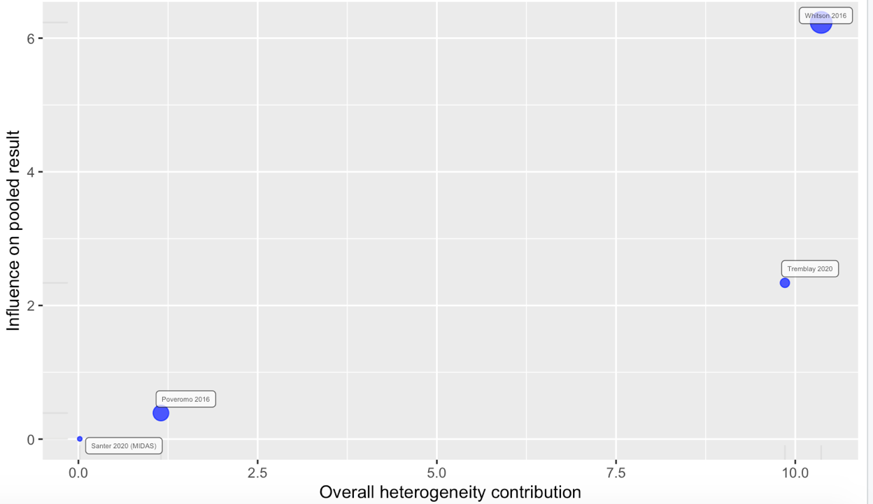

Supplementary Figure 1-B: Baujat plot of mean duration of hospital length of stay
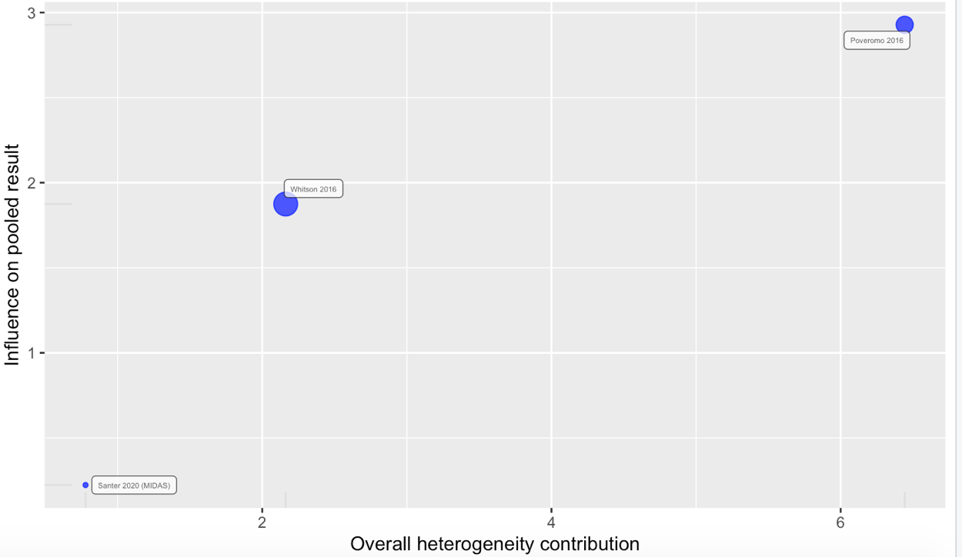

Supplementary Figure 1-C: Baujat plot of in-hospital mortality
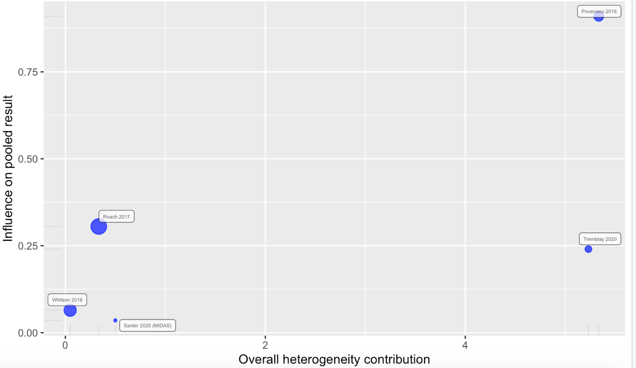

Supplementary Figure 1-D: Baujat plot of intravenous vasopressors reinstitutions
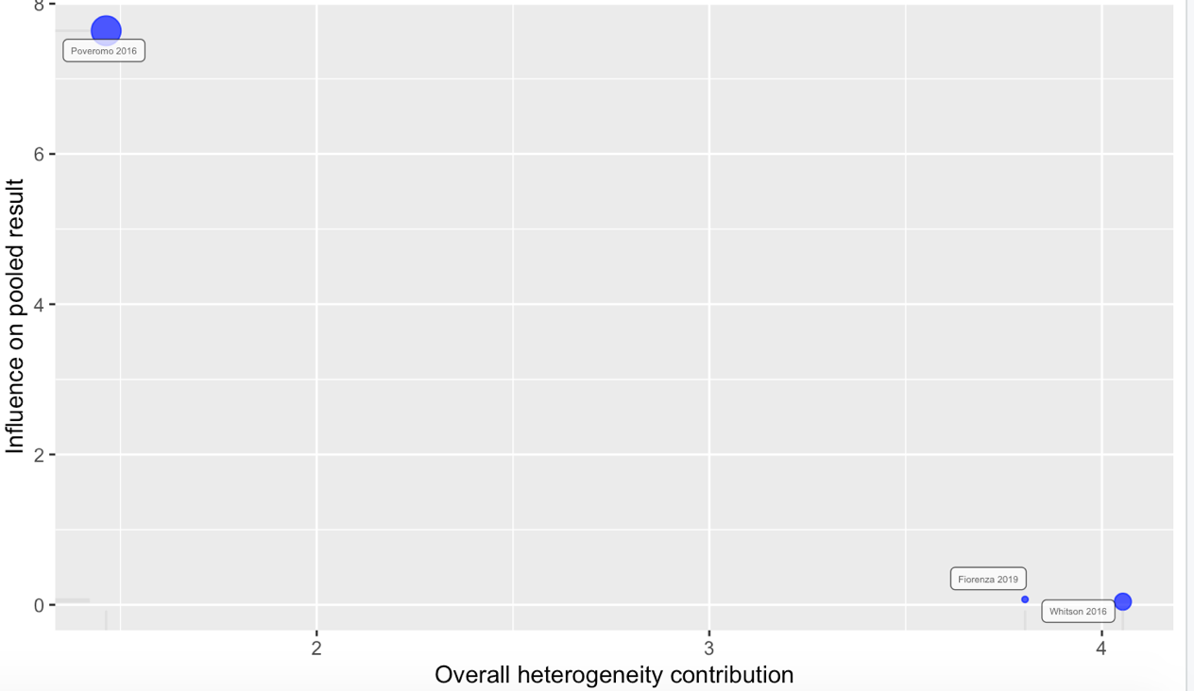

Supplementary Figure 1-E: Baujat plot lot of ICU readmission

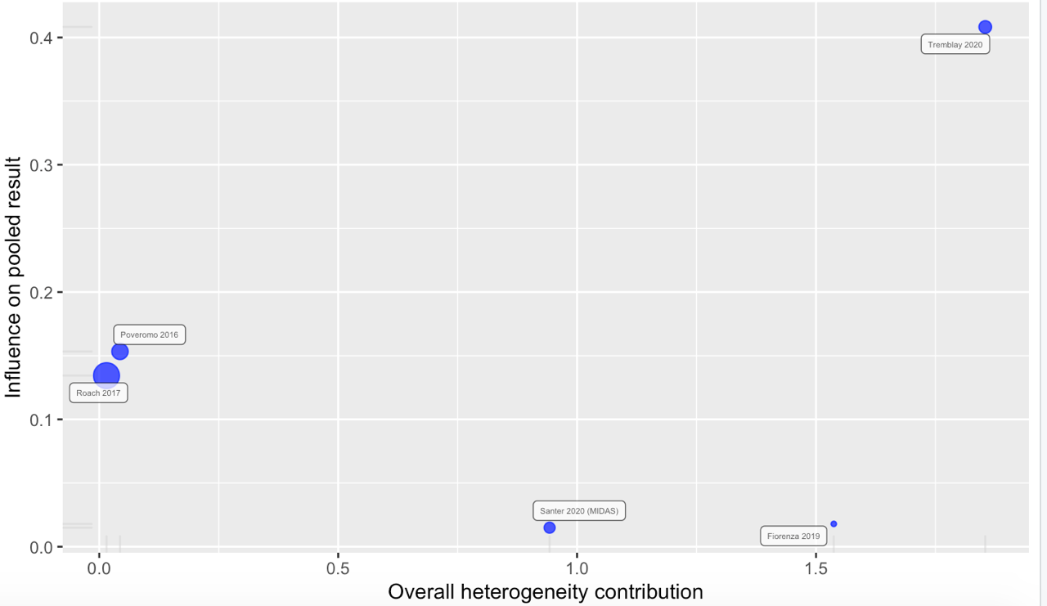
Supplementary Figure 1-F: Baujat plot of bradycardia
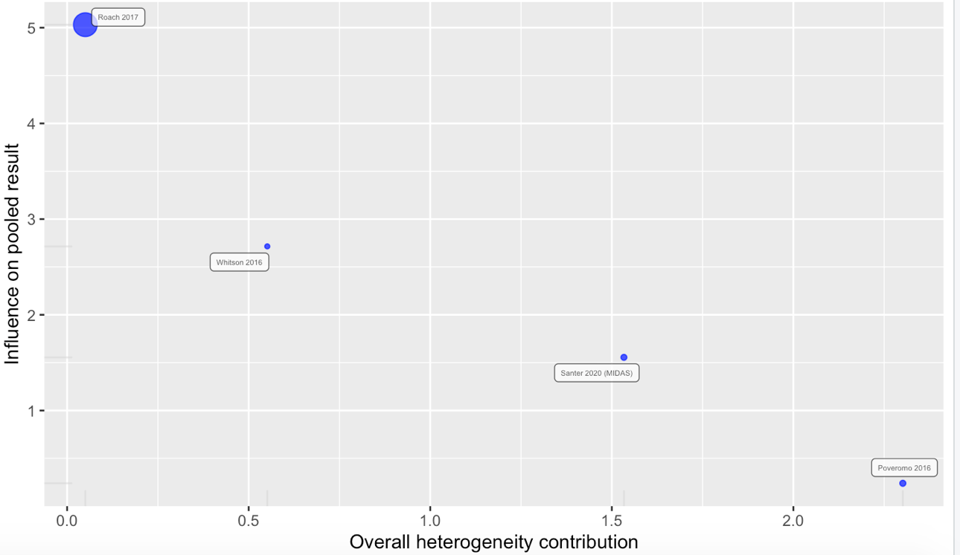

Supplementary Figure 2-A: Leave-one out analysis of mean duration of ICU length of stay
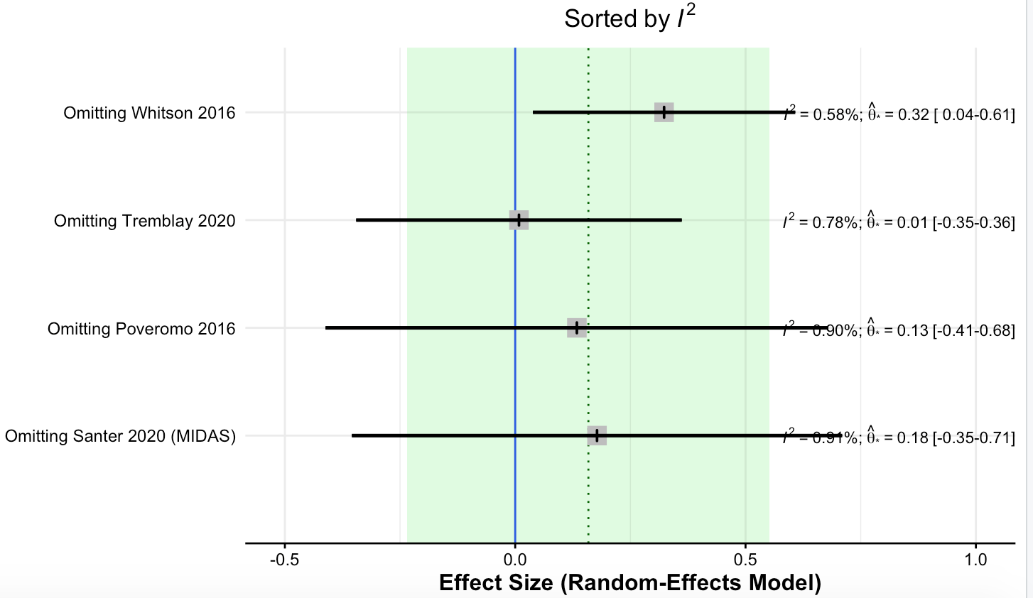
Supplementary Figure 2-B: Leave-one out analysis of mean duration of hospital length of stay
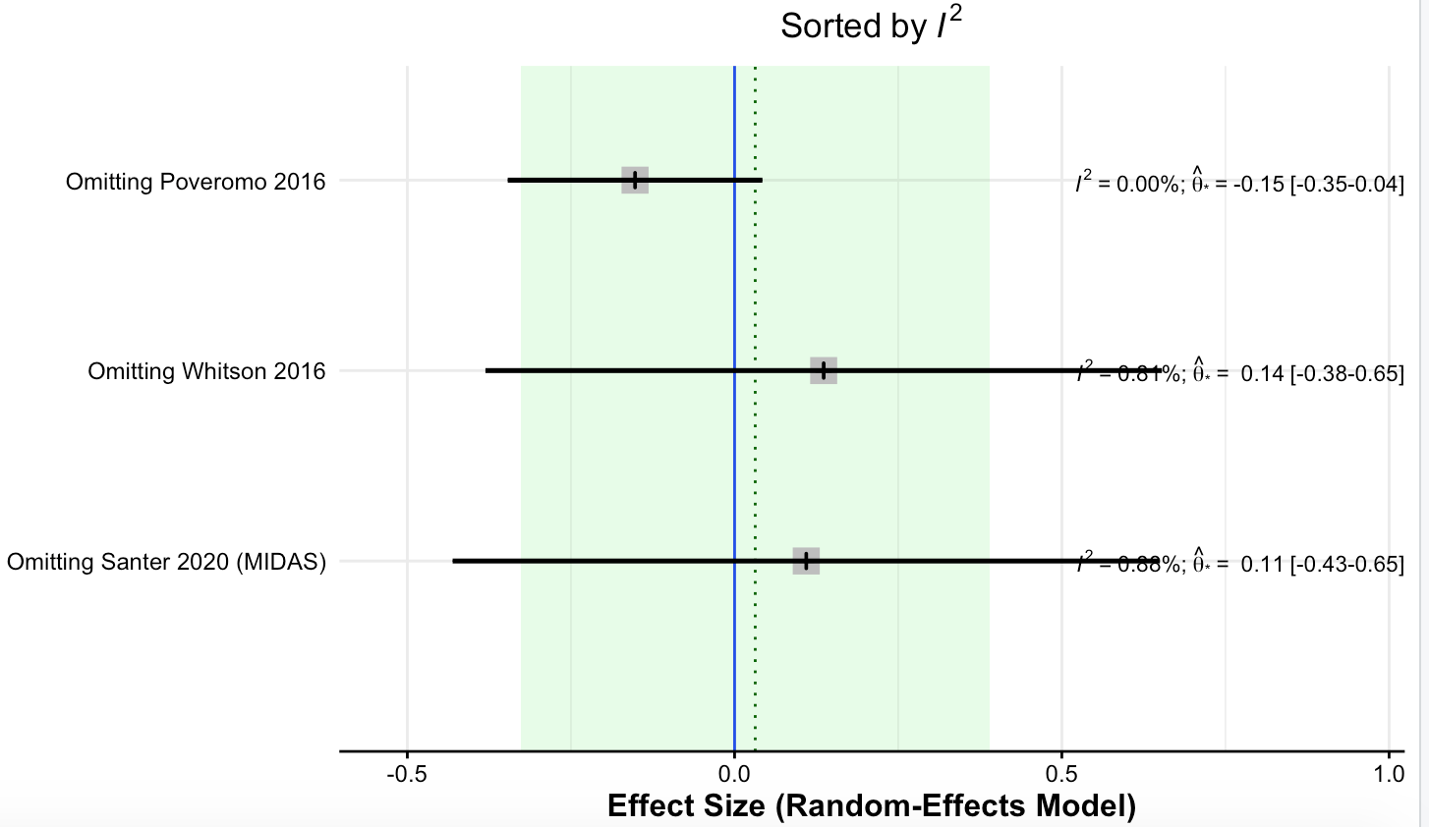

Supplementary Figure 2-C: Leave-one out analysis of in-hospital mortality
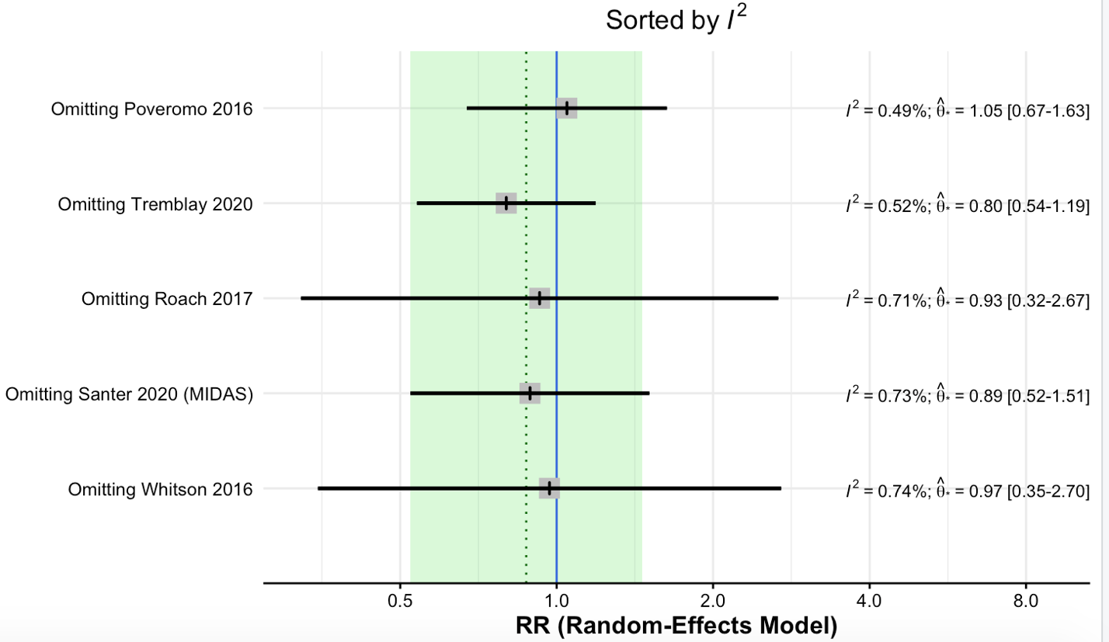 Supplementary Figure 2-D: Leave-one out analysis of intravenous vasopressors reinstitutions
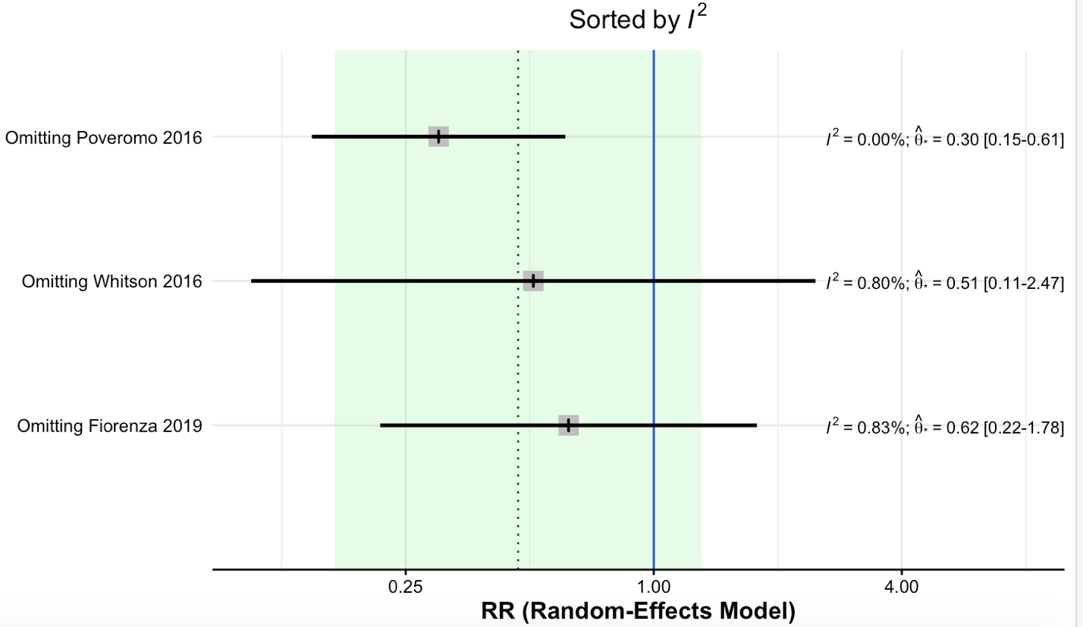

Supplementary Figure 2-E: Leave-one out analysis of ICU readmission
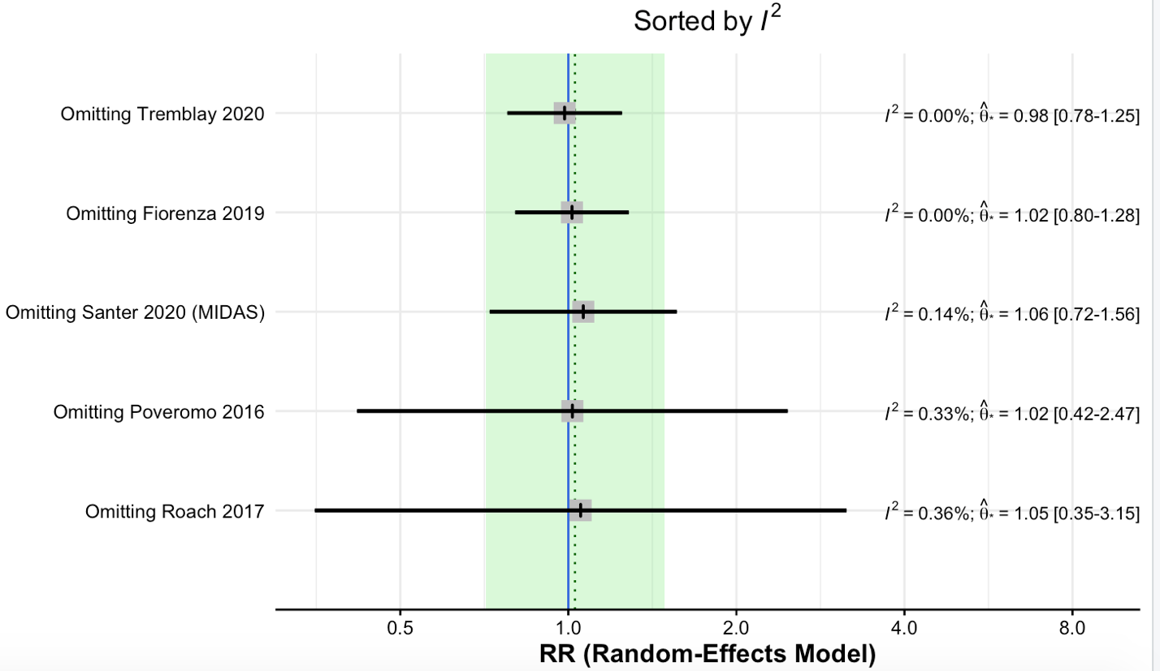
Supplementary Figure 2-E: Leave-one out analysis of bradycardia


